Complementary DNA oligonucleotide direct in-gel quantification (cDINGQ) for precise tRNA fragment analysis

AUTHORS
Marko Jörg¹, Marco Kristen¹, Lukas Walz¹, Christine Lietz¹, Max Müller¹, Sebastian Nathal¹, Virginie Marchand², Yuri Motorin^{2,3}, Marie-Luise Winz¹, Mark Helm¹ and Kristina Friedland^{1,}*

¹ Institute of Pharmaceutical and Biomedical Sciences, Johannes Gutenberg University, Mainz, Staudinger Weg 5, 55128 Mainz, Rhineland palatinate, Germany
² Université de Lorraine, Epitranscriptomics and RNA Sequencing (EpiRNA-Seq) Core Facility, SMP IBSLor, Nancy, 54000, France
³Université de Lorraine, IMoPA UMR7365 CNRS-UL, BioPole, 54000 Nancy, France

* To whom correspondence should be addressed. Tel: +49 6131 39 20337; Email: kfriedla@uni-mainz.de

SUPPLEMENTARY INFORMATION

Supplementary Table S1: Sequences for tRF standards and hybridization probes
Description | tRNA/tRF | Anticodon | Sequence
tRF standard | Gly | GCC | 5′-GCAUUGGUGGUUCAGUGGUAGAAUUCUCGCC-3′
tRF standard | Glu | CTC | 5′-UCCCUGGUGGUCUAGUGGUUAGGAUUCGGGCGCCUC-3′
tRF standard | Val | CAC | 5′-GUUUCCGUAGUGUAGUGGUUAUCACGUUCGCCUCAC-3′
tRF standard | Pro | AGG | 5′-GGCUCGUUGGUCUAGGGGUAUGAUUCUCGCUUAGG-3′
tRF standard | Lys | CTT | 5′-GCCCGGCUAGCUCAGUCGGUAGAGCAUGAGACUCUU-3′
Probe | Gly | GCC | 5′-AGGCGAGAATTCTACCACTGAACCACCAATGC-3′
Probe | Gly | CCC | 5‘-AATCTTGCATGATACCACTACACCAGCGGCGC-3’
Probe | Glu | CTC | 5’-AGCGCCGAATCCTAACCACTAGACCACCAGGG A-3’
Probe | Val | CAC | 5’-AGGCGAACGTGATAACCACTACACTACGGAAAC-3’
Probe | Pro | AGG | 5’-AAGCGAGAATCATACCCCTAGACCAACGAGCC-3’
Probe | Lys | CTT | 5’-AGAGTCCCATGCTCTACCGACTGAGCTAGCCGGGC-3’
Probe (DORQ-Seq) | Gly | GCC | 5‘-AGACGTGTGCTCTTCCGATCTTGGTGCATTGGCCGGGAATCGA  ACCCGGGCCTCCCGCGTGGATCGTCGGACTGTAGAACTCTGAAC-3‘

Supplementary figures
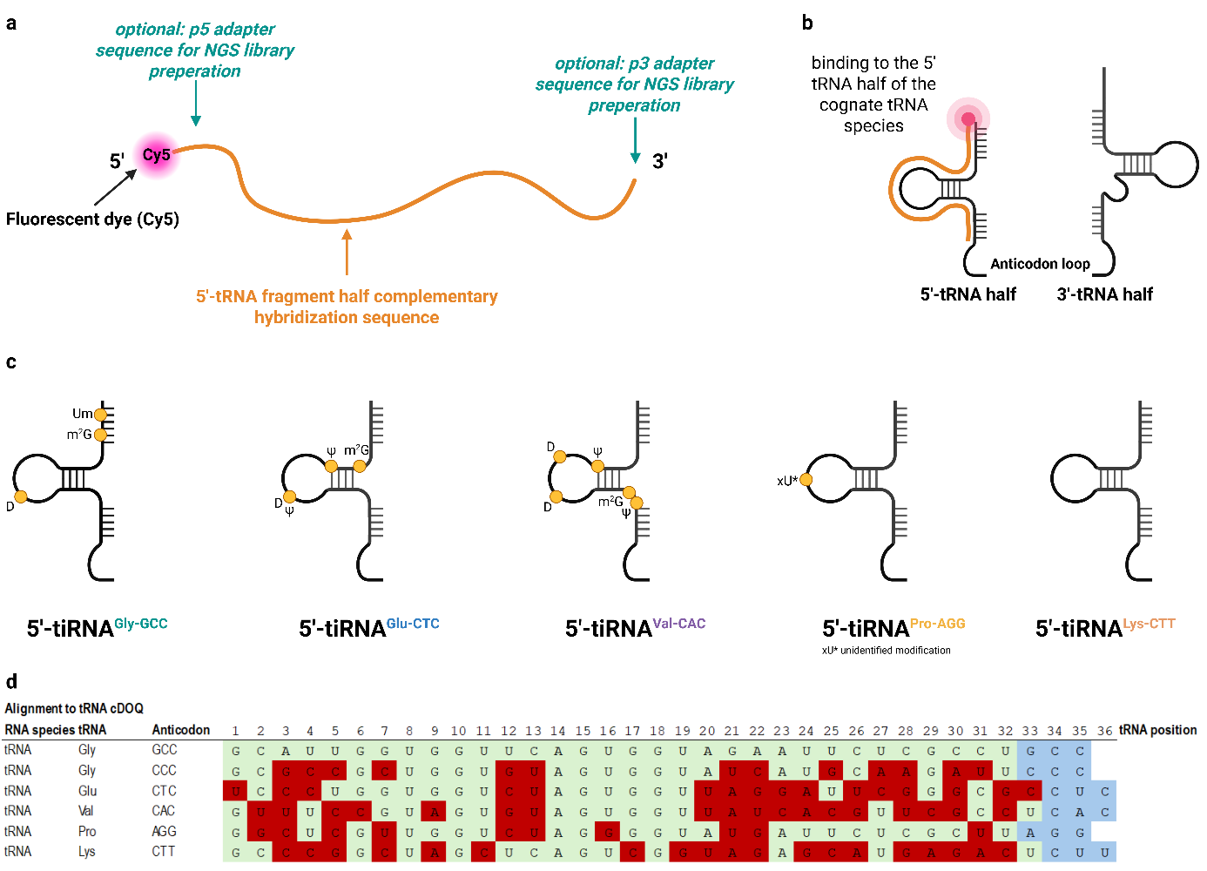

Figure S1. cDINGQ cDOQ design. a-b) Schematic representation of the cDNA oligo for quantification (cDOQ), showing key design elements including the fluorescent dye Cy5 (a), and its hybridization to the complementary sequence of a 5′-tRNA half (b). Adapter ligation to 5’ and 3’-ends of cDOQ for NGS is optional and was not performed in our analysis. c) Known RNA modifications within the hybridization region of the target tRFs were identified according to MODOMICS (Boccaletto et al., 2018, 2022; Cappannini et al., 2024; Czerwoniec et al., 2009; Dunin-Horkawicz, 2006; Machnicka et al., 2012). d Sequence similarity among the analyzed 5’-tRNA fragments. Nucleotides that differ from tRNA^{Gly-GCC} are highlighted in red. The anticodon positions are indicated in blue.

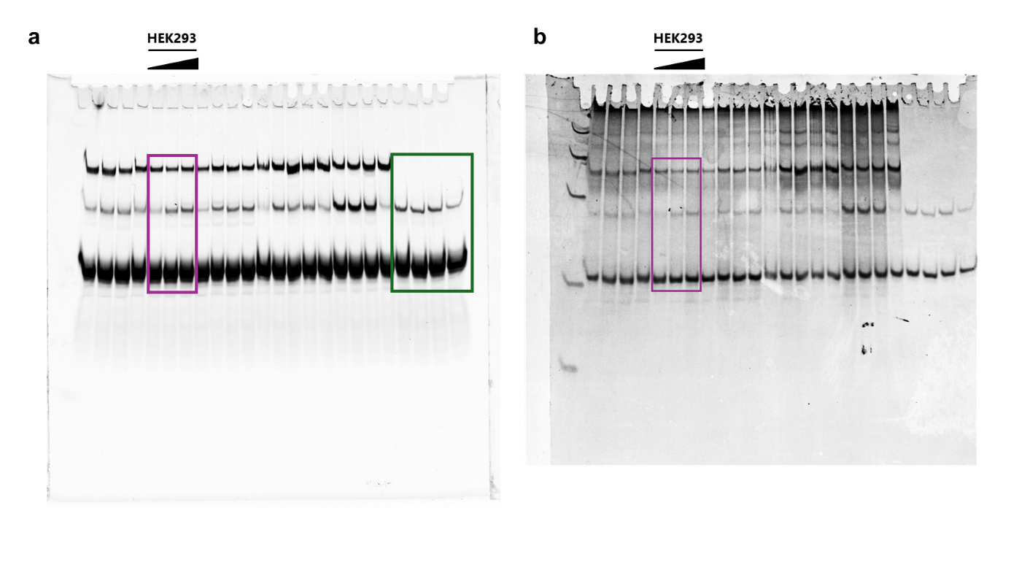
Figure S2. (a) cDINGQ analysis of total RNA from HEK293 cells with increasing RNA concentrations, alongside (b) GelRed staining. Full gel images were acquired using a fluorescence imager in Cy5 or GelRed scanning modes and correspond to the main Figure 1c. Upper band: tRNA:cDOQ hybrid, middle band: 5’-tiRNA:cDOQ hybrid, lower band: remaining cDOQ. Images were acquired using a Typhoon Trio+ scanner (fluorescence acquisition mode, 200 microns pixel size, 670 BP 30 Cy5 filter or GelRed filter, sensitivity set to normal). Cropped regions used in the main figure are marked in purple. A synthetic tRF standard was loaded for absolute quantification (green), from left to right: 4.8 ng, 2.4 ng, 0.48 ng, and 0.2 ng.

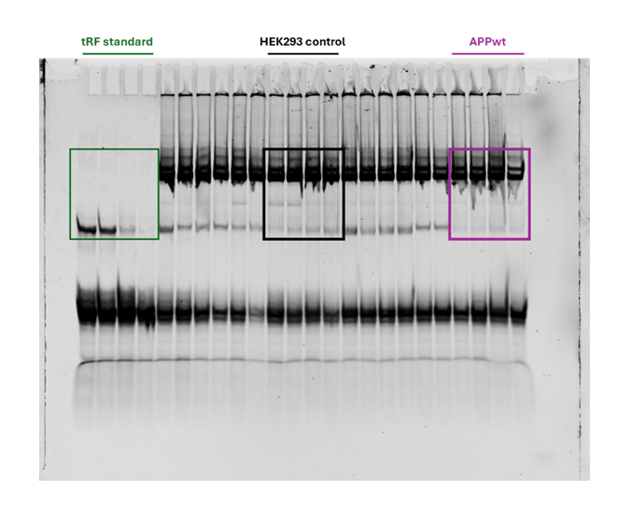
Figure S3. cDOQ direct in-gel quantification of HEKut and APPwt cells uaing 10 µg of total RNA as input. The full gel image was acquired using a fluorescence imager in Cy5 scanning mode and corresponds to the main Figure 1d. Image was acquired using a Typhoon Trio+ scanner (fluorescence acquisition mode, 200 microns pixel size, 670 BP 30 Cy5 filter, sensitivity set to “normal”, image acquisition time under these settings was 4 min 56 s). Cropped regions used in the main figure are marked in purple. A synthetic tRF standard was included for absolute quantification (green), loaded from left to right: 4.8 ng, 2.4 ng, 0.48 ng, and 0.2 ng.
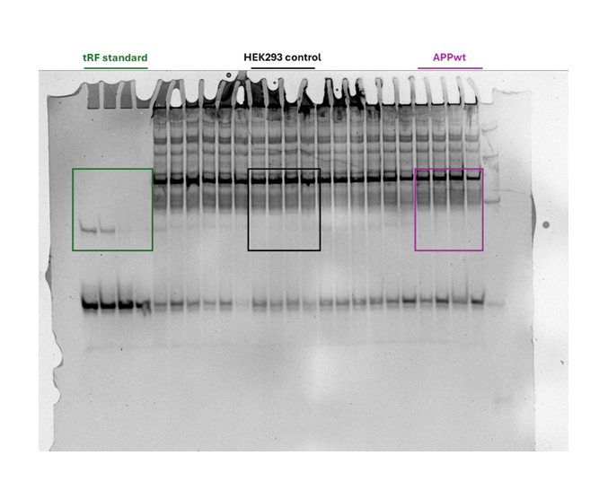
Figure S4. GelRed staining corresponding to the cDINGQ analysis of HEKut and APPwt cells shown in Figure S3. The full gel image was acquired using a fluorescence imager in GelRed scanning mode. Image was acquired using a Typhoon Trio+ scanner (fluorescence acquisition mode, 200 microns pixel size, GelRed filter, sensitivity set to “normal”, image acquisition time under these settings was 4 min 56 s). A synthetic tRF standard was included for absolute quantification (green), loaded from left to right: 4.8 ng, 2.4 ng, 0.48 ng, and 0.2 ng.

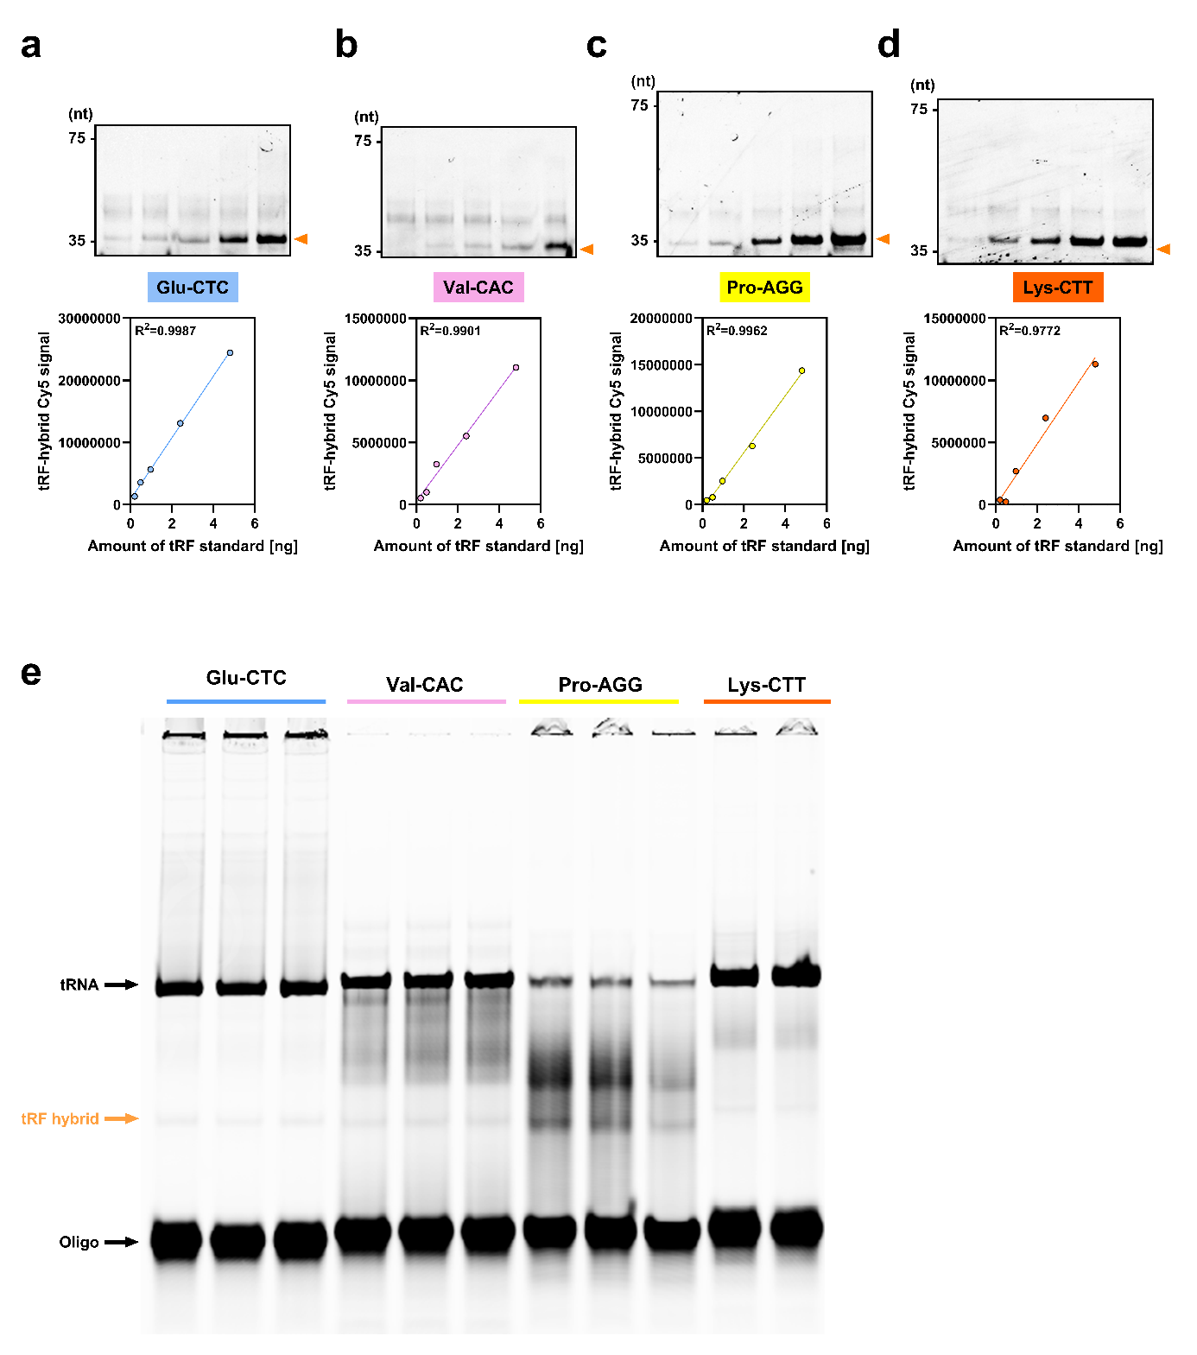
Figure S5. Validation of Cy5-labeled cDOQ probes using synthetic 5′-tRF standards (a-d). e Total RNA from HEK293 control cells was hybridized with cDOQs targeting distinct 5′-tRFs. Each probe produced a discrete 5′-tRF hybridization band and a corresponding full-length tRNA band, confirming probe specificity and detection of both fragment and precursor species.

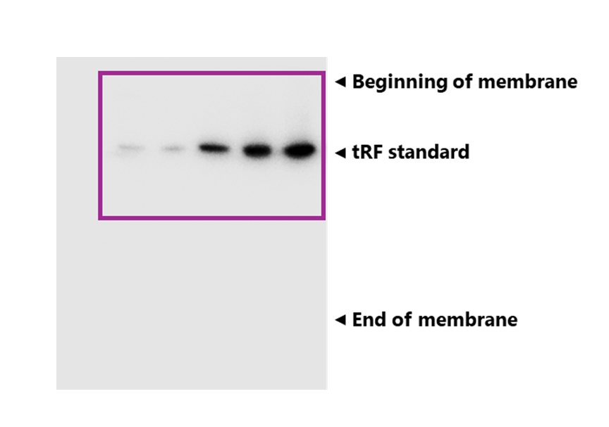
Figure S6. [³²P]-labeled Northern blot of the synthetic tRF standard. Cropped areas are highlighted in purple. This uncropped membrane corresponds to main Figure 2b. Arrows indicate the start and end of the membrane as shown. All membranes were exposed for 6 hours to ensure comparability of signal sensitivity across samples.

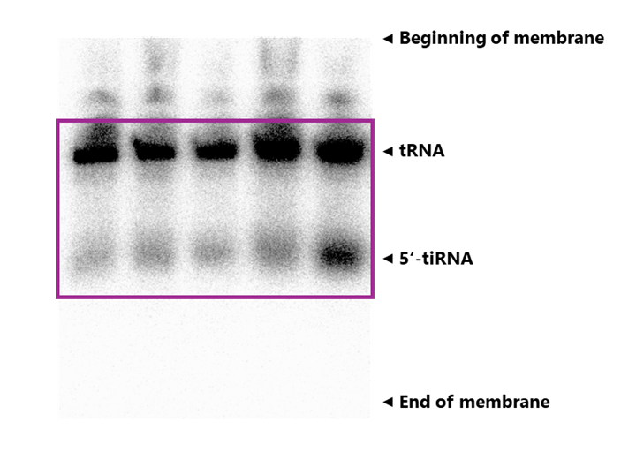
Figure S7. [³²P]-labeled Northern blot of 5’-tiRNA^{Gly-GCC} in HEK293ut control cells. Cropped areas are highlighted in purple. This uncropped membrane corresponds to the main Figure 2c. Arrows indicate the start and end of the membrane as shown. All membranes were exposed for 6 hours to ensure comparability of signal sensitivity across samples.

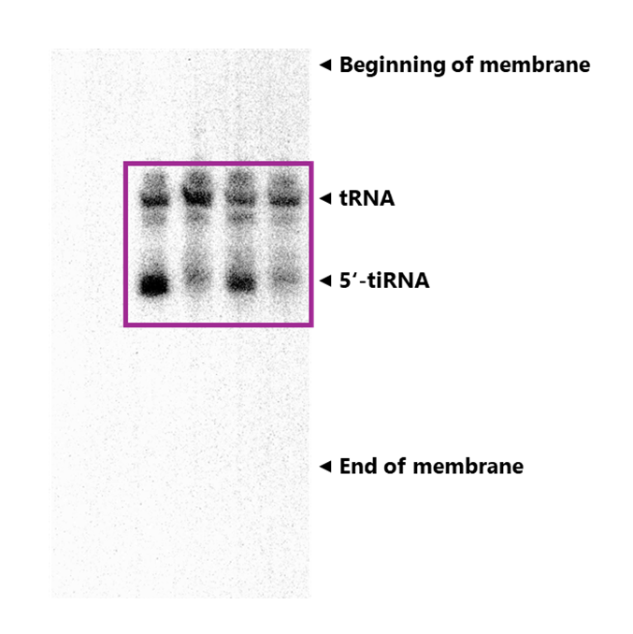
Figure S8. [³²P]-labeled Northern blot of 5’-tiRNA^{Gly-GCC} in HEK293ut control and APPwt cells. Cropped areas are highlighted in purple. This uncropped membrane corresponds to the main Figure 2d. Arrows indicate the start and end of the membrane as shown. All membranes were exposed for 6 hours to ensure comparability of signal sensitivity across samples.
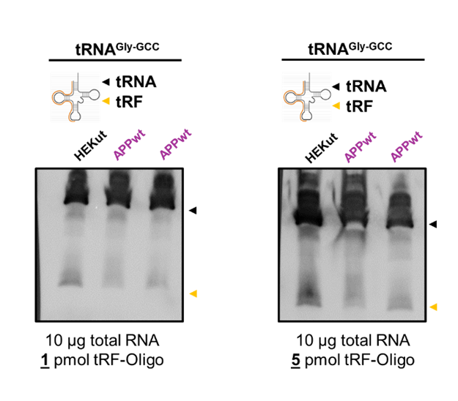
Figure S9. Determination of DIG-labeled hybridization probe concentration. Labeling was enzymatically performed according to the manufacturer’s protocol. The recommended probe concentration is 1-10 pmol; we selected 1 pmol to minimize background noise and reduce nonspecific binding.

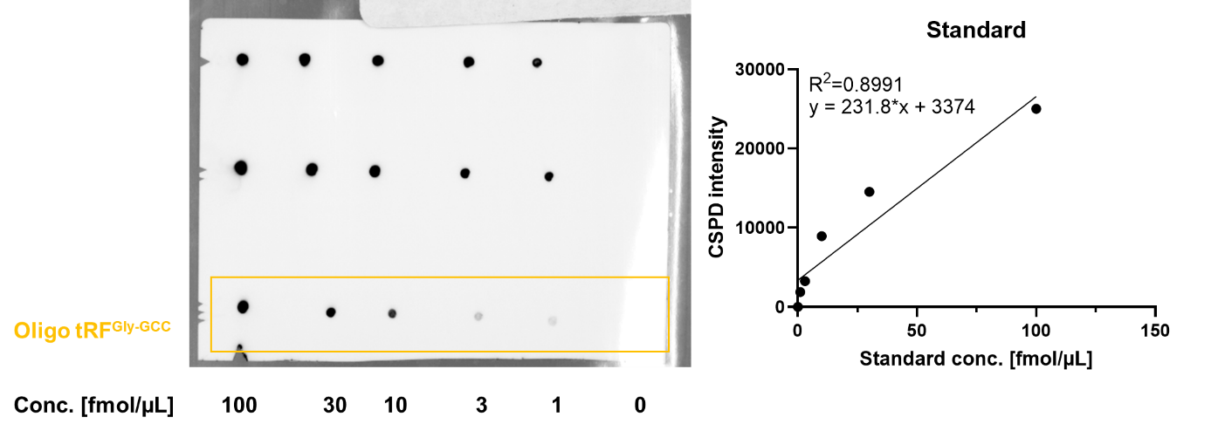
Figure S10. Determination of labeling efficiency compared to a DIG-labeled control oligonucleotide provided by the manufacturer. The orange box indicates the DIG-labeled hybridization probe in different concentrations. The procedure was carried out according to the manufacturer’s protocol.

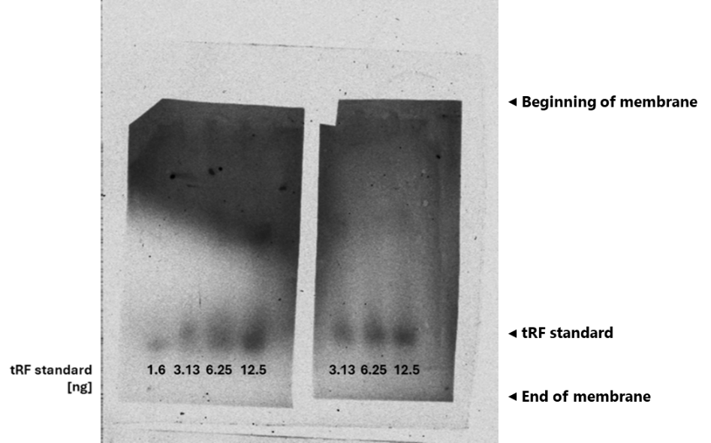
Figure S11. Non-radioactive DIG-labeled Northern blot of the synthetic tRF standard at low RNA concentrations ranging from 1.6 to 12.5 ng. All bands exhibited weak signals with high background noise. Image acquisition time was 15 minutes.

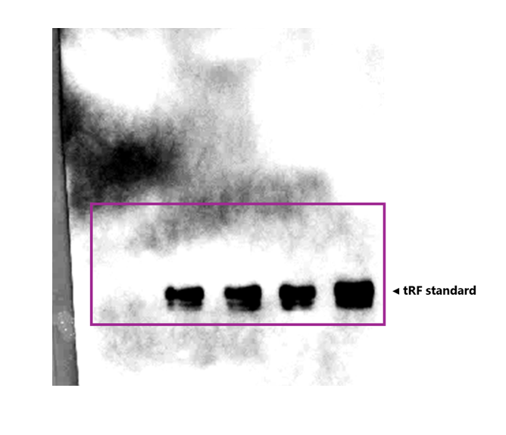
Figure S12. DIG-labeled Northern blot of the synthetic tRF standard. Cropped areas are highlighted in purple. This uncropped membrane corresponds to the main Figure 3b. Arrows indicate the start and end of the membrane as indicated. Exposure time for all membranes was 15 minutes, as recommended by the manufacturer.

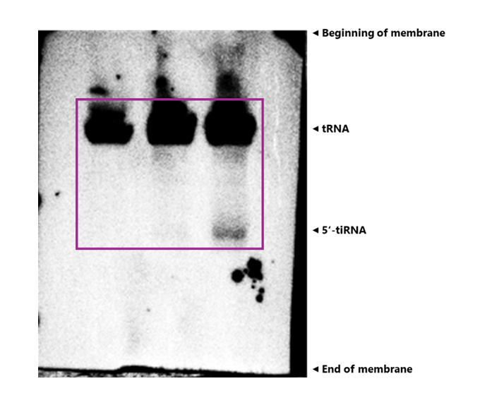
Figure S13. DIG-labeled Northern blot of 5’-tiRNA^{Gly-GCC} in HEK293ut control cells. This uncropped membrane corresponds to the main Figure 3c. Arrows indicate the start and end of the membrane as indicated. Exposure time for all membranes was 15 minutes, as recommended by the manufacturer.

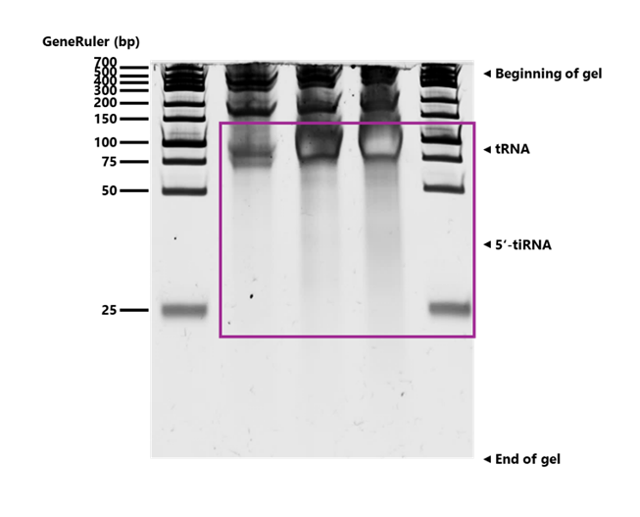
Figure S14. SYBR Gold staining of the gel corresponding to Figure S12. This uncropped gel corresponds to main Figure 3c. Cropped areas are highlighted in purple. GeneRuler was loaded as a size marker in lanes 1 and 5. Arrows indicate the start and end of the gel as shown.

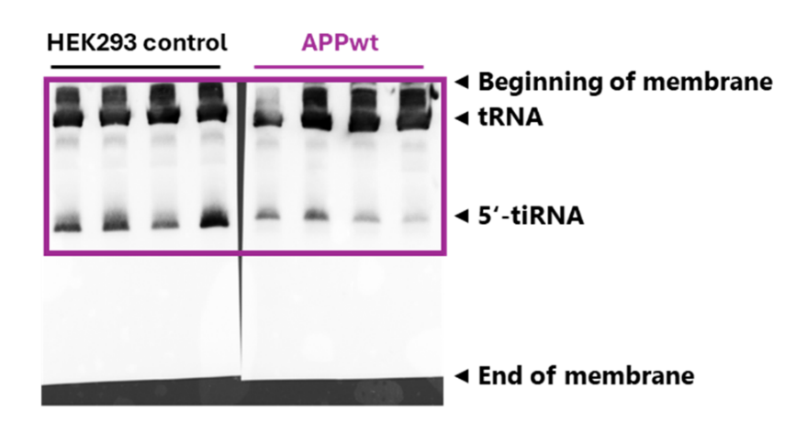
Figure S15. DIG-labeled Northern blot of 5’-tiRNA^{Gly-GCC} in HEK293ut control and APPwt cells. Cropped areas are highlighted in purple. This uncropped membrane corresponds to the main Figure 3d. Arrows indicate the start and end of the membrane as indicated. The membrane was cut prior to antibody incubation due to limited space in the incubation box. Transfer, hybridization, and image acquisition were all performed on the same membrane. Exposure time for all membranes was 15 minutes, as recommended by the manufacturer.

Raw data section
All unprocessed and normalized raw data generated for this manuscript are provided in this section. Details on how values were calculated, including the respective formulas, are included within the raw data files.

cDINGQ raw data (corresponding to main Figure 1)
Raw Data Table 1: Cy5 signal intensities for the synthetic tRF standard. Band intensities were quantified using ImageLab software (Bio-Rad Laboratories). Image was acquired using a Typhoon Trio+ scanner (fluorescence acquisition mode, 200 microns pixel size, 670 BP 30 Cy5 filter, sensitivity set to “normal”, image acquisition time under these settings was 4 min 56 s).
Amount tRF standard [ng] | Cy5 signal intensity of tRF | Cy5 signal intensity of unhybridized cDOQ probe
4.8 | 238394.84 | 1065297
2.4 | 120724.19 | 1395476
0.96 | 34726.41 | 1800109
0.48 | 21877.66 | 1823304
0.2 | 7625.2 | 1713515
0 | 0 | 1923304

Raw data table 2: Cy5 signal intensities in the HEK293 cell model. Band intensities were evaluated using ImageLab software (Bio-Rad Laboratories). Image was acquired using a Typhoon Trio+ scanner (fluorescence acquisition mode, 200 microns pixel size, 670 BP 30 Cy5 filter, sensitivity set to “normal”, image acquisition time under these settings was 4 min 56 s).
Total RNA concentration  [µg] | Cy5 signal intensity of tRF band | Cy5 signal intensity of unhybridized cDOQ probe
0.5 | 113578.73 | 1793806
2.5 | 311266.73 | 1770456
10 | 343671.76 | 1243466

Raw data table 3: GelRed signal intensities in the HEK293 cell model. Band intensities were evaluated using ImageLab software (Bio-Rad Laboratories).
Total RNA concentration  [µg] | GelRed signal intensity of tRF band | GelRed signal intensity of unhybridized cDOQ probe
0.5 | 11858.6 | 191027
2.5 | 19873.4 | 153498
10 | 33974.4 | 156617

Raw data table 4: Cy5 fluorescence signal intensities in the HEK AD cell model. The labels (#x) indicate individual biological replicates used in the study (e.g. #1 = biological replicate 1). Band intensities were quantified using ImageLab software (Bio-Rad Laboratories). Image was acquired using a Typhoon Trio+ scanner (fluorescence acquisition mode, 200 microns pixel size, 670 BP 30 Cy5 filter, sensitivity set to “normal”, image acquisition time under these settings was 4 min 56 s).
Sample name | Cy5 signal intensity of tRF band | Cy5 signal intensity of tRNA band | Ratio  [tRF:tRNA] | Normalized to control
HEKut #1 | 16.648,87 | 2.750.359,36 | 0.00605334 | 0.94342617
HEKut #2 | 19.939,03 | 2.936.633,59 | 0.00678976 | 1.05819788
HEKut #3 | 15.053,66 | 3.239.974,55 | 0.00464623 | 0.7241244
HEKut #4 | 22.788,51 | 2.787.234,16 | 0.00817603 | 1.27425155
APPwt #1 | 7.788,18 | 1.780.951,66 | 0.00437305 | 0.68154862
APPwt #2 | 6.075,03 | 1.960.246,10 | 0.00309911 | 0.48300351
APPwt #3 | 6.373,24 | 1.877.444,70 | 0.00339464 | 0.5290611
APPwt #4 | 2.827,79 | 1.020.775,11 | 0.00277024 | 0.43174822
Normalization to control was performed according to the following formula:
$$Normalized value=\frac{Ratio \left[tRF:tRNA\right] of individual sample}{Mean ratio [tRF:tRNA] HEKut \#1-4}$$

Example calculation:
$$Normalized value=\frac{0.00437305 (APPwt \#1 [tRF:tRNA]}{0.00641634 (Mean \left[tRF:tRNA\right]HEKut \#1-4}= 0.68154862$$

Raw data table 5: Absolute quantification of the 5’-tiRNA^{Gly-GCC} in the HEK AD cell model.
Sample name | Absolute amount of 5‘-tiRNA^{Gly-GCC}
HEKut #1 | 0.40431825
HEKut #2 | 0.46956166
HEKut #3 | 0.37268552
HEKut #4 | 0.52606651
APPwt #1 | 0.2286122
APPwt #2 | 0.19464051
APPwt #3 | 0.20055404
APPwt #4 | 0.13024837
Calculation was performed according to the following formula:
Formula obtained from the calibration:
$$y=50429*x-3741$$

Absolute quantification:
$$5^{'}-tiRNAGlyGCC [ng]=\frac{Cy5 signal intensity tRF band-(-3741)}{50429}$$

[³²P]-labeled Northern blot raw data (corresponding to main Figure 2)

Raw data table 6: [³²P] signal intensities of the synthetic tRF standard. Band intensities were quantified using ImageLab software (Bio-Rad Laboratories).
Amount tRF standard [ng] | [³²P] signal intensity of tRF standard
0 | 10707480
0.1 | 20707480
0.2 | 22706456
2.4 | 134451072
4.8 | 193950114
10 | 271461926

Raw data table 7: [³²P] signal intensities in the HEK293 cell model. Band intensities were quantified using ImageLab software (Bio-Rad Laboratories).
Total RNA concentration [µg] | [³²P] signal intensity
0.5 | 21115366
2.5 | 30945425
5 | 26106462
10 | 54124261
30 | 104797146

Raw data table 8: [³²P] signal intensities in the AD cell model. The labels (#x) indicate individual biological replicates used in the study (e.g. #1 = biological replicate 1). Band intensities were quantified using ImageLab software (Bio-Rad Laboratories).
Sample name | [³²P] signal intensity norm. to mean HEKut control intensity
HEKut #1 | 1.50288041
HEKut #2 | 0.90100246
HEKut #3 | 0.49054029
HEKut #4 | 1.10557684
APPwt #1 | 0.29466037
APPwt #2 | 0.37187128
APPwt #3 | 0.33417171
APPwt #4 | 0.33807643

DIG-labeled Northern blot raw data (corresponding to main Figure 3)

Raw data table 9: CSPD-DIG signal intensities for the synthetic tRF standard. Band intensities were quantified using ImageLab software (Bio-Rad Laboratories). Image acquisition time was 15 minutes, as recommended by the manufacturer’s protocol.
Amount tRF standard [ng] | CSPD-DIG signal intensity of tRF band
0 | 31041
50 | 87941
100 | 94073
250 | 99401
500 | 134566

Raw data table 10: CSPD-DIG signal intensities in the HEK293 cell model. Band intensities were quantified using ImageLab software (Bio-Rad Laboratories). Image acquisition time was 15 minutes, as recommended by the manufacturer’s protocol.
Total RNA concentration [µg] | CSPD-DIG signal intensity of tRF band
2.5 | 603.477
5 | 1835.347
10 | 17768.291

Raw data table 11: SYBR Gold signal intensities in the HEK293 cell model. Band intensities were quantified using ImageLab software (Bio-Rad Laboratories).
Total RNA concentration [µg] | SYBR Gold signal intensity of tRF band
2.5 | 755.698
5 | 4810.004
10 | 8447.815

Raw data table 12: CSPD-DIG signal intensities in the AD cell model. The labels (#x) indicate individual biological replicates used in the study. Band intensities were quantified using ImageLab software (Bio-Rad Laboratories).
Sample name | CSPD-DIG signal intensity tRF band | CSPD-DIG signal intensity tRNA band | Ratio  [tRF:tRNA] | Normalized to control
HEKut #1 | 233447661 | 322059897 | 0.7248579 | 0.80017282
HEKut #2 | 269822202 | 259724530 | 1.03887839 | 1.14682099
HEKut #3 | 200312221 | 308762837 | 0.64875755 | 0.71616541
HEKut #4 | 358460561 | 296000619 | 1.21101288 | 1.33684077
APPwt #1 | 132983586 | 228197089 | 0.58275759 | 0.64330786
APPwt #2 | 146373662 | 378548997 | 0.38667032 | 0.42684653
APPwt #3 | 97274653 | 402943802 | 0.24140997 | 0.2664932
APPwt #4 | 80396326 | 345568634 | 0.23264937 | 0.25682234
Normalization to control was performed according to the following formula:
$$Normalized value=\frac{Ratio \left[tRF:tRNA\right] of individual sample}{Mean ratio [tRF:tRNA] HEKut \#1-4}$$

llumina small RNA next-generation sequencing raw data (corresponding to main Figure 4)
Raw files have been deposited in BioProject (https://www.ncbi.nlm.nih.gov/bioproject/) with the accession number PRJNA1304200. Quality scores and calculations are listed below.
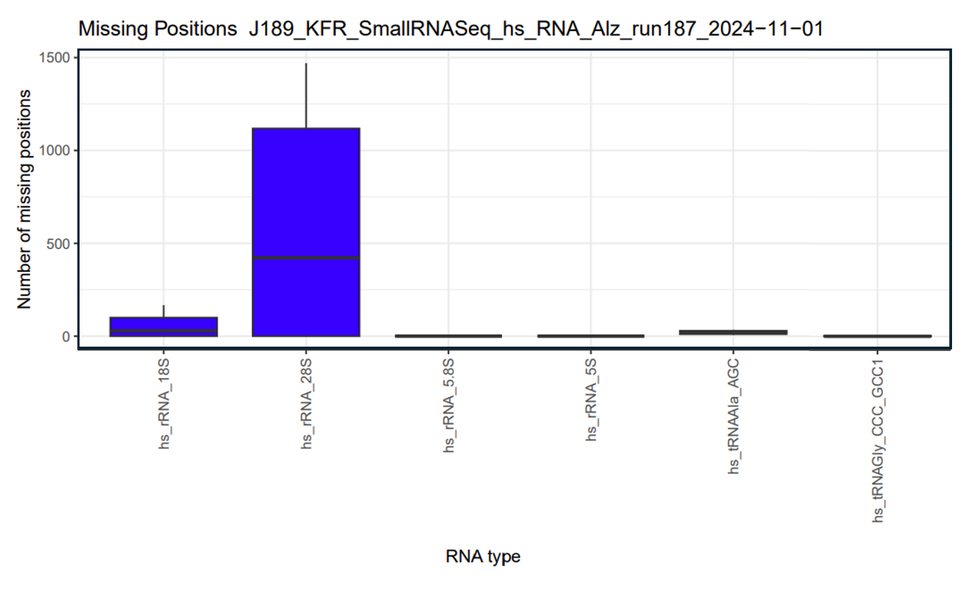
Raw data 13: Missing positions of run J189_KFR (containing sequencing data from this manuscript). The run was performed on November 1, 2024, using a NextSeq 2000 Illumina sequencing system with 100 ng of total RNA for library preparation. Library preparation followed the manufacturer’s protocol, as detailed in the Materials and Methods section of the main manuscript.

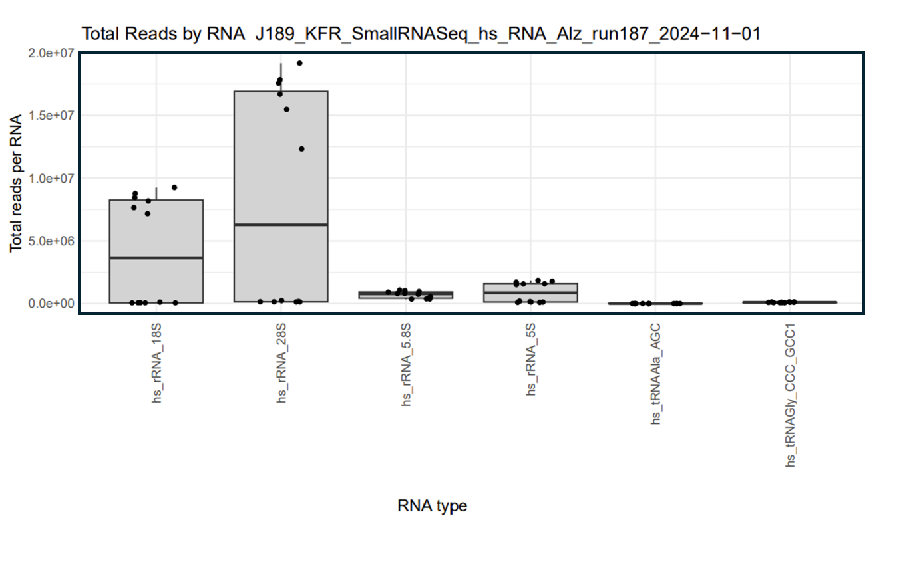
Raw data 14: Total reads per RNA type of run J189_KFR.

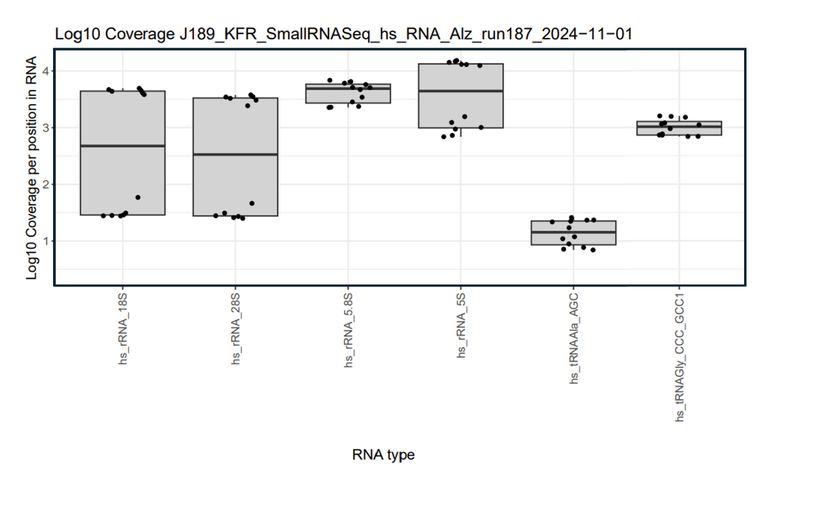
Raw data 15: Log₁₀-transformed coverage per nucleotide position, grouped by RNA type, from small RNA next-generation sequencing.

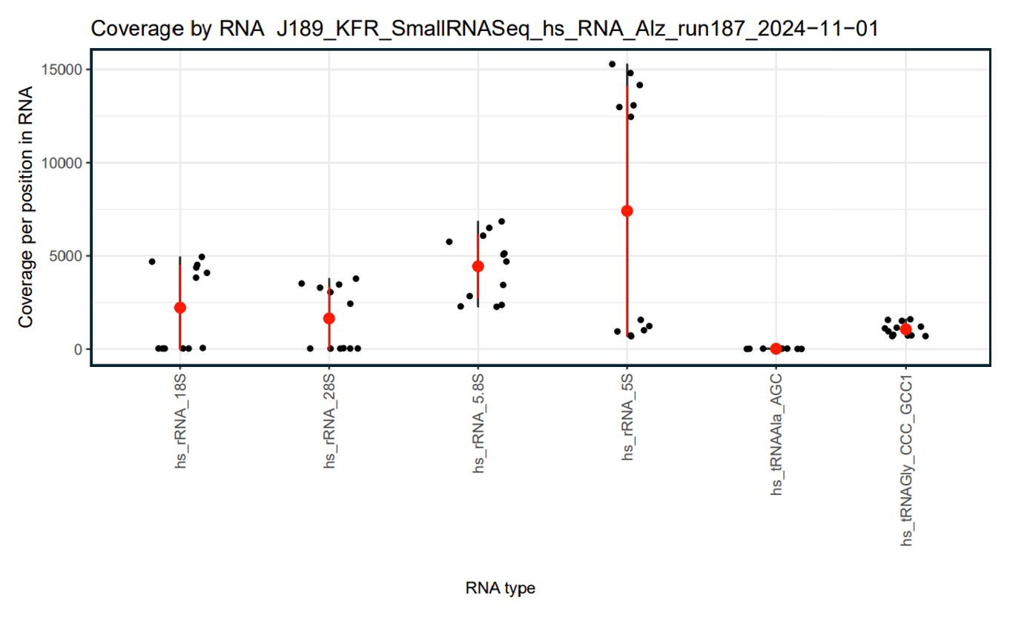
Raw data 16: Coverage per position in RNA type from small RNA next-generation sequencing.

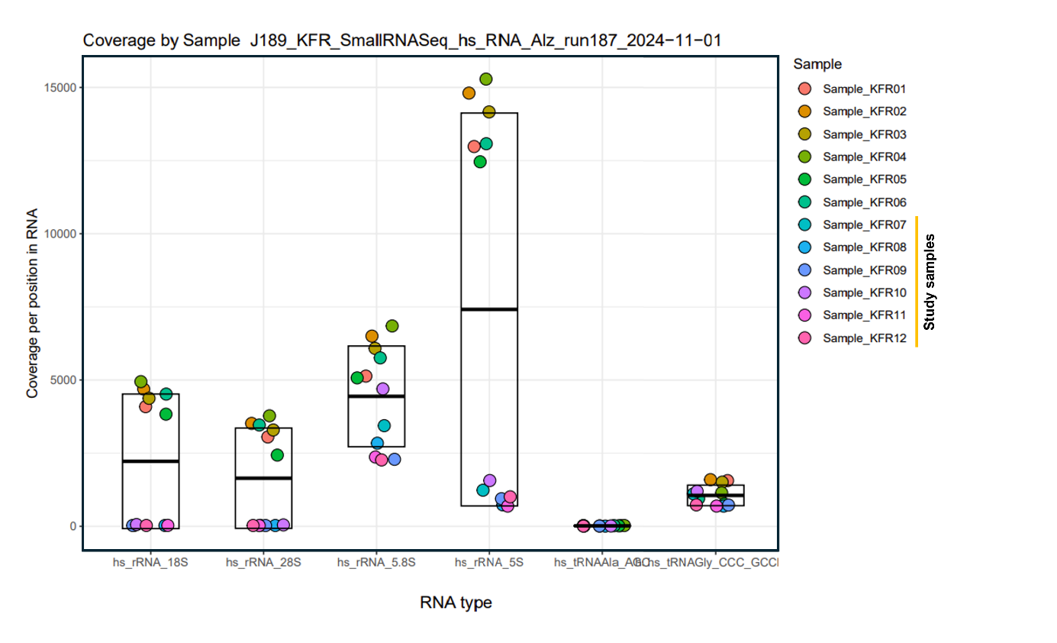
Raw data 17: Coverage per position in RNA by each sample from small RNA next-generation sequencing.

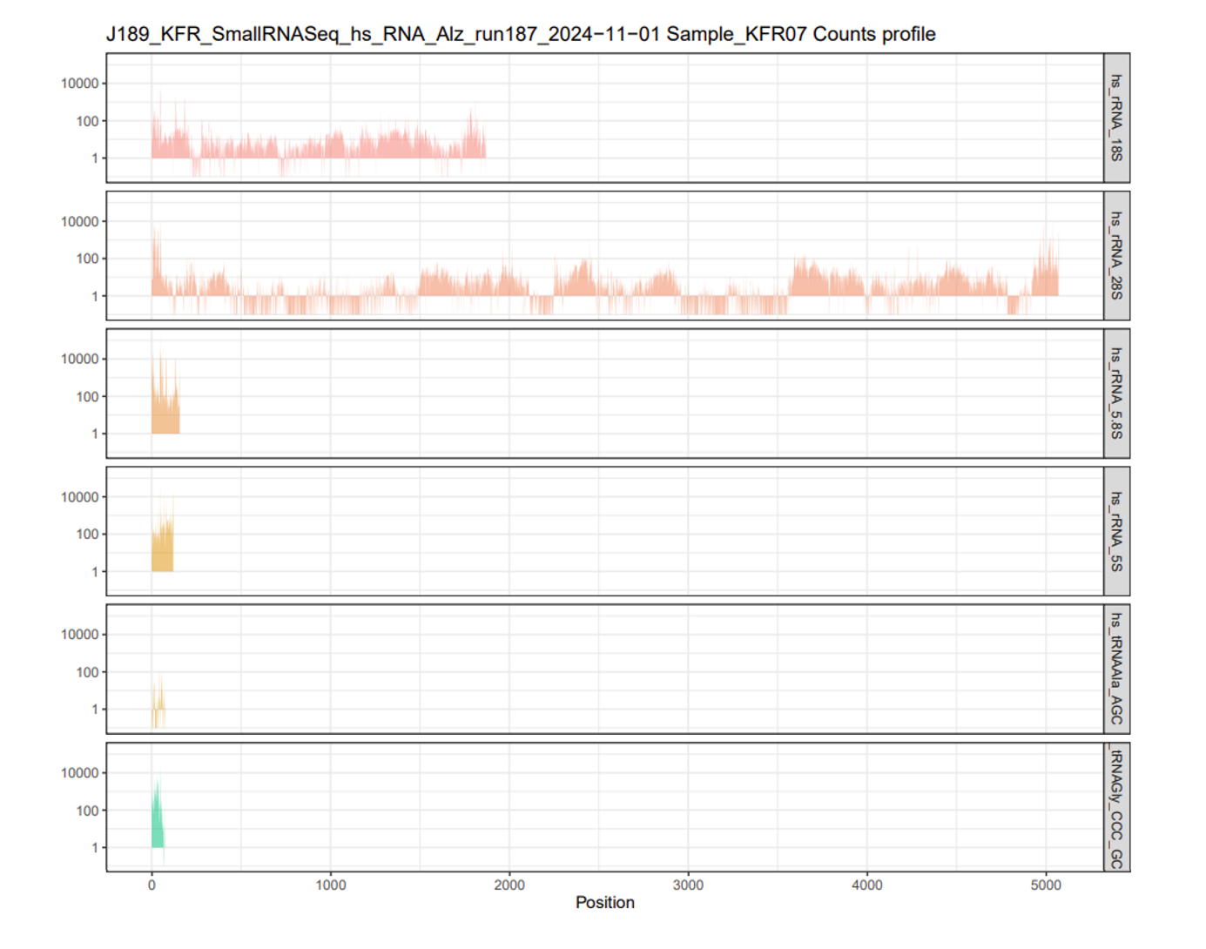
Raw data 18: Count profile of sample KFR07 per position in RNA from small RNA next-generation sequencing.

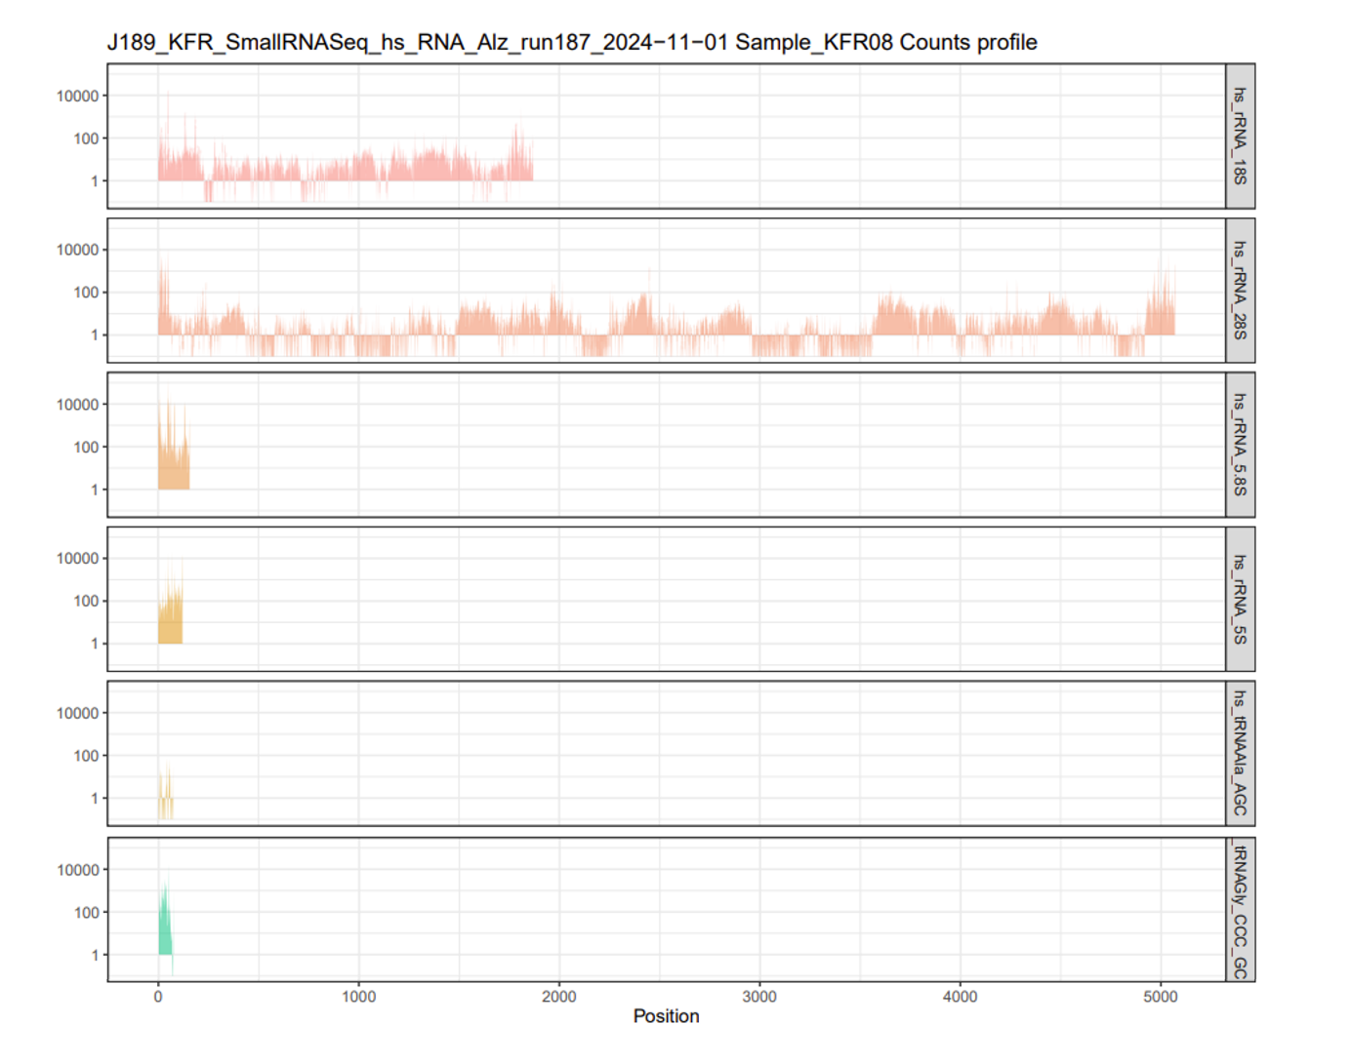
Raw data 19: Count profile of sample KFR08 per position in RNA from small RNA next-generation sequencing.

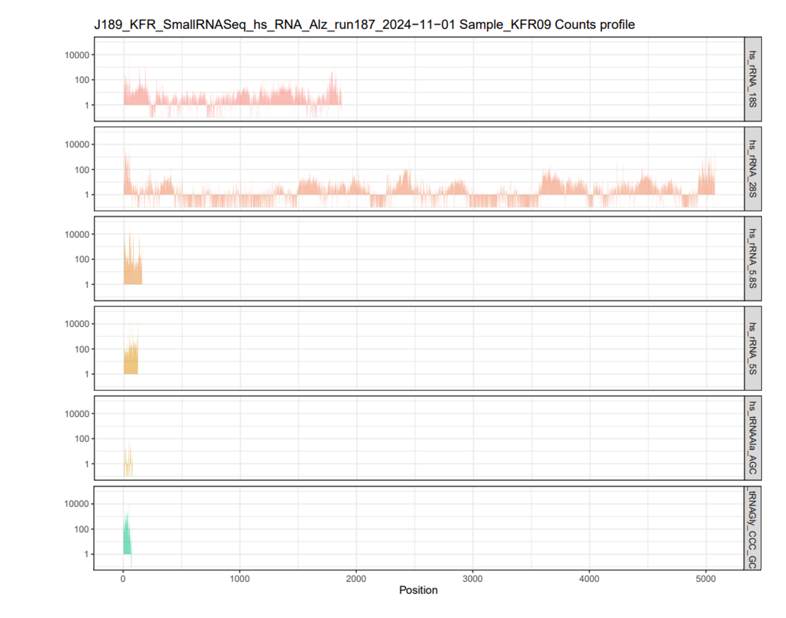
Raw data 20: Count profile of sample KFR09 per position in RNA from small RNA next-generation sequencing.

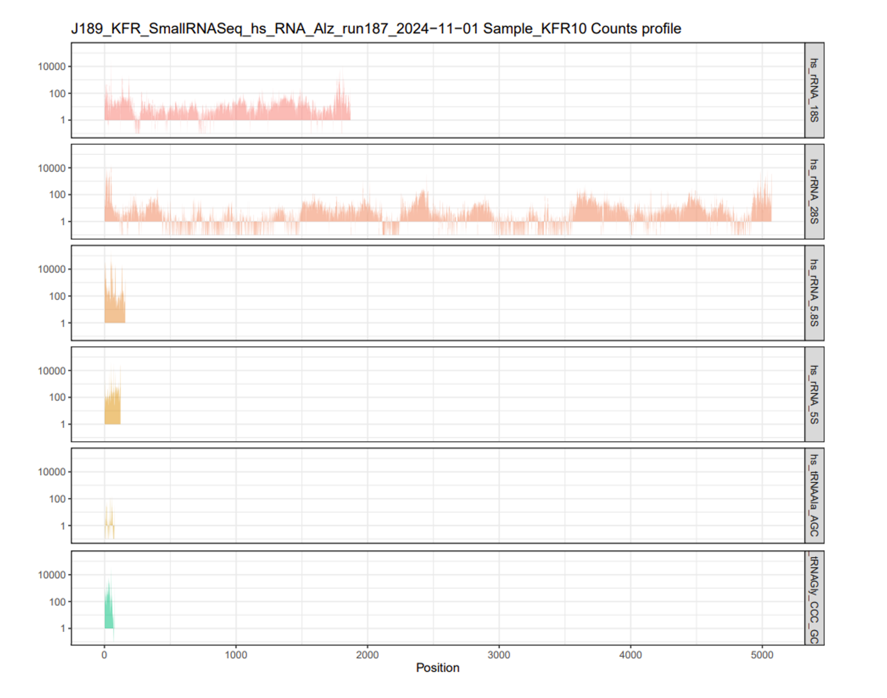
Raw data 21: Count profile of sample KFR10 per position in RNA from small RNA next-generation sequencing.

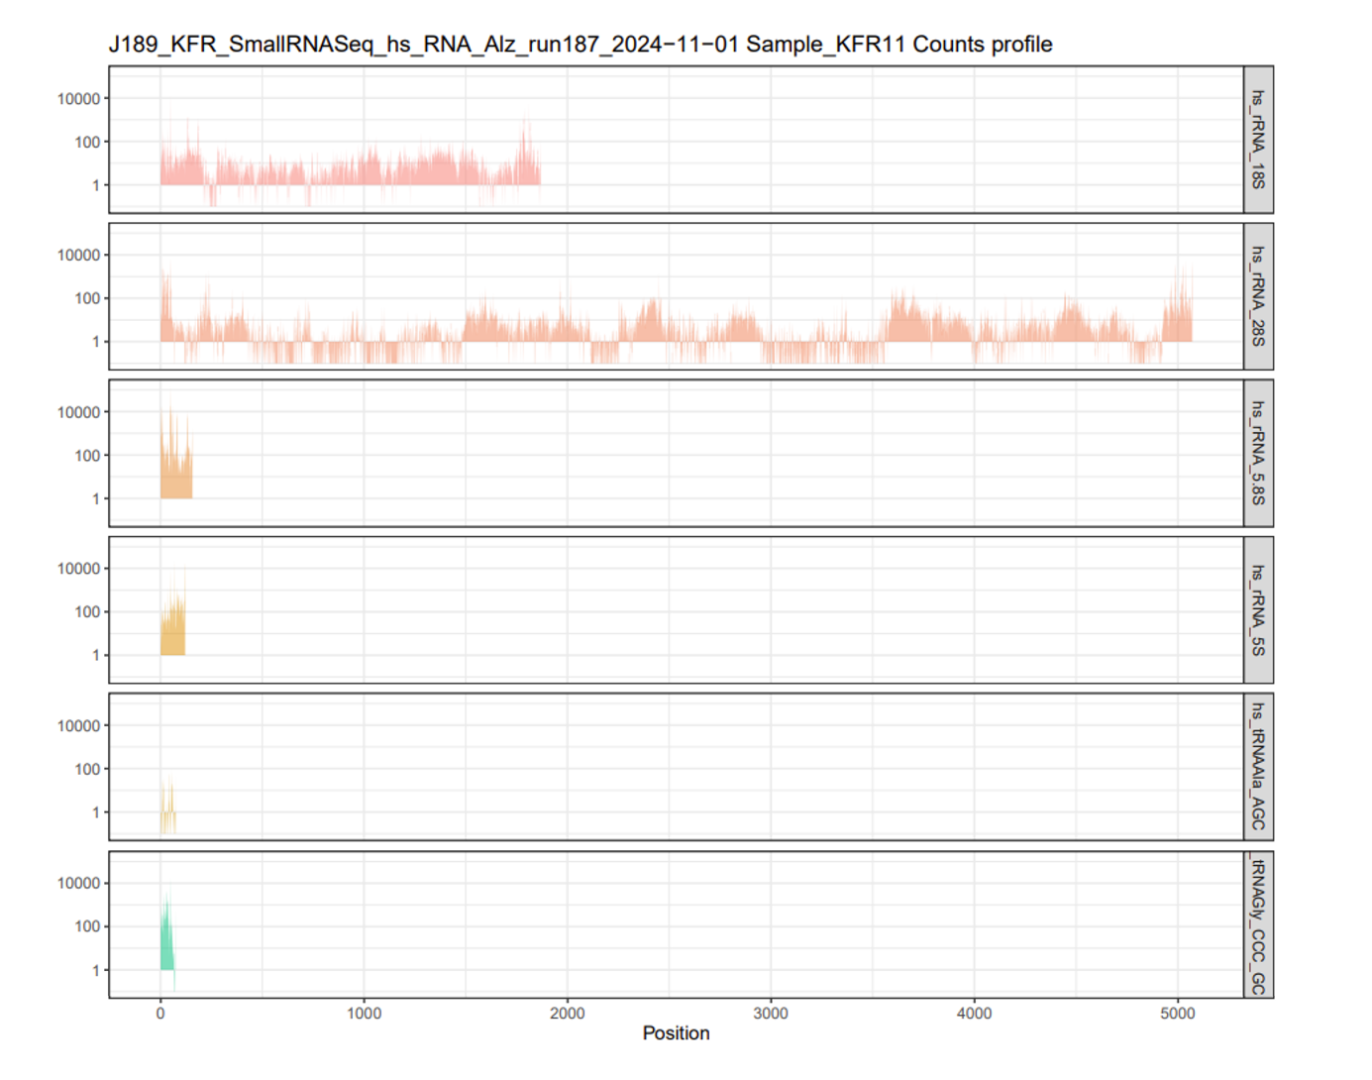
Raw data 22: Count profile of sample KFR11 per position in RNA from small RNA next-generation sequencing.

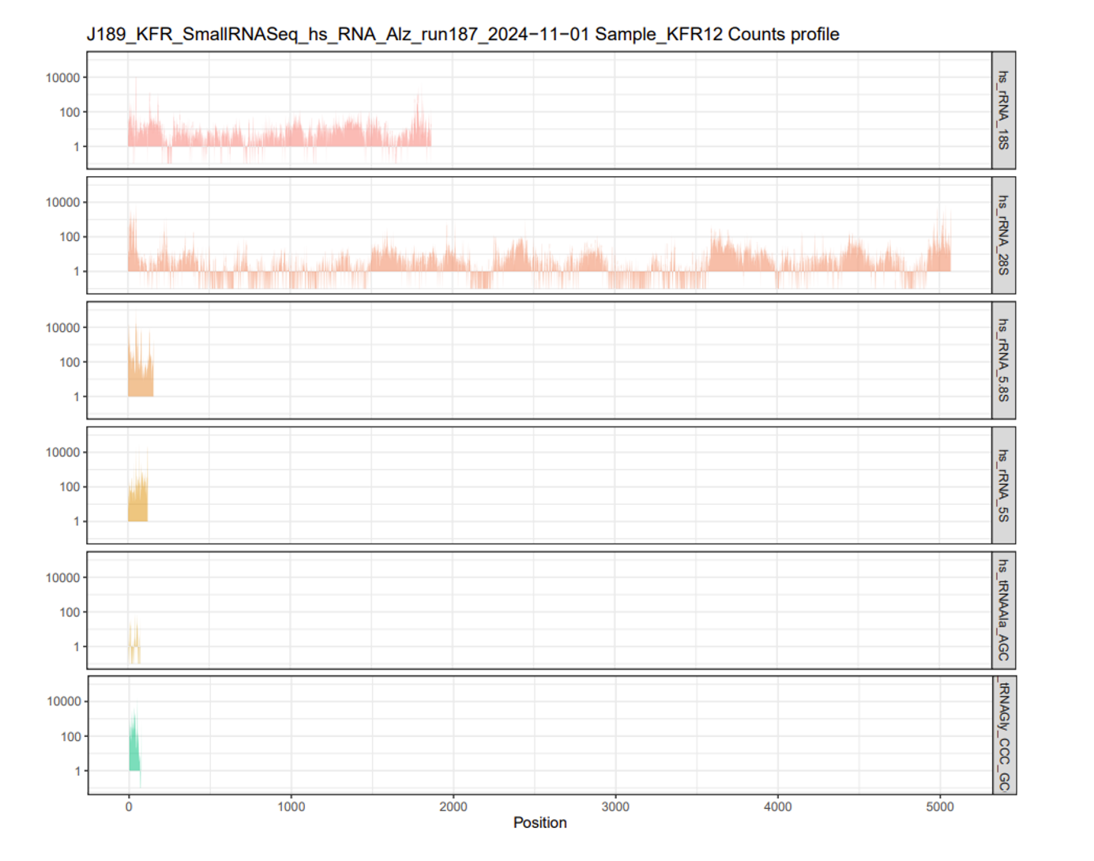
Raw data 23: Count profile of sample KFR12 per position in RNA from small RNA next-generation sequencing.

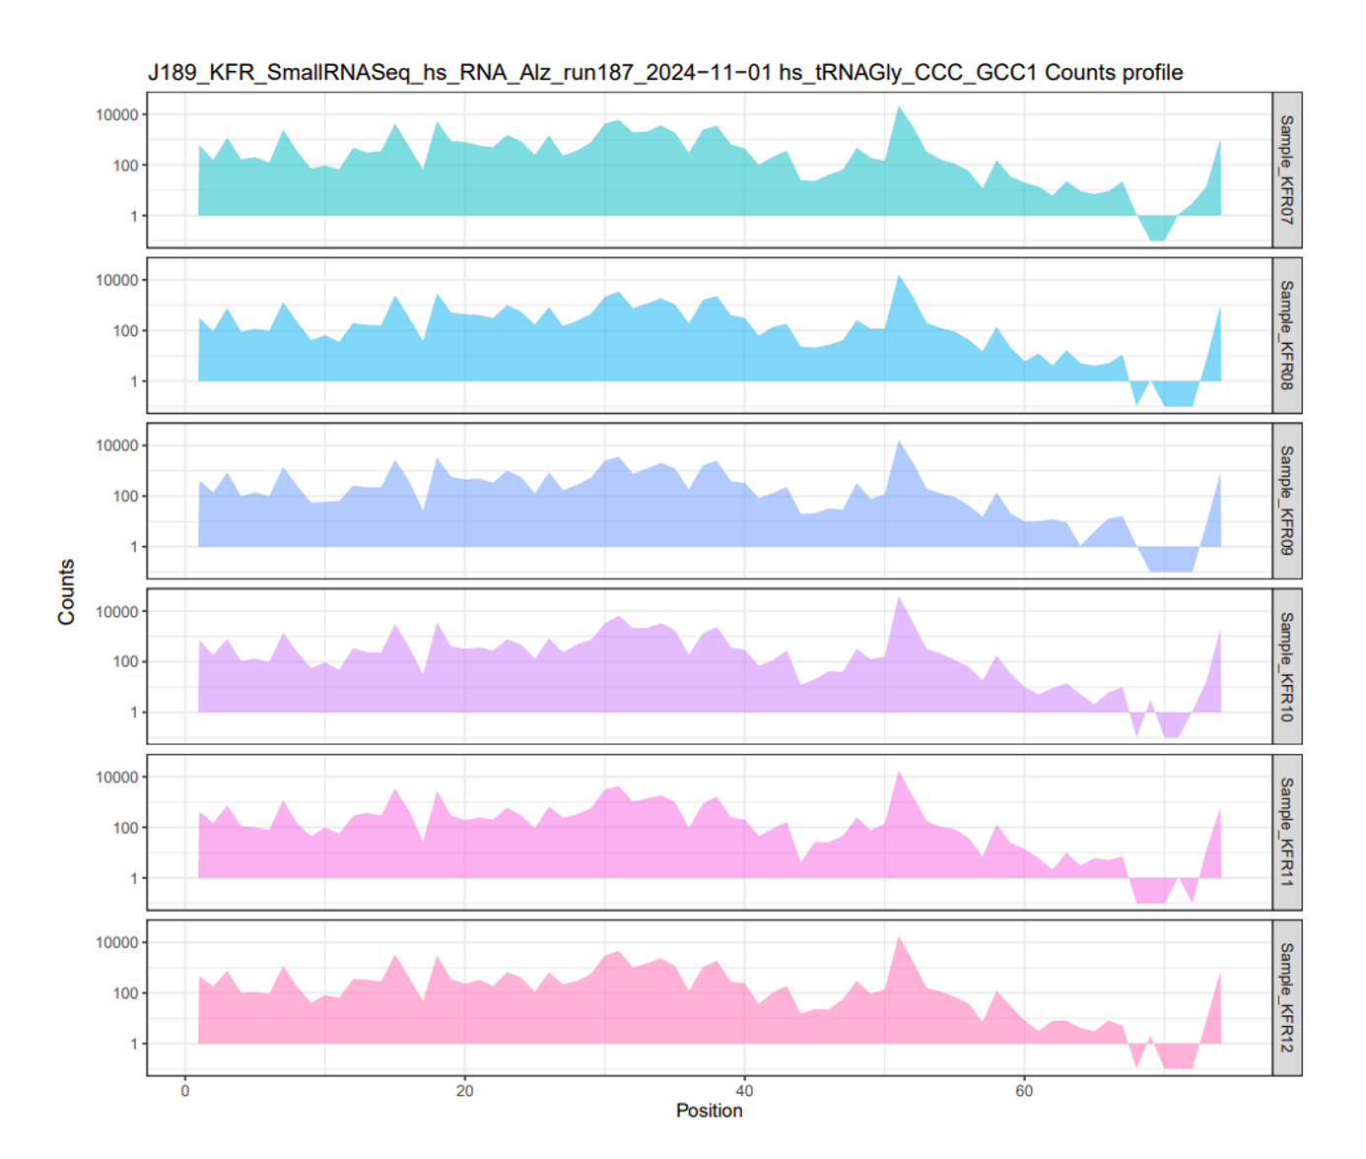
Raw data 24: Count profile of all samples per position in RNA from small RNA next-generation sequencing.

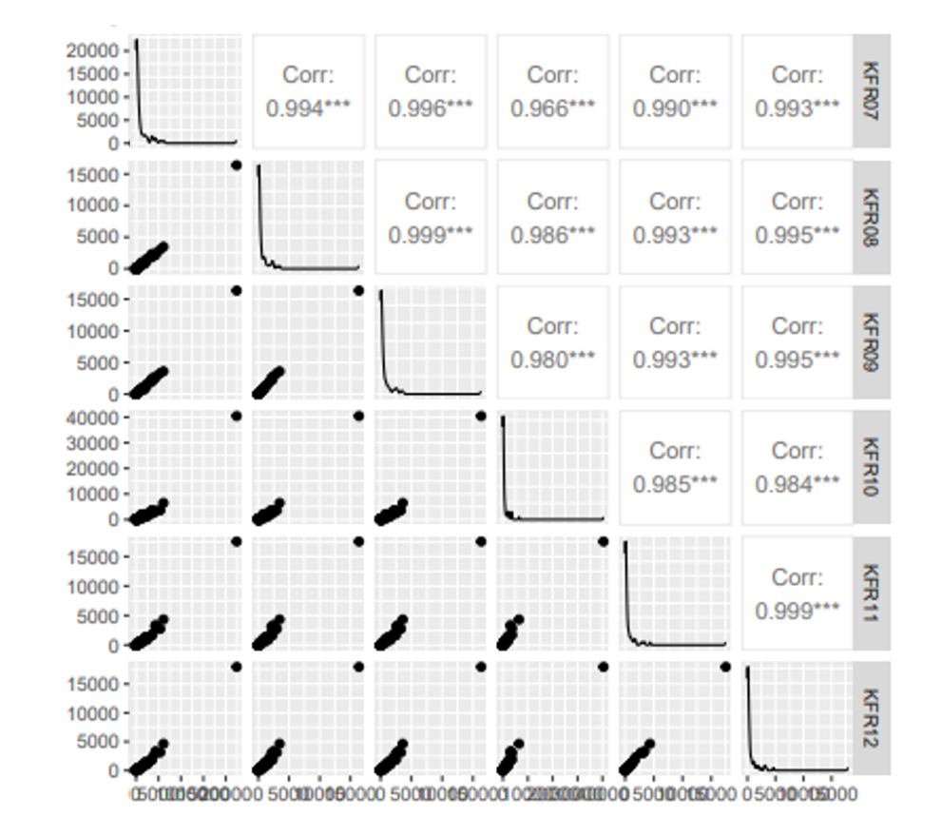
Raw data 25: Count correlation profile of all samples from small RNA next-generation sequencing.

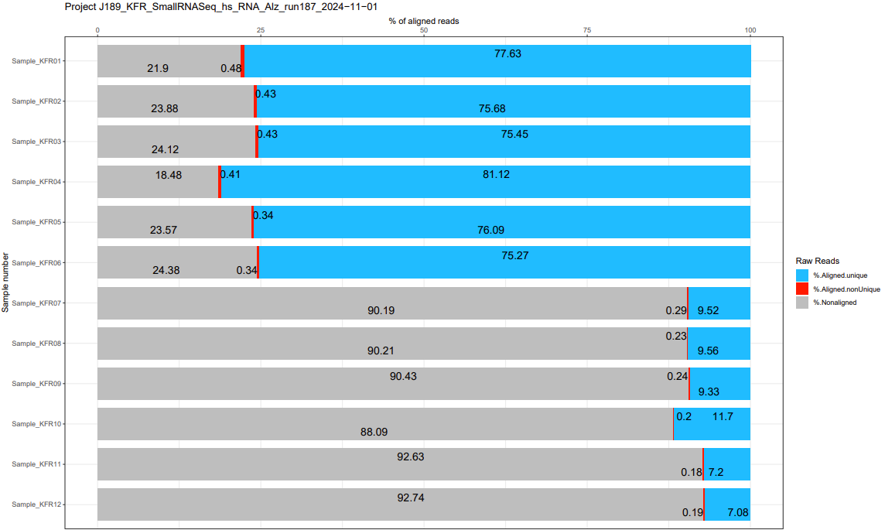
Raw data 26: Bowtie alignment rates (%) for all samples from small RNA next-generation sequencing. Only samples KFR07-12 were used in this study.

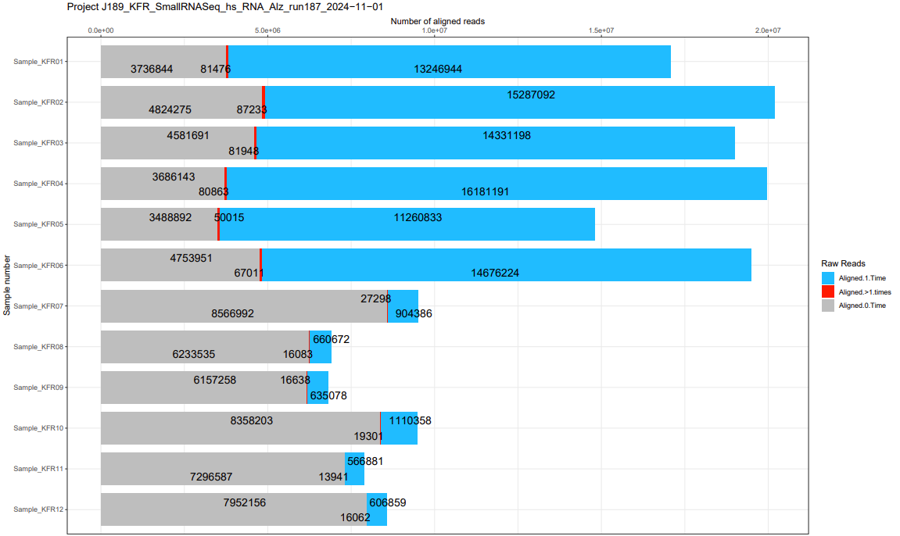
Raw data 27: Bowtie barplot showing raw aligned read counts for all samples during small RNA next-generation sequencing. Only samples KFR07-12 were included in this study.

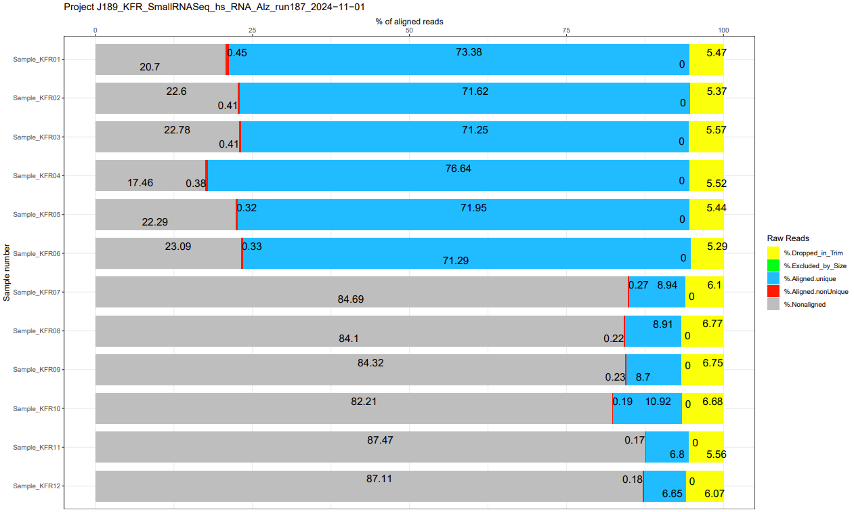
Raw data 28: Full bar plot of alignment rates from quality control of all samples during small RNA next-generation sequencing. Only samples KFR07-12 were used in this study.

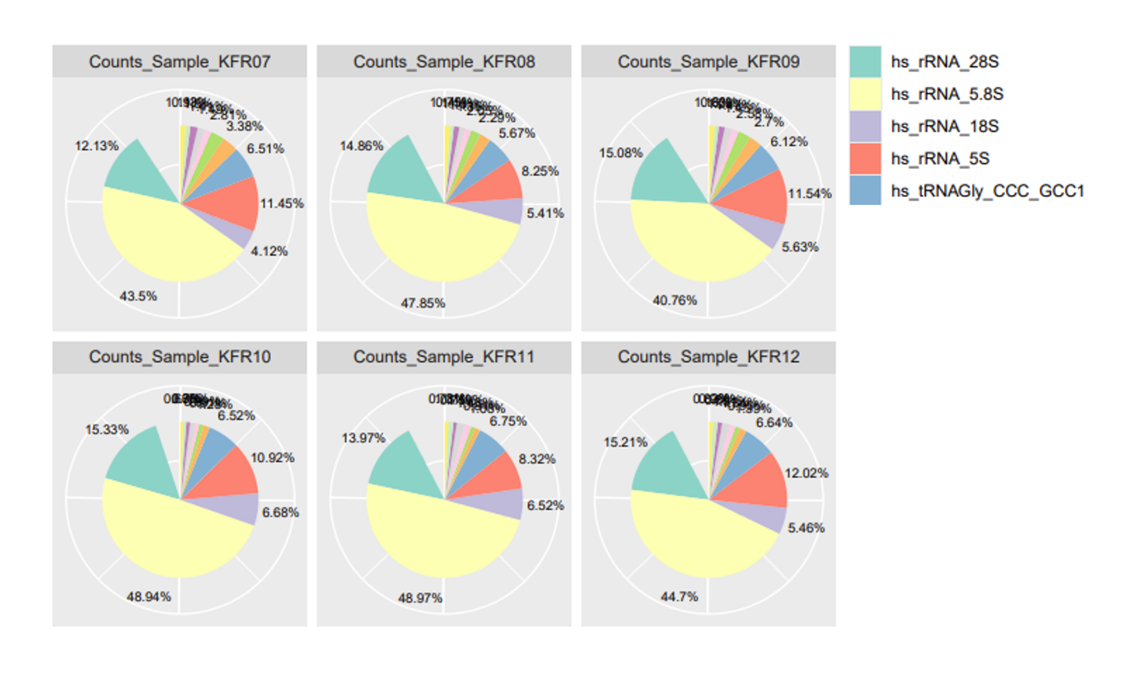
Raw data 29: Alignment statistics by sample during small RNA next-generation sequencing. Colors not specified in the legend correspond to additional tRNA species.

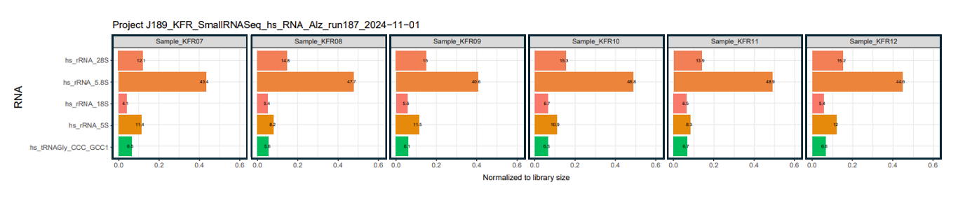
Raw data 30: Reads normalized to library size during small RNA next-generation sequencing.

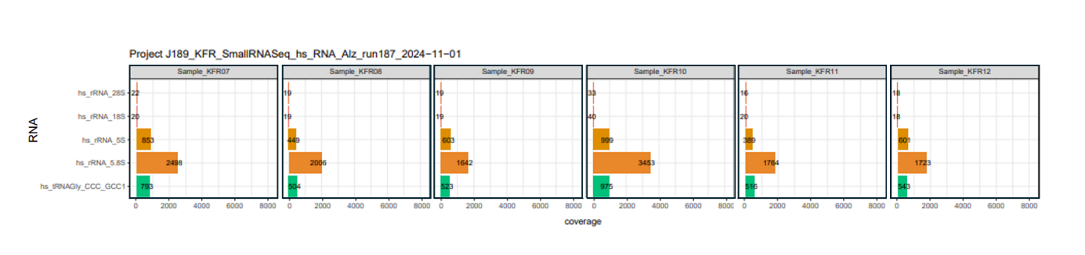
Raw data 31: Coverage per RNA during small RNA next-generation sequencing.
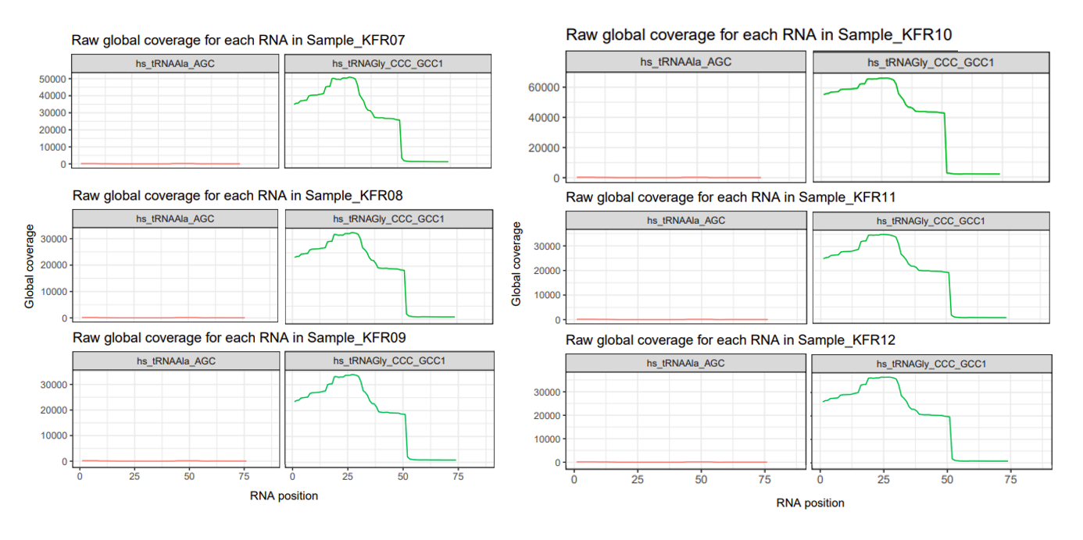
Raw data 32: Unnormalized raw global coverage by sample during small RNA next-generation sequencing. This enables assessment of whether signals arise from full-length tRNAs (e.g., tRNA^{Ala-AGC}) or from tRNA halves.

Raw data table 33: Mapped counts for each detected RNA per sample KFR07-12.
RNA type | Counts KFR07 | Counts KFR08 | Counts KFR09 | Counts KFR10 | Counts KFR11 | Counts KFR12
hs_rRNA_18S | 37100 | 35624 | 35610 | 74007 | 36902 | 33057
hs_rRNA_28S | 109320 | 97786 | 95388 | 169810 | 79008 | 92070
hs_rRNA_5.8S | 392154 | 314871 | 257767 | 542135 | 276949 | 270475
hs_rRNA_5S | 103248 | 54295 | 72952 | 120909 | 47078 | 72750
hs_tRNAAla_AGC | 497 | 330 | 435 | 592 | 358 | 340
hs_tRNAGly_CCC_GCC1 | 58670 | 37302 | 38730 | 72179 | 38195 | 40210
hs_tRNAAla_CGC_TGC_AGC | 10030 | 7502 | 7365 | 6949 | 4408 | 4984
hs_tRNAArg_ACG | 714 | 465 | 477 | 529 | 389 | 362
hs_tRNAArg_CCG_TCG | 1280 | 666 | 949 | 979 | 513 | 610
hs_tRNAArg_CCT_CCG | 5834 | 2864 | 3368 | 3668 | 2448 | 2833
hs_tRNAArg_TCG | 118 | 83 | 107 | 98 | 65 | 85
hs_tRNAArg_TCT | 399 | 196 | 202 | 170 | 87 | 101
hs_tRNAAsn_GTT | 3283 | 1888 | 2243 | 1918 | 1719 | 1589
hs_tRNAAsp_GTC | 10216 | 5023 | 5538 | 4346 | 1992 | 3321
hs_tRNACys_GCA | 7834 | 5377 | 5714 | 6098 | 4190 | 4285
hs_tRNAGln_CTG_TTG | 8400 | 4948 | 5245 | 6691 | 5718 | 5824
hs_tRNAGlu_CTC_TTC | 30461 | 15096 | 17089 | 14211 | 6132 | 8406
hs_tRNAGlu_TTC | 2517 | 1182 | 1358 | 1558 | 928 | 1251
hs_tRNAGly_CCC2 | 609 | 390 | 389 | 804 | 645 | 646
hs_tRNAGly_TCC | 5065 | 3358 | 3437 | 3180 | 2328 | 2536
hs_tRNAHis_GTG | 5841 | 3055 | 3283 | 3836 | 2843 | 3498
hs_tRNAIle_AAT_GAT | 4901 | 3512 | 4413 | 4257 | 2983 | 3153
hs_tRNAIle_TAT | 108 | 75 | 88 | 72 | 76 | 78
hs_tRNAiMet_CAT | 2152 | 1533 | 1664 | 1123 | 751 | 833
hs_tRNALeu_AAG_TAG | 5927 | 4333 | 4549 | 5019 | 5059 | 4465
hs_tRNALeu_CAA1 | 2188 | 1735 | 1783 | 4097 | 4075 | 3269
hs_tRNALeu_CAA2 | 22 | 9 | 7 | 29 | 11 | 41
hs_tRNALeu_CAG_CAA | 136 | 109 | 77 | 35 | 33 | 29
hs_tRNALeu_TAA | 571 | 335 | 381 | 444 | 358 | 357
hs_tRNALys_CTT | 13564 | 7413 | 7932 | 8634 | 4029 | 5383
hs_tRNALys_TTT | 1679 | 835 | 835 | 756 | 483 | 590
hs_tRNAMet_CAT | 2432 | 1513 | 1690 | 1814 | 2370 | 2234
hs_tRNAPhe_GAA | 10124 | 6172 | 7198 | 4665 | 2808 | 3518
hs_tRNAPro_AGG_CGG_TGG | 25336 | 13489 | 16307 | 10124 | 4743 | 5830
hs_tRNASeC_TCA | 138 | 85 | 59 | 106 | 64 | 86
hs_tRNASer_AGA_TGA | 1165 | 781 | 697 | 1200 | 730 | 845
hs_tRNASer_CGA_TGA1 | 166 | 103 | 114 | 121 | 106 | 108
hs_tRNASer_CGA2 | 84 | 54 | 55 | 106 | 68 | 89
hs_tRNASer_GCT | 1232 | 844 | 901 | 1543 | 1318 | 1151
hs_tRNAThr_AGT_CGT_TGT | 1568 | 938 | 1229 | 1681 | 1269 | 1431
hs_tRNAThr_CGT | 157 | 104 | 125 | 115 | 85 | 98
hs_tRNAThr_TGT_CGT | 2379 | 1785 | 1803 | 1846 | 1154 | 1538
hs_tRNATrp_CCA | 1381 | 904 | 1057 | 1082 | 710 | 852
hs_tRNATyr_ATA | 116 | 67 | 88 | 39 | 42 | 43
hs_tRNATyr_GTA1 | 12685 | 7301 | 9307 | 11113 | 8999 | 9154
hs_tRNAVal_AAC_CAC_TAC1 | 13402 | 8883 | 9155 | 9805 | 8075 | 8134
hs_tRNAVal_TAC | 4374 | 2822 | 3250 | 3215 | 2286 | 2609
Total mapped reads per sample | 901577 | 658035 | 632410 | 1107708 | 565580 | 605151

Raw data table 34: Mapped counts per tRNA fragment for the tRNA^{Gly-GCC}.
tRNA fragment type | Counts KFR07 | Counts KFR08 | Counts KFR09 | Counts KFR10 | Counts KFR11 | Counts KFR12
tRF-5a | 11563 | 6485 | 7495 | 8156 | 7876 | 7922
tRF-5b | 22168 | 12789 | 14312 | 14442 | 12478 | 13253
tRF-5c | 24478 | 14201 | 15774 | 16140 | 13800 | 14546
5'tiRNA | 43327 | 24050 | 26514 | 34374 | 17503 | 27561
tRF-3a | 1465 | 1208 | 1089 | 2305 | 826 | 957
tRF-3b | 2127 | 1667 | 1550 | 3017 | 1228 | 1336
3'tiRNA | 29669 | 21347 | 21223 | 48255 | 21307 | 22114

Raw data table 35: Calculated RPM values per tRNA fragment for the tRNA^{Gly-GCC}.
tRNA fragment type | Counts KFR07 | Counts KFR08 | Counts KFR09 | Counts KFR10 | Counts KFR11 | Counts KFR12
tRF-5a | 12825 | 9855 | 11851 | 7363 | 13926 | 13091
tRF-5b | 24588 | 19435 | 22631 | 13038 | 22062 | 21900
tRF-5c | 27150 | 21581 | 24943 | 14571 | 24400 | 24037
5'tiRNA | 48057 | 36548 | 41925 | 31032 | 30947 | 24881
tRF-3a | 1625 | 1836 | 1722 | 2081 | 1460 | 1581
tRF-3b | 2359 | 2533 | 2451 | 2724 | 2171 | 2208
3'tiRNA | 32908 | 32441 | 33559 | 43563 | 37673 | 36543
For the calculation, the following formula was used:

$$RPM=\frac{read count fragment}{total mapped reads per sample}*{10}^{6}$$

Method comparison raw data (corresponding to main Figure 5)

Raw data table 36: Normalized values for direct cDINGQ, [³²P]- and DIG-labeled Northern blot, and Illumina NGS method comparison.
Sample name | cDINGQ | DIG-Northern blot | [³²P]-Northern blot | Illumina NGS
HEKut #1 | 0.94342617 | 0.80017282 | 1.50288041 | 1.13941521
HEKut #2 | 1.05819788 | 1.14682099 | 0.90100246 | 0.86654736
HEKut #3 | 0.7241244 | 0.71616542 | 0.49054029 | 0.99403743
HEKut #4 | 1.27425155 | 1.33684077 | 1.10557684 | -
APPwt #1 | 0.68154862 | 0.64330786 | 0.29466037 | 0.73575123
APPwt #2 | 0.48300351 | 0.42684653 | 0.37187128 | 0.73374417
APPwt #3 | 0.5290611 | 0.26649319 | 0.33417171 | 0.58992377
APPwt #4 | 0.43174822 | 0.25682234 | 0.33807643 | -

Normalization within each dataset was performed according to the following formula*:
$$Normalized value=\frac{individual sample value}{Mean HEKut \#1-4}$$

*For Illumina NGS, where only n = 3 was available, the mean of HEKut samples #1-3 was used for normalization. Each biological replicate was included across all methods to ensure comparability.

Raw data table 37: log₂ fold change values for direct method comparison. HEKut values are set to 0, as they serve as the respective control.
Method | HEKut [log₂FC] | APPwt [log₂FC]
cDINGQ | 0 | -0.91
DIG-Northern blot | 0 | -1.58
[³²P]-Northern blot | 0 | -1.33
Illumina NGS | 0 | -0.54

Raw data table 38: Correlation analysis comparing cDINGQ and [³²P]-labeled Northern blot results. Values from each respective method in Raw Data Table 35 were plotted against the corresponding cDINGQ values.
Method | cDINGQ | [³²P]-Northern blot
HEKut #1 | 0.94342617 | 1.50288041
HEKut #2 | 1.05819788 | 0.90100246
HEKut #3 | 0.7241244 | 0.49054029
HEKut #4 | 1.27425155 | 1.10557684
APPwt #1 | 0.68154862 | 0.29466037
APPwt #2 | 0.48300351 | 0.37187128
APPwt #3 | 0.5290611 | 0.33417171
APPwt #4 | 0.43174822 | 0.33807643

Raw data table 39: Correlation analysis comparing cDINGQ and DIG-labeled Northern blot results. Values from each respective method in Raw Data Table 35 were plotted against the corresponding cDINGQ values.
Method | cDINGQ | DIG-Northern blot
HEKut #1 | 0.94342617 | 0.80017282
HEKut #2 | 1.05819788 | 1.14682099
HEKut #3 | 0.7241244 | 0.71616542
HEKut #4 | 1.27425155 | 1.33684077
APPwt #1 | 0.68154862 | 0.64330786
APPwt #2 | 0.48300351 | 0.42684653
APPwt #3 | 0.5290611 | 0.26649319
APPwt #4 | 0.43174822 | 0.25682234

Raw data table 40: Correlation analysis comparing cDINGQ and Illumina small RNA NGS results. Values from each respective method in Raw Data Table 35 were plotted against the corresponding cDINGQ values.
Method | cDINGQ | Illumina NGS
HEKut #1 | 0.94342617 | 1.13941521
HEKut #2 | 1.05819788 | 0.86654736
HEKut #3 | 0.7241244 | 0.99403743
APPwt #1 | 0.68154862 | 0.73575123
APPwt #2 | 0.48300351 | 0.73374417
APPwt #3 | 0.5290611 | 0.58992377
Since in Illumina NGS only an n = 3 was performed, only the corresponding cDINGQ measurements of n = 1-3 were used for comparison.

Supplementary References
Boccaletto, P., Machnicka, M. A., Purta, E., Piątkowski, P., Bagiński, B., Wirecki, T. K., de Crécy-Lagard, V., Ross, R., Limbach, P. A., Kotter, A., Helm, M., & Bujnicki, J. M. (2018). MODOMICS: a database of RNA modification pathways. 2017 update. Nucleic Acids Research, 46(D1), D303–D307. https://doi.org/10.1093/nar/gkx1030
Boccaletto, P., Stefaniak, F., Ray, A., Cappannini, A., Mukherjee, S., Purta, E., Kurkowska, M., Shirvanizadeh, N., Destefanis, E., Groza, P., Avşar, G., Romitelli, A., Pir, P., Dassi, E., Conticello, S. G., Aguilo, F., & Bujnicki, J. M. (2022). MODOMICS: a database of RNA modification pathways. 2021 update. Nucleic Acids Research, 50(D1), D231–D235. https://doi.org/10.1093/nar/gkab1083
Cappannini, A., Ray, A., Purta, E., Mukherjee, S., Boccaletto, P., Moafinejad, S. N., Lechner, A., Barchet, C., Klaholz, B. P., Stefaniak, F., & Bujnicki, J. M. (2024). MODOMICS: a database of RNA modifications and related information. 2023 update. Nucleic Acids Research, 52(D1), D239–D244. https://doi.org/10.1093/nar/gkad1083
Czerwoniec, A., Dunin-Horkawicz, S., Purta, E., Kaminska, K. H., Kasprzak, J. M., Bujnicki, J. M., Grosjean, H., & Rother, K. (2009). MODOMICS: a database of RNA modification pathways. 2008 update. Nucleic Acids Research, 37(Database), D118–D121. https://doi.org/10.1093/nar/gkn710
Dunin-Horkawicz, S. (2006). MODOMICS: a database of RNA modification pathways. Nucleic Acids Research, 34(90001), D145–D149. https://doi.org/10.1093/nar/gkj084
Machnicka, M. A., Milanowska, K., Osman Oglou, O., Purta, E., Kurkowska, M., Olchowik, A., Januszewski, W., Kalinowski, S., Dunin-Horkawicz, S., Rother, K. M., Helm, M., Bujnicki, J. M., & Grosjean, H. (2012). MODOMICS: a database of RNA modification pathways—2013 update. Nucleic Acids Research, 41(D1), D262–D267. https://doi.org/10.1093/nar/gks1007

