5’ UTR Cis-Regulatory Logic Governs Ribosome Engagement on Canonical and Non-Coding RNAs (Supplementary Materials)

Figures
Supplementary Figure 1
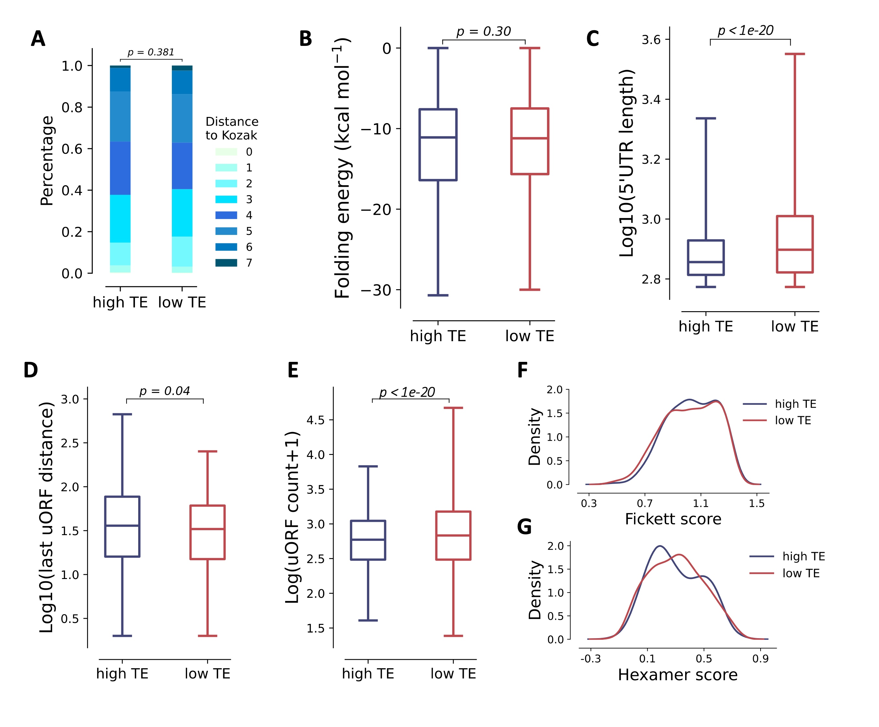
Fig. S1 Comparison of translational features between mRNA with long 5' UTR grouped by translational efficiency. higher than 50th: high TE (n=265), lower than 25th: low TE (n=415). A The edit distance from TIS sequence to Kozak consensus sequence (One-sided Mann-Whitney U p-value=0.381). B The box plot of folding energy of 50-nt downstream sequence of start codon (One-sided T-Test p-value=0.30). C The box plot of uORFs count (One-sided Mann-Whitney U p-value<1e-20). D The box plot of last uORF distance (One-sided T-Test p-value=0.04). E The box plot of 5' UTR length (One-sided T-Test p-value<1e-20). F and G Fickett score and hexamer score of ORFs.

Supplementary Figure 2
Fig. S2 Motifs in high TE database using MEME motif search program.

Supplementary Figure 3
Fig. S3 Motifs in low TE database using MEME motif search program.

Supplementary Table 1
The feature importance of the model trained to predict translation efficiency in HEK, Muscle and PC3 cell lines. Please see additional file Supplementary Table 1 for details.

Supplementary Table 2
Runtime and memory usage of PlusCE model training across datasets.

Dataset (Samples) | Avg Time (s) | Std Time (s) | Avg Memory (MB) | Avg Peak (MB)
HEK (14,410) | 26.04 | 0.7 | 2768.88 | 3033.75
PC3 (12,579) | 22.3 | 0.58 | 2586 | 2822.89
Muscle (1,257) | 1.31 | 0.02 | 1417.99 | 1873.7
All values are averages from three runs.
All runs were conducted on a dual Xeon Gold 5218 (2.3 GHz, 64 cores) Linux server using 40 threads.

Supplementary Table 3
The mean and variance of the Spearman correlation coefficients for the predictions of each model.

 |  | plusCE | UTR-LM | Cao-RF | MTtrans | RNABERT_MLP
Muscle | mean | 0.712 | 0.67 | 0.63 | 0.50 | 0.56
Muscle | std | 0.037 | 0.04 | 0.04 | 0.068 | 0.06
PC3 | mean | 0.697 | 0.65 | 0.63 | 0.54 | 0.48
PC3 | std | 0.019 | 0.02 | 0.02 | 0.023 | 0.04
HEK | mean | 0.648 | 0.60 | 0.55 | 0.50 | 0.41
HEK | std | 0.023 | 0.02 | 0.02 | 0.016 | 0.04

