Loop of Fate: Structural and Mechanistic Insights into hnRNPA1 Binding to the Hepatitis C Virus RNA
Ajit Kumar ^{1,2}, Srinivas Penumutchu ^{4,5}, Love Panchariya ⁶, Priyanka Kumari ¹, Shubham Thakur ¹, Purba Daripa ¹, Vandana Singh ¹, Arockiasamy Arulandu ⁶, Souvik Maiti ^{1,2}, Mandar V. Deshmukh ³ , and Niyati Jain ^{1,2 #}

1. CSIR-Institute of Genomics and Integrative Biology, New Delhi, 110025, India.
2. Academy of Scientific and Innovative Research (AcSIR), Ghaziabad, 201002, India
3. CSIR-Centre for Cellular and Molecular Biology, Hyderabad, 500007, Telangana, India.
4. Department of Biochemistry and Biophysics, University of Pennsylvania,
Philadelphia, PA 19104, USA.
5. Howard Hughes Medical Institute, Chevy Chase, MD 20815, USA.

6. International Centre for Genetic Engineering and Biotechnology (ICGEB) 110067
New Delhi, India

#Correspondence may be addressed to Niyati jain, email-niyati2002us@gmail.com phone number +919560403258

Running Title: Structural Basis of hnRNPA1–HCV RNA Binding

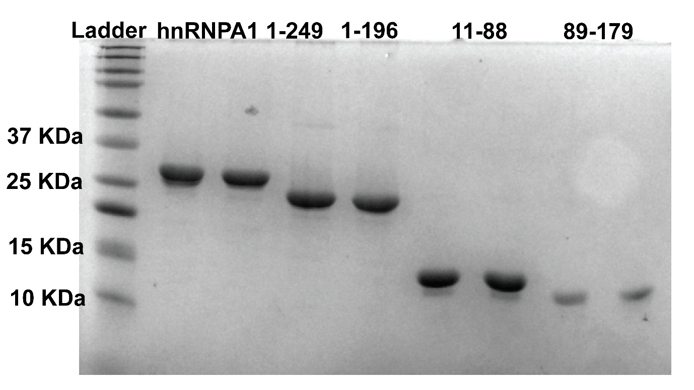

Figure S1. SDS-PAGE analysis of purified hnRNPA1 truncated constructs.
Recombinant full-length hnRNPA1 (residues 1–249) and truncated variants (residues 1–196, 11–88, and 89–179) were expressed in E. coli and purified as described in Methods. Proteins were resolved on a 15% SDS-polyacrylamide gel and stained with Coomassie Brilliant Blue. The apparent molecular weights of the purified proteins are consistent with their expected sizes.

Figure S2. Predicted secondary structures of the 5BSL3.2 RNA element from various HCV isolates.
A-K RNAfold was used to predict the minimum free energy structures of 5BSL3.2 sequences derived from different HCV isolates. All structures exhibit a conserved stem-loop architecture with a prominent apical loop and internal bulge, highlighted in red. Despite sequence variations among the isolates, both the apical loop and the bulge maintain a highly conserved fold, suggesting their essential role in HCV RNA structure and function. The calculated folding free energies (ΔG) for each structure are indicated below the respective structures.

Figure S3. Structural and thermal characterization of the HCV 5BSL3.2 domain and its apical loop mutant.
A. Predicted secondary structure of the wild-type HCV 5BSL3.2 RNA. The apical loop sequence is highlighted in red. B. UV thermal denaturation profile of 5BSL3.2 showing normalized absorbance at 280 nm as a function of temperature. C. First derivative of the UV melting curve (shown in B), revealing two thermal transitions at ~73°C and ~90 °C, indicating distinct unfolding events. D. Predicted secondary structure of the upper stem loop RNA, with apical loop highlighted in red.E. UV thermal denaturation profile of the upper stem loop RNA showing normalized absorbance at 280 nm as a function of temperature. F. First derivative of the melting curve (shown in E) revealing a single thermal transition at ~68°C. G. Circular Dichroism (CD) spectrum of 5BSL3.2 RNA at 20°C, indicating typical A-form RNA characteristics with a positive peak near 265 nm and a negative peak near 210 nm.H. 1H NMR spectra of 5BSL3.2 RNA at 283.15 K (blue) and 303.15 K (red), showing imino proton resonances indicative of base pairing and secondary structure formation.

Figure S4. NMR analysis of the 5BSL3.2 _{Apical stem loop}.
A. Secondary structure of the 5BSL3.2 apical stem-loop highlighting the ribose conformations: red pentagons represent riboses adopting a 2′-endo sugar pucker, while dashed pentagons indicate dynamic riboses that sample both 2′-endo and 3′-endo conformations. B. NOESY spectra recorded in D₂O at 303 K. The upper panel presents intra-nucleotide H1′–H6/H8 and inter-nucleotide H1′–H6/H8/H2 correlations. Assigned cross-peaks are annotated with residue numbers; adenosine H2 protons are marked in red. C. The lower panel displays the TOCSY spectrum highlighting the H6–H5 correlations of pyrimidine residues.

Figure S5. Circular Dichroism (CD) spectra of various SL2 RNAs and their mutants.
All RNA samples exhibit a characteristic CD spectrum with a negative band near 210–220 nm and a positive band near 260 nm, consistent with the A-form helical conformation typically adopted by RNA. These data suggest that all wild-type and mutant RNAs analyzed in this study maintain an overall A-form fold.

Figure S6. Isothermal Titration Calorimetry (ITC) analysis of hnRNPA1 (1-196) binding to wild-type and mutant 5BSL3.2 RNAs.
A–G. Left panels show the secondary structures of wild-type 5BSL3.2 and various mutants used in the study. Mutated nucleotides are highlighted in red. Middle panels show the raw ITC thermograms (upper sub-panels) and corresponding integrated binding isotherms (lower sub-panels) for titrations of hnRNPA1 (1-196) into the respective RNAs. The solid red lines represent the best fit to a one-site binding model. Calculated binding stoichiometry (n) and dissociation constants (K_{D}) are indicated.
Figure S7. Analytical Size Exclusion Chromatography (SEC).

A–F. represent SEC profiles. The bottom panel shows the elution profile of free UP1 protein, while the top panel shows free RNA (5 µM) followed by titrations with increasing UP1 protein at molar ratios of 0.25:1, 0.5:1, 0.75:1, 1:1, and 1.5:1 (protein: RNA). For the wild-type RNA, no free RNA peak is detected beyond the 1:1 ratio, indicating complete binding. In contrast, the mutant RNAs display a persistent free RNA peak even at a 1.5:1 protein: RNA ratio, suggesting reduced binding affinity compared to the wild type.

Figure S8. Superposition of 2D ¹H–¹⁵N HSQC spectra.
The hnRNPA1 (1–196) in the free state (red) and in complex with 5BSL3.2 RNA A. 0.25 (green), B. 0.5 (blue) and C. 0.75 (cyan).

Figure S9. Isothermal Titration Calorimetry (ITC) analysis of the mutants of hnRNPA1 (1-196) binding to 5BSL3.2 RNAs.
A. SDS-PAGE analysis of purified hnRNPA1 mutant constructs. B–I. The raw ITC thermograms (upper sub-panels) and corresponding integrated binding isotherms (lower sub-panels) for titrations of mutant constructs of hnRNPA1 (1-196) into the 5BSL3.2 RNA. The solid red lines represent the best fit to a one-site binding model. Calculated binding stoichiometry (n) and dissociation constants (K_{D}) are indicated.

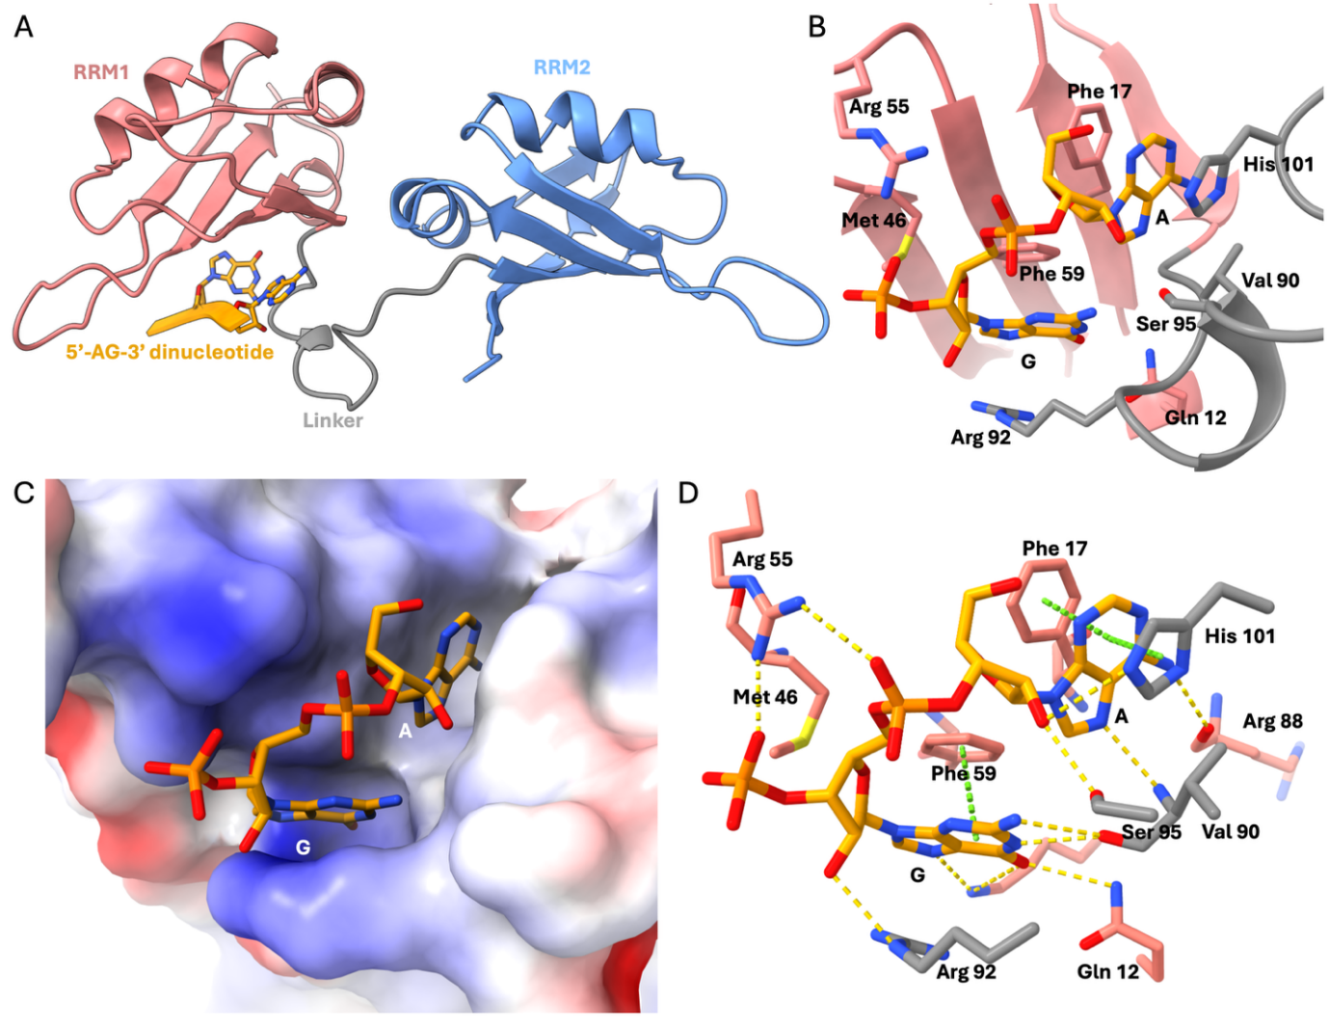

Figure S10. Crystal structure of UP1 bound to 5’AG3’ dinucleotide.
A. Crystal structure of the UP1–5’AG3’ complex solved at 1.75 Å, showing the RRM1-linker-RRM2 bound to the 5′-AG-3′ dinucleotide. RRM1, linker, and RRM2 regions of UP1 are shown as salmon, grey, and blue ribbons, respectively. 5’-AG-3” dinucleotide is shown as an orange ribbon. B. Close-up view of the RRM1 and linker regions of UP1 interacting with the 5′-AG-3′ dinucleotide, showing key amino acid residues involved in binding. C. Electrostatic surface potential of the RNA binding pocket, colored according to the calculated potential ranging from −4 kT/e (red) to +4 kT/e (blue), is shown. The 5′-AG-3′ dinucleotide is shown in stick representation. D. Detailed illustration of molecular interactions between UP1 and the 5′-AG-3′ dinucleotide, emphasizing the specific contacts contributing to complex stability. Hydrogen bonds and π- π stacking interactions are represented as yellow and green dashed lines, respectively.

Figure S11. Superimposition of this UP1-5BSL3.2 complex with the UP1-ESS3 complex structure.
The crystal structures of UP1-ESS3 (PDB ID: 4YOE, 1.95 Å, shown in red) and UP1-5BSL3.2 complex (1.75 Å, shown in cyan) reveal a clamp-like architecture involved in RNA recognition.

Figure S12. ¹H-¹³C HMQC spectra of the upper apical stem loop of 5BSL3.2.
The upper panel displays the HMQC spectrum highlighting guanosine residues, while the lower panel shows the corresponding spectrum for adenosine residues. Both residues highlighted in red adopt a syn conformation in the UP1 complex, but do not exhibit the characteristic downfield shift at the C8 position typically associated with syn orientation.

5BSL3.2 _{Apical stem loop} construct | HMQC | NOESY | TOCSY | HSQC
¹H
¹³C(A)
¹³C(G)
¹³C(C)
¹³C(U)
²H AGCU 3’, 4’,5’,5’’ and CU H5
¹⁵N(GU)
Table S1. List of 5BSL3.2 RNA samples and corresponding NMR experiments performed in this study. Check marks denote the specific experiments conducted for each sample.

Table S2. Thermodynamic parameters obtained from ITC experiments.

Constructs | K_{D} (µM) | n | ∆H (kcal/mol) | ∆G (kcal/mol) | -T∆S (kcal/mol)
HnRNPA1(1-196)-5BSL3.2_{Mut1} | 0.789 ± 0.036 | 0.95 ± 0.08 | -14.93 ± 3.33 | -8.33 ± 0.03 | 6.61 ± 3.29
HnRNPA1(1-196)-5BSL3.2_{Mut2} | 0.785 ± 0.033 | 1.01 ± 0.16 | -18.27 ± 3.59 | -8.33 ± 0.03 | 9.98 ± 3.5
HnRNPA1(1-196)-5BSL3.2_{Mut3} | 0.623 ± 0.037 | 1.08 ± 0.10 | -18.1 ± 4.7 | -8.5 ± 0.04 | 9.62 ± 4.68
HnRNPA1(1-196)-5BSL3.2_{Mut4} | 1.43 ± 0.25 | 1.38 ± 0.20 | -18.6 ± 2.97 | -7.98 ± 0.1 | 10.61 ± 2.98
HnRNPA1(1-196)-5BSL3.2_{JFH1} | 0.738 ± 0.016 | 1.21 ± 0.12 | -21.23 ± 1.19 | -8.37 ± 0.02 | 12.83 ± 1.19
HnRNPA1(1-196)-5BSL3.2_{Apical-stem loop ccc} | 1.18 ± 0.32 | 1.03 ± 0.12 | -12.33 ± 2.68 | -8.11 ± 0.16 | 4.2 ± 2.73
The table summarizes the binding parameters derived from ITC titrations between UP1 and various RNA constructs. The parameters include the dissociation constant (K_{D}), stoichiometry (n), enthalpy change (ΔH), entropy contribution (TΔS), and Gibbs free energy change (ΔG). Values are reported as the mean ± standard deviation from at least three independent experiments.

Table S3. Thermodynamic parameters obtained from ITC experiments

Constructs | K_{D} (µM) | n | ∆H (kcal/mol) | ∆G (kcal/mol) | -T∆S (kcal/mol)
F150A | 0.692±0.067 | 0.88±0.2 | -22.3 ±3.6 | -8.41 ± 0.06 | 13.9 ± 3.6
G110A | 0.561±0.03 | 0.86±0.2 | -33.2 ± 2.1 | -8.53 ± 0.03 | 24.7 ± 0.06
G111A | 0.667±0.052 | 0.85±0.04 | -33.8 ± 2.1 | -8.43 ± 0.04 | 25.3 ± 2.6
I107A | 1.81±0.325 | 0.69±0.15 | -31.0 ± 1.9 | -7.85 ± 0.11 | 23.2 ± 1.8
V163A | 0.547±0.026 | 0.74±0.07 | -32.6 ± 2.7 | -8.55 ± 0.03 | 24.1 ± 2.7
I164A | 0.537±0.019 | 0.75±0.02 | -26.5 ± 3.0 | -8.56 ± 0.02 | 17.9± 3.1
Y167A | 0.578±0.014 | 0.72±0.08 | -26.6 ± 6.4 | -8.51± 0.02 | 18.1 ± 6.42
R75D, R88D | 0.881±0.054 | 0.83±0.04 | -31.5 ± 2.7 | -8.27± 0.04 | 23.2± 2.6

The table summarizes the binding parameters derived from ITC titrations between various mutant UP1 constructs and 5BSL3.2 RNA. The parameters include the dissociation constant (K_{D}), stoichiometry (n), enthalpy change (ΔH), entropy contribution (TΔS), and Gibbs free energy change (ΔG). Values are reported as the mean ± standard deviation from at least three independent experiments.

Table S4. Crystallographic data collection and refinement parameters.
Data collection​ | ​ UP1–5BSL3.2
Space group​ | P1
Cell dimensions​  a, b, c ​  α, β, ϒ​ | ​  36.935 37.967 38.599 ​  64.379◦ 67.629◦ 84.779◦​
Rmerge​ | 0.442​
Resolution (Å)​ | 34.022 - 1.750​
< I/σ(I) >​ | 4.3 ​
% Data completeness​ | 91.7
Redundancy​ | 2.9
​ | ​
Refinement​ | ​
Resolution (Å)​ | 34.05 – 1.750​
Number of reflections​ | 16734
Rwork, Rfree​ | 0.205, 0.160
B factors​ | ​
Protein​ | 26.6
Nucleic acid | 28.8
​ | ​
RMS deviations​ | ​
Bond length​ | 0.0148
Bond angles​ | 2.354

