Supplemental Materials, Section 1
Synthesis of modified dinucleotide derivatives.
FIGURE S1. Example of the synthesis of TCP using “classical” route.
FIGURE S2. Synthesis of TCP using alternative “one-pot-two-step” route 1.
FIGURE S3. Synthesis of TCP using alternative “one-pot-two-step” route 2.
FIGURE S4. Synthesis of TCP using alternative “one-pot-two-step” route 3.
FIGURE S5. Preparative separation of TCP diastereomers 2-5A1 and 2-5A2.
FIGURE S11. Typical solvent gradient and chromatography profile for “Blank” AX-HPLC run.
FIGURE S12. Typical gradient parameters (A) for RP-HPLC analysis of TCPs and (B) gradient parameters for RP-HPLC analysis of compound 3-15B aggregates.
Tables S1. Summary of synthesis and analytical data for prepared TCPs.
Table S2. Analytical data and structures (as neutral molecules) for prepared TCPs.
Parameters for AX-HPLC and RP-HPLC-MS analytical methods.

Synthesis of modified dinucleotide derivatives
Synthesis of p(S)A_{m}pG dinucleotide
Step 1: Synthesis of 5’-hydroxy-2’-O-methyladenylyl-(3’-phosphoryl-5’)-guanosine (5’-H0-A_{m}pG)
A fully protected 5’-HO-A_{m}pG (3.00 g, 3.20 mmole; WUXI APPTEC, custom order) was suspended in 60 mL of 1:1 solution of 1 M ammonium hydroxide and 33% aqueous methylamine and stirred in acetone-CO₂ bath (at -70 °C) for 30 min before warming to a room temperature. The progress of deprotection reactions was monitored by analytical RP-HPLC and found to be complete after 4 hours. All volatiles were removed by rotary evaporation at 30ºC, reducing the reaction mixture to a viscous residue. The residue was then resuspended in water (112 mL) and extracted once with ethyl acetate (96 mL) in a separatory funnel. The aqueous layer was transferred to a round-bottom flask and placed briefly on rotavapor to remove a residual ethyl acetate. The resulted solution (approx. 100 mL) was then diluted with 5-volumes of water, loaded on QFF Sepharose column (2.5 x 40 cm) column, and isolated and purified using linear triethylammonium bicarbonate (TEAB) gradient (0 – 20% of 1 M TEAB in water, pH 8; over 6 column volumes). The >95% RP-HPLC-pure fractions of 5’-HO-A_{m}pG were pooled, concentrated using rotary evaporation, and co-evaporated with methanol to afford the pure product as TEAH⁺ salt (2.14 g; 2.95 mmol, 92.2% yield).
RP-HPLC Method for 5’-HO-A_{m}pG analysis
Instruments: Vanquish Flex HPLC coupled to Orbitrap Exploris 120 mass spectrometer.
Column: Acquity UPLC BEH C18, 130A, 1.7 um, 2.1 x 100 mm ( Waters part ID:186002352).
Buffer A: 100 mM TEAA pH 7.2 (±0.2).
Buffer B: Acetonitrile.
Flow rate: 0.25 mL/min.
Temperature: approx. 20ºC.

Step 2. Synthesis of 5’-O-thiophosphoryl-2’-O-methyladenylyl-(3’-O-phosphoryl-O-5’)-guanosine (p(S)-A_{m}pG)
The 5’-HO-A_{m}pG (TEAH⁺ salt; 130 mg; 0.179 mmol; Step 1) was suspended in anhydrous triethyl phosphate (900 µL). 2,6-lutidine (93.8 µL) was added to the suspension, and the mixture was stirred for 30 min at 25 °C and then at -5 °C for 20 min. Freshly distilled PSCl₃ (N mL) was added dropwise to the suspension over 10 min while the mixture continued stirring at -5 °C overnight. The progress of the reaction was monitored by analytical AX-HPLC. After 18 hr, when 85% of the starting material was consumed, the reaction was quenched by adding 1 M TEAB (1.35 mL) and the mixture was stirred vigorously for 3 hours at 25 °C, before storing overnight at 4 °C. The mixture was then diluted with 100 mL of water and loaded on QFF Sepharose column (2.5 x 40 cm) column. The p(S)-A_{m}pG was isolated and purified using linear TEAB gradient (30 – 60% of 1 M TEAB in water, pH 8.0; over 6 column volumes). Fractions with >70% purity (by analytical AX-HPLC) were pooled, diluted with 5-volumes of water and further purified by reverse phase chromatography on Nova-Pak HR C18 column (19 x 300 mm, 6µm 60Å; Waters WAT025822). The >95% AX-HPLC-pure fractions of p(S)-A_{m}pG were pooled, concentrated using rotary evaporation, and co-evaporated three times with methanol to afford the pure product as 1 x TEAH⁺ salt (98.5mg; 0.117 mmol; 65% yield).
Synthesis of pS-A_{m}pG dinucleotide
Step 1: Synthesis of N4-benzoyl-5’-iodo-2’-O-methyladenylyl-(3’-O-cyanoethylphosphoryl-O-5’)-N2-isobutyryl-2’,3’-bis(acetyl)-guanosine (5’-Iodo-A_{m}pG)

Fully protected 5’-HO-A_{m}pG (1.5 g, 1.60 mmole; WuXi AppTec, custom order) was dissolved in 6.4 mL of N-methyl pyrrolidine-2-one (NMP) using magnetic stirring at 25 °C. Solid imidazole (650 mg, 9.60 mmol) and triphenylphosphine (1.26 g, 4.80 mmol) were added to the stirring solution until all solids were fully dissolved. In a separate glass vial, a solid iodine (1.22 g 4.80 mmol) was dissolved in NMP (6.4 mL) and added dropwise to the stirring mixture for over 2 minutes. The reaction progress was monitored by analytical RP-HPLC (same as above). After the reaction was completed (18 hours) the mixture was poured in 128 mL of water. The resulting precipitate was dissolved in 25 mL of ethyl alcohol and ZnCl₂ (436.10, 3.20 mmol) was added to precipitate the triphenylphosphine oxide. The ethanol supernatant was decanted, and solvents were removed by rotary evaporation to afford the desired 5’-Iodo-A_{m}pG (1.0 g, 0.95 mmol; 59.4% yield).
Step 2: Synthesis of 5’-S-phosphoryl-2’-O-methyladenylyl-(3’-O-phosphoryl-O-5’)-guanosine, pS-A_{m}pG
A fully protected 5’-Iodo-A_{m}pG (1.00 g, 0.954 mmol; Step 1) was dissolved in anhydrous DMF (5mL). In a separate glass vessel, a TEAH⁺ salt of thiophosphate (2.12 g, 4.77 mmol; prepared as in reference [1], see below) was resuspended in DMF (5 mL) and added to the dinucleotide solution with stirring at 25 °C. The progress of reaction was monitored by RP-HPLC (same as above). After the reaction was completed (20 hr), a 1:1 mixture of 1 M ammonium hydroxide in water and 40% aqueous methylamine (20 mL) was added to remove all protecting groups. The mixture was stirred at 25 °C and a progress of reaction was monitored by analytical AX-HPLC. Once the reaction was complete, the mixture was partially evaporated on rotavapor to remove the volatile solvents. The residue was resuspended in water (37.3 mL) and extracted once with ethyl acetate (32 mL). The aqueous phase was briefly placed on rotavapor to remove residual ethyl acetate, then diluted with 9-volumes of water. The whole mixture then was loaded on QFF Sepharose column (2.5 x 40 cm) column and pS-A_{m}pG was isolated and purified using TEAB gradient (0 – 60% of 1 M TEAB in water, pH 8; over 6 column volumes). Fractions with >95% purity by analytical AX-HPLC were pooled, concentrated on rotavapor, co-evaporated three times with methanol to afford pure pS-A_{m}pG as 2 x TEAH⁺ salt (0.49 g, 0.60 mmol; 63% yield).
Reference:
- Kowalska J, Lewdorowicz M, Darzynkiewicz E, Jemielity J. A simple and rapid synthesis of nucleotide analogues containing a phosphorothioate moiety at the terminal position of the phosphate chain. Tetrahedron letters. 2007;48(31):5475-5479. doi:10.1016/j.tetlet.2007.05.170

Synthesis of pCH₂pA_{m}pG dinucleotide

The A_{m}pG (TEAH+ salt, 1.0 g, 1.37 mmol; WuXi AppTec, custom order) was placed into a round bottom flask and dried under high vacuum overnight. The argon gas was purged in the flask and 13.7 mL of dry trimethyl phosphate was added to the solid. The flask was heated with a heat gun until all suspended solid was dissolved and then cooled in an ice-water bath for 30 minutes. To the obtained solution methylenebis(phosphonic dichloride) (687 mg, 2.75 mmol) was added and the mixture was stirred for 1 hour at 0ºC (ice-water bath). The reaction was quenched with 1 M TEAB (pH 7.6, 15 mL) and stirred for 2 hours at room temperature and diluted with 10 x volume of water. The whole mixture then was loaded on QFF Sepharose column (2.5 x 40 cm) and pS-A_{m}pG was isolated and purified using TEAB gradient (0 – 80% of 1 M TEAB in water, pH 7.6; over 10 column volumes). The fractions containing pCH₂pA_{m}pG (>95% purity, AX-HPLC) were pooled and dried on rotavapor to give a white solid (660 mg, 0.47 mmol; 34% yield).
MS: [M+H]⁺ Expected Mass: 785.11; [M+H]⁺ Detected: m/z=785.10

Synthesis of pNHpA_{m}pG dinucleotide

The A_{m}pG (TEAH⁺ salt, 1.0 g, 1.60 mmol; WuXi AppTec, custom order) was placed into a round bottom flask and dried under high vacuum overnight. The solid was dissolved in 40 mL of dry trimethyl phosphate, mixture was cooled to -12 ºC and N-(dichlorophosphinoyl)phosphorimidic trichloride (1.72g, 6.4 mmol) was added. The mixture was kept for 25 min and then quenched with 1M TEAB (pH 8.0; 16 mL). The solution was diluted with 10 x volume of water. The whole mixture then was loaded on QFF Sepharose column (2.5 x 40 cm) and pNHpA_{m}pG was isolated and purified using TEAB gradient (0 – 80% of 1 M TEAB in water, pH 7.6; over 10 column volumes and holding at 80% for 1.5 column volume). The fractions containing pNHpA_{m}pG (>72% purity by AX-HPLC) were pooled and dried on rotavapor. The QFF isolated product was further purified by reverse phase chromatography on Triart column (20 x 250 mm, 5 µm, 120Å; YMC, Cat#TA12S05-2520WX) using linear gradient of acetonitrile in water from 0 to 20% over 10 column volumes. Fractions containing pNHpA_{m}pG with >95% purity (by RP-HPLC; same as above) were pooled, concentrated using rotary evaporation, and co-evaporated three times with methanol to afford the 98% pure product as 2 x TEAH⁺ salt (118 mg; 0.120 mmol; 7.5% overall yield).
MS: [M+H]⁺ Expected Mass: 785.11; [M+H]⁺ Detected: m/z=785.10

Synthesis of 5’-vinyl phosphonate dinucleotide derivative, pCH=CH-A_{m}pG

pCH=CH-A_{m}pG was synthesized on CPG-support using POM-protected 5’-vinyl-2’-O-methyladenosine-phosphoramidite (Hongene Biotech; E-isomer; Cat# PR1-028) and standard solid phase oligonucleotide synthesis protocol at 1 mmole starting scale and at 1:1 ratio of 5’-HO- and P-components. After standard full deprotection and cleavage from support, the crude pCH=CH-A_{m}pG was isolated and purified with anion exchange chromatography using QFF Sepharose column (2.5 x 40 cm) and TEAB gradient (0 – 80% of 1 M TEAB in water, pH 7.6; over 10 column volumes). The fractions containing pCH=C-A_{m}pG with >95% purity by AX-HPLC were pooled, evaporated on rotavapor to a solid and further held under vacuum to yield a white solid material as 2 x TEAH⁺ salt (435.5mg, 0.62 mmol; 62% yield).
¹H NMR (500 MHz, D₂O) δ: 8.31(s,1H), 8.18(s,1H), 7.94(s, 1H), 6.38-6.46(1H), 6.08-6.14(2H), 5.84(d,1H), 4.50-4.78(2H), 4.35(s, 1H), 4.20-4.21(2H), 3.46(s, 3H) 3.05-3.09(2H). ³¹P NMR (200 MHz, D₂O) δ: 10.17 (s,1P), 0.48 (s,1P). MS ([M+H]⁺ ): Expected Mass: 703.13; [M+H]⁺ Detected: m/z=703.90

FIGURE S1. Scheme for a “classic” two step approach to the synthesis of TCP. Synthesis of ^{7m}G_{m}pppA_{m}pG is shown as an example.

FIGURE S2. Alternative route 1 for the synthesis of TCP using “one-pot-two-step” approach. Synthesis of ^{7m}G_{m}pp(NH)pA_{m}pG (2-8A) is shown as an example.

FIGURE S3. Alternative route 2 for the synthesis of TCP using “one-pot-two-step” approach. Synthesis of ^{7m}G_{m}p(s)ppA_{m}pG is shown as an example.
FIGURE S4. Alternative route 3 for the synthesis of TCP using “one-pot-two-step” approach. Synthesis of ^{7m}G_{m}pp(s)pA_{m}pG is shown as an example.
Preparative separation of TCP diastereomers

A
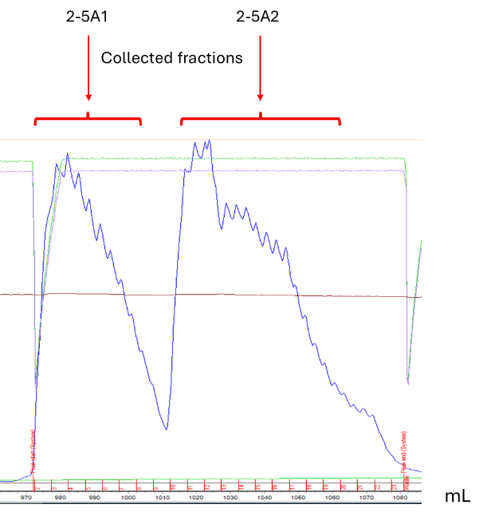
B
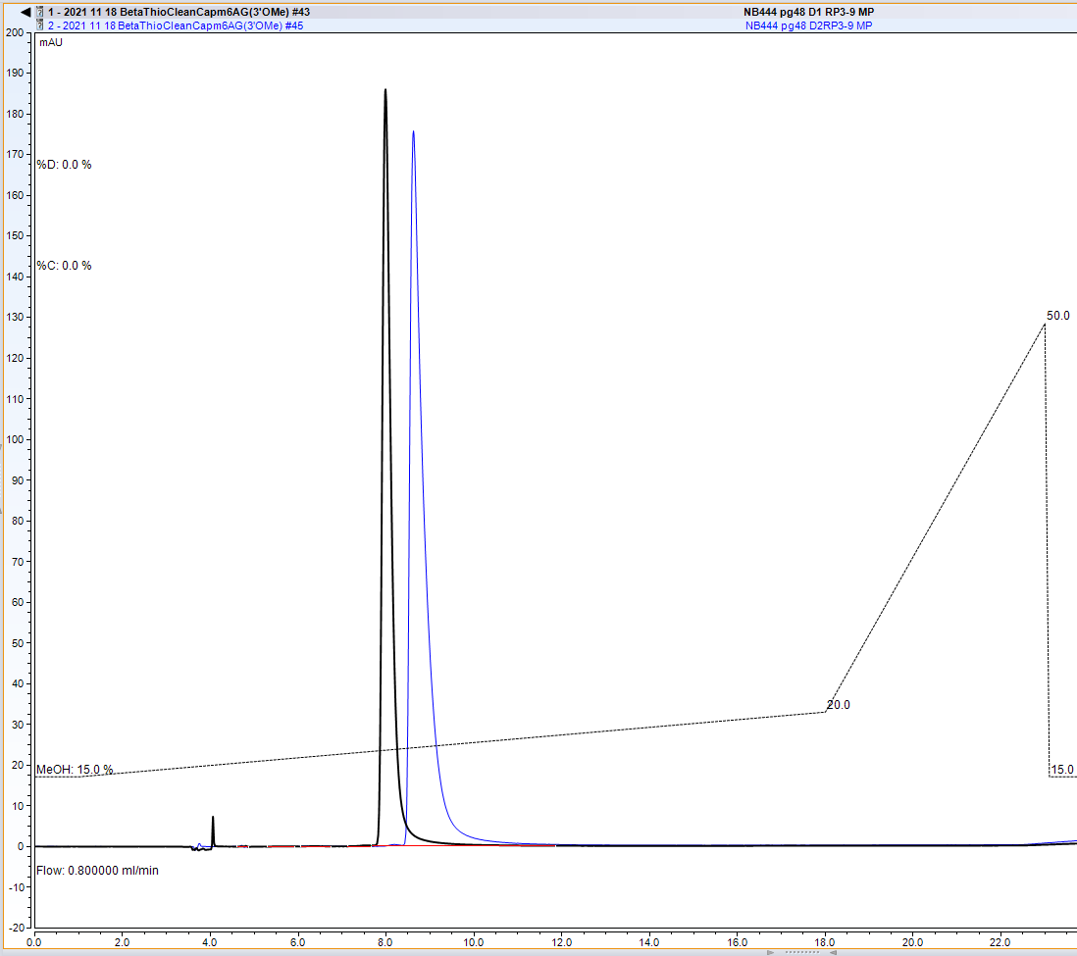 min
FIGURE S5. (A) Preparative separation of TCP diastereomers 2-5A1 and 2-5A2 (see Materials and Methods). A fragment of the chromatogram is shown. (B) RP-HPLC analysis of separated 2-5A1 and 2-5A2 diastereomers (overlaid HPLC traces are shown: 2-5A1 (black) and 2-5A2 (blue).
Table S1. Summary of synthesis and analytical data for prepared TCPs
TCP | Route | Scale | Isolated Yield |  | Analytical (nucleotide based) |  |  | Mass Spectrum (negative mode)
 |  | mmol | mmol | % | ³¹P NMR ^{1*} | ¹H NMR ^{2*} | AX HPLC ^{3*} | Calculated mass | Observed Ion (m/z)
1-1A | Standard | 720 | 520 | 72.2 | NOI | CTS | 99.7 | 1145.1556 | 1144.1471
1-2A | Standard | 720 | 530 | 73.6 | NOI | CTS | 98.9 | 1159.1712 | 1158.1623
1-3A | Standard | 0.21 | 0.16 | 76.2 | NOI | CTS | 99.5 | 1159.1712 | 1158.1638
1-4A | Standard | 0.24 | 0.14 | 58.3 | NOI | CTS | 99.1 | 1173.1869 | 1172.1792
1-5A | Standard | 0.19 | 0.13 | 68.4 | NOI | CTS | 99.3 | 1175.1484 | 1174.1403
1-7A | Standard | 0.14 | 0.04 | 28.6 | NOI | CTS | 99.9 | 1183.1712 | 1182.1633
1-8A | Standard | 0.10 | 0.02 | 20.0 | NOI | CTS | 98.9 | 1186.1821 | 1185.1735
1-9A | Standard | 0.24 | 0.15 | 62.5 | NOI | CTS | 99.6 | 1203.1974 | 1202.1891
1-10A | Standard | 0.17 | 0.10 | 58.8 | NOI | CTS | 97.8 | 1147.1512 | 1146.1435
1-11A | Standard | 0.87 | 0.70 | 80.5 | NOI | CTS | 99.2 | 1157.1556 | 1156.1474
1-12A | Standard | 0.50 | 0.38 | 76.0 | NOI | CTS | 99.8 | 1159.1712 | 1158.1632
1-13A | Standard | 0.33 | 0.22 | 66.7 | NOI | CTS | 99.4 | 1145.1556 | 1144.1477
1-1B | Standard | 0.50 | 0.34 | 68.0 | NOI | CTS | 99.7 | 1159.1712 | 1158.1631
1-2B | Standard | 3.00 | 2.49 | 83.0 | NOI | CTS | 99.5 | 1173.1869 | 1172.1788
1-3B | Standard | 0.21 | 0.14 | 66.7 | 99.6 | CTS | 99.3 | 1173.1869 | 1172.1795
1-4B | Standard | 0.24 | 0.15 | 62.5 | NOI | CTS | 98.8 | 1187.2025 | 1186.1944
1-5B | Standard | 0.19 | 0.11 | 57.9 | NOI | CTS | 98.1 | 1189.1640 | 1188.1558
1-6B | Standard | 0.24 | 0.06 | 25.0 | NOI | CTS | 99.4 | 1214.1883 | 1213.1804
1-7B | Standard | 0.14 | 0.06 | 42.9 | NOI | CTS | 99.6 | 1197.1869 | 1196.1786
1-8B | Standard | 0.29 | 0.10 | 34.5 | NOI | CTS | 99.4 | 1200.1978 | 1199.1894
1-9B | Standard | 0.24 | 0.16 | 66.7 | NOI | CTS | 99.2 | 1217.2131 | 1216.2046
1-10B | Standard | 0.19 | 0.10 | 52.6 | NOI | CTS | 100.0 | 1161.1669 | 1160.1584
1-11B | Standard | 0.22 | 0.05 | 22.7 | NOI | CTS | 97.1 | 1171.1712 | 1170.1625
1-12B | Standard | 0.50 | 0.44 | 88.0 | NOI | CTS | 99.8 | 1173.1869 | 1172.1789
1-13B | Standard | 0.34 | 0.26 | 76.5 | NOI | CTS | 99.4 | 1159.1712 | 1158.1629
1-14B | Standard | 0.17 | 0.09 | 52.9 | NOI | CTS | 99.8 | 1101.1658 | 1100.1580
1-15B | Standard | 0.35 | 0.11 | 31.4 | NOI | CTS | 98.2 | 1199.2025 | 1198.1941
1-16B | Standard | 0.42 | 0.16 | 38.1 | NOI | CTS | 100.0 | 1221.1270 | 1220.1188
2-1A | Alternative route 3  (^{7m}GMP instead of ^{7m}GDP) | 2.20 | 0.92 | 41.8 | NOI | CTS | 95.1 | 1079.2049 | 1078.1968
2-2A | Alternative route 2  (^{7m}GDP instead of ^{7m}GMP) | 2.20 | 1.01 | 45.8 | NOI | CTS | 98.0 | 1239.1376 | 1238.1300
2-3A | Alternative route 3 | 2.00 | 0.27 | 13.7 | NOI | CTS | 98.9 | 175.1484 | 1174.1400
2-4A12 | Alternative route 2 | 0.07 | 0.03 | 43.3 | NOI | CTS | 97.7 (D1+D2) | 1175.1484 | 1174.1402
2-5A12 ^{4*} | Alternative route 3 | 0.35 | 0.13 | 37.1
2-5A1 Individual diastereomer |  |  |  |  | NOI | CTS | 99.2 | 1175.1484 | 1174.1403
2-5A2 Individual diastereomer |  |  |  |  | NOI | CTS | 99.6 | 1175.1484 | 1174.1400
2-6A12 | Standard | 0.24 | 0.13 | 54.2 | NOI | CTS | 99.0 (D1+D2) | 1175.1484 | 1174.67 (LR MS) ^{5*}
2-7A | Standard | 3.00 | 1.00 | 33.3 | 98.8 | CTS | 99.2 | 1175.1484 | 1174.1400
2-8A | Alternative route 1 | 1.60 | 0.71 | 44.5 | NOI | CTS | 96.3 | 1158.1872 | 1157.1787
2-9A | Alternative route 1 | 0.64 | 0.11 | 16.8 | NOI | CTS | 99.6 | 1157.1920 | 1156.1843
2-10A | Standard | 0.08 | 0.06 | 71.3 | NOI | CTS | 99.6 | 1155.1763 | 1154.1683
2-11A | Standard | 0.08 | 0.06 | 68.8 | NOI | CTS | 99.5 | 1141.1607 | 1140.1522
2-1B | Alternative route 3  (^{7m}GMP instead of ^{7m}GDP) | 6.94 | 2.91 | 42.0 | NOI | CTS | 97.0 | 1093.2206 | 1092.2123
2-2B | Alternative route 2  (^{7m}GDP instead of ^{7m}GMP) | 6.94 | 1.83 | 26.3 | NOI | CTS | 98.0 | 1253.1532 | 1252.1451
2-3B | Standard | 0.37 | 0.17 | 45.9 | NOI | CTS | 99.6 | 1189.1640 | 1188.1554
2-4B12 | Alternative route 2 | 0.29 | 0.18 | 62.1 | NOI | CTS | 99.5 (D1+D2) | 1189.1640 | 1188.1558
2-5B12 ^{4*} | Alternative route 3 | 0.40 | 0.09 | 22.5
2-5B1 Individual diastereomer |  |  |  |  | NOI | CTS | 98.5 | 1189.1640 | 1187.5 (LR MS)^{5*}
2-5B2 Individual diastereomer |  |  |  |  | NOI | CTS | 98.4 | 1189.1640 | 1188.1559
2-6B1 | Standard | 0.20 | 0.03 | 12.8 | NOI | CTS | 95.3 | 1189.1640 | 1188.1561
3-1A | Standard | 0.24 | 0.16 | 66.7 | NOI | CTS | 99.9 | 1160.1665 | 1159.1584
3-3A | Standard | 0.33 | 0.23 | 69.7 | NOI | CTS | 99.6 | 1143.1399 | 1142.1318
3-4A12 ^{4*} | Standard | 0.22 | 0.13 | 59.1
3-4A1 Individual diastereomer |  |  |  |  | NOI | CTS | 99.5 | 1159.1171 | 1158.1086
3-4A2 Individual diastereomer |  |  |  |  | NOI | CTS | 98.9 | 1159.1171 | 1158.1085
3-5A | Standard | 0.40 | 0.25 | 62.5 | NOI | CTS | 99.6 | 1104.1178 | 1103.1104
3-8A12 ^{4*} | Standard | 0.22 | 0.13 | 57.4
3-8A1 Individual diastereomer |  |  |  |  | NOI | CTS | 98.20 | 1149.1128 | 1148.33 (LR MS )^{5*}
3-8A2 Individual diastereomer |  |  |  |  | NOI | CTS | 97.2 | 1149.1128 | 1148.1042
3-9A | Standard | 0.40 | 0.21 | 52.5 | NOI | CTS | 94.0 | 1094.1135 | 1093.1054
3-10A | Standard | 0.5 | 0.28 | 55.0 | NOI | CTS | 96.6 | 1159.1712 | 1158.1632
3-11A | Standard | 234 | 95 | 40.6 | NOI | CTS | 98.5 | 1106.1335 | 1105.1255
3-12A | Standard | 0.64 | 0.34 | 53.0 | NOI | CTS | 99.2 | 1143.1763 | 1142.1678
3-13A | Standard | 0.20 | 0.10 | 50.0 | NOI | CTS | 96.3 | 1120.1491 | 1119.1413
3-15A | Standard | 0.25 | 0.05 | 21.1 | NOI | CTS | 99.0 | 1161.1505 | 1160.4 (LR MS)^{5*}
3-1B | Standard | 0.24 | 0.16 | 66.7 | NOI | CTS | 99.5 | 1174.1821 | 1173.1743
3-2B12 | Standard | 0.22 | 0.06 | 27.3 | NOI | CTS | 97.6 | 1190.1593 | 1189.1504
3-3B | Standard | 0.31 | 0.21 | 67.7 | NOI | CTS | 99.5 | 1157.1556 | 1156.1476
3-5B | Standard | 0.40 | 0.28 | 70.0 | NOI | CTS | 99.5 | 1118.1335 | 1117.1258
3-6B12 ^{4*} | Standard | 0.30 | 0.20 | 67.7
3-6B1 Individual diastereomer |  |  |  |  | NOI | CTS | 98.20 | 1189.1640 | 1188.8 (LR MS) ^{5*}
3-6B2 Individual diastereomer |  |  |  |  | NOI | CTS | 95.8 | 1189.1640 | 1188.1554
3-7B1 Individual diastereomer | Standard | 0.13 | 0.05 | 38.5 | NOI | CTS | 99.4 | 1175.1484 | 1174.1404
3-7B2 Individual diastereomer | Standard | 0.21 | 0.10 | 47.6 | NOI | CTS | 98.5 | 1175.1484 | 1174.1404
3-9B | Standard | 0.40 | 0.23 | 57.5 | NOI | CTS | 99.4 | 1108.1291 | 1107.1206
3-10B | Standard | 0.50 | 0.32 | 64.0 | NOI | CTS | 97.9 | 1173.1869 | 1172.1783
3-11B | Standard | 0.20 | 0.15 | 75.0 | NOI | CTS | 98.1 | 1120.1491 | 1119.1409
3-12B | Standard | 240 | 100 | 41.7 | NOI | CTS | 99.6 | 1157.1920 | 1156.1836
3-13B | Standard | 0.57 | 0.30 | 53.0 | NOI | CTS | 99.7 | 1134.1648 | 1133.1567
3-14B | Standard | 1.29 | 0.60 | 46.5 | NOI | CTS | 99.9 | 1143.1763 | 1142.1681
3-15B | Standard | 0.25 | 0.02 | 9.6 | NOI | CTS | 99.0 | 1175.1661 | 1174.3 (LR MS)^{5*}
^{1*} NOI - no observed nucleotide impurities
^{2*} CTS - conforms to the structure; may contain variable amounts of residual triethylammonium and/or acetate ions and/or ethanol signals
^{3*} Low HPLC purity was detected due to accidental degradation of TCP in HPLC test sample (opening of imidazole ring of ^{7m}G base)
^{4*} Individual diastereomers were separated and isolated post-synthetically by reverse phase chromatography
^{5*} Low Resolution mass spectrum data

Table S2. Analytical data and structures (as neutral molecules) for prepared TCPs
Compounds related to Table 1, Series A
Compound 1-1A

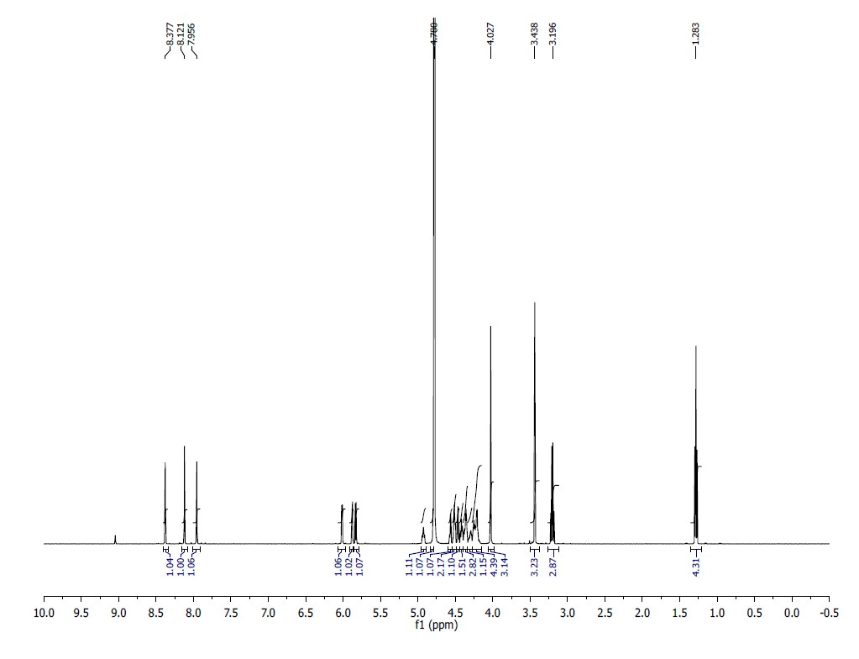
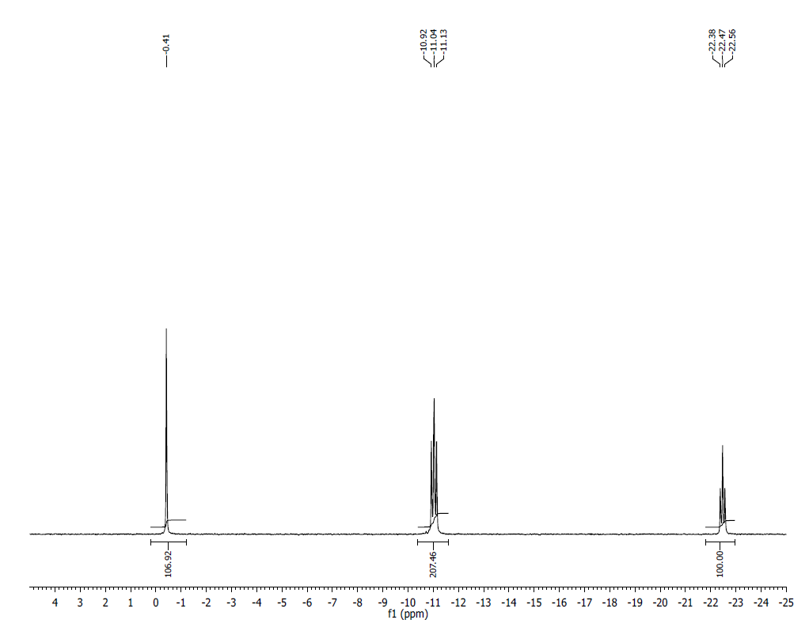
¹HNMR (500MHz, D2O) δ: 8.37 (s, 1H), 8.12 (s, 1H), 7.95 (s, 1H), 6.02 (d, J = 5.5 Hz, 1H), 5.88 (d, J = 4 Hz, 1H), 5.83 (d, J = 5.5 Hz, 1H), 4.93 (m, 1H), 4.56-4.55 (m, 1H), 4.51-4.50 (m, 2H), 4.46-4.41 (m, 1H), 4.36-4.35 (m, 2H), 4.35-4.55 (m, 4H), 4.21-4.20 (m, 4H), 4.02 (s, 3H), 3.43 (s, 3H).
³¹P NMR (200 MHz, D2O) δ: -0.41 (1P), -11.04 (2P), -22.47 (1P).
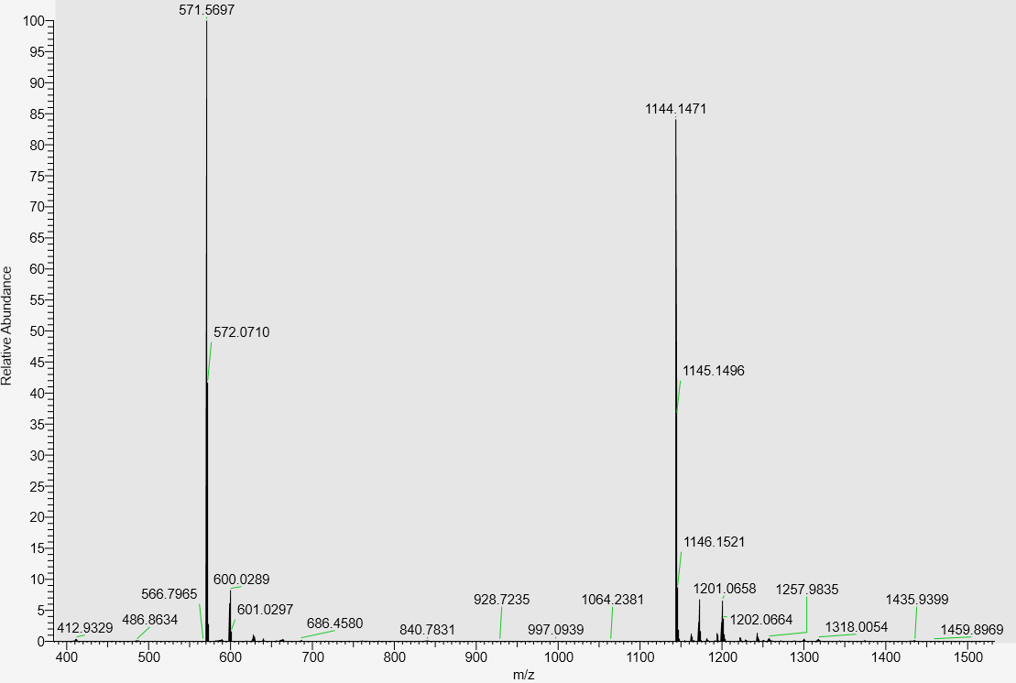
LC-MS data, calculated mass: 1145.1556; detected m/z: 1144.1471 (M-H).

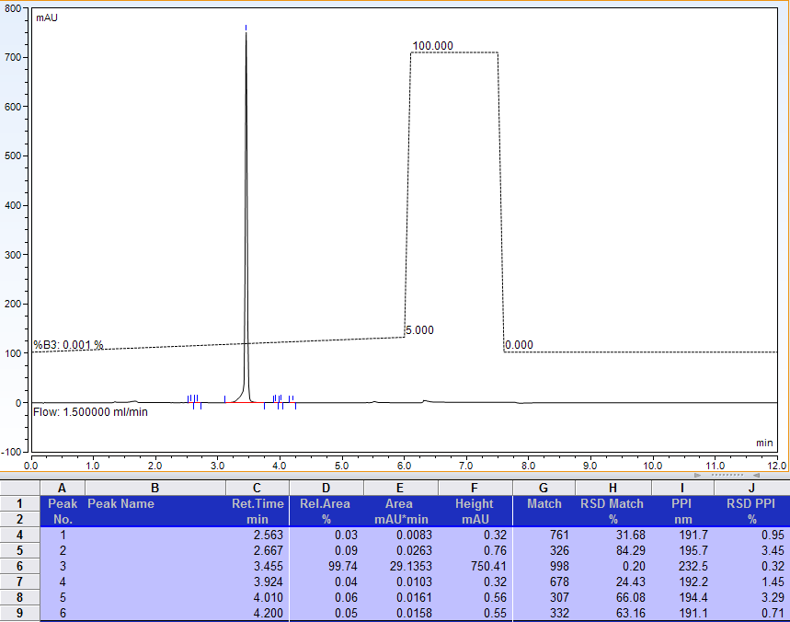
AX-HPLC Analysis
Compound 1-2A

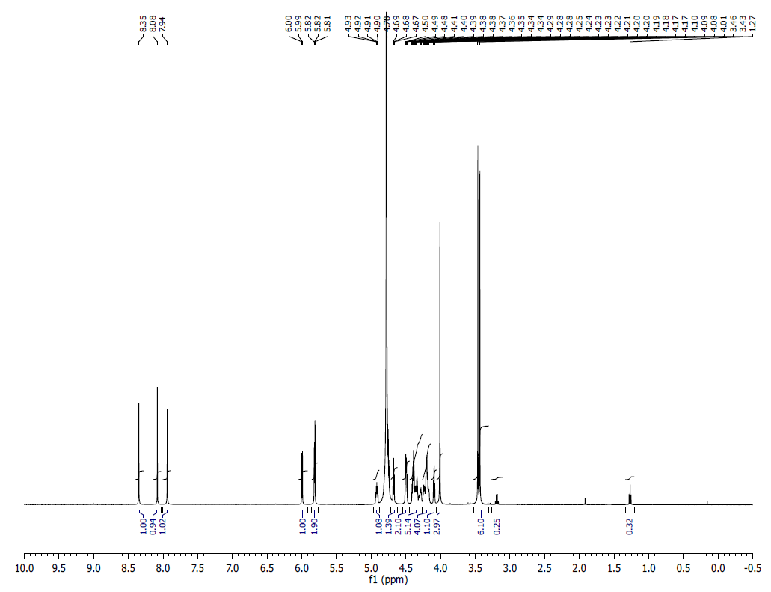
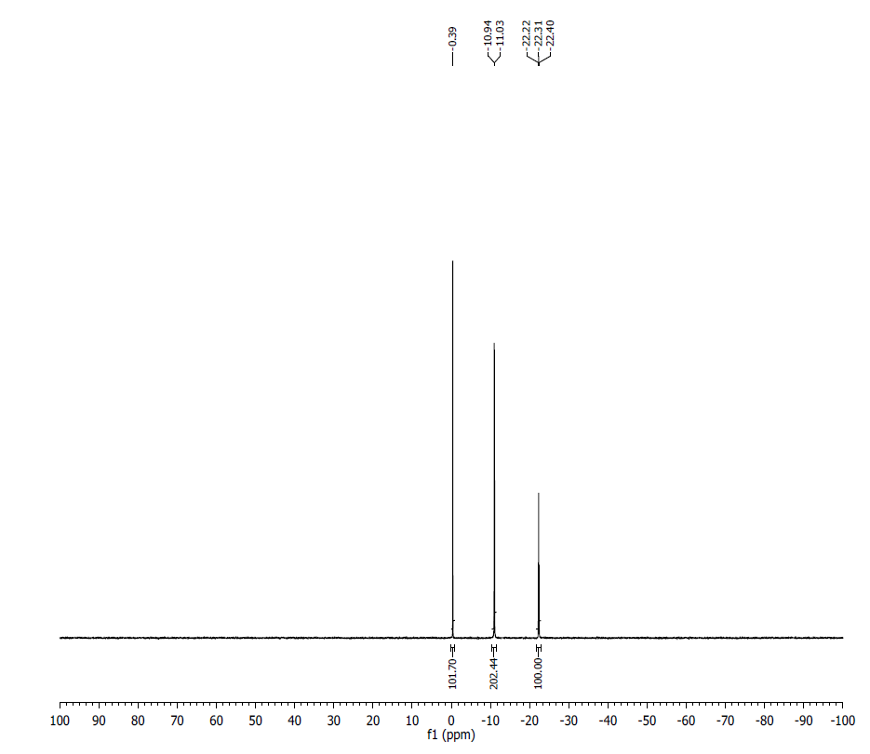
¹HNMR (500MHz, D2O) δ: 8.35 (s, 1H), 8.08 (s, 1H), 7.94 (s, 1H), 6.00 (d, J = 5 Hz, 1H), 5.82-5.81 (t, J = 5 Hz, 2H), 4.94-4.90 (m, , 1H), 4.93 (m, 1H), 4.69-4.67 (t, J = 5 Hz, 1H), 4.50-4.48 (m, 2H), 4.41-4.37 (m, 5H), 4.36-4.08 (m, 5H), 4.01 (s, 3H),3.46- 3.43 (m, 6H).
³¹P NMR (200 MHz, D2O) δ: -0.39 (1P), -10.99 (2P), -22.31 (1P).
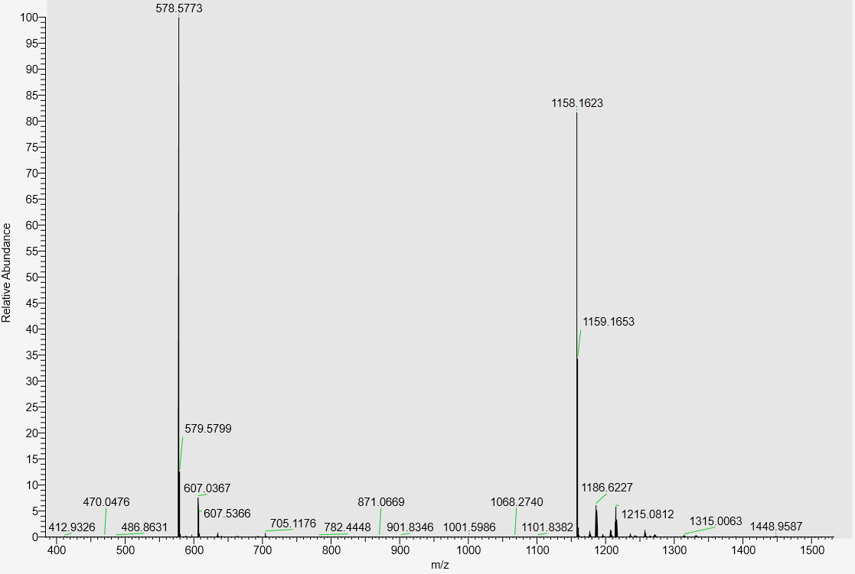
LC-MS data, calculated mass: 1159.1712; detected m/z: 1158.1623 (M-H)

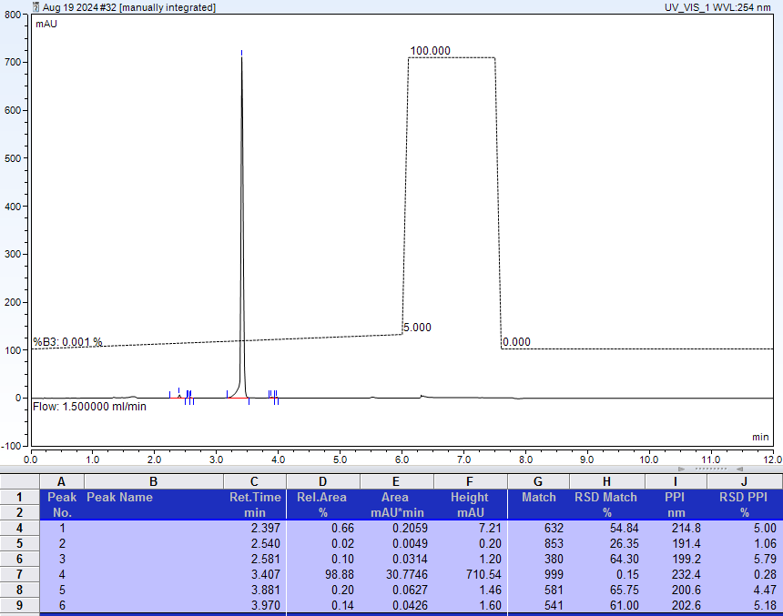
AX-HPLC Analysis

Compound 1-3A
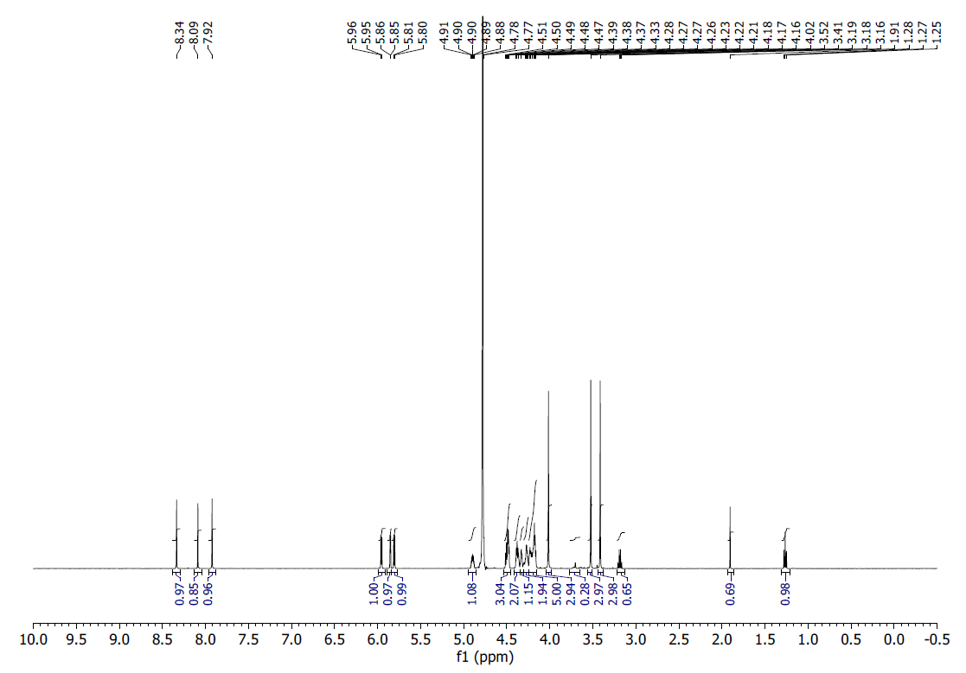
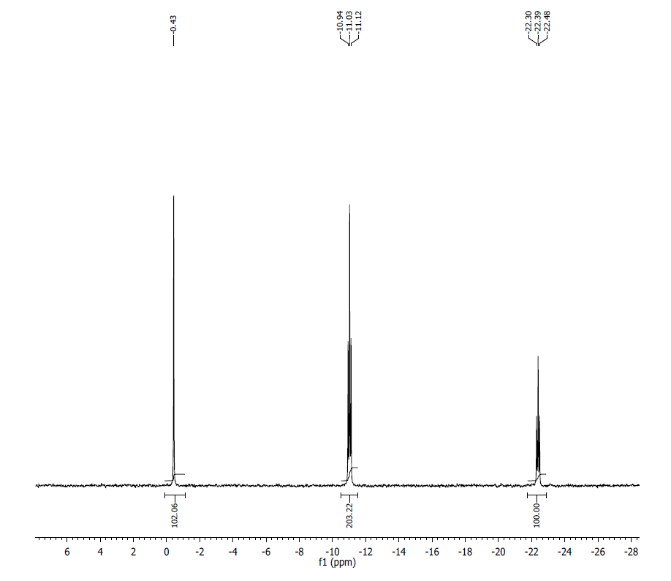
¹H NMR (500MHz, D₂O) δ: 8.34 (s, 1H), 8.09 (s, 1H), 7.92 (s, 1H), 5.96 (d, 1H, J=9 Hz), 5.86 (d, 1H, J=5 Hz), 5.80 (d, 1H, J=9 Hz), 4.90 (m, 1H), 4.51 (d, 1H, J=5 Hz), 4.48 (m, 2H), 4.38 (m, 2H), 4.33 (m, 1H), 4.27 (m, 2H), 4.23-4.16 (m, 5H), 4.02 (s, 3H), 3.52 (s, 3H), 3.41 (s, 3H)

³¹P NMR (200 MHz, D₂O) δ: -0.43 (1P), -10.99 (1P), -11.07 (1P), -22.39 (1P).

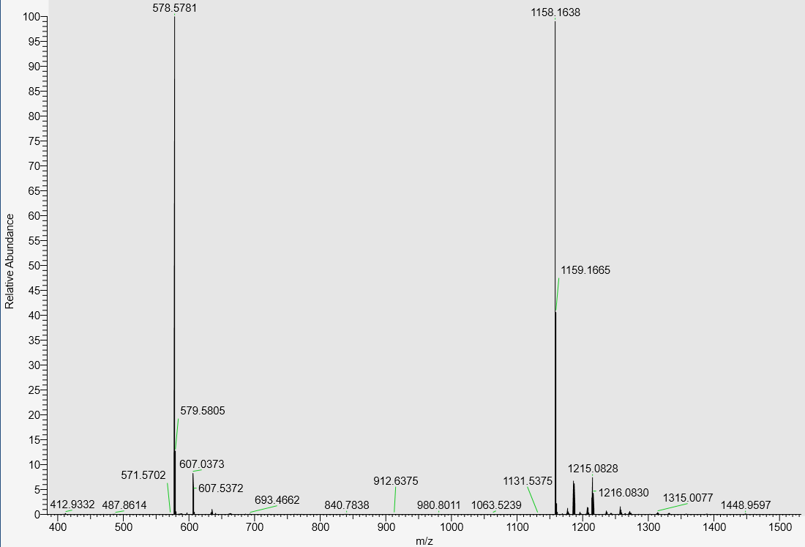

LC-MS data, calculated mass: 1159.1712; detected m/z= 1158.1638 (M-H)

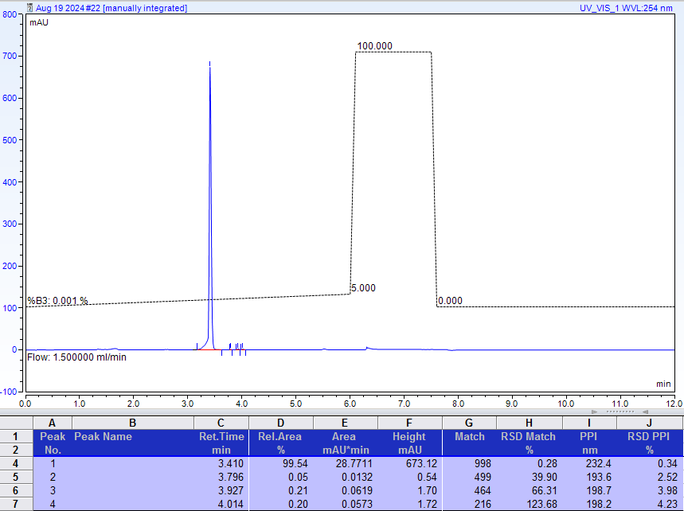
AX-HPLC Analysis

Compound 1-4A

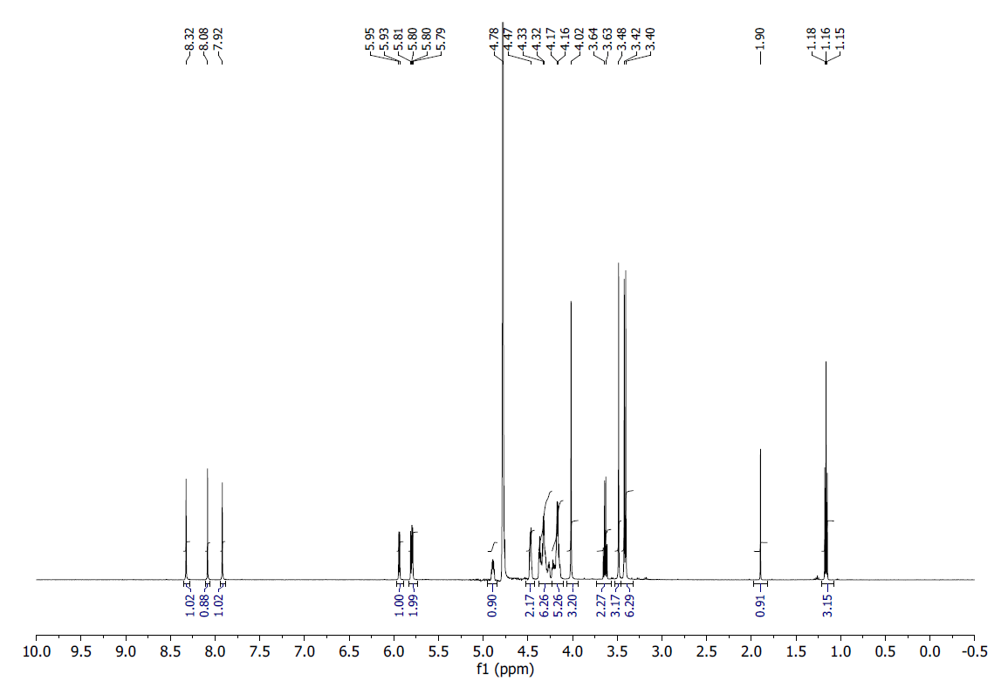
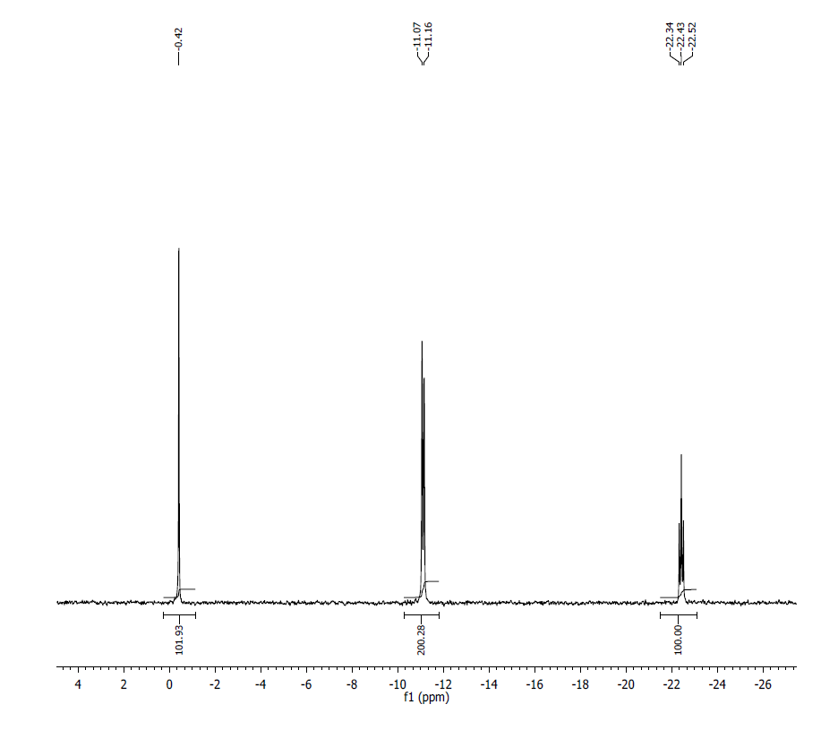
¹H NMR (500 MHz, D₂O) δ: 8.32 (s, 1), 8.06 (s, 1), 7.92 (s, 1), 5.94 (d,1, J=10 Hz), 5.80 (d, 1, J=10 Hz), 5.79 (d, 1, J=10Hz), 4.89 (m, 1), 4.47 (m, 2), 4.37 (t, 1, J=5 Hz), 4.33 (m, 4), 4.24 (m, 2), 4.14 (m,4), 4.02 (s, 3), 3.48 (s, 3), 3.42 (s, 3), 3.40 (s, 3).

³¹P NMR (200 MHz, D₂O) δ: -0.42 (1P), -11.13 (2P), -22.43 (1P).

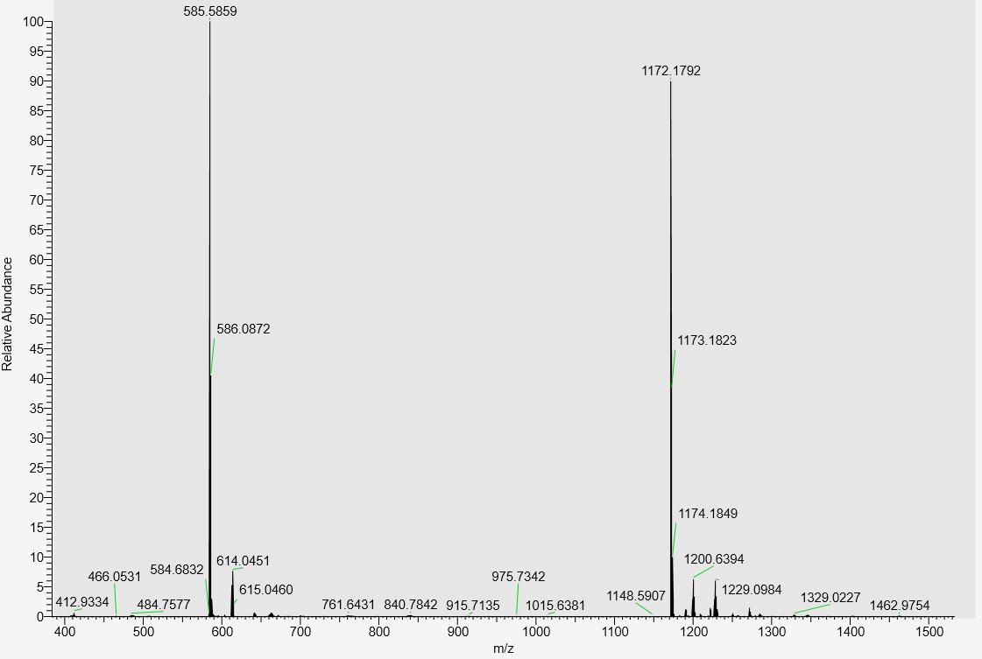

LC-MS data, calculated mass: 1173.1869; detected m/z: 1172.1792 (M-H)

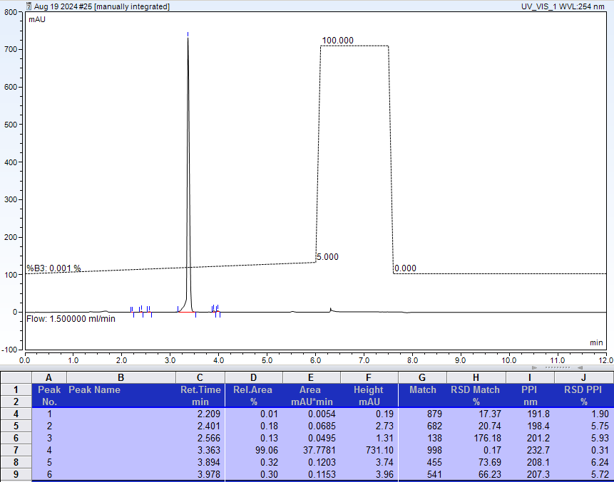
AX-HPLC Analysis

Compound 1-5A

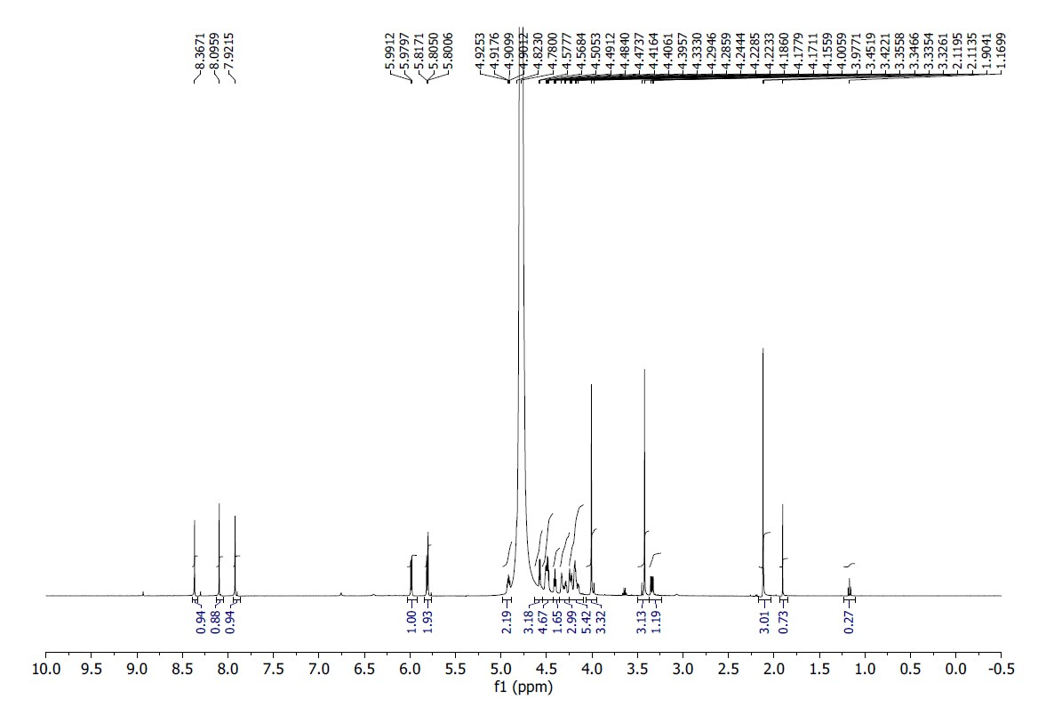

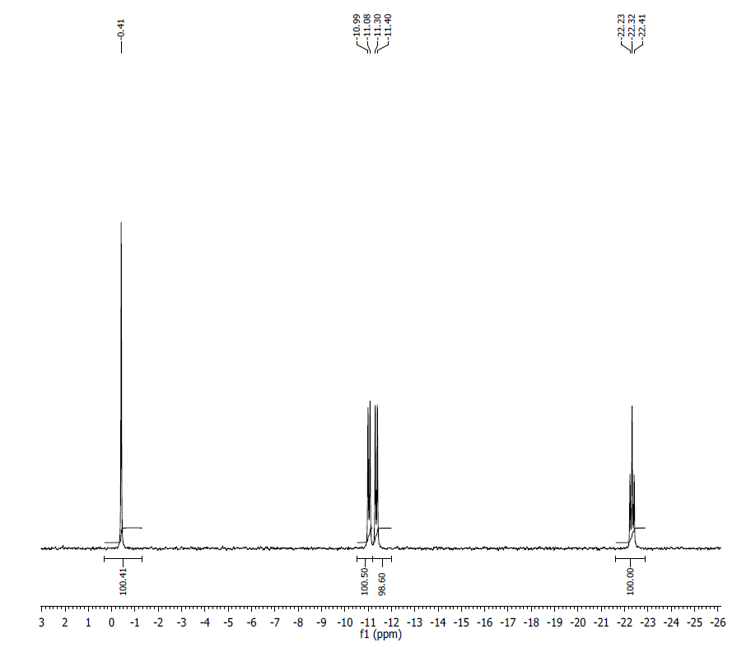
¹H NMR (500MHz, D₂O) δ: 8.37 (s, 1H), 8.10 (s, 1H), 7.92 (s, 1H), 5.98 (d, J = 5.8, 1H), 5.81 (m, 2H), 4.92 (m, 2H), 4.57 (d, J = 4.7, 2H), 4.47-4.51 (m, 4H), 4.41 (t, J = 5.2, 1H), 4.29-4.40 (m, 3H), 4.15-4.24 (m, 5H), 4.01 (s, 3H), 3.42 (s, 3H), 2.12 (s, 3H).
³¹P NMR (200 MHz, D₂O) δ: -0.41 (1P), -10.99 (1P), -11.20 (1P), -22.32 (1P).

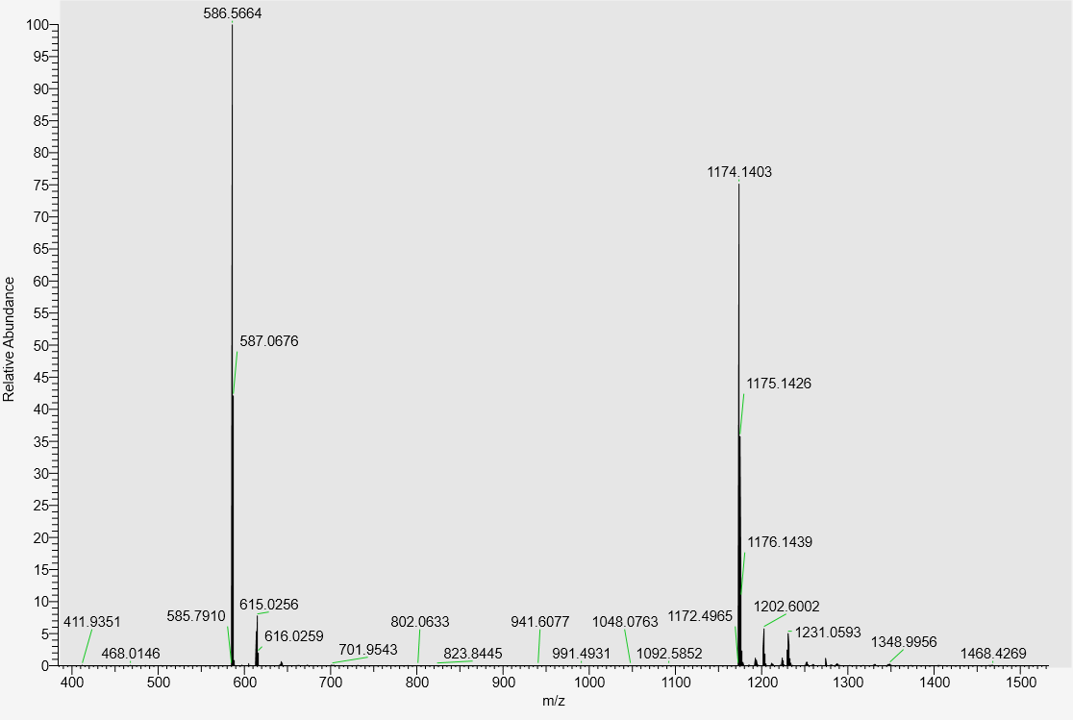
LC-MS data, calculated mass: 1175.1484, detected m/z: 1174.1403 (M-H)

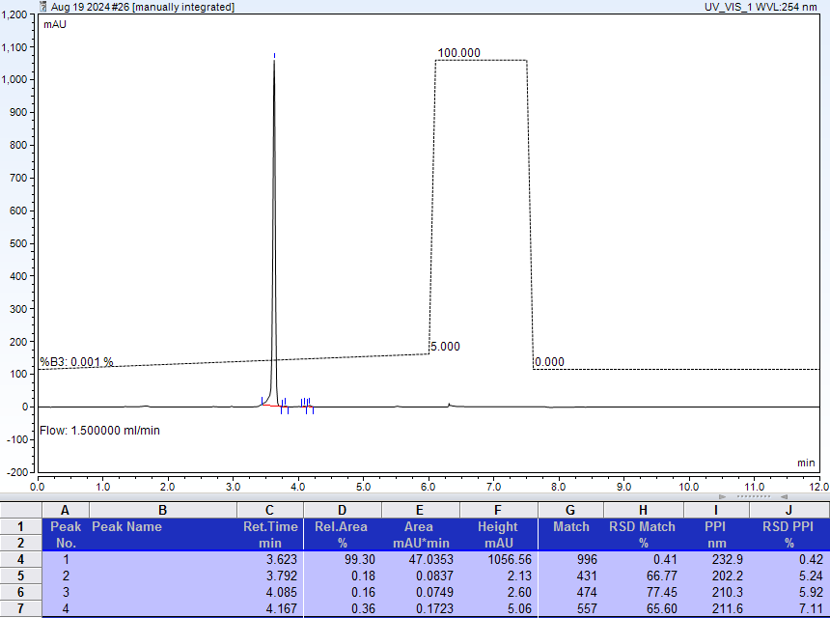
AX-HPLC Analysis
Compound 1-7A

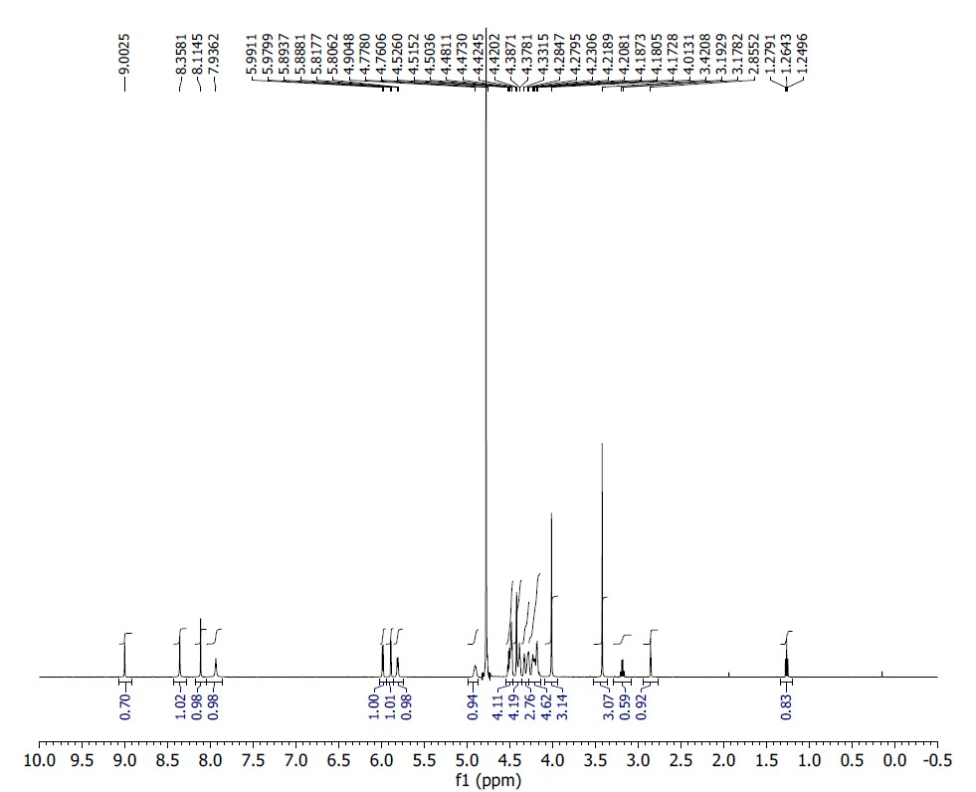
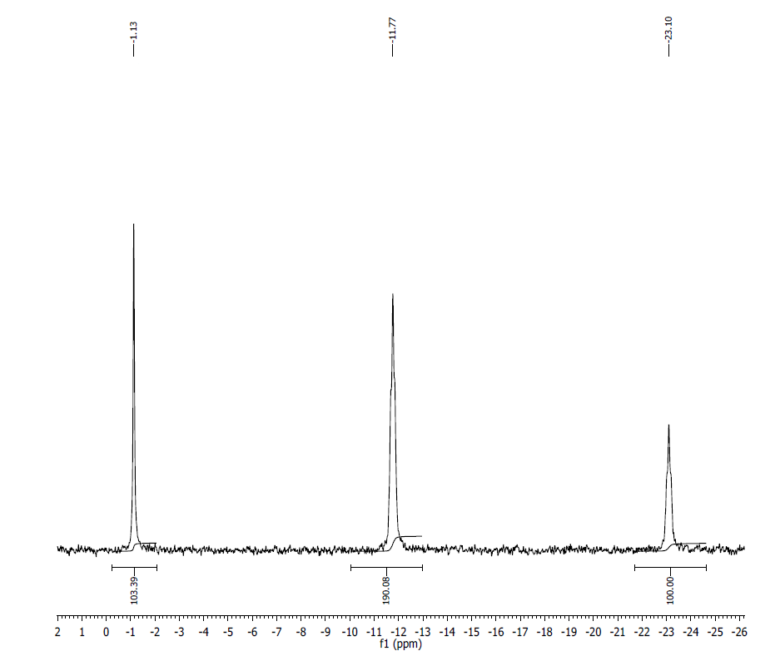
¹H NMR (500MHz, D₂O) δ: 9.00 (s, 1H), 8.36 (s, 1H), 8.11 (s, 1H), 7.94 (s, 1H), 5.99 (d, 1H, J=5.6 Hz), 5.89 (d, 1H, J=2.8 Hz), 5.81 (d, J=5.8 Hz, 1H), 4.90 (br s, 1H), 4.53-4.47 (m, 4H), 4.42-4.38 (m, 4H), 4.35-4.27 (m, 3H), 4.23-4.17 (m, 5H), 4.01 (s, 3H), 3.42 (s, 3H), 2.86 (s, 1H).
³¹P NMR (200 MHz, D₂O) δ: -1.13 (1P), -11.77 (2P), -23.10 (1P).
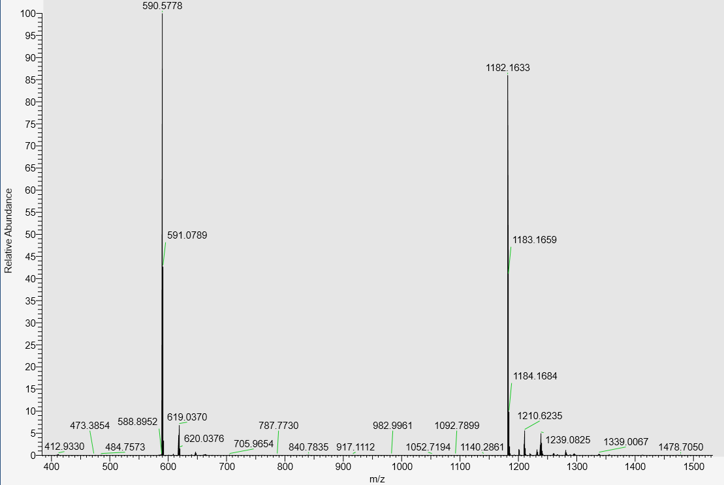
LC-MS data, calculated mass: 1183.1712; detected m/z: 1182.1633 (M-H)

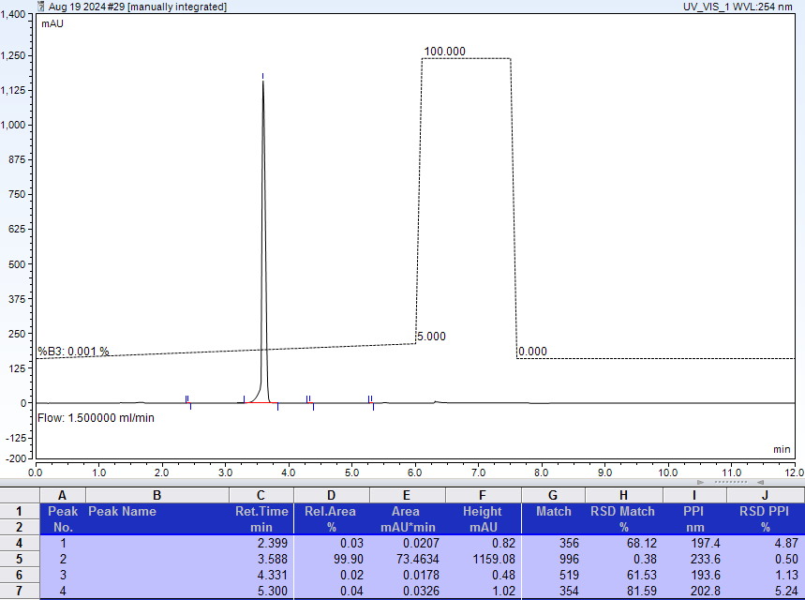
AX-HPLC Analysis

Compound 1-8A

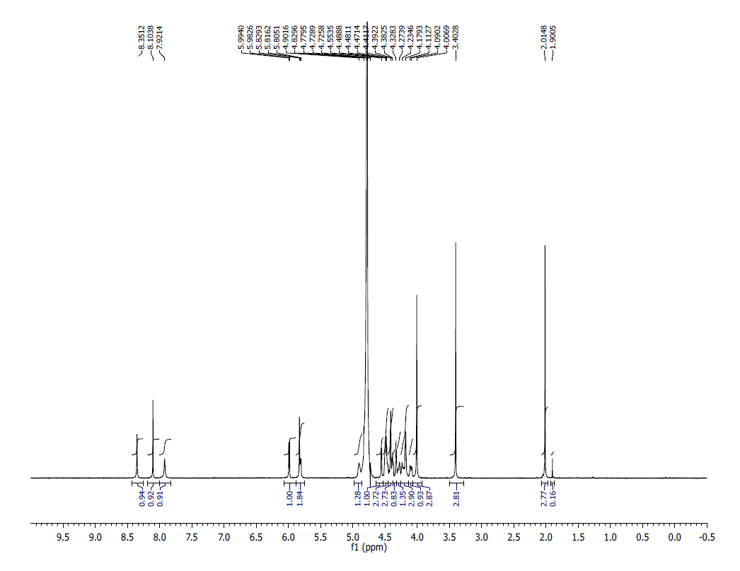
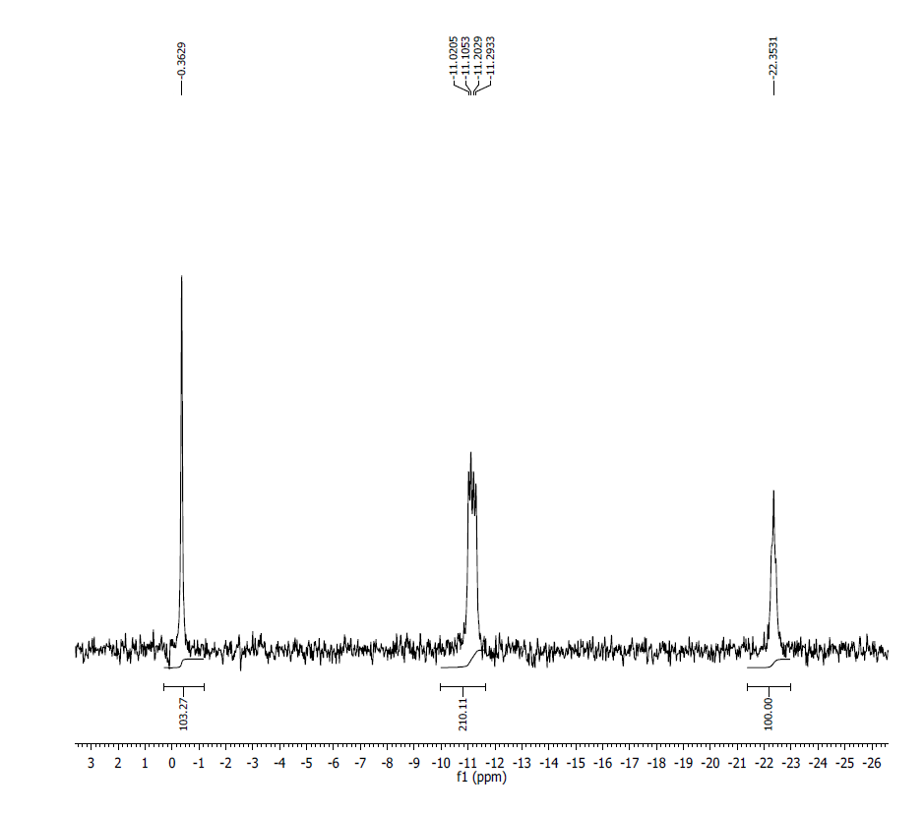
¹H NMR (500MHz, D₂O) δ: 8.35 (s, 1H), 8.10 (s, 1H), 7.92 (s, 1H), 5.99 (d, 1H, J=5.7 Hz), 5.83-5.80 (m, 2H), 4.90 (s, 1H), 4.55 (s, 1H), 4.52-4.42 (m, 3H), 4.41-4.38 (m, 3H), 4.33-4.27 (m, 2H), 4.23-4.16 (m, 3H), 4.12-4.08 (m, 1H), 4.01 (s, 3H), 3.40 (s, 3H), 2.01 (s, 3H).
³¹P NMR (200 MHz, D₂O) δ: -0.36 (s, 1P), -11.16 ( 2P), -22.35 (1P).
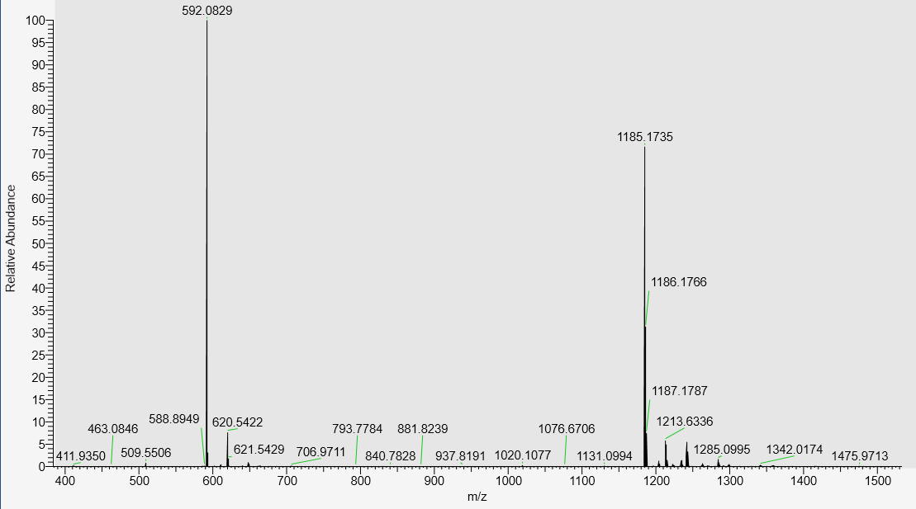
LC-MS data, calculated mass: 1186.1821; detected m/z: 1185.1735 (M-H)

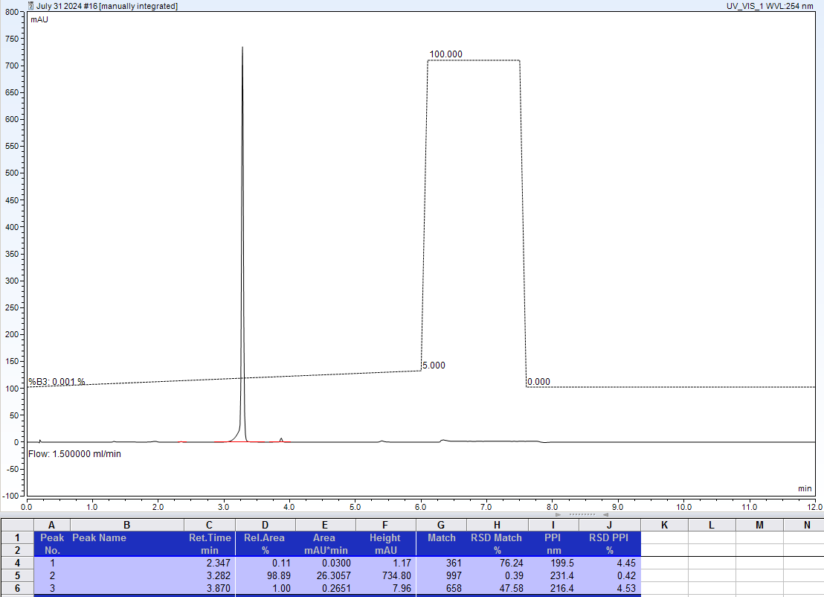
AX-HPLC Analysis
Compound 1-9A

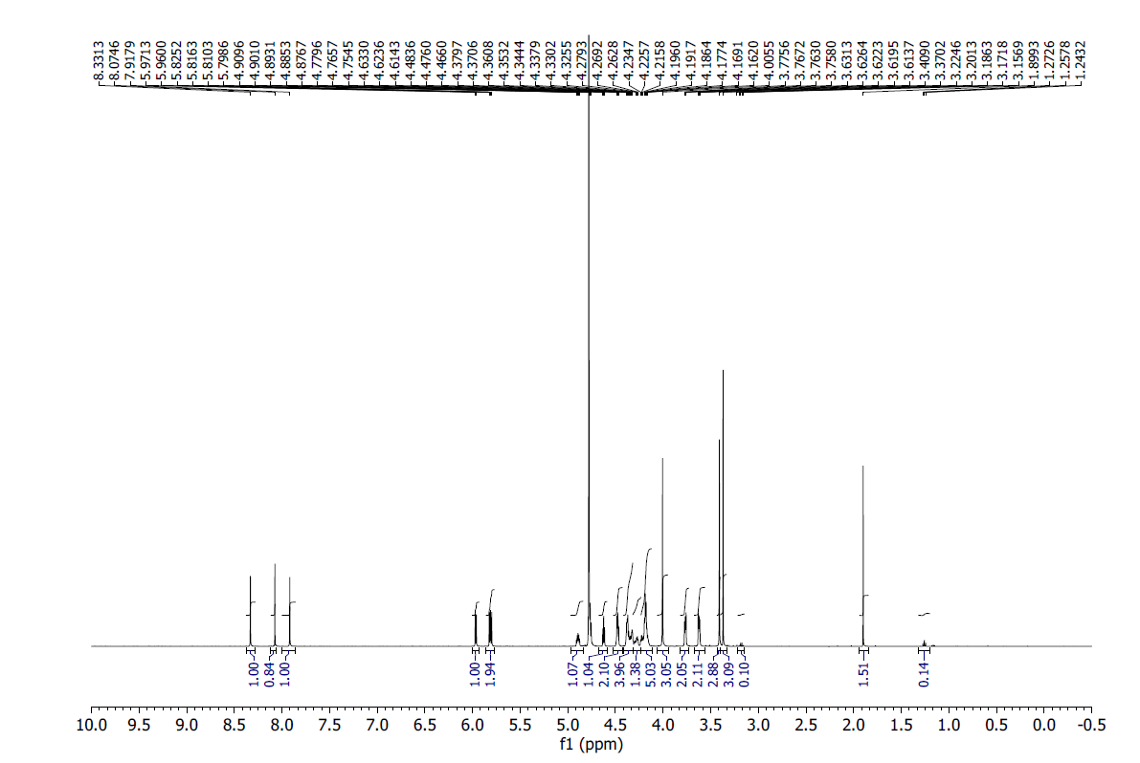

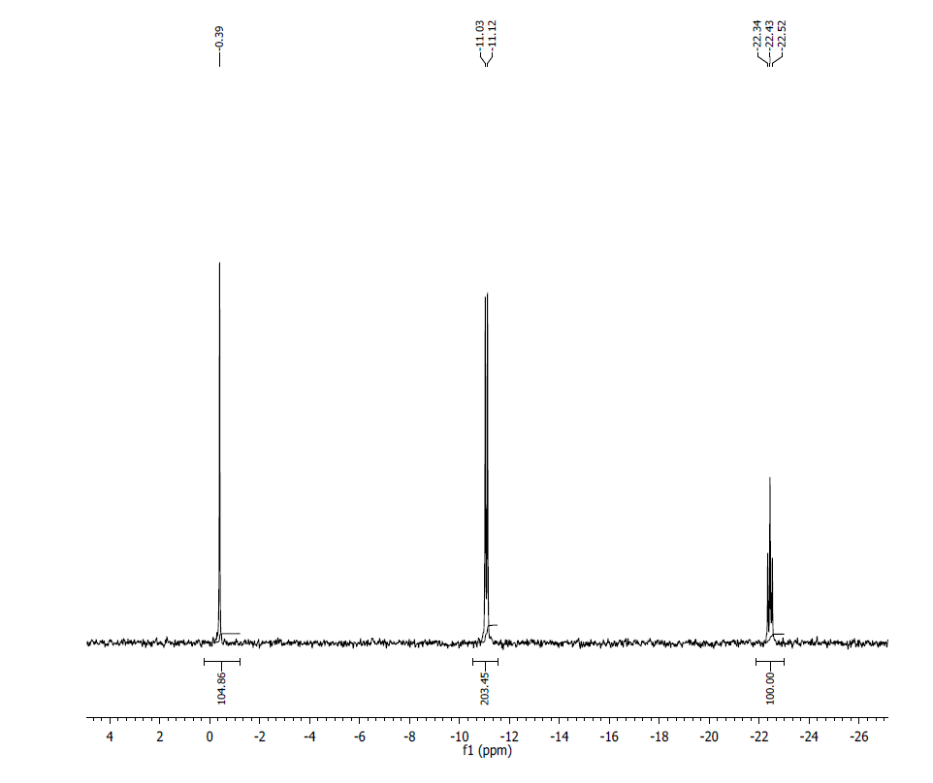
¹H NMR (500MHz, D₂O) δ: 8.33 (s, 1H), 8.07 (s, 1H), 7.92 (s, 1H) 5.96 (d, 1H, J=5.6 Hz), 5.82 (d, 1H, J=7.4 Hz), 5.81 (d, 1H, J=8.8 Hz), 4.89 (m, 1H), 4.77 (t, 1H, J=5.6 Hz), 4.62 (t, 1H, J=9.4 Hz), 4.48 (m, 12H), 4.35 (m, 2H), 4.32 (m, 2H), 4.22 (m, 1H), 4.20 (m, 4H), 4.01 (s, 3H), 3.76 (m, 2H), 3.62 (m, 2H), 3.41 (s, 3H), 3.37 (s, 3H).

³¹P NMR (200 MHz, D₂O) δ: -0.39 (1P), -11.08 (2P), -22.43 (1P).
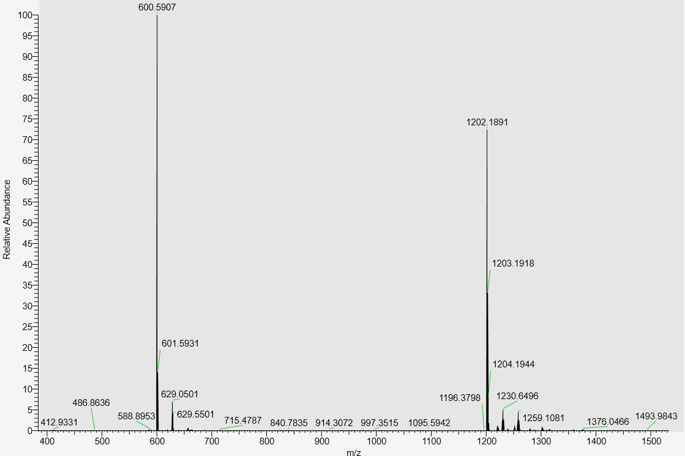

LC-MS data, calculated mass: 1203.1974; detected m/z: 1202.1891 (M-H)

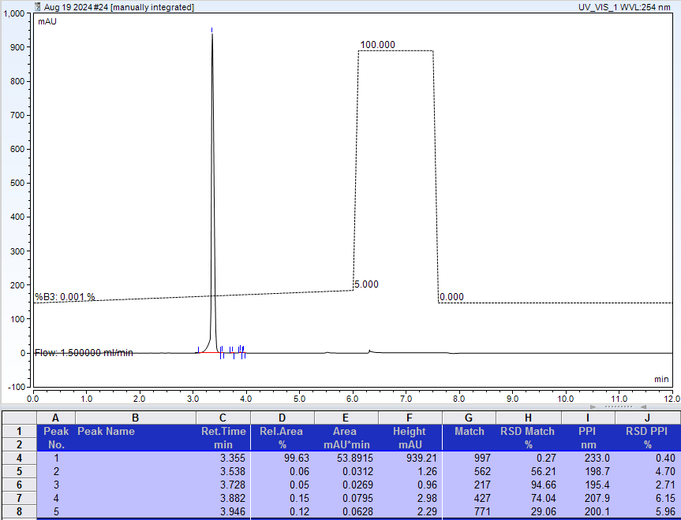
AX-HPLC Analysis
Compound 1-10A

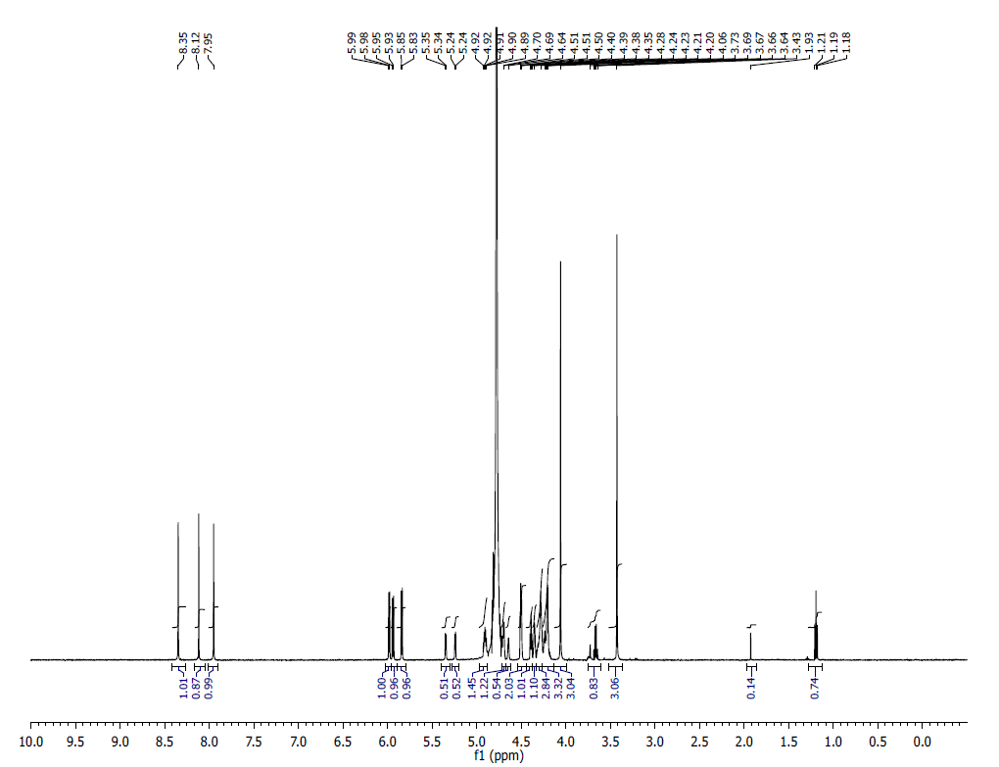
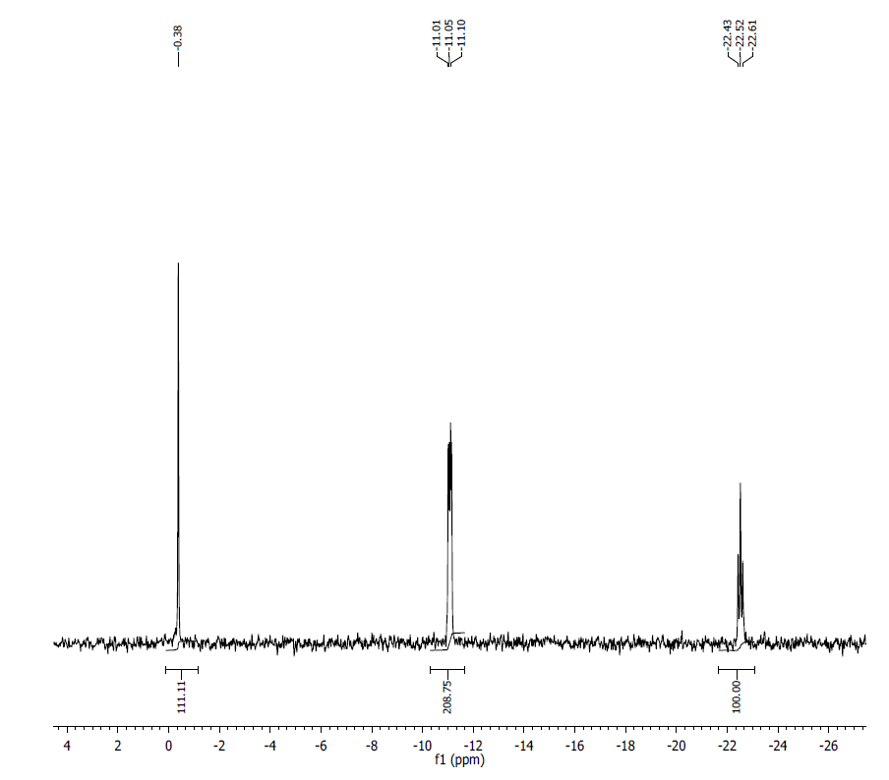
¹H NMR (500MHz, D₂O) δ: 8.35 (s, 1H), 8.12 (s, 1H), 7.95 (s, 1H), 5.98 (d, 1H, J=5.4 Hz), 5.94 (d, 1H, J=9 Hz), 5.84 (d, 1H, J=9 Hz), 5.34 (d, 1H, J=5 Hz), 5.24 (d, 1H, J=5 Hz), 4.95 (m, 1H), 4.70 (m, 1H), 4.64 (br s, 1H), 4.51 (t, 2H, J=5 Hz), 4.39 (t, 1H, J=5 Hz), 4.35 (m, 1H), 4.28 (m, 3H), 4.24 (m, 1H), 4.21 (m, 1H), 4.06 (s, 3H), 3.43 (s, 3H).

³¹P NMR (200 MHz, D₂O) δ: -0.38 (1P), -11.05 (2P), -22.52 (1P)
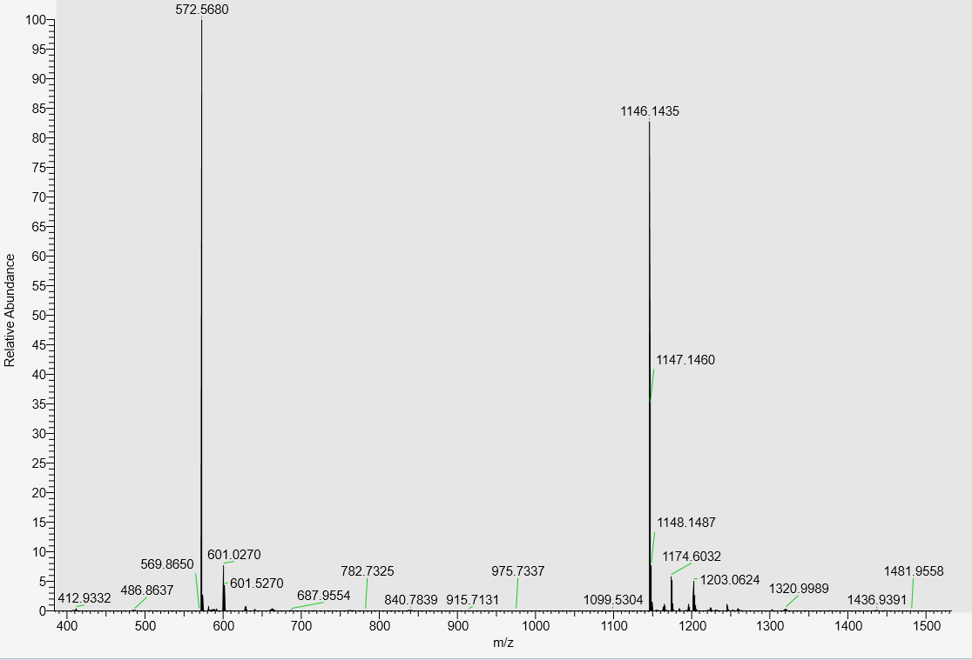

LC-MS data, calculated mass: 1147.1512; Detected m/z: 1146.1435 (M-H)

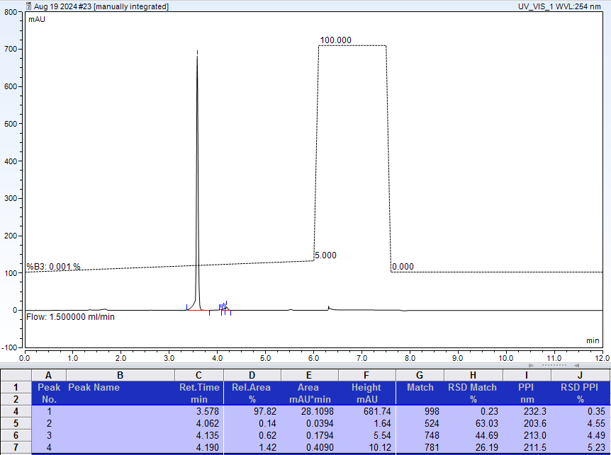
AX-HPLC Analysis
Compound 1-11A

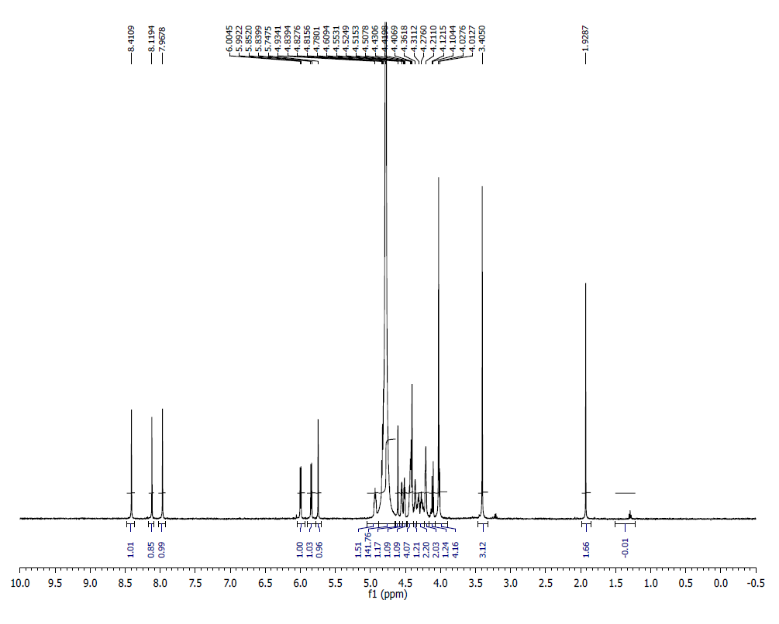
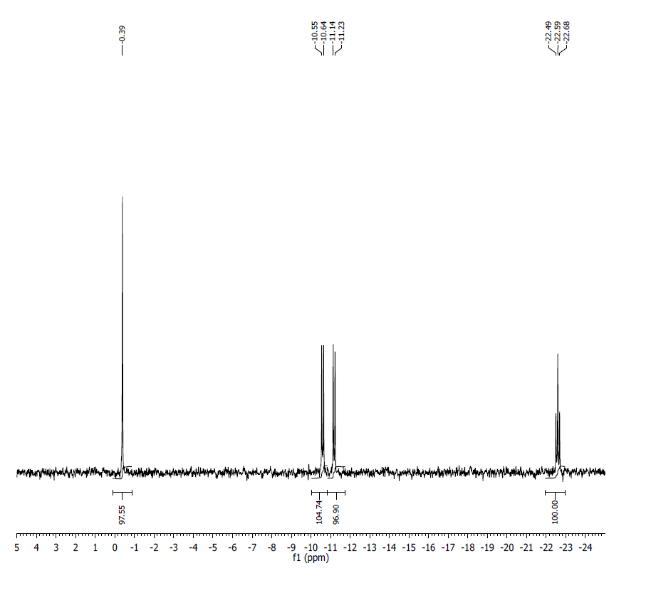
¹H NMR (400MHz, D₂O) δ: 8.41 (s, 1H), 8.11 (s, 1H), 7.97 (s, 1H), 6.00 (d, 1H, J= 6.15 Hz), 5.85 (d, 1H, J= 6.05 Hz), 5.74 (s, 1H), 4.93-4.81(m, 2H), 4.78 (s, 1H), 4.60-4.55 (m, 1H), 4.52-4.51 (m, 1H), 4.50-4.43 (m, 4H), 4.41-4.40 (m, 1H), 4.36-4.31 (m, 2H), 4.27-4.21 (m, 2H), 4.12 (d, 1H, J= 10 Hz), 4.03-4.01 (m, 4H), 3.40 (s, 3H).
³¹P NMR (200 MHz, D₂O) δ: -0.39 (1P), -10.55 (1P). -11.14 (1P), -22.59 (1P).
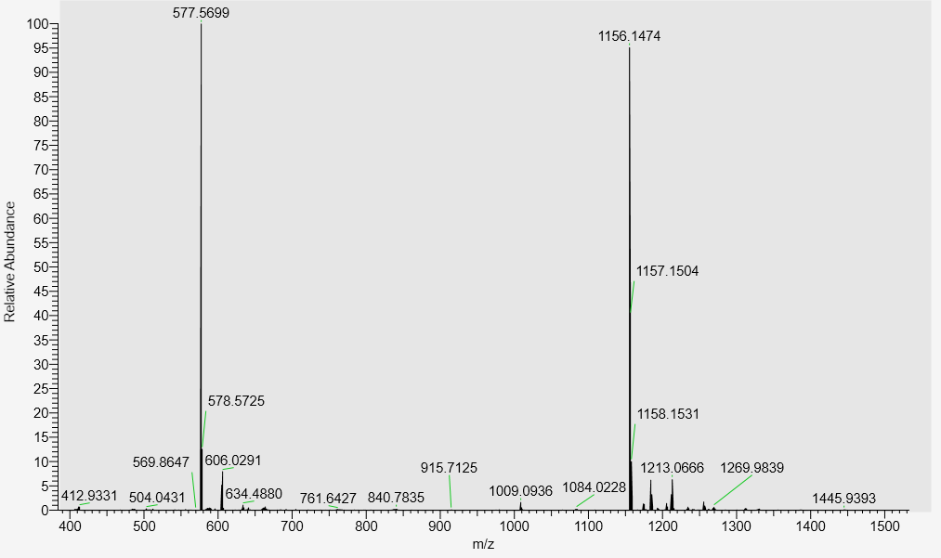
LC-MS data, calculated mass: 1157.1556; observed m/z: 1156.1474 (M-H)

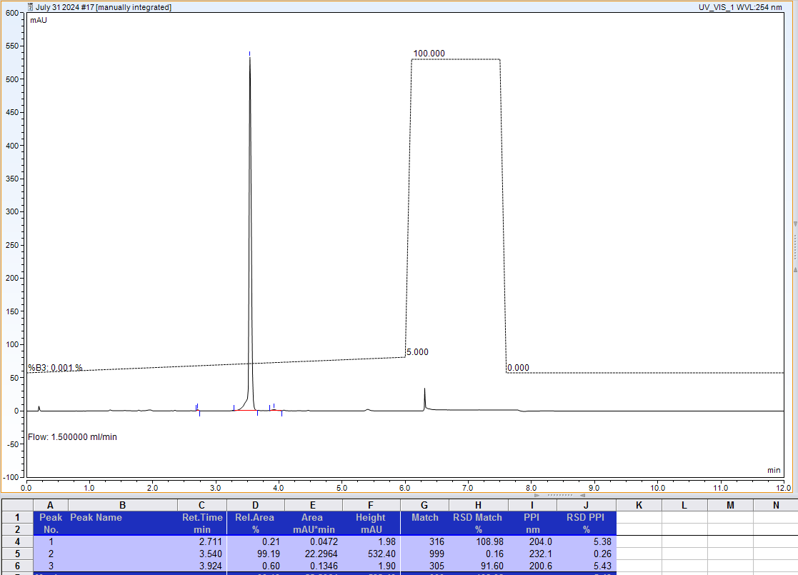
AX-HPLC Analysis
Compound 1-12A

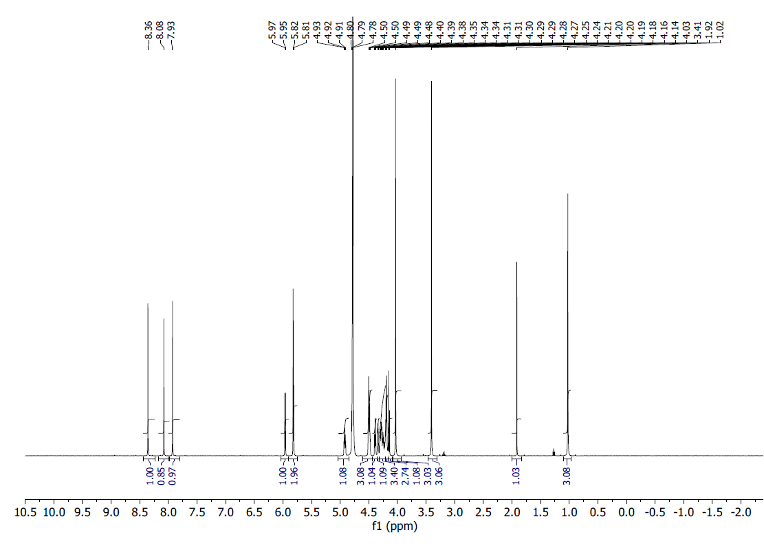
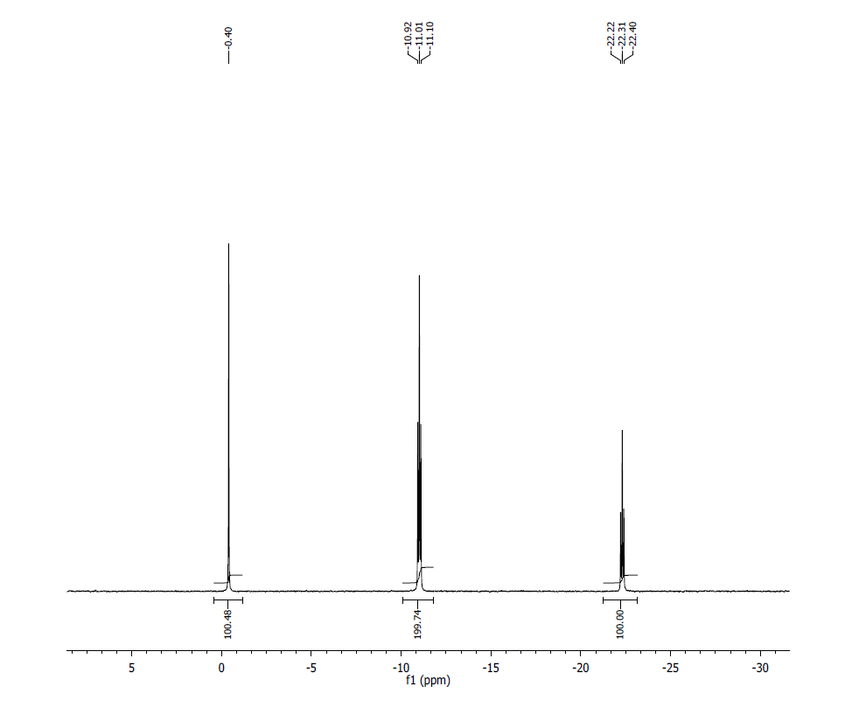
¹H NMR (500 MHz, D2O): δ 8.36 (S, 1H), 8.02 (s, 1H), 7.93 (s, 1H), 5.96 (d, J=5.7 Hz, 1H), 5.82 (s, 1H), 5.81 (s, 1H), 4.91 (m, 1H), 4.49 (m, 3H), 4.39 (t, J=5.1Hz, 1H), 4.34 (m, 1H), 4.29 (m, 3H), 4.20(m, 3H), 4.14 (m, 1H), 4.03 (s,3H), 3.41(s,3H), 1.02 (s, 3H).

³¹P NMR (202MHz, D2O): δ -0.40 (1P), -11.01 (2P), -22.31 (1P).
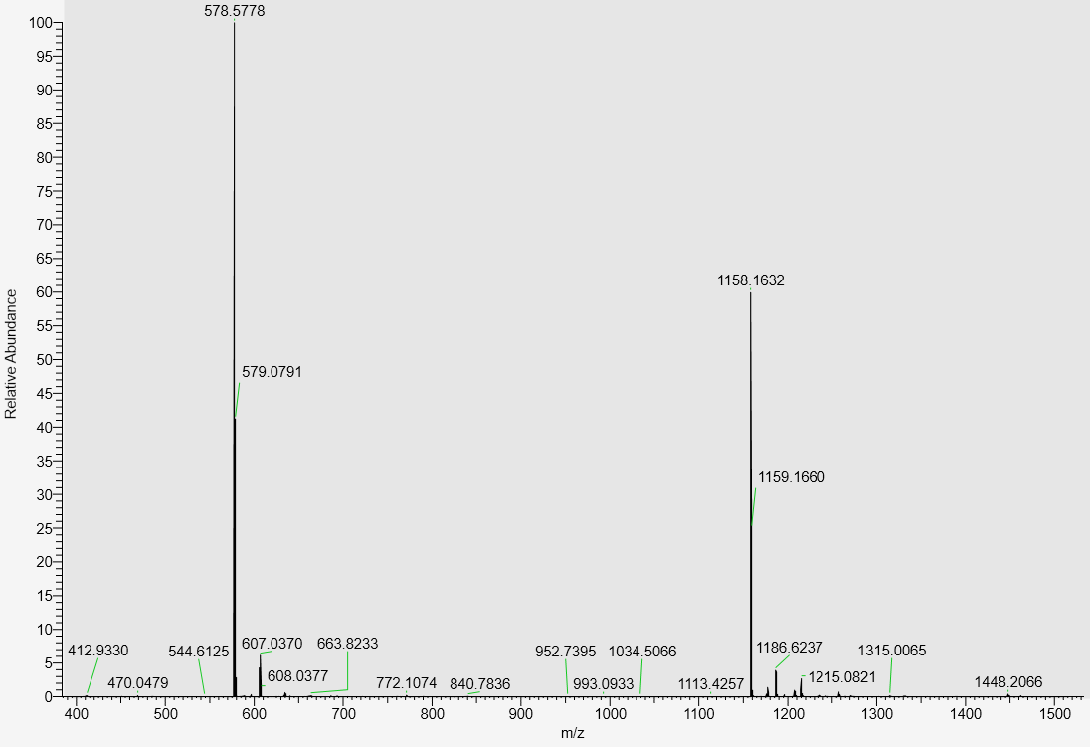

LC-MS data, calculated mass: 1159.1712; detected m/z: 1158.1632 (M-H)

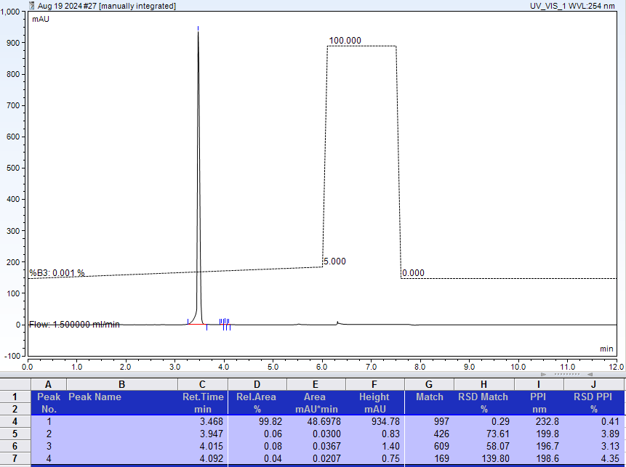
AX-HPLC Analysis
Compound 1-13A
^{7m}G(L-sugar isomer)
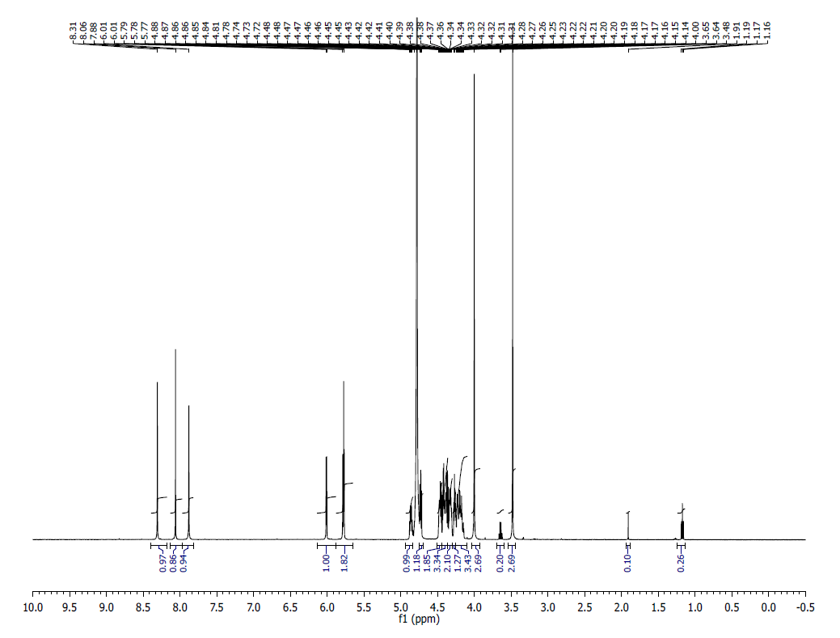
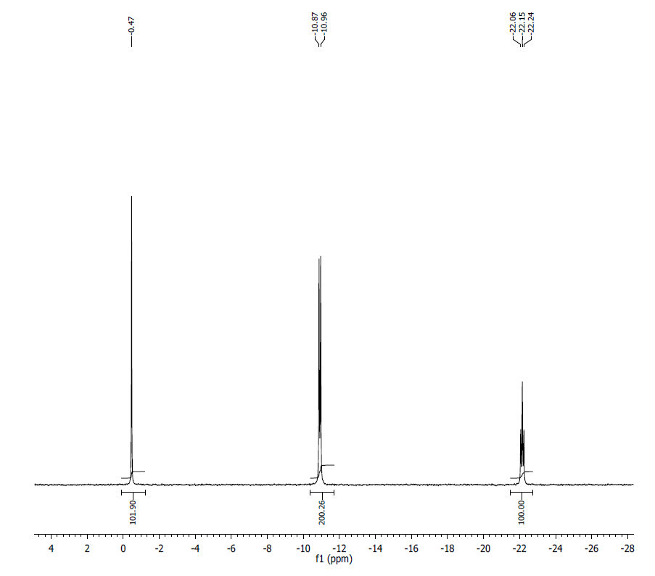
¹H NMR (500 MHz, D₂O): δ 8.30 (s, 1H), 8.06 (s, 1H) , 7.87 (s, 1H), 6.01 (d, J=4.4, 1H), 5.77 (m, 2H), 4.86 (m, 1H), 4.73 (m, 1H), 4.48- 4.46 (m, 2H), 4.46- 4.45 (m, 3H), 4.43-4.42 (m, 1H) 4.38-4.19 (m, 4H) 4.00 (s, 3H), 3.47 (s, 3H), 1.90 (s, 1H), 1.17 (t, J=7.1 Hz ,1H).
³¹P NMR (200 MHz, D₂O) δ: 0.47(1P), -10.92(2P), -22.15 (1P).
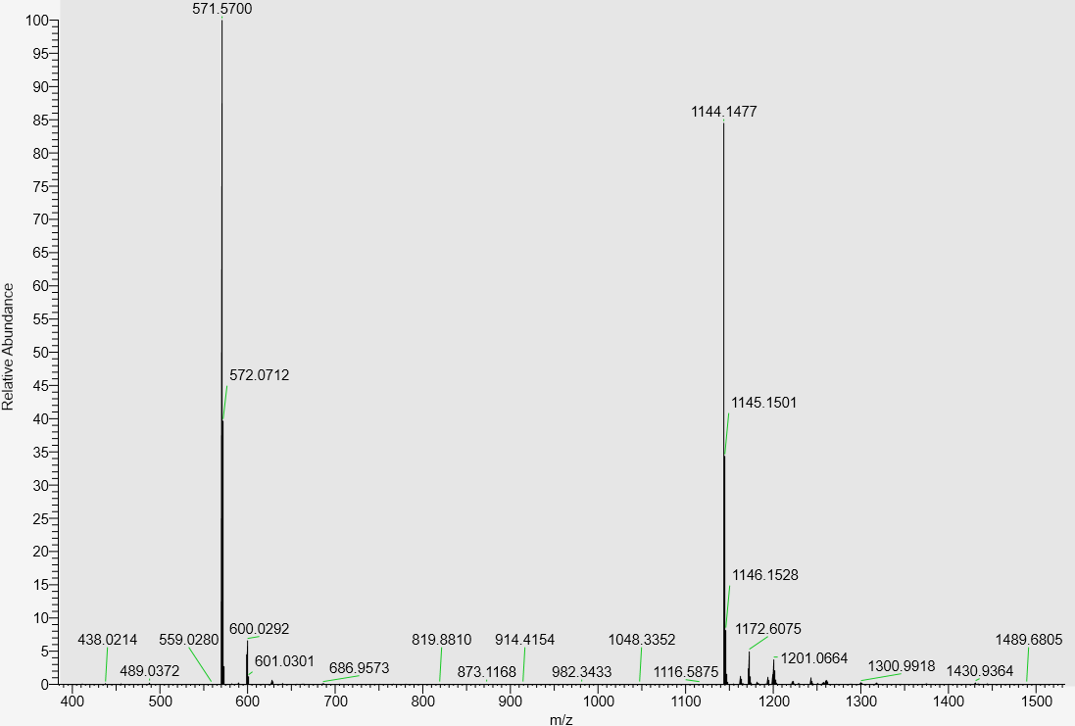
LC-MS data, calculated mass: 1145.1556; detected m/z: 1144.1477 (M-H)

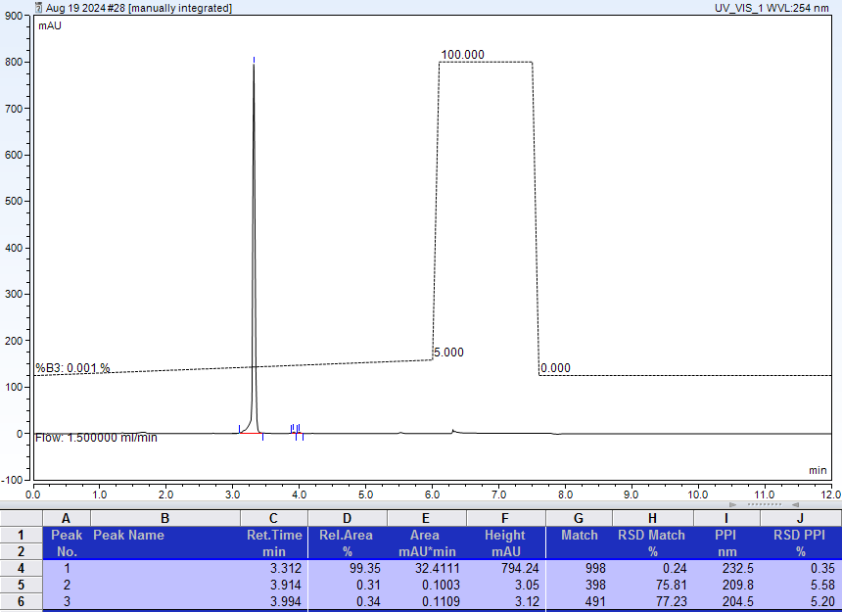
AX-HPLC Analysis
Compounds related to Table 1, Series B

Compound 1-1B

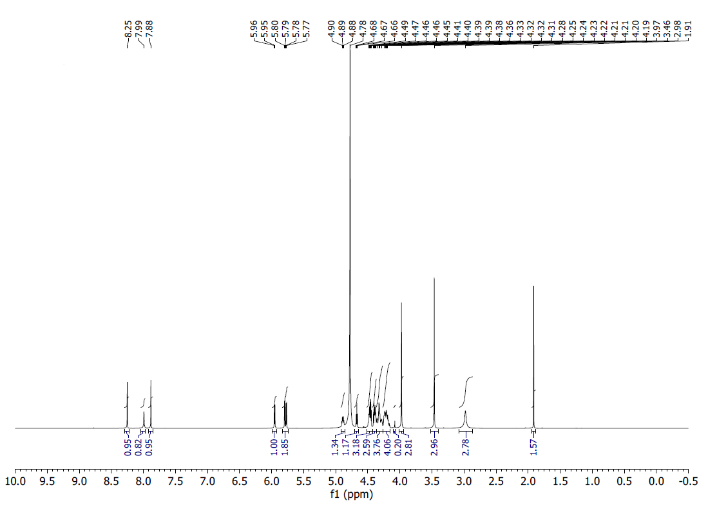
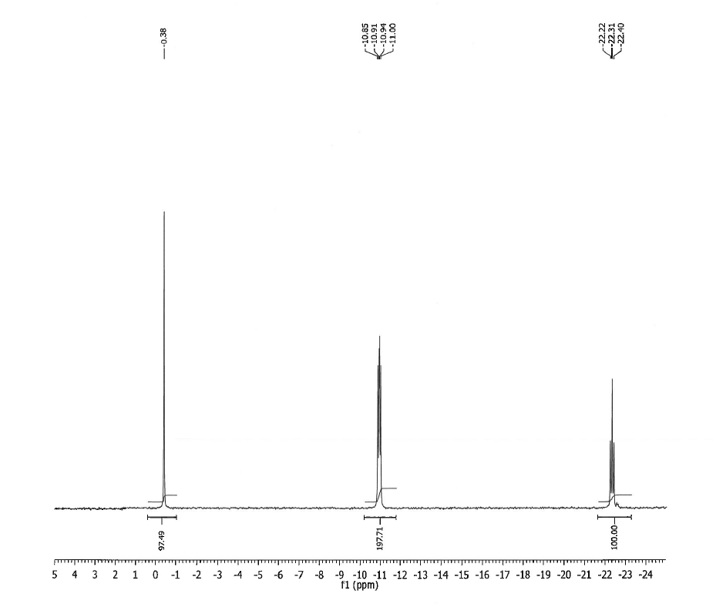¹H NMR (500 MHz, D₂O) δ: 8.25 (s, 1H), 7.99 (s, 1H), 7.88 (s, 1H), 5.96 (d, J = 5.2 Hz, 1H), 5.80 (d, J = 3.5 Hz, 1H), 5.78 (d, J = 5.3 Hz, 1H), 4.87-4.91 (m, 1H), 4.66-4.68 (m, 1H), 4.45-4.49 (m, 3H), 4.38-4.41 (m, 3H), 4.28-4.36 (m, 4H), 4.17-4.25 (m, 4H), 3.97 (s, 3H), 3.46 (s, 3H), 2.98 (s, 3H).
³¹P NMR (200 MHz, D₂O) δ: -0.38 (1P), -10.91 (1P), -10.94 (1P), -22.31 (1P).
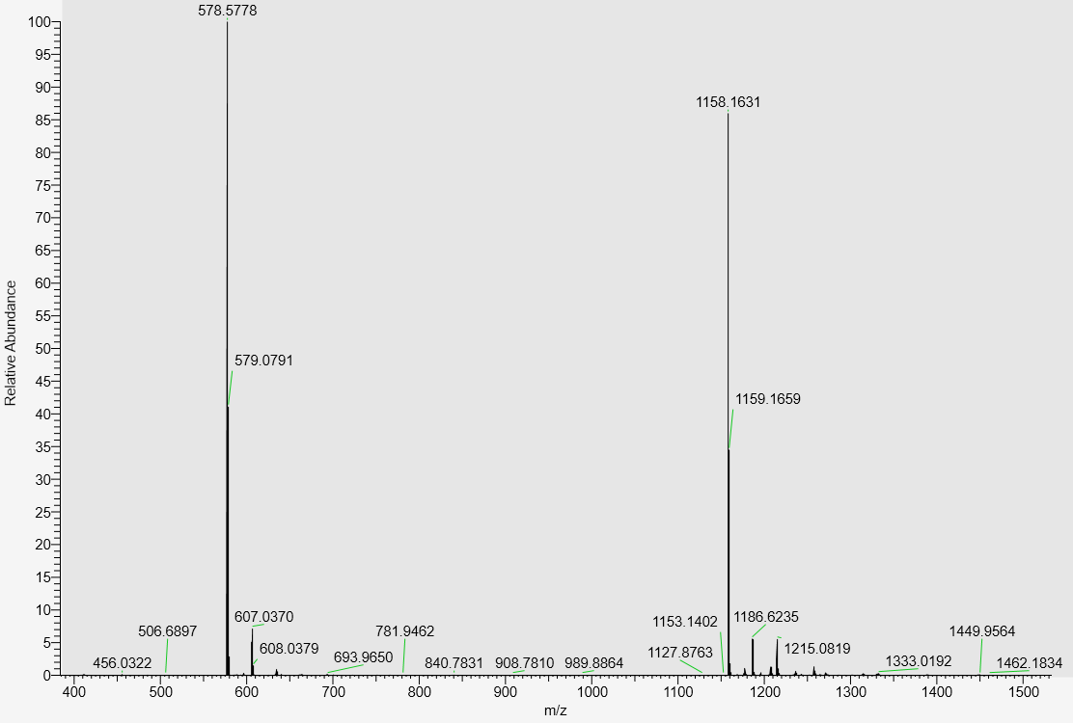
LC-MS, calculated mass:1159.1712; detected m/z: 1158.1631 (M-H)

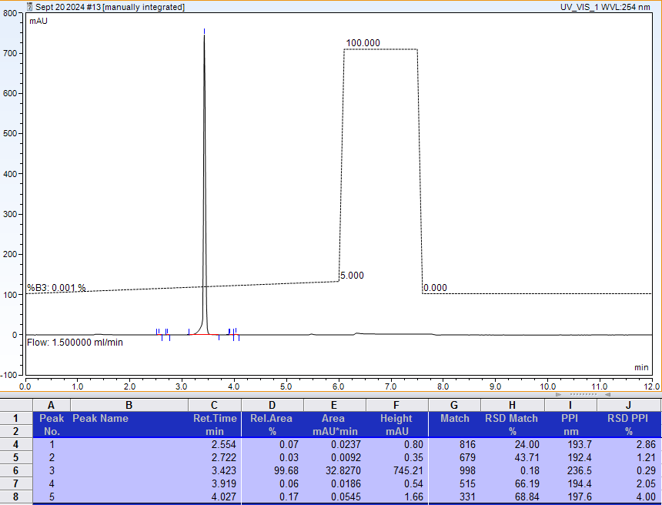
AX-HPLC Analysis

Compound 1-2B
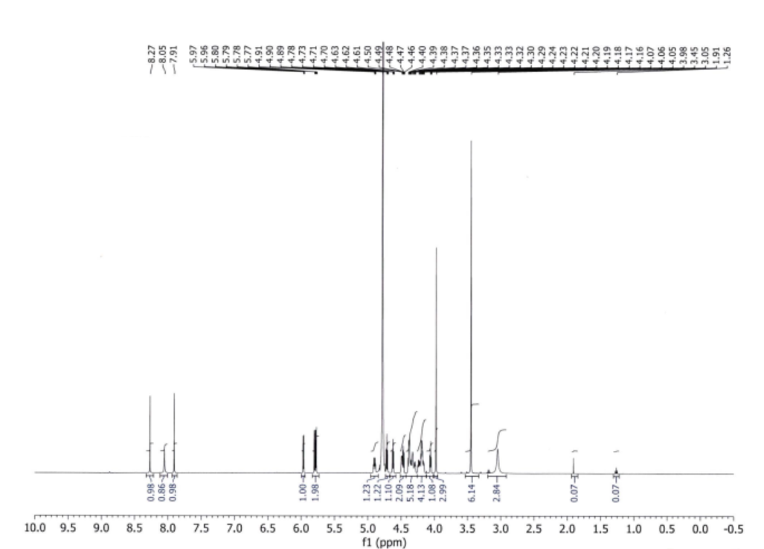

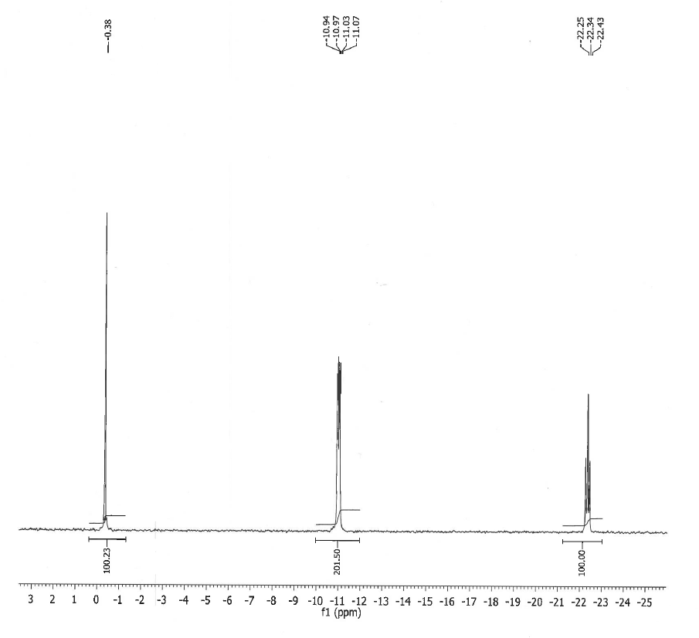
¹H NMR (500MHz, D2O) δ: 8.27 (s, 1H), 8.05 (s, 1H), 7.91 (s, 1H), 5.97 (d, J = 5.0 Hz, 1H), 5.80-5.77 (m, 2H), 4.91-4.89 (m, 1H), 4.63-4.61 (m, 1H), 4.50-4.46 (m, 2H), 4.40-4.35 (m, 5H), 4.33-4.16 (m, 4H), 4.07-3.98 (m, 1H), 3.98 (s, 3H), 3.45 (s, 6H), 3.05 (s, 3H)
³¹P NMR (200MHz, D2O) δ: -0.38 (1P), -10.98 (1P), -11.02 (1P), -22.34 (1P).
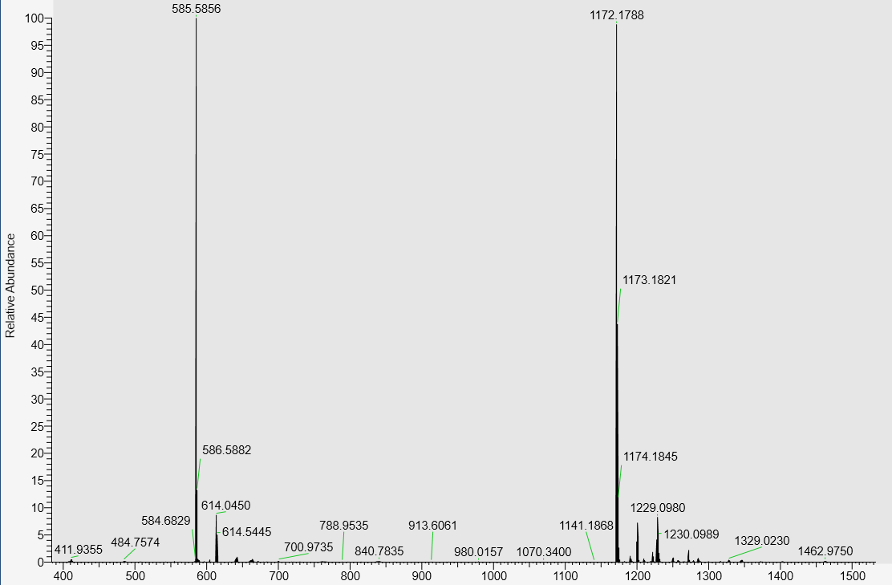
LC-MS data, calculated mass: 1173.1869, detected m/z: 1172.1788 (M-H)

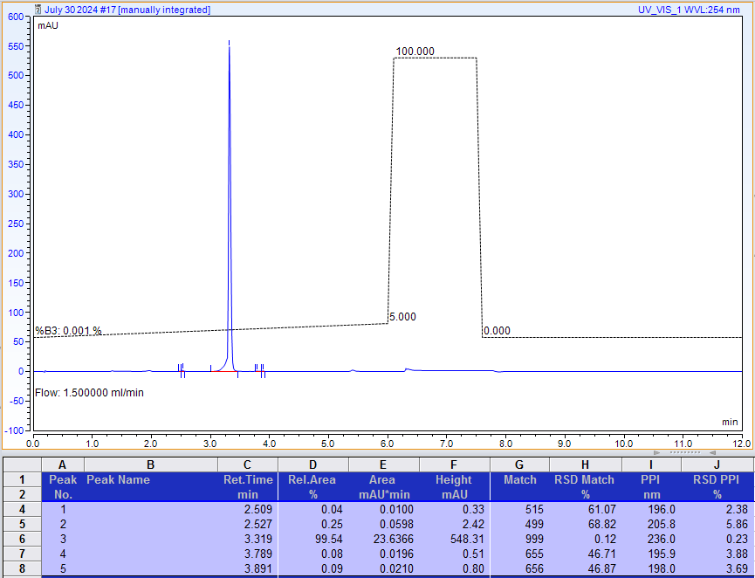

AX-HPLC analysis
Compound 1-3B

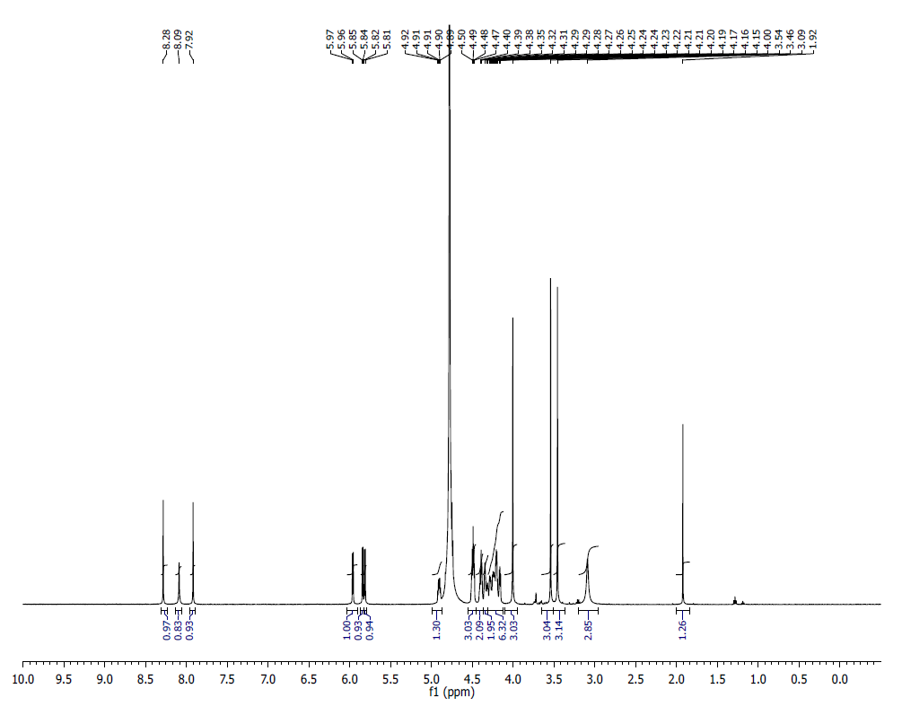

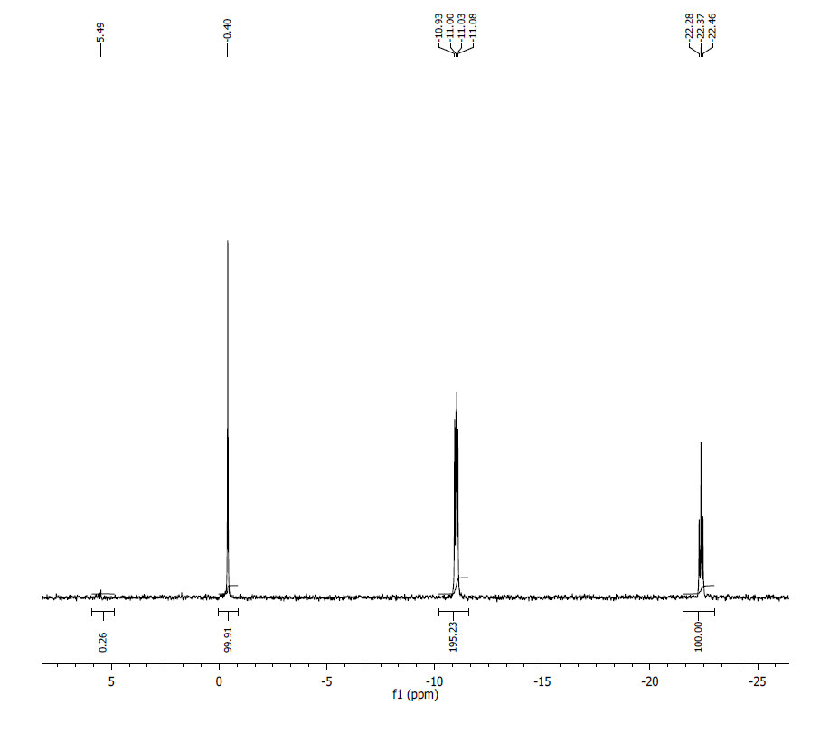
¹H NMR (500 MHz, D₂O) δ: 8.28 (s, 1H), 8.09 (br s, 1H), 7.92 (s, 1H), 5.96 (d, 1H, J=5 Hz), 5.84 (d, 1H, J=5 Hz), 5.82 (d, 1, J=9 Hz), 4.91 (m, 1H), 4.49 (m, 3H), 4.39 (m, 2H), 4.25 (m, 2H), 4.20-4.15 (m, 6H), 4.00 (s, 3H), 3.54 (s, 3H), 3.46 (s, 3H), 3.09 (br s, 3H).

³¹P NMR (200 MHz, D₂O) δ: -0.40 (1P), -11.00 (1P), -11.03 (1P), -22.37 (1P).

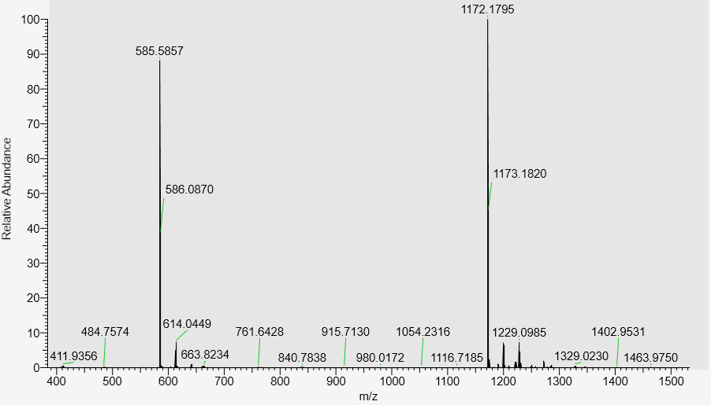

LC-MS analysis, calculated mass: 1173.1869; detected m/z: 1172.1795 (M-H)

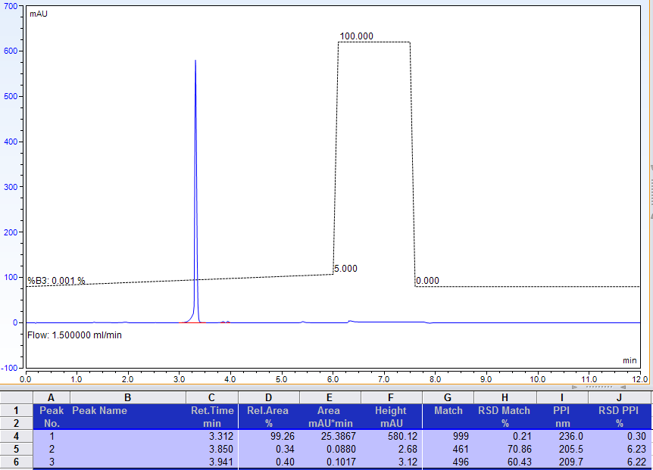
AX-HPLC Analysis
Compound 1-4B
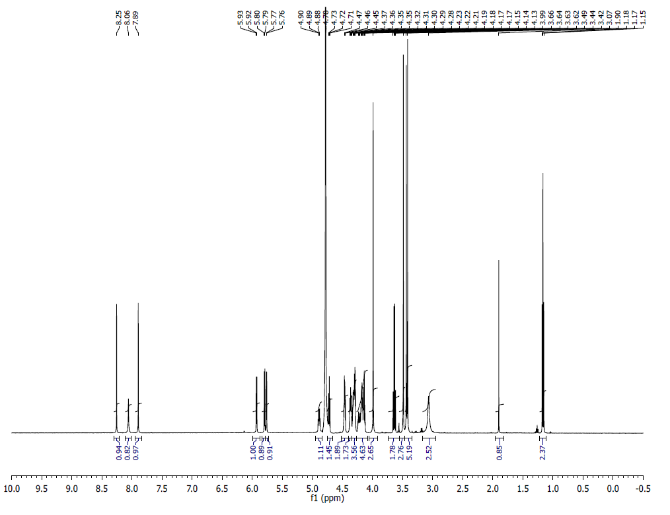
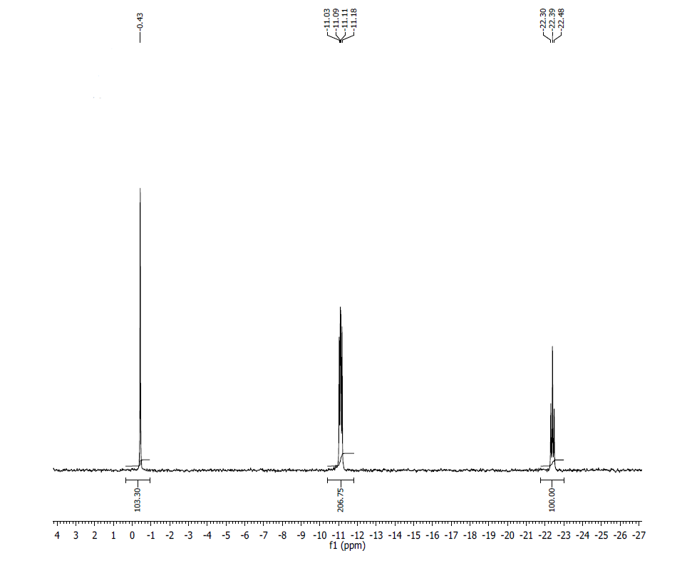
¹H NMR (500 MHz, D₂O) δ: 8.26 (s,1), 8.07 (s,1), 7.70 (s,1) 5.94 (d, 1, J=10 Hz), 5.80 (d, 1, J=10 Hz), 5.76 (d, 1 j=5 Hz), 4.89 (m, 1), 4.73, (m, 1), 4.21 (m, 1), 4.18 (m, 2), 4.14 (t, 2, J=5 Hz), 3.99 (s, 3) 3.49 (s, 3), 3.42 (s, 3), 3.08 (br s , 3);

³¹P NMR (200 MHz, D₂O) δ: -0.43 (1P), -11.07 (1P), -11.13 (1P), -22.39 (1P)
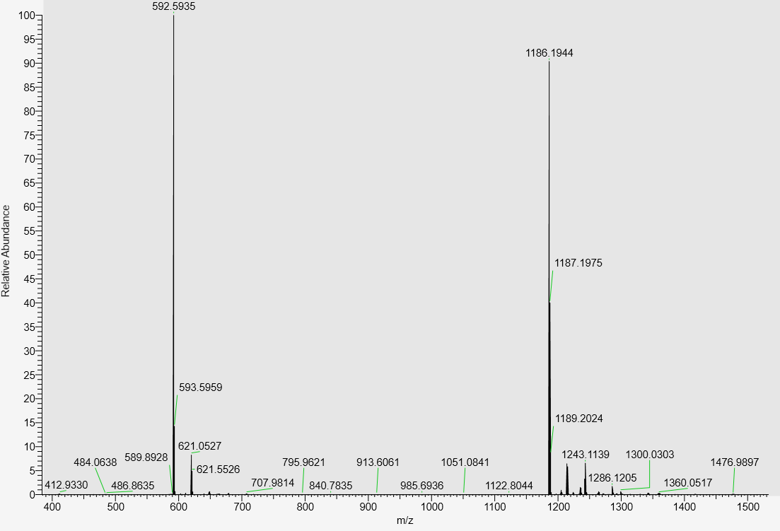

LC-MS data, calculated mass: 1187.2025; detected m/z: 1186.1944 (M-H)

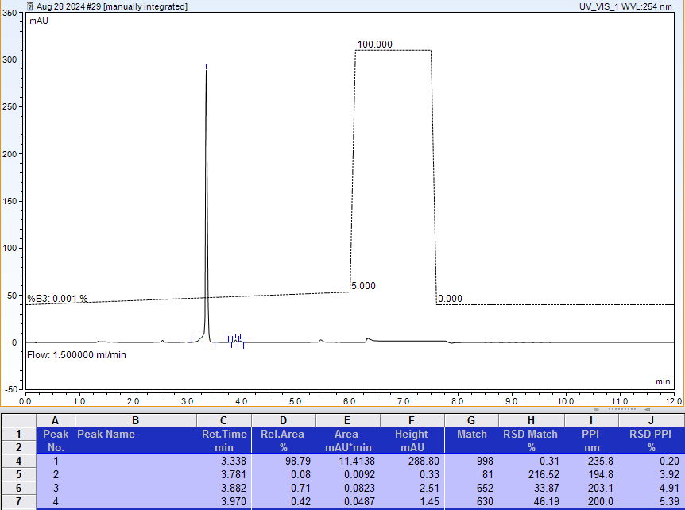
AX-HPLC Analysis

Compound 1-5B

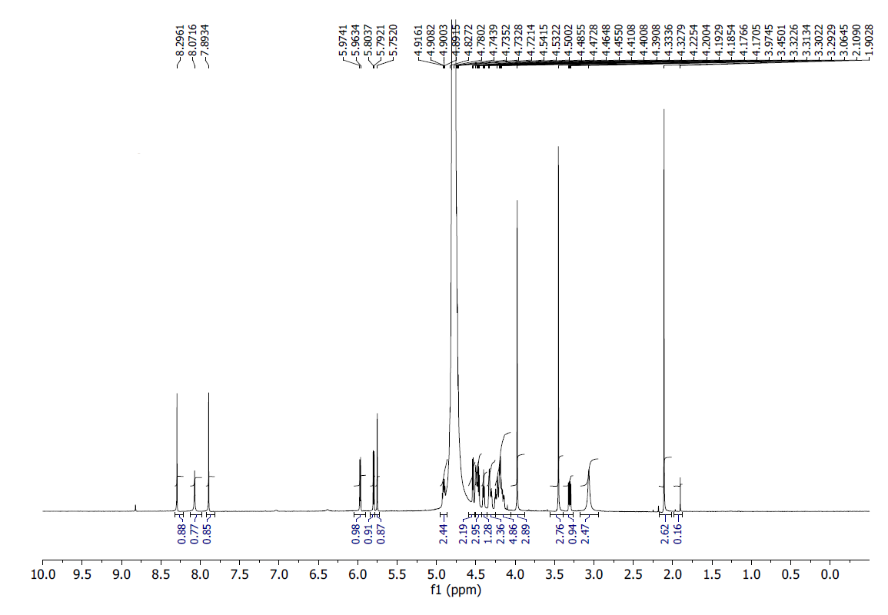
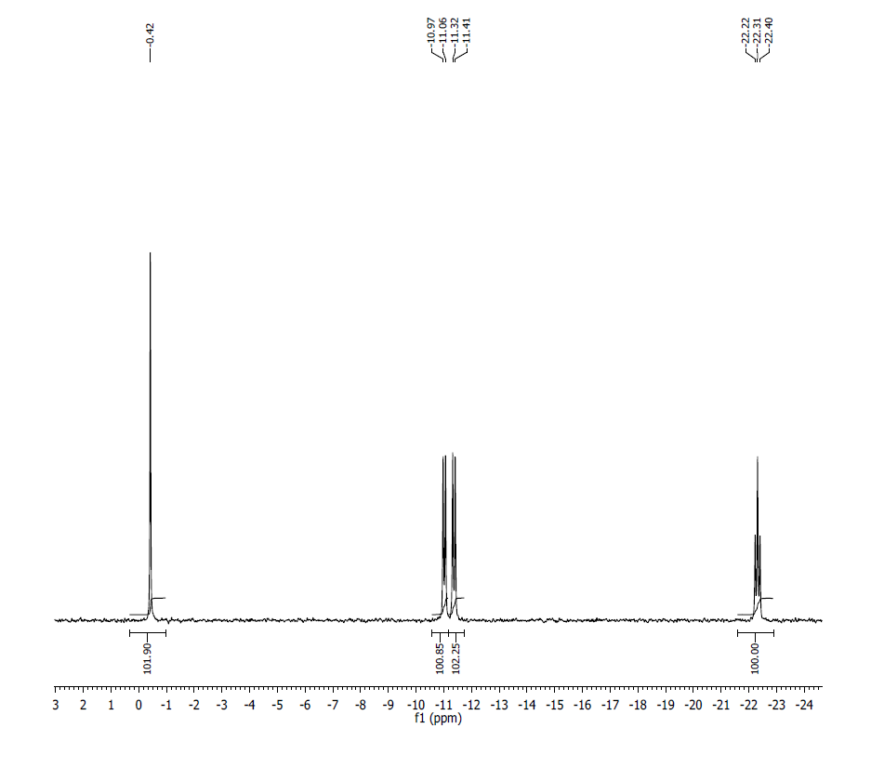
¹H NMR (500MHz, D2O) δ: 8.30 (s, 1H), 8.07 (s, 1H), 7.89 (s, 1H), 5.97 (d, J = 5.4, 1H), 5.79 (d, J = 5.8), 5.75 (s, 1H), 4.91 (m, 2H), 4.54 (d, J = 4.7, 1H), 4.45-4.50 (m, 3H), 4.40 (t, J = 5.0, 1H), 4.24-4.33 (m, 2H), 4.15-4.23 (m, 5H), 3.97 (s, 3H), 3.45 (s, 3H), 3.06 (bs, 3H), 2.1 (s, 3H).
³¹P NMR (200 MHz, D2O) δ: -0.42 (1P), -11.02 (1P), -11.36 (1P), -22.31 (1P).
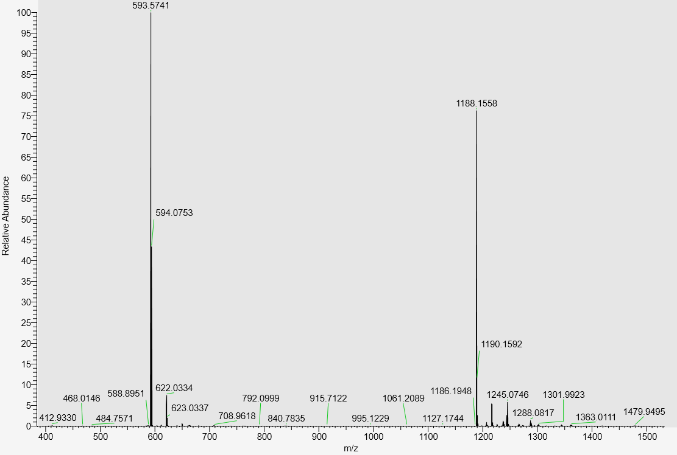
LC-MS data, calculated mass: 1189.1640; detected m/z: 1188.1558 (M-H)

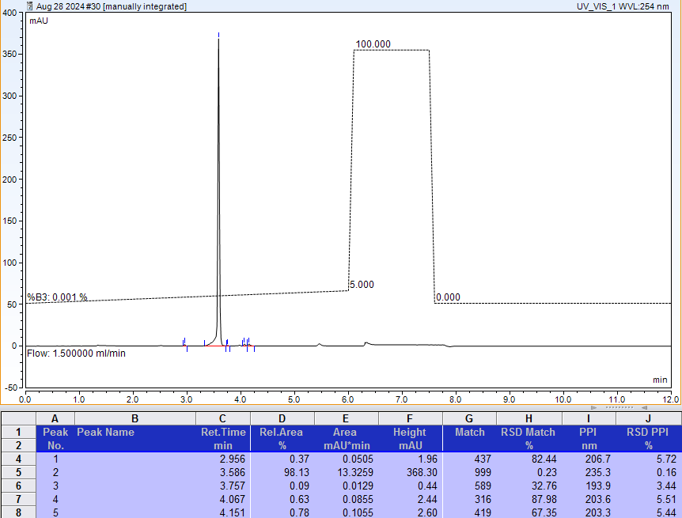

AX-HPLC Analysis

Compound 1-6B

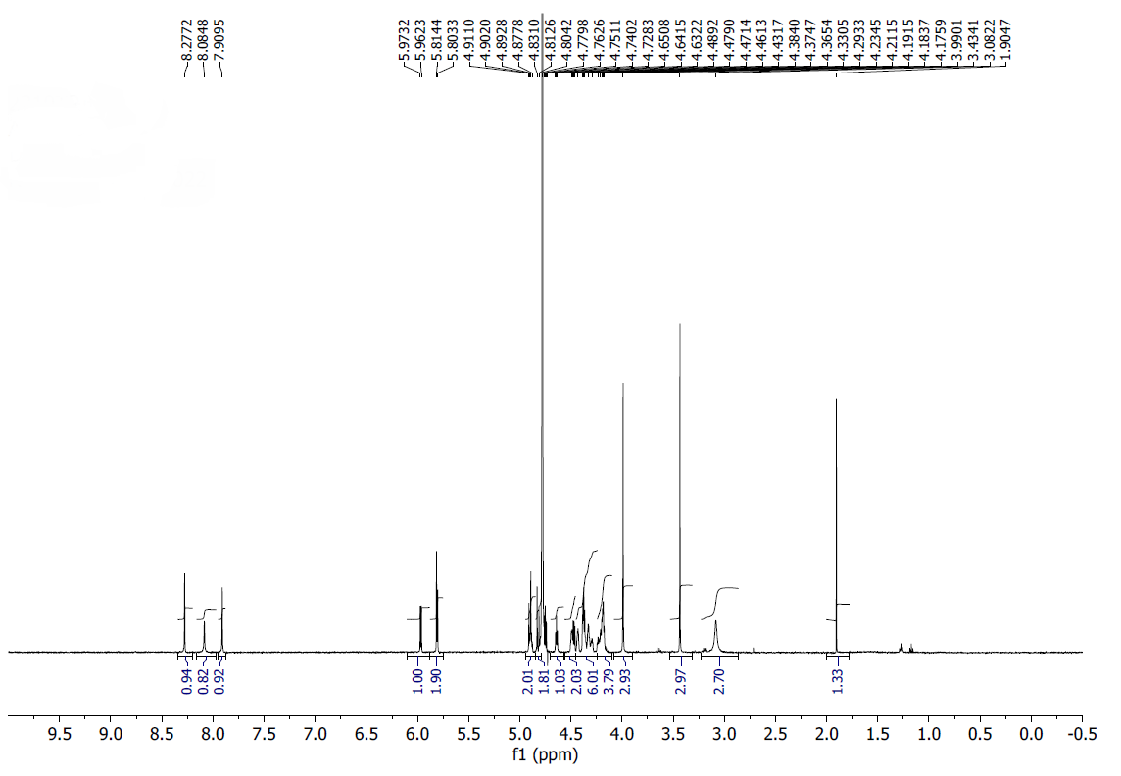
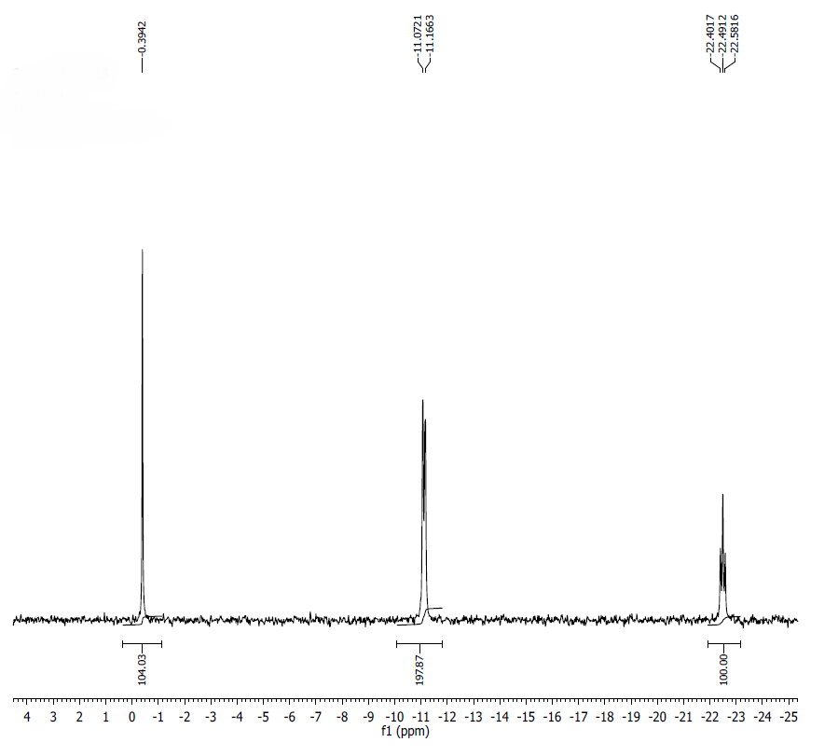
¹H NMR (500MHz, D2O) δ: 8.28 (s, 1H), 8.08 (s, 1H), 7.91 (s, 1H), 5.97 (d, 1H, J=10 Hz), 5.82-5.80 (m, 2H), 4.91-4.88 (m, 2H), under D₂O (3H), 4.63 (t, 1H, J=5 Hz), 4.50-4.46 (m, 2H), 4.43 (s, 1H), 4.39-4.30 (m, 5H), 4.24-4.17 (m, 4H), 3.99 (s, 3H), 3.45 (s, 3H), 3.08 (s, 3H).
³¹P NMR (200 MHz, D2O) δ: -0.40 (1P), -11.12 (2P), -22.49 (1P).
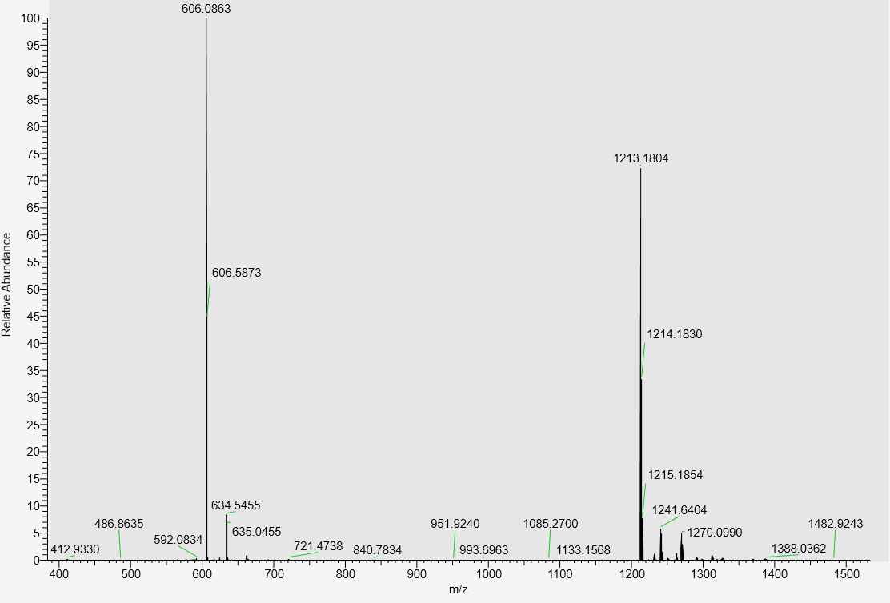
LC-MS data, calculated mass: 1214.1883; detected m/z: 1213.1804 (M-H)

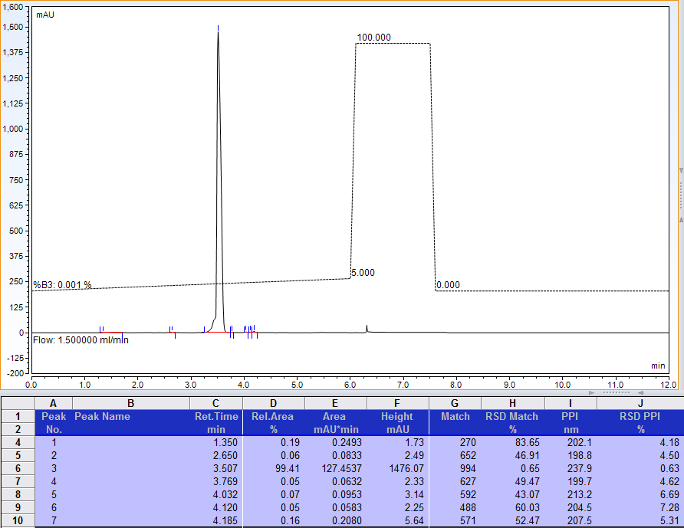
AX-HPLC Analysis
Compound 1-7B
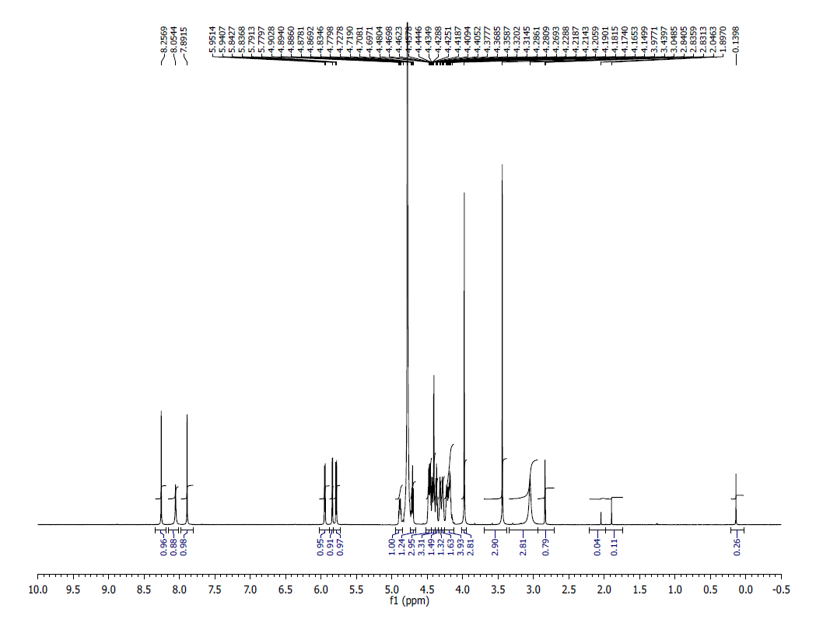
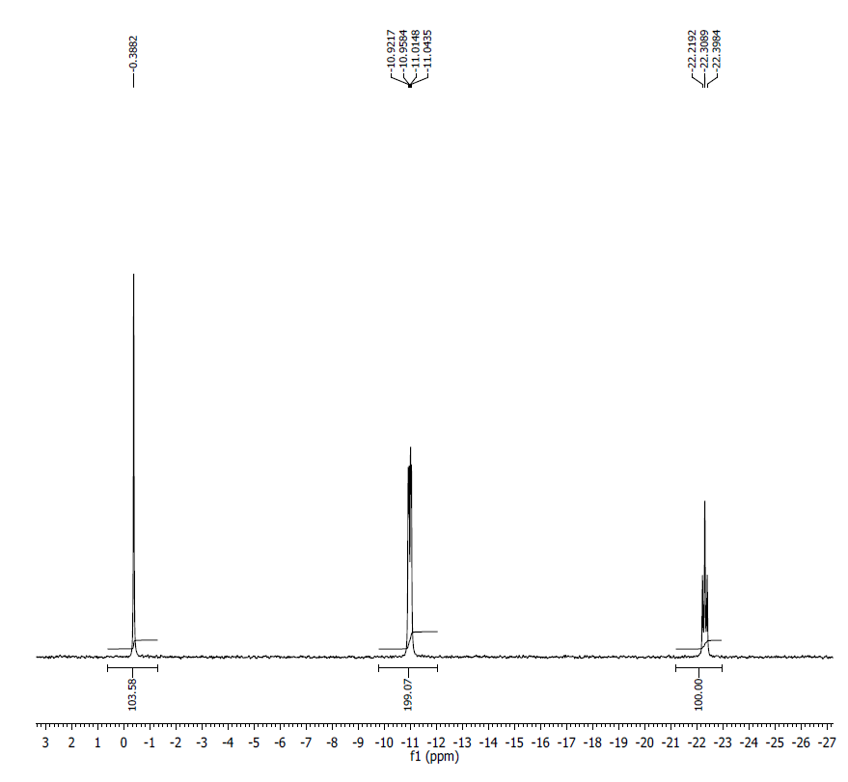
¹H NMR (500 MHz, D₂O) δ: 8.26 (s, 1H), 8.05 (s, 1H), 7.89 (s, 1H), 5.95 (d, 1H, J=5.4 Hz), 5.84 (d, J=3.0 Hz, 2H), 5.79 (d, J=5.8 Hz, 2H), 4.88 (quintet, J=4.4 Hz, 1H), 4.71 (t, J=5.5 Hz, 1H), 4.48-4.45 (m, 3H), 4.45-4.40 (m, 3H), 4.38-4.36 (m, 1H), 4.32-4.31 (m, 1H), 4.29-4.27 (m, 2H), 4.23-4.15 (m, 4H), 3.98 (s, 3H), 3.44 (s, 3H), 3.05 (br s, 3H), 2.83 (t, J=2.3 Hz, 1H).
³¹P NMR (200 MHz, D₂O) δ: -0.39 (1P), -10.97 (1P), -11.00 (1P), -22.31 (1P).
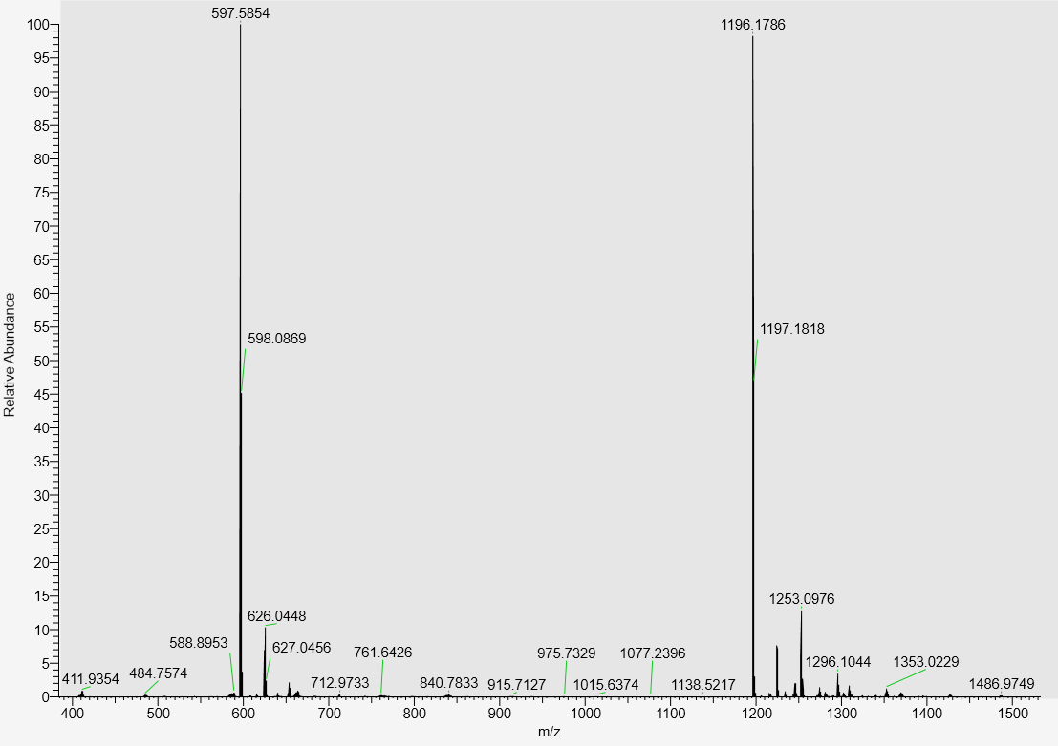
LC-MS data, calculated mass: 1197.1869; detected m/z: 1196.1786 (M-H)

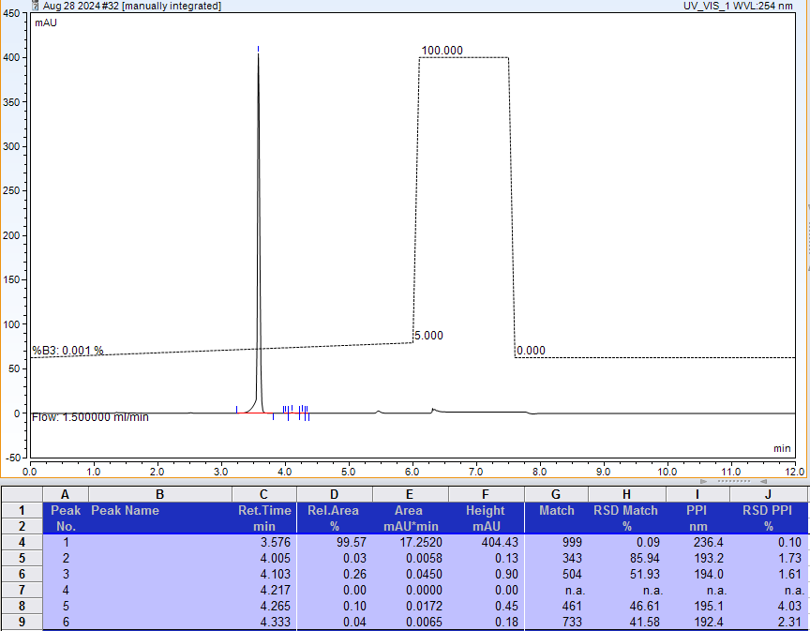
AX-HPLC Analysis
Compound 1-8B

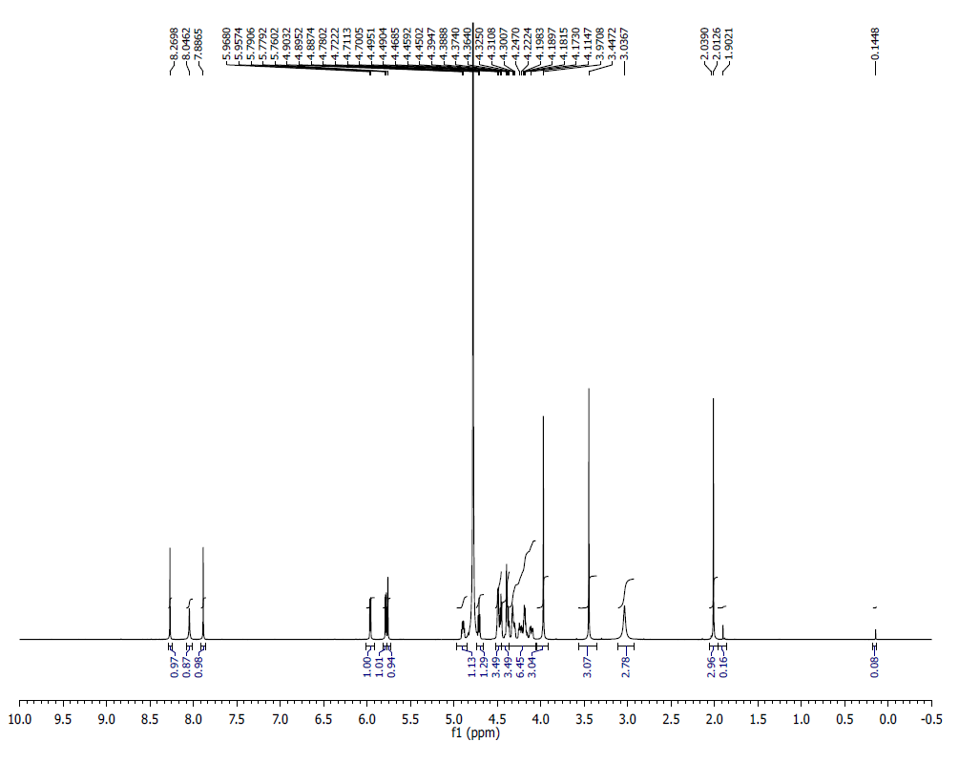
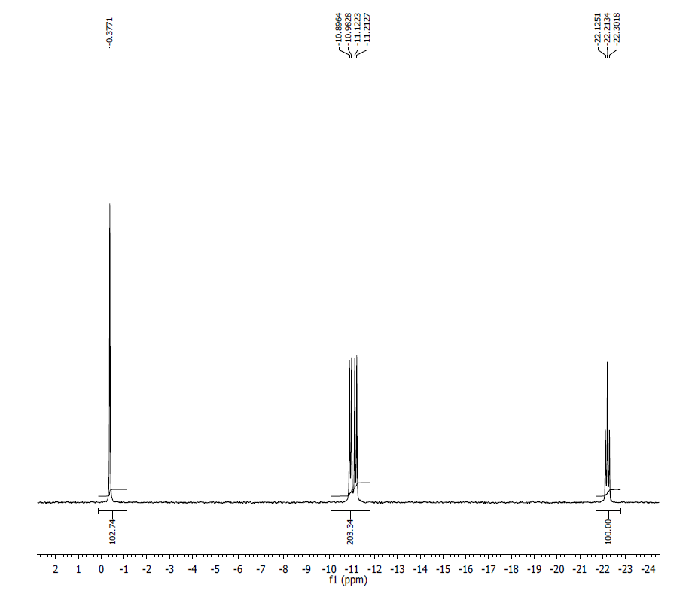
¹H NMR (500MHz, D2O) δ: 8.27 (s, 1H), 8.05 (s, 1H), 7.89 (s, 1H), 5.96 (d, 1H, J= 5.3 Hz), 5.79 (d, J= 5.7 Hz, 1H), 5.76 (s, 1H), 4.89 (quintet, J= 4 Hz, 1H), 4.71 (t, J= 5.5 Hz, 1H), 4.50-4.44 (m, 4H), 4.39-4.37 (m, 3H), 4.36-4.10 (m, 6H), 3.97 (s, 3H), 3.45 (s, 3H), 3.04 (s, 3H), 2.01 (s, 3H).
³¹P NMR (200 MHz, D2O) δ: -0.38 (1P), -10.94 (1P), -11.17 (1P), -22.21 (1P).
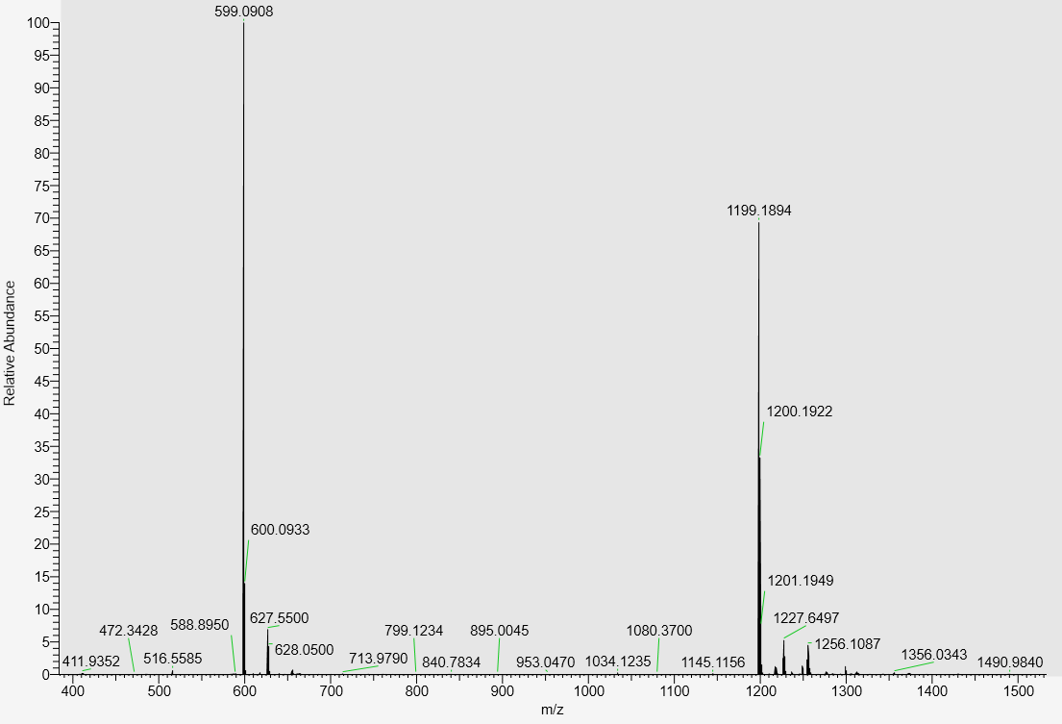
LC-MS data, calculated mass: 1200.1978; detected m/z: 1199.1894 (M-H)

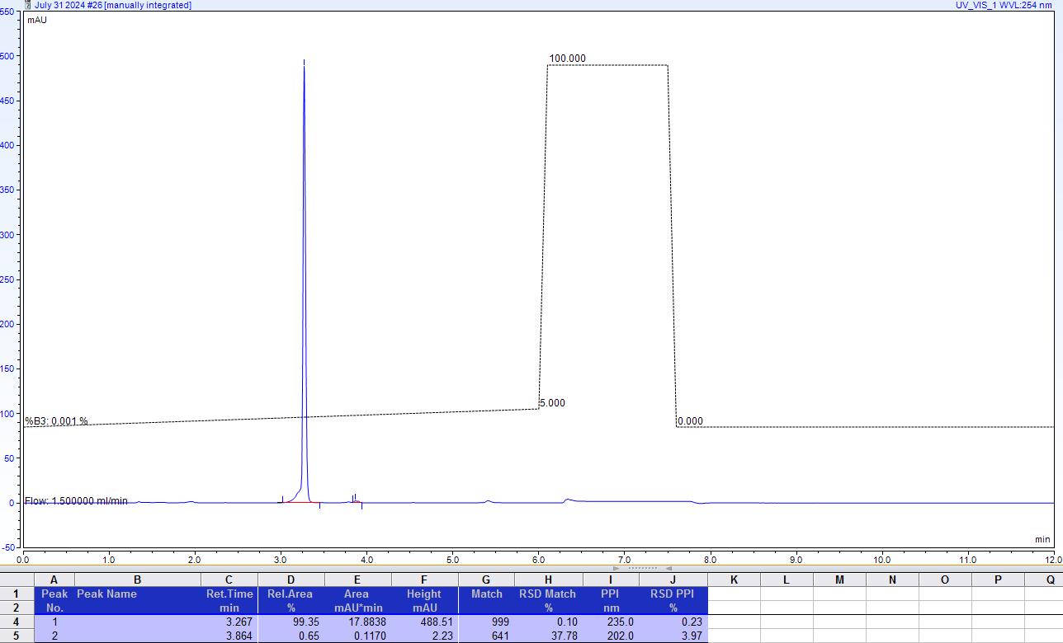
AX-HPLC Analysis
Compound 1-9B

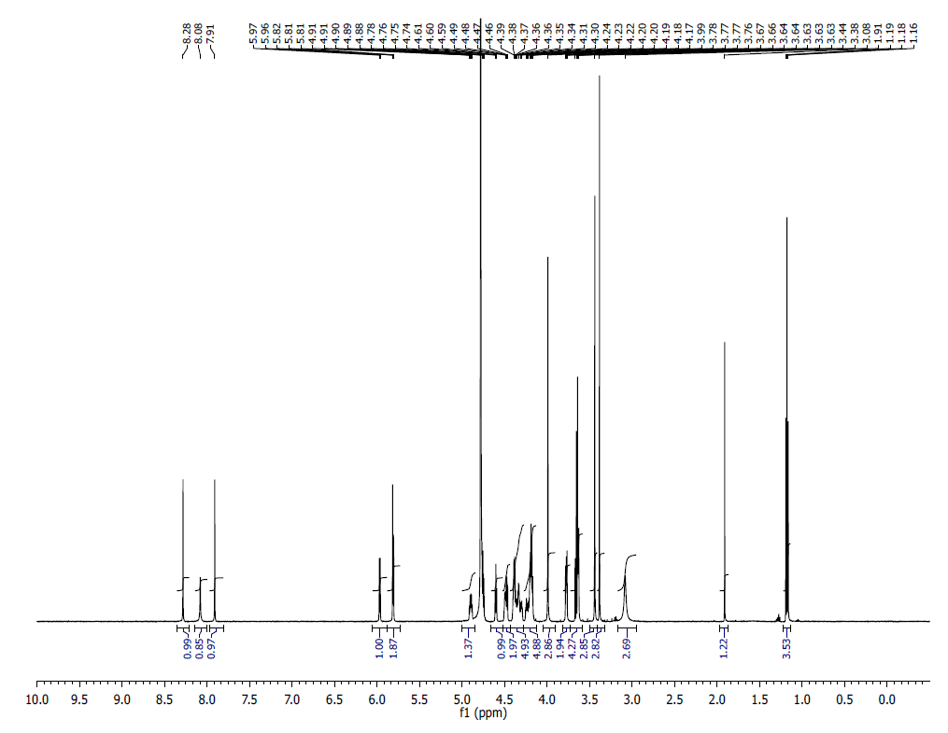

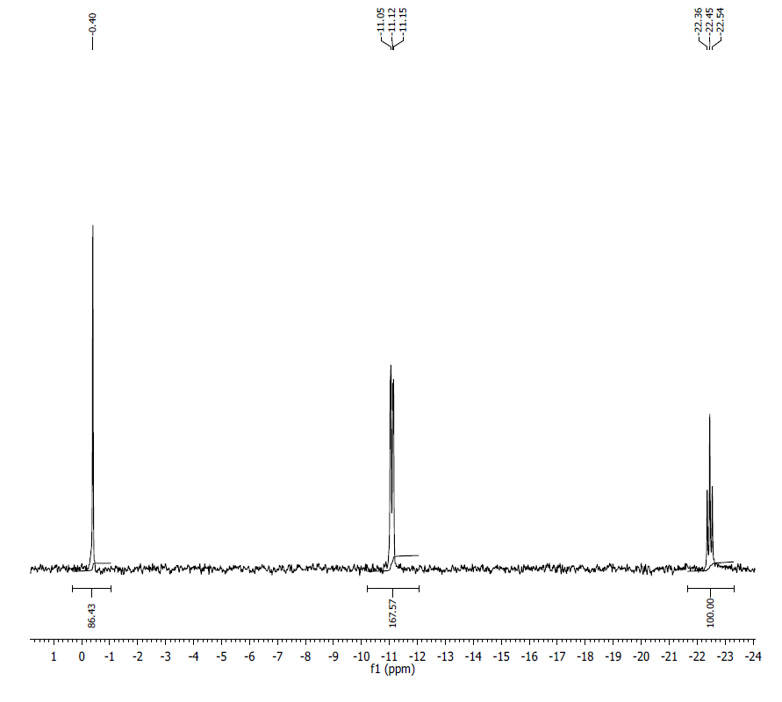
¹HNMR (500MHz, D2O) δ: 8.21 (s, 1H), 8.06 (br s, 1H), 7.89 (s, 1H), 5.96 (d, 1H, J=5.5 Hz), 5.82 (s,1H), 5.81 (d, 1H, J=5.5 Hz), 4.88 (m, 1H), 4.73 (t, 1H, J=5.5 Hz), 4.60 (t, 1H, J=4.7), 4.47 (m, 1H), 4.46 (m, 1H), 4.36 (m, 2H), 4.35 (M, 2H), 4.32 (M, 1H), 4.22 (m, 1H), 4.17 (m, 4H), 3.98 (s,3H), 3.76 (m, 2H), 3.62 (m, 2H), 3.43 (s, 3H), 3.37 (s, 3H), 3.07 (br s, 3H).

³¹PNMR (200 MHz, D2O) δ: -0.40 (1P), -11.10 (2P), -22.45 (1P).

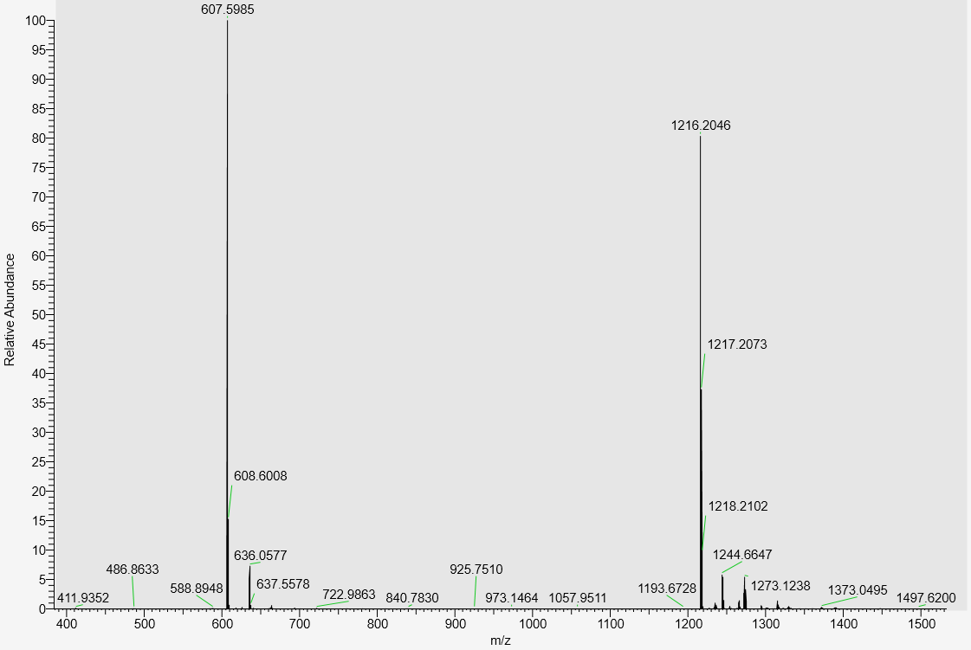

LC-MS data, calculated mass: 1217.2131; detected m/z: 1216.2046 (M-H)

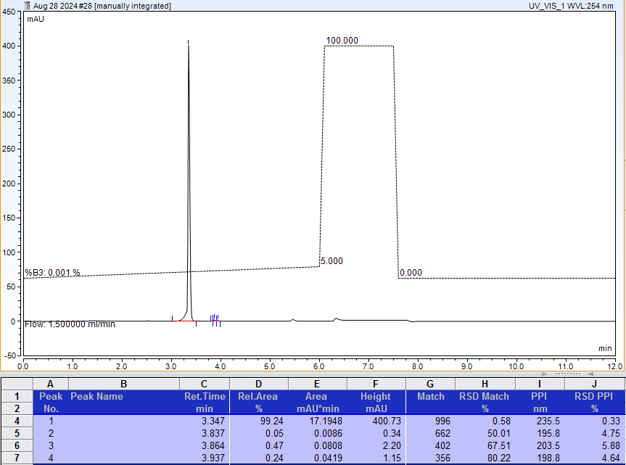
AX-HPLC Analysis
Compound 1-10B
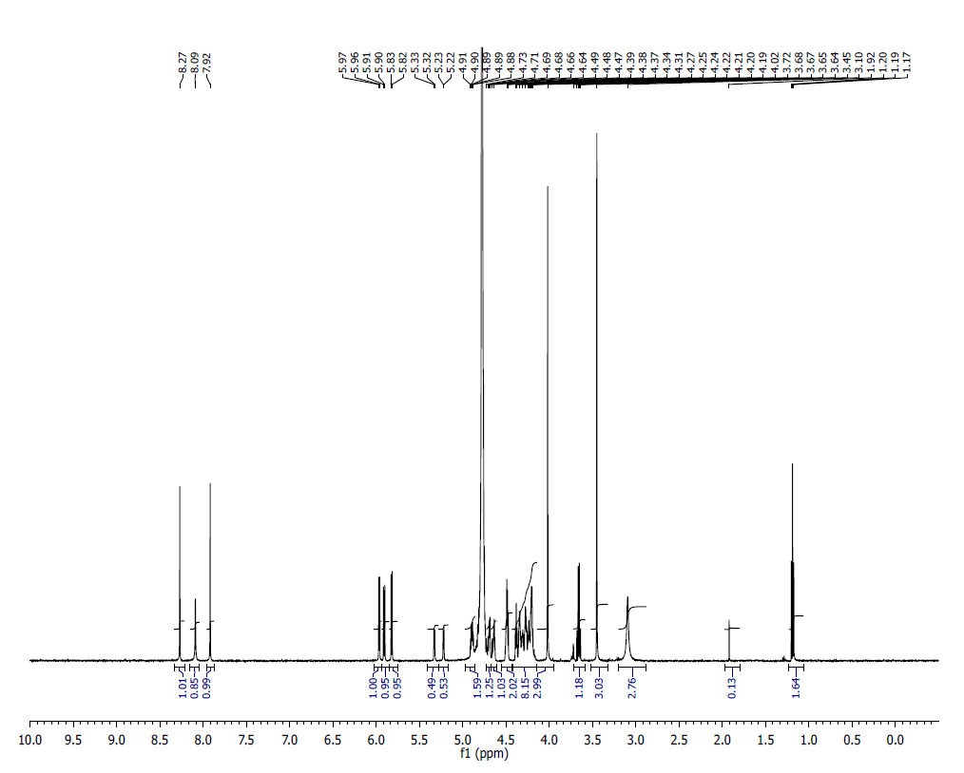
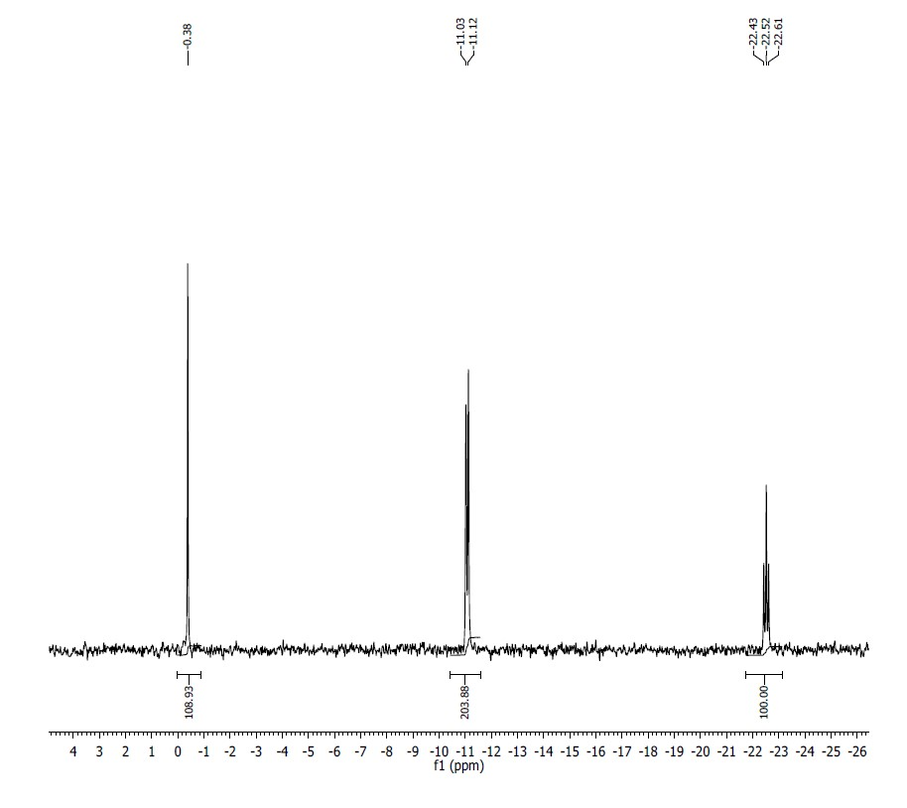
¹HNMR (500MHz, D2O) δ: 8.27 (s, 1H), 8.09 (br s, 1H), 7.92 (s, 1H), 5.96 (d, 1H, J=9 Hz), 5.82 (d, 1, J=5 Hz), 5.80 (d, 1H, J=9 Hz), 5.32 (d, 1H, J=5 Hz), 5.22 (d, 1, J=5 Hz), 4.89 (m, 1H), 4.72 (m, 1H), 4.68 (m, 1H), 4.48 (m, 2H), 4.38 (t, 1H, J=5 Hz), 4.30-4.20 (M, 7H), 4.02 (s, 3H), 3.45 (s, 3H), 3.10 (br s, 3H).

³¹PNMR (200 MHz, D2O) δ: -0.38 (1P), -11.07 (2P), -22.52 (1P).

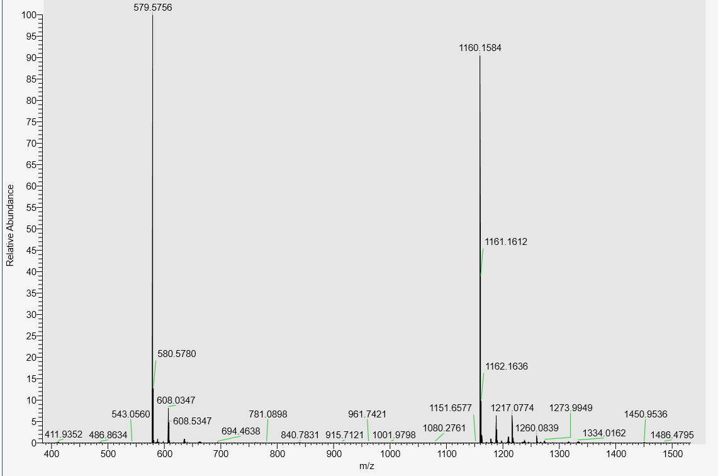

LC-MS, calculated mass: 1161.1669, observed m/z: 1160.1584 (M-H)

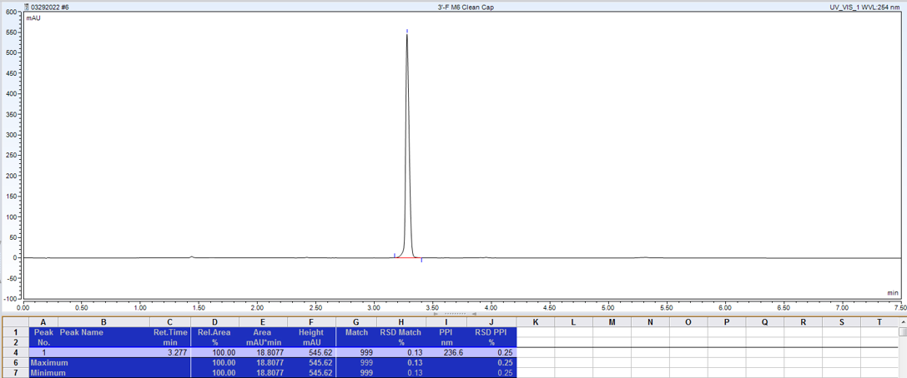
AX-HPLC Analysis

Compound 1-11B
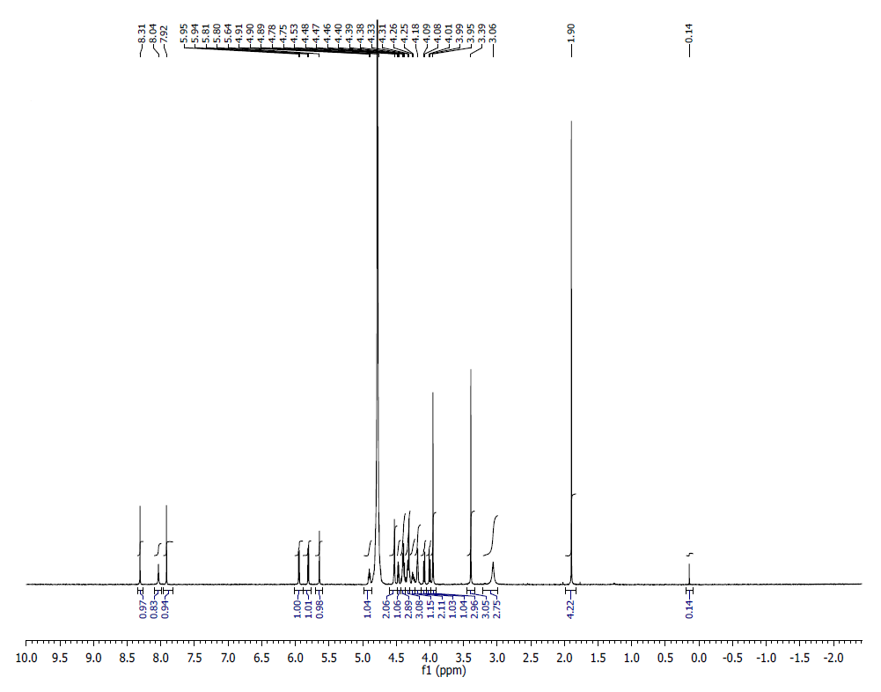
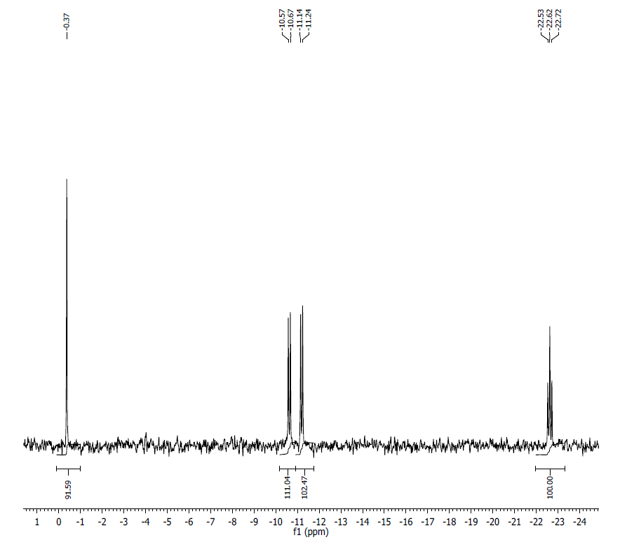
¹H NMR (500MHz, D2O ) δ: 8.31 (s, 1H), 8.04 (s, 1H), 7.92 (s, 1H), 5.94 (d,1H, J=10 Hz), 5.80 (d, 1H, J=10 Hz), 5.64 (d, 1H, J=10Hz), 4.90 (m, 1H), 4.53 (br s, 2H), 4.47 (m, 1H), 4.44-4.22 (m, 6H), 4.32 (s. 1H), 4.18 (m, 2H), 4.24 (m, 2), 4.08 (d, 1H, J=10 Hz), 4.00 (d, 1H, J=10 Hz), 3.95 (s, 3H), 3.39 (s, 3H), 3.06 (br s, 3H).
³¹P NMR (200 MHz, D2O) δ: -0.37 (1P), -10.62 (1P), -11.19 (1), -22.62 (1P).
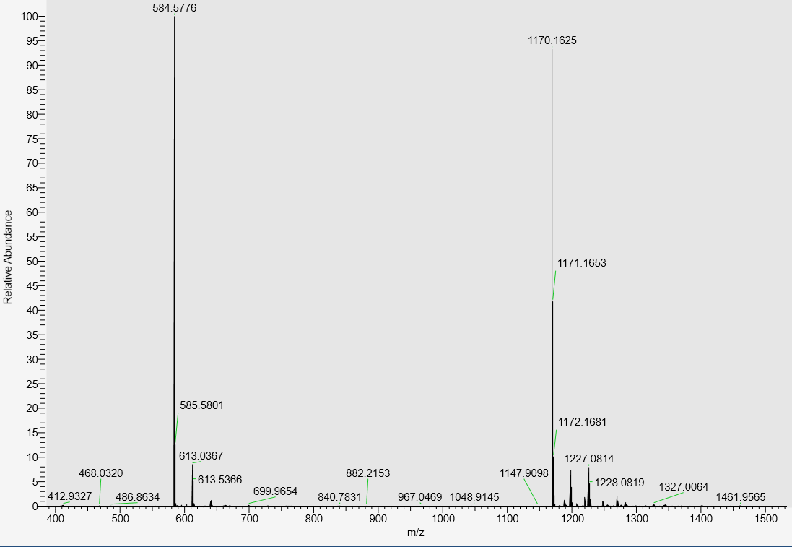
LC-MS data, calculated mass: 1171.1712; detected m/z: 1170.1625 (M-H)

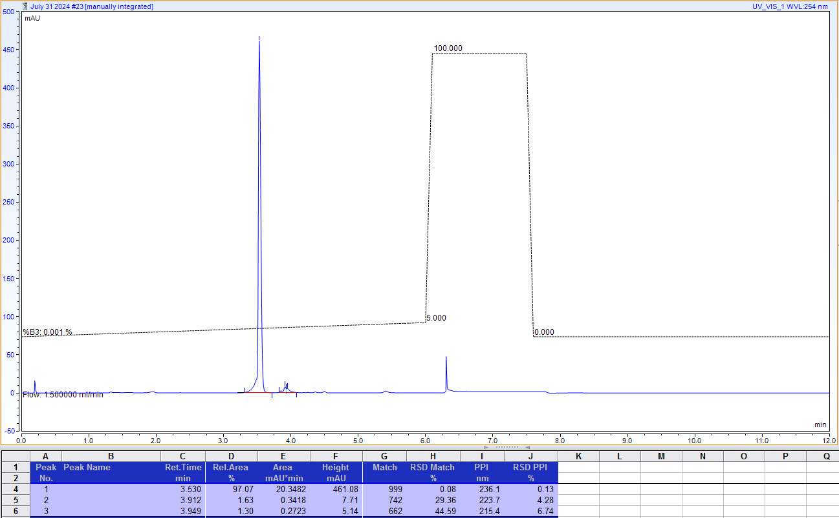
AX-HPLC Analysis

Compound 1-12B
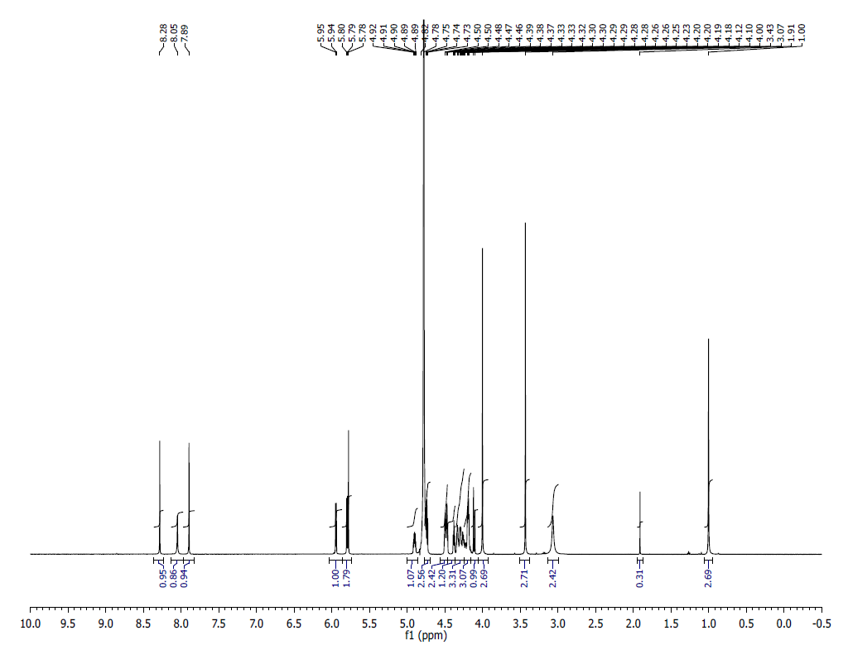
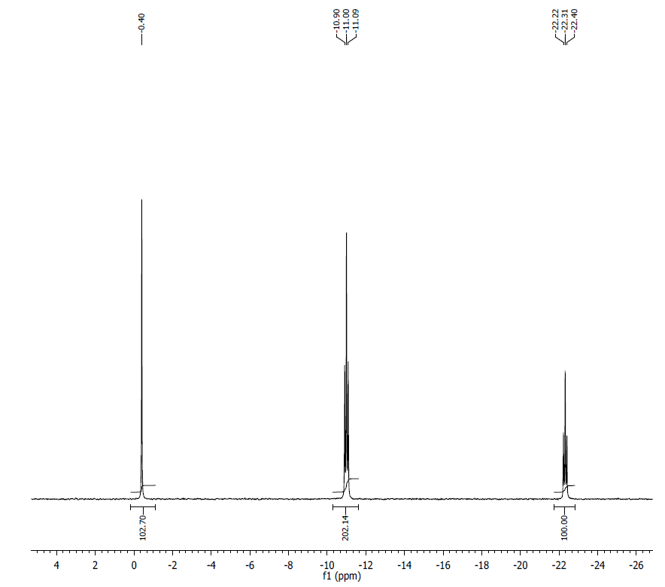
¹H NMR (500 MHz, D2O) δ: 8.28 (S, 1H), 8.05 (s, 1H), 7.89 (s, 1H), 5.95 (d, J=5.4Hz, 1H), 5.80 (d, J=5.75Hz, 1H), 5.77 (S, 1H), 4.91 – 4.88 (m, 1H), 4.81 - 4.72 (m, 3H), 4.50 – 4.46 (m, 2H), 4.37 (t, J=4.95Hz, 1H), 4.33 – 4.26 (m, 3H), 4.25 – 4.18 (m, 3H), 4.12 - 4.10 (m, 1H), 4.00 (s, 3H), 3.43 (s, 3H), 3.06 (br s, 3H), 1.00 (s, 3H).
³¹P NMR (200 MHz, D2O) δ: -0.40 (1P), -10.95 (1P), -1.05 (1P), -22.31 (1P).
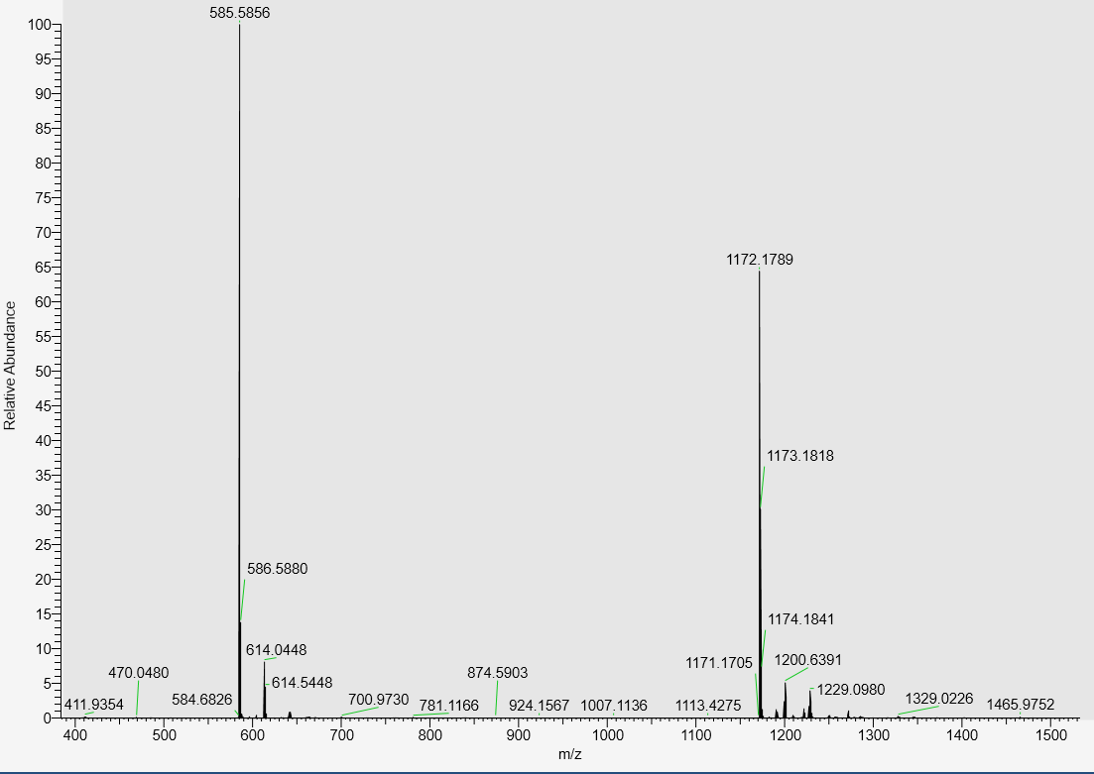
LC-MS data, calculated mass: 1173.1869; detected m/z: 1172.1789 (M-H)

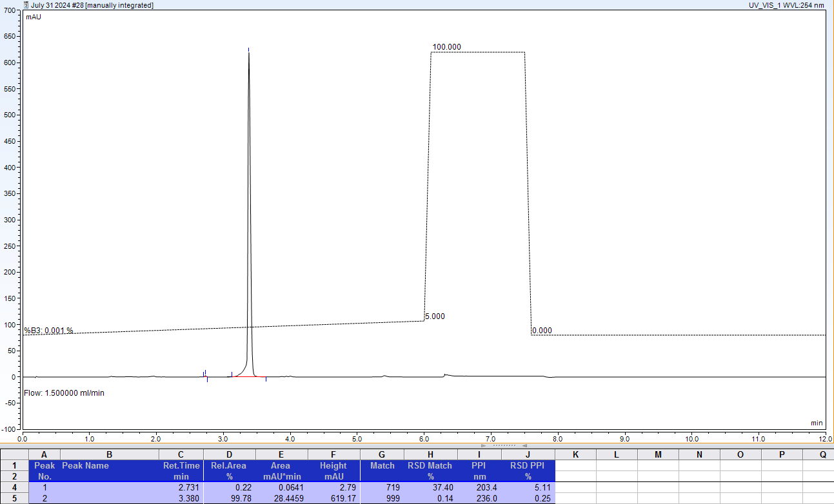
AX-HPLC Analysis

Compound 1-13B
^{7m}G(L-sugar isomer)
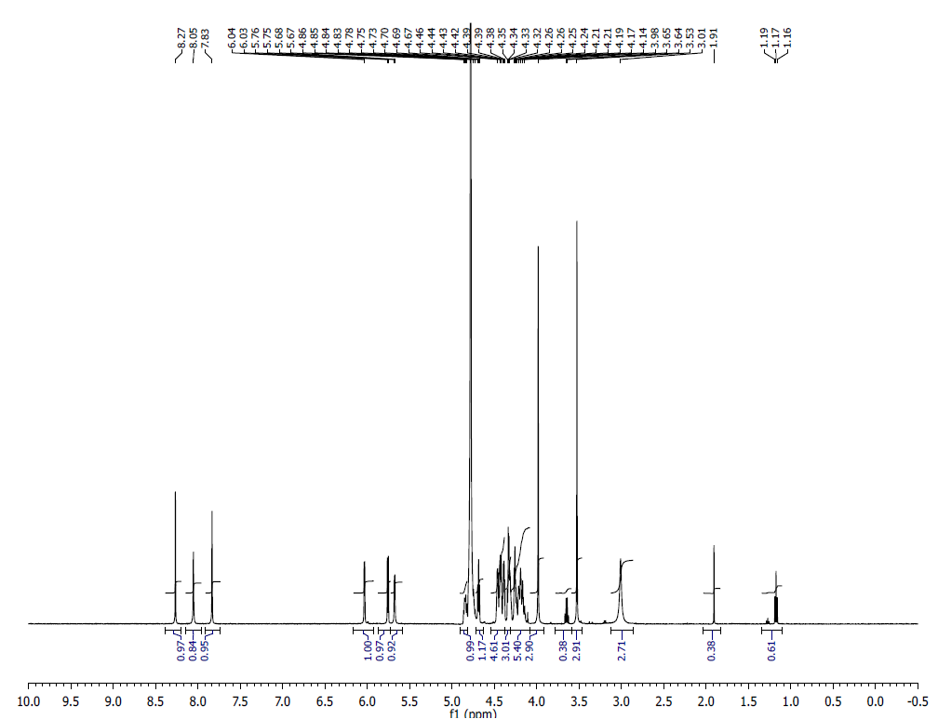
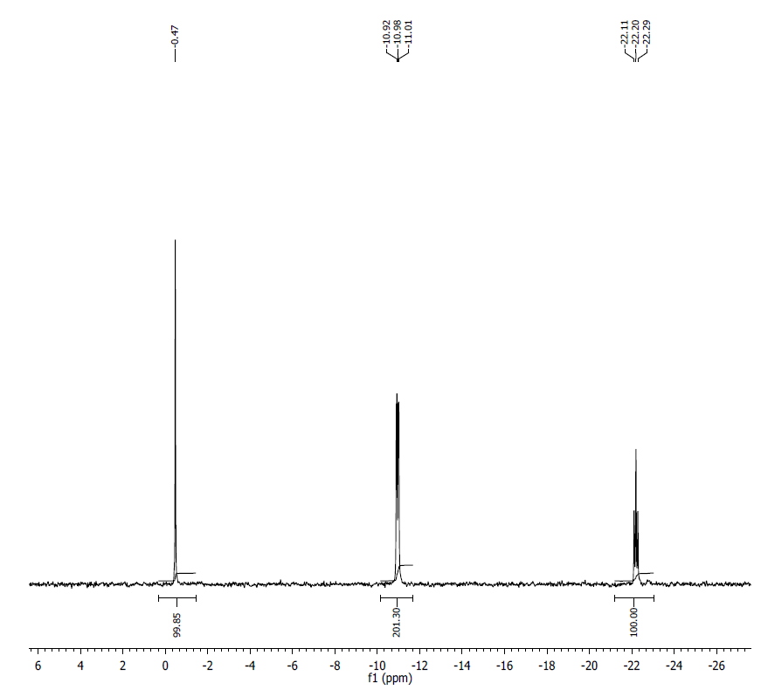
¹H NMR (500 MHz, D2O) δ: 8.26 (s, 1H), 8.05 (s, 1H), 7.83 (s, 1H), 6.03 (d, J=3.6 Hz, 1H), 5.76 (d, J=6.05 Hz, 1H) 5.67 (d, 2.8 Hz, 1H), 4.86 (m, 1H), 4.69-4.67 (t, J=5.5 Hz, 1H), 4.46-4.41 (m, 5H), 4.39-4.37 (m, 3H), 4.34-4.31 (m, 5H), 3.98 (s, 3H), 4.52 (s, 3H), 3.00 (bs, 3H), 1.90 (s, 1H), 1.18 (t, J=7.05 Hz, 1H).
³¹P NMR (200 MHz, D2O) δ: -0.47(1P), -10.98(2P), -22.11 (1P).
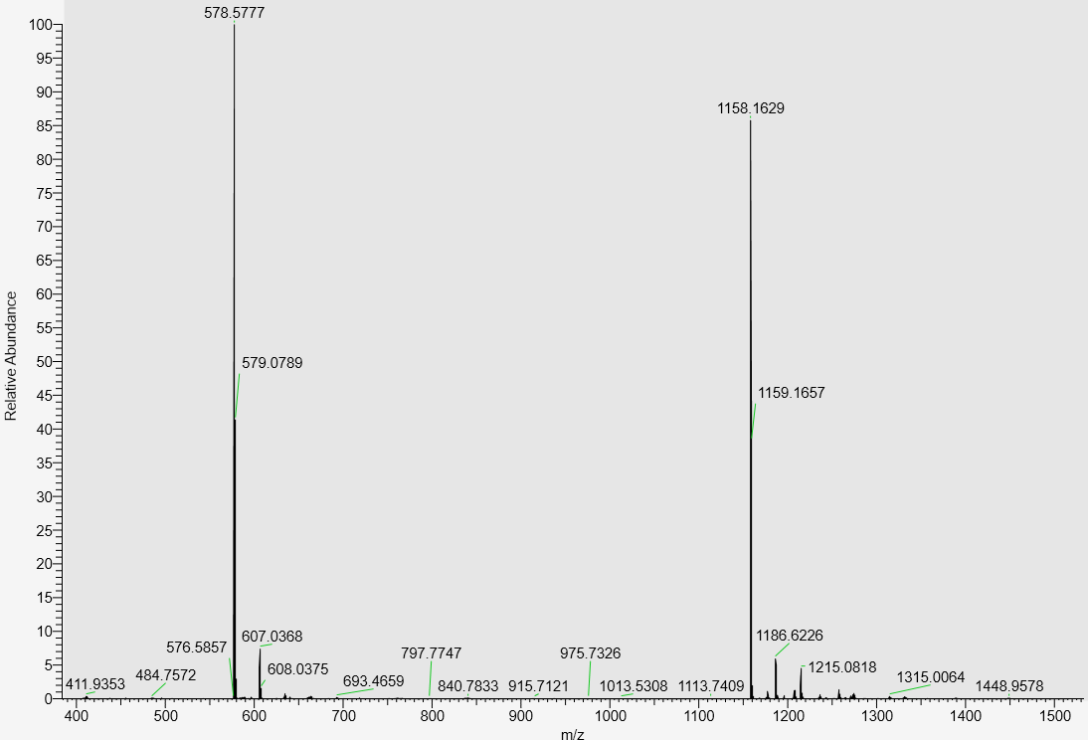
LC-MS data, calculated mass: 1159.1712; detected m/z: 1158.1629 (M-H)

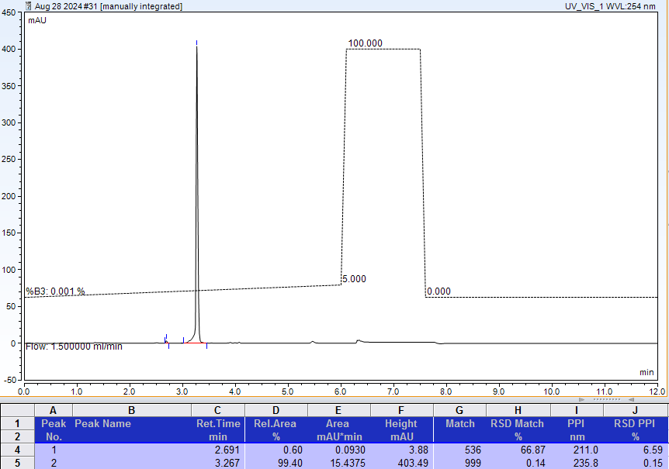
AX-HPLC Analysis
Compound 1-14B

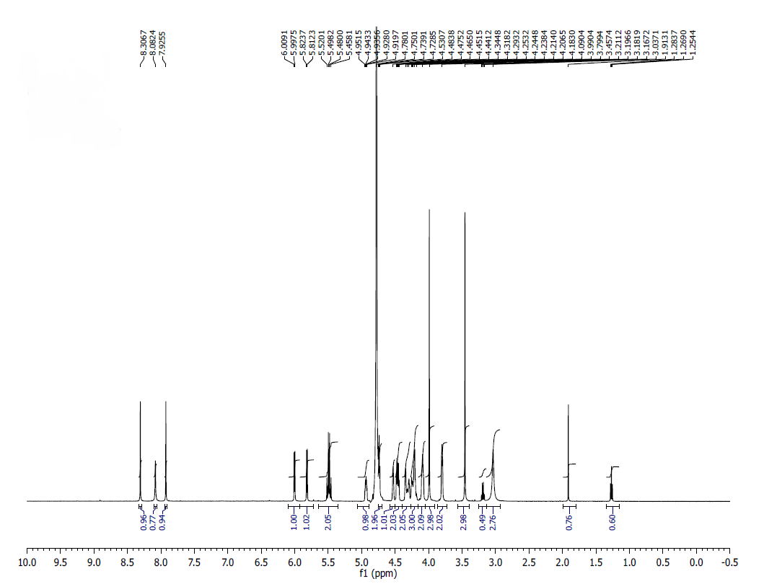
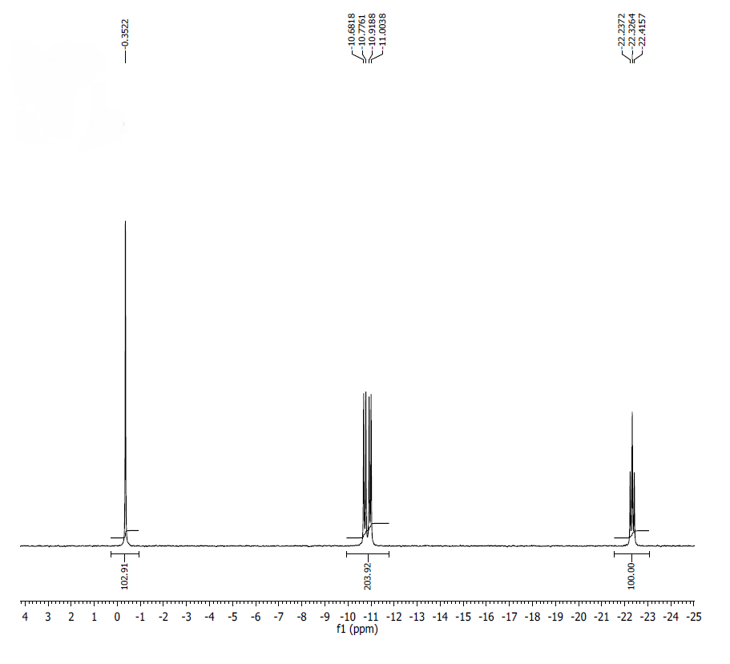
¹H NMR (500 MHz, D₂O): δ 8.30 (s, 1H), 8.08 (s, 1H), 7.92 (s, 1H), 6.00 (d, J=5.8Hz, 1H), 5.82 (d, J=5.7Hz, 1H), 5.52-5.45 (q, J=10.95Hz, 2H), 4.95-4.91 (m, 1H), 4.78-4.72 (m, 2H), 4.53 (br s, 1H), 4.48-4.44 (m, 2H), 4.34-4.29 (m, 2H), 4.25-4.21 (m, 3H), 4.20-4.09 (m, 2H), 3.99 (s, 3H), 3.79 (m, 2H), 3.45 (s, 3H), 3.03 (br s, 3H).
³¹P NMR (200 MHz, D₂O): δ -0.35 (1P), -10.73 (1P), -10,97 (1P) -22.33 (1P).

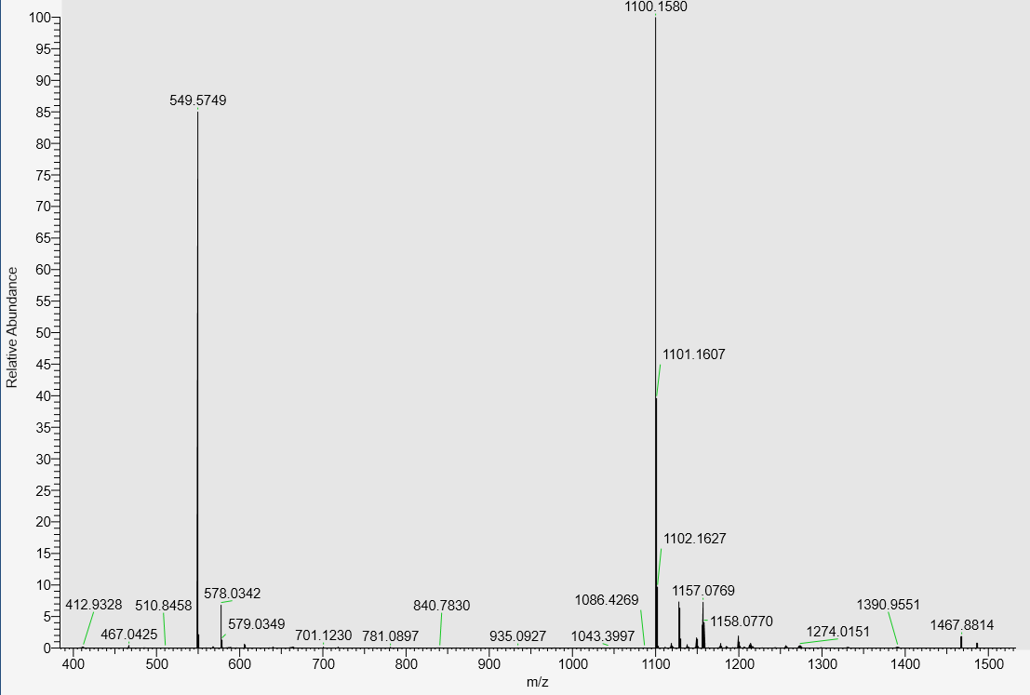
LC-MS data, calculated mass: 1101.1658; detected m/z: 1100.1580 (M-H)

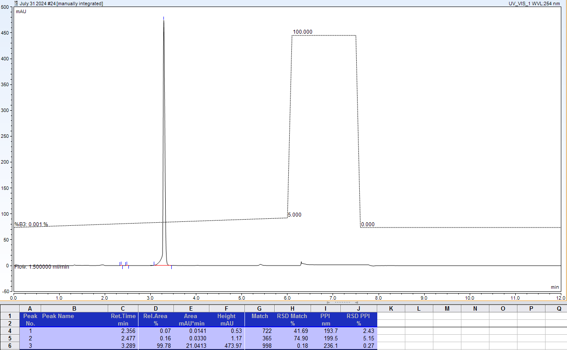
AX-HPLC Analysis
Compound 1-15B

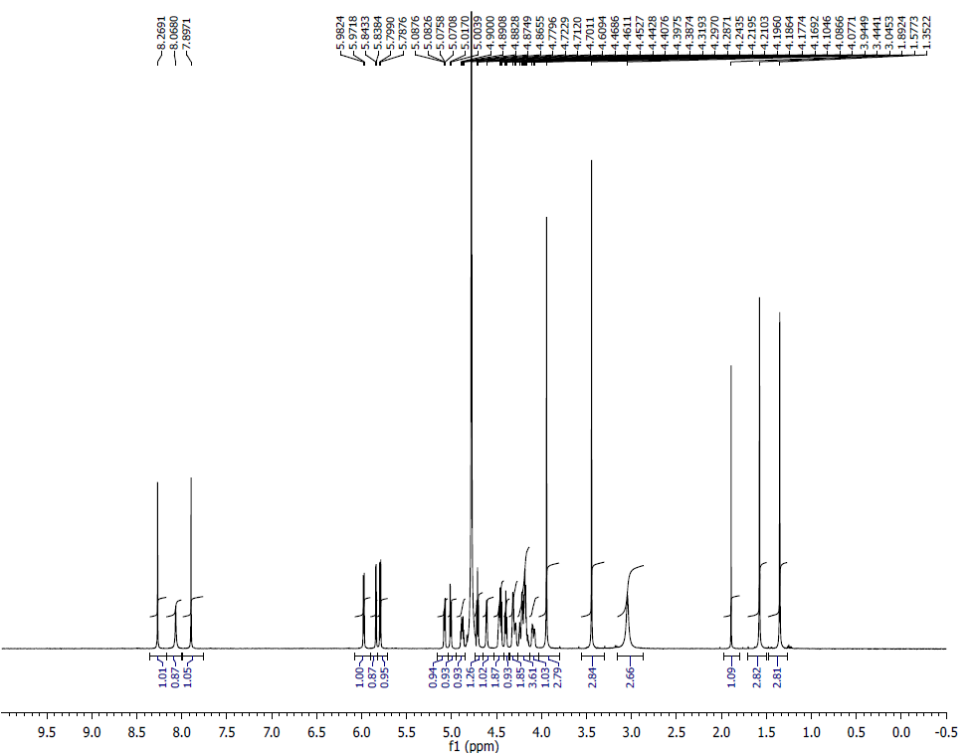
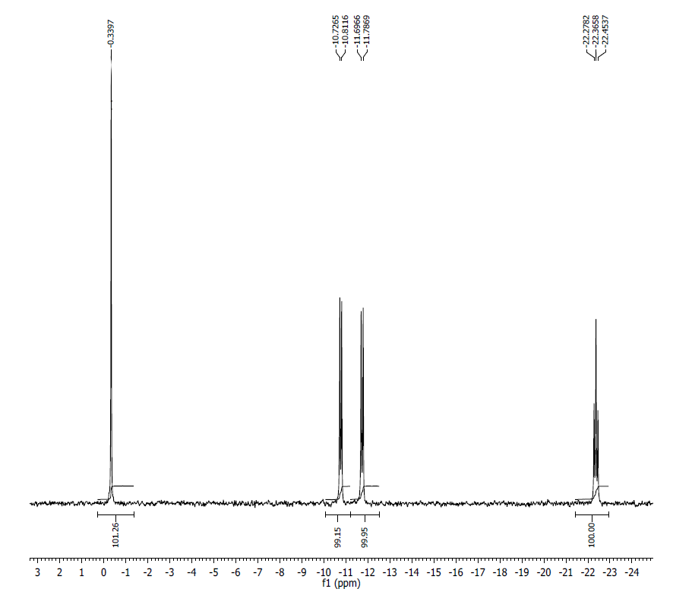
¹H NMR (500MHz, D2O) δ: 8.27 (s, 1H), 8.07 (s, 1H), 7.90 (s, 1H), 5.98 (d, 1H, J=5.3 Hz), 5.84 (d, 1H, J=2.5 Hz), 5.79 (d, 1H, J=5.7 Hz), 5.08 (dd, 1H, J=5.9, 2.5 Hz), 5.01 (d, 1H, J=6.6 Hz), 4.88 (q, 1H, J=4.6 Hz), 4.71 (t, 1H, J=5.5 Hz), 4.61 (s, 1H), 4.47-4.44 (m, 2H), 4.40 (t, 1H, J=5.1 Hz), 4.32-4.29 (m, 2H), 4.24-4.17 (m, 4H), 4.10-4.08 (m, 1H), 3.94 (s, 3H), 3.44 (s, 3H), 3.05 (br s, 3H), 1.58 (s, 3H), 1.35 (s, 3H)
³¹P NMR (200 MHz, D2O) δ: -0.34 (1P), -10.77 (1P), -11.74 (1P), -22.37 (1P).

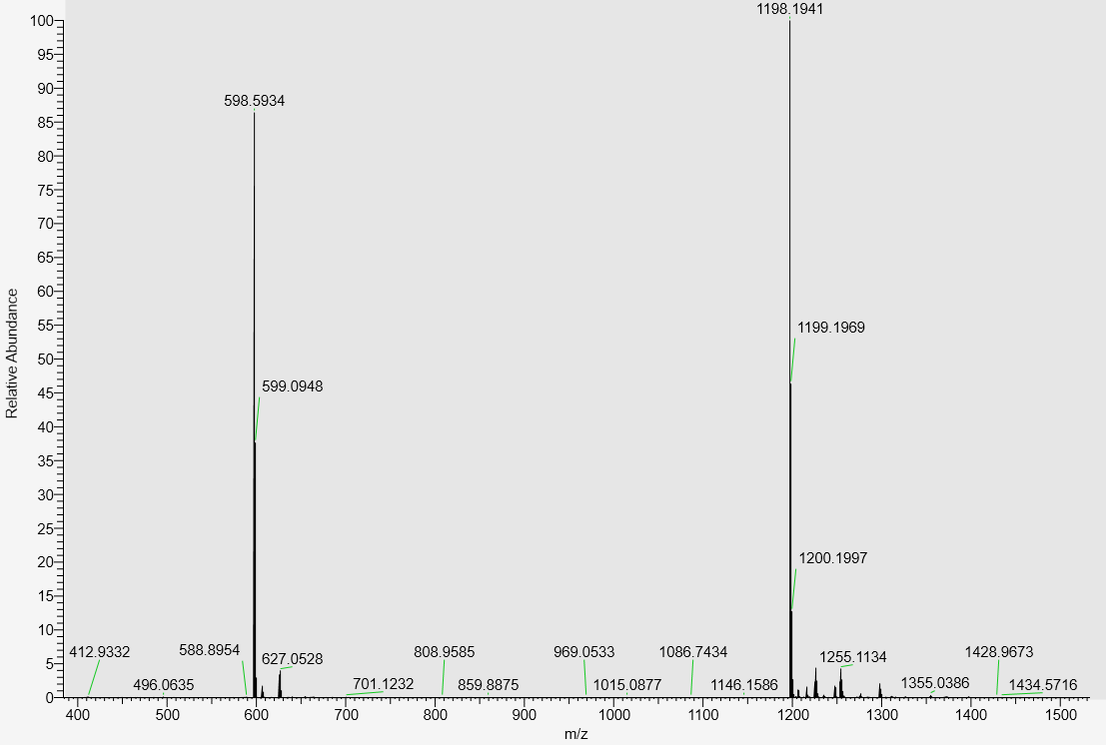
LC-MS data, calculated mass: 1199.2025; detected m/z: 1198.1941 (M-H)

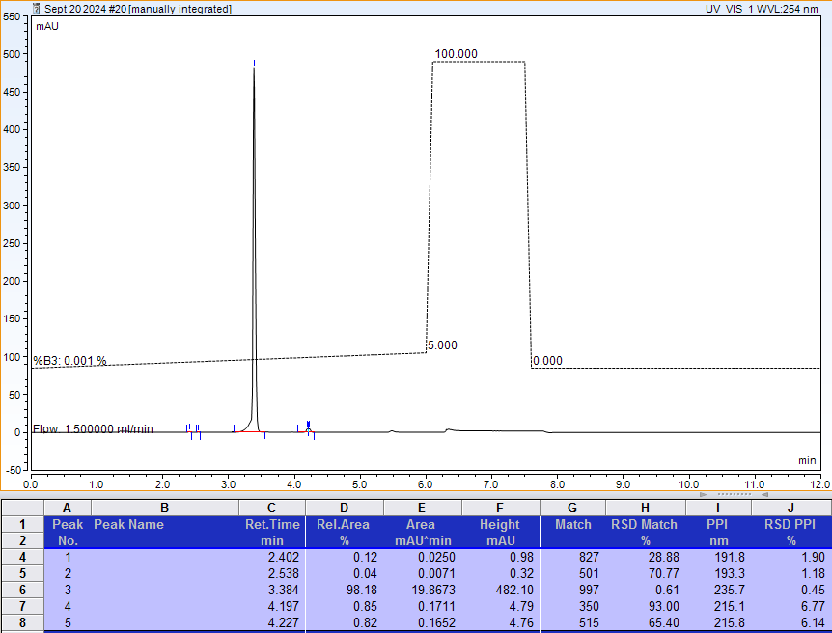
AX-HPLC Analysis
Compound 1-16B

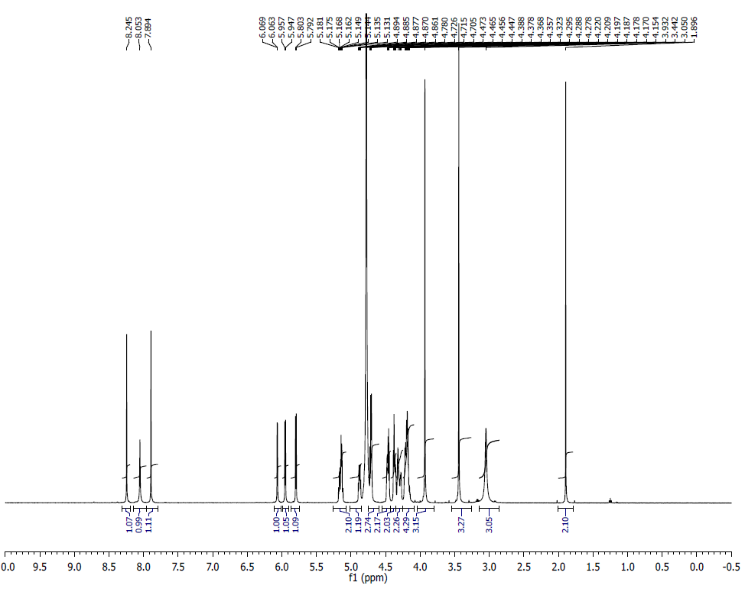
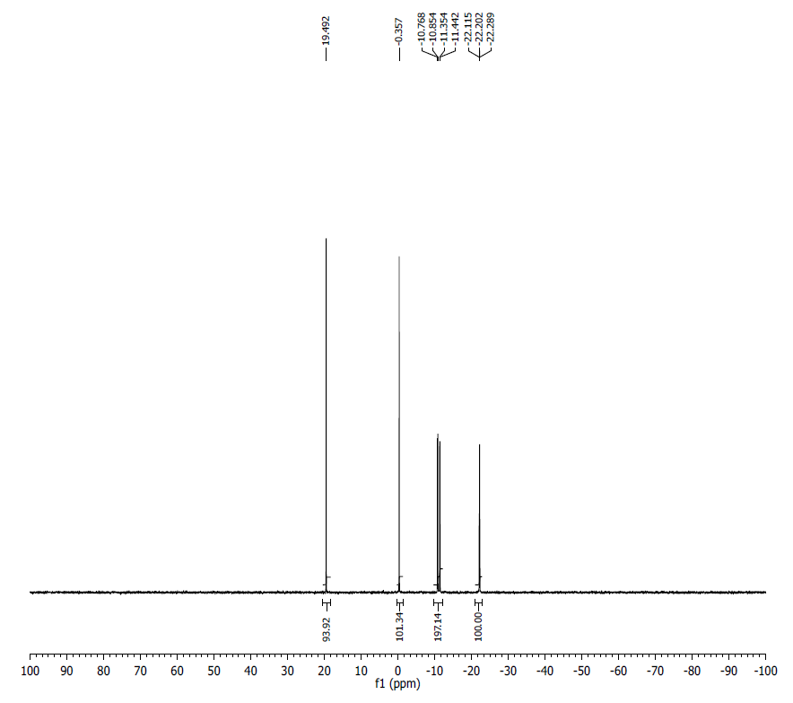
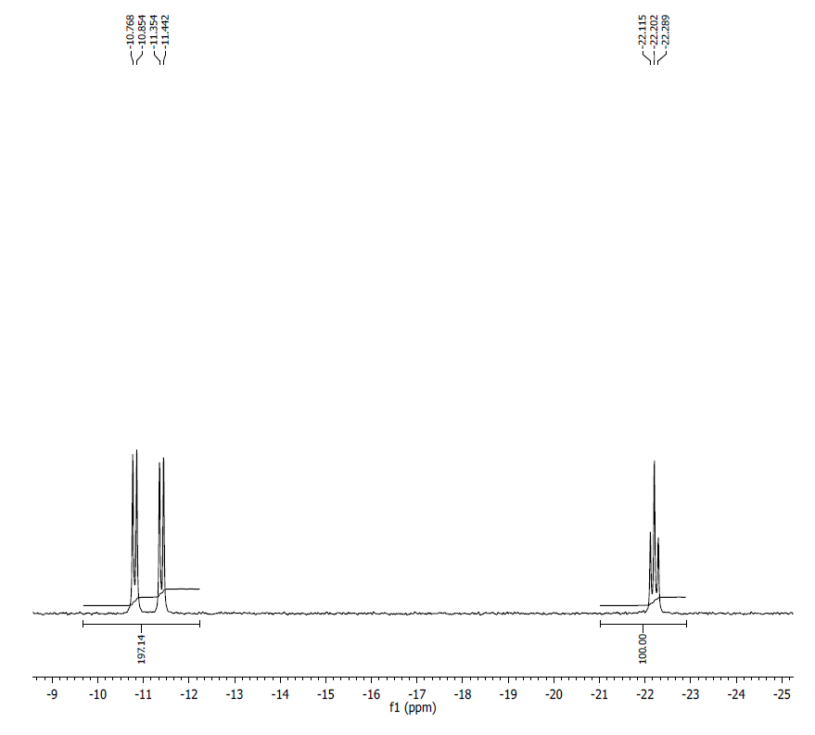
¹H NMR (500MHz, D2O) δ: 8.25 (s, 1H), 8.05 (s, 1H), 7.89 (s, 1H), 6.06 (d, 1H, J=3 Hz), 5.96 (d, 1H, J=5 Hz), 5.80 (d, 1H, J=5.5 Hz), 5.18-5.13 (m, 2H), 4.88 (quintet, 1H, J=3.5 Hz), 4.73-4.71 (m, 3H), 4.47-4.45 (m, 2H), 4.39-4.36 (m, 2H), 4.32-4.28 (m, 2H), 4.22-4.15 (m, 4H), 4.32-4.29 (m, 2H), 3.93 (s, 3H), 3.44 (s, 3H), 3.05 (br s, 3H).
³¹P NMR (200 MHz, D2O) δ:19.49(1P), -0.36 (1P), -10.81 (1P), -11.39 (1P), -22.20 (1P).

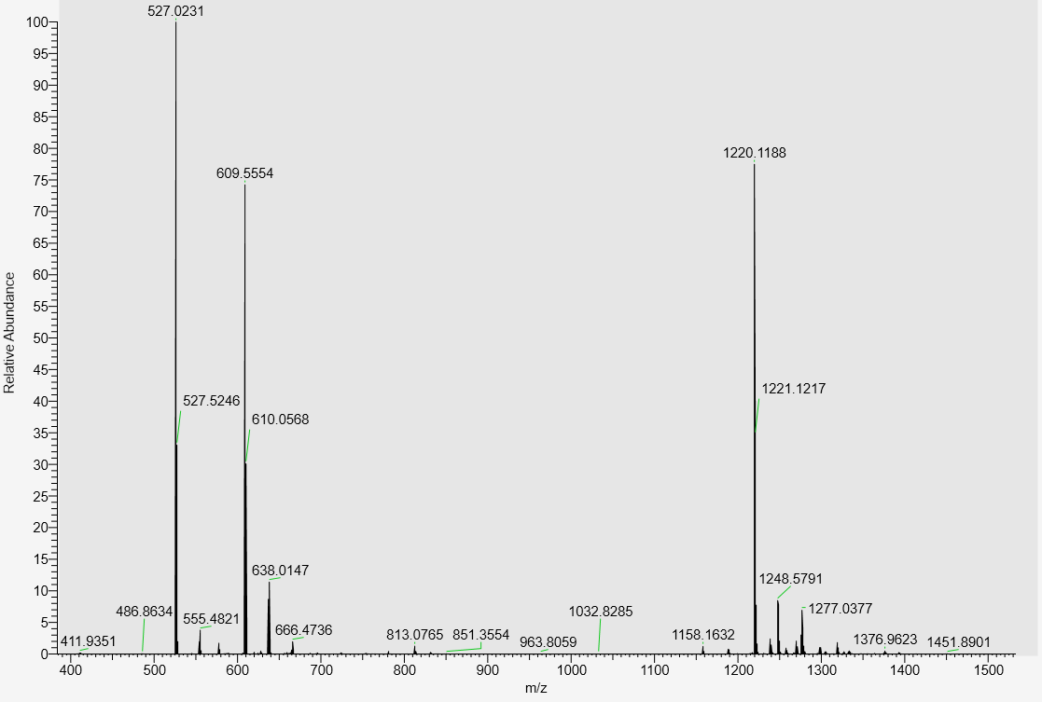
LC-MS data, calculated Mass: 1221.1270; detected m/z: 1220.1188 (M-H)

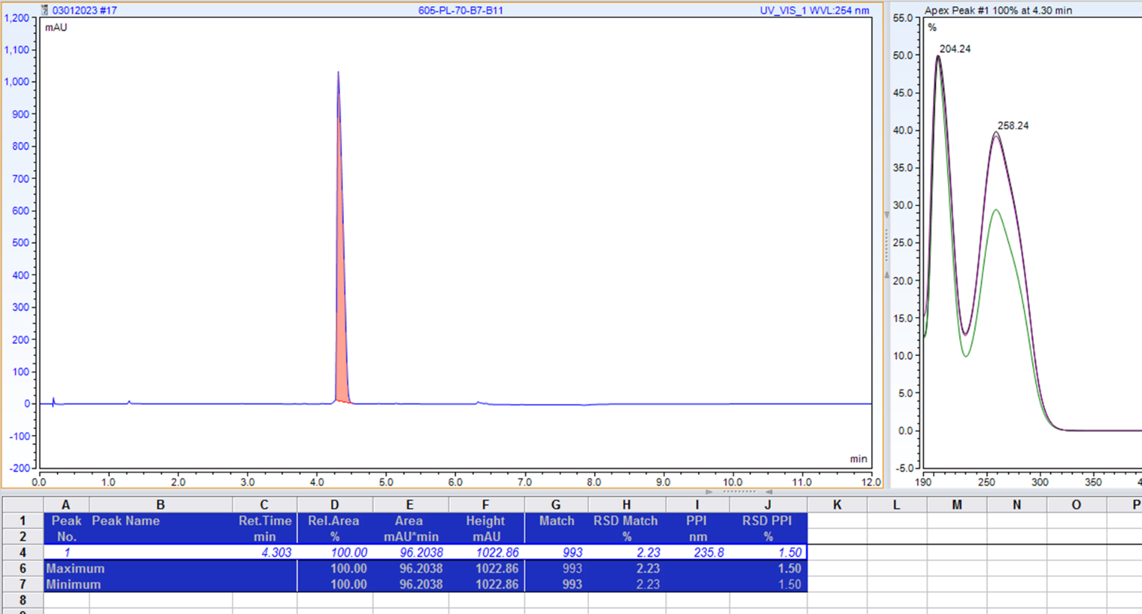
AX-HPLC Analysis

Compounds related to Table 2, Series A
Compound 2-1A

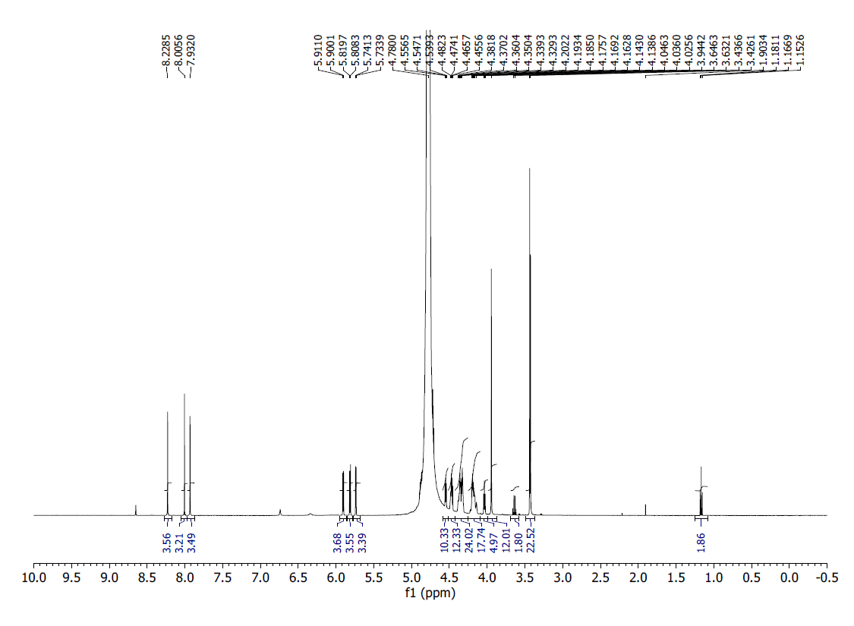
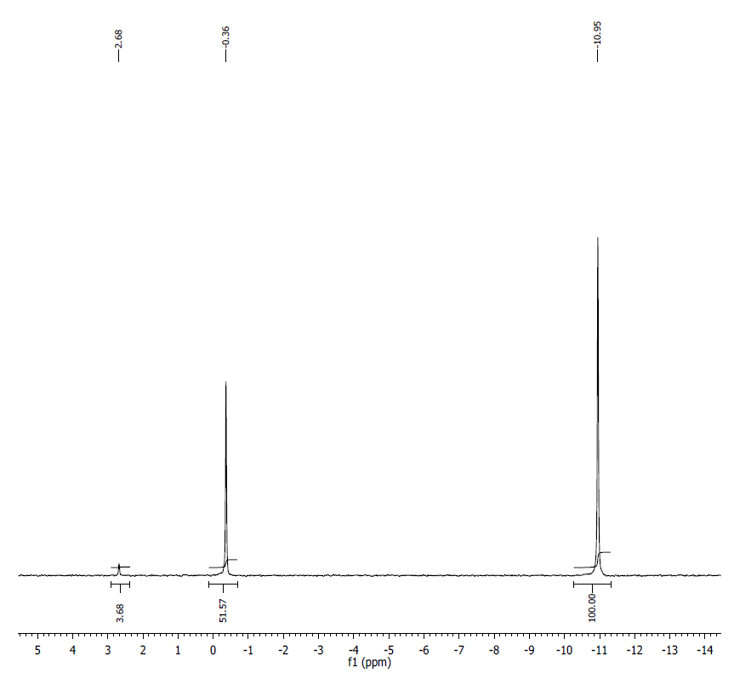
¹H NMR (500MHz, D2O) δ: 8.23 (s, 1H), 8.01 (s, 1H), 7.93 (s, 1H), 5.91 (d, J = 5.5, 1H), 5.81 (d, J = 5.7, 1H), 5.74 (d, J = 3.7, 1H), 4.55 (t, J = 4.7, 1H), 4.46-4.48 (m, 2H), 4.33-4.47 (m, 5H), 4.14-4.20 (m, 5H), 4.04 (t, J = 5.2, 1H), 3.94 (s, 3H), 3.44 (s, 3H), 3.43 (s, 3H).
³¹P NMR (200 MHz, D2O) δ: -0.36 (1P), -10.95 (2P). Signal at 2.68 ppm belongs to inorganic monophosphate contamination.
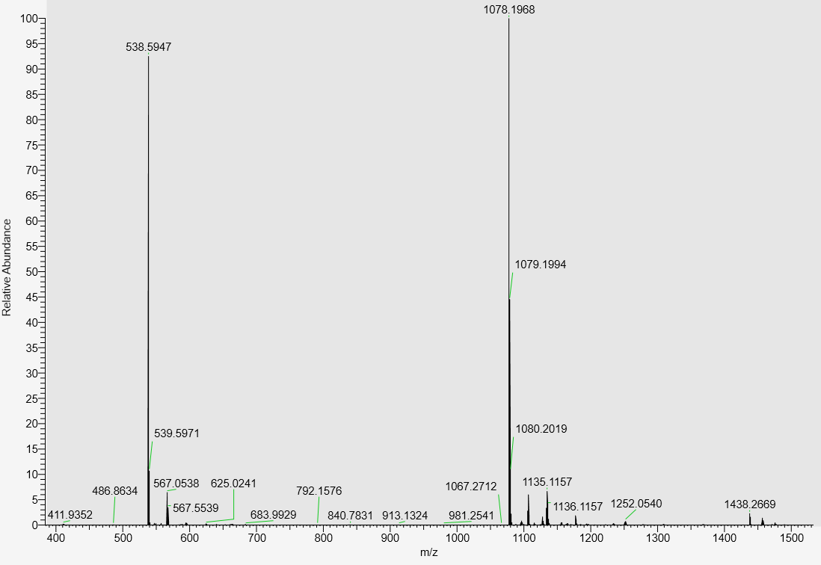
LC-MS data, calculated mass: 1079.2049; detected m/z: 1078.1968 (M-H)

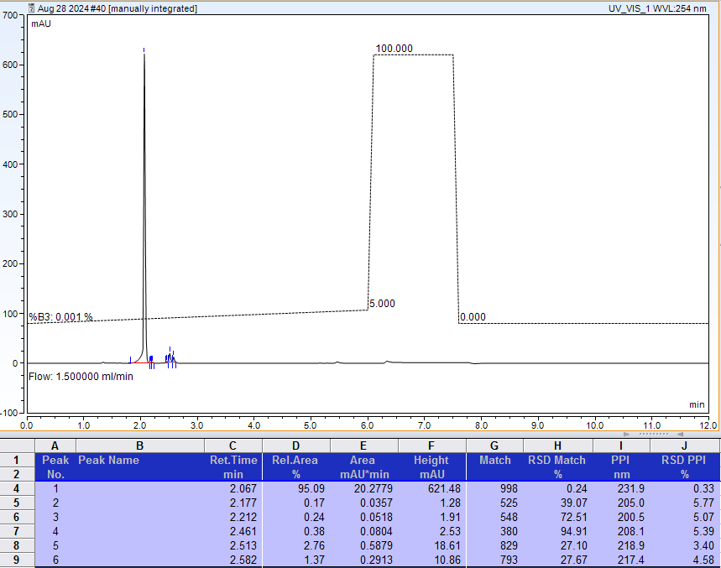
AX-HPLC Analysis
Compound 2-2A
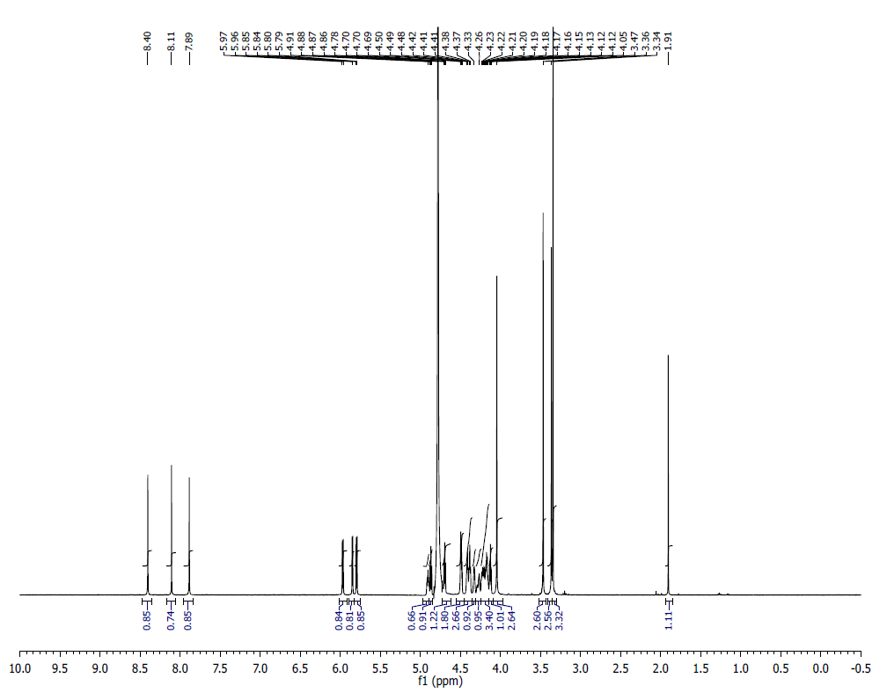
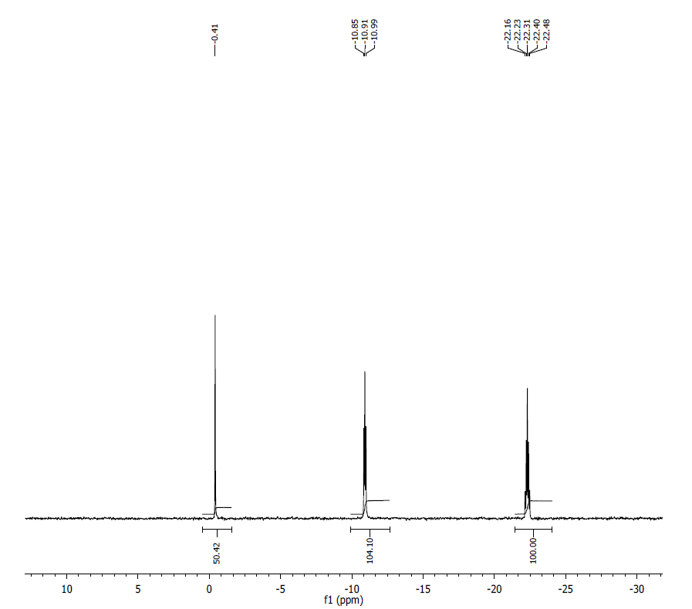
¹H NMR (500 MHz, D2O) δ: 8.40 (s, 1H), 8.10 (s,1H), 7.88(s, 1H), 5.97 (d, J=6Hz, 1H), 5.85 (d, J=4.25Hz, 1H), 5.80(d, J=5.8Hz, 1H) 4.90(m,1H) 4.86(t, J=5.5Hz, 1H) 4.69(t, J=4.65Hz, 1H) 4.48(m, 2H), 4.49- 4.40(m, 3H) 4.38 (bs, 1H) 4.32-4.26 (m, 1H) 4.23-4.16 (m, 4H) 4.15-4.11 (m, 1H) 4.04 (s, 3H) 3.46(s, 3H) 3.36(s, 3H) 3.34(s, 3H) 1.9(s, 1H)
³¹P NMR (200 MHz, D2O) δ: -0.41 (1P), -10.88 (1P), -10.95 (1P), 22.23 (1P), -22.40 (1P).
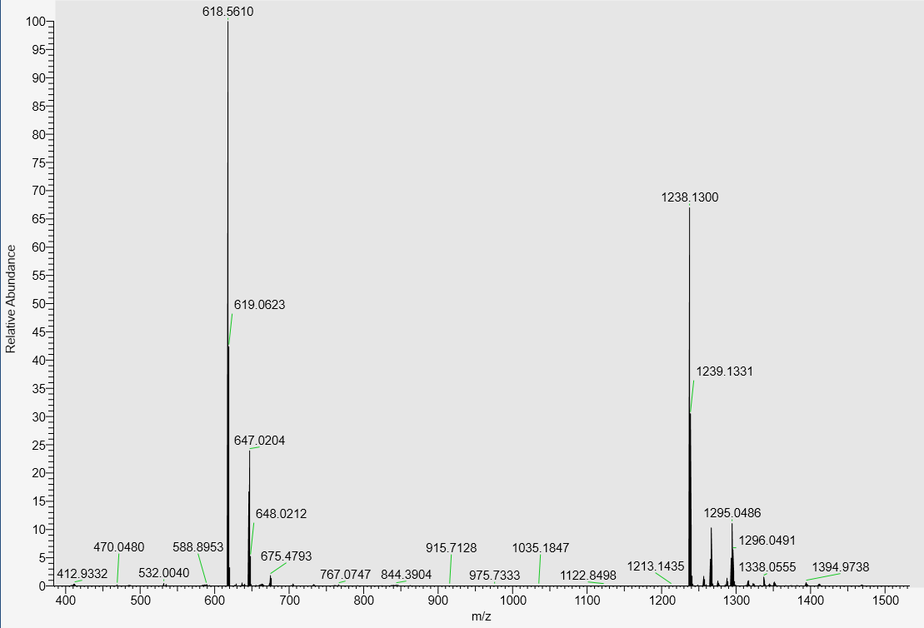
LC-MS data, calculated mass: 1239.1376; detected m/z: 1238.1300 (M-H)

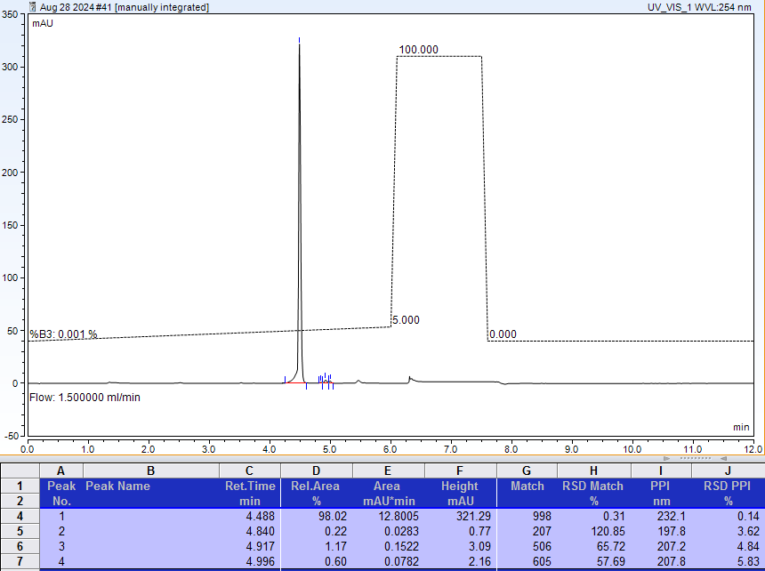
AX-HPLC Analysis
Compound 2-3A

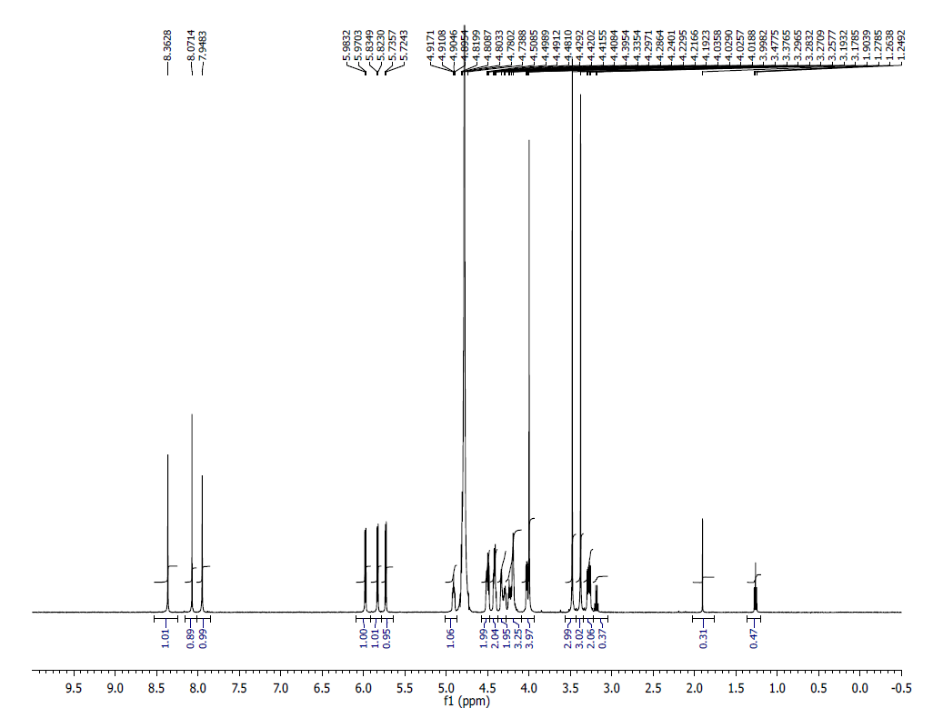
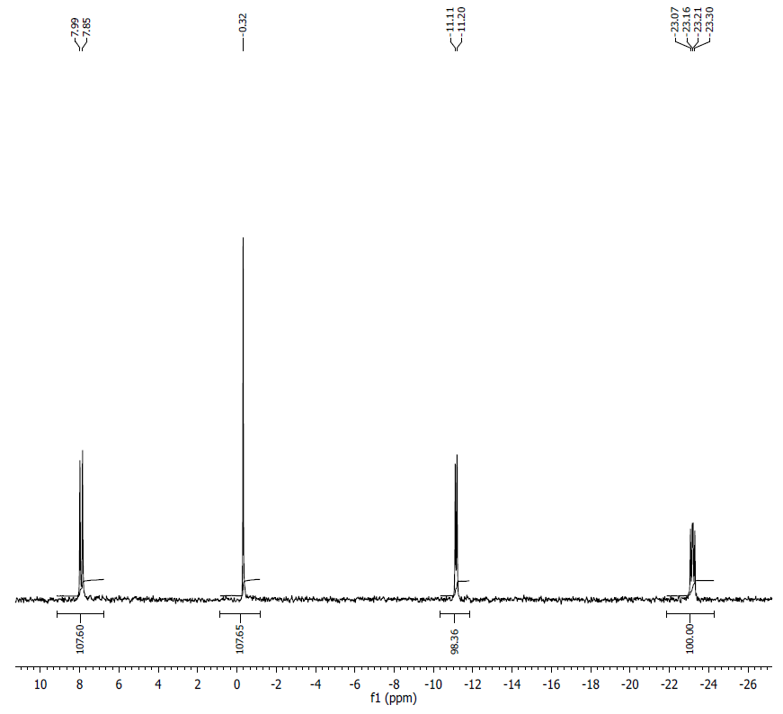
¹H NMR (500 MHz, D2O): δ 8.36 (s, 1H), 8.07 (s, 1H), 7.94 (s, 1H), 5.98 (d, J = 6.45 Hz, 1H), 5.83 (d, J = 5.95 Hz, 1H), 5.73 (d, 5.7 Hz, 1H), 4.91 (m, 1H), 4.50-4.48 (m, 2H), 4.42-4.40 (m, 2H), 4.33-4.29 (m, 2H), 4.28-4.19 (m, 3H), 4.03-3.99 (m, 4H), 3.47 (s, 3H), 3.37 (s, 3H), 3.28 (dd, J = 12.8 Hz, 2H).
³¹P NMR (202 MHz, D2O): δ 7.99 ( 1P) -0.32 (s, 1P), -11.11 (t, 1P), -23.07 (m, 1P)
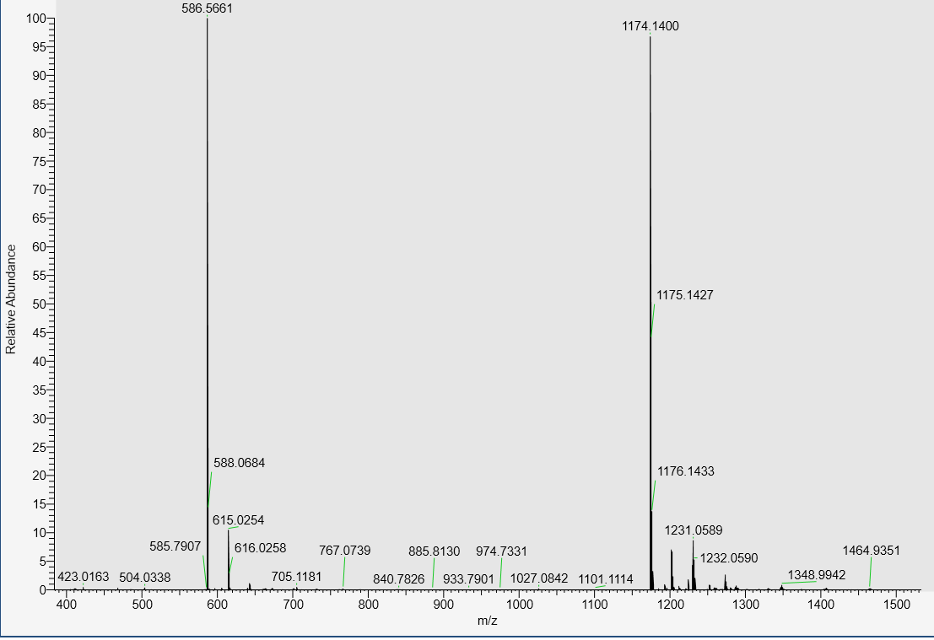
LC-MS data, calculated mass: 1175.1484, detected m/z: 1174.1400 (M-H)

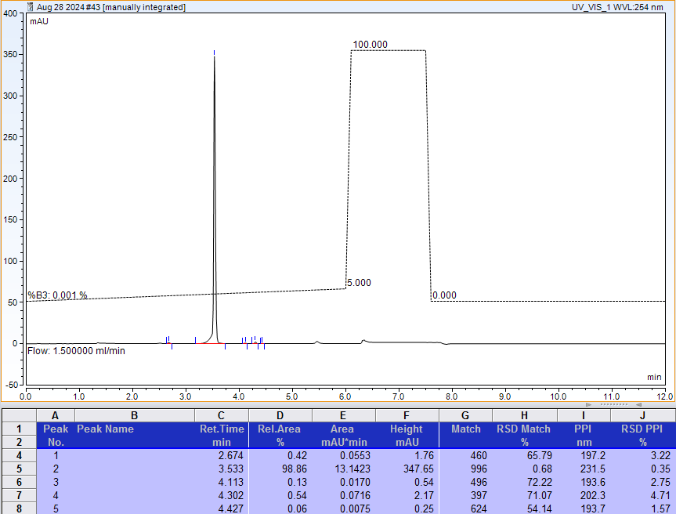
AX-HPLC Analysis

Compound 2-4A12
Mixture of two diastereomers (asymmetric phosphorus is shown in bold)

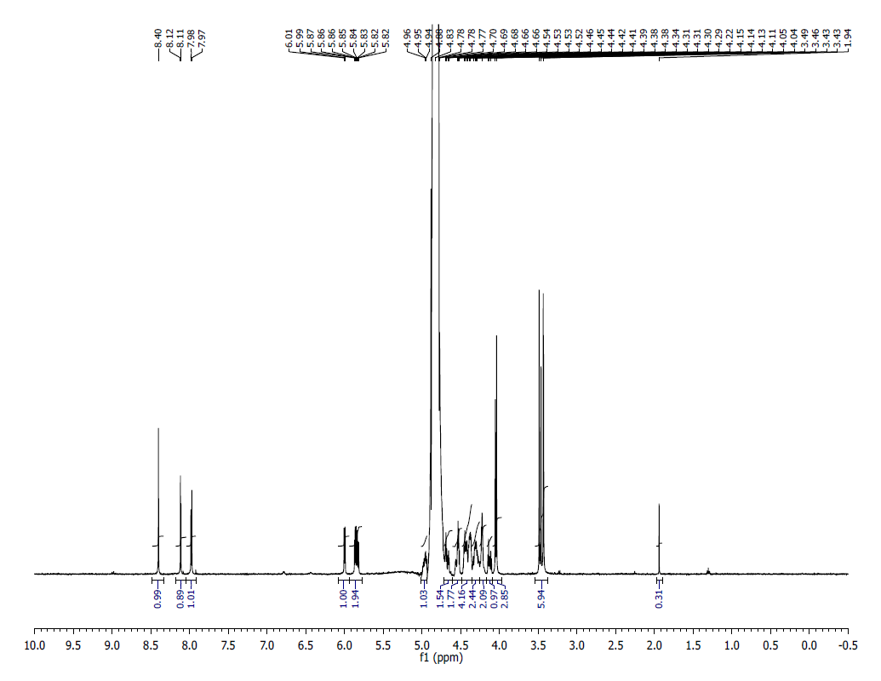
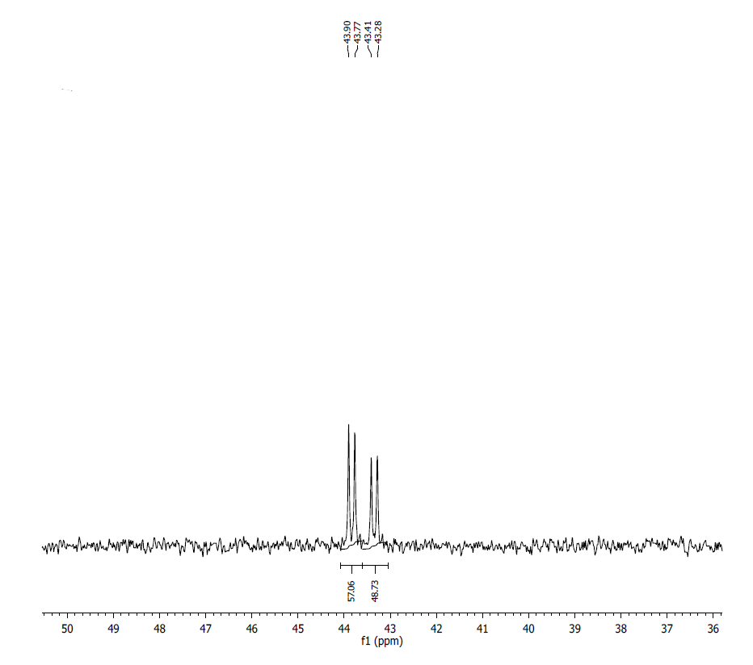
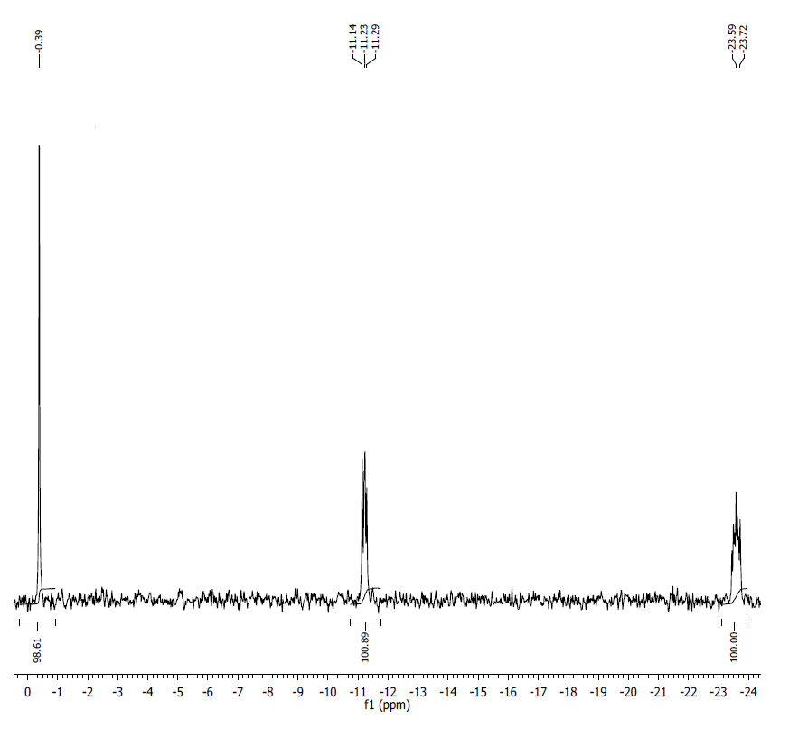

¹H NMR (500 MHz, D2O) δ: 8.40 (s, 1H), 8.17 (d, J=3.1Hz, 1H), 7.98 (d, J=5.8 Hz, 1H), 6.00 (d, J=5.85 Hz, 1H), 5.86-5.81 (m, 2H), 4.97-4.88 (m, 1H), 4.69-4.68 (m, 2H), 4.66-4.65 (m, 2H), 4.45-4.37 (m, 4H), 4.33-4.30 (m, 2H), 4.28-4.22 (m, 2H), 4.15-4.10 (m, 1H), 4.05-4.03 (d, J=8.15, 3H), 3.48-3.42 (m, 6H), 1.93 (s, 1H).
³¹P NMR (200 MHz, D2O) δ (overlapping signals of two diastereomers, tentative assignment). Diastereomer 1: 43.84 (1P), 0.39 (1P), -11.23 (1P), -23.65 (1P); Diastereomer 2: 43.35 (1P), 0.39 (1P), -11.23 (1P), -23.65 (1P).
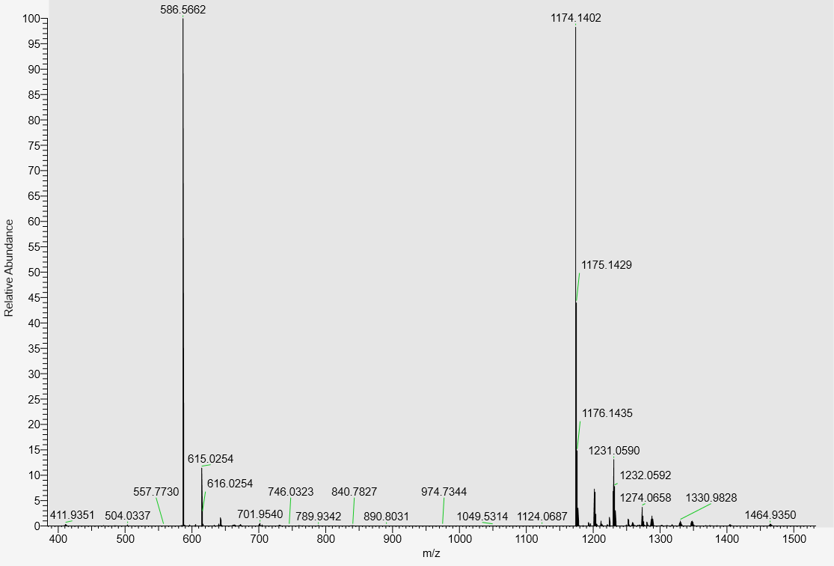
LC-MS data, calculated mass: 1175.1484; detected m/z: 1174.1402 (M-H)

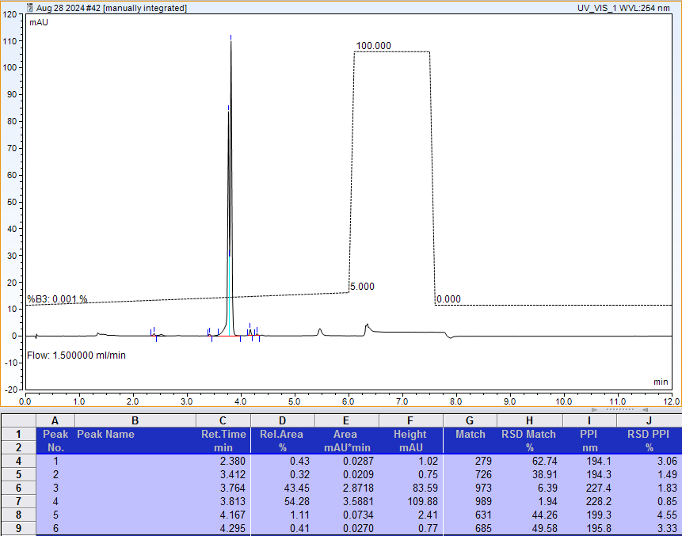
AX-HPLC Analysis (total: 43.45 + 54.28 = 97.73%)

Compound 2-5A1
Diastereomer 1 (asymmetric phosphorus is shown in bold)
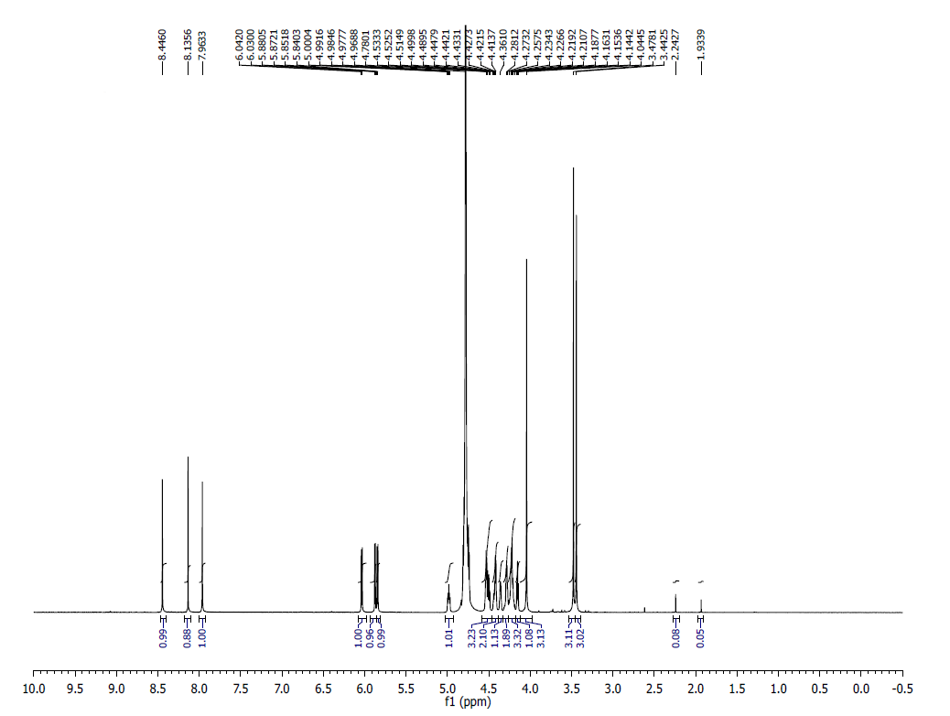
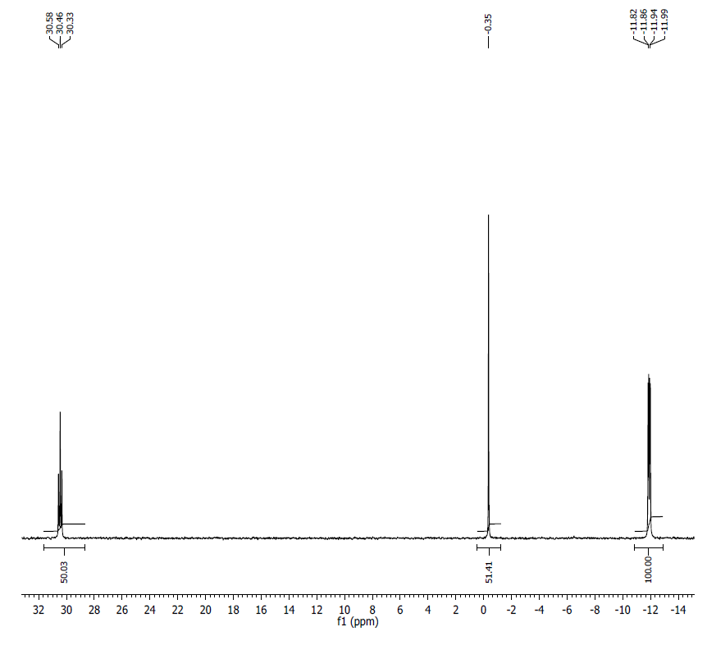
¹H NMR (500MHz, D₂O) δ: 8.45 (s, 1H), 8.14 (s, 1H), 7.96 (s, 1H), 6.04 (d, J = 6.0, 1H), 5.88 (d, J = 4.2, 1H), 5.85 (d, J = 5.8, 1H), 4.98 (m, 1H), 4.49-4.53 (m, 3H), 4.41-4.45 (m, 2H), 4.36 (m, 1H), 4.19-4.28 (m, 5H), 4.15 (t, J = 4.8, 1H), 4.04 (s, 3H), 3.48 (s, 3H), 3.44 (s, 3H).
³¹P NMR (200 MHz, D₂O) δ: 30.46 (1P), -0.35 (1P), -11.88 (1P), -11.93 (1P).
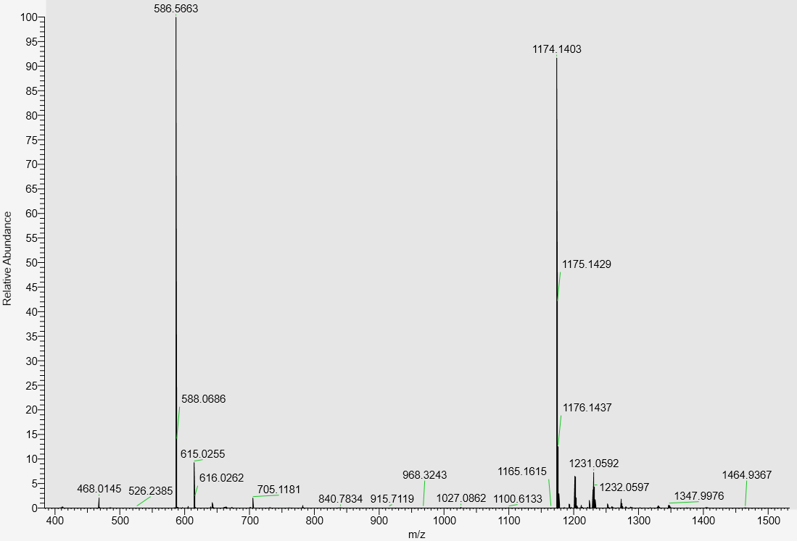
LC-MS data, calculated mass: 1175.1484; detected m/z: 1174.1403 (M-H)

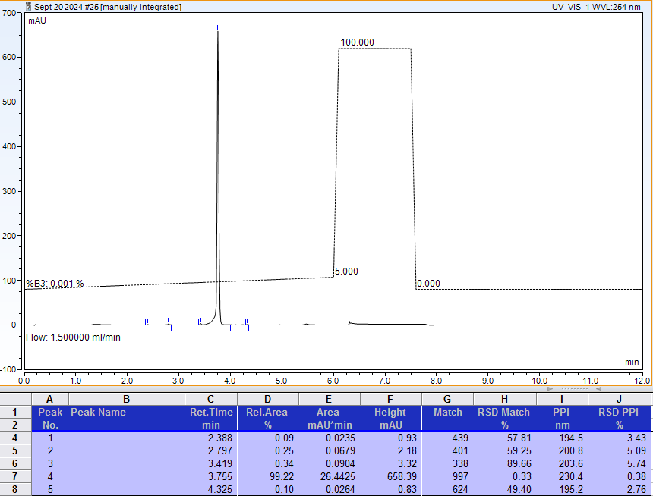
AX-HPLC Analysis

Compound 2-5A2
Diastereomer 2 (asymmetric phosphorus is shown in bold)

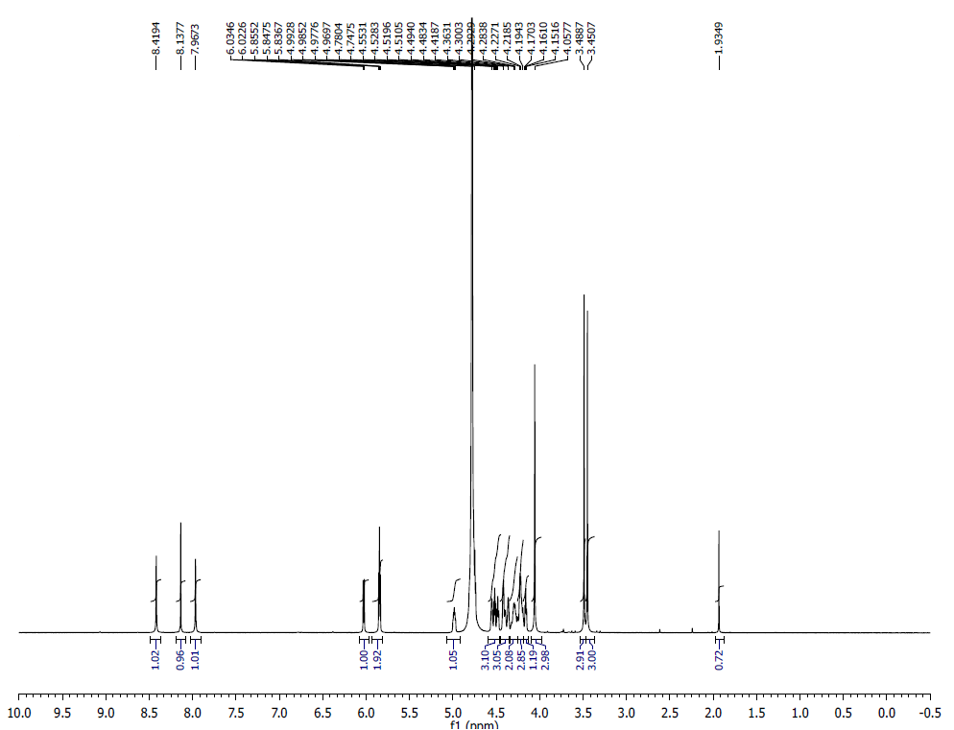
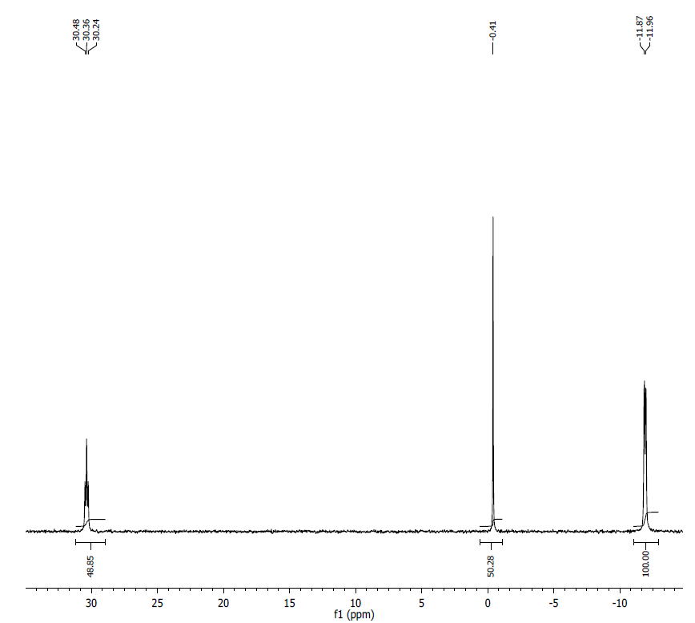
¹H NMR (500MHz, D₂O) δ: 8.42 (s, 1H), 8.14 (s, 1H), 7.97 (s, 1H), 6.03 (d, J = 6.0, 1H), 5.85 (m, 2H), 4.98 (m, 1H), 4.51-4.55 (m, 3H), 4.36-4.48 (m, 3H), 4.19-4.30 (m, 5H), 4.16 (t, J = 4.7, 1H), 4.06 (s, 3H), 3.49 (s, 3H), 3.45 (s, 3H).
³¹P NMR (200 MHz, D₂O) δ: 30.36 (1P), -0.41 (1P), -11.92 (2P).

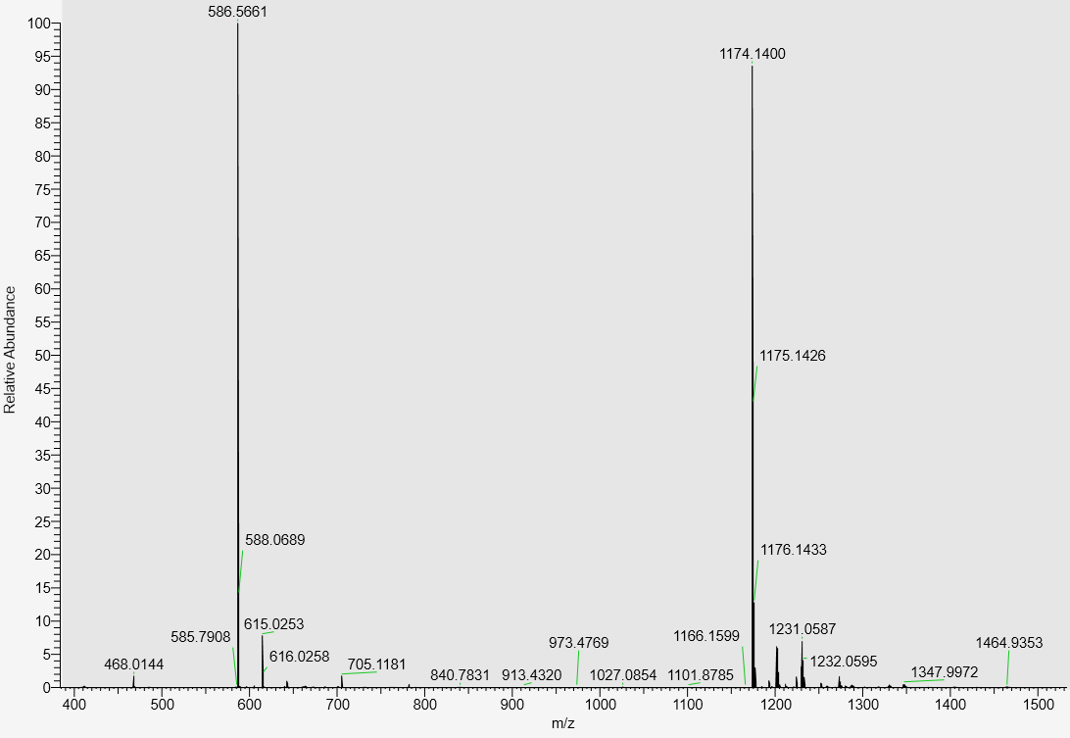
LC-MS data, calculated mass: 1175.1484, detected m/z: 1174.1400 (M-H)

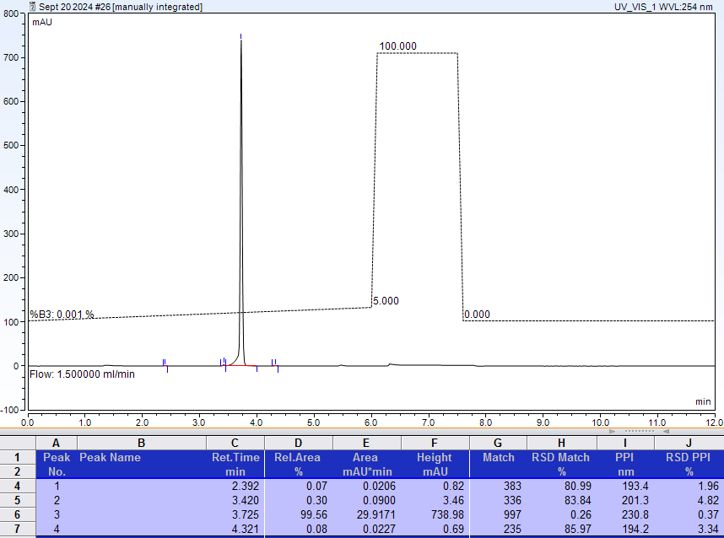
AX-HPLC Analysis
Compound 2-6A12
Mixture of two diastereomers (asymmetric phosphorus is shown in bold)
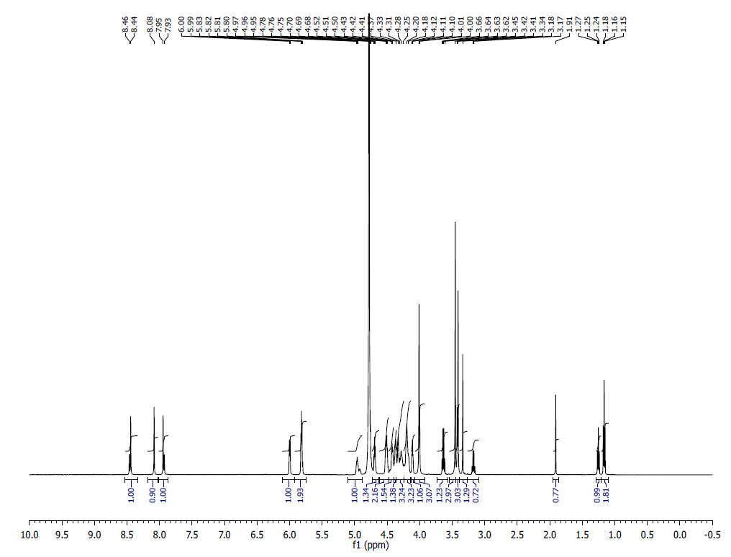
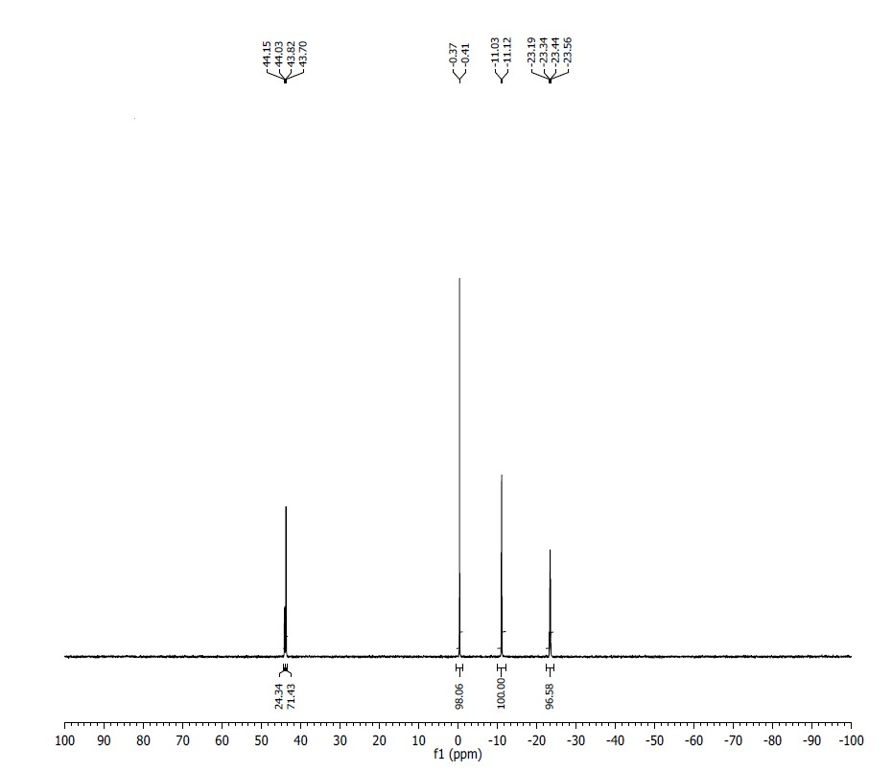
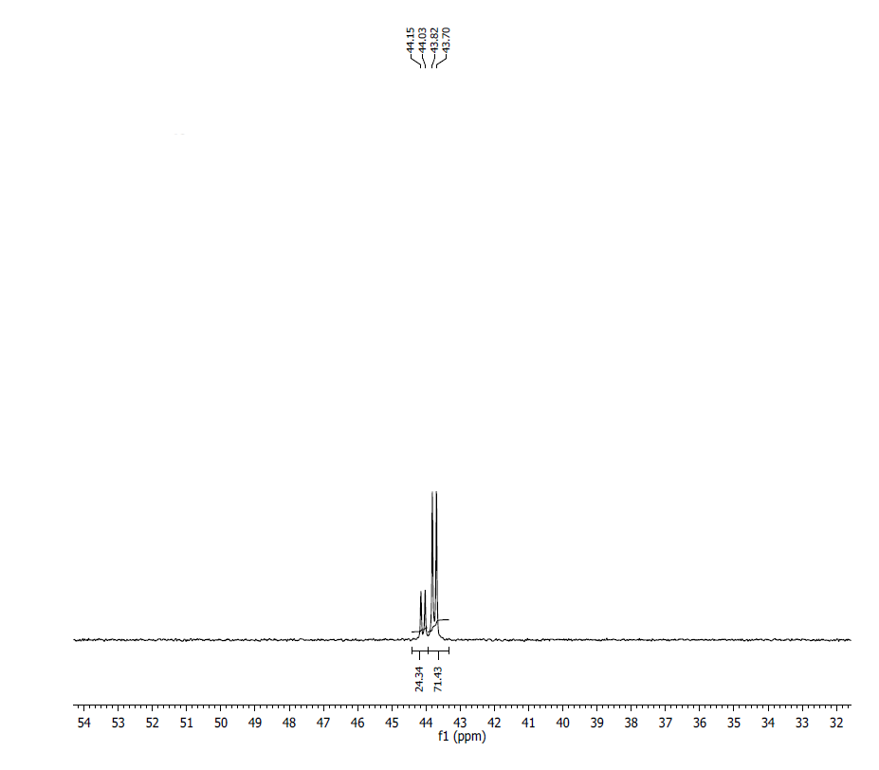
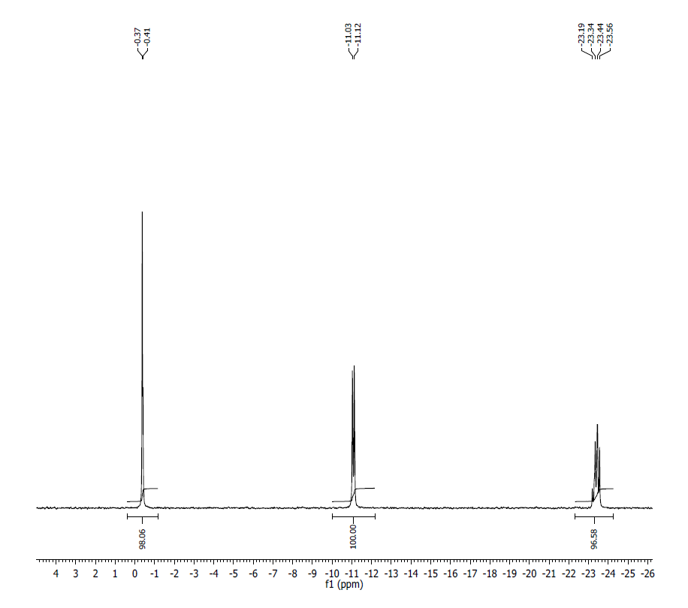
¹H NMR (500 MHz, D2O) δ: 8.44 (s, 1H), 8.08 (s, 1H), 7.93 (s, 1H), 6.00 (m, 1H), 5.83 (m, 2H), 4.95 (m, 1H), 4.68 (m, 1H), 4.50 (m, 2H), 4.42 (m, 1H), 4.37 (m, 1H), 4.33 – 4.25 (m, 3H), 4.20 (m, 3H), 4.12 (m, 1H), 4.01 (s, 3H), 3.45 (s, 3H), 3.41 (s, 3H). Sample contains residual acetate ion, triethylammonium ion, and ethanol signals.
³¹P NMR (200 MHz, D2O) δ: (overlapping signals of two diastereomers, tentative assignment): Diastereomer 1 (minor): 44.09 (1P), -0.37 (1P), -11.06 (1P), -23.32 (1P); Diastereomer 2 (major): 43.76 (1P), -0.41 (1P), -11.08 (2P), -23.44 (1P).

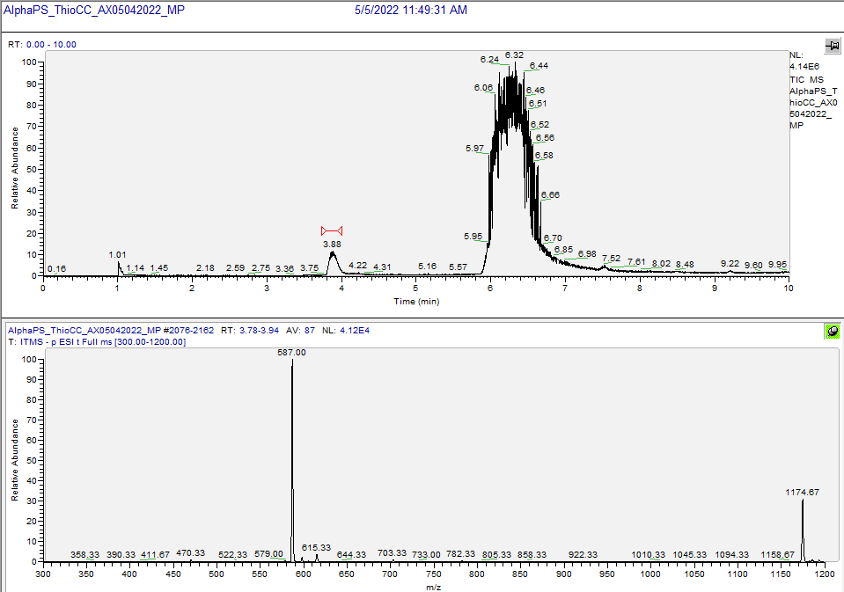
LC-MS data, calculated mass: 1175.1484; detected m/z: 1174.67 (M-H) (low resolution, partial deuterium substitution)
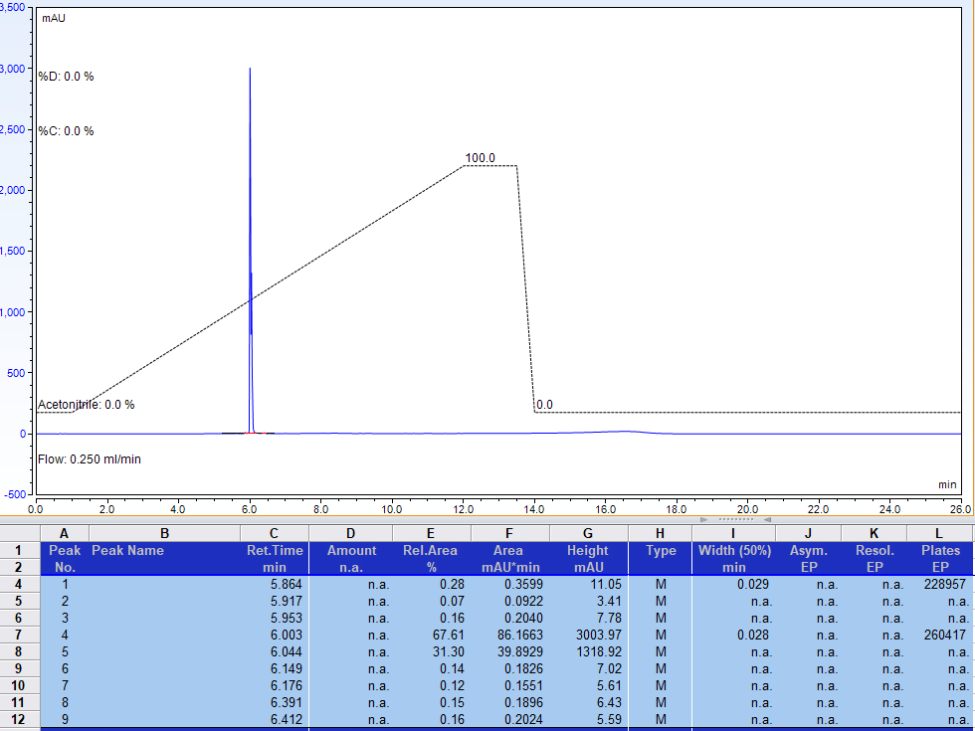
RP-HPLC analysis. Gradient of acetonitrile in 100 mM Triethylammonium acetate, pH 6.8 (total: 67.61 + 31.30 = 98.91%)
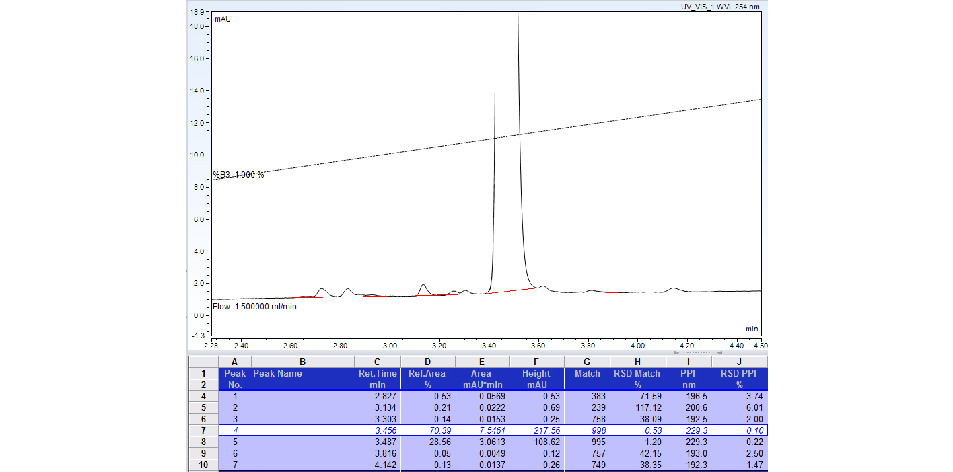
AX-HPLC analysis (total: 70.39 + 28.56 = 98.95%)

Compound 2-7A
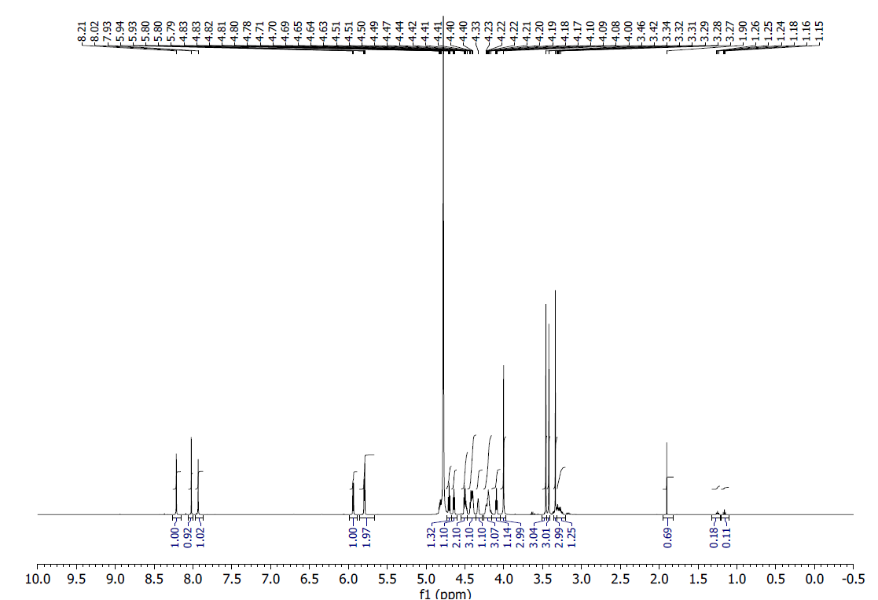
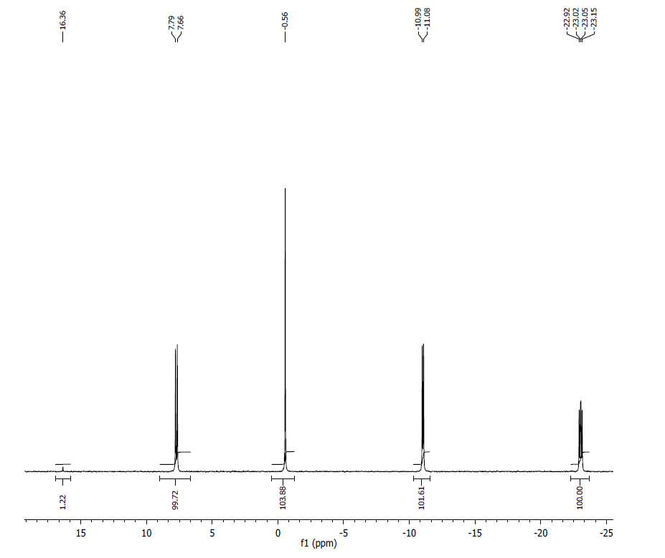
¹H NMR (500 MHz, D2O) δ: 8.21 (s, 1H), 8.02 (s, 1H), 7.93 (s, 1H), 5.93 (d, J = 5 Hz, 1H), 5.79 (m, 2H), 4.81 (m, 1H), 4.70 (m, 1H), 4.64 (m, 1H), 4.50 (m, 2H), 4.42 (m, 3H), 4.33 (m, 1H), 4.21 (m, 3H), 4.08 (t, J = 5 Hz, 1H), 4.00 (s, 3H), 3.46 (s, 3H), 3.42 (s, 3H).

³¹P NMR (200 MHz, D2O) δ: 7.73 (1P), -0.56 (1P), -11.04 (1P), -23.04 (1P).
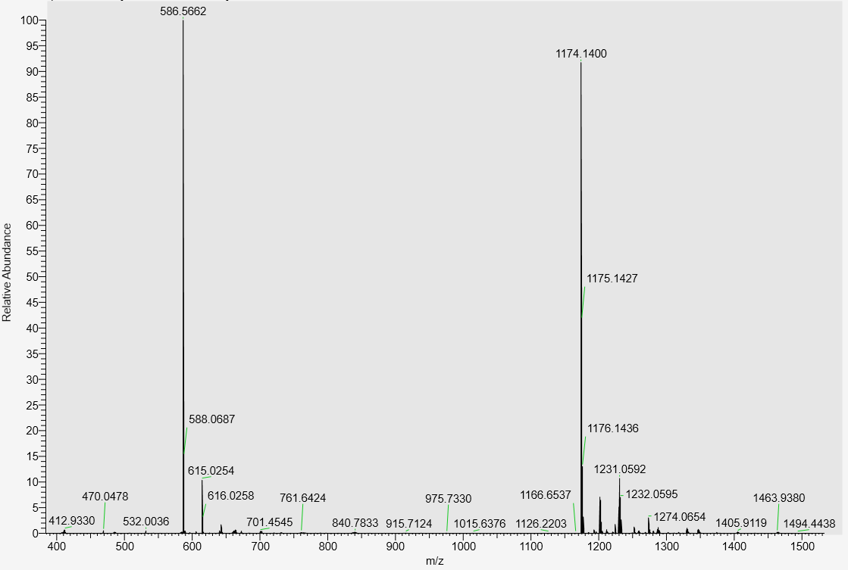

LC-MS data, calculated mass: 1175.1484; detected m/z: 1174.1400 (M-H)

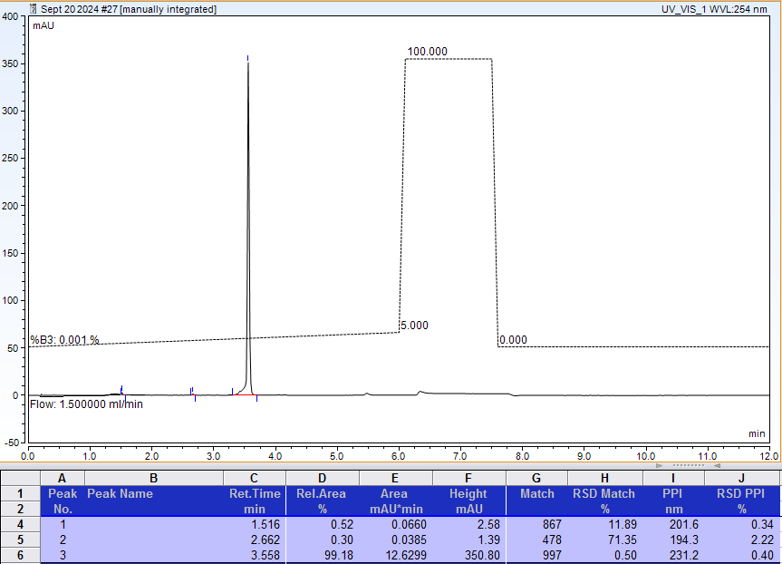
AX-HPLC Analysis
Compound 2-8A

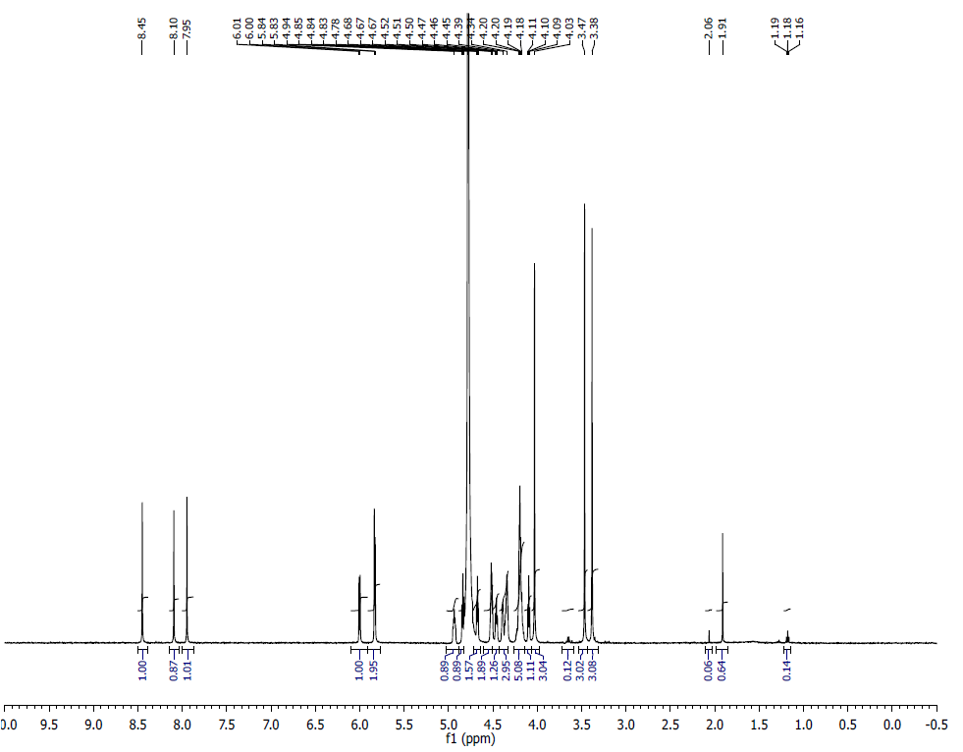
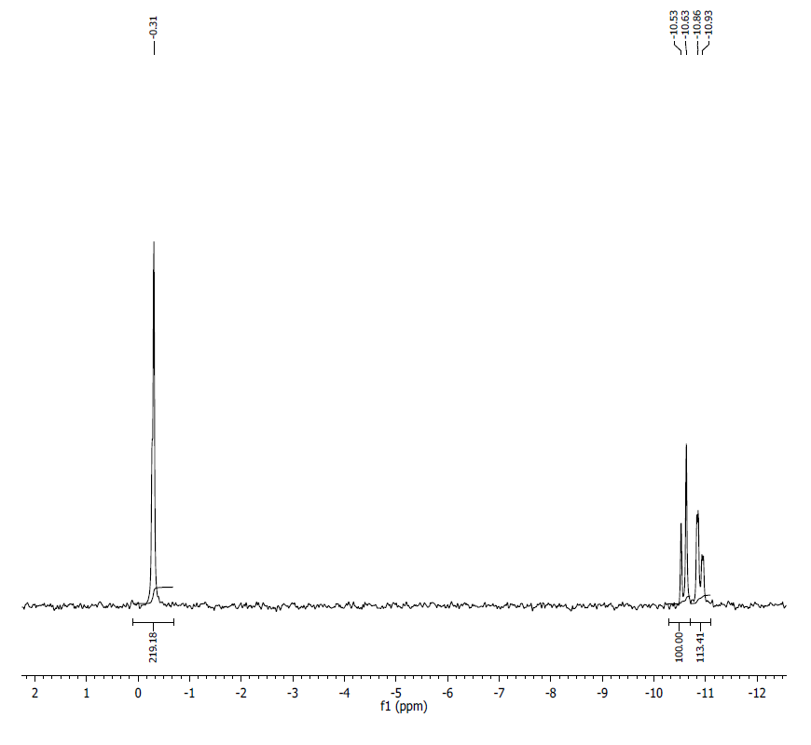
¹H NMR (500 MHz, D₂O) δ: 8.45 (s, 1H), 8.09 (s, 1H), 7.94 (s, 1H), 6.00 (d, J=6.2Hz, 1H), 5.83 (d, J=5.0Hz, 2H), 4.93 (m, 1H), 4.84-4.82 (m, 1H), 4.68-4.66 ( t, J=4.55Hz, 2H), 4.52-4.50 (m, 2H), 4.47-4.45 (t, J=5.5Hz), 4.38-4.34 (m, 3H), 4.20-4.17 (m, 5H), 4.10-4.08 (t, J=4.95, 1H), 4.03 (s, 3H), 3.46 (s, 3H) 3.38 (s, 3H), 1.91 (s, 1H).
³¹P NMR (202 MHz, D2O) δ: 0.28-0.31 (2P), -10.59 (1P), -10.88 (1P).
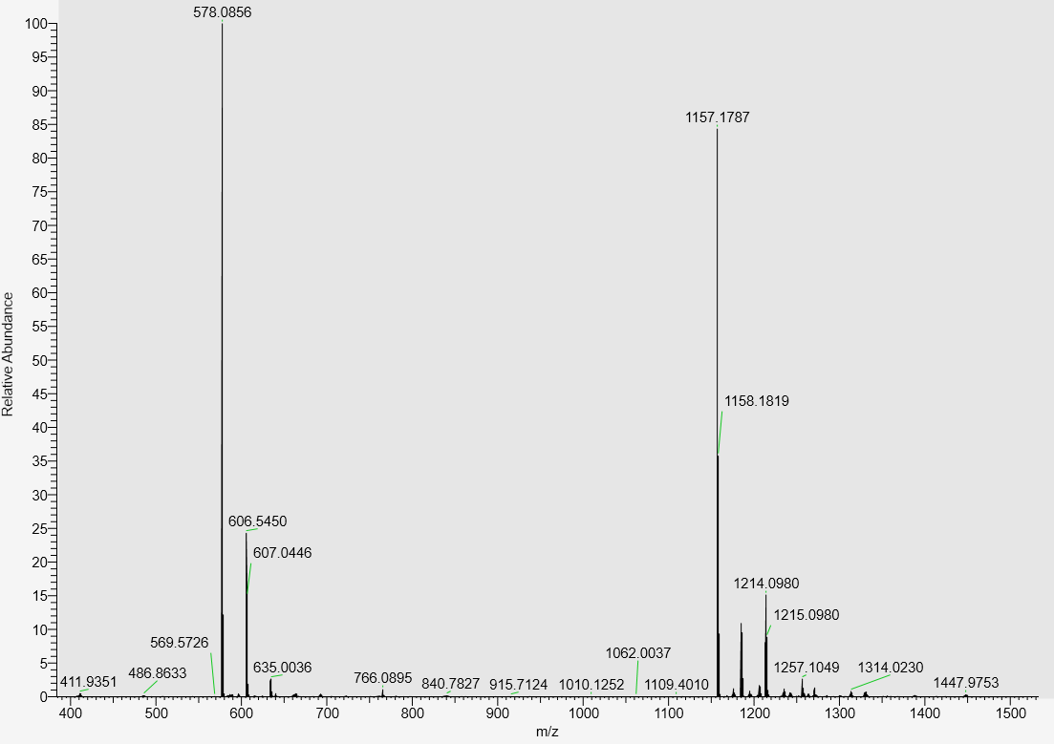
LC-MS data: calculated mass: 1158.1872; detected m/z: 1157.1787 (M-H)

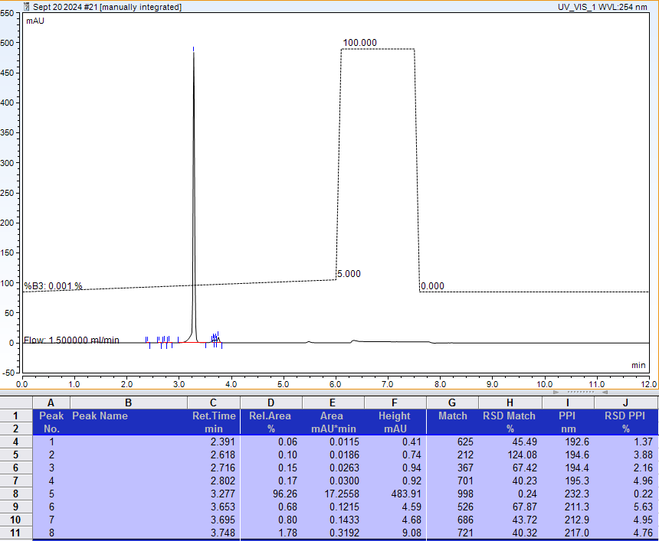
AX-HPLC Analysis
Compound 2-9A

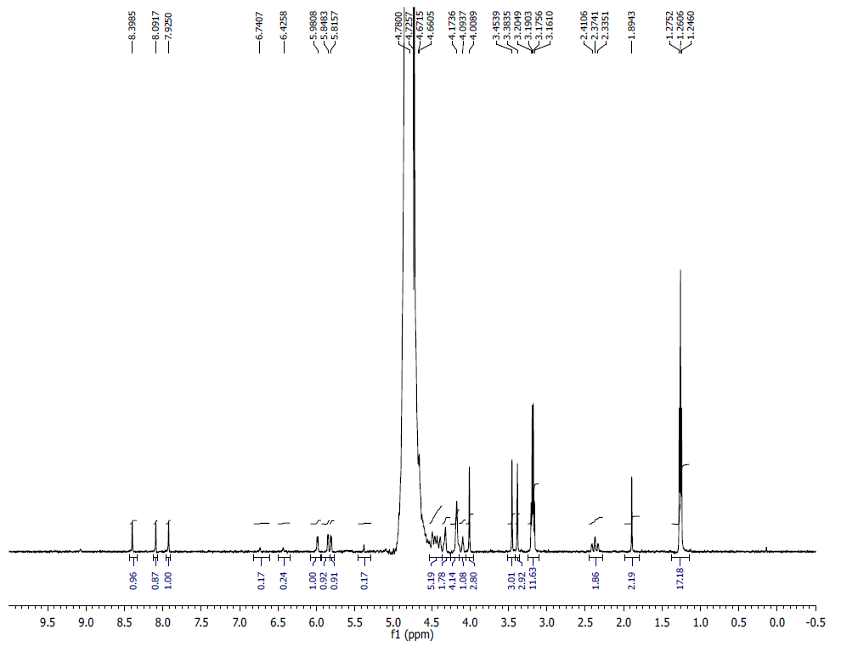
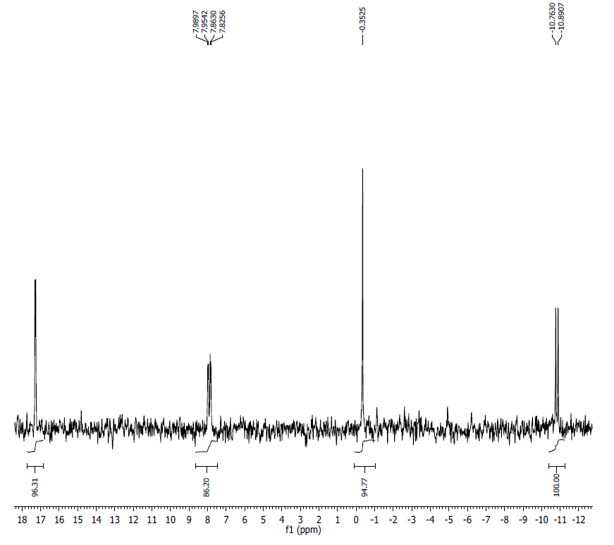
¹H NMR (500 MHz, D₂O) δ: 8.39 (s, 1H), 8.09 (s, 1H), 7.92 (s, 1H), 5.98 (s, 1H), 5.99-5.81 (m, 2H), 4.67-4.66 (m, 5H), 4.17-4.09 (m, 5H), 4.00 (s, 1H), 3.45 (s, 3H), 3.38 (s, 3H), 3.20-3.16 (m, 12H), 2.41-2.33 (m, 2H), 1.89 (s, 1H). Note: mixed Na⁺ and TEAH⁺ salt form.
³¹P NMR (202 MHz, D2O) δ: 17.40 (1P), 7.91(1P), -0.35 (1P), -10.83 (1P).
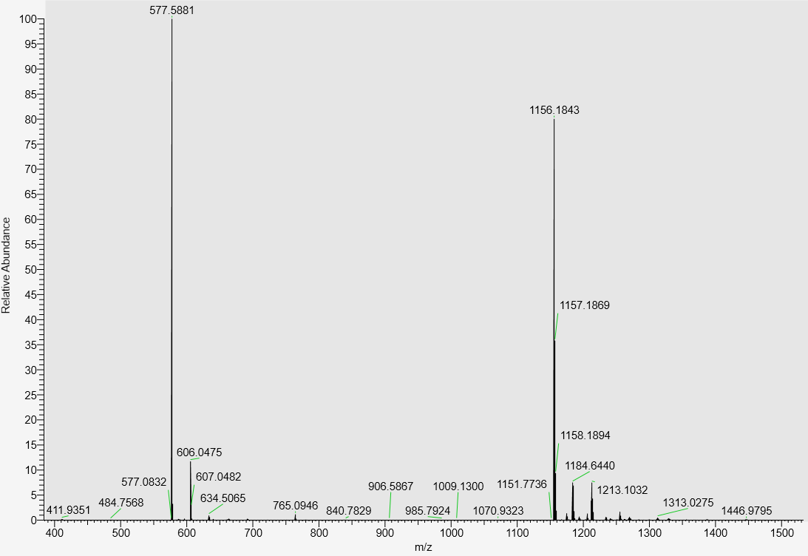
LC-MS data, calculated mass: 1157.1920; detected m/z: 1156.1843 (M-H)

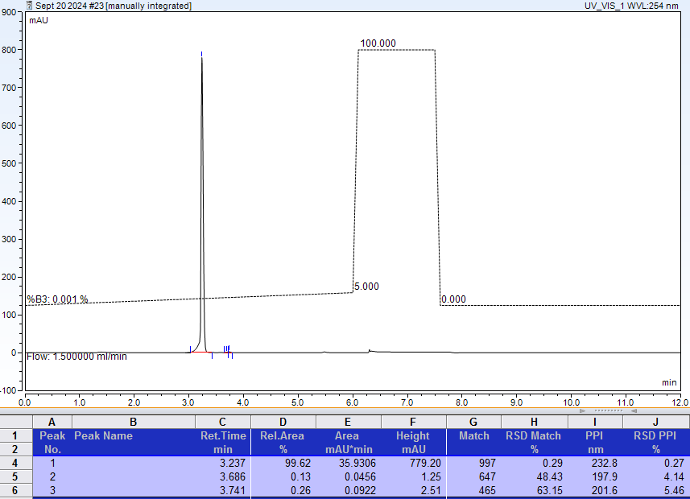
AX-HPLC Analysis
Compound 2-10A
E-isomer
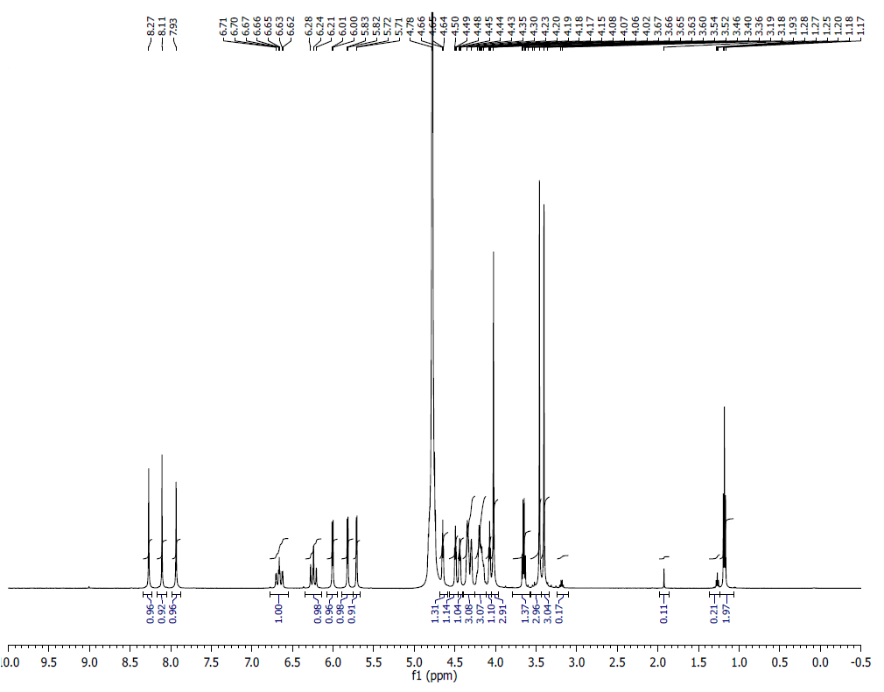
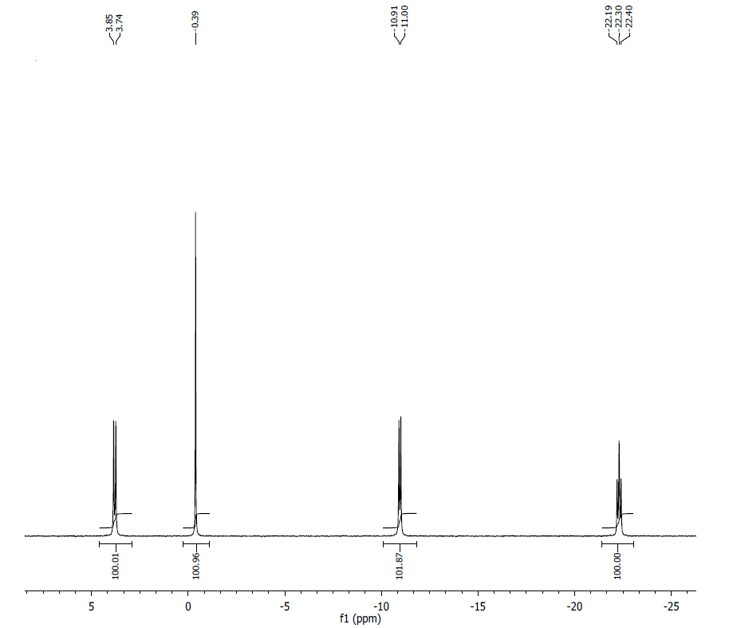
¹H NMR (500 MHz, D₂O) δ: 8.27 (s, 1H), 8.11 (s, 1H), 7.93 (s, 1H), 6.62 (m, 1H), 6.21 (t, J = 17.5 Hz, 1H), 6.00 (d, J = 5.9 Hz, 1H), 5.82 (d, J = 5.45 Hz, 1H), 5.71 (d, J = 4.25 Hz, 1H), 4.64 (m, 1H), 4.48 (m, 1H), 4.43 (m, 1H), 4.35 – 4.23 (m, 3H), 4.15 (m, 3H), 4.08 (m, 1H), 4.02 (s, 3H), 3.46 (s, 3H), 3.40 (s, 3H).
³¹P NMR (200 MHz, D₂O) δ: 3.79 (1P), -0.39(1P), -10.96 (2P), -22.30(1P).
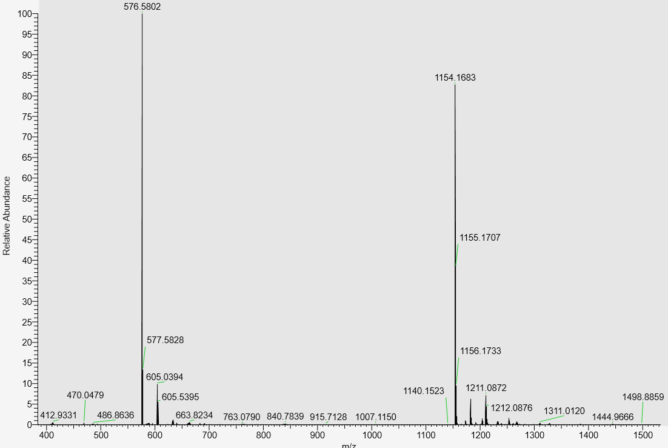
LC-MS data, calculated mass: 1155.1763; detected m/z: 1154.1683 (M-H)

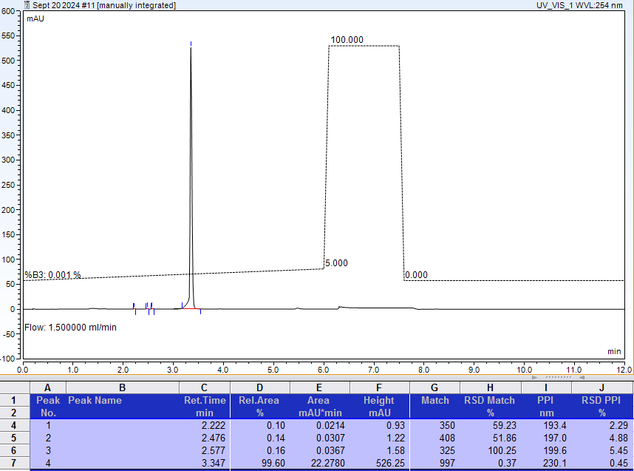
AX-HPLC Analysis

Compound 2-11A
E-isomer

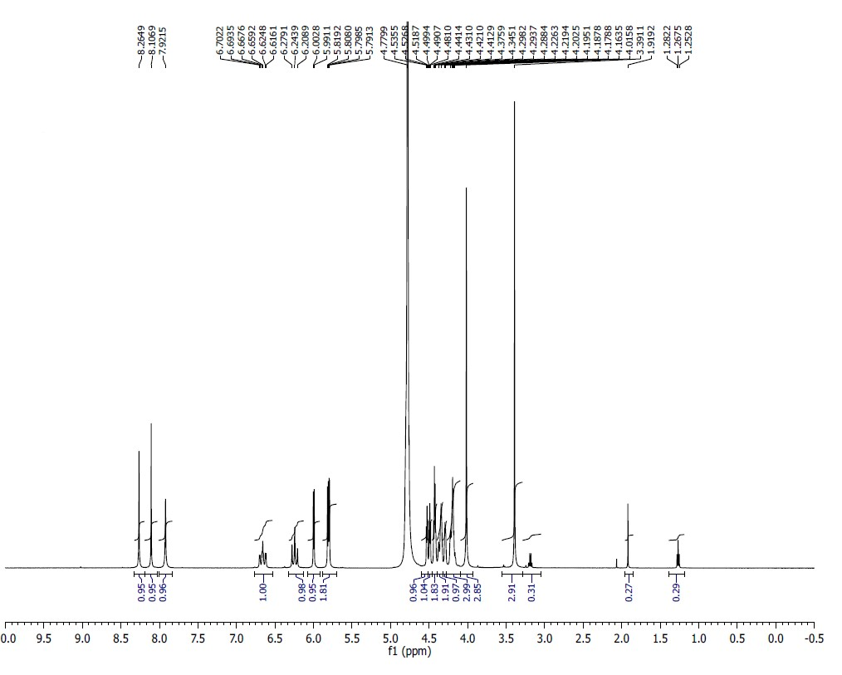
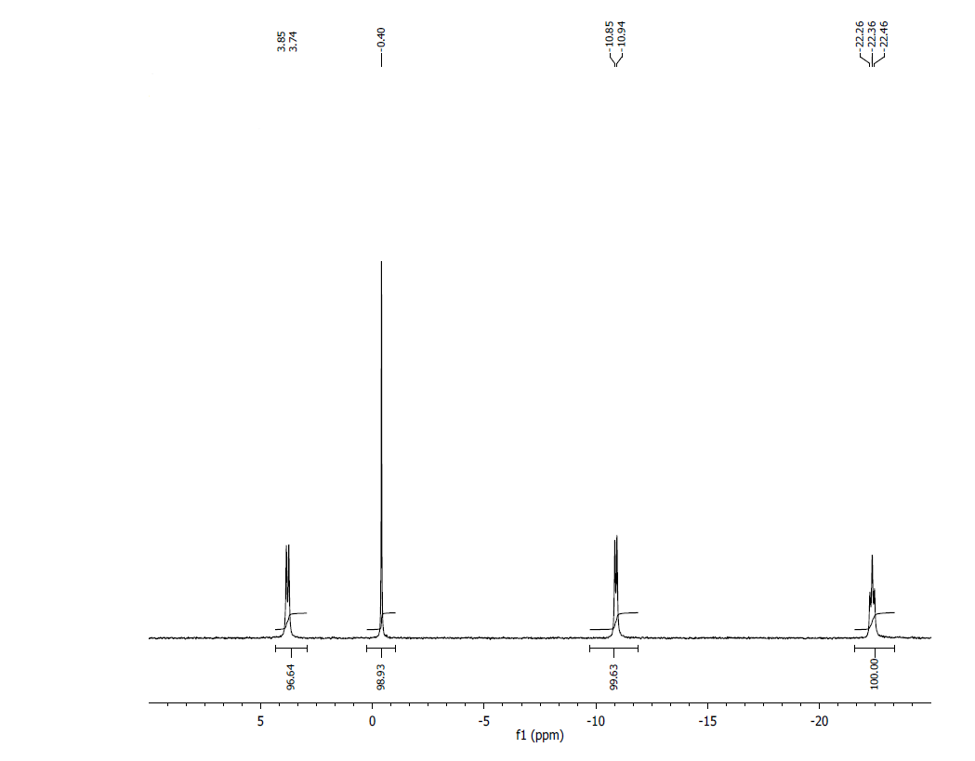
¹H NMR (500 MHz, D₂O) δ: 8.26 (s, 1H), 8.11 (s, 1H), 7.92 (s, 1H), 6.62 (m, 1H), 6.21 (t, J = 17.6 Hz, 1H), 6.00 (d, J = 5.9 Hz, 1H), 5.79 (m, 2H), 4.54 – 4.35 (m, 7H), 4.16 (m, 3H), 4.02 (s, 3H), 3.39 (s, 3H).
³¹P NMR (200 MHz, D₂O) δ: 3.79(1P), -0.40(1P), -10.89 (2P), -22.36 (1P).
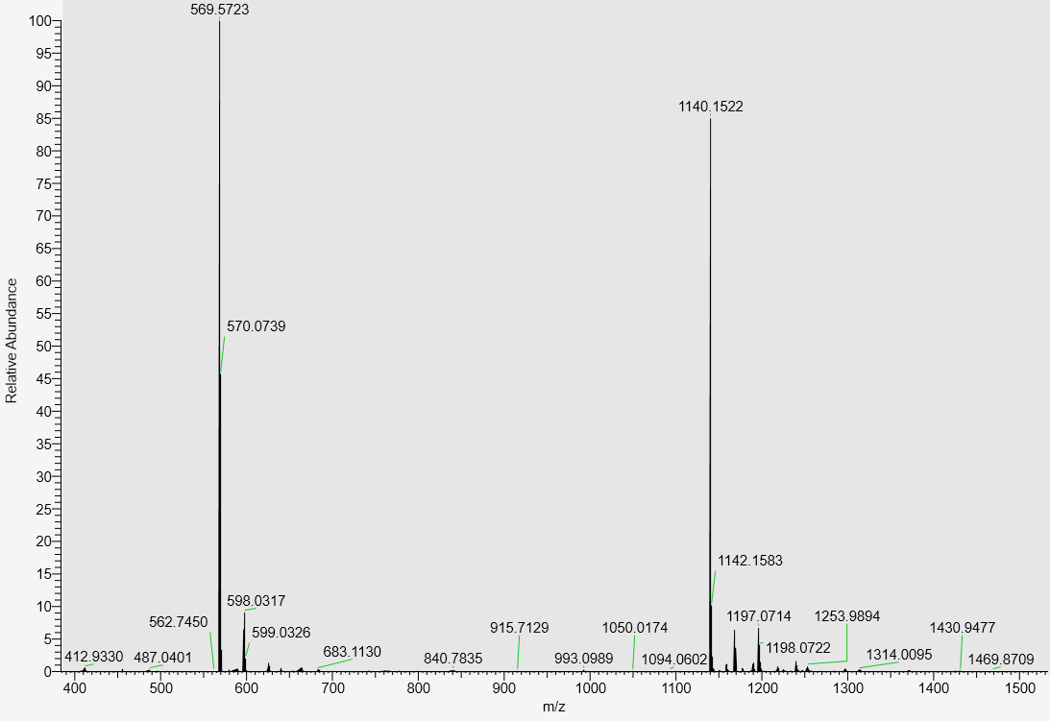
LC-MS data, calculated mass: 1141.1607; detected m/z: 1140.1522 (M-H)

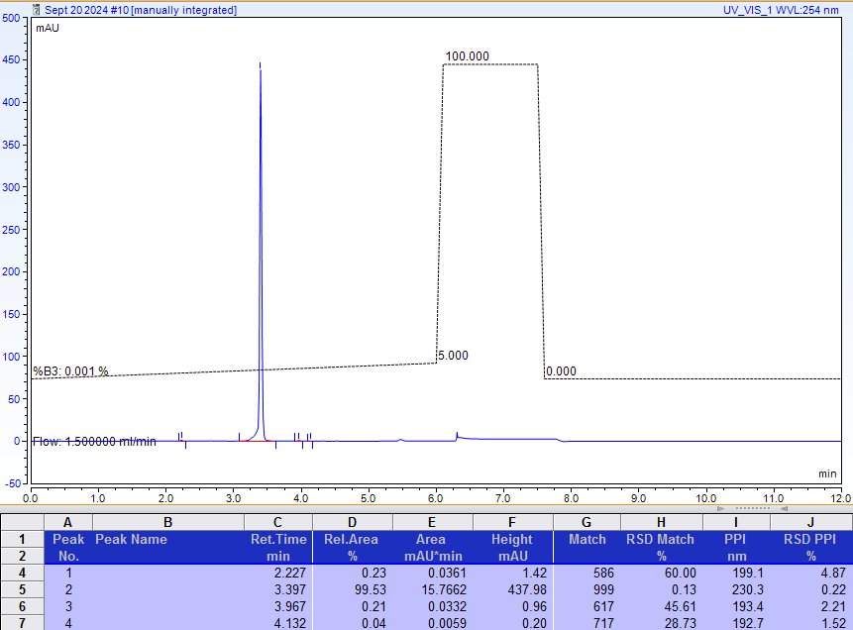
AX-HPLC Analysis
Compounds related to Table 2, Series B
Compound 2-1B

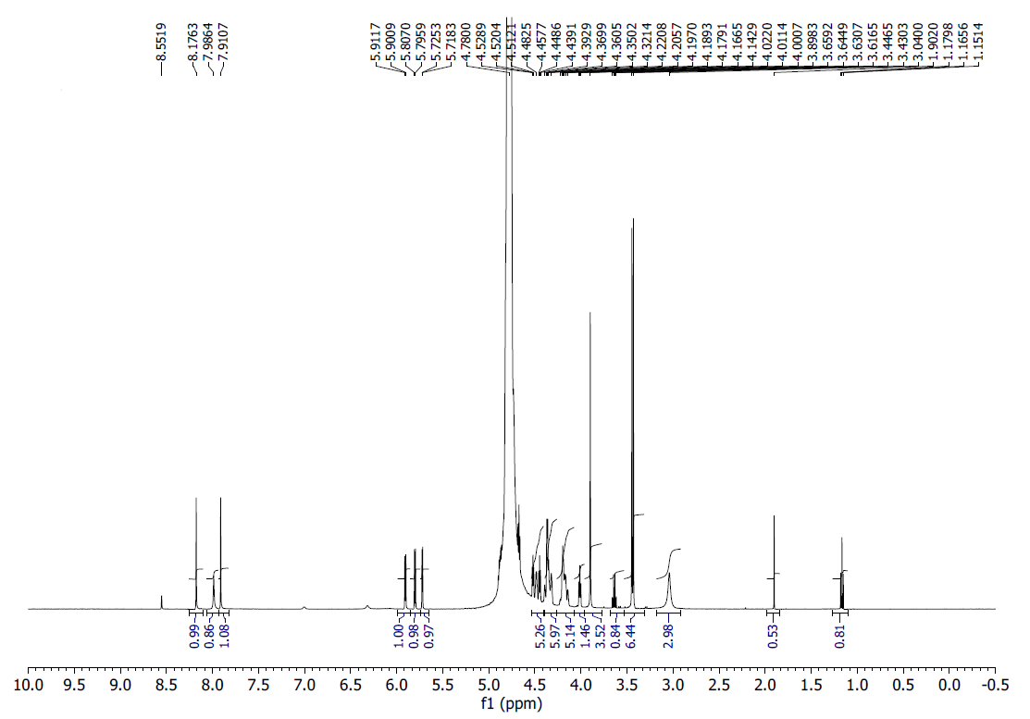
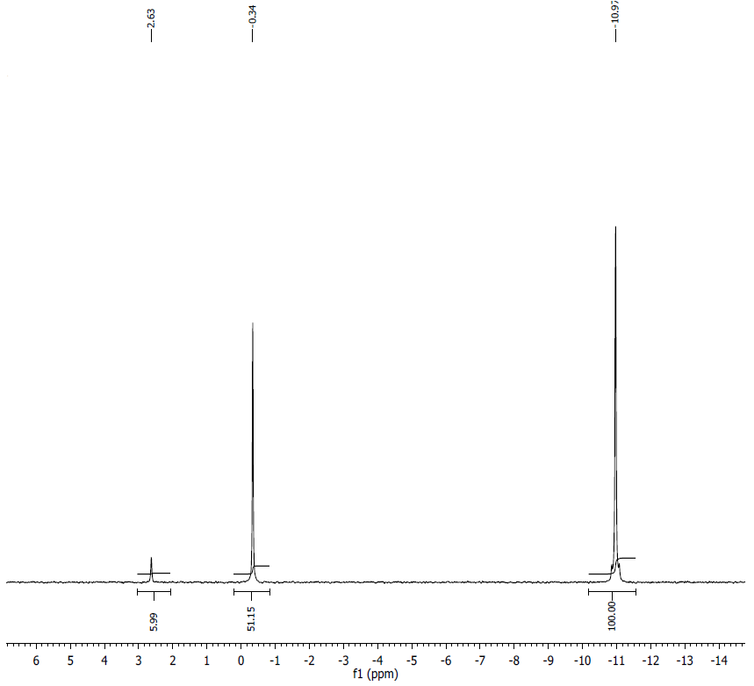
¹H NMR (500MHz, D2O) δ: 8.18 (s, 1H), 7.99 (s, 1H), 7.91 (s, 1H), 5.91 (d, J = 5.4, 1H), 5.80 (d, J = 5.6, 1H), 5.72 (d, J = 3.5, 1H), 4.52 (t, J = 4.3, 1H), 4.48 (m, 1H), 4.45 (t, J = 4.6, 1H), 4.32-4.44 (m, 6H), 4.14-4.22 (m, 5H), 4.01 (t, J = 5.3, 1H), 3.90 (s, 3H), 3.45 (s, 3H), 3.43 (s, 3H), 3.04 (bs, 3H)
³¹P NMR (200 MHz, D2O) δ: -0.34 (1P), -10.97 (2P); Signal at 2.63 ppm belongs to inorganic monophosphate contamination.
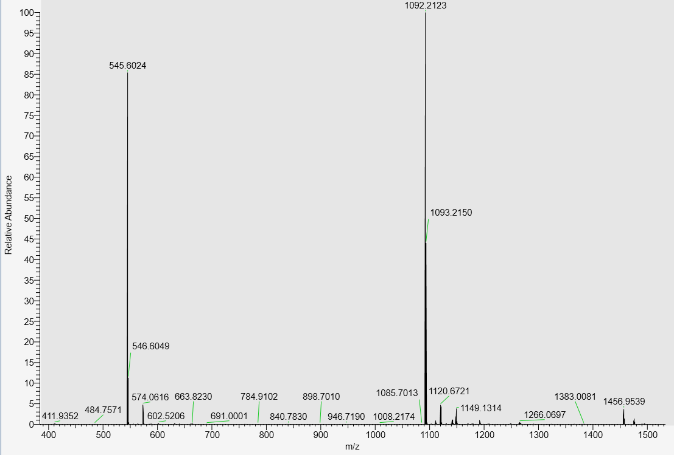
LC-MS analysis, calculated mass: 1093.2206; detected m/z: 1092.2123 (M-H)

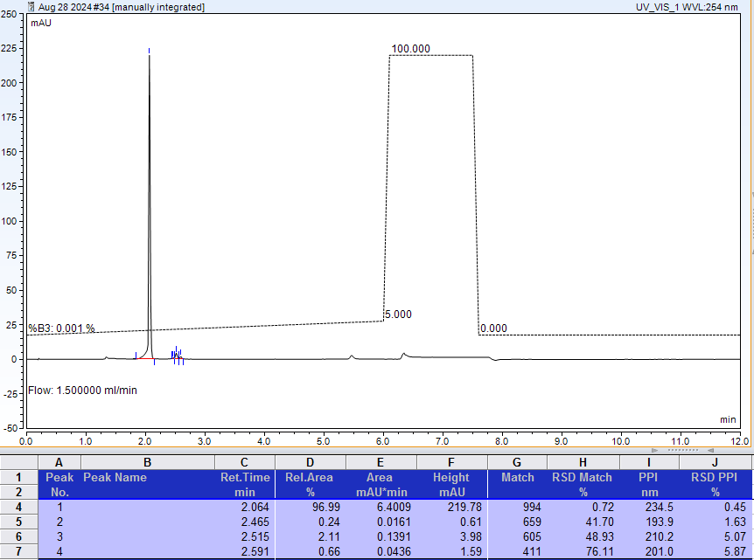
AX-HPLC Analysis

Compound 2-2B
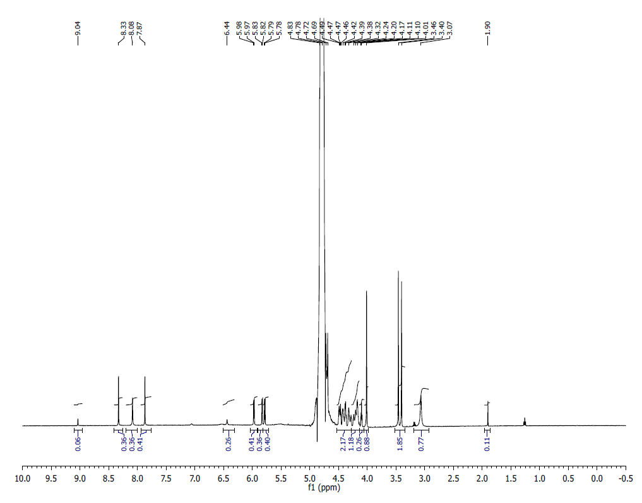
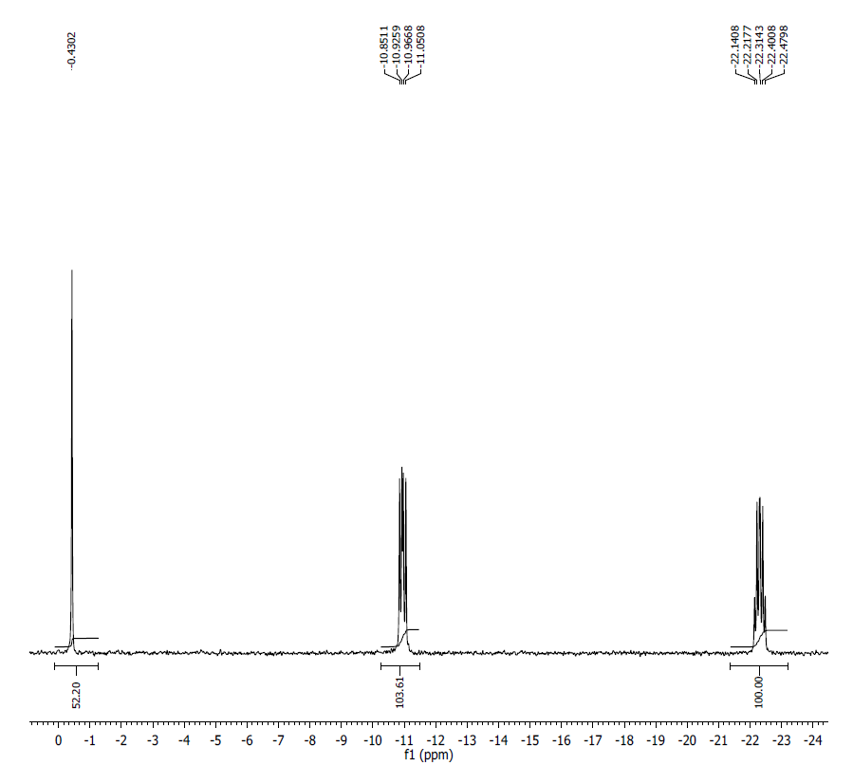
¹H NMR (500 MHz, D₂O) δ: 8.3 (s,1H), 8.08 (s, 1H), 7.86 (s, 1H), 6.44 (s, 1H), 5.97 (d, J=5.5 Hz, 1H) 5.83 (d, J=4.15 Hz, 1H), 5.78 (d, J=5.75 Hz, 1H) 4.48-4.45 (m, 4H), 4.42-4.32 (m, 2H) 4.10-4.09 (m, 1H) 4.01 (s, 3H), 3.45 (s, 3H) 3.40 (s, 2H), 3.06 (bs, 1H), 1.9 (s, 1H).

³¹P NMR (200 MHz, D₂O) δ: 0.43 (1P), -10.92 (1P), -10.98 (1P0, -22.22 (1P), -22.41 (1P).

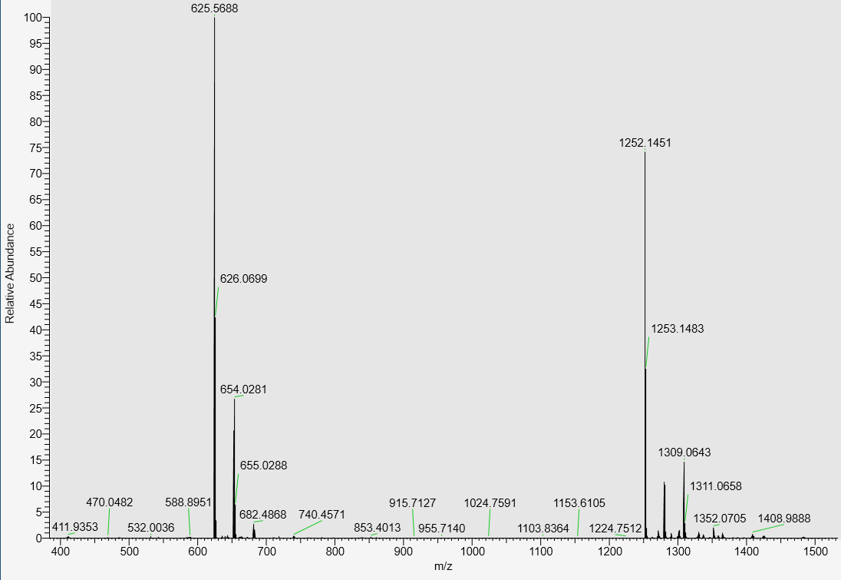

LC-MS data, calculated mass: 1253.1532, detected m/z: 1252.1451 (M-H)

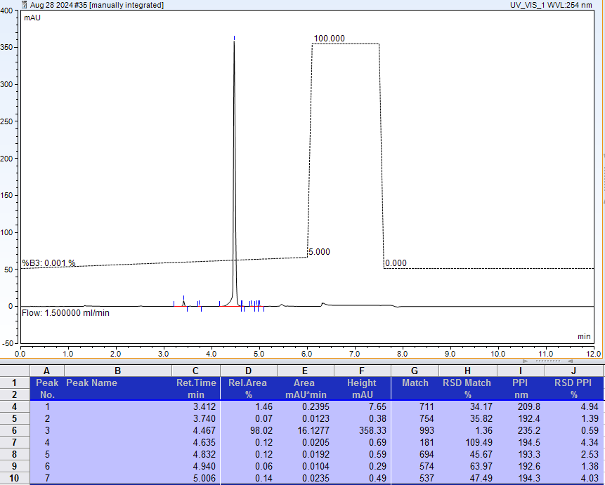

AX-HPLC Analysis

Compound 2-3B

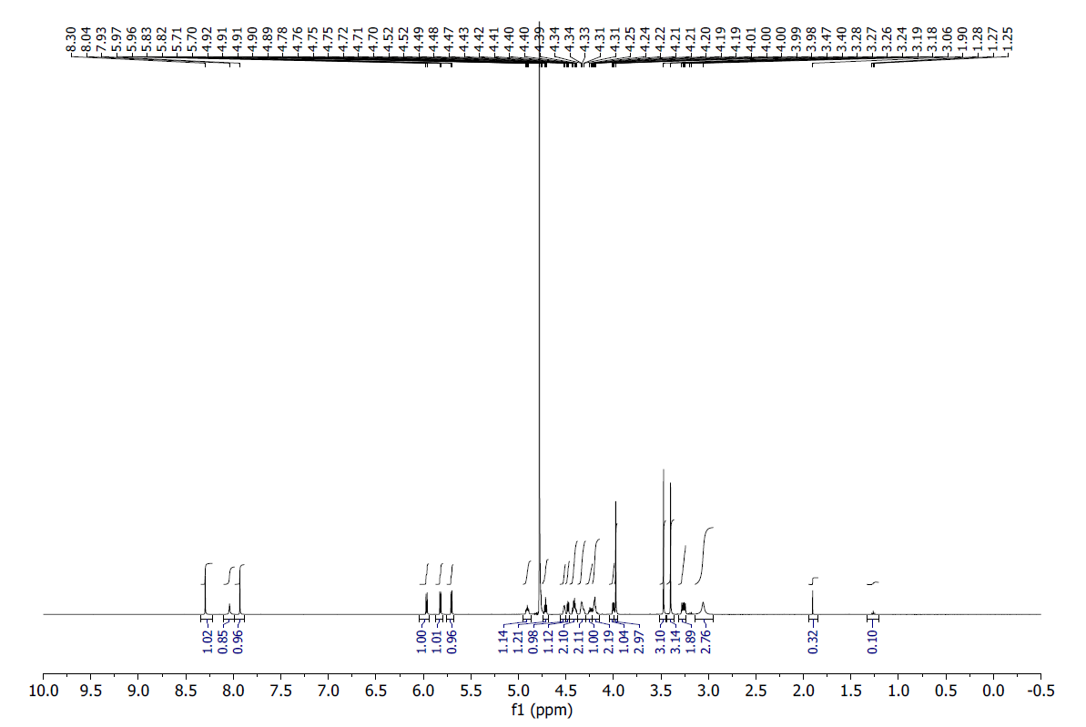
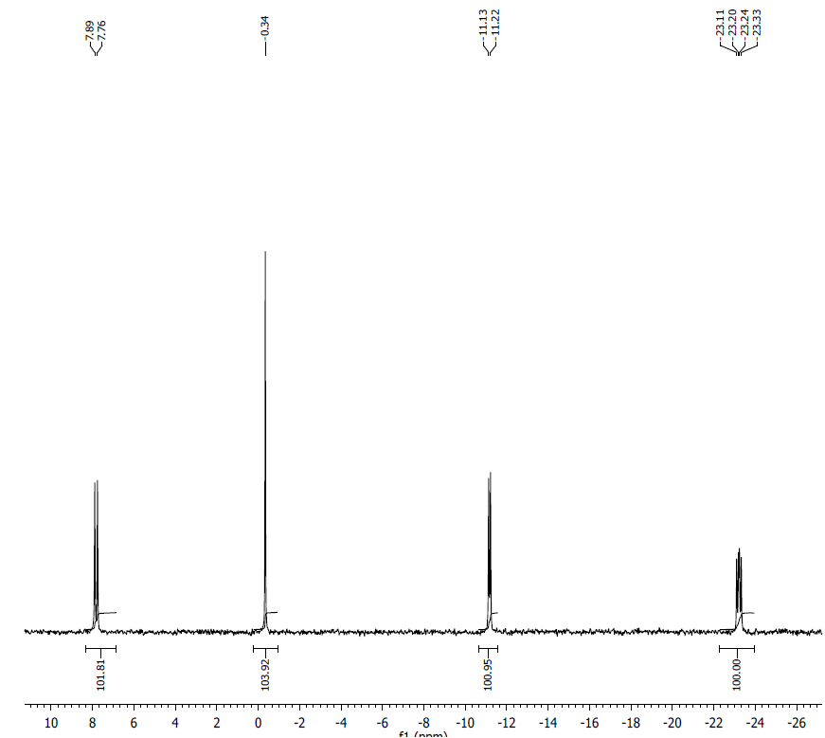
¹H NMR (500 MHz, D₂O) δ: 8.29 (s, 1H), 8.04 (s, 1H), 7.93 (s, 1H), 5.996 (d, J = 6.2 Hz, 1H), 5.821 (d, J = 5.9 Hz, 1H), 5.704 (d, J = 5.5 Hz, 1H), 4.89-4.92, (m, 1H), 4.74 (t, J = 3.6 Hz), 4.48-4.52, (m, 1H), 4.43-4.47 (m, 1H), 4.38-4.40 (m, 2H), 4.30-4.34 (m, 2H), 4.21-4.24 (m, 1H), 4.18-4.20 (m, 2H), 4.00 (t, J = 3.75Hz, 1H), 3.97 (s, 3H), 3.47 (s, 3H), 3.39 (s, 3H), 3.26, (q, J = 6.4Hz, 2H), 3.05, (s, 3H).

³¹P NMR (200 MHz, D₂O) δ: 7.72 (1P), 0.34 (1P), -11.17, (1P), -23.22 (1P).
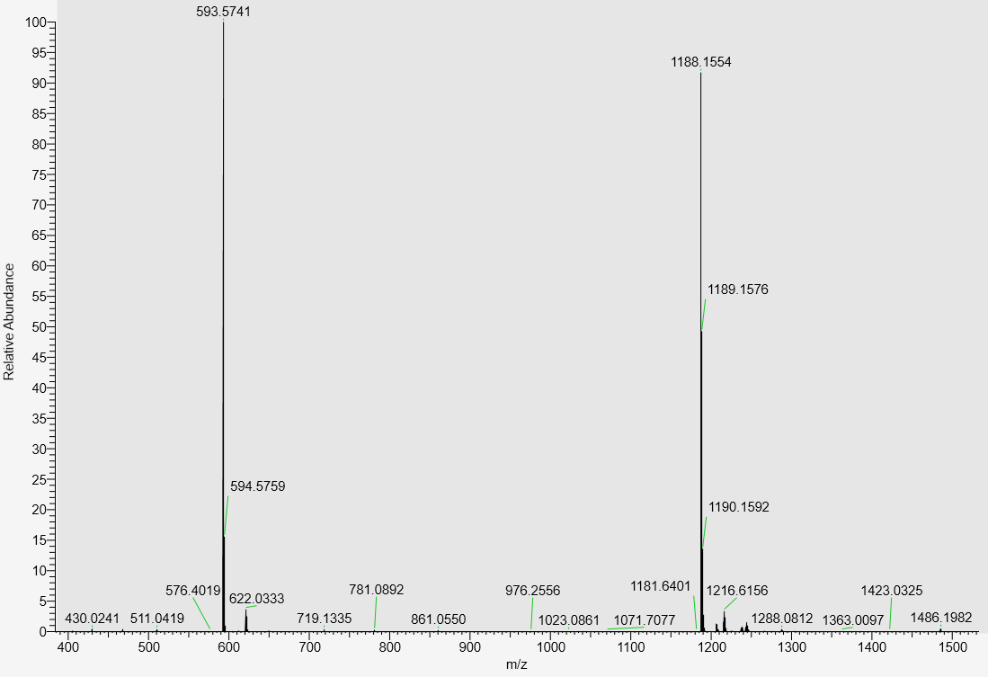
LC-MS data, calculated mass: 1189.1640; detected m/z: 1188.1554 (M-H)

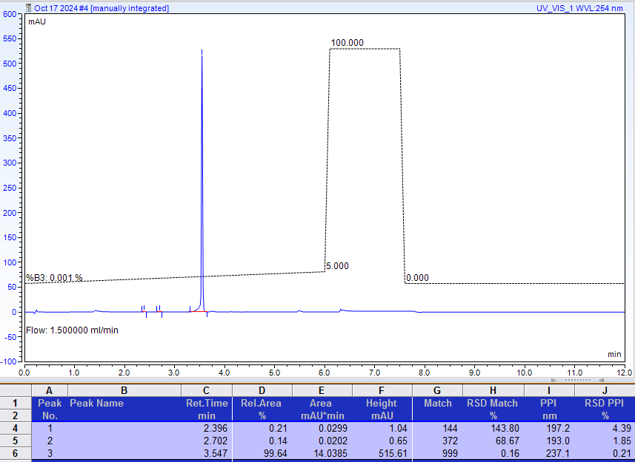
AX-HPLC Analysis
Compound 2-4B12
Mixture of two diastereomers (asymmetric phosphorus is shown in bold)
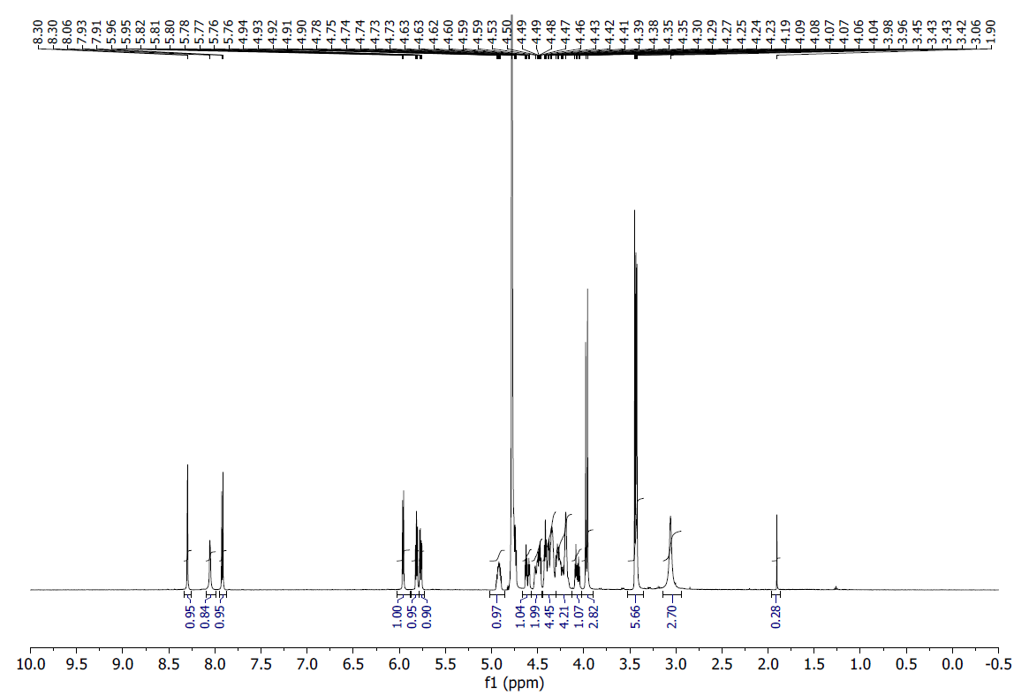
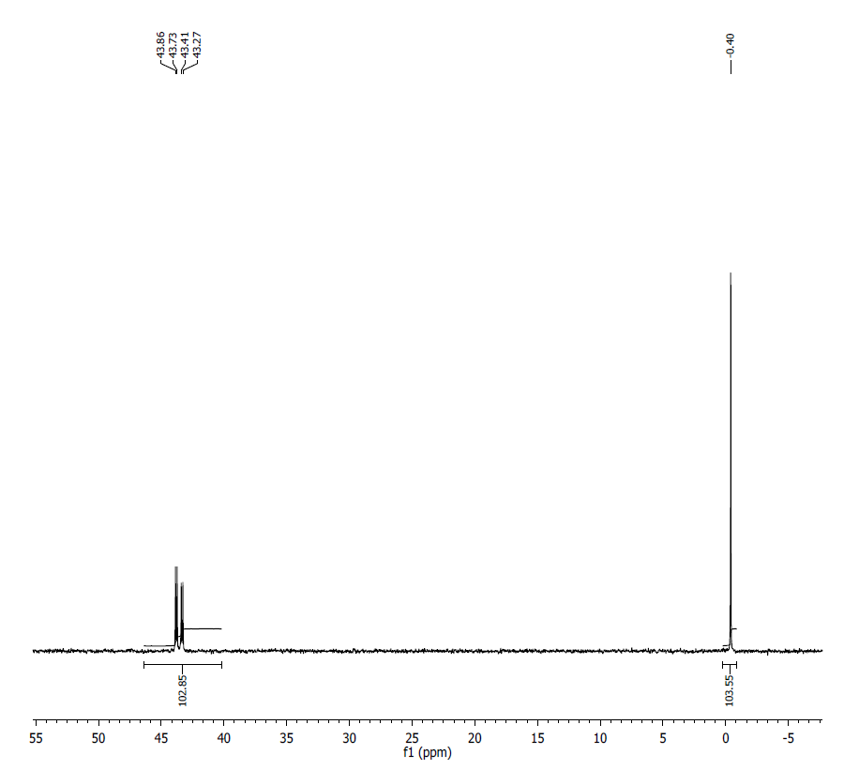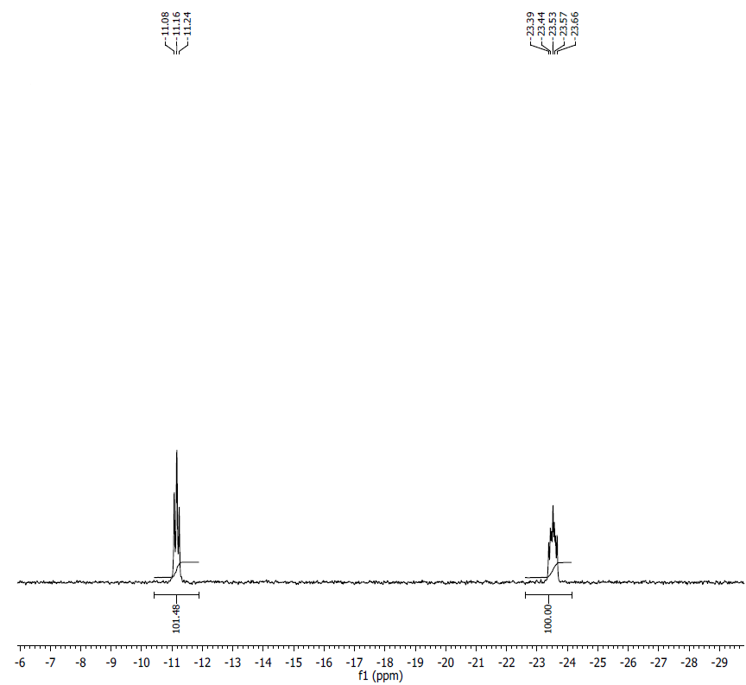
¹H NMR (500 MHz, D₂O) δ: 8.30 (s,1H), 8.05 (s,1H), 7.92 (d, J=4.4 Hz, 1H), 5.96 (d, J=5.75Hz, 1H), 5.81 (t, J=4.91Hz, 1H) 5.77-5.76 (dd, J=3.9Hz, 3.15Hz, 1H) 4.94-4.89 (m, 1H), 4.63-4.58 (m, 1H), 4.58-4.52 (m, 2H) 4.46-4.34 (m, 4H), 4.3-4.2 (m, 4H), 4.09-4.05 (m, 1H), 3.97-3.95 (d, J=9.95Hz, 3H), 3.44-42 (m, J=2.35Hz, 6H), 3.05 (bs, 1H), 1.9 (s,1H).

³¹P NMR (200 MHz, D2O) δ (overlapping signals of two diastereomers, tentative assignment): Diastereomer 1: 43.79 (1P), 0.40 (1P), -11.12 (1P), -23.53 (1P); Diastereomer 2: 43.34 (1P), 0.40 (1P), -11.20 (1P), -23.57 (1P).
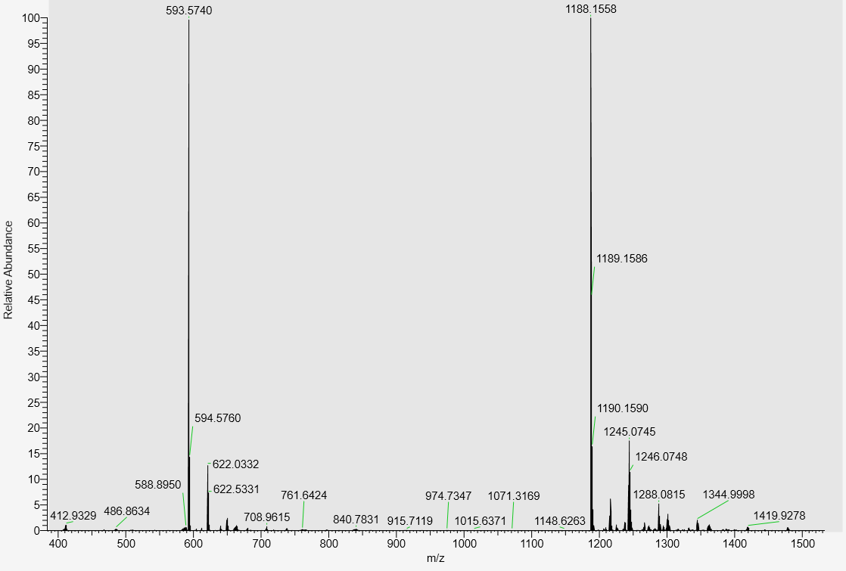
LC-MS data, calculated mass: 1189.1640; detected m/z: 1188.1558 (M-H)

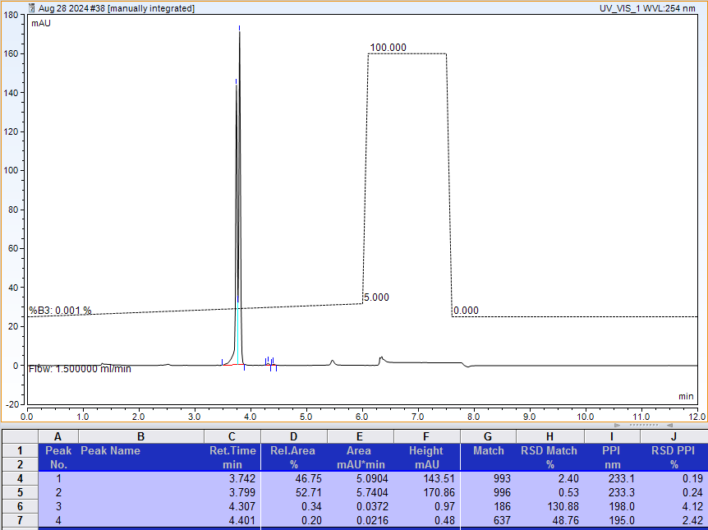
AX-HPLC Analysis (total: 46.75 + 52.71 = 99.46%)
Compound 2-5B1
Diastereomer 1 (asymmetric phosphorus is shown in bold)
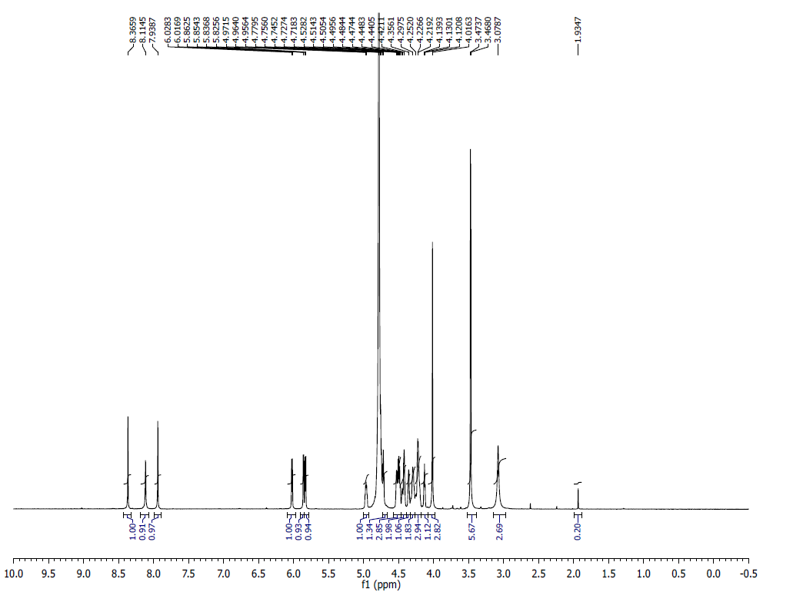
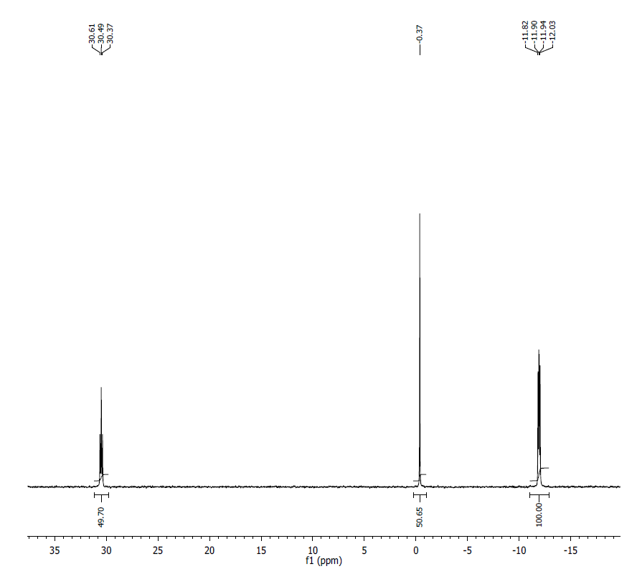
¹H NMR (500MHz, D₂O) δ: 8.37 (s, 1H), 8.11 (s, 1H), 7.94 (s, 1H), 6.02 (d, J = 5.7, 1H), 5.86 (d, J = 4.1, 1H), 5.83 (d, J = 5.6, 1H), 4.96 (m, 1H), 4.71 (m, 1H), 4.47-4.53 (m, 3H), 4.42-4.44 (m, 2H), 4.36 (m, 1H), 4.21-4.30 (m, 5H), 4.13 (t, J = 4.6, 1H), 4.02 (s, 3H), 3.47 (s, 3H), 3.46 (s, 3H), 3.08 (bs, 3H).
³¹P NMR (200 MHz, D₂O) δ: 30.49 (1P), -0.37 (1P), -11.86 (1P), -11.98 (1P).
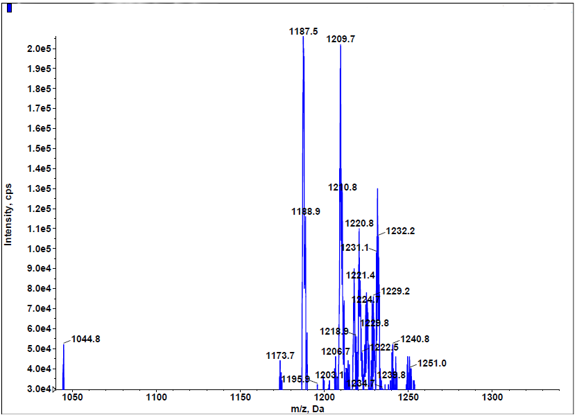 Low resolution MS spectrum; calculated mass: 1189.1640; detected m/z: 1187.5 (M-H)
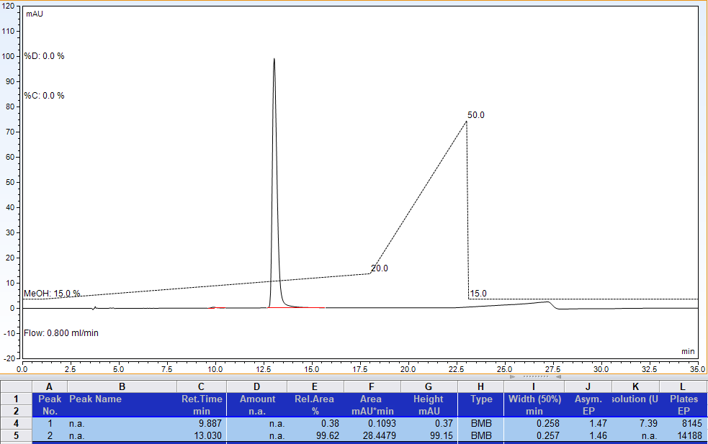
RP-HPLC analysis. Gradient of methanol in 100 mM Triethylammonium acetate, pH 7.0.
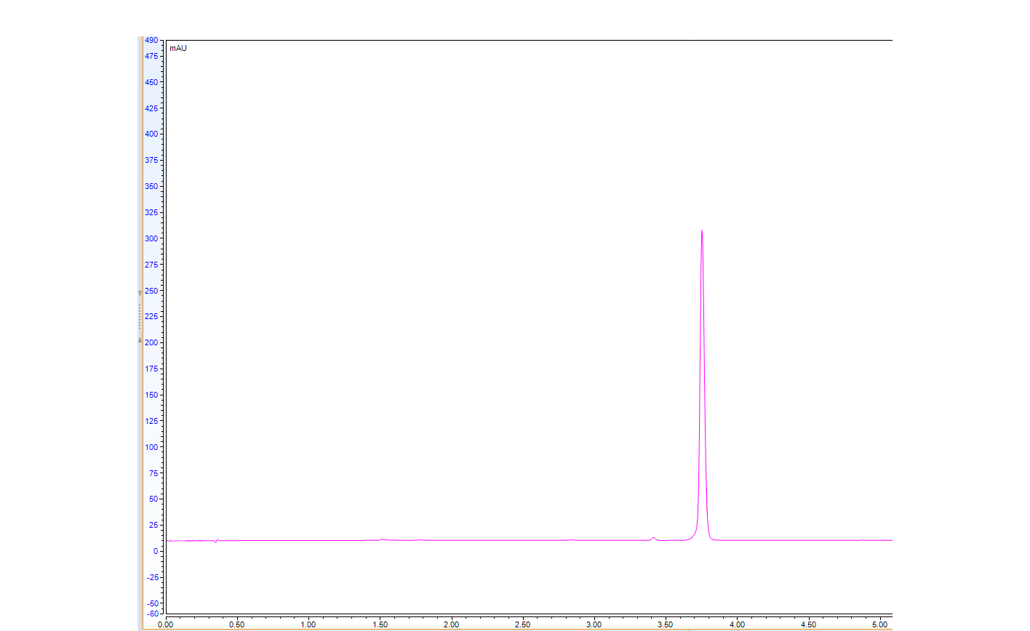
AX-HPLC Analysis (manual integration: 98.49%)

Compound 2-5B2
Diastereomer 2 (asymmetric phosphorus is shown in bold)
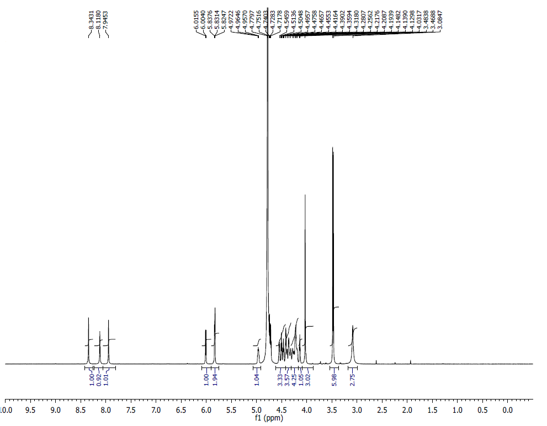
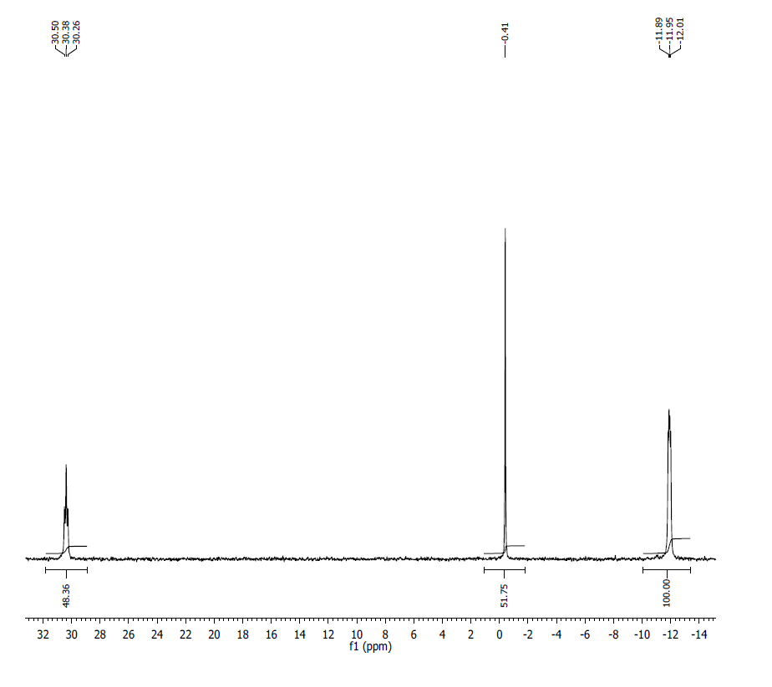
¹H NMR (500MHz, D₂O) δ 8.34 (s, 1H), 8.12 (s, 1H), 7.95 (s, 1H), 6.01 (d, J = 5.8, 1H), 5.83 (m, 2H), 4.96 (m, 1H), 4.42-4.55 (m, 3H), 4.32-4.39 (m, 4H), 4.19-4.28 (m, 4H), 4.14 (t, J = 4.6, 1H), 4.03 (s, 3H), 3.48 (s, 3H), 3.47 (s, 3H), 3.08 (bs, 3H).
³¹P NMR (200 MHz, D₂O) δ: 30.38 (1P), -0.41 (1P), -11.93 (1P), -11.97 (1P).
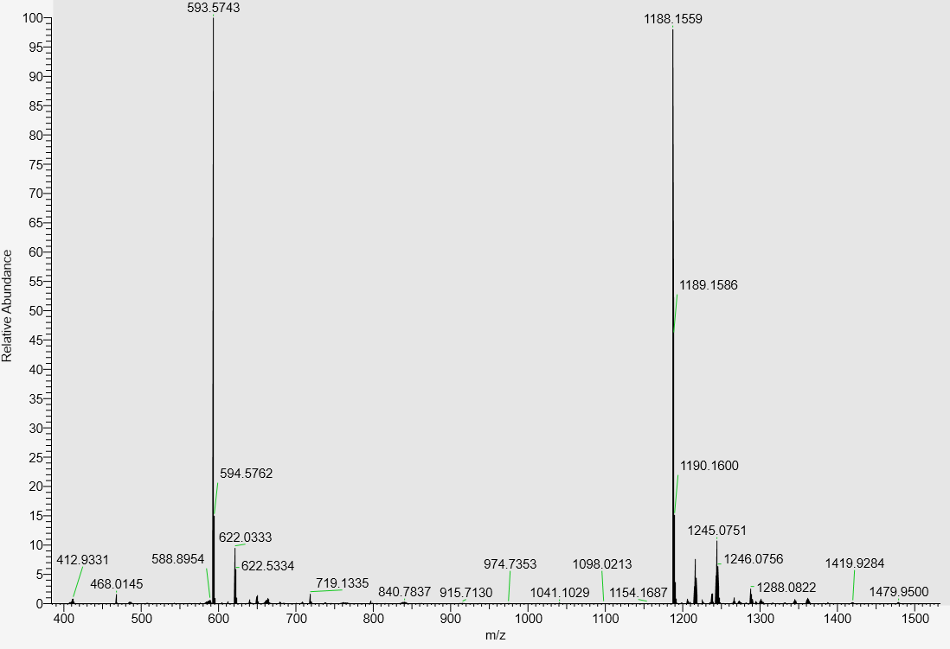
LC-MS data, calculated mass: 1189.1640; detected m/z: 1188.1559 (M-H)

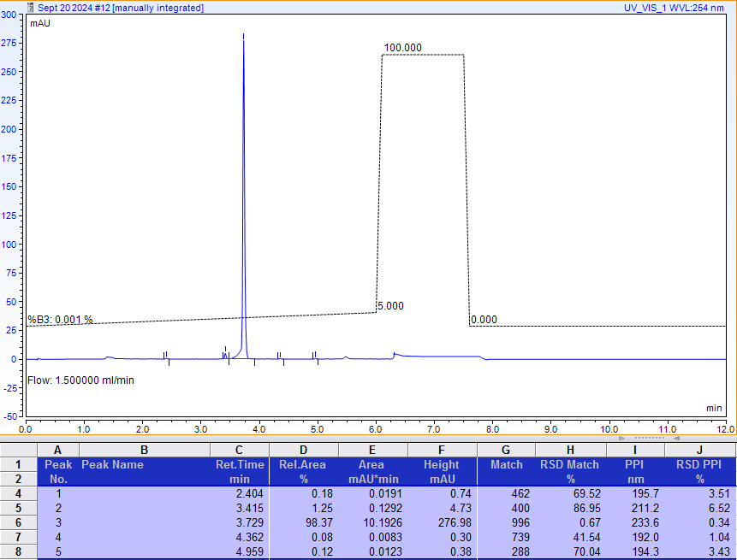
AX-HPLC Analysis
Compound 2-6B1
Diastereomer 1 (asymmetric phosphorus is shown in bold)
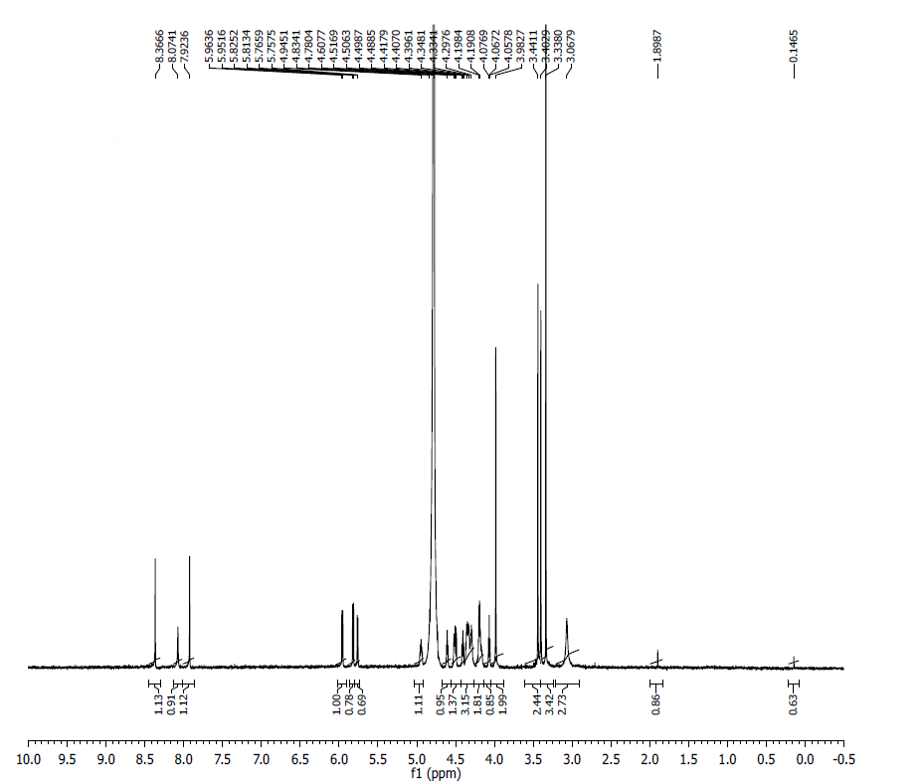
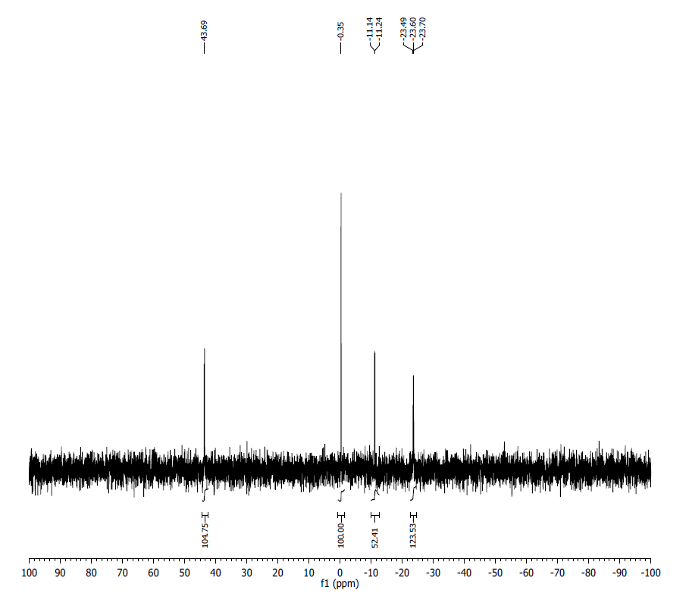
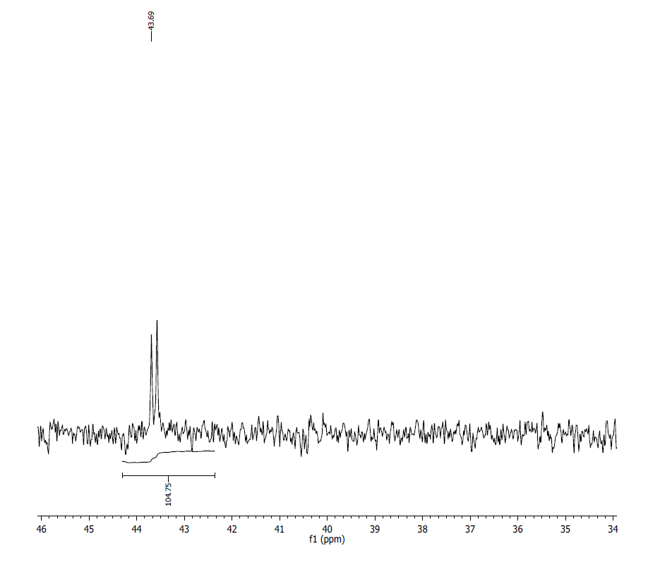
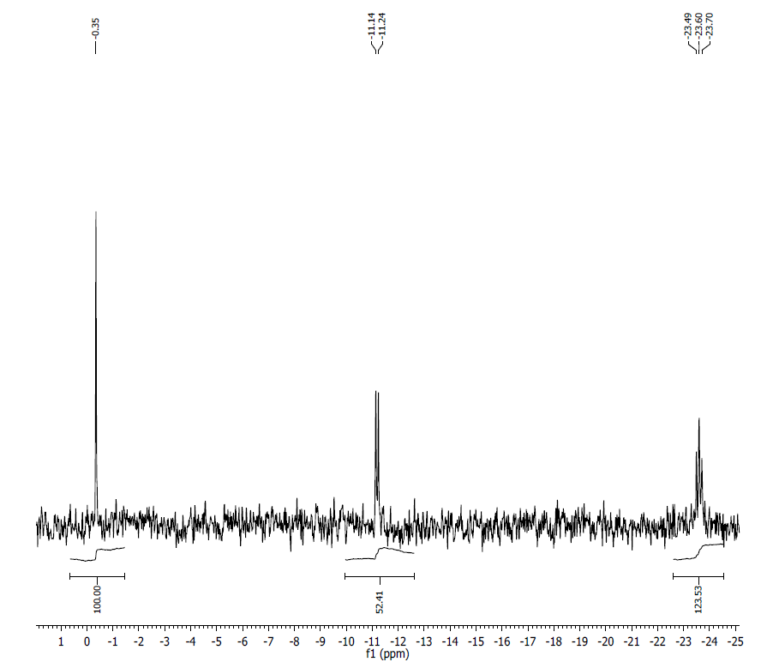
¹H NMR (500MHz, D2O) δ: 8.37 (s, 1H), 8.07 (s, 1H), 7.92 (s, 1H), 5.96 (d, 1H, J= 6 Hz), 5.83 (d, 1H, J= 5.9 Hz), 5.77 (d, 1H, J= 4.2 Hz), 4.95-4.83 (m, 1H), 4.61-4.51(m, 1H), 4.49-4.40 (m, 1H), 4.35-4.30 (m, 3H), 4.20-4.19 (m, 2H), 4.08-4.06 (t, 1H, J= 4.85 Hz), 3.98 ( s, 2H), 3.44-3.40 (d, 2H, J= 19 Hz), 3.34 (s, 3H), 3.07 (br s, 3H).
³¹P NMR (200 MHz, D2O) δ: 43.65 (1P), -0.35 (1P), -11.19 (1P), -23.60 (1P).
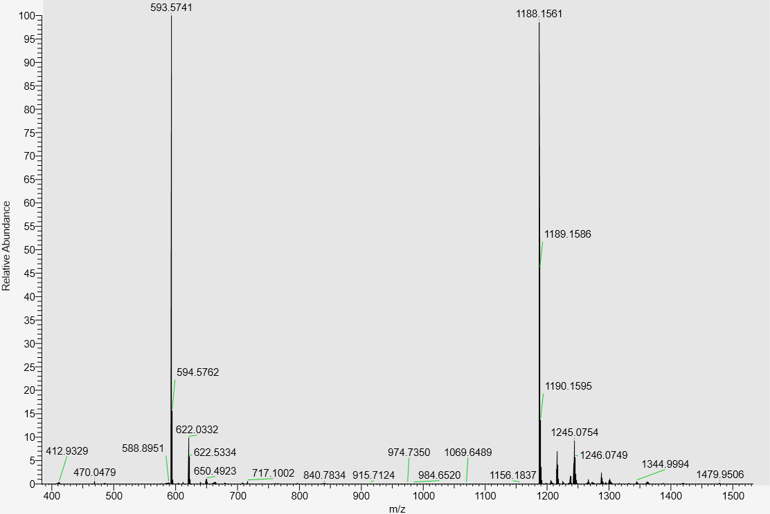
LC-MS data, calculated mass: 1189.1640; detected m/z: 1188.1561 (M-H)

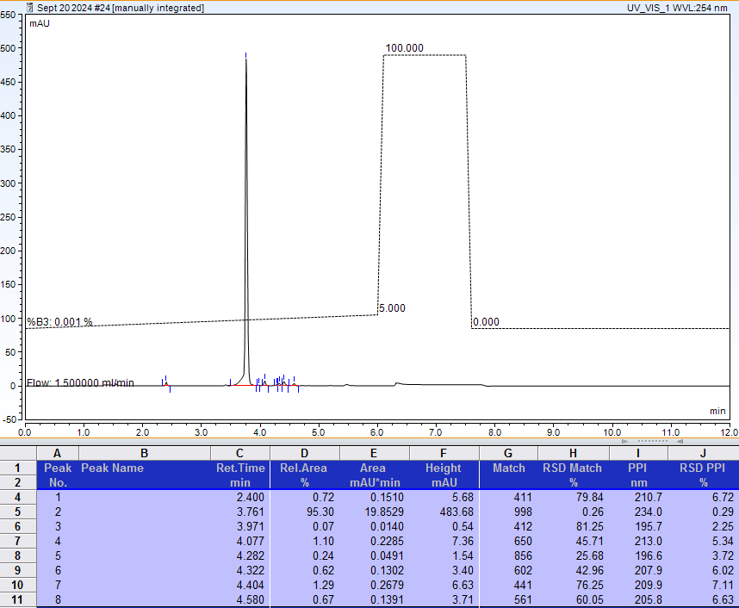
AX-HPLC Analysis
Compounds related to Table 3, Series A

Compound 3-1A
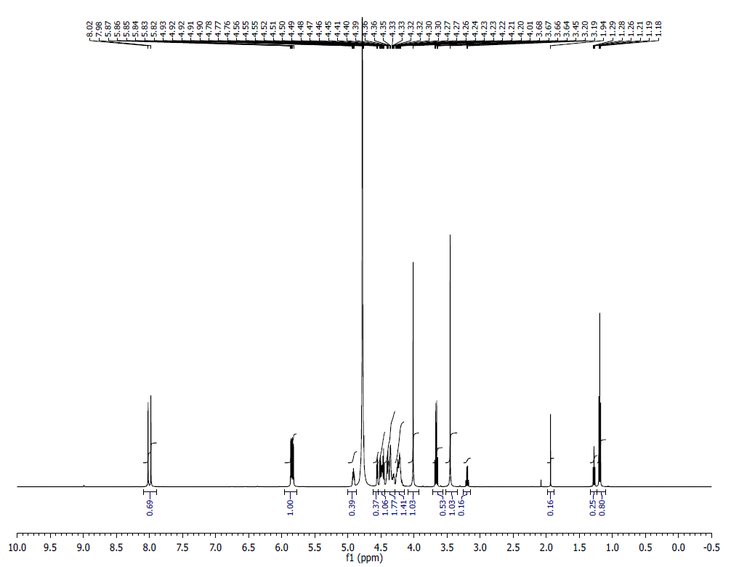
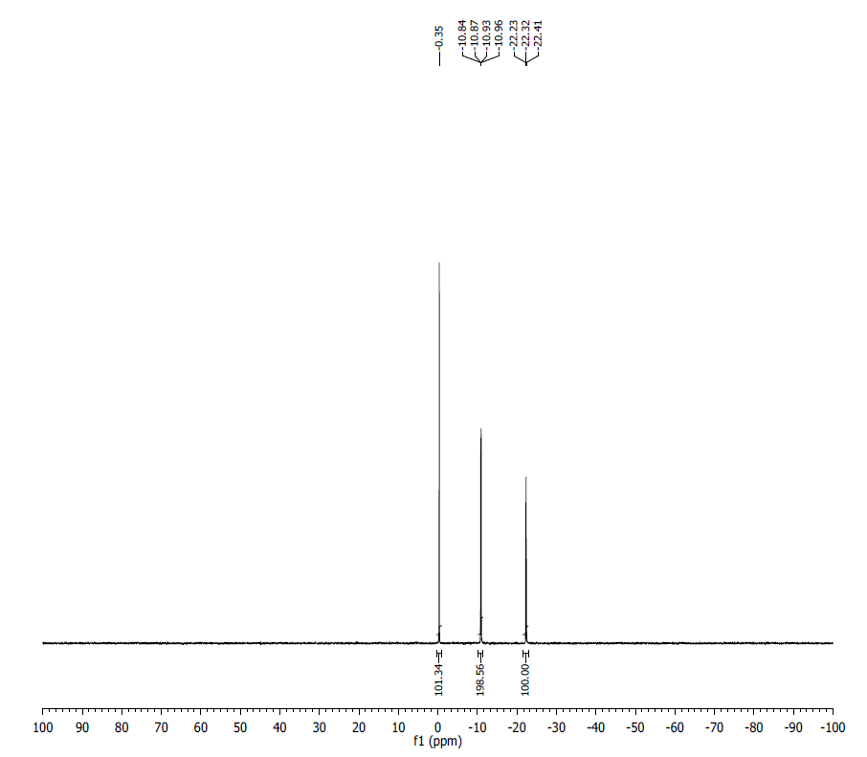
¹H NMR (500 MHz, D₂O) δ: 8.02 (s, 1H), 7.98 (s, 1H), 5.82 (m, 3H), 4.90 (m, 1H), 4.55 (m, 1H), 4.52 – 4.20 (m, 13H), 4.01 (s, 3H), 3.45 (s, 3H).
³¹P NMR (200 MHz, D₂O) δ: -0.35 (1P), -10.89 (1P), -10.91 (1P), -22.32 (1P).
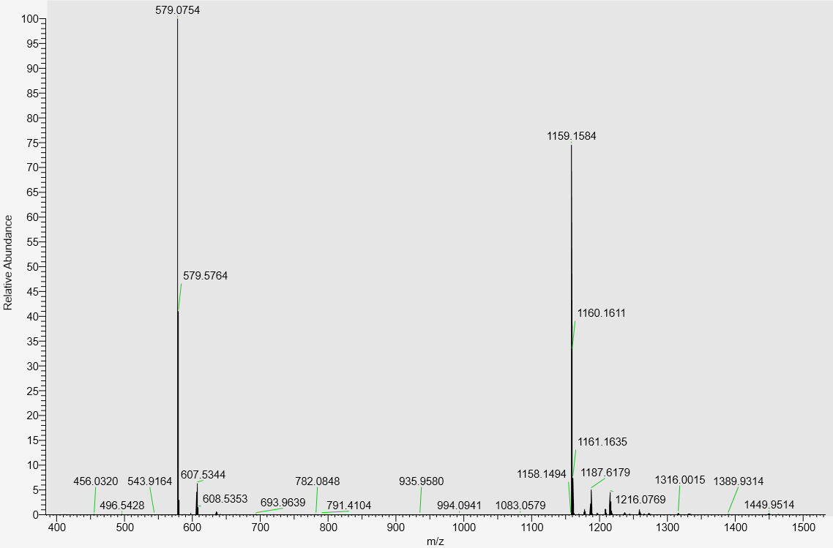
LC-MS data, calculated mass: 1160.1665; detected m/z: 1159.1584 (M-H)

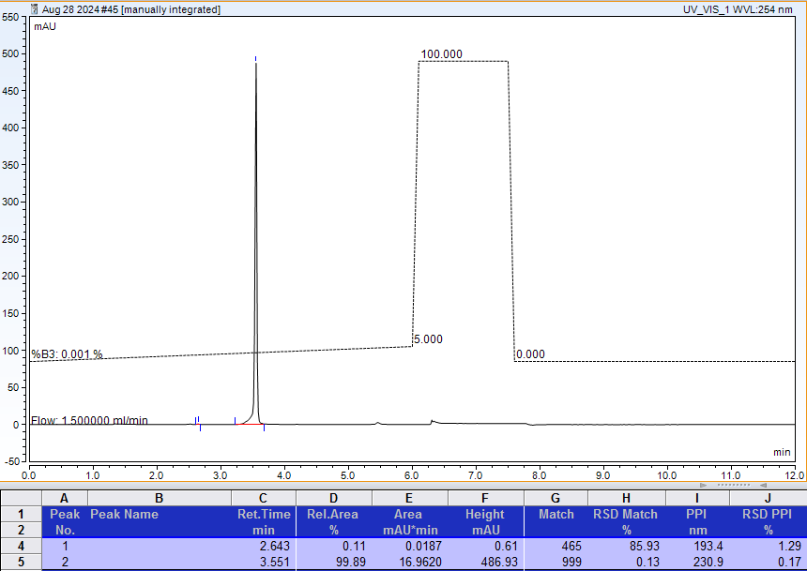
AX-HPLC Analysis
Compound 3-3A

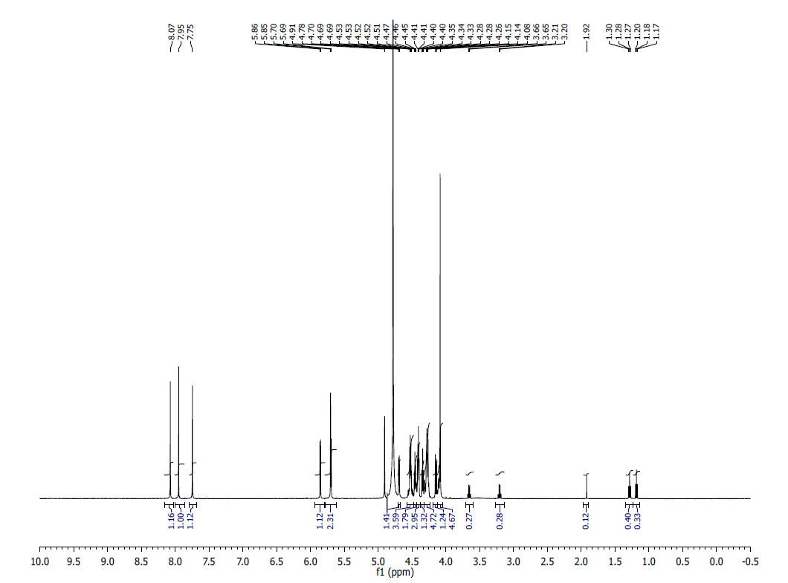
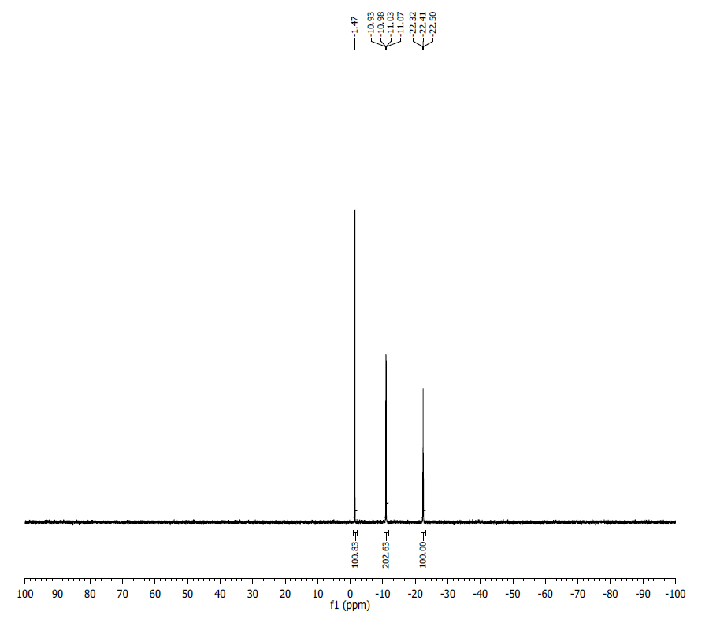
¹H NMR (500 MHz, D₂O) δ: 8.07 (s, 1H), 7.95 (s, 1H), 7.75 (s, 1H), 5.85 (d, J = 4.2 Hz, 1H), 5.69 (d, J = 5.5 Hz, 2H), 4.69 (m, 1H), 4.53 – 4.28 (m, 15H), 4.08 (s, 3H).
³¹P NMR (200 MHz, D₂O) δ: -1.47 (1P), -10.98 (1P), -11.03 (1P), -22.41 (1P).
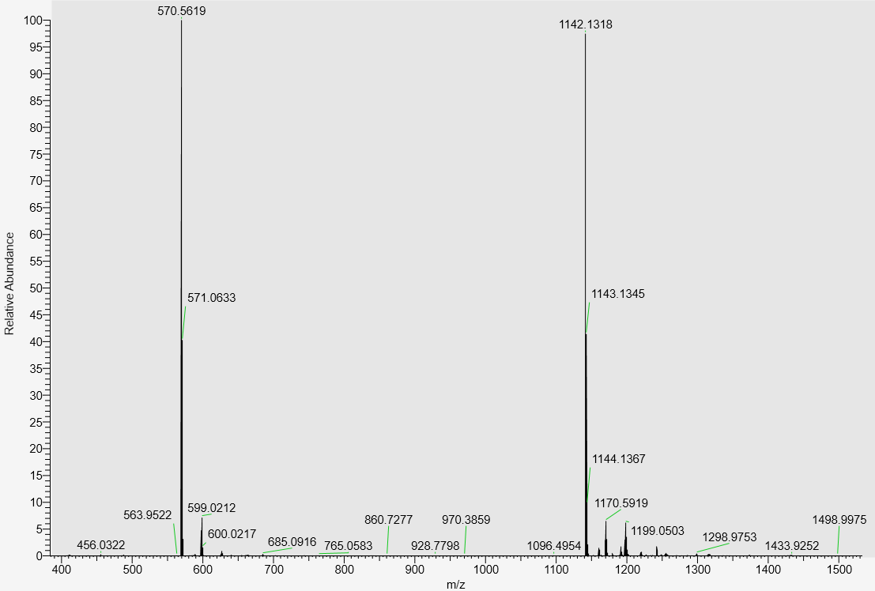
LC-MS data, calculated mass: 1143.1399; detected m/z: 1142.1318 (M-H)

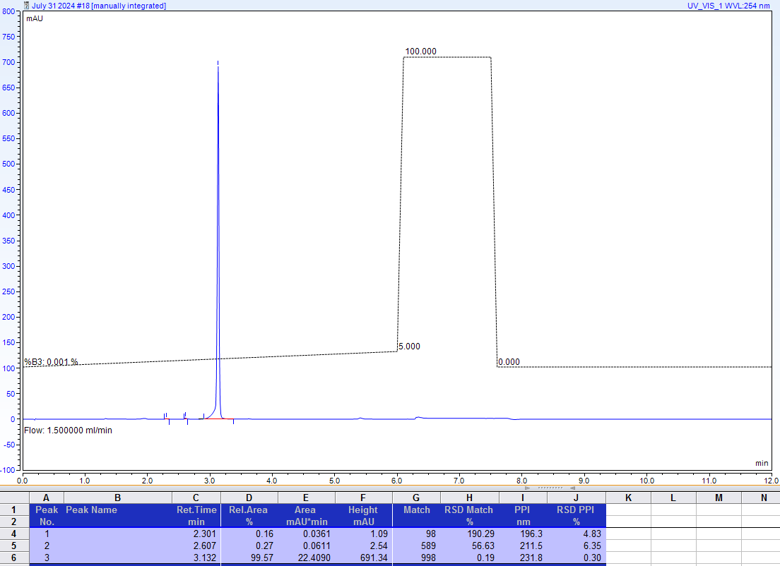
AX-HPLC Analysis
Compound 3-4A1
Diastereomer 1 (asymmetric phosphorus is shown in bold)
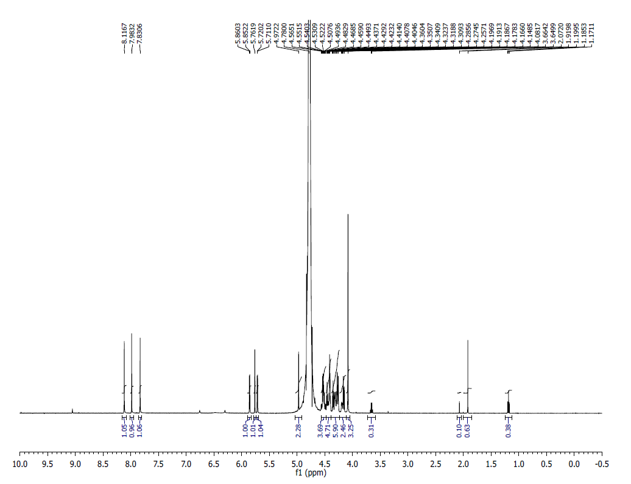
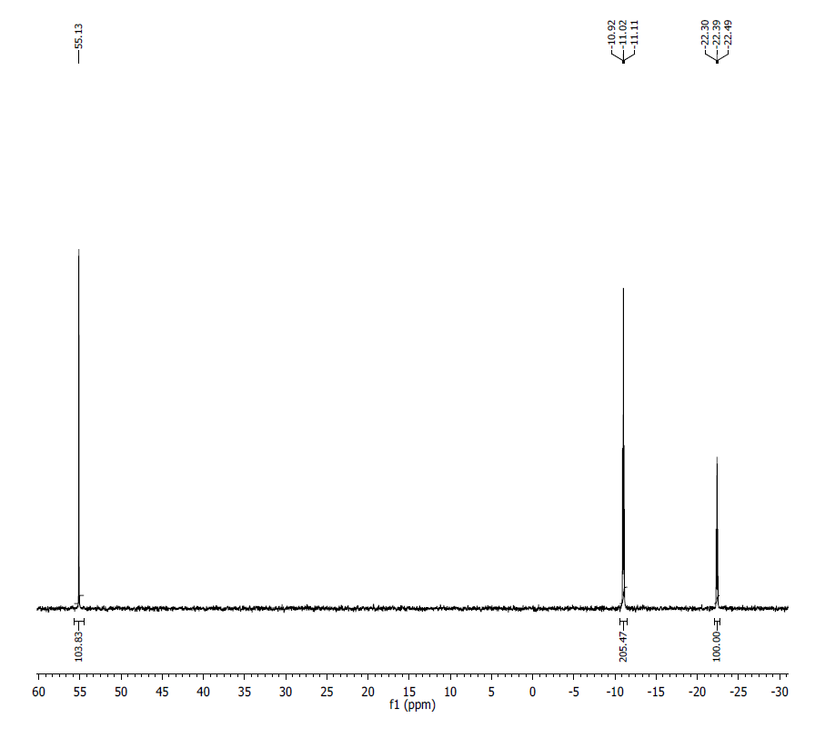
¹HNMR (500 MHz, D₂O) δ: 8.12 (s, 1H), 7.98 (s, 1H), 7.83 (s, 1H), 5.86 (d, J = 4.1, 1H), 5.76 (s, 1H), 5.72 (d, J = 4.6, 1H), 4.97 (s, 2H), 4.49-4.57 (m, 3H), 4.40-4.48 (m, 5H), 4.15-4.36 (m, 8H), 4.08 (s, 3H).
³¹P NMR (200 MHz, D₂O) δ: 55.13 (1P), -10.97 (1P), -11.07 (P), -22.39 (1P).
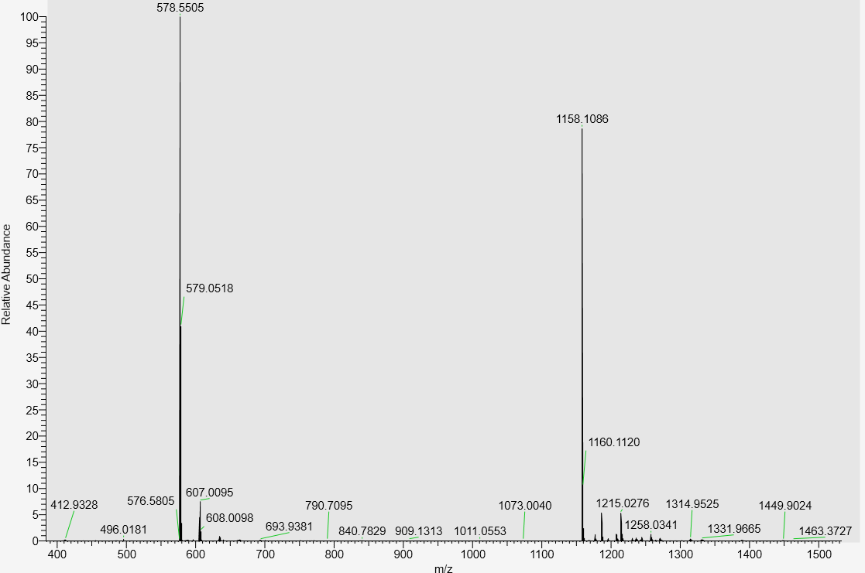
LC-MS data, calculated mass: 1159.1171; detected m/z: 1158.1086 (M-H)

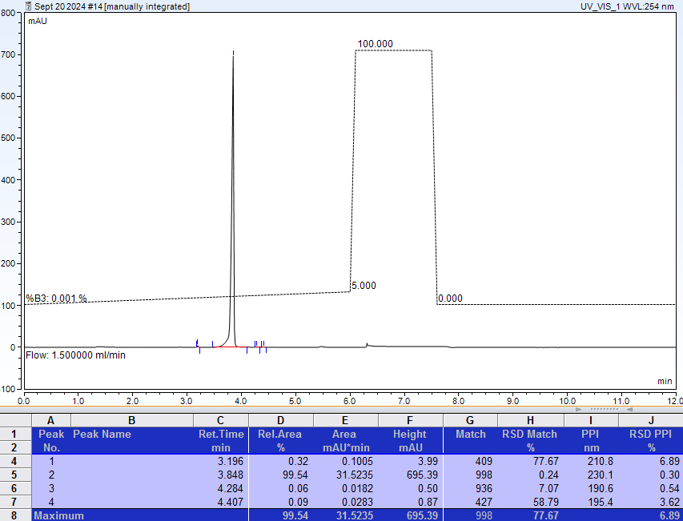
AX-HPLC Analysis
Compound 3-4A2
Diastereomer 2 (asymmetric phosphorus is shown in bold)

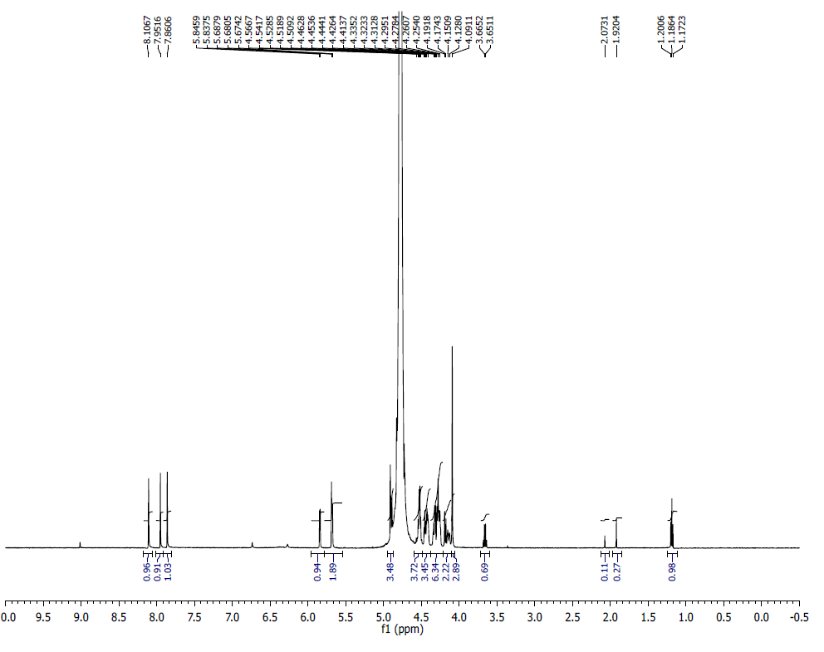
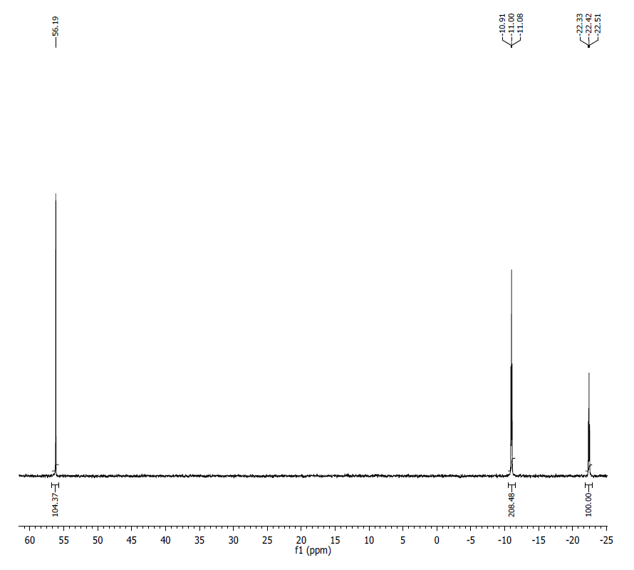¹H NMR (500 MHz, D₂O) δ: 8.11 (s, 1H), 7.95 (s, 1H), 7.86 (s, 1H), 5.84 (d, J = 4.2, 1H), 5.68 (m, 2H), 4.90 (m, 2H), 4.50-4.57 (m, 3H), 4.41-4.46 (m, 3H), 4.25-4.33 (m, 6H), 4.13-4.19 (m, 2H), 4.09 (s, 3H).
³¹P NMR (200 MHz, D₂O) δ: 56.19 (1P), -10.95 (1P), -11.05 (P), -22.42 (1P).
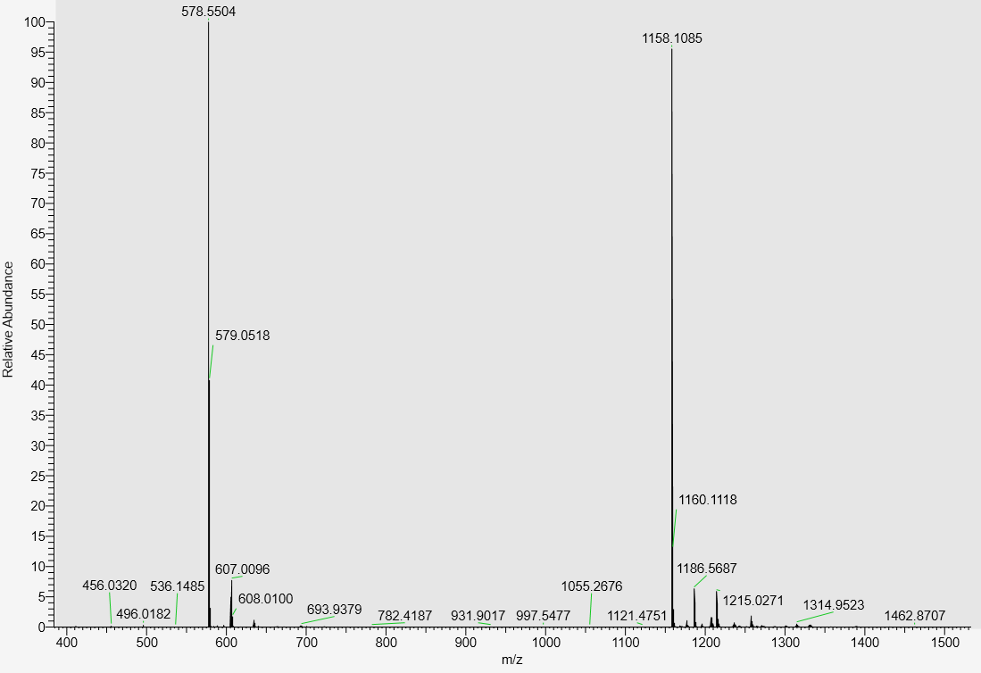
LC-MS data, calculated mass: 1159.1171, detected m/z: 1158.1085 (M-H)

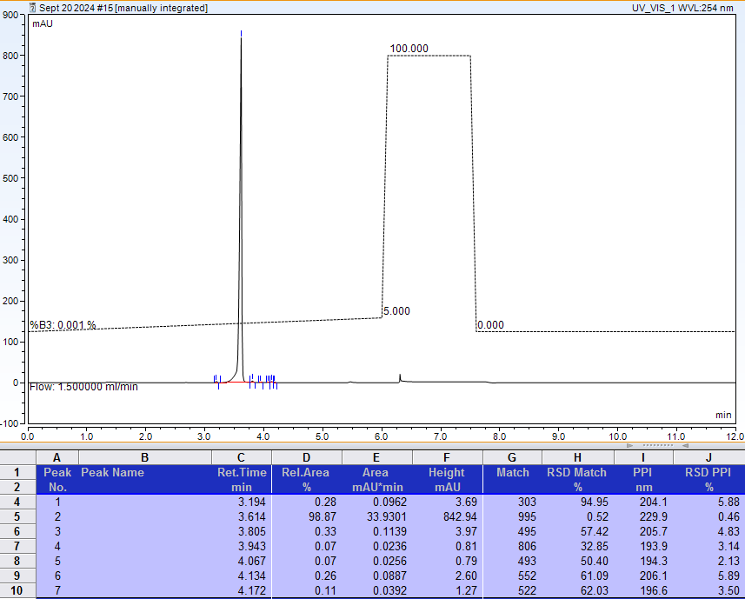
AX-HPLC Analysis
Compound 3-5A

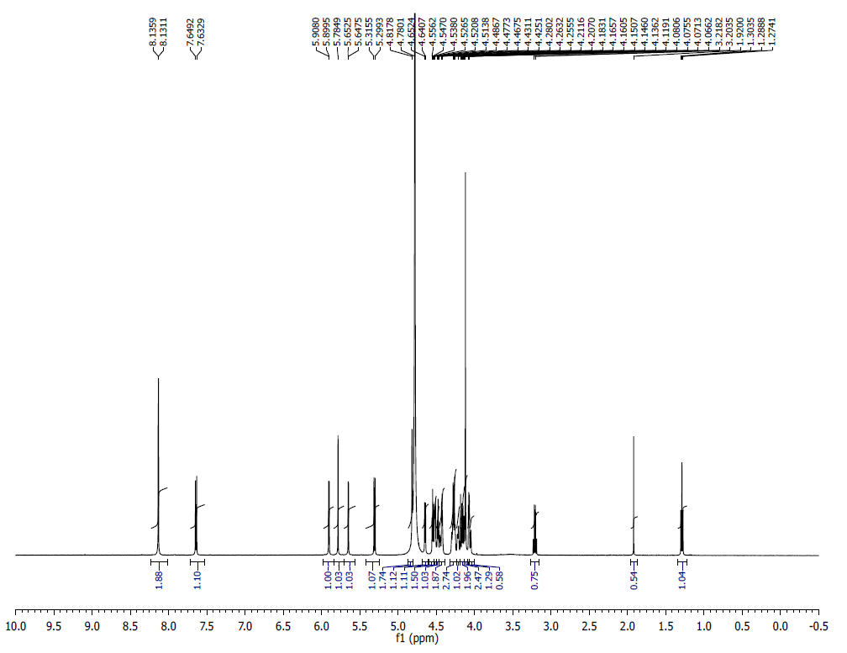
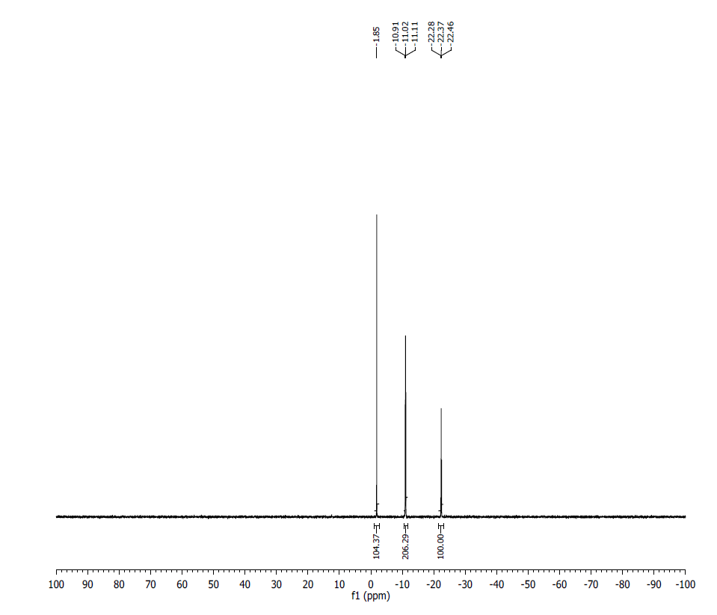
¹H NMR (500 MHz, D₂O) δ: 8.14-8.13 (m, 2H), 7.65 (d, J = 8.15 Hz ,1H), 5.91 (d, J = 4.25 Hz,1H), 5.78 (s, 1H), 5.65 (d, J = 2.50 Hz, 1H), 5.32 (d, J = 8.1 Hz, 1H) , 4.81-4.80 (m, 2H), 4.65 (d, J = 5.85 Hz, 1H), 4.55-4.54 (m, 1H), 4.53-4.51 (m, 2H), 4.49-4.43 (m, 1H), 4.43-4.25 (m, 2H), 4.28-4.26 (m, 3H), 4.21- 4-17 (m, 2H), 4.16 (s, 3H), 4.15-4.14 (m, 1H), 4.12-4.06 (m, 1H),
³¹P NMR (200 MHz, D₂O) δ: -1.85 (1P), -10.96 (1P), -11.07 (1P), -22.28 (1P).
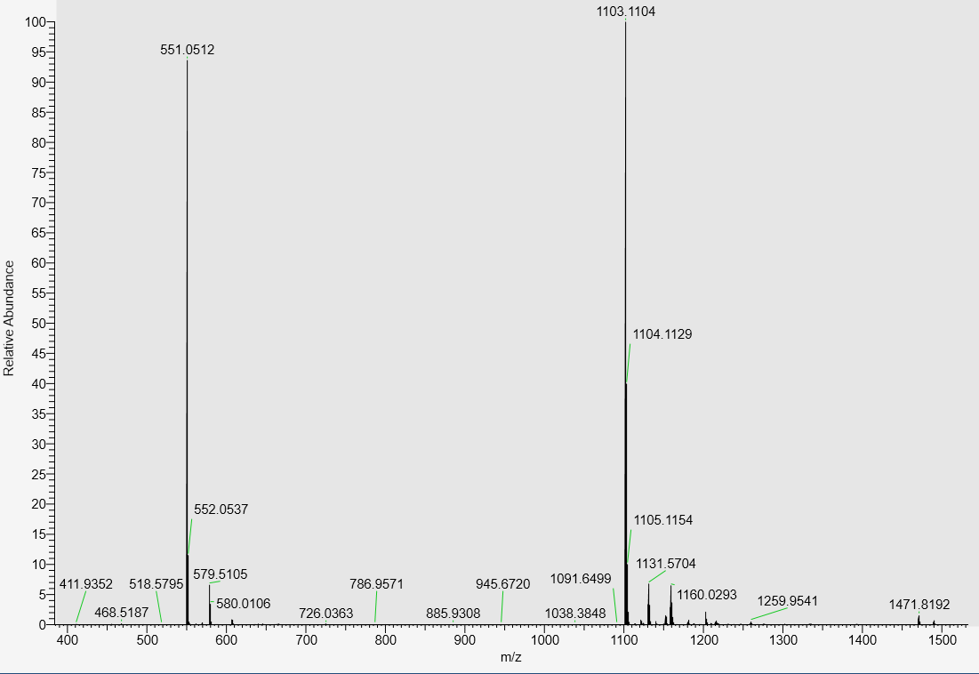
LC-MS data, calculated mass: 1104.1178; detected m/z: 1103.1104 (M-H)

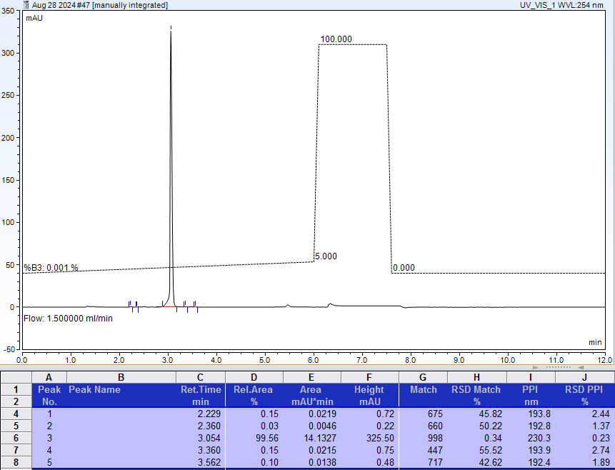
AX-HPLC Analysis
Compound 3-8A1
Diastereomer 1 (asymmetric phosphorus is shown in bold)

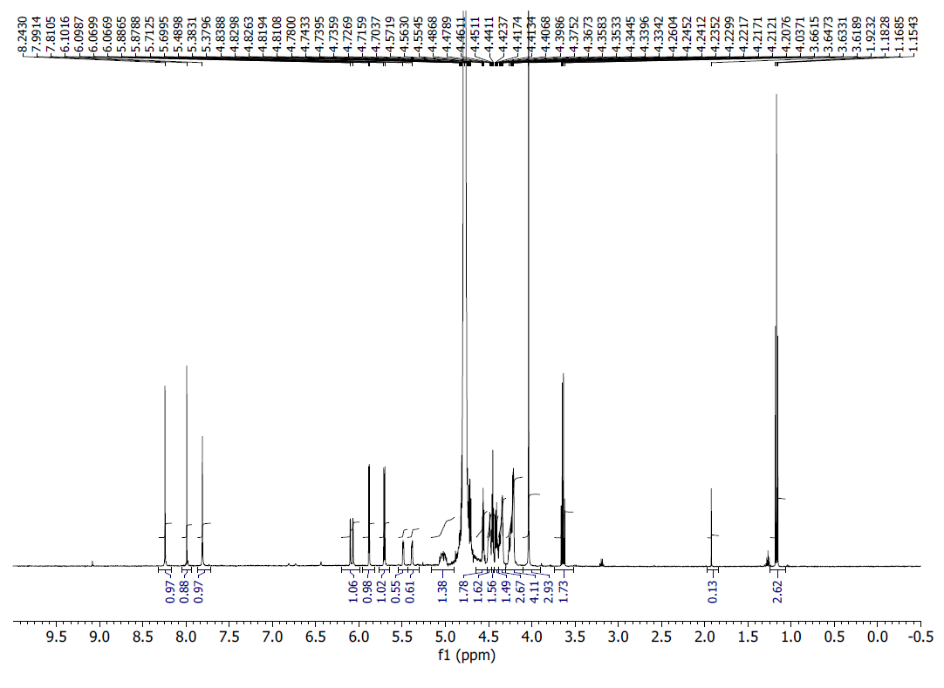

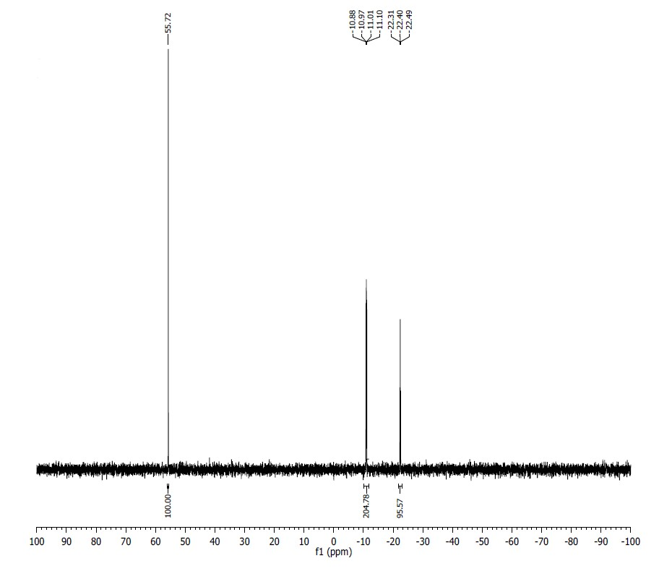
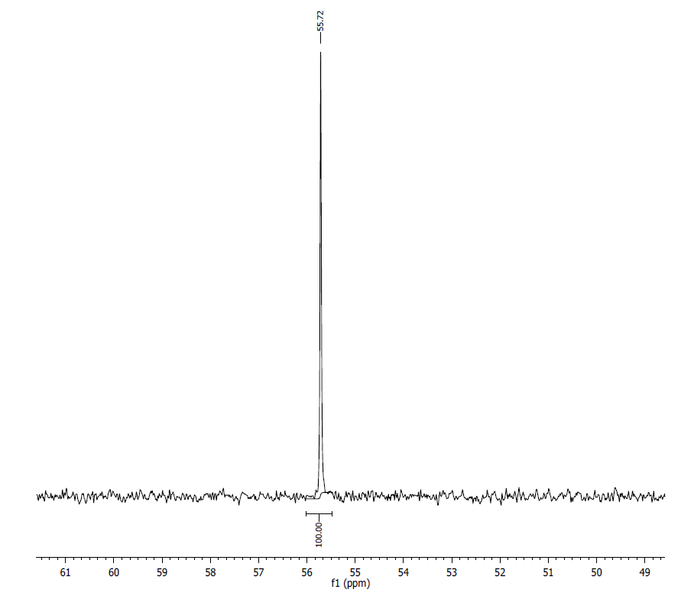
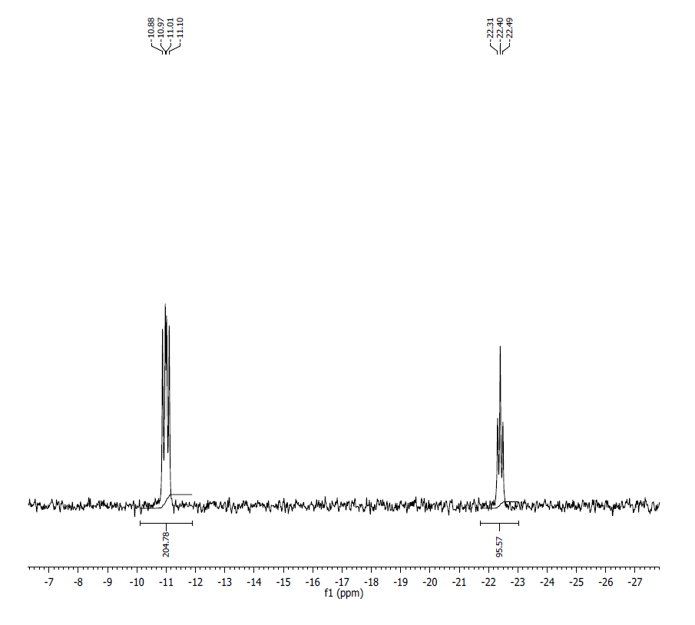
¹H NMR (500 MHz, D₂O) δ: 8.24 (s, 1H), 7.99 (s, 1H), 7.81 (s, 1H), 6.09 (d, J = 15.9 Hz, 1H), 5.88 (d, J = 3.9 Hz, 1H), 5.70 (d, J = 6.5 Hz, 1H), 5.49-5.38 (m, 1H), 5.05-5.01 (m, 1H), 5.56 (t, J = 4.5 Hz, 2H), 4.49-4.33 (m, 7H), 4.26-4.20 (m, 4H), 4.04 (s, 3H)
³¹PNMR (200 MHz, D₂O) δ: 55.72 (1P), -10.92 (1P), -11.05 (1P), -22.40 (1P).
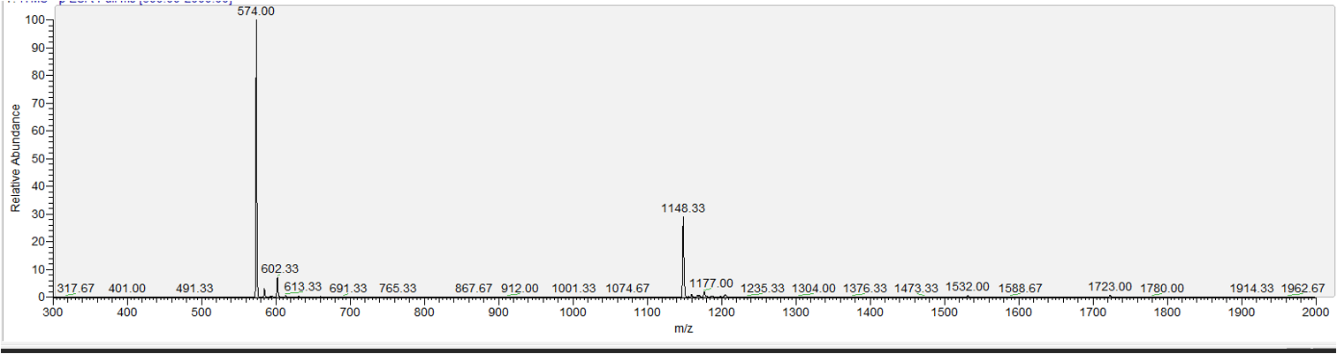
LC-MS data, calculated mass: 1149.1128; detected m/z: 1148.33 (M-H) (low resolution MS)

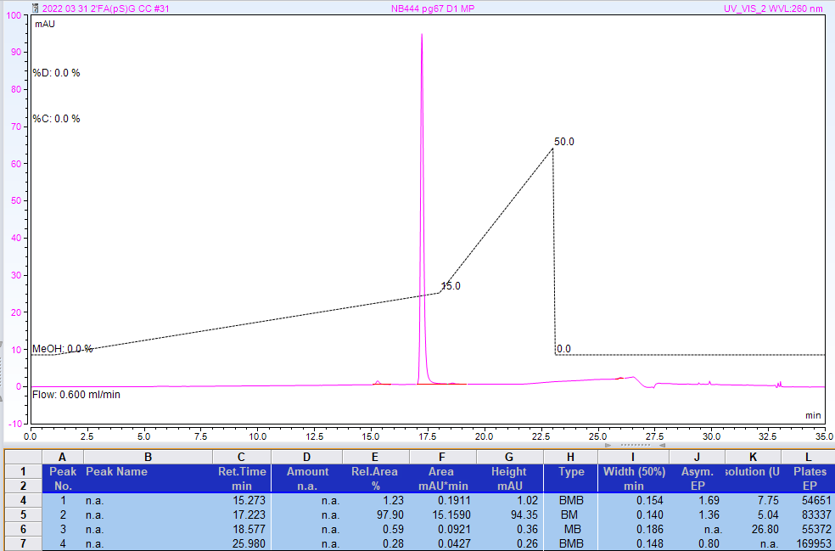
RP-HPLC analysis. Gradient of methanol in 100 mM Triethylammonium acetate, pH 7.0.

Compound 3-8A2
Diastereomer 2 (asymmetric phosphorus is shown in bold)
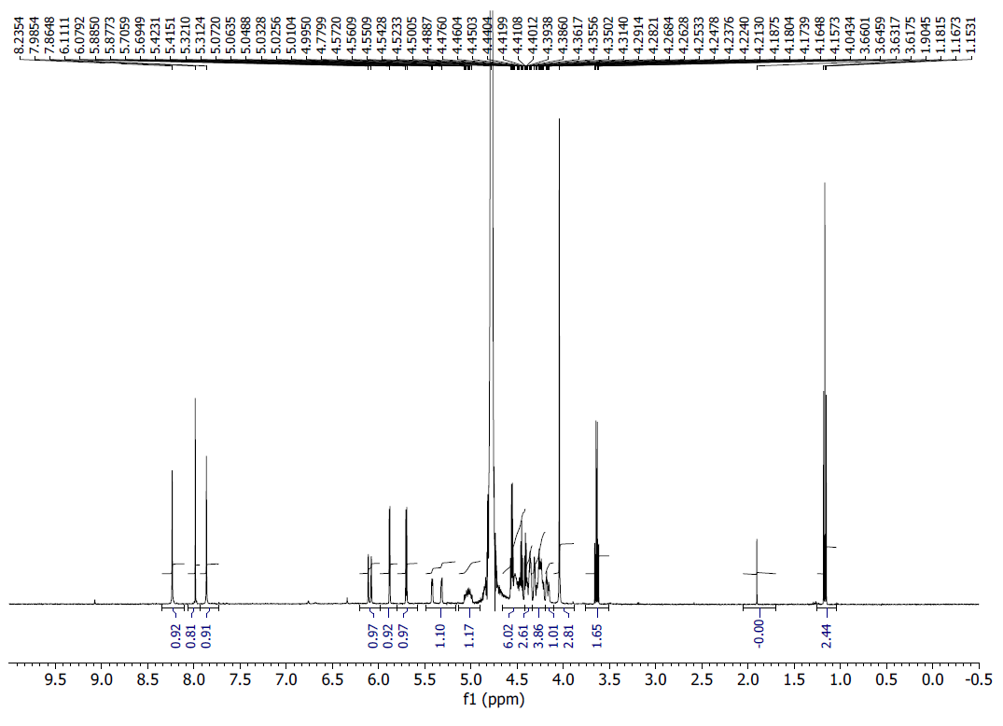
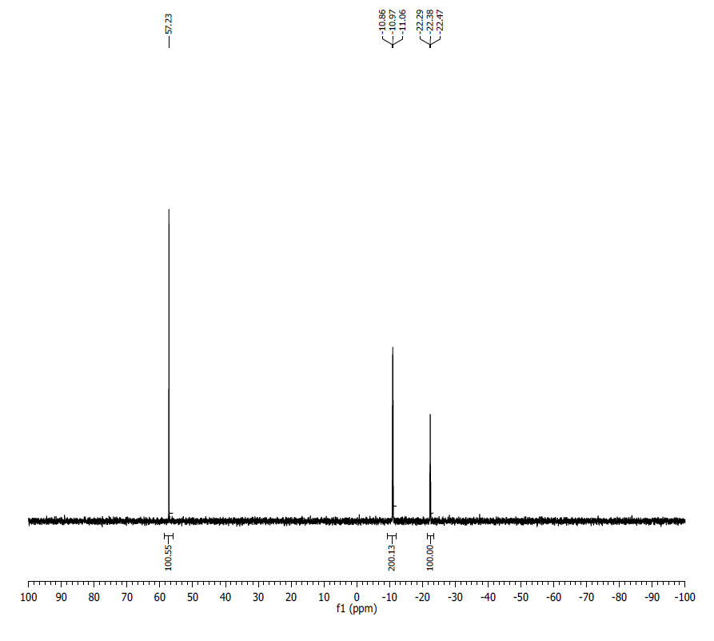
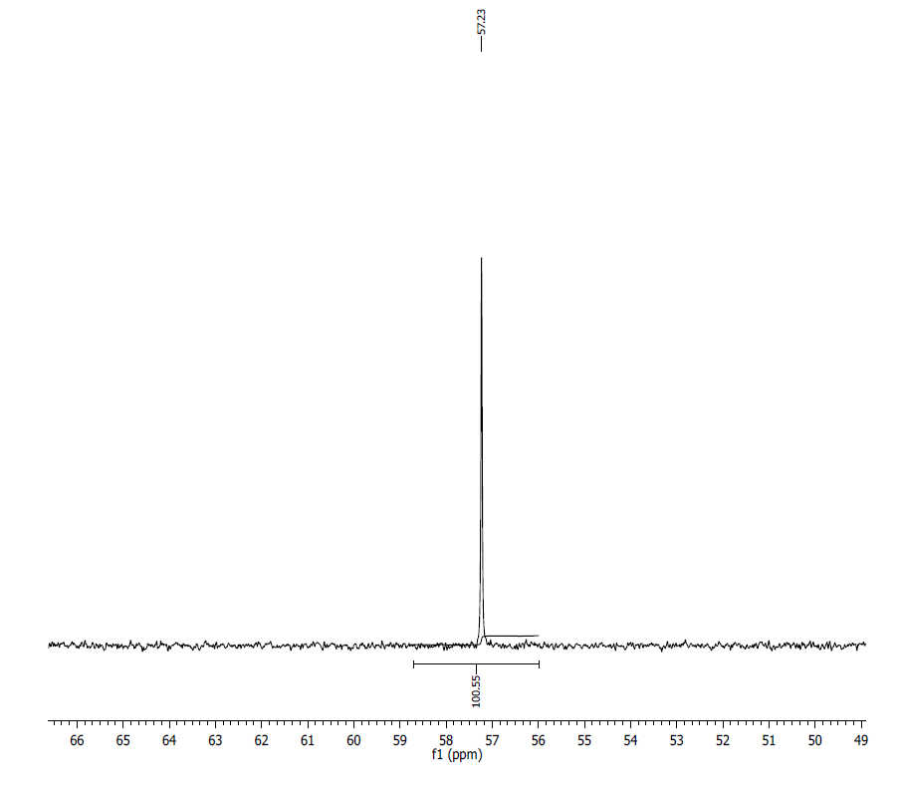
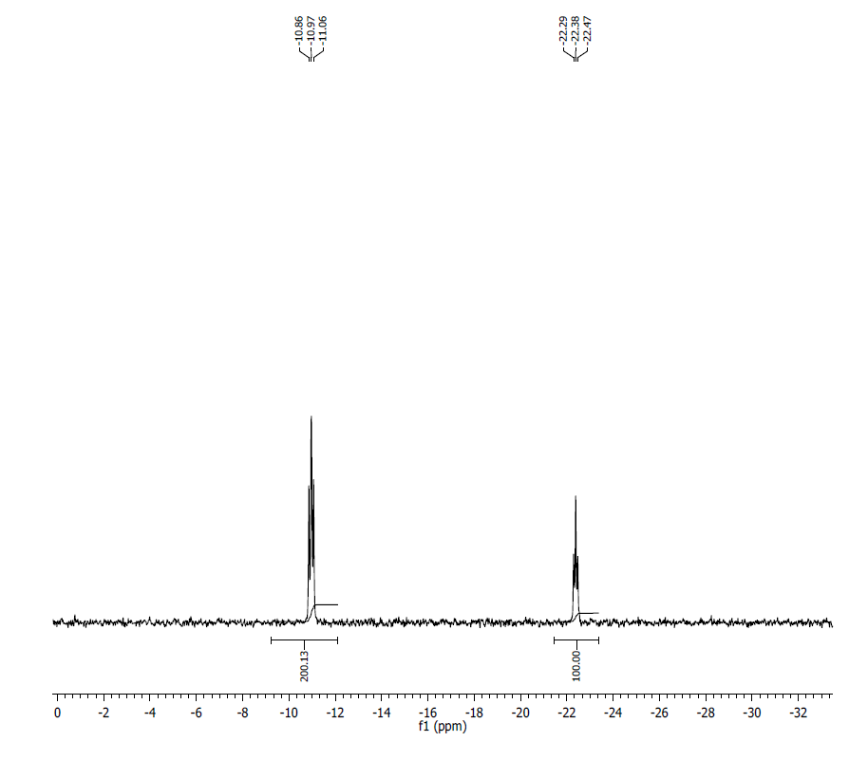
¹H NMR (500 MHz, D₂O) δ: 8.24 (s, 1H), 7.99 (s, 1H), 7.86 (s, 1H), 6.10 (d, J = 16.0 Hz, 1H), 5.88 (d, J = 3.9 Hz, 1H), 5.70 (d, J = 5.5 Hz, 1H), 5.42-5.31 (m, 1H), 5.07-4.99 (m, 1H), 4.57-4.44 (m, 6H), 4.42-4.21 (m, 7H), 4.19-4.16 (m, 1H), 4.04 (s, 3H).
³¹P NMR (200 MHz, D₂O) δ: 57.23 (1P), -10.92 (1P), -11.02 (1P), -22.38 (1P).
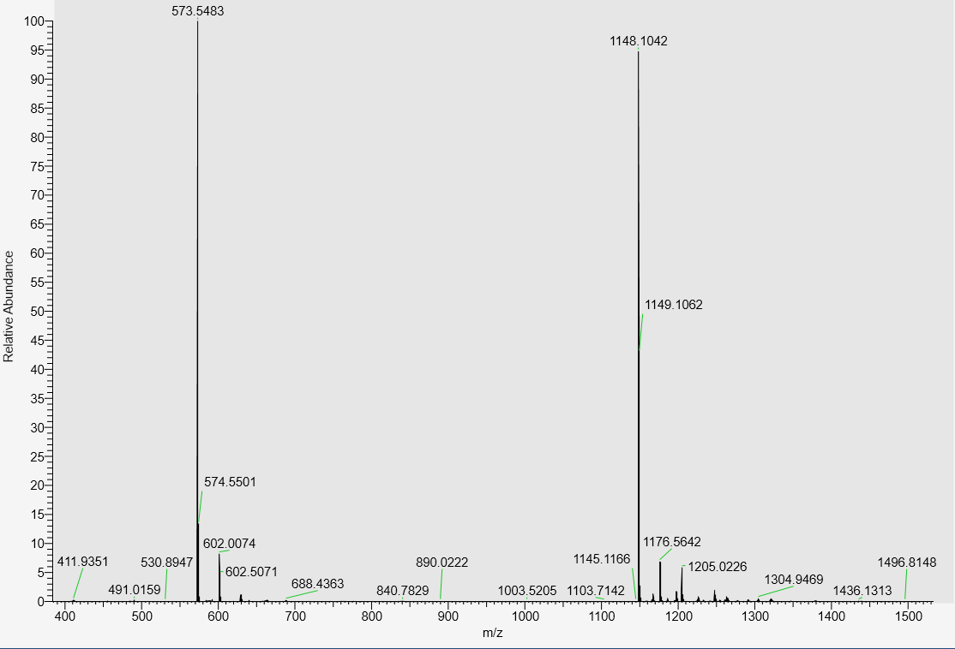
LC-MS data, calculated mass: 1149.1128; detected m/z: 1148.1042 (M-H)
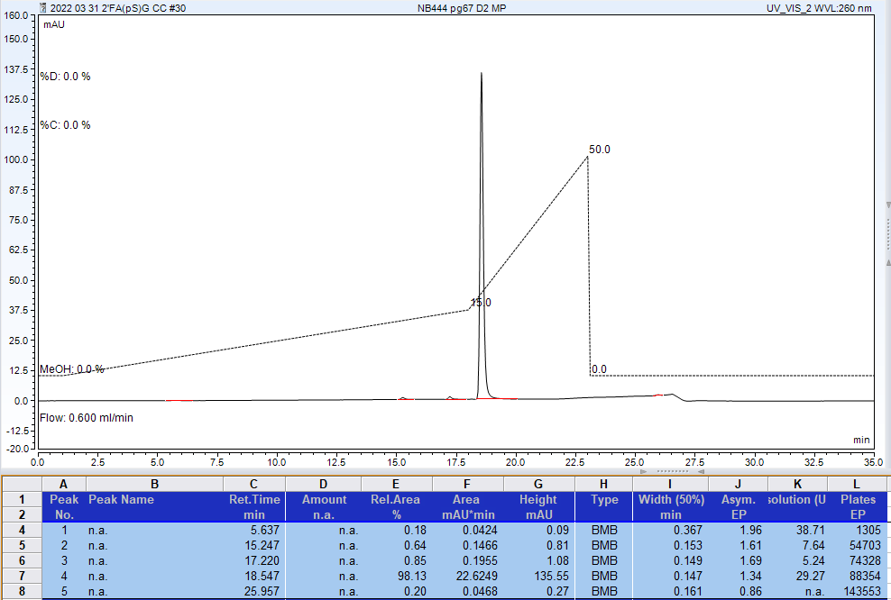
RP-HPLC analysis. Gradient of methanol in 100 mM Triethylammonium acetate, pH 7.0.
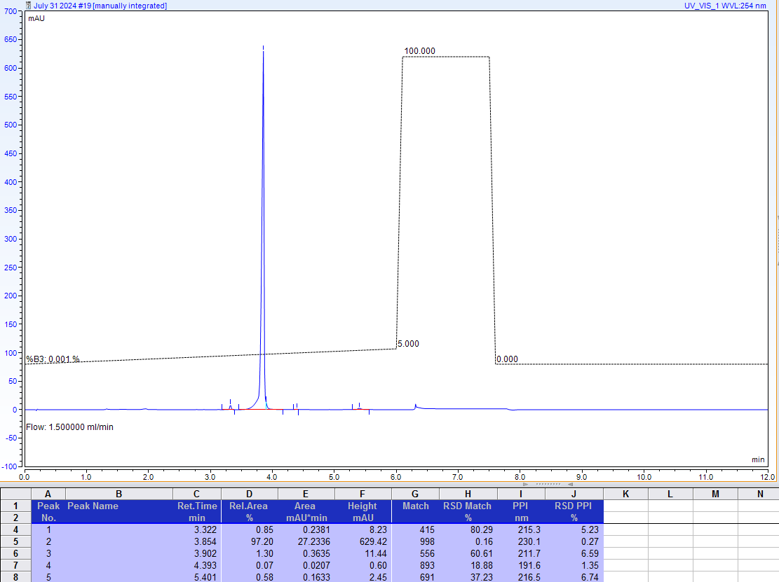
AX-HPLC Analysis

Compound 3-9A

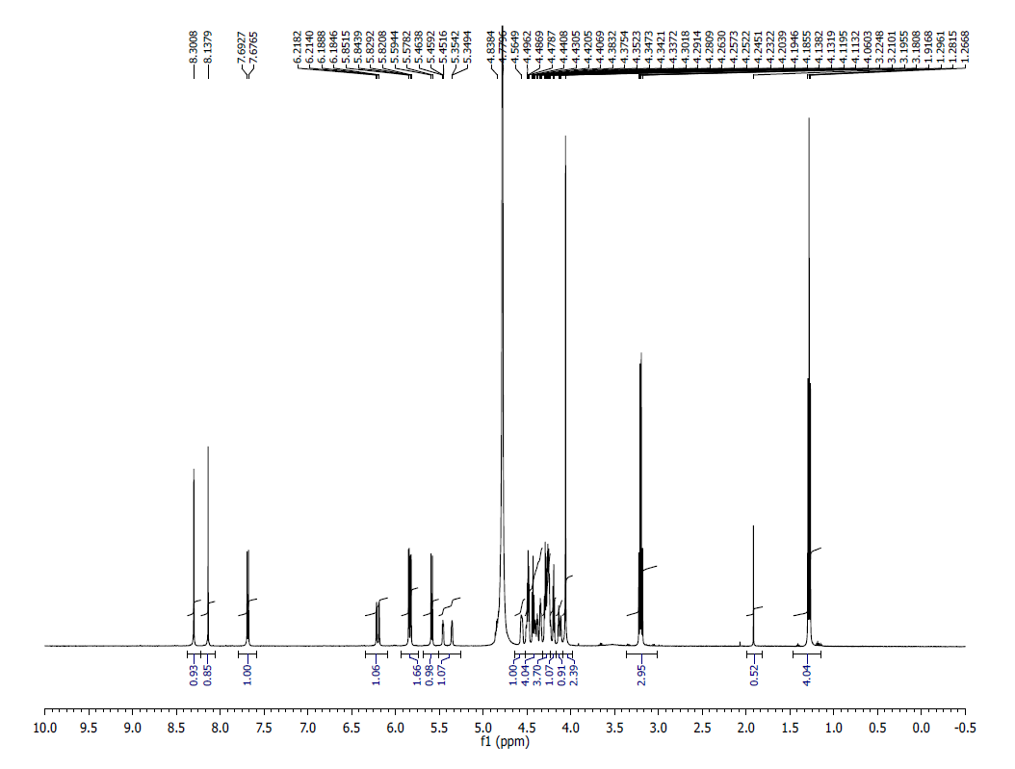
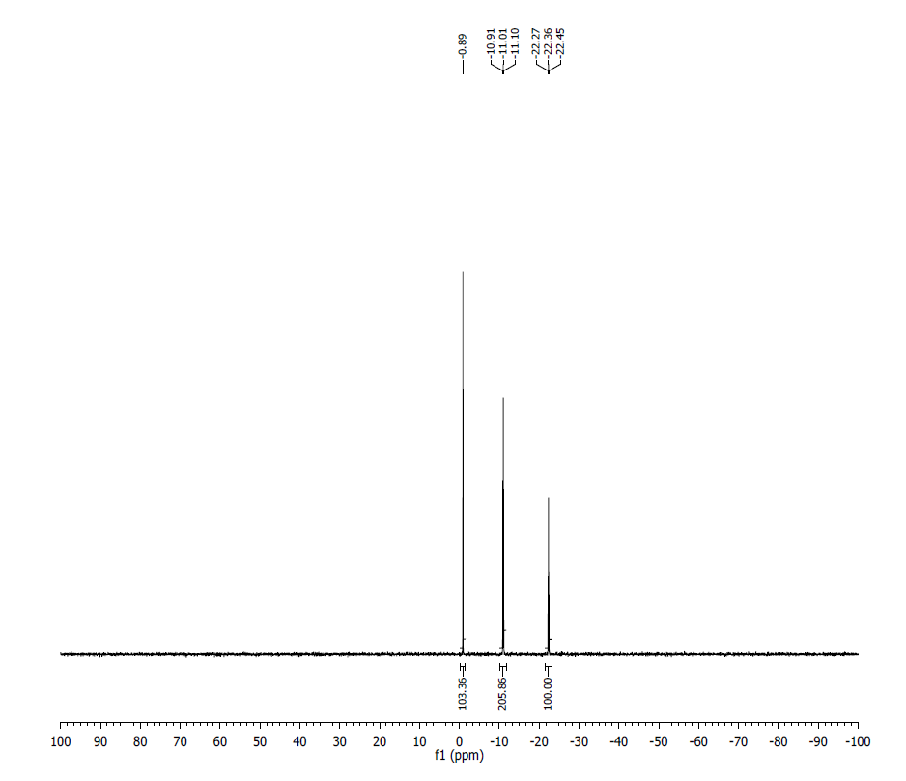
¹H NMR (500 MHz, D₂O) δ: 8.30 (s, 1H), 8.13 (s, 1H), 7.70 (d, J = 8.1 Hz, 1H), 6.22-6.18 (dd, J = 14.7 Hz, J = 2.1 Hz, 1H), 5.85-5.82 (dd, J = 11.15 HZ ,J = 3.8 Hz, 1H, 5.59 (d, J = 8.10 Hz, 1H), 5.46-5.34 (m, 1H), 4.56 (s br, 1H), 4.51-4.30 (m, 4H), 4.29-4.23 (m, 4H), 4.20-4.14 (m, 1H), 4.13-4.11 (m, 1H), 4.06 (s, 2H).
³¹P NMR (200 MHz, D₂O) δ: -0.89 (1P), -10.96 (1P), -11.05 1P), -22.27 (1P).
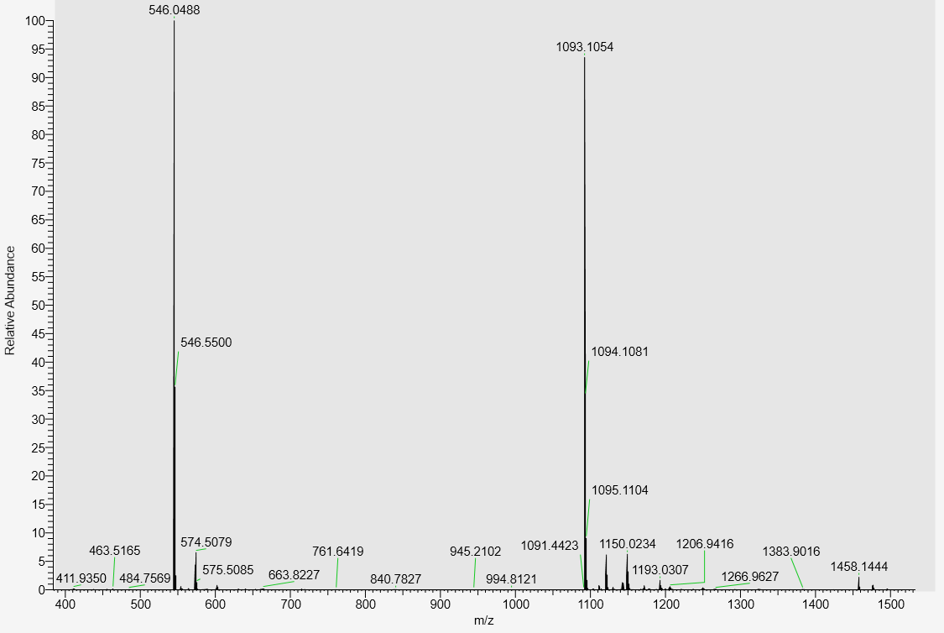
LC-MS data, calculated Mass: 1094.1135; detected m/z: 1093.1054 (M-H)

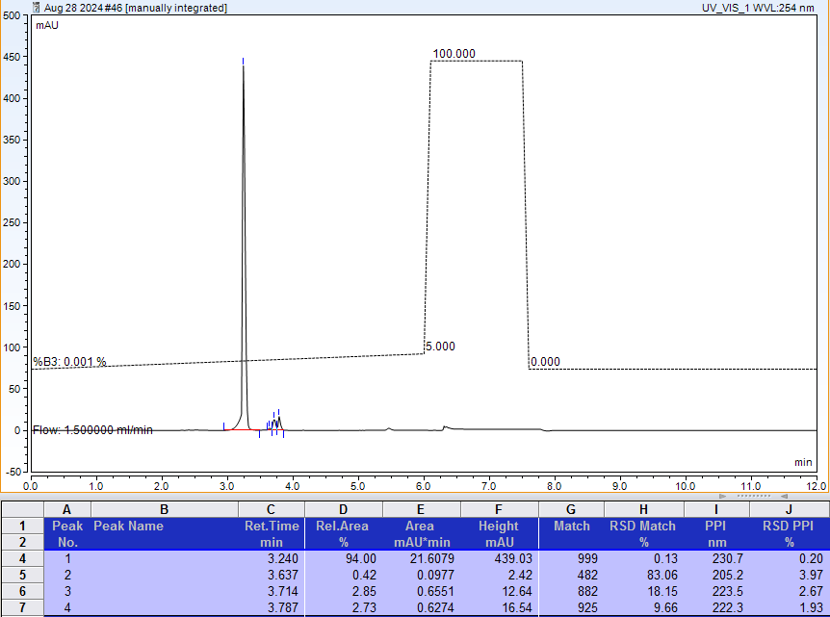
AX-HPLC Analysis (peaks at 3.714 and 3.787 are products of accidental degradation of TCP in analytical sample; opened imidazole ring of the ^{7m}G base)

Compound 3-10A

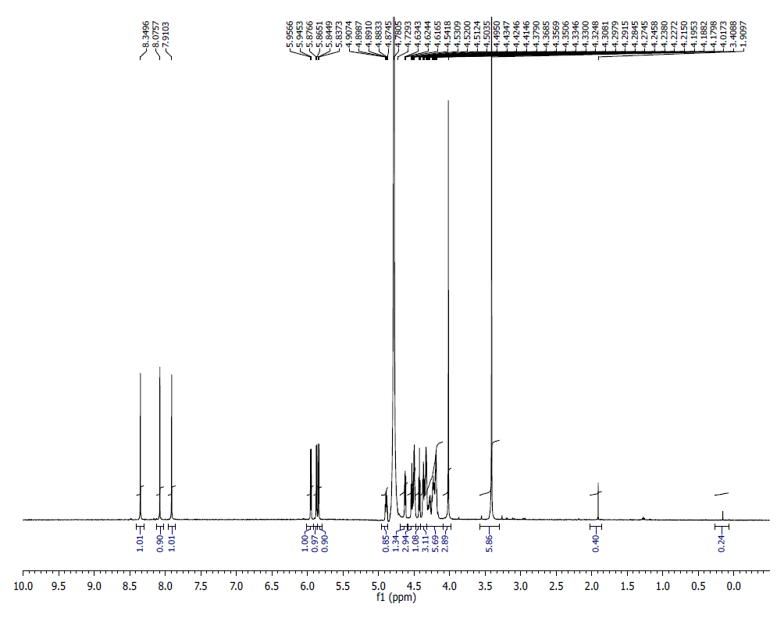
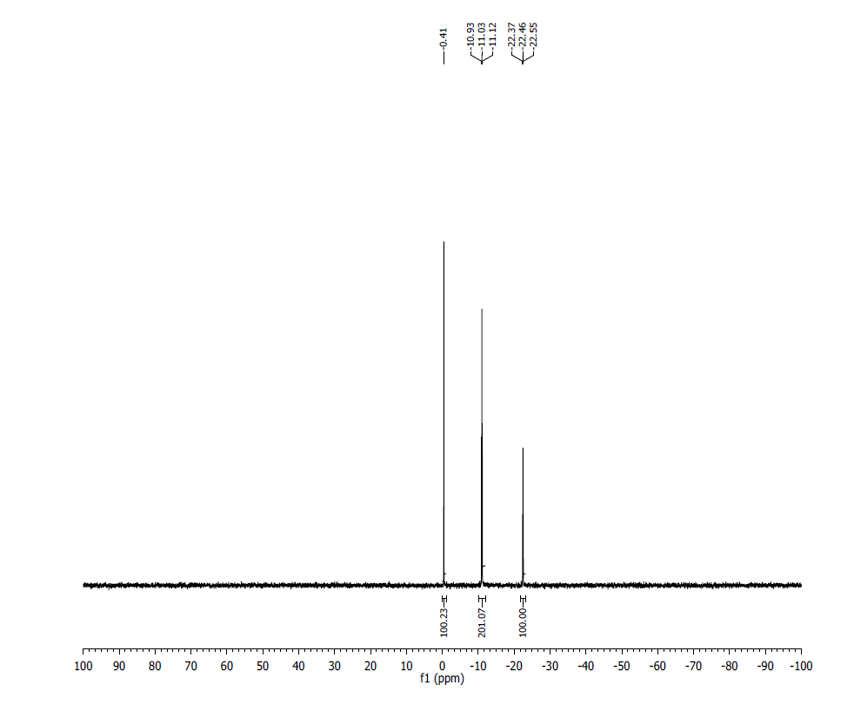
¹H NMR (500 MHz, D₂O) δ: 8.34 (S, 1H), 8.07 (s, 1H), 7.91 (s, 1H), 5.95 (d, J=5.65 Hz, 1H), 5.87 (d, J=5.75 Hz, 1H), 5.84 (d, J=3.8 Hz, 1H), 4.90 – 4.87 (m, 1H), 4.78 - 4.61 (m, 1H), 4.54 – 4.41 (m, 3H), 4.37- 4.35 (t, J=5.25 Hz, 1H), 4.35 – 4.27 (m, 3H), 4.24 – 4.17 (m, 6H), 4.01 (s, 3H), 3.40 (s, 6H).
³¹P NMR (202 MHz, D₂O) δ: -0.41 (1P), -10.98 (1P), -11.07 (1P), -22.37 (1P).
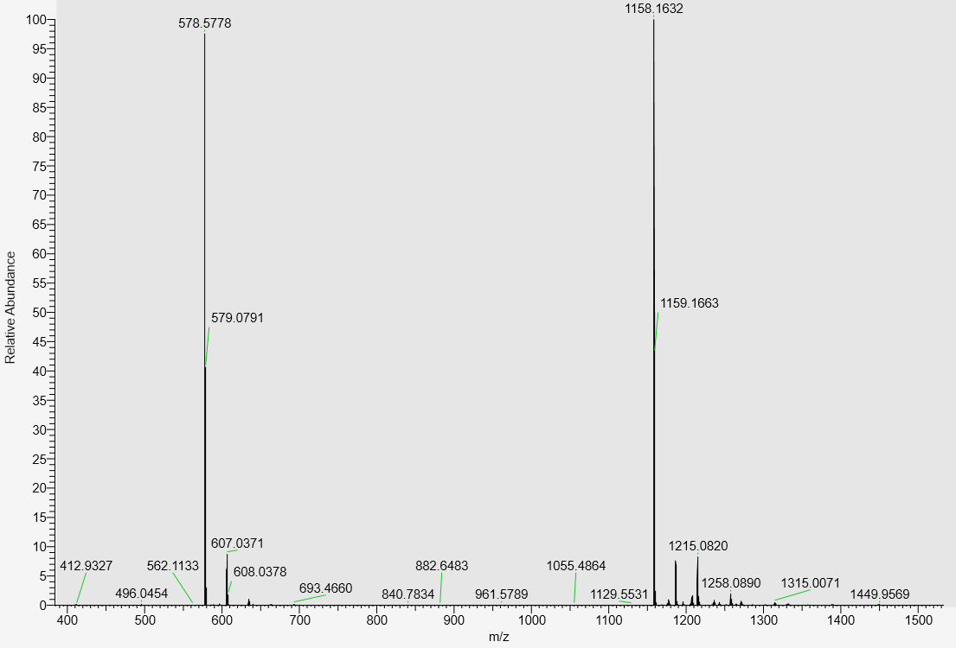
LC-MS data, calculated mass: 1159.1712; detected m/z: 1158.1632 (M-H)

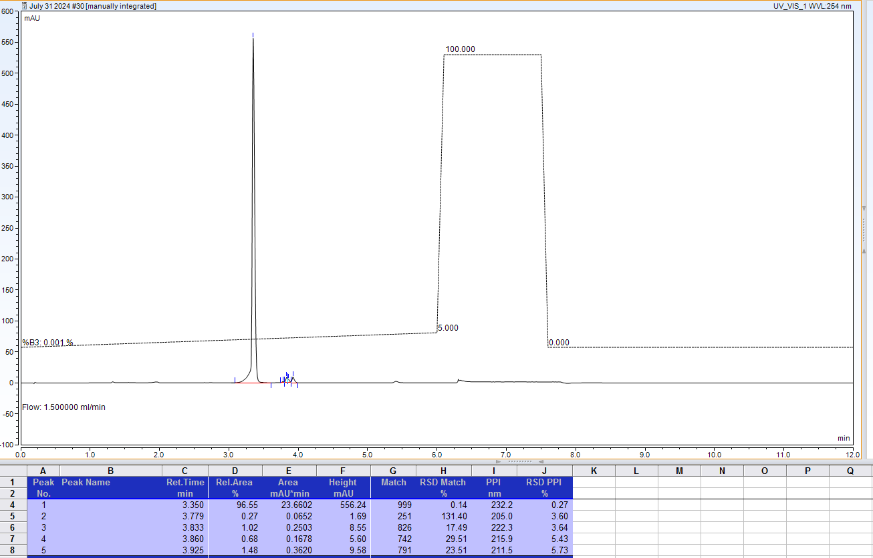
AX-HPLC Analysis (peaks at 3.860 and 3.925 are products of accidental degradation of TCP in analytical sample (opened imidazole ring of ^{7m}G base)

Compound 3-11A

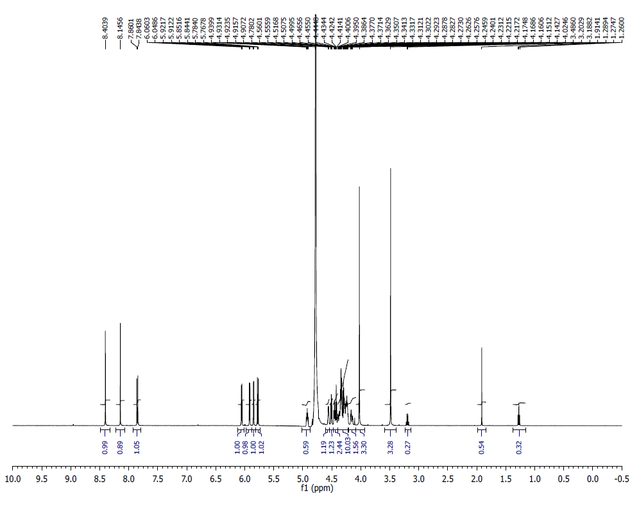
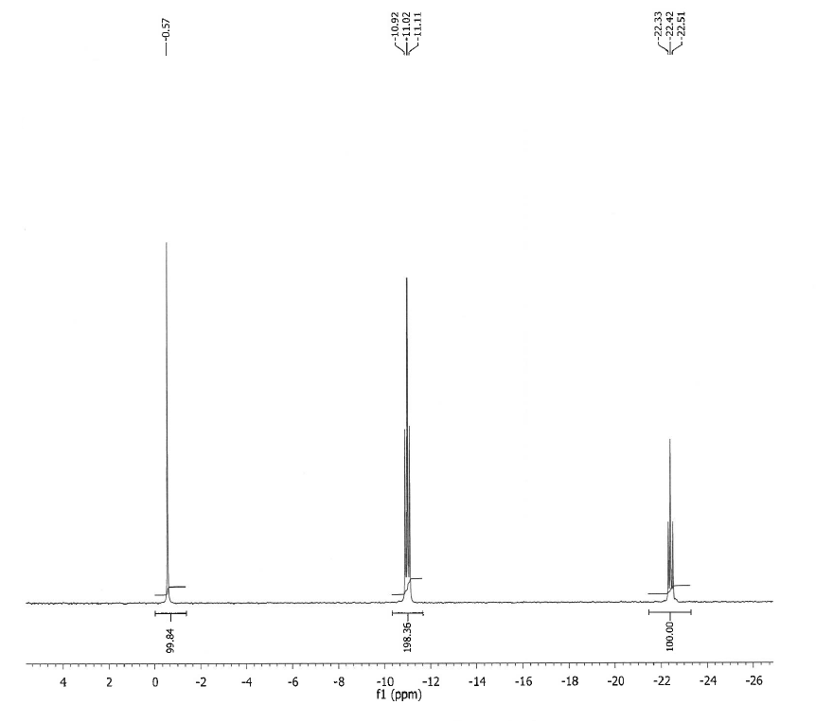
¹H NMR(500 MHz, D2O) δ: 8.40 (s, 1H), 8.15 (s, 1H), 7.86 (d, 1H, J= 8.15 Hz), 6.06 (d, 1H, J= 5.85 Hz), 5.92 (d, 1H, J= 4.75 Hz), 5.85 (d, 1H, J= 3.75 Hz), 5.78 (d, 1H, J= 8.10 Hz), 4.93-4.90 (m, 1H), 4.56-4.55 (m, 1H),4.51-4.49 (m, 1H), 4.46-4.41 (m, 2H), 4.40-4.23 (m, 10H), 4.17-4.14 (m, 2H), 4.11 (s, 3H), 4.02 (s, 3H).
³¹P NMR (200 MHz, D₂O) δ: -0.57 (1P), -10.97 (1P), -11.06 (1P), -22.42(1P).
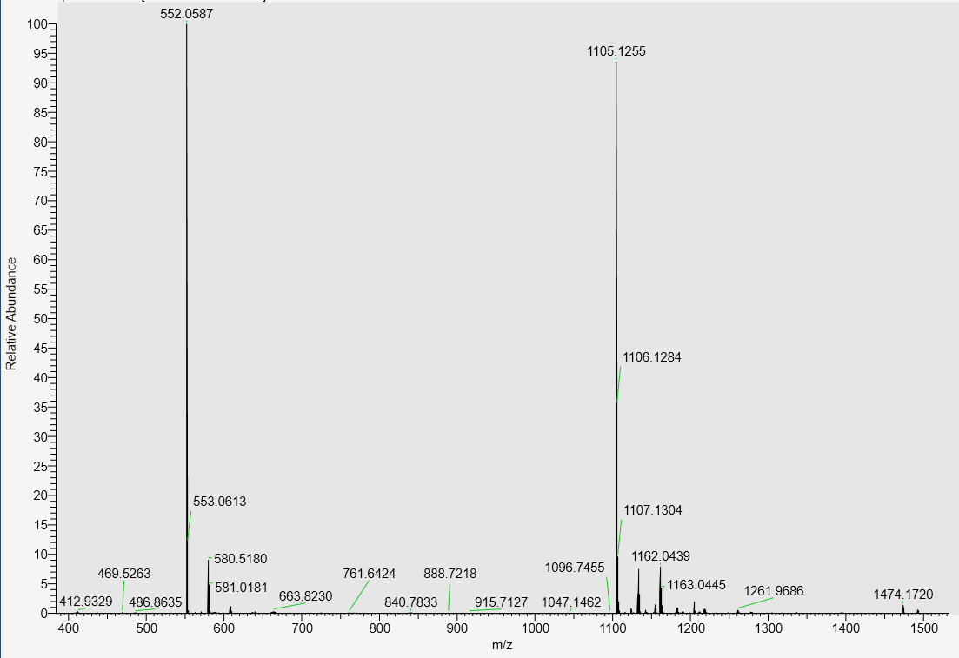
LC-MS data, calculated mass: 1106.1335; detected m/z: 1105.1255 (M-H)

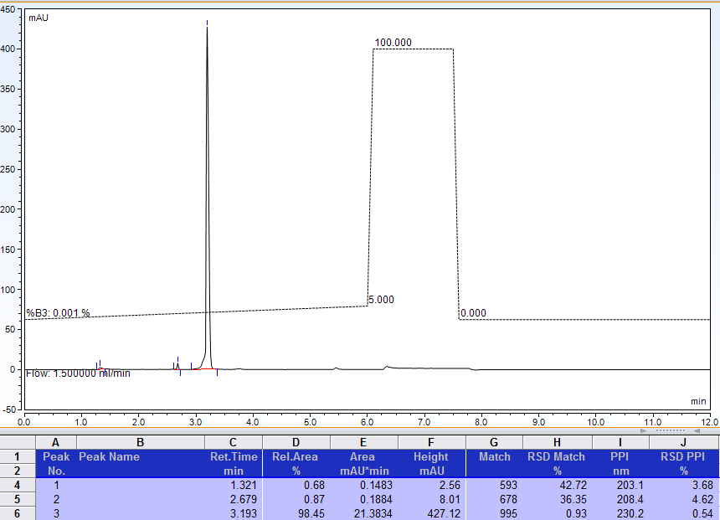
AX-HPLC Analysis

Compound 3-12A

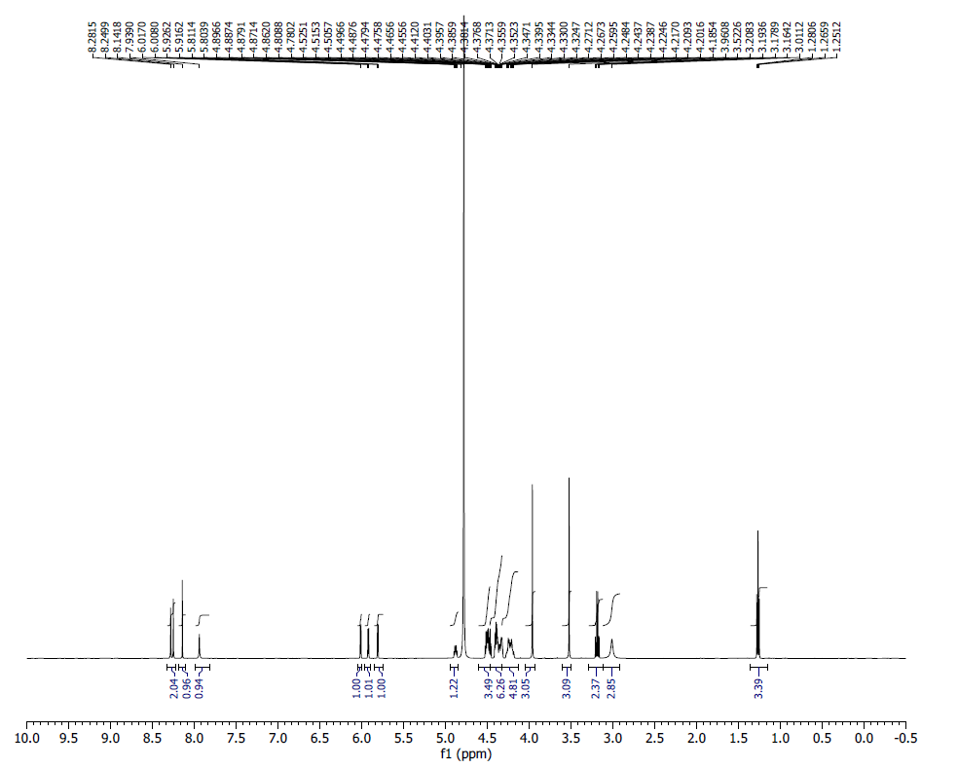
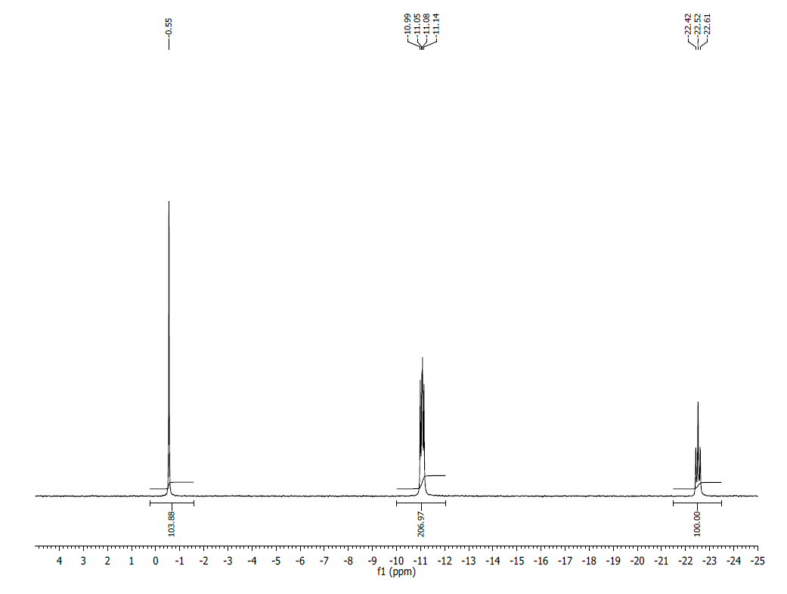
¹H NMR (500 MHz, D₂O) δ: 8.28 (S, 1H), 8.25 (s, 1H), 8.14 (s, 1H ), 7.94 (br s, 1H), 6.02 (d, J=4.50 Hz, 1H), 5.93 (d, J=5.00 Hz, 1H), 5.81 (d, J=3.75 Hz, 1H), 4.52– 4.45 (m, 4H), 4.41– 4.32 (m, 6H), 4.27– 4.18 (m, 5H), 3.96 (s, 3H), 3.52 (s, 3H), 3.96 (br s, 3H).
³¹P NMR (202 MHz, D₂O) δ: -0.55 (1P), -11.04 (1P), -11.09 (1P), -22.52 (1P).
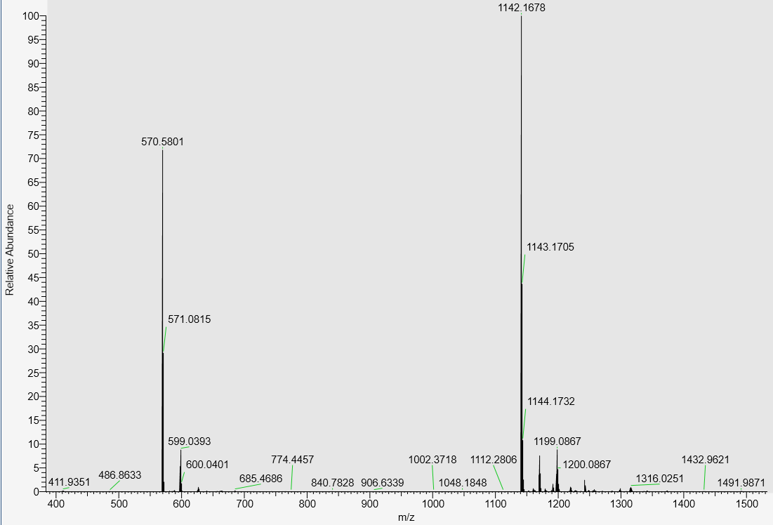
LC-MS data, calculated mass: 1143.1763; detected m/z: 1142.1678 (M-H)
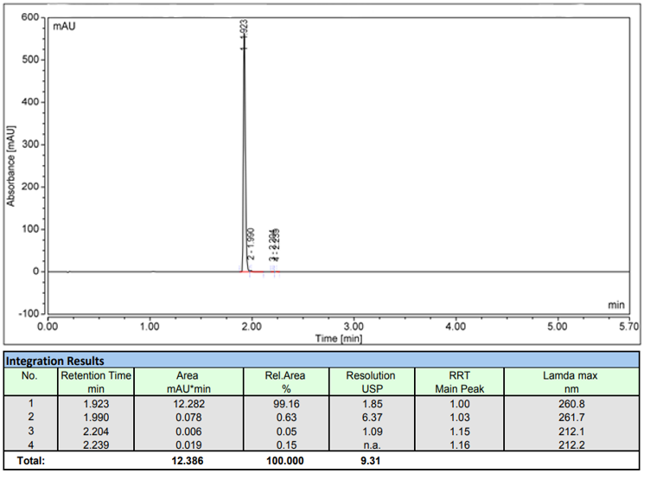
AX-HPLC Analysis
Compound 3-13A

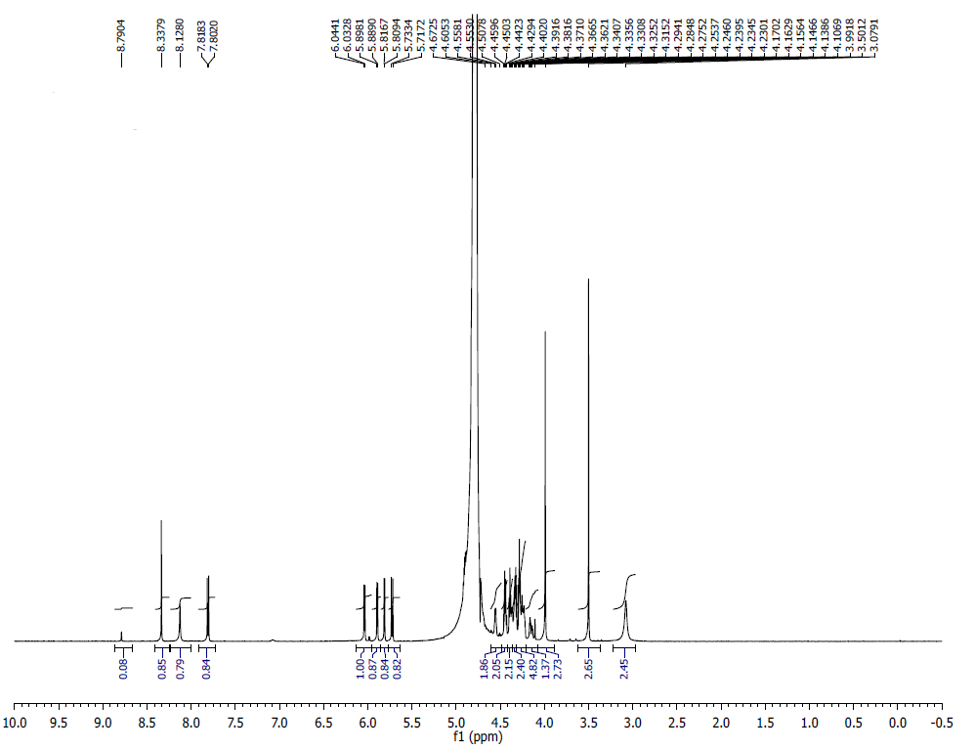
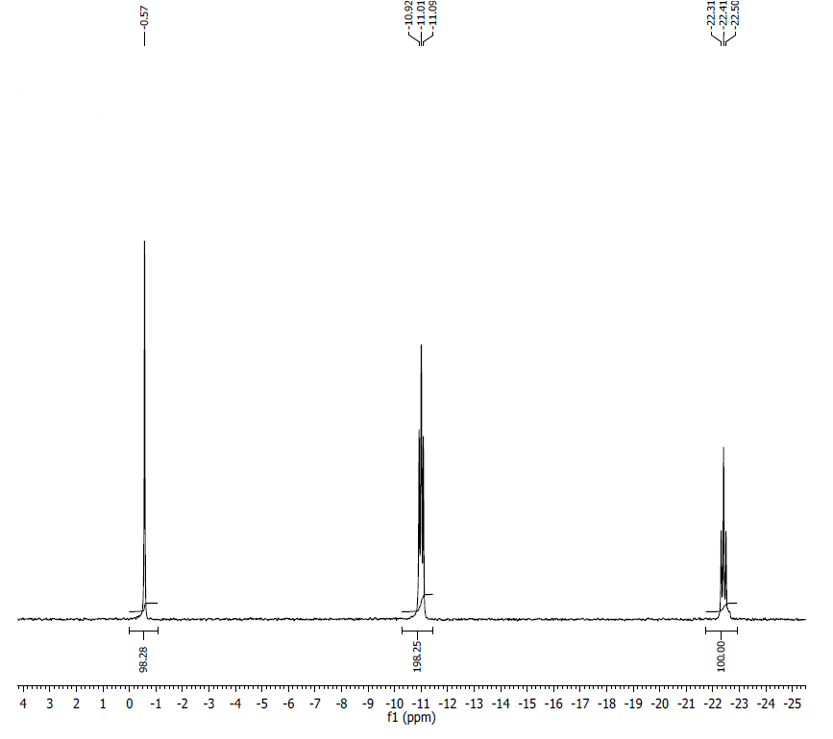
¹H NMR (500 MHz, D2O) δ: 8.34 (s, 1H), 8.13 (s, 1H), 7.81 (d, J = 8.2, 1H), 6.04 (d, J = 5.7, 1H), 5.89 (d, J = 4.6, 1H), 5.81 (d, J = 3.7, 1H), 5.72 (d, J = 8.1, 1H), 4.55 (m, 1H), 4.40-4.46 (m, 2H), 4.32-4.39 (m, 4H), 4.23-4.29 (m, 5H), 4.17 (m, 1H), 3.99 (s, 3H), 3.50 (s, 3H), 3.08 (bs, 3H).
³¹P NMR (200 MHz, D2O) δ: -0.57 (1P), -10.97 (1P), -11.04 (1P), -22.41 (1P).
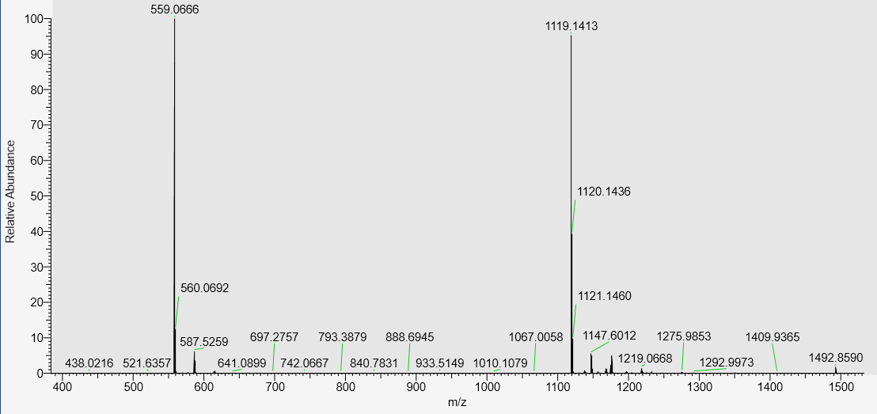
LC-MS data, calculated mass:1120.1491, detected m/z = 1119.1413 (M-H)

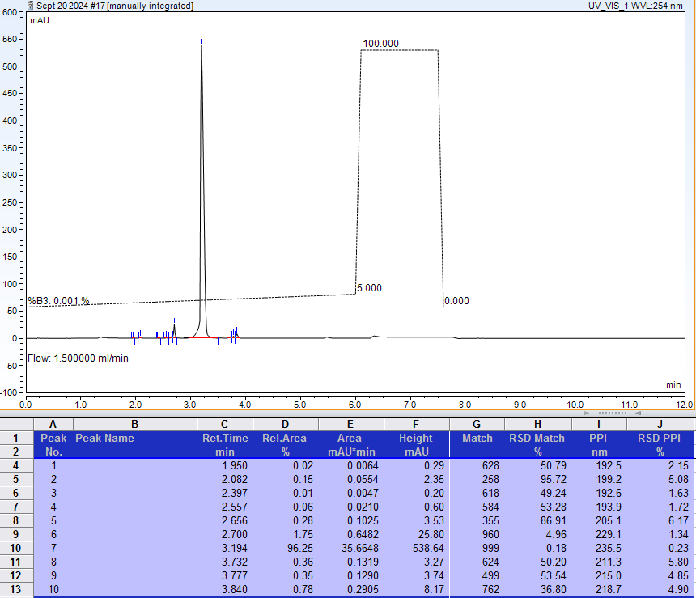
AX-HPLC Analysis
Compound 3-15A

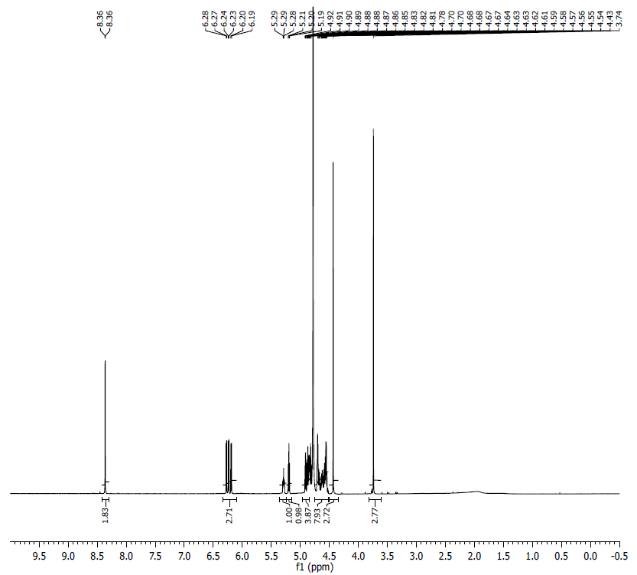
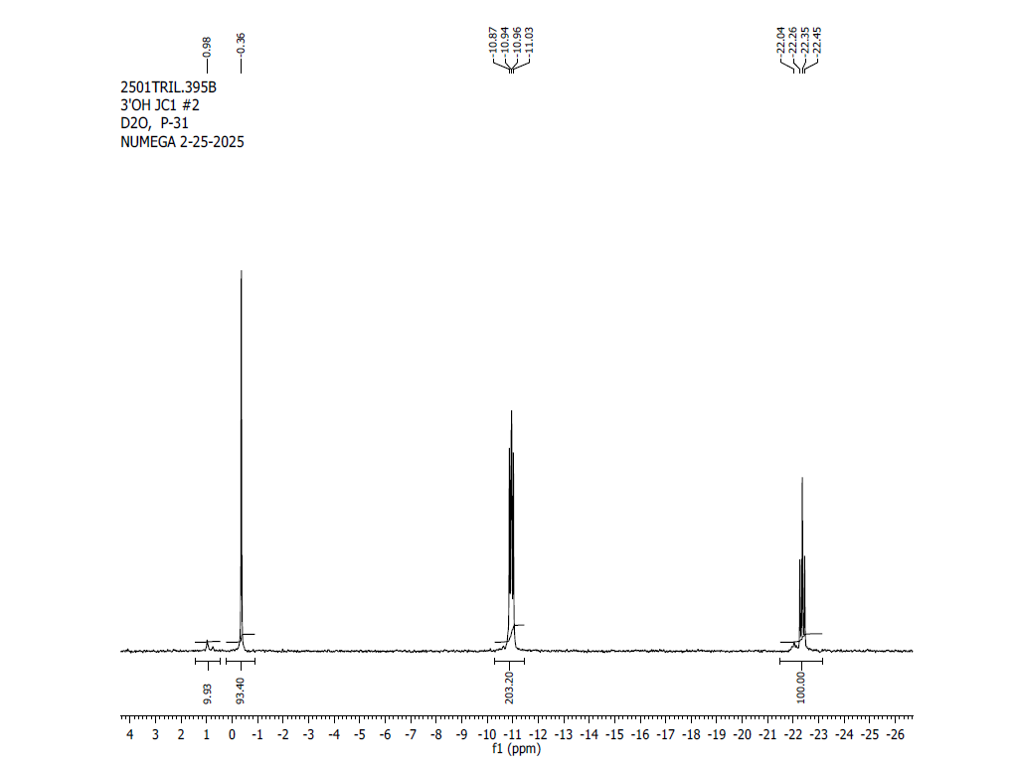
¹H NMR (500 MHz, D2O, at 60ºC) δ: 8.35 (s, 1H), 8.36 (s, 1H), 6.27 (d,1H), 6.23 (d,1H), 6.19 (d, 1H), 5.29 (m, 1H), 5.20 (t, 1H), 4.91 (t, 1H), 4.78-4.89 (m, 3H), 4.54-4.70 (m, 8H), 4.43 (s, 3H), 3.74 (s, 3H).
³¹P NMR (200 MHz, D2O, at 60ºC) δ: -0.36 (1P), -10.92 (1P), -10.99 (1P), -22.35 (1P); additional small resonances belong to residual aggregate forms of ^{7m}GpppG_{m}pG.

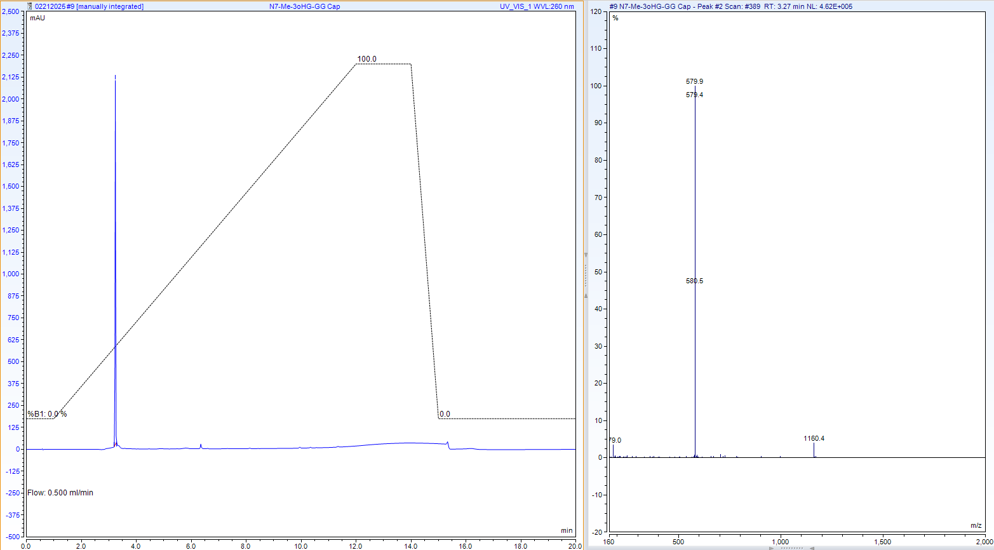
RP-HPLC-MS data, calculated mass:1161.1505, detected m/z = 1160.04 (M-H)

Compounds related to Table 3, Series B
Compound 3-1B
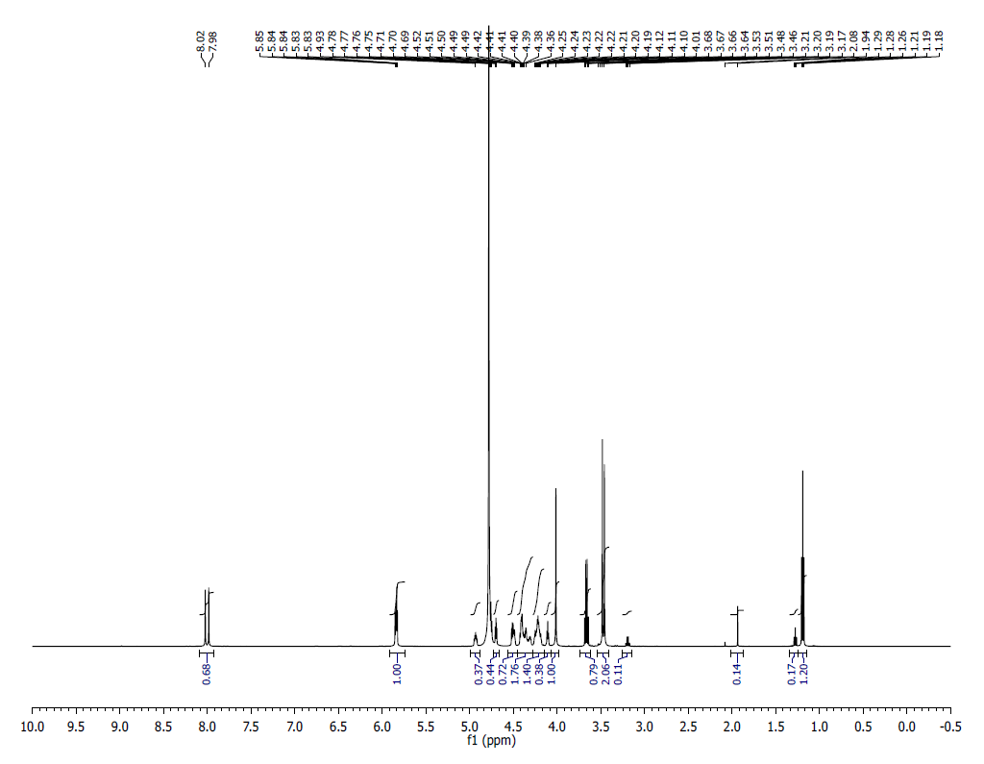
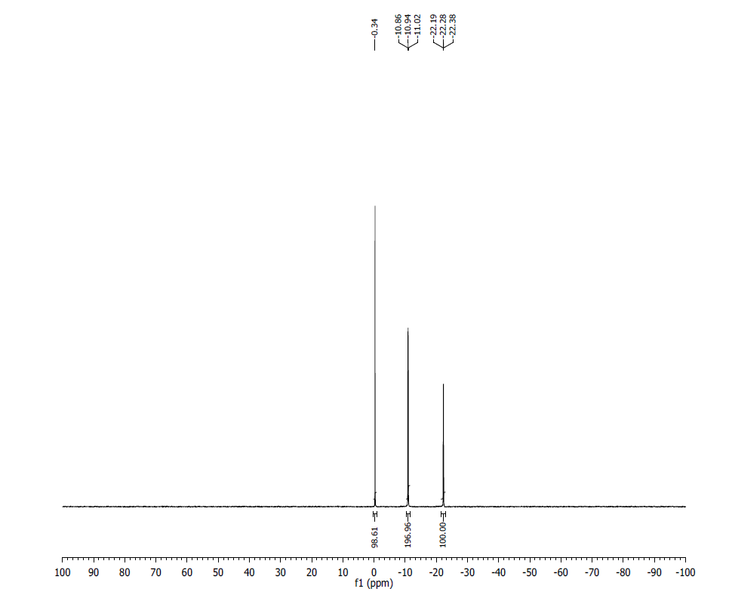
¹H NMR (500 MHz, D₂O) δ: 8.02 (s, 1H), 7.98 (s, 1H), 5.82 (m, 3H), 4.93 (m, 1H), 4.69 (m, 1H), 4.49 (m, 1H), 4.42 – 4.10 (m, 11H), 3.68 (s, 3H), 3.48 (s, 3H), 3.46 (s, 3H).
³¹P NMR (200 MHz, D₂O) δ: -0.34 (1P), -10.90 (1P), -10.98 (1P) -22.28 (1P).
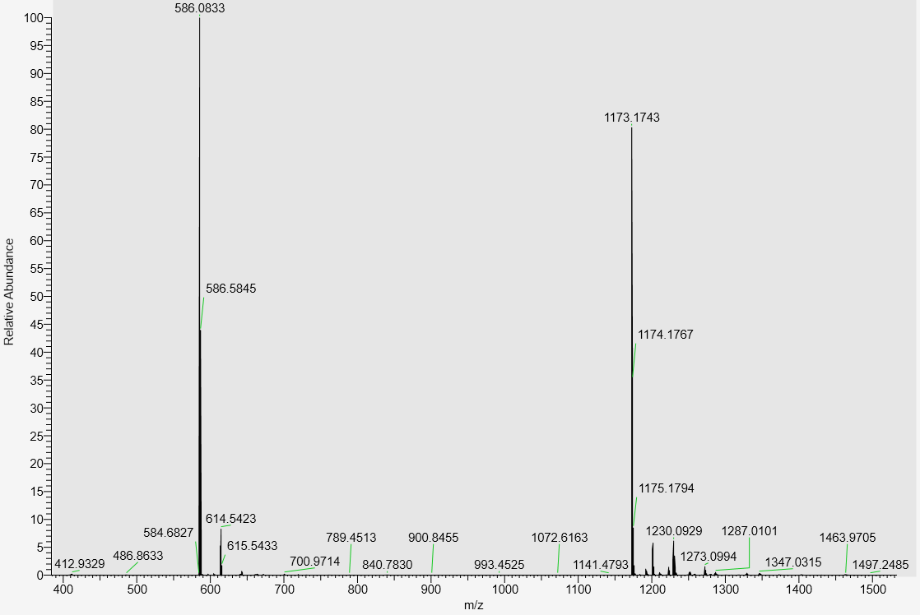
LC-MS data, calculated Mass: 1174.1821; detected m/z: 1173.1743 (M-H)

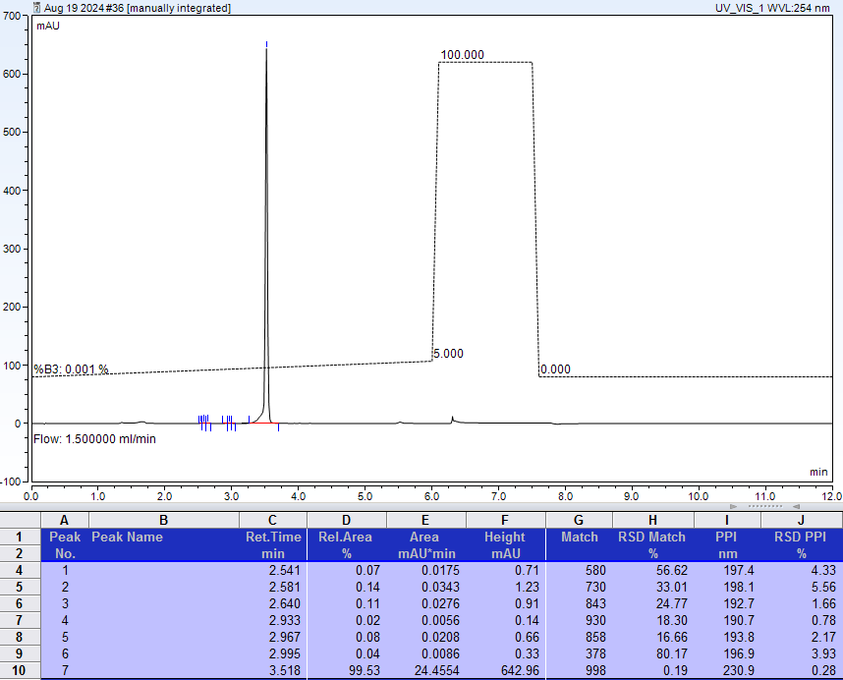
AX-HPLC analysis
Compound 3-2B12
Mixture of two diastereomers (asymmetric phosphorus is shown in bold)
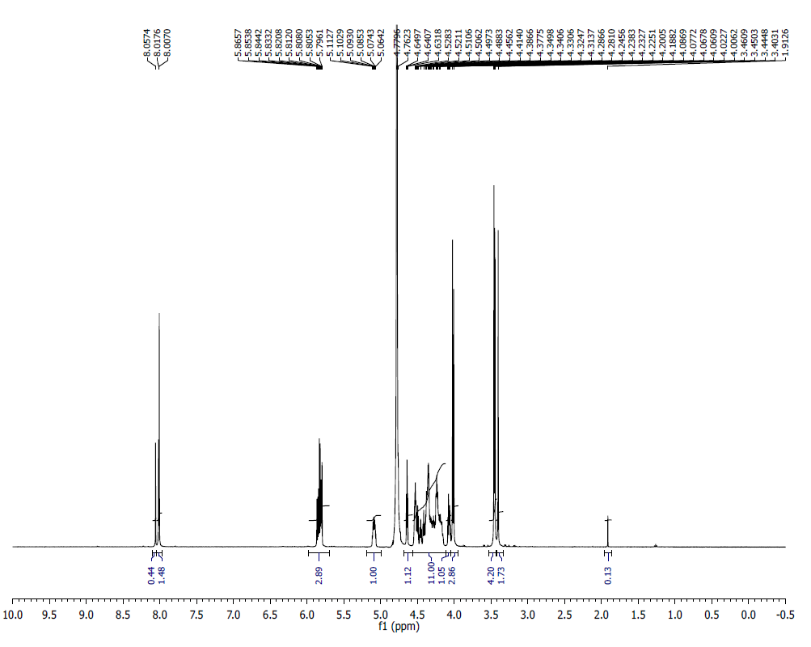
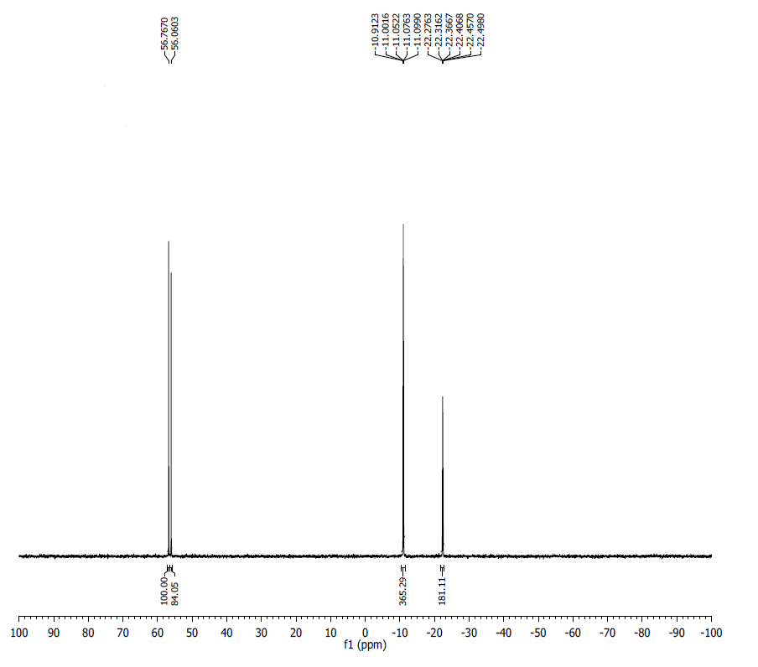
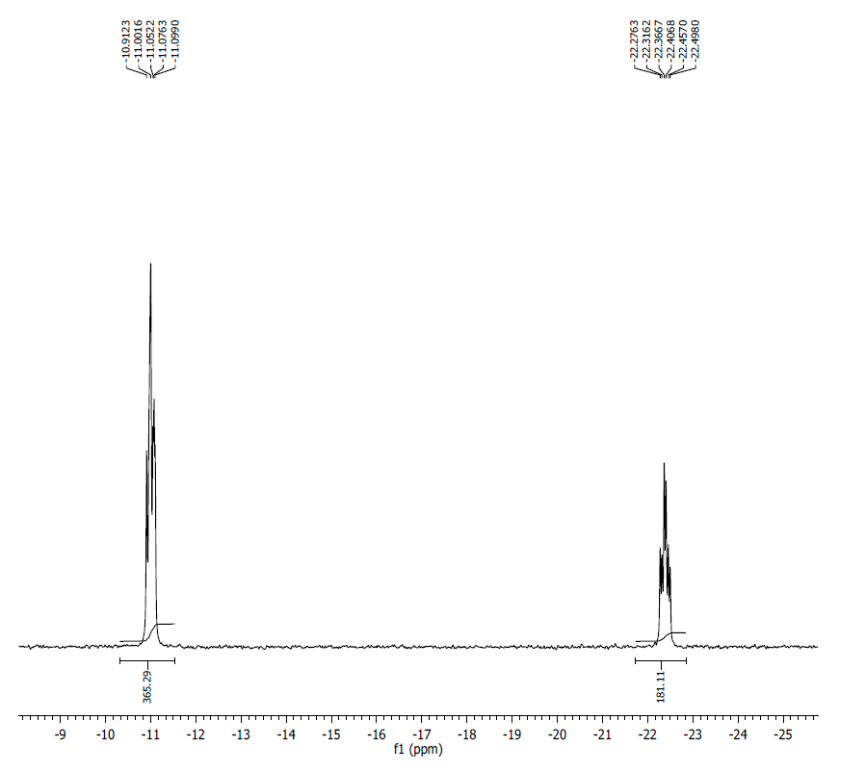
¹H NMR (500 MHz, D₂O) δ: 8.05 (s, 1H), 8.01-8.00 (m, 2H), 5.86-5.79 (m, 3H), 5.11-5.06 (m, 1H), 4.64 (t, J= 4.5 Hz, 1H), 4.52-4.15 (m, 11H), 4.08-4.05 (m, 1H), 4.02 (d, J=8.25 Hz, 3H), 3.46-3.44 (m, 4H), 3.40 (s, 2H).
³¹P NMR (200 MHz, D2O) δ (overlapping signals of two diastereomers, tentative assignment): Diastereomer 1: 56.76 (1P), -11.00 (1P), -11.06 (1P), -22.37 (1P); Diastereomer 2: 56.06 (1P), -11.00 (1P), -11.09 (1P), -22.41 (1P).
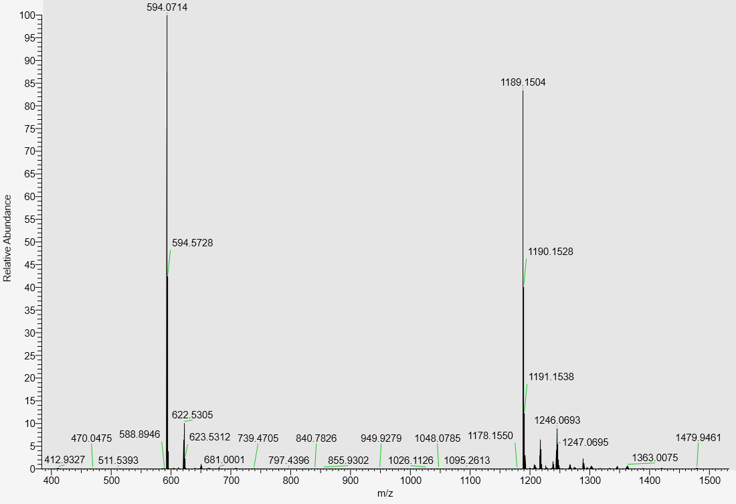
LC-MS data, calculated mass=1190.1593; detected m/z: 1189.1504 (M-H)

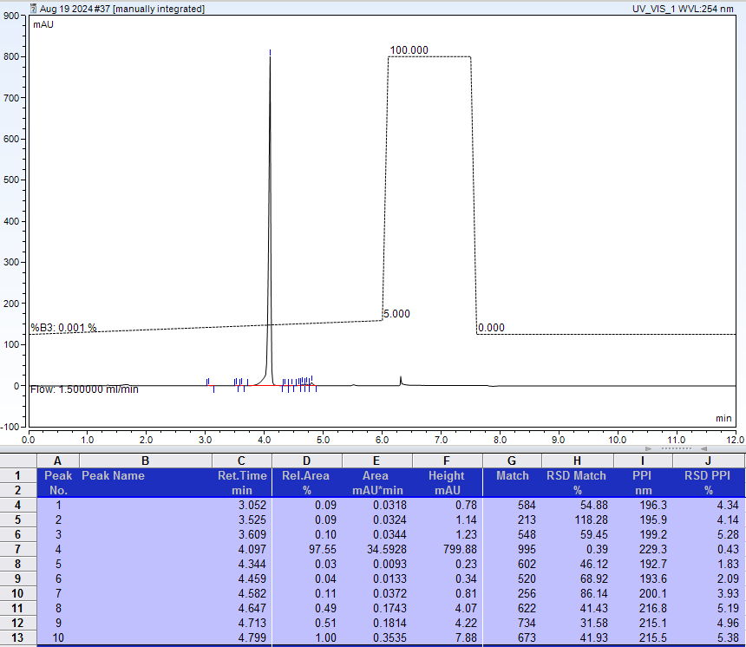
AX-HPLC Analysis
Compound 3-3B

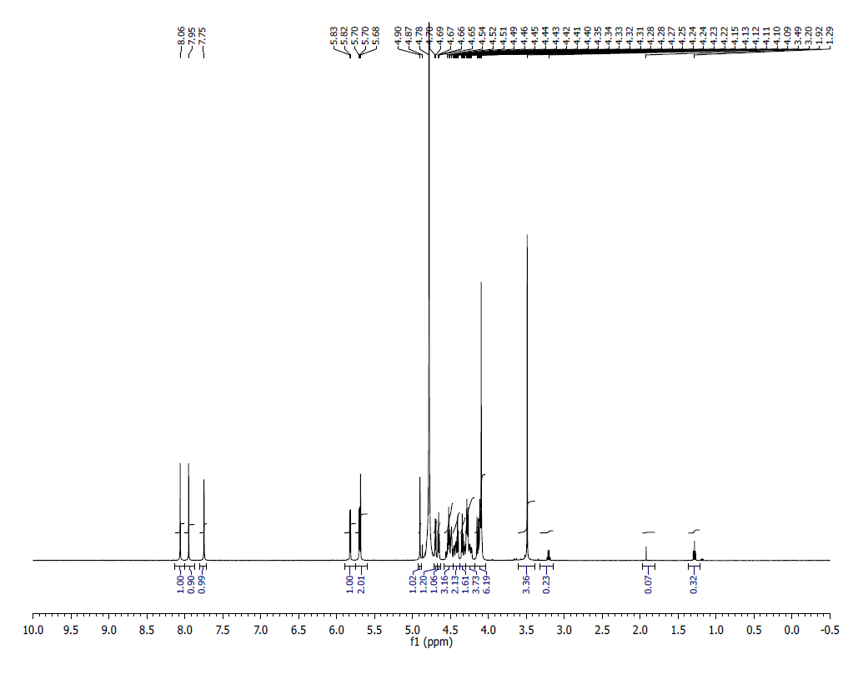
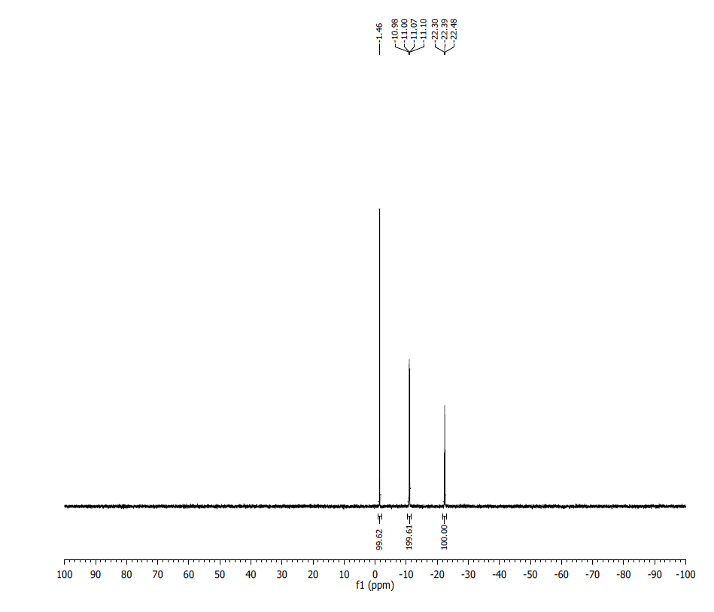
¹H NMR (500 MHz, D₂O) δ: 8.06 (s, 1H). 7.95 (s, 1H), 7.75 (s, 1H), 5.82 (d, J = 4.7 Hz, 1H), 5.68 (m, 2H), 4.90 (m, 1H), 4.69 – 4.11 (m, 13H), 4.09 (s, 3H), 3.49 (s, 3H).
³¹P NMR (200 MHz, D₂O) δ: -1.46 (1P), -11.02 (1P), -11.05 (1P), -22.39 (1P).
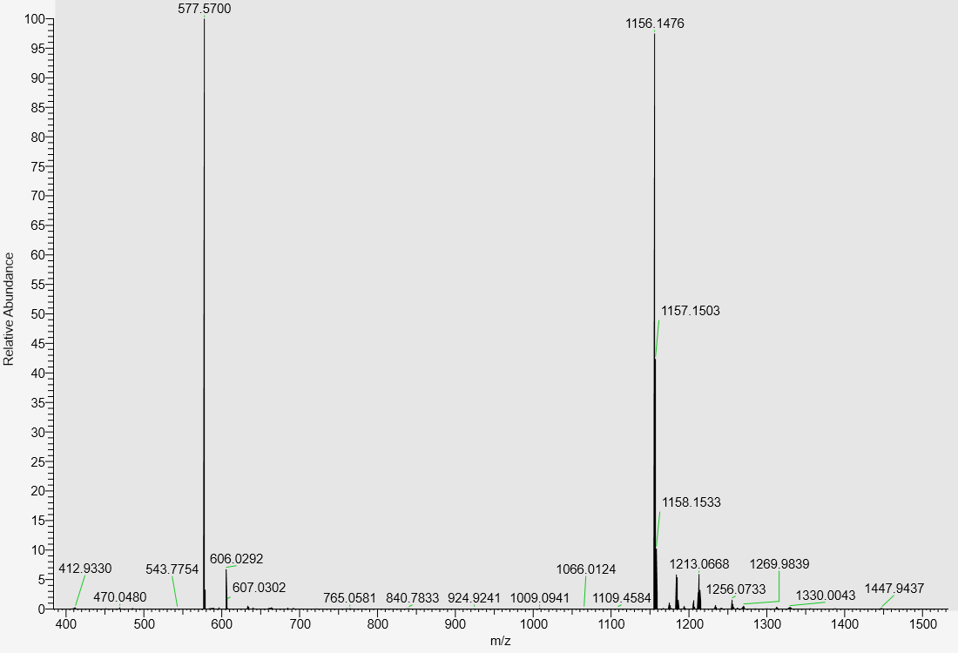
LC-MS data, calculated mass: 1157.1556, detected m/z: 1156.1476 (M-H)

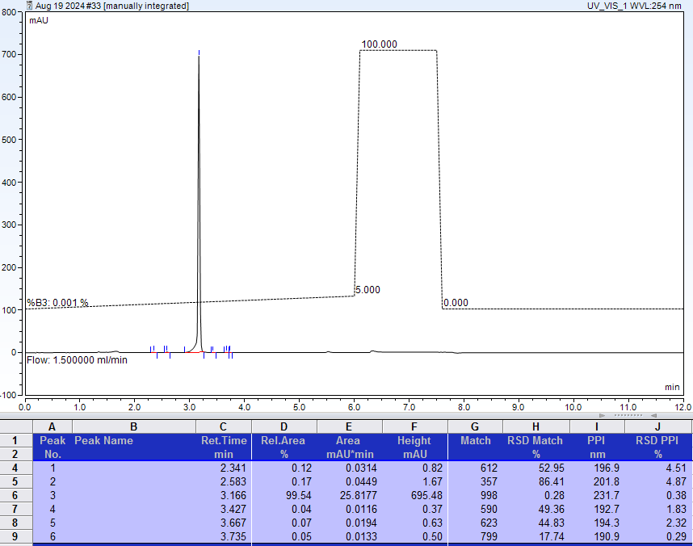
AX-HPLC analysis
Compound 3-5B

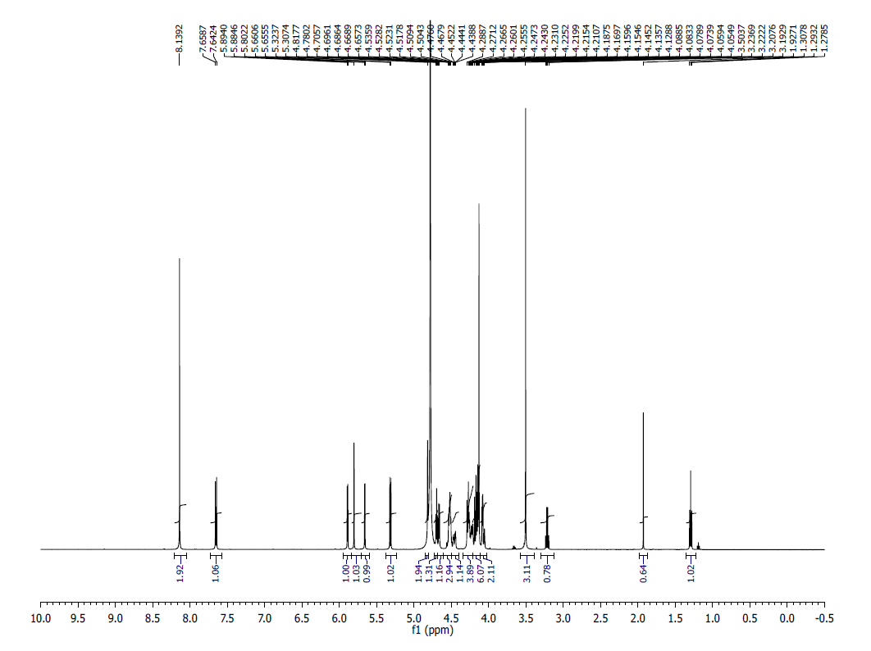
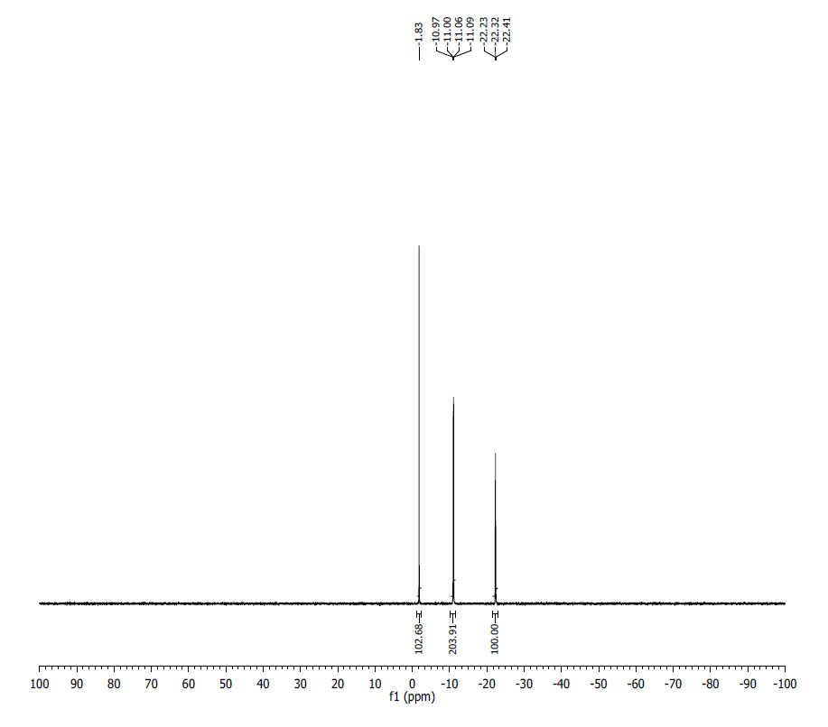
¹H NMR (500 MHz, D₂O) δ: 8.14 (s, 1H), 7.66 (d, J = 8.5 Hz, 1H), 5.89 (d, J = 4.7 Hz, 1H), 5.80 (s, 1H), 5.66 (d, J= 2.55, 1H) 5.32 (d, J= 8.15, 1H), 4.81(s, 1H), 4.71-4.69 (t, , J= 4.85,1H), 4.67 (d, , J= 5.80, 1H), 4.54-4.50 (m, 3H), 4.47-4.43 (m, 1H), 4.29-4.21 (m, 4H), 4.18-4.13(m, 6H), 4.09-4.05 (m,1H).
³¹P NMR (200 MHz, D₂O) δ: -1.83 (1P), -11.01 (1P), -11.05 (1P), -22.32 (1P).
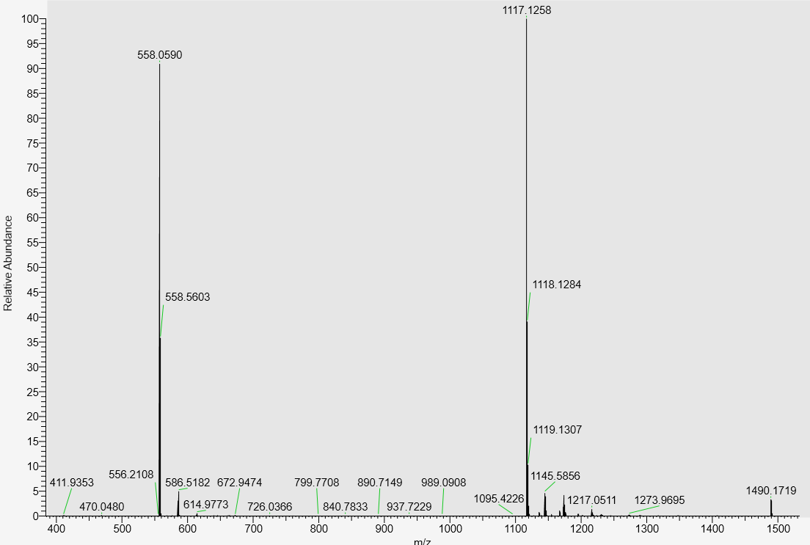
LC-MS data, calculated mass: 1118.1335; detected m/z: 1117.1258 (M-H)

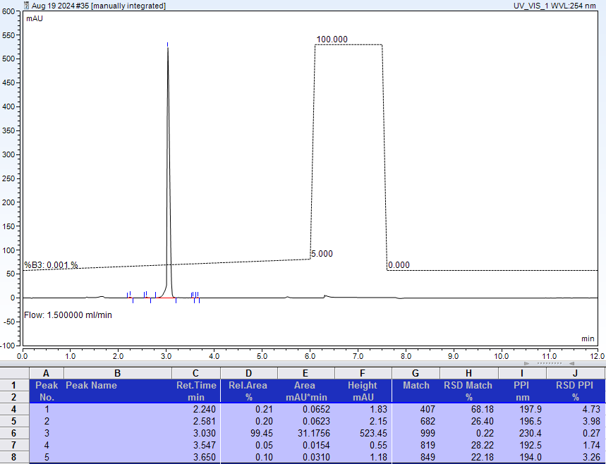
AX-HPLC analysis
Compound 3-6B1
Diastereomer 1 (asymmetric phosphorus is shown in bold)
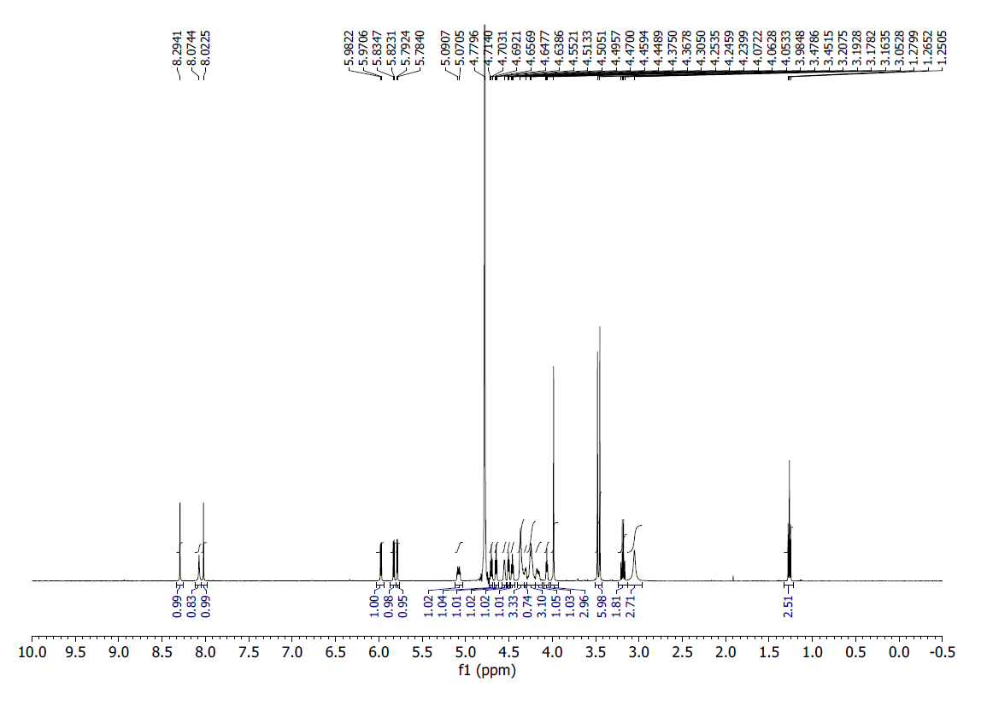

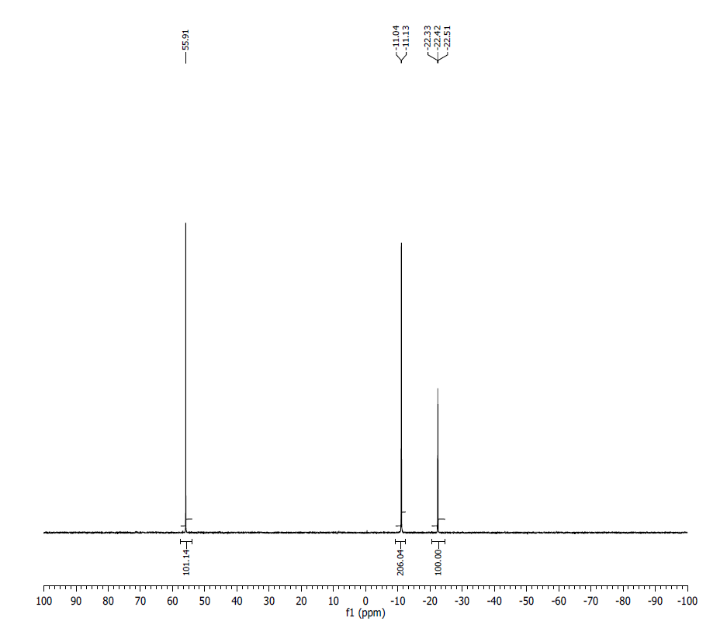
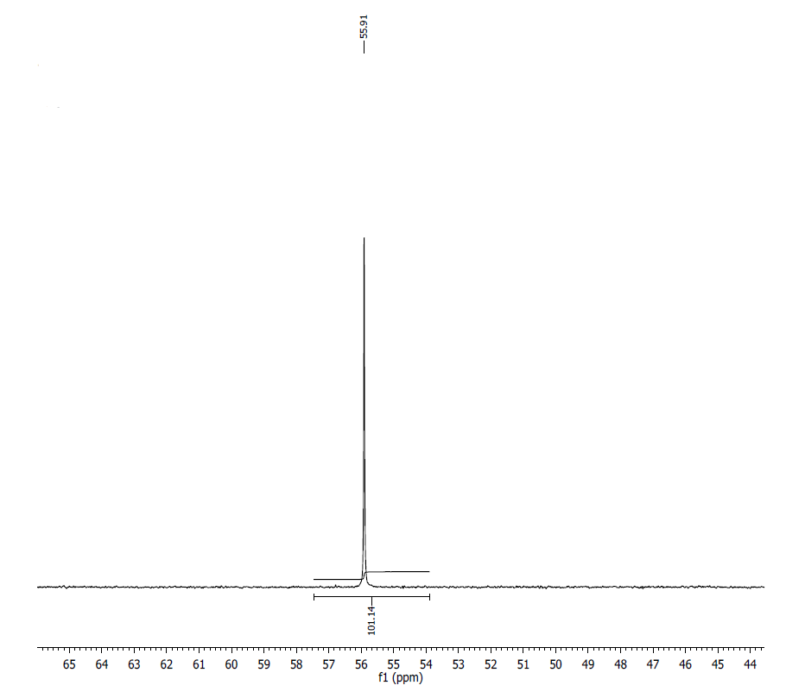
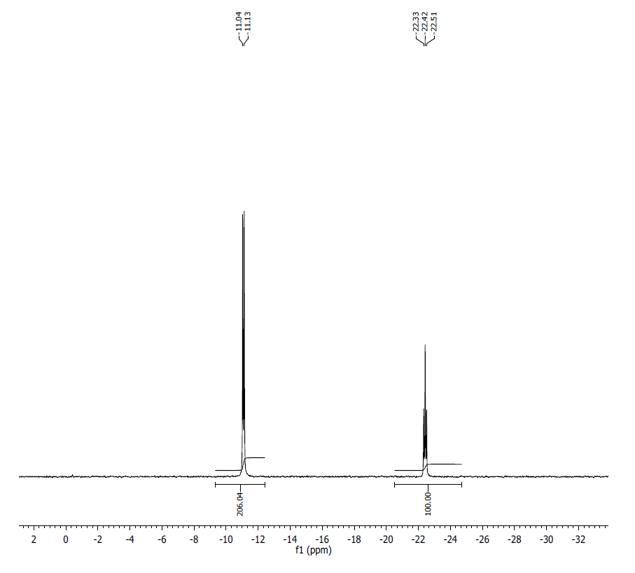
¹H NMR (500MHz, D₂O) δ: 8.29 (s, 1H), 8.07 (s, 1H), 8.02 (s, 1H), 5.98 (d, J = 5.8, 1H), 5.83 (d, J = 5.8, 1H), 5.79 (d, J = 4.2, 1H), 5.08 (m, 1H), 4.70 (t, J = 5.5, 1H), 4.65 (t, J = 4.6, 1H), 4.55 (m, 1H), 4.51 (t, J = 4.1, 1H), 4.46 (t, J = 5.3, 1H), 4.37 (m, 3H), 4.34 (m, 1H), 4.25 (m, 3H), 4.18 (m, 1H), 4.06 (t, J = 4.7, 1H), 3.98 (s, 3H), 3.48 (s, 3H), 3.45 (s, 3H), 3.05 (bs, 3H).
³¹P NMR (200 MHz, D₂O) δ: 55.91 (1P), -11.09 (2P), -22.42 (1P).
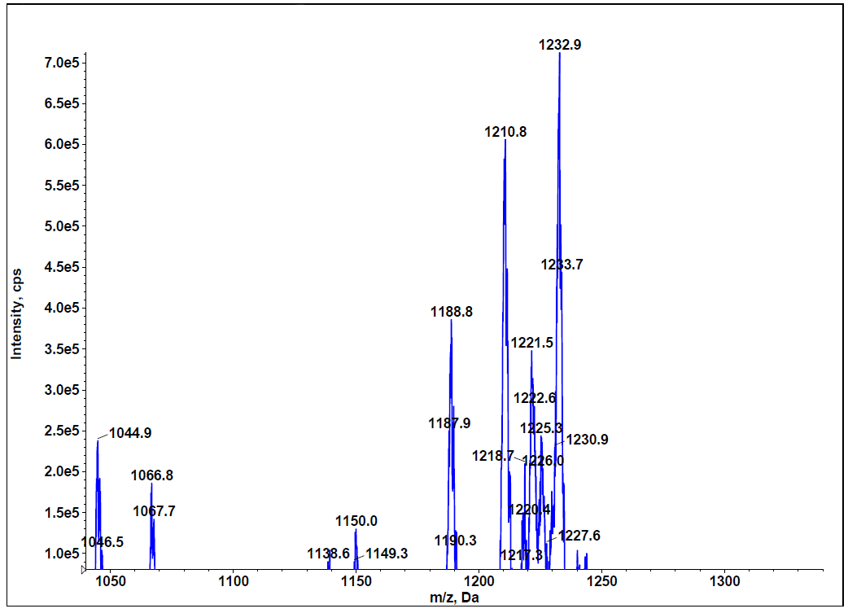
LC-MS data, calculated mass: 1189.1640; detected m/z: 1188.8 (M-H) ) (low resolution MS)
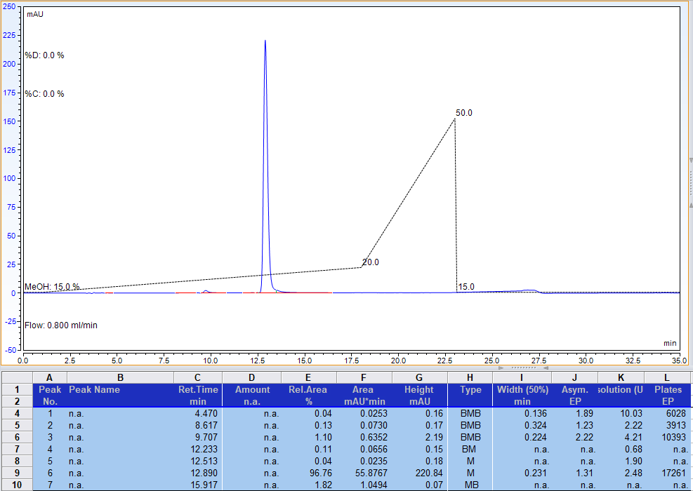
RP-HPLC analysis. Gradient of methanol in 100 mM Triethylammonium acetate, pH 7.0
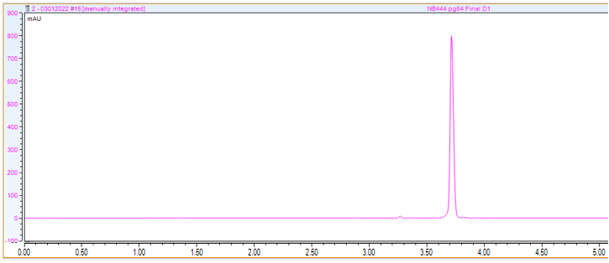
AX-HPLC Analysis (manual integration: 98.2%)

Compound 3-6B2
Diastereomer 2 (asymmetric phosphorus is shown in bold)

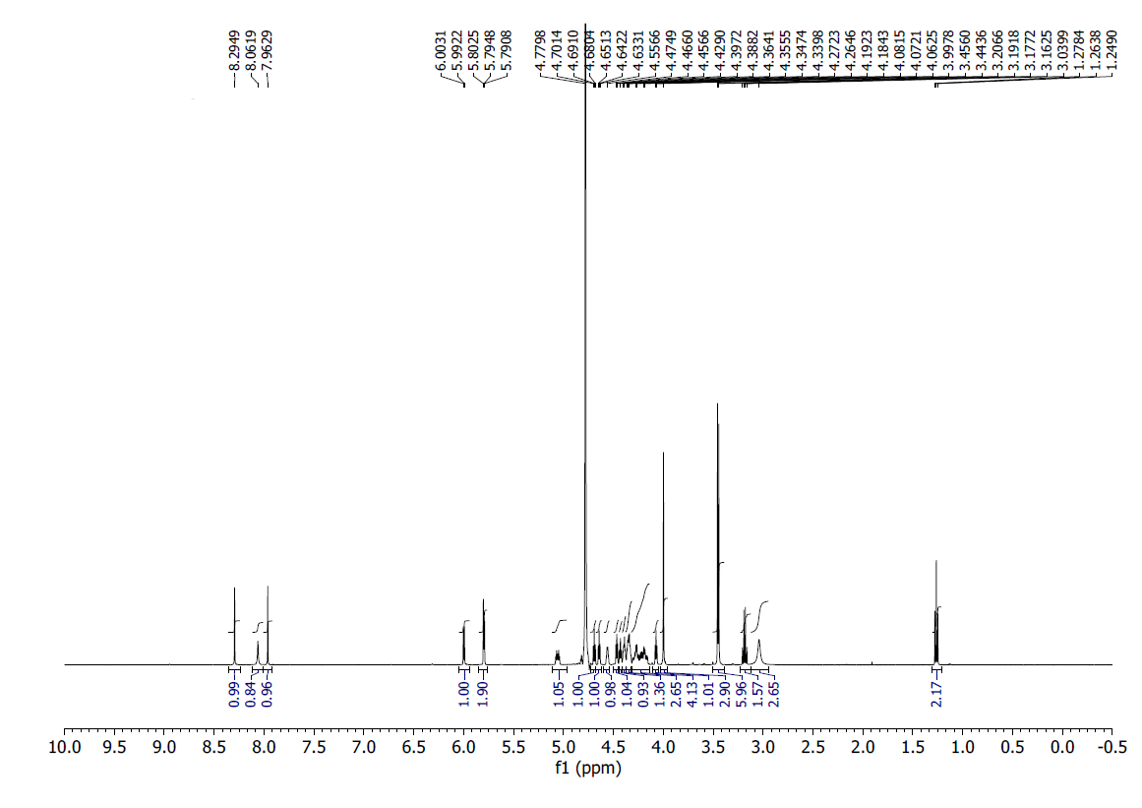
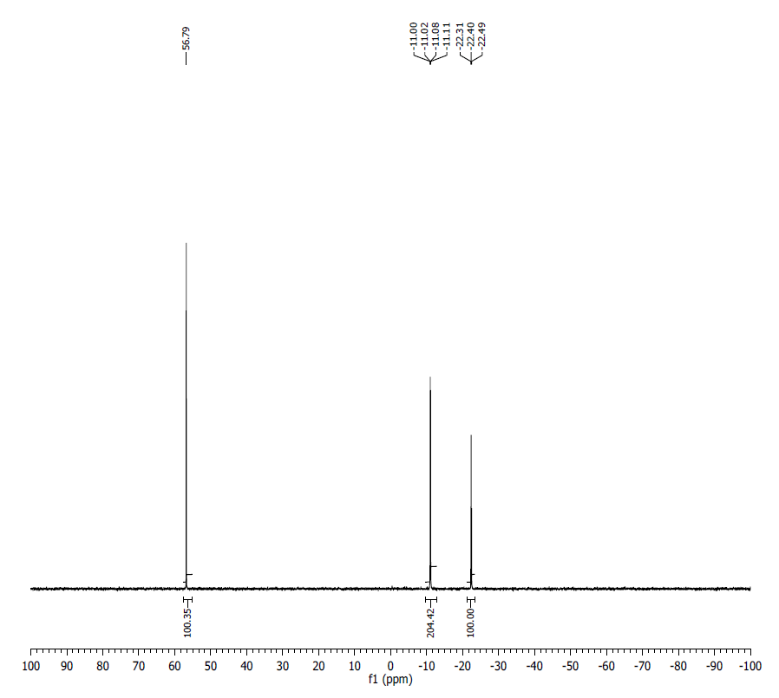
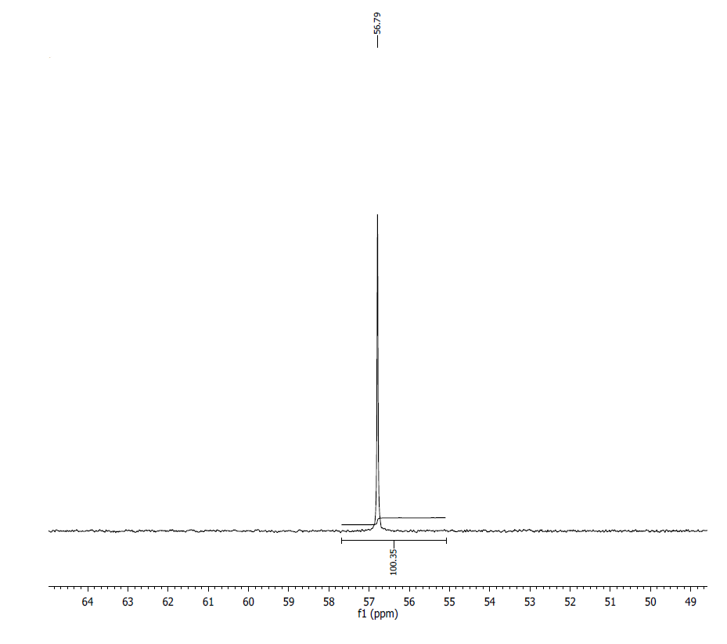
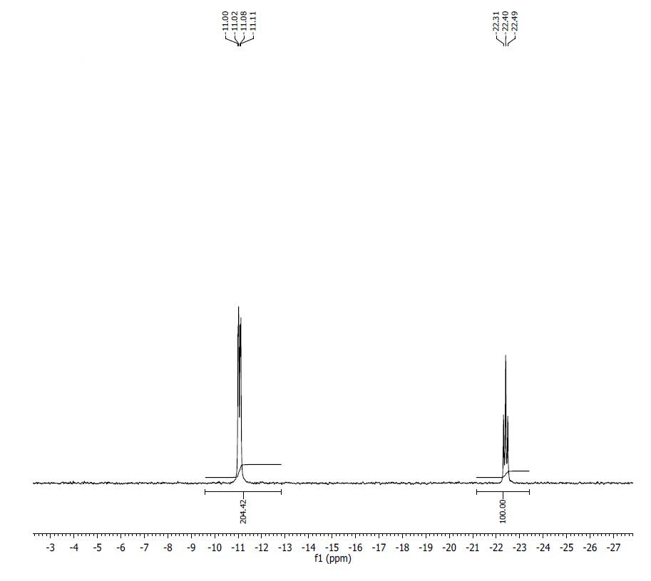
¹HNMR (500MHz, D₂O) δ: 8.29 (s, 1H), 8.06 (s, 1H), 7.96 (s, 1H), 6.00 (d, J = 5.5, 1H), 5.79 (m, 2H), 5.06 (m, 1H), 4.69 (t, J = 5.2, 1H), 4.64 (t, J = 4.6, 1H), 4.56 (m, 1H), 4.47 (t, J = 4.5, 1H), 4.29 (m, 1H), 4.39 (m, 1H), 4.35 (m, 3H), 4.18-4.27 (m, 4H), 4.07 (t, J = 4.7, 1H), 4.00 (s, 3H), 3.46 (s, 3H), 3.44 (s, 3H), 3.054 (b s, 3H).
³¹P NMR (200 MHz, D₂O) δ: 56.79 (1P), -11.05 (2P), -22.40 (1P).
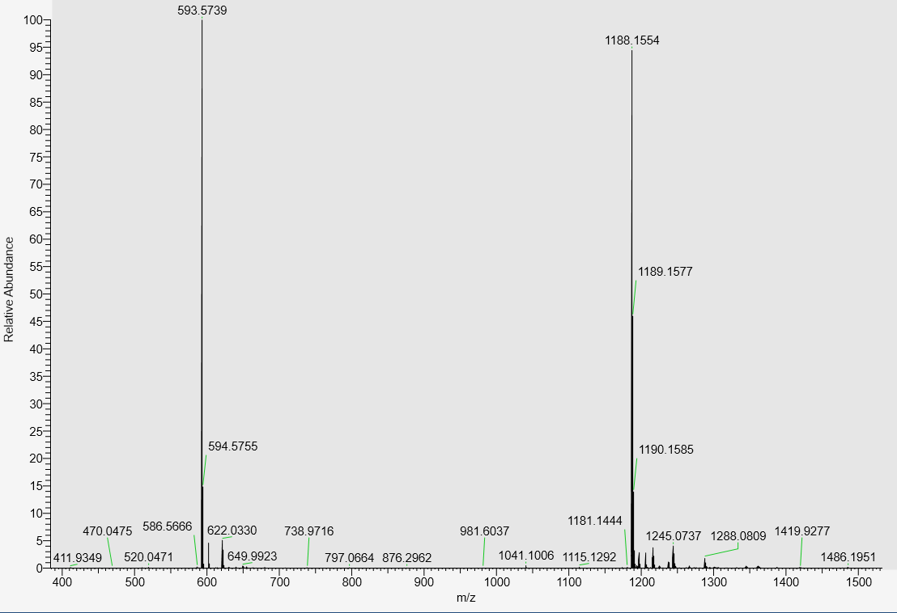
LC-MS data, calculated mass: 1189.1640, detected m/z: 1188.1554 (M-H)
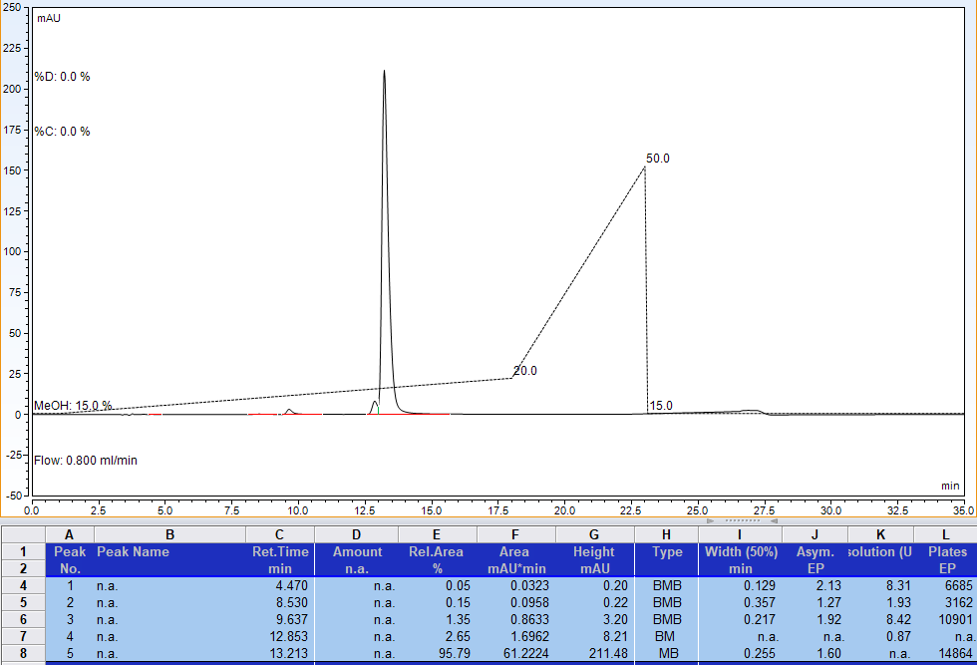
RP-HPLC analysis; gradient of methanol in 100 mM Triethylammonium acetate, pH 7.0 (peak at 12.853 min is diastereomer 1 contaminant)
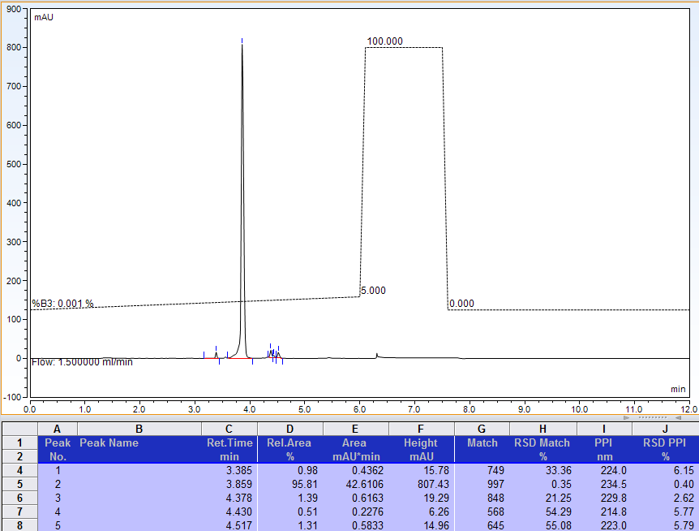
AX-HPLC analysis; peaks at 4.378 and 4.517 are products of accidental degradation of TCP in analytical sample (opened imidazole ring of ^{7m}G base)

Compound 3-7B1
Diastereomer 1 (asymmetric phosphorus is shown in bold)
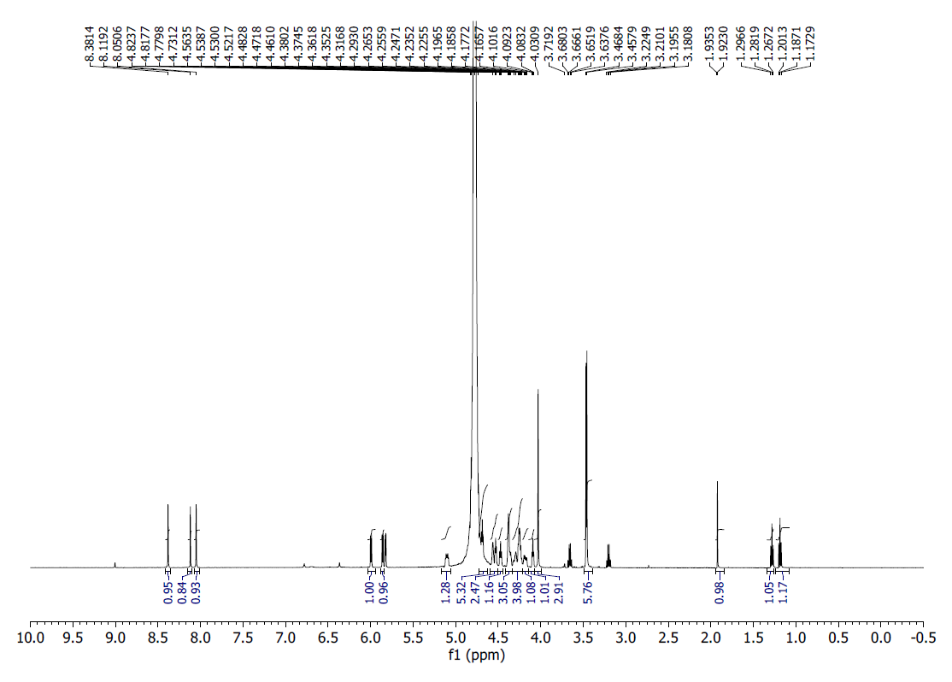
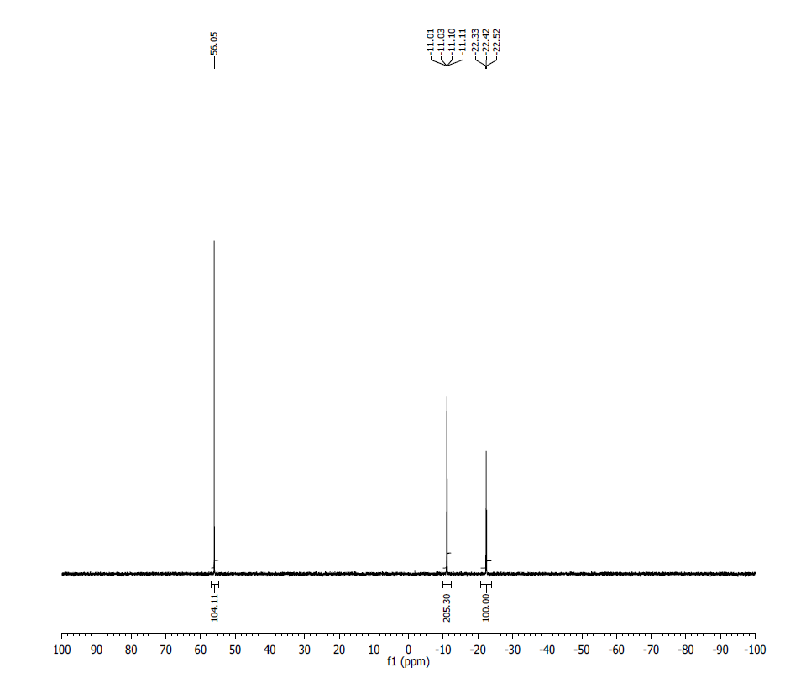
¹H NMR (500 MHz, D₂O) δ: 8.38 (s, 1H), 8.12 (s, 1H), 8.05 (s, 1H), 6.00 (d, J = 6.0 Hz, 1H), 5.86 (d, J = 5.9 Hz, 1H), 5.83 (d, J = 4.3 Hz, 1H), 5.11-5.08 (m, 1H), 4.82-4.73 (m, 1H), 4.56-4.52 (m, 2H), 4.48 (t, J = 5.5 Hz, 1H), 4.40-4.35 (m, 3H), 4.32-4.23 (m, 4H), 4.20-4.17 (m, 1H), 4.09 (t, J = 4.6 Hz, 1H), 4.03 (s, 3H), 3.47 (s, 3H), 3.46 (s, 3H).
³¹P NMR (200 MHz, D₂O) δ: 56.05 (1P), -11.05 (1P), -11.07 (1P), -22.42 (1P).
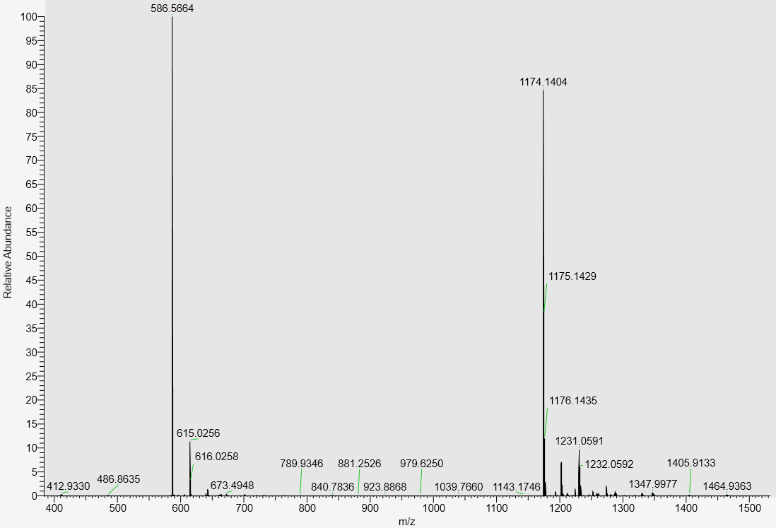
LC-MS data, calculated mass= 1175.1484; detected m/z = 1174.1404 (M-H)

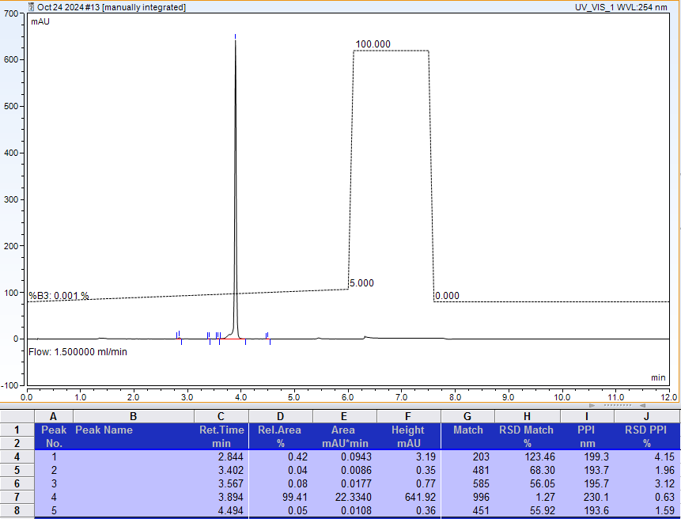
AX-HPLC Analysis
Compound 3-7B2
Diastereomer 2 (asymmetric phosphorus is shown in bold)

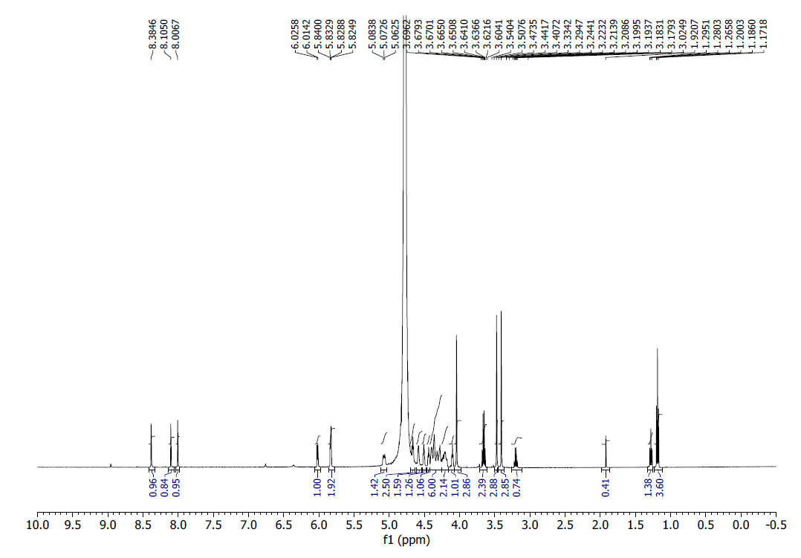
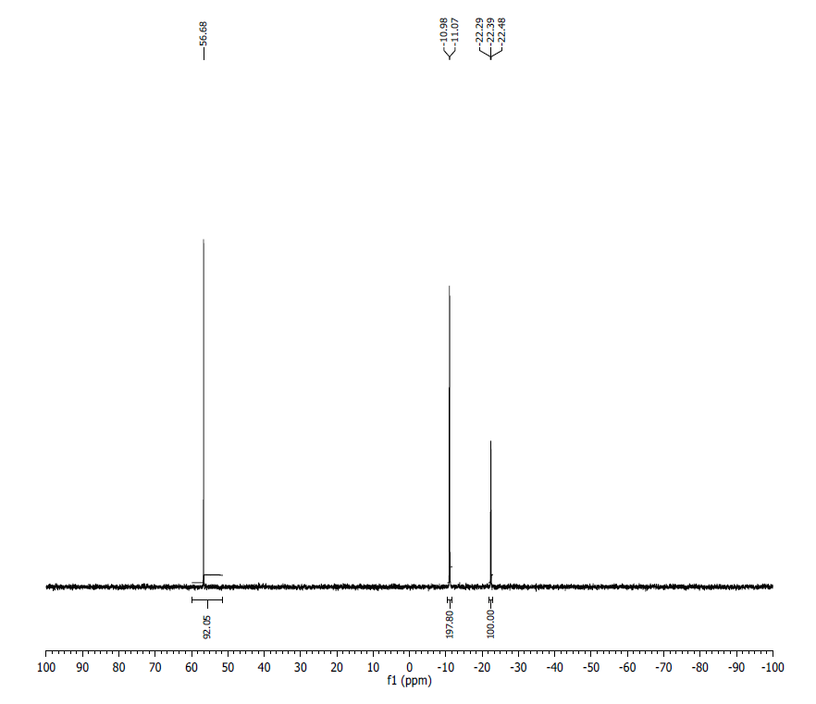
¹H NMR (500 MHz, D₂O) δ: 8.39 (s, 1H), 8.11 (s, 1H), 8.01 (s, 1H), 6.20 (d, J = 6.0 Hz, 1H), 5.85 (d, J = 5.6 Hz, 1H), 5.83 (d, J = 4.0 Hz, 1H), 5.08-5.06 (m, 1H), 4.67-4.65 (m, 1H), 4.59-4.57 (m, 1H), 4.51 (t, J = 4.2 Hz, 1H), 4.44 (t, J = 5.3), 4.41-4.25 (m, 6H), 4.24-4.20 (m, 3H), 4.10 (t, J = 4.6 Hz, 1H), 4.04 (s, 3H), 3.47 (s, 3H), 3.41 (s, 3H). Extra signals are from TEAH⁺ , acetate ion and ethanol.
³¹P NMR (200 MHz, D₂O) δ: 56.68 (1P), -11.02 (2P), -22.39 (1P).
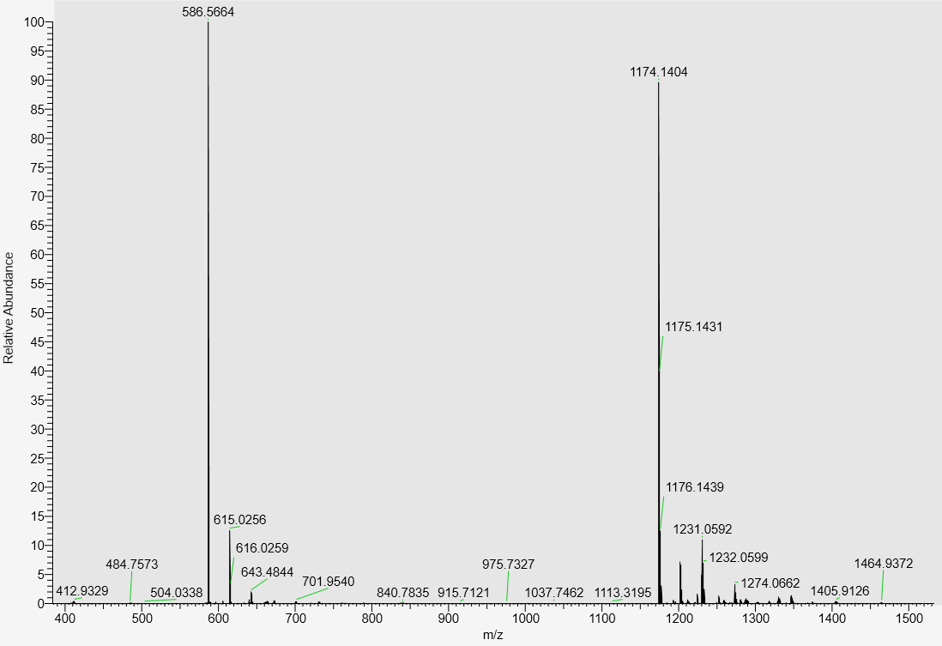
LC-MS data, calculated mass: 1175.1484; detected m/z = 1174.1404 (M-H)
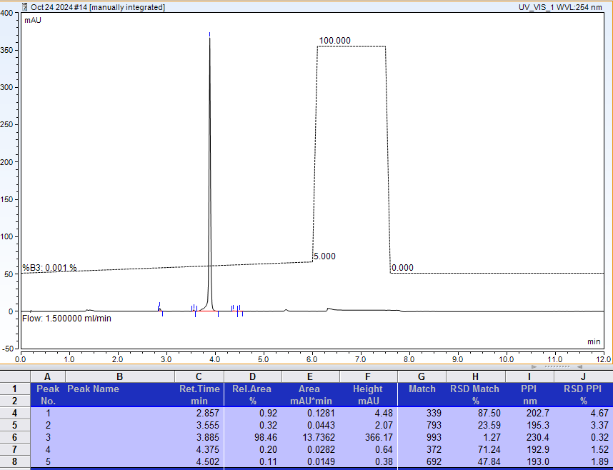
AX-HPLC Analysis
Compound 3-9B

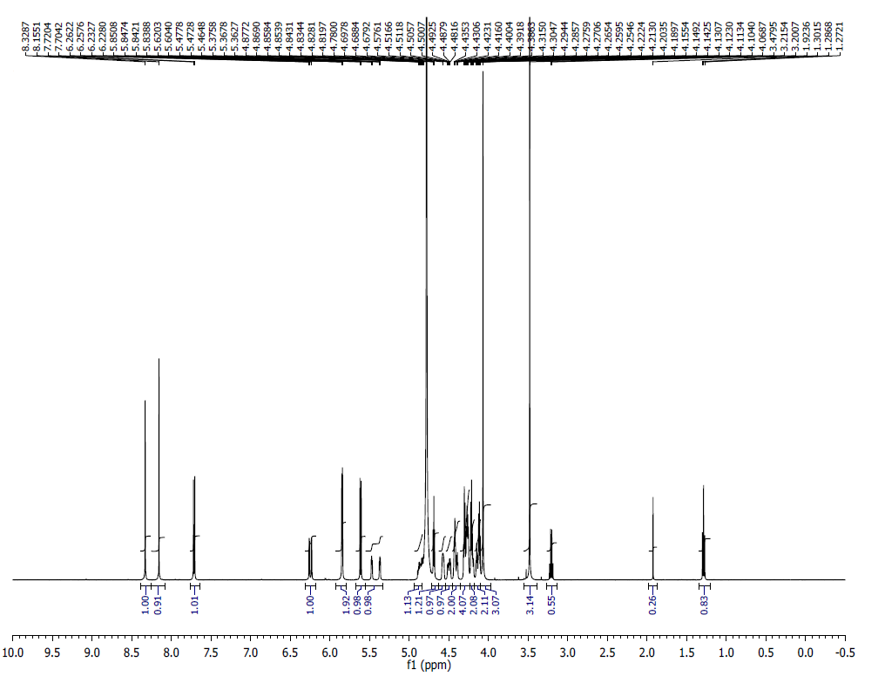
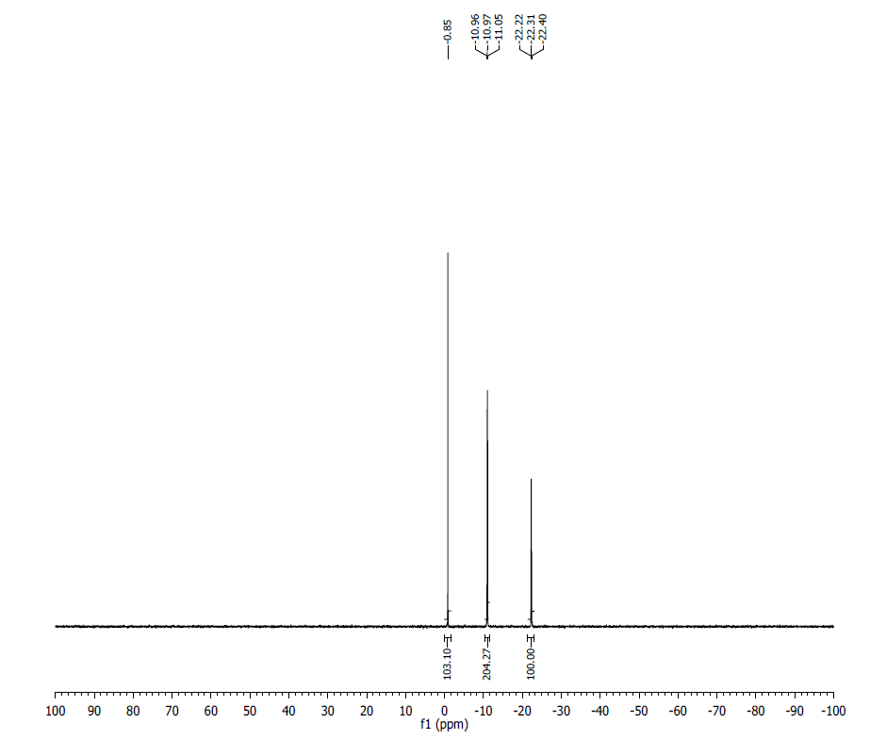
¹H NMR (500 MHz, D₂O) δ: 8.33 (s, 1H), 8.16 (s, 1H), 7.72 (d, J = 8.1 Hz, 1H), 6.26 (d, J = 2.3 Hz, 1H), 6.23 (d, J = 2.35 Hz, 1H), 5.85-5.83 (m, 2H), 5.62 (d, J = 8.15 Hz 1H), 5.48-5.46 (m, 1H), 5.38-5.36 (m, 1H), 4.87– 4.78 (m, 1H), 4.72 – 4.67 (m, 1H), 4.57 (s br, 1H), 4.51-4.50 (m, 1H), 4.49-4.43 (m, 1H), 4.42-4.40 (m, 2H), ), 4.39-4.29 (m, 4H), 4.28-4.20 (m, 2H), 4.19-4.11 (m, 2H), 4.10 (s, 3H), 4.06 (s, 3H).
³¹P NMR (200 MHz, D₂O) δ: -0.85 (1P), -11.00 (2P), -22.31 (1P).
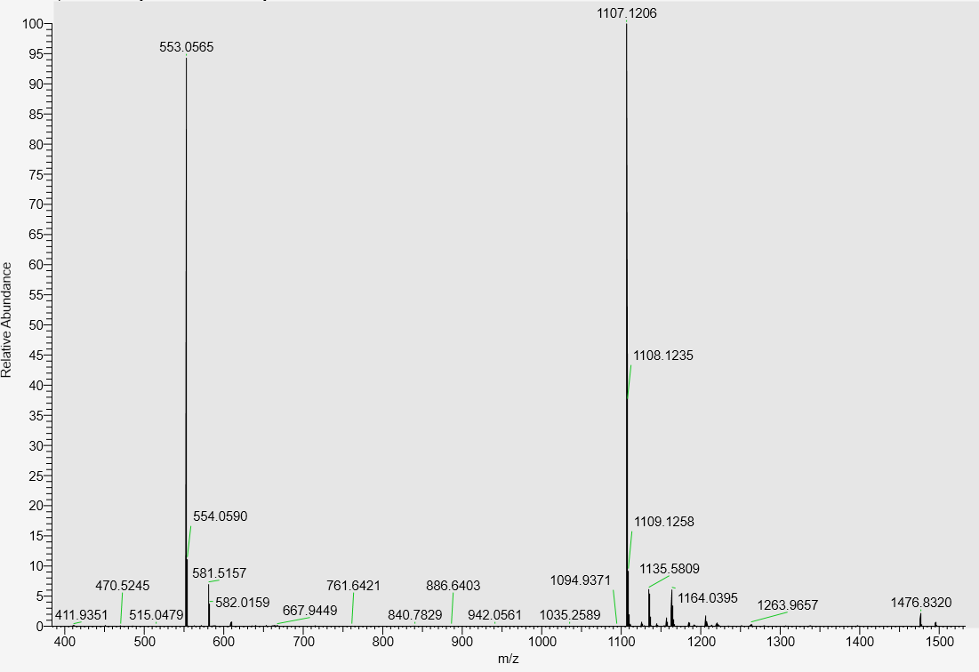
LC-MS, calculated mass: 1108.1291; detected m/z: 1107.1206 (M-H)

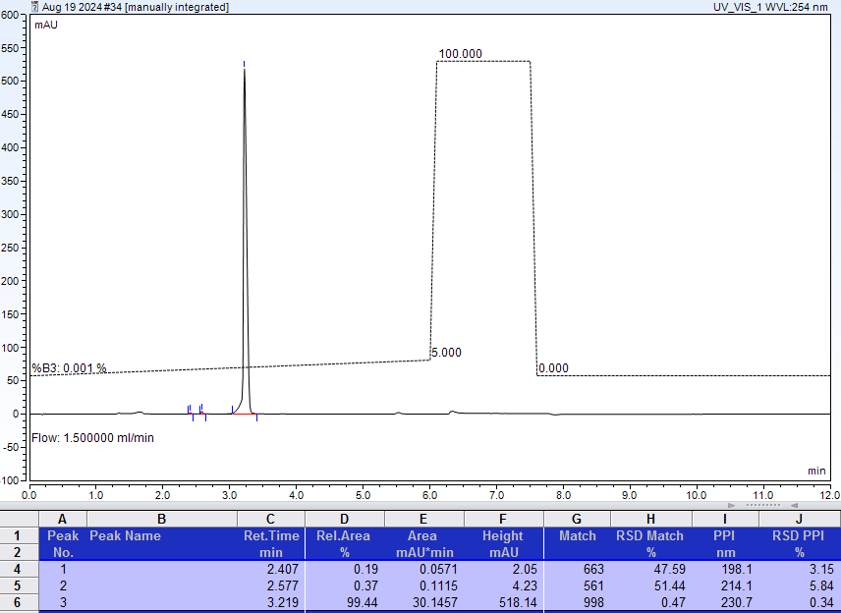
AX-HPLC Analysis

Compound 3-10B

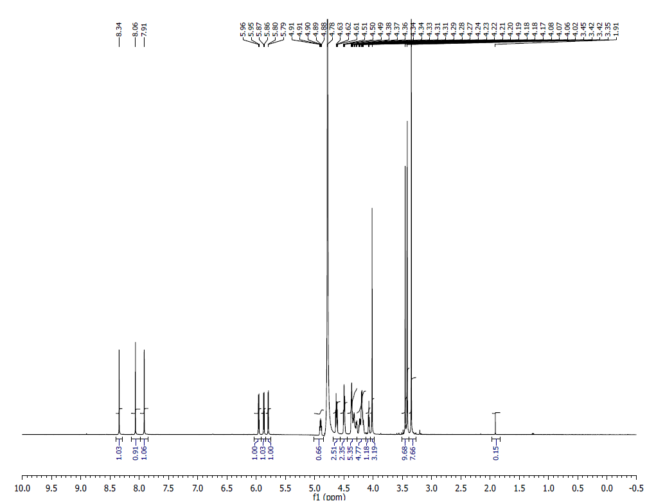
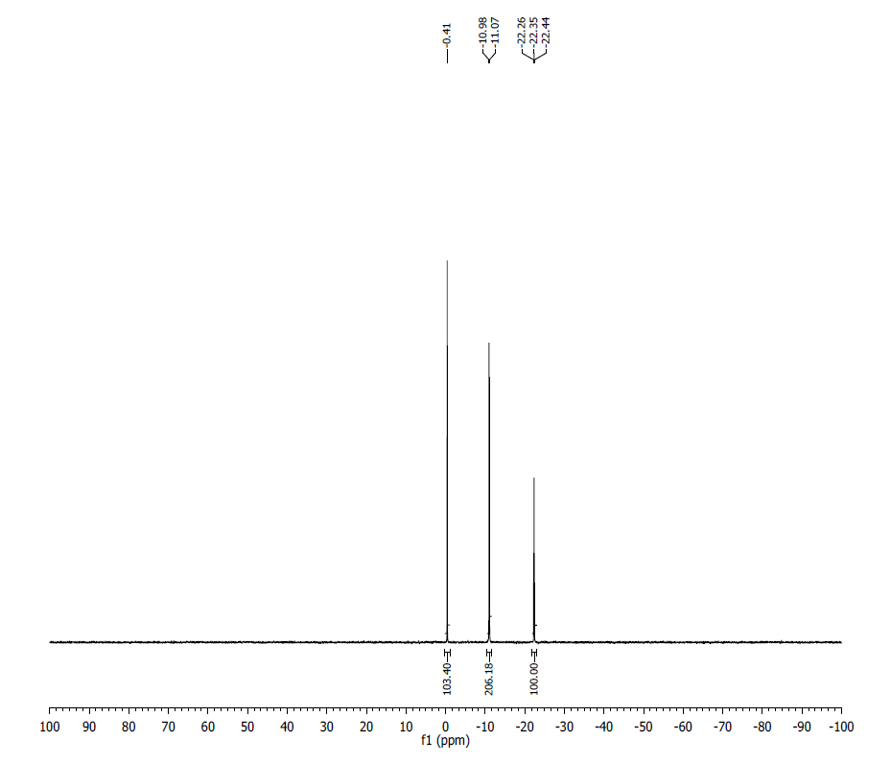
¹H NMR (500 MHz, D₂O) δ: 8.34 (s, 1H), 8.06 (s, 1H), 7.91 (s, 1H), 5.96 (d, J= 5.55 Hz, 1H), 5.87 (d, J= 5.65 Hz, 1H), 5.79 (d, J= 4.2 Hz, 1H), 4.91-4.88 (m, 1H), 4.63-4.61 (m, 3H), 4.50-4.48 (m, 2H), 4.37-4.28 (m, 5H), 4.27-4.16 (m, 5H), 4.08-4.06 (t, J= 4.8 Hz, 3H), 4.01 (s, 3H), 3.45-3.41 (m, 9H), 3.34 (s, 8H).
³¹P NMR (200 MHz, D₂O) δ: -0.41 (1P), -11.03 (2P), -22.35 (1P).
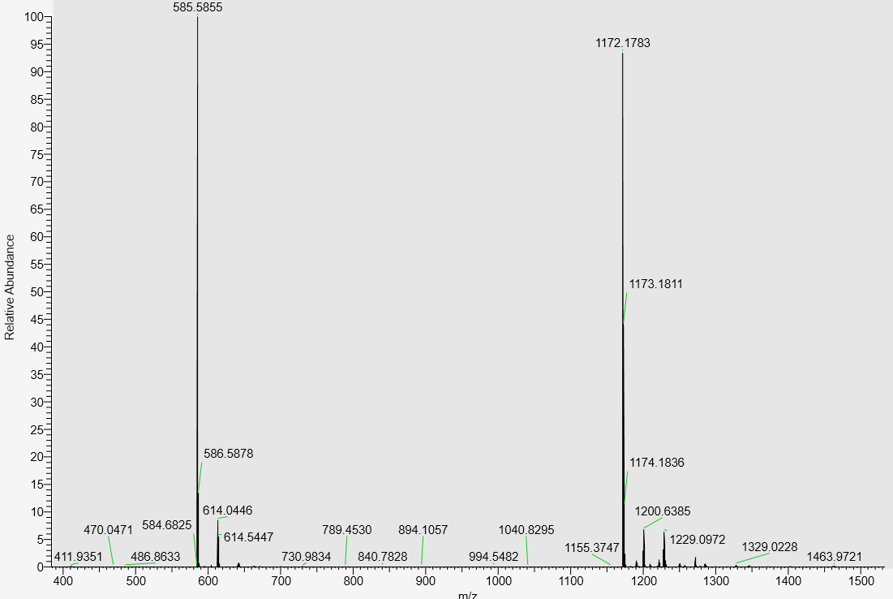
LC-MS data, calculated mass: 1173.1869; detected m/z: 1172.1783 (M-H)

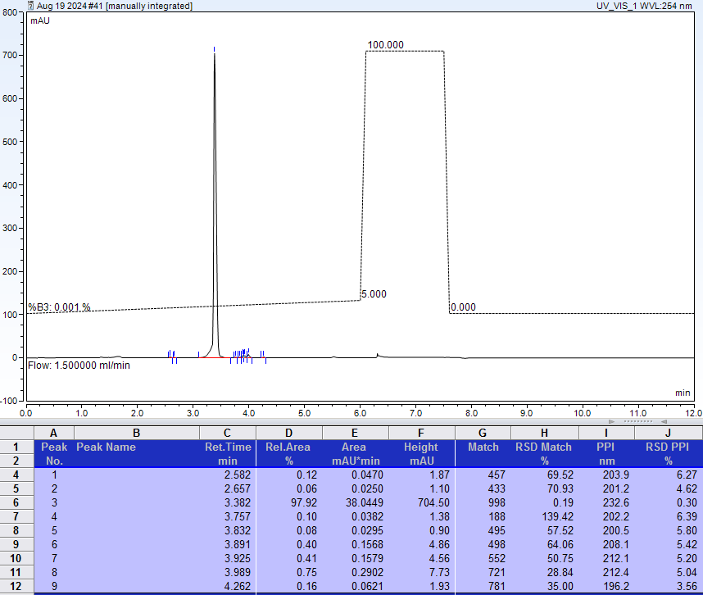
AX-HPLC Analysis
Compound 3-11B

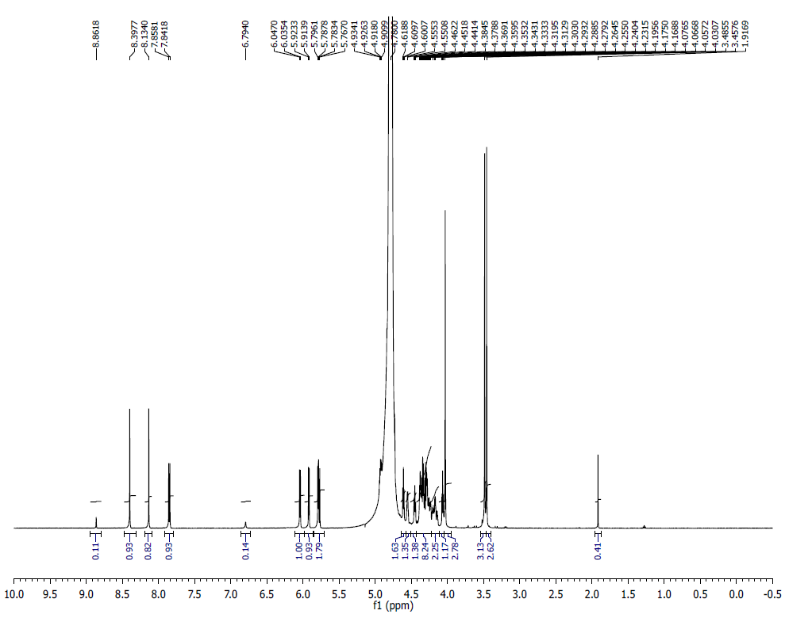
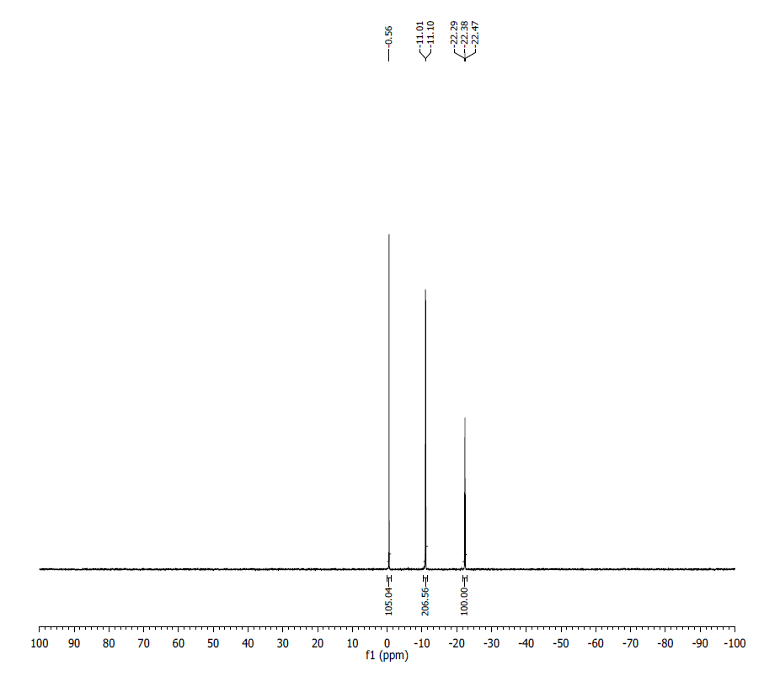
¹H NMR (500 MHz, D₂O) δ: 8.40 (s, 1H), 8.13 (s, 1H), 7.85 (d, J = 8.2, 1H), 6.04 (d, J = 5.8, 1H), 5.92 (d, J = 4.7), 5.78 (m, 2H), 4.61 (t, J = 4.6, 1H), 4.55 (m, 1H), 4.45 (t, J = 5.2, 1H), 4.17-4.38 (m, 10H), 4.07 (t, J = 4.9, 1H), 4.03 (s, 3H), 3.49 (s, 3H), 3.46 (s, 3H).
³¹P NMR (200 MHz, D₂O) δ: -0.56 (1P), -11.05 (2P), -22.38 (1P).
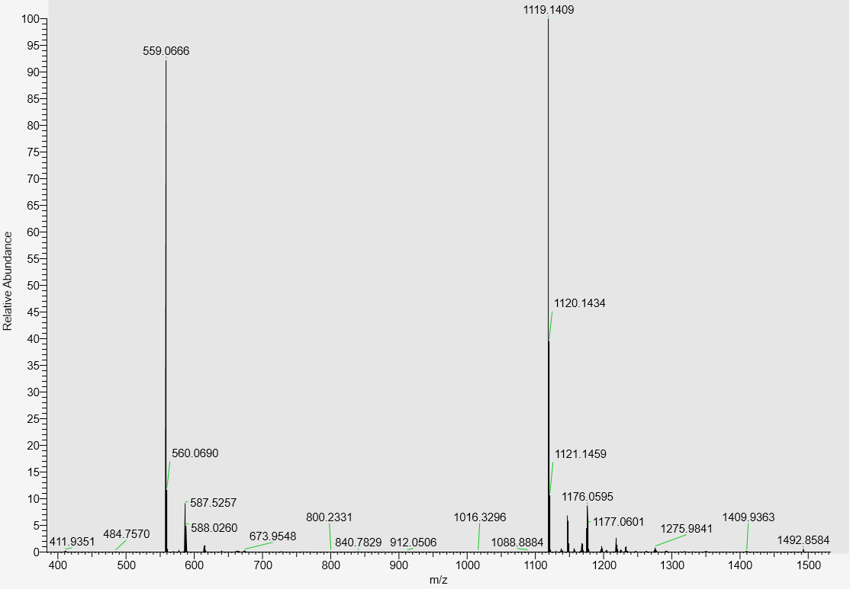
LC-MS data, calculated mass: 1120.1491; detected m/z: 1119.1409 (M-H)

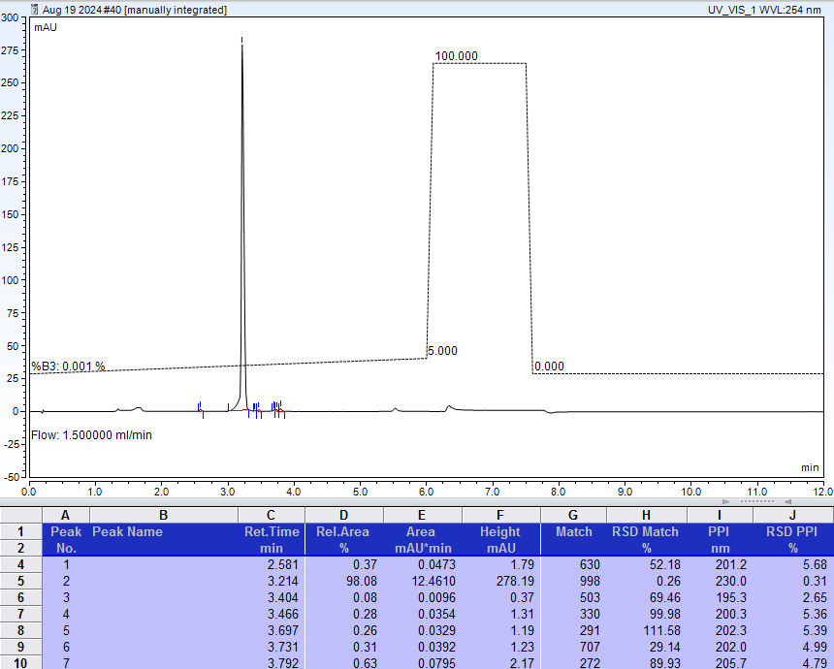
AX-HPLC Analysis
Compound 3-12B

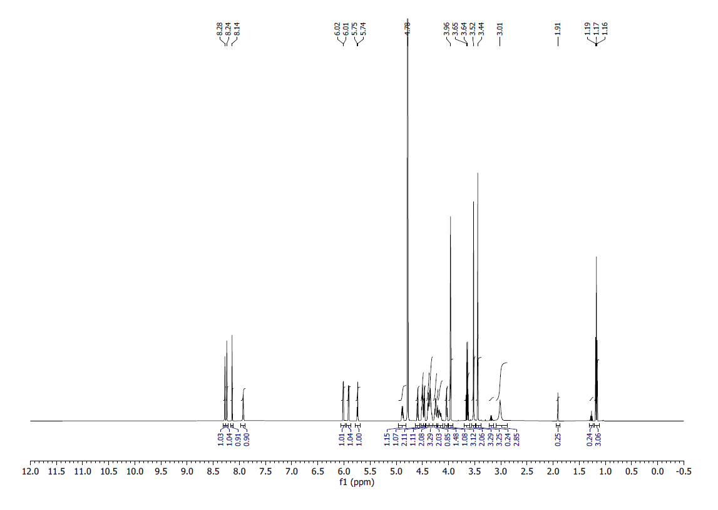
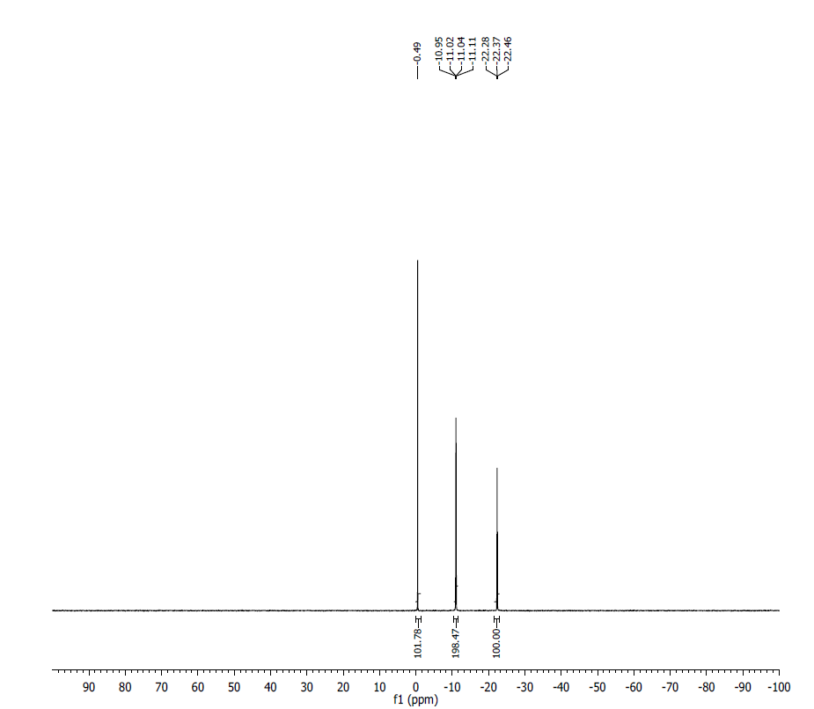
¹H NMR (500 MHz, D₂O) δ: (s, 1H), 8.24 (s, 1H), 8.14 (s, 1H), 7.93 (s, 1H), 6.01 (d, J = 5 Hz, 1H), 5.91 (d, J = 5 Hz, 1H), 5.74 (d, J = 5 Hz, 1H), 4.87 (m, 1H), 4.58 (t, J = 5 Hz, 1H), 4.49 (m, 2H), 4.45 (m, 1H), 4.40 – 4.32 (m, 5H), 4.25 – 4.16 (m, 4H), 4.03 (t, J = 5 Hz, 1H), 3.52 (s, 3H), 3.44 (s, 1H), 3.01 (bs, 2H), 1.16 (t, J = 5 Hz, 3H).
³¹P NMR (200 MHz, D₂O) δ: -0.49 (1P), -11.00 (1P), 11.06 (1P), -22.37 (1P).
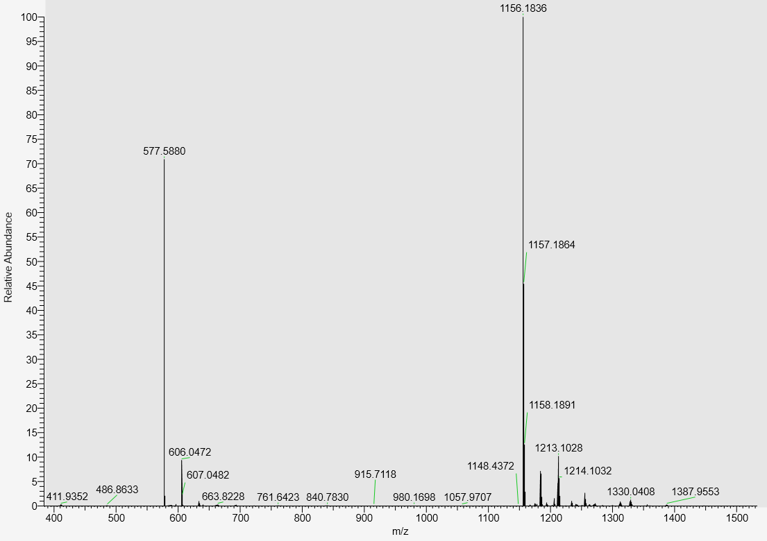
LC-MS data, calculated mass= 1157.1920; detected m/z= 1156.1836 (M-H)

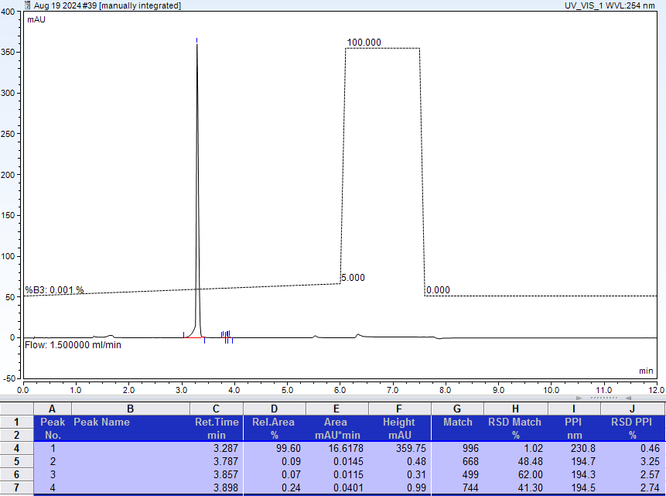
AX-HPLC Analysis
Compound 3-13B

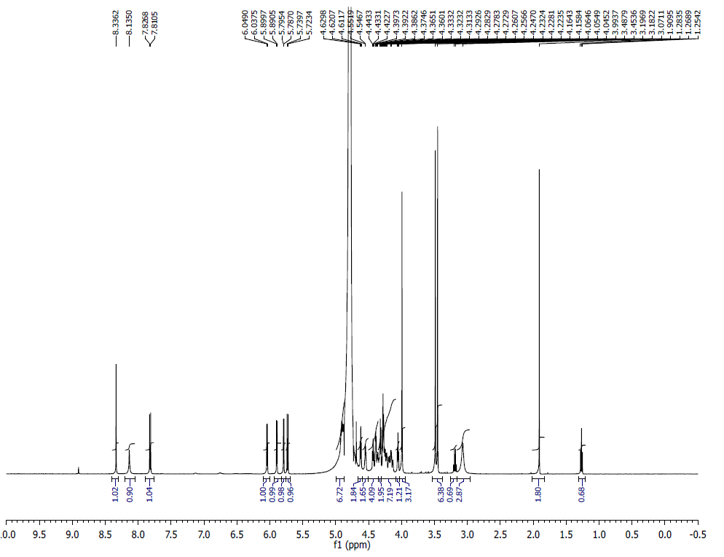
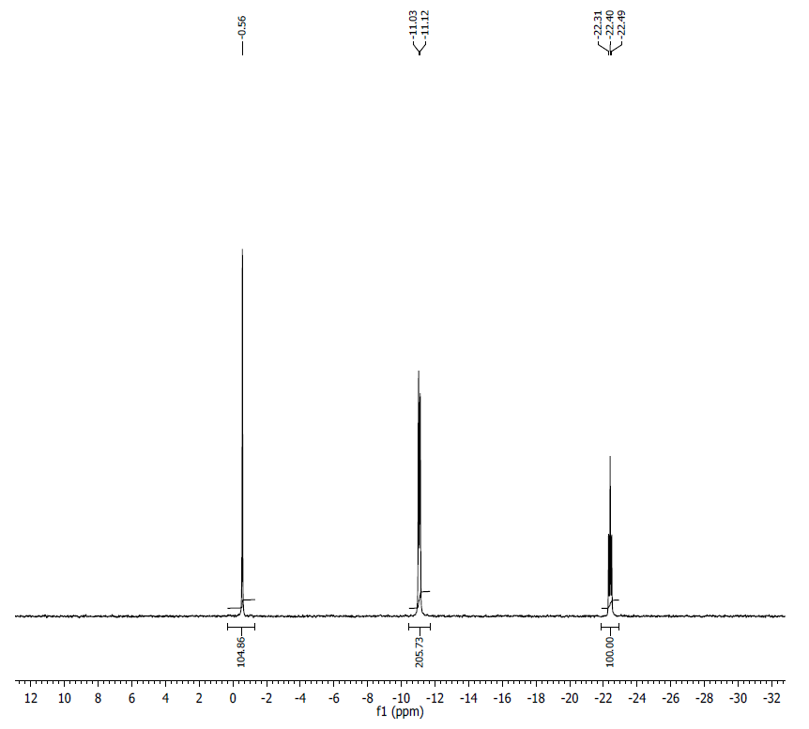
¹H NMR (500 MHz, D₂O) δ: 8.34 (s, 1H), 8.14 (bs, 1H), 7.82 (d, J = 8.2, 1H), 6.04 (d, J = 5.8, 1H), 5.90 (d, J = 4.6, 1H), 5.79 (d, J = 4.2, 1H), 5.73 (d, J = 8.2, 1H), 4.95 (m, 1H), 4.60 (t, J = 4.5, 1H), 4.55 (m, 1H), 4.36-4.44 (m, 4H), 4.33 (m, 2H), 4.15-4.29 (m, 7H), 4.05 (t, J = 4.9, 1H), 3.99 (s, 3H), 3.49 (s, 3H), 3.45 (s, 3H), 3.07 (bs, 3H).
³¹P NMR (200 MHz, D₂O) δ: -0.56 (1P), -11.08 (2P), -22.40 (1P).
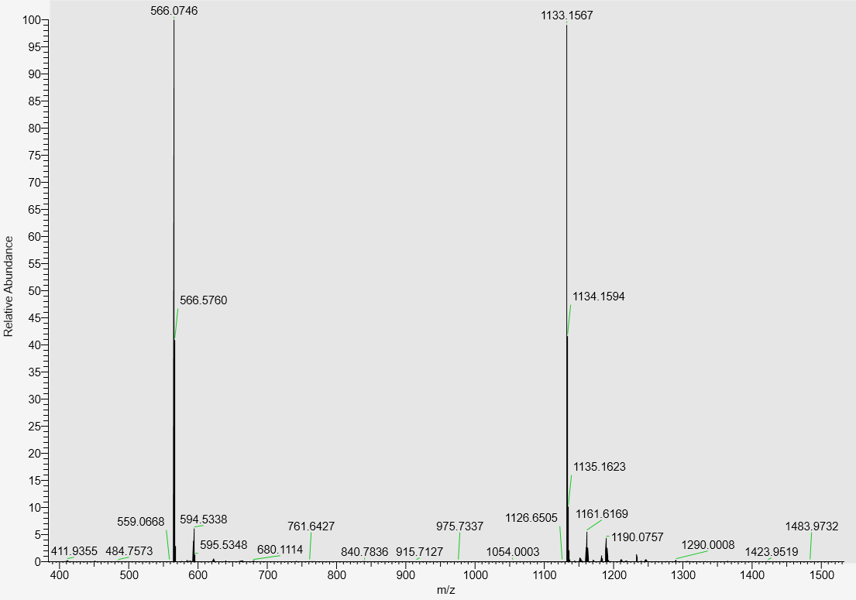
LC-MS data, calculated mass: 1134.1648; detected m/z = 1133.1567 (M-H)

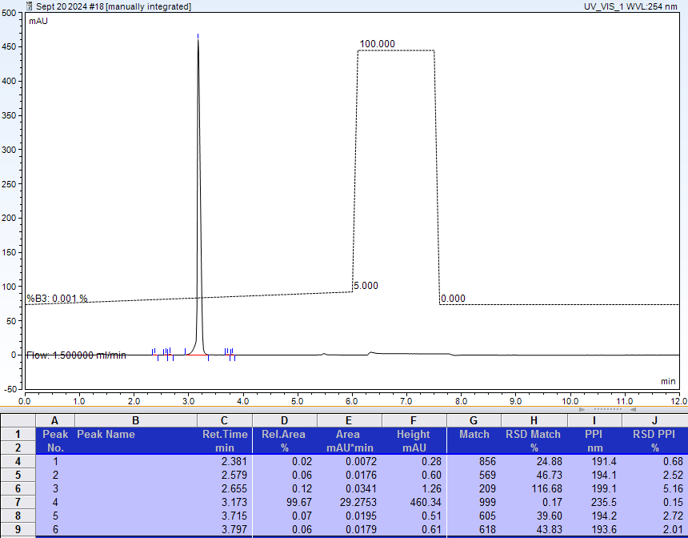
AX-HPLC Analysis
Compound 3-14B

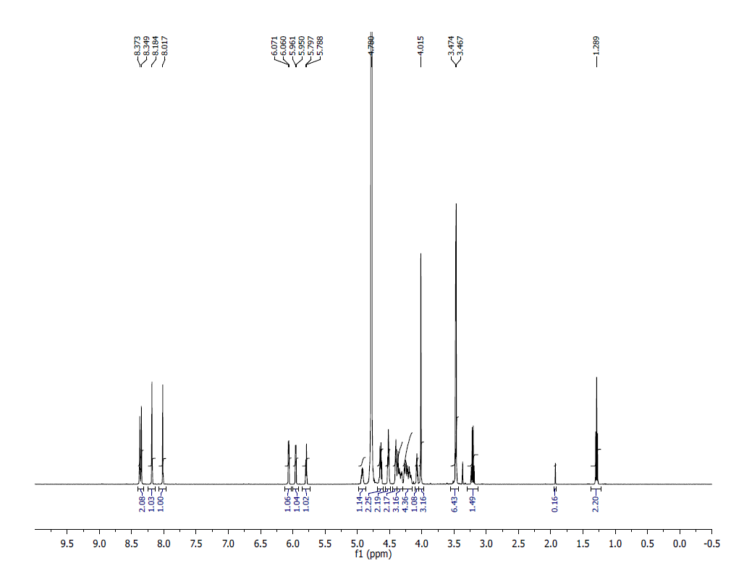
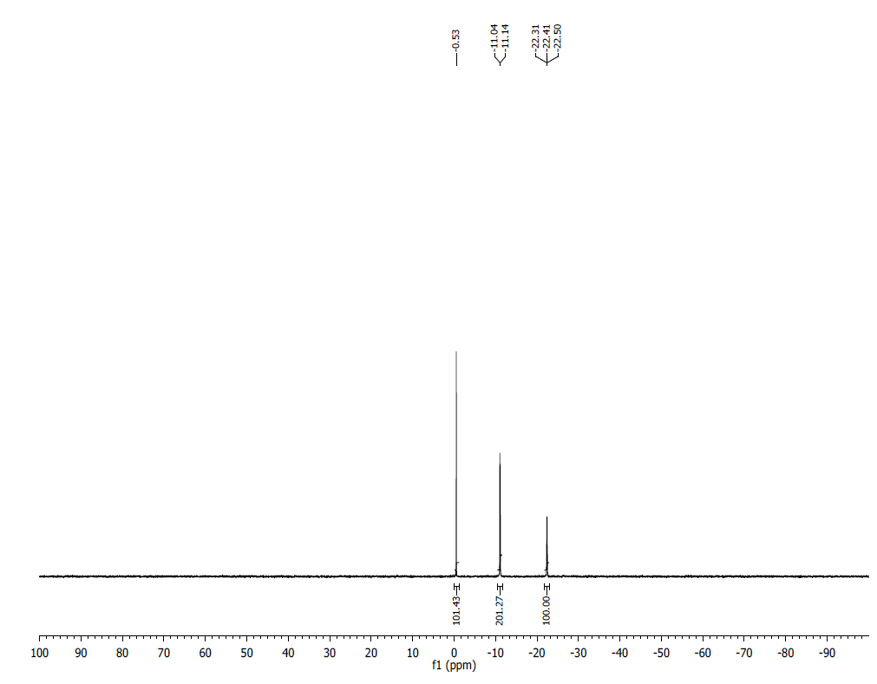

¹H NMR (D₂O, 500 MHz) δ: 8.37 (s, 1H), 8.35 (s, 1H), 8.18 (s, 1H), 8.017 (s, 1H), 6.07 (d, J = 5.5 Hz, 1H), 5.96 (d, J = 5.5 Hz, 1H), 5.79 (d, J = 4.5 Hz, 1H), 4.93-4.90 (m, 1H), 4.65-4.62 (m, 2H), 4.52-4.50 (m, 2H), 4.41-4.39 (m, 2H), 4.37 – 4.26 (m, 3H), 4.25 – 4.197 (m, 4H), 4.085-4.076 (m, 1H), 3.52 (s, 3H), 3.23-3.19 (t, J = 7.0, 1H), 1.30-1.27 (t, J = Hz, 2H).
³¹P NMR (202 MHz, D2O) δ: -0.53 (1P), -11.04 (2P), -22.31 (1P).
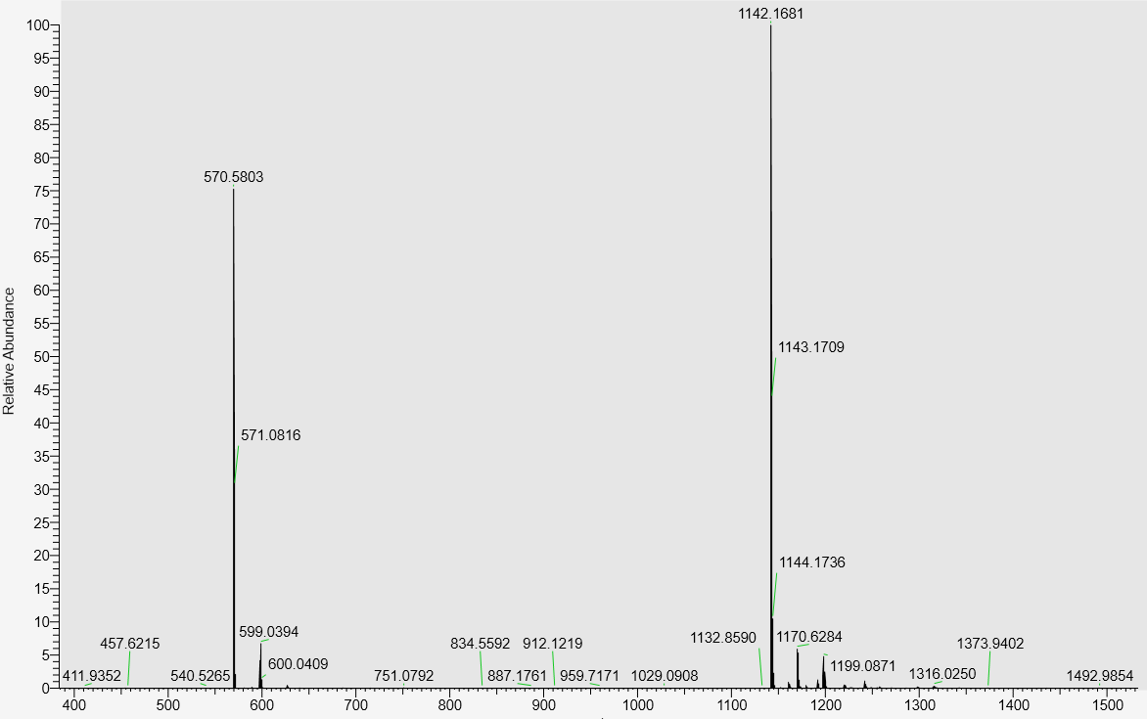
LC-MS data, calculated mass: 1143.1763; detected m/z: 1142.1681 (M-H)

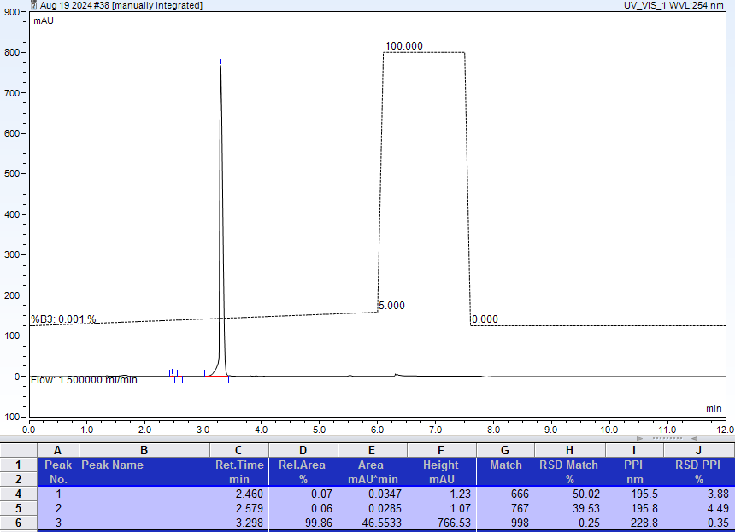
AX-HPLC Analysis
Compound 3-15B
¹H NMR at 20ºC
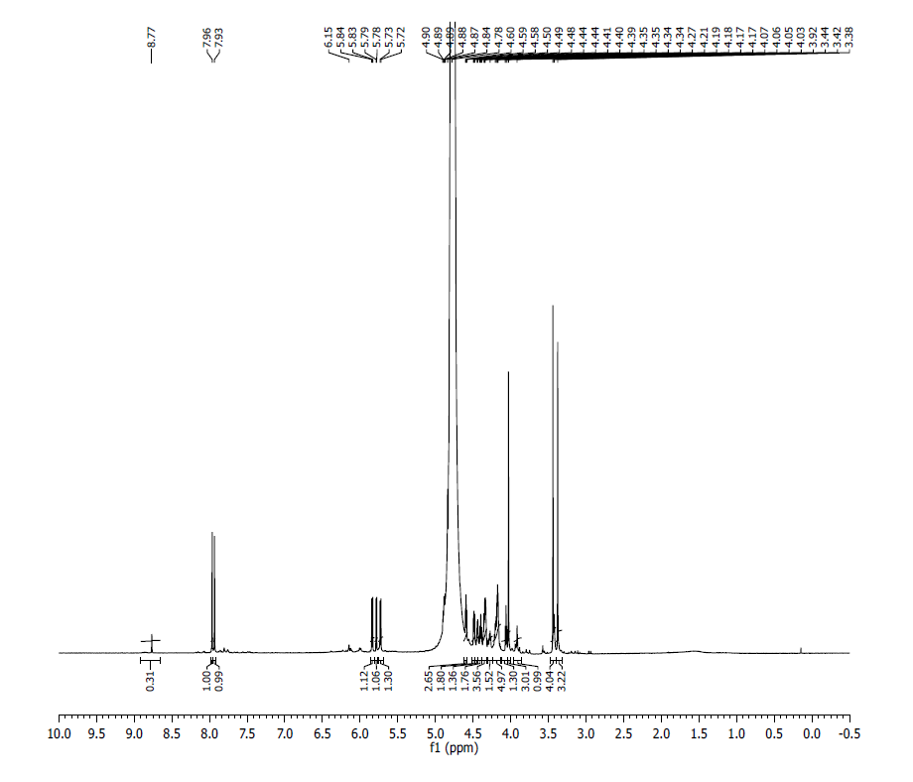

¹H NMR after 20 min at 60ºC

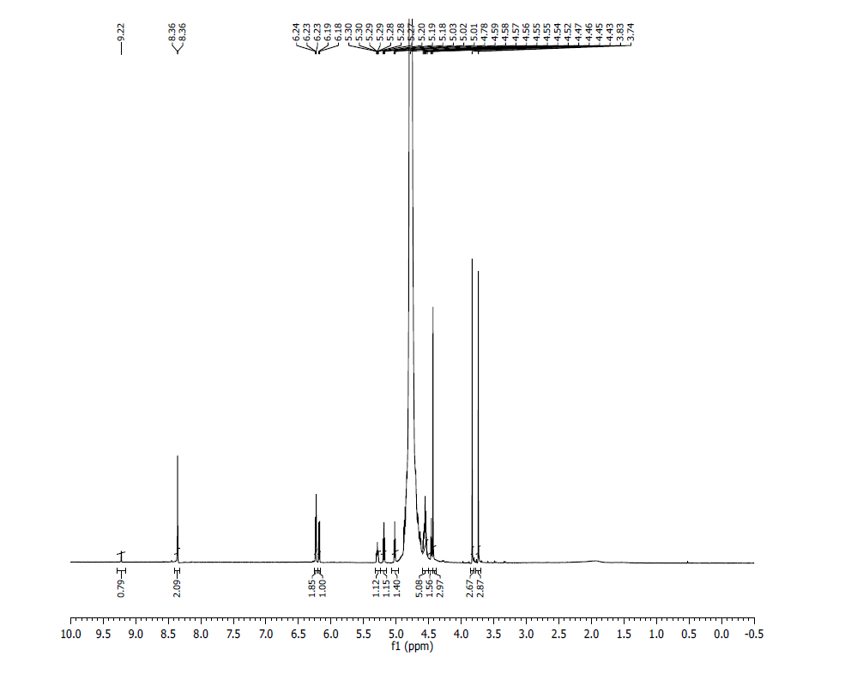
¹H NMR (D₂O, 500 MHz, at 60ºC) δ: 9.22 (s, 1H), 8.36 (s, 2H), 6.23 (m, 2H), 6.18 (d, 1H), 5.29 (m, 1H), 5.19 (t, 1H), 4.52-4.59 (m, 4H), 4.46 (t, 1H), 4.43 (s, 3H), 3.83 (s, 3H), 3.74 (t, 3H).

³¹P NMR at 20ºC
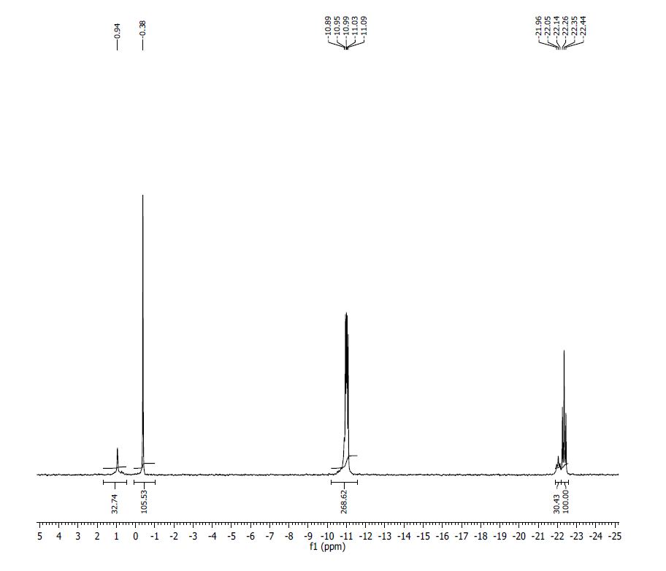
³¹P NMR after 20 min 60ºC
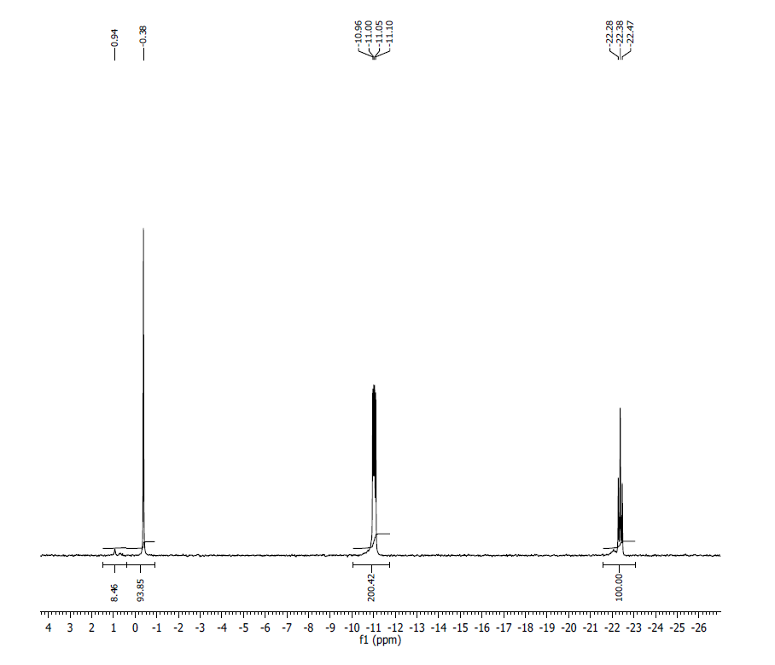
³¹P NMR (202 MHz, D2O, at 60ºC) δ: -0.38 (1P), -11.00 (1P), -11.05 (1P), -22.38 (1P) ); additional small resonances belong to residual aggregate forms of ^{7m}G_{m}pppG_{m}pG
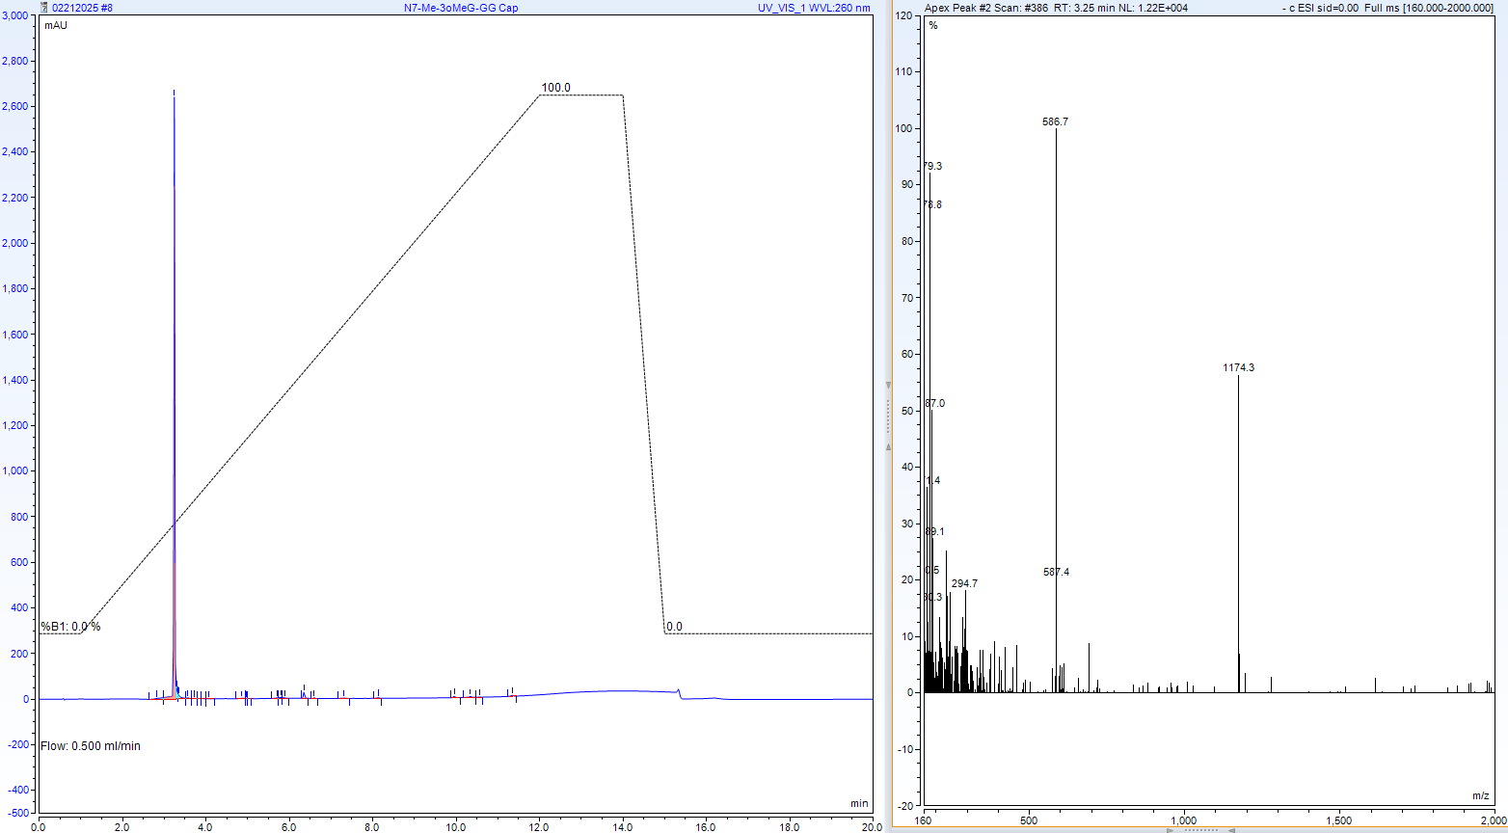
RP-HPLC-MS analysis of compound 3-15B (freshly prepared 100mM stock solution).
Calculated mass: 1175.1661; detected m/z: 1174.3 (M-H) (low resolution MS)

AX-HPLC analysis of compound 3-15B

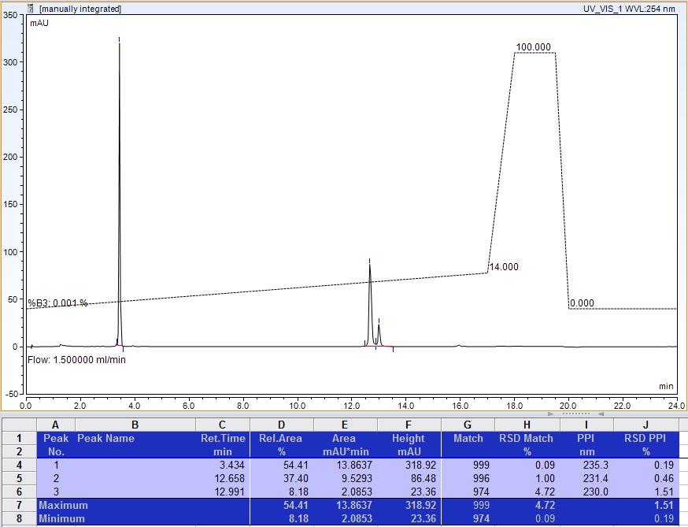
A
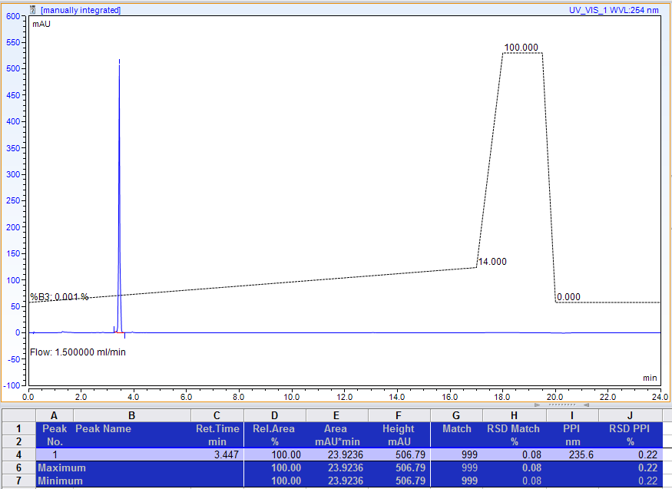
B
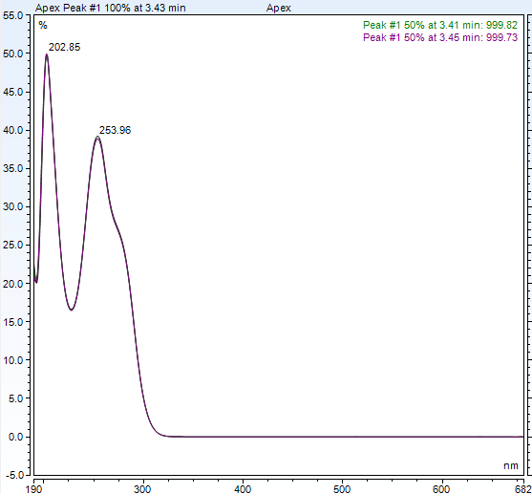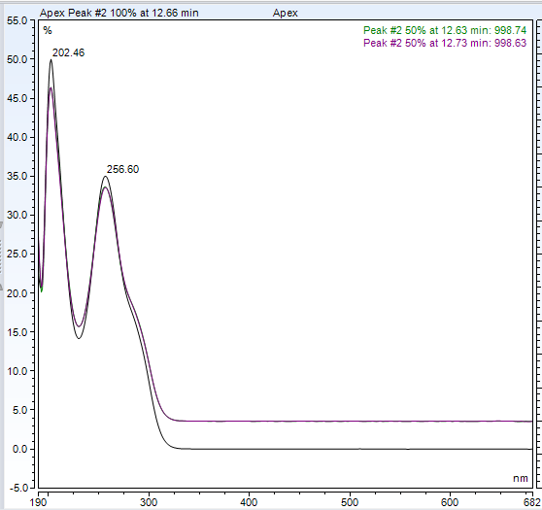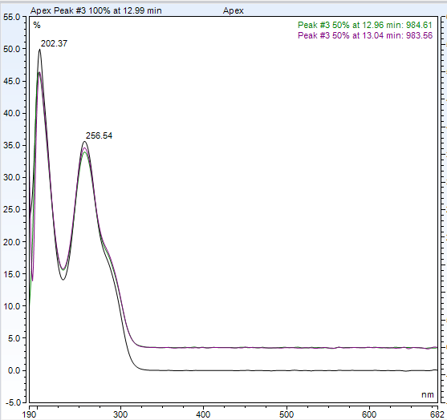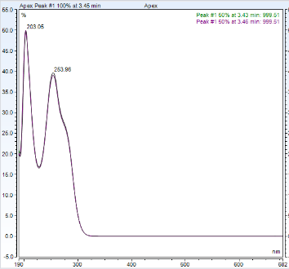
D E F G
AX-HPLC analysis (A and B) and UV spectra (D-G) of detected species of compound 3-15B. Samples for analysis were taken from stock solution (stored for 4 weeks at 4ºC), diluted 100-fold with water and analyzed before (A) or after (B) incubation at 60ºC for 15 min. Peak 1 is monomeric form; peaks 2 and 3 are presumably dimeric and trimeric aggregate forms of 3-15B.

Detection of compound 3-15B aggregates by RP-HPLC-MS analysis of (the method parameters are described below)
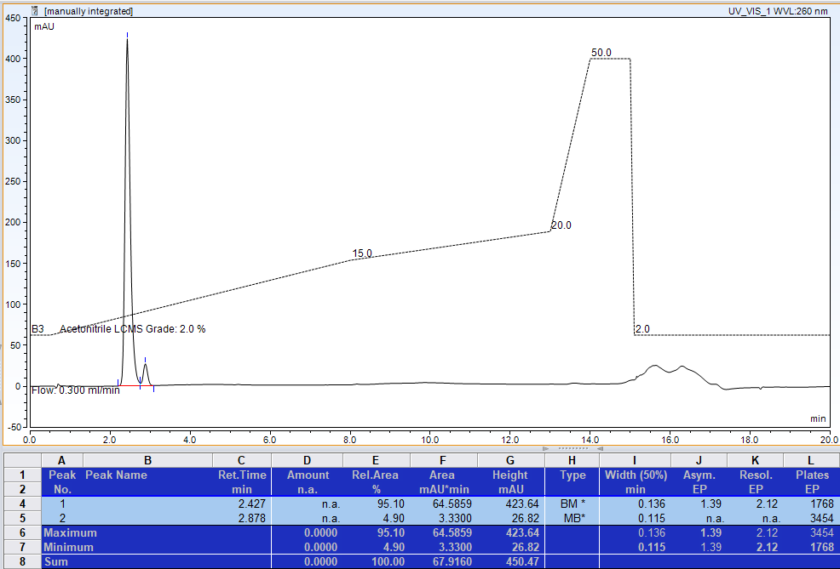
RP-HPLC-MS: LC trace

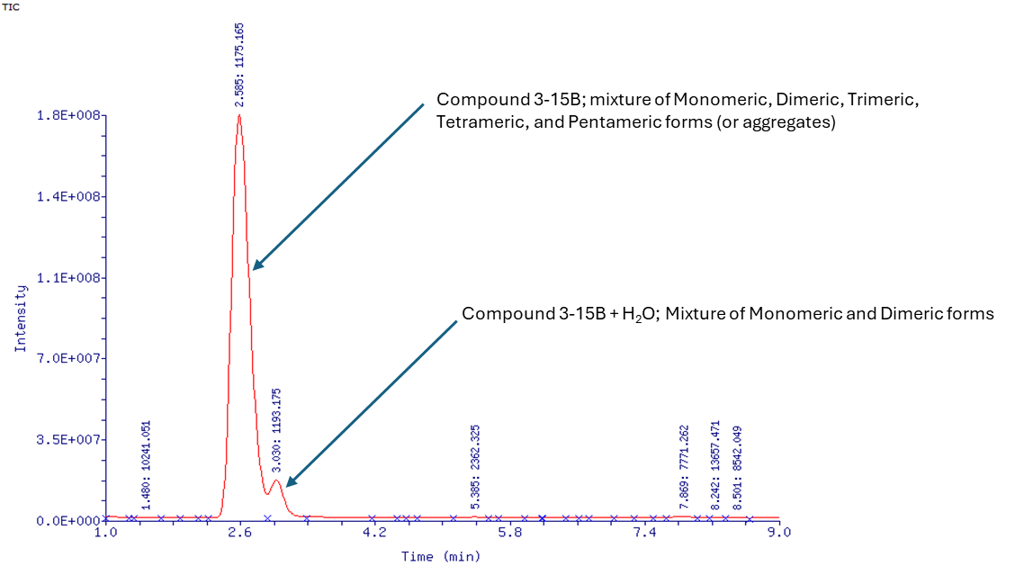
RP-HPLC-MS: TIC trace
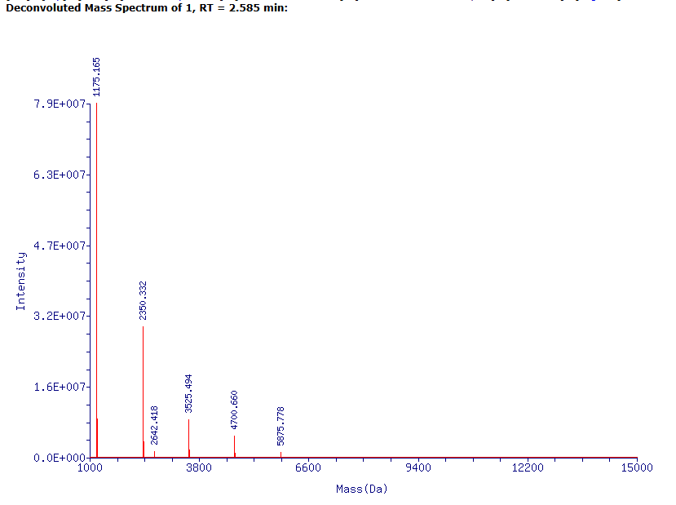
Mass Peak List Sorted by Intensity
Mass (Da) | Standard Deviation (±) | Intensity | Score | Delta Mass | %Relative | %Total | Presumed Identity
1175.165 | 0.012 | 7.90E+07 | 7.9 | 0 | 100 | 57.28 | 3-15B, Monomeric form
2350.332 | 0.024 | 2.91E+07 | 7.46 | 1175.167 | 36.85 | 21.11 | 3-15B, Dimeric form
1193.174 | 0.012 | 8.56E+06 | 6.93 | 18.009 | 10.85 | 6.21 | 3-15B, Monomeric form + H₂O
3525.494 | 0.035 | 8.36E+06 | 6.92 | 2350.329 | 10.59 | 6.07 | 3-15B, Trimeric form
4700.660 | 0.047 | 4.68E+06 | 6.67 | 3525.495 | 5.93 | 3.39 | 3-15B, Tetrameric form
2368.339 | 0.024 | 3.38E+06 | 6.53 | 1193.174 | 4.28 | 2.45 | 3-15B, Dimeric form + H₂O
3543.500 | 0.035 | 1.62E+06 | 6.21 | 2368.335 | 2.05 | 1.17 | 3-15B, Trimeric form + H₂O
2642.418 | 0.026 | 1.22E+06 | 6.09 | 1467.253 | 1.55 | 0.89 | Unidentified
5875.778 | 0.063 | 1.09E+06 | 6.04 | 4700.613 | 1.38 | 0.79 | 3-15B, Pentameric form
4718.666 | 0.047 | 8.60E+05 | 5.93 | 3543.501 | 1.09 | 0.62 | 3-15B, Tetrameric form + H₂O
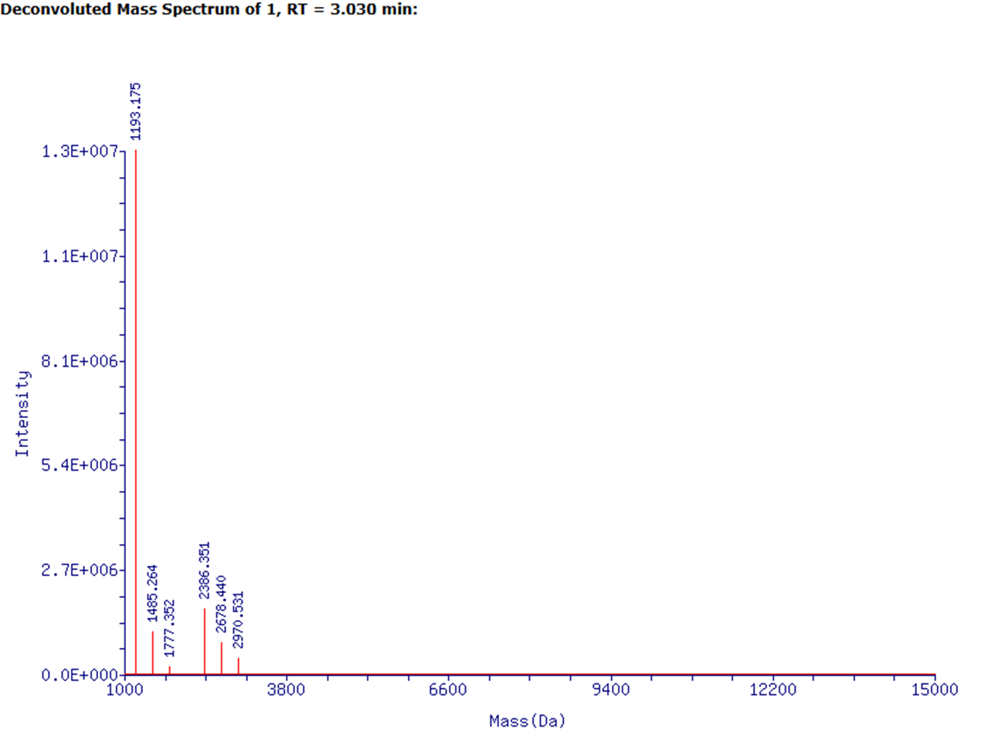
Mass Peak List Sorted by Intensity
Mass (Da) | Standard Deviation (±) | Intensity | Score | Delta Mass | %Relative | %Total | Presumed Identity
1193.175 | 0.012 | 1.34E+07 | 7.13 | 0 | 100 | 76.44 | 3-15B, Monomeric form + H₂O
2386.351 | 0.024 | 1.69E+06 | 6.23 | 1193.176 | 12.55 | 9.59 | 3-15B, Dimeric form + 2 H₂O
1485.264 | 0.015 | 1.08E+06 | 6.03 | 292.089 | 8.07 | 6.17 | Unidentified
2678.44 | 0.027 | 8.04E+05 | 5.91 | 1485.265 | 5.99 | 4.58 | Unidentified
2970.531 | 0.03 | 3.88E+05 | 5.59 | 1777.356 | 2.89 | 2.21 | Unidentified
1777.352 | 0.018 | 1.78E+05 | 5.25 | 584.177 | 1.33 | 1.01 | Unidentified

RP-HPLC-MS analysis of compound 3-15B aggregates: RP and TIC chromatograms, deconvoluted mass spectra and mass peak lists with presumed identities. Sample was taken from stock solution (stored for 4 weeks at 4ºC). The detected 3-15B aggregates containing +18.01 mass (+H₂O) are species with opened imidazole ring.

Parameters for AX-HPLC and RP-HPLC-MS analytical methods
AX-HPLC method for TCP and dinucleotide analysis
Instrument: Vanquish Horizon HPLC
Column: DNA Pack PA200 RS, 4um, 4.6 x 50mm analytical column, Fisher Scientific DX082508 Buffer A: 25 mM Tris HCl, 0.8M NaClO₄ 10% Acetonitrile, pH 7.5 (±0.2).
Buffer B: 25 mM Tris HCl, 10% Acetonitrile, pH 7.5 (±0.2).
Flow rate: 1.5 mL/min
Temperature: approx. 20ºC
Gradient: 0 min (buffer A only); from 0 to 5% of Buffer B over 6 minutes.
“Blank” HPLC run was performed prior to each TCP analysis. Typical “Blank” HPLC run is shown in Figure S11 below. The unidentified peaks were observed in each “Blank” run; they were not integrated and not counted in calculation of the TCP analytical purity. Note: the peak intensity of each detected peak in “Blank” run does not exceed 6 mAU at 254 nm detection wavelength.

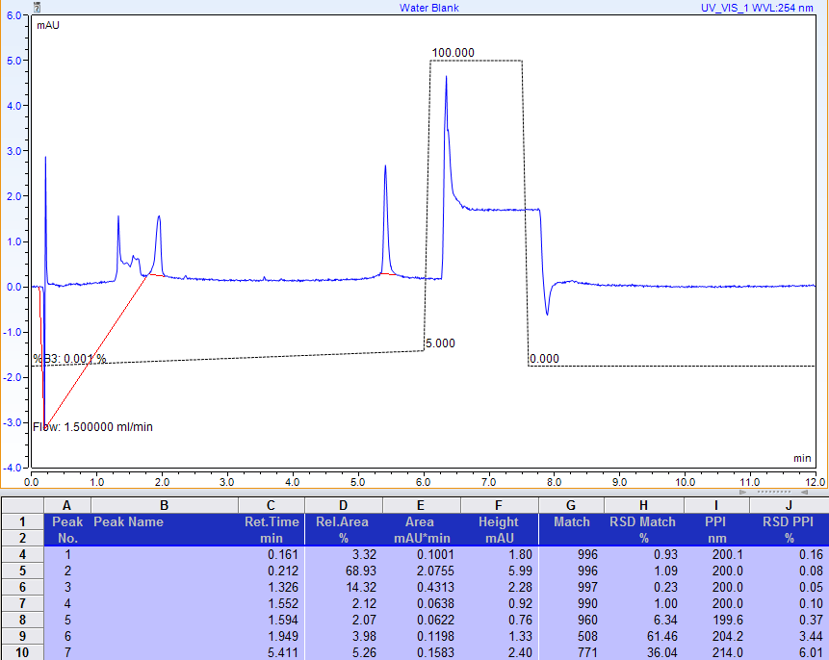
FIGURE S11. Typical AX-HPLC profile for “Blank” run.

RP-HPLC-MS Method for TCP analysis
Instruments: Vanquish Flex HPLC coupled to Orbitrap Exploris 120 Mass Spectrometer
LCMS data analysis: Freestyle 1.8 SP2 application (Thermo Scientific)
Column: Acquity UPLC BEH C18, 130A, 1.7 um, 2.1 x 50 mm ( Waters part No:186002350)
Buffer A: 100 mM TEAA, pH 7.2 (±0.2)
Buffer B: 10 mM TEAA, pH 7.2 (±0.2), in Acetonitrile-Water (9:1)
Flow rate: 0.4 mL/min
Temperature: 60ºC
Gradient parameters are shown in Figure S12A below
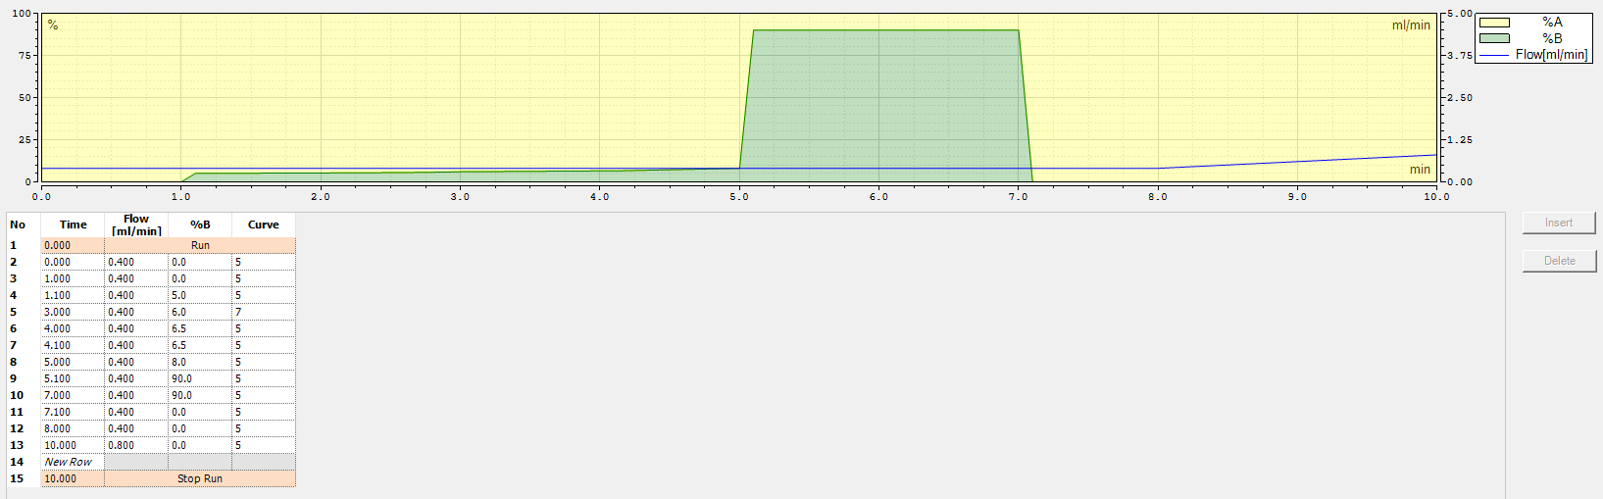
FIGURE S12A. Typical RP-HPLC gradient parameters for analysis of TCPs.

RP-HPLC-MS method used for analysis of 3-15B aggregates
Instruments: Vanquish Flex Binary HPLC coupled to LTQ-Orbitrap XL Mass Spectrometer
LCMS data analysis: ProMass HR for Xcalibur, Version 3.0 Rev. 12 (Enovatia)
Column: Acquity UPLC Oligonucleotide BEH C18 Column, 130Å, 1.7 um, 2.1 x 50 mm (Waters Part No.186003949)
Buffer A: 1% HFIP, 0.1% DIEA, 2 μM EDTA in Water
Buffer B: Acetonitrile
Flow rate: 0.3 mL/min
Temperature: 65 °C
Gradient parameters are shown in Figure S12B below
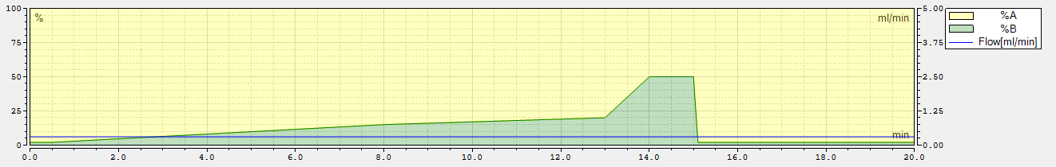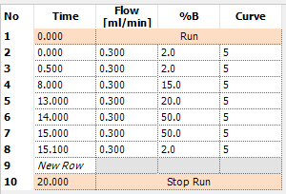
FIGURE S12B. RP-HPLC gradient parameters for analysis of compound 3-15B aggregates

