Supplemental Data

Miniature NAD⁺-II riboswitches control bacterial genes for nicotinamide salvage and de novo NAD⁺ biosynthesis

CHRISTOPHER G. KING¹, KENNY P. CHENG², and RONALD R. BREAKER^{1,2}

¹Department of Molecular Biophysics and Biochemistry, Yale University, New Haven, Connecticut 06511, USA
²Department of Molecular, Cellular and Developmental Biology, Yale University, New Haven, Connecticut 06520, USA

Corresponding Author: ronald.breaker@yale.edu

Supplemental Fig. 1. In-line probing assay for the F. durionis 60 pnuC RNA in the presence of NAD⁺. Reaction conditions and annotations are as described for Fig. 2C.

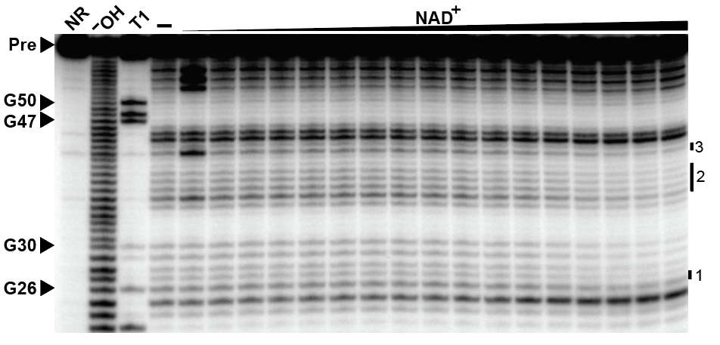

Supplemental Fig. 2. Ligand binding analysis of the 70 pncB RNA construct, representing a second mini-NAD⁺-II aptamer. (A) Sequence and secondary structure model for the 70 pncB RNA construct. Annotations are as described for Fig. 2A. (B) In-line probing analysis of the 70 pncB RNA construct. Annotations are as described for Fig. 2B.

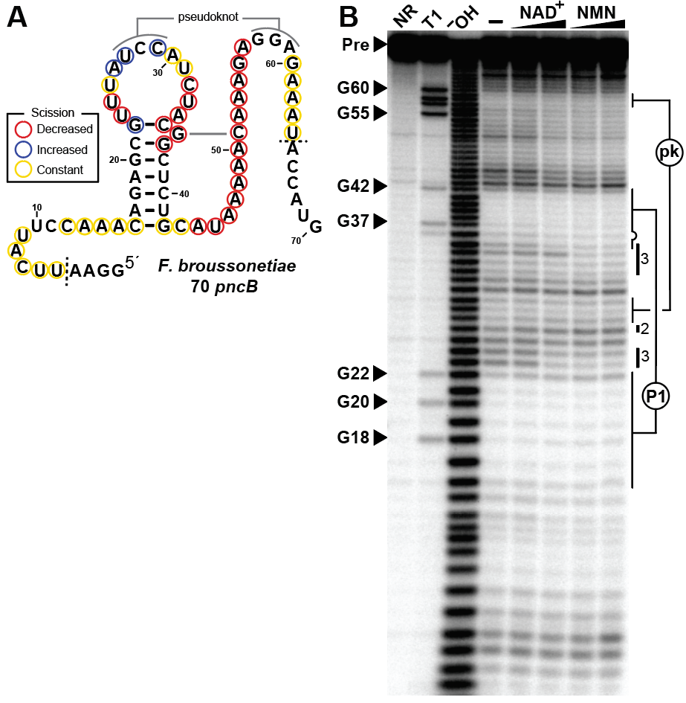

TABLE S1. Oligonucleotides used in this study. Bold letters identify nucleotides corresponding to the T7 RNA polymerase promoter.

Name | Sequence | Purpose
NAD001 | TAATACGACTCACTATAGGAACACATGGTGCGTTGCTTCCGATGACGGCACCTTAAAAACAATAGGAGAACACATATG | Top strand oligonucleotide for the construction of a template for transcription of the F. durionis 60 pnuC RNA
NAD002 | CATATGTGTTCTCCTATTGTTTTTAAGGTGCCGTCATCGGAAGCAACGCACCATGTGTTCCTATAGTGAGTCGTATTA | Bottom strand oligonucleotide for the construction of a template for transcription of the F. durionis 60 pnuC RNA
NAD003 | TAATACGACTCACTATAGGAATTCATTCCAAACAGAGCGTTTATCCATCTACGGCTCTGCATAAAAACAAAGAGGAGAAATACCATG | Top strand oligonucleotide for the construction of a template for transcription of the F. broussonetiae 70 pncB RNA
NAD004 | CATGGTATTTCTCCTCTTTGTTTTTATGCAGAGCCGTAGATGGATAAACGCTCTGTTTGGAATGAATTCCTATAGTGAGTCGTATTA | Bottom strand oligonucleotide for the construction of a template for transcription of the F. broussonetiae 70 pncB RNA

