TABLE S1. Oligonucleotides for PLP-RCA detection of AAV DNA and mRNA.
Oligonucleotide name | Sequence
PLP-ssDNA (+)-intron | 5′ phosphate-aagcttgagtatcggcTTCCTTTTACGATCAATGCACATGTTTGGCTCTCTTGatactcgaattcgtc
PLP-ssDNA (-)-EcoRV-3 | 5′ phosphate-caaaatttgtgaaagaTTCCTTTTACGACCTCAATGCTGCTGCTGTACTACTCTTatcaacctctggatta
PLP-dsDNA-EcoRV-5 | 5′ phosphate-caaaatttgtgaaagaTTCCTTTTACGAAGTAGCCGTGACTATCGACTTCTTatcaacctctggatta
PLP-mRNA-EGFP | 5′ phosphate-ctcggcgcgggtcttgTTCCTTTTACGATGCGTCTATTTAGTGGAGCCTCTTcgccctcgaacttcac
PLP-ssDNA (-)-StuI-3 | 5′ phosphate-taaaagctgcggaattTTCCTTTTACGACCTCAATGCTGCTGCTGTACTACTCTTagtgttacttctgctc
PLP-dsDNA-StuI-5 | 5′ phosphate-taaaagctgcggaattTTCCTTTTACGAAGTAGCCGTGACTATCGACTTCTTagtgttacttctgctc
RCA primer-1 | GAGCCAAACATGTGCATTGA
RCA primer-2 | GTAGTACAGCAGCAGCATTGAGG
RCA primer-3 | GGCTCCACTAAATAGACGCA
RCA primer-4 | AGTCGATAGTCACGGCTACT
Detection probe-1 | 5’ Cy5-TCAATGCACATGTTTGGCTC
Detection probe-2 | 5’ Cy7-CCTCAATGCTGCTGCTGTACTAC
Detection probe-3 | 5’ Cy3-TGCGTCTATTTAGTGGAGCC
Detection probe-4 | 5’ TXR-AGTAGCCGTGACTATCGACT
Detection probe-5 | 5’ Cy5-AGTAGCCGTGACTATCGACT
The two padlock probe target-specific ends complementary to the target sequence are shown in lower-case letters. Binding sites for RCA primers are shown in bold letters.

SUPPLEMENTARY FIGURE 1. rAAV DNA detection by PLP-RCA in HeLa cells transduced with ssAAV2-CAG-EGFP-intron vectors. (A) Schematic of PLP-RCA protocol for detection of rAAV ssDNA (±). Specific PLPs for rAAV ssDNA (+) and rAAV ssDNA (-), respectively, hybridized with the target sequences. PLPs annealed to their targets are circularized with the splintR ligase. RCA primers were hybridized with the circular PLPs, followed by rolling circle amplification to generate RCPs, thereby amplifying the signal. Fluorescently labeled detection probes were hybridized with the RCPs for imaging using a fluorescent microscope. (B) Representative images showing the specificity of rAAV ssDNA (±) detection. PLP-RCA detection of rAAV ssDNA (±) in HeLa cells transduced with ssAAV2-CAG-EGFP-intron after 48 hours (MOI=10,000). Before the ssDNA (±) PLP hybridization, cells were treated with buffer alone, RNase A or DNase I. Scale bar, 50 μm.

SUPPLEMENTARY FIGURE 2. rAAV ssDNA (±) detected using PLP-RCA following pretreatment with DNase I. The targeting of PLP-ssDNA (+) allowed for the identification of intron regions on the positive strand. Scale bar, 50 μm.

SUPPLEMENTARY FIGURE 3. rAAV DNA and mRNA detection by PLP-RCA in HeLa cells transduced with ssAAV2-CAG-EGFP-intron vectors at increasing MOIs for 48 hrs. (A) Representative images showing PLP-RCA detection of rAAV ssDNA (±) and mRNA in HeLa cells transduced with ssAAV2-CAG-EGFP-intron for 48 hours. Scale bar, 100 μm. (B) Quantification of rAAV ssDNA (±) and mRNA RCPs in HeLa cells under the conditions assayed in (A). A total of 600-800 cells were counted in each group, and the data shown are mean ± SEM. *P< 0.05，***P< 0.001，****P< 0.0001. (C) Regression analysis of rAAV ssDNA (+), ssDNA (-), and mRNA RCPs in HeLa cells under MOI gradients based on the data in (B). The solid line represents a linear regression on the plotted data, and the goodness of fit was measured by R².
SUPPLEMENTARY FIGURE 4. Visualizing scAAV2-CB-EGFP dsDNA and mRNA. HeLa cells were transduced with scAAV2-CB-EGFP (MOI=10,000) and analyzed at 48 hpt. Images were captured with a Nikon A1 confocal microscopic system. Supplementary movies 1 and 2 were produced based on volume-rendered Z-stacks of confocal images.

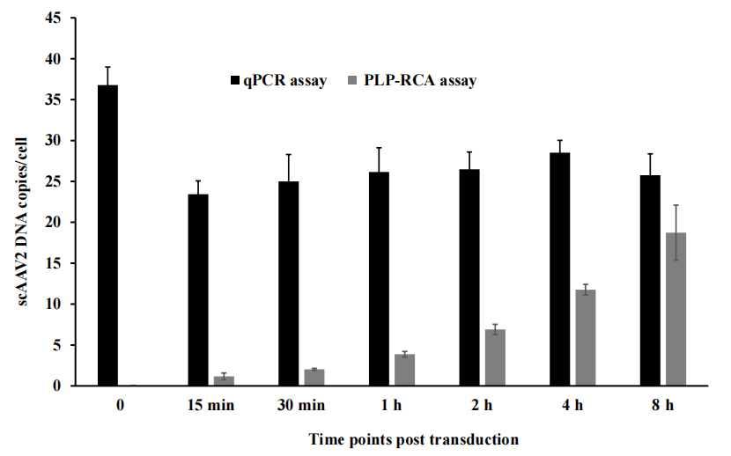
SUPPLEMENTARY FIGURE 5. The number of scAAV2 DNA copies per cell was compared by qPCR and PLP-RCA. HeLa cells were transduced with 10,000 vg/cell scAAV2-EGFP, rAAV DNA copies were detected by qPCR and RCA-PLP at various time points (0-8 hr) post-transduction, respectively.

SUPPLEMENTARY FIGURE 6. Agarose gel electrophoresis of ssAAV2-EGFP particles. Lane 1: 10 µL 4% PFA+10 µL ssAAV2-EGFP vectors, RT 30 min; Lane 2: 10 µL 100% Ethanol+10 µL ssAAV2-EGFP vectors, RT 5 min; Lane 3:10 µL 0.1 M HCl +10 µL ssAAV2-EGFP vectors, RT 5 min; Lane 4: 10 µL 2× Hyb buffer 2 (12 × SSC, 20% Formamide) +10 µL ssAAV2-EGFP vectors, 37°C, 2 hrs. Once the reactions above end, added 20 µL of PBS buffer, then added 8 µL of 6× loading buffer. Lane 5: 28 µL lysis buffer+2 µL protein K+ 10 µL ssAAV2-EGFP vectors, 60°C, 1 hr; 95°C, 10 min, then added 8 µL of 6×loading buffer; Lane 6: 30 µL PBS buffer+10 µL ssAAV2-EGFP vectors+ 8 µL of 6× loading buffer. All samples were loaded 0.8% of agarose gel at equal volume of 24 µL, then run at 100 V, 70 min.

