SUPPLEMENTARY INFORMATION
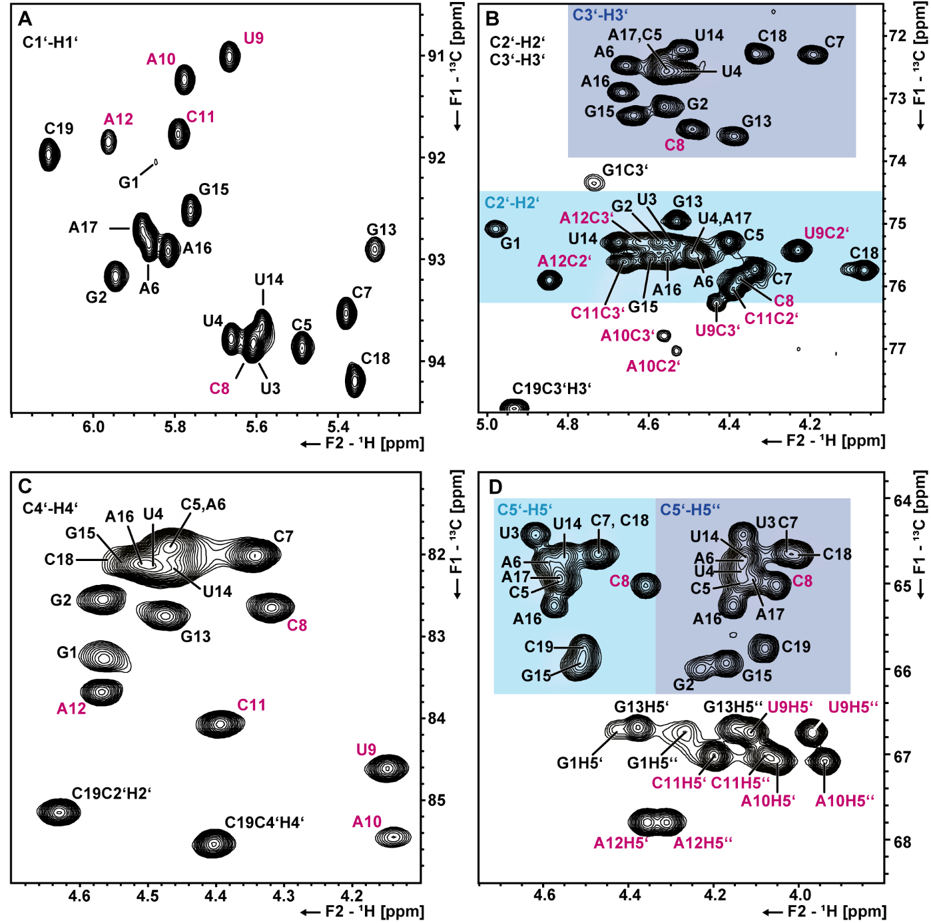
Supplementary Figure S1: Assigned ¹H,¹³C HSQCs of the s2m_omicron ribose resonances. (A) Ribose H1’C1’ chemical shift assignments. (B) H2’C2’ and H3’C3’ assignments. Typical chemical shift regions of canonical H2’C2’ or H3’C3’ resonances are highlighted with a light blue or dark blue color respectively. C) H4’C4’ assignments. (D) H5’C5’ and H5’’C5’ assignments. Canonical regions for C5’H5’ and C5’H5’’ are highlighted in a light and dark blue box respectively. Loop nucleotide assignments are shown in magenta.

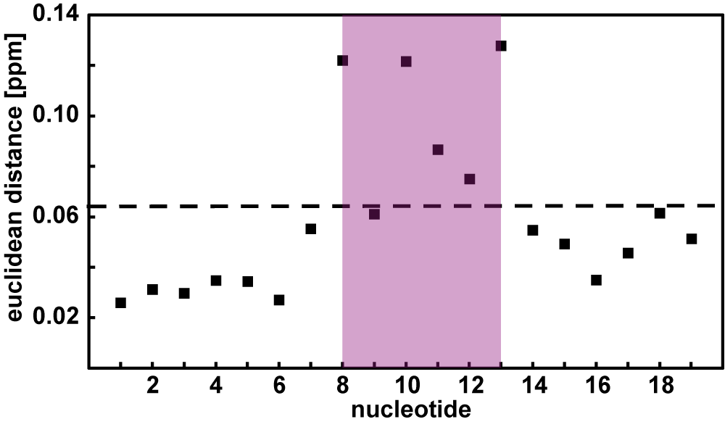
Supplementary Figure S2: Chemical shift perturbation of aromatic H6/8-C6/8 resonances from 278K to 298K. The Euclidean distance was calculated based on the ¹H and ¹³C chemical shift differences (see methods section). A threshold of two times the standard deviation is shown as a dotted line.
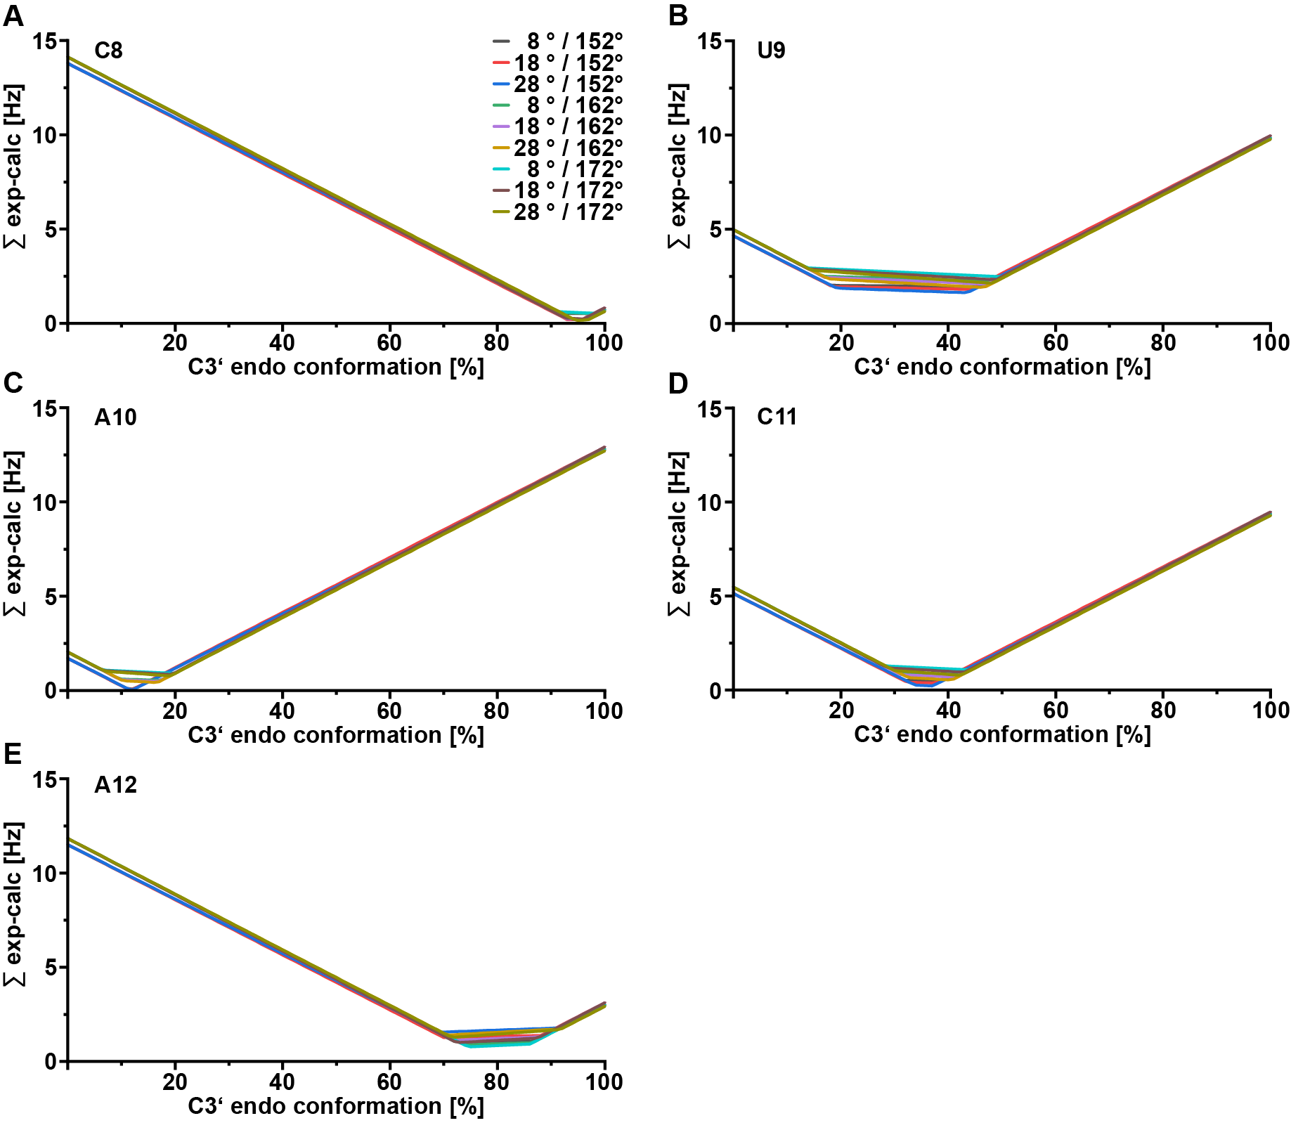
Supplementary Figure S3: Determination of the population of the s2m_omicron loop nucleotides in C3’ endo conformation with varying reference values for the pseudorotation phase. Based on the ³J-coupling constants (H1’H2’ and H3’H4’) the population of nucleotides in C3’-endo conformation was estimated. The couplings were fitted simultaneously to different percentages of C3’-endo conformation for each nucleotide (A: C8, B: U9, C: A10, D: C11 and E: A12) and the sum of the differences between the experimental and calculated values was plotted against the percentages of C3’ endo conformation. For C3’-endo P = 8 °, 18 ° and 28 ° were used in every possible combination with P = 152 °, 162 ° and 172 ° for C2’ endo.
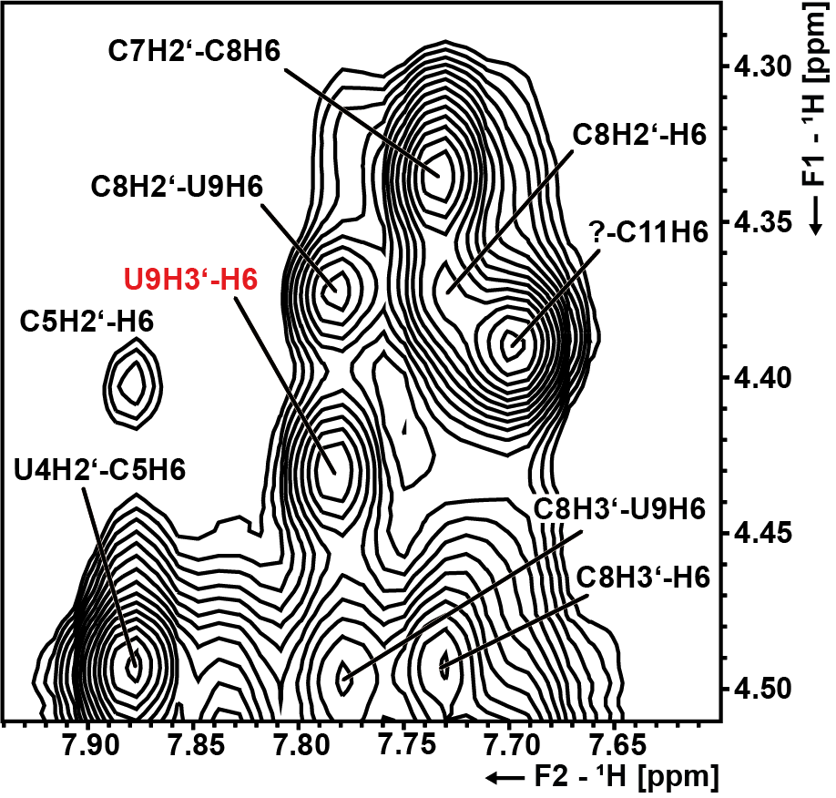
Supplementary Figure S4: U9H3’-H6 cross peak observed in the NOESY spectra used for the NMR structure calculation. The spectrum was recorded with a 680 µM RNA sample in D₂O (sample #3) at 298K and a NOESY mixing time of 150 ms. The U9H3’-H6 cross peak is labeled in red.

Supplementary Figure S5: Relationship between simulation solution NMR starting structure (colored dots) and subsequent production trajectories following equilibration (colored crosses) depicted in the PC1/PC2 space determined from the concatenated trajectory pentaloop covariances. Most simulations sample conformations beyond the starting structures and sample multiple distinct states, while some (e.g., Simulation 0) remain kinetically trapped in one region for most of the simulation.

Supplementary Figure S6: Representative CS1 pentaloop hydrogen bonds. Hydrogen bonds (brown dashed lines) are annotated with the proportion of frames where the interaction was measured (3.5 Å and 30° cutoff).
Supplementary Figure S7: (A) Agreement between simulation and experiment for stem and loop ³J-coupling constants before (red) and after (blue) reweighting. (B) Relationship between the proportion of effective frames following reweighting (black) and the relative reduction in error (red).
Supplementary Figure S8: Relationship between CSs and NMR States. (A) Proportions of sampled structures classified by secondary structure state for the MD-derived ensemble (PCA projection + clustering, blue), Markov state model (TICA projection, partitioning by k-means into 300 microstates, and coarse graining by PCCA+, orange), and the BME-refined ensemble (PCA projection + clustering, green). (B) Correspondence between PCA projection of structures and NMR states from MD. (B) Correspondence between PCA projection of structures and NMR states from the BME optimized ensemble.

Supplementary Figure S9: Pseudorotation angles and amplitudes of the pentaloop nucleotides in the MD ensemble. The computed mean is given by a red dot while the pseudorotation phase from H1’H2’ and H3’H4’ ³J-coupling constants are given by yellow triangles.

Supplementary Figure S10: Distribution of χ torsions and CCRs in the ³J-coupling constant optimized ensemble. (A) Distribution of the χ dihedral angle sampled over the reweighted ensemble for each pentaloop nucleotide. (B) Cross-correlated relaxation (CCR) rate calculated from the ³J ensemble, where mean values are given by dots (C8 = -3.6 Hz; U9 = 16.2 Hz; A10 = 3.0 Hz).

Supplementary Figure S11: Construction of Markov state model (MSM) based on pentaloop dihedral TICA dimensionality reduction. (A) Simulation dependence on sampling within the TICA projection. (B) Centroids of k-means clusters used to define microstates for the MSM depicted as purple dots over sampling density (yellow greater, purple less). (C) Implied timescales of the eight slowest relaxation processes in the constructed MSM, plotted as a function of the lag time used for model estimation. Each curve corresponds to an implied timescale derived from the non-trivial eigenvalues of the MSM transition matrix. A plateau in all eight timescales is observed beginning around a lag time of 30 ns, indicating convergence of the slow dynamical modes and suggesting that the dynamics are reasonably Markovian at this timescale.
Supplementary Figure S12: Chapman-Kolmogorov test validation of our reported MSM following consolidation into six macrostates. Each panel shows the predicted (solid black) and estimated (dashed blue) transition probability for a given macrostate pair as a function of lag time, with shaded regions indicating the 95% confidence intervals. Consistency between the predicted and estimated curves indicates that the MSM provides an adequate description of the underlying dynamics over the tested lag times.

Supplementary Figure S13: PCCA+ coarse graining of MSM into macrostates. (A) Distribution of MSM CSs derived from PCCA+ in the TICA projection with the average structure of each CS given by a red dot. (B) Intra-CS RMSF with respect to each average structure.

Supplementary Table S1: S2m_omicron samples including labelling scheme, buffer conditions and concentrations.
number | sample | concentration
1 | natural abundance 95 % H₂O / 5 % D₂O | 50 µM
2 | ¹³C, ¹⁵N labeled 95 % H₂O / 5 % D₂O | 700 µM
3 | ¹³C, ¹⁵N labeled 100 % D₂O | 680 µM
4 | ¹³C, ¹⁵N labeled 95 % H₂O / 5 % D₂O | 605 µM
5 | ¹³C, ¹⁵N labeled 100 % D₂O | 500 µM
All samples were measured in 25 mM K₂HPO₄/KH₂PO₄ (pH 6.2) and 50 mM KCl.
Supplementary Table S2: NMR Experiments and Parameters.
experiment | parameters
¹H, ¹H NOESY  (jump return)  (Sklenář 1995;  Sklenář & Bax 1987)(Sklenář 1995;  Sklenář & Bax 1987) | 800 MHz, ns: 584, sw(f2): 21.1 ppm, sw(f1): 11.9 ppm, TD(f2): 2048, TD(f1): 300, aq(f2): 61 ms, o1p(¹H): 4.7 ppm, d1: 1 s, frequency jump (f1) to 8.75 ppm, mixing time: 250 ms, 64 h (278 K), sample #1
¹H, ¹⁵N BEST-TROSY  (Favier & Brutscher 2011; Lescop et al. 2007; Schulte-Herbrüggen & Sørensen 2000;  Solyom et al. 2013)(Favier & Brutscher 2011; Lescop et al. 2007; Schulte-Herbrüggen & Sørensen 2000;  Solyom et al. 2013) | 800 MHz, ns: 16, sw(f2): 21.1 ppm, sw(f1): 24.7 ppm, TD(f2): 2018, TD(f1): 256, aq(f2): 60 ms, o1p(¹H): 4.7 ppm, o2p(¹⁵N): 153 ppm, d1: 0.3 s, 30 min, (278 K, 283 K, 289 K, 293 K, 298 K), sample #2
HNN-COSY  (Dingley & Grzesiek 1998; Lescop et al. 2010)(Dingley & Grzesiek 1998; Lescop et al. 2010) | 800 MHz, ns: 32, sw(f3): 19.7 ppm, sw(f2): 30 ppm, sw(f1): 99.6 ppm, TD(f3): 2500, TD(f2): 1, TD(f1): 320, aq(f3): 80 ms, o1p(¹H): 4.7 ppm, o2p(¹³C): 105 ppm, o3p(¹⁵N): 183 ppm, d1: 0.3 s, 1.5 h, (278 K), sample #2
¹H, ¹⁵N-HSQC  (amino)  (Mori et al. 1995)(Mori et al. 1995) | 800 MHz, ns: 32, sw(f2): 10 ppm, sw(f1): 31 ppm, TD(f2): 1024, TD(f1): 256, aq(f2): 64 ms, o1p(¹H): 4.7 ppm, o2p(¹³C): 101 ppm, o3p(¹⁵N): 86.5 ppm, d1: 0.8 s, 2 h, (278 K), sample #2
¹H, ¹⁵N CPMG NOESY  (Mueller et al. 1995; Mulder et al. 1996)(Mueller et al. 1995; Mulder et al. 1996) | 800 MHz, ns: 144, sw(f2): 21 ppm, sw(f1): 103 ppm, TD(f2): 2048, TD(f1): 256, aq(f2): 61 ms, o1p(¹H): 4.7ppm, o2p(¹³C): 101 ppm, o3(¹⁵N): 116 ppm, d1: 1 s, mixing time: 150 ms, 13h (278 K, 298 K), sample #2
HCCNH  (Piotto et al. 1992; Sklenář et al. 1996) | 600 MHz, ns: 256, sw(f3): 21 ppm, sw(f2): 10 ppm, sw(f1): 30 ppm, TD(f3): 2254, TD(f2): 128, TD(f1): 1, aq(f3): 90 ms, o1p(¹H): 4.7 ppm, o2p(¹³C): 137 ppm, o3p(¹⁵N): 154 ppm, d1: 1.8 s, C6/8-N1/9 transfer time: 24 ms, TOCSY mixing time (H6/8)C6/8(CC)NH: 28 ms, 19 h, (283 K) sample #2
¹H, ¹³C HSQC  (Bodenhausen & Ruben 1980; Vuister & Bax 1992) | aromatic region:  600, 700 and 800 MHz, ns: 4, sw(f2): 8.3 ppm, sw(f1): 24 ppm, TD(f2): 1024, TD(f1): 384, aq(f2): 77 ms, o1p(¹H): 4.7 ppm, o2p(¹³C): 143 ppm, d1: 1 s, INEPT transfer time: 2.5 ms, 30 min, (278 K, 283 K, 289 K, 293 K, 298 K), samples #2/3/4  C1’ region:  600, 700 and 800 MHz, ns: 4, sw(f2): 8.3 ppm, sw(f1): 12 ppm, TD(f2): 1024, TD(f1): 384, aq(f2): 77 ms, o1p(¹H): 4.7 ppm, o2p(¹³C): 90 ppm, d1: 1 s, INEPT transfer time: 2.94 ms, 30 min, (278 K, 298 K), samples #2/3/4  CT HSQC ribose C1’ to C5’:  600, 700 and 800 MHz, ns: 4, sw(f2): 8.3 ppm, sw(f1): 38 ppm, TD(f2): 1024, TD(f1): 256, aq(f2): 77 ms, o1p(¹H): 4.7 ppm, o2p(¹³C): 77 ppm, d1: 1 s, constant time delay: 12.5 ms, 20 min, (308 K), samples #2/3/5
3D HCN  (Sklenář et al. 1993a) | ¹H detected:  800 MHz, ns: 32, sw(f3): 9 ppm, sw(f2): 22 ppm, sw(f1): 33 ppm TD(f3): 1024, TD(f2): 60, TD(f1): 100 aq(f3): 71 ms, o1p(¹H): 4.7 ppm, o2p(¹³C): 95 ppm, o3p(¹⁵N): 158 ppm, d1: 1 s, INEPT transfer times: 2.8 ms (HC) and 30 ms (CN), recorded with 20 % NUS, 13 h, (298 K), sample #3  ¹³C detected:  800 MHz, ns: 32, sw(f3): 24.5 ppm, sw(f2): 34.7 ppm, sw(f1): 12 ppm TD(f3): 1024, TD(f2): 56, TD(f1): 104 aq(f3): 104 ms, o2p(¹³C): 90 ppm, o3p(¹⁵N): 157 ppm, d1: 0.5 s, INEPT transfer times: 2.5 ms (HC) and 30 ms (CN), 36 h, (298 K), sample #2
¹⁵N filtered NOESY  (Ikura & Bax 1992; Piotto et al. 1992; Sklenář et al. 1993b) | 800 MHz, ns: 72, sw(f2): 9 ppm, sw(f1): 6.3 ppm TD(f2): 1024, TD(f1): 700, aq(f2): 71 ms, o1p(¹H): 4.7 ppm, o2p(¹³C): 115 ppm, o3p(¹⁵N): 81 ppm, d1: 1 s, NOESY mixing time: 250 ms, 20 h, (289 K), sample #2
3D ¹H, ¹³C NOESY-HSQC  (Zhang et al. 1994) | 700 MHz, ns: 24, sw(f3): 10.1 ppm, sw(f2): 24 ppm, sw(f1): 6.2 ppm TD(f3): 1024, TD(f2): 180, TD(f1): 180 aq(f3): 72 ms, o1p(¹H): 4.7 ppm, o2p(¹³C): 143 ppm, o3p(¹⁵N): 151 ppm, d1: 1.15 s, INEPT transfer time: 2.7 ms (HC), NOESY mixing time: 250 ms, frequency jump to 5.5 ppm, recorded with 25 % NUS, 3 d 12 h (298 K), sample #3
3D fw-HCCH-TOCSY  Glaser et al. 1996; Kay et al. 1993; Marino et al. 1996; Schwalbe et al. 1995) | 600 MHz, ns: 16, sw(f3): 15 ppm, sw(f2): 35 ppm, sw(f1): 3.4 ppm TD(f3): 1024, TD(f2): 92, TD(f1): 138 aq(f3): 56 ms, o1p(¹H): 4.7 ppm, o2p(¹³C): 77 ppm, o3p(¹⁵N): 160 ppm, d1: 1 s, INEPT transfer times: 3.6 ms, TOCSY mixing time: 12 ms, constant time delay: 8.8 ms, 2 d 8 h, (308 K), sample #3
H5-H6 TOCSY  (Braunschweiler & Ernst 1983; Hwang & Shaka 1995; Shaka et al. 1988) | 600 MHz, ns: 32, sw(f2): 8.8 ppm, sw(f1): 6.2 ppm TD(f2): 1398, TD(f1): 256, aq(f2): 133 ms, o1p(¹H): 4.7 ppm, o2p(¹³C): 137 ppm, o3p(¹⁵N): 86 ppm, d1: 1 s, TOCSY mixing time: 30 ms, 3 d, (298 K), sample #2
¹H, ¹³C hetNOE  (Duchardt & Schwalbe 2005; Farrow et al. 1994) | aromatic region:  600 MHz, ns: 24, sw(f3): 9.3 ppm, sw(f2): 21 ppm, TD(f3): 1024, TD(f2): 400, aq(f3): 92 ms, o1p(¹H): 4.7 ppm, o2p(¹³C): 143 ppm, o3p(¹⁵N): 153 ppm, d1: 5 s, presaturation delay: 3 s, INEPT transfer time: 3.2 ms, 1 d 20 h, (298 K), sample #3  c1’ region:  600 MHz, ns: 32, sw(f3): 9.3 ppm, sw(f2): 12 ppm, TD(f3): 1024, TD(f2): 300, aq(f3): 92 ms, o1p(¹H): 4.7 ppm, o2p(¹³C): 90 ppm, o3p(¹⁵N): 153 ppm, d1: 5 s, presaturation delay: 3 s, INEPT transfer time: 3.2 ms, 1 d 20 h (298 K), sample #3  NOE/noNOE experiments were recorded as pseudo 3D. An off-resonant pulse at -4000 ppm was used for temperature compensation in the reference experiment.
NOESY (for structure calculations)  (Hwang & Shaka 1995; Sklenář 1995) | D₂O sample for non-exchangeable protons:  800 MHz, ns: 120, sw(f2): 20 ppm, sw(f1): 5 ppm, TD(f2): 2048, TD(f1): 700, aq(f2): 64 ms, o1p(¹H): 4.7 ppm, d1: 1 s, frequency jump (f1) to 6.15 ppm, mixing times: 50/100/150 ms, 1 d 4/5/7 h, (298 K), sample #3  H₂O sample for exchangeable protons:  800 MHz, ns: 96, sw(f2): 21 ppm, sw(f1): 12 ppm, TD(f2): 2048, TD(f1): 600, aq(f2): 61 ms, o1p(¹H): 4.7 ppm, d1: 1 s, frequency jump (f1) to 8.75 ppm, mixing times: 100/150 ms, 19/20 h, (298 K), sample #4
fw-HCC-TOCSY-CCH-ECOSY  (Glaser et al. 1996; Kay et al. 1993; Marino et al. 1996; Schwalbe et al. 1995) | 800 MHz, ns: 24, sw(f3): 10 ppm, sw(f2): 35 ppm, sw(f1): 3.4 ppm TD(f3): 1440, TD(f2): 90, TD(f1): 128 aq(f3): 90 ms, o1p(¹H): 4.7 ppm, o2p(¹³C): 77.5 ppm, o3p(¹⁵N): 160 ppm, d1: 1 s, INEPT transfer times: 3.1 ms, constant time delay: 7.6 ms, 3 d 18 h, (298 K), sample #3  Analysis of the spectra was carried out with the Ecosy2 script (see scripts section of the supplementary information)
Γ-HCN  (Rinnenthal et al. 2007) | 800 MHz, ns: 224/1504 (reference/cross experiment), sw(f2): 9 ppm, sw(f1): 12.4 ppm, TD(f2): 1024, TD(f1): 102, aq(f2): 71 ms, o1p(¹H): 4.7 ppm, o2p(¹³C): 90 ppm, o3p(¹⁵N): 158 ppm, d1: 1.3 s, INEPT transfer times: 2.5 ms (HC), 32 ms (C6/8 to N1/9) and 36 ms (N1/9 to C1’), mixing time: 25 ms, 10/67 h (reference/cross experiment), (298 K), sample #3
quantitative HCP  (Richter et al. 1998) | 2D reference and cross experiments  700 MHz, ns: 32, sw(f2): 20.1 ppm, sw(f1): 23 ppm, TD(f2): 2048, TD(f1): 182, aq(f2): 73 ms, o1p(¹H): 4.7 ppm, o2p(¹³C): 72 ppm, o3p(³¹P): 1.2 ppm, d1: 1 s, INEPT transfer times: 3.2 ms (HC), 25 ms (CP), 2 h, (298 K), sample #3  3D HCP  700 MHz, ns: 32, sw(f3): 12 ppm, sw(f2): 23 ppm, sw(f1): 3.5 ppm TD(f3): 1024, TD(f2): 128, TD(f1): 70, aq(f3): 61 ms, o1p(¹H): 4.7 ppm, o2p(¹³C): 72 ppm, o3p(³¹P): -1 ppm, d1: 1 s, INEPT transfer times: 3.2 ms (HC) and 25 ms (CP), 3 d 20 h, (298 K), sample #3  As intensities are derived from experiments with different overall measurement time (3D cross, 2D reference), a calibration constant was used determined via carbons that are only coupled to one ³¹P in the 2D cross experiment (e.g. C5’P or C3’P+).
PFIDS  (Schwalbe et al. 1993) | 700 MHz, ns: 384, sw(f2): 10 ppm, sw(f1): 23 ppm, TD(f2): 1024, TD(f1): 200, aq(f2): 73 ms, o1p(¹H): 4.7 ppm, o2p(¹³C): 72.5 ppm, o3p(³¹P): 0.6 ppm, d1: 2 s, INEPT transfer times: 3.2 ms (HC), 25 ms (CP), 1 d 22 h, (298 K), sample #3  Analysis of the spectra was carried out with the pfids.v2 script (see scripts section of the supplementary information)

Supplementary Table S3: Chemical shift assignment of unexchangeable proton chemical shifts in ppm.
[ppm] | H1' | H2' | H3' | H4' | H5'1 | H5'2 | H6/H8 | H5 | H2
G1 | 5.85 | 4.98 | 4.73 | 4.57 | 4.43 | 4.27 | 8.16 | - | -
G2 | 5.95 | 4.57 | 4.56 | 4.56 | n.d. | 4.23 | 7.56 | - | -
U3 | 5.61 | 4.54 | n.d. | 4.52 | 4.61 | 4.14 | 7.83 | 5.15 | -
U4 | 5.66 | 4.49 | 4.53 | 4.49 | n.d. | 4.14 | 7.99 | 5.63 | -
C5 | 5.49 | 4.4 | 4.55 | 4.47 | 4.56 | 4.14 | 7.88 | 5.7 | -
A6 | 5.87 | 4.47 | 4.66 | 4.47 | 4.58 | 4.13 | 8.08 | - | 7.32
C7 | 5.38 | 4.34 | 4.19 | 4.34 | 4.47 | 4.03 | 7.24 | 5.03 | -
C8 | 5.61 | 4.37 | 4.49 | 4.32 | 4.36 | 4.05 | 7.73 | 5.64 | -
U9 | 5.67 | 4.23 | 4.43 | 4.14 | 4.11 | 3.97 | 7.78 | 5.74 | -
A10 | 5.78 | 4.54 | 4.55 | 4.14 | 4.05 | 3.94 | 8.15 | - | 8.03
C11 | 5.8 | 4.39 | 4.66 | 4.39 | 4.2 | 4.07 | 7.70 | 5.73
A12 | 5.97 | 4.84 | 4.62 | 4.57 | 4.35 | 4.31 | 8.46 | - | 8.07
G13 | 5.31 | 4.53 | 4.39 | 4.48 | 4.38 | 4.15 | 7.46 | - | -
U14 | 5.59 | 4.67 | 4.53 | 4.47 | 4.55 | 4.12 | 7.72 | 5.11 | -
G15 | 5.76 | 4.6 | 4.64 | 4.52 | 4.51 | 4.17 | 7.69 | - | -
A16 | 5.82 | 4.55 | 4.66 | 4.51 | 4.58 | 4.15 | 7.78 | - | 7.06
A17 | 5.88 | 4.49 | 4.56 | n.d. | 4.56 | 4.11 | 7.77 | - | 7.78
C18 | 5.36 | 4.07 | 4.33 | 4.56 | 4.49 | 4.00 | 7.41 | 5.18 | -
C19 | 6.11 | 4.63 | 4.93 | 4.4 | 4.5 | 4.07 | 7.45 | 5.47 | -
complete | 100% | 100% | 95% | 95% | 89% | 100% | 100% | 100% | 100%

Supplementary Table S4: Chemical shift assignment of ¹³C chemical shifts in ppm.
[ppm] | C1' | C2' | C3' | C4' | C5' | C6/C8 | C2
G1 | 92.03 | 75.08 | 74.35 | 83.28 | 66.73 | 139.10
G2 | 93.17 | 75.32 | 73.14 | 82.55 | 65.97 | 136.90
U3 | 93.88 | 75.31 | n.d. | n.d. | 64.43 | 141.90
U4 | 93.80 | 75.43 | 72.56 | 82.11 | 64.89 | 142.40
C5 | 93.89 | 75.28 | 72.59 | 81.91 | 65.02 | 141.50
A6 | 92.85 | 75.54 | 72.52 | 81.95 | 64.77 | 139.50 | 153.30
C7 | 93.55 | 75.74 | 72.32 | 82.00 | 64.64 | 140.20
C8 | 93.84 | 75.86 | 73.51 | 82.61 | 65.02 | 141.40
U9 | 91.00 | 75.41 | 76.29 | 84.62 | 66.75 | 143.60
A10 | 91.24 | 77.03 | 76.79 | 85.46 | 67.08 | 141.50 | 155.00
C11 | 91.76 | 76.05 | 75.61 | 84.07 | 67.03 | 143.40
A12 | 91.85 | 75.91 | 75.29 | 83.69 | 67.80 | 142.20 | 152.30
G13 | 92.92 | 74.93 | 73.67 | 82.76 | 66.70 | 137.00
U14 | 93.69 | 75.32 | 72.31 | 82.19 | 64.68 | 141.50
G15 | 92.52 | 75.54 | 73.28 | 82.08 | 65.92 | 136.30
A16 | 92.93 | 75.59 | 72.93 | 82.12 | 65.28 | 139.50 | 152.90
A17 | 92.75 | 75.52 | 72.61 | n.d. | 64.94 | 139.00 | 153.90
C18 | 94.23 | 75.74 | 72.30 | 82.07 | 64.65 | 140.70
C19 | 91.97 | 85.17 | 77.96 | 85.53 | 65.76 | 141.80
complete | 100% | 100% | 95% | 89% | 100% | 100% | 100%

Supplementary Table S5: Experimentally determined dihedral restraints for the loop nucleotides of s2m_omicron applied in the NMR structure calculation.
 | ν₀ [°] | ν₁ [°] | ν₂ [°] | ν₃ [°] | ν₄ [°] | χ [°] | β [°] | ε [°] | γ [°]
C8 | 19±22 | -36±20 | 39±14 | -27±15 | 5±23 | 200±40 | 170±40 | 230±40 | 90±30
U9 | -21±22 | 35±16 | -35±15 | 24±23 | -2±23 | n.d. | 167±40 | 210±40 | 74±30
A10 | -21±22 | 35±16 | -35±15 | 24±23 | -2±25 | 240±40 | 180±40 | 230±40 | 92±30
C11 | -21±22 | 35±16 | -35±15 | 24±23 | -2±25 | n.d. | 171±40 | 210±40 | 92±30
A12 | 3±22 | -25±20 | 36±15 | -35±15 | 20±25 | n.d. | 204±40 | 210±40 | 107±30
For U9, A10 and A12 typical angles for C2’- and C3’-endo conformation respectively were used as the exact angle determination has not been possible due to averaging of the ³J-coupling constants and CCRs. Instead of errors, the intervals used in the structure calculation as soft restraints are shown. The values for γ are based on the canonical coordinates.
Supplementary Table S6: Dihedral restraints used for the stem nucleotides in the structure calculation of s2m_omicron.
ν₀ [°] | ν₁ [°] | ν₂ [°] | ν₃ [°] | ν₄ [°] | χ [°] | β [°] | ε [°] | α [°] | ζ [°] | γ [°]
3±22 | -25±20 | 36±14 | -35±15 | 20±23 | 200±40 | 180±40 | -140±40 | -85±25 | -80±30 | 90±30

Supplementary Table S7: Experimentally determined ribose J-coupling constants of s2m_omicron.
 | ³J_{H1’H2’} [Hz] | ³J_{H3’H4’} [Hz]
G1 | 2.4±0.5 | 10.3±0.5
U3 | 1.1±0.5
U4 | 1.4±0.5 | 11.2±0.5
C5 | 1.1±0.5 | 8.8±0.5
C7 | 2.0±0.5 | 7.8±0.5
C8 | 1.6±0.5 | 8.8±0.5
U9 | 6.9±0.5 | 4.9±0.5
A10 | 7.3±0.5 | 2.4±0.5
C11 | 5.9±0.5 | 4.4±0.5
A12 | 2.0±0.5 | 6.9±0.5
G13 | 2.9±0.5 | 9.3±0.5
U14 | 1.0±0.5
G15 | <1 | 8.8±0.5
A16 | 1.8±0.5
C18 | <1
C19 | 2.0±0.5

Supplementary Table S8: Experimentally determined CCRs across the glycosidic bond and the determined phosphate backbone J-coupling constants of loop nucleotides of s2m_omicron.
 | Γ^{DD,DD}_{C1’H1’C6/8H6/8} [Hz] | ³J_{H3’P+} [Hz] | ³J_{H5’P} [Hz] | ³J_{H5’’P} [Hz] | ³J_{C4’P} [Hz] | ³J_{C4’P+}[Hz]
C8 | 5.8±0.4 | 9.1±0.9 | 3.3±0.4 | 0.2±0.1 | 11.1±0.6 | 5.0±0.3
U9 | 9.7±1.5 | 7.1±0.7 | 3.5±0.4 | 0.2±0.1 | 9.4±0.5 | 7.5±0.4
A10 | 3.6±0.3 | 7,9±0.8 | n.d. | 3.7±0.4 | 8.6±0.5 | 5.6±0.3
C11 | n.d. | 8.3±0.8 | 4.0±0.4 | n.d. | 8.9±0.5 | 8.1±0.4
A12 | n.d. | 7.0±0.7 | 4.0±0.4 | 5.6±0.6 | 8.4±0.5 | 10.9±0.6

Supplementary Table S9: Hydrogen bonds present in at least 40% of simulated structures within CS1.
Donor | Acceptor | Population
C8 H4 | C11 OP2 | 87.2%
C8 HO2' | U9 OP1 | 77.4%
C8 H2' | A10 O4' | 43.1%
U9 HO2' | A10 OP1 | 91.0%
A10 HO2' | C11 OP1 | 93.4%
C11 H4 | A10 OP1 | 82.3%
A12 H6 | C8 O2 | 88.3%

Scripts:
The scripting language used was Jython. Scripts were implemented/ used in the Topspin Version 4.1.4 as direct processing on experimental data.

Ecosy2
from math import sqrt
import os

low1, high1 = str(sys.argv[1]).split("-")
low2, high2 = str(sys.argv[2]).split("-")

XCMD("dpl") # Get limits from currently visible region
f1p = float(GETPAR("2 F1P"))
f2p = float(GETPAR("2 F2P"))

hz = float(GETPAR("2s HZpPT"))
#print hz

oldDataset = CURDATA()
range1 = CURDATA()
range1[2] = "1"+low1
#RSR(str(sys.argv[1]),str(sys.argv[1]),"y")
XCMD("f2sum %s %s %s" %(low1, high1, "1"+low1))
RE(range1)
procdata1 = list(GETPROCDATA(f1p,f2p))
#print procdata1
#print len(procdata1)
CLOSEWIN(CURDATA())
RE(oldDataset)

oldDataset = CURDATA()
range2 = CURDATA()
range2[2] = "1"+low2
#RSR(str(sys.argv[2]),str(sys.argv[2]),"y")
XCMD("f2sum %s %s %s" %(low2, high2, "1"+low2))
RE(range2)
procdata2 = list(GETPROCDATA(f1p,f2p))
#print procdata2
#print len(procdata2)
CLOSEWIN(CURDATA())
RE(oldDataset)

diffs = []
shifts = []

for x in range(len(procdata1)):
summe = sum(abs(procdata1[i] - procdata2[i]) for i in range(len(procdata1)))
diffs.append(summe)
tmp = procdata1.pop(0)
procdata1.append(tmp)

for x in range(len(procdata1)):
shift = x * hz
shifts.append(shift)

#print diffs
#print shifts
disprop = GET_DISPLAY_PROPS(xStart = str(0), xEnd = str(max(shifts)), xUnit = 'Hz', xLegend='shift', yLegend='difference')
DISPLAY_DATALIST_XY([diffs,], [shifts,], propList = [disprop,], winTitle = "Dreck")
#print disprop

minimum_diffs = min(diffs)

for y in range(len(diffs)):
if diffs[y] == minimum_diffs:
minimum = shifts[y]

devis = []

for z in range(len(diffs)):
if diffs[z] <= 1.02*minimum_diffs:
devis.append(shifts[z])

if minimum-min(devis) >= max(devis)-minimum:
devi=minimum-min(devis)
else:
devi=max(devis)-minimum

result="ECOSY analysis of rows "+str(sys.argv[1])+" and "+str(sys.argv[2])+"\n\nCoupling constant: "+str(round(minimum, 3))+" +- "+str(round(devi, 3))+" Hz."
VIEWTEXT(title="Result", header="", text=result, modal=1)

pfidsv2
from math import sqrt
import os

def re(name=None,expno=None,procno=None,directory=None,user=None,show="y"):
currentDataset = CURDATA()
if (name != None):
currentDataset[0] = name
if (expno != None):
currentDataset[1] = str(expno)
if (procno != None):
currentDataset[2] = str(procno)
if (directory != None):
currentDataset[3] = directory
if (user != None):
currentDataset[4] = user
RE(currentDataset,show)
return currentDataset

low1, high1 = str(sys.argv[1]).split("-")
vbase = str(int("8"+low1)+int(1))
addbase = str(int("8"+low1)+int(2))
subbase = str(int("8"+low1)+int(3))

XCMD("dpl") # Get limits from currently visible region
f1p = float(GETPAR("2 F1P"))
f2p = float(GETPAR("2 F2P"))

coupled = CURDATA()
specsafe = CURDATA()
specsafe[2] = vbase
XCMD("f2sum %s %s %s" %(low1, high1, vbase))
RE(specsafe)
CLOSEWIN(CURDATA())
RE(coupled)

specint = CURDATA()
specint[2] = addbase
XCMD("f2sum %s %s %s" %(low1, high1, addbase))
RE(specint)
CLOSEWIN(CURDATA())
RE(coupled)

RE(specsafe)
XCMD("accumulate %s %s %s %s %s" % (0, 1, "ppm", specint[2], specint[1]), WAIT_TILL_DONE)
WR(specint, "y")
RE(coupled)

currentDataset = re() #takes all required information of current expno
re(None,int(currentDataset[1])+1) #goes into the next expno

uncoupled = CURDATA()
specbase = CURDATA()
specbase[2] = vbase
XCMD("f2sum %s %s %s" %(low1, high1, vbase))
RE(specbase)
CLOSEWIN(CURDATA())
RE(uncoupled)

specadd = CURDATA()
specadd[2] = addbase
XCMD("f2sum %s %s %s" %(low1, high1, addbase))
RE(specadd)
CLOSEWIN(CURDATA())
RE(uncoupled)

specsub = CURDATA()
specsub[2] = subbase
XCMD("f2sum %s %s %s" %(low1, high1, subbase))
RE(specsub)
CLOSEWIN(CURDATA())
RE(uncoupled)

#print(coupled)
#print(uncoupled)

summs = []
shifts = []

for x in range(0, 140, 1):
RE(specadd, "n")
XCMD("sr %s" % (x*0.05), WAIT_TILL_DONE)
RE(specsub, "n")
XCMD("sr %s" % (-x*0.05), WAIT_TILL_DONE)
RE(specadd, "n")
XCMD("accumulate %s %s %s %s %s" % (0, 1, "ppm", specsub[2], specsub[1]), WAIT_TILL_DONE)
RE(specint)
XCMD("accumulate %s %s %s %s %s" % (0, -1, "ppm", specadd[2], specadd[1]), WAIT_TILL_DONE)
procdata1 = list(GETPROCDATA(f1p,f2p))
abspdata = [abs(x) for x in procdata1]
integral = sum(abspdata)**2
summs.append(integral)
RE(specsafe)
WR(specint, "y")
RE(specbase)
WR(specadd, "y")
WR(specsub, "y")

for x in range(0, 140, 1):
shift = (x*0.1)
shifts.append(shift)

#print(diffs)
#print shifts
#VIEWTEXT(title="Result", header="", text=str(shifts))
#VIEWTEXT(title="Result", header="", text=str(diffs))
disprop = GET_DISPLAY_PROPS(xStart = str(0), xEnd = str(max(shifts)), xUnit = 'Hz', xLegend='shift', yLegend='difference')
DISPLAY_DATALIST_XY([summs,], [shifts,], propList = [disprop,], winTitle = "Dreck")
#print disprop

for y in range(len(summs)):
if summs[y] == min(summs):
minimum = shifts[y]
result="The P-FIDS analysis of row "+str(sys.argv[1])+" resulted in\n\nCoupling constant: "+str(round(minimum, 3))+" Hz."
VIEWTEXT(title="Result", header="", text=result, modal=1)

