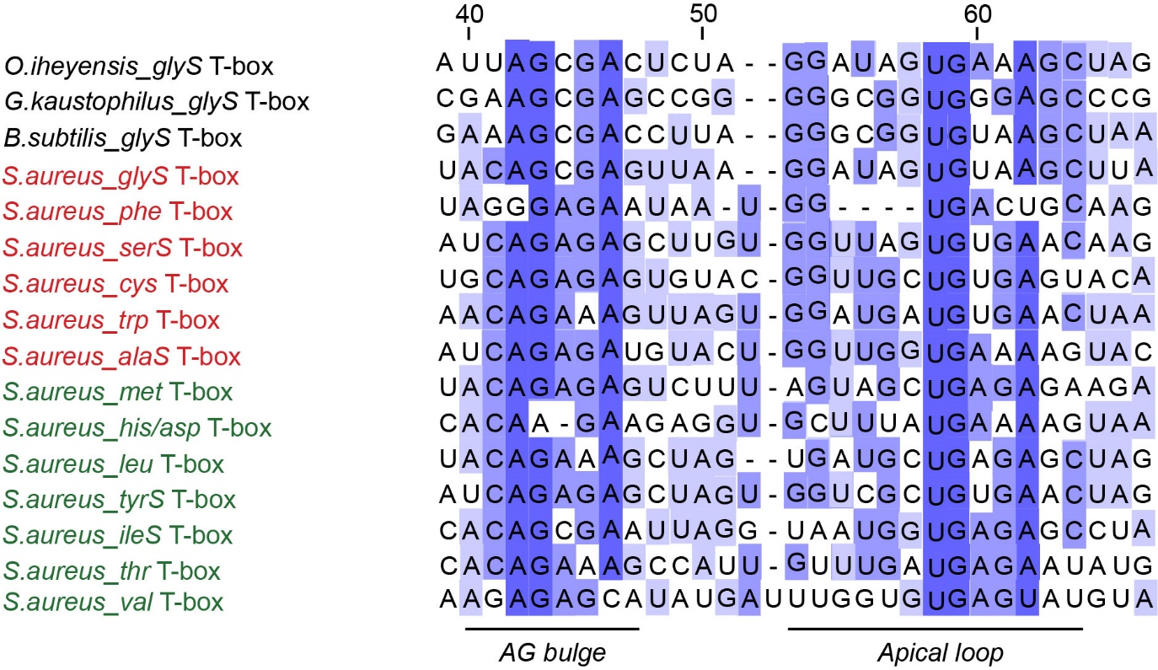
Supplementary Figure S7. Sequence alignment of the AG bulge and apical loop regions of S. aureus T-box riboswitches. T-boxes affected by T-box-I are marked in red, while those that are unaffected are marked in green. The alignment also includes the glyS T-boxes from O. iheyensis, G. kaustophilus and B. subtilis. For the alignment, highly conserved nucleotides (80–100%) are indicated in dark blue, moderately conserved nucleotides (50–80%) are indicated in blue, and less conserved nucleotides (≤50%) are indicated in light blue. Alignment numbering corresponds to the numbering of O. iheyensis glyS T-box.

