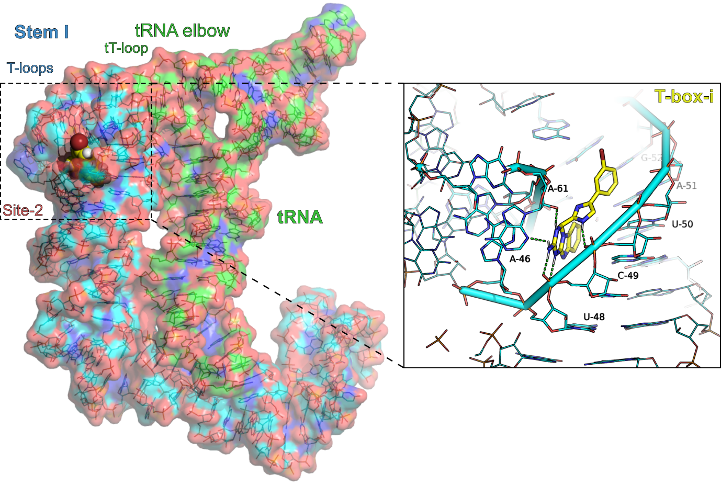
Supplementary Figure S4. Molecular model of the T-box bound inhibitor, T-box-i (Z1272834847 in Table 1 and Scheme S1) at the targeted site-2 in the Stem I T-loops. Inset the docked conformation of T-box-i illustrating putative hydrogen bonding interactions with A-61 and the phosphate backbone of U-48 and C-49 (green dashed lines).

