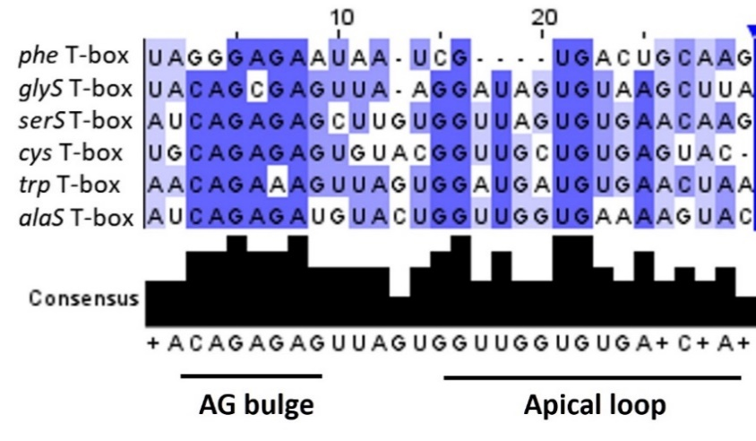
Supplementary Figure S3. Alignment of the putative AG bulge and Apical loop regions of T-boxes whose regulated genes are affected by the presence of the compound. For the alignment, the highly conserved nucleotides (80–100%) are indicated by dark blue color, the moderately conserved nucleotides (60–80%) are indicated with blue color, while the less conserved nucleotides (≤60%) are indicated with light blue color.

