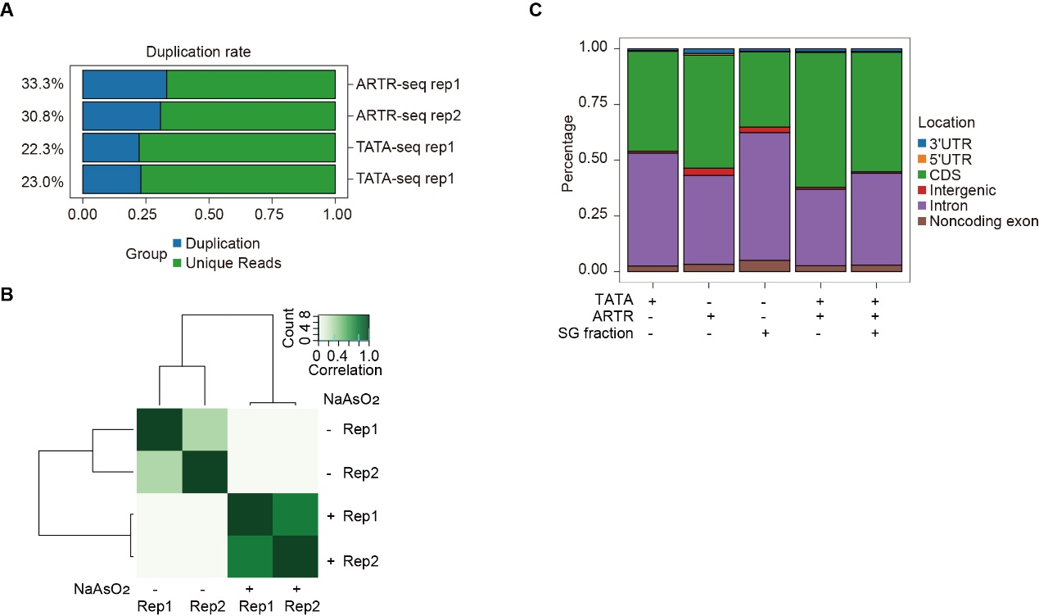
FIGURE S1. Data analysis of SG-enriched RNAs in HeLa cells under SA-induced stress. (A) Bar plot showing the PCR duplication ratio of TATA-seq and ARTR-seq data. (B) Heatmap depicting the correlation of TATA-seq data targeting SGs, with and without SA treatment, across two biological replicates. (C) Stacked plots illustrating the ratio of SA-induced SG enriched transcripts mapped to different genomic regions. The data were generated from TATA-seq, ARTR-seq, SG fraction, overlapping TATA-seq and ARTR-seq, and overlapping TATA-seq, ARTR-seq, and SG fraction.

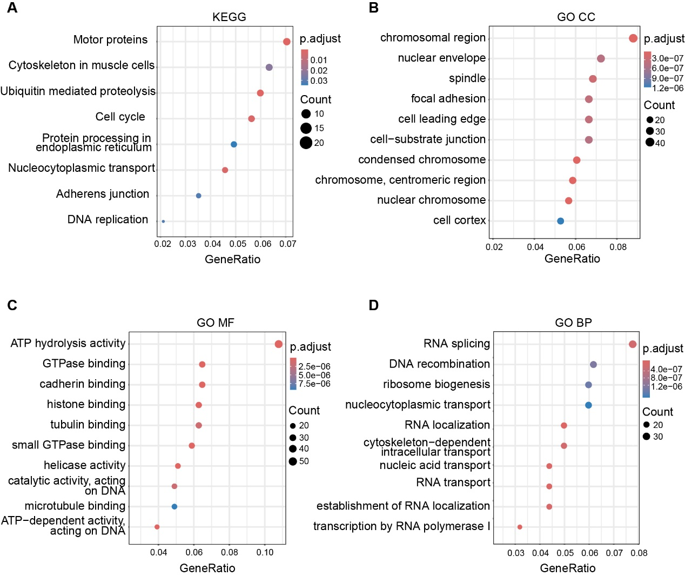
FIGURE S2. Functional analysis of SG-enriched RNAs in HeLa cells under AS-induced stress. (A) Dot plot showing the enrichment of SG-enriched transcripts in distinct pathways as determined by Kyoto Encyclopedia of Genes and Genomes (KEGG) analysis. (B–D) Dot plots representing the top ten cellular components (B), molecular functions (C), and biological processes (D) of SG-enriched transcripts, as identified by Gene Ontology (GO) enrichment analysis. In all dot plots, the size of each point corresponds to the number of genes annotated within the functional pathway, while the color indicates the significance of enrichment, based on adjusted P values. The GeneRatio represents the ratio of input genes annotated within each pathway.

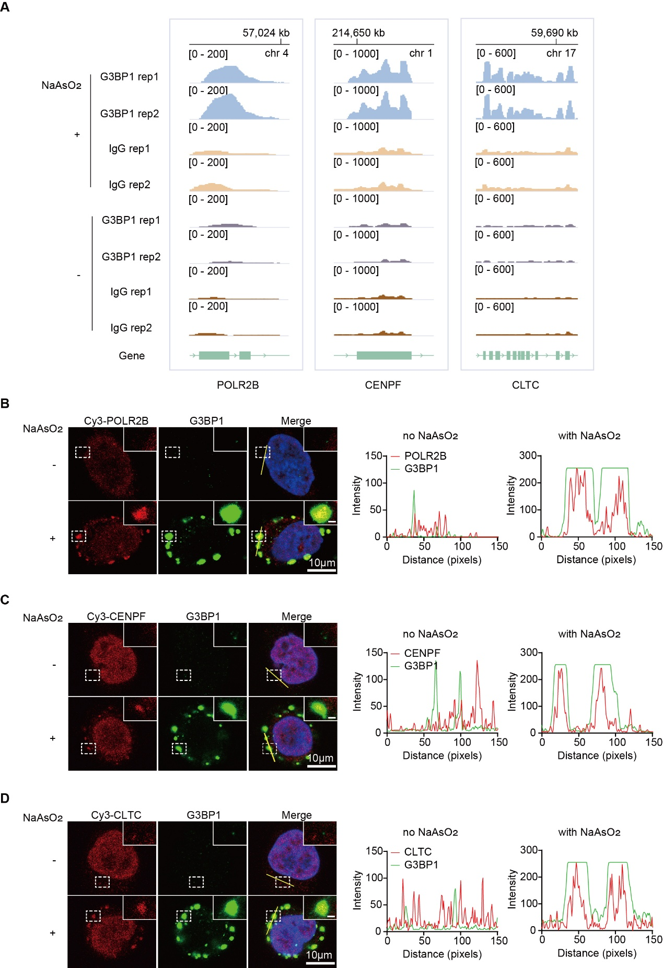
FIGURE S3. Validation of TATA-seq-identified transcripts enriched in SGs in HeLa cells under NaAsO₂-induced stress. (A) IGV snapshots illustrating the significant TATA-seq signal at three transcripts (POLR2B, CENPF, and CLTC) in sequencing libraries derived from NaAsO₂ treated and untreated groups. (B), (C), and (D) Representative confocal images of fluorescence in situ hybridization (FISH) using Cy3-labeled DNA probes targeting POLR2B (B), CENPF (C), and CLTC (D), combined with immunofluorescence against G3BP1, with or without NaAsO₂ treatment. The overlay images and corresponding plot profiles demonstrate colocalization between G3BP1 and POLR2B (overlap coefficient: r = 0.795), CENPF (overlap coefficient: r = 0.674), or CLTC (overlap coefficient: r = 0.777). Scale bars are 10 μm for the full images and 1 μm for the enlarged sections. DAPI staining was used to visualize cell nuclei. The fluorescence intensities along the yellow line in the merged images are shown in the histograms on the right. All experiments were performed independently three times with consistent results.

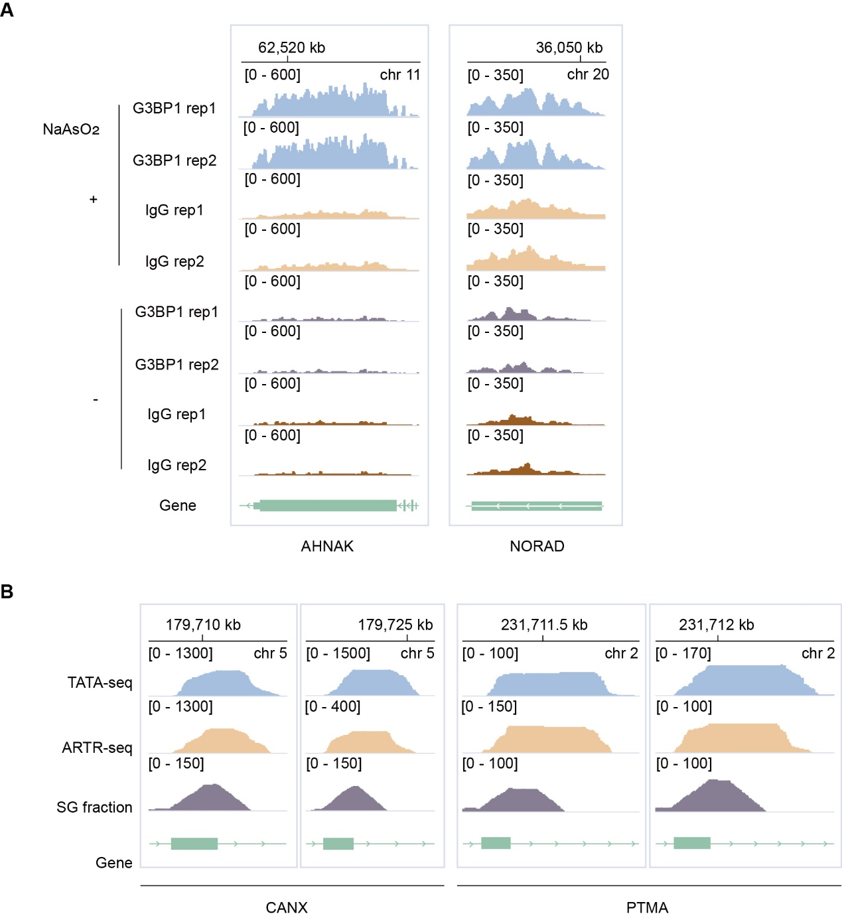
FIGURE S4. IGV snapshots of TATA-seq signal at representative transcripts. (A) IGV snapshots showing read coverage of mRNA AHNAK and lncRNA NORAD in sequencing libraries derived from SA-treated and untreated groups. (B) IGV snapshots displaying read coverage of the intronic regions of CANX and PTMA in sequencing libraries derived from SA-treated groups.

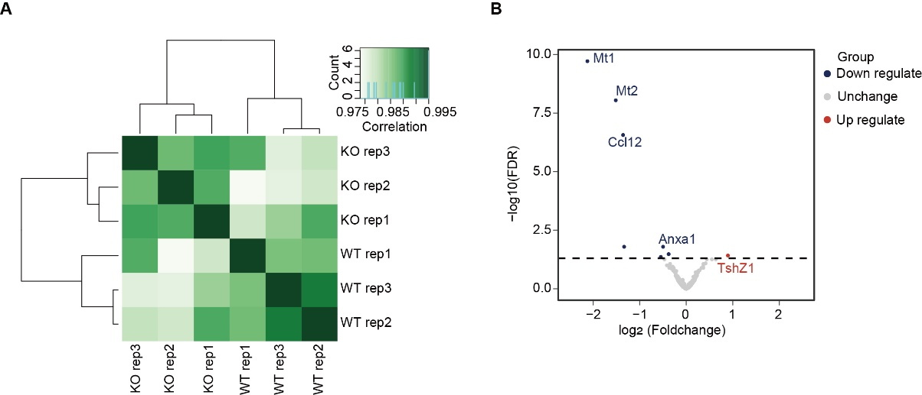
FIGURE S5. Transcript profiling of P-body-enriched RNAs in bone marrow-derived macrophages (BMDMs) from wild-type (WT) and Irg1-/- (KO) mice using TATA-seq. (A) Heatmap showing the correlation of TATA-seq data targeting the P-body of macrophages isolated from WT and KO mice across three biological replicates. (B) Volcano plot displaying representative transcripts with differential abundance in the P-body of WT and KO macrophages. Transcripts with upregulated abundance in the KO group are colored in red, while those with downregulated abundance are colored in blue. The cutoff is set at fold change ≥ 2 and FDR ≤ 0.05.

TABLE S1. Data processing parameters.

ID | Raw reads (G base) | reads after trimming | reads after deduplication | mapped reads | mapping ratio
AS-G3BP-1 | 35,455,341 | 35,418,223 | 27,503,723 | 25,258,280 | 91.84%
AS-G3BP-2 | 39,300,273 | 39,261,795 | 30,221,138 | 27,686,293 | 91.61%
Ctrl-IgG-1 | 41,596,011 | 41,547,164 | 31,043,138 | 28,147,368 | 90.67%
Ctrl-IgG-2 | 42,023,449 | 41,965,755 | 32,106,267 | 29,066,549 | 90.53%
Ctrl-G3BP-1 | 37,710,898 | 37,655,652 | 28,734,827 | 25,763,518 | 89.66%
Ctrl-G3BP-2 | 37,930,610 | 37,904,791 | 27,946,513 | 25,698,670 | 91.96%
AS-IgG-1 | 44,410,989 | 44,366,606 | 33,925,708 | 31,091,506 | 91.65%
AS-IgG-2 | 38,497,154 | 38,457,515 | 29,756,521 | 27,272,644 | 91.65%

