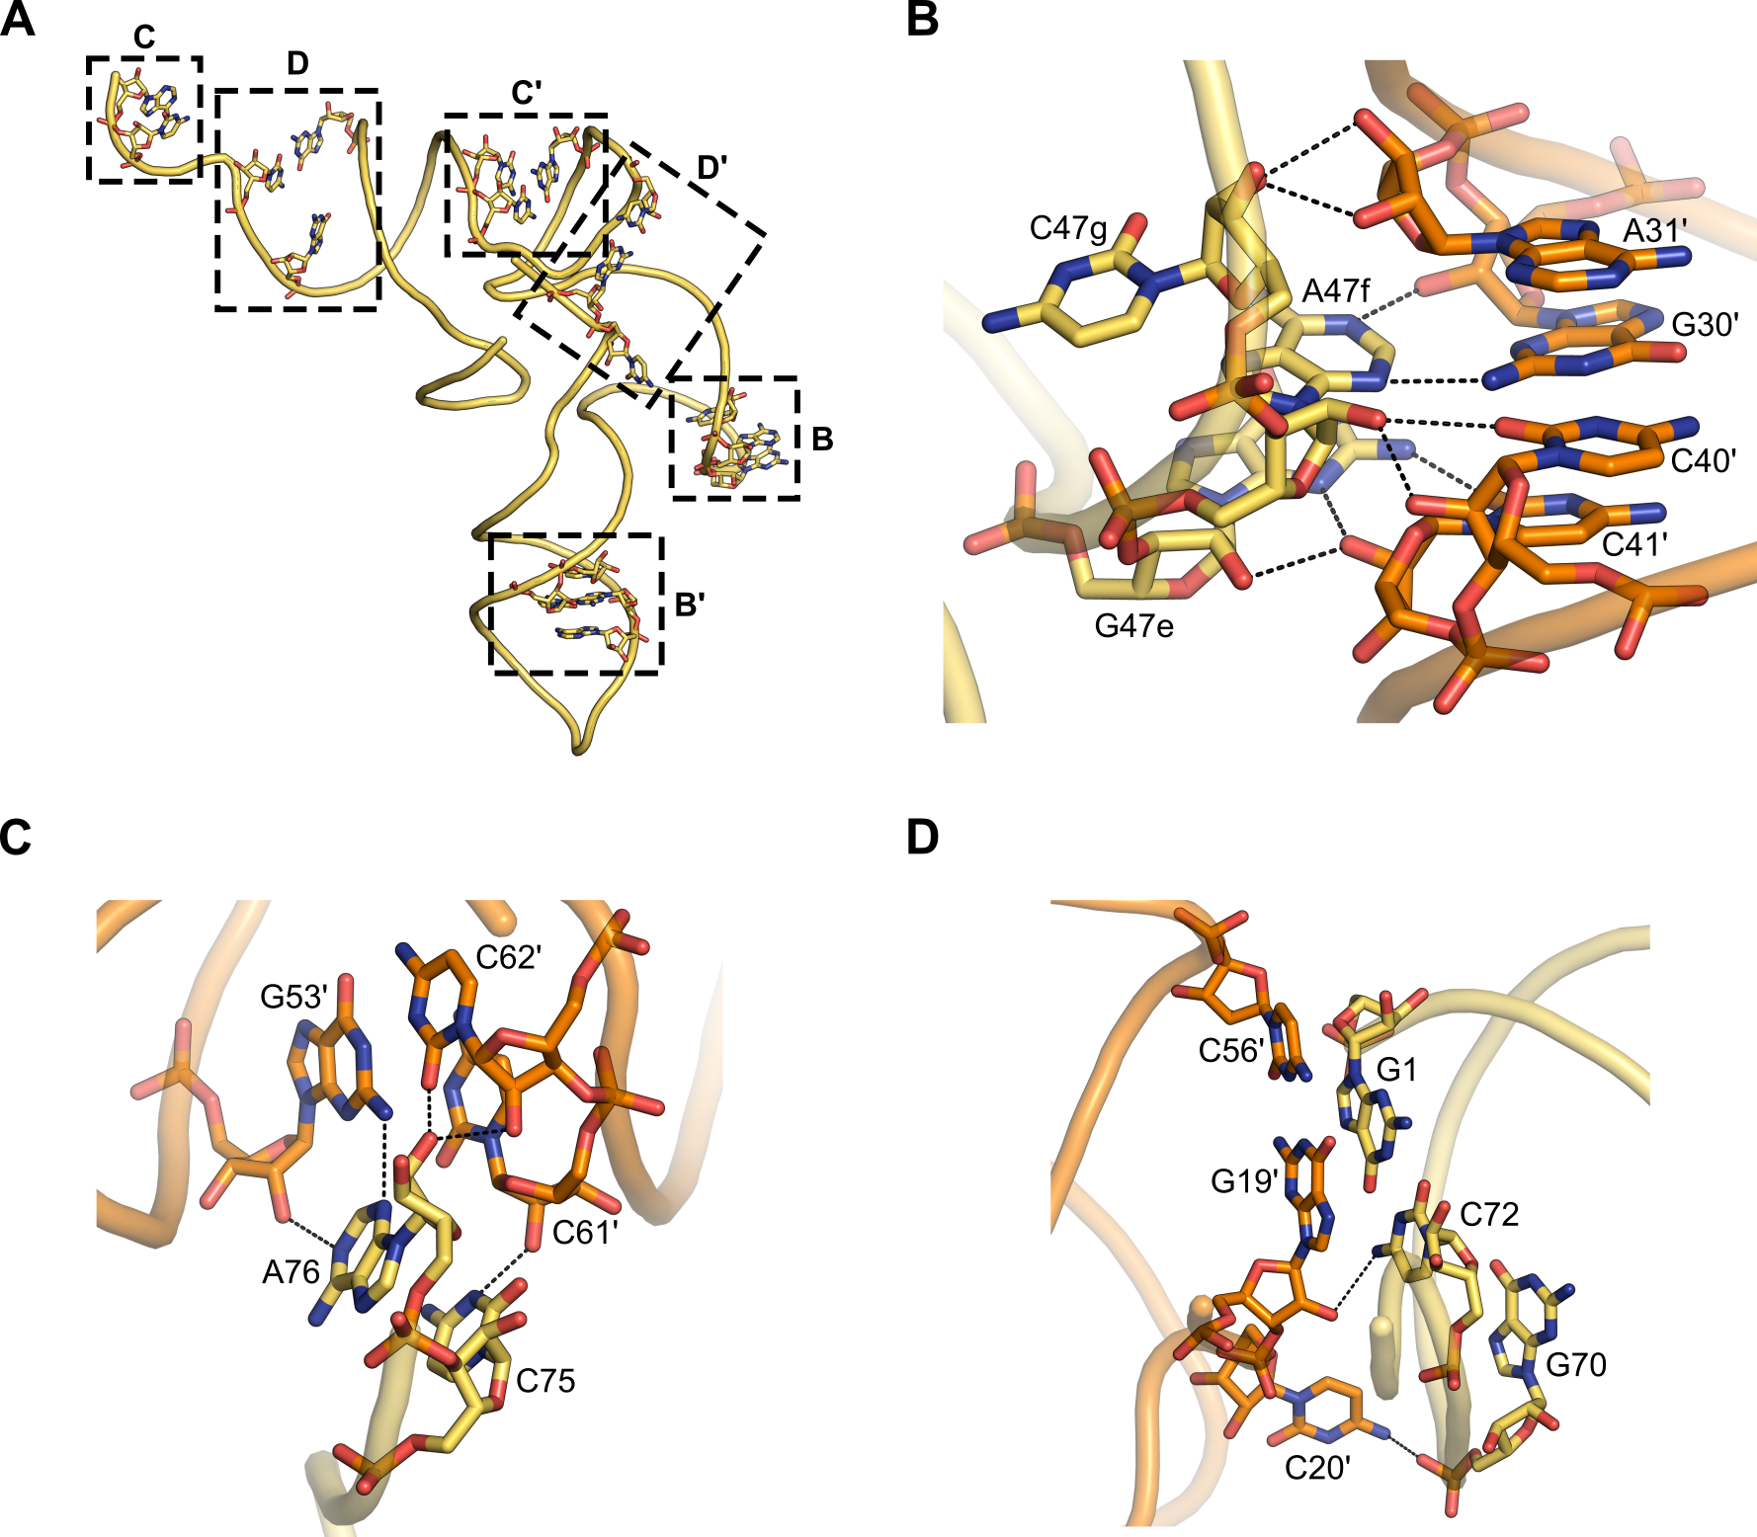
SUPPLEMENTARY FIGURE 1. Crystallographic packing interactions near the variable arm of BstRNA^{Leu}_{UAA}. (A) Overall structure of BstRNA^{Leu}_{UAA} shown as a cartoon and colored yellow. Residues involved in major crystallographic contacts are depicted as sticks. Black dashed boxes indicate regions of intermolecular interaction, which are shown in detail in panels (B-D). Symmetry-related molecules are denoted with apostrophes (‘). (B) Interaction between the variable loop and the anticodon stem. (C, D) Interactions between the acceptor arm and neighboring TψC-loop (C) or D-loop (D). Symmetry-related tRNA molecules are colored orange. Residues involved in contacts are labeled, with apostrophes indicating residues from neighboring molecules. Intermolecular hydrogen bonds are shown as black dashed lines.

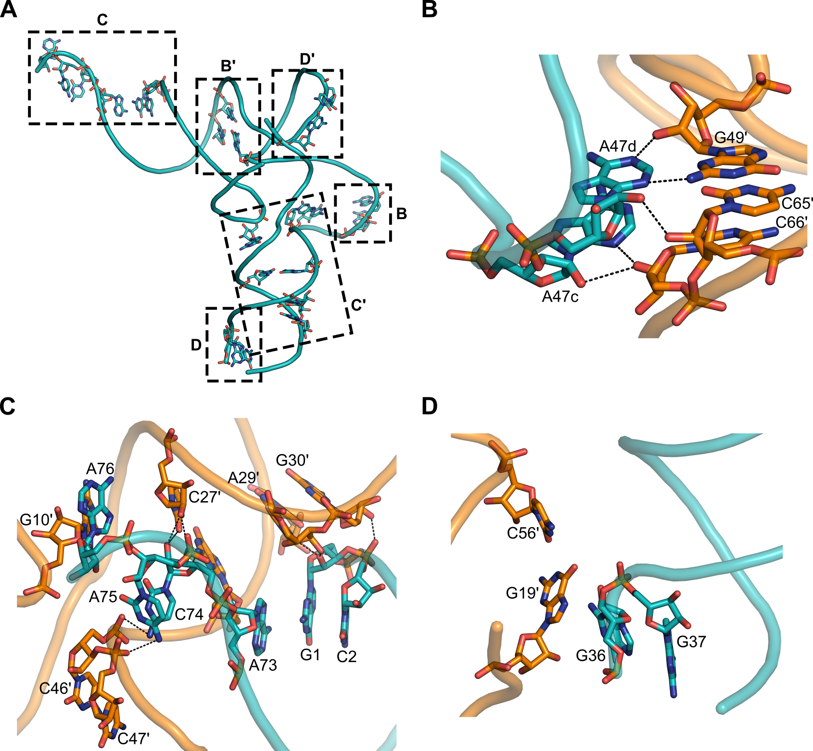
SUPPLEMENTARY FIGURE 2. Crystallographic packing interactions near the variable arm of EctRNA^{Leu}_{UAG}. (A) Overall structure of EctRNA^{Leu}_{UAG} shown as a cartoon and colored teal. Residues involved in major crystallographic contacts are displayed as sticks. Black dashed boxes indicate regions of intermolecular interaction, which are shown in detail in panels (B-D). Symmetry-related molecules are denoted with apostrophes (‘). (B) Interaction between the variable loop and TψC-loop. (C) Interaction between the acceptor arm and neighboring ASL, D-loop, and variable stem. (D) Interaction between the ASL and the conserved G19-C56 tertiary base pair. Symmetry-related molecules are shown in orange. Residues are labeled, with apostrophes indicating symmetry-related residues. Intermolecular hydrogen bonds are represented by black dashed lines.

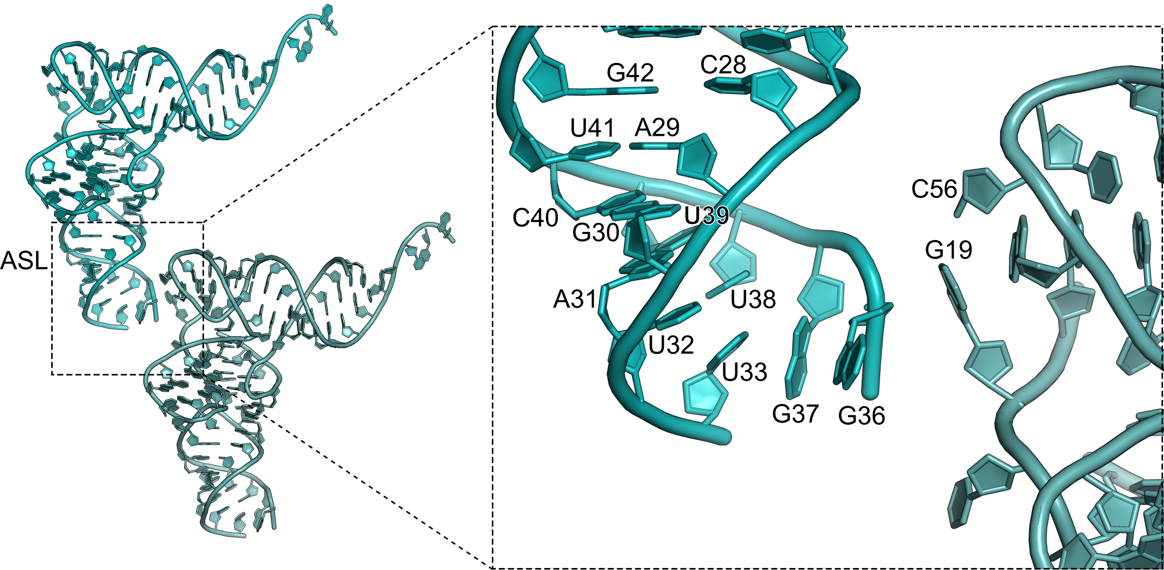
SUPPLEMENTARY FIGURE 3. Structural analysis of the ASL of EctRNA^{Leu}_{UAG}. Two crystallographically related symmetry pairs of free EctRNA^{Leu}_{UAG} molecules are shown in teal and light teal. The iInset shows a zoomed-in view of the ASL of one molecule.

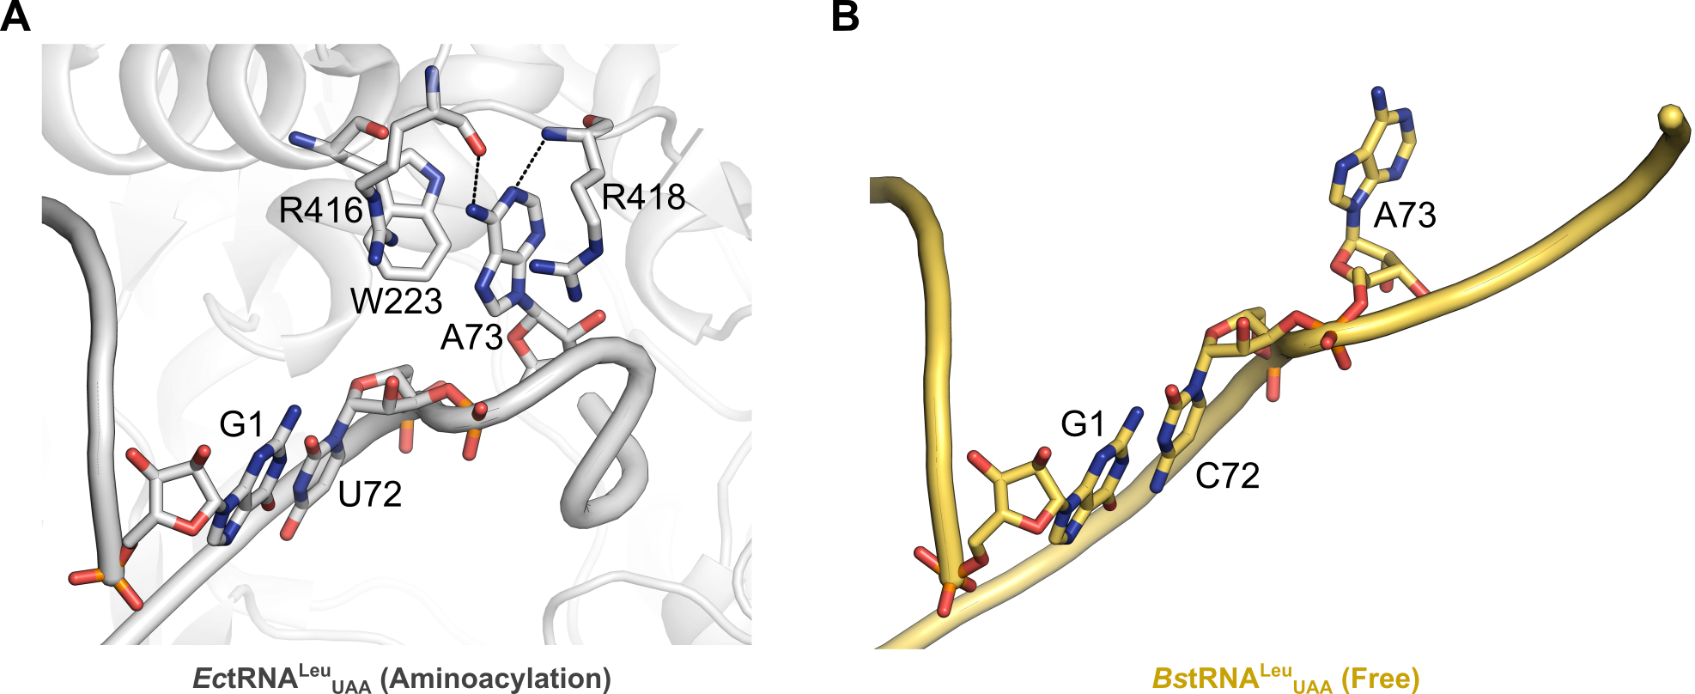
SUPPLEMENTARY FIGURE 4. Structural comparison of the discriminator base A73 and the G1-C/U72 base pair. The discriminator base A73 and the G1-C/U72 base pair are shown as sticks. (A) LeuRS-bound EctRNA^{Leu}_{UAA} in the aminoacylation state (PDB: 5ONH). LeuRS residues involved in interactions with EctRNA^{Leu}_{UAA} are also shown as sticks. Hydrogen bonds between the tRNA and LeuRS are indicated by black dashed lines. (B) Free-state BstRNA^{Leu}_{UAA} is shown as a yellow cartoon.

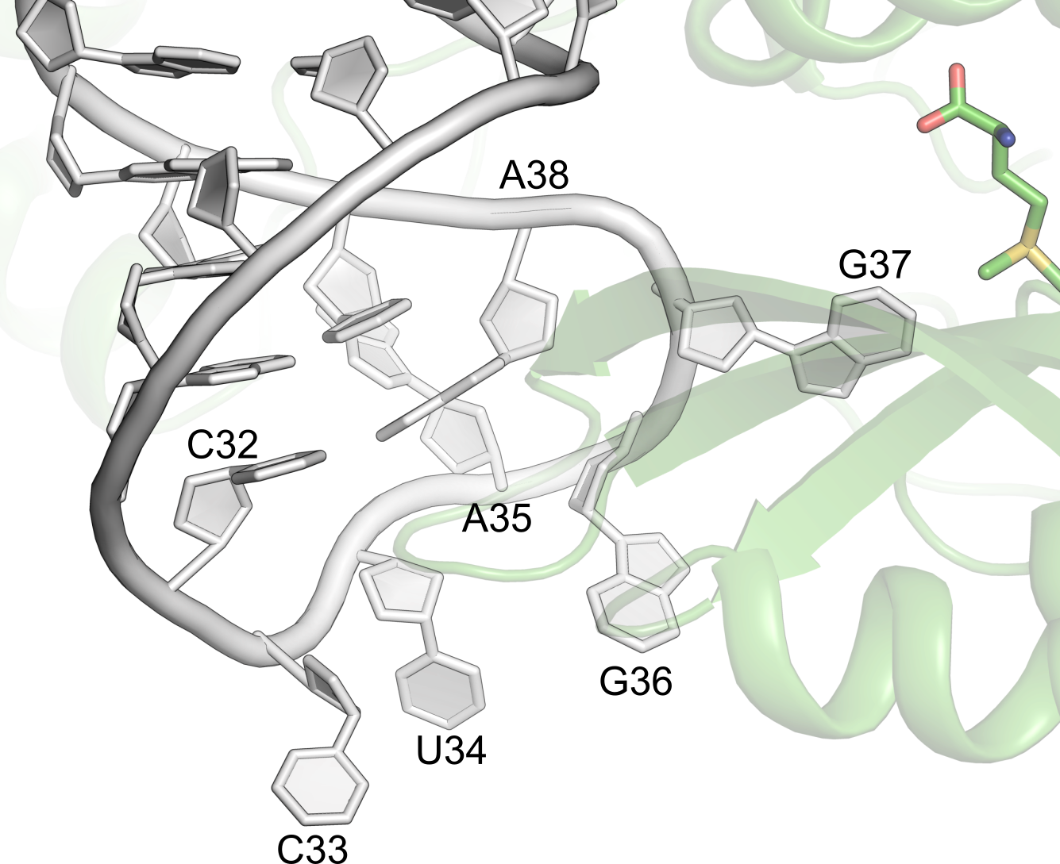
SUPPLEMENTARY FIGURE 5. Flipped-out nucleotides upon interaction with the tRNA modifying enzyme Trm5 (PDB: 2ZZM). The protein chain is shown as green cartoon representation, and the bound ligand is shown as green stick.

