Supplementary Materials for:

Unraveling Unbreakable Hairpins: Characterizing RNA secondary structures that are persistent after dinucleotide shuffling

Alyssa A Pratt^{1,2}, David A Hendrix^{1,2,*}

1 Department of Biochemistry and Biophysics, Oregon State University, Corvallis Oregon
2 School of Electrical Engineering and Computer Science, Oregon State University, Corvallis Oregon
* to whom correspondence should be addressed david.hendrix@oregonstate.edu

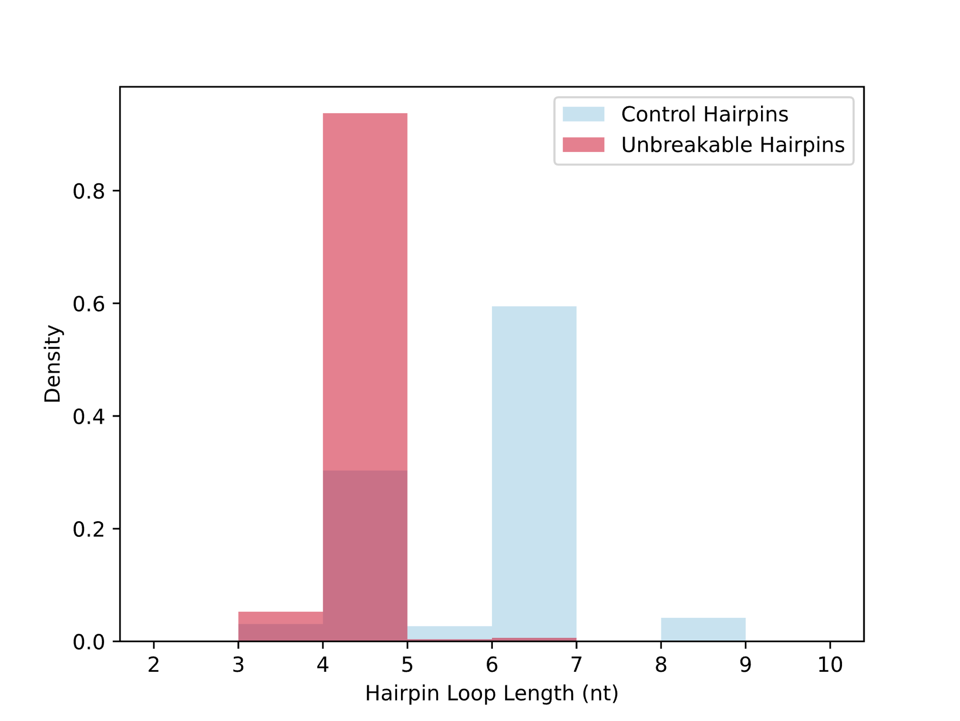
Supplementary Figure 1: Unbreakable are more likely to contain tetraloops than the length-matched representative sample of breakable hairpins. X-axis labels correspond to the lower bound of the 1-nt bin—for example the most frequent length of unbreakable hairpins is 4nt.

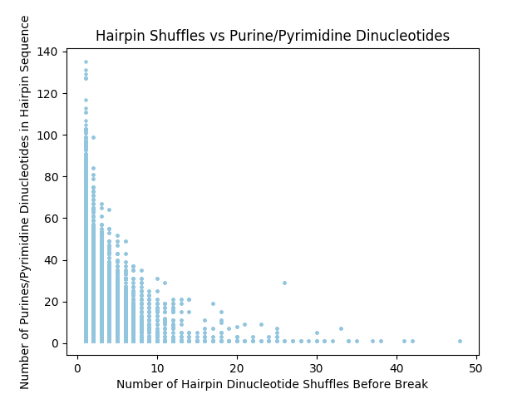
Supplementary Figure 2: The number of dinucleotide shuffles for each RNA hairpin until a “break”, resulting in a non-hairpin structure, has an inverse relationship with the number of purine/pyrimidine split dinucleotides. The outlier at around 27 shuffles corresponds to an unusually long unbreakable hairpin.

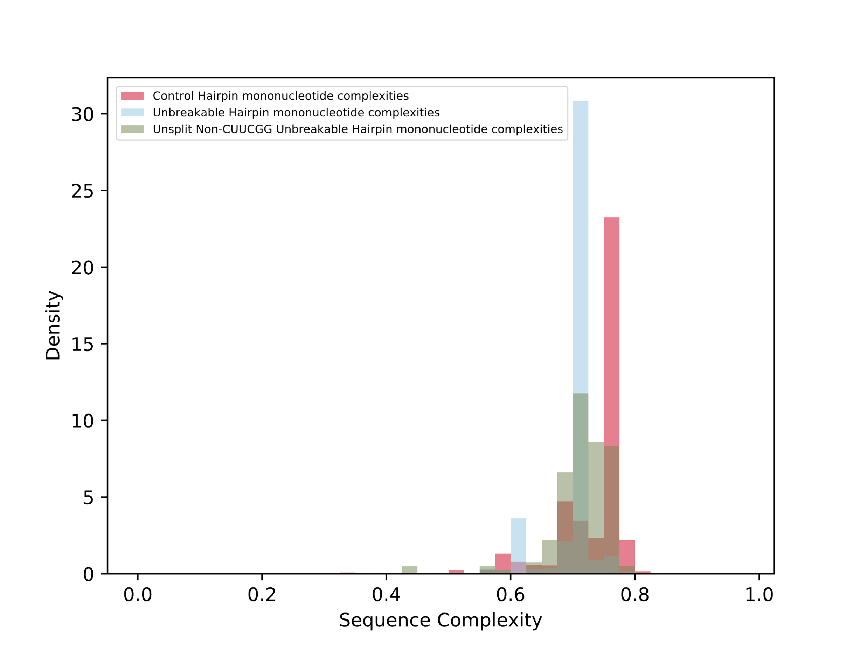Supplementary Figure 3: Normalized histogram showing the empirical probability density of the sequence complexity of hairpins. The distributions vary between a representative set of control hairpins, unbreakable hairpins, and hairpins that lack two of the key features of the majority of unbreakable hairpins: a purine/pyrimidine split and C[UUCG]G tetraloop. On average, unbreakable hairpins have lower sequence complexity.

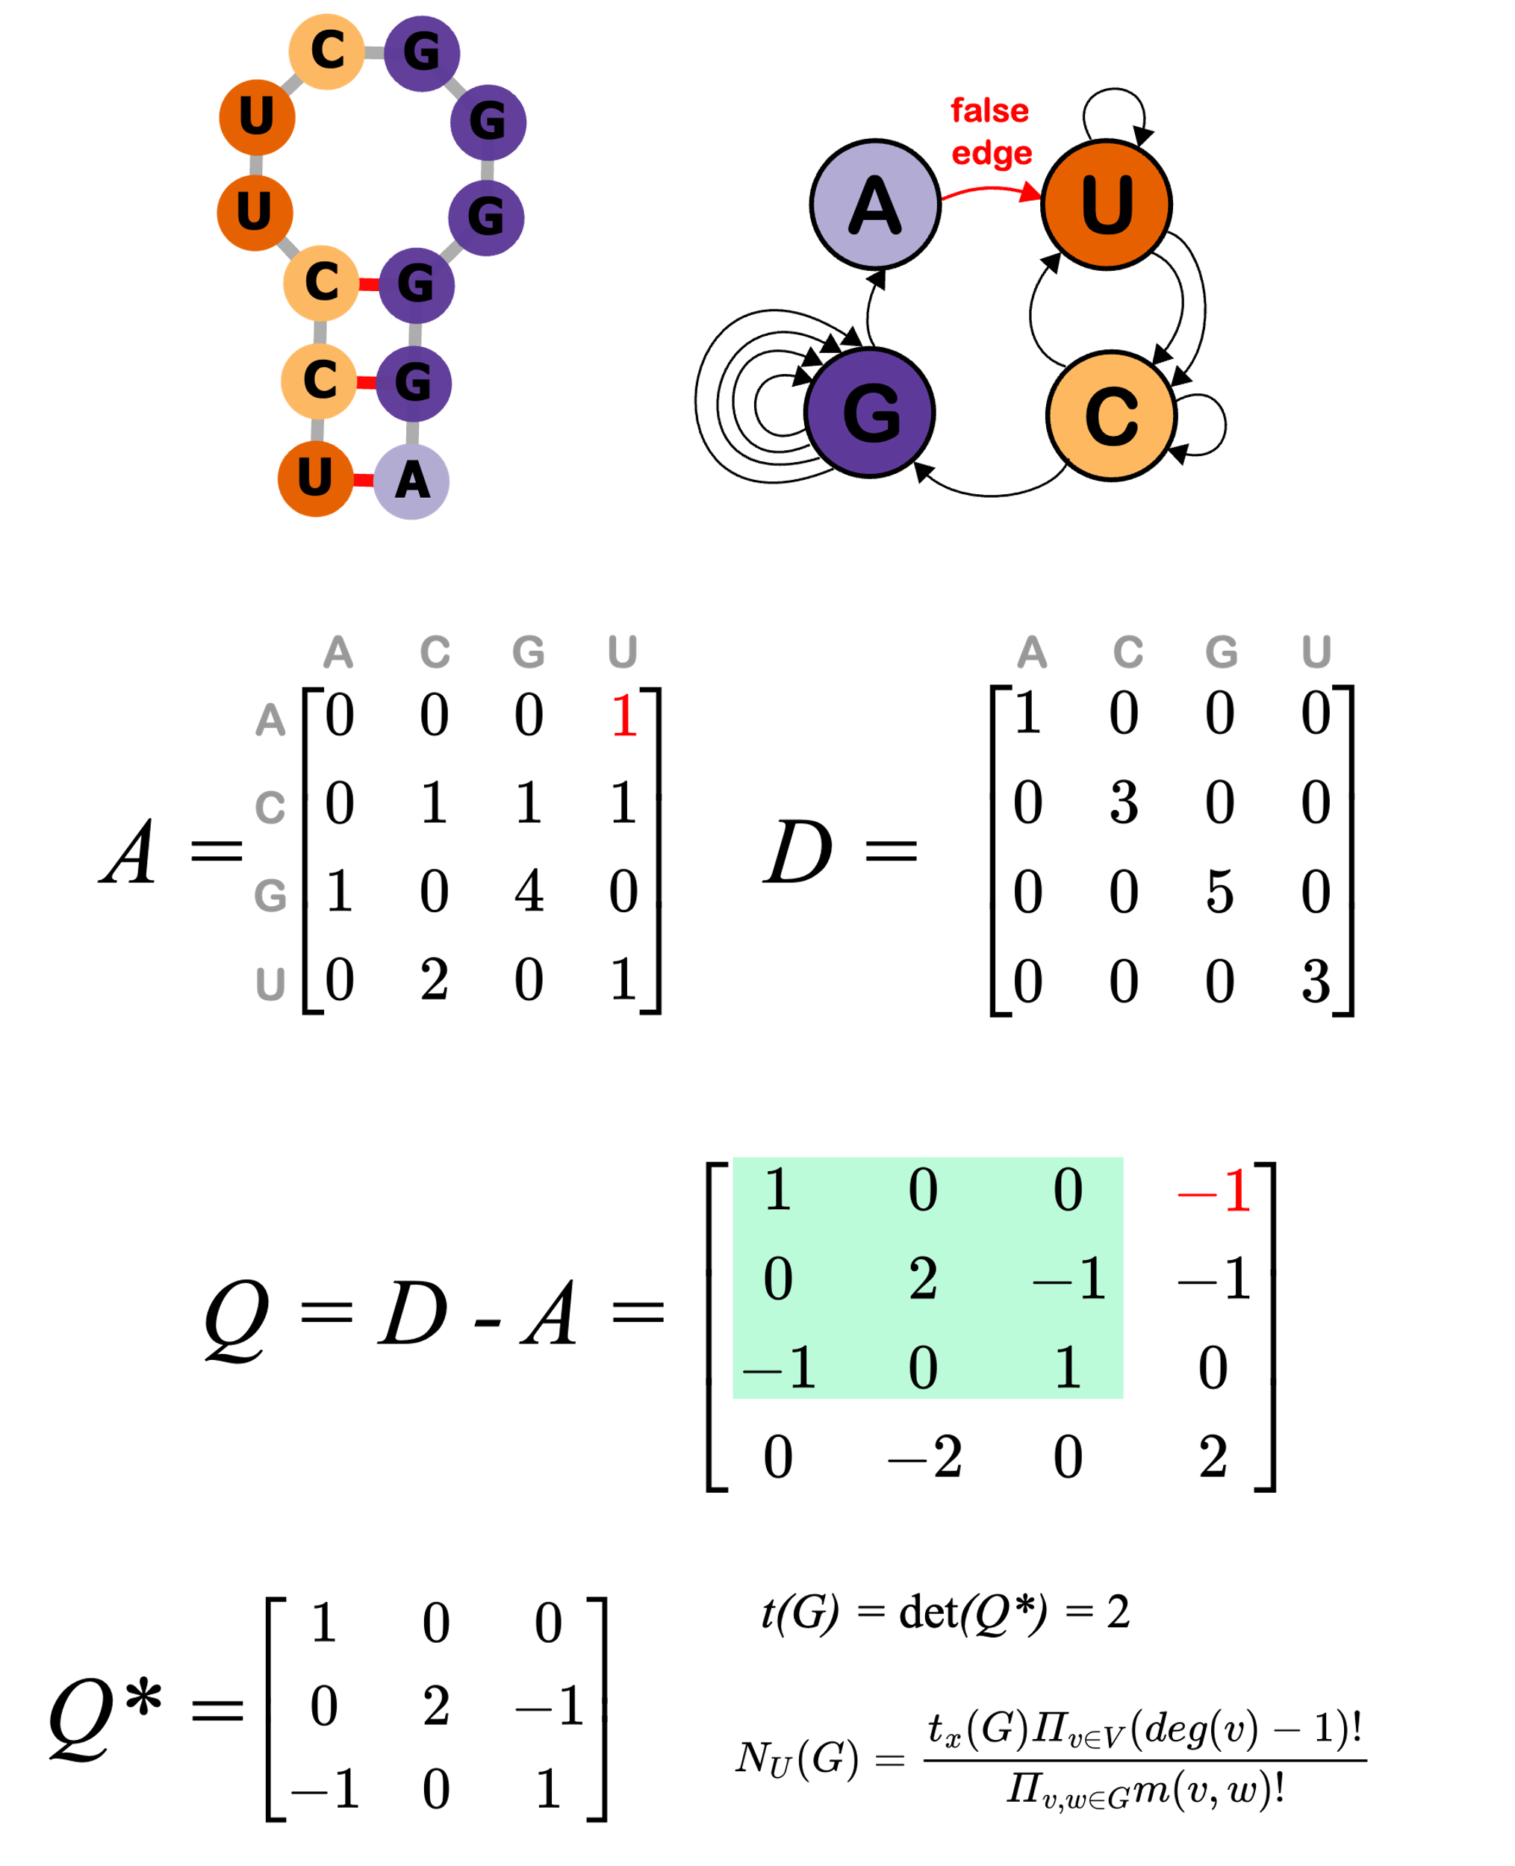
Supplementary Figure 4: The calculation of the number of unique sequences possible through dinucleotide shuffling. The matrix A corresponds to an adjacency matrix that includes the false. The matrix D is a diagonal matrix containing the in-degrees of each nucleotide vertex. The matrix Q is the difference of A and D, and Q* is reduced by removing the row and column where the path begins (the nucleotide that the false edge points to. The calculation of the determinant of the resultant Q* produces a value that that can be used to calculate $N_{U}(G)$.

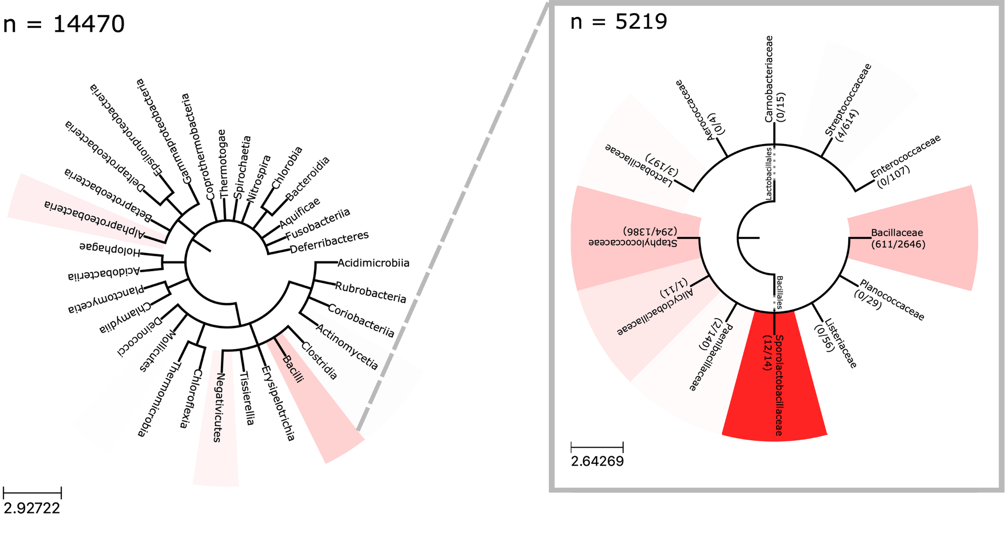
Supplementary Figure 5: Phylogenetic distribution of unbreakable hairpins in Bacillales, with white representing no unbreakable hairpins in all sequenced 16S RNA and a complete saturation of red representing 100% of sequences containing unbreakable hairpins. Unbreakable hairpins appear to be enriched in 16S rRNA of Bacillales, particularly in endospore-forming orders. Scale bars correspond to branch length of the tree

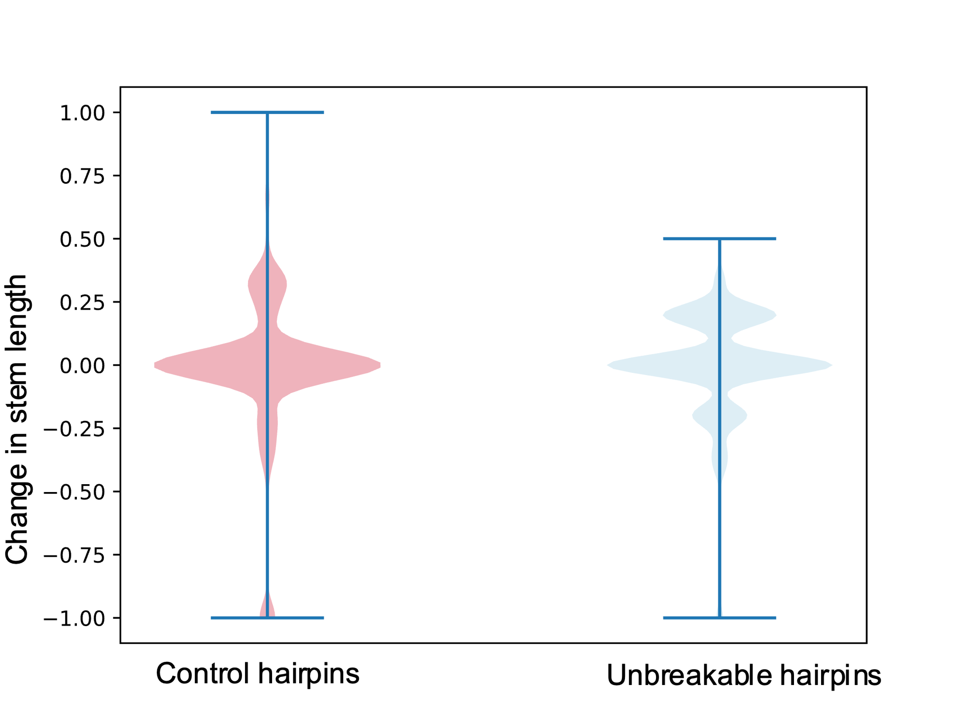
Supplementary Figure 6: Violin plots representing the relative change in stem length for unbreakable hairpins and control hairpins with the same length distribution after a single-nucleotide random insertion. A change of -1 represents a complete loss of hairpin structure.

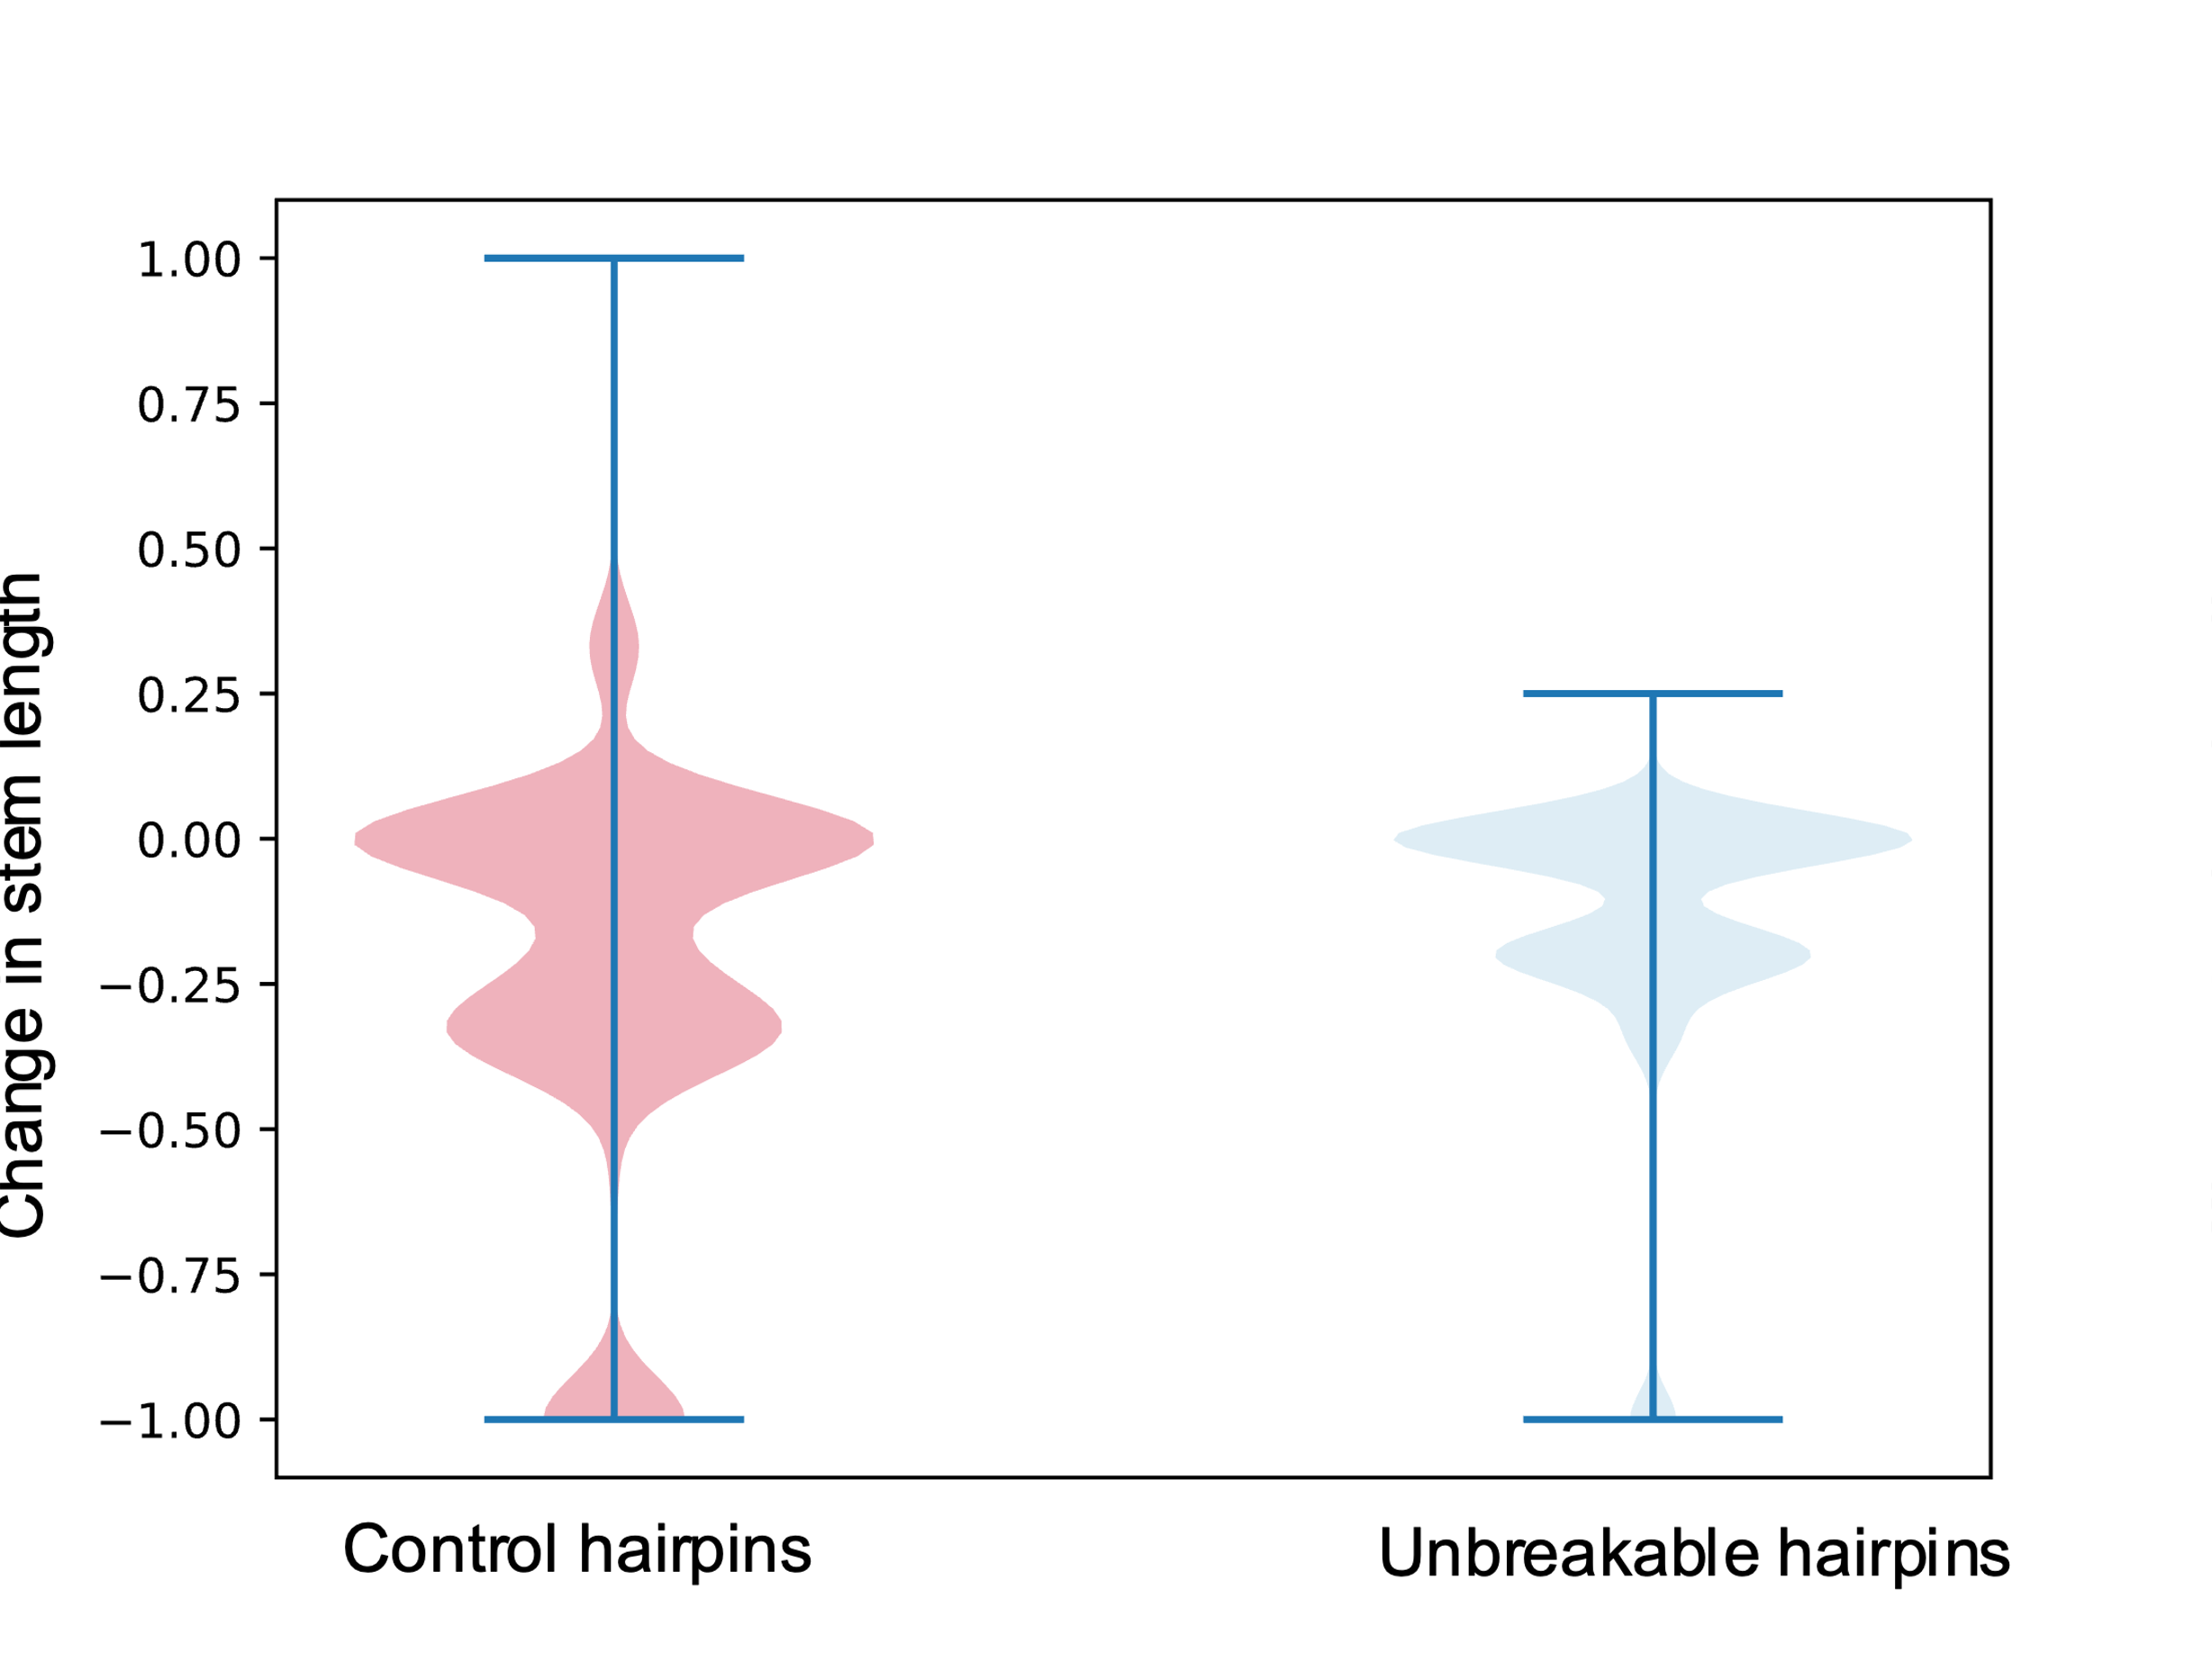
Supplementary Figure 7: Violin plots representing the relative change in stem length for unbreakable hairpins and control hairpins with the same length distribution after a single-nucleotide random deletion. A change of -1 represents a complete loss of hairpin structure.

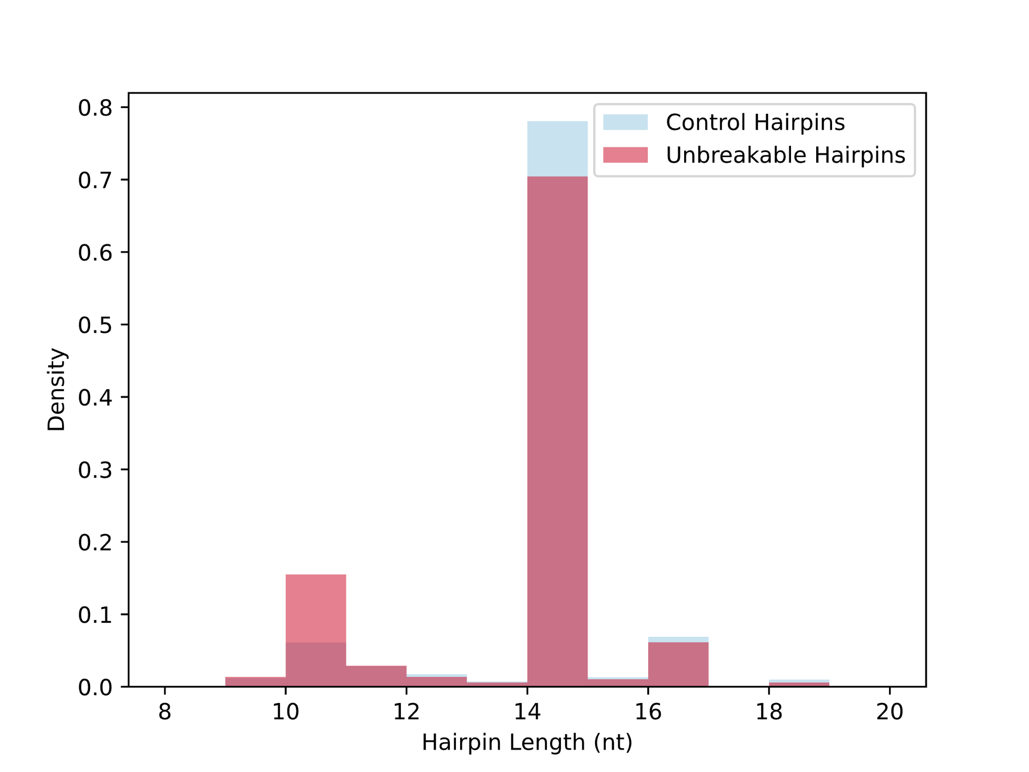
Supplementary Figure 8: Unbreakable hairpins and the length-matched representative sample of breakable hairpins share a similar length distribution.

