SI Appendix
Positioning of sperm tail longitudinal columns depend on Nsun7, an RNA binding protein destabilizing elongated spermatid transcripts
Ekaterina A. Guseva^{1,2,3}, Olga A. Averina^{2,3}, Sergey V. Isaev⁴, Philipp I. Pletnev³, Elizaveta E. Bragina^{2,5}, Oleg A. Permyakov^{2,3}, Vitaly S. Buev^{3,6}, Anastasia V. Priymak², Mariia A. Emelianova^{1,2}, Lizaveta Pshanichnaya³, Evgeny A. Romanov⁷, Svetlana E. Novikova⁸, Kirill S. Petriukov³, Anna Ya. Golovina², Olga O. Grigorieva^{2,3}, Vasily N. Manskikh², Diana S. Korshunova⁹, Yuliya Yu. Silaeva⁹, Alexey V. Deykin¹⁰, Maria P. Rubtsova³, Victor G. Zgoda⁸, Alexander M. Mazur¹¹, Egor B. Prokhortchouk¹¹, Olga A. Dontsova^{1,2,3,12}, Petr V. Sergiev^{1,2,3*}
¹Center of Molecular and Cellular Biology, Skolkovo Institute of Science and Technology, 143025 Skolkovo, Russia
²Belozersky Institute of Physico-Chemical Biology, Lomonosov Moscow State University, 119991 Moscow, Russia
³Faculty of Chemistry, Lomonosov Moscow State University, 119991 Moscow, Russia
⁴Center for Brain Research, Medical University Vienna, 1090 Vienna, Austria
⁵Research Centre for Medical Genetics, Moscow 115522, Russia
⁶Faculty of Bioengeneering and Bioinformatics, Lomonosov Moscow State University, 119991 Moscow, Russia
⁷National Medical Research Center for Obstetrics, Gynecology and Perinatology named after Academician V.I.Kulakov, 117198 Moscow, Russia
⁸Institute of Biomedical Chemistry, 119121 Moscow, Russia
⁹Institute of gene biology, 119334 Moscow, Russia
¹⁰Belgorod State University, 308015 Belgorod, Russia
¹¹Institute of Bioengineering, Research Center of Biotechnology of the Russian Academy of Sciences, 119071 Moscow, Russia
¹²Shemyakin–Ovchinnikov Institute of Bioorganic Chemistry, 117997 Moscow, Russia
*To whom correspondence should be addressed. Email: petya@genebee.msu.ru.

Supplementary figures
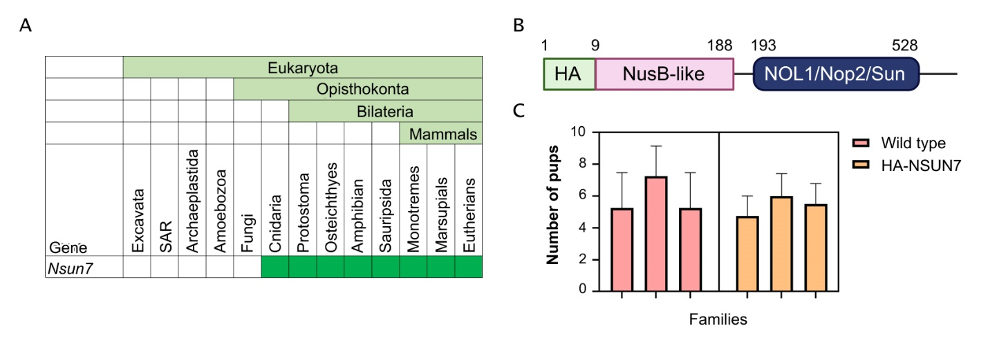Figure S1. (A) Phylogenetic distribution of NSUN7 among eukaryotes. NSUN7 is present in most multicellular eukaryotes that contain flagella. (B) Scheme of HA-Nsun7 genetic cassette. (C) Comparison of fertility of wild type and HA-NSUN7 mice. For each of the mice line, three families, consisting of 1 male and 1 female mouse each, were monitored for 3 months. ANOVA test result: p-value = 0.5383.
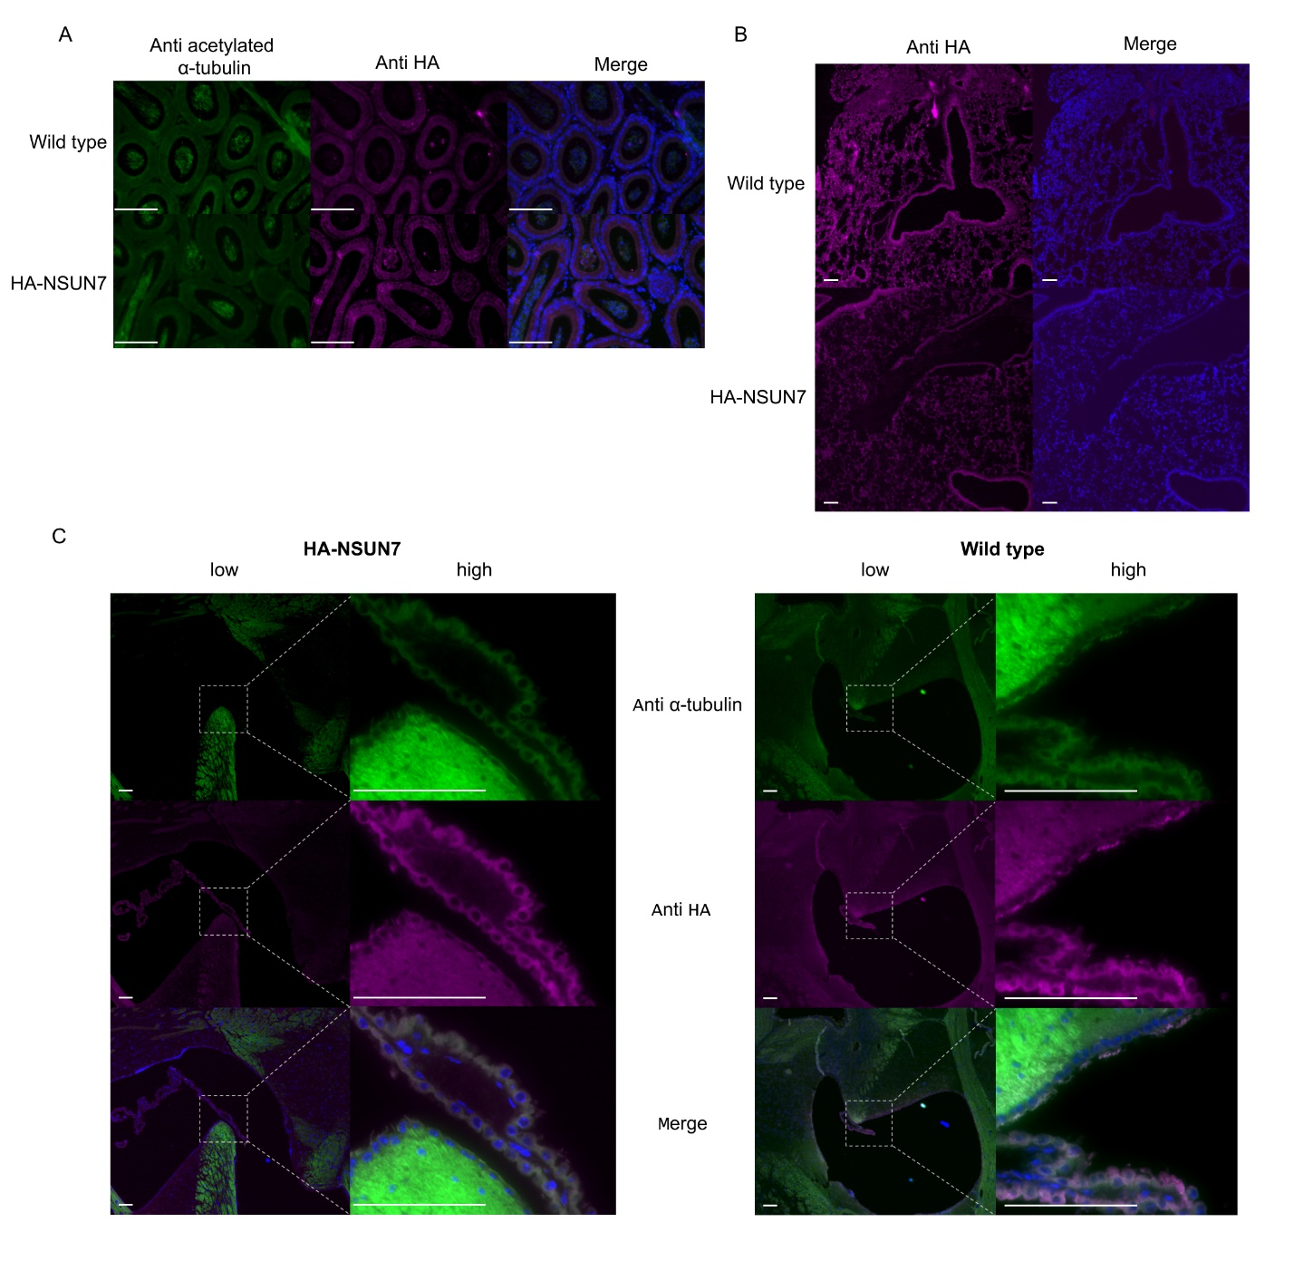Figure S2. NSUN7 is absent in ciliated organs. (A) Immunostaining of epididymis cross-sections from wild type and HA-NSUN7. (B) Immunostaining with anti-HA tag antibodies of lung cross-sections from wild type and HA-NSUN7 mice. (C) Immunostaining with anti-HA tag antibodies of the brain cross-sections from wild type and HA-NSUN7 mice. White bars = 100 μm.
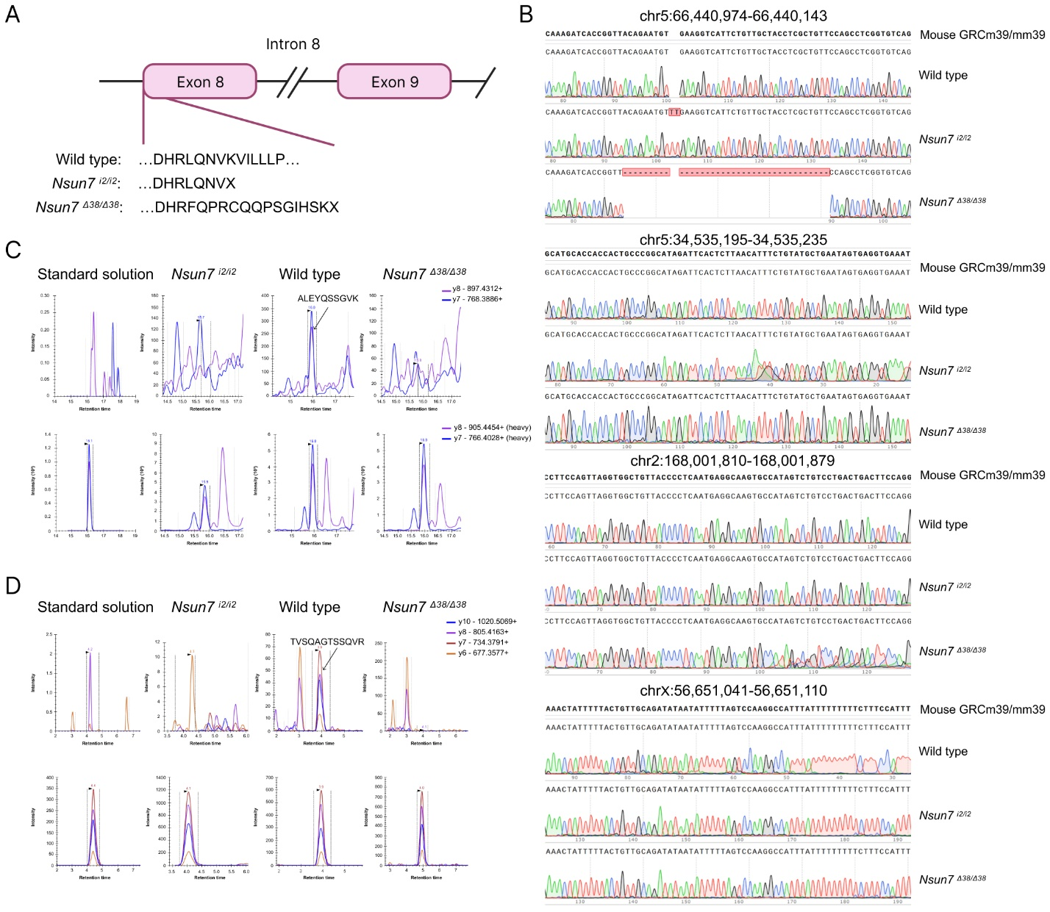
Figure S3. Generation of Nsun7^{-/-} mouse lines. (A) Scheme of the genome editing site for Nsun7 knockout generation. (B) Sequences of the target and most probable off-target genome loci in the Nsun7 knockout mice. (C-D) Trace of selected reaction monitoring (SRM) transitions for the mice testicular extracts (upper panel) and stable isotope-labeled peptide standard (SIS) (lower panel) registered in SIS standard solution and in experimental samples for peptide ALEYQSSGVK (C) and TVSQAGTSSQVR (D). Arrow indicates the signal for native peptide in wild type sample.
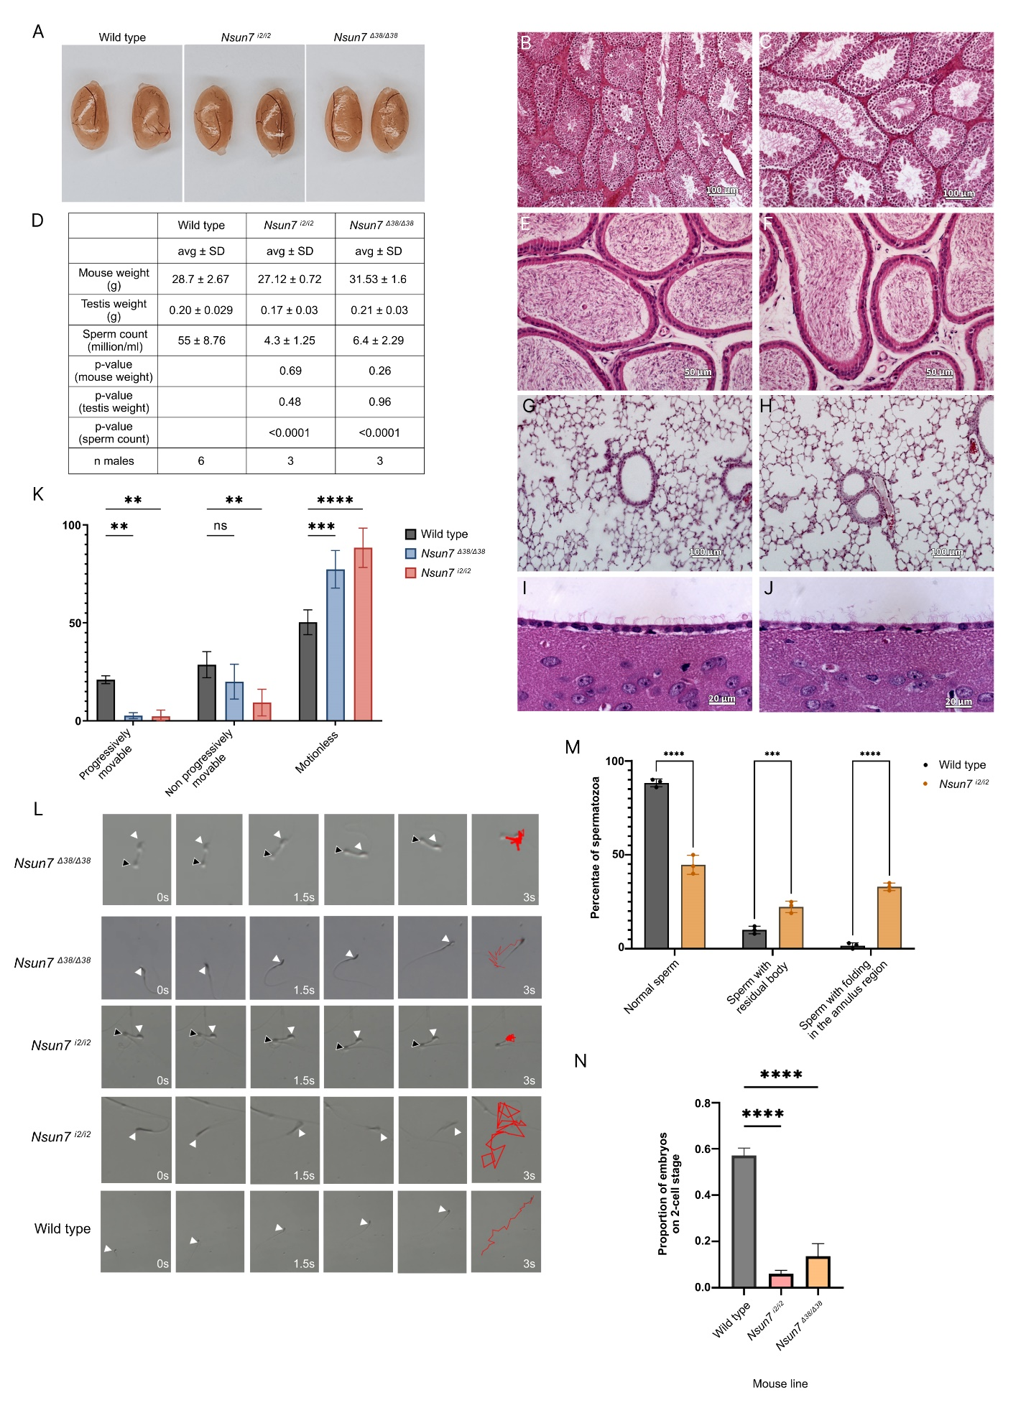
Figure S4. Phenotypic characteristics of Nsun7^{-/-} mice. (A) Photographs of testes from control, Nsun7 ^{i2/i2} and Nsun7 ^{d38/d38}. (B-C) H&E-stained testis cross-sections from control (B) and Nsun7^{i2/i2} mice (C). (D) Average mouse weight, testis weight, and sperm counts from three mice of each of the following lines: wild type, Nsun7 ^{i2/i2} and Nsun7 ^{d38/d38}. (E-F) H&E-stained epididymis cross-sections from control (E) and Nsun7^{i2/i2} mice (F). (G-H) H&E-stained lung cross-sections from control (G) and Nsun7^{i2/i2} mice (H). (I-J) H&E-stained brain cross-sections from control (I) and Nsun7^{i2/i2} mice (J). (K) Motility tests of sperm of 3 individual mice of each mice line. ANOVA test result: **** – p-value < 0.0001, *** – p-value < 0.001, ** – p-value < 0.01. (L) Motion tracks of spermatozoa of different mice lines. Red lines show the motion tracks of spermatozoa, white arrowheads indicate head position, black arrowheads – cytoplasmic bugling position. (M) Statistic of sperm morphology of wild type and Nsun7^{i2/i2} mice. For each of the mice line was calculated 100 spermatozoa for 3 male mice. On the graph the results of ANOVA test are shown as follows: **** – p-value < 0.0001, *** – p-value = 0.001, ns – p-value > 0.05. (N) Fertilization test results. ANOVA test was used, stars **** – p-value <0.0001. Means are shown ± standard deviation (n=3).
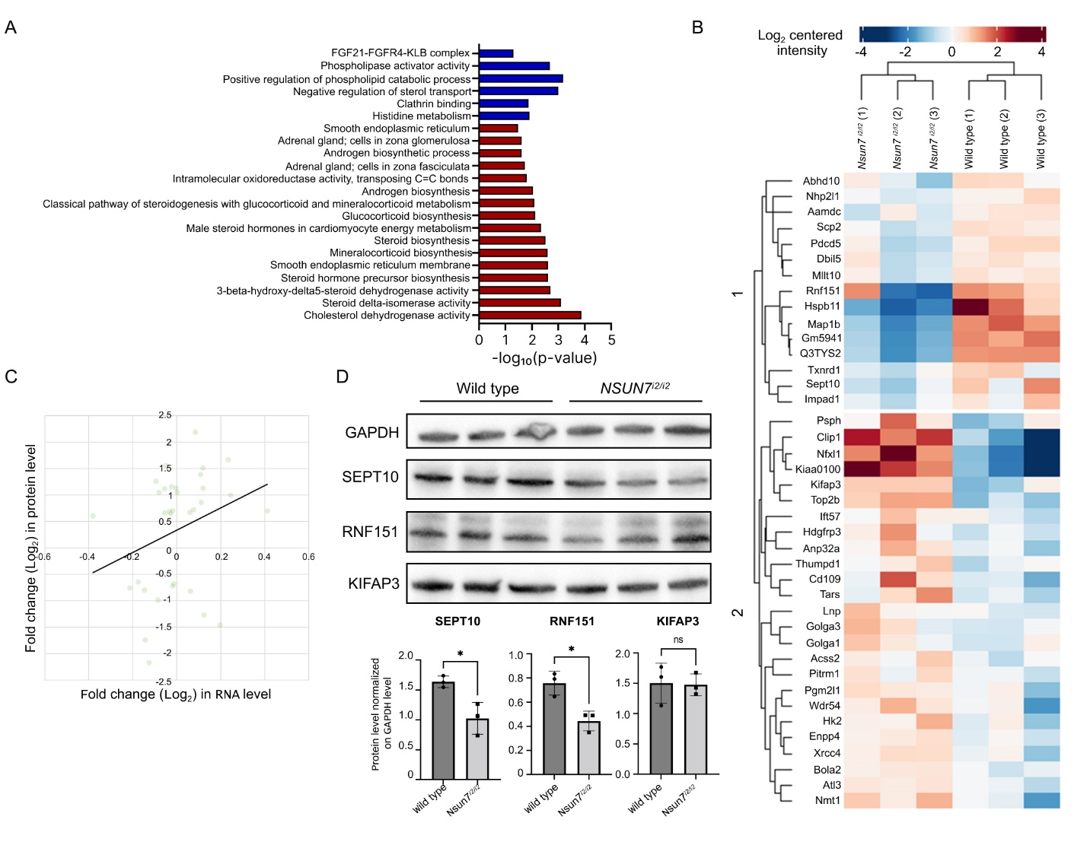
Figure S5. Comparative proteome analysis of wild type and Nsun7^{-/-} mice testis. (A) GO term enrichment analysis of up regulated (red) and down regulated (blue) genes in Nsun7^{i2/i2} mice. (B) Heatmap clustering of differential proteins in testis proteome of Nsun7^{i2/i2} mice line. For proteome analysis, testis from 3 individual mice were used. (C) Correlation between transcriptome data and DEGs from testis proteome data. (D) Comparative immunoblotting of testis lysates of wild type (left 3 lanes) and Nsun7 ^{i2/i2} (right 3 lanes) mice. Antibodies against SEPTIN10, KIFAP3 and RNF151 and control antibodies against GAPDH were used as indicated left to the panels. Bars showing GAPDH normalized levels of SEPTIN10, KIFAP3 and RNF151 in wild type and Nsun7 ^{i2/i2} mice according to the immunoblotting. Means ± standard deviation are shown (n=3). Results of unpaired t-test are shown, * – p-value < 0.05.
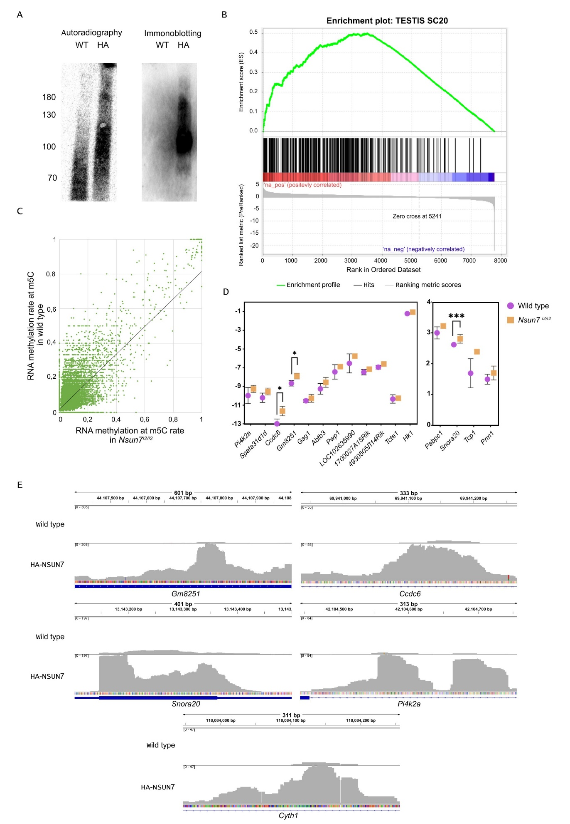
Figure S6. NSUN7 possess RNA-binding function. (A) Autoradiography (left) with ³²P and immunoblotting with anti-HA antibodies of HA-NSUN7-RNA covalent conjugates. WT – wild type mice, HA – HA-NSUN7 mice. (B) GSEA analysis of enriched cell types. (C) Scatter plot of the methylation extend of the particular m⁵C RNA methylation sites of the wild type and Nsun7^{i2/i2} mice elongated spermatids. (D) Comparison of mRNA levels of potential RNA targets of NSUN7. (E) Genomic tracks of the most representative peaks of RNAs co-precipitated with HA-NSUN7.

