Supplemental Fig. S4. Ae. aegypti Dcr2 interactions with dsRNA in the active dicing state. Below, WT Dcr2. Highly conserved residues in the WT Dcr2 PAZ domain have been highlighted. (A) Dcr2 structure bound with dsRNA. (B) Zoomed in view of panel A showing binding of dsRNA with the PAZ domain. (C, D, E) Panel B rotated at an angle of 90°, 180° or 270° respectively.
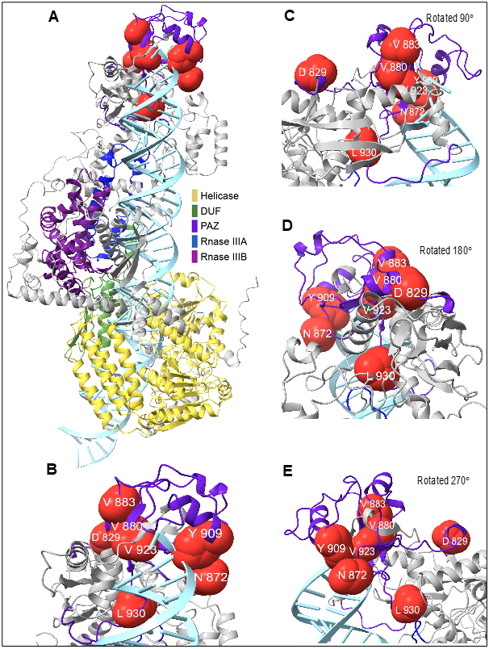

Below, Ae. aegypti Dcr2 PAZ domain mutant M1 interactions with dsRNA in the active dicing state. (A) Dcr2 structure bound with dsRNA. (B) Zoomed in view of panel A showing binding of dsRNA with the PAZ domain. (C, D, E) Panel B rotated at an angle of 90°, 180° or 270° respectively.
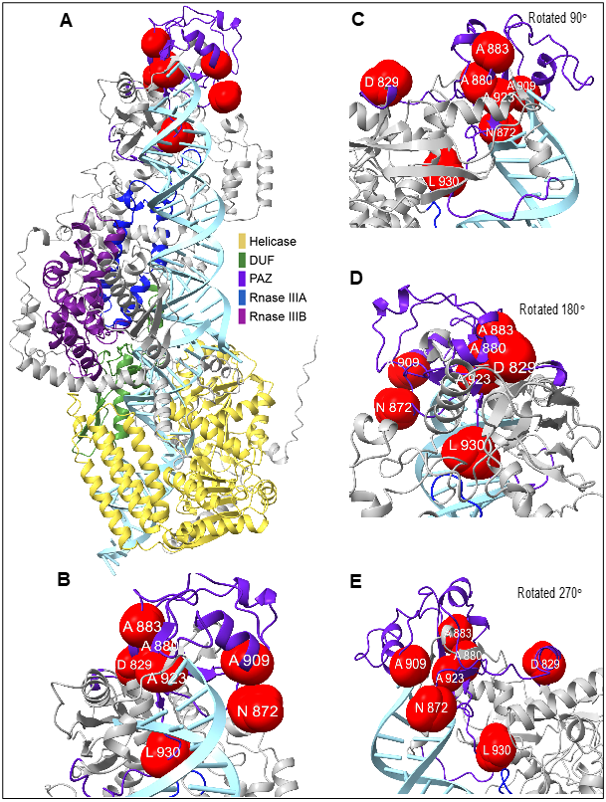

Below, Ae. aegypti Dcr2 PAZ domain mutant M2 interactions with dsRNA in the active dicing state. (A) Dcr2 structure bound with dsRNA. (B) Zoomed in view of panel A showing binding of dsRNA with the PAZ domain. (C, D, E) Panel B rotated at an angle of 90°, 180° or 270° respectively.
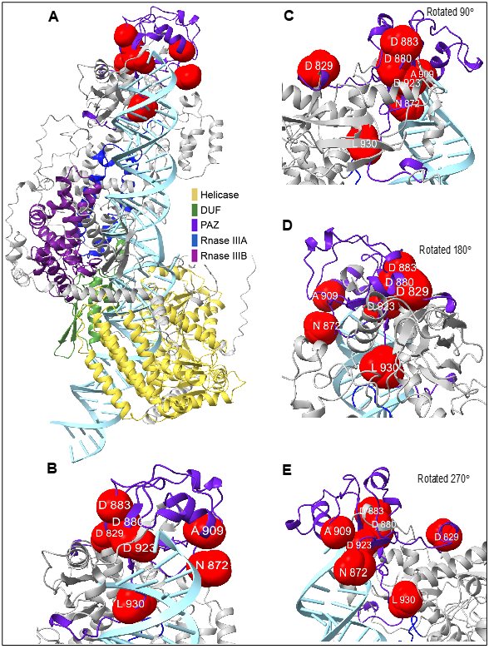

Below, Ae. aegypti Dcr2 PAZ domain mutant M3 interactions with dsRNA in the active dicing state. (A) Dcr2 structure bound with dsRNA. (B) Zoomed in view of panel A showing binding of dsRNA with the PAZ domain. (C, D, E) Panel B rotated at an angle of 90°, 180° or 270° respectively.
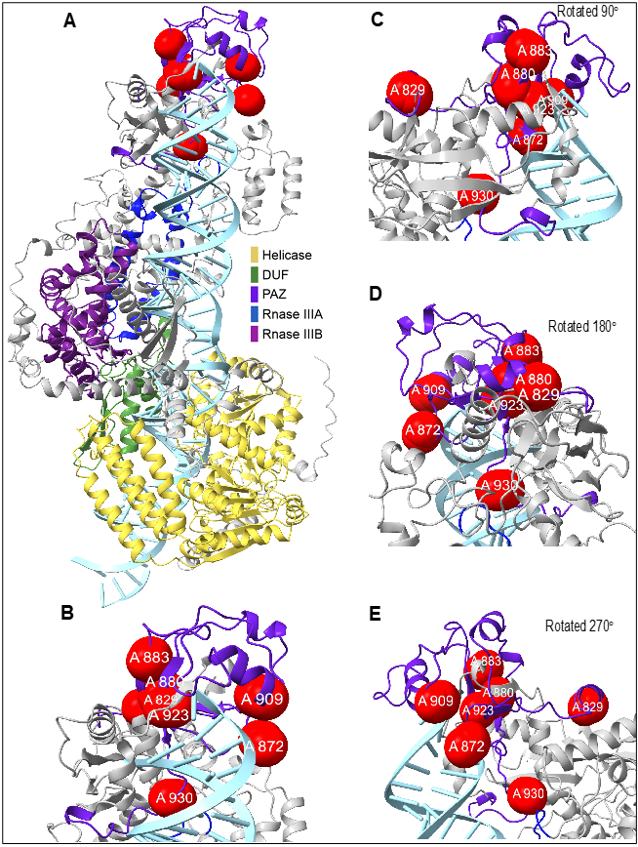

Below, Ae. aegypti Dcr2 PAZ domain mutant M4 interactions with dsRNA during active dicing state. (A) Dcr2 structure bound with dsRNA. (B) Zoomed in view of panel A showing binding of dsRNA with the PAZ domain. (C, D, E) Panel B rotated at an angle of 90°, 180° or 270° respectively.
