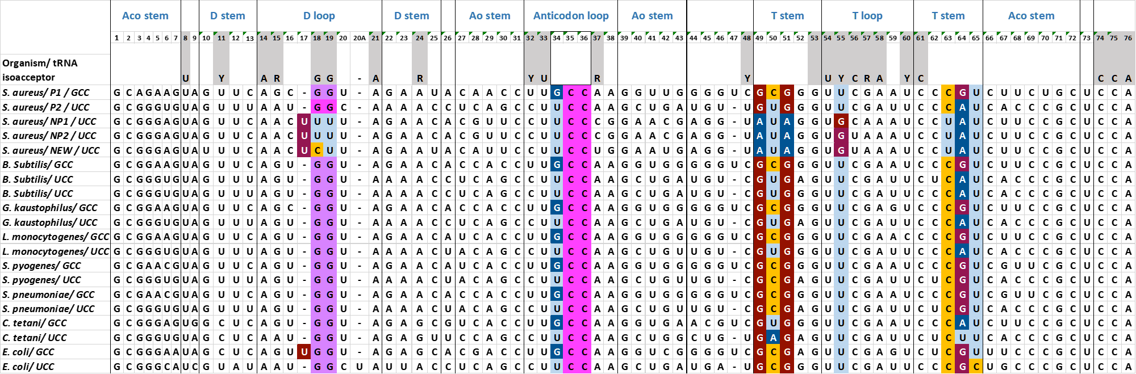
Supplementary Figure S5. Multiple sequence alignment of tRNA^{Gly} isoacceptors bearing GCC or UCC anticodons found in S. aureus, B. subtilis, G. kaustophilus, L. monocytogenes, S. pyogenes, S. pneumoniae, C. tetani and E. coli. D-loop and T-stem/loop sequence differentiations at specific positions are indicated by coloured nucleotides. Identity elements identified for aminocylation by GlyRS are boxed and have a grey background. 'Aco' and 'Ao' are acceptor and anticodon stems, respectively. Multiple sequence alignment of the tRNA^{Gly} molecules bearing both GCC and UCC anticodons from L. monocytogenes, S. pyogenes, S. pneumoniae, C. tetani, S. aureus, B. subtilis and G. kaustophilus was performed. The tRNA^{Gly} from the latter three organisms have been previously used in various structural and functional studies to elucidate and demonstrate the regulatory role of glyQS T-boxes mainly from bacilli and staphylococcal species. The alignment revealed that all bacilli tRNA^{Gly} are identical and that minor differences are observed with the tRNAs bearing the same anticodon in different organisms. The sequences of the non-proteinogenic tRNAs from S. aureus reveal a greater variability, as their sequences vary in position 37 and the wobble position 34 of the anticodon loop, in the D-arm/-loop and the T-arm/-loop. Moreover, the tRNA^{Gly}_{GCC} are identical between the two streptococcal species analysed, but they exhibit difference in their acceptor stem at positions 4, 6, 67 and 69 compared to the B. subtilis tRNA^{Gly}_{GCC}. Additionally, C. tetani tRNA^{Gly}_{GCC} exhibits several variations compared to B. subtilis tRNA^{Gly}_{GCC} at position 5 of the acceptor stem, 11 and 24 of the D-stem, 27 and 43 of the anticodon stem and 50 and 64 of the T-stem. L. monocytogenes tRNA^{Gly}_{GCC} exhibits only a few differences from the B. subtilis tRNA^{Gly}_{GCC} at position 27 of the anticodon stem and 60 of the D-loop. However, these differences between the streptococcal, L. monocytogenes and C. tetani tRNA^{Gly}_{GCC} compared to B. subtilis tRNA^{Gly}_{GCC} are not in positions that are important for tRNA binding on the T-box or for recognition by GlyRS, for the following in vivo and in vitro experiments B. subtilis tRNA^{Gly}_{GCC} is used.

