Supplementary Data

Supplementary Table 1. DNA sequences

Name | Sequence
DNA1_F | TGAGTGGAACGGCAAGGGAG
IRES-Cas_F | CTTCGGTTTCTTTTAATCTTTTCGG
DNA1 | TAGAGTACACGAGTCAGGCTACAGCATCCTCTGGTTCAGACTACTTGATTCATGTGTACCCTATATGCGAGGATATGTGTATCGTAGAAATTGTCAG  GCAGTAACGTTCCGCGAGTTTTAATGGGCGCGCCATGACTCTAAGAGTGATATACCTCCTCGGTCTCGGGCCCGGGGTGTAATTAGCCCAGTTAGAC  ACGATCGCCCGACGTATATTGTTGCTTGGGTATCGTCGCATGCGAAGTATTGCCCAAGGAGACACAACAAGCAACTTATGTTGACTCCCTTCGACCA  TTAAAATTTGTTAGAACGGACAGAAAGGATGCGCCTTATAAATGTCCTGTGCAGTGATGAAGCGACCTCAAAACGCTTCATGATCTAACCGACTCA  CCTTGCCGTTCCCTCCGCGCCTTAAAACCGGCCGGTCTTGCGAAAAGCGGGAAACGAGTTTACCCACGGATAGCAGGGAATGTTGCGGCTGGCTAG  GGAGCATGAAGGTAGATACTCCACGGCTTACCTTTCCGGGGCTCAACATCTAGCCACAGACCTTTTCGTTAAGCCCACCCCCACTGGATACTGAATC  ATCAGGGAACCGGACCCAACCAGTTTGGGCTCGTCCAAGCTTCGGTCTCGTCCCTAAGTGCAAAGATATGGAAAGAGCAGCATAGGTATATGGATT  ATTCTTTTACCACTCGTTTCTTACCGTAACTTACGCAATGGATCACGTGCCGAGGCGGCGGTACAGCTGTTCGAAGGGCTCTGTCGGGAACGCTAAC  ATCCAGCCGGTAAATTCCAAACTAGGGAAAGGACACGCACTGAATTGAATATAGTCGTGAAGGGTGGTGTAAGTCGTGCACAGCCCGCATTAAGTA  CTAAACAGCGTCCAATCTTGATCTACTTACGGCCTGATGTTCTTCAGCACCTCCTAGCACTGGAGTACTTCGCTATCAATGAGATTAGCACTTTGTAC  ATGTCATCCAGCCCGAGTCTGGGGTCCGACAATGCGGTCGCCGATTGGTATCTGCATGTAGTATTAAACGGAGCTGCCGCGGCTGCGGATTATAGTT  CATGTCTTGACGGTCCTCGTGAACTGT
IRES-Cas | CCCCTCTCCCTCCCCCCCTAACGTTACTGGCCGAAGCCGCTTGGAATAAGGCCGGTGTGCGTTTGTCTATATGTTATTTTCCACCATATTGCCGTCTTTTG  GCAATGTGAGGGCCCGGAAACCTGGCCCTGTCTTCTTGACGAGCATTCCTAGGGGTCTTTCCCCTCTCGCCAAAGGAATGCAAGGTCTGTTGAATGTC  GTGAAGGAAGCAGTTCCTCTGGAAGCTTCTTGAAGACAAACAACGTCTGTAGCGACCCTTTGCAGGCAGCGGAACCCCCCACCTGGCGACAGGTGC  CTCTGCGGCCAAAAGCCACGTGTATAAGATACACCTGCAAAGGCGGCACAACCCCAGTGCCACGTTGTGAGTTGGATAGTTGTGGAAAGAGTCAAAT  GGCTCTCCTCAAGCGTATTCAACAAGGGGCTGAAGGATGCCCAGAAGGTACCCCATTGTATGGGATCTGATCTGGGGCCTCGGTGCACATGCTTTACAT  GTGTTTAGTCGAGGTTAAAAAACGTCTAGGCCCCCCGAACCACGGGGACGTGGTTTTCCTTTGAAAAACACGATGATAATATGGGCGAAAGCGTGAAA  GCAATTAAGCTGAAGATCCTGGATATGTTTCTGGACCCCGAGTGCACGAAGCAGGATGATAACTGGCGCAAAGATTTGTCTACTATGTCCAGATTCTGC  GCTGAGGCCGGGAATATGTGCCTGCGGGACCTGTATAATTACTTTAGCATGCCCAAGGAAGATCGGATTTCCAGCAAAGACTTATACAACGCCATGTATC  ATAAAACTAAACTTCTCCACCCAGAGCTGCCAGGTAAGGTCGCGAATCAAATCGTGAACCACGCTAAGGATGTTTGGAAACGCAACGCTAAACTCATTT  ATCGGAATCAAATCTCAATGCCTACTTATAAGATCACAACCGCCCCAATCCGGCTGCAGAATAACATTTATAAGTTAATCAAGAATAAGAACAAGTACATC  ATAGACGTGCAGCTGTACTCCAAGGAATACTCCAAGGATAGTGGTAAGGGCACTCATAGGTATTTCCTGGTCGCCGTTAGAGACTCATCTACCCGGATGAT  ATTCGATAGGATTATGAGTAAGGACCATATTGACAGTTCTAAGTCATACACGCAGGGACAGCTCCAGATCAAGAAAGACCACCAGGGGAAGTGGTATTGC  ATCATCCCCTATACTTTCCCTACACATGAGACAGTCCTCGACCCGGATAAAGTCATGGGAGTCGACCTTGGCGTGGCCAAAGCTGTGTACTGGGCGTTCAA  TAGCTCTTACAAAAGAGGCTGTATCGATGGAGGGGAGATCGAGCATTTCCGCAAAATGATACGAGCACGAAGAGTGAGCATCCAAAATCAGATCAAGCA  CTCAGGAGACGCCCGTAAAGGACATGGGCGCAAAAGGGCCCTAAAACCCATAGAAACATTGAGCGAGAAGGAGAAGAATTTTAGGGATACCATAAACCA  CAGATATGCAAATCGAATTGTAGAAGCCGCTATTAAGCAGGGCTGTGGGACGATCCAGATCGAGAACCTTGAGGGTATAGCTGACACCACAGGCAGTAAA  TTTCTCAAGAACTGGCCTTACTACGACCTGCAGACAAAGATTGTGAATAAAGCCAAGGAACACGGCATTACCGTGGTTGCAATCAACCCCCAATATACATC  CCAAAGGTGCTCGATGTGCGGGTATATTGAAAAAACCAACCGTTCTAGCCAGGCAGTGTTTGAGTGTAAGCAGTGCGGTTACGGCAGTCGGACTATATGTA  TTAACTGCAGGCACGTCCAAGTATCCGGGGATGTTTGTGAGGAATGTGGCGGCATCGTAAAAAAAGAAAACGTGAACGCAGACTACAATGCGGCCAAGAA  CATTTCCACCCCGTACATCGACCAGATAATCATGGAGAAGTGTCTGGAACTAGGGATTCCTTACCGCAGCATCACCTGTAAGGAATGTGGTCACATCCAGGC  TTCAGGAAATACCTGCGAGGTGTGCGGATCTACTAATATTTTGAAGCCAAAGAAAATTAGAAAAGCCAAA

Supplementary Table 2. Pairwise error rates (×10⁻⁶) for polymerase and amplicon combinations

Amplicon | RNAP | RT | RNAP  substitution | RNAP deletion | RNAP insertion | RNAP  Total | RT substitution | RT deletion | RT insertion | RT  Total
DNA1 | T7 | Induro | 38 ± 7 | 2 ± 0 | 13 ± 0 | 53 ± 7 | 57 ± 2 | 7 ± 0 | 49 ± 1 | 113 ± 1
 | T7 | LINE-1 | 36 ± 2 | 2 ± 0 | 12 ± 0 | 50 ± 2 | 220 ± 4 | 9 ± 0 | 49 ± 2 | 278 ± 6
 | T7 | FBu | 39 ± 5 | 2 ± 0 | 13 ± 1 | 54 ± 5 | 130 ± 75 | 7 ± 1 | 52 ± 15 | 189 ± 69
IRES-Cas | T7 | Induro | 60 ± 9 | 15 ± 3 | 51 ± 3 | 125 ± 11 | 63 ± 7 | 7 ± 2 | 126 ± 9 | 196 ± 14

Supplementary Table 3. Number of substitutions, deletions, and insertions detected in Roll-Seq concatemers

RNA polymerase | RT | Amplicon | SNP |  |  |  | DEL |  |  |  | INS
 |  |  | Total¹ | "One"² | "All"³ | Other⁴ | Total¹ | "One"² | "All"³ | Other⁴ | Total¹ | "One"² | "All"³ | Other⁴
T7 RNA polymerase | Induro RT | DNA1 | 80,369 | 66,558 | 13,271 | 540 | 9,220 | 8,408 | 755 | 57 | 62,383 | 57,463 | 4,749 | 171
T7 RNA polymerase | L1-RT | DNA1 | 211,564 | 199,840 | 9,732 | 1,992 | 9,191 | 8,567 | 520 | 104 | 47,712 | 44,142 | 3,210 | 360
T7 RNA polymerase | R2-RT | DNA1 | 171,669 | 156,740 | 13,239 | 1,690 | 9,385 | 8,454 | 788 | 143 | 66,758 | 62,025 | 4,395 | 338
T7 RNA polymerase | Induro RT | IRES-Cas | 6,474 | 4,893 | 1,517 | 64 | 921 | 525 | 374 | 22 | 11,763 | 9,739 | 1,291 | 733
¹ Total is the total number of detected mutations.
² “One” is the number of mutations present in one concatemer only (RT errors).
³ “All” is the number of mutations present in all concatemers (RNAP errors).
⁴ Other is the number of mutations present in more than one but not all concatemers (ambiguous errors).

Supplementary Table 4. Frequency of ambiguous mutations in Roll-Seq

RNA polymerase | RT | Amplicon | SNP |  | DEL |  | INS
 |  |  | rel. Total¹ | rel. "All"² | rel. Total¹ | rel. "All"² | rel. Total¹ | rel. "All"²
T7 RNA polymerase | Induro RT | DNA1 | 0.7% | 4.1% | 0.6% | 7.5% | 0.3% | 3.6%
T7 RNA polymerase | L1-RT | DNA1 | 0.9% | 20.5% | 1.1% | 20.0% | 0.8% | 11.2%
T7 RNA polymerase | R2-RT | DNA1 | 1.0% | 12.8% | 1.5% | 18.1% | 0.5% | 7.7%
T7 RNA polymerase | Induro RT | IRES-Cas | 1.0% | 4.2% | 2.4% | 5.9% | 6.2% | 56.8%
¹ Frequency of ambiguous mutations relative to the total number of detected mutations.
² Frequency of ambiguous mutations relative to “All” mutations.

Supplementary Figure 1. cDNA synthesis by reverse transcriptases. (A) rolling circle reverse transcription of 1.2 kb circular RNA template. Products are analyzed by 1.2% 1xTBE agarose gel. (B) Temperature dependence of cDNA synthesis yield of a 1 kb linear RNA measured by TapeStation. Temperature dependence of cDNA synthesis yield of a 4 kb linear RNA.
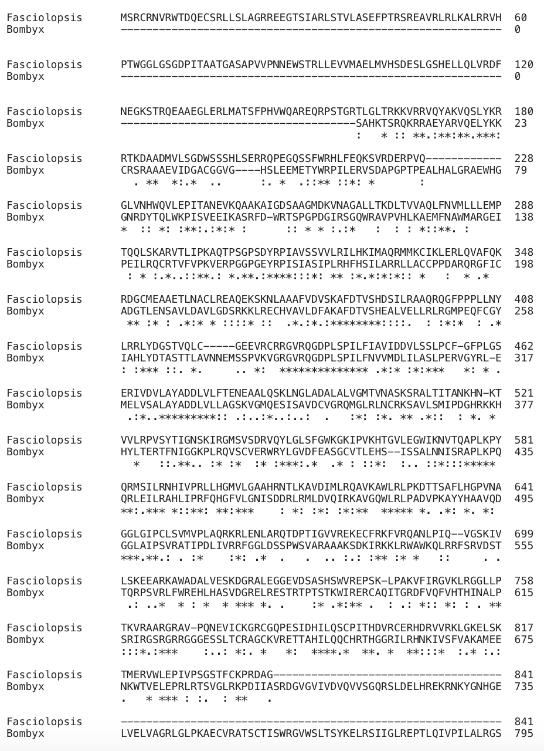
Supplementary Figure 2. Sequence alignment of FBu and BMo by ClustalOmega. FBu shares 31% sequence identity to BMo.

Supplementary Figure 3. Pacific Biosciences SMRT Sequel II run quality data. (A-C) Linear sequencing. (D-F) Roll-Seq.

Supplementary Figure 4. Differences in error rate between Roll-Seq (color) and linear sequencing (grey).
Supplementary Figure 5. Fraction of deletion mutations at each nucleotide position on template DNA1 for (A) T7, (B) Induro, (C) L1-RT, and (D) FBu. Most prevalent deletions are labeled red with asterisks with three adjacent nucleotides shown in black.

Supplementary Figure 6. Fraction of insertion and deletion mutations at each nucleotide position on template IRES-Cas.

