Supporting Information

List of oligos
Table S1 List of oligos
 | Sequence (5’-3’) | Procured from
T7 (forward primer) | GAATTCTAATACGACTCACTATAGGG | Integrated DNA Technologies, USA
Unirev (reverse primer) | ATCGAACCGAACCGAAGCCCAATTT | Integrated DNA Technologies, USA
5’Cy3-Unirev | Cy3-ATCGAACCGAACCGAAGCCCAATTT | Integrated DNA Technologies, USA
5’Alexa488-Unirev | Alexa488-ATCGAACCGAACCGAAGCCCAATTT | Integrated DNA Technologies, USA
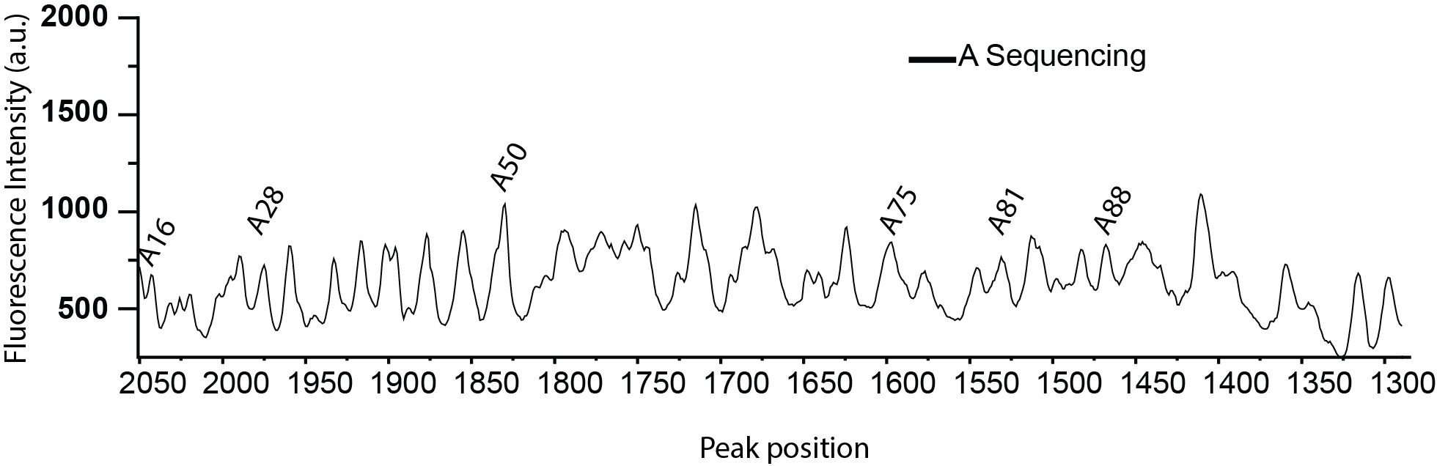
Figure S1 A and G, sequencing data for 2dG-Apt RNA. The sequencing ladders are prepared by dideoxy method. The molar ratio of dNTP and dideoxy NTP is kept at 500:333.

Explicit-solvent simulation

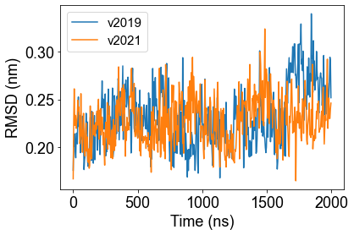
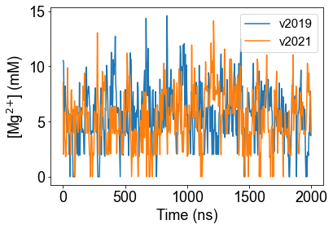
GROMACS v2019 and v2021
a)
b)
Figure S2. Comparisons between two simulations of Gromacs v2019 and v2021 under the same condition, tested with 5 mM Mg²⁺, dG[+]. a) RMSD as a function of time; b) the corrected Magnesium concentration as a function of time.
Table S2 Parameter sets of ε for hydrated ions. Set 1 is obtained by roughly estimating the energy minimum using original ε of water and ions. Set 2 used the parameter of oxygen for all ions because the closest atom between hydrated ions and other species in the solution is usually oxygen. Set 3 used the parameter of K⁺ for all ions as a reference. Set 4 used 0.2 for all as another reference.
Because The simulations are conducted at both Rice University and Los Alamos National Laboratory, 2 versions of GROMACS, v2019 and v2021, were applied. Thus, it is necessary to show that the two versions provide similar results. Here, we compare the results of Magnesium concentration and RMSD as a function of time of 2 simulations, for the case 5 mM Mg²⁺, dG[+], conducted with different versions (Figure S2), proving that the results are similar.

Van der Waals potential parameters when water is absent
 |  | Original | Set 1 | Set 2 | Set 3 | Set 4
Mg²⁺ |  | 3.74342 | 0.910000 | 0.650629 | 0.418400 | 0.200000
K⁺ |  | 0.418400 | 0.780000 | 0.650629 | 0.418400 | 0.200000
Cl⁻ |  | 0.418400 | 0.760000 | 0.650629 | 0.418400 | 0.200000
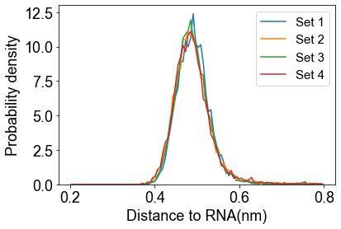
Van der Waals force is given by Lennard-Jones potential in the force field, thus has two parameters: van der Waals radius σ and an energy term ε. While doing equilibration for the water-free system, the van der Waals potential parameters of ions need to be adjusted. The van der Waals radii of ions are set to be the summation of the van der Waals radii of ions and twice of the van der Waals radius of water to mimic the hydrated ions. For the energy term, when no changes were made, Mg²⁺ would condense to RNA because the parameter is too large for hydrated Mg²⁺. Thus, different parameter sets are tested, and the distribution of RNA-Mg²⁺ distance were shown in (Figure S3). It tells that all the parameter sets prevent Mg²⁺ from condensing and provides similar distribution.
Figure S3. Mg²⁺-RNA distance distribution with different van der Waals parameter sets.

Ion concentration and preferential interaction coefficients
The region close to the negatively charged RNA attracts cations like Mg²⁺ and K⁺, creating a much denser region for cations. However, those ions near the RNA backbone are much less mobile than the free ions this high concentration region should be excluded when ion concentrations are calculated. Thus, we took the following steps to calculate the actual concentration of ions.¹
Consider the region D as the collection of points at least 15 Å away from RNA, where the potential generated by RNA is small and ions are considered free. The raw concentration of ion species i in region D is obtained by
$$\begin{aligned}\text{[}\text{i}\text{]*} \text{=} \text{55.51M}\frac{{\text{N}}_{\text{i}\text{,} \text{D}}}{{\text{N}}_{\text{water}\text{,} \text{D}}}\text{,}\#\text{(S}\text{ SEQ Equation \backslash * ARABIC }\text{1}\text{)}\end{aligned}$$where N_{i, D} and N_{water, D} represents the number of species i and number of water molecule in region D respectively.
Table S3 Raw and corrected concentrations with different thresholds to determine region D for the case 20 mM Mg²⁺, dG[-].
 |  | $\text{[}\text{Mg}\text{2+}\text{]}\text{*}$/mM | $\text{[}\text{K}\text{+}\text{]}\text{*}$/mM | $\text{[}\text{Cl}\text{-}\text{]}\text{*}$/mM | [Mg²⁺]/mM | [K⁺]/mM | [Cl⁻]/mM
15 Å |  | 21.2 ± 4.0 | 98.9 ± 7.5 | 137.8 ± 6.2 | 20.7 ± 3.7 | 97.8 ± 7.0 | 139.2 ± 5.9
20 Å |  | 21.1 ± 4.8 | 98.9 ± 9.2 | 139.0 ± 8.7 | 20.7 ± 4.5 | 98.2 ± 8.6 | 139.7 ± 8.0
However, there is no guarantee that this concentration gives a neutral solution, and we need to correct this raw concentration with an ion-ion interaction term to give electroneutral results. Let the corrected ion concentration of species i be [i]. With a mean-field assumption that ions feel a general potential V($\vec{\text{r}}$), the concentration of species i at position $\vec{\text{r}}$ can be written as
$$\begin{aligned}{\text{c}}_{\text{i}}\text{(}\vec{\text{r}}\text{) = [}\text{i}\text{]}{\text{e}}^{\text{-}\frac{{\text{q}}_{\text{i}}\text{V}\text{(}\vec{\text{r}}\text{)}}{\text{kT}}}\text{,}\#\text{(S}\text{ SEQ Equation \backslash * ARABIC }\text{2}\text{)}\end{aligned}$$where q_{i} is the charge, k is Boltzmann coefficient and T is the temperature. Since the charge of RNA is almost screened in region D and ion concentrations are low, the potential is small. Thus, we can only keep the first term of the Taylor expansion, giving that
$$\begin{aligned}{\text{c}}_{\text{i}}\text{(}\vec{\text{r}}\text{) = [}\text{i}\text{] (1 }\text{- }\frac{{\text{q}}_{\text{i}}\text{V}\text{(}\vec{\text{r}}\text{)}}{\text{kT}}\text{).}\#\text{(S}\text{ SEQ Equation \backslash * ARABIC }\text{3}\text{)}\end{aligned}$$Integrate in the region D and divide by its volume
$$\begin{aligned}\frac{\int_{\text{D}}{{\text{c}}_{\text{i}}\text{(}\vec{\text{r}}\text{)}}\text{d}\vec{\text{r}}}{\int_{\text{D}}{\text{d}\vec{\text{r}}} }\text{ = [}\text{i}\text{](1 -} {\text{q}}_{\text{i}}\frac{\int_{\text{D}}{\frac{\text{V}\text{(}\vec{\text{r}}\text{)}}{\text{kT}}}\text{d}\vec{\text{r}}}{\int_{\text{D}}{\text{d}\vec{\text{r}}} }\text{).}\#\text{(S}\text{ SEQ Equation \backslash * ARABIC }\text{4}\text{)}\end{aligned}$$Notice that the LHS of Eq. S4 is exactly the raw concentration [i]*, and the integral of the RHS gives a constant, denoted by C in the following context. Thus, Eq. S4 can be rewritten as
$$\begin{aligned}\text{[}\text{i}\text{]* = [}\text{i}\text{] (1 - }\text{C}{\text{q}}_{\text{i}}\text{).}\#\text{(S}\text{ SEQ Equation \backslash * ARABIC }\text{5}\text{)}\end{aligned}$$Since C is also small, Eq. S5 can also be written as
$$\begin{aligned}\text{[}\text{i}\text{] = [}\text{i}\text{]}\text{*}\text{ (1 + }\text{C}{\text{q}}_{\text{i}}\text{).}\#\text{(S}\text{ SEQ Equation \backslash * ARABIC }\text{6}\text{)}\end{aligned}$$
Now we need to calculate the value of constant C. Multiply Eq. S5 by q_{i}, and summarize over all ion species. Notice that the solution should be neutral, meaning that the first term on the RHS of the result is 0, we obtain
$$\begin{aligned}\sum_{\text{i}}{{\text{q}}_{\text{i}}\text{[}\text{i}\text{]*}}\text{ = }\text{-C}\sum_{\text{i}}{{\text{q}}_{\text{i}}^{\text{2}}\text{[}\text{i}\text{].}}\#\text{(S}\text{ SEQ Equation \backslash * ARABIC }\text{7}\text{)}\end{aligned}$$Approximately [i] = [i]*, thus
$$\begin{aligned}\text{C}\text{ = -}\frac{\sum_{\text{i}}{{\text{q}}_{\text{i}}\text{[}\text{i}\text{]*}}}{\sum_{\text{i}}{{\text{q}}_{\text{i}}^{\text{2}}\text{[}\text{i}\text{]*}}}\text{.}\#\text{(S}\text{ SEQ Equation \backslash * ARABIC }\text{8}\text{)}\end{aligned}$$Take Eq. S8 back to Eq. S6, we get the final expression for corrected concentration (which guarantees the electroneutral condition),
$$\begin{aligned}\text{[}\text{i}\text{] = [}\text{i}\text{]}\text{*}\text{ -} {\text{q}}_{\text{i}}\text{[}\text{i}\text{]}\text{*}\frac{\sum_{\text{i}}{{\text{q}}_{\text{i}}\text{[}\text{i}\text{]*}}}{\sum_{\text{i}}{{\text{q}}_{\text{i}}^{\text{2}}\text{[}\text{i}\text{]*}}}\text{.}\#\text{(S}\text{ SEQ Equation \backslash * ARABIC }\text{9}\text{)}\end{aligned}$$And the preferential interaction coefficient is defined as
$$\begin{aligned}{\text{Γ}}_{\text{i}}\text{ = }{\text{N}}_{\text{i}}\text{ - }{\text{N}}_{\text{water}}\frac{\text{[}\text{i}\text{]}}{\text{55.51M}}\text{.}\#\text{(S}\text{ SEQ Equation \backslash * ARABIC }\text{10}\text{)}\end{aligned}$$However, while determine the region D, we used a rather arbitrary threshold of 15 Å, to show that this threshold is enough, 20 Å was also tested for 20 mM Mg²⁺, dG[-], giving good consistency with the threshold we used in the paper. (Table S3)

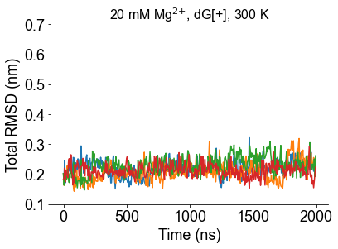
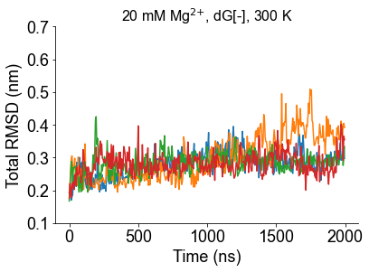
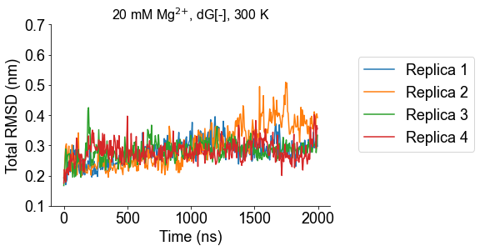
RMSD and principal component analysis for 20 mM Mg²⁺ cases
a)
b)
Figure S4 Global fluctuation RMSD for one the first four of eight replicas for of 20 mM Mg²⁺ cases at 300 K. In general, the fluctuation of the system is similar when Mg²⁺ concentration raises from 5 mM to 20 mM.

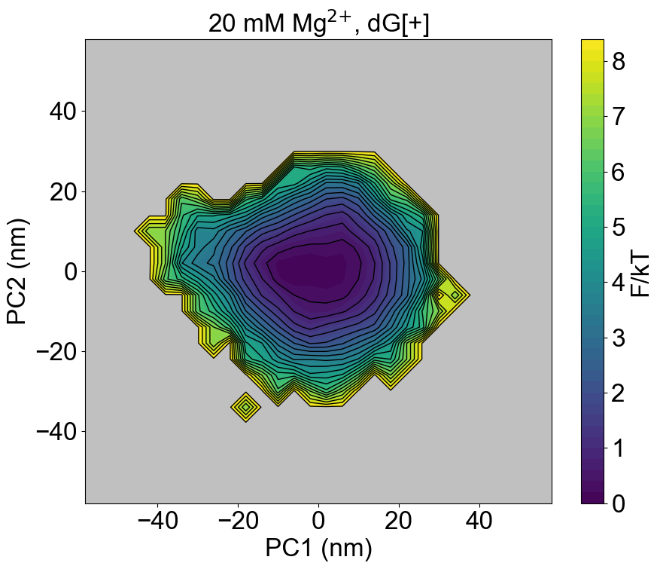
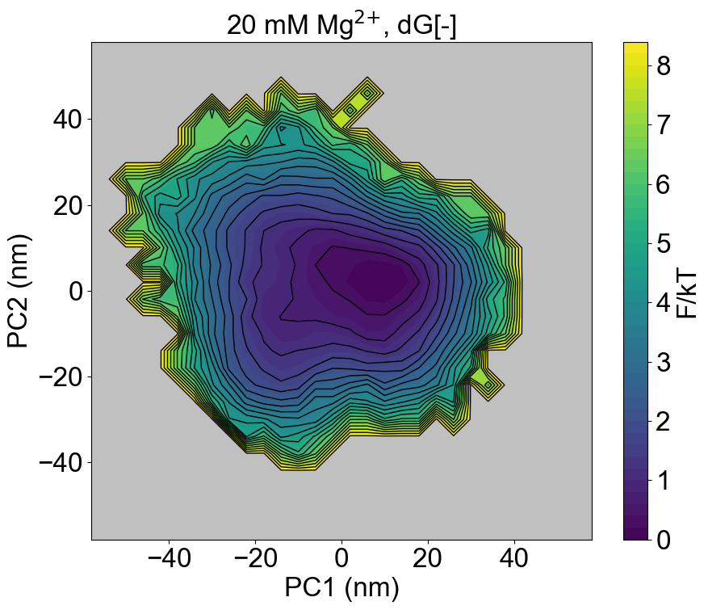
Figure S5 Energy landscape in the PC1-PC2 space of 20 mM Mg²⁺ cases at 300 K. The energy landscape is similar with the 5 mM Mg²⁺ case with the presence of ligand, but are more funneled with the absence of ligand.
a)
b)

Stability of helices at 300 K
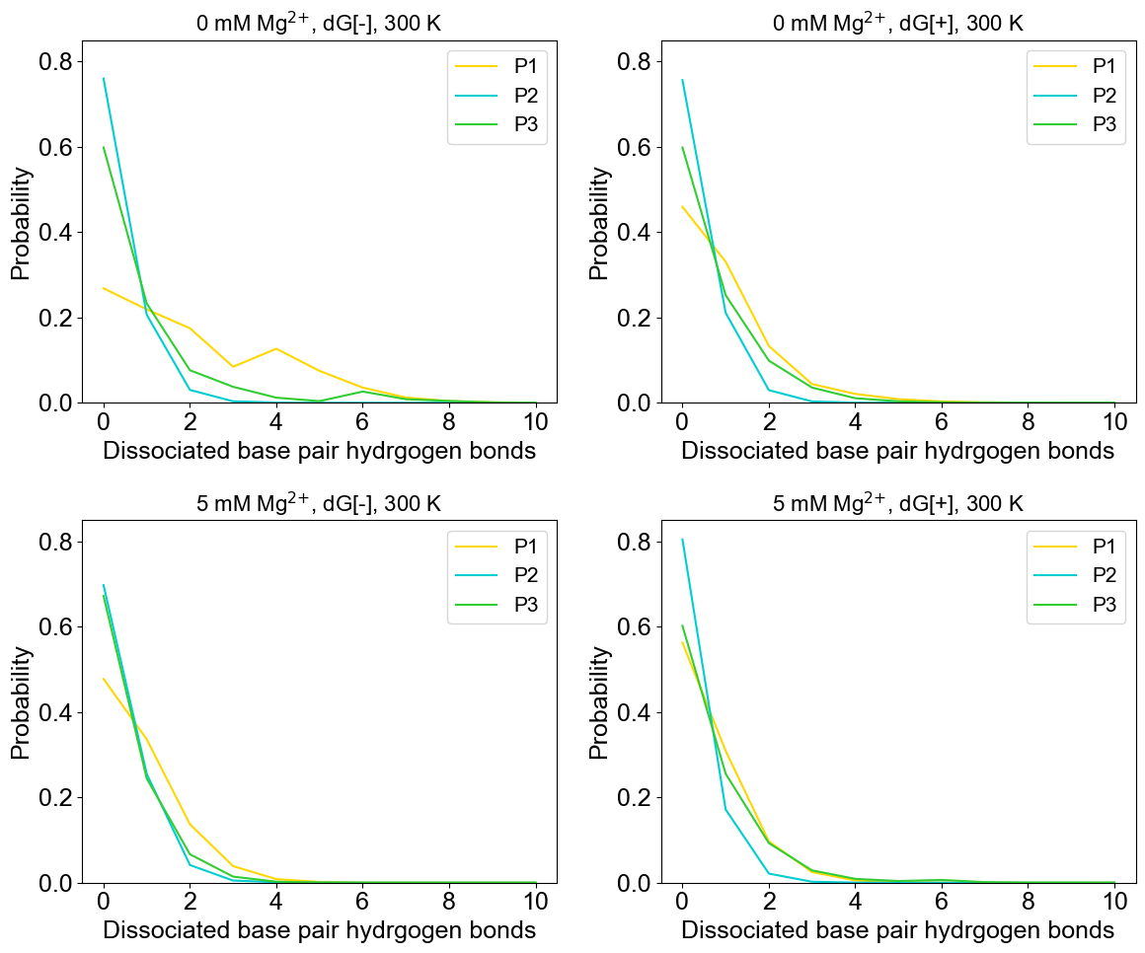
Figure S6 The combinational results of 8 simulations among on native hydrogen bonds dissociation probability for a) 0 mM Mg²⁺, dG[-]; b) 0 mM Mg²⁺, dG[-]; c) 5 mM Mg²⁺, dG[-]; d) 5 mM Mg²⁺, dG[-]. The hydrogen bonds on P1 helix break much more often compared with other helices except the case with the existence of both ligand and Mg²⁺, and the probability difference becomes much more significant with the removal of Mg²⁺ or ligand. The P2 is slightly more stable than the P3 helix, but the difference is not large so that no firm conclusion can be made. The 3 bonds between G22-C89 on the P1 helix were cut off because of its location at the tail.
a)
b)
c)
d)

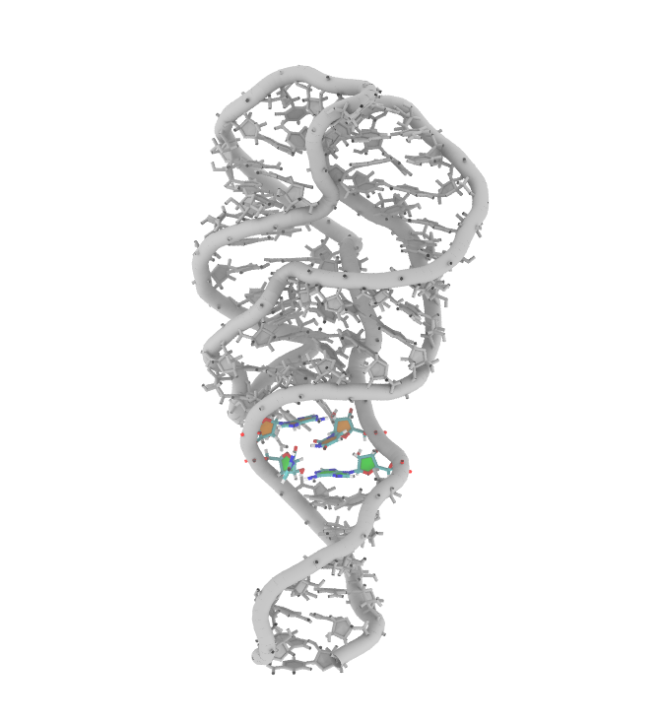
Altered stacking inside the P1 helix with 0 mM Mg²⁺, dG[+].
Figure S7 A frame picked from the 4th replica of the simulation with 0 mM Mg²⁺, dG[-]. The altered stacking is colored, and the orange and green filling shows the base-pairing in the crystal structure

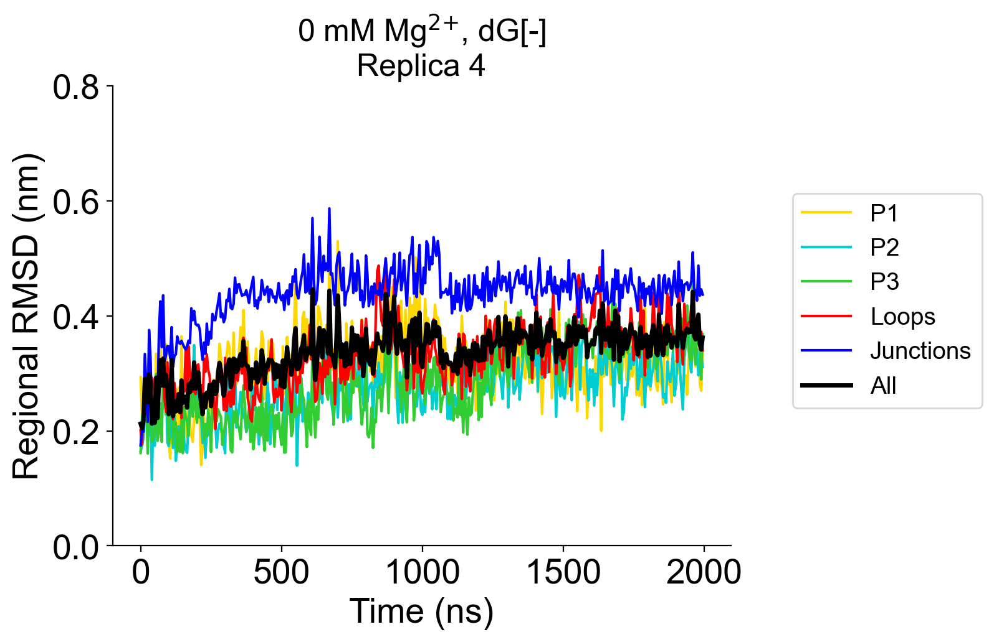
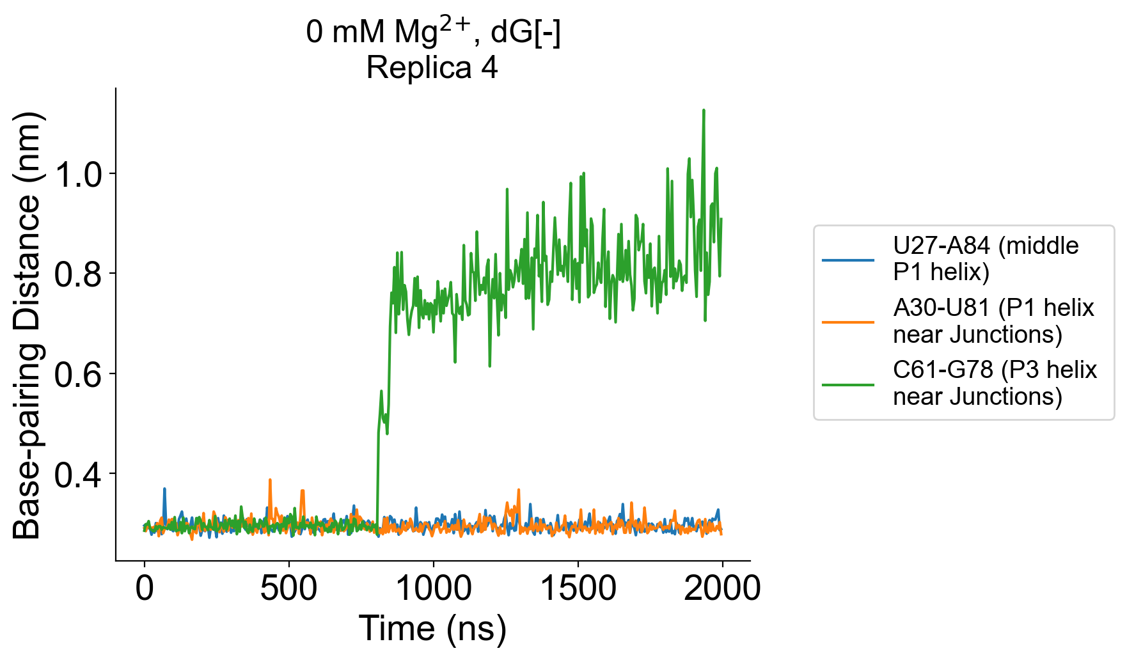
Breaking base-pairing on P3 helix does not break the helix with 0 mM Mg²⁺, dG[-]
Figure S8 The breaking of base-pairings on P3 helix only induces local fluctuation at the time scale of simulations without inducing a metastable state in the case of 0 mM Mg²⁺, dG[-], 300 K.
a)
b)

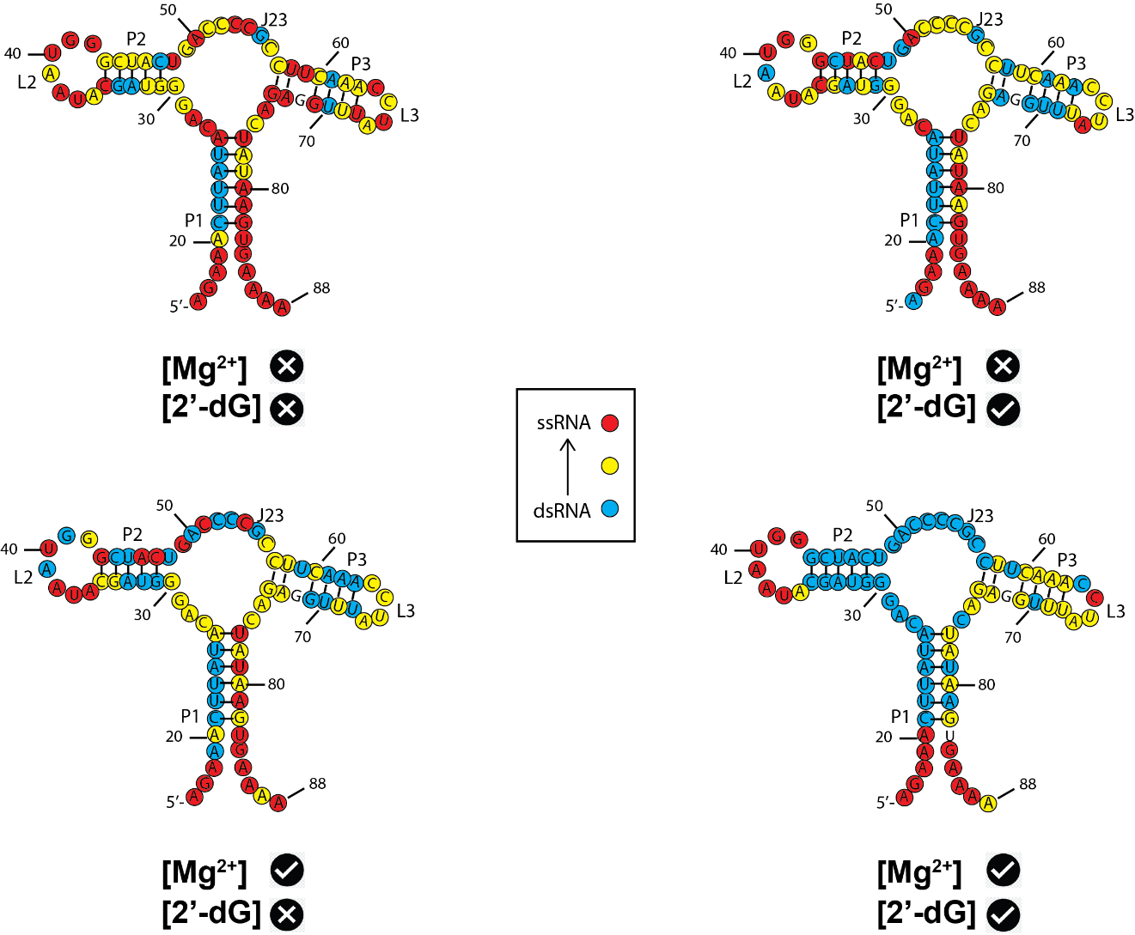
SHAPE reactivity with a 3-colored scale scheme.
Figure S9 Overlay of SHAPE reactivities onto a secondary structure model portraying a 76-nucleotide mlf-2-dG aptamer RNA (Figure 9b-e) with a three-colored scale scheme.
a)
b)
c)
d)

Movies.
Movie S1. Fluctuation associated with principal component 1 (PC1) with 0 mM Mg²⁺, dG[+]. P1: yellow; P2: cyan; P3: green; Loops (PK): red; Junctions (Pocket region): blue
Movie S2. Fluctuation associated with PC2 with 0 mM Mg²⁺, dG[+].
Movie S3. Fluctuation associated with PC3 with 0 mM Mg²⁺, dG[+].
Movie S4. Fluctuation associated with PC1 with 0 mM Mg²⁺, dG[-].
Movie S5. Fluctuation associated with PC2 with 0 mM Mg²⁺, dG[-].
Movie S6. Fluctuation associated with PC3 with 0 mM Mg²⁺, dG[-].
Movie S7. Fluctuation associated with PC1 with 5 mM Mg²⁺, dG[+].
Movie S8. Fluctuation associated with PC2 with 5 mM Mg²⁺, dG[+].
Movie S9. Fluctuation associated with PC3 with 5 mM Mg²⁺, dG[+].
Movie S10. Fluctuation associated with PC1 with 5 mM Mg²⁺, dG[-].
Movie S11. Fluctuation associated with PC2 with 5 mM Mg²⁺, dG[-].
Movie S12. Fluctuation associated with PC3 with 5 mM Mg²⁺, dG[-].
Movie S13. Fluctuation associated with PC1 with 20 mM Mg²⁺, dG[+].
Movie S14. Fluctuation associated with PC2 with 20 mM Mg²⁺, dG[+].
Movie S15. Fluctuation associated with PC3 with 20 mM Mg²⁺, dG[+].
Movie S16. Fluctuation associated with PC1 with 20 mM Mg²⁺, dG[-].
Movie S17. Fluctuation associated with PC2 with 20 mM Mg²⁺, dG[-].
Movie S18. Fluctuation associated with PC3 with 20 mM Mg²⁺, dG[-].
Movie S19. One of the simulation trajectories with 20 mM Mg²⁺, dG[+].
Movie S20. One of the simulation trajectories with 0 mM Mg²⁺, dG[-].
Movie S21. Residence time at the ion association surface in logarithm scale for one of eight replicas of different conditions at 300 K
Movie S22. Residence time at all the individual ion association sites in logarithm scale for one of eight replicas of different conditions at 300 K

