Supplemental Information: Transcription factors ERα and Sox2 have differing multiphasic DNA and RNA binding mechanisms

Wayne O. Hemphill^{1,2,†}, Halley R. Steiner^{1,†}, Jackson R. Kominsky^{1,2,†}, Deborah S. Wuttke^{1,*}, Thomas R. Cech^{1,2,•}

¹ Department of Biochemistry, University of Colorado Boulder, Boulder, Colorado 80303 USA
² Howard Hughes Medical Institute and BioFrontiers Institute, University of Colorado Boulder, Boulder, Colorado 80303 USA
† Authors contributed equally
* Corresponding authors: thomas.cech@colorado.edu & deborah.wuttke@colorado.edu

Running Title: ERα and Sox2 exhibit multiphasic binding kinetics

Keywords: RNA, DNA, transcription factor, kinetics

Oligonucleotides Synthesized by IDT
Identifier |  | Sequence (IDT Nomenclature, 5’ 3’)
CBS dsDNA  (ligand) | s1 | /56-FAM/GCCATTGTGC
CBS dsDNA  (ligand) | s2 | /56-FAM/GCACAATGGC
CBS dsDNA  (competitor) | s1 | GCCATTGTGC
CBS dsDNA  (competitor) | s2 | GCACAATGGC
NBS dsDNA  (ligand) | s1 | CGCGCTCGATCGCCCGGGT/36-FAM/
NBS dsDNA  (ligand) | s2 | ACCCGGGCGATCGAGCGCG/36-FAM/
NBS dsDNA  (competitor) | s1 | CGCGCTCGATCGCCCGGGT
NBS dsDNA  (competitor) | s2 | ACCCGGGCGATCGAGCGCG
rG4 / G4 RNA (ligand) |  | rGrGrGrArArGrGrGrArArGrGrGrArArGrGrGrArA/36-FAM/
rG4 / G4 RNA  (competitor) |  | rGrGrGrArArGrGrGrArArGrGrGrArArGrGrGrArA
rA20 / poly-A RNA  (ligand) |  | rArArArArArArArArArArArArArArArArArArArA/36-FAM/
rA20 / poly-A RNA  (competitor) |  | rArArArArArArArArArArArArArArArArArArArA
Sox2 hRNA  (ligand) |  | rGrCrGrArCrUrGrUrCrArCrCrGrArArUrCrCrGrArArArArArCrGrGrArUrUrCrGrGrUrGrArCrArGrUrCrGrC/36-FAM/
Sox2 hRNA  (competitor) |  | rGrCrGrArCrUrGrUrCrArCrCrGrArArUrCrCrGrArArArArArCrGrGrArUrUrCrGrGrUrGrArCrArGrUrCrGrC
ERE dsDNA  (ligand) | s1 | /56-FAM/CAGGTCAGAGTGACCTGA
ERE dsDNA  (ligand) | s2 | TCAGGTCACTCTGACCTG
ERE dsDNA  (competitor) | s1 | CAGGTCAGAGTGACCTGA
ERE dsDNA  (competitor) | s2 | TCAGGTCACTCTGACCTG
ERE dsDNA  (SPR) | s1 | /5Biosg/CAGGTCAGAGTGACCTGA
ERE dsDNA  (SPR) | s2 | TCAGGTCACTCTGACCTG
∆ERE dsDNA  (ligand) | s1 | /56-FAM/TATAAAGGTCACTCC
∆ERE dsDNA  (ligand) | s2 | GGAGTGACCTTTATA
∆ERE dsDNA  (competitor) | s1 | TATAAAGGTCACTCC
∆ERE dsDNA  (competitor) | s2 | GGAGTGACCTTTATA
∆ERE dsDNA  (SPR) | s1 | /5Biosg/TATAAAGGTCACTCC
∆ERE dsDNA  (SPR) | s2 | GGAGTGACCTTTATA
XBP1_Template |  | GCGCGCGAATTCTAATACGACTCACTATAGGTCCTCTCTGCTTGGTGTAAACCATTCTTGGGAGGAC
XBP1_3’-PCR |  | GTCCTCCCAAGAATGGTTTACACC
XBP1_5’-PCR |  | GCGCGCGAATTCTAATACGACTCACTATAG

Supplemental Table 1: Sequences of IDT-Synthesized Polynucleotide Species. The nomenclature used for ordering oligonucleotides from IDT (Sequence) is provided for all oligonucleotides named (Identifier) in the paper.

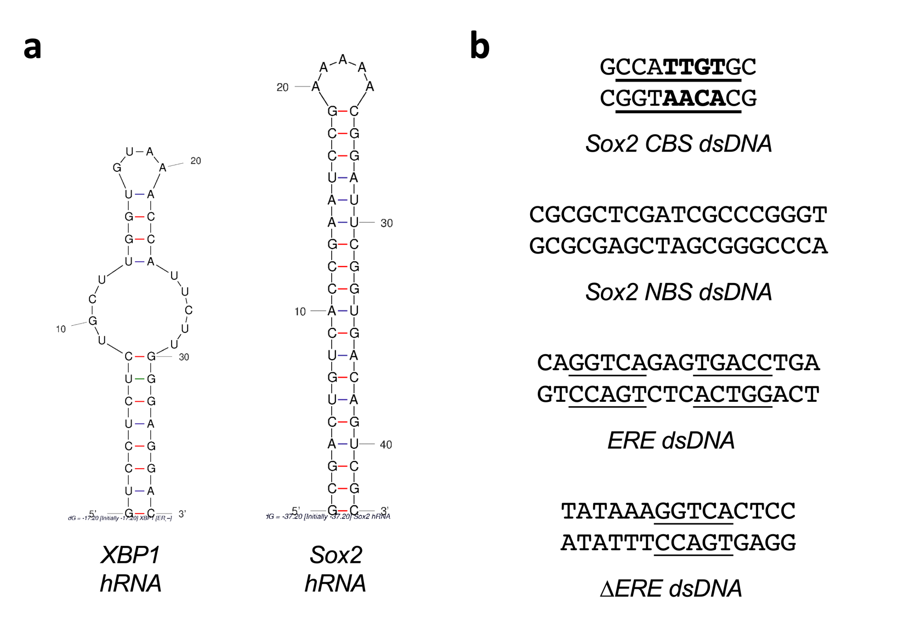

Supplemental Figure 1: RNA Secondary Structures and DNA Target Sequences. [a] The mfold (Zuker 2003) secondary structure predictions for applicable RNA ligands from these studies. [b] DNA ligands from these studies with TF recognition sequences (underlined) identified. Bolded letters within Sox2 target DNA sequence represent the highly conserved core sequence across Sox2 ortholog recognition sequences.

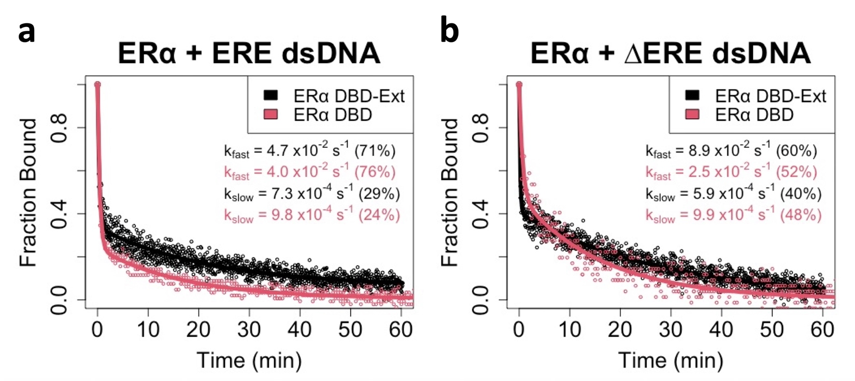

Supplemental Figure 2: Basic Amino Acids C-terminal of the ERα DBD do not Contribute to Multiphasic ERα-dsDNA Dissociation. FPCD experiments (Figure 2a) were performed using 5 nM ligand, 10 µM competitor, and 100 nM ERα protein (DBD or DBD-Ext constructs); protein-ligand reactions were incubated to equilibrium before competitor addition. Anisotropy traces were normalized to the internal controls to give ‘Fraction Bound’ over time, then normalized data fit with bi-exponential regression (Eq. 3) to determine rate constants. Open circles are data points and solid lines are regression fits. Data and regression are from a single experiment for each ligand, and rate constants are the averages from independent experiments (2 for DBD-Ext with ∆ERE, 1 otherwise). Percent contributions of fast versus slow components to the bi-exponential curve are in parentheses. Error analyses for DBD-Ext rate constant values are in Table 1, and DBD rate constants are from a single experiment.

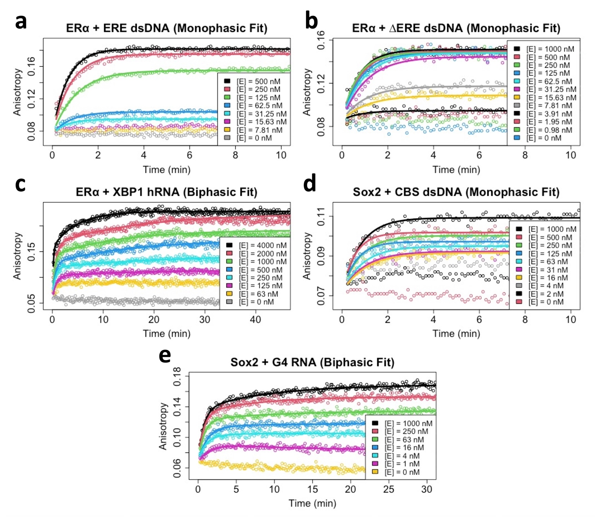

Supplemental Figure 3: Initial Complex Formation for ERα_{DBD-Ext} and Sox2_{HMG}. Association data from Figure 4 were abbreviated to the indicated times and regressed with an equation for monophasic (a,b,d) (Eq. 2.1) or biphasic (c,d) (Eq. 2.2) association. Open circles are data and solid lines are regression fits. Data and regression are from the same individual experiments shown in Figure 4a-e.

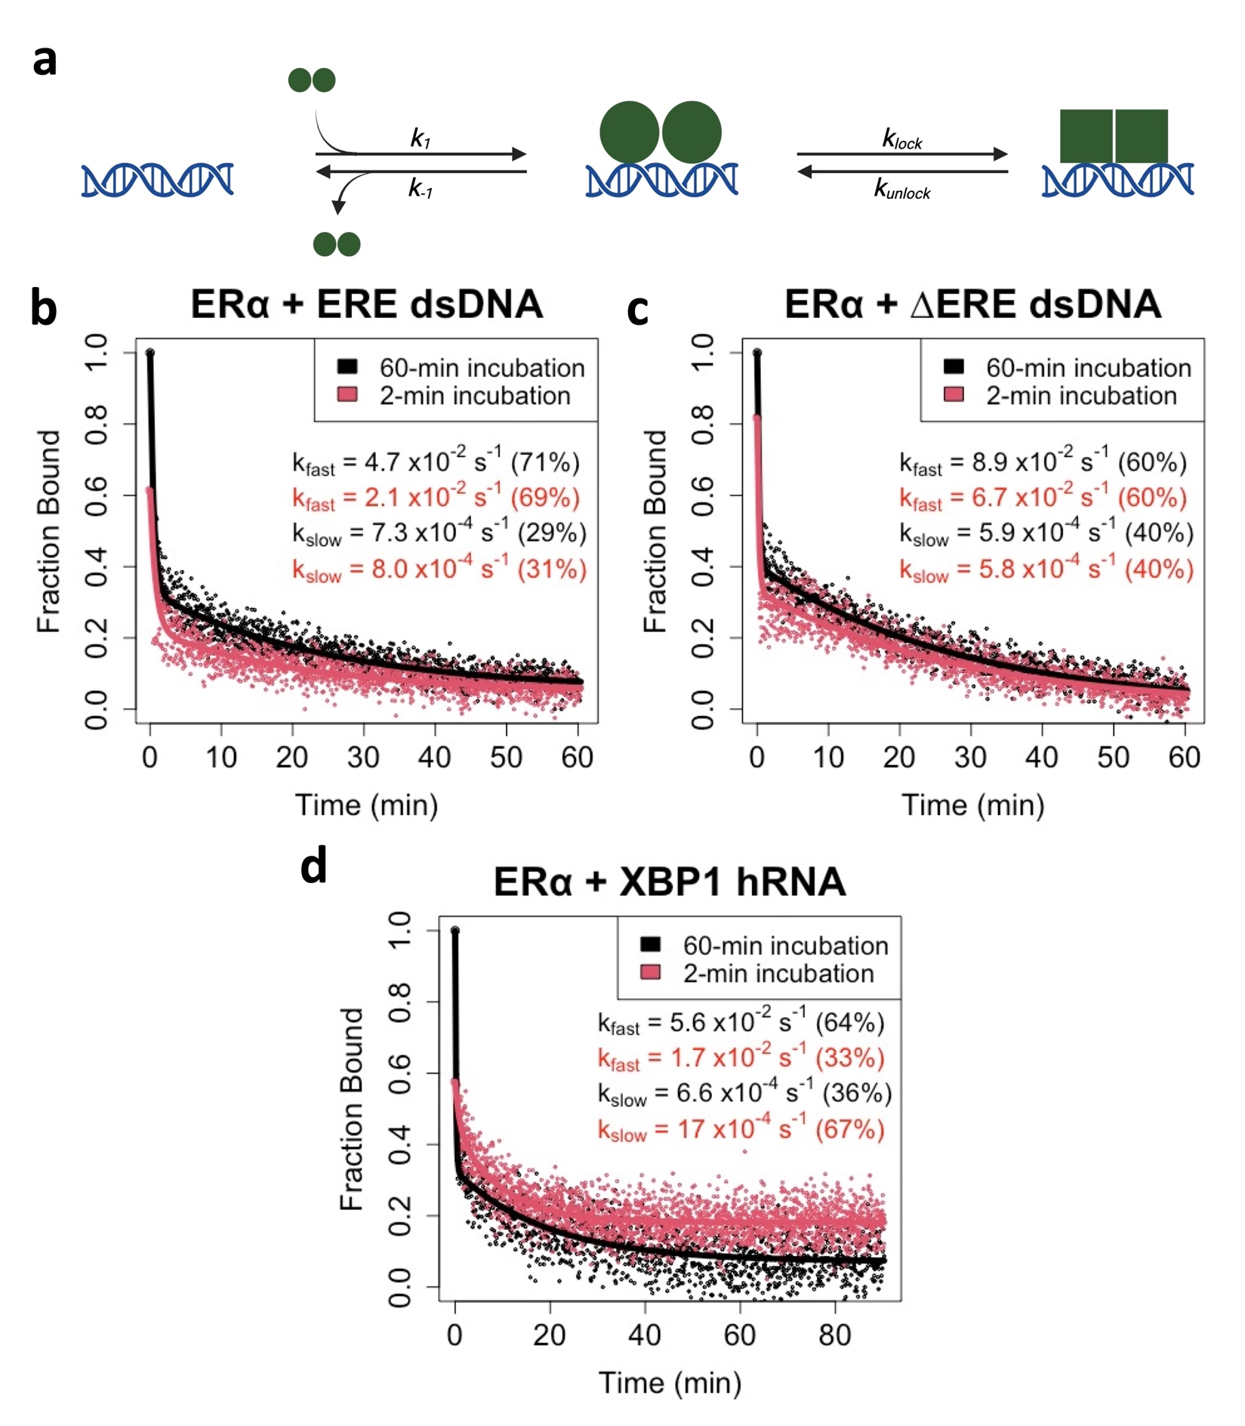

Supplemental Figure 4: Multiphasic ERα_{DBD-Ext} Ligand Dissociation Isn’t Explained by a Simple “Locked” Binding Conformation Model. [a] “Locked” Binding Conformation Model for GR Biphasic Ligand Dissociation. After initial protein-ligand association, the complex can isomerize to another state. The alternative complex state must isomerize back to the original state before complex dissociation can occur. If isomerization is slow relative to complex dissociation, then multiphasic dissociation kinetics can be produced. This model predicts that early in a protein-ligand reaction complexes should predominantly be in the “unlocked” state and dissociate quickly. [b-d] FPCD experiments (see Figure 2a) were performed using 5 nM ligand, 10 µM competitor, and 100-500 nM protein; protein-ligand reactions were incubated for ~2 min or ~60 min before competitor addition. Anisotropy traces were normalized to the internal controls to give ‘Fraction Bound’ over time, then normalized data fit with bi-exponential regression (Eq. 3) to determine rate constants. Dots are data points and solid lines are regression fits. Data and regression are from a single experiment for each ligand, and rate constants are the averages from independent experiments (1 for ERE, 2 otherwise). Percent contributions of fast versus slow components to the bi-exponential curve are in parentheses. For 60 min incubations, rate constant value error is reported in Table 1. For the ∆ERE 2 min incubation, k_{fast} = 6.7 ± 3.2 x10⁻² s⁻¹, k_{slow} = 5.8 ± 1.0 x10⁻⁴ s⁻¹, and for the XBP1 2 min incubation, k_{fast} = 1.7 ± 0.83 x10⁻² s⁻¹, k_{slow} = 17 ± 2.9 x10⁻⁴ s⁻¹ (mean ± ½ range).

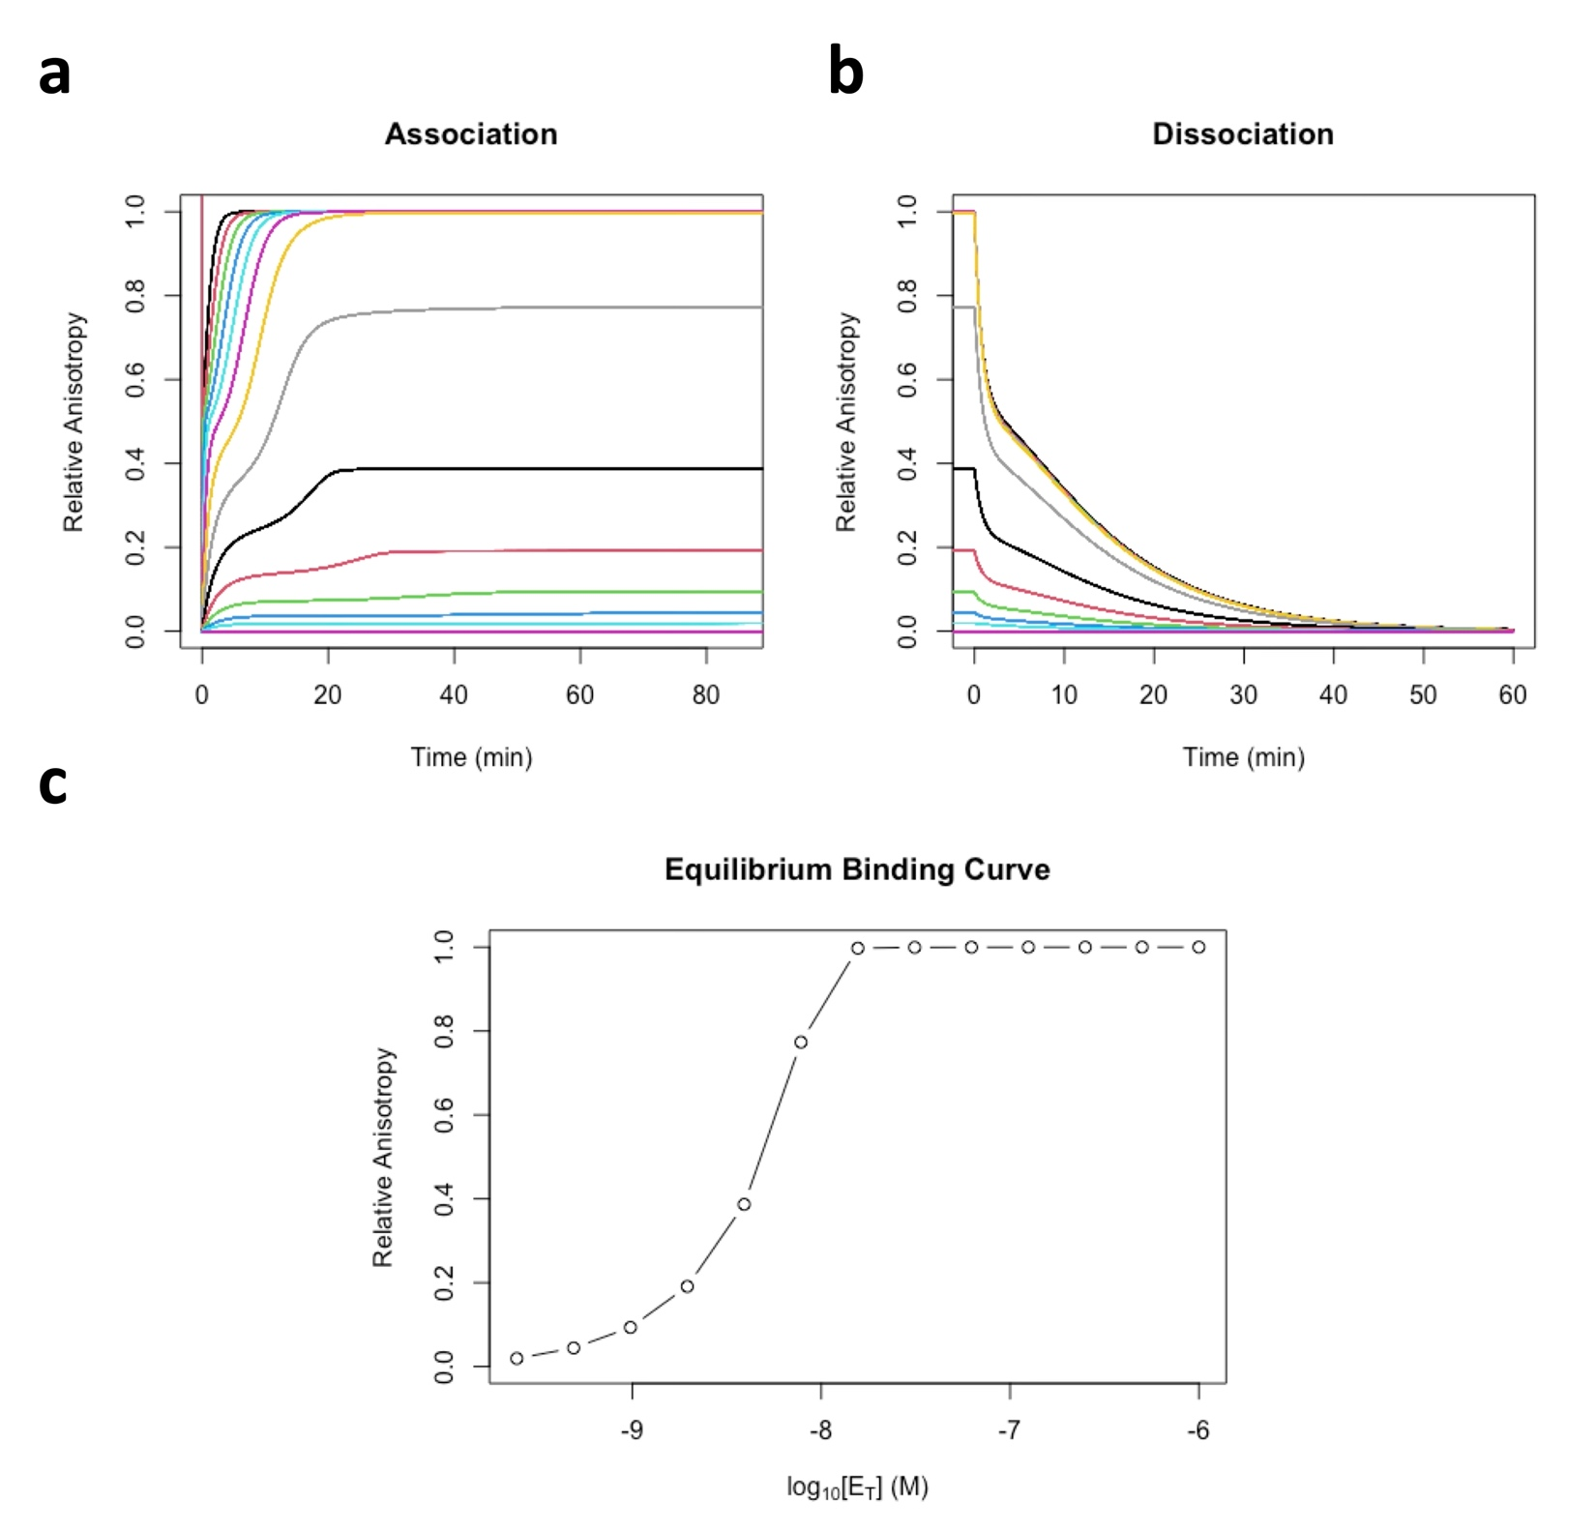

Supplemental Figure 5: Reaction Simulations for Figure 7c Model. Reactions based on the Figure 7c model were simulated as described (see Methods) to show association curves (a), dissociation curves via jump-dilution (b), and equilibrium binding curves (c). Equilibrium binding curve data points are the endpoints of the association curves in panel a. Differentially colored lines indicate simulated reactions at different protein concentrations ([E_{T}]). Protein concentrations were two-fold serial dilutions from 1 µM, ligand concentration was 5 nM, and rate constants are detailed in methods). The behaviors of these simulations included (1) “lagged” triphasic association that is conditional on lower protein concentrations, (2) biphasic dissociation from equilibrium complex states, (3) biphasic dissociation at high protein concentrations with short protein-ligand incubation times, (4) monophasic slow dissociation at low protein concentrations with short protein-ligand incubation times, and (5) equilibrium binding curves with higher Hill coefficients.
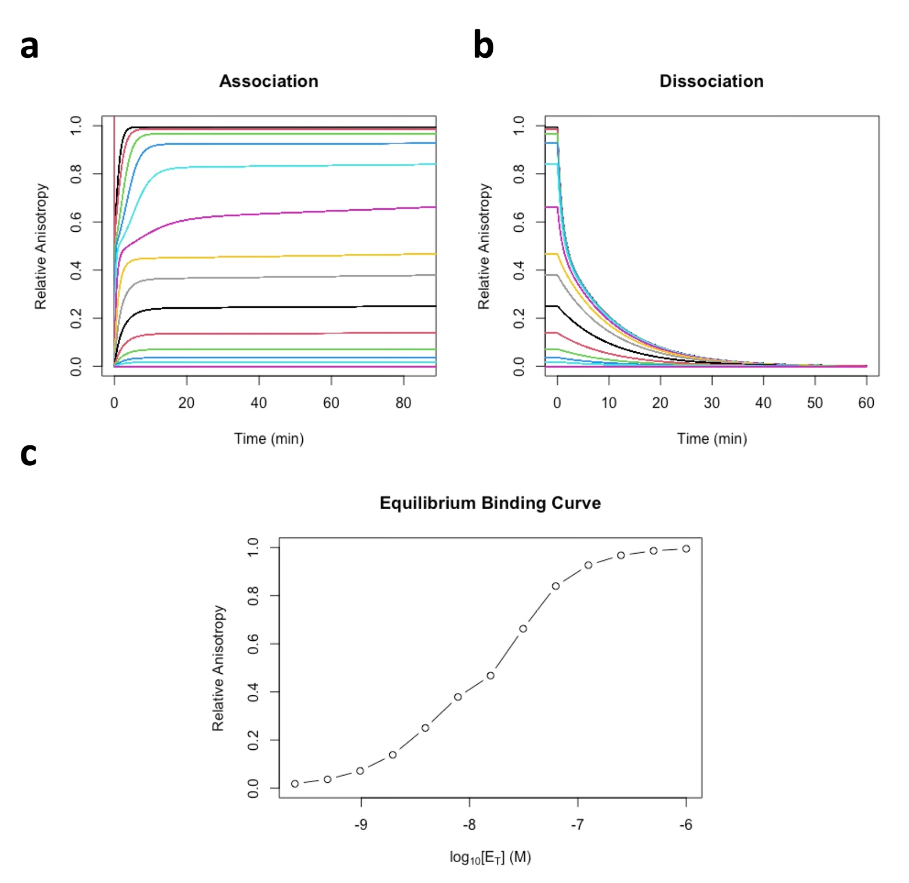

Supplemental Figure 6: Modified Reaction Simulations for Figure 7c Model. Supplemental Figure 5 reaction simulations were specifically modified to accelerate Figure 7c reverse isomerization (i.e., increased k₋₂) – association curves (a), dissociation curves via jump-dilution (b), and equilibrium binding curves (c). Equilibrium binding curve data points are the endpoints of the association curves in panel a. Differentially colored lines indicate simulated reactions at different protein concentrations ([E_{T}]). Protein concentrations were two-fold serial dilutions from 1 µM, ligand concentration was 5 nM, and rate constants are detailed in methods. Relative to Supplemental Figure 5 simulations, accelerating the reverse isomerization (i.e., increasing k₋₂) had limited effects on biphasic dissociation rates (at high protein concentrations) and initial association rates, but it produced seemingly biphasic association curves, increased the K_{d}^{app}, and lowered the apparent Hill coefficient.

