SUPPLEMENTARY INFORMATION

for

PACRAT: Pathogen detection with aptamer-observed cascaded recombinase polymerase amplification-in vitro transcription
Pavana Khan, Lauren M. Aufdembrink, Katarzyna P. Adamala and Aaron E. Engelhart

Table of Contents

Table S1. Table showing oligonucleotides used in this work
Figure S1. Reactions conducted in varying temperatures with or without SARS-CoV-2 target and monitored for Pepper aptamer fluorescence
Figure S2. Reactions with varying concentrations of polyethylene glycol (PEG)
Figure S3. Reactions with varying concentrations of inorganic pyrophosphatase
Figure S4. Testing the sensitivity of PACRAT with E. coli RNA target
Figure S5. Dual detection of wild-type SARS-CoV-2 and Delta variant
Figure S6. Testing the sensitivity of PACRAT for direct detection of E. coli cells
Figure S7. Scheme showing different folds predicted by Geneious bioinformatics software for PACRAT constructs.
Figure S8. PACRAT reactions using different fluorescent aptamers (Pepper, Corn, and Broccoli) with the same SARS-CoV-2 B.1.167 target as shown in Figure S7 folding predictions

Name | Sequence (5′-3′)
Templates for amplicon transcription
aggR gene with T7 promoter | AAT TCT AAT ACG ACT CAC TAT AGG GAG ACA GCG ATA CAT TAA GAC GCC TAA AGG ATG CCC TGA TGA TAA TAT ACG GAA TAT CAA AAG TAG ATG CTT GCA GTT GTC CGA ATT GGT CAA AAG GAA TAA TTG TAG CTG ATG CTG ACG
aggR forward PCR primer | AAT TCT AAT ACG ACT CAC TAT AGG
aggR reverse PCR primer | CGT CAG CAT CAG CTA CAA TTA
SARS-CoV-2 WT Nucleocapsid N3 gene | IDT: CAT_10006625_2019-nCoV_N_Positive Control  nCoV-N control: Severe acute respiratory syndrome coronavirus 2 isolate Wuhan-Hu-  1, complete genome (GenBank: NC_045512.2)
SARS-CoV-2 WT forward PCR primer with T7 promoter | AAT TCT AAT ACG ACT CAC TAT AGG GAG AGG GAG CCT TGA ATA CAC CAA AA
SARS-CoV-2 WT reverse PCR primer | GAA GTT GTA GCA CGA TTG CAG
SARS-CoV-2 B.1.167 Spike gene with T7 promoter | AAT TCT AAT ACG ACT CAC TAT AGG GAT TTT TGG ACG TTT ATT ACC ACA AAA ACA ACA AAA GTT GGA TGG AAA GTG GCG TTT AT
SARS-CoV-2 B.1.167 forward PCR primer | AAT TCT AAT ACG ACT CAC TAT AGG GAT TTT TGG ACG TT
SARS-CoV-2 B.1.167 reverse PCR primer | ATA AAC GCC ACT TTC CAT CCA ACT
PACRAT primers
aggR T7 primer | AAT TCT AAT ACG ACT CAC TAT AGG GAG ACG TCA GCA TCA GCT ACA ATT ATT CC
aggR Broccoli primer | GAG CCC ACA CTC TAC TCG ACA GAT ACG AAT ATC TGG ACC CGA CCG TCT CCA GCG ATA CAT TAA GAC GCC TAA AG
SARS-CoV-2 Spike WT T7 primer | AAT TCT AAT ACG ACT CAC TAT AGG GAG ATG TAG CAC GAT TGC AGC ATT G
SARS-CoV-2 Spike WT Broccoli primer | GAG CCC ACA CTC TAC TCG ACA GAT ACG AAT ATC TGG ACC CGA CCG TCT CGG GAG CCT TGAA TAC ACC AAAA
SARS-CoV-2 Spike B.1.167 T7 primer | AAT TCT AAT ACG ACT CAC TAT AGG GAT TTT TGG ACG TTT
SARS-CoV-2 Spike B.1.167 Pepper primer | CGG CGC CAG TGC CTG CCG AAG CAG GCC GAC ACG CCA CGA TTG GAT AAA CGC CAC TT
E. coli 16s rRNA T7 primer | GCT GAA AGT ACT TTA CAA CCC GAA GGC CAG AGG GAT ATC ACT CAG CAT AAT CTT AA
E. coli 16s rRNA Pepper primer | TCC CGG CGC CAG TGC CTG CCG AAG CAG GCC GAC ACG CCA CGA TTG GAG CCC GGG GAT TTC ACA TCT GAC TT
Table S1. Table showing oligonucleotides used in this work

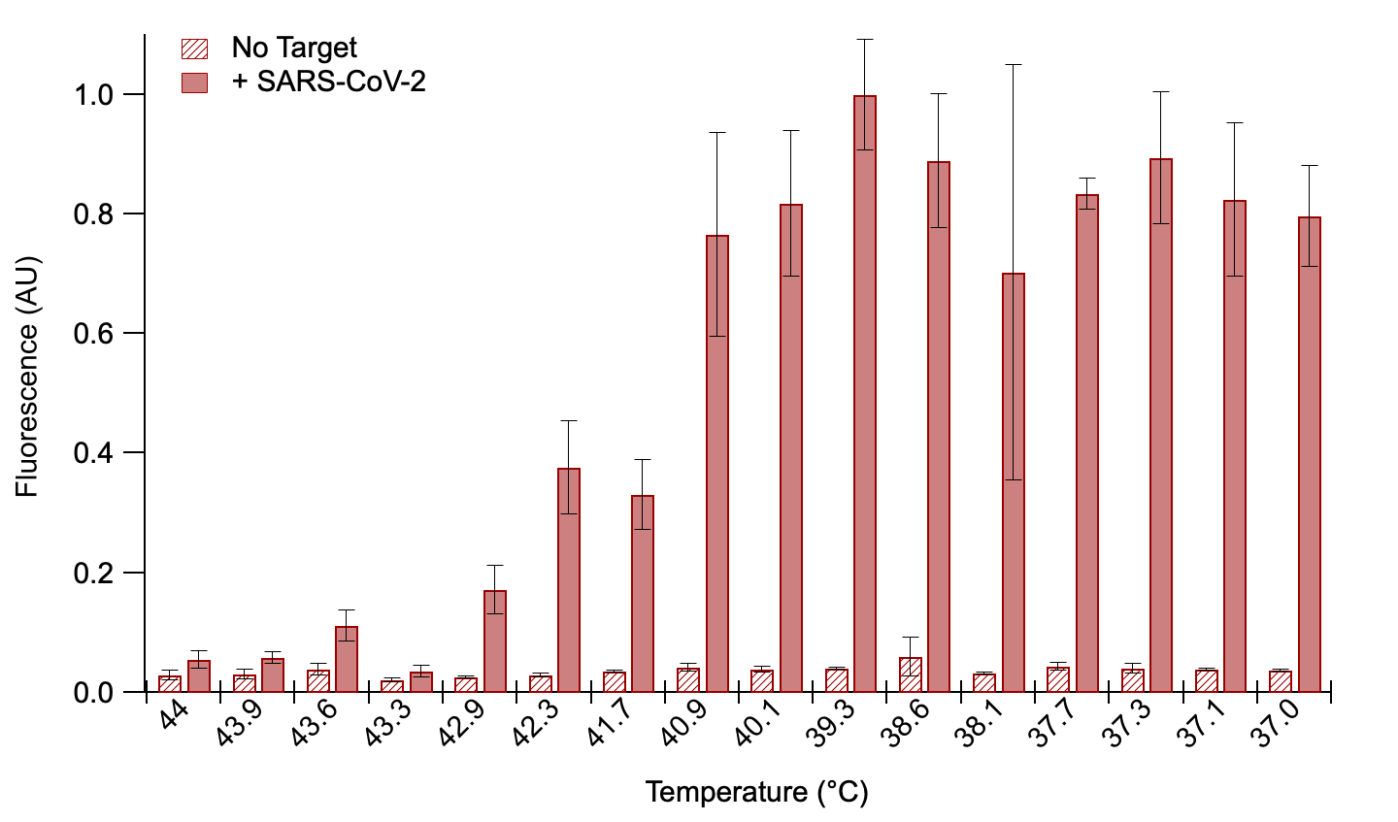

Figure S1. Reactions conducted in varying temperatures with or without SARS-CoV-2 target and monitored for Pepper aptamer fluorescence. Error bars represent S.E.M. where n = 3.

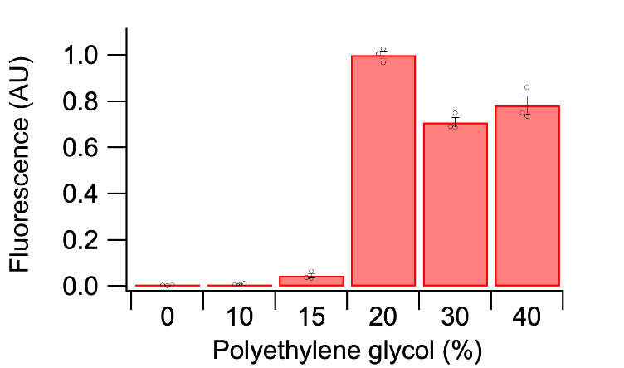

Figure S2. Reactions with varying concentrations of polyethylene glycol (PEG). PEG 20,000 was used for these reactions and reactions were carried out with SARS-Cov-2 Spike B.1.167 target and monitored for Pepper aptamer fluorescence. Individual data points for each replicate are shown as black circles. Error bars represent S.E.M. where n = 3.

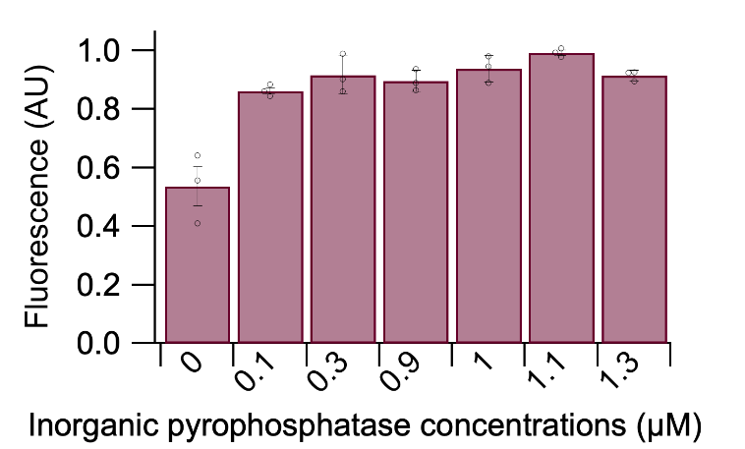

Figure S3. Reactions with varying concentrations of inorganic pyrophosphatase. Individual data points for each triplicate are shown as black circles. Error bars represent S.E.M. where n = 3.

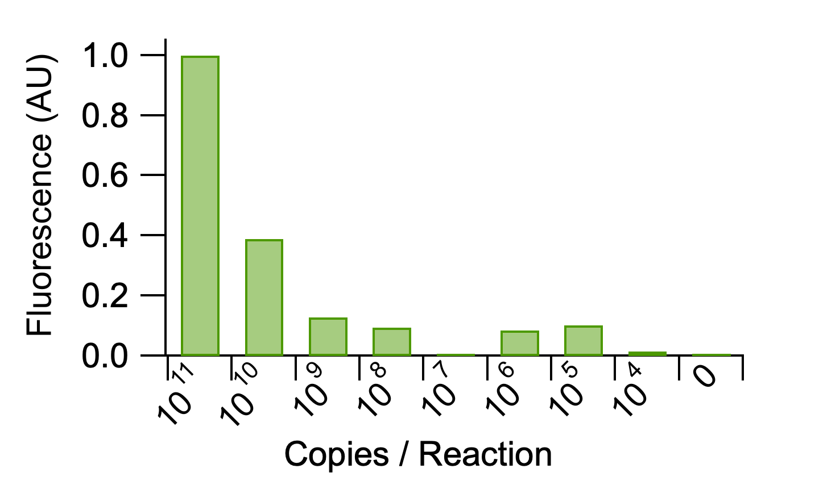

Figure S4. Testing the sensitivity of PACRAT with E. coli RNA target. Bar plot shows the normalized endpoint Broccoli aptamer fluorescence values for PACRAT reactions with different target copies of the AggR gene in E. coli.

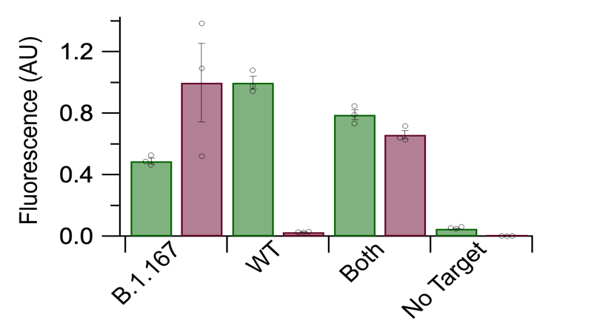
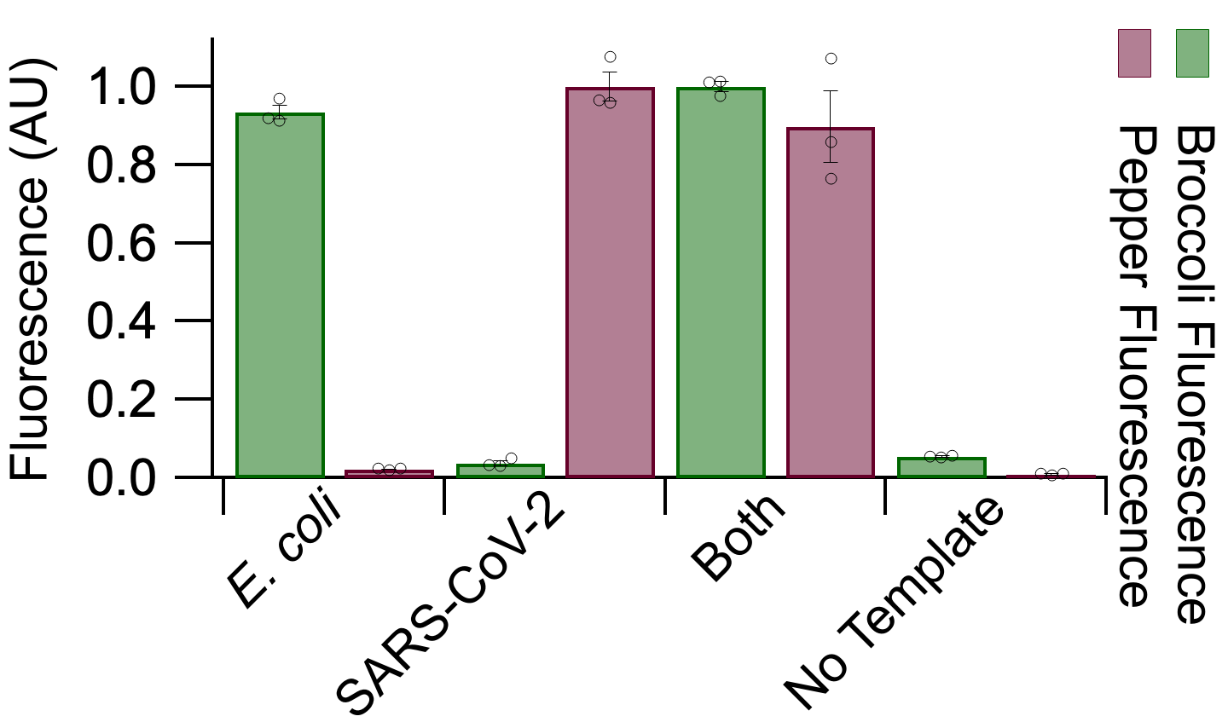
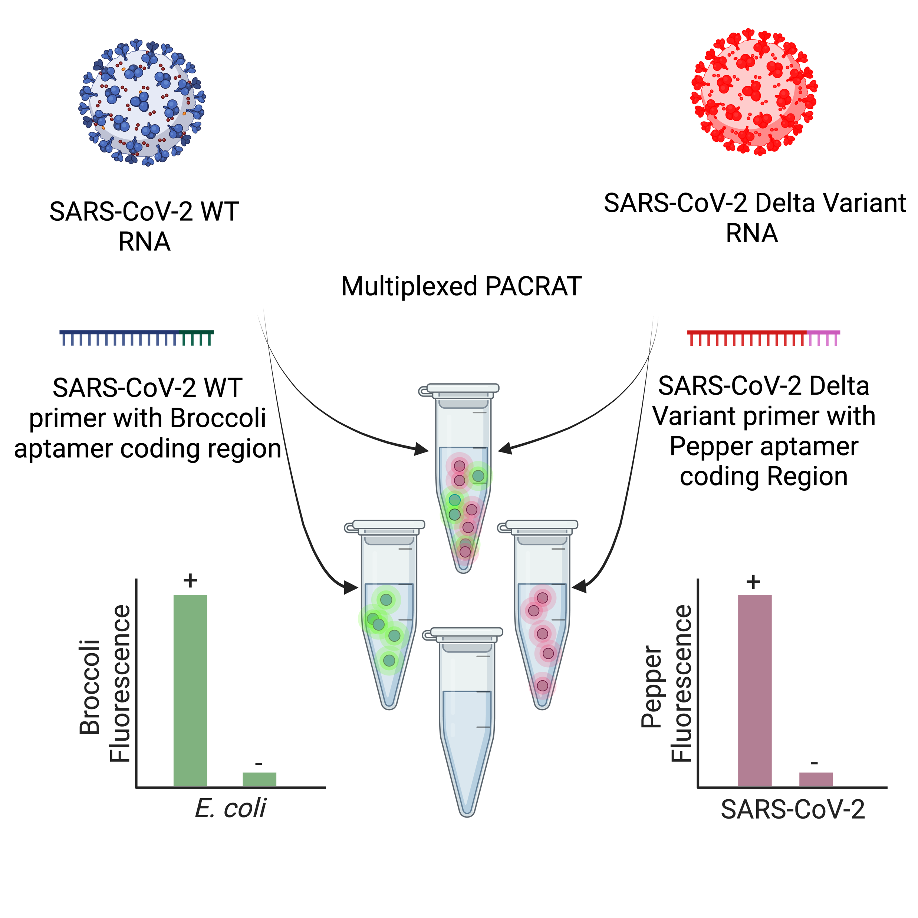
a
b

Figure S5. Dual detection of wild-type SARS-CoV-2 and Delta variant. a) Schematic of dual detection between wild-type SARS-CoV-2 and Delta variant. b) Normalized fluorescence endpoint values for Broccoli and Pepper aptamers in reactions with SARS-CoV-2 wild-type RNA target (WT) or SARS-CoV-2 Delta variant RNA target (B.1.167), both targets, or neither target. Individual data points for each triplicate are shown as black circles. Error bars represent S.E.M. where n = 3.

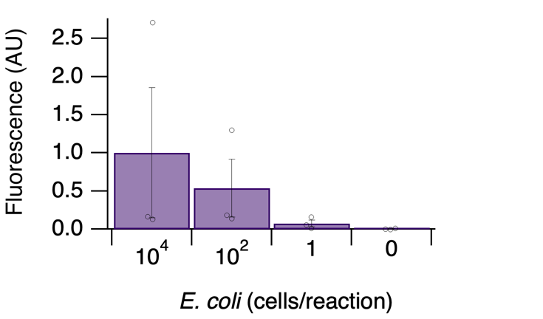
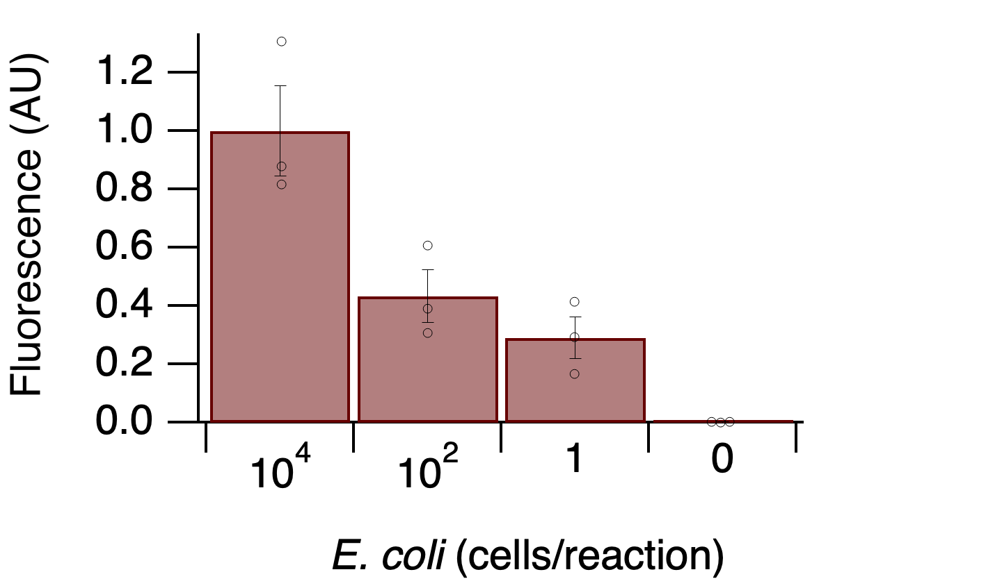
a
b

Figure S6. Testing the sensitivity of PACRAT for direct detection of E. coli cells. E. coli cell lysate was added to PACRAT reactions either after sonication and spin down (a) or without sonication and spin down (b). Individual data points for each triplicate are shown as black circles. Error bars represent S.E.M. where n = 3.

 | Pepper
PACRAT | Works the best
RNA product | 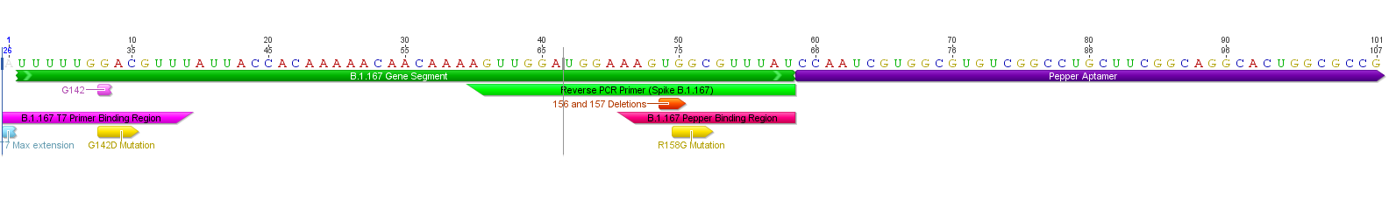  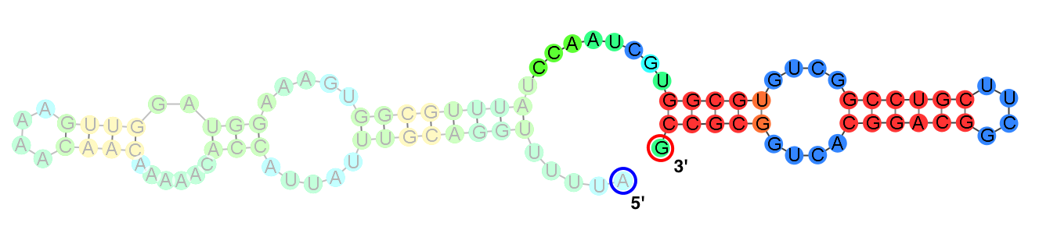
Interaction between aptamer primer and B.1.167 RNA | 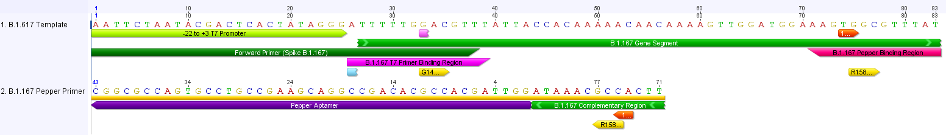  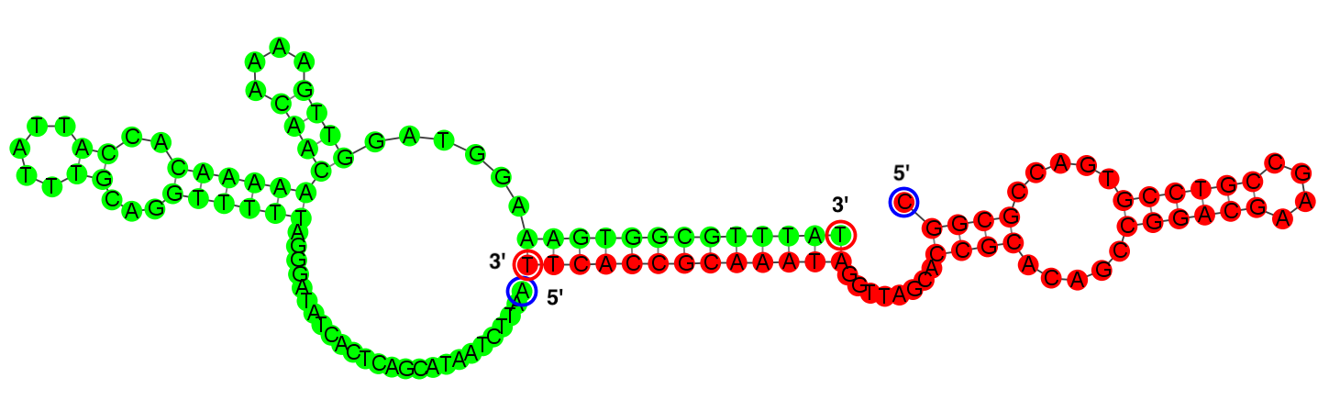
Interaction between T7 primer and B.1.167 RNA | 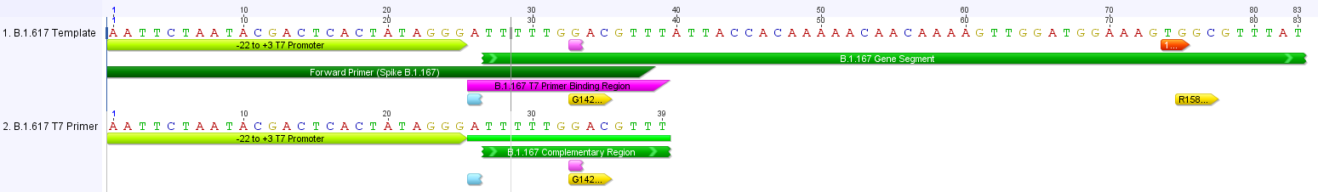  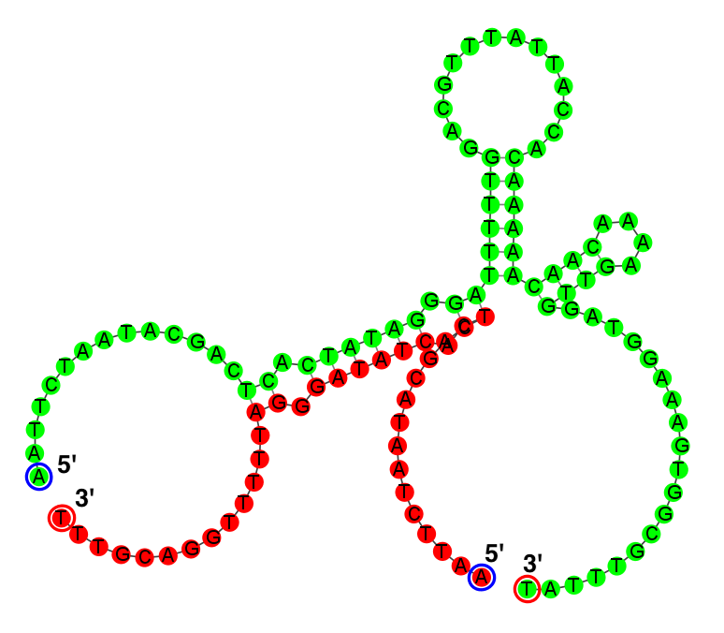
Interaction between aptamer primer and T7 primer | 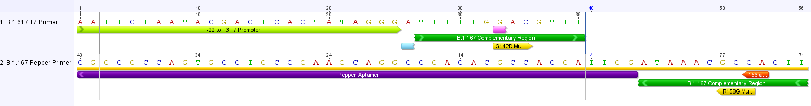  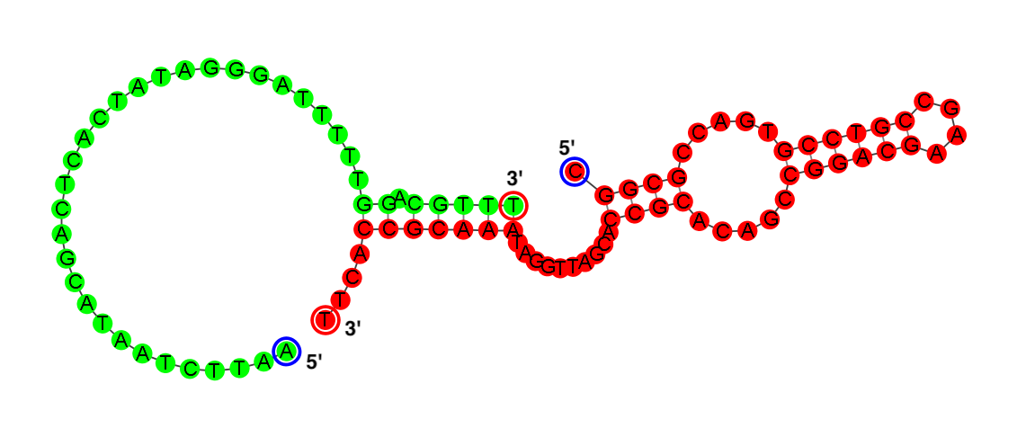
Interaction between aptamer primer and RNA product | 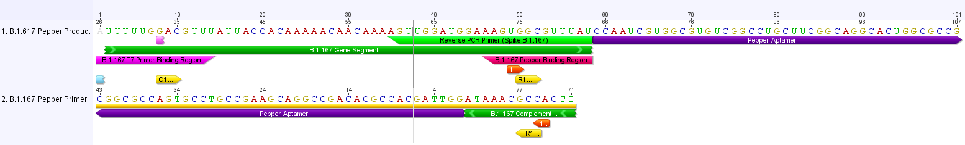  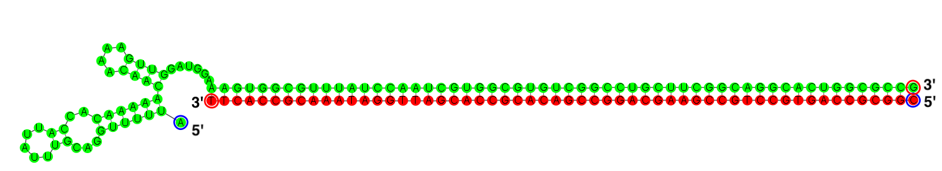
Interaction between T7 primer and product | 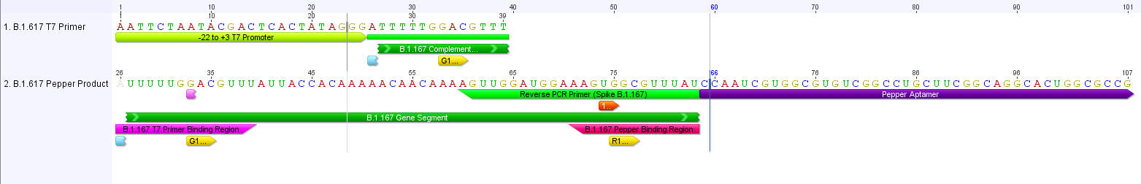  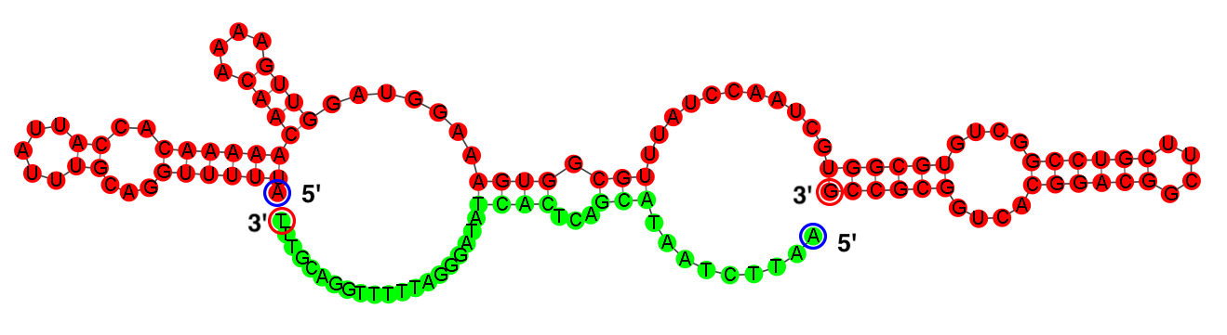
 | Corn
PACRAT | Works poorly
RNA product | 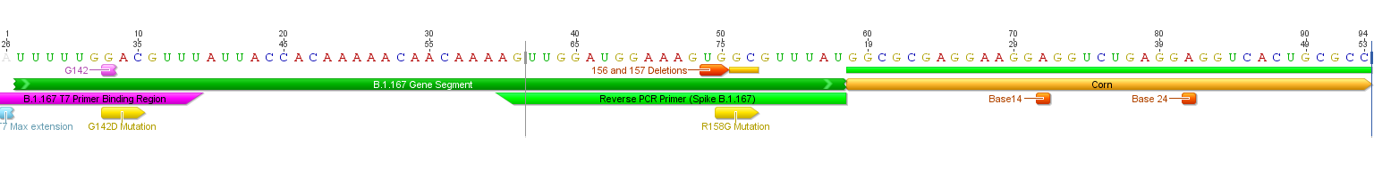  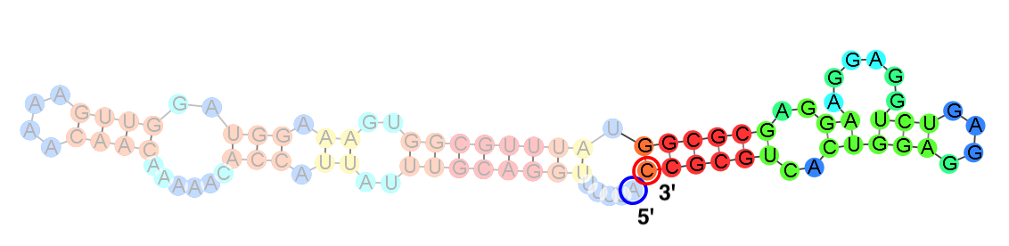
Interaction between aptamer primer and B.1.167 RNA | 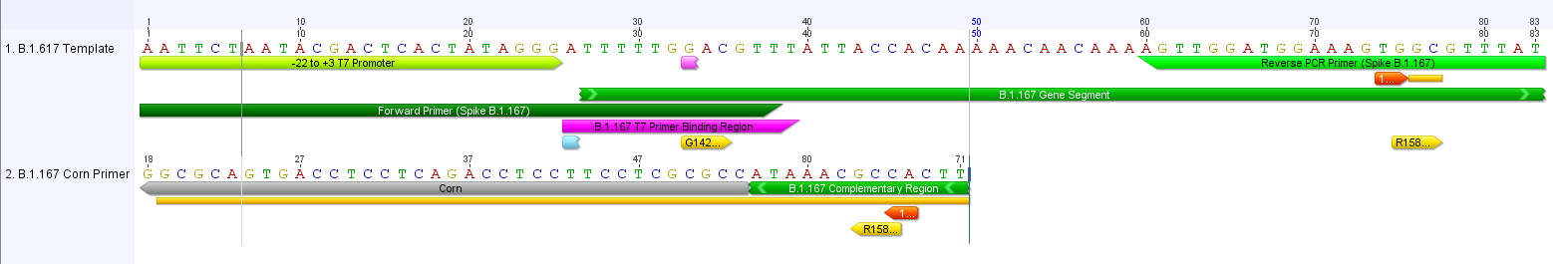  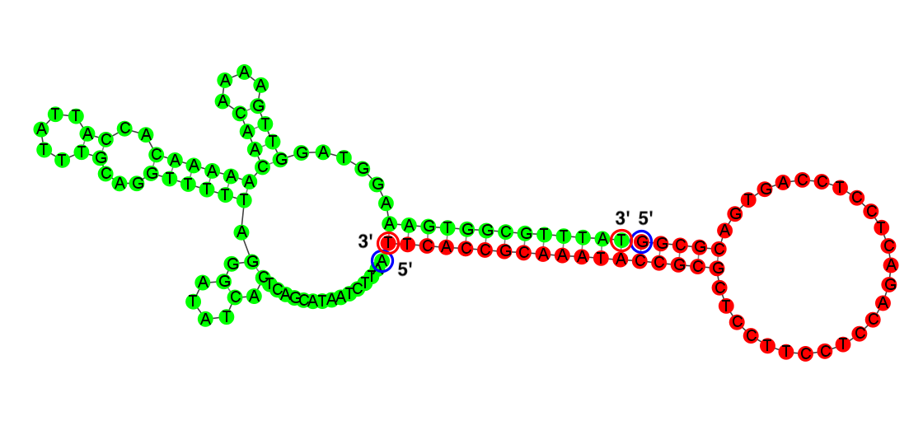
Interaction between T7 primer and B.1.167 RNA
Interaction between aptamer primer and T7 primer | 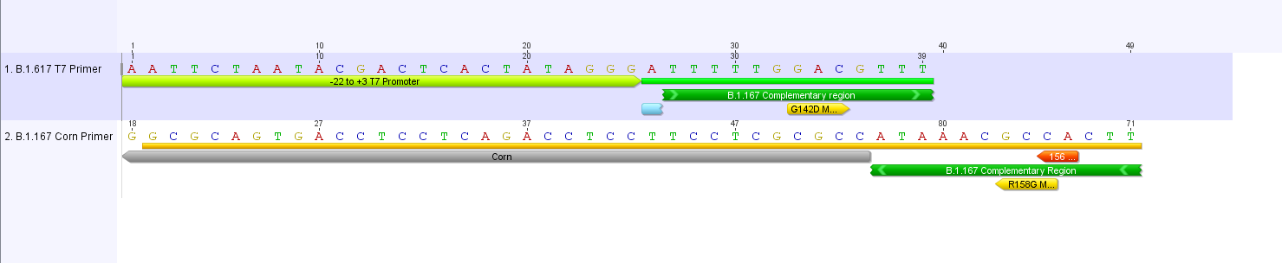  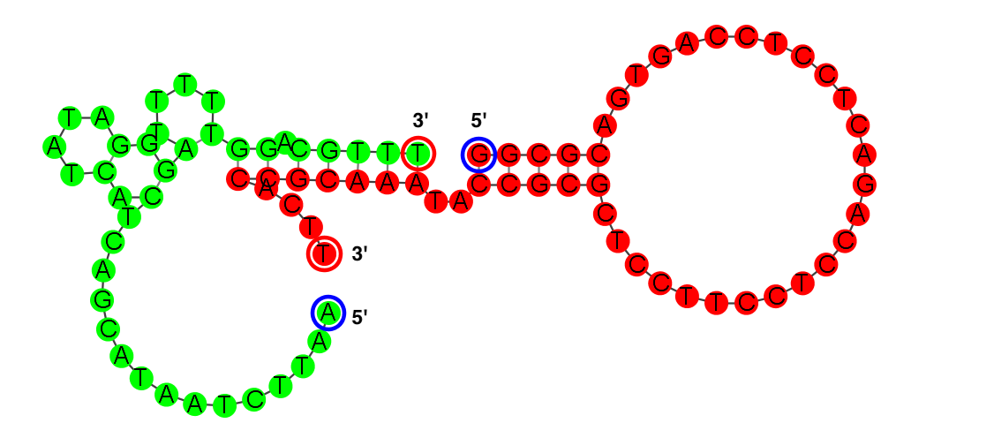
Interaction between aptamer primer and RNA product | 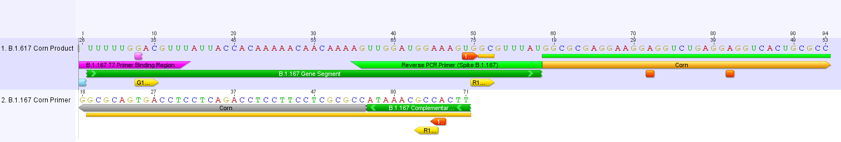  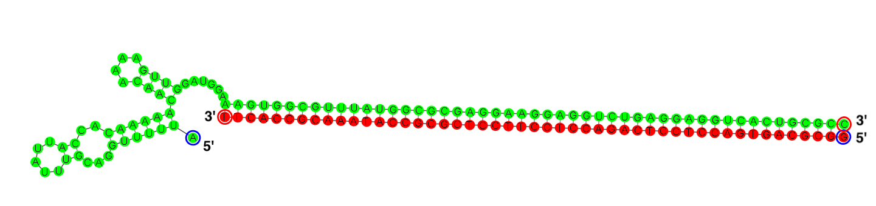
Interaction between T7 primer and product | 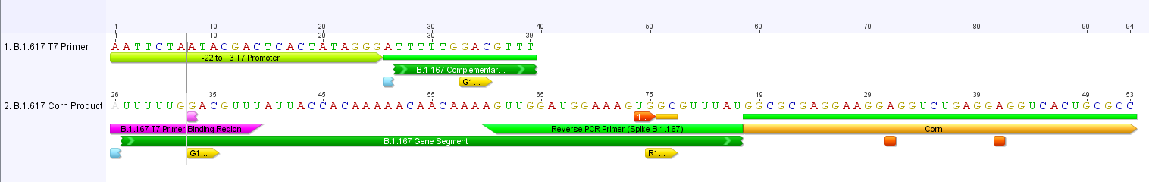  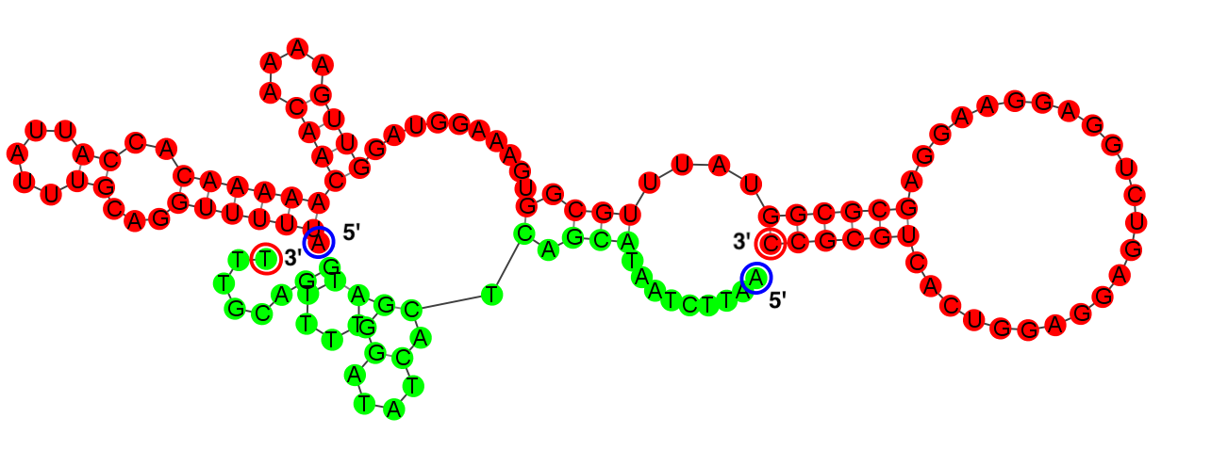
 | Broccoli
PACRAT | Does not work
RNA product | 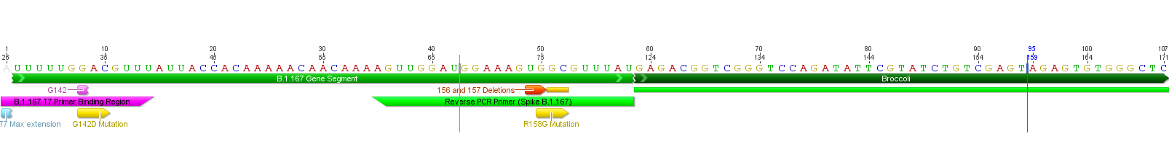  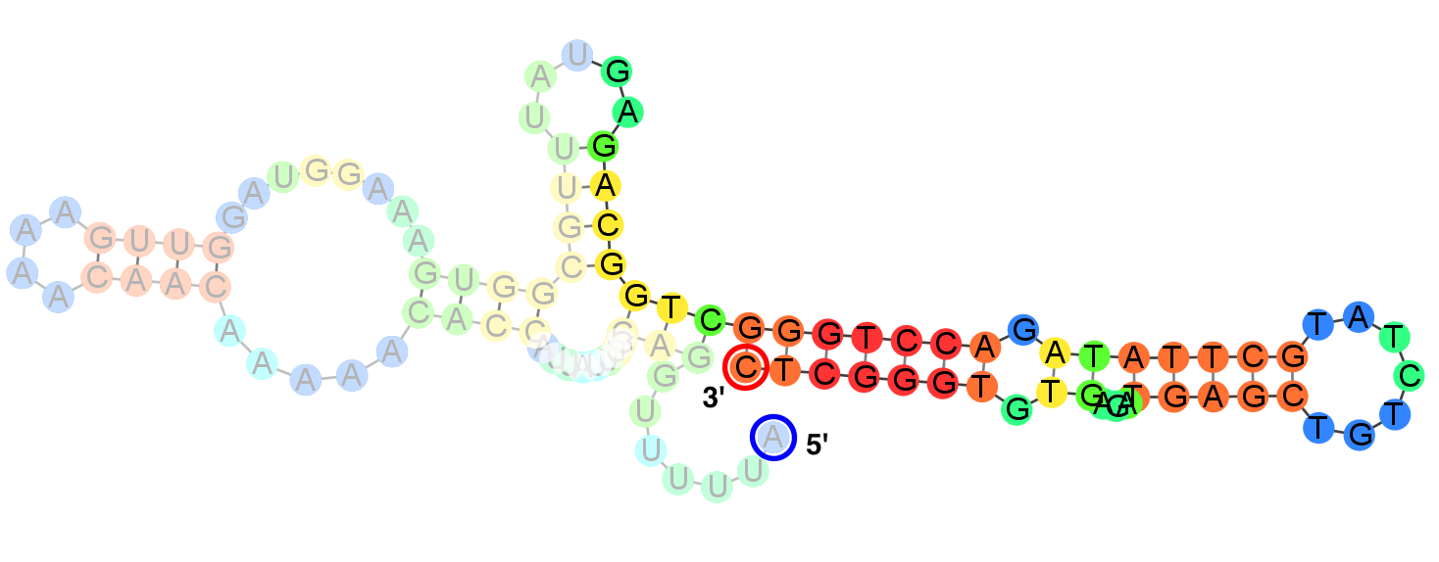
Interaction between aptamer primer and B.1.167 RNA | 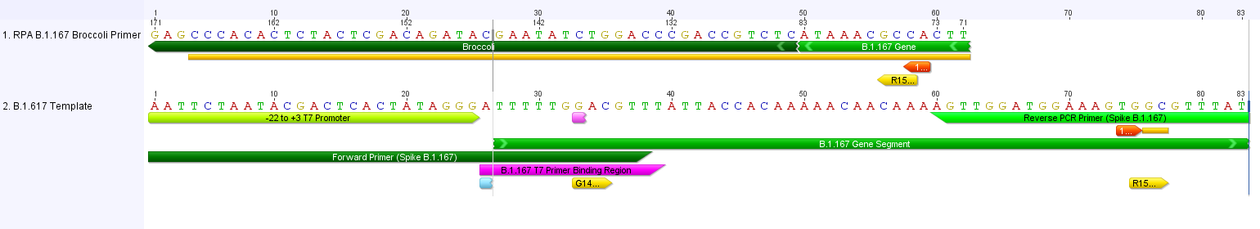  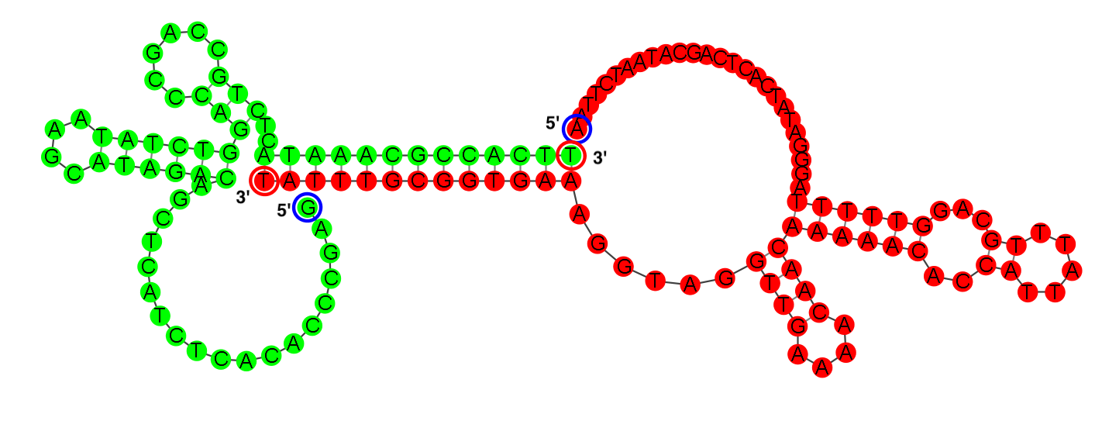
Interaction between T7 primer and B.1.167 RNA | 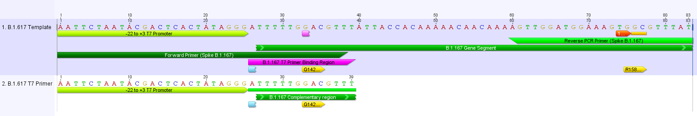
Interaction between aptamer primer and T7 primer | 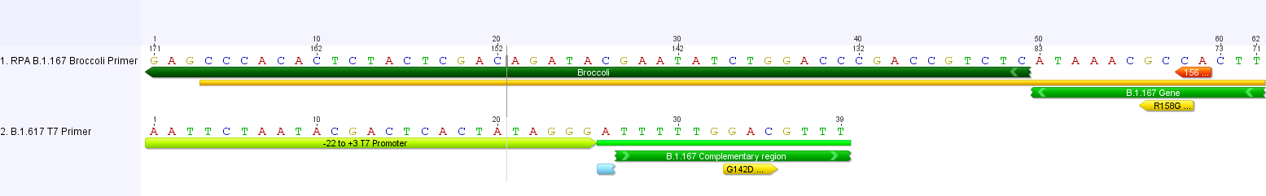  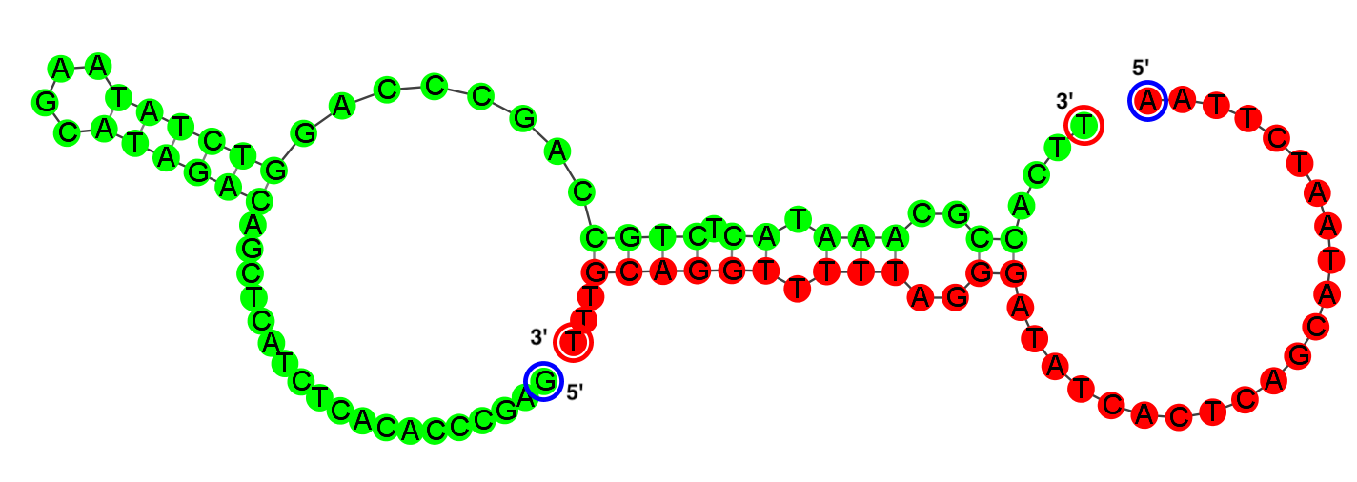
Interaction between aptamer primer and RNA product | 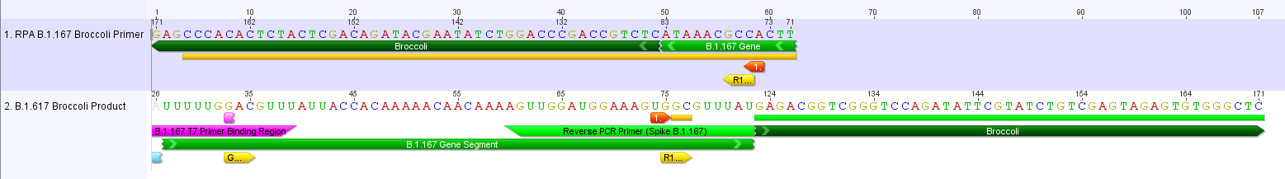  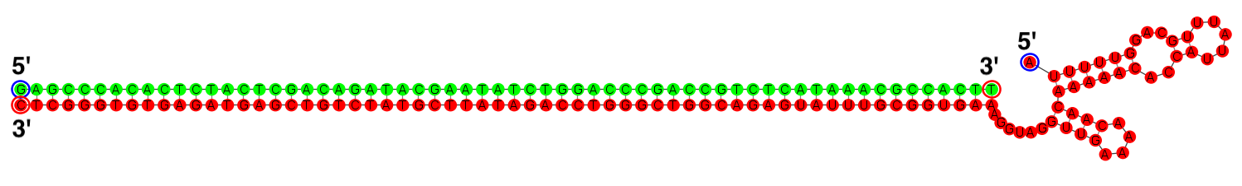
Interaction between T7 primer and product | 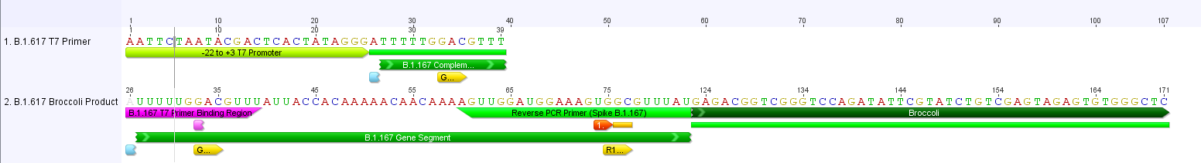  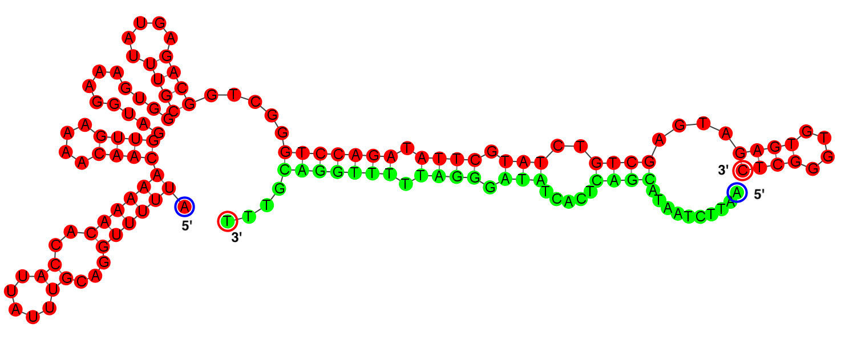

Figure S7. Scheme showing different folds predicted by Geneious bioinformatics software for PACRAT constructs employing different aptamers and SARS-CoV-2 B.1.167 RNA target. For PACRAT predicted products, bases are colored by base-pairing probabilities, where red: high, yellow/green: mid and blue: low probability. For interactions, sequence 1 is shown in green, while sequence 2 is shown in red. PACRAT real-time fluorescence results from these constructs are shown in Figure S8.

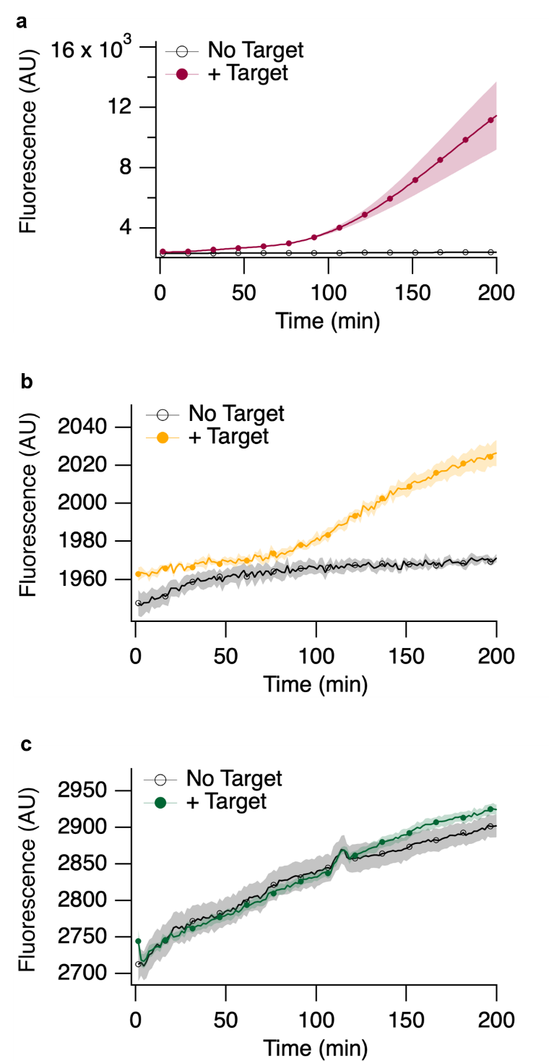

Figure S8. Real-time fluorescence curves from PACRAT reactions using different fluorescent aptamers (a) Pepper, (b) Corn, and (c) Broccoli with the same SARS-CoV-2 B.1.167 RNA target as shown in Figure S7 folding predictions. Shaded area represents S.E.M. where n = 3.

