Supplemental information

Cytosolic RNA binding of the mitochondrial TCA cycle enzyme malate dehydrogenase (MDH2)
Michelle Noble^{1,2}, Aindrila Chatterjee¹, Thileepan Sekaran¹, Thomas Schwarzl¹, and Matthias W. Hentze^{1*}
¹European Molecular Biology Laboratory (EMBL), Meyerhofstrasse 1, 69117, Heidelberg, Germany
²Collaboration for joint PhD degree between EMBL and Heidelberg University, Faculty of Biosciences, Germany
*To whom correspondence should be addressed

Supplemental figure 1:

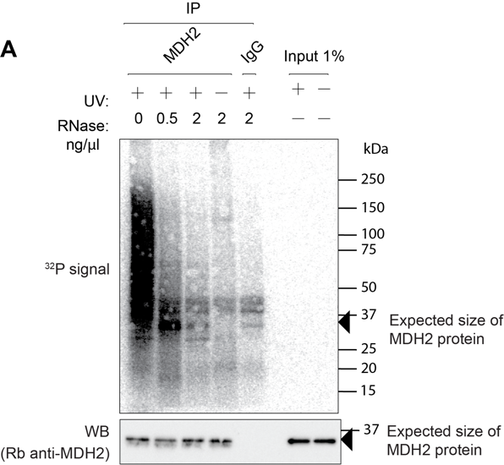
Supplementary figure 1. RNA binding of MDH2 measured by PNK assay from lysates of cells treated with or without UV (254 nm, 150 mJ/cm² energy) crosslinking. A specific signal for MDH2 was only observed in immunoprecipitations from UV-crosslinked lysates. Top panel shows the phosphor image to visualise end-labeled RNA co-purified with MDH2 and the bottom panel confirms equal IP efficiency.

Supplemental figure 2:

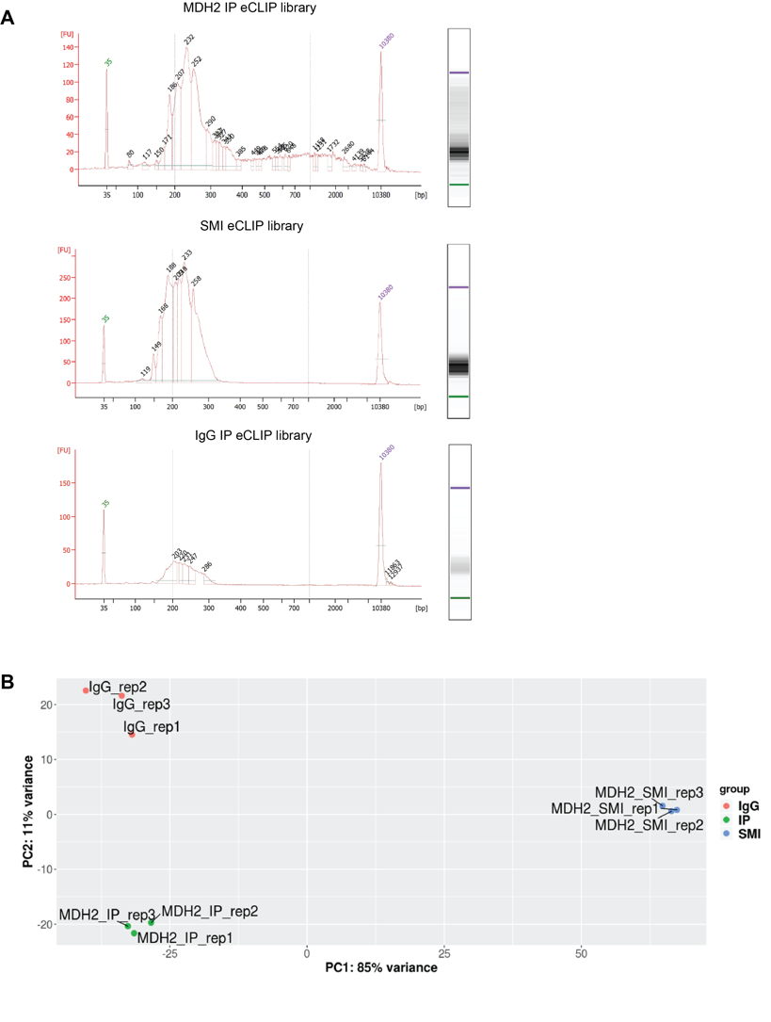
Supplementary figure 2. (A) Bioanalyzer traces of the pooled replicates of MDH2 IP, SMI and IgG IP eCLIP libraries to analyse library size distribution. (B) PCA plot of eCLIP libraries to assess the variability between replicates and samples.

Supplemental figure 3:

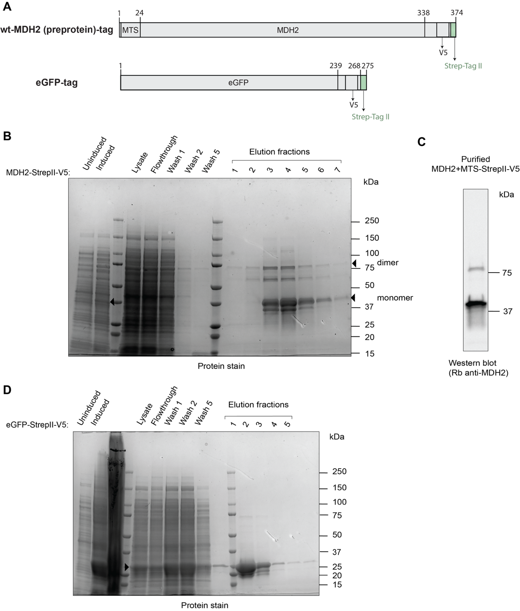
Supplementary figure 3. Protein purification for EMSA. (A) Schematic of constructs used for protein purification. (B) Purification of the FL-MDH2 (Full-length MDH2) construct. Arrows mark the bands at the expected molecular mass of FL-MDH2 (monomer and potential dimer). The prominent bands just below the arrows could be bacterial MDH. Mass spectrometry analysis confirms that bacterial MDH was copurified with human FL-MDH2. (C) Western blot analysis of purified MDH2. (D) Purification of eGFP.
Supplemental figure 4:
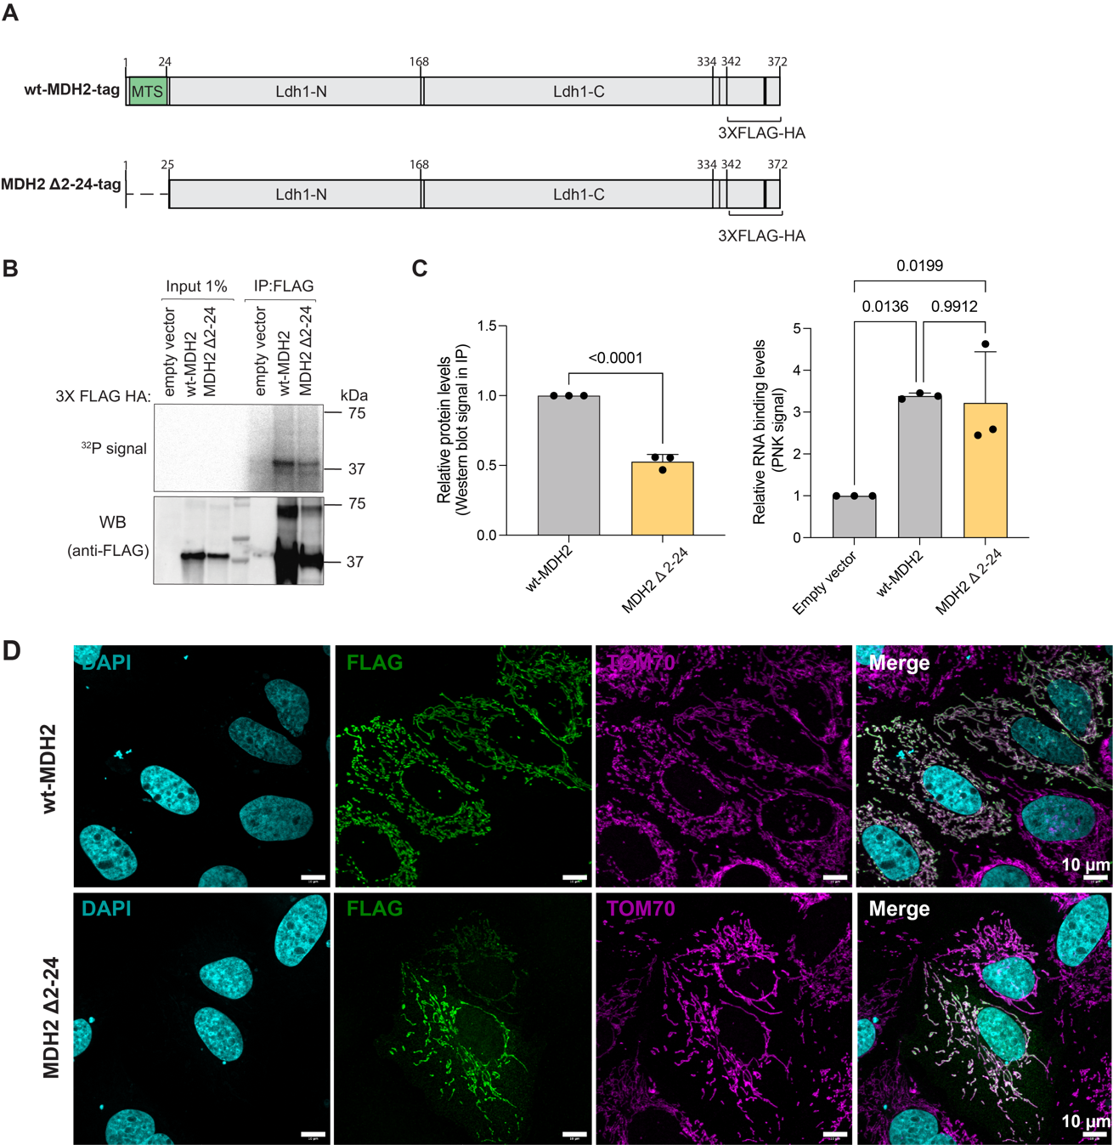
Supplementary figure 4. Canonical MTS is dispensable for RNA binding. (A) Schematic of the wt-MDH2 construct and MDH2 Δ2-24 construct (B) PNK assay comparing levels of RNA bound by wt-MDH2 and MDH2 Δ2-24 (C) Quantification of immunoprecipitated protein amounts and PNK signal. Data reported as mean ± S.D, number of experiments, n=3, p value reported as the results of an unpaired two-tailed t-test for the protein levels and of an ordinary one-way ANOVA with Tukey’s multiple comparison test correction for PNK signals. (D) Confocal immunofluorescence images showing staining of wt-MDH2 and MDH2 Δ2-24 (using FLAG tag) and an outer mitochondrial membrane marker, Tom70. Images are maximum intensity projections of Z- stack images.

