Supplementary material

for

NMR characterization and ligand binding site of the stem loop 2 motif (s2m) from the Delta variant of SARS-CoV-2

Tobias Matzel^{1,‡}, Maria Wirtz Martin^{1,‡}, Alexander Herr, Anna Wacker¹, Christian Richter¹, Sridhar Sreeramulu¹ and Harald Schwalbe^{1,*}
¹ Institute for Organic Chemistry and Chemical Biology
Center for Biomolecular Magnetic Resonance (BMRZ)
Goethe-Universität Frankfurt
Max-von-Laue-Str. 7, 60438 Frankfurt (Germany)
‡Authors contributed equally
*To whom correspondence should be addressed. Tel: +496979829737; Fax: +496979827915; Email: schwalbe@nmr.uni-frankfurt.de
Short title: NMR Characterization of SCoV-2 s2m Delta
Keywords: Covid-19, s2m, NMR assignment, NMR dynamics, ligand screening

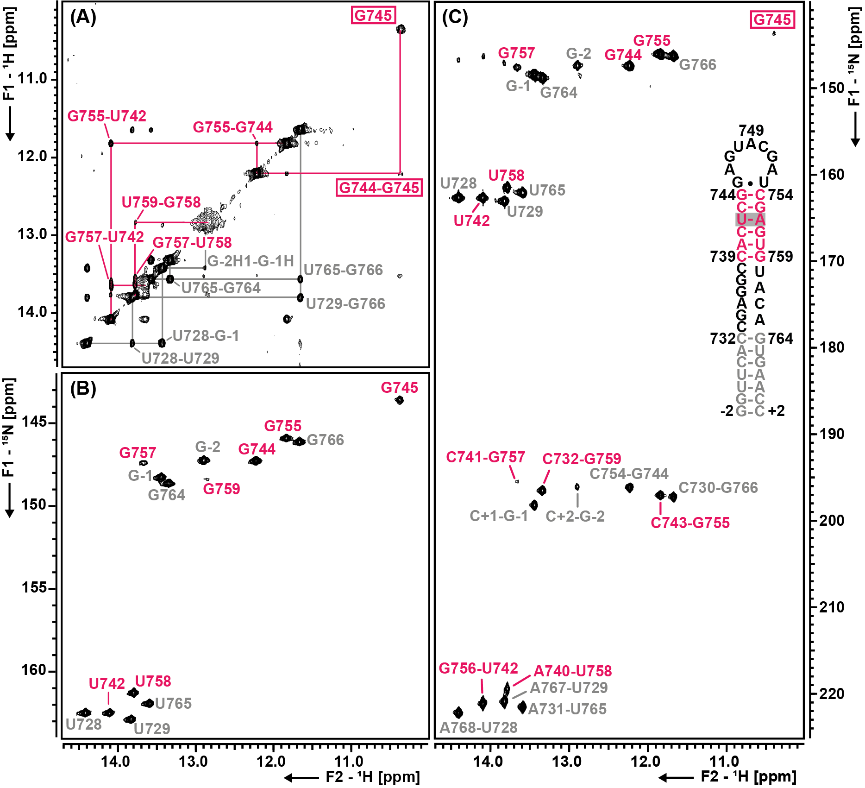
Supplementary Figure S1. Imino assignment of s2m Delta at 283 K. The assignment is annotated in each spectrum. The notation of nucleotides equals the position in the genome -29000. Artificial G-C base pairs are annotated as G-1/2 or C+1/2 respectively. Nucleotides labeled in grey belong to the lower stem and nucleotides labeled in magenta belong to the upper stem. (A) ¹H, ¹H NOESY spectrum of the imino proton region. (B) ¹H, ¹⁵N BEST-TROSY of the base-paired region of s2m Delta. (C) HNN-COSY spectrum showing correlations across hydrogen bonds (H1/H3 G/U to N3/N1 C/A) of base-paired nucleotides. A schematic representation of the secondary structure is given on the right.
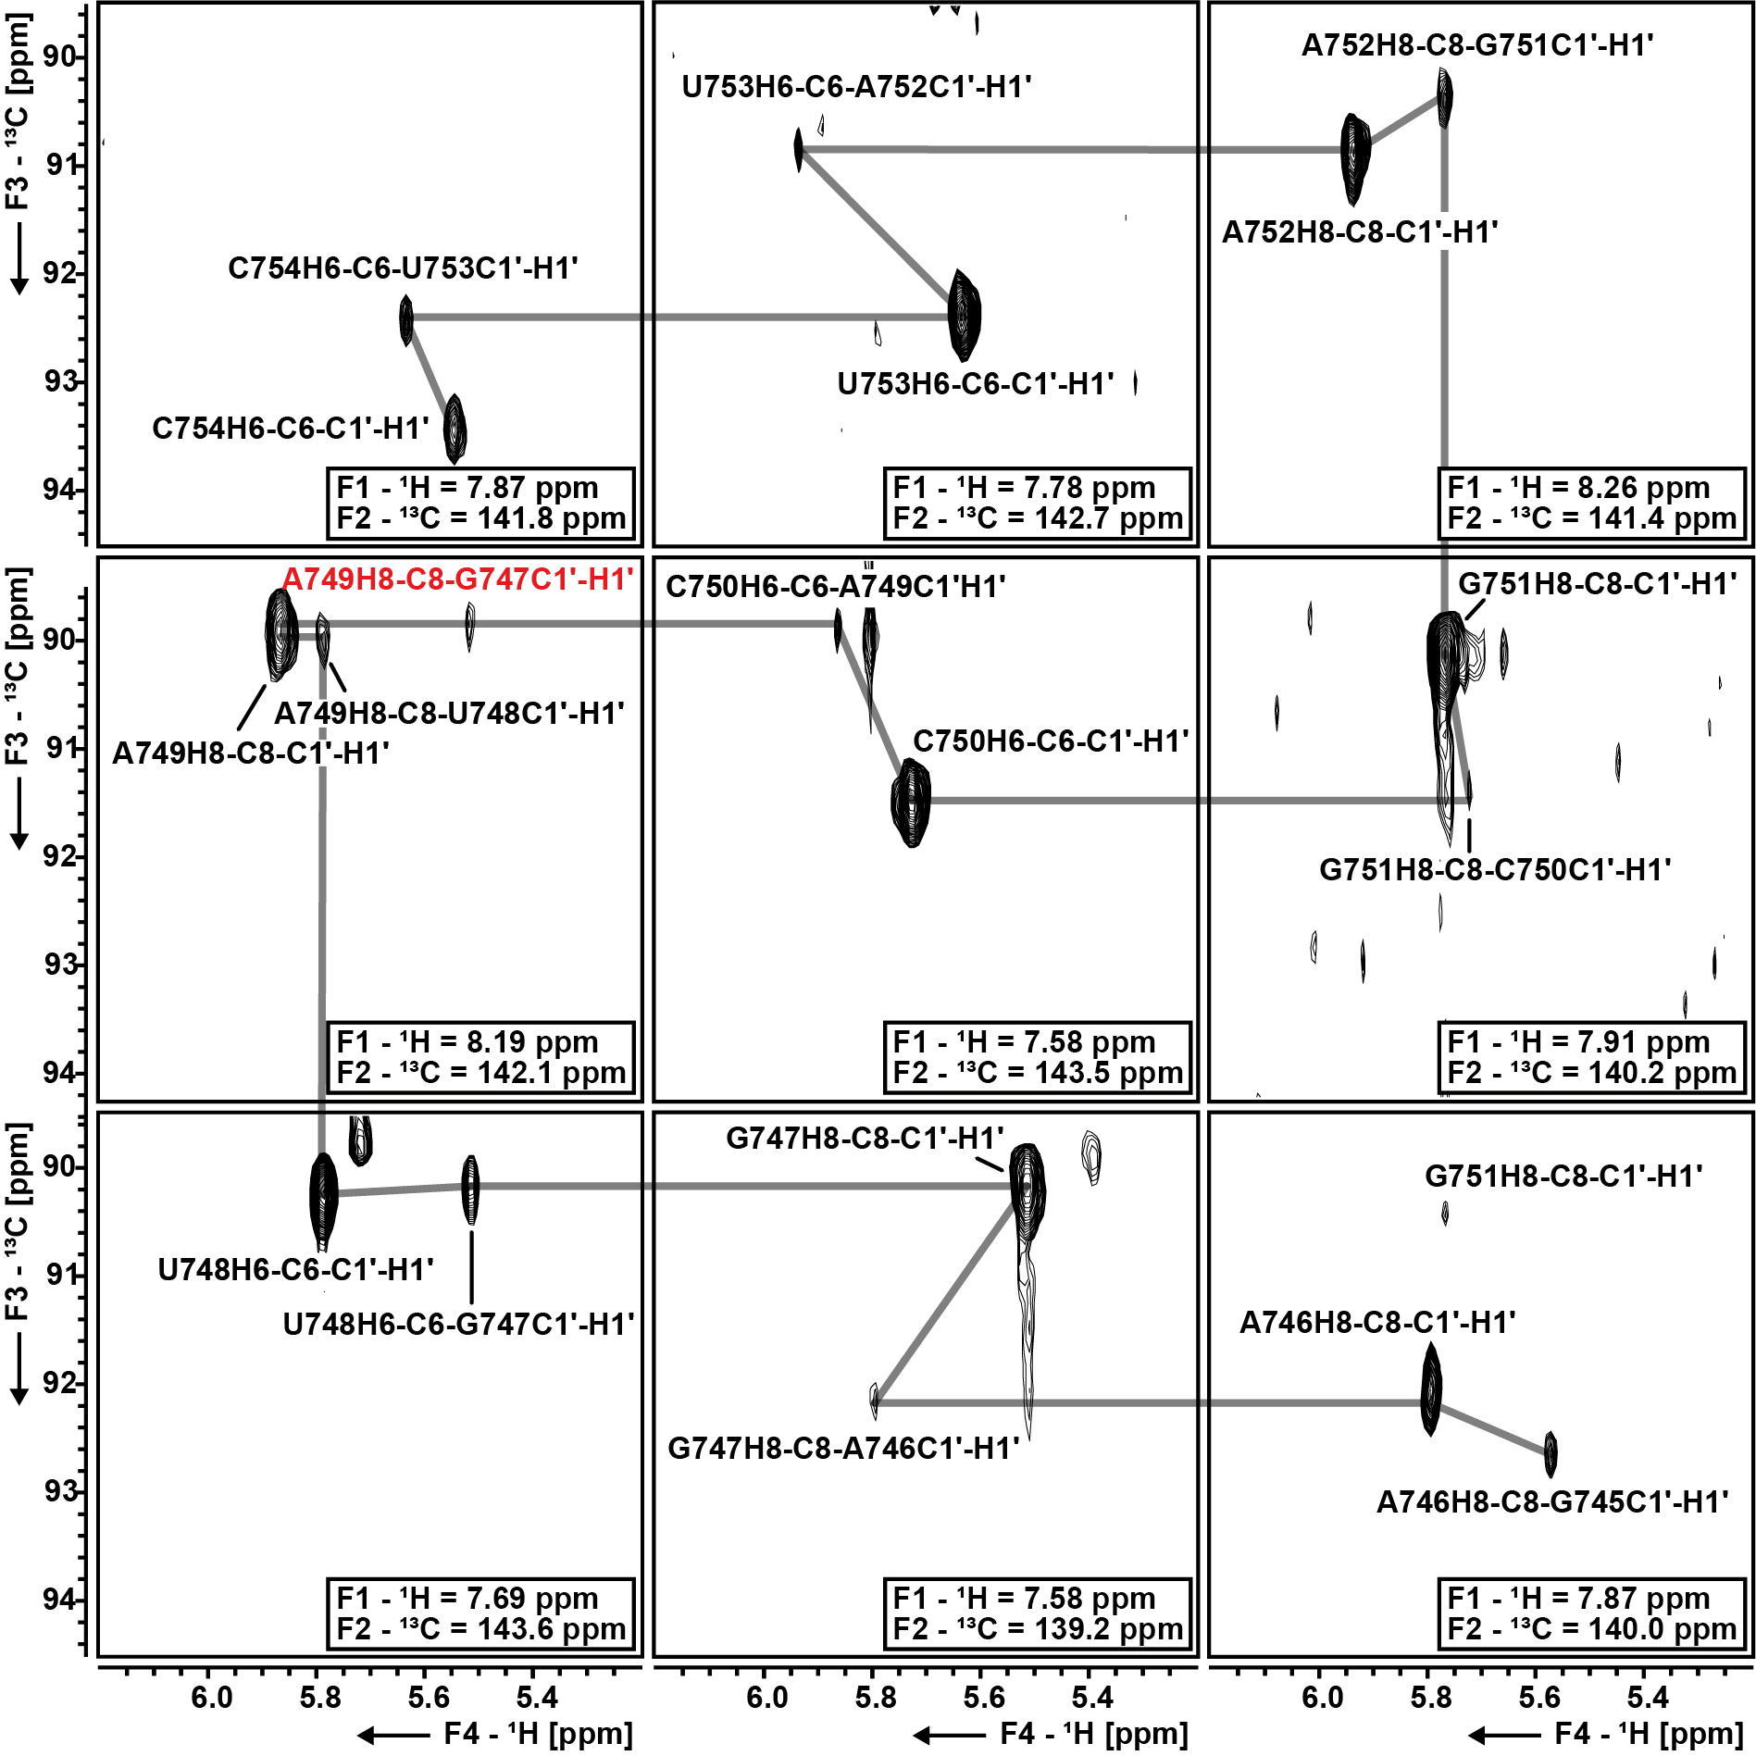
Supplementary Figure S2. 4D HMQC-NOESY-HMQC planes corresponding to the loop nucleotides of s2m Delta. By subsequently looking at the HSQC like 2D planes of the 4D in the H1’C1’ dimension a NOESY walk is possible. Starting from an aromatic signal of a specific nucleotide (i) peaks are visible for the H1’C1’ resonance corresponding to the same nucleotide and to the previous nucleotide (i-1). By going through the planes from 3’ to 5’ direction a sequential assignment is facilitated. The resonance assignment of all nucleotides is annotated and the H6C6/H8C8 aromatic chemical shift that leads to the shown planes is shown in the lower right corner of each spectrum. The notation of nucleotides corresponds to the position in the genome -29000.
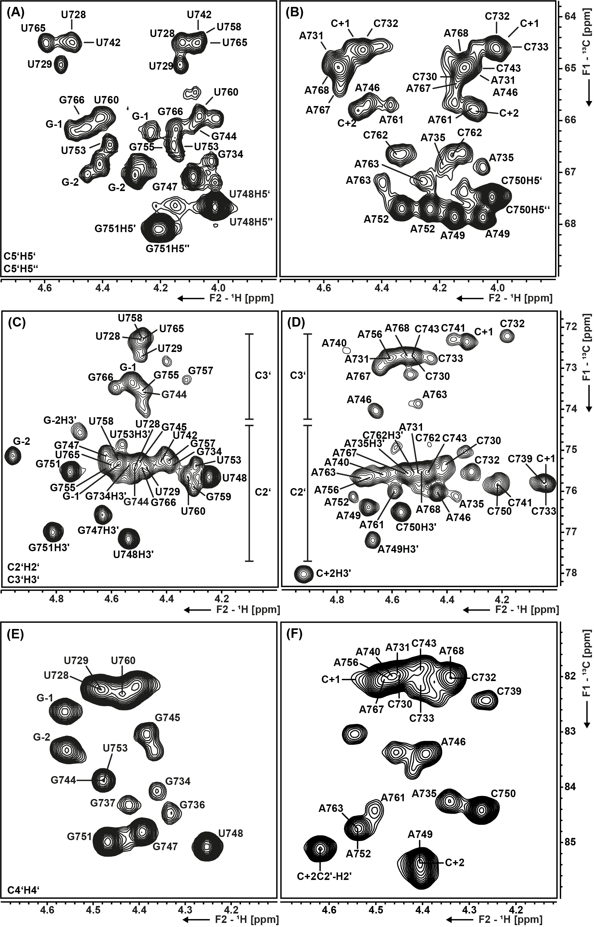
Supplementary Figure S3. Constant time HSQCs of the C2’-C5’ ribose region of s2m Delta. Spectra were recorded with selectively ¹³C, ¹⁵N labeled samples (GU and AC labeled). The assignment is annotated. The notation of nucleotides equals the position in the genome -29000. Artificial G-C base pairs are annotated as G-1/2 or C+1/2 respectively. (A), (C) and (E) correspond to the GU labeled sample and (B), (D) and (F) to the AC labeled sample.

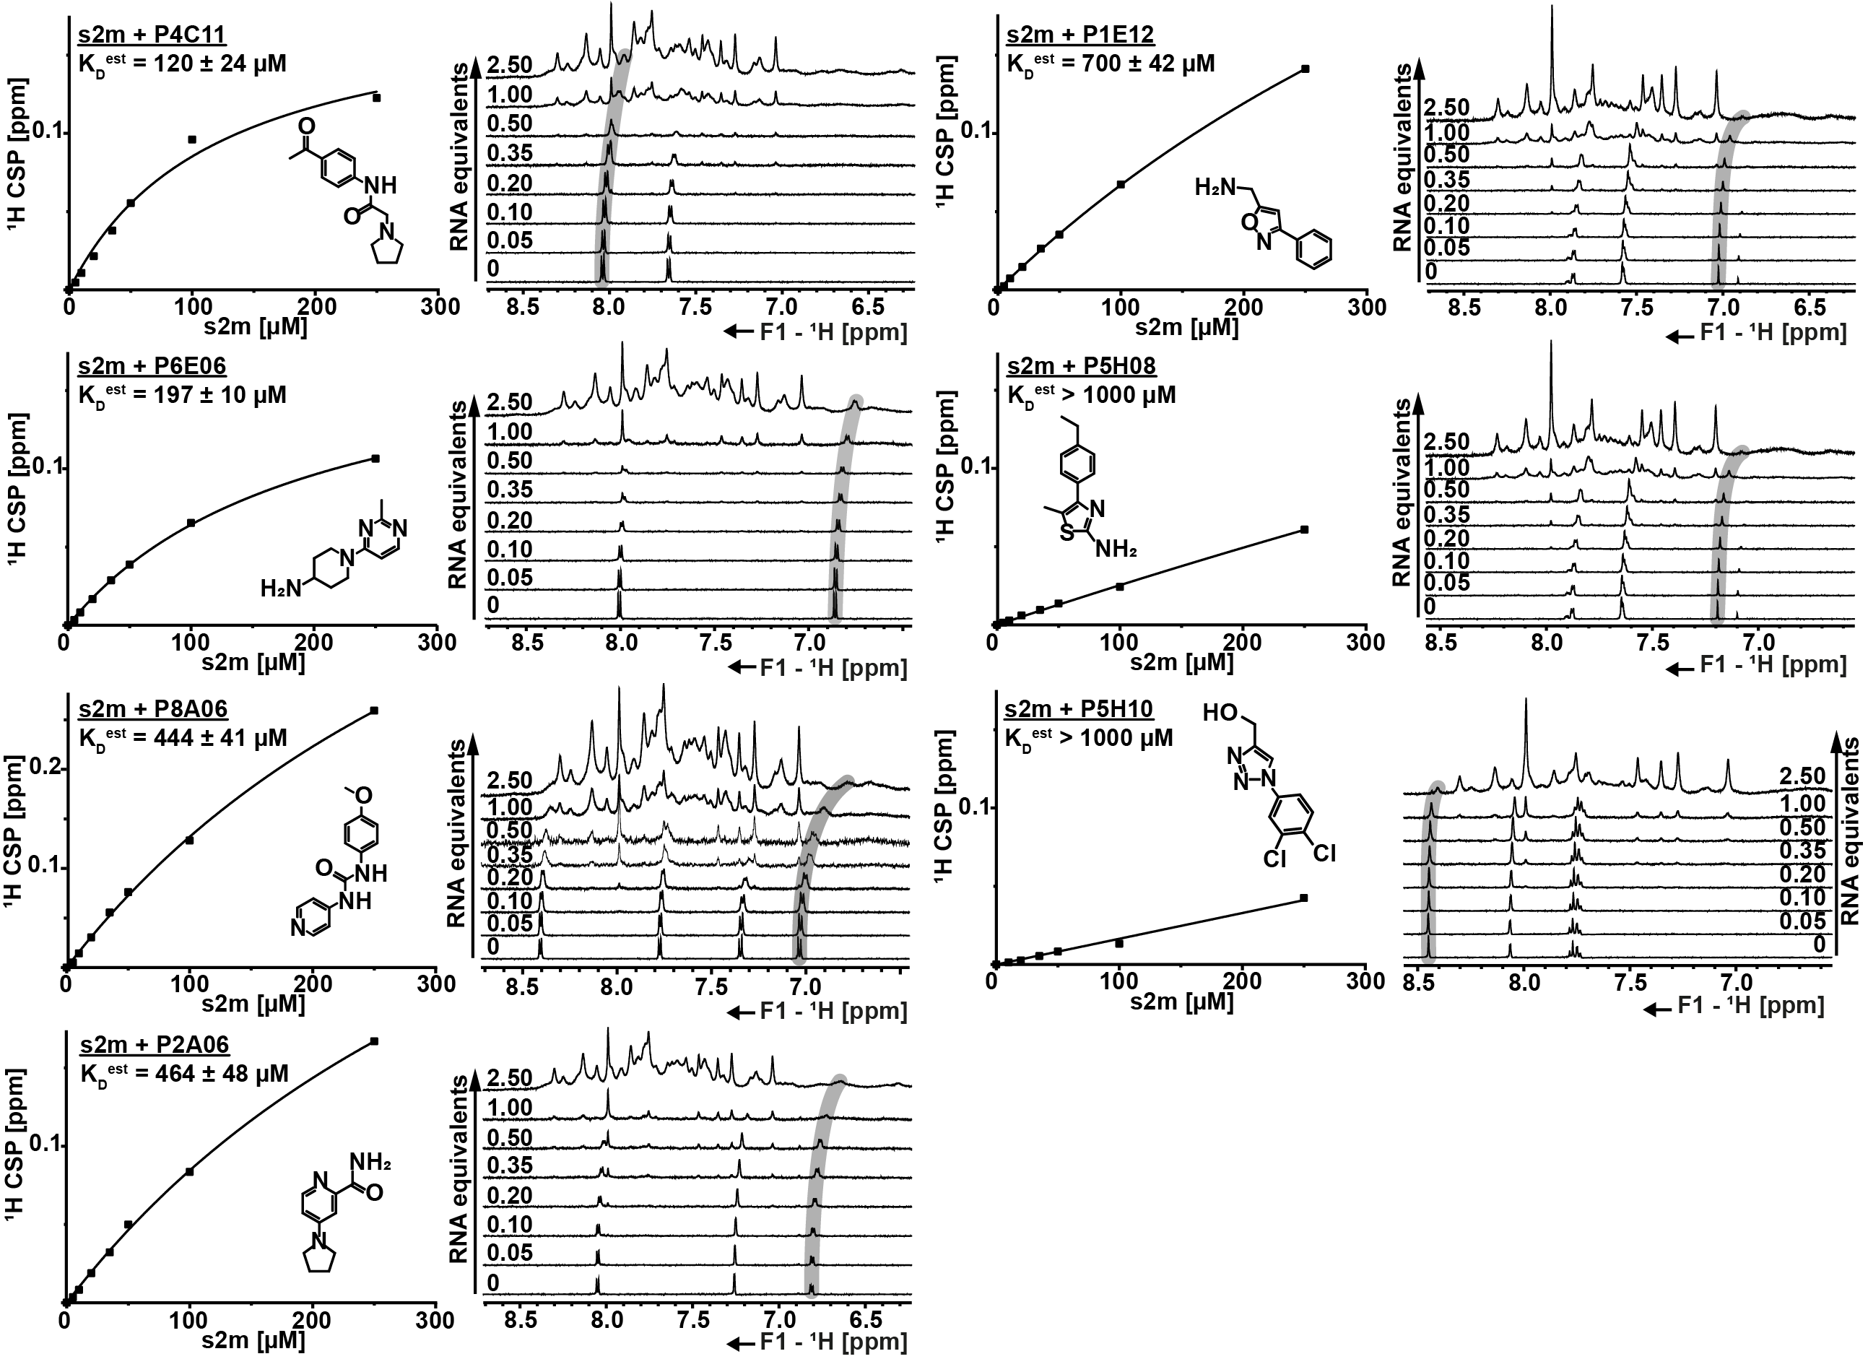

Supplementary Figure S4. ¹H-1D Titration experiments with fixed ligand concentrations (100 µM) and increasing RNA concentrations (0-250 µM). For each ligand the CSP is plotted against the RNA concentration and K_{D}^{est} values were determined using a Michaelis Menten fit (left side). The structural formula of each ligand is given next to its fitting curve. The corresponding 1D spectra are shown to the right of each graph. RNA concentrations are annotated.

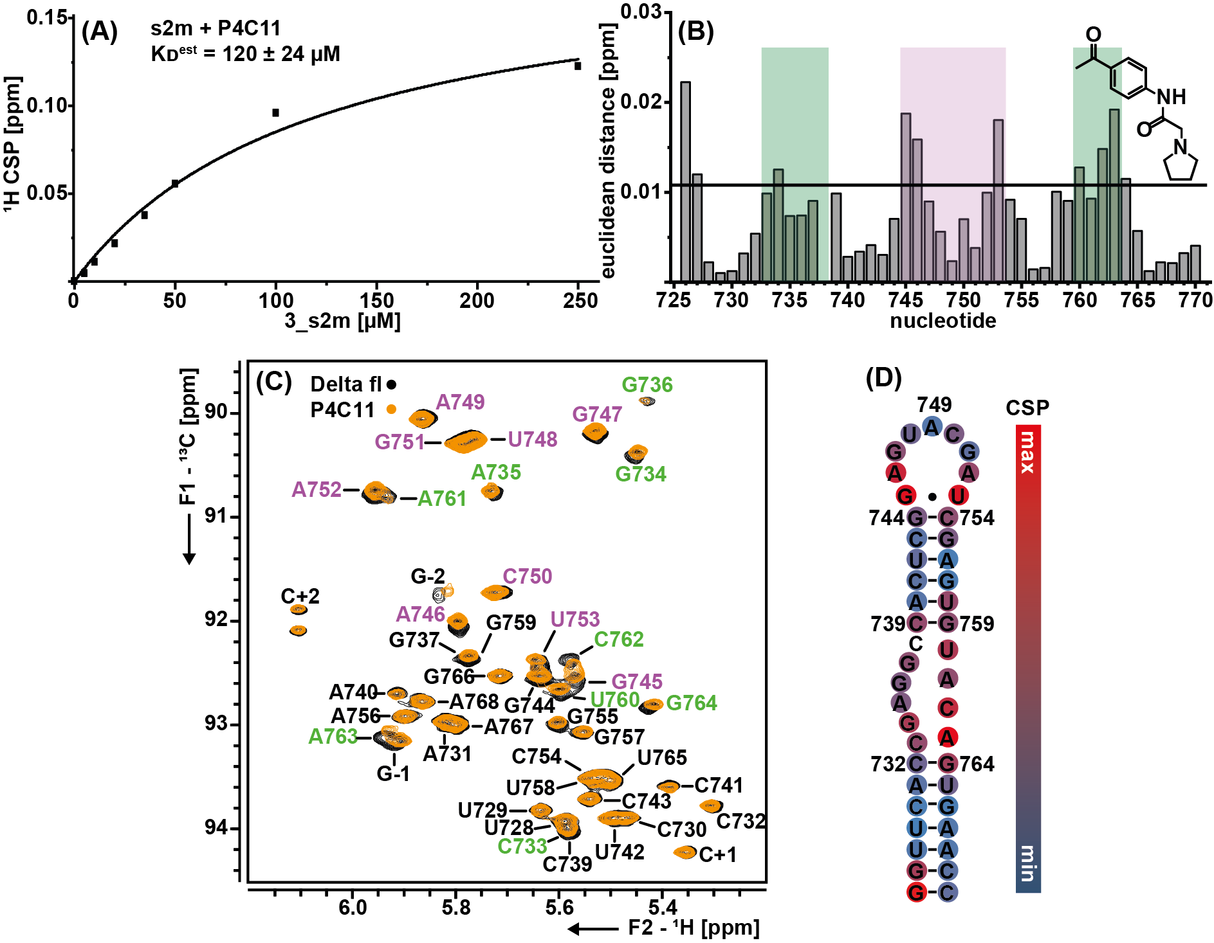
Supplementary Figure S5. (A) Determination of estimated K_{D} (K_{D}^{est}) via ligand detected ¹H-1D NMR titration. (B) RNA based euclidean distance plot to determine the binding site of P4C11 to s2m Delta. The structural formular of the ligand is shown on the right. Internal loop residues are highlighted in green and loop residues are highlighted in magenta. A threshold of twofold the standard deviation was used. (C) ¹H, ¹³C HSQC spectra of the aromatic region of s2m (100 µM) with 0 µM (black) and 500 µM (yellow) P4C11. Resonance assignments are annotated and the notation of nucleotides corresponds to the position in the genome -29000. Loop resonances are labeled in magenta and internal loop resonances are labeled in green. (D) Secondary structure of s2m Delta colored with HSQC based CSP heatmap (strong: red, weak; blue) while red corresponds to the maximum CSP detected.
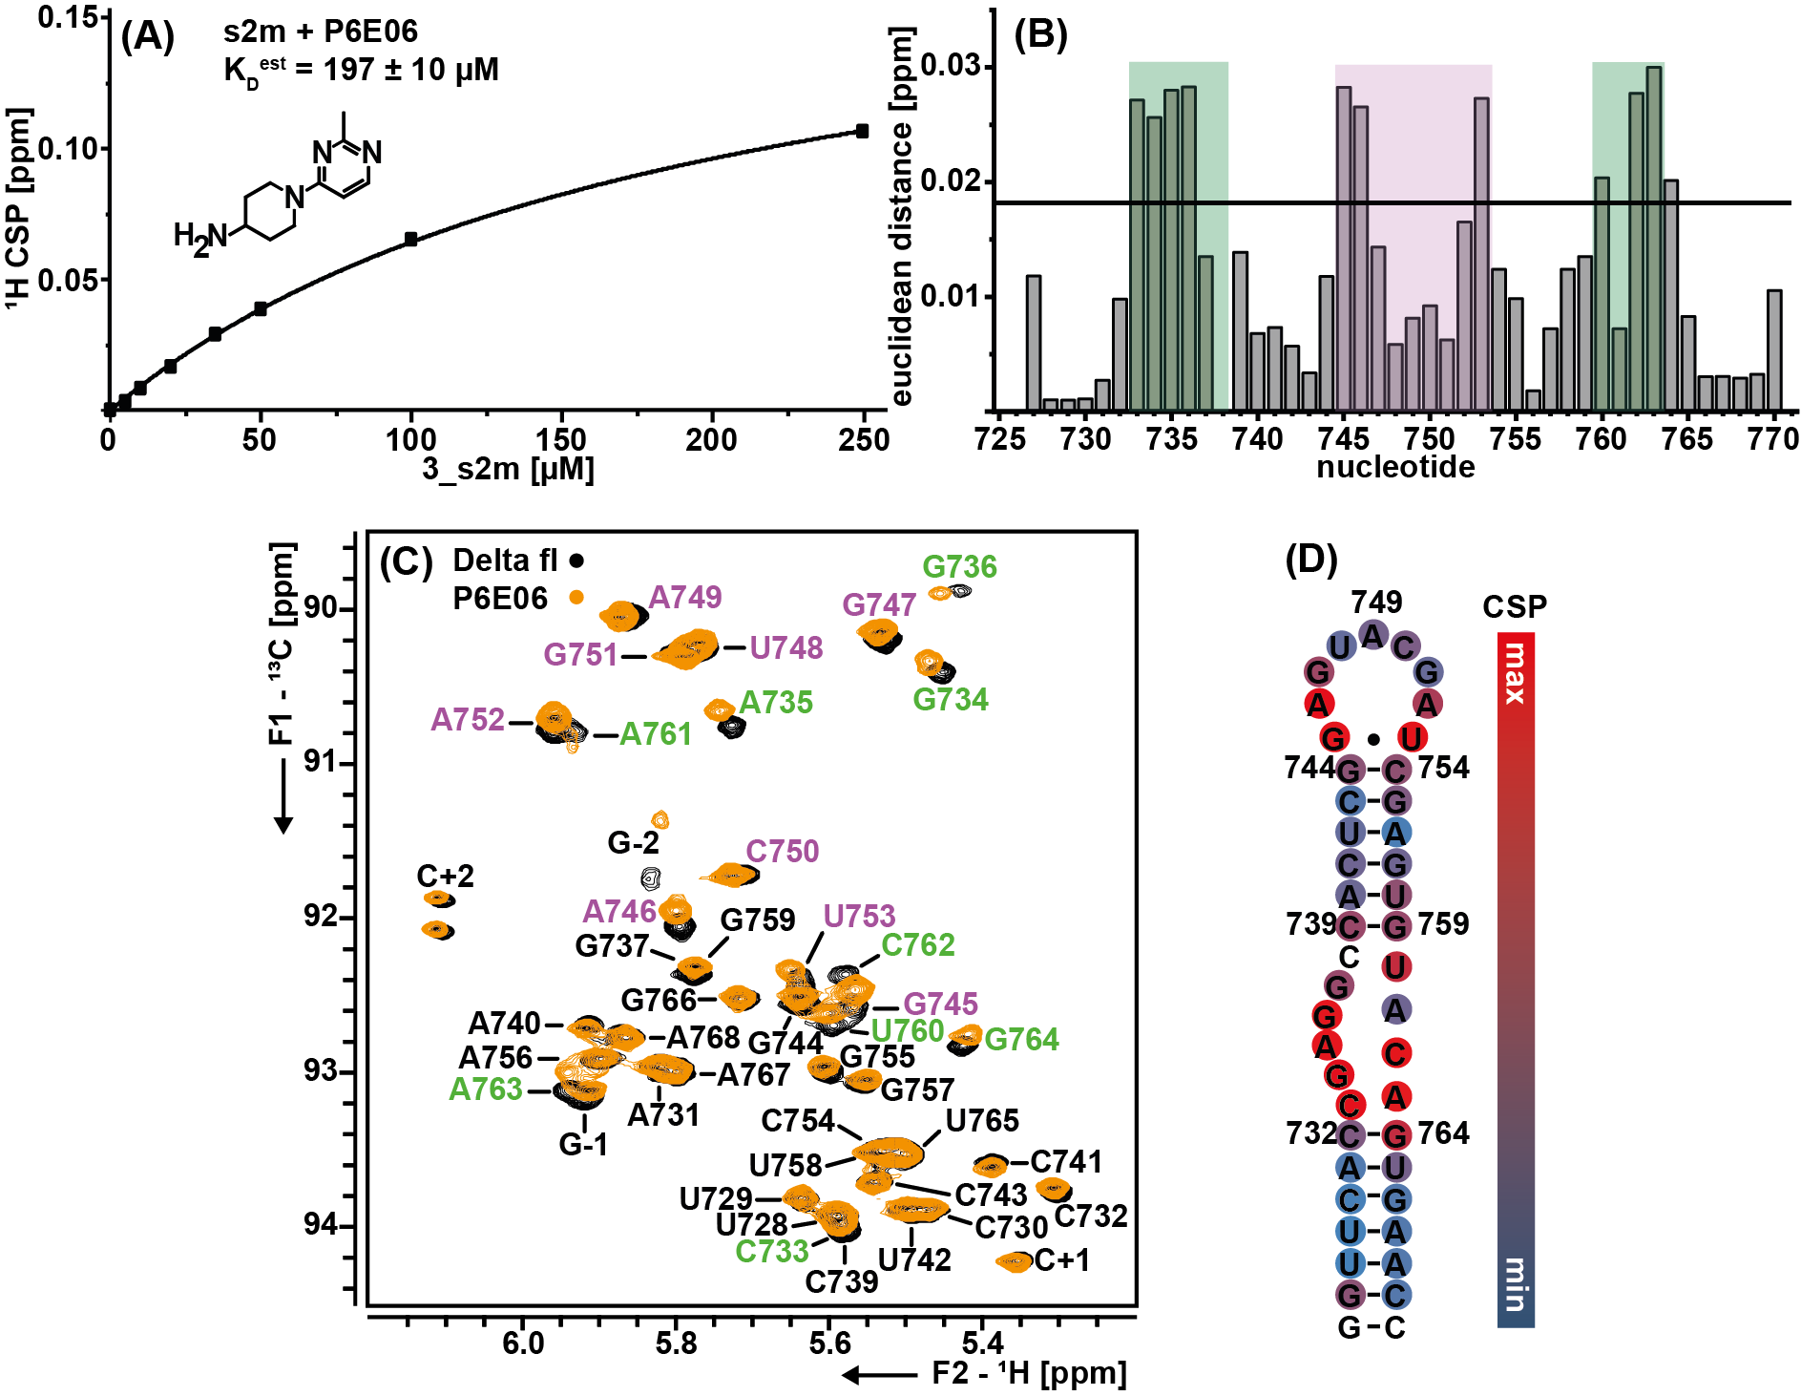
Supplementary Figure S6. (A) Determination of estimated K_{D} (K_{D}^{est}) via ligand detected ¹H-1D NMR titration. The structural formular of the ligand is shown in the middle. (B) RNA based euclidean distance plot to determine the binding site of P6E06 to s2m Delta. Internal loop residues are highlighted in green and loop residues are highlighted in magenta. A threshold of twofold the standard deviation was used. (C) ¹H, ¹³C HSQC spectra of the aromatic region of s2m (100 µM) with 0 µM (black) and 500 µM (yellow) P6E06. Resonance assignments are annotated and the notation of nucleotides corresponds to the position in the genome -29000. Loop resonances are labeled in magenta and internal loop resonances are labeled in green. (D) Secondary structure of s2m Delta colored with HSQC based CSP heatmap (strong: red, weak; blue) while red corresponds to the maximum CSP detected.

Supplementary Figure S7. Native PAGE of s2m Delta before and after folding (95 °C, 5 min). Monomer and dimer species are indicated with arrows.

Supplementary Table S1. Relevant ¹³C chemical shifts of s2m Delta in ppm.
 | C1' [ppm] | C2' [ppm] | C3' [ppm] | C4' [ppm] | C5' [ppm] | C6/C8 [ppm]
G-2 | 91.75 | 75.15 | 74.53 | 83.32 | 67.05 | 139.14
G-1 | 93.13 | 75.31 | 73.31 | 82.62 | 66.19 | 136.97
U728 | 93.90 | 75.40 | 72.31 | 82.22 | 64.49 | 141.81
U729 | 93.81 | 75.45 | 72.68 | 81.92 | 64.93 | 142.30
C730 | 93.88 | 75.34 | 72.79 | 81.95 | 65.18 | 141.51
A731 | 92.95 | 75.50 | 72.82 | 81.93 | 64.98 | 139.55
C732 | 93.76 | 75.51 | 72.22 | 82.01 | 64.62 | 140.47
C733 | 93.97 | 75.79 | 72.79 | 82.41 | 64.61 | 141.16
G734 | 90.53 | 75.31 | 75.37 | 84.07 | 66.78 | 138.44
A735 | 90.88 | 76.07 | 75.56 | 84.24 | 66.87 | 141.01
G736 | 89.84 | 75.60 | - | 84.46 | - | 139.07
G737 | 92.39 | - | - | 84.32 | - | 140.06
C738 | - | - | - | - | - | -
C739 | 93.99 | 75.81 | 74.90 | 82.41 | - | 141.66
A740 | 92.67 | 75.53 | 72.63 | 81.98 | - | 140.03
C741 | 93.57 | 75.74 | 72.31 | - | - | 140.43
U742 | 93.85 | 75.22 | - | - | 64.49 | 141.86
C743 | 93.70 | 75.61 | 72.75 | 81.87 | 64.98 | 141.42
G744 | 92.55 | 75.44 | 73.53 | 83.87 | 66.09 | 136.49
G745 | 92.64 | 75.27 | 73.87 | 83.03 | - | 137.25
A746 | 92.11 | 75.99 | 74.08 | 83.38 | 65.74 | 140.02
G747 | 90.14 | 75.04 | 76.54 | 84.79 | 67.08 | 139.13
U748 | 90.22 | 75.63 | 77.12 | 85.07 | 67.64 | 143.64
A749 | 90.15 | 76.35 | 77.16 | 85.37 | 67.87 | 142.07
C750 | 91.74 | 75.90 | 76.54 | 84.41 | 67.47 | 143.56
G751 | 90.37 | 75.51 | 76.95 | 85.00 | 68.09 | 140.14
A752 | 90.86 | 76.25 | - | 84.74 | 67.70 | 141.48
U753 | 92.42 | 75.42 | - | - | 66.47 | 142.67
C754 | 93.46 | 75.55 | 73.20 | - | - | 142.22
G755 | 92.96 | 75.36 | 73.50 | - | 66.48 | 136.45
A756 | 92.87 | 75.69 | 72.74 | 82.00 | - | 139.44
G757 | 93.06 | 75.26 | 73.28 | - | - | 136.11
U758 | 93.45 | 75.21 | 72.27 | - | 64.50 | 141.48
G759 | 92.36 | 75.89 | - | - | - | 136.60
U760 | 92.75 | 75.58 | 74.00 | 82.30 | 65.93 | 142.08
A761 | 90.80 | 75.99 | - | 84.41 | 65.68 | 141.00
C762 | 92.41 | 74.85 | 75.55 | - | 66.66 | 142.29
A763 | 93.02 | 75.64 | 73.95 | 84.75 | 67.18 | 142.27
G764 | 92.80 | 75.03 | 72.85 | - | - | 136.05
U765 | 93.53 | 75.24 | 72.26 | - | 64.50 | 141.07
G766 | 92.52 | 75.50 | 73.51 | - | 66.16 | 136.33
A767 | 92.96 | 75.62 | 72.85 | 82.04 | 65.35 | 139.54
A768 | 92.77 | 75.55 | 72.71 | 82.01 | 64.98 | 139.02
C+1 | 94.21 | 75.79 | 72.36 | 82.04 | 64.62 | 140.77
C+2 | 92.03 | 85.12 | 78.02 | 85.38 | 65.80 | 141.84
 | 98 % | 96 % | 82 % | 71 % | 73 % | 98 %
Supplementary Table S2. Relevant ¹H chemical shifts of s2m Delta in ppm.
 | H1' | H2' | H3' | H4' | H5' | H5'' | H6/H8 | H5
G-2 | 5.85 | 4.96 | 4.73 | 4.56 | 4.46 | 4.29 | 8.16 | -
G-1 | 5.93 | 4.57 | 4.53 | 4.56 | 4.50 | 4.23 | 7.55 | -
U728 | 5.60 | 4.53 | 4.49 | 4.48 | 4.51 | 4.13 | 7.81 | 5.26
U729 | 5.65 | 4.48 | 4.51 | 4.48 | 4.54 | 4.13 | 7.97 | 5.60
C730 | 5.48 | 4.41 | 4.53 | 4.46 | - | 4.13 | 7.85 | 5.68
A731 | 5.82 | 4.50 | 4.61 | 4.45 | 4.55 | 4.12 | 8.04 | -
C732 | 5.30 | 4.31 | 4.18 | 4.34 | 4.46 | 4.01 | 7.31 | 5.09
C733 | 5.59 | 4.05 | 4.46 | 4.26 | - | 4.01 | 7.73 | 5.61
G734 | 5.45 | 4.39 | 4.54 | 4.37 | 4.30 | 4.02 | 7.58 | -
A735 | 5.71 | 4.38 | 4.56 | 4.34 | 4.19 | 4.05 | 7.91 | -
G736 | 5.41 | 4.34 | - | 4.32 | - | 3.99 | 7.59 | -
G737 | 5.79 | 4.58 | - | 4.41 | - | 4.13 | 7.86 | -
C738 | - | - | - | - | - | - | - | -
C739 | 5.57 | 4.05 | 4.45 | 4.26 | - | - | 7.70 | 5.64
A740 | 5.92 | 4.62 | 4.77 | 4.48 | - | - | 8.26 | -
C741 | 5.39 | 4.21 | 4.38 | 4.40 | 4.50 | 4.08 | 7.56 | 5.33
U742 | 5.50 | 4.43 | 4.48 | - | 4.52 | 4.07 | 7.80 | 5.13
C743 | 5.55 | 4.47 | 4.52 | 4.40 | 4.21 | 4.10 | 7.80 | 5.59
G744 | 5.64 | 4.52 | 4.49 | 4.48 | - | 4.08 | 7.49 | -
G745 | 5.57 | 4.51 | 4.49 | 4.38 | 4.44 | 4.06 | 7.21 | -
A746 | 5.79 | 4.44 | 4.66 | 4.39 | 4.44 | 4.10 | 7.87 | -
G747 | 5.52 | 4.63 | 4.64 | 4.39 | 4.29 | 4.08 | 7.58 | -
U748 | 5.79 | 4.26 | 4.55 | 4.26 | 4.02 | 4.02 | 7.69 | 5.72
A749 | 5.87 | 4.70 | 4.68 | 4.41 | 4.15 | 4.05 | 8.19 | -
C750 | 5.72 | 4.23 | 4.57 | 4.27 | 4.03 | 4.02 | 7.58 | 5.80
G751 | 5.77 | 4.76 | 4.82 | 4.47 | 4.22 | 4.19 | 7.91 | -
A752 | 5.94 | 4.74 | 4.69 | 4.54 | 4.33 | 4.23 | 8.26 | -
U753 | 5.64 | 4.30 | 4.48 | 4.57 | 4.37 | 4.15 | 7.77 | 5.66
C754 | 5.55 | 4.55 | 4.57 | 4.41 | 4.45 | 4.16 | 7.91 | 5.76
G755 | 5.61 | 4.62 | 4.49 | 4.51 | 4.41 | 4.14 | 7.49 | -
A756 | 5.91 | 4.69 | 4.61 | 4.48 | 4.39 | 4.12 | 7.75 | -
G757 | 5.57 | 4.39 | 4.34 | 4.50 | 4.44 | 4.00 | 7.10 | -
U758 | 5.53 | 4.58 | 4.50 | - | - | 4.07 | 7.75 | 4.94
G759 | 5.79 | 4.31 | 4.44 | - | - | 4.10 | 7.65 | -
U760 | 5.59 | 4.33 | 4.48 | 4.38 | 4.41 | 4.06 | 7.46 | 5.12
A761 | 5.94 | 4.59 | 4.68 | 4.50 | 4.36 | 4.16 | 8.14 | -
C762 | 5.58 | 4.46 | 4.53 | - | 4.37 | 4.16 | 7.68 | -
A763 | 5.94 | 4.71 | 4.52 | 4.53 | 4.40 | 4.25 | 8.23 | -
G764 | 5.42 | 4.41 | 4.41 | - | - | 4.07 | 7.16 | -
U765 | 5.51 | 4.60 | 4.50 | 4.41 | 4.60 | 4.07 | 7.60 | 5.02
G766 | 5.73 | 4.52 | 4.59 | 4.40 | 4.46 | 4.14 | 7.63 | -
A767 | 5.81 | 4.55 | 4.65 | 4.48 | 4.54 | 4.15 | 7.76 | -
A768 | 5.87 | 4.48 | 4.55 | 4.33 | 4.55 | 4.11 | 7.76 | -
C+1 | 5.37 | 4.06 | 4.33 | 4.55 | 4.47 | 4.00 | 7.40 | 5.16
C+2 | 6.11 | 4.62 | 4.93 | 4.40 | 4.48 | 4.09 | 7.45 | 5.46
 | 98 % | 98 % | 93 % | 87 % | 76 % | 93 % | 98 % | 90 %

Supplementary Table S3. s2m RNA sequences.
s2m | sequence
Wuhan-Hu-1 | 5’-GGUUCACCGAGGCCACGCGGAGUACGAUCGAGUGUACAGUGAACC-3’
Delta | 5’-GGUUCACCGAGGCCACUCGGAGUACGAUCGAGUGUACAGUGAACC-3’

Supplementary Table S4. s2m RNA samples and concentrations. All RNAs were measured in 25 mM K₂HPO₄/KH₂PO₄ (pH 6.2) and 50 mM KCl.
number | sample | concentration
1 | natural abundance 95 % H₂O / 5 % D₂O | 400 µM
2 | ¹³C, ¹⁵N labeled 95 % H₂O / 5 % D₂O | 400 µM
3 | ¹³C, ¹⁵N labeled 100 % D₂O | 640 µM
4 | ¹³C, ¹⁵N selectively labeled A,C 100 % D₂O | 290 µM
5 | ¹³C, ¹⁵N selectively labeled G,U 100 % D₂O | 360 µM

Supplementary Table S5. NMR experiments and parameters.
experiment | parameters
¹H, ¹H NOESY  (jump return)  (Sklenar 1995;  Sklenář and Bax 1987) | 900 MHz, ns: 256, sw(f2): 21 ppm, sw(f1): 11.5 ppm, TD(f2): 2018, TD(f3): 392, aq(f2): 53 ms, o1p(¹H): 4.7 ppm, d1: 1 s, frequency jump (f1) to 8.75 ppm, mixing time: 150 ms, 34 h (298 K), sample #1
¹H, ¹⁵N BEST-TROSY  (Schulte-Herbrüggen and Sorensen 2000;  Favier and Brutscher 2011;  Lescop et al. 2007;  Solyom et al. 2013) | 600 MHz, ns: 16, sw(f2): 21 ppm, sw(f1): 25 ppm, TD(f2): 2018, TD(f3): 512, aq(f2): 80 ms, o1p(¹H): 4.7 ppm, o2p(¹³C): 101 ppm, o3p(¹⁵N): 153 ppm, d1: 0.3 s, ¹H (298 K, 308 K), sample #2
HNN-COSY  (Lescop et al. 2010;  Dingley and Grzesiek 1998) | 600 MHz, ns: 32, sw(f3): 20 ppm, sw(f2): 30 ppm, sw(f1): 100 ppm, TD(f3): 2500, TD(f2): 1, TD(f1): 384, aq(f3): 100 ms, o1p(¹H): 4.7 ppm, o2p(¹³C): 105 ppm, o3p(¹⁵N): 183 ppm, d1: 0.3 s, 2 h, (298 K), sample #2
¹H, ¹⁵N-HSQC (amino)  (Mori et al. 1995) | 600 MHz, ns: 32, sw(f2): 10 ppm, sw(f1): 31 ppm, TD(f2): 1024, TD(f1): 256, aq(f2): 85 ms, o1p(¹H): 4.7 ppm, o2p(¹³C): 101 ppm, o3p(¹⁵N): 86.5 ppm, d1: 0.8 s, 2 h, (298 K), sample #2
¹H, ¹⁵N CPMG NOESY  (Mulder et al. 1996;  Mueller et al. 1995) | 600 MHz, ns:256, sw(f2): 21 ppm, sw(f1): 103 ppm, TD(f2): 2048, TD(f1): 256, aq(f2): 81 ms, o1p(¹H): 4.7ppm, o2p(¹³C): 101 ppm, o3(¹⁵N): 116 ppm, d1: 1 s, mixing time: 150 ms, 24h (298 K), sample #2
HCCNH  (Piotto et al. 1992;  Sklenář et al. 1996) | 600 MHz, ns: 208, sw(f3): 21 ppm, sw(f2): 10 ppm, sw(f1): 30 ppm, TD(f3): 2254, TD(f2): 128, TD(f1): 1, aq(f3): 90 ms, o1p(¹H): 4.7 ppm, o2p(¹³C): 137 ppm, o3p(¹⁵N): 154 ppm, d1: 1.8 s, C6/8-N1/9 transfer time: 24 ms, TOCSY mixing time (H6/8)C6/8(CC)NH: 28 ms, 15 h, (298 K, 308 K) sample #2
¹H, ¹³C HSQC  (Bodenhausen and Ruben 1980; Vuister and Bax 1992) | aromatic region:  950 MHz, ns: 2, sw(f2): 8.3 ppm, sw(f1): 24 ppm, TD(f2): 1024, TD(f1): 384, aq(f2): 65 ms, o1p(¹H): 4.7 ppm, o2p(¹³C): 143 ppm, d1: 1 s, INEPT transfer time: 2.5 ms, 15 min, (308 K), sample #3  C1’ region:  950 MHz, ns: 2, sw(f2): 8.3 ppm, sw(f1): 12 ppm, TD(f2): 1024, TD(f1): 384, aq(f2): 65 ms, o1p(¹H): 4.7 ppm, o2p(¹³C): 90 ppm, d1: 1 s, INEPT transfer time: 2.94 ms, 15 min, (308 K), sample #3  CT HSQC ribose C1’ to C5’:  950 MHz, ns: 4, sw(f2): 8.3 ppm, sw(f1): 38 ppm, TD(f2): 1024, TD(f1): 256, aq(f2): 88 ms, o1p(¹H): 4.7 ppm, o2p(¹³C): 77 ppm, d1: 1 s, constant time delay: 12.5 ms, 20 min, (308 K), samples #4/5
4D HMQC-NOESY-HMQC  (Stanek et al. 2013) | 950 MHz, ns: 8, sw(f4): 9.1 ppm, sw(f3): 14.7 ppm, sw(f2): 22 ppm, sw(f1): 2.8 ppm TD(f4): 1146, TD(f3): 56, TD(f2): 64, TD(f1): 120 aq(f4): 66 ms, o1p(¹H): 4.7 ppm, o2p(¹³C, f3): 143 ppm, o2p(¹³C, f2): 137 ppm, o3p(¹⁵N): 157 ppm, d1: 0.88 s, INEPT transfer times: 2.5 ms (aromatics) and 3.1 ms (H1’C1’), NOESY mixing time: 250 ms, recorded with 14 % NUS, 5 d 12 h (308 K), sample #3
3D HCN  (Sklenář et al. 1993a) | ¹H detected:  800 MHz, ns: 56, sw(f3): 9 ppm, sw(f2): 22 ppm, sw(f1): 33 ppm TD(f3): 1024, TD(f2): 168, TD(f1): 184 aq(f3): 70 ms, o1p(¹H): 4.7 ppm, o2p(¹³C): 115 ppm, o3p(¹⁵N): 158 ppm, d1: 1 s, INEPT transfer times: 2.8 ms (HC) and 34 ms (CN), recorded with 25 % NUS, 3 d, (308 K), sample #2  ¹³C detected:  800 MHz, ns: 24, sw(f3): 24.5 ppm, sw(f2): 34.5 ppm, sw(f1): 12 ppm TD(f3): 666, TD(f2): 24, TD(f1): 104 aq(f3): 70 ms, o2p(¹³C): 90 ppm, o3p(¹⁵N): 157 ppm, d1: 1 s, INEPT transfer times: 2.5 ms (HC) and 30 ms (CN), 2 d 14 h, (308 K), sample #2
3D fw-HCCH-TOCSY  (Glaser et al. 1996; Kay et al. 1993; Marino et al. 1996; Schwalbe et al. 1995) | 800/700 MHz, ns: 16, sw(f3): 15 ppm, sw(f2): 36 ppm, sw(f1): 3.4 ppm TD(f3): 1678, TD(f2): 104, TD(f1): 104 aq(f3): 80 ms, o1p(¹H): 4.7 ppm, o2p(¹³C): 77 ppm, o3p(¹⁵N): 155 ppm, d1: 1 s, INEPT transfer times: 3.4 ms, TOCSY mixing time: 12 ms, constant time delay: 8.3 ms, 2 d 8 h, (308 K), samples #4/5
3D HCC(H) TOCSY  (Kay et al. 1993) | 950/700 MHz, ns: 8, sw(f3): 8.5 ppm, sw(f2): 9.5 ppm, sw(f1): 35.5 ppm TD(f3): 1024, TD(f2): 100, TD(f1): 150 aq(f3): 63 ms, o1p(¹H): 4.7 ppm, o2p(¹³C): 76.5 ppm, o3p(¹⁵N): 153 ppm, d1: 1.1 s, INEPT transfer times: 3.2 ms, TOCSY mixing time: 5.5 ms and 16 ms, 2 d, (308 K), samples #4/5
)H5H6 TOCSY  (Hwang and Shaka 1995;  Shaka et al. 1988) | 600 MHz, ns: 32, sw(f2): 8.8 ppm, sw(f1): 6.2 ppm TD(f2): 1398, TD(f1): 256, aq(f2): 133 ms, o1p(¹H): 4.7 ppm, o2p(¹³C): 137 ppm, o3p(¹⁵N): 86 ppm, d1: 1 s, TOCSY mixing time: 30 ms, 3 d, (308 K), sample #2
¹³C, ¹⁵N filtered NOESY  (Piotto et al. 1992;  Sklenar et al. 1993;  Otting and Wüthrich 1989) | 800 MHz, ns: 96, sw(f2): 8 ppm, sw(f1): 6.2 ppm TD(f2): 1024, TD(f1): 512, aq(f2): 80 ms, o1p(¹H): 4.7 ppm, o2p(¹³C): 145 ppm, o3p(¹⁵N): 201 ppm, d1: 1 s, NOESY mixing time: 250 ms, 3 d 5 h, (308 K), sample #4/5 (4 spectra recorded in an interleaved manner to receive ¹²C¹²C, ¹²C¹³C, ¹³C¹²C and ¹³C¹³C bound proton planes).
¹H, ¹³C hetNOE experiments  (Duchardt and Schwalbe 2005; Farrow et al. 1994) | aromatic region:  800 MHz, ns: 32, sw(f3): 9 ppm, sw(f2): 20 ppm (AC) and 10 ppm (GU), TD(f3): 1024, TD(f2): 448 (AC) and 312 (GU), aq(f3): 71 ms, o1p(¹H): 4.7 ppm, o2p(¹³C): 144 ppm (AC) and 137 ppm (GU), o3p(¹⁵N): 158 ppm, d1: 5 s, presaturation delay: 3 s, INEPT transfer time: 2.7 ms, 2 d 17 h (AC) and 1 d 21 h (GU), (308 K), samples #4/5  c1’ region:  800 MHz, ns: 32, sw(f3): 9 ppm, sw(f2): 8 ppm, TD(f3): 1024, TD(f2): 320 (AC) and 312 (GU), aq(f3): 71 ms, o1p(¹H): 4.7 ppm, o2p(¹³C): 90 ppm, o3p(¹⁵N): 153 ppm, d1: 5 s, presaturation delay: 3 s, INEPT transfer time: 3.0 ms, 1 d 23 h (AC) and 1 d 22 h (GU), (308 K), samples #4/5  NOE/noNOE experiments were recorded as pseudo 3D.  An off resonant pulse at -1000 ppm was used for temperature compensation in the reference experiment. Separate experiments were carried out for two NMR sample with different labeled nucleotides (AC or GU labeled).
T1 relaxation measurements  (Kay et al. 1992;  Duchardt and Schwalbe 2005; Farrow et al. 1994) | aromatic region:  800 MHz, ns: 24 (AC) and 32 (GU), sw(f3): 10 ppm, sw(f2): 20 ppm (AC) and 12 ppm (GU), TD(f3): 1024, TD(f2): 124 (AC) and 137 ppm (GU), aq(f3): 64 ms, o1p(¹H): 4.7 ppm, o2p(¹³C): 144 ppm (AC) and 137 ppm (GU), o3p(¹⁵N): 153 ppm, d1: 2.6 s, constant time delay: 8.8 s, INEPT transfer time: 2.7 ms, 1 d 18 h (AC) and 1 d 9 h (GU), (308 K), samples #4/5  c1’ region:  800 MHz, ns: 24 (AC) and 32 (GU), sw(f3): 10 ppm, sw(f2): 8 ppm, TD(f3): 1024, TD(f2): 72, aq(f3): 64 ms, o1p(¹H): 4.7 ppm, o2p(¹³C): 90 ppm, o3p(¹⁵N): 153 ppm, d1: 2.6 s, constant time delay: 12.5 s, INEPT transfer time: 3.0 ms, 1 d (AC) and 1 d 8 h (GU), (308 K), samples #4/5  Experiments were recorded as pseudo 3Ds using a vdlist with eight different T1 delays ranging from 20 ms to 1.5 s. Separate experiments were carried out for two NMR samples with different labeled nucleotides (AC or GU labeled).
1D (ligand titrations)  (Nguyen et al. 2007;  Adams et al. 2013;  Hwang and Shaka 1995) | 600 MHz, ns: 512, sw: 24.5 ppm, TD: 29410, aq(f3): 1 s, o1p(¹H): 4.7 ppm, d1: 1 s, 18 min , (298 K)  Water suppression using soggy with gradients. Perfect echo version.

REFERENCES
Adams RW, Holroyd CM, Aguilar JA, Nilsson M, Morris GA. 2013. “Perfecting” WATERGATE: clean proton NMR spectra from aqueous solution. Chem. Commun. 49: 358–360. doi: 10.1039/C2CC37579F
Bodenhausen G, Ruben DJ. 1980. Natural abundance nitrogen-15 NMR by enhanced heteronuclear spectroscopy. Chemical Physics Letters 69: 185–189. doi: 10.1016/0009-2614(80)80041-8
Dingley AJ, Grzesiek S. 1998. Direct Observation of Hydrogen Bonds in Nucleic Acid Base Pairs by Internucleotide 2JNN Couplings Couplings. Journal of the American Chemical Society 120: 8293–8297. doi: 10.1021/ja981513x
Duchardt E, Schwalbe H. 2005. Residue specific ribose and nucleobase dynamics of the cUUCGg RNA tetraloop motif by MNMR 13C relaxation. Journal of biomolecular NMR 32: 295–308. doi: 10.1007/s10858-005-0659-x
Farrow NA, Muhandiram R, Singer AU, Pascal SM, Kay CM, Gish G, Shoelson SE, Pawson T, Forman-Kay JD, Kay LE. 1994. Backbone dynamics of a free and phosphopeptide-complexed Src homology 2 domain studied by 15N NMR relaxation. Biochemistry 33: 5984–6003. doi: 10.1021/bi00185a040
Favier A, Brutscher B. 2011. Recovering lost magnetization: polarization enhancement in biomolecular NMR. Journal of biomolecular NMR 49: 9–15. doi: 10.1007/s10858-010-9461-5
Glaser SJ, Schwalbe H, Marino JP, Griesinger C. 1996. Directed TOCSY, a Method for Selection of Directed Correlations by Optimal Combinations of Isotropic and Longitudinal Mixing. Journal of Magnetic Resonance, Series B 112: 160–180. doi: 10.1006/jmrb.1996.0126
Hwang TL, Shaka AJ. 1995. Water Suppression That Works. Excitation Sculpting Using Arbitrary Wave-Forms and Pulsed-Field Gradients. Journal of Magnetic Resonance, Series A 112: 275–279. doi: 10.1006/jmra.1995.1047
Kay LE, Nicholson LK, Delaglio F, Bax A, Torchia DA. 1992. Pulse sequences for removal of the effects of cross correlation between dipolar and chemical-shift anisotropy relaxation mechanisms on the measurement of heteronuclear T1 and T2 values in proteins. Journal of Magnetic Resonance (1969) 97: 359–375. doi: 10.1016/0022-2364(92)90320-7
Kay LE, Xu GY, Singer AU, Muhandiram DR, Formankay JD. 1993. A Gradient-Enhanced HCCH-TOCSY Experiment for Recording Side-Chain 1H and 13C Correlations in H2O Samples of Proteins. Journal of Magnetic Resonance, Series B 101: 333–337. doi: 10.1006/jmrb.1993.1053

Lescop E, Kern T, Brutscher B. 2010. Guidelines for the use of band-selective radiofrequency pulses in hetero-nuclear NMR: Example of longitudinal-relaxation-enhanced BEST-type 1H–15N correlation experiments. Journal of Magnetic Resonance 203: 190–198. doi: 10.1016/j.jmr.2009.12.001
Lescop E, Schanda P, Brutscher B. 2007. A set of BEST triple-resonance experiments for time-optimized protein resonance assignment. Journal of Magnetic Resonance 187: 163–169. doi: 10.1016/j.jmr.2007.04.002
Marino JP, Schwalbe H, Glaser SJ, Griesinger C. 1996. Determination of γ and Stereospecific Assignment of H5‘ Protons by Measurement of ² J and ³ J Coupling Constants in Uniformly ¹³ C Labeled RNA. Journal of the American Chemical Society 118: 4388–4395. doi: 10.1021/ja953554o
Mori S, Abeygunawardana C, Johnson MO, Vanzijl PCM. 1995. Improved Sensitivity of HSQC Spectra of Exchanging Protons at Short Interscan Delays Using a New Fast HSQC (FHSQC) Detection Scheme That Avoids Water Saturation. Journal of Magnetic Resonance, Series B 108: 94–98. doi: 10.1006/jmrb.1995.1109
Mueller L, Legault P, Pardi A. 1995. Improved RNA Structure Determination by Detection of NOE Contacts to Exchange-Broadened Amino Protons. Journal of the American Chemical Society 117: 11043–11048. doi: 10.1021/ja00150a001
Mulder FransAA, Spronk ChrisAEM, Slijper M, Kaptein R, Boelens R. 1996. Improved HSQC experiments for the observation of exchange broadened signals. Journal of Biomolecular NMR 8: 223–228. doi: 10.1007/BF00211169
Nguyen BD, Meng X, Donovan KJ, Shaka AJ. 2007. SOGGY: Solvent-optimized double gradient spectroscopy for water suppression. A comparison with some existing techniques. Journal of Magnetic Resonance 184: 263–274. doi: 10.1016/j.jmr.2006.10.014
Otting G, Wüthrich K. 1989. Extended heteronuclear editing of 2D 1H NMR spectra of isotope-labeled proteins, using the X(ω1, ω2) double half filter. Journal of Magnetic Resonance (1969) 85: 586–594. doi: 10.1016/0022-2364(89)90249-7
Piotto M, Saudek V, Sklenář V. 1992. Gradient-tailored excitation for single-quantum NMR spectroscopy of aqueous solutions. Journal of Biomolecular NMR 2: 661–665. doi: 10.1007/BF02192855
Schulte-Herbrüggen T, Sørensen OW. 2000. Clean TROSY: Compensation for Relaxation-Induced Artifacts. Journal of Magnetic Resonance 144: 123–128. doi: 10.1006/jmre.2000.2020
Schwalbe H, Marino JP, Glaser SJ, Griesinger C. 1995. Measurement of H,H-Coupling Constants Associated with .nu.1, .nu. 2, and .nu.3 in Uniformly 13C-Labeled RNA by HCC-TOCSY-CCH-E.COSY. Journal of the American Chemical Society 117: 7251–7252. doi: 10.1021/ja00132a028
Shaka AJ, Lee CJ, Pines A. 1988. Iterative schemes for bilinear operators; application to spin decoupling. Journal of Magnetic Resonance (1969) 77: 274–293. doi: 10.1016/0022-2364(88)90178-3
Sklenář V. 1995. Suppression of Radiation Damping in Multidimensional NMR Experiments Using Magnetic Field Gradients. Journal of Magnetic Resonance, Series A 114: 132–135. doi: 10.1006/jmra.1995.1119
Sklenář V, Bax A. 1987. Spin-echo water suppression for the generation of pure-phase two-dimensional NMR spectra. Journal of Magnetic Resonance (1969) 74: 469–479. doi: 10.1016/0022-2364(87)90269-1
Sklenář V, Dieckmann T, Butcher SE, Feigon J. 1996. Through-bond correlation of imino and aromatic resonances in 13C-,15N-labeled RNA via heteronuclear TOCSY. Journal of Biomolecular NMR 7: 83–87. doi: 10.1007/BF00190460
Sklenář V, Peterson RD, Rejante MR, Feigon J. 1993a. Two-and three-dimensional HCN experiments for correlating base and sugar resonances in 15N, 13C-labeled RNA oligonucleotides. Journal of Biomolecular NMR 3: 721–727. doi: 10.1007/BF00198375
Sklenář V, Piotto M, Leppik R, Saudek V. 1993b. Gradient-Tailored Water Suppression for 1H-15N HSQC Experiments Optimized to Retain Full Sensitivity. Journal of Magnetic Resonance, Series A 102: 241–245. doi: 10.1006/jmra.1993.1098
Solyom Z, Schwarten M, Geist L, Konrat R, Willbold D, Brutscher B. 2013. BEST-TROSY experiments for time-efficient sequential resonance assignment of large disordered proteins. Journal of biomolecular NMR 55: 311–21. doi: 10.1007/s10858-013-9715-0
Stanek J, Podbevšek P, Koźmiński W, Plavec J, Cevec M. 2013. 4D Non-uniformly sampled C,C-NOESY experiment for sequential assignment of 13C,15N-labeled RNAs. Journal of Biomolecular NMR 57: 1–9. doi: 10.1007/s10858-013-9771-5
Vuister GW, Bax A. 1992. Resolution enhancement and spectral editing of uniformly 13C-enriched proteins by homonuclear broadband 13C decoupling. Journal of Magnetic Resonance (1969) 98: 428–435. doi: 10.1016/0022-2364(92)90144-V

