Supplemental Material
Chemical manipulation of m¹A mediates its detection in human tRNA

Kinga Pajdzik^{1,#}, Ruitu Lyu^{1,#}, Xiaoyang Dou^{1,#}, Chang Ye¹, Li-Sheng Zhang^{1,2}, Qing Dai^{1,}*, Chuan He*^{,1,3,4,5}

¹Department of Chemistry, The University of Chicago, Chicago, IL, USA.
²Division of Life Science, The Hong Kong University of Science and Technology (HKUST), Kowloon, Hong Kong SAR, China.
³Howard Hughes Medical Institute, The University of Chicago, Chicago, IL, USA.
⁴Department of Biochemistry and Molecular Biology, The University of Chicago, Chicago, IL, USA.
⁵Institute for Biophysical Dynamics, The University of Chicago, Chicago, IL, USA.
#These authors contributed equally.
*Correspondence: chuanhe@uchicago.edu; daiqing@uchicago.edu

This file includes:
Supplemental Figures 1 – 3
Supplemental Table 1

Figure S1

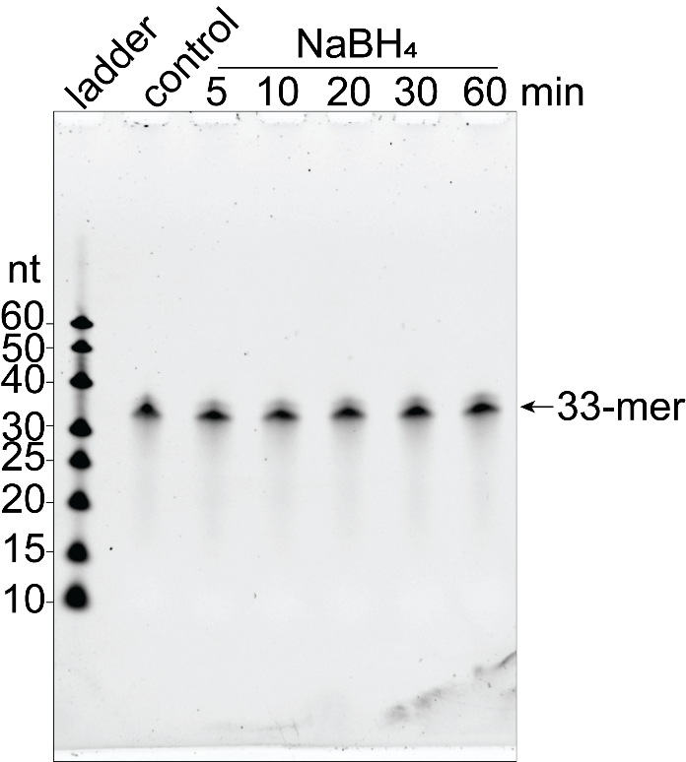
Supplemental Figure S1. RNA degradation upon treatment with NaBH₄. TBE-UREA gel of 33-mer RNA oligonucleotide untreated and treated with 0.1M NaBH₄ at room temperature for 5, 10, 20, 30 or 60 min.

Figure S2
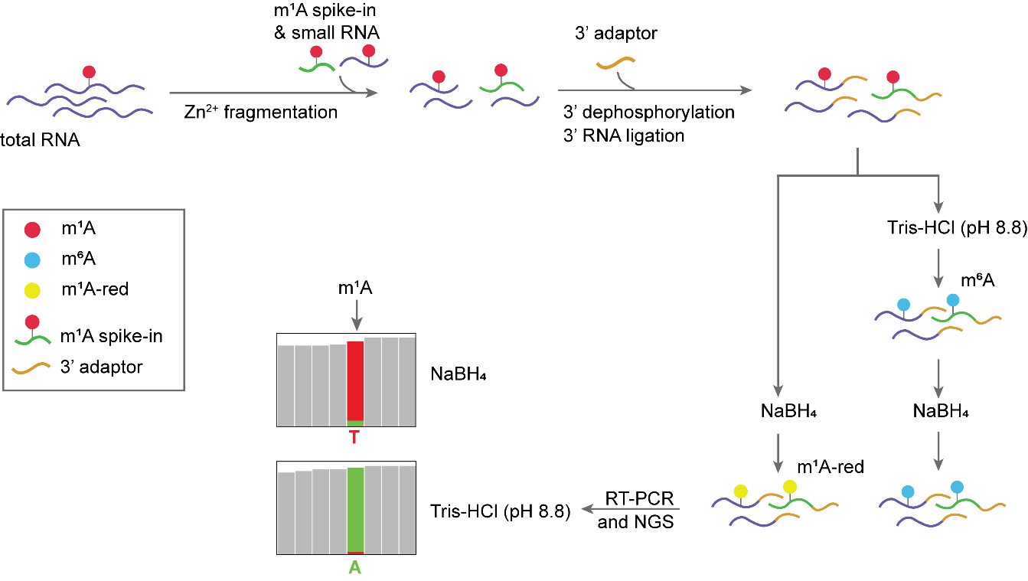
Supplemental Figure S2. Library construction outline. Total RNA is fragmented with Zn²⁺ and spike-in RNA containing m1A is added to fragmented RNA. 3’ ends are dephosphorylated, and RNA is undergone 3’ RNA ligation. After ligation, RNA is split into two halves: one half is treated with NaBH₄ to reduce m1A (m¹A-red) and another half is treated with Tris-HCl pH 8.8 to convert m¹A into m⁶A and then undergone treatment with NaBH₄. After treatment, RNA is undergone reverse transcription and PCR, followed by next-generation sequencing (NGS). M1A site reduced with NaBH₄ is read as “T”, while m¹A converted to m⁶A under alkaline conditions is read as “A”.

Figure S3
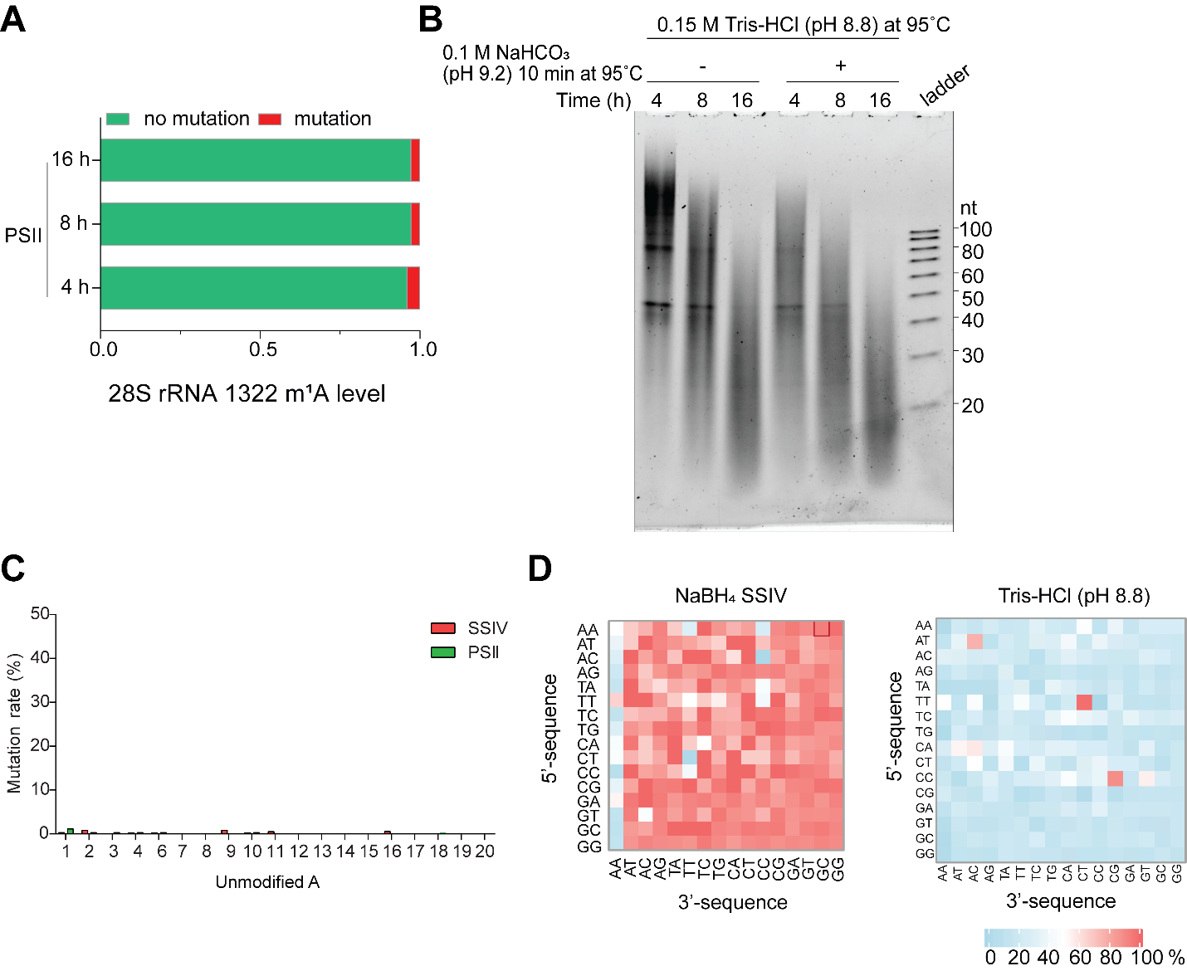
Supplemental Figure S3. Quality control analysis for red-m¹A-seq. (A) Mutation levels at 1322 m¹A site in HeLa 28S rRNA in the control libraries treated with 0.15M Tris-HCl (pH 8.8) at 95°C for 4, 8 or 16 hours followed by additional treatment with 0.1M NaHCO₃ (pH 9.2) at 95°C for 10 min. (B) TBE-UREA gel of HeLa total RNA mixed with m¹A synthetic RNA oligonucleotides treated with 0.15M Tris-HCl (pH 8.8) at 95°C for 4, 8 or 16 hours followed by additional treatment with 0.1M NaHCO₃ (pH 9.2) at 95°C for 10 min. (C) Bar plot showing the mutation rate (%) of unmodified adenosines in the Spike-In oligo RNA with a fixed sequence. These libraries underwent NaBH₄ reduction and were prepared using SSIV or PS II RT enzymes. (D) The heatmaps showing the mutation rates at the m¹A site in the NNm¹ANN Spike-In oligos in the reduction libraries built with SSIV RT enzyme (left) and within the control (Tris-treated) libraries built with SSIV RT enzyme. The mutation rates are determined by NGS. Mutation rates in percentage are color coded.

Supplemental Table 1. Oligonucleotide sequences.
Oligonucleotide name | Sequence (5’ - 3’) | Notes
5mer | rArCrm¹ArUrG | For MALDI TOF MS
33-mer_15U | rGrGrArGrArCrGrGrUrCrGrGrGrUrCrCrArGrArUrArUrUrCrGrUrArUrCrUrGrUrC | For RT-PCR-IVT
33mer_15A | rGrGrArGrArCrGrGrUrCrGrGrGrArCrCrArGrArUrArUrUrCrGrUrArUrCrUrGrUrC | For RT-PCR-IVT
33mer_15m¹A | rGrGrArGrArCrGrGrUrCrGrGrGrm¹ArCrCrArGrArUrArUrUrCrGrUrArUrCrUrGrUrC | - For RT-PCR-IVT  - For RT-PCR-Sanger-seq  - For read-through assay
RT-primer /For-01 | GCG GAG CCC ACA CTC TAC TCG ACA GAT ACG AAT AT | - RT primer and PCR forward primer for RT-PCR-IVT  - RT primer for RT-PCR-Sanger-seq
FAM-RT-primer | FAM/CGG AGC CCA CACT CTA CTC GAC AGA TAC GAA TAT | For read-through assay
Rev-01 | CTAATACGACTCACTATAGGGCGGAGACGGTCGGG | - PCR reverse primer in RT-PCR-IVT  - PCR reverse primer in RT-PCR-Sanger-seq
For-02 | TTTGCTGAGGAGTGCCGTTAATTAAGTGCGGAGCCCACACTCT | - PCR forward primer in RT-PCR-Sanger-seq
Sanger seq primer | HZ149:  TGCTGAGGAGTGCCGT | For Sanger seq
43mer_m¹A | /Phos/rCrCrUrArCrCrUrCrCrCrUrCrArCrCrArArm¹ArGrCrCrCrArUrArArArArArU rArArArArArArUrUrArUrArArC | Spike-in for NGS library
45mer_m¹A | /Phos/rGrUrArArUrUrArUrArCrNrNrm¹ArNrNrArUrUrCrGrUrUrGrU rArCrGrUrGrArUrGrCrCrUrArArUrGrCrCrUrGrArA | Spike-in for NGS library
3’ RNA adaptor | rApp-NN NNN ATC ACG AG ATC GGA AGA GCA CAC GTC T/3BioTEG/ | For NGS library preparation
3’ cDNA adaptor | /Phos/NNN NNG ATC GTC GGA CTG TAG AAC TCT GAA C/3SpC3 | For NGS library preparation
SR RT primer | AGA CGT GTG CTC TTC CGA TCT | For NGS library preparation

