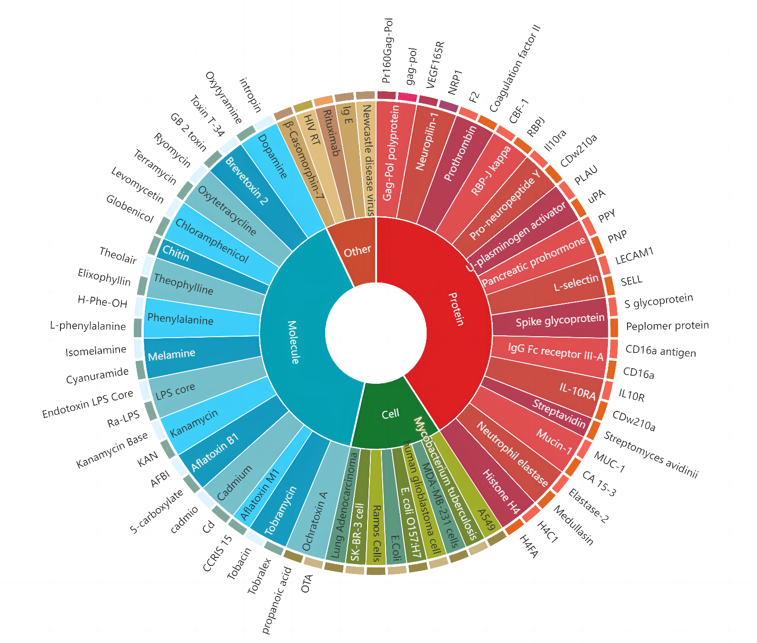
Fig. S2. Different categories of targets with the highest number of interactions with aptamers.

