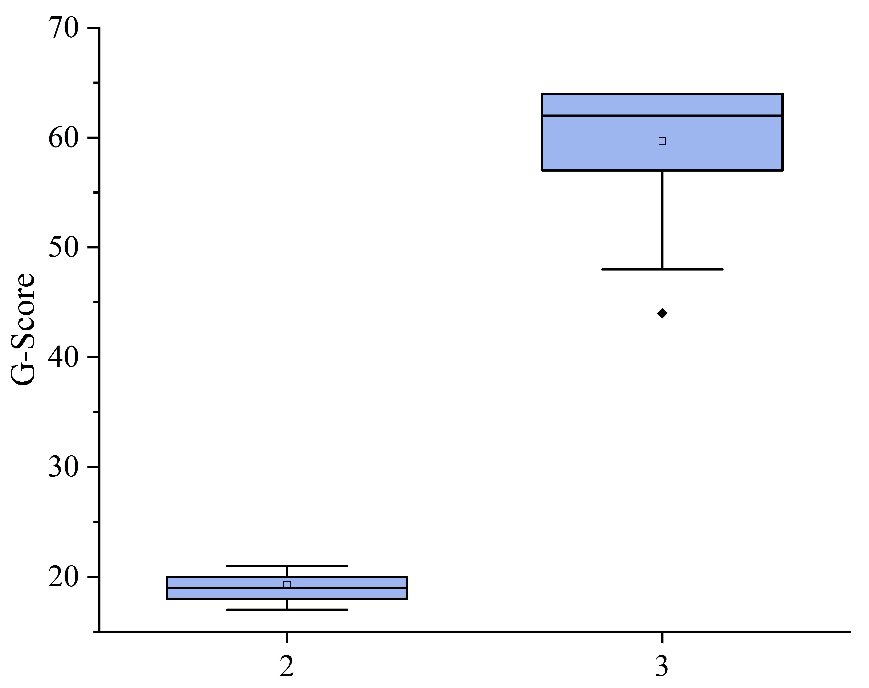
Fig. S1. Distribution of G-score with different number of G-quadruplex.

