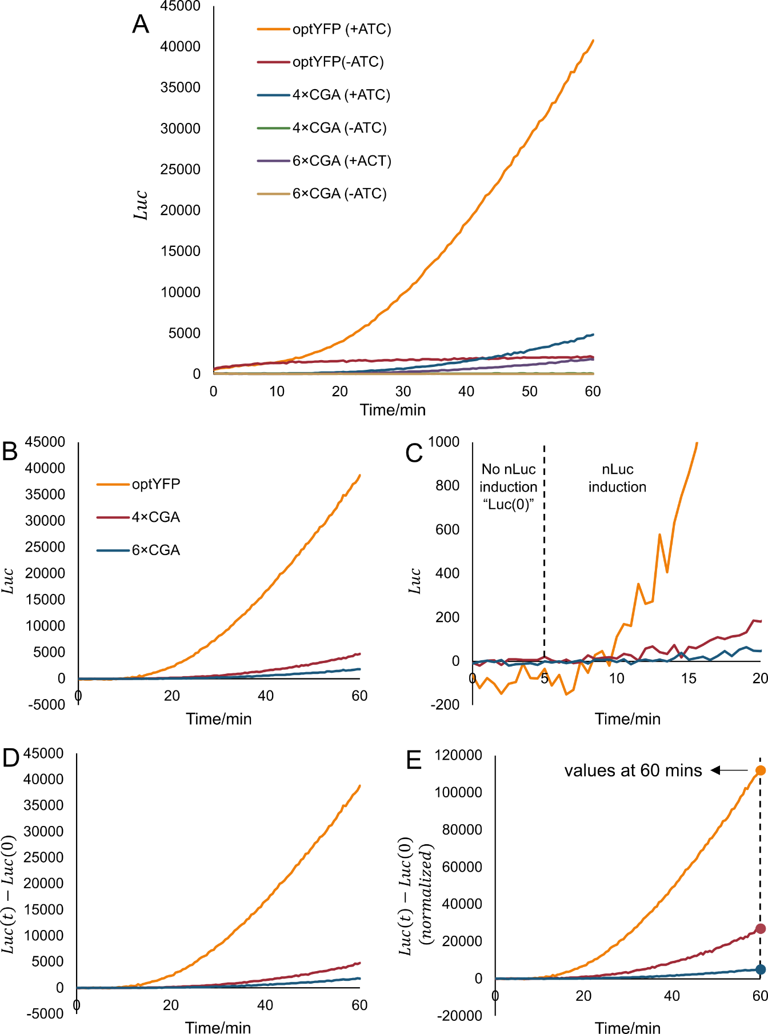
Figure 1 Data re-processing of raw nLuc assay data
A: nLuc assay data with and without ATC addition.
B: nLuc assay data with pure ATC-induced. ($Luc=Luc \left(+ATC\right)-Luc(-ATC)$)
C: nLuc assay data of 0~20 mins time-frame.
D: nLuc assay data with mechanical or technical errors ($Luc(0)$) subtracted.
E: nLuc assay data with OD normalized.
Three strains (optYFP, 4×CGA and 6×CGA) were used to run nLuc assay as an example to show data analysis method to quantify protein expression and elongation duration. Figure 1 shows the protocol of data re-processing of raw nLuc assay data.

(1) In the raw nLuc assay data, Luciferase (Luc) is plotted against Time (t), which is shown in Figure 1A. Because of the leakiness of TetO7 promoter, we could find positive nLuc expression when there isn’t ATc addition (e.g. optYFP(-ATC)). To acquire the pure ATC-induced protein expression (Figure 1B), for each sample, we calculate by subtracting the samples lacking ATC from the corresponding samples with ATC across all measured timepoints. Formulas are listed below:
$$Luc=Luc \left(+ATc\right)-Luc(-ATc)$$
$$e.g. Luc \left(optYFP\right)=Luc (optYFP\left(+ATC\right))-Luc(optYFP(-ATC))$$

(2) Since control for time of pre-induction steps (such as ATc absorption, activation of TetO7 promoter and transcription intiation), theoretically, we should find no nLuc induction (Luc = 0) in the beginning of the nLuc assay plot until we get the first nLuc expression. If we enlarge the beginning part of nLuc assay data (0~20 mins in Figure 1C), we find non-zero basal levels during 0~5mins (which may be induced by mechanical or technical errors). To eliminate mechanical or technical errors, all values ($Luc(t)$) were then subtracted by the “average Luc of the first 5 minutes” ($Luc(0)$) to acquire “$Luc\left(t\right)-Luc(0)$” in Figure 1D.

(3) Samples were normalized to an OD600 of 1.0 by dividing their protein expression over time by their respective ODs. Thus, in Figure 1E, we plotted the normalized ATC-induced protein expression ($Luc\left(t\right)-Luc(0)(normalized)$) against time ($Time/min$) of all samples. Additionally, the values at 60 mins timepoints in Figure 1E were picked to evaluate relative protein expression of multiple samples.

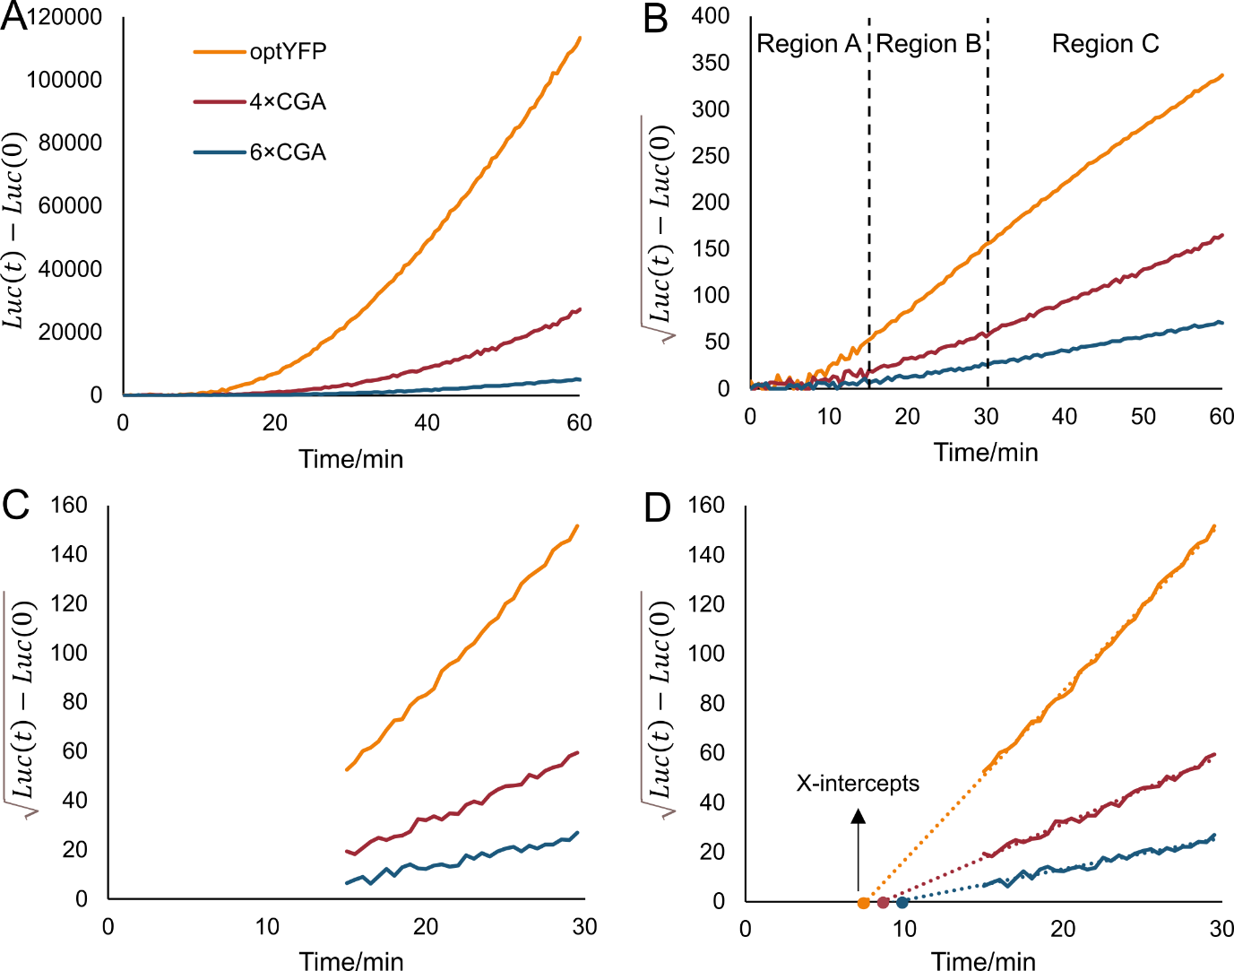
Figure 2 Schleif Plot method to quantify elongation duration
A: nLuc assay data that shows the nLuc induction of optYFP, 4×CGA and 6×CGA strains. Y-axis (luc) is normalized.
B: Square root of each luc values. The plot was divided into three regions (A, B and C) according to the shape.
C: Data selection of 15-30 mins, which shows the most linear and consistent increasing trend of curves.
D: Linear fitting and extend the fitting lines backward to get X-intercepts that describes the timepoints of initial nLuc induction of each sample.

The Schleif Plot methodology was adapted from (Schleif et al. 1973) and slightly modified to assume a non-constant basal expression protein level. The general principle is that upon sufficient time for transcriptional induction to start there will be a proportional increase in mRNA level to time (t):
Luciferase ∝ mRNA level and time (t)
The increase of luciferase from a single mRNA is also proportional to DNA level which is a constant and time (t):
mRNA level ∝ DNA level and time (t)
As mRNA levels are also increasing with time this means that the total amount of luciferase is proportional to t²:
Luciferase ∝ t² OR $\sqrt{luciferase}$ ∝ t
Based on the Schleif Plot methodology, we developed the following data analysis method to acquire elongation duration. Protocol to quantify elongation duration is shown in Figure 2.

1: For elongation duration quantification, the square root of each value in Figure 2A ($\sqrt{Luc\left(t\right)-Luc(0)}$) was calculated and plotted against time ($Time/min$) in Figure 2B.

2: We could roughly divide Figure 2B into three regions according to the shape of curves. Region A (0~15 mins) is where we get initial nLuc expression and the nLuc induction in this region is highly variable. In region B (15~30 mins), $\sqrt{Luc\left(t\right)-Luc(0)}$ shows nice linear relationship with time. When we go to Region C (30~60 mins), the linear increasing of curve collapses which is caused by degradation of RNA or protein. For accurate and consistent quantification of elongation duration, we selected data in region B where there are the most linear and consistent increasing curves (Figure 2C)

3: Based on the selected data in Figure 2C, we run linear fitting and extended the fitting lines backward to get their X-intercepts (Figure 2D). Those X-intercepts describes the timepoints of initial nLuc induction of each sample. In addition, the difference between two X-intercepts describes the elongation difference (including transcription and translation) two sample. For example, the difference of X-intercepts between optYFP and 4×CGA samples includes their transcription and translation elongation time difference. One we subtracted the transcription elongation time (calculated by transcriptional elongation rate and length difference), we get translation elongation time difference between optYFP and 4×CGA samples, which depicts the elongation duration induced by 4×CGA sequence.

