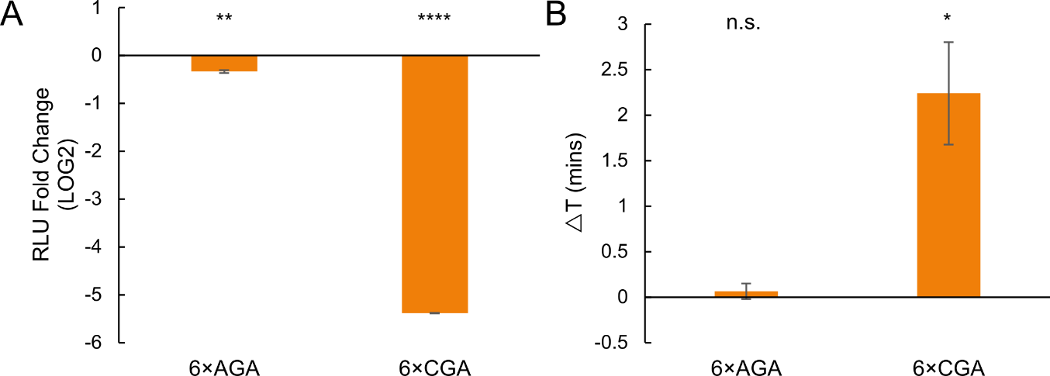

Supplementary Figure 1. 6×CGA acute stall is induced by sequential non-optimal CGA codons, instead of its coding Arginine.
A: Protein expression fold change of 6×AGA and 6×CGA constructs. (n=3 for both constructs)
B: Elongation change of 6×AGA and 6×CGA constructs vs. (n=3 for both constructs)
All error bars indicate SEM. All statistical significances were calculated for each construct using two-tailed paired Student’s t-Test against optYFP.

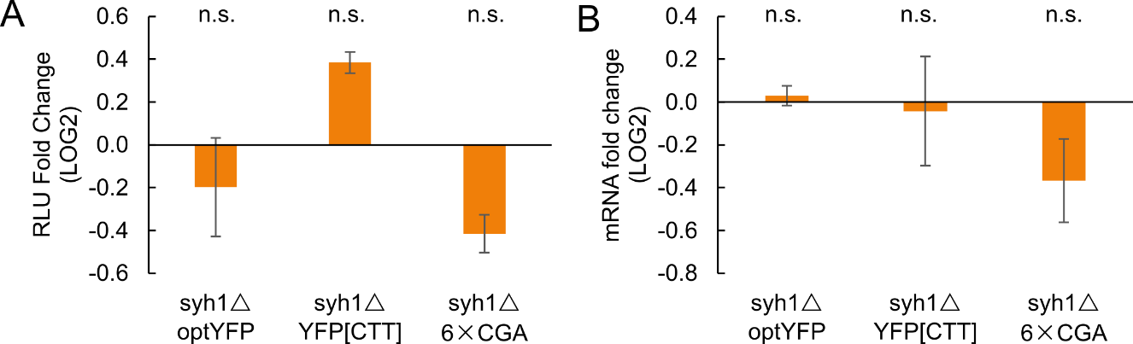
Supplementary Figure 2. Syh1 doesn’t significantly affects protein expression, mRNA expression and elongation of CTT and CGA-derived ribosome stalls
A: Protein expression fold change of optYFP, YFP[CTT] and 6×CGA constructs in syh1△ vs WT (n=3 for all constructs)
B: mRNA expression fold change of optYFP, YFP[CTT] and 6×CGA constructs in syh1△ vs WT (n=3 for all constructs)
All error bars indicate SEM. All statistical significances were calculated for each construct using two-tailed paired Student’s t-Test against WT constructs.

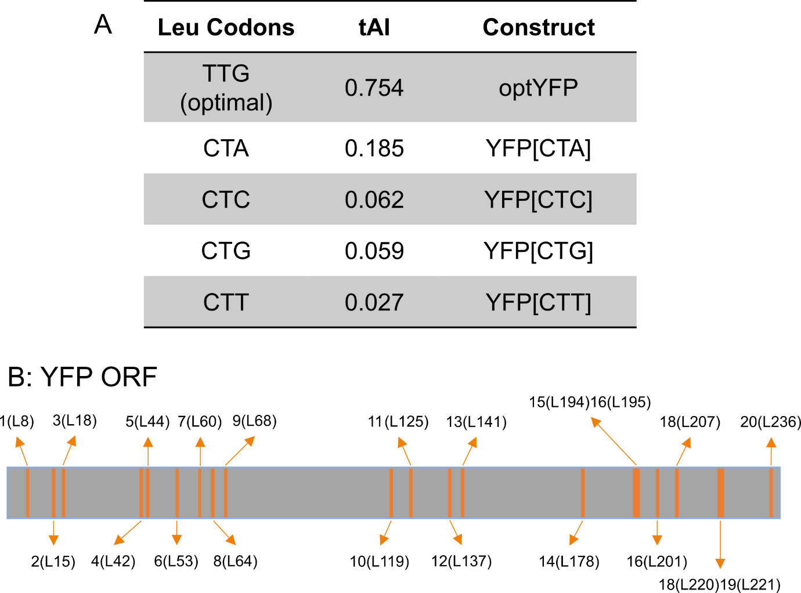
Supplementary Figure 3. Leucine codon variants.
A:Table of leucine codons used in this study. The optimal TTG codon is present in the optYFP control. Other constructs contain a nonoptimal leucine variant which is denoted in brackets. The tRNA Adaptation Index (tAI) is a metric that represents codon optimality and ranges from 0 (most nonoptimal) to 1 (most optimal).
B: 21 Leucine (L) position on YFP ORF gene. The YFP ORF gene contains 714 bp or 238 aa (stop codon isn’t included). Inside the 238 amino acids, there are 21 Leucine amino acids in total and 20 of them are mutated to five different Leu codon (shown in Figure A). The amino acids position and codon number of Leu in YFP are labeled (for example: X(LY) means Xth Leu codon and Yth amino acids from 5’ end of YFP)

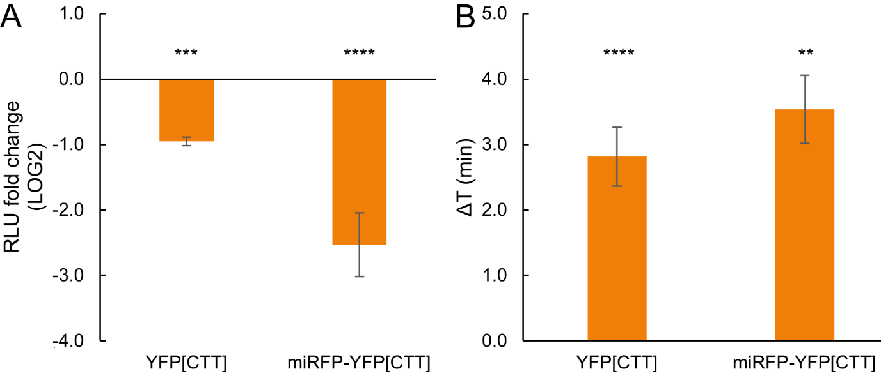Supplementary Figure 4 Decrease of protein expression does not depend on the non-optimal codons near the initiation codon
A: Protein expression of miRFP-YFP[CTT] with/without miRFP at 5’ end (n=11 for YFP[CTT], n=6 for miRFP-YFP[CTT])
B: Elongation delay measurements of YFP[CTT] with/without miRFP at 5’ end (n=11 for YFP[CTT], n=6 for miRFP-YFP[CTT])
All error bars indicate SEM. Statistical significances of YFP[CTT] were calculated using two-tailed paired Student’s t-Test against optYFP; Statistical significances of miRFP-YFP[CTT] were calculated using two-tailed paired Student’s t-Test against miRFP-optYFP

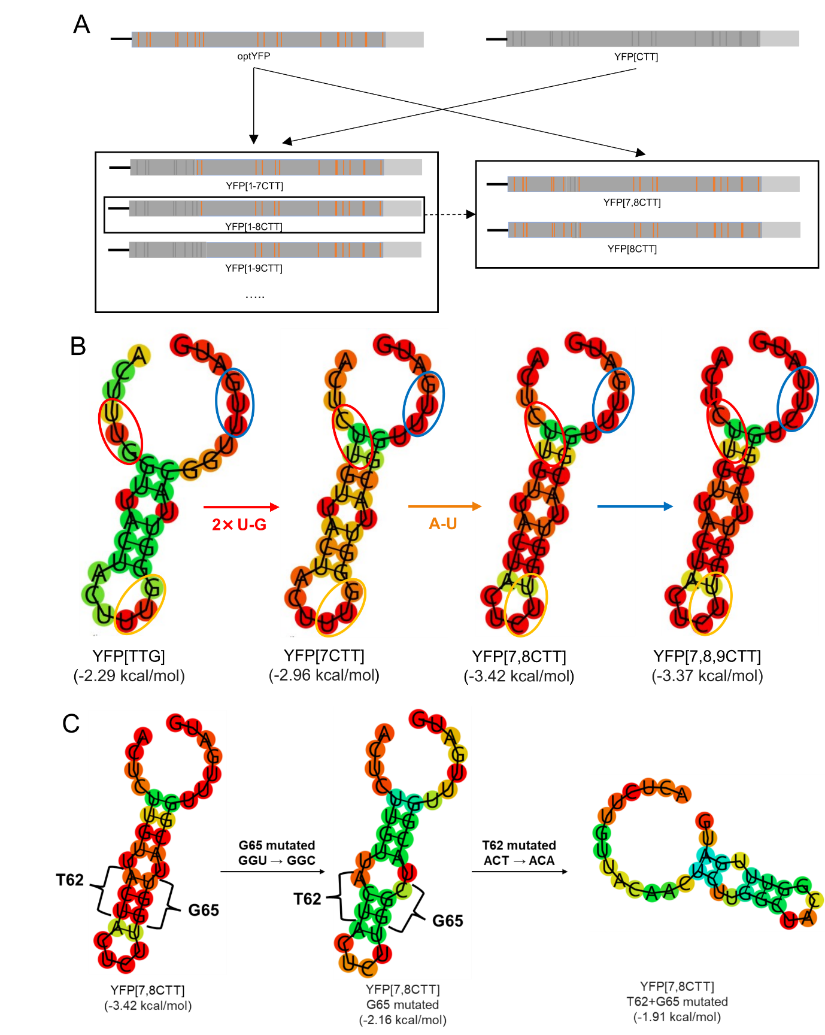

Supplementary Figure 5. Cloning strategy of chimeric leucine constructs and mRNA structure induced stalls
A: Diagram of Chimeric YFP construction. YFP[1-7CTT], YFP[1-8CTT], YFP[1-9CTT], YFP[1-10CTT], YFP[10-20CTT] are constructed based on optYFP and YFP[CTT]; YFP[7,8CTT] and YFP[8CTT] are constructed based on optYFP and YFP[1-8CTT]
B: RNA-fold prediction, with the sequence of the region from No.178 to No.207 bp of each construct listed below the structure. CODON mutation from TTG to CTT increases the stability of the stem loop. Red circle is Leu 7 (L60), Yellow circle Leu 8 (L64), Blue circle Leu 9 (L68) as either TTG(UUG) or CTT(CUU).
C: RNA-fold prediction, with the sequence of the region from No.178 to No.207 bp of each construct listed below the structure. T62+G65 mutation decreases the stabilization of the stem loop.

