Supplemental Information
In vivo structure probing of RNA in Archaea: Novel insights into the ribosome structure of Methanosarcina acetivorans

Allison M. Williams^{1,2,6}, Elizabeth A. Jolley^{2,3}, M. Geovanni Santiago-Martinez^{1,7},
Cheong Xin Chan⁴, Robin R. Gutell⁵, J. Gregory Ferry¹, Philip C. Bevilacqua^{1,2,3,*}

¹Department of Biochemistry and Molecular Biology, Pennsylvania State University, University Park, PA, 16802, United States
²Center for RNA Molecular Biology, Pennsylvania State University, University Park, PA, 16802, United States
³Department of Chemistry, Pennsylvania State University, University Park, PA, 16802, United States
⁴Australian Centre for Ecogenomics, School of Chemistry and Molecular Biosciences, The University of Queensland, Brisbane QLD 4072, Australia
⁵Department of Integrative Biology, The University of Texas at Austin, Austin, TX, 78712, United States
⁶Present address: Division of Rheumatology, Inflammation, and Immunity, Department of Medicine Brigham and Women’s Hospital, Harvard Medical School, Boston, MA 02115, United States
⁷Present address: Department of Molecular and Cell Biology, The University of Connecticut, Storrs, CT, 06269, United States
*Corresponding author: pcb5@psu.edu
Table of contents

- Supplemental Tables
Supplemental Table 1. List of DNA oligonucleotides S4
Supplemental Table 2. Sequencing reads and mapping percentages S6
Supplemental Table 3. Reverse transcription stop percentages by nucleotide identity S6
- Supplemental Figures
Supplemental Figure S1: DMS-probing workflow S7
Supplemental Figure S2: Single hit kinetics of the 5′-end of 16S rRNA S8
Supplemental Figure S3: Methanol replicate correlation plots. S9
Supplemental Figure S4: Acetate replicate correlation plots. S9
Supplemental Figure S5: DMS reactivity of 16S rRNA for acetate S10
Supplemental Figure S6: DMS reactivity of 16S rRNA for methanol S11
Supplemental Figure S7: DMS reactivity difference for 16S rRNA S12
Supplemental Figure S8: DMS reactivity of 5′-end of 23S rRNA for acetate S13
Supplemental Figure S9: DMS reactivity map of 5′-end of 23S rRNA for methanol S14
Supplemental Figure S10: DMS reactivity difference for 5′-end of 23S rRNA S15
Supplemental Figure S11: DMS reactivity map of 3′-end of 23S rRNA for acetate S16
Supplemental Figure S12: DMS reactivity map of 3′-end of 23S rRNA for methanol S17
Supplemental Figure S13: DMS reactivity difference for 3′-end of 23S rRNA S18
Supplemental Figure S14: Conservation of 5S rRNA S19
Supplemental Figure S15: Conservation of 16S rRNA S20
Supplemental Figure S16: Conservation of the 5′-end of 23S rRNA S21
Supplemental Figure S17: Conservation of the 3′-end of 23S rRNA S22

Supplemental Table 1: List of DNA oligonucleotides
Nameª | Step Used | Sequence | Type | Purification method
16S RT primer | Single-hit kinetics primer | TCC GGT ATT ATC CCC AGT T | DNA | Standard desalting
Random Hexamer | Reverse transcription | CAG ACG TGT GCT CTT CCG ATC NNN NNN | DNA | HPLC
Hairpin adapter | Ligation | /5Phos/ TGA AGA GCC TAG TCG CTG TTC ANN NNN NCT GCC CAT AGA G/3SpC3/^{b} | DNA | HPLC
Forward primer | PCR | AAT GAT ACG GCG ACC ACC GAG ATC TAC ACT CTT TCC CTA CAC GAC GCT CTT CCG ATC TTG AAC AGC GAC TAG GCT CTT CA | DNA | HPLC
M –DMS 1 | PCR reverse primer | CAA GCA GAA GAC GGC ATA CGA GAT CGT GAT GTG ACT GGA GTT CAG ACG TGT GCT CTT CCG ATC | DNA | HPLC
M +DMS 1 | PCR reverse primer | CAA GCA GAA GAC GGC ATA CGA GAT ACA TCG GTG ACT GGA GTT CAG ACG TGT GCT CTT CCG ATC | DNA | HPLC
M –DMS 2 | PCR reverse primer | CAA GCA GAA GAC GGC ATA CGA GAT GCC TAA GTG ACT GGA GTT CAG ACG TGT GCT CTT CCG ATC | DNA | HPLC
M +DMS 2 | PCR reverse primer | CAA GCA GAA GAC GGC ATA CGA GAT TCA AGT GTG ACT GGA GTT CAG ACG TGT GCT CTT CCG ATC | DNA | HPLC
M –DMS 3 | PCR reverse primer | CAA GCA GAA GAC GGC ATA CGA GAT CTG ATC GTG ACT GGA GTT CAG ACG TGT GCT CTT CCG ATC | DNA | HPLC
M +DMS 3 | PCR reverse primer | CAA GCA GAA GAC GGC ATA CGA GAT AAG CTA GTG ACT GGA GTT CAG ACG TGT GCT CTT CCG ATC | DNA | HPLC
A –DMS 1 | PCR reverse primer | CAA GCA GAA GAC GGC ATA CGA GAT TGG TCA GTG ACT GGA GTT CAG ACG TGT GCT CTT CCG ATC | DNA | HPLC
A +DMS 1 | PCR reverse primer | CAA GCA GAA GAC GGC ATA CGA GAT CAC TGT GTG ACT GGA GTT CAG ACG TGT GCT CTT CCG ATC | DNA | HPLC
A –DMS 2 | PCR reverse primer | CAA GCA GAA GAC GGC ATA CGA GAT ATT GGC GTG ACT GGA GTT CAG ACG TGT GCT CTT CCG ATC | DNA | HPLC
A +DMS 2 | PCR reverse primer | CAA GCA GAA GAC GGC ATA CGA GAT GAT CTG GTG ACT GGA GTT CAG ACG TGT GCT CTT CCG ATC | DNA | HPLC
A –DMS 3 | PCR reverse primer | CAA GCA GAA GAC GGC ATA CGA GAT ACG GAA CTG TGA CTG GAG TTC AGA CGT GTG CTC TTC CGA TC | DNA | HPLC
A +DMS 3 | PCR reverse primer | CAA GCA GAA GAC GGC ATA CGA GAT GTG CGG ACG TGA CTG GAG TTC AGA CGT GTG CTC TTC CGA TC | DNA | HPLC
Custom sequencing primer | Sequencing | TCT TCC GAT CTT GAA CAG CGA CTA GGC TCT TCA | DNA | HPLC
ª‘M’ is grown in methanol. ‘A’ is grown in acetate. ^{b’}5Phos’ is a 5′-phosphate. ‘3SpC3’ is a 3′-three carbon spacer. ^{c}The barcode for each library is underlined.

Supplemental Table 2: Sequencing reads and mapping percentages
Sample | Total sequencing reads | Effective reads (passed trimming) | Mapped reads to transcriptome | % of Effective reads mapped to transcriptome
Methanol 1 (–DMS) | 15,388,736 | 14,248,338 | 10,356,971 | 72.7%
Methanol 2 (–DMS) | 12,815,418 | 12,346,677 | 10,186,151 | 82.5%
Methanol 3 (–DMS) | 13,260,092 | 12,239,145 | 8,835,390 | 72.2%
Methanol 1 (+DMS) | 16,016,218 | 15,445,892 | 12,932,404 | 83.7%
Methanol 2 (+DMS) | 16,292,440 | 15,669,423 | 13,495,866 | 86.1%
Methanol 3 (+DMS) | 15,032,572 | 14,009,423 | 11,684,102 | 83.4%
Acetate 1 (–DMS) | 11,259,554 | 9,268,022 | 7,347,215 | 79.3%
Acetate 2 (–DMS) | 7,608,053 | 7,195,904 | 5,201,102 | 72.3%
Acetate 3 (–DMS) | 8,289,818 | 7,190,750 | 3,631,017 | 50.5%
Acetate 1 (+DMS) | 11,308,078 | 10,148,510 | 8,713,707 | 85.9%
Acetate 2 (+DMS) | 9,830,827 | 8,835,744 | 5,990,830 | 67.8%
Acetate 3 (+DMS) | 9,911,951 | 8,202,151 | 5,125,341 | 62.4%

Supplemental Table 3: Reverse transcription stop percentages by nucleotide identity
Sample | A | T | G | C
Methanol 1 (–DMS) | 26.2% | 27.1% | 25.2% | 21.4%
Methanol 2 (–DMS) | 20.5% | 24.2% | 18.1% | 37.2%
Methanol 3 (–DMS) | 26.1% | 30.1% | 22.1% | 21.6%
Methanol 1 (+DMS) | 63.0% | 12.1% | 11.9% | 13.0%
Methanol 2 (+DMS) | 60.7% | 13.4% | 12.5% | 13.4%
Methanol 3 (+DMS) | 59.3% | 14.9% | 11.6% | 14.2%
Acetate 1 (–DMS) | 22.4% | 22.9% | 21.6% | 33.1%
Acetate 2 (–DMS) | 21.4% | 22.2% | 22.6% | 33.8%
Acetate 3 (–DMS) | 23.4% | 20.3% | 25.2% | 31.1%
Acetate 1 (+DMS) | 55.4% | 12.0% | 13.4% | 19.2%
Acetate 2 (+DMS) | 59.0% | 11.2% | 14.0% | 15.8%
Acetate 3 (+DMS) | 55.7% | 11.1% | 14.4% | 18.8%

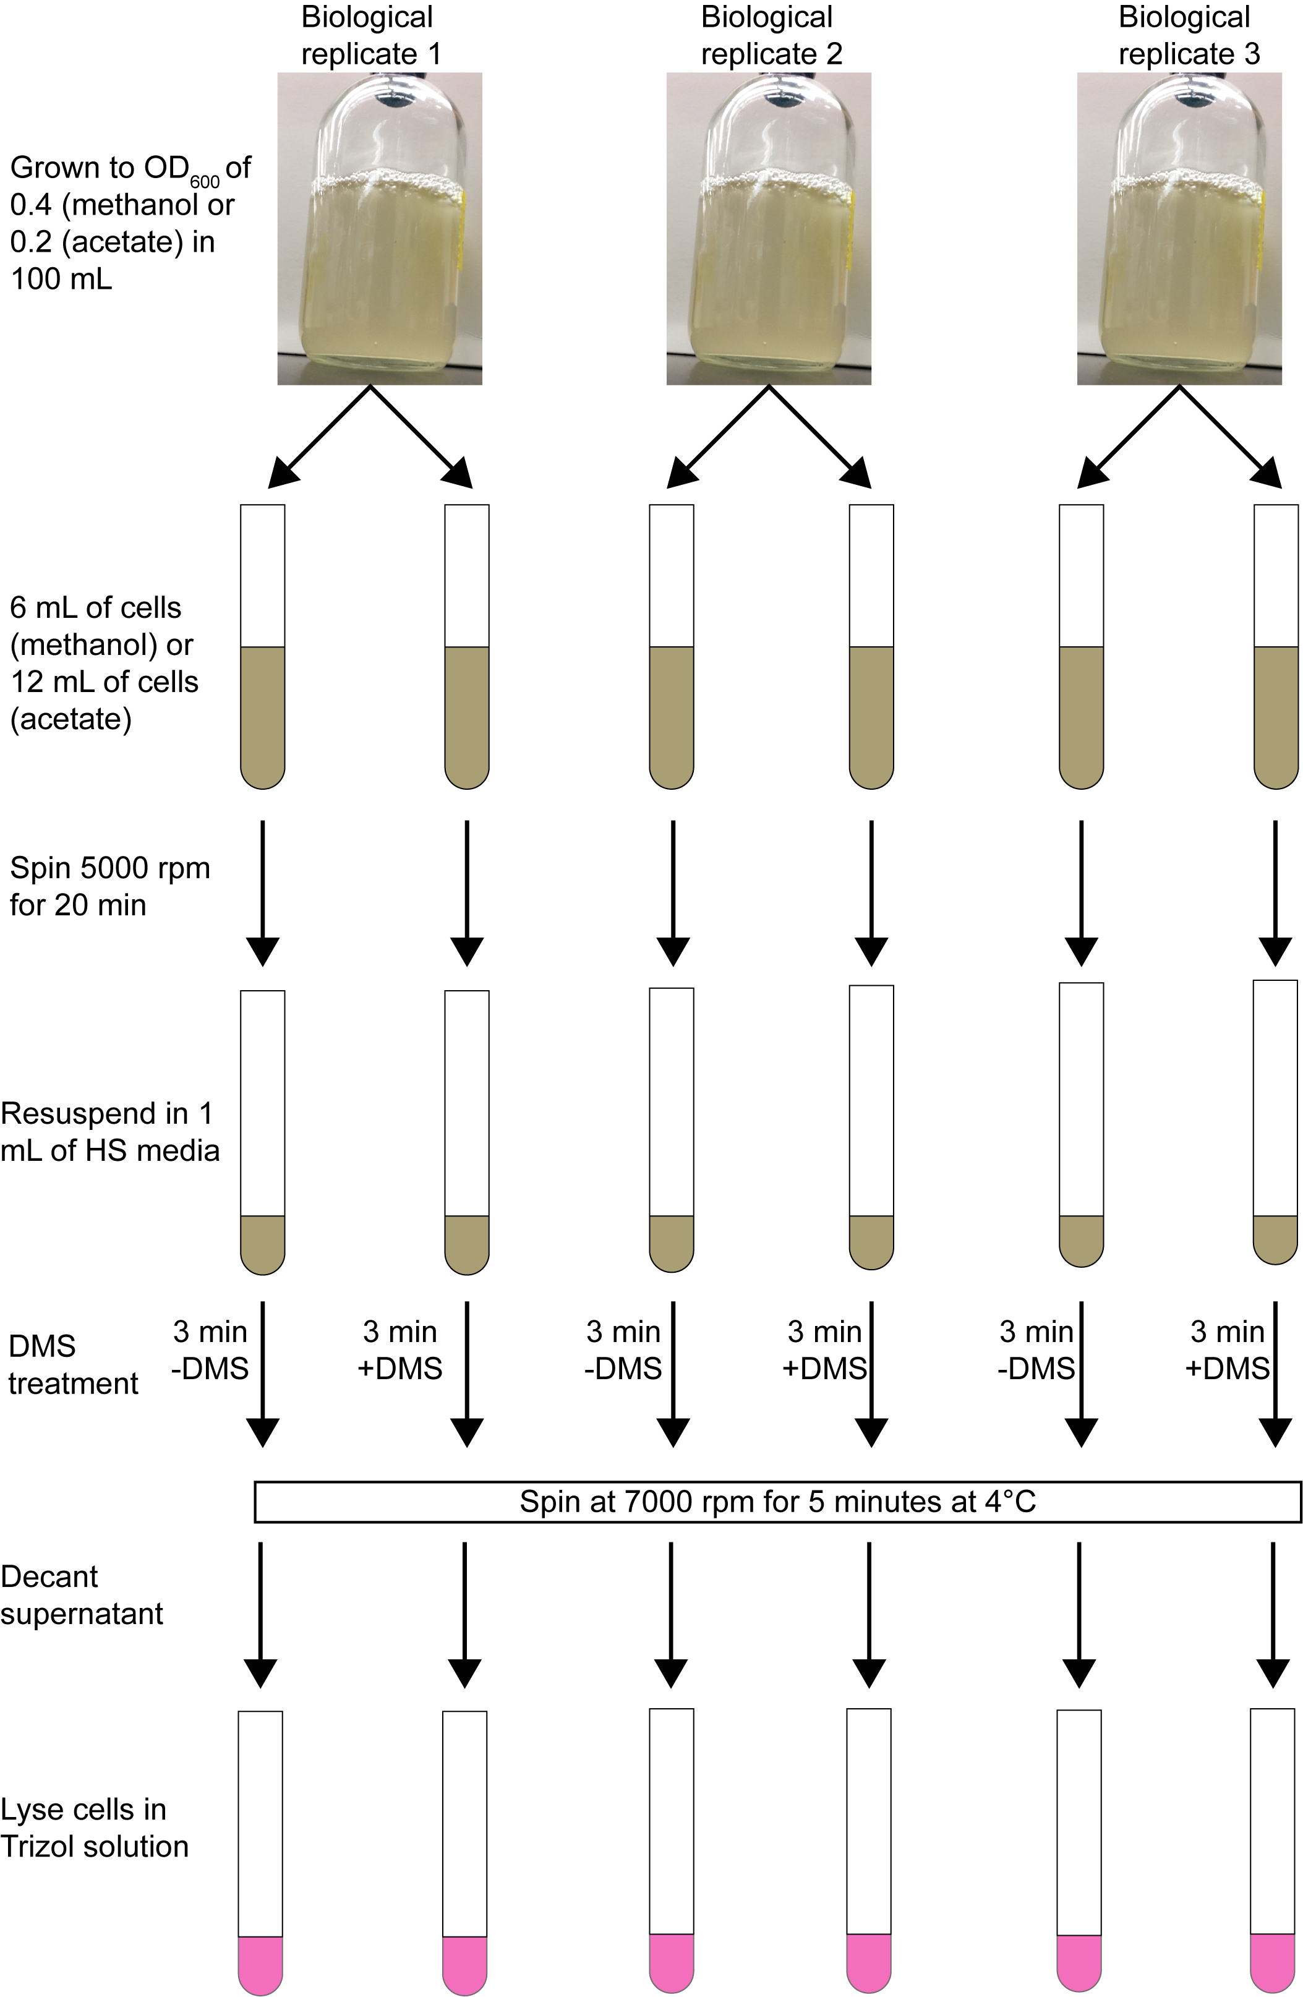
Supplemental Figure S1: DMS-probing workflow. Briefly, aliquots are taken from anaerobically grown cultures, spun down, and resuspended in a smaller volume. Treatment samples are incubated with 150 mM DMS for 3 min before being spun down at 4°C. The supernatant with DMS is then decanted, and all samples are lysed with 1 mL of Trizol. Unlike the previous method, no quench is added. The majority of the DMS is removed when samples are spun down and the supernatant is decanted, as well as during the Trizol extraction.
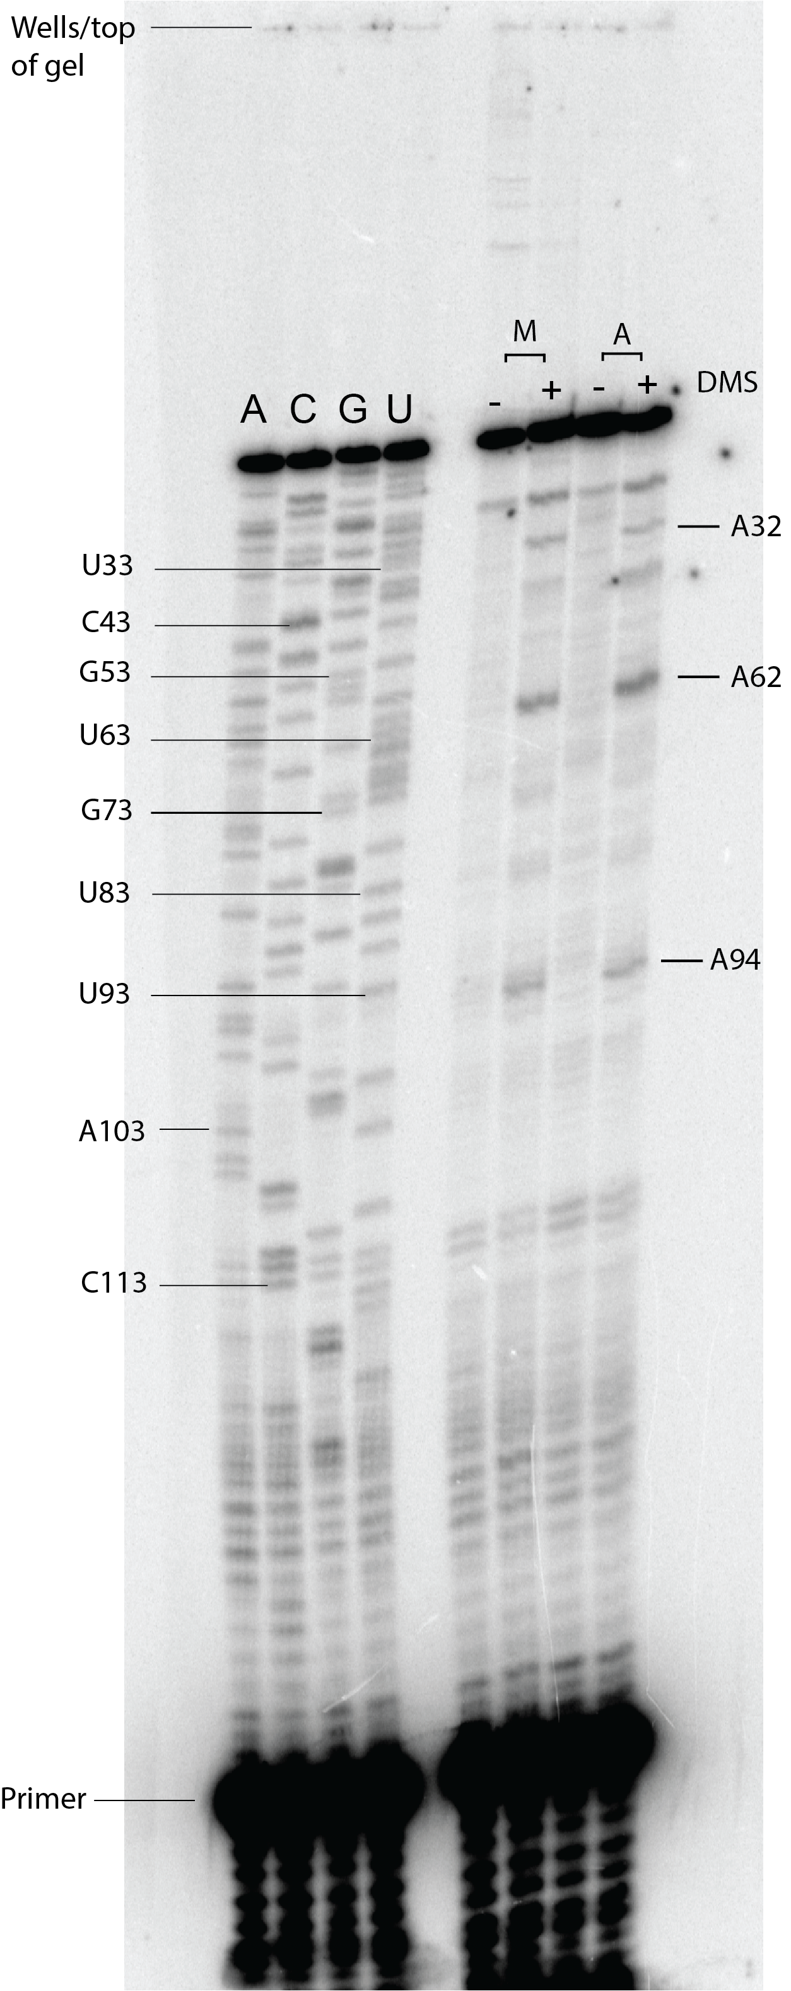
Supplemental Figure S2: Single hit kinetics gel of the 5′-end of 16S rRNA. Reverse transcription on a 10% denaturing PAGE gel with sequencing lanes (labeled as ‘A’, ‘C’, ‘G’, and ‘U’), as well as methanol (M) and acetate (A) samples without DMS (–) or with 150 mM DMS (+). The percent modification is 10% for methanol and 8% for acetate. Reactive nucleotides agree with sequencing data (see Supplemental Fig. 5 and 6).
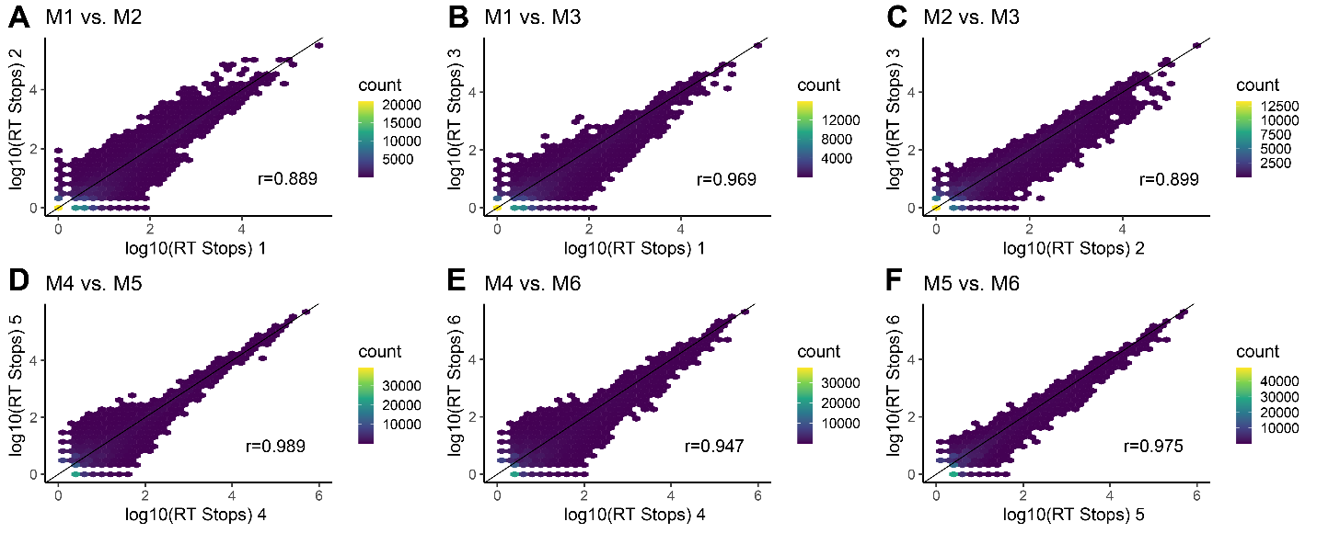
Supplemental Figure S3: Methanol replicate correlation plots. Correlation between RT stops for pairwise comparisons of biological triplicates (A-C) without and (D-F) with DMS treatment. Replicate numbers are as in Supplemental Table 2. All replicates had r-values ≥ 0.89. A line indicating a 1:1 correlation was added for reference.

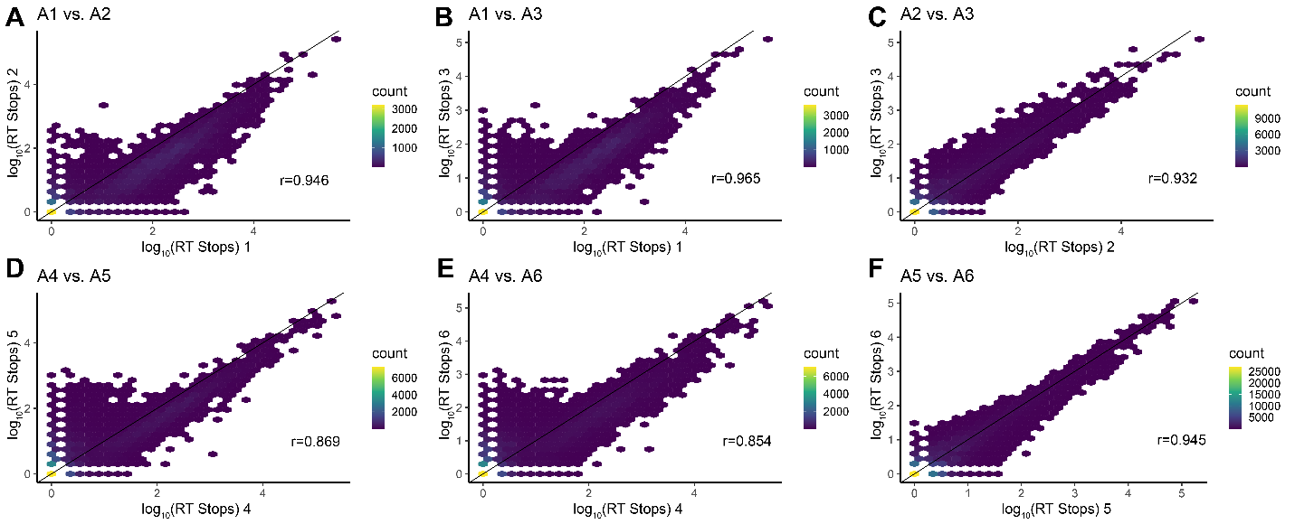
Supplemental Figure S4: Acetate replicate correlation plots. Correlation between RT stops for pairwise comparisons of biological triplicates (A-C) without and (D-F) with DMS treatment. Replicate numbers are as in Supplemental Table 2. All replicates had r-values ≥ 0.85. A line indicating a 1:1 correlation was added for reference.

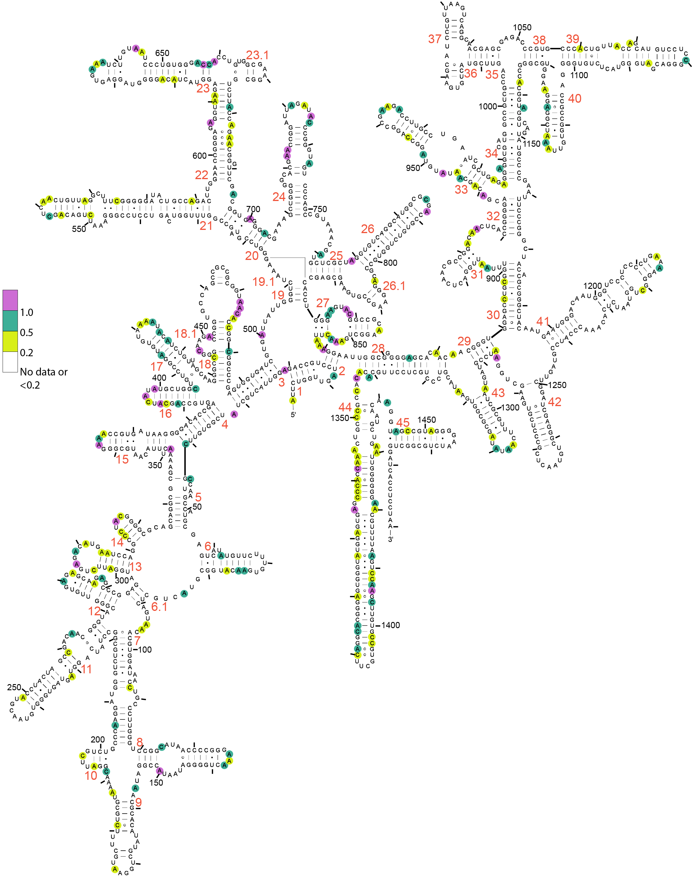
Supplemental Figure S5: DMS reactivity map of 16S rRNA for acetate samples.
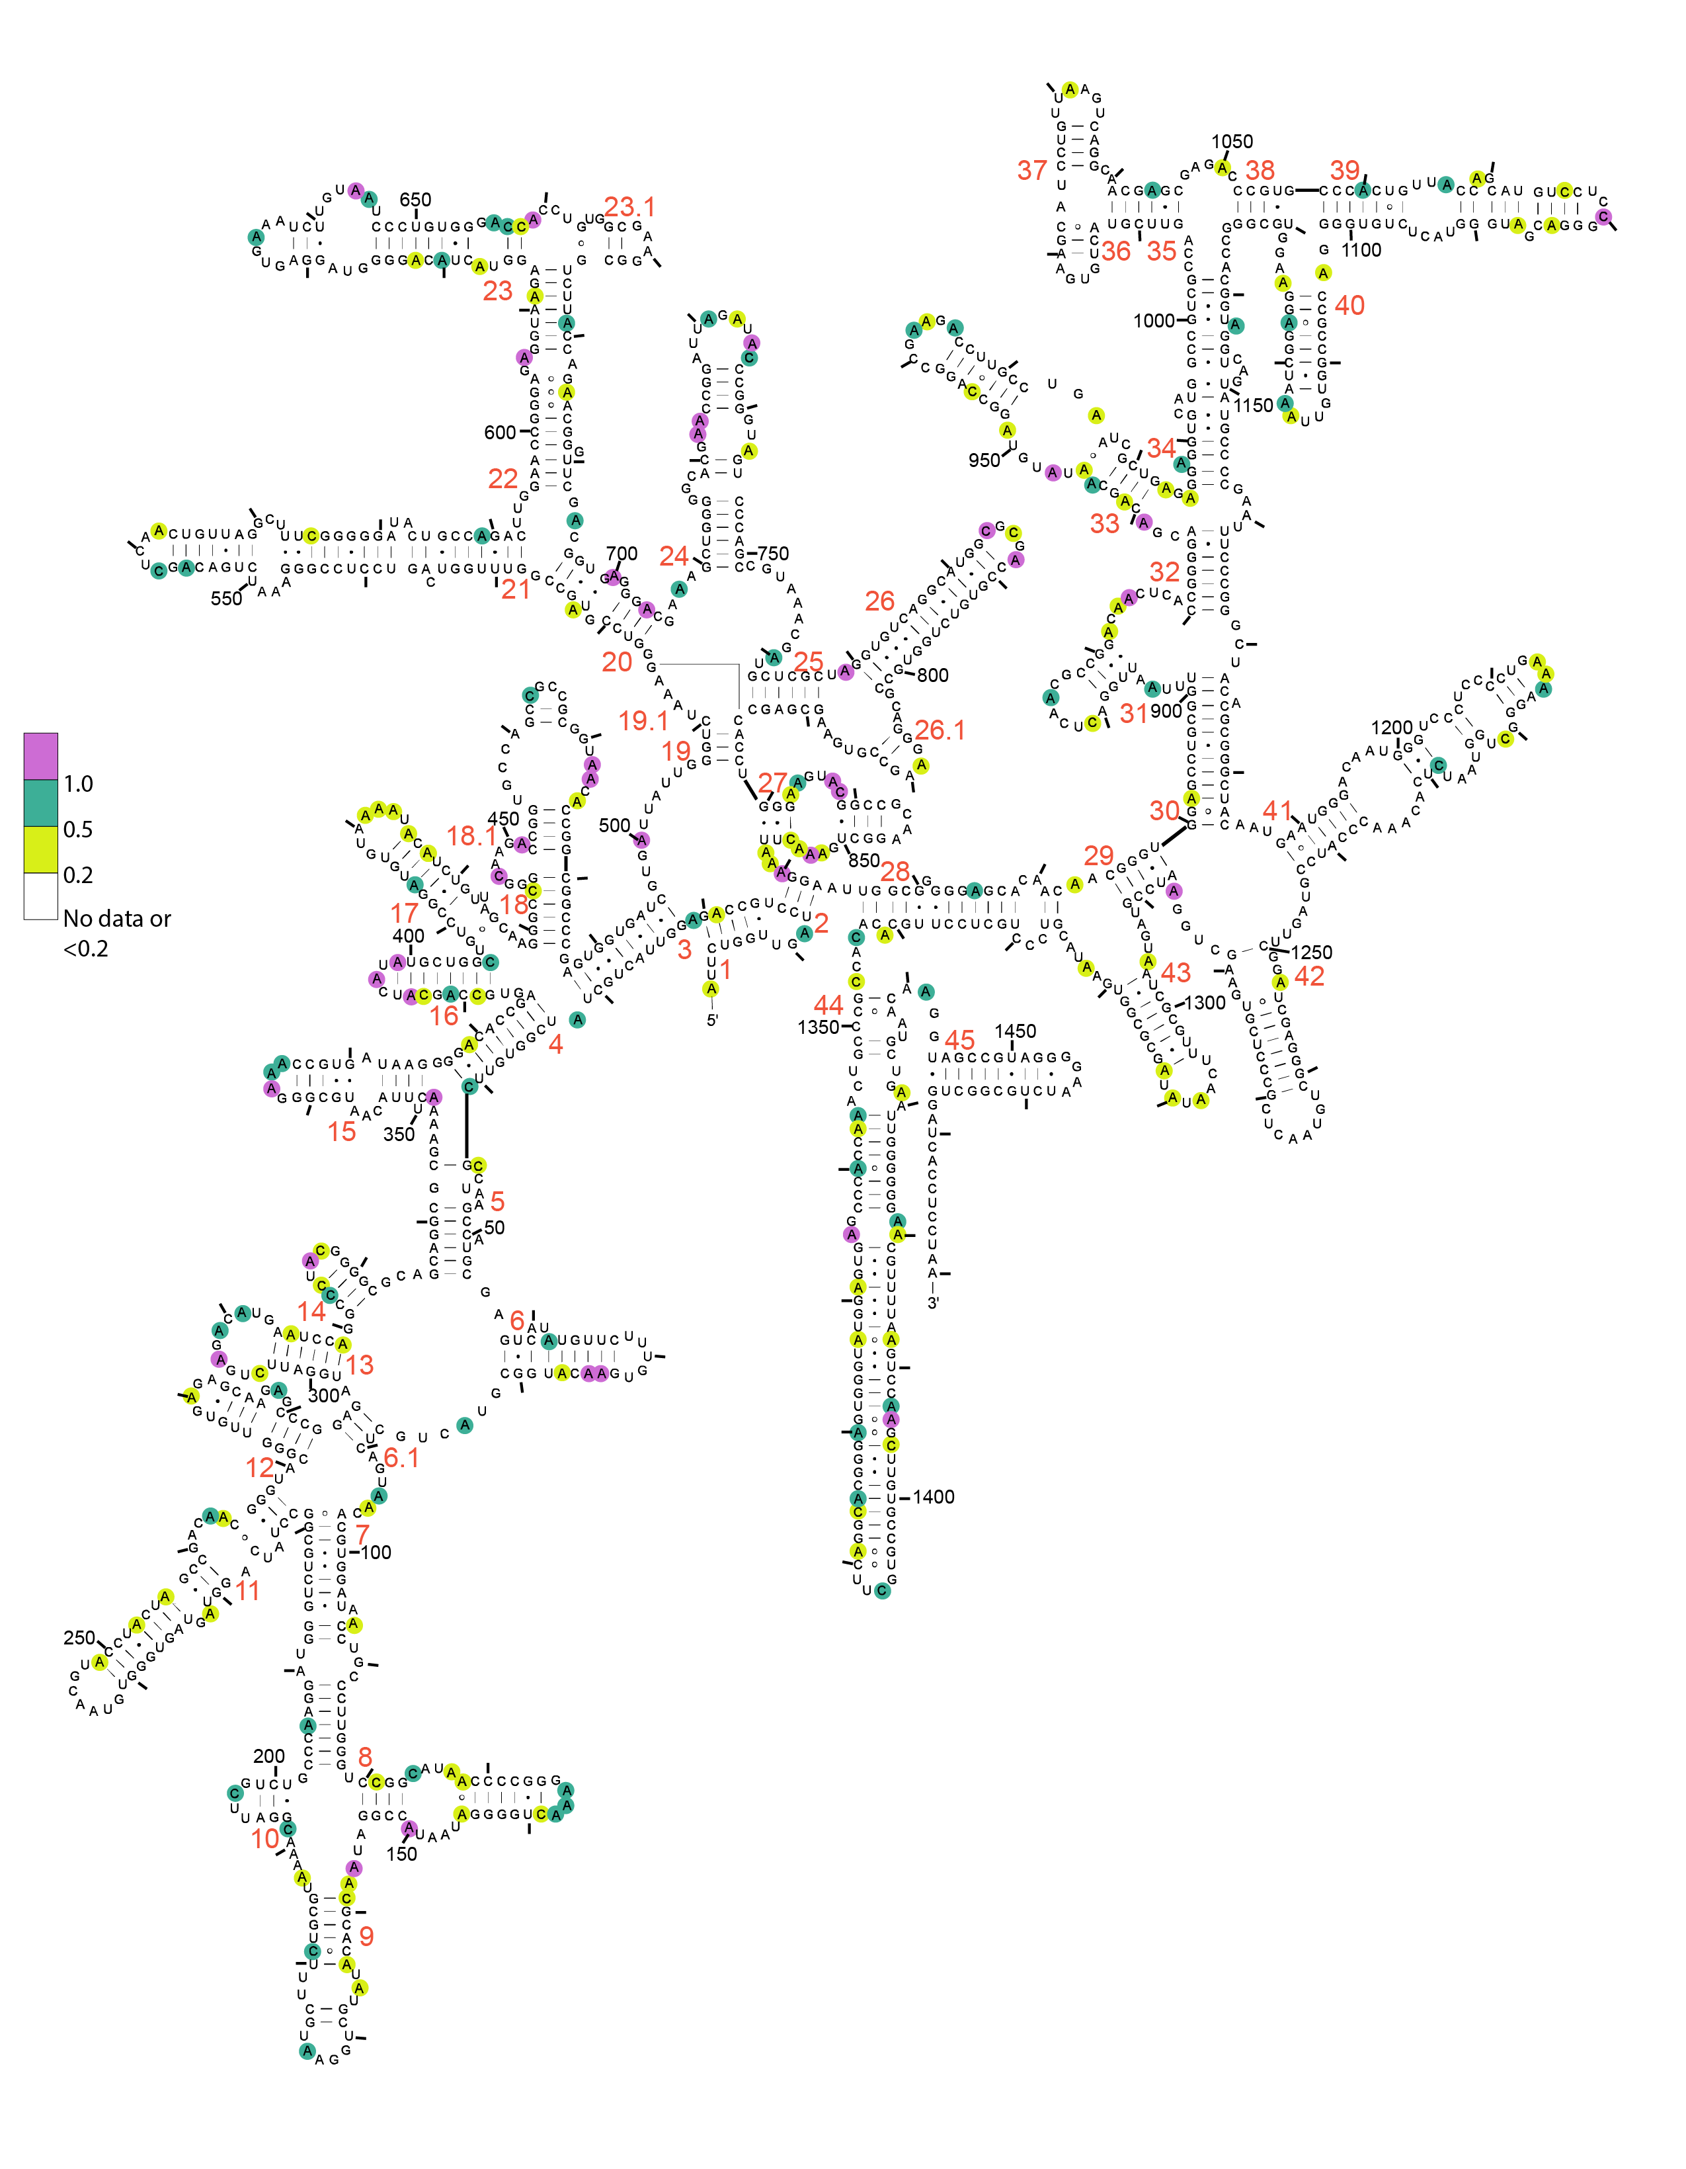
Supplemental Figure S6: DMS reactivity map of 16S rRNA for methanol samples.
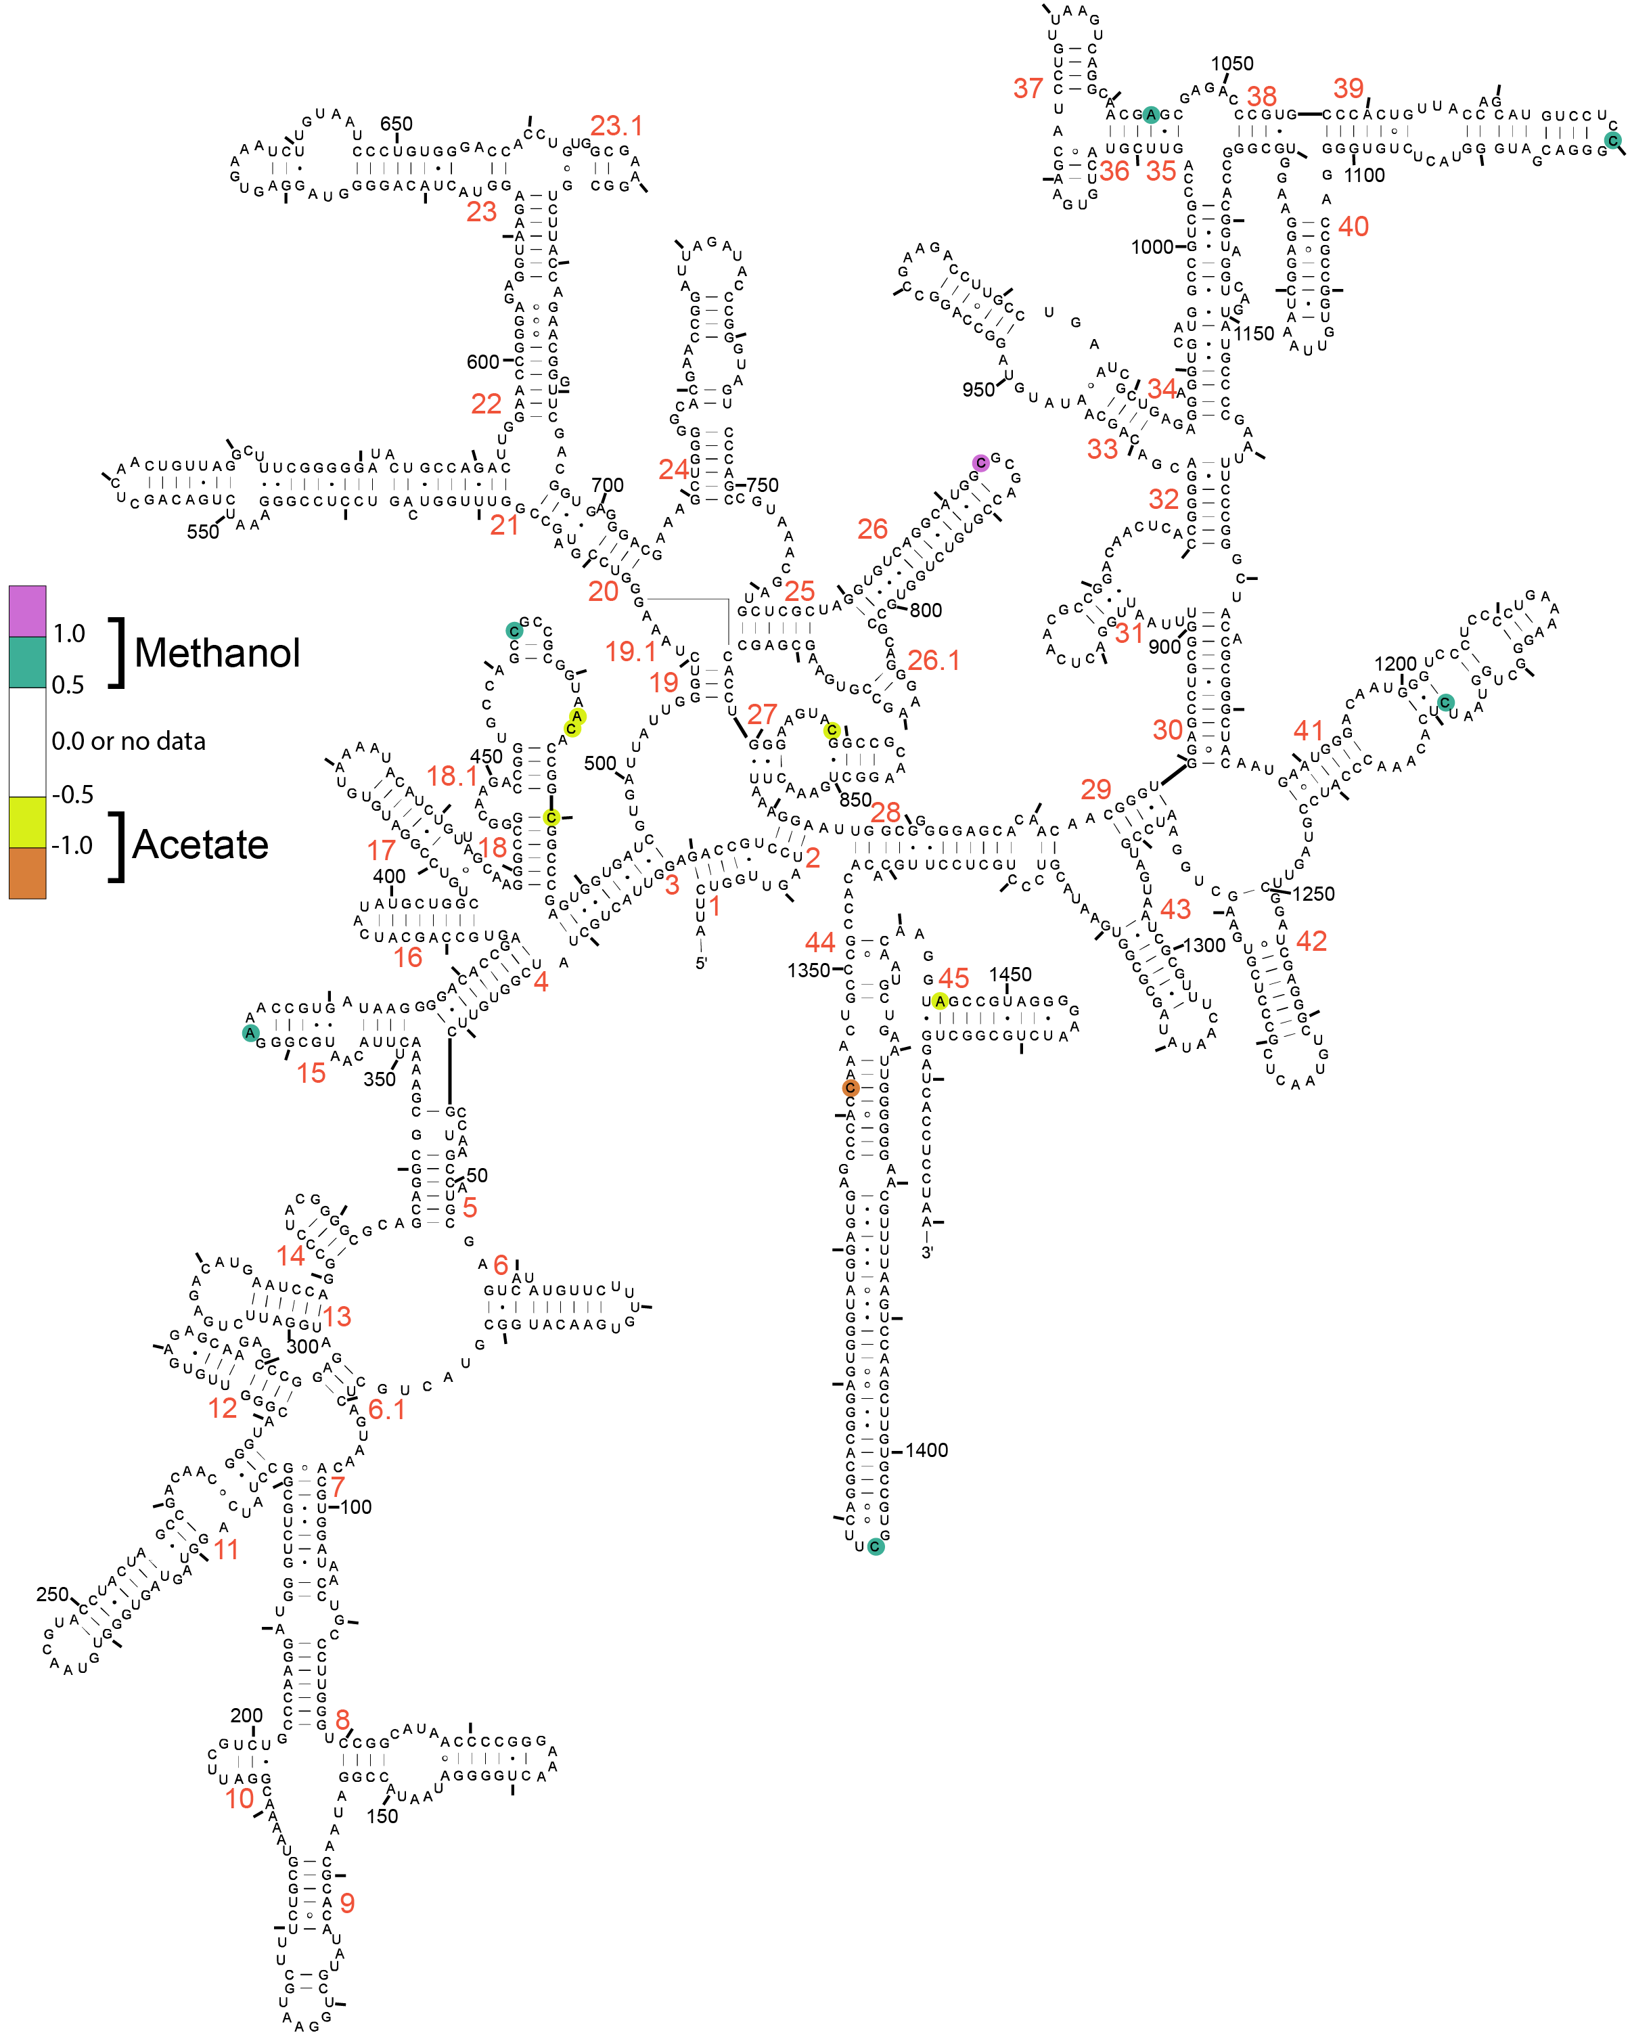
Supplemental Figure S7: DMS reactivity difference map for 16S rRNA. Difference represents DMS reactivity in methanol – acetate.

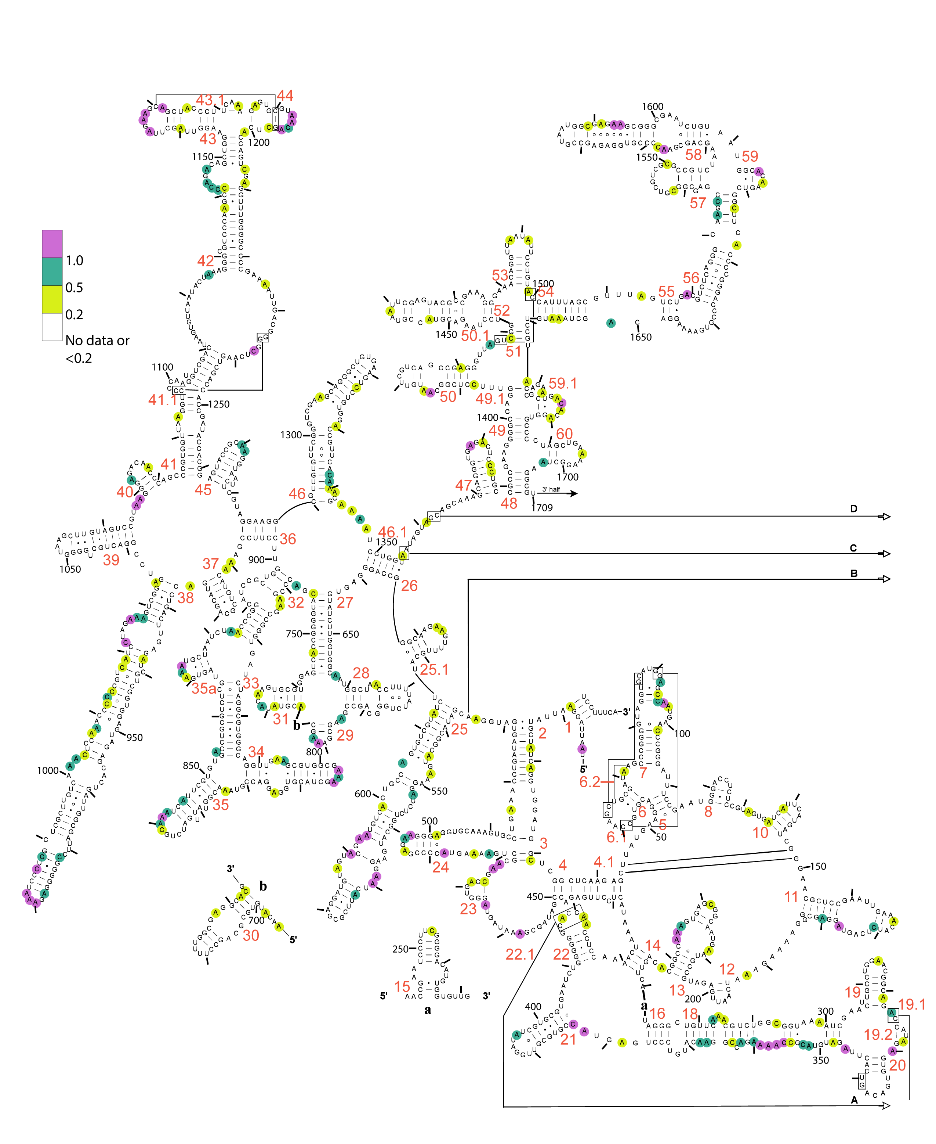
Supplemental Figure S8: DMS reactivity map of 5′-end of 23S rRNA for acetate samples.
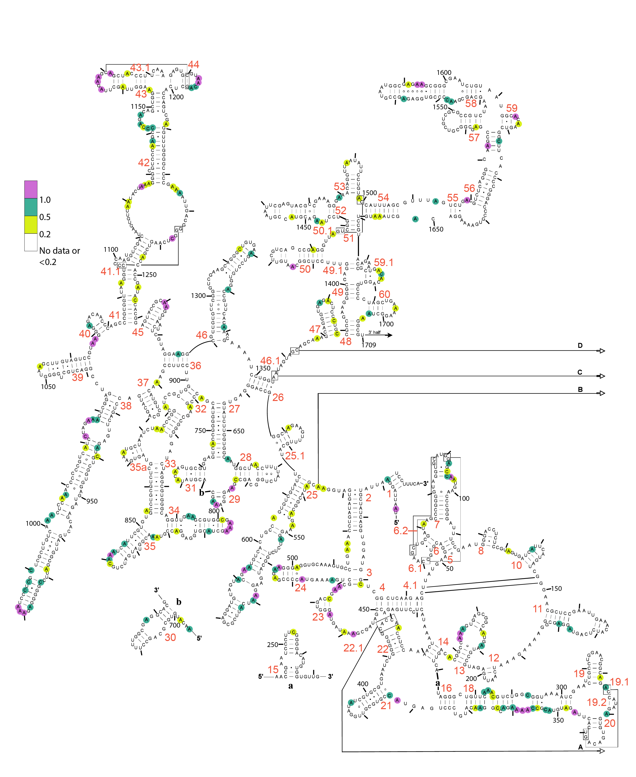
Supplemental Figure S9: DMS reactivity map of 5′-end of 23S rRNA for methanol samples.
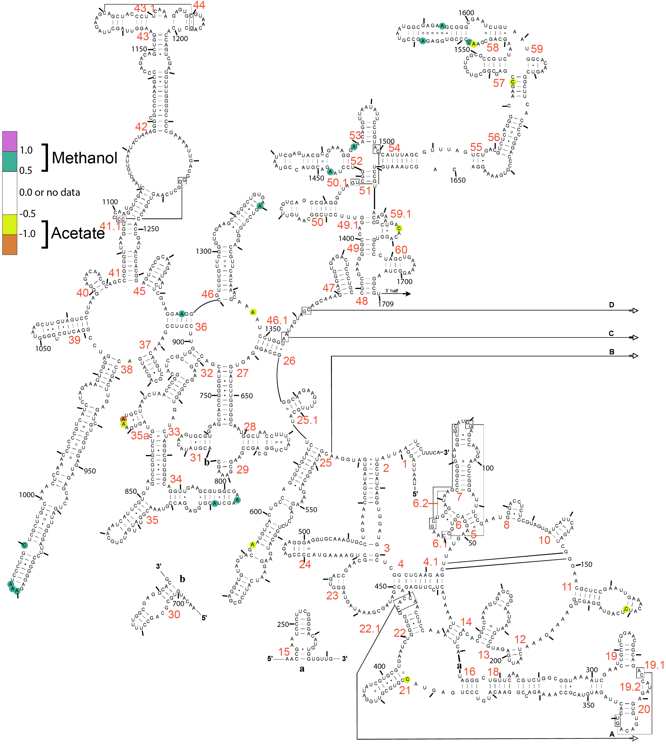
Supplemental Figure S10: DMS reactivity difference map of 5′-end for 23S rRNA. Difference represents DMS reactivity in methanol – acetate.
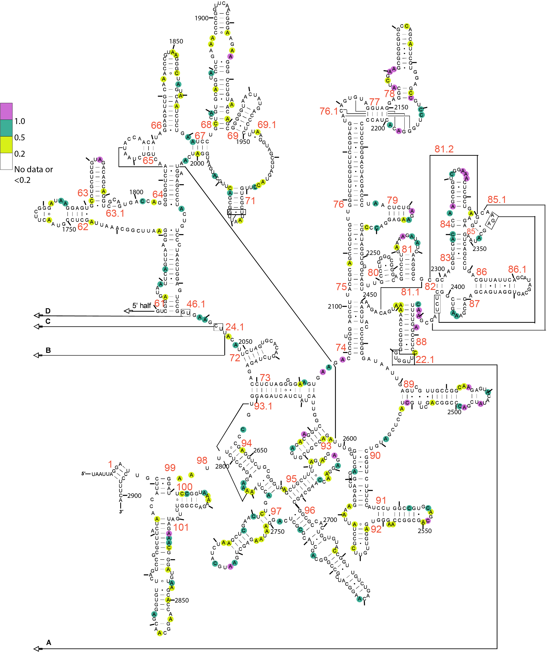
Supplemental Figure S11: DMS reactivity map of 3′-end of 23S rRNA for acetate samples.
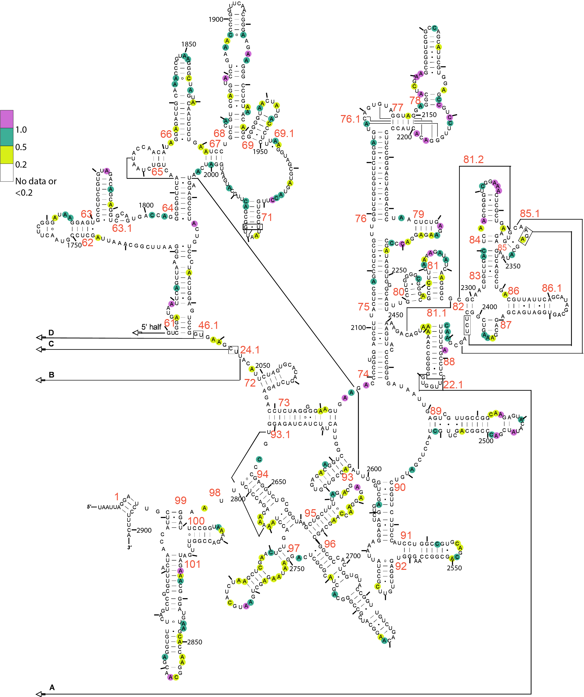
Supplemental Figure S12: DMS reactivity map of 3′-end of 23S rRNA for methanol samples.
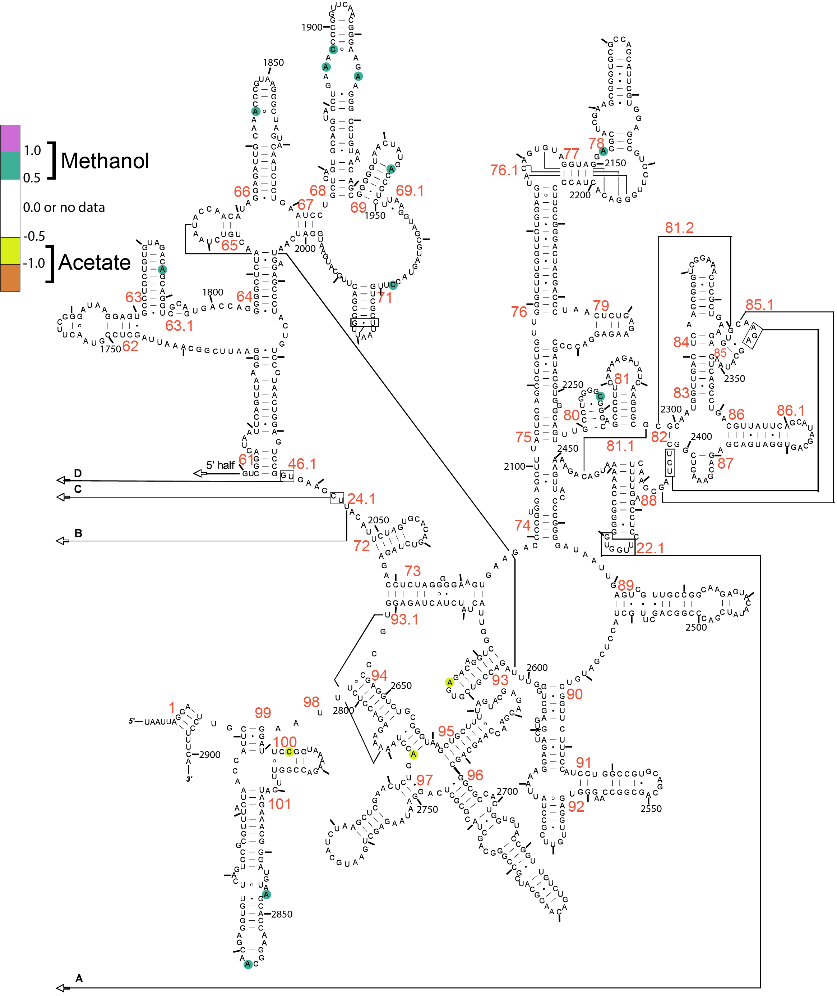
Supplemental Figure S13: DMS reactivity difference map of the 3′-end for 23S rRNA. Difference represents DMS reactivity in methanol – acetate.

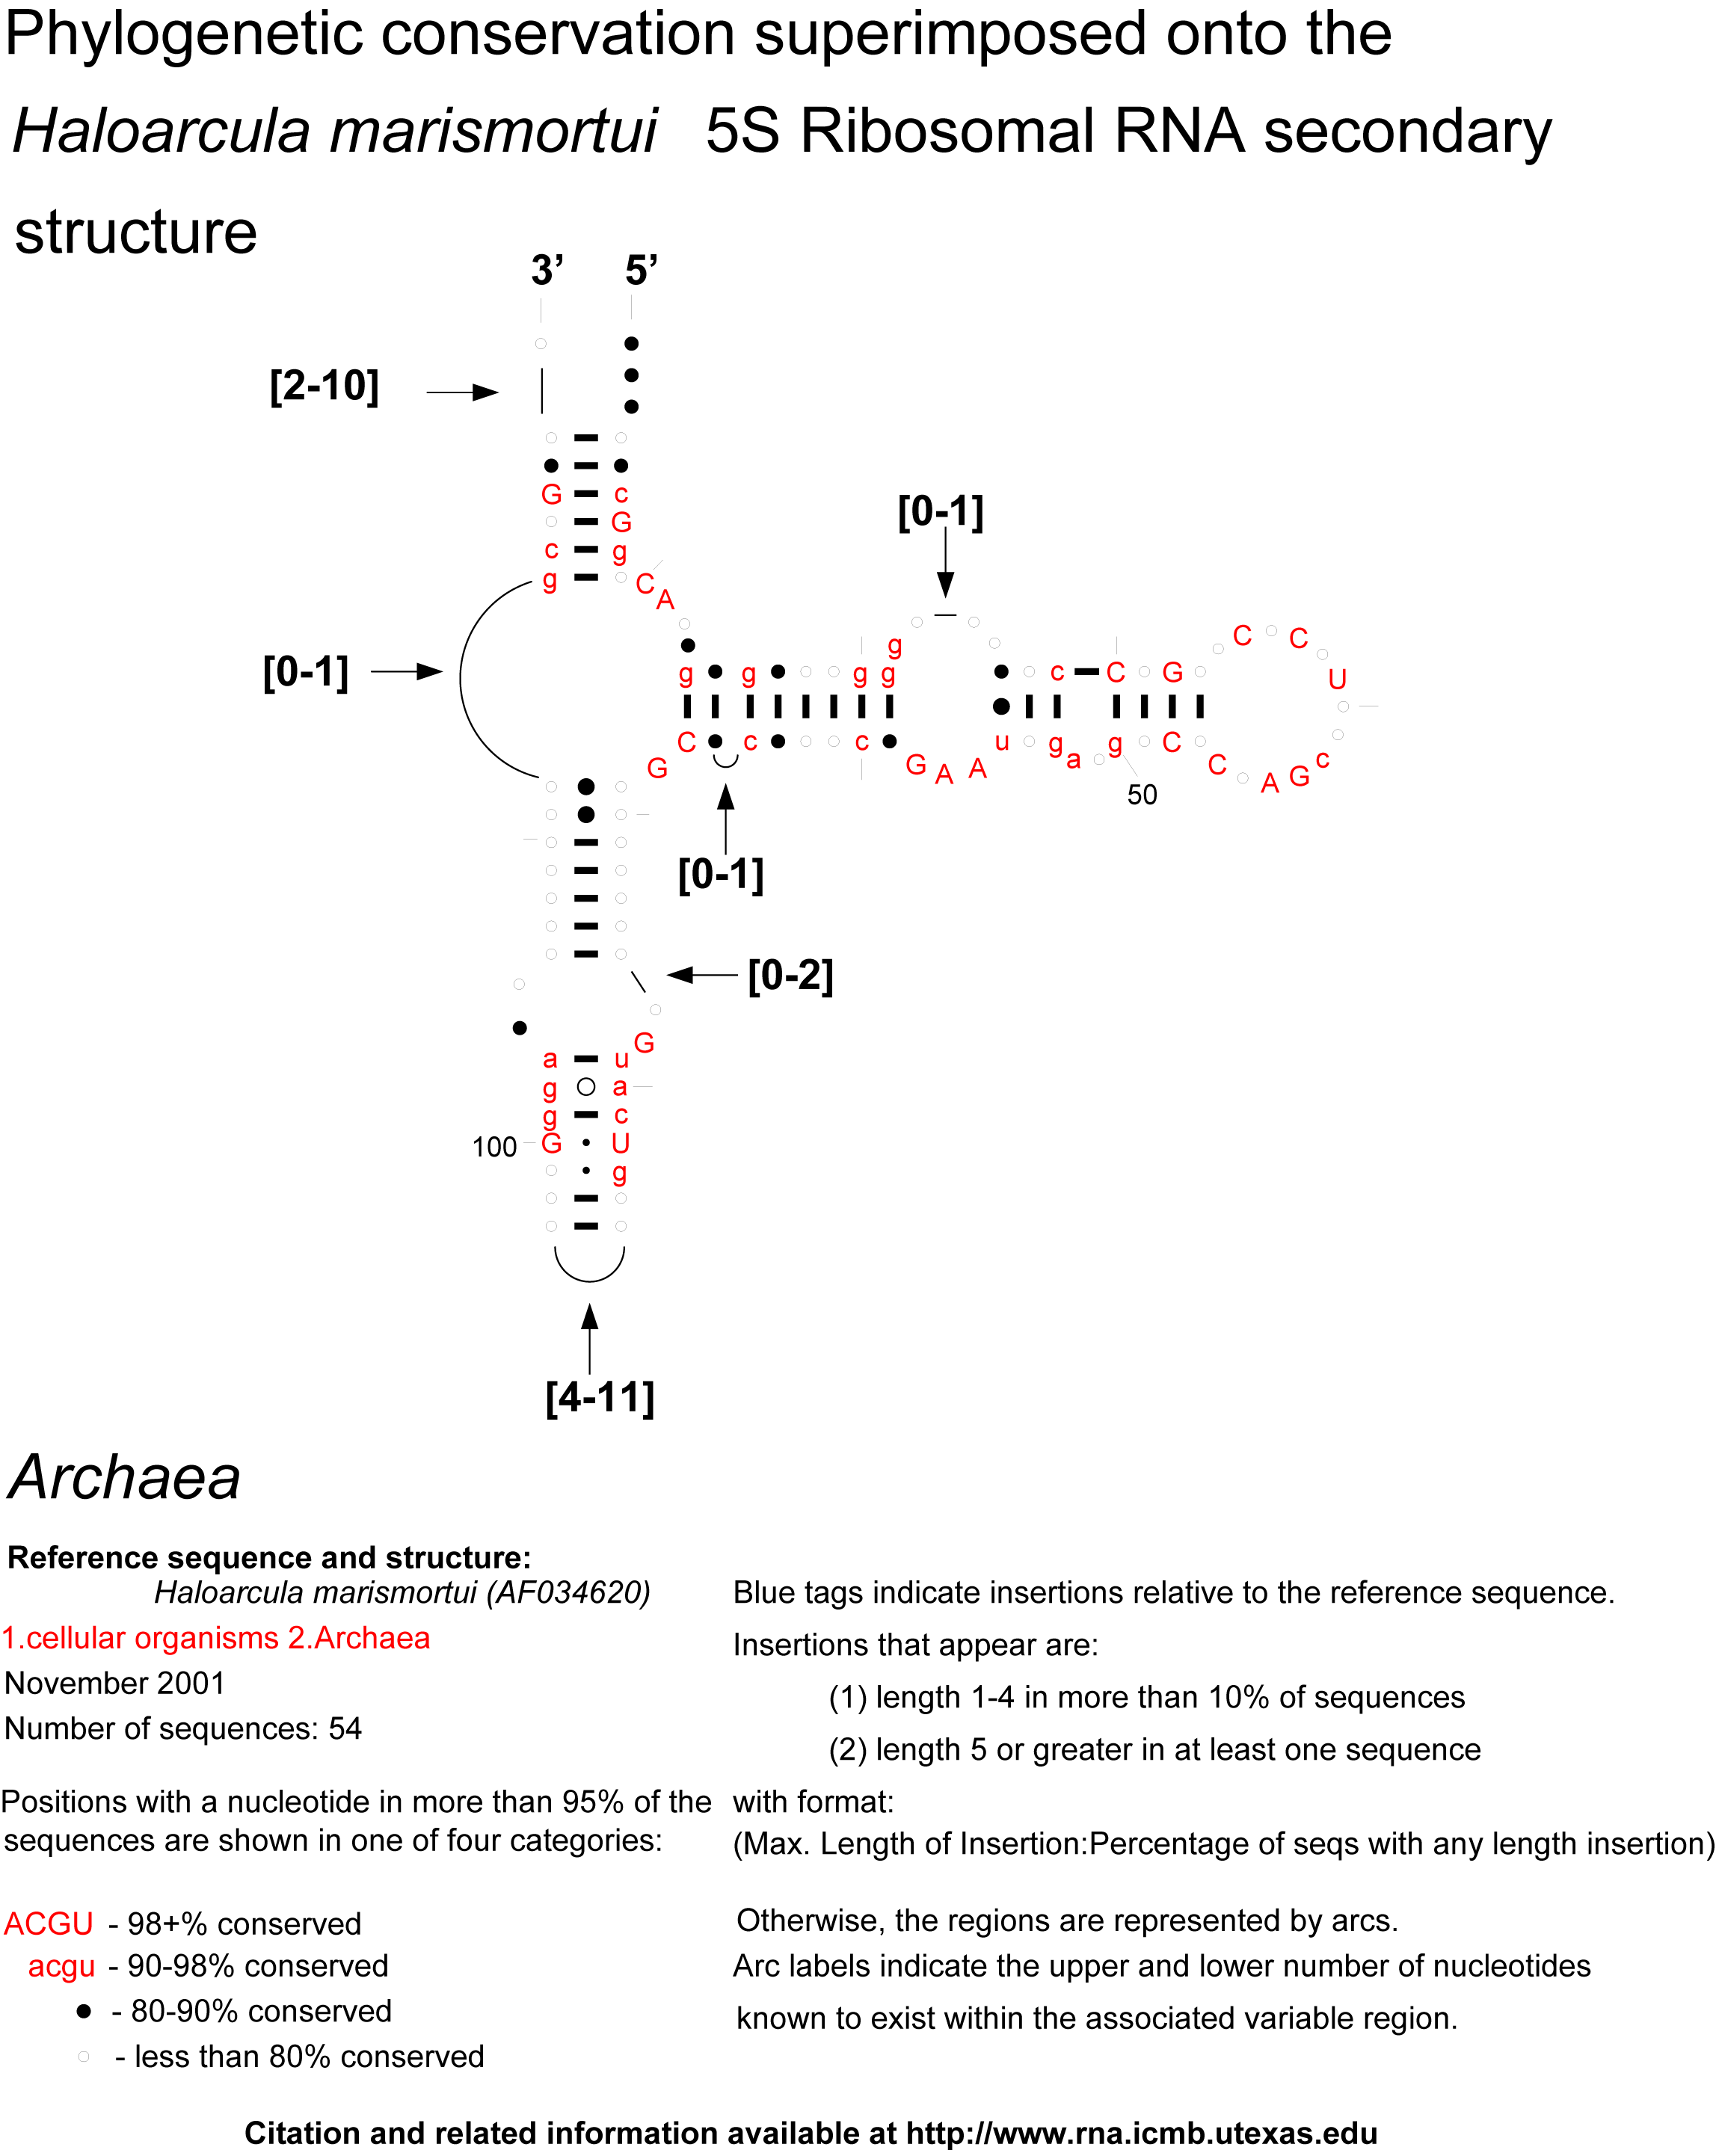
Supplemental Figure S14: Conservation of 5S rRNA.
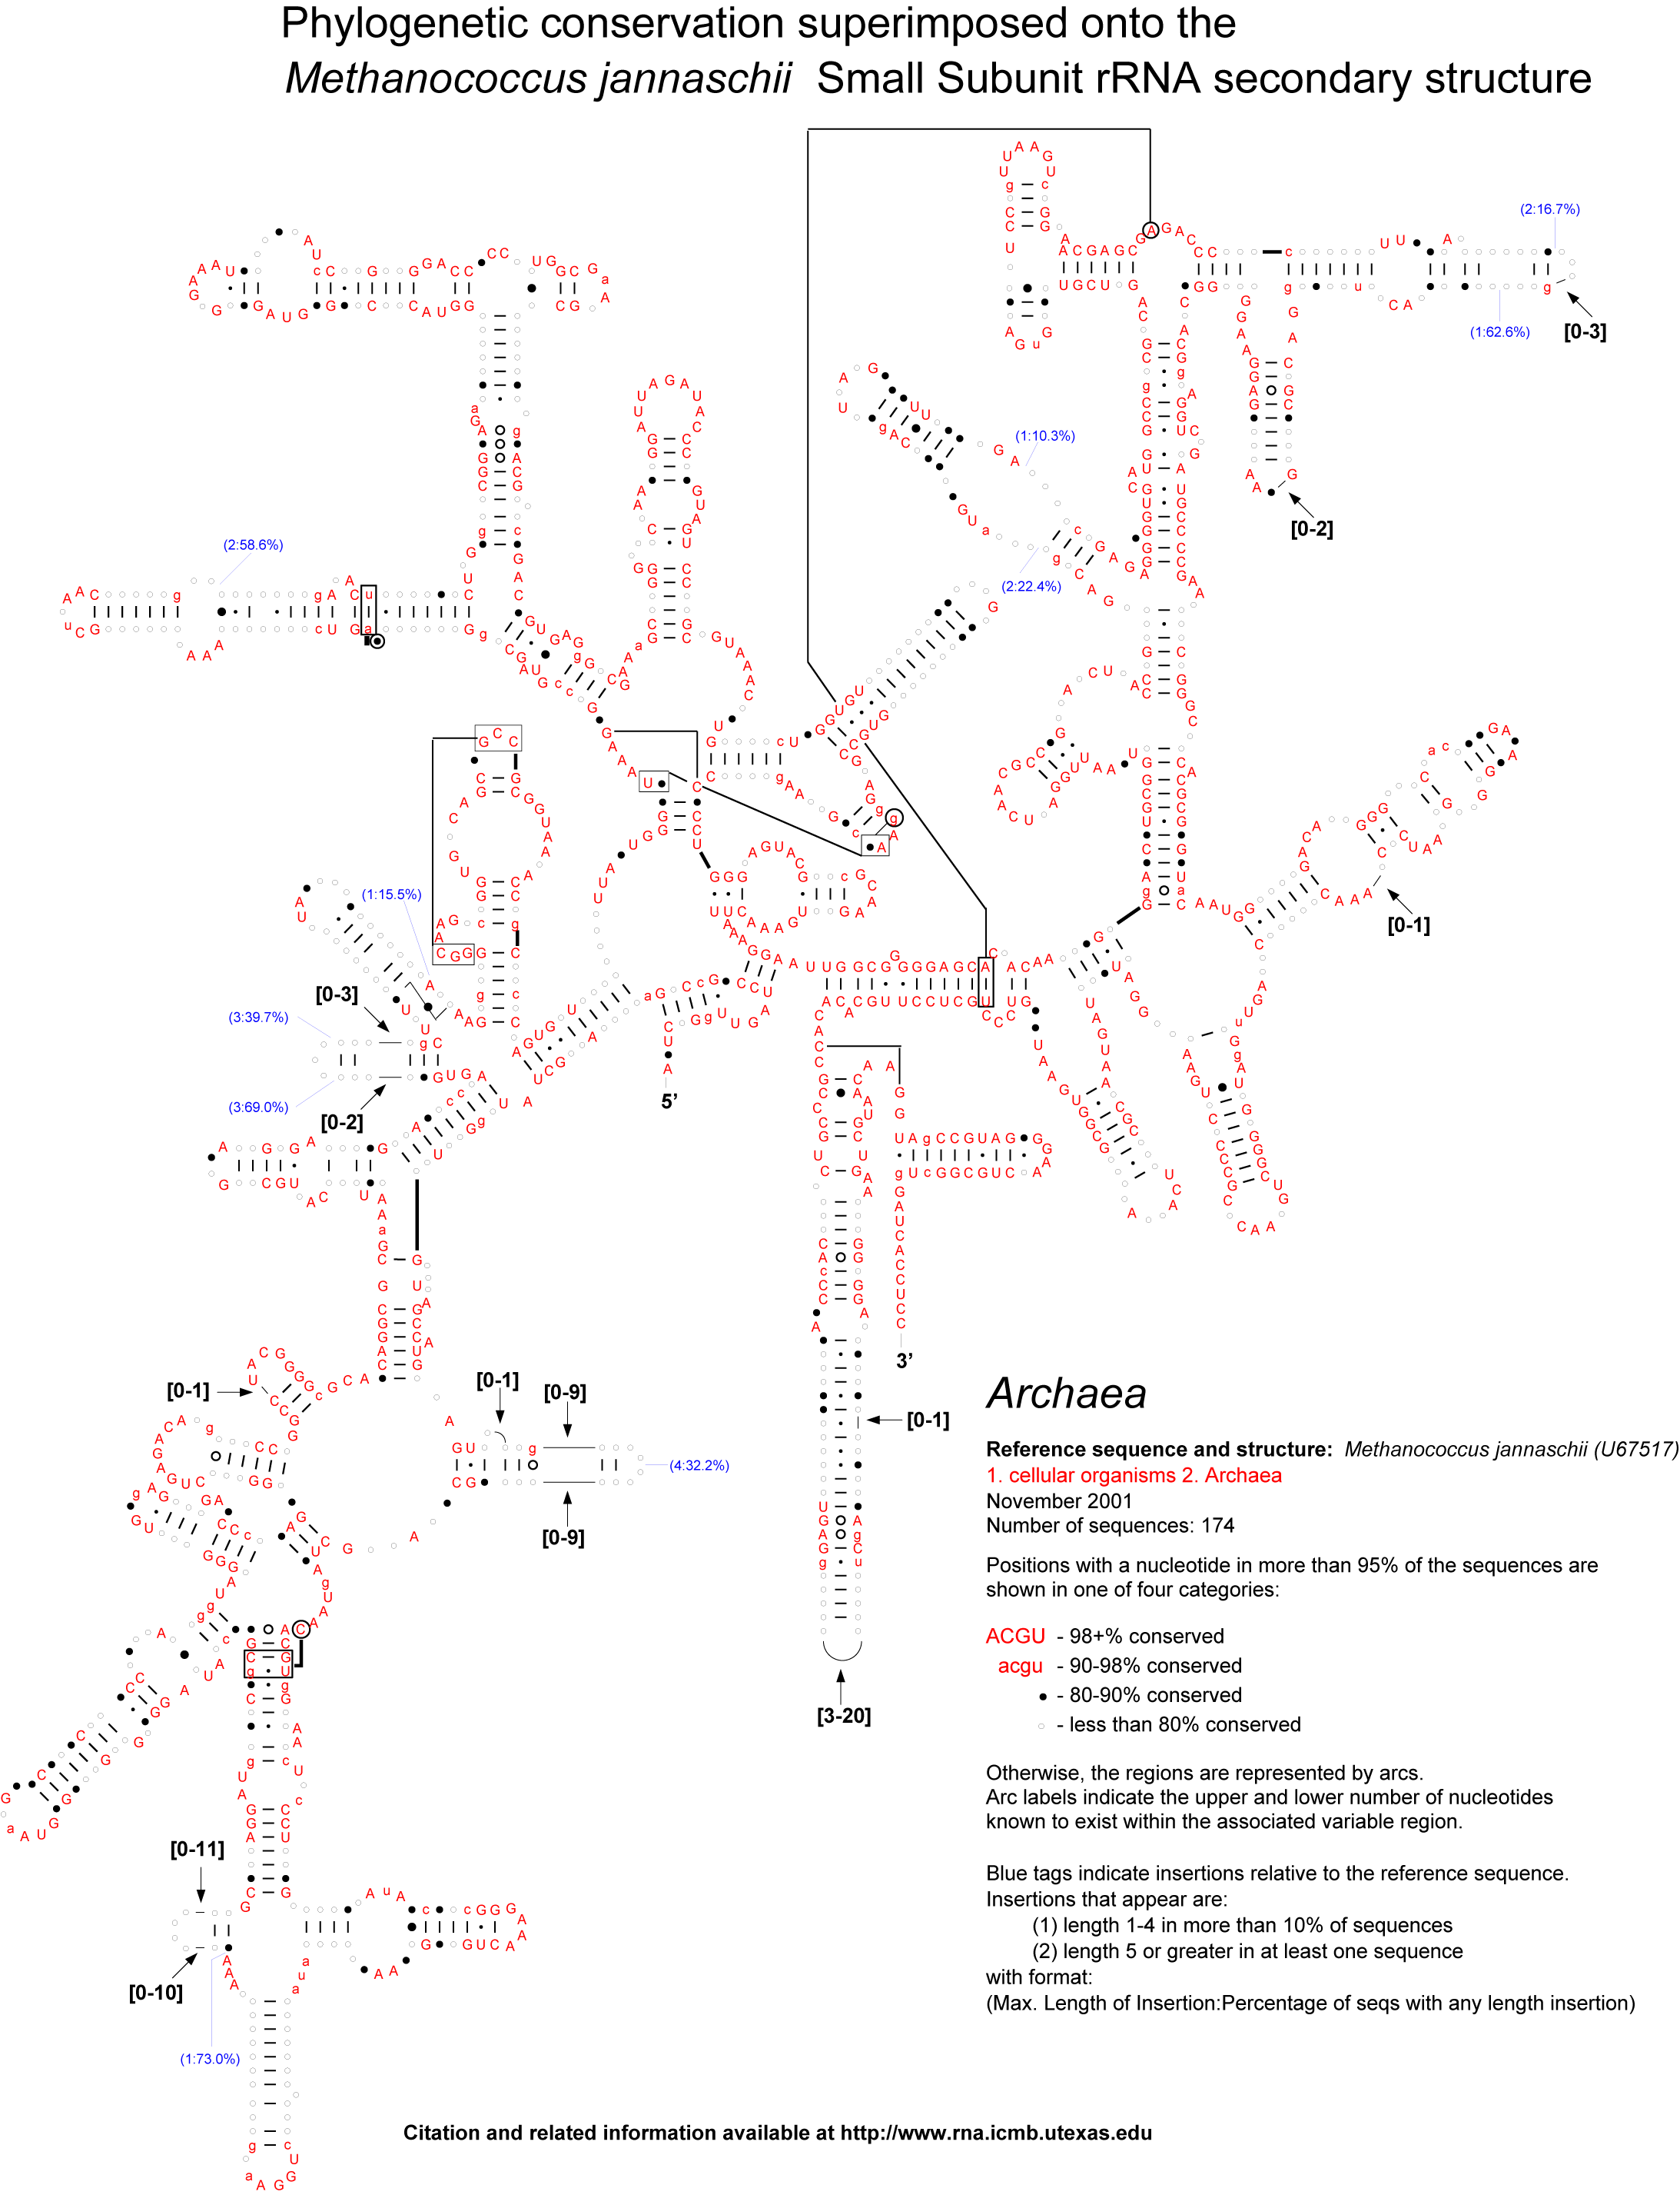
Supplemental Figure S15: Conservation of 16S rRNA.
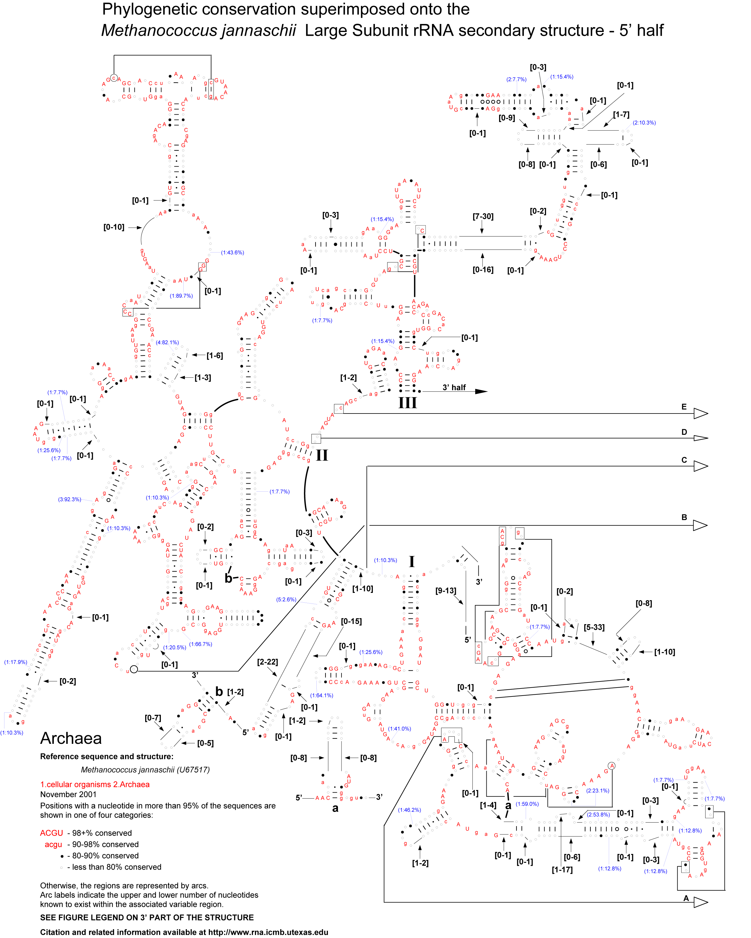
Supplemental Figure S16: Conservation of the 5′-end of 23S rRNA.
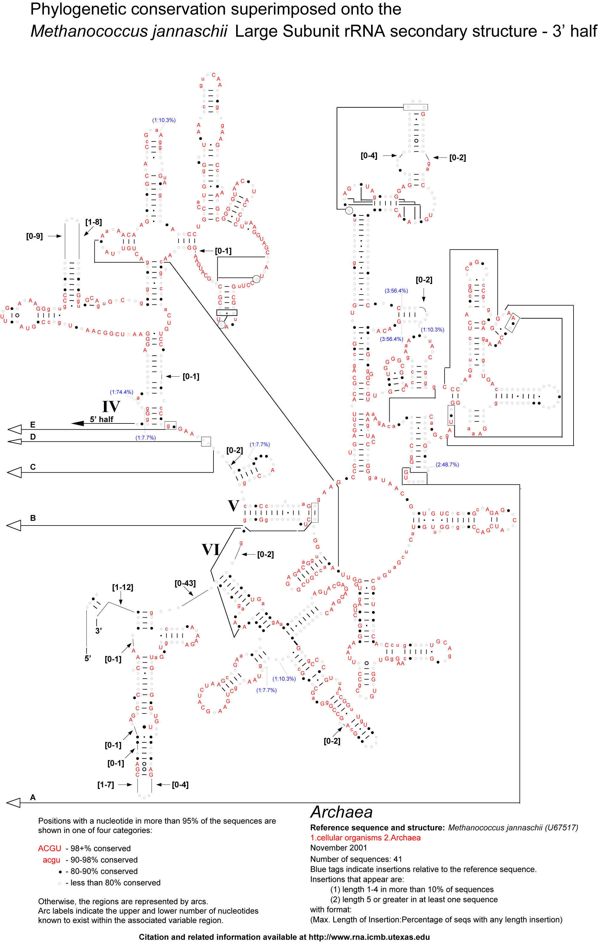
Supplemental Figure S17: Conservation of the 3′-end of 23S rRNA.

