Supplemental Information

Two-stemmed and split structural variants of fluorescent RNA Mango aptamers

Jeremy Herrera-Gutierrez¹, Steven J Burden¹, Sarah E. Kobernat¹, Nicholas H Shults², Mark Smith¹, Daniel Fologea^{1,2}, Eric J Hayden^{1,3}

¹Biomolecular Sciences Graduate Programs, Boise State University
² Department of Physics, Boise State University
³Department of Biological Sciences, Boise State University

corresponding author: erichayden@boisestate.edu

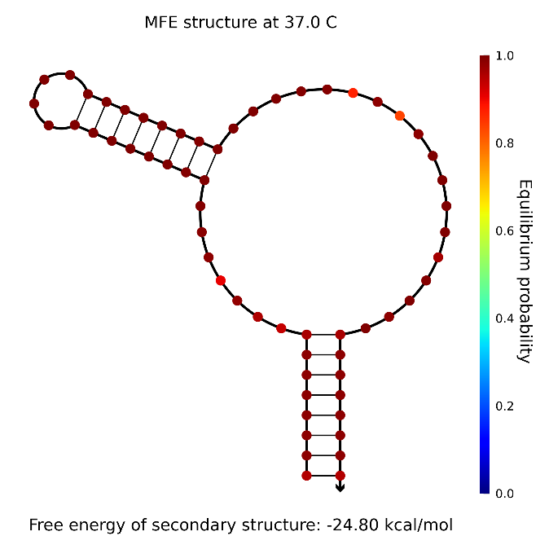
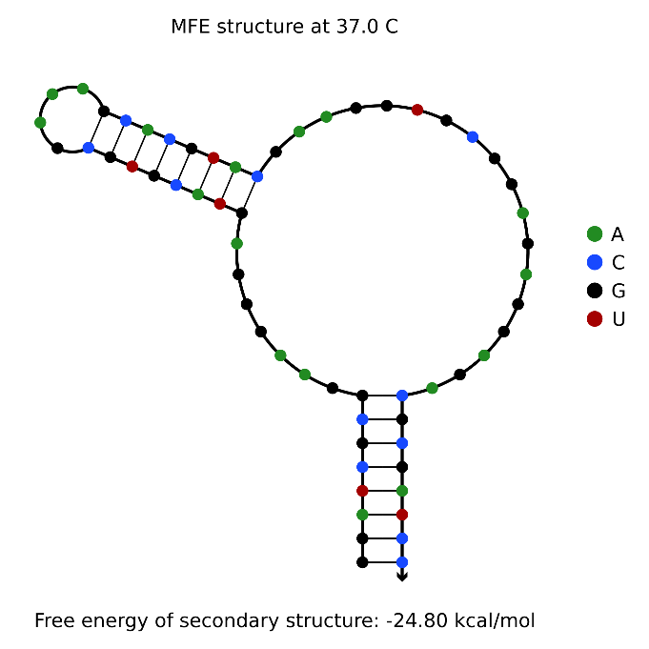
a
b
Figure S1. Predicted folding of RNA dsMango i-iv ii-i at 37 °C. (a) Predicted minimum free energy (MFE) secondary structure showing base composition (Nupack). Quadruplex nucleotides are predicted as a large assymetrical bulge. (b) Predicted minimum free energy (MFE) secondary structure with the equilibrium probability of each base-pair interaction represented by color.

Table S1. K_{D} and F_{max} values for double stemmed mango constructs calculated from fluorescence data (see Materials and Methods). F_{max} values are normalized to Mango I.
Aptamer | K_{D} (nM) | Normalized F_{max}
Mango I | 4.05 ±2.9 | 1.00 ±0.82
dsMango i-iv ii-i | 4.66 ±2.7 | 1.75 ±0.199
dsMango i-iv iv-iii | 11.93 ±15.6 | 0.32 ±0.010
dsMango i-iv iii-ii | 88.49 ±31.2 | 0.27 ±0.022
dsMango ii-i iii-ii | 6.32 ±1.2 | 0.98 ±0.040
dsMango ii-i iv-iii | 62.78 ±26.8 | 0.86 ±0.110
dsMango iii-ii iv-iii | 7.05 ±4.6 | 0.36 ±0.030

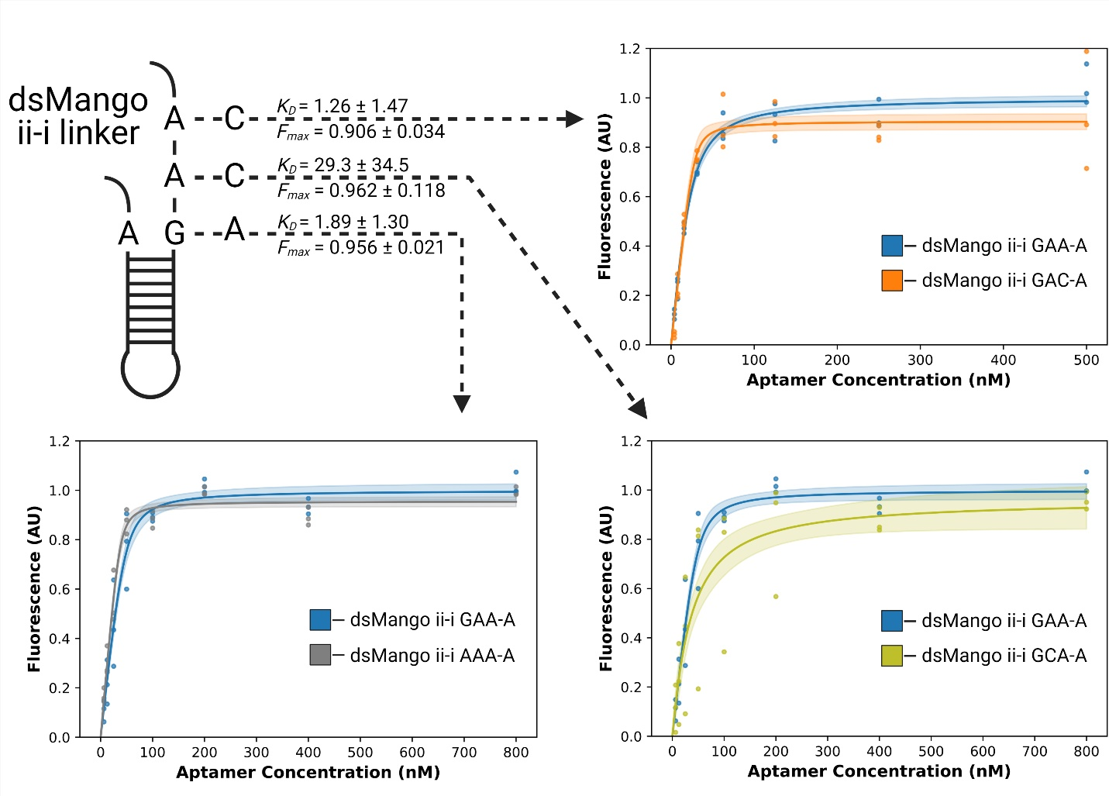
Figure S2. Abstract representation of dsMango ii-i tetraloop-like linker. Each arrow represents a single mutation to the linker sequence and points toward the resultant saturation curve. Fluorescence values for each curve were normalized to the unmutated ii-i linker sequence. Indicated K_{D} and F_{max} for each mutation were derived from non-linear curve fits of the saturation curve. Shaded areas of the curve represent 68% confidence intervals.
Figure S3. Fluorescence of dsMango stem ii-i linker variants. (a) Saturation curves comparing the binding and fluorescence of A38 single mutations variants of double-stemmed Mango. Each color represents a mutated linker sequence with the bolded nucleotides indicating sites of mutation. (b) Saturation curves comparing G36 single mutations. (c) Saturation curves representing double and triple mutants of the ii-i linker. Curves represent non-linear curve fit with 68% confidence interval. All experiments contained 40 nM TO1-biotin.

Table S2. K_{D} and F_{max} values for split dsMango. Fmax is normalized to dsMango i-iv ii-i.
Aptamer | K_{D} (nM) | Normalized F_{max}
split dsMango (Equimolar) | 2.06 ± 3.18 | 0.851 ± 0.031
5’ 125nM split dsMango | 1.00 ± 0.83* | 0.842 ± 0.016
3’ 125nM split dsMango | 1.29 ± 1.58 | 0.798 ±0.025

Figure S4. Native gel analysis of Mango constructs. Single stemmed Mango I (Mango I), dsMango i-iv ii-I (dsMango), and split dsMango i-iv ii-I (Split Mango) analyzed by non-denaturing polyacryalamide gele electrophoresis. Each construct was incubated with or without TO1-b prior to running. The “Pre-Stain” image represents fluorescence from TO1b bound during incubation prior to loading the gel. The “Post TO1-b Stain” image was obtained by soaking the same gel in a TO1-b solution. Total RNA was then visualized by soaking the same gel again in 1X Gel-Red for the “Post Gel-Red Stain” image.

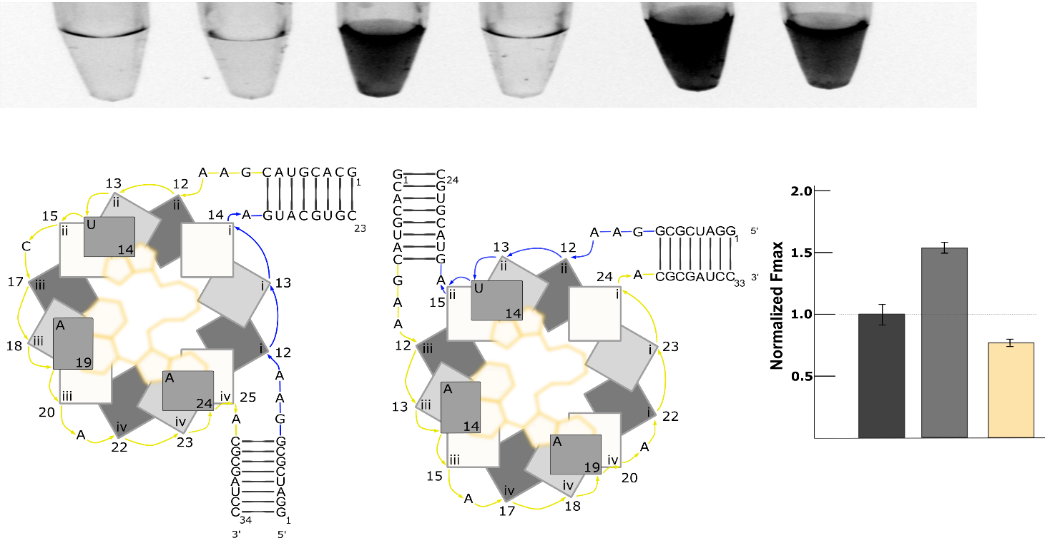
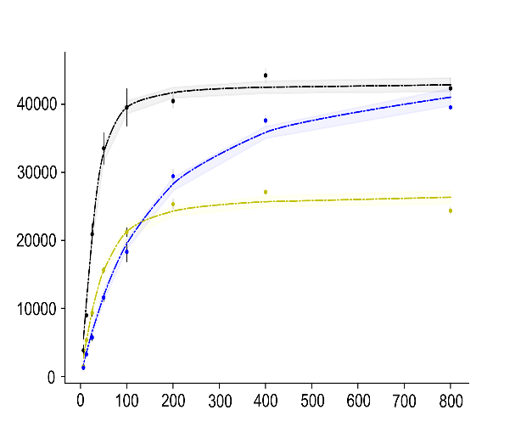
a
Figure S5. Fluorescence of split Mango ii-i iii-ii. (a) Abstract representation of the Split dsMango ii-i iii-ii with the 5’ strand (blue) and 3’ strand (yellow) highlighted. (b) Fluorescence saturation curves in which the 5’ strand (blue trace) or the 3’ strand (yellow trace) was varied and compared to the unimolecular construct (black trace) for dsMango ii-i iii-ii. Fluorescence measurements were performed with a TO1-biotin concentration of 40 nM. Shaded regions represent 95% confidence intervals of the best-fit non-linear curve.
Fluorescence (A.U.)
[RNA] (nM)
b

Name | RNA Sequence (5' - 3')
DS i-iv | GGAUCGCGGAAGGGACGGUGCGGAGAGGAGACGCGAUCC
DS i-iv ii-i | GGAUCGCGGAAGGGAGUACGUGCGAAAGCACGUACGAAGGUGCGGAGAGGAGACGCGAUCC
DS i-iv iii-ii | GGAUCGCGGAAGGGACGGUGAGUACGUGCGAAAGCACGUACGAAGGAGAGGAGACGCGAUCC
DS i-iv iv-iii | GGAUCGCGGAAGGGACGGUGCGGAGAGUACGUGCGAAAGCACGUACGAAGGAGACGCGAUCC
DS ii-i iii-ii | GGAUCGCGGAAGGUGAGUACGUGCGAAAGCACGUACGAAGGAGAGGAGAGGGACGCGAUCC
DS ii-i iv-iii | GGAUCGCGGAAGGUGCGGAGAGUACGUGCGAAAGCACGUACGAAGGAGAGGGACGCGAUCC
DS iii-ii iv-iii | GGAUCGCGGAAGGAGAGUACGUGCGAAAGCACGUACGAAGGAGAGGGACGGUGACGCGAUCC
DS i-iv ii-i GAC-A | GGAUCGCGGAAGGGAGUACGUGCGAAAGCACGUACGACGGUGCGGAGAGGAGACGCGAUCC
DS i-iv ii-I AAA-A | GGAUCGCGGAAGGGAGUACGUGCGAAAGCACGUACAAAGGUGCGGAGAGGAGACGCGAUCC
DS i-iv ii-I GAU-A | GGAUCGCGGAAGGGAGUACGUGCGAAAGCACGUACGAUGGUGCGGAGAGGAGACGCGAUCC
DS i-iv ii-i CAA-A | GGAUCGCGGAAGGGAGUACGUGCGAAAGCACGUACCAAGGUGCGGAGAGGAGACGCGAUCC
DS i-iv ii-i UAA-A | GGAUCGCGGAAGGGAGUACGUGCGAAAGCACGUACUAAGGUGCGGAGAGGAGACGCGAUCC
DS i-iv ii-i CUU-G | GGAUCGCGGAAGGGGGUACGUGCGAAAGCACGUACCUUGGUGCGGAGAGGAGACGCGAUCC
DS i-iv ii-i GCA-A | GGAUCGCGGAAGGGAGUACGUGCGAAAGCACGUACGCAGGUGCGGAGAGGAGACGCGAUCC
DS i-iv ii-i GAG-A | GGAUCGCGGAAGGGAGUACGUGCGAAAGCACGUACGAGGGUGCGGAGAGGAGACGCGAUCC
DS i-iv ii-i GCC-A | GGAUCGCGGAAGGGAGUACGUGCGAAAGCACGUACGCCGGUGCGGAGAGGAGACGCGAUCC
5' split dsMango i-iv ii-i | GGAUCGCGGAAGGGAGUACGUGC
3' split dsMango i-iv ii-i | GGCACGUACGAAGGUGCGGAGAGGAGACGCGAUCC
5' split dsMango ii-i iii-ii | GGCACGUACGAAGGAGAGGAGAGGGACGCGAUCC
3' split dsMango ii-i iii-ii | GGAUCGCGGAAGGUGAGUACGUGC
Table S3. RNA oligonucleotide sequences

