A
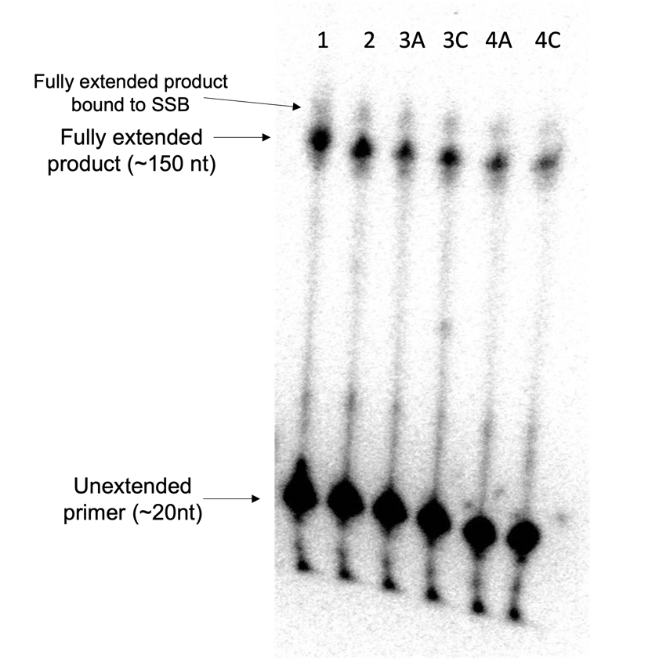
B

Supplemental Figure 1 . Comparison of reverse transcriptase bias between six RNA library templates with various amounts of structure. The primer extension assay was performed using ImProm-II RT using the same reaction conditions as Figure 2A. After a 5 min incubation at 25°C for primer-template annealing, the reaction was performed for 1 hr at 42°C using 15 pmol of RNA library template and 30 pmol of γ³²P labeled reverse primer. Libraries 1, 2, 3A, 3C, 4A, 4C (left to right) were used for these reactions. N=1 (A) To directly compare the reverse transcriptase bias between the six RNA library templates, the reactions were run on the same PAGE gel and visualized using a phosphorimager. (B) The yield and processivity for each reaction were quantified and plotted. Yield is determined by the ratio of fully extended primer to the unextended primer. Processivity is the ratio of full extended product to all (partially and fully) extended primer.

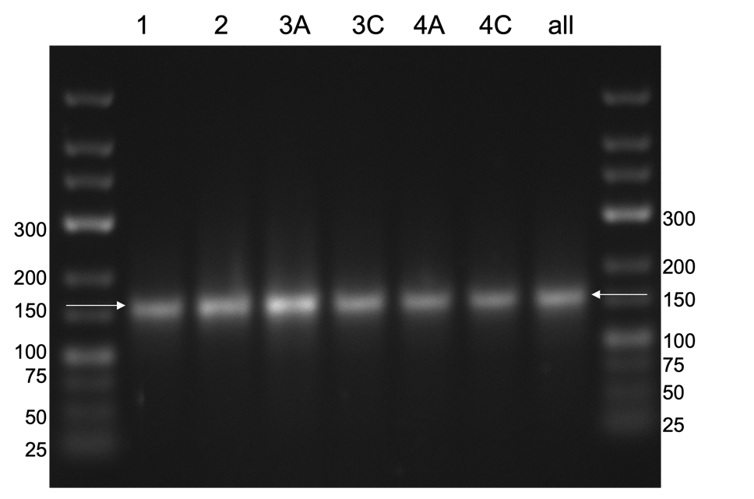

Supplemental Figure 2. Minimizing PCR bias between 6 different libraries. PCR for the 6 different selection libraries was optimized to minimize undesired products, primer dimers, and discrepancy in PCR amplification. 5 cycles of PCR were performed, and products were run on an ethidium bromide stained 2% agarose gel and visualized with UV-Vis. The observed bands match the predicted size of 156 base pairs and no undesired products were observed. Although there were some small differences in band intensity (eg. library 3A), no large discrepancy in PCR product or amplification was observed between the six libraries.

A

C
B

Supplemental Figure 3. Alternative perspectives on amplification-only selection. (A) Log₂ enrichment values comparing Round 6 to Round 1 were determined for the ImProm-II and BST trajectories. SSIV enrichment values compared Round 6 to Round 2 due to low number of reads in round 1. Points falling within the red region are ≥4-fold depleted. None of the points fell within the green region (≥4-fold enriched). Libraries are arranged according to their predicted ∆G values based on their secondary structure (most negative ∆G values to most positive from left to right). As the predicted ∆G values get increasingly stable, the depletion increases. (B) Any rounds with fewer than 1,000 total unique processed reads were excluded from these data sets. Percent of nucleotides with no mutations was calculated in each round for each trajectory and plotted. (C) Approximate mutation rate per position was determined for each selection round and plotted.

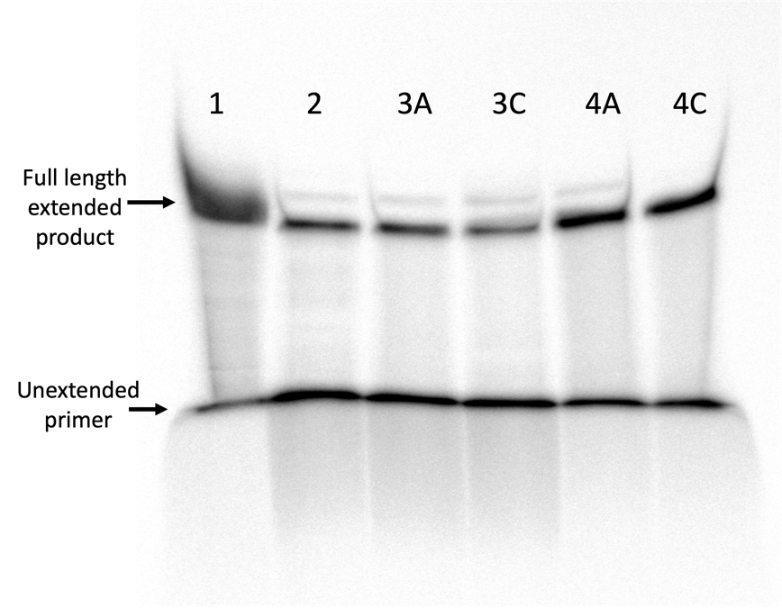
A

B

Supplemental Figure 4. Comparison of BST’s inter-library bias for six library templates using substoichiometric primer concentrations. Primer extension assays were performed with BST 3.0 DNA Polymerase using 50 pmol of RNA library template and 25 pmol of γ³²P labeled reverse primer. Reactions were incubated for 1 hr at 65°C with 2M Betaine, 0.6M Trehalose, & 1 μg SSB (optimized conditions identified in Figure 3C, same conditions used in Figure 4-6). Libraries 1, 2, 3A, 3C, 4A, 4C (left to right) were used for these reactions. N=1 (A) To compare the reverse transcriptase bias among the six RNA library templates directly, reaction products were run on the same PAGE gel and visualized using a phosphorimager. (B) Yields for each reaction was quantified and plotted relative to maximal value (1). Yield is determined by the ratio of fully extended primer to the unextended primer.

ImProm-II | Round 1 | Round 2 | Round 3 | Round 4 | Round 5 | Round 6
Raw total reads | 133,124 | 4,613 | 7,970 | 416,663 | 15,825 | 2,228
Long sequences | 17,443 | 2,417 | 7,224 | 25,422 | 15,448 | 922
Unique long sequences | 11,572 | 2,211 | 5,747 | 17,561 | 9,973 | 892
Short sequences | 27,880 | 334 | 58 | 40,974 | 54 | 89
Unique short sequences | 21,626 | 224 | 39 | 29,871 | 53 | 67
Total processed sequence reads | 87,801 | 1,862 | 688 | 350,267 | 323 | 1,217
Unique processed sequences | 67,029 | 1,472 | 613 | 267,184 | 323 | 935

Supplemental Table 1. ImProm-II high-throughput sequencing raw data and processing. Data processing was performed using cutadapt to trim the 5’ and 3’ constant regions from sequences and to discard any uncut sequences or sequences with lengths not within ± 9 nt of the expected size (90 nt) after trimming. Raw total reads is the number of sequences prior to any processing. Long and short sequences did not fit within the ± 9 nt parameter. Total processed sequence reads were analyzed using FASTAptameR 2.0.

ImProm-II | Round 1 RPM | Round 2 RPM | Round 3 RPM | Round 4 RPM | Round 5 RPM | Round 6 RPM | Enrichment (R6/R1)
Library 1 | 412,080 | 469,925 | 88,663 | 424,288 | 9,288 | 98,603 | 0.24
Library 2 | 41,093 | 13,426 | 5,814 | 8,291 | - | 3,287 | 0.08
Library 3A | 95,101 | 90,763 | 59,593 | 123,246 | 18,576 | 184,059 | 1.94
Library 3C | 104,862 | 52,095 | 15,988 | 69,584 | 37,152 | 95,316 | 0.91
Library 4A | 101,388 | 60,687 | 27,616 | 34,340 | 9,288 | 23,007 | 0.23
Library 4C | 245,476 | 313,104 | 802,326 | 340,252 | 925,697 | 595,727 | 2.43

Supplemental Table 2. ImProm-II pre-processed and analyzed HTS data. Library reads shown in reads per million (RPM). The processed reads (supplemental table 2) were analyzed in FASTAptameR2.0 and each read was identified as belonging to one of the six libraries using sequence markers. The enrichment values of each of the six libraries calculated by comparing round 6 to round 1.

SSIV | Round 1 | Round 2 | Round 3 | Round 4 | Round 5 | Round 6
Raw total reads | 1,363 | 151,377 | 85,360 | 79,385 | 82,293 | 309,736
Long sequences | 1,124 | 12,912 | 8,606 | 7,833 | 7,810 | 148,716
Unique long sequences | 1,165 | 9,660 | 6,870 | 6,405 | 6,374 | 113,528
Short sequences | 12 | 4,313 | 5,982 | 3,429 | 3,130 | 12,304
Unique short sequences | 9 | 3,226 | 4,653 | 2,599 | 2,323 | 9,430
Total processed sequence reads | 227 | 134,152 | 70,772 | 68,123 | 71,353 | 148,716
Unique processed sequences | 189 | 102,421 | 56,624 | 51,989 | 54,201 | 113,528

Supplemental Table 3. SSIV high-throughput sequencing raw data and processing. Data processing was performed using cutadapt to trim the 5’ and 3’ constant regions from sequences and to discard any uncut sequences or sequences with lengths no within ± 9 nt of the expected size (90 nt) after trimming. Raw total reads is the number of sequences prior to any processing, long and short sequences did not fit within the ± 9 nt parameter, and the total processed sequence reads were analyzed using FASTAptameR2.0.

SSIV | Round 1 RPM | Round 2 RPM | Round 3 RPM | Round 4 RPM | Round 5 RPM | Round 6 RPM | Enrichment (R6/R2)
Library 1 | 180,617 | 140,140 | 124,908 | 50,020 | 29,165 | 15,923 | 0.11
Library 2 | 61,674 | 58,642 | 33,686 | 14,698 | 11,408 | 5,769 | 0.1
Library 3A | 114,537 | 137,732 | 89,612 | 75,470 | 74,755 | 72,938 | 0.53
Library 3C | 132,159 | 211,074 | 277,384 | 343,626 | 346,292 | 330,287 | 1.56
Library 4A | 136,564 | 153,006 | 169,036 | 170,273 | 167,029 | 149,856 | 0.98
Library 4C | 374,449 | 299,407 | 305,375 | 345,914 | 371,351 | 425,227 | 1.42

Supplemental Table 4. SSIV pre-processed and analyzed HTS data. Library reads shown in reads per million. The processed reads (supplemental table 2) were analyzed in FASTAptameR2.0 and each read was identified as belonging to one of the six libraries using sequence markers. The enrichment values of each of the six libraries calculated by comparing round 6 to round 2 instead of round 1 due to low number of reads in round 1.

BST | Round 1 | Round 2 | Round 3 | Round 4 | Round 5 | Round 6
Raw total reads | 92,494 | 11,212 | 7,383 | 10,134 | 161,986 | 78,395
Long sequences | 8,071 | 5,813 | 5,854 | 6,356 | 11,252 | 14,897
Unique long sequences | 6,652 | 4,808 | 4,792 | 5,061 | 8,907 | 9,912
Short sequences | 731 | 84 | 36 | 112 | 5,911 | 658
Unique short sequences | 591 | 67 | 32 | 85 | 4,100 | 500
Total processed sequence reads | 83,692 | 5,315 | 1,493 | 3,666 | 144,823 | 62,840
Unique processed sequences | 64,627 | 4,020 | 1,182 | 2,774 | 113,385 | 47,653

Supplemental Table 5. BST high-throughput sequencing raw data and processing. Data processing was performed using cutadapt to trim the 5’ and 3’ constant regions from sequences and to discard any uncut sequences or sequences with lengths no within ± 9 nt of the expected size (90 nt) after trimming. Raw total reads is the number of sequences prior to any processing, long and short sequences did not fit within the ± 9 nt parameter, and the total processed sequence reads were analyzed using FASTAptameR2.0.

BST | Round 1 RPM | Round 2 RPM | Round 3 RPM | Round 4 RPM | Round 5 RPM | Round 6 RPM | Enrichment (R6/R1)
Library 1 | 322,181 | 292,380 | 257,200 | 390,616 | 368,243 | 402,132 | 1.25
Library 2 | 76,196 | 36,877 | 32,150 | 11,184 | 17,925 | 15,213 | 0.2
Library 3A | 96,987 | 105,174 | 121,902 | 93,290 | 106,468 | 90,484 | 0.93
Library 3C | 126,762 | 139,040 | 117,883 | 103,928 | 113,228 | 98,727 | 0.78
Library 4A | 117,824 | 127,940 | 82,384 | 54,010 | 65,556 | 56,779 | 0.48
Library 4C | 260,050 | 298,589 | 388,480 | 346,972 | 328,580 | 336,665 | 1.29

Supplemental Table 6. BST pre-processed and analyzed HTS data. Library reads shown in reads per million. The processed reads (supplemental table 2) were analyzed in FASTAptameR2.0 and each read was identified as belonging to one of the six libraries using sequence markers. The enrichment values of each of the six libraries calculated by comparing round 6 to round 1.

ImProm-II | Round 1 RPM | Round 2 RPM | Round 3 RPM | Round 4 RPM | Round 5 RPM | Round 6 RPM
Library 1 Total | 412,080 | 469,925 | N.D. | 424,288 | N.D. | 98,603
Library 1 No Mutations | 351,454 | 396,885 | N.D. | 333,691 | N.D. | 76,417
Percent of Sequences with ≥ 1 Mismatches | 14.7 | 15.5 | N.D. | 21.4 | N.D. | 22.5
Adjusted Fidelity | 99.6 | 99.6 | N.D. | 99.5 | N.D. | 99.5
Cumulative Mutation Rate/Position | 0.4 | 0.4 | N.D. | 0.5 | N.D. | 0.5

Supplemental Table 7. ImProm-II fidelity for library 1. Fraction of un-mutated and mutated library 1 sequences were determined for each round. Fraction of sequences with more than one mismatch was calculated by dividing library 1 with ≥ 1 mutations (library 1- no mutations subtracted from library 1) by total library 1 sequences. The mutation rate per position was calculated by diving the fraction of sequences with ≥ 1 mutations by the total number of nucleotides (42). Adjusted fidelity is (1 - mutation rate/position). In cases where the read count was too low, values were not determined (N.D.).

SSIV | Round 1 RPM | Round 2 RPM | Round 3 RPM | Round 4 RPM | Round 5 RPM | Round 6 RPM
Library 1 Total | N.D. | 140,140 | 124,908 | 50,020 | 29,165 | 15,923
Library 1 No Mutations | N.D. | 115,488 | 99,149 | 38,314 | 21,905 | 11,317
Percent of Sequences with ≥ 1 Mismatches | N.D. | 17.6 | 20.6 | 23.4 | 24.9 | 28.9
Adjusted Fidelity | N.D. | 99.6 | 99.5 | 99.4 | 99.4 | 99.3
Cumulative Mutation Rate/Position | N.D. | 0.4 | 0.5 | 0.6 | 0.6 | 0.7

Supplemental Table 8. SSIV fidelity for library 1. Fraction of un-mutated and mutated library 1 sequences were determined for each round. Fraction of sequences with more than one mismatch was calculated by dividing library 1 with ≥ 1 mutations (library 1- no mutations subtracted from library 1) by total library 1 sequences. The mutation rate per position was calculated by diving the fraction of sequences with ≥ 1 mutations by the total number of nucleotides (42). Adjusted fidelity is (1 - mutation rate/position). In cases where the read count was too low, values were not determined (N.D.).

BST | Round 1 RPM | Round 2 RPM | Round 3 RPM | Round 4 RPM | Round 5 RPM | Round 6 RPM
Library 1 Total | 322,181 | 292,380 | 257,200 | 390,616 | 368,243 | 402,132
Library 1 No Mutations | 247,421 | 240,640 | 208,305 | 230,769 | 282,614 | 305,490
Percent of Sequences with ≥ 1 Mutations | 23.2 | 17.7 | 19.0 | 40.9 | 23.3 | 24.0
Adjusted Fidelity | 99.4 | 99.6 | 99.5 | 99.0 | 99.4 | 99.4
Cumulative mutation Rate/Position | 0.6 | 0.4 | 0.5 | 1.0 | 0.6 | 0.6

Supplemental Table 9. BST fidelity for library 1. Fraction of un-mutated and mutated library 1 sequences were determined for each round. Fraction of sequences with more than one mismatch was calculated by dividing library 1 with ≥ 1 mutations (library 1- no mutations subtracted from library 1) by total library 1 sequences. The mutation rate per position was calculated by diving the fraction of sequences with ≥ 1 mutations by the total number of nucleotides (42). Adjusted fidelity is (1 - mutation rate/position).

Name | Sequence (5’ 3’)
Library 1 | AGGACCGGCCUAAACGGCAUUGCACUCCGCCGUAGGUAGCGNNNNNNNNNNCGUGNNNNNNNNNNNNNNNNNNNNCACGNNNNNNNNNNACCAUUCGAAAGAGUGGGACGCAAACCAAUCCGCUUCGGCGGAUACA
Library 2 | AGGACCGGCCUAAACGGCAUUGCNNNNNNNNNGAUGGNNNNNNNNNNNGCAAUGCCGUCAUGGCAANNNNNNNNNNNNNNNUUGCCAUGUGGCCGNNNNNNNNNNNNNNNNUCACCAAUCCGCUUCGGCGGAUACA
Library 3A | AGGACCGGCCUAAACGGCAUUGCNNNNNNNNNNNNNNNNNNNNNNNNNNNNNNNNNNNNNNNNNNNNNNNNNNNNNNNNNNNNNNNNNNNNNNNNNNNNNNNNNNNNNNNNNNACCAAUCCGCUUCGGCGGAUACA
Library 3C | AGGACCGGCCUAAACGGCAUUGCNNNNNNNNNNNNNNNNNNNNNNNNNNNNNNNNNNNNNNNNNNNNGCCGGUNNNNNNNNNNNNNNNNNNNNNNNNNNNNNNNNNNNNNNNNACCAAUCCGCUUCGGCGGAUACA
Library 4A | AGGACCGGCCUAAACGGCAUUGCNNNNNNNNNNNNNNNNNNNNNNNNNNNNNNNNNNNNNNNNNNNNNNNNNNNNNNNNNNNNNNNNNNNNGGUCCNNNNNNNNNNNNNNNGGACCAAUCCGCUUCGGCGGAUACA
Library 4C | AGGACCGGCCUAAACGGCAUUGCNNNNNNNNNNNNNNNNNNNNNNNNNNNNNNNNNNNNNNNNNNNNNNNNNNNNNNNNNNNNNNGGUCCNNNNNGCCGGUNNNNNNNNNNGGACCAAUCCGCUUCGGCGGAUACA
Library Reverse Primer | TGTATCCGCCGAAGCGGATTGGT
Library Forward Primer | GCGTAATACGACTCACTATTAGGACCGGC
5’ HIV UTR Reverse Primer | CCGACGCTCTCGCACCCATCTC

Supplemental Table 10. Library and primer sequences. Primer binding sites of the library sequences are bolded and underlined. Regions with red letters represent incorporated structural regions. Segments highlighted in yellow were used to identify library of origin during high-throughput sequencing analysis. Note, library 3A’s yellow region was fully randomized and therefore library 3A sequences were identified through process of elimination.

Name | Sequence (5’ 3’)
Forward Primer for HTS | AATGATACGGCGACCACCGAGATCTACACTCTTTCCCTACACGACGCTCTTCCGATCTAGGACCGGCCTAAACGGCATT
Reverse Primer 1 for HTS | CAGACGTGTGCTCTTCCGATCTGTATCCGCCGAAGCGGATTGG
Reverse Primer 2 for HTS | CAAGCAGAAGACGGCATACGAGATNNNNNNGTGACTGGAGTTCAGACGTGTGCTCTTCCGATCTGTATCCGCCGAAGCGGATTGG
5’ Universal HTS Adapter | AATGATACGGCGACCACCGAGATCTACACTCTTTCCCTACACGACGCTCTTCCGATCT
3’ Indexed HTS Adapter | CAAGCAGAAGACGGCATACGAGATNNNNNNGTGACTGGAGTTCAGACGTGTGCTCTTCCGATC

Supplemental Table 11. Sequences for the high-throughput sequencing primers used to append the Illumina adapters and their respective sequencing indices. We used the NEBNext Index (1-38) Primers for Illumina. 38 reverse primers (corresponding to the 38 indices) were used in the second PCR for high-throughput sequencing preparation. The index region is indicated by the six red N region in the reverse primer 2 for HTS sequence. Index sequences are from the instruction manual for the NEBNext Multiplex Small RNA Library Prep Set 1, Set 2, Index Primers 1-48 and Multiplex Compatible (https://rb.gy/0dbqe9).

