Supplemental Figures:
Figure S1: Analysis of depth vs. RV trend is unbiased. Left: Replication of data shown in Fig. 3C. Right: Identical analysis as performed in Fig. 3C but on simulated homoskedastic data where there is no relationship between RV and sequencing depth.

Figure S2: logit(θ) calibration analysis for the three implementations of the novel hierarchical model. X-axis represents a particular logit(θ) credible interval width (i.e., 0.25 is a credible interval width that the model predicts will contain the true logit(θ) 25% of the time). Y-axis is percentage of the time the credible interval contained the true logit(θ) value. Data is 500 lines obtained from bootstrapped samples of 1000 transcripts from a total of 10000 transcripts.
Figure S3: Simulated data validation of extensions of existing models of NR-seq data. Top: Accuracy of $θ$ estimates for existing models. Diagonal line is y = x. *Schofield et al./GRAND-SLAM model is a U-content adjusted Poisson rather than the original binomial mixture model. See Methods and Supplemental Methods for details. Note, pulseR only provides replicate average $θ$ estimates, whereas all other models provide estimates of $θ$ in each replicate. Bottom: L2FC($k_{deg})$calibration for both implementations of the existing models. The x-axis represents the coverage probability of the L2FC($k_{deg})$ credible/confidence interval and the y-axis is the percentage of transcripts who’s true L2FC($k_{deg})$ fall within the credible/confidence interval. 500 lines obtained from bootstrapped samples of 1000 transcripts from a total of 10000 transcripts are depicted for each implementation.

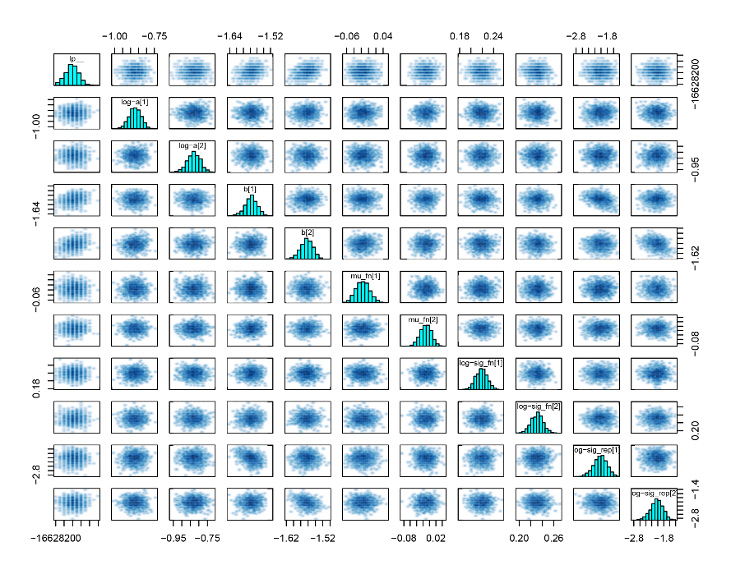
Figure S4: Pairs plots for hierarchical hyperparameters indicate unbiased estimation. Pairs plots of marginal posterior distributions are shown for the hyper-parameters labeled along the diagonal. The lack of correlation between any of the marginals indicates identifiability of all parameters.

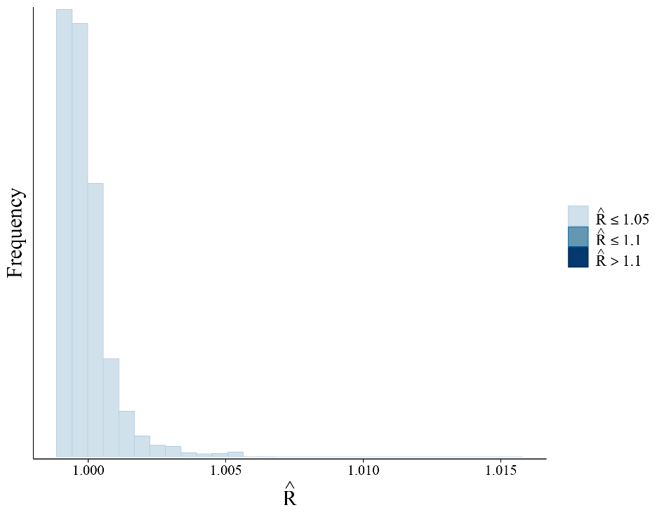
Figure S5: $\hat{R}$ distribution indicates model convergence. The $\hat{R}$ is a quantification of the extent to which multiple independent Markov chains converged to the same posterior samples for a parameter. An $\hat{R}$ closer to 1 is better.

Figure S6: Additional simulations show that bakR implementations outperform extensions of existing models. Top: Simulated ln(RV) vs. standardized read count trend. The gray bar around the trend lines represents the range for 99% of simulated replicate variabilities. The left and center columns are results for simulations of two biological replicates; right column is for simulation of three biological replicates. The center column is a simulation of low mutation rate in new reads (1%, as opposed to the 5% new read mutation rate simulated in Fig. 5 data). Middle: False discovery rate (FDR) as a function of significance cutoff for all implementations. Bottom: Power as a function of significance cutoff for all implementations. The average FDR and Power for five simulation replicates are plotted at each cutoff
Figure S7: Fraction new estimation accuracy at a new read mutation rate of 1%. Accuracy of $θ$ estimates for the three implementations of the new hierarchical model and two existing statistical models. Diagonal line is y = x. A p_{new} of 1% means that each U in a new read has a 1% chance of being converted to a C.
Figure S8: Fraction new estimation accuracy at a new read mutation rate of 0.7%. Accuracy of $θ$ estimates for the three implementations of the new hierarchical model and two existing statistical models. Diagonal line is y = x. A p_{new} of 0.7% means that each U in a new read has a 0.7% chance of being converted to a C.
Figure S9: Fraction new estimation accuracy at a new read mutation rate of 0.4%. Accuracy of $θ$ estimates for the three implementations of the new hierarchical model and two existing statistical models. Diagonal line is y = x. A p_{new} of 0.4% means that each U in a new read has a 0.4% chance of being converted to a C

Figure S10: MLE θ uncertainty is well quantified at high sequencing depth and is conservative at low seqeuncing depths and extreme θ. Comparison of Fisher Information θ uncertainty estimate used by the MLE implementation to the θ posterior standard deviation estimated by the MCMC implementation. Left plot is colored by number of sequencing reads. Right plot is colored by |logit(θ)| (higher numbers represent θ further from 0.5).

Figure S11: MCMC and Hybrid implementations are more robust to lower mutation rates than other implementations. Top: Power as a function of significance cutoff for all implementations and two different new read mutation rates (p_{new}). Middle: FDR as a function of significance cutoff for all implementations. The average FDR and Power for 5 simulation replicates are plotted at each cutoff. Bottom: Matthews’ Correlation Coefficient (MCC) at a significance cutoff of 0.05 for all implementations tested. Black point is mean MCC for 5 replicates; error bars represent +/- 1 standard error.

Figure S12: MCMC and Hybrid implementations retain statistical power at lower mutation rates than other implementations. Statistical power as a function of significance cutoff for the four new read mutation rates simulated. Results are shown for all five implementations tested. Plotted power is average of five simulation replicates.
Figure S13: MCMC and Hybrid implementations retain binary classification performance at lower mutation rates than other implementations. Matthew’s correlation coefficient (MCC) at a significance cutoff of 0.05 for the four new read mutation rates simulated. Results are shown for all five implementations tested. Black point is mean MCC for 5 replicates; error bars represent +/- 1 standard error.
Figure S14: A moderate amount of U-to-U mutation rate variability exists in real NR-seq data. A) Distribution of log-fold differences (lfd) between U-specific mutation rates and gene-wide averages. Black line is from a single replicate of published WT HEK293T cell TimeLapse-seq data. Green line is for simulated data where each U in a transcript is assumed to have a mutation rate equal to the gene-wide average. B) Same as A but with two additional simulations assuming differing degrees of U-to-U mutation rate variability. U-specific mutation rates are drawn from a logit-Normal distribution centered on the gene-wide average. Moderate variability means a logit-sd of 0.5 and high variability means a logit-sd of 1. C) Distribution of mutation rate asymmetries. Each U is given an asymmetry score of 1 if its mutation rate is greater than the gene-wide average, -1 if it is less than the gene-wide average, and 0 if it is equal to the gene-wide average. Average scores less than 0 represent genes with a preponderance of below average U-specific mutation rates. D) Same as C) but including U-to-U p_{new} variability simulations.
Figure S15: All bakR implementations retain θ estimation accuracy even with moderate p_{new} variability. Accuracy of $θ$ estimates for the three implementations of the new hierarchical model and two existing statistical models. Diagonal line is y = x. Top left density plot is distribution of simulated U-specific p_{new}. The p_{new} for each U in a new read is drawn from a logit-Normal distribution centered on a global average with logit-sd of 1.

Figure S16: All bakR implementations retain θ estimation accuracy even with extreme p_{new} variability. Accuracy of $θ$ estimates for the three implementations of the new hierarchical model and two existing statistical models. Diagonal line is y = x. Top left density plot is distribution of simulated U-specific p_{new}. The p_{new} for each U in a new read is drawn from a logit-Normal distribution centered on a global average with logit-sd of 1.
Figure S17: All bakR implementations retain binary classification performance even with varying amounts of p_{new} variability. Top: Density plots representing range of U-specific p_{news} simulated in each dataset. Second row: Statistical power as a function of significance cutoff. Plotted value is average of five simulated replicates. Third row: FDR as a function of significance cutoff. Plotted value is average of five simulated replicates. Bottom: Matthew’s correlation coefficient (MCC) at a significance cutoff of 0.05. Black points represent average MCC. Error bars are +/- one standard error.
Figure S18: Original MCMC implementation less robust to U-content variability than other bakR implementations. Accuracy of $θ$ estimates for the three bakR implementations. Diagonal line is y = x. Top left density plot is distribution of simulated read-specific T-contents. The probability that each nucleotide in a read is a T is drawn from a logit-Normal distribution centered on a gene-wide average with logit-sd of 0.5.
Figure S19: Original MCMC implementation less robust to extreme U-content variability than other bakR implementations. Accuracy of $θ$ estimates for the three bakR implementations. Diagonal line is y = x. Top left density plot is distribution of simulated read-specific T-contents. The probability that each nucleotide in a read is a T is drawn from a logit-Normal distribution centered on a gene-wide average with logit-sd of 1.
Figure S20: Original MCMC implementation less robust to U-content variability than other bakR implementations. Top: Density plots representing range of read-specific T-contents simulated in each dataset. Second row: Statistical power as a function of significance cutoff. Plotted value is average of five simulated replicates. Third row: FDR as a function of significance cutoff. Plotted value is average of five simulated replicates. Bottom: Matthew’s correlation coefficient (MCC) at a significance cutoff of 0.05. Black points represent average MCC. Error bars are +/- one standard error. All analyses were done with older version of bakR implementations (0.2.4).
Figure S21: New MCMC implementation U-content adjustment strategy makes all bakR implementations robust to U-content variation. Accuracy of $θ$ estimates for the three bakR implementations, version 0.4.0, and the two implementations of existing statistical models. Diagonal line is y = x. Top left density plot is distribution of simulated read-specific T-contents. The probability that each nucleotide in a read is a T is drawn from a logit-Normal distribution centered on a gene-wide average with logit-sd of 0.5.
Figure S22: New MCMC implementation U-content adjustment strategy makes all bakR implementations robust to U-content variation. Accuracy of $θ$ estimates for the three bakR implementations, version 0.4.0, and the two implementations of existing statistical models. Diagonal line is y = x. Top left density plot is distribution of simulated read-specific T-contents. The probability that each nucleotide in a read is a T is drawn from a logit-Normal distribution centered on a gene-wide average with logit-sd of 1.

Figure S23: New MCMC implementation U-content adjustment strategy makes all bakR implementations robust to U-content variation. Top: Density plots representing range of read-specific T-contents simulated in each dataset. Second row: Statistical power as a function of significance cutoff. Plotted value is average of five simulated replicates. Third row: FDR as a function of significance cutoff. Plotted value is average of five simulated replicates. Bottom: Matthew’s correlation coefficient (MCC) at a significance cutoff of 0.05. Black points represent average MCC. Error bars are +/- one standard error. All analyses were done with newer version of bakR implementations (0.4.0).
Figure S24: Generating ground truth differential stability with four replicate NR-seq datasets. A) Workflow for creating ground truth with replicates of real NR-seq data. Two sets of batch-mixed replicates are used as the “reference” and “experimental” samples for differential stability analyses. Real instances of differential stability are generated by permuting feature labels (e.g., gene names) for a subset of features in the “experimental” replicate set. B) To reduce the simulated effect sizes generated by label permutation, we restricted the set features which could be part of the permuted subgroup. C) Effect size distributions with and without restrictions on permutable features described in B).

Figure S25: HEL NR-seq data correlates across replicates with minimal batch effects. Batch 1 represents data from untreated WT HEL cells. Batch 2 is data from WT HEL cells treated with doxycycline to induce expression of a control WT U2AF1 plasmid. Red dotted line is y = x. Avg. difference is the difference between the logit(θ) estimated in the x-axis sample and the y-axis sample, averaged over all transcripts.
Figure S26: HEK293T NR-seq data correlates across replicates but suffers from moderate batch effects. Batch 1 is WT HEK293T TimeLapse-seq data from Luo et al. 2019. Batch 2 is WT HEK293T TimeLapse-seq data from Na et al. 2020. All TimeLapse-seq samples were collected by the same individual in the same lab. Red dotted line is y = x. Avg. difference is the difference between the logit(θ) estimated in the x-axis sample and the y-axis sample, averaged over all transcripts.

Figure S27: bakR MCMC and Hybrid implementations outperform other implementations on real data. Top: Density plots representing range logit(θ) estimates in each dataset. Second row: Statistical power as a function of significance cutoff. Plotted value is average of five simulated replicates. Third row: FDR as a function of significance cutoff. Plotted value is average of five simulated replicates. Bottom: Matthew’s correlation coefficient (MCC) at a significance cutoff of 0.05. Black points represent average MCC. Error bars are +/- one standard error.
Figure S28: bakR MCMC and Hybrid implementations outperform other implementations on real data. Effect sizes were decreased as described in text and Supplemental Figure S24. Mutations were downsampled as described in Supplemental Methods for the middle and right datasets. Top: Statistical power as a function of significance cutoff. Plotted value is average of five simulated replicates. Middle: FDR as a function of significance cutoff. Plotted value is average of five simulated replicates. Bottom: Matthew’s correlation coefficient (MCC) at a significance cutoff of 0.05. Black points represent average MCC. Error bars are +/- one standard error.

Figure S29: All bakR implementations reveal expected biological signal in TimeLapse-seq data. A) Left: Volcano plots from the comparison of DCP2 KO and WT HEK293T cells using data from Luo et al. The top volcano plot is from analysis with the Hybrid implementation and the bottom volcano plot is from analysis with the MLE implementation. Right: GSEA analysis using the transcripts identified as stabilized as the gene set of interest and P-body enrichment scores as the scoring function. B) Venn diagram showing overlap of transcripts identified as stabilized (adjusted p value < 0.05) by all three bakR implementations. C) Correlation of MCMC and Hybrid z-scores. Transcripts called stabilized by either the MCMC or Hybrid implementation, but not both, are colored.

Figure S30: bakR provides an improved list of differentially stable transcripts independent of differential expression. A) Comparison of conclusions using the previous anlaysis strategy of Luo et al. and bakR’s MCMC implementation. B) Correlation between estimates of the log-2 fold change in the degradation rate constant (L2FC(k_{deg}); comparing DCP2 KO to WT) from the previous analysis strategy and bakR’s MCMC implementation. Red line is y = x. C) bakR MCMC volcano plot for transcripts identified as stabilized with the previous analysis strategy. D) bakR MCMC volcano plot for the transcripts identified as not stabilized/destabilized with the previous analysis strategy. E) bakR MCMC volcano plot for the transcripts identified as not differentially expressed by the previous analysis strategy’s use of DESeq2. F) Correlation between differential expression and differential stability. Red line is y = x.

Figure S31: bakR provides an improved list of DCP2 KO stabilized transcripts. A) Same data as in Fig. 6C but with two transcripts highlighted. HLA-C is an example of a low confidence, trivial effect size transcript that the previous anlaysis identified as stabilized and bakR’s MCMC implementation identified as not significant. SOX4 is an example of a transcript that the previous anlaysis did not consider because it was not identified as differentially expressed by DEseq2, despite having strong evidence for stabilization. B) Sequencing tracks for the two representative transcripts from one replicate of the two conditions (WT and DCP2 KO). Tracks are colored by the mutational content of sequencing reads

Figure S32: The bakR list of DCP2 KO stabilized transcripts demonstrate an increased signal for P-body enrichment compared with the previous anlaysis. The x-axis is derived from the scoring function used for GSEA. Positive scores represent transcripts that are enriched in P-bodies. Negative scores represent transcripts that are depleted from P-bodies. MCMC stabilized is the set of transcripts identified as stabilized (FDR = 0.05) by bakR’s MCMC implementation. Previous stabilized is the set of transcripts identified as stabilized by the previous analysis strategy. MCMC but not Previous stabilized are those transcripts in the MCMC stabilized set and not the Previous stabilized set. Previous but not MCMC stabilized is those transcripts in the Previous stabilized set and not the MCMC stabilized set. The Venn diagram depicts the relationships between these four sets.

Figure S33: bakR identifies biological signal in SLAM-seq datasets. Top: MA plots for comparison of Mettl3 KO and WT mESC SLAM-seq data. Results for all three bakR implementations shown. Bottom: GSEA using transcripts previously identified as being targets of Mettl3 as the gene set of interest and L2FC(k_{deg}) z-scores as the scoring function.

Figure S34: Binomial and U-content adjusted Poisson mixture models perform equally well. Left half: Statistical power as a function of significance cutoff for binomial and U-content adjusted Poisson versions of all bakR implementations. Binomial mixture model implementations are identical to bakR’s U-content Poisson adjusted implementations except that mutations are modeled as coming from a binomial distribution rather than a U-content adjusted Poisson distribution. Right half: FDR as a function of significance cutoff for binomial and U-content adjusted Poisson versions of all bakR implementations. For all plots, simulated data used for analyses presented in Figure 5 (middle column).

Figure S35: Fraction new prior predictive distributions used in bakR represent realistic values. A) Prior distribution of replicate logit(θ) estimates. The simulation is effectively of three biological replicates for 100,000 transcripts and represents the model’s per-transcript per-replicate logit(θ) prior. B) Same simulation as A) but on the natural rather than logit scale. C) Prior predictive distribution of replicate logit(θ) for a transcript with an average logit(θ) of 0 (average θ of 0.5). Simulation shown for theoretical low, average, and high coverage transcript. D) Same as C) but on the natural rather than logit scale

Supplemental Table:
 | 2 replicate simulation;  moderate heteroskedasticity | 2 replicate Luo et al. TimeLapse-seq dataset | 3 replicate simulation
MLE | 4m 14s | 5m 15s | 6m 23s
CPNB | 33 m 8s | 53m 30s | 43 m 24 s
Hybrid | 1h 56m | 1h 30m | 4 h 13m
NHPMM | ~2d | ~2d | ~3d
MCMC | ~2d | ~2d | ~3d

Table S1: Representative runtimes of the five implementations tested. Runtimes shown are for one run of each of the three datasets listed. Analyses were performed on the Ruddle HPC cluster at Yale University using a one CPU core for the MLE and CPNB implementations and two cores for the MCMC, NHPMM, and Hybrid implementations. For the MCMC, NHPMM, and Hybrid implementations, two Markov chains were run in parallel for 3000 iterations (1500 warmup samples). The MLE implementation was run with StanRateEst set to true; all other settings were the default. In general, runtimes for the MLE implementation on the datasets analyzed in this paper were on the order of minutes, for the CPNB implementation they were on the order of tens of minutes to an hour, for the Hybrid implementation they were on the order of hours, and for the NHPMM and MCMC implementations they were on the order of 1-3 days. As the CPNB implementation is the only implementation to not model sequencing read mutational data directly, its runtimes scale more slowly with the number of replicates and transcripts, leading to roughly similar runtimes for all three datasets discussed in this table.

