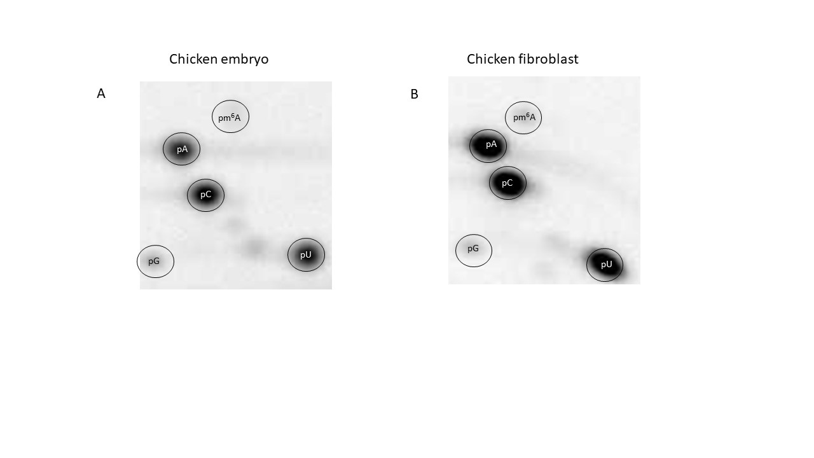
Supplementary Figure S1. TLC results from chicken embryo and chicken fibroblast cells
A) A representative of three replicates of detecting and quantifying m⁶A after Gsusing the TLC method in chicken embryos. The quantification results are presented in Fig. 1A. B) A representative of three replicates of detecting and quantifying m⁶A after Gs using the TLC method in chicken fibroblast cells. The quantification results are presented in Fig. 1A.

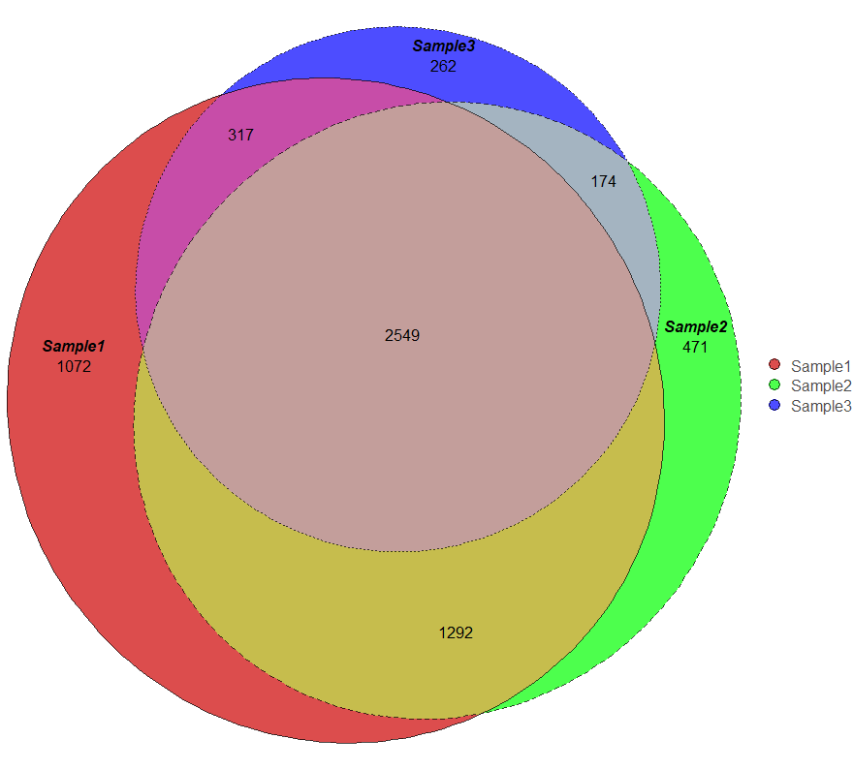
Supplementary Figure S2. Peak overlaps from three replicates
The data for Venn diagrams created in the RNAmod (http://61.147.117.195/RNAmod/) online tool for m⁶A analysis using peak files with high confidence peaks p < 0.05 and > 4-fold enriched in IP vs input.
Supplementary Figure S3. Gene type statistics
The genetype statistics is the summary of 3 MeRIPSeq replicates using the online tool RNAmod (http://61.147.117.195/RNAmod/). Only high confidence peaks with p< 0.05 and > 4-fold enrichment for peak intensity were used for the analysis.

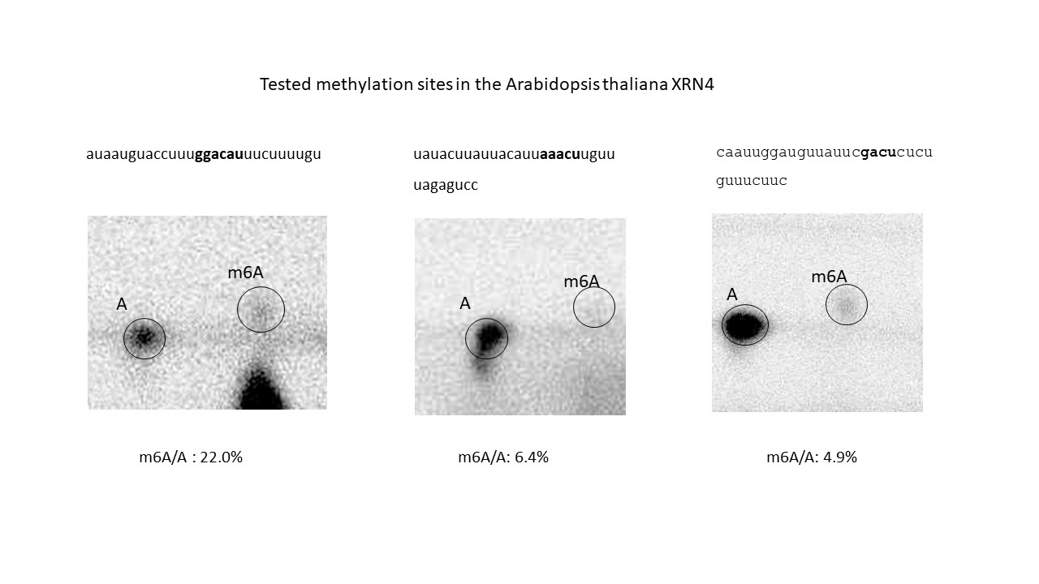

Supplementary Figure S4. Testing m⁶A sites in the A. thaliana XRN4 mRNA
Using the RedBaron method we tested three candidate methylation sites in the 3′UTR. These sites were under the summit of the methylation peak detected in the MeRIPSeq experiment (presented in Figure 4E) in the wt Arabidopsis lines.

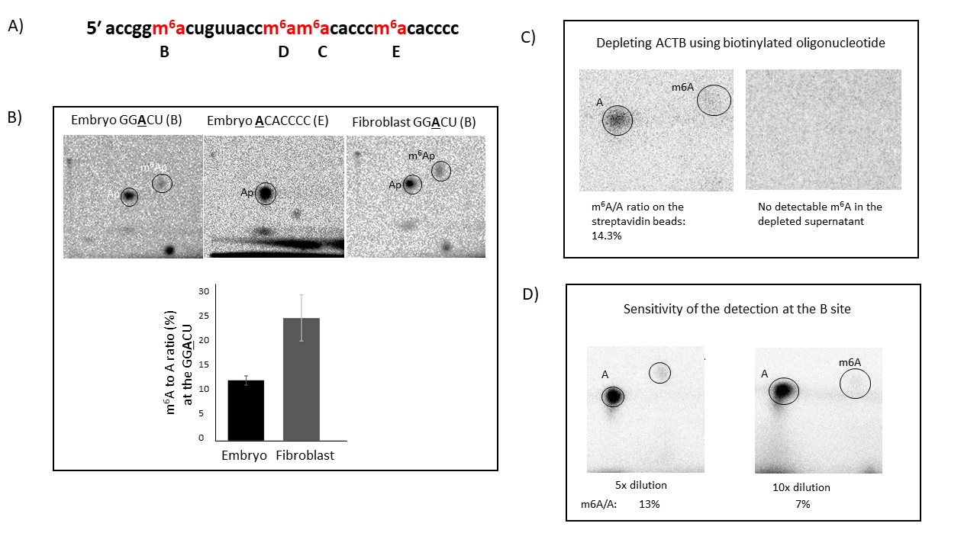

Supplementary Figure S5. The precise detection and quantification of m⁶A positions in the chicken ACTB zipcode. A) The positions of the potential m⁶A sites assayed in gel shift experiments in the chicken β-actin core zipcode sequence. B) The TLC images demonstrate the presence of m⁶A at the GGACU sequence in chicken embryo and embryonal fibroblast, and the lack of m⁶A at the ACACCCC site. The bar chart indicates a significant difference (t-test, p = 0.05) in m⁶A quantities between embryo and embryonal fibroblast. Error bars represent standard error from 3 replicates. C) The TLC images are representing the m⁶A/A ratios at the GGACU site from the RedBaron experiment on ACTB depleted mRNA fraction and the on the streptavidin magnetic beads. D) The TLC images and the quantification of m⁶A/A ratios at the GGACU site from the 5 fold and 10 fold diluted chicken ACTB. We used the mRNA from the laboratory yeast, S. cerevisiae to dilute the mRNA from chicken embryo.

