SUPPLEMENTARY INFORMATION

Identification of U^{p}47 in three thermophilic and one mesophilic archaea and one hyperthermophilic bacterium

- Philippe Wolff¹*, Antony Lechner¹, Louis Droogmans², Henri Grosjean², Eric Westhof¹*
¹ Architecture et Réactivité de l’ARN, Institut de Biologie Moléculaire et Cellulaire du CNRS, Université de Strasbourg, F-67084, Strasbourg, France
² Laboratoire de Chimie Biologique, Université Libre de Bruxelles, Institut Labiris, Avenue Emile Gryzon 1, B-1070, Belgium

* Correspondence:
Eric Westhof
e.westhof@ibmc-cnrs.unistra.fr
Philippe Wolff
p.wolff@ibmc-cnrs.unistra.fr

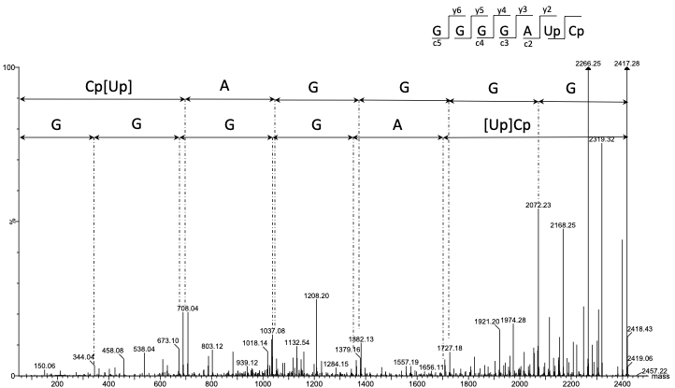

Figure S1. Deconvoluted MS/MS sequencing spectrum of M. maripaludis Arg-tRNA-UCU containing U^{p}47 after RNase A digestion (m/z = 1208,14 z =-2).

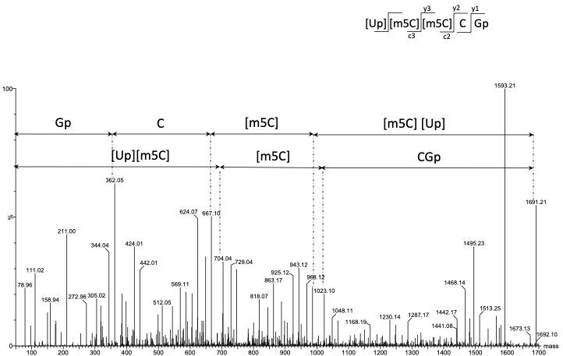

Figure S2. Deconvoluted MS/MS sequencing spectrum of P. furiosus Thr-tRNA-GGU containing U^{p}47 after RNase T1 digestion (m/z = 845,12 z =-2).
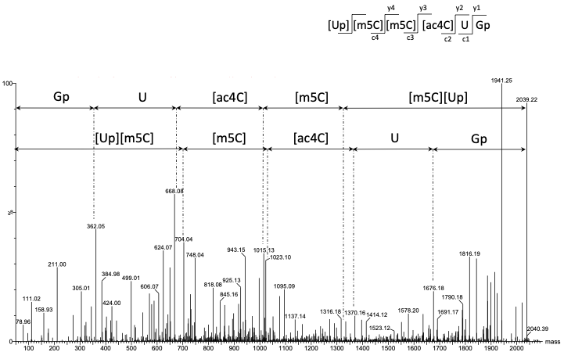

Figure S3. Deconvoluted MS/MS sequencing spectrum of S. shibatae Ini-tRNA-CAU containing U^{p}47 after RNase T1 digestion (m/z = 1019,11 z =-2).

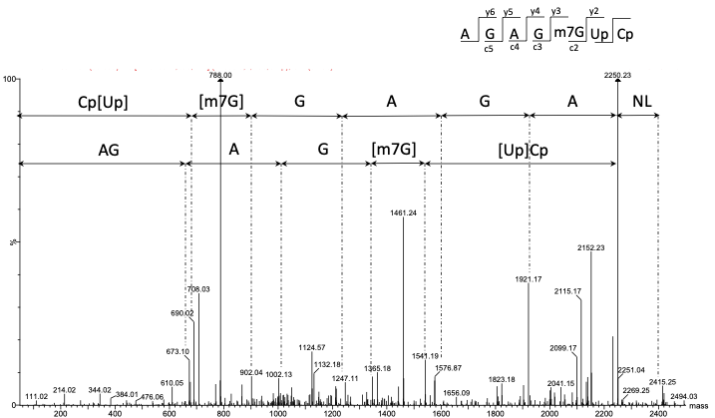

Figure S4. Deconvoluted MS/MS sequencing spectrum of A. aeolicus Val-tRNA-Pro-GGG containing U^{p}47 after RNase A digestion (m/z = 1207,15 z =-2). NL corresponds to the neutral loss of the m7G base during CID fragmentation.

