Supplementary Information

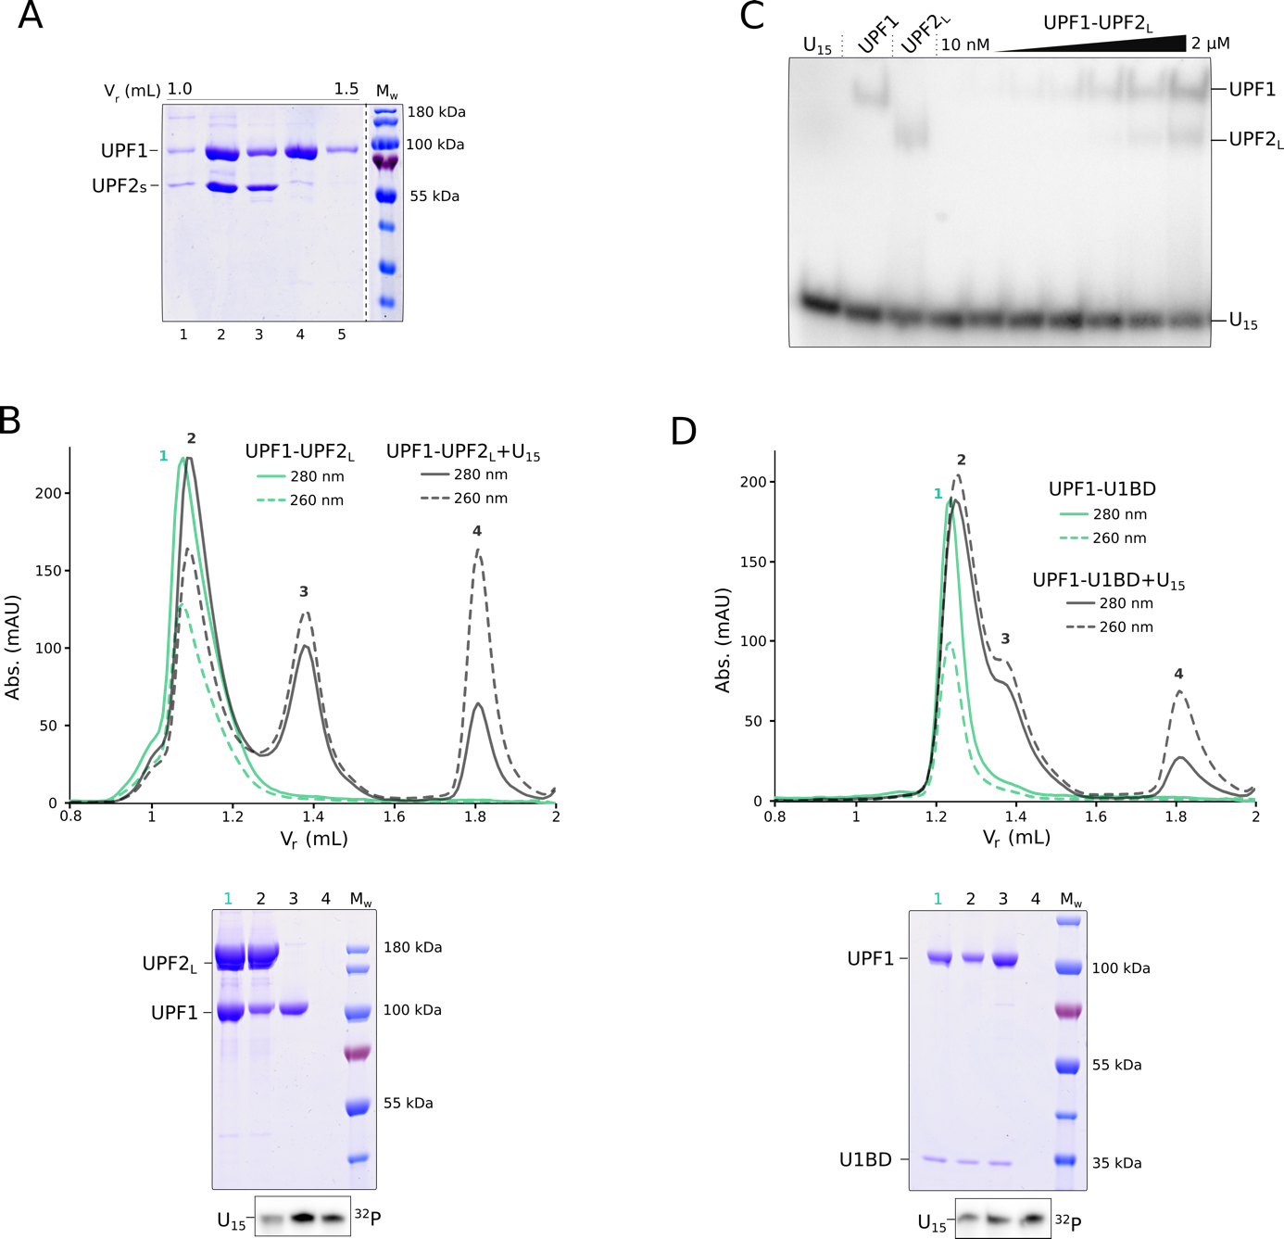

Supplementary Figure 1: Impact of different UPF2 constructs on RNA-binding by UPF1
- Coomassie-stained SDS-PAGE analysis of the peak fractions of the UPF1-UPF2_{S} complex + U₁₅ RNA SEC run, shown in Figure 1B. Fractions are loaded in ascending order of retention volume. A careful comparison of lanes 2 and 3 reveals a change in the relative intensity of the UPF1 and UPF2_{S} bands, which indicates partial dissociation of the UPF1-UPF2_{S} complex. Dissociation of the UPF1-UPF2_{S} complex releases free UPF2_{S} which co-migrates with the complex peak (Peak 1 in Figure 1B, bottom panel) and UPF1 that binds the U₁₅ RNA (Peak 2). C) Electrophoretic mobility shift assay of the UPF1-UPF2_{S} complex with ³²P-labeled U₁₅ RNA. The absence of a super-shifted band in comparison to RNA-bound UPF1 and UPF2 suggests that no ternary complex of UPF1-UPF2_{S}-U₁₅ is formed. As seen in SEC analysis, addition of RNA to the UPF1-UPF2_{S} complex causes it to dissociate. B) and D) Analytical SEC and corresponding PAGE analyses of UPF1-UPF2_{L} and UPF1-UPF2-U1BD complexes in the presence of RNA. Proteins are visualized by staining with Coomassie Brilliant Blue while U₁₅ RNA is detected by radiolabeling the peak fractions with ³²P. Addition of RNA to both complexes leads to their dissociation, as indicated by appearance of a UPF1-RNA peak (peak 3 in both chromatograms). As in figures in the main text, solid and dashed lines denote absorbance at 280 nm and 260 nm, respectively. The higher absorbance at 260 nm and appearance of U₁₅ RNA in peak 2 is not due to RNA binding of the UPF1-UPF2-U1BD complex but due to partial overlap of the complex peak with that of RNA-bound UPF1 (peak 3).

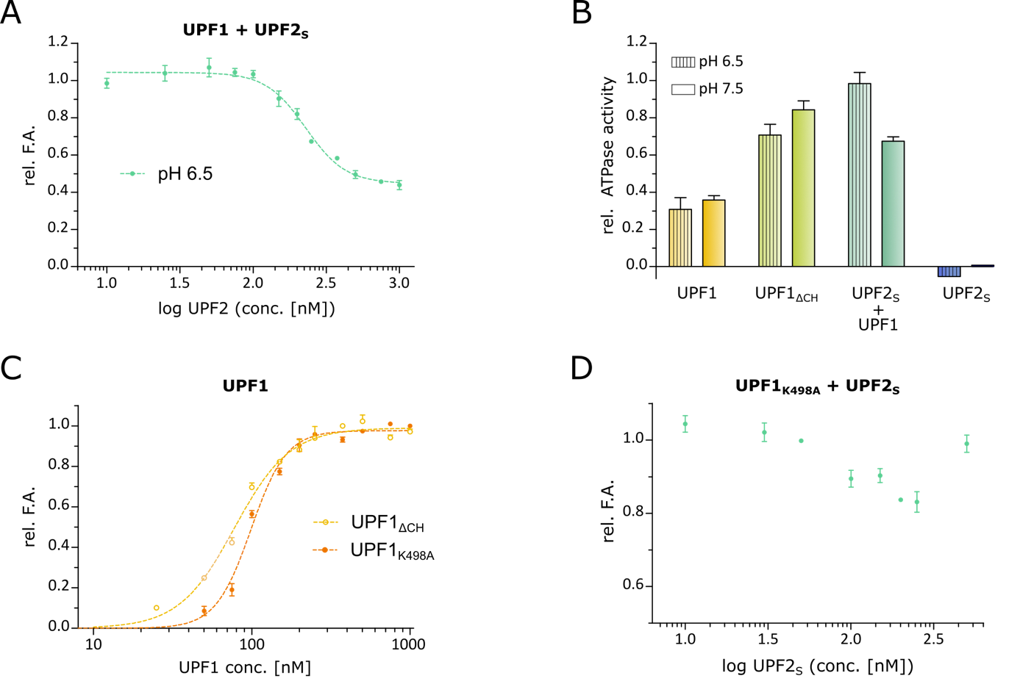

Supplementary Figure 2: The UPF2-mediated dissociation of UPF1 from RNA is not affected by pH or the nucleotide-binding ability of the helicase
A) Fluorescence anisotropy competition assay of UPF1 with UPF2_{S} at pH 6.5. Increasing amounts of UPF2_{S} titrated into a mixture of UPF1-6-FAM-U₁₂ RNA lead to dissociation of the RNA from the helicase and a decrease in fluorescence anisotropy, similar to that observed at pH 7.5 (Figure 2A). B) Comparison of the RNA-dependent ATPase activities of UPF1, UPF1ΔCH, and a mixture of UPF1 and 1.5-fold molar excess of UPF2_{S} at pH 6.5 and 7.5. ATPase activity was assayed at 30°C using a coupled enzymatic reaction to quantify the amount of inorganic phosphate released upon ATP hydrolysis (Enzcheck Kit, Invitrogen). The reaction buffers only varied in the buffering agent (50 mM MES pH 6.5 vs. 50 mM HEPES pH 7.5) while keeping all other components constant (50 mM KOAc, 5 mM Mg(OAc)₂, 2 mM DTT, 0.1% Tween20). The amount of phosphate released in each reaction was detected over a period of 15 minutes and fitted to straight lines, the slopes of which are plotted as columns in the bar graph. All values were normalized against the highest slope (UPF1-UPF2_{S} at pH 6.5), which was set to 100% ATPase activity. The highest pH-dependent variation in catalytic activity is observed for UPF1-UPF2_{S}, where the activity at pH 6.5 is higher than that at pH 7.5. C) Fluorescence anisotropy assay to determine the K_{D} of binding of 6-FAM-labeled U₁₂ RNA to UPF1ΔCH and UPF1_{K498A} (78 nM and 98 nM, respectively). The RNA-binding affinities of both UPF1 proteins is similar to that of wild type UPF1. D) Fluorescence anisotropy competition assay to determine how addition of UPF2_{S} affects binding of UPF1_{K498A} to 6-FAM-U₁₂ RNA. Increasing amounts of UPF2 leads to partial dissociation of UPF1_{K498A} from RNA, albeit to a far lesser extent than wild type UPF1.

