Supplementary material for:
Replication of alphaviruses requires a pseudoknot that involves the polyA tail.

René CL Olsthoorn
Leiden Institute of Chemistry, Leiden University, P.O. Box 9502, 2300 RA Leiden, The Netherlands

Correspondence: olsthoor@chem.leidenuniv.nl

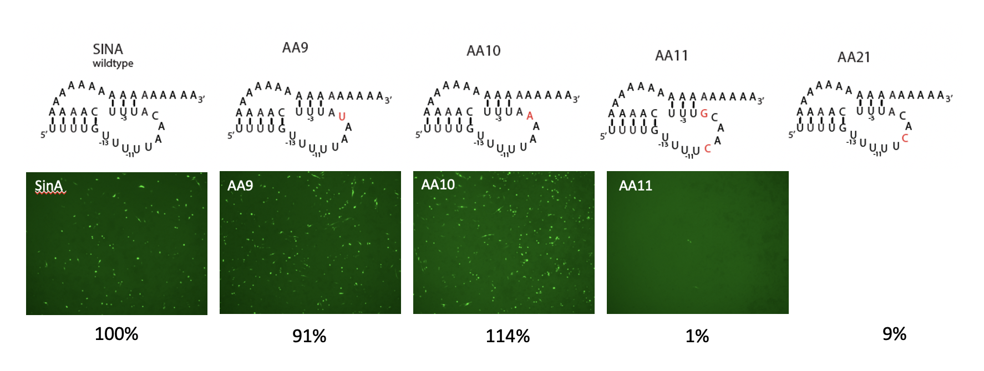

Fig. S1. Replication of mutants in the conserved UAANA motif. The UAANA motif that is in between the U-stretches is a strongly conserved feature that has been investigated by others before (Kuhn et al. 1990; Hardy & Rice, 2005). To check whether the SINV replicon system is equally sensitive towards changes in this motif several mutants were tested. The activities of UAAUA, UAAAA and UCACA were 91%, 114%, and 9% respectively, matching quite well with 135%, 72%, and 0.8% as reported for minus strand synthesis by Hardy & Rice (2005), although in the replicon system UAAAA performed better than UAAUA. To test whether A₋₈ may be involved in a base pair with U₋₄ these bases were replaced by G and C respectively. The resulting mutant AA11 was nearly dead (1%) suggesting the identity of these bases is crucial for replication and/or that the forced base-pairing severely affects the structure of the pseudoknot.

Fig. S2. “Raju’s revertants”. Sequences of stable deletion mutants and revertants obtained in studies by Raju and coworkers (Raju et al. 1999; George & Raju, 2000) were manually drawn as pseudoknot structures involving the polyA tail. S3-4, S3-23, ZA1-5 contain additional nucleotide insertions (not shown here) upstream of the predicted pseudoknot.
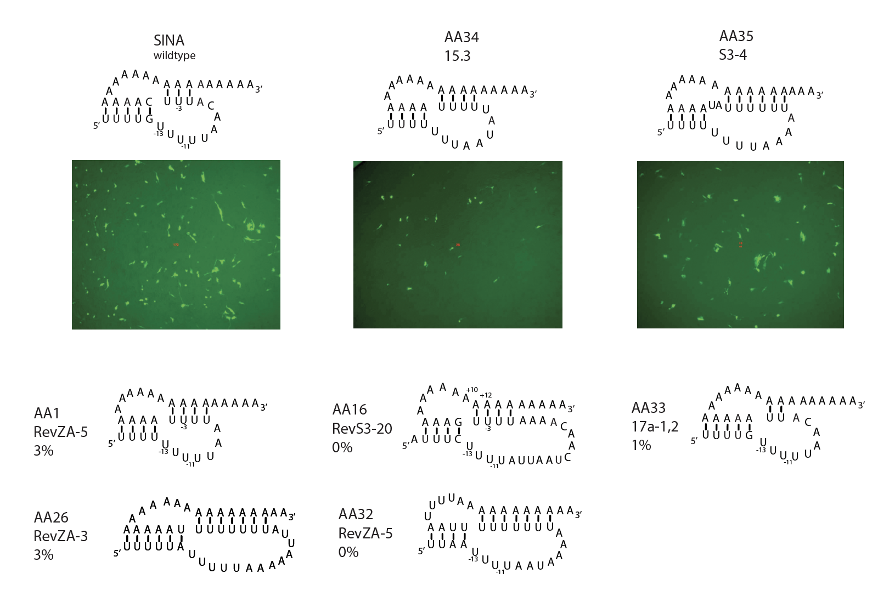

Fig. S3. Replication of a selection of pseudoknot variants as found in the indicated Raju revertants and mutants. AA1 and AA32 are two possible pseudoknot structures predicted for the ZA-5 revertant (Fig. S2).

Supplementary Table S1: PCR PRIMERS
SP6SIN | ATCGTATACGATTTAGGTGACACTATAGATTGACGGCGTAGTACACAC
SP6FLU | CCATTAAGCTTATTTAGGTGACACTATAGAAGAGATCACTAGAAGCTAGCAAAAGCAGGG
SINA29 | TTTTTTTTTTTTTTTTTTTTTTTTTTTTTGAAATGTTAAAAACAAAATTTTGTTG
SINA20 | TTTTTTTTTTTTTTTTTTTTGAAATGTTAAAAACAAAATTTTGTTG
SINA14 | TTTTTTTTTTTTTTGAAATGTTAAAAACAAAATTTTGTTG
SINA11 | TTTTTTTTTTTGAAATGTTAAAAACAAAATTTTGTTG
SINA8 | TTTTTTTTGAAATGTTAAAAACAAAATTTTGTTG
SINA4 | TTTTGAAATGTTAAAAACAAAATTTTGTTG
SINA0 | GAAATGTTAAAAACAAAATTTTGTTG
SINB1 | TTTTTTTTTTTTTTTTTTTTTTTTTTTTTGAAATGTTAAAAATAAAATTTTGTTG
SINB2 | TTTTTTTTTTTTTTTTTTTTTTTTTTTTTAAAATGTTAAAAATAAAATTTTGTTG
SINC1 | TTTTTTTTTTTTTTTTTTTTTTTTTTTTTGAAATGTTAAAAACCAAATTTTGTTG
SINC2 | TTTTTTTTTTTTTTTTTTTTTTTTTTTTGGAAATGTTAAAAACCAAATTTTGTTG
SIND1 | TTTTTTTTTTTTTTTTTTTTTTTTTTTTTGAAATGTTAAAAACTATATTTTGTTG
SIND2 | TTTTTTTTTTTTTTTTTTTTTTTTTTATAGAAATGTTAAAAACTATATTTTGTTG
SINE1 | TTTTTTTTTTTTTTTTTTTTTTTTTGTGGAAATGTTAAAAACGAGTTTTGTTGATTAATAAAAG
SINE2 | TTTTTTTTTTTTTTTTTTTTTTTTTGTGGAAATGTTAAAAACCACTTTTGTTGATTAATAAAAG
SINF | TTTTTTTTTTTTTTTTTTTTTTTTTCCTTGAAATGTTAAAAACAAGGTTTTGTTG
SING | TTTTTTTTTTTTTTTTTTTTTTTTTCCCGGAAATGTTAAAAACCGGGTTTTGTTGATTAATAAAAG
SINH | TTTTTTTTTTTTTTTTTTTTTTTTTTTTTGAAAATGTTAAAAACAAAATTTTGTTG
SINI | TTTTTTTTTTTTTTTTTTTTTTTTTGTGGAAATGTTAAAAACGAGTTTTGTTG
SINJ | TTTTTTTTTTTTTTTTTTTTTTTTTTTTTGGAATGTTAAAAACAAAATTTTGTTG
SINK1 | TTTTTTTTTTTTTTTTTTTTTTTTTTTTTGAGATGTTAAAAACAAAATTTTGTTG
SINK2 | TTTTTTTTTTTTTTTTTCTTTTTTTTTTTGAGATGTTAAAAACAAAATTTTGTTG
SINL1 | TTTTTTTTTTTTTTTTTTTTTTTTTTTTTGAAATGTTAAAAGCAAAATTTTGTTG
SINL2 | TTTTTTTTTTTTTTTTTTTTTTTTTTTTTGAAATGTTAAAACCAAAATTTTGTTG
SINL3 | TTTTTTTTTTTTTTTTTTTTTTTTTTTTTGAAATGTTAAAGACAAAATTTTGTTG
SINL4 | TTTTTTTTTTTTTTTTTTTTTTTTTTTTTGAAATGTTAAGAACAAAATTTTGTTG
SINL5 | TTTTTTTTTTTTTTTTTTTTTTTTTTTTTGAAATGTTAAGGACAAAATTTTGTTG
SINL6 | TTTTTTTTTTTTTTTTTTTTTTTTTTTTTGAAATGTTTTAAACAAAATTTTGTTG
SINM | TTTTTTTTTTTTTTTTTTTTTTTTTTTTTGAGATGTTAAAGACAAAATTTTGTTG
SINN | TTTTTTTTTTTTTTTTTCTTTTTTTTTTTGAGATGTTAAAGACAAAATTTTGTTG
SINO | TTTTTTTTTTTTTTTTTTTTTTTTTTTTTGAGATGTTAAGAACAAAATTTTGTTG
SINP | TTTTTTTTTTTTTTTTTCTTTTTTTTTTTGAGATGTTAAGAACAAAATTTTGTTG
SINQ | TTTTTTTTTTTTTTTTTTTTTTTTTTTTTGGAATGTTAAAGACAAAATTTTGTTG
SINR | TTTTTTTTTTTTTTTTTTCTTTTTTTTTTGGAATGTTAAAGACAAAATTTTGTTG
SINS | TTTTTTTTTTTTTTTTTTTTTTTTTTTTTGAAGTGTTAGAAACAAAATTTTGTTG
SINT | TTTTTTTTTTTTTTTTCTTTTTTTTTTTTGAAGTGTTAGAAACAAAATTTTGTTG
SINU | TTTTTTTTTTTTTTTTTCTTTTTTTTTTTGAAATGTTAAGAACAAAATTTTGTTG
SINV | TTTTTTTTTTTTTTTTTCTTTTTTTTTTTGAAATGTTAAAAACAAAATTTTGTTG
AA1 | TTTTTTTTTTTTTTTTTTTTTTTTTTTTTAAAATTAAAAAAAAATTTTGTTG
AA9 | TTTTTTTTTTTTTTTTTTTTTTTTTTTTTGAAATATTAAAAACAAAATTTTGTTG
AA10 | TTTTTTTTTTTTTTTTTTTTTTTTTTTTTGAAATTTTAAAAACAAAATTTTGTTG
AA11 | TTTTTTTTTTTTTTTTTTTTTTTTTTTTTGAAACGTTGAAAACAAAATTTTGTTG
AA16 | TTTTTTTTTTTTTTTTTTTTTTTTTTTTCAAAATTTTGTTGATTAATAAAAGAAATAATAAAAGTTATGCAGACG
AA21 | TTTTTTTTTTTTTTTTTTTTTTTTTTTTTGAAATGTGAAAAACAAAATTTTGTTG
AA26 | TTTTTTTTTTTTTTTTTTTTTTTTTTTTTAAAAAAAATAATTTTTAAAAATAAAAATTTTGTTGATTAATAAAAG
AA32 | TTTTTTTTTTTTTTTTTTTTTTTTTTTTTAAAATTAAAAAAAAATTTTATTAAAATTAATTTTGTTG
AA33 | TTTTTTTTTTTTTTTTTTTTTTTTTTTTTTAATGTTAAAAACAAAATTTTGTTG
AA34 | TTTTTTTTTTTTTTTTTTTTTTTTTTTTTAAAAATATTAAAAAAATTTTGTTG
AA35 | TTTTTTTTTTTTTTTTTTTTTTTTTTTTTATAAAAAATTTTAAAAAAAATTTTGTTG
AA36 | TTTTTTTTTTTTTTTTTTTTTTTTTTTTTGAATGTTAAAAACAAAATTTTGTTG
SIN-MID | TTTTTTTTTTTTTTTTTTTTTTTTGGAATATTAAAACCAATTTTGTTG

