SUPPLEMENTAL INFORMATION

Biological solution conditions and flanking sequence
modulate LLPS of RNA G-quadruplex structures

Allison M. Williams^{1,2}, Taylor M. Dickson³, Claudia A. Lagoa-Miguel^{4,5}, Philip C. Bevilacqua^{1,2,4}*
*Author to whom correspondence should be addressed pcb5@psu.edu

¹Department of Biochemistry, Microbiology, and Molecular Biology, Pennsylvania State University, University Park, Pennsylvania, 16802, United States
²Center for RNA Molecular Biology, Pennsylvania State University, University Park, Pennsylvania, 16802, United States
³Department of Veterinary and Biomedical Sciences, Pennsylvania State University, University Park, Pennsylvania, 16802, United States
⁴Department of Chemistry, Pennsylvania State University, University Park, Pennsylvania, 16802, United States
⁵Current Address: Department of Biochemistry, University of Wisconsin

Table of contents

- Supplemental Tables
Supplemental Table S1. List of GQ sequences studied S3
Supplemental Table S2. List of metabolite concentrations S3
- Supplemental Figures
Supplemental Figure 1. Structures of guanine interactions with other bases S4
Supplemental Figure 2. (G₃A₂)₄ UV-detected melts in the presence of amino acids S5
Supplemental Figure 3. 5′-flank UV-thermal denaturation of individual polyamines S5
Supplemental Figure 4. Predicted hairpin structure of 5′-U₉ and 5’-C₉ hairpin structures S6
Supplemental Figure 5. CD spectra for 5′-flanking sequences in the absence and presence of spermine S7
Supplemental Figure 6. CD spectroscopy of A10 in the presence and absence of spermine S7
Supplemental Figure 7. UV thermal denaturation of 3’-flanked sequences for individual polyamines. S8
Supplemental Figure 8. CD spectroscopy of dual-flanked sequences S8
Supplemental Figure 9. UV-thermal denaturation and CD spectroscopy of NRAS S9
Supplemental Figure 10. Confocal microscopy of NRAS at increasing concentrations of spermine S9
Supplemental Figure 11. Confocal microscopy of NRAS in arginine and CTP S9
Supplemental Figure 12. Confocal microscopy of NRAS in PEG and spermine S10

Supplemental Table 1: Sequences used. Includes shortened name and variation from core sequence.
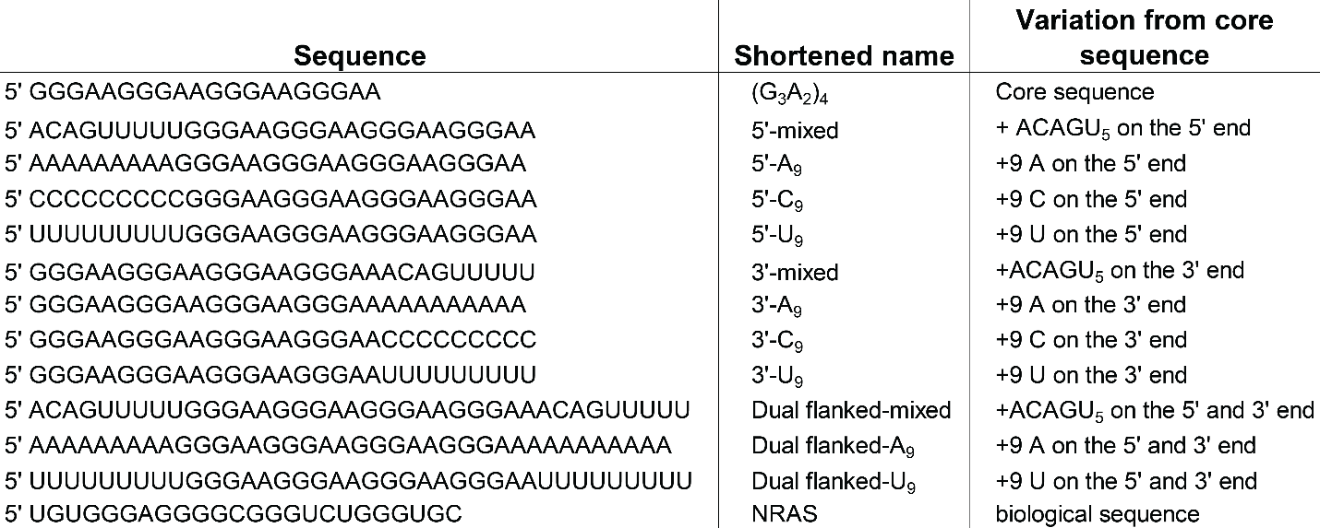

Supplemental Table 2: Metabolite concentrations used in this study. Includes yeast metabolite concentrations from two different sources.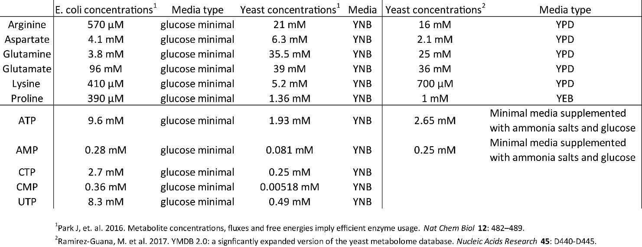

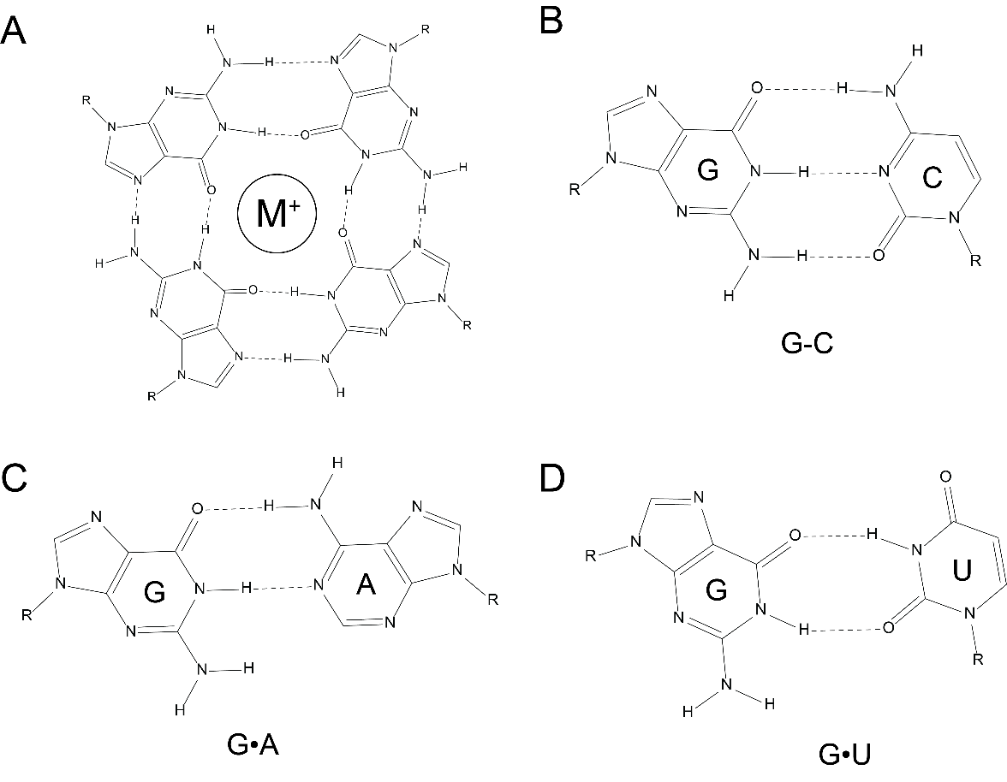
Supplemental Figure 1: Potential guanine base pairing interactions. Representative (A) G-quartet, (B) GC, and (C) GA, and (D) GU interactions. Those shown in panels (B)-(D) represent potential flanking sequence interactions. G-quartet represents one of the tiers of the G-quadruplex. M⁺ represents a monovalent ion, particularly potassium or sodium.

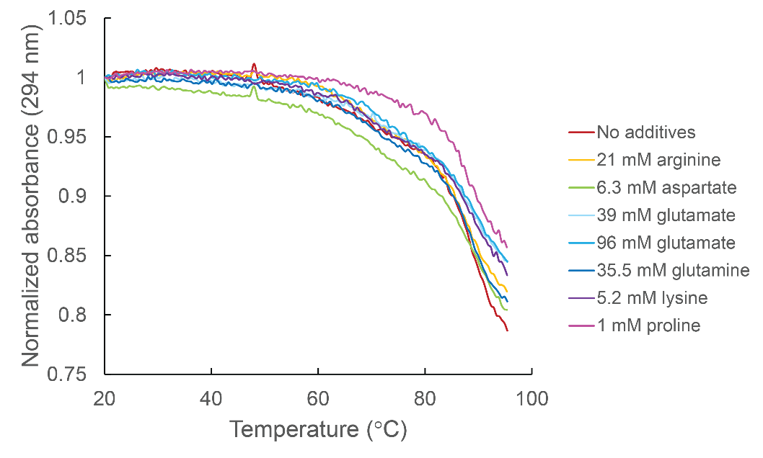
Supplemental Figure 2: (G₃A₂)₄ UV-detected melts in the presence of amino acids. All amino acids and their concentrations are reported in the legend. Melts are monitored at 294 nm. All samples are in the background of 10 mM HEPES and contain
K₁₅₀N₁₀M_{0.5 free}.

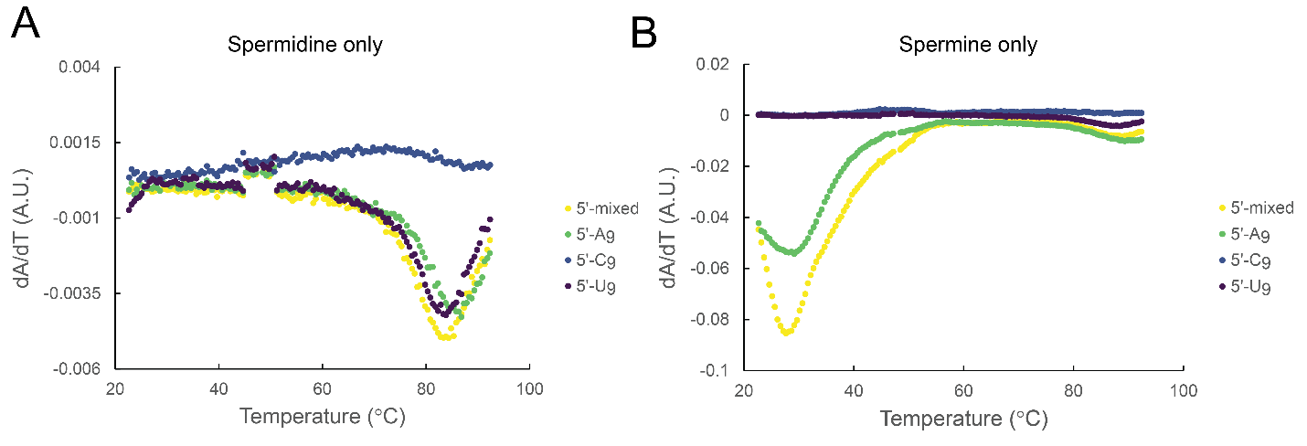
Supplemental Figure 3: 5′-flank UV-thermal denaturation of individual polyamines. First derivative plots in (A) spermidine (B) and spermine. All samples were 11-point smoothed after taking the first derivative. Melt is monitored at 294 nm. All samples are in the background of 10 mM HEPES and contain K₁₅₀N₁₀M_{0.5}. T_{m} is the temperature with a minimum in the first derivative.
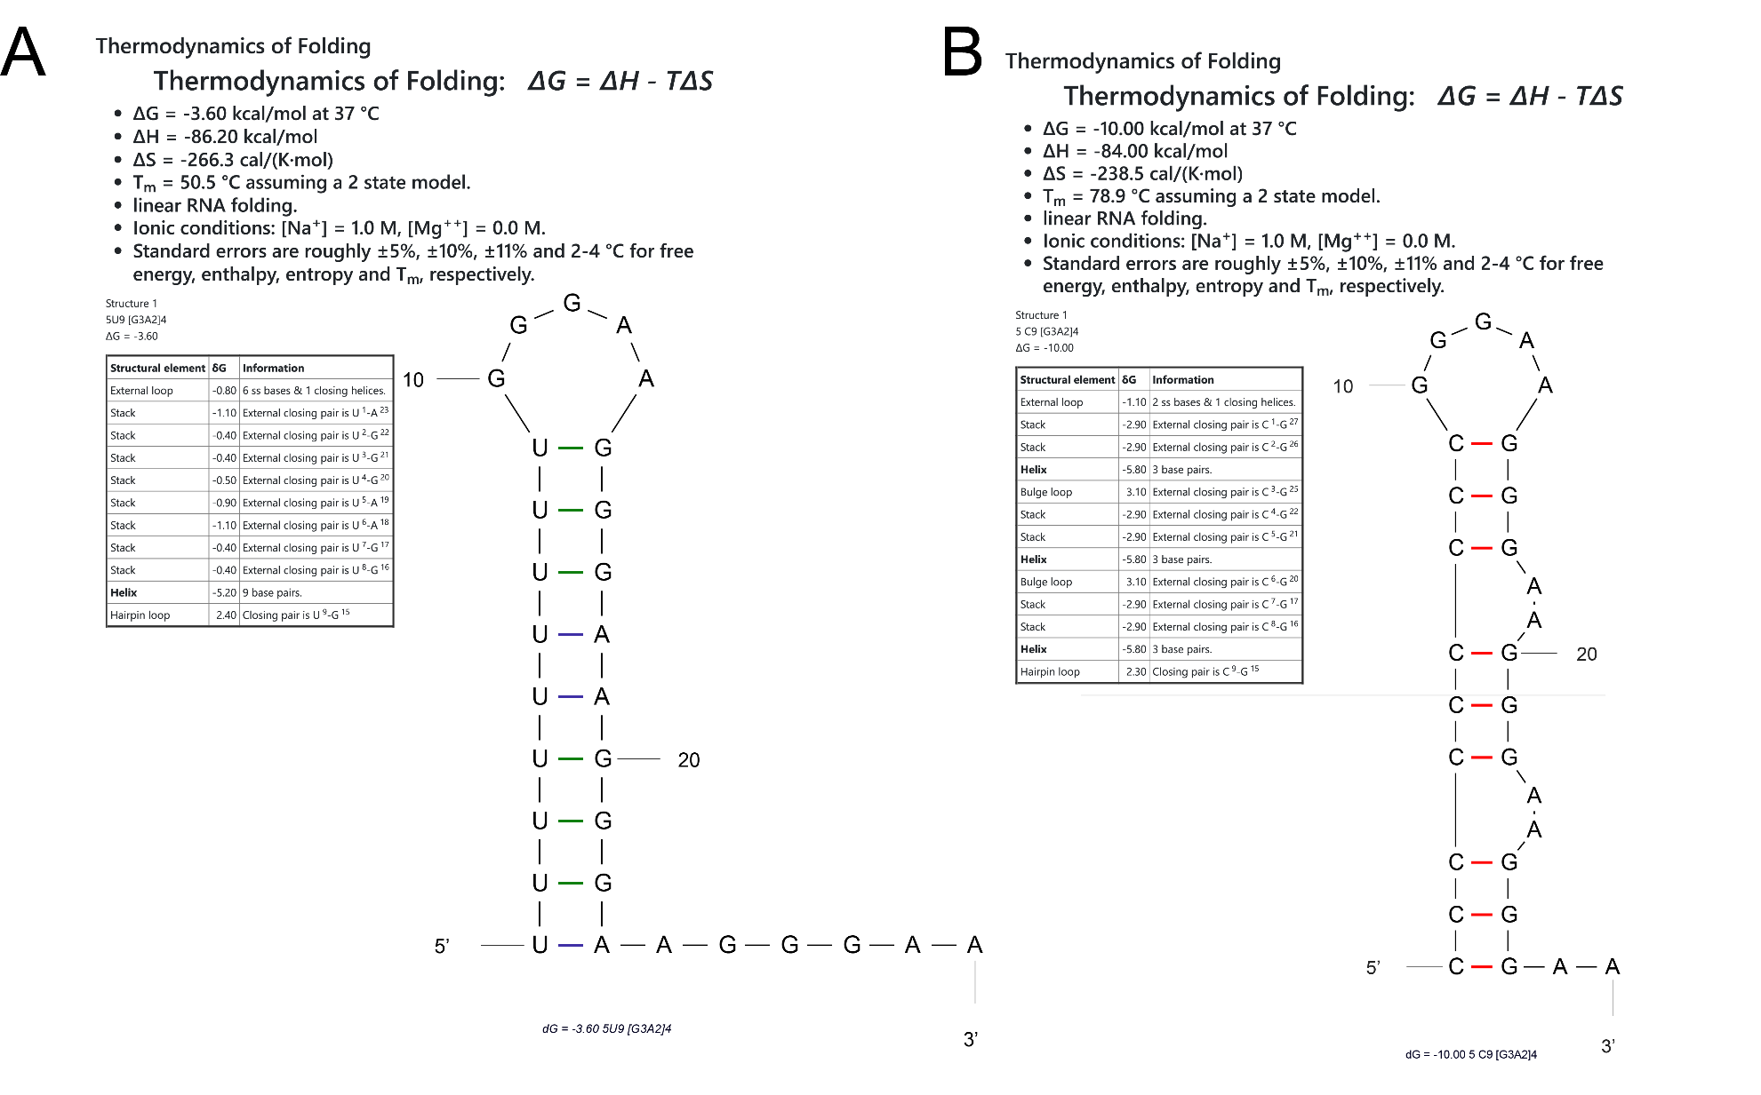
Supplemental Figure 4: mFold prediction of (A) 5′U₉ and (B) 5′C₉ hairpin structures. Combined output of the thermodynamic data and the hairpin image from mFold prediction software.
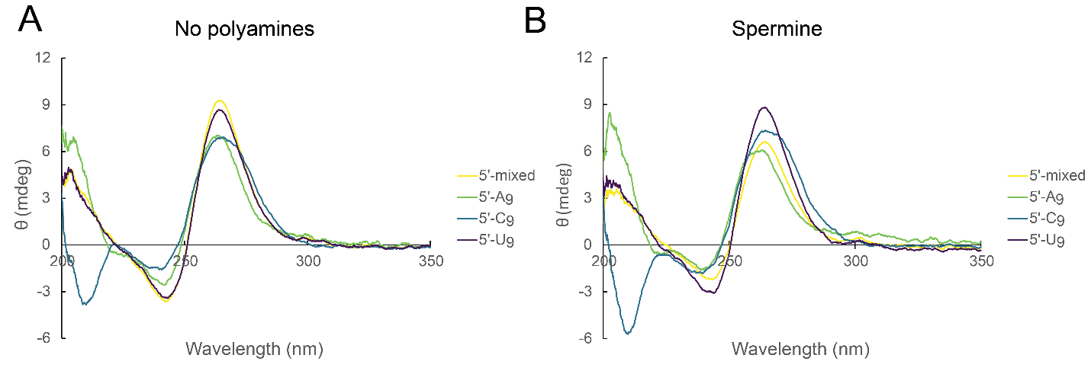
Supplemental Figure 5: CD spectra for 5′-flanking sequences in the absence and presence of spermine. (A) Absence and (B) presence of 0.30 mM spermine for 5′-mixed (yellow), 5′-A₉ (green), 5′-C₉ (blue), and 5′-U₉ (purple). All spectra are buffer corrected and the 5′-A₉ sequence is corrected for 9/10 the spectrum of A₁₀, which is found in Supplemental Fig. 6. Samples are in the background of 10 mM HEPES (pH 7.5) and K₁₅₀N₁₀M_{0.5}.

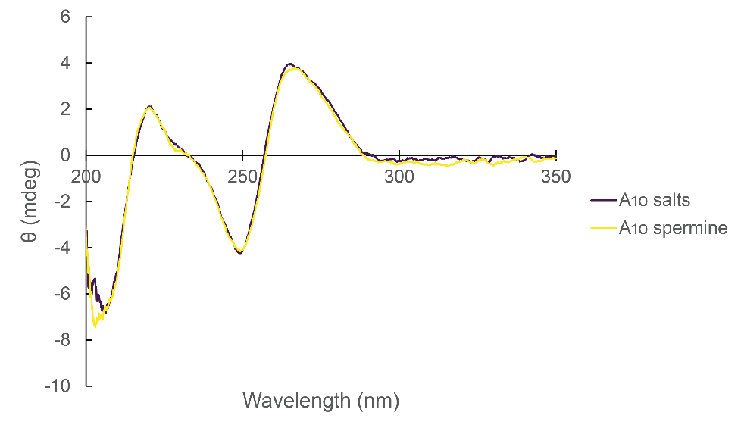
Supplemental Figure 6: CD spectroscopy of A10 in the presence and absence of spermine. Signal at 210 nm is about -5.1 mdeg, indicating that it contributes significant negative signature at this wavelength.

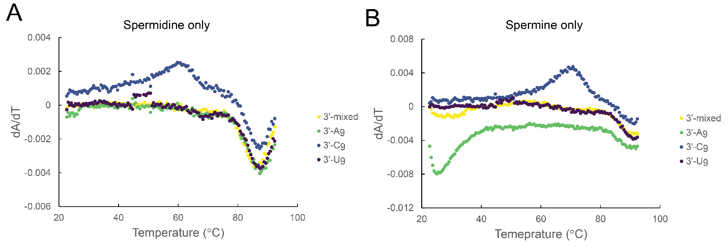
Supplemental Figure 7: UV thermal denaturation of 3’-flanked sequences for individual polyamines. First derivative plots in (A) spermidine and (B) spermine only. All samples were 11-point smoothed after taking the first derivative. Melt is monitored at 294 nm. All samples are in the background of 10 mM HEPES and contain K₁₅₀N₁₀M_{0.5}.

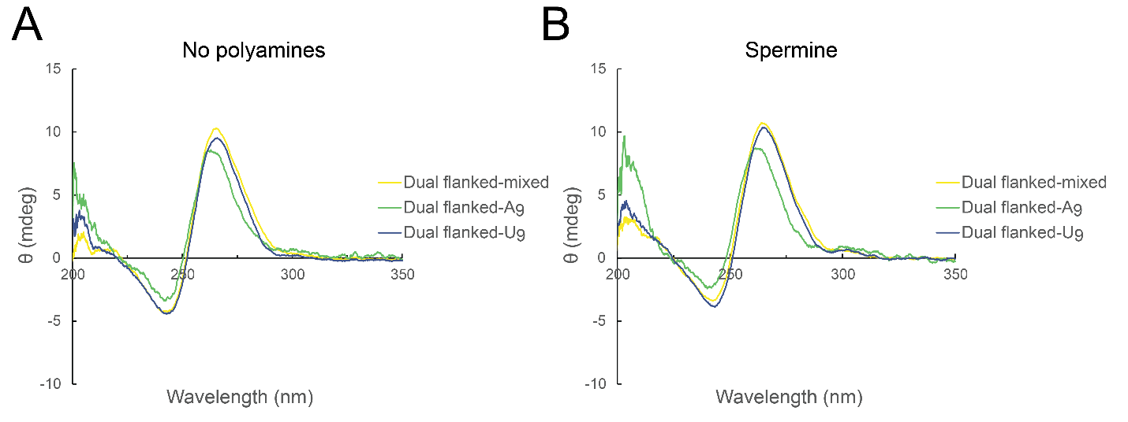
Supplemental Figure 8: CD spectroscopy of dual-flanked sequences. Selected flanked sequences in the (A) absence and (B) presence of 0.3 mM spermine. Samples are in the background of 10 mM HEPES (pH 7.5) K₁₅₀N₁₀M_{0.5} and buffer corrected and the dual flanked-A₉ sequence is corrected for the spectrum of the two A₉ tails.

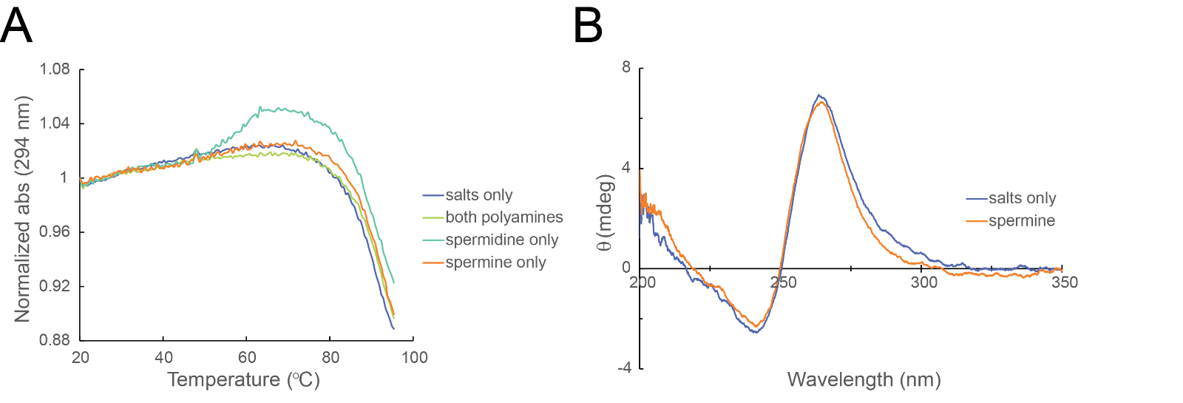
Supplemental Figure 9: UV-thermal denaturation and CD spectroscopy of NRAS. (A) UV-thermal denaturation monitored at 294 nm in varying polyamine conditions in the background of 10 mM HEPES and K₁₅₀N₁₀M_{0.5} (B) CD spectra in K₁₅₀N₁₀M_{0.5} and 10 mM HEPES alone or with 0.3 mM spermine.

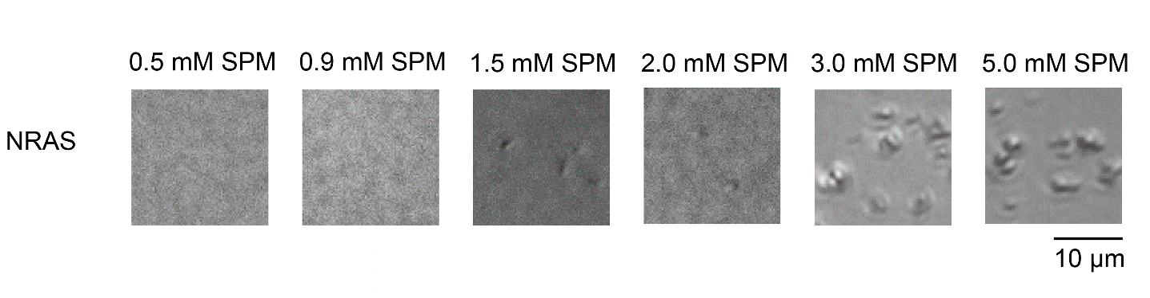Supplemental Figure 10: Increasing spermine concentrations in the presence of 10 µM NRAS RNA. All samples are in the background of K₁₅₀N₁₀M_{0.5} and 10 mM HEPES.

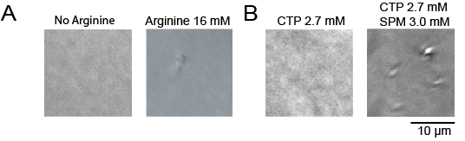
Supplemental Figure 11: (A) Arginine at 16 mM does not induce phase separation of NRAS. (B) CTP at 2.7 mM does not inhibit the formation of droplets induced by 3.0 mM spermine. All samples are in the background of K₁₅₀N₁₀M_{0.5} and 10 mM HEPES.

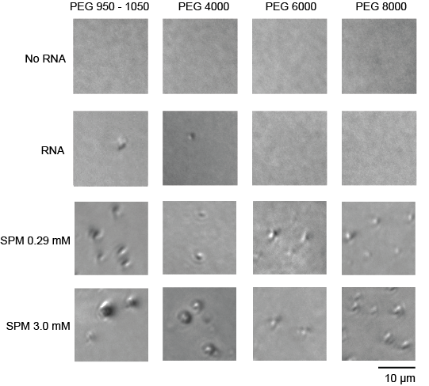

Supplemental Figure 12: NRAS at 5% PEG in various PEG molecular weights and spermine concentrations. All samples are in the background of K₁₅₀N₁₀M_{0.5} and 10 mM HEPES.

