Supplementary data
Table S1: Oligonucleotides used in this study
Oligonucleotide name | Sequence | Purpose
rrnO-F | GATCTAATACGACTCACTATAGGTTAAGTTAGAAAGGGCGC | Amplification of B. subtilis rrnO gene
rrnO-R | GATCCTCGAGATGGTTAAGTCCTCGATC | Amplification of B. subtilis rrnO gene
G2553A-1 | GGTCCCAAGGGTATGGCTATTCGCCATTTAAAGTGGTACG | B. subtilis rrnO gene mutagenesis
G2553A-2 | CGTACCACTTTAAATGGCGAATAGCCATACCCTTGGACC | B. subtilis rrnO gene mutagenesis
G2553C-1 | GGTCCCAAGGGTATGGCTCTTCGCCATTTAAAGTGGTACG | B. subtilis rrnO gene mutagenesis
G2553C-2 | CGTACCACTTTAAATGGCGAAGAGCCATACCCTTGGACC | B. subtilis rrnO gene mutagenesis
G2553U-1 | GGTCCCAAGGGTATGGCTTTTCGCCATTTAAAGTGGTACG | B. subtilis rrnO gene mutagenesis
G2553U-2 | CGTACCACTTTAAATGGCGAAAAGCCATACCCTTGGACC | B. subtilis rrnO gene mutagenesis
ysgA-DNAz | AATGGGCGAAGGCTAGCTACAACGAAGCCCAACCC | DNAzyme
Hyb-1 | AATGGGCGAACAGCCCAACCC | Hybridization-protection spanning 2543-2562 of 23S rRNA
Hyb-2 | TAAGCCTGTTATCCCCGGG | Hybridization-protection spanning 1906-1925 of 23S rRNA
Hyb-3 | GGCGACCGCCCCAGTCAAACT | Hybridization-protection spanning 2241-2261 of 23S rRNA
Hyb-4 | GGACCGTTATAGTTACGGCC | Hybridization-protection spanning 2440-2459 of 23S rRNA
MS-1 | ATGAGCCGACATCGAGGTGCC | RNAseH cleavage of 23S rRNA
MS-2 | TTCTGAACCCAGCTCGCGTA | RNAseH cleavage of 23S rRNA

Table S2. Data collection and refinement statistics (Statistics for the highest-resolution shell are shown in parentheses).

Wavelength | 0.980109
Resolution range | 45.85 - 1.877 (1.944 - 1.877)
Space group | P 21 21 21
Unit cell | 64.88 66.45 129.6 90 90 90
Total reflections | 719932 (69808)
Unique reflections | 46485 (4520)
Multiplicity | 15.5 (15.4)
Completeness (%) | 99.73 (97.86)
Mean I/sigma(I) | 30.08 (2.21)
Wilson B-factor | 39.62
R-merge | 0.04927 (1.161)
R-meas | 0.051 (1.201)
R-pim | 0.01297 (0.3008)
CC1/2 | 0.999 (0.796)
CC* | 1 (0.941)
Reflections used in refinement | 46482 (4519)
Reflections used for R-free | 2323 (223)
R-work | 0.1821 (0.3186)
R-free | 0.2074 (0.3386)
CC(work) | 0.965 (0.764)
CC(free) | 0.959 (0.663)
RMS(bonds) | 0.017
RMS(angles) | 1.45
Ramachandran favored (%) | 99.19
Ramachandran outliers (%) | 0.00

min
10³ cpm

Figure S1. YsgA methylates RNA from E. coli and B. subtilis ΔysgA cells. 50 µg of total RNA extracted from E. coli (▲) or B. subtilis ΔysgA (●) cells were incubated with 0.25 μM [methyl ³H] SAM and 100 ng of purified YsgA. After incubation, reaction mixtures were processed as described in Materials and Methods and the radioactivity incorporated in the different RNA preparations was measured using a scintillation counter.

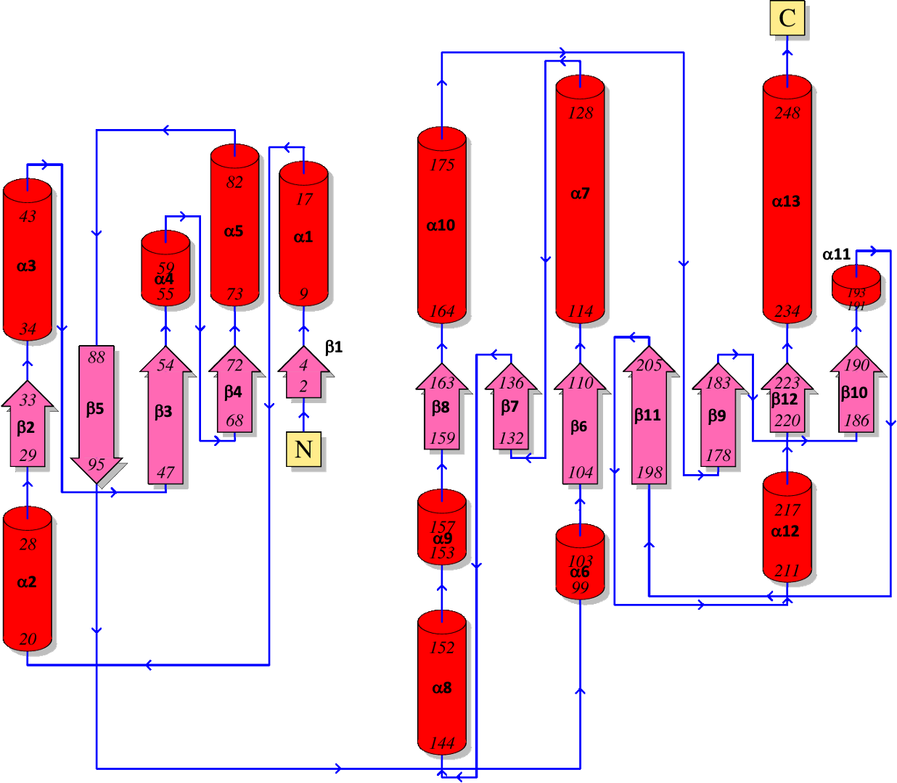
Figure S2. Topology diagram of YsgA (PDBSum).

Figure S3. Size exclusion chromatography analysis of YsgA. The pure protein was loaded on a Superose 12 10/300 GL (GE Healthcare) and eluted with buffer B (20 mM Tris, 100 mM, NaCl, 2 mM DTT, pH 8.0). Flow rate: 0.5 mL/min. UV absorbance was monitored at 280 nm. The column was calibrated using a gel filtration standard mix resuspended in the same buffer (lyophilized mix of thyroglobulin, bovine γ-globulin, chicken ovalbumin, equine myoglobin, and vitamin B12 (Biorad).

1 MKQIESAKNQKVKDWKKLHTKKERTKTNTFLIEGEHLVEEALKSPGIVKEILVKDETRIPSDLETGIQCY
71 MLSEDAFSAVTETETPQQIAAVCHMPEEKLATARKVLLIDAVQDPGNLGTMIRTADAAGLDAVVLGDGTA
141 DAFNGKTLRSAQGSHFHIPVVRRNLPSYVDELKAEGVKVYGTALQNGAPYQEIPQSESFALIVGNEGAGV
211 DAALLEKTDLNLYVPLYGQAESLNVAVAAAILVYHLRG
Figure S4. Amino acid sequence of YsgA. The three sequence motifs (Gustafsson et al. 1996) that characterize the SPOUT RNA methyltransferase superfamily are highlighted in gray. Residues mutated in this study to confirm that YsgA belongs to the SPOUT superfamily are underlined (N117, R123, E206 and N234).

Figure S5. A. Overlay of the closest structural homologs of YsgA based on the SPOUT domain (CTD, left) or the N-terminal domain (NTD, right): YsgA, Ttha0275, RlmB, SPOUT RNA methyltransferases from Sinorhizobium meliloti (SmMTase) or Porphyromonas gingivalis (PgMTase), AviRB, RrmA, NHR and Tsr. For the sake of clarity, only one protomer is represented. B. Overlay of the YsgA NTD with the L7Ae/L30e ribosomal proteins (L7Ae: Archaeoglobus fulgidus; L30e-h: human; L30e-sc Saccharomyces cerevisiae).

