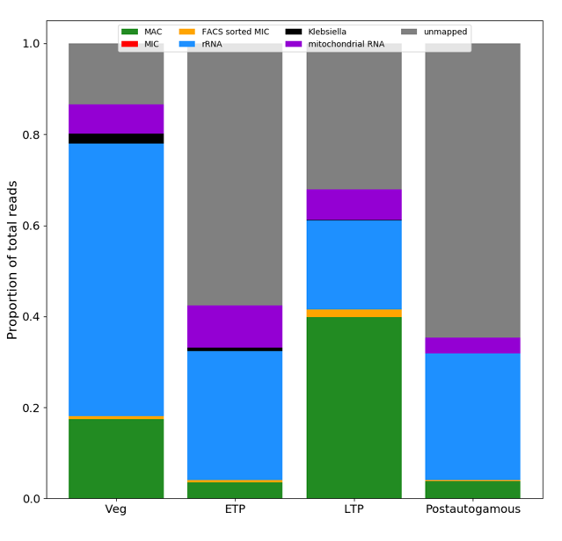

Supplementary Figure S1. Coverage of obtained reads. Reads were aligned to the MAC (green), MAC+IES (red) and the FACS sorted MIC (yellow) genomes, rRNA (blue), the feeding bacteria’s genome (black) and the mitochondrial DNA (purple). Bar plot shows the proportion of reads that mapped to the corresponding reference. As evident, the rRNA depletion was not complete but removed enough rRNA to not mask other alignments. A significant amount of reads (grey) did not align at all.

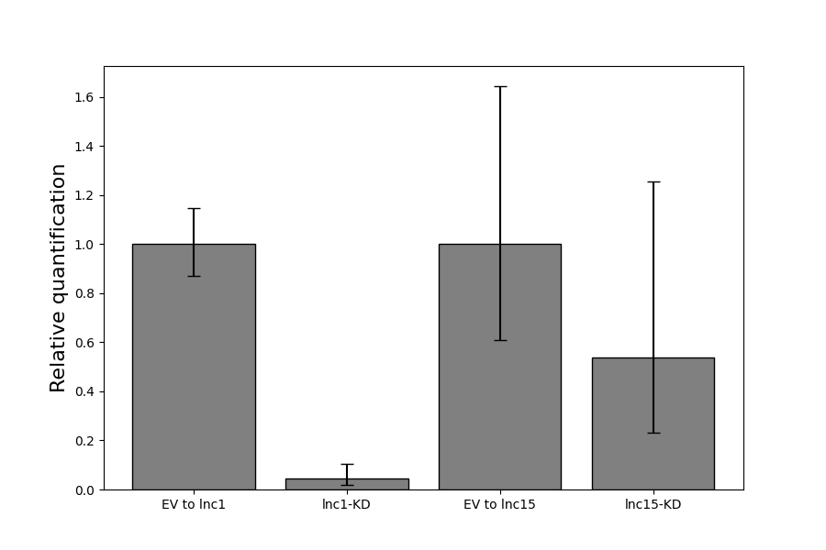
Supplementary Figure S2. RT-qPCR analysis of the lnc1 and lnc15 knock-downs. Relative expression levels normalised to the GAPDH housekeeping gene and to the negative control (EV) using the ddCt method in technical triplicates. Errorbars represent the standard error, with the following p-values: 0.025 and 0.132, obtained for the technical replicates between the dCt values of the EV and lnc1 and lnc15 respectively.

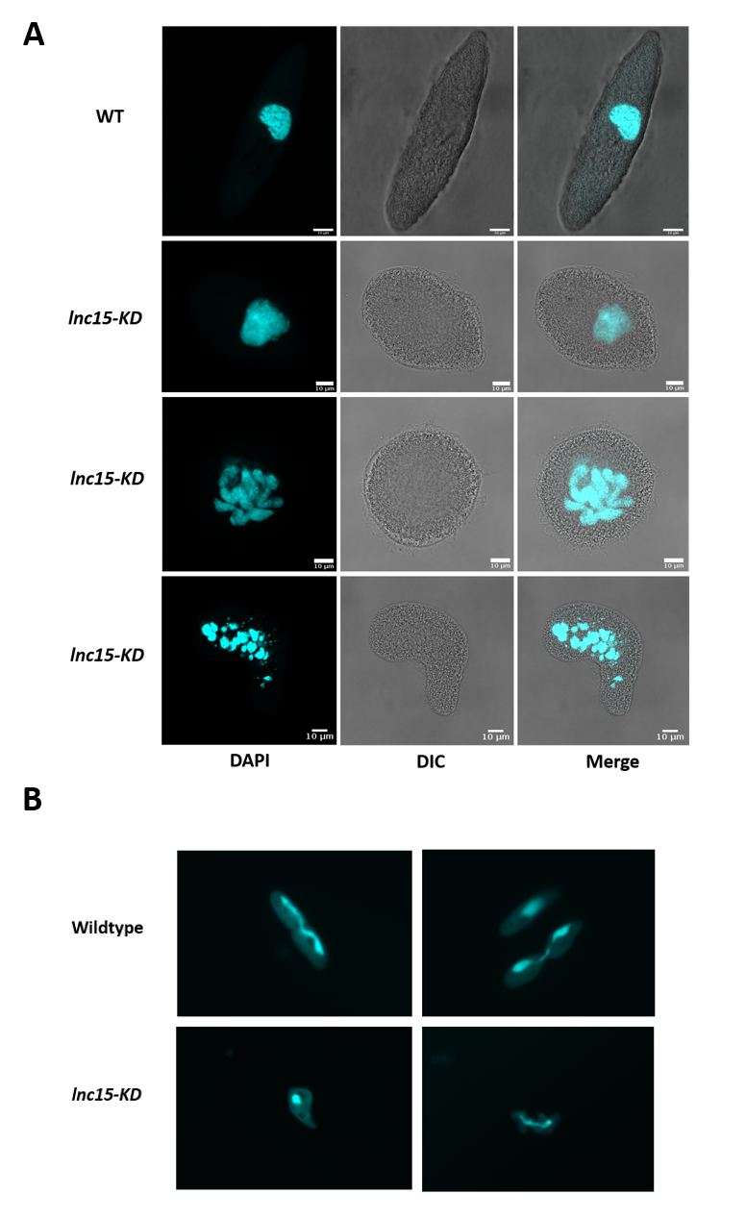
Supplementary Figure S3. lnc15 is involved in maintaining the cell’s morphology. (A) Confocal microscopy pictures of DAPI stained cells during silencing of lnc15. Approximately 90 % of all lnc15 silenced cells show this phenotype (n = 100). (B) Light microscopy pictures of wildtype and abnormally dividing cells. lnc15 knock-down affects dividing cells and leads to an increased division time. This in turn results in a slower division rate and presumably a higher mortality.

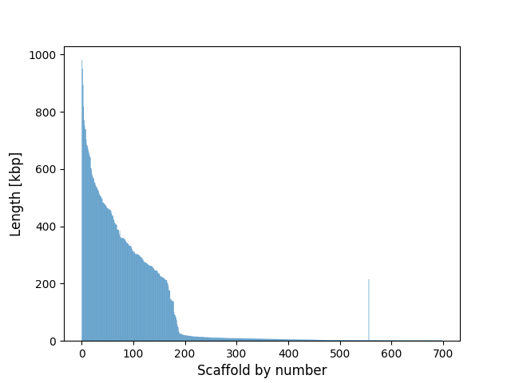
Supplementary Figure S4. Size distribution of Paramecium MAC genome scaffolds. Scaffolds 1 through 200 comprise the longest scaffolds and as such contain the majority of all IESs found in the genome.

Supplementary Table 1. General information on the predicted lncRNAs. Given are the predicted length, GC-content, location on the MAC genome, orientation of the transcript, its classification and whether the candidate was validated by RT-PCR and depletion, as well as the GenBank accession number.
lncRNA | Predicted length [bp] | GC-content [%] | Location on the genome | Orientation | Classification | RT-PCR validated | Silencing validated | GenBank accession number
lnc1 | 5.871 | 25,8 | scaffold51_387  20..5.985 | + | intergenic | Yes | Yes | OL962699
lnc3 | 4.185 | 22,9 | scaffold51_186  41..4.274 | - | intergenic | Yes | Yes | OL962700
lnc7 | 3.614 | 24 | scaffold51_170  426..4.098 | + | intergenic | Yes | Yes | OL962701
lnc13 | 1.188 | 27 | scaffold51_251  10.386..11.647 | - | intergenic | Yes | Yes | OL962702
lnc14 | 1.089 | 25,7 | scaffold51_125  1.289..2.399 | - | intergenic | Yes | No | OL962703
lnc15 | 931 | 30,5 | scaffold51_359  21..979 | + | intergenic | Yes | Yes | OL962704
lnc24 | 611 | 25,9 | scaffold51_125  1.848..2.480 | - | intergenic | No | No | OL962705
lnc32 | 392 | 24,5 | scaffold51_132  2.131..2.547 | - | intergenic | No | No | OL962706
lnc34 | 301 | 27,2 | scaffold51_111  186.628..186.954 | + | intergenic | No | No | OL962707
lnc35 | 257 | 29,9 | scaffold51_60  325.360..325.639 | + | intergenic | No | No | OL962708
lnc36 | 247 | 31,6 | scaffold51_49  365.135..365.408 | + | intergenic | No | No | OL962709
lnc37 | 239 | 25,1 | scaffold51_104  35.686..35.952 | - | intergenic | No | No | OL962710
lnc38 | 235 | 26,8 | scaffold51_41  231.674..231.916 | - | intergenic | No | No | OL962711
lnc39 | 226 | 28,3 | scaffold51_122  77.724..77.977 | - | intergenic | No | No | OL962712
lnc40 | 217 | 26,7 | scaffold51_83  216.993..217236 | + | intergenic | No | No | OL962713

Supplementary Table 2. Primers used in this study.
Assay | Name | 5’-3’ Sequence
RT-PCR | lnc_1.1.fwd | CCTGTTACTTCAGAAGAGGAAG
 | lnc_1.rev | CCATTAAATCTATTCCAGCAGC
 | lnc_1.2.fwd | CCAAAGAAACCCTTTGATGATATAAATTC
 | lnc_1.2.rev | CCCTTTCTCAACAATCCTTTTTG
 | lnc_3.fwd | GAATCTTTTAGCATCAAAGGAGG
 | lnc_3.1.rev | CATCATTCAAAAGTGAATTTTCTTTTGC
 | lnc_3.2.fwd | GATCCAATTCCATAAGTGAATGAAC
 | lnc_3.2.rev | CTCAATATCGATGGCATCATTTATAG
 | lnc_7.fwd | GAA ATG CCA AAC ATC CTA TAG AAA ATT G
 | lnc_7.1.rev | GTTAAATCTTCATTTACGCTCTGC
 | lnc_7.2.fwd | CAAACATTGAAGACAAAATGTTAACTC
 | lnc_7.2.rev | CCTTTATTATAAGTTATCTAACTCCAGTTTC
 | lnc13.1_fwd | GTTGTCGGCTAAGGATAAATTACTG
 | lnc13.1_rev | CTAAATCTTGAGTAATTAGATACCGAAC
 | lnc13.2_fwd | CTATAATGGTAAAGAATGGTTACCTGAAC
 | lnc13.2_rev | CACTGAAAATTCTACAATTCCATTTTTTAC
 | lnc14.1_fwd | GCTTAAAATGCGAAAAAGTTTTGATG
 | lnc14.1_rev | CATATTCTCCAGATAAATCTATTTACACC
 | lnc14.2_fwd | GGAAGTTGATTATTAGCAAATAGAAATATATTTG
 | lnc15.1_fwd | CATGCGGATTTATTGGTATTACAA AAG
 | lnc15.1_rev | CTGGCTTATCTCATCCTTTATACTG
 | lnc15.2_fwd | CAGTATAAAGGATGAGATAAGCCAG
 | lnc15.2_rev | CAACAATTCTCTCAGTTTTGTTTGG
RT-qPCR | lnc1_qPCR_fwd | ACCTTTGCCAGAAGAGAAGTAA
 | lnc1_qPCR-rev | AAAGTGATCAGCGTCAGGATAT
 | lnc15_qPCR_fwd | GGTGATTAATCTTGTGATCTGG
 | lnc15_qPCR_rev | GCTCCCTCTTCTTCATCAA
 | GAPDH.qPCR.fwd | GAGAGCCGGAAGAGCTGCTA
 | GAPDH.qPCR.rev | TGGTTGGAACTCTGAAGGCCATA
IES retention PCR | IES4.fwd | GCTATAACTCTTGAAGCTGCTTGTAATATG
 | IES4.rev | TTGTCAATGAGCCATTAACAGTTGCTGGAT
 | IES5.fwd | CTGTTGCTACACATTGTGCATATGTTACT
 | IES5.rev | GCTGTAAGATTAACATTGAGCATGCTCAAG
 | IES6.fwd | AATGCATCAAATGTAGTAACTACTCCTGCT
 | IES6.rev | AATTTGTAAAGTATCCAGCGCAGGCAG
 | IES7.fwd | TTTGTCAAAAAGACATGTATCAAAATGCAG
 | IES7.rev | TAGAATACTAAGAGATTCAATACAACAAAC
 | IES8.fwd | TAATGTATTGATAAGGCTTGCTCTACAGCC
 | IES8.rev | ATCTAACATCCTTGAATAGTTACTGATCC
 | IES9.fwd | ATGTGTTTGGACTGGATTGGCATGTAGAAG
 | IES9.rev | GATGTAGCATAACATTTATCAACAATCCAT
 | IES10.fwd | TGGAATAGTGCTGCATCACCAGCTGCTTGC
 | IES10.rev | CCAGTTATTGAACTGCAACTTACTGCAGTG

