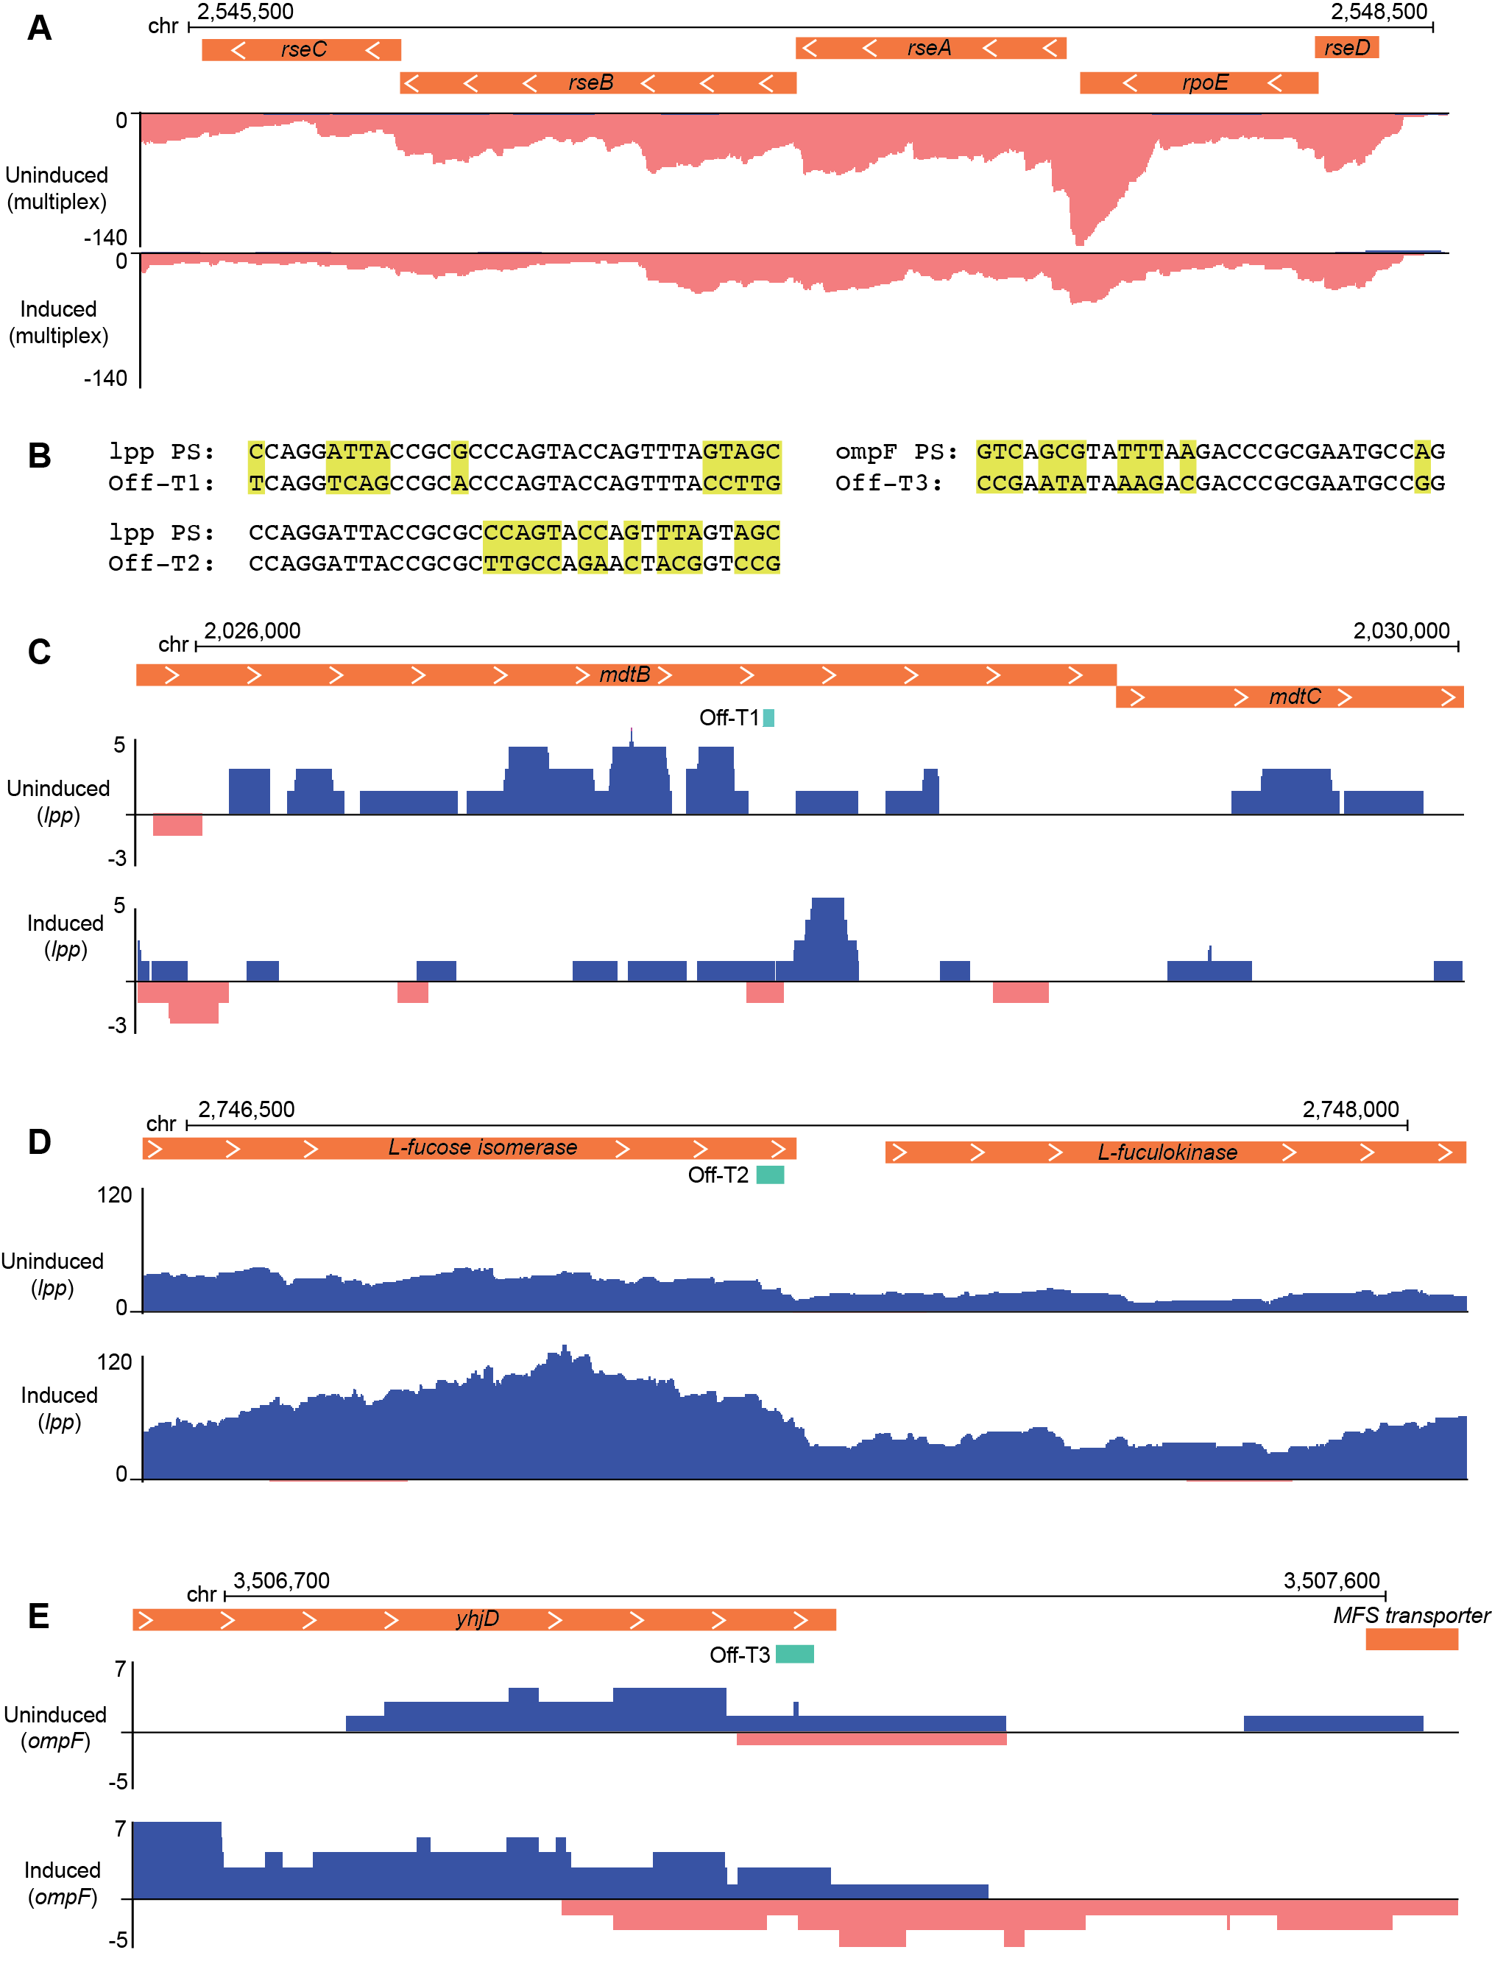

Supplemental Figure S3. RNAseq analysis of potential off-target genes. (A) Genome browser tracks show stranded total RNAseq read density over selected regions of the host (E. coli) chromosome. Reads aligned to the top strand are colored blue; bottom strand, pink. Orange bars indicate ORFs for potential off-target genes. The x-axis indicates cumulative read depth. Inducing type IIIA crRNP expression led to reduced coverage across the operon. (B) Three regions with partial matches to designed crRNA were identified; alignments between the designed spacer and the partial match are shown, mismatches are highlighted in yellow. (C-E) Representative RNAseq tracks are shown for three genes containing partial matches as identified in B. Teal bars show positions of the partial match protospacer for mdtB (C), L-fucose isomerase (D), and yhjD (E).

