Supplementary Materials
Ligands with poly-fluorophenyl moieties promote a local structural rearrangement in the Spinach2 and Broccoli aptamers that increases ligand affinities
Sharif Anisuzzaman, Ivan Geraskin, Muslum Ilgu, Lee Bendickson, George A Kraus and Marit Nilsen-Hamilton

Chemistry
NMR and MS results are shown for the chemicals synthesized for this study. The correct chemical name is given below the molecule. However, to facilitate referencing these compounds in the manuscript some were given letter names to describe the moiety added to DFHBI. As DFHBI has a methyl group on the imidazole nitrogen from which we added extensions, the additional chemical group that were added are identified in a letter format. Thus, although the chemical group attached to the imidazole nitrogen in many of these derivatives is a benzyl group, the first carbon from the imidazole nitrogen is considered part of DFHBI and therefore the addition to DFHBI is a phenyl group. Thus, the letter abbreviations for the series DFHBI, P-DFHBI, MFP-DFHBI, TFP-DFHBI and PFP-DFHBI.
DFHBI (Difluoro Hydroxy Benzylidene Imadazolinone)
(Z)-5-(3,5-difluoro-4-hydroxybenzylidene)-2,3-dimethyl-3,5-dihydro-4H-imidazol-4-one. Yellow solid: 1H NMR (400 MHz, CD₃OD) δ 7.77 (s, 2H), 6.90 (s, 1H), 3.18 (s, 3H), 2.40 (s, 3H); HRMS ESI (m/z): calcd. for C₁₂H₁₁F₂N₂O₂ [M+H]⁺, 253.0744; found 253.0781.

DFHBI-1T:
(Z)-5-(3,5-difluoro-4-hydroxybenzylidene)-2-methyl-3-(2,2,2-trifluoroethyl)-3,5-dihydro-4H-imidazol-4-one. This compound was prepared according to the literature procedure with a few modifications. Modifications: DMF was used instead of ethanol as a solvent. Reaction was run in a sealable tube at 40 ºC. 43% yield. The compound showed spectroscopic data identical to previously reported (1).

MFP-DFHBI (Mono Fluoro Phenyl-DFHBI):
(Z)-5-(3,5-difluoro-4-hydroxybenzylidene)-3-(4-fluorobenzyl)-2-methyl-3,5-dihydro-4H-imidazol-4-one. Yellow solid: 1H NMR (400 MHz, CD₃OD) δ 7.81 (d, J = 9.6 Hz, 2H), 7.28-7.32 (m, 2H), 7.10 (t, J = 8.8 Hz, 2H), 6.98 (s, 1H), 4.85 (s, 2H), 2.30 (s, 3H); HRMS ESI (m/z): calcd. for C₁₈H₁₄F₃N₂O₂ [M+H]⁺, 347.1002; found 347.1008.

MIP-DFHBI (Mono Iodo Phenyl-DFHBI):
(Z)-5-(3,5-difluoro-4-hydroxybenzylidene)-3-(4-iodobenzyl)-2-methyl-3,5-dihydro-4H-imidazol-4-one. Yellow solid: 1H NMR (400 MHz, CD₃OD) δ 7.82 (d, J = 10.0 Hz, 2H), 7.73 (d, J = 8.4 Hz, 2H), 7.06 (d, J = 8.4 Hz, 2H), 6.98 (s, 1H), 4.83 (s, 2H), 2.29 (s, 3H); HRMS ESI (m/z): calcd. for C₁₈H₁₄F₂IN₂O₂ [M+H]⁺, 455.0063; found 455.0074.
P-DFHBI (Phenyl-DFHBI):

(Z)-3-benzyl-5-(3,5-difluoro-4-hydroxybenzylidene)-2-methyl-3,5-dihydro-4H-imidazol-4-one 12. Orange solid. 75% yield. 1H NMR (400 MHz, CD3OD): δ 7.81 (d, J = 9.8 Hz, 2H, ArH), 7.37 (t, J = 7.2 Hz, 2H, ArH), 7.31 (d, J = 7.3 Hz, 1H, ArH), 7.26 (t, J = 7.3 Hz, 2H), 6.99 (s, 1H), 2.28 (s, 3H). HRMS ESI (m/z): calcd. for C18H14F2N2O2 [M + H]+, 329.1096; found 329.1104.

PFP-DFHBI (Penta Fluoro Phenyl-DFHBI):
(Z)-5-(3,5-difluoro-4-hydroxybenzylidene)-2-methyl-3-((perfluorophenyl)methyl)-3,5-dihydro-4H-imidazol-4-one. Yellow solid: 1H NMR (400 MHz, CD₃OD) δ 7.82 (d, J = 9.6 Hz, 2H), 6.89 (s, 1H), 4.98 (s, 2H), 2.42 (s, 3H); HRMS ESI (m/z): calcd. for C₁₈H₁₀F₇N₂O₂ [M+H]⁺, 419.0625; found 419.0633.

PNP-DFHBI (Para Nitro Phenyl-DFHBI):
(Z)-5-(3,5-difluoro-4-hydroxybenzylidene)-2-methyl-3-(4-nitrobenzyl)-3,5-dihydro-4H-imidazol-4-one. Orange solid: 1H NMR (400 MHz, CD₃OD) δ 8.26 (d, J = 8.4 Hz, 2H), 7.82 (d, J = 9.6 Hz, 2H), 7.52 (d, J = 8.4 Hz, 2H), 7.01 (s, 1H), 5.01 (s, 2H), 2.31 (s, 3H); HRMS ESI (m/z): calcd. for C₁₈H₁₄F₂N₃O₄ [M+H]⁺, 374.0947; found 374.0950.
TFP-DFHBI (Tri Fluoro Phenyl-DFHBI):
(Z)-5-(3,5-difluoro-4-hydroxybenzylidene)-2-methyl-3-(2,4,6-trifluorobenzyl)-3,5-dihydro-4H-imidazol-4-one. Yellow solid: 1H NMR (400 MHz, CD₃OD) δ 7.79 (d, J = 9.6 Hz, 2H), 6.90-6.95 (m, 2H), 6.89 (s, 1H), 4.91 (s, 2H), 2.38 (s, 3H); HRMS ESI (m/z): calcd. for C₁₈H₁₂F₅N₂O₂ [M+H]⁺, 383.0813; found 383.0820.

Compound 1:
(Z)-5-(3,5-difluoro-4-hydroxybenzylidene)-3-(4-hydroxybenzyl)-2-methyl-3,5-dihydro-4H-imidazol-4-one. Yellow solid: 1H NMR (400 MHz, CD₃OD) δ 7.81 (d, J = 9.2 Hz, 2H), 7.10 (d, J = 8.4 Hz, 2H), 6.96 (s, 1H), 6.77 (d, J = 8.4 Hz, 2H), 4.75 (s, 2H), 2.29 (s, 3H); HRMS ESI (m/z): calcd. for C₁₈H₁₅F₂N₂O₃ [M+H]⁺, 345.1045; found 345.1045.

Compound 2:
(Z)-3-(4-aminobenzyl)-5-(3,5-difluoro-4-hydroxybenzylidene)-2-methyl-3,5-dihydro-4H-imidazol-4-one. Orange solid: 1H NMR (400 MHz, CD₃OD) δ 7.79 (d, J = 9.6 Hz, 2H), 7.01 (d, J = 8.4 Hz, 2H), 6.95 (s, 1H), 6.70 (d, J = 8.4 Hz, 2H), 4.71 (s, 2H), 2.29 (s, 3H); HRMS ESI (m/z): calcd. for C₁₈H₁₆F₂N₃O₂ [M+H]⁺, 344.1205; found 344.1214.
Compound 3:
(Z)-3-(4-(allyloxy)benzyl)-5-(3,5-difluoro-4-hydroxybenzylidene)-2-methyl-3,5-dihydro-4H-imidazol-4-one. Yellow solid: 1H NMR (400 MHz, CD₃OD) δ 7.75 (d, J = 8.0 Hz, 2H), 7.16 (d, J = 8.4 Hz, 2H), 6.96 (s, 1H), 6.88 (d, J = 8.4 Hz, 2H), 5.99-6.09 (m, 1H), 5.41 (d, J = 17.2 Hz, 1H), 5.29 (d, J = 10.4 Hz, 1H), 4.76 (s, 2H), 4.51 (s, 2H), 2.29 (s, 3H); HRMS ESI (m/z): calcd. for C₂₁H₁₉F₂N₂O₃ [M+H]⁺, 385.1379; found 385.1377.

Compound 4:
(Z)-5-(3,5-difluoro-4-hydroxybenzylidene)-3-(4-hydroxyphenethyl)-2-methyl-3,5-dihydro-4H-imidazol-4-one. Yellow solid: 1H NMR (400 MHz, CD₃OD) δ 7.77 (d, J = 9.6 Hz, 2H), 6.97 (d, J = 8.4 Hz, 2H), 6.90 (s, 1H), 6.72 (d, J = 8.4 Hz, 2H), 3.81 (t, J = 6.8 Hz, 2H), 2.84 (t, J = 6.8 Hz, 2H), 1.96 (s, 3H); HRMS ESI (m/z): calcd. for C₁₉H₁₇F₂N₂O₃ [M+H]⁺, 359.1202; found 359.1210.

Compound 5:
(Z)-5-(3,5-difluoro-4-hydroxybenzylidene)-3-(4-fluorophenethyl)-2-methyl-3,5-dihydro-4H-imidazol-4-one. Yellow solid: 1H NMR (400 MHz, CD₃OD) δ 7.77 (d, J = 10.0 Hz, 2H), 7.17-7.21 (m, 2H), 7.02 (t, J = 8.8 Hz, 2H), 6.89 (s, 1H), 3.85 (t, J = 6.8 Hz, 2H), 2.93 (t, J = 6.8 Hz, 2H), 2.06 (s, 3H).
Compound 6:
(Z)-5-(3,5-difluoro-4-hydroxybenzylidene)-3-(4-iodophenethyl)-2-methyl-3,5-dihydro-4H-imidazol-4-one. Yellow solid: 1H NMR (400 MHz, CD₃OD) δ 7.77 (d, J = 9.6 Hz, 2H), 7.65 (d, J = 8.4 Hz, 2H), 6.99 (d, J = 8.4 Hz, 2H), 6.89 (s, 1H), 3.85 (t, J = 6.8 Hz, 2H), 2.93 (t, J = 6.8 Hz, 2H), 2.08 (s, 3H); HRMS ESI (m/z): calcd. for C₁₉H₁₆F₂IN₂O₂ [M+H]⁺, 469.0219; found 469.0227.

Compound 7:
(Z)-5-(3,5-difluoro-4-hydroxybenzylidene)-3-(2,4-dimethoxybenzyl)-2-methyl-3,5-dihydro-4H-imidazol-4-one. Orange solid: 1H NMR (400 MHz, CD₃OD) δ 7.82 (d, J = 10.4 Hz, 2H), 6.98 (d, J = 8.4 Hz, 1H), 6.94 (s, 1H), 6.55 (d, J = 2.4 Hz, 1H), 6.49 (dd, J = 8.4 Hz, 1H), 4.76 (s, 2H), 3.84 (s, 3H), 3.78 (s, 3H), 2.27 (s, 3H).

Compound 8:
(Z)-5-(3,5-difluoro-4-hydroxybenzylidene)-3-(3-hydroxybenzyl)-2-methyl-3,5-dihydro-4H-imidazol-4-one. Yellow solid: 1H NMR (400 MHz, CD₃OD) δ 7.82 (d, J = 10.0 Hz, 2H), 7.17 (t, J = 8.0 Hz, 1H), 6.98 (s, 1H), 6.72 (d, J = 8.0 Hz, 2H), 6.64 (s, 1H), 4.79 (s, 2H), 2.28 (s, 3H); HRMS ESI (m/z): calcd. for C₁₈H₁₅F₂N₂O₃ [M+H]⁺, 345.1045; found 345.1050.

TABLES

Table S1: Letter abbreviations for DFHBI derivatives
Letter abbreviation | Basis of abbreviation | Chemical Name
DFHBI |  | (Z)-5-(3,5-difluoro-4-hydroxybenzylidene)-2,3-dimethyl-3,5-dihydro-4H-imidazol-4-one
DFHBI-1T |  | (Z)-5-(3,5-difluoro-4-hydroxybenzylidene)-2-methyl-3-(2,2,2-trifluoroethyl)-3,5-dihydro-4H-imidazol-4-one
MFP-DFHBI | monofluorophenyl-DFHBI | (Z)-5-(3,5-difluoro-4-hydroxybenzylidene)-3-(4-fluorobenzyl)-2-methyl-3,5-dihydro-4H-imidazol-4-one
MIP-DFHBI | monoiodorophenyl-DFHBI | (Z)-5-(3,5-difluoro-4-hydroxybenzylidene)-3-(4-iodobenzyl)-2-methyl-3,5-dihydro-4H-imidazol-4-one
P-DFHBI | phenyl-DFHBI | (Z)-3-benzyl-5-(3,5-difluoro-4-hydroxybenzylidene)-2-methyl-3,5-dihydro-4H-imidazol-4-one 12
PFP-DFHBI | pentafluorophenyl-DFHBI | (Z)-5-(3,5-difluoro-4-hydroxybenzylidene)-2-methyl-3-((perfluorophenyl)methyl)-3,5-dihydro-4H-imidazol-4-one
PNP-DFHBI | paranitrophenyl-DFHBI | (Z)-5-(3,5-difluoro-4-hydroxybenzylidene)-2-methyl-3-(4-nitrobenzyl)-3,5-dihydro-4H-imidazol-4-one
TFP-DFHBI | trifluorophenyl-DFHBI | (Z)-5-(3,5-difluoro-4-hydroxybenzylidene)-2-methyl-3-(2,4,6-trifluorobenzyl)-3,5-dihydro-4H-imidazol-4-one

Table S2: Aptamers and buffers
Name | Buffer contents/RNA sequence (5’ → 3’)
Buffer IC Intracellular buffer | 13.5 mM NaCl, 150 mM KCl, 20 mM HEPES, 0.22 mM Na₂HPO₄, 0.44 mM KH₂PO₄, 0.12 mM MgCl₂, 120 nM CaCl₂, 0.1 mM MgSO₄, pH 7.4
Buffer IC+Mg | 13.5 mM NaCl, 150 mM KCl, 20 mM HEPES, 0.22 mM Na₂HPO₄, 0.44 mM KH₂PO₄, 4.9 mM MgCl₂, 120 nM CaCl₂, 0.1 mM MgSO₄, pH 7.4
Buffer SX selection buffer | 20 mM HEPES, 125 mM KCl, 5 mM MgCl₂, pH 7.4
BRC | GAGACGGUCGGGUCCAGAUAUUCGUAUCUGUCGAGUAGAGUGUGGGCUC
SPN2 | GGGAUGUAACUGAAUGAAAUGGUGAAGGACGGGUCCAGUAGGCUGCUUCGGCAGCCUACUUGUUGAG⁶⁷UAGA⁷¹GUGUGAGCUCCGUAACUAGUUACAUC
SPN2 [A71C] | GGGAUGUAACUGAAUGAAAUGGUGAAGGACGGGUCCAGUAGGCUGCUUCGGCAGCCUACUUGUUGAG⁶⁷UAGC⁷¹GUGUGAGCUCCGUAACUA‌GUUACAUC
SPN2 [A71G] | GGGAUGUAACUGAAUGAAAUGGUGAAGGACGGGUCCAGUAGGCUGCUUCGGCAGCCUACUUGUUGAG⁶⁷UAGG⁷¹GUGUGAGCUCCGUAACUA‌GUUACAUC
SPN2 [A71U] | GGGAUGUAACUGAAUGAAAUGGUGAAGGACGGGUCCAGUAGGCUGCUUCGGCAGCCUACUUGUUGAG⁶⁷UAGU⁷¹GUGUGAGCUCCGUAACU‌A‌GUUACAUC
Split aptamers were constituted of the first sequence (spSPN2 complement) and one of the remaining sequences:
spSPN2 complement | GACGCGACCGAAUGAAAUGGUGAAGGACGGGUCCAGCCGGCUGCCCC
spSPN2 | GCAGCCGGCUUGUUGAGUAGAGUGUGAGCUCCGUAACUGGUCGCGUCCCC
spSPN2 [2AP21] | GCAGCCGGCUUGUUGAGUAG2AP⁷¹GUGUGAGCUCCGUAACUGGUCGCGUC
spSPN2 [dG17] | GCAGCCGGCUUGUUGAdG⁶⁷UAGAGUGUGAGCUCCGUAACUGGUCGCGUC
spSPN2 [Apu21] | GCAGCCGGCUUGUUGAGUAGapu⁷¹GUGUGAGCUCCGUAACUGGUCGCGUC
Tandem-SPN2 (tSPN2) | GGGAUGUAACUGAAUGAAAUGGUGAAGGACGGGUCCAGUAGGCGCUGAAUGAAAUGGUGAAGGACGGGUCCAGUAGGCUGCUUCGGCAGCCUACUUGUUGAGUAGAGUGUGAGCUCCGUAACUAGCGCCUACUUGUUGAGUAGAGUGUGAGCUCCGUAACUAGUUACAUC

Legend: For buffers all pH values were measured at 25°C. For aptamers the primed number after a base identifies the position number in SPN2. 2AP: 2-aminopurine; apu: apurinic.

Table S3: Dissociation constants
Ligand | K_{d} (µM, Buffer SX) | K_{d} (µM, Buffer IC) | Predicted planar?
DFHBI | 2.0 ± 0.06 (4) | 7.1 ± 1.1 (6) | Y
MFP-DFHBI | 0.78 ± 0.50 (3) | 2.2 ± 0.58 (3) | N
MIP-DFHBI | 0.81 ± 0.44 (3) | 1.6 ± 0.49 (3) | N
P-DFHBI | 1.0 ± 0.49 (3) | 1.5 (1) | N
PFP-DFHBI | 0.24 ± 0.042 (8) | 0.26 ± 0.018 (4) | N
PNP-DFHBI | 1.2 (1) | ND | Y
TFP-DFHBI | 0.30 ± 0.08 (4) | 0.53 ± 0.052 (3) | N
Compound 1 | 0.38 ± 0.0071 (2) | ND | N
Compound 2 | 0.19 ± 0.045 (4) | 0.71 (1) | N
Compound 3 | 0.37 ± 0.11 (5) | ND | N
Compound 4 | 1.4 ± 0.050 (2) | ND | Y
Compound 5 | 3.3 (1) | ND | Y
Compound 8 | 0.37 ± 0.015 (2) | ND | N

Legend: Dissociation constants (K_{d}) were determined as described in Materials and Methods by tracking fluorescence as a function of ligand concentrations. This is the same data as shown in Figure 2 where it is represented as its inverse, K_{a}. Values are shown ± SEM and the number of independent estimates is shown in parentheses for each value. The preferred configuration of the ligand regarding planarity is shown in the fourth column as determined by ChemBio® 3D Ultra 12 Suite. ND, not determined.

Table S4. Fluorescence changes with incubation in the presence and absence of SPN2
 | Fluorescence (3h)/ Fluorescence (10 min)
 | No aptamer |  | With SPN2
compound | average | SEM | average | SEM | N
DFHBI | 0.99 | 0.019 | 1.22 | 0.015 | 2
DHBI-1T | 0.96 | 0.030 | 1.07 | 0.012 | 2
P-DFHBI | 0.98 | 0.018 | 1.45 | 0.111 | 2
MFP-DFHBI | 1.02 | 0.051 | 1.09 | 0.052 | 1
MIP-DHBI | 1.02 | 0.022 | 1.35 | 0.084 | 2
TFP-DFHBI | 1.02 | 0.033 | 1.15 | 0.020 | 2
PFP-DFHBI | 1.02 | 0.022 | 1.22 | 0.015 | 3
Compound 2 | 0.94 | 0.043 | 1.33 | 0.096 | 2
Compound 4 | 0.93 | 0.026 | 1.29 | 0.069 | 2

Legend: The average fluorescence at 3 h* for each concentration of compound over the number of experiments identified was divided by the equivalent value measured at 10 min. The resulting ratio, SEM and N is shown for each compound. The concentrations sampled for the compounds in the absence of aptamer were: 0.05, 0.1, 0.2, 0.5, 1, 2, 5, 10, 20, 50 μM. Because of the effect of the affinity change on the fluorescence at concentrations below aptamer saturation, only concentrations of compounds at saturation and above were sampled 50 nM SPN2. These concentrations were: 5, 10, 20, 50 μM. *In a few experiments the long incubation time was 4h instead of 3h.

Table S5. Spectral properties of DFHBI and PFP-DFHBI
Aptamer | Compound | Excitation/ emission maximum | extinction coefficient  (M–1 /cm) | Quantum yield | Brightness | K_{d} (nM) | Reference
Spinach | DFHBI | 469/501 | 24271 | 0.72 | 1.00 | 562 | (2)
SPN2 | DFHBI | 447/501 | 22,000 | 0.72 | 0.91 | 530 | (1)
SPN2 | DFHBI | 445/501 | NR | NR |  | 1450 | (3)
iSpinach | DFHBI | 442/503 | NR | NR |  | 920 | (3)
tSPN2 | DFHBI | 442/503 | 31000 | 0.71 | 1.26 | 2000 | this work
tSPN2 | PFP-DFHBI | 467/503 | 36000 | 0.82 ± 0.035 (2) | 1.68 ± 0.072 (2) | 240 | this work
tSPN2 | PFP-DFHBI | 445/502 | 36000 | 0.85 |  | 240 | this work
BRC | DFHBI-IT | 470/505 | 28900 | 0.41 | 0.68 |  | (4)
BRC | BI | 470/505 | 33600 | 0.67 | 1.29 |  | (4)
BRC | TBI | 485/527 | 35100 | 0.64 | 1.29 |  | (4)
Legend: The spectral properties of DFHBI and PFP-DFHBI determined from our studies (this work) are compared with those from the literature. The photophysics of DFHBI and PFP-DFHBI in the absence of aptamer were examined in detail by us previously and both were found to have similar photoisomerization characteristics and pH dependence of fluorescence (5). The quantum yield in this work was determined from a single estimate for DFHBI and from two independent estimates with different preparations of RNA for PFP-DFHBI. The average ± SEM (N) are shown. NR, not reported.

Table S6. Fitting parameters for binding curves
aptamer | buffer | n |  | R² |  | N
aptamer | buffer | average | SEM | average | SEM | N
DFHBI | SX | 0.90 | 0.018 | 1.00 | 0.00026 | 28
PFP-DFHBI | SX | 1.2 | 0.023 | 0.93 | 0.027 | 53
DFHBI | IC | 0.99 | 0.031 | 0.97 | 0.025 | 40
PFP-DFHBI | IC | 1.1 | 0.023 | 0.99 | 0.00049 | 15
Legend: Binding curves were fit using the formula F = F_{min}+(F_{max}*L^{n})/( L^{n}+ K_{d}^{n}) (6) as discussed in Materials and Methods of the manuscript. The Hill n values for all binding curves were averaged for each condition. Similarly, the R² values for the fits are shown as an average with the SEM. The total number of fits for each condition is listed (N).

Table S7. Comparison of reported affinities
Aptamer | Compound | Buffer | Kd (µM) | STD | N | Incubation time | Assay type | Temperature (°c) | Reference
BRC | DFHBI-1T | SB | 0.36 | NR | 3 | NR | Fl | NR | (7)
BRC | DFHBI-1T | SB | 0.31 | 0.039 | NR | NR | Fl | 25 | (8)
BRC | DFHBI | SB | NR | NR | NR | NR | NR | NR | NR
BRC | DFHBI | SB | 1.3 | 0.88 | 2 | 10 min | Fl | 23-24 | this work
BRC | DFHBI | SB | 1.6 | 1.2 | 2 | 10 min | Fl | 37 | this work
BRC | DFHBI | SB | 1.3 | 0.34 | 2 | 3 h | Fl | 23-24 | this work
BRC | PFP-DFHBI | SB | 0.17 | 0.06 | 6 | 10 min | Fl | 23-24 | this work
BRC | PFP-DFHBI | SB | 0.19 | 0.11 | 3 | 10 min | Fl | 37 | this work
BRC | PFP-DFHBI | SB | 0.054 | 0.013 | 3 | 3 h | Fl | 23-24 | this work
Spinach | DFHBI | SX | 0.56 | NR | NR | NR | NR | NR | (9)
SPN2 | DFHBI | SX | 0.53 | NR | NR | NR | NR | NR | (1)
SPN2 | DFHBI | SX | 2.2 | 0.96 | 7 | 10 min | Fl | 23-24 | this work
SPN2 | DFHBI* | SX | 1.3 | 0.071 | 2 | 10min | FI | 23-24 | this work
SPN2 | DFHBI | SB | 1.45 | 0.2 | 3 | NR | Fl | 25 | (10)
SPN2 | DFHBI | SX | 3.0 | 0.36 | 2 | 3 h | Fl | 23-24 | this work
SPN2 | PFP-DFHBI | SX | 0.35 | 0.35 | 9 | 10 min | Fl | 23-24 | this work
SPN2 | PFP-DFHBI | SX | 0.14 | 0.047 | 5 | 3 h | Fl | 23-24 | this work
SPN2 | DFHBI-1T | SX | 0.56 | NR | NR | NR | NR | NR | (1)
SPN2 | DFHBI-1T | SX | 2.2 | 0.21 | 2 | 10 min | Fl | 23-24 | this work
SPN2 | DFHBI-1T | SX | 1.8 | 0.034 | 2 | 3 h | Fl | 23-24 | this work
SPN2 | DFHBI-2T | SX | 1.30 | NR | NR | NR | Fl | NR | (1)
iSpinach | DFHBI | SB | 0.92 | 0.1 | 3 | NR | Fl | 25 | (10)

Legend: Reported K_{d}s and standard deviations of the estimate (when available) are compared with the values reported here. BRC and SPN2, sequences shown in Table S2, Spinach and Broccoli, versions of these aptamers that are not identical to the sequences of SPN2 and BRC respectively. N, number of independent estimates. NR, not reported

FIGURES

Figure S1. Effect of Incubation on UV-Vis and mass spectrum of PFP-DFHBI

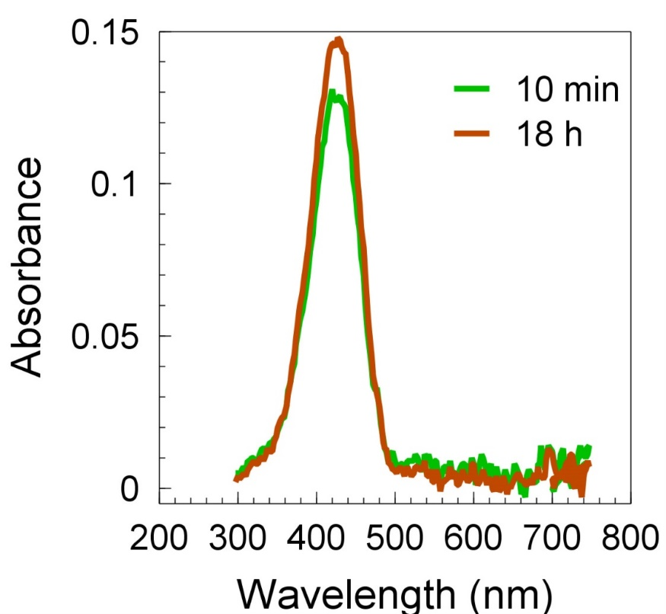

Legend: The UV-Vis absorbance spectra for 10 min and 18 h incubations are shown. PFP-DFHBI (3 mM) in SX buffer, 5% DMSO was incubated 1) for 10 min and then exposed to 485 nm for 30 sec or 2) over a period of 18 h with 30 sec exposures to 485 nm at 10, 12,15, 20, 25, 30, 36, 40, 45, 50, 55, 60 min and 18 h. This protocol was the same as used for determining the effect of incubation time on K_{a}. The samples were then diluted to 2.5% DMSO in SX buffer. UV-Vis spectra of 24 μM PFP-DFHBI were determined using a 0.1 cm path length. High resolution mass spectrometry was applied to 240 μM PFP-DFHBI ionized by ESI. In both spectra the expected ionized peaks were found, including peaks at 417.0460 (calc’d 417.0479) (m/z) C₁₈H₁₀F₇N₂O₂ [M-H] or 462.9504 (calc’d 463.053) C₁₉H₁₀F₇N₂O₄ [M+CO₂H]+ (m/z).

Figure S2. Apposition of A69 and G65 in the Spinach aptamer crystal structure

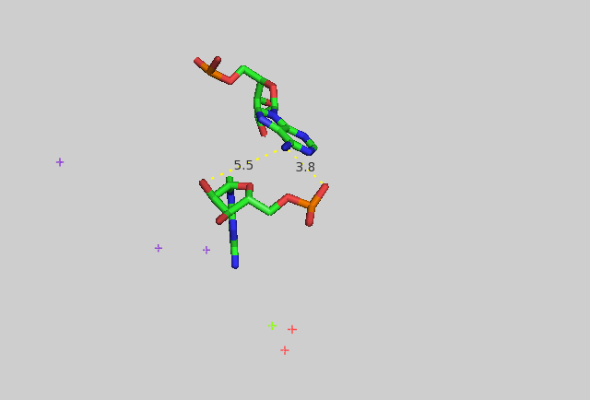
Legend: Distances between atoms in A71 and G67 in the Spinach aptamer crystal structure from reference (11) In the crystal structure the relevant positions are A69 and G65 because the SPN2 used in this study includes the two additional Gs added at the 5’ end by T7 polymerase when it initiates transcription from its promoter during in vitro transcription.

Figure S3. Sample titrations, examples of the primary data

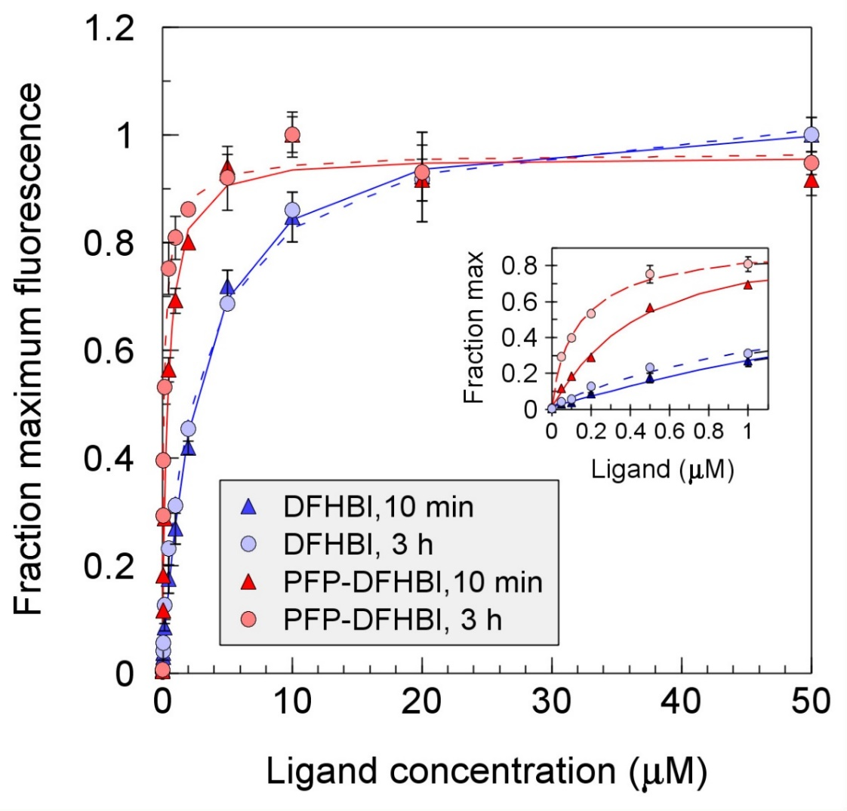

Legend: Titrations of SPN2 with DFHBI or PFP-DFHBI after 10 min and 3 h are shown. Titrations were all taken out to 50 μM ligand concentration even though in some cases (such as with PFP-DFHBI) this concentration is well beyond saturation. The inset shows the first 10 μM range of the titrations. For each experiment the fluorescence output was normalized to the maximum value. For these experiments, the fluorescence maxima (after subtracting the background) were 1376 (DFHBI, 10 min), 1717 (DFHBI, 3 h), 4410 (PFP-DFHBI, 10 min) and 5247 (PFP-DFHBI, 3 h). All values were determined in duplicate and the error bars are shown as standard deviations. The standard deviation calculation was calculated as the square root of the sum of the squares of the errors in the background (ligand alone) and the aptamer plus ligand condition, thereby including the error in the background as well as the ligand/aptamer titration. Where error bars are not visible, they are smaller than the size of the symbol.

Figure S4. Characteristics of PNP-DFHBI
Legend: A) The UV-Vis absorbance spectra of PNP-DFHBI was compared with that of DFHBI and compounds 3 and 4, all at 10 µM. B) The fluorescence spectra of 10 µM PNP-DFHBI with and without 1 µM SPN2 and 10 µM DFHBI or 10 µM PFP-DFHBI with 1 µM SPN2. C) Displacement of DFHBI or PFP-DFHBI by PNP-DFHBI. The conditions were 0.5 µM DFHBI or PFP-DFHBI and 0.5 µM SPN2. D) The effect of the position of the nitrogen group on the phenyl addition to DFHBI and the effect of moving the group one carbon from the imidazolinone nitrogen is shown by this series of compounds, which were each at 10 µM incubated with or without 0.5 µM SPN2. The only structure for which no fluorescence is observed in the presence of SPN2 is PNP-DFHBI. All reactions were in buffer SX with 5% DMSO.

Figure S5. K_{a} for DFHBI and PFP-DFHBI of BRC at 37°C after 10 min and 3 hours incubation time.

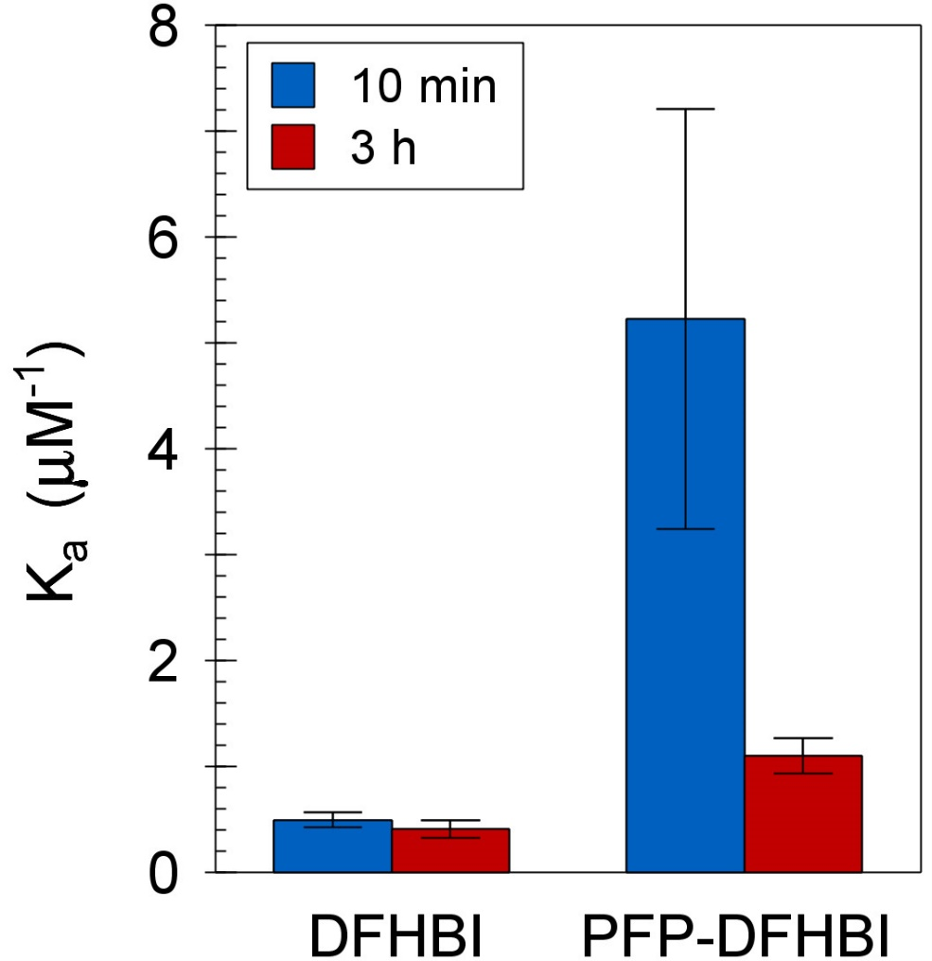

Legend: BRC was incubated for 10 min or 3 hours with DFHBI or PFP-DFHBI at 0, 0.05, 0.1, 0.2, 0.5, 1, 2, 5, 10, 20 and 50 µM in buffer SX with 5% DMSO. The K_{a} ± SEM are shown (N=2).

References:
1. Song, W., Strack, R.L., Svensen, N. and Jaffrey, S.R. (2014) Plug-and-Play Fluorophores Extend the Spectral Properties of Spinach. Journal of the American Chemical Society, 136, 1198-1201.
2. Paige, J.S., Wu, K.Y. and Jaffrey, S.R. (2011) RNA Mimics of Green Fluorescent Protein. Science, 333, 642-646.
3. Autour, A., Westhof, E. and Ryckelynck, M. (2016) iSpinach: a fluorogenic RNA aptamer optimized for in vitro applications. Nucleic Acids Research, 44, 2491-2500.
4. Li, X., Wu, J. and Jaffrey, S.R. (2021) Engineering Fluorophore Recycling in a Fluorogenic RNA Aptamer. Angewandte Chemie International Edition, 60, 24153-24161.
5. Santra, K., Geraskin, I.M., Nilsen-Hamilton, M., Kraus, G.A. and Petrich, J.W. (2019) Characterization of the Photophysical Behavior of DFHBI Derivatives: Fluorogenic Molecules that Illuminate the Spinach RNA Aptamer. The Journal of Physical Chemistry B, 123, 2536-2545.
6. Huang, H., Suslov, N.B., Li, N.-S., Shelke, S.A., Evans, M.E., Koldobskaya, Y., Rice, P.A. and Piccirilli, J.A. (2014) A G-quadruplex-containing RNA activates fluorescence in a GFP-like fluorophore. Nat Chem Biol, 10, 686-691.
7. Filonov, G.S., Moon, J.D., Svensen, N. and Jaffrey, S.R. (2014) Broccoli: rapid selection of an RNA mimic of green fluorescent protein by fluorescence-based selection and directed evolution. J Am Chem Soc, 136, 16299-16308.
8. Li, X., Kim, H., Litke, J.L., Wu, J. and Jaffrey, S.R. (2020) Fluorophore-Promoted RNA Folding and Photostability Enables Imaging of Single Broccoli-Tagged mRNAs in Live Mammalian Cells. Angew Chem Int Ed Engl, 59, 4511-4518.
9. Paige, J.S., Nguyen-Duc, T., Song, W. and Jaffrey, S.R. (2012) Fluorescence imaging of cellular metabolites with RNA. Science, 335, 1194.
10. Autour, A., C Y Jeng, S., D Cawte, A., Abdolahzadeh, A., Galli, A., Panchapakesan, S.S.S., Rueda, D., Ryckelynck, M. and Unrau, P.J. (2018) Fluorogenic RNA Mango aptamers for imaging small non-coding RNAs in mammalian cells. Nat Commun, 9, 656.
11. Warner, K.D., Chen, M.C., Song, W., Strack, R.L., Thorn, A., Jaffrey, S.R. and Ferré-D'Amaré, A.R. (2014) Structural basis for activity of highly efficient RNA mimics of green fluorescent protein. Nat Struct Mol Biol, 21, 658-663.

