Supporting Information

Plasticity and conditional essentiality of modification enzymes
for domain V of Escherichia coli 23S ribosomal RNA

Josefine Liljeruhmª, Margus Leppik^{b}, Letian Baoª, Triin Truu^{b}, Maria Calvo-Noriegaª, Nicola S. Freyerª, Aivar Liiv^{b}, Jinfan Wangª, Rubén Crespo Blancoª, Rya Ero^{b}, Jaanus Remme^{b,1} and Anthony C. Forster^{a,1}

ªDepartment of Cell and Molecular Biology, Uppsala University, Husargatan 3, Box 596, Uppsala 75124, Sweden;

^{b}Department of Molecular Biology, University of Tartu, 51010 Tartu, Estonia.

¹To whom correspondence may be addressed. E-mail: jaanus.remme@ut.ee or a.forster@icm.uu.se

Contents

Fig. S1. PCR analysis of ΔrluC/ΔrlmE.

Fig. S2. HPLC analysis of nucleosides from ΔrluC/ΔrlmE, ΔCKLNMuE and WT 50S subunits.

Fig. S3. Additional controls for ΔrluC/ΔrlmE growth assays in Fig. 2A-E.

Fig. S4. Ribosome sucrose gradients for ΔrluC/ΔrlmE and associated controls.

Fig. S5. HPLC analysis of peptidyl transferase "fragment reactions" with ΔCKLNMuE and WT 50S subunits.

Fig. S6. Translational frameshifting in vivo of ΔCKLNMuE and WT at 20ºC.

Tables S1 and S2. Source data for frameshifting Figs. 4 and S6 (in separate xlsx file).

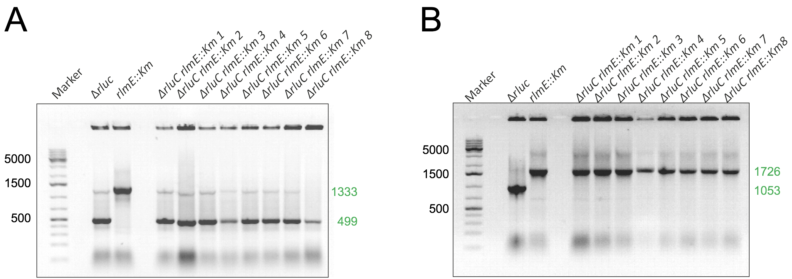

Fig. S1. PCR analysis of ΔrluC/ΔrlmE strains. PCRs of eight ΔrluC/ΔrlmE colonies with primer pairs that would amplify the gene rluC (A) or rlmE (B). The sizes of the darkest marker bands are indicated (GeneRuler 1 kb plus DNA ladder, ThermoFisher Scientific). All colonies 1-8 analysed here (right lanes) gave bands at the expected sizes (indicated in green). (A) Amplification from rluC would give 1333 bp whereas its deletion and subsequent removal of the kanamycin cassette would yield 499 bp. (B) Amplification from rlmE would give 1053 bp whereas the kanamycin cassette replacing the gene would yield 1726 bp.

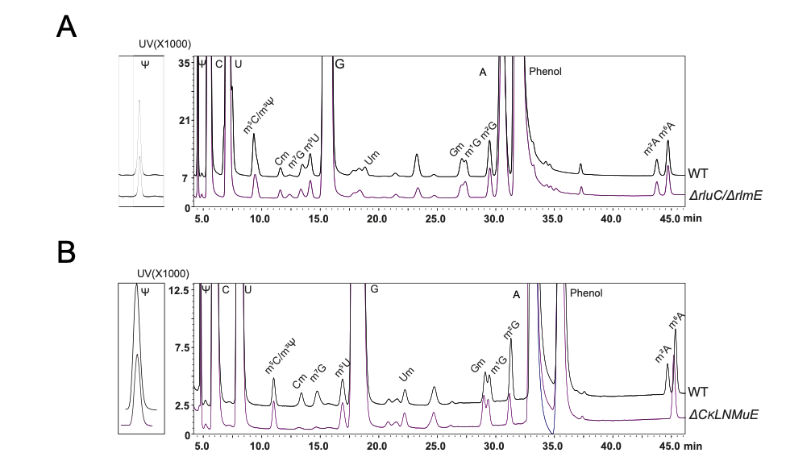

Fig. S2. HPLC analysis of nucleosides from ΔrluC/ΔrlmE, ΔCKLNMuE and WT 50S subunits. 50S ribosomal subunits were purified from mature 70S ribosomes, 23S and 5S rRNAs were extracted, the rRNAs were digested with nuclease P1, and the digests were treated with alkaline phosphatase. Products were separated by HPLC and identified based on mobilities (see Materials and Methods). Representative comparisons with WT are shown for ΔrluC/ΔrlmE (A), and ΔCKLNMuE (B). Quantifications of HPLC peak areas are included in Fig. 1B.

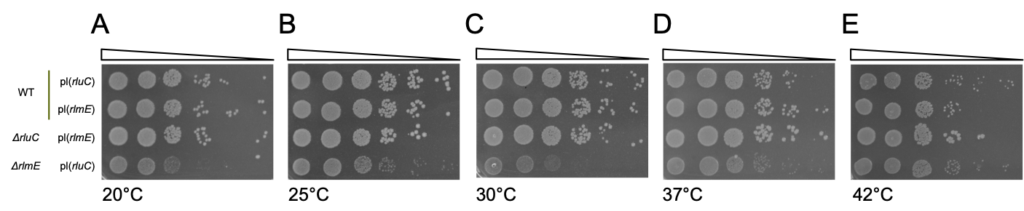

Fig. S3. Additional controls for ΔrluC/ΔrlmE growth assays in Fig. 2A-E. Spot growth assays on chloramphenicol agar plates using the “rescue” plasmids (pl) indicated with progressive dilutions of cells (see Materials and Methods). This shows a lack of phenotype due to the rescue plasmids per se.

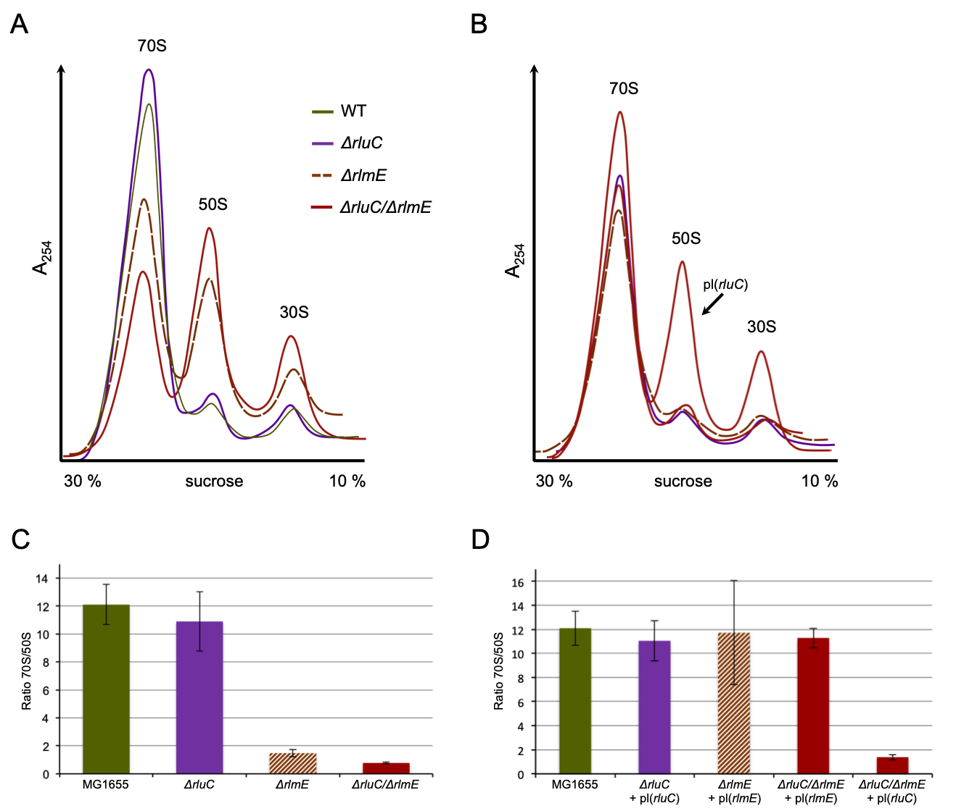

Fig. S4. Ribosome sucrose gradients for ΔrluC/ΔrlmE and associated controls. Ribosome sucrose gradients of all (A) unrescued and (B) plasmid-rescued strains exactly as indicated in Fig. 2F performed under the same conditions. Some of the gradients from Fig. 2H and I are shown again for comparison. Sedimentation is from right to left. (C) and (D) are plots of the ratios of the 70S/50S peak areas with standard errors from at least two biological replicates of the respective gradients shown above.

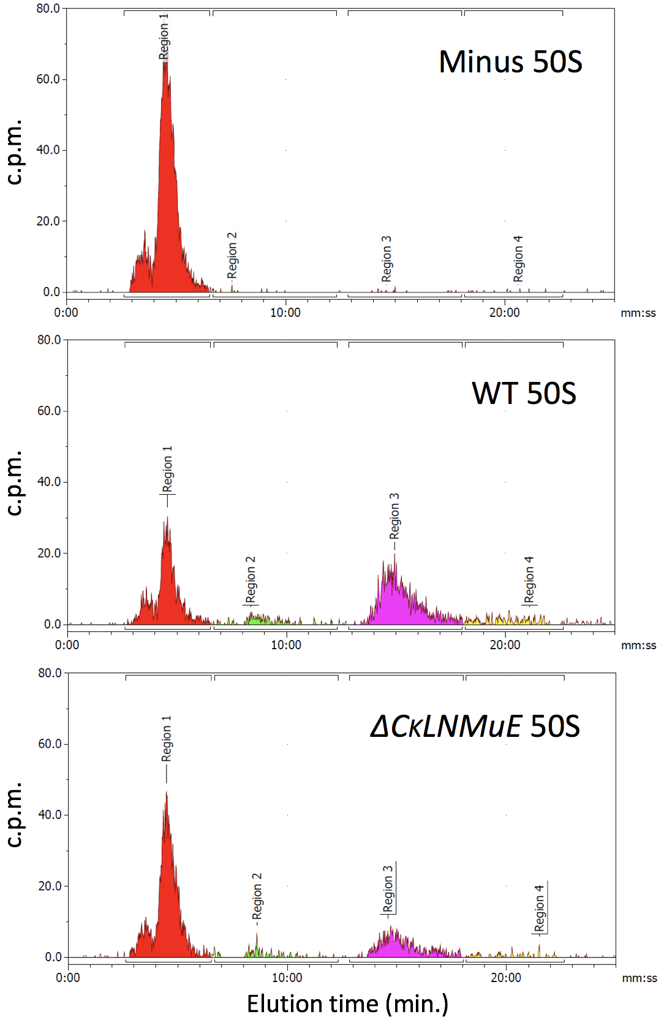

Fig. S5. HPLC analysis of peptidyl transferase "fragment reactions" with ΔCKLNMuE and WT 50S subunits. The major (right) red peak corresponds to f[³H]Met while the purple peak corresponds to f[³H]Met-puromycin product (see Materials and Methods).

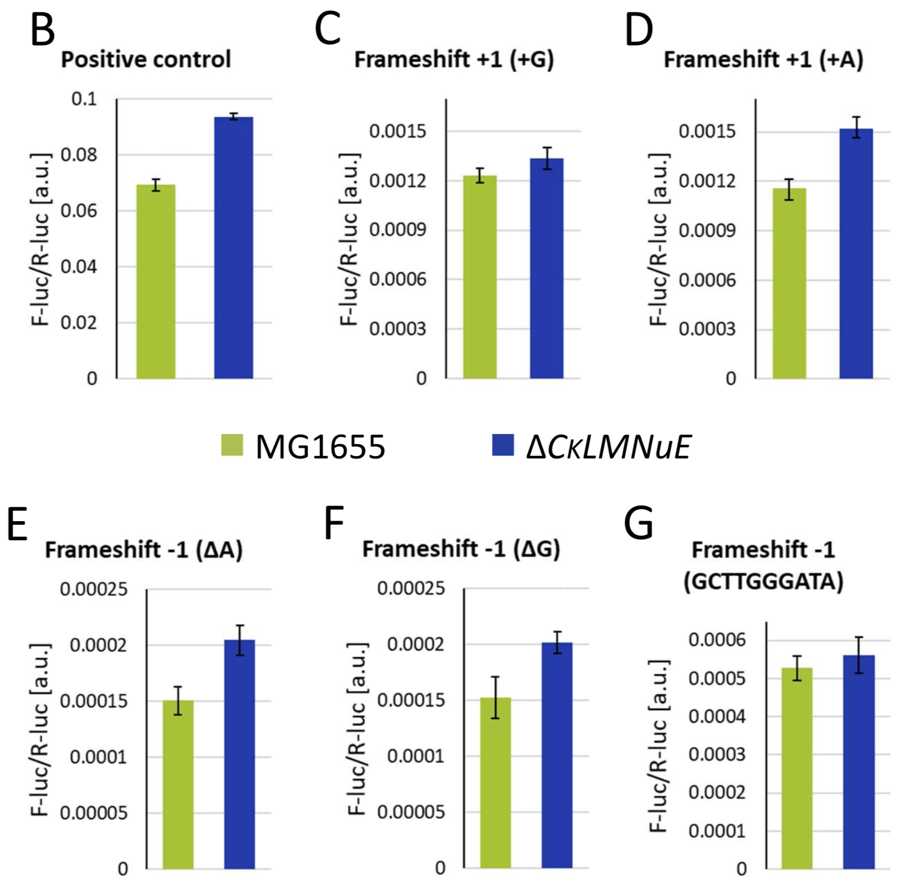

Fig. S6. Translational frameshifting in vivo of ΔCKLNMuE and WT at 20ºC. B-G (there is no A) correspond to plasmids used in Fig. 4B-G and assays were performed identically (see Materials and Methods) except that growth was at 20ºC and induction was for 7 h. P < 0.05 for B, D, E and F.
----

