Supplementary material

Correlated sequence signatures are present within the genomic 5’UTR RNA and NSP1 protein in coronaviruses

Piotr SOSNOWSKI, Antonin TIDU, Gilbert ERIANI, Eric WESTHOF*, Franck MARTIN*

Université de Strasbourg, Institut de Biologie Moléculaire et Cellulaire, Architecture et Réactivité de l’ARN, CNRS UPR9002, 2, allée Konrad Roentgen, F-67084 Strasbourg (France)

*Corresponding authors
Email for correspondence:
f.martin@ibmc-cnrs.unistra.fr
e.westhof@ibmc-cnrs.unistra.fr

Running title: SL1 and NSP1 in SARS-CoV-2 viral translation

Keywords: SARS-CoV-2, NSP1, SL1, 5’UTR, translation, ribosome

Detailed descriptions of variants

Type I SL1 and NSP1 variants

In some bat sequences, the type I SL1 hairpin presents very minor variations (Figure 2), except importantly for a change in the TRS sequence in the SL3 hairpin to UUUAAAC from UCUAAAC (Figure S1). Although the number of mutations in the 5’UTR is small (Figure S1), the corresponding NSP1 variants display between 9 and 13 mutations compared to the other type I sequences (Figures S6). These variants have been observed only in bats up to now. At this stage, with the available sequences, it is not statistically relevant to attempt to correlate the types I depending on the bat species or the sample geographic location.

Type II SL1 and NSP1 variants

The type II variants are interesting (Figure 4 for SL1 and Figure S7 for NSP1). For the sequences isolated from human, the 5’UTR has one mutation but none in the NSP1 protein. However, the Guangdong Pangolin (Liu et al. 2020) and the R. shameli (Hul et al. 2021), also with a single mutation in the 5’UTR, present between six and seven NSP1 mutations with type III NSP1 (Figure S7). Thus, the pangolin sequence from Guangdong (EPI_ISL_410721) (Liu et al. 2019), which has a type II SL1, presents NSP1 sequence with variations departing strongly from the consensus NSP1 of type II. Interestingly, its NSP1 sequence is identical to that of MT121216 (or MP789) but for which, unfortunately, the 5’UTR is lacking (Liu et al. 2020) (Figure S12). In two sequences (BtKY72 and BM38-41), variations in NSP1 amount to 30 and 29 changes respectively, and several fall in identical new positions (Figure S12). For the Bt_KY72, a sequence from a bat captured in Kenya (Tao and Tong 2019), the 5’UTR belongs to type II. Unfortunately, the corresponding 5’UTR sequence for BM38-41, from a bat captured in Bulgaria (Drexler et al. 2010), is not available; by homology, one could suggest that it belongs to such a type II variant. The bat sequences RmYN02 and RpYN06 have two mutations in the 5’UTR and the NSP1 protein, which amounts to slightly less than for RaTG13. Interestingly, the sequences RmYN08 and RsYN04 (Zhou et al. 2021), although they have only about five mutations in the 5’UTR, present more than 22 changes in their NSP1 proteins.

Further SL1 and NSP1 variants

Two unusual types of 5’UTR segments were noticed in the available sequences. The type IV variants (Figure S2 for the 5’UTR and Figure S12 for the corresponding NSP1) occur in sequences isolated only from pangolins (Lam et al. 2020) and the type V from either infected bats or humans (Figure S12). The type IV sequences are close to type II with the apical UCCC apical loop of SL1 surrounded by A residues. The consensus secondary structure is shown on Figure S2. The NSPS1 sequences are all very similar and they contain signatures attached to both types I and III with up to 16 point mutations compared to type III. These NSP1 sequences differ from those already observed in pangolins (Figures S6 and S12).

The sequences observed in type V are surprising. They have been observed in infected humans as well as in bats. For those from humans, the NSP1 sequences are those normally attached to type III; while those from bats derive from type II (Figure S13). The bat sequences come from a single bat isolate (RacCS203) (Wacharapluesadee et al. 2021). The 5’UTR sequences are unusual because they fold as a long hairpin with a GGGA apical loop, which is the reverse complement of the usual UCCC tetraloop at the top of SL1. The reverse complementarity can be extended (in cyan in Figure S13), leading to the formation of a very long hairpin. Other sequences also show the complementarity, but they are shorter. In two human sequences the complementarity occurs only in the flanking regions. If such sequences do not reflect errors in sequence processing, they would indicate errors in the viral replication machinery. In any case, genomes with such 5’UTR sequences should be unable to be translated or replicated.

Comments about variants

Up to now, the 5’UTR type I sequences could be derived from infected civets, bats, or humans; type II mainly from bats (with five cases from humans, two cases from pangolins collected in Guangdong (Liu et al. 2019; Lam et al. 2020; Liu et al. 2020)); with type III sequences coming only from infected humans. The types I and III are, respectively, linked to SARS-CoV-1 and SARS-CoV-2, and the intermediate type II gathers sequences like RmYN02 (Zhou et al. 2020), RaTG13 (Zhou et al. 2021), ZXC21 (Hu et al. 2018), ZX45 (Hu et al. 2018), Rc-0319 (Murakami et al. 2020), with BM48-31 (Drexler et al. 2010) and BtKY72 (Tao and Tong 2019) well separated. The first sequences have been suggested as being the closest to the SARS-CoV-2 sequences.

Concerning the NSP1 protein, two and three mutations separate, respectively, the RmYN02 and RaTG13 sequences from the type III NSP1 sequence. The recently identified PrC31 sequence from bats in Yunnan province (Li et al. 2021) has four mutations with the common type II sequence. The other bat sequences have more than six mutations in NSP1 with 30 and 29 mutations for BtKY72 and BM38-41, respectively. Interestingly, the Guandong pangolins have 6 mutations in NSP1. In contrast, the Guanxi pangolins, linked with type IV 5’UTR, have 15 mutations in their NSP1 sequences compared to type III (and 26 against type I sequences). A very recent publication (Zhou et al. 2021) reported retrospective genome data on four new bat genomes related to SARS-CoV-2 viruses. One of them, RpYN06, is a variant of type II (with two point-mutations from the type II sequence) with a NSP1 sequence that is separated by two mutations from SARS-CoV-2 type III NSP1. The two mutations occur at the same locations than those in RmYN02 discussed above. The other three sequences (RsYN04, RmYN05, RmYN08) present a hitherto unknown type II 5’UTR with NSP1 sequences departing by many mutations from type II NSP1 sequences. Those numbers of mutations between sequences are summarized in Table S1.

Supplementary Figure and Table legends

Figure S1: Selected sets of aligned variant sequences of the first 80 nucleotides of SARS-CoV-1 (type I) and SARS-CoV-2 (type III) genomes. Same annotations as in Figure 1. The nucleotides in bold vary.

Figure S2: Selected sets of aligned sequences of the first 80 nucleotides of SARS-CoV-2 (type IV) genomes isolated from Guangxi pangolins (Wacharapluesadee et al. 2021) compared to the standard Type III. Same annotations as in Figure 1. The consensus secondary structure of the Type IV SL1 hairpin is shown below. See Figure S10 for the NSP1 sequences.

Figure S3: Consensus sequences and secondary structures of SL1 for Types I to IV of the first 80 nucleotides of SARS beta coronaviruses. The Type IV sequences are 9 mutations away from Type III sequences (SARS-CoV-2) and the Type III sequences are 8 mutations away from Type I sequences (SARS-CoV-1). Please note that the secondary structure for Type II sequences refer to those derived from bats; for sequences derived from infected humans the SL1 hairpin is identical to that of Type III sequences (see main text and Figure 4 for details).

Figure S4: CLUSTAL-W alignment of the NSP1 protein sequences of various betacorona viruses. The 16 aligned identical residues are highlighted in cyan. The important residues Y/F157 and R/K175 are indicated by #. The residues highlighted in red are in contact with ribosomal elements (Schubert et al. 2020; Thoms et al. 2020).

Figure S5: Two Pymol views of the binding of NSP1 observed in cryo-EM maps. Left: Detailed view of the NSP1 binding to the small subunit with in green, ribosomal proteins and orange, ribosomal RNA both as backbones surrounding the entry site. The NSP1 sequence between E148 and G180 is shown in red and in cyan are shown residues 160NWNT, Y154, 157FQE, S166, T170, and M174. Data are from (Thoms et al. 2020). Right: View of the small subunit with h44 in cyan and the NSP1 sequence between E148 and G180 is shown in red. Data are from (Schubert et al. 2020).

Figure S6: Examples of sequences that are variants of Type I 5’UTR (SARS-CoV-1). The residues characteristic of Type I are shown in cyan and mutations observed are shown in red. The number of point mutations is indicated.

Figure S7: Examples of sequences that are variants of Type II 5’UTR (SARS-CoV-1). The residues characteristic of Type II are shown in green and of Type III in white on blue background, and mutations observed are shown in red. The number of point mutations is indicated. The last three bat sequences deviate by more than 22 mutations.

Figure S8: (A) Translation inhibition mediated by SARS-CoV-1 and SARS-CoV-2 NSP1 using a reporter mRNAs containing the β-globin 5’UTR upstream of the Renilla coding sequence in RRL. (B) Viral evasion measured by translation of reporter mRNA containing the β-globin 5’UTR or the SARS-CoV-1 5’UTR in the presence of increasing concentrations of SARS-CoV-1 NSP1. (C) Viral evasion measured by translation of reporter mRNA containing the β-globin 5’UTR or the SARS-CoV-2 5’UTR in the presence of increasing concentrations of SARS-CoV-2 NSP1. The curves represent the average relative activities measured after translation in RRL in absence or in the presence of 0.1, 0.2, 0.3, 0.4 or 0.5 μM of each NSP1. The averages are obtained from three independent experiments. Standard deviations or translational activity for each transcript are shown and calculated from four independent experiments. ns: non-significant; *: 0,05 > p value > 0,01; **: 0,01 > p value > 0,001; ***: p value < 0,001; based on Student‘s t-test.

Figure S9: Evasion to NSP1-mediated translation inhibition with NSP1 variants containing mutations in the N-terminal domain of NSP1.
(A) Curves representing the average relative activities with SARS-CoV-2 SL1 measured after translation in RRL in absence or in the presence of 0.1, 0.2, 0.3, 0.4 or 0.5 μM of wild type NSP1, Δ12 and P6L/F8V. (B) Curves representing the average relative activities with mut3 measured after translation in RRL in absence or in the presence of 0.1, 0.2, 0.3, 0.4 or 0.5 μM of wild type NSP1, Δ12 and P6L/F8V. (C) Curves representing the average relative activities with SARS-CoV-1 SL1 measured after translation in RRL in absence or in the presence of 0.1, 0.2, 0.3, 0.4 or 0.5 μM of wild type NSP1, Δ12 and P6L/F8V. The averages are obtained from four independent experiments. Standard deviations or translational activity for each transcript are shown four independent experiments.

Figure S10: Viral evasion measured by translation of reporter mRNA containing the β-globin 5’UTR or the SARS-CoV-2 5’UTR in the presence of increasing concentrations of SARS-CoV-1 NSP1, SARS-CoV-2 NSP1 and mutant SARS-CoV-2 NSP1 P6L F8V. The curves represent the average relative activities measured after translation in RRL in absence or in the presence of 0.1, 0.2, 0.3, 0.4 or 0.5 μM of each NSP1. The averages are obtained from three independent experiments. Standard deviations or translational activity for each transcript are shown and calculated from four independent experiments. ns: non-significant; *: 0,05 > p value > 0,01; **: 0,01 > p value > 0,001; ***: p value < 0,001; based on Student‘s t-test.

Figure S11: Evasion to NSP1-mediated translation inhibition with NSP1 variants containing mutations in the N-terminal domain of NSP1.
(A) Curves representing the average relative activities with SARS-CoV-2 SL1 measured after translation in RRL in absence or in the presence of 0.1, 0.2, 0.3, 0.4 or 0.5 μM of mutant NSP1 R77L/T78S/A79T/P80N, R77L/T78S/A79T/P80N/V84K/M85V, E102I. (B) Curves representing the average relative activities with SARS-CoV-2 SL1 measured after translation in RRL in absence or in the presence of 0.1, 0.2, 0.3, 0.4 or 0.5 μM of mutant NSP1 V84K/M85V, L92M/E93D, L92M/E93D/E102I. (C) Curves representing the average relative activities with mut3 measured after translation in RRL in absence or in the presence of 0.1, 0.2, 0.3, 0.4 or 0.5 μM of mutant NSP1 R77L/T78S/A79T/P80N, R77L/T78S/A79T/P80N/V84K/M85V, E102I. (D) Curves representing the average relative activities with mut3 measured after translation in RRL in absence or in the presence of 0.1, 0.2, 0.3, 0.4 or 0.5 μM of mutant NSP1 V84K/M85V, L92M/E93D, L92M/E93D/E102I. (E) Curves representing the average relative activities with SARS-CoV-1 SL1 measured after translation in RRL in absence or in the presence of 0.1, 0.2, 0.3, 0.4 or 0.5 μM of mutant NSP1 R77L/T78S/A79T/P80N, R77L/T78S/A79T/P80N/V84K/M85V, E102I. (F) Curves representing the average relative activities with SARS-CoV-1 SL1 measured after translation in RRL in absence or in the presence of 0.1, 0.2, 0.3, 0.4 or 0.5 μM of mutant NSP1 V84K/M85V, L92M/E93D, L92M/E93D/E102I. The averages are obtained from four independent experiments. Standard deviations or translational activity for each transcript are shown four independent experiments.

Figure S12: Sequences of the NSP1 proteins of the Type IV pangolin infected coronavirus (Wacharapluesadee et al. 2021). The alignments show that these sequences (at least 16 mutations away from typical Type III sequences) contain conserved residues belonging to type I (cyan), to type II (green) and to type III (white on blue).

Figure S13: The special case of Type V 5’UTR sequences which can form long hairpins of various lengths (highlighted in cyan) with an apical loop (GGGA, complementary to the conserved UCCC tetraloop) in several cases. These long hairpins do not evade NSP1 inhibition of initiation (data not shown). Notice that while the human sequences display typical Type III NSP1 sequences, the bat sequences are 9 mutations away from the conserved Type III NSP1 sequence. Such nonfunctional 5’UTR could either result from errors in the sequencing data treatment or from errors of the RdRp during which the copied negative RNA strand is attached to a positive strand.

Table S1: Summary for some selected sequences of the number of mutations in the 5’UTR and NSP1 protein compared to values of whole genome similarities or the Spike protein, with in parentheses the RBD domain. Data of genome comparisons are from (Wacharapluesadee et al. 2021). The evolution patterns of the 5’UTR coupled with the NSP1 protein appear decorrelated from that of the Spike and especially the RBD domain, as shown by the sequences RpYN06 and RmYN02. However, above a threshold (around 10 total mutations in both 5’UTr and NSP1), the percentage similarities converge to lower values.

Acknowledgment Table: We gratefully acknowledge the authors, originating and submitting laboratories of the sequences from GISAID’s EpiFlu™ Database on which this research is based. The list is detailed in the supplementary Excel file Acknowledgment_Table_Gisaid. All submitters of data may be contacted directly via www.gisaid.org.

Figure S1

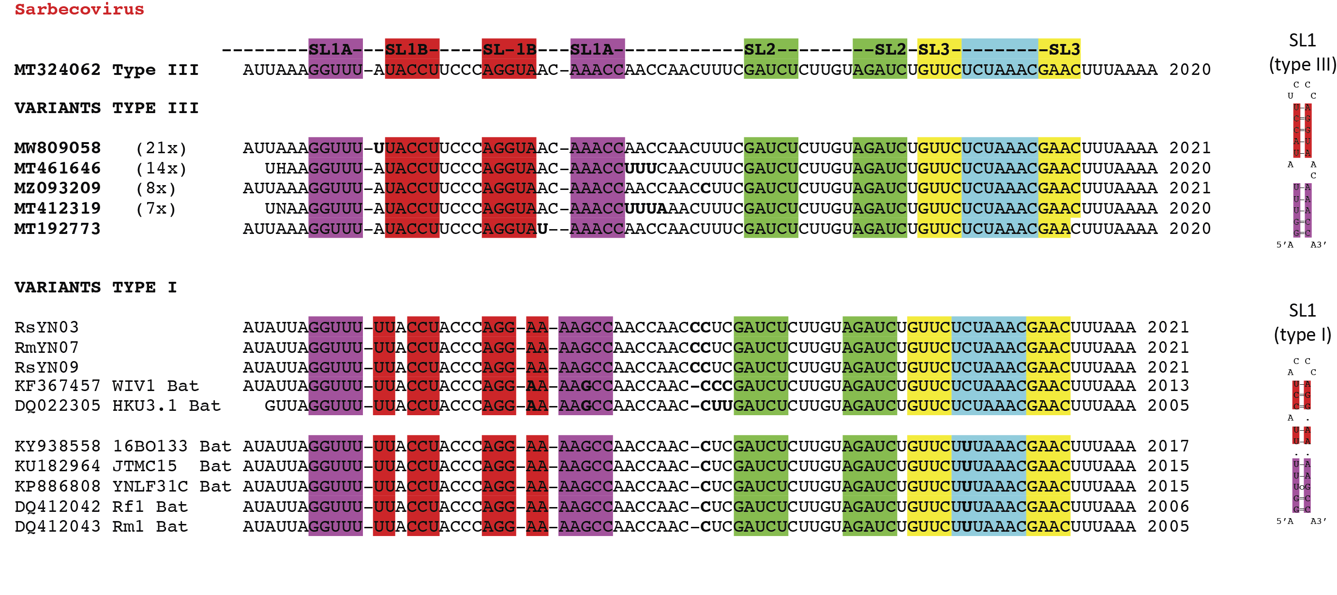

Figure S2

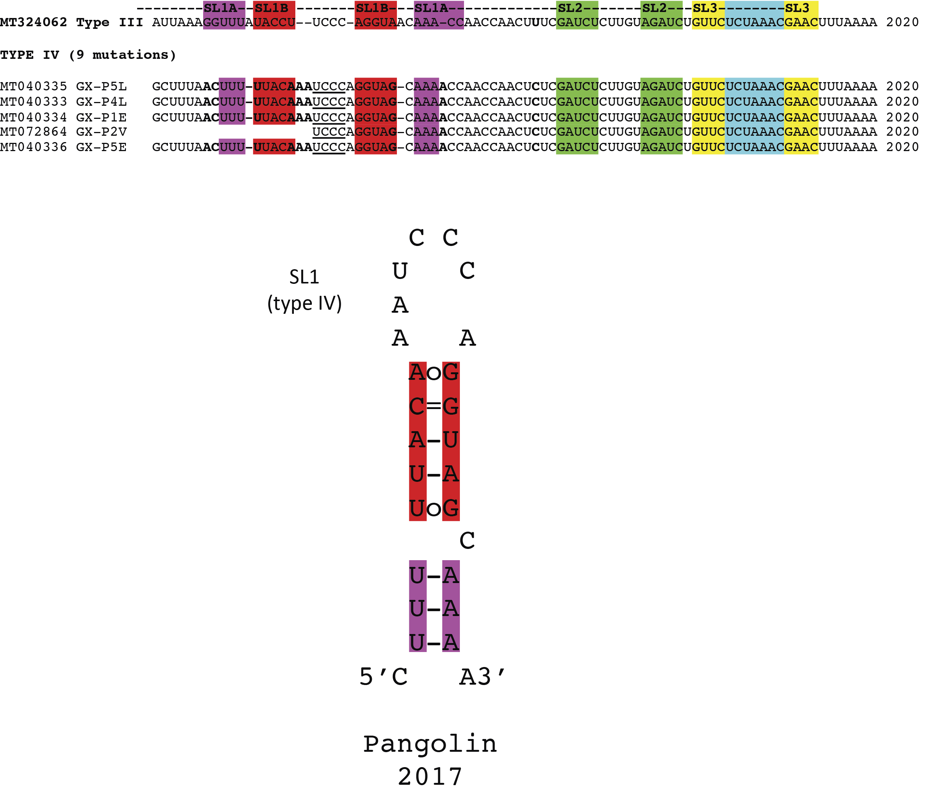

Figure S3

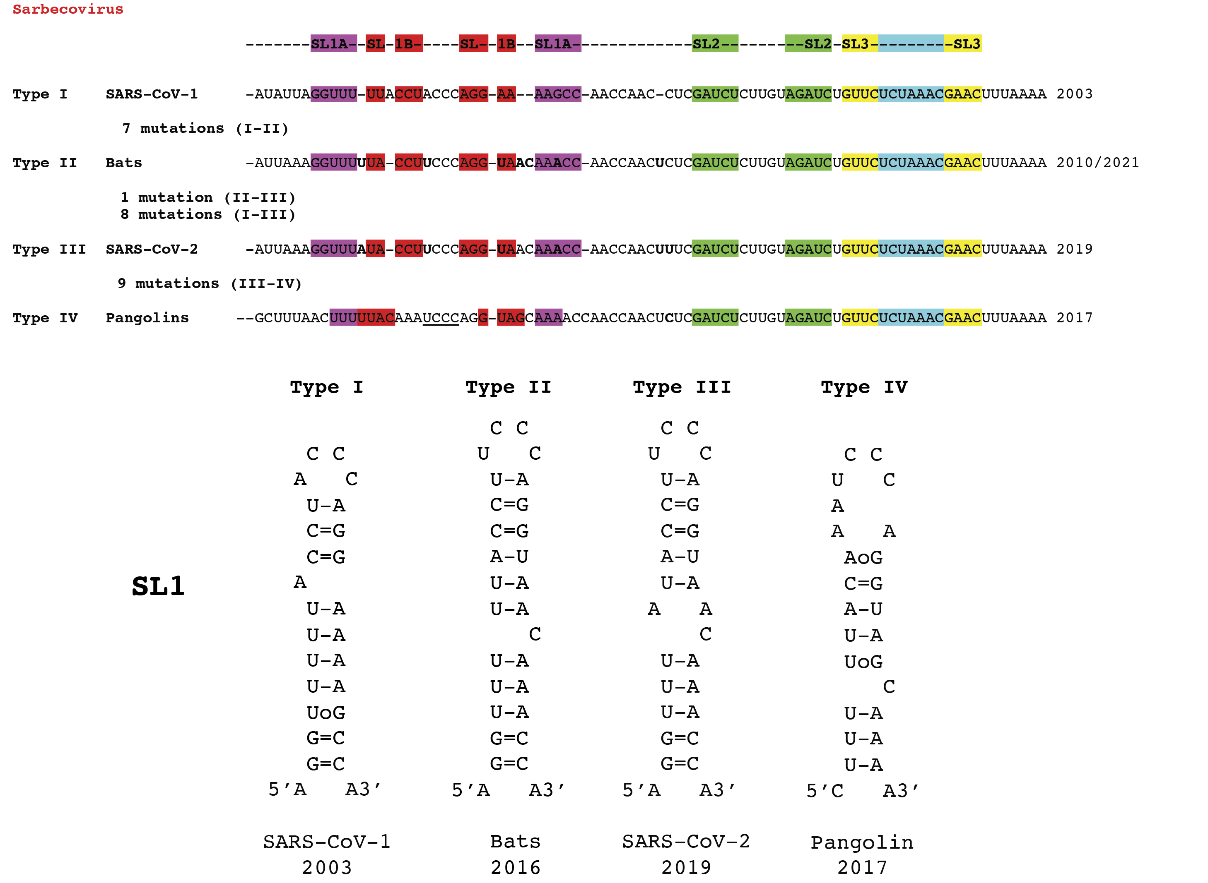

Figure S4

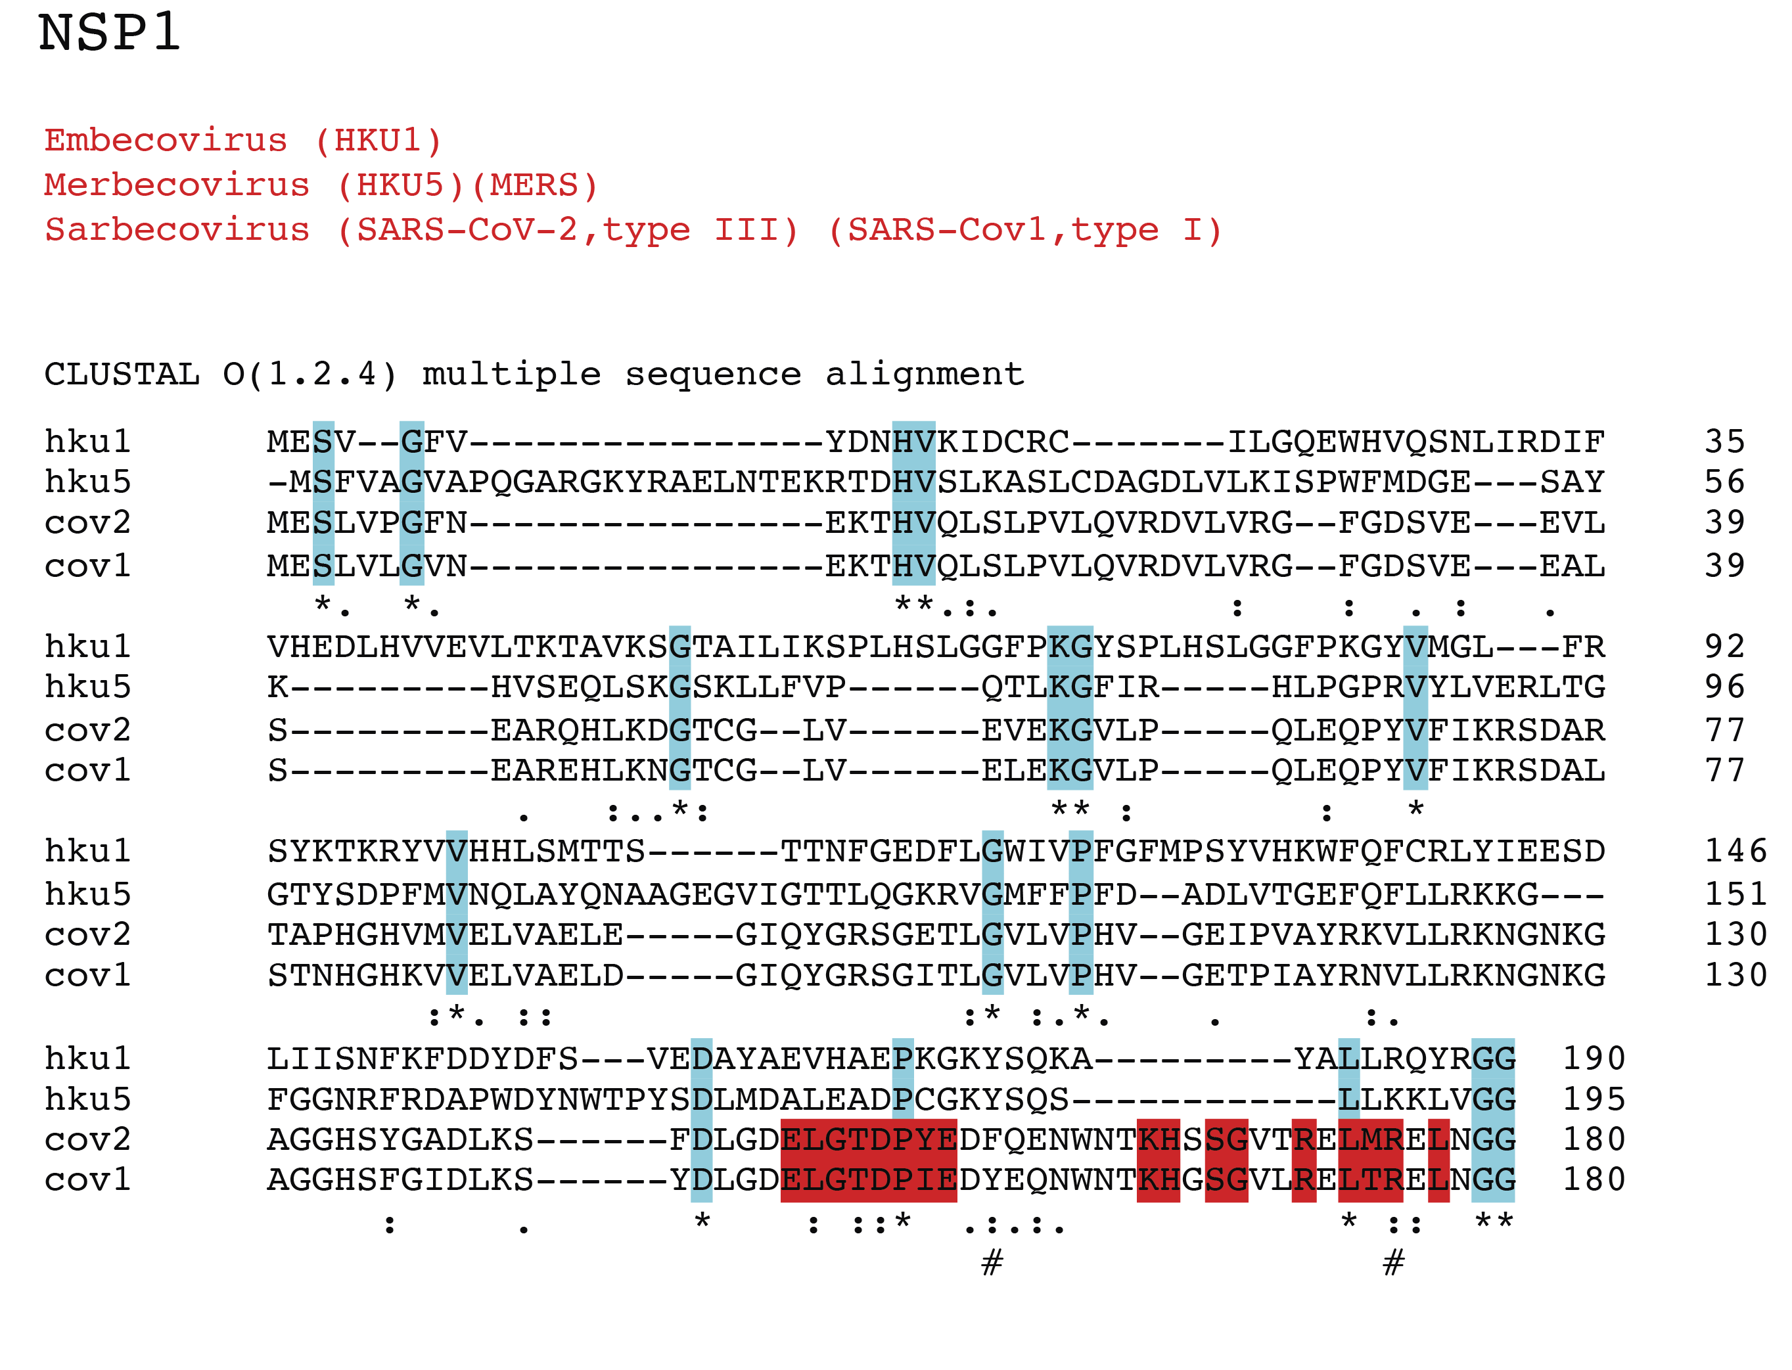

Figure S5

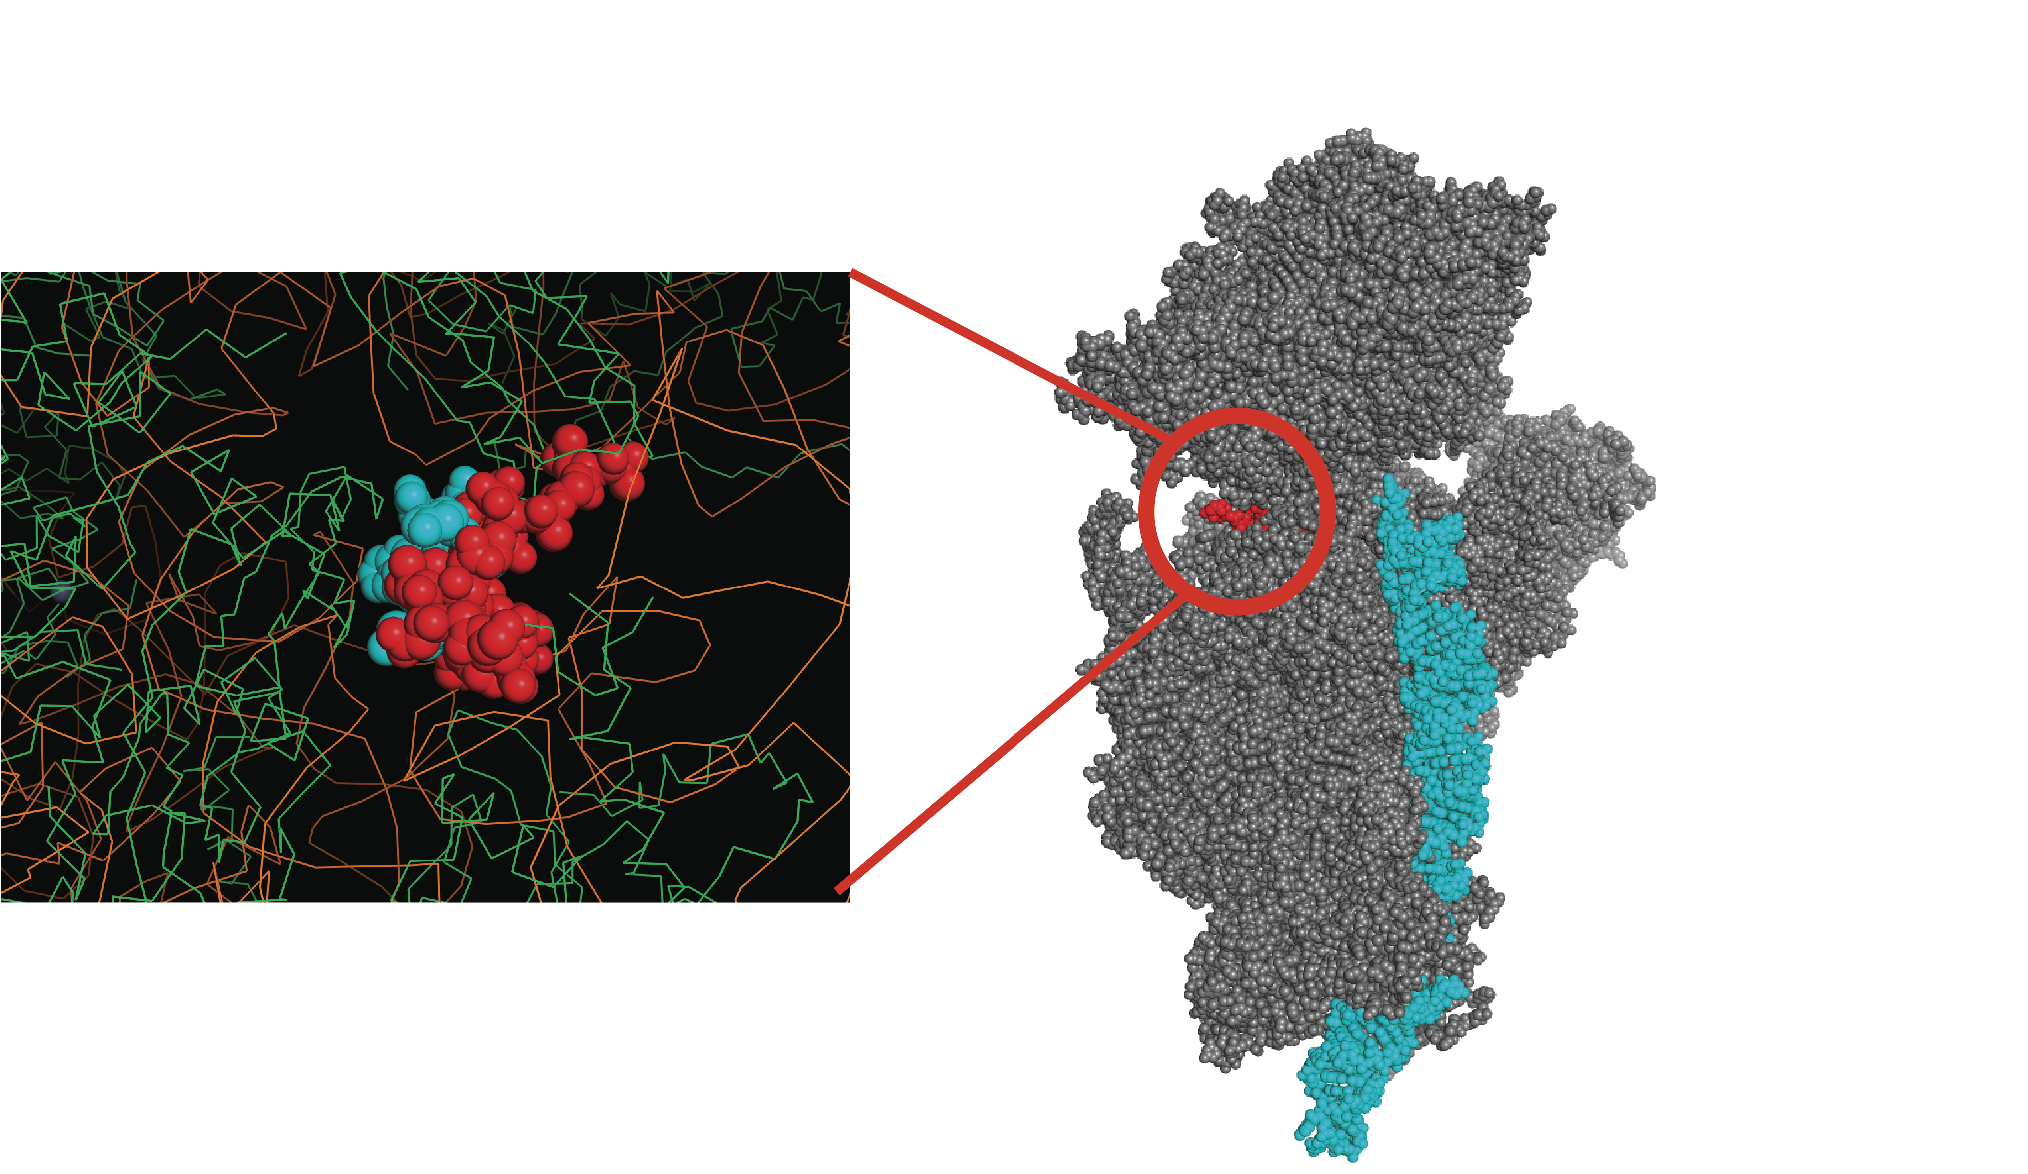

Figure S6

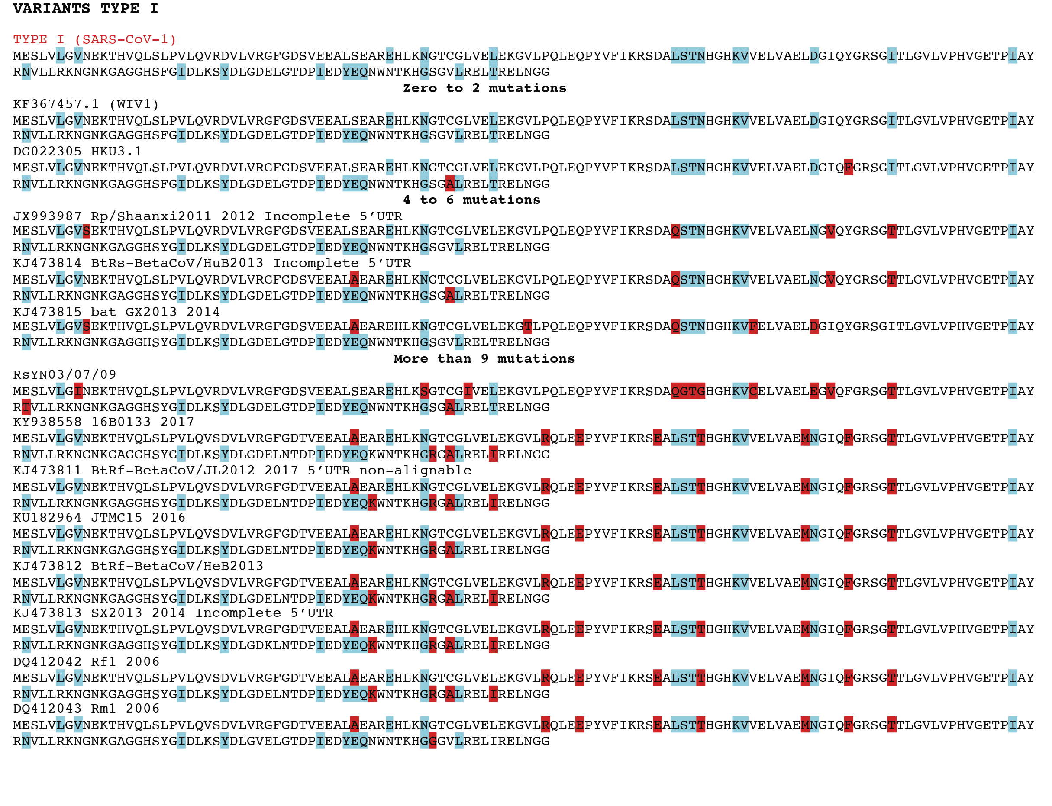

Figure S7

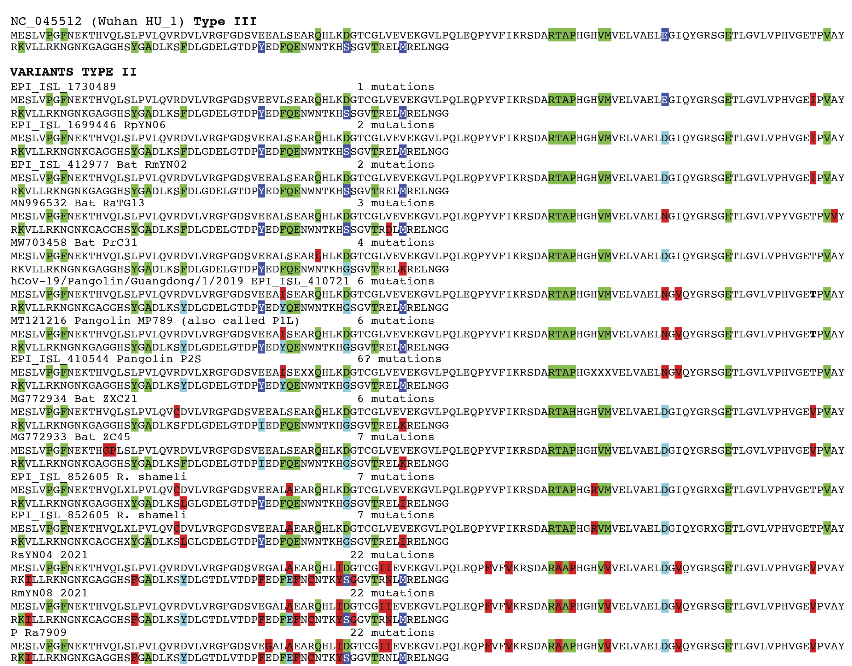
Figure S8

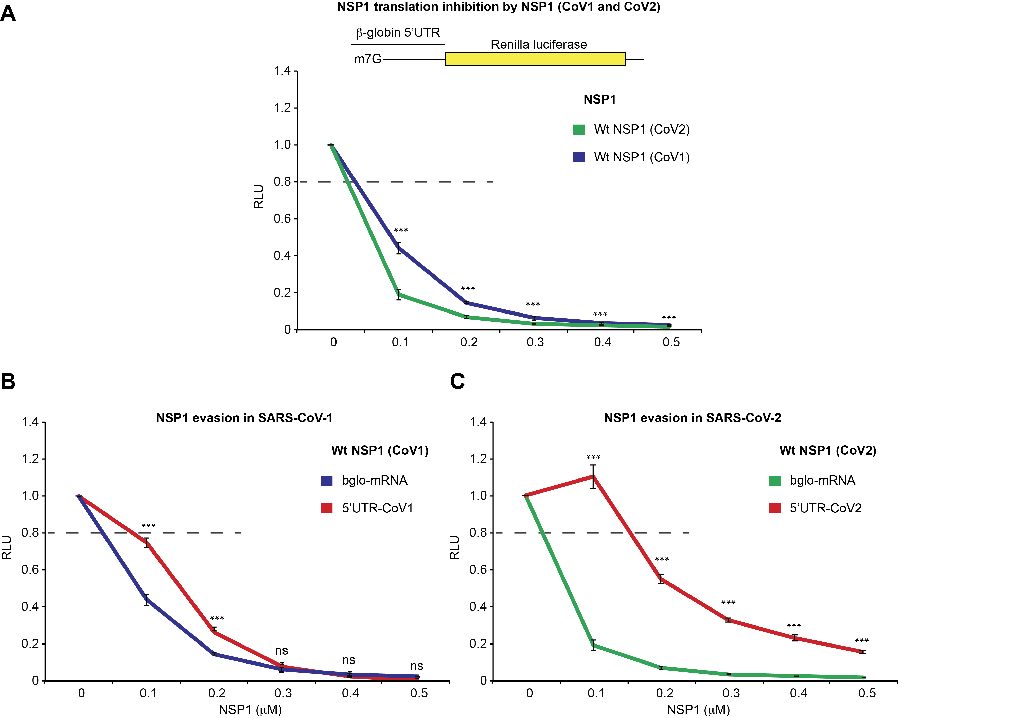

Figure S9

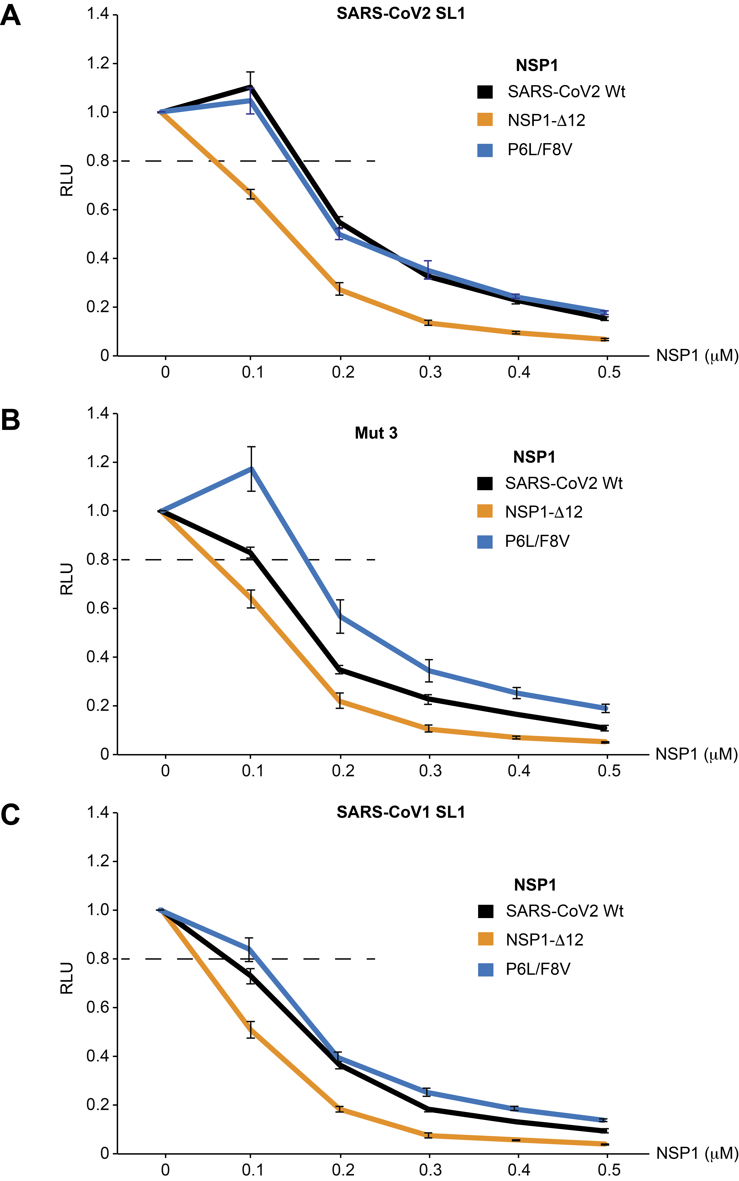
Figure S10

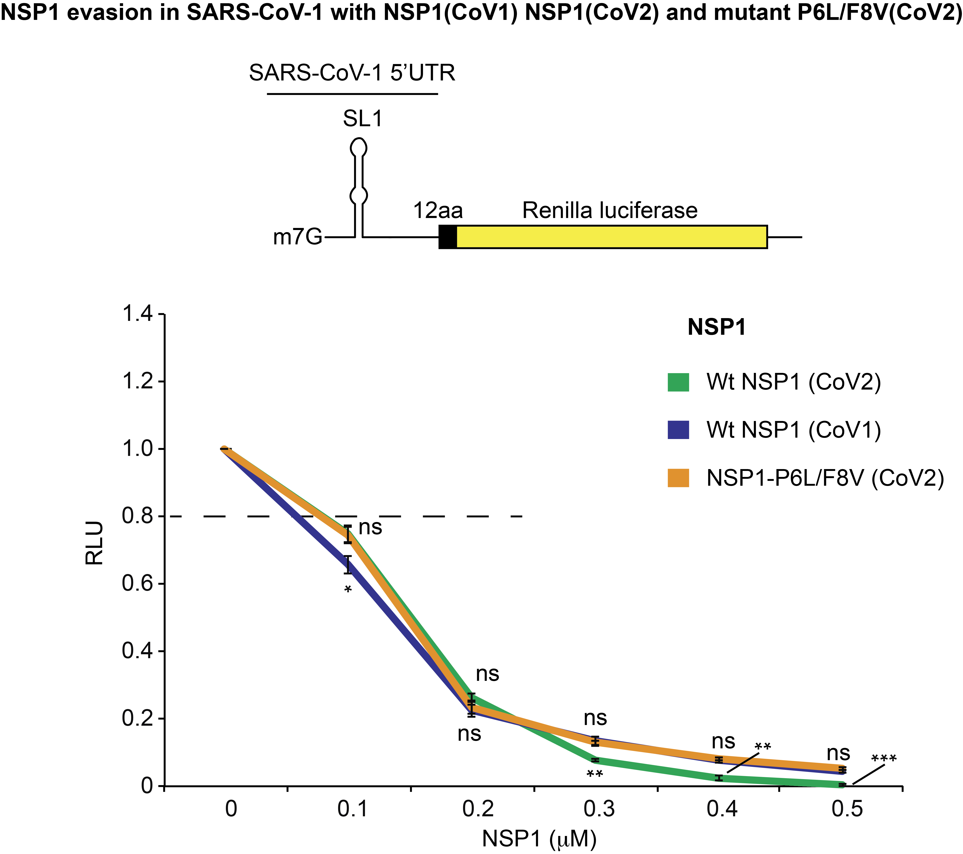
Figure S11

Figure S12

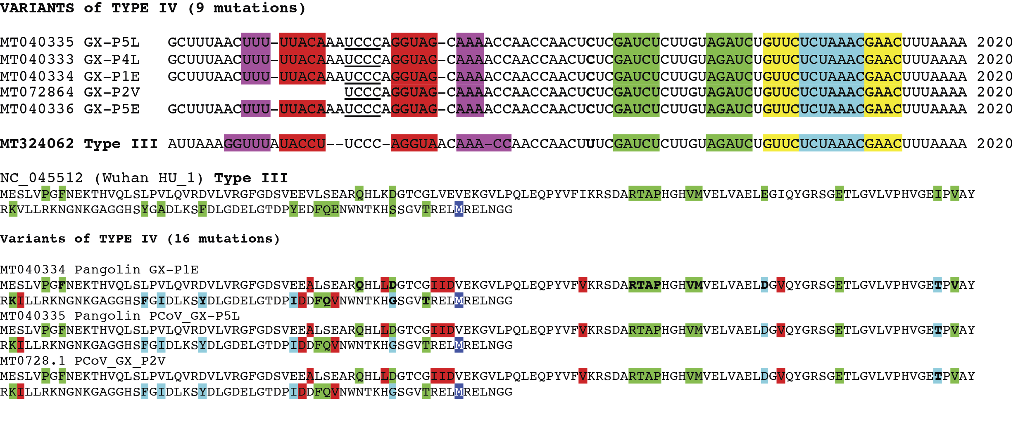

Figure S13

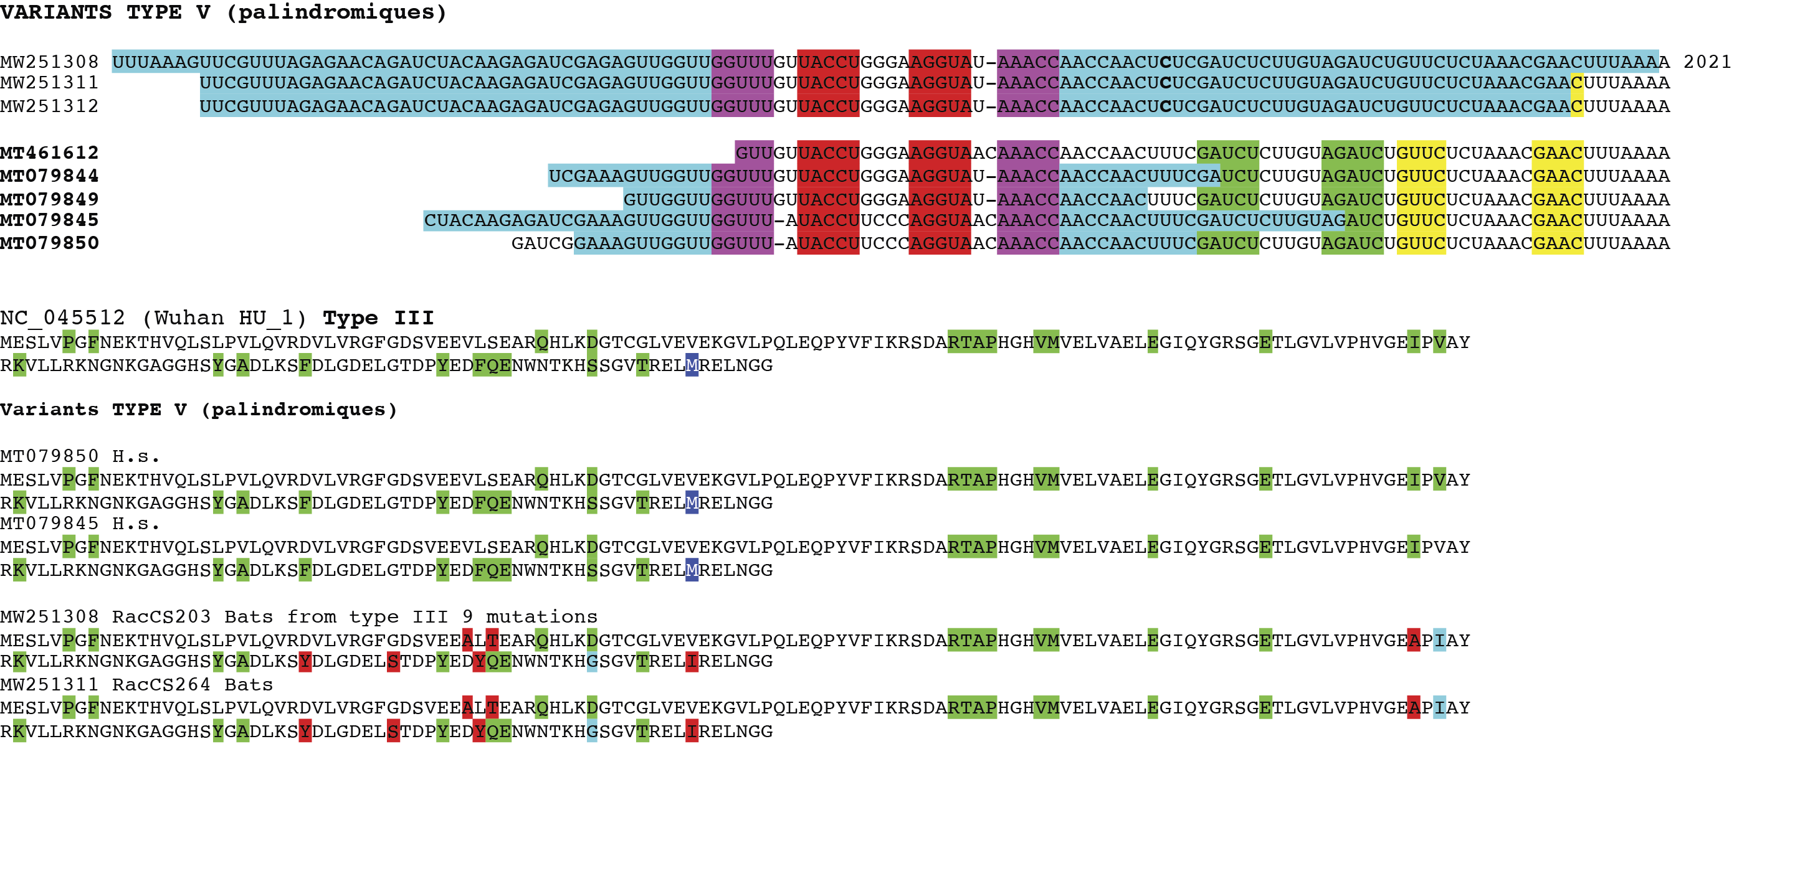

Table 1

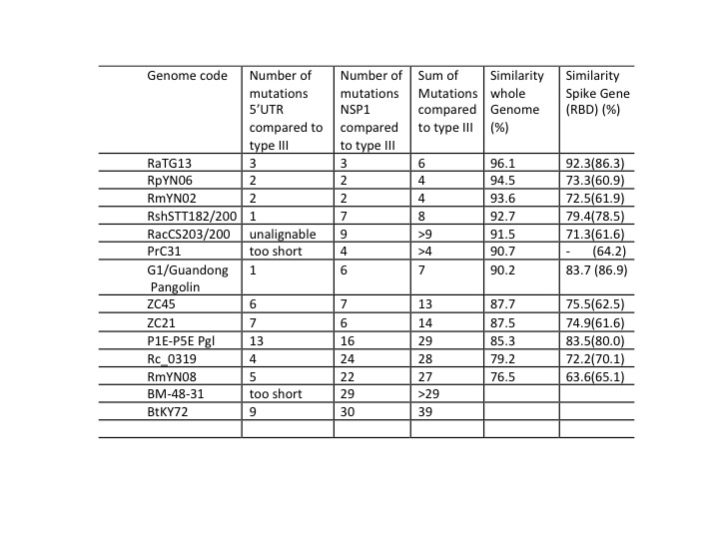

References

Drexler JF, Gloza-Rausch F, Glende J, Corman VM, Muth D, Goettsche M, Seebens A, Niedrig M, Pfefferle S, Yordanov S, et al. 2010. Genomic Characterization of Severe Acute Respiratory Syndrome-Related Coronavirus in European Bats and Classification of Coronaviruses Based on Partial RNA-Dependent RNA Polymerase Gene Sequences. J Virol 84: 11336–11349.
Hu D, Zhu C, Ai L, He T, Wang Y, Ye F, Yang L, Ding C, Zhu X, Lv R, et al. 2018. Genomic characterization and infectivity of a novel SARS-like coronavirus in Chinese bats. Emerg Microbes Infect 7. https://pubmed.ncbi.nlm.nih.gov/30209269/.
Hul V, Delaune D, Karlsson EA, Hassanin A, Tey PO, Baidaliuk A, Gámbaro F, Tu VT, Keatts L, Mazet J, et al. 2021. A novel SARS-CoV-2 related coronavirus in bats from Cambodia. bioRxiv 2021.01.26.428212. https://www.biorxiv.org/content/10.1101/2021.01.26.428212v1 (Accessed August 13, 2021).
Lam TTY, Jia N, Zhang YW, Shum MHH, Jiang JF, Zhu HC, Tong YG, Shi YX, Ni XB, Liao YS, et al. 2020. Identifying SARS-CoV-2-related coronaviruses in Malayan pangolins. Nature 583: 282–285. https://pubmed.ncbi.nlm.nih.gov/32218527/ (Accessed August 16, 2021).
Li L, Wang J, Ma X, Sun X, Li J, Yang X, Shi W, Duan Z. 2021. A novel SARS-CoV-2 related coronavirus with complex recombination isolated from bats in Yunnan province, China. Emerg Microbes Infect 1–22. https://pubmed.ncbi.nlm.nih.gov/34348599/ (Accessed August 16, 2021).
Liu P, Chen W, Chen JP. 2019. Viral metagenomics revealed sendai virus and coronavirus infection of malayan pangolins (manis javanica). Viruses 11. https://pubmed.ncbi.nlm.nih.gov/31652964/ (Accessed August 16, 2021).
Liu P, Jiang JZ, Wan XF, Hua Y, Li L, Zhou J, Wang X, Hou F, Chen J, Zou J, et al. 2020. Are pangolins the intermediate host of the 2019 novel coronavirus (SARS-CoV-2)? PLoS Pathog 16. https://pubmed.ncbi.nlm.nih.gov/32407364/ (Accessed August 13, 2021).
Murakami S, Kitamura T, Suzuki J, Sato R, Aoi T, Fujii M, Matsugo H, Kamiki H, Ishida H, Takenaka-Uema A, et al. 2020. Detection and Characterization of Bat Sarbecovirus Phylogenetically Related to SARS-CoV-2, Japan. Emerg Infect Dis 26: 3025–3029. https://pubmed.ncbi.nlm.nih.gov/33219796/ (Accessed August 16, 2021).
Schubert K, Karousis ED, Jomaa A, Scaiola A, Echeverria B, Gurzeler LA, Leibundgut M, Thiel V, Mühlemann O, Ban N. 2020. SARS-CoV-2 Nsp1 binds the ribosomal mRNA channel to inhibit translation. Nat Struct Mol Biol 27: 959–966.
Smith EC, Sexton NR, Denison MR. 2014. Thinking outside the triangle: Replication fidelity of the largest RNA viruses. Annu Rev Virol 1: 111–132. https://pubmed.ncbi.nlm.nih.gov/26958717/ (Accessed August 13, 2021).
Tao Y, Tong S. 2019. Complete Genome Sequence of a Severe Acute Respiratory Syndrome-Related Coronavirus from Kenyan Bats. Microbiol Resour Announc 8. https://pubmed.ncbi.nlm.nih.gov/31296683/ (Accessed August 16, 2021).
Thoms M, Buschauer R, Ameismeier M, Koepke L, Denk T, Hirschenberger M, Kratzat H, Hayn M, MacKens-Kiani T, Cheng J, et al. 2020. Structural basis for translational shutdown and immune evasion by the Nsp1 protein of SARS-CoV-2. Science (80- ) 369: 1249–1256.
Wacharapluesadee S, Tan CW, Maneeorn P, Duengkae P, Zhu F, Joyjinda Y, Kaewpom T, Chia WN, Ampoot W, Lim BL, et al. 2021. Evidence for SARS-CoV-2 related coronaviruses circulating in bats and pangolins in Southeast Asia. Nat Commun 12. https://pubmed.ncbi.nlm.nih.gov/33563978/ (Accessed August 13, 2021).
Zhou H, Chen X, Hu T, Li J, Song H, Liu Y, Wang P, Liu D, Yang J, Holmes EC, et al. 2020. A Novel Bat Coronavirus Closely Related to SARS-CoV-2 Contains Natural Insertions at the S1/S2 Cleavage Site of the Spike Protein. Curr Biol 30: 2196-2203.e3. https://pubmed.ncbi.nlm.nih.gov/32416074/ (Accessed August 13, 2021).
Zhou H, Ji J, Chen X, Bi Y, Li J, Wang Q, Hu T, Song H, Zhao R, Chen Y, et al. 2021. Identification of novel bat coronaviruses sheds light on the evolutionary origins of SARS-CoV-2 and related viruses. Cell S0092-8674(21)00709–1. https://pubmed.ncbi.nlm.nih.gov/34147139/ (Accessed August 13, 2021).

