Supplementary Material

Vault RNA1-1 riboregulates the autophagic function of p62 by binding to K7/R21 that are critical for p62 oligomerisation

Magdalena Büscher^{1,2}, Rastislav Horos^{1,3}, Ina Huppertz^{1,3}, Kevin Haubrich¹, Nikolay Dobrev¹, Florence Baudin¹, Janosch Hennig¹, Matthias W. Hentze^{1,*}

¹European Molecular Biology Laboratory, 69117Heidelberg, Germany
²Collaboration for joint PhD degree between EMBL and Heidelberg University, Faculty of Biosciences, Heidelberg, Germany
³Equal contribution

*To whom correspondence should be addressed: hentze@embl.org

Supplementary Figure 1:

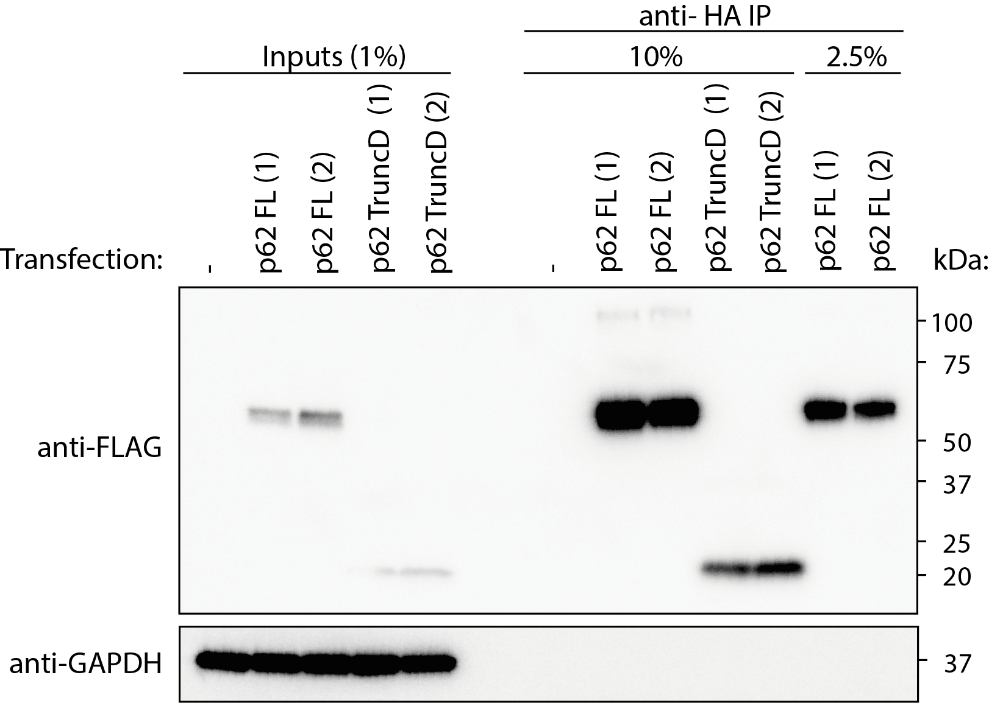

Native co-immunoprecipitation of FLAG-HA-p62 WT or truncation D expressed in HuH-7 p62 KO cells followed by quantitative RT-PCR of bound RNA. Representative Western blot analysis of p62 immunoprecipitation, including the normalization of eluates according to the protein content for subsequent RNA extraction.

Supplementary Figure 2:

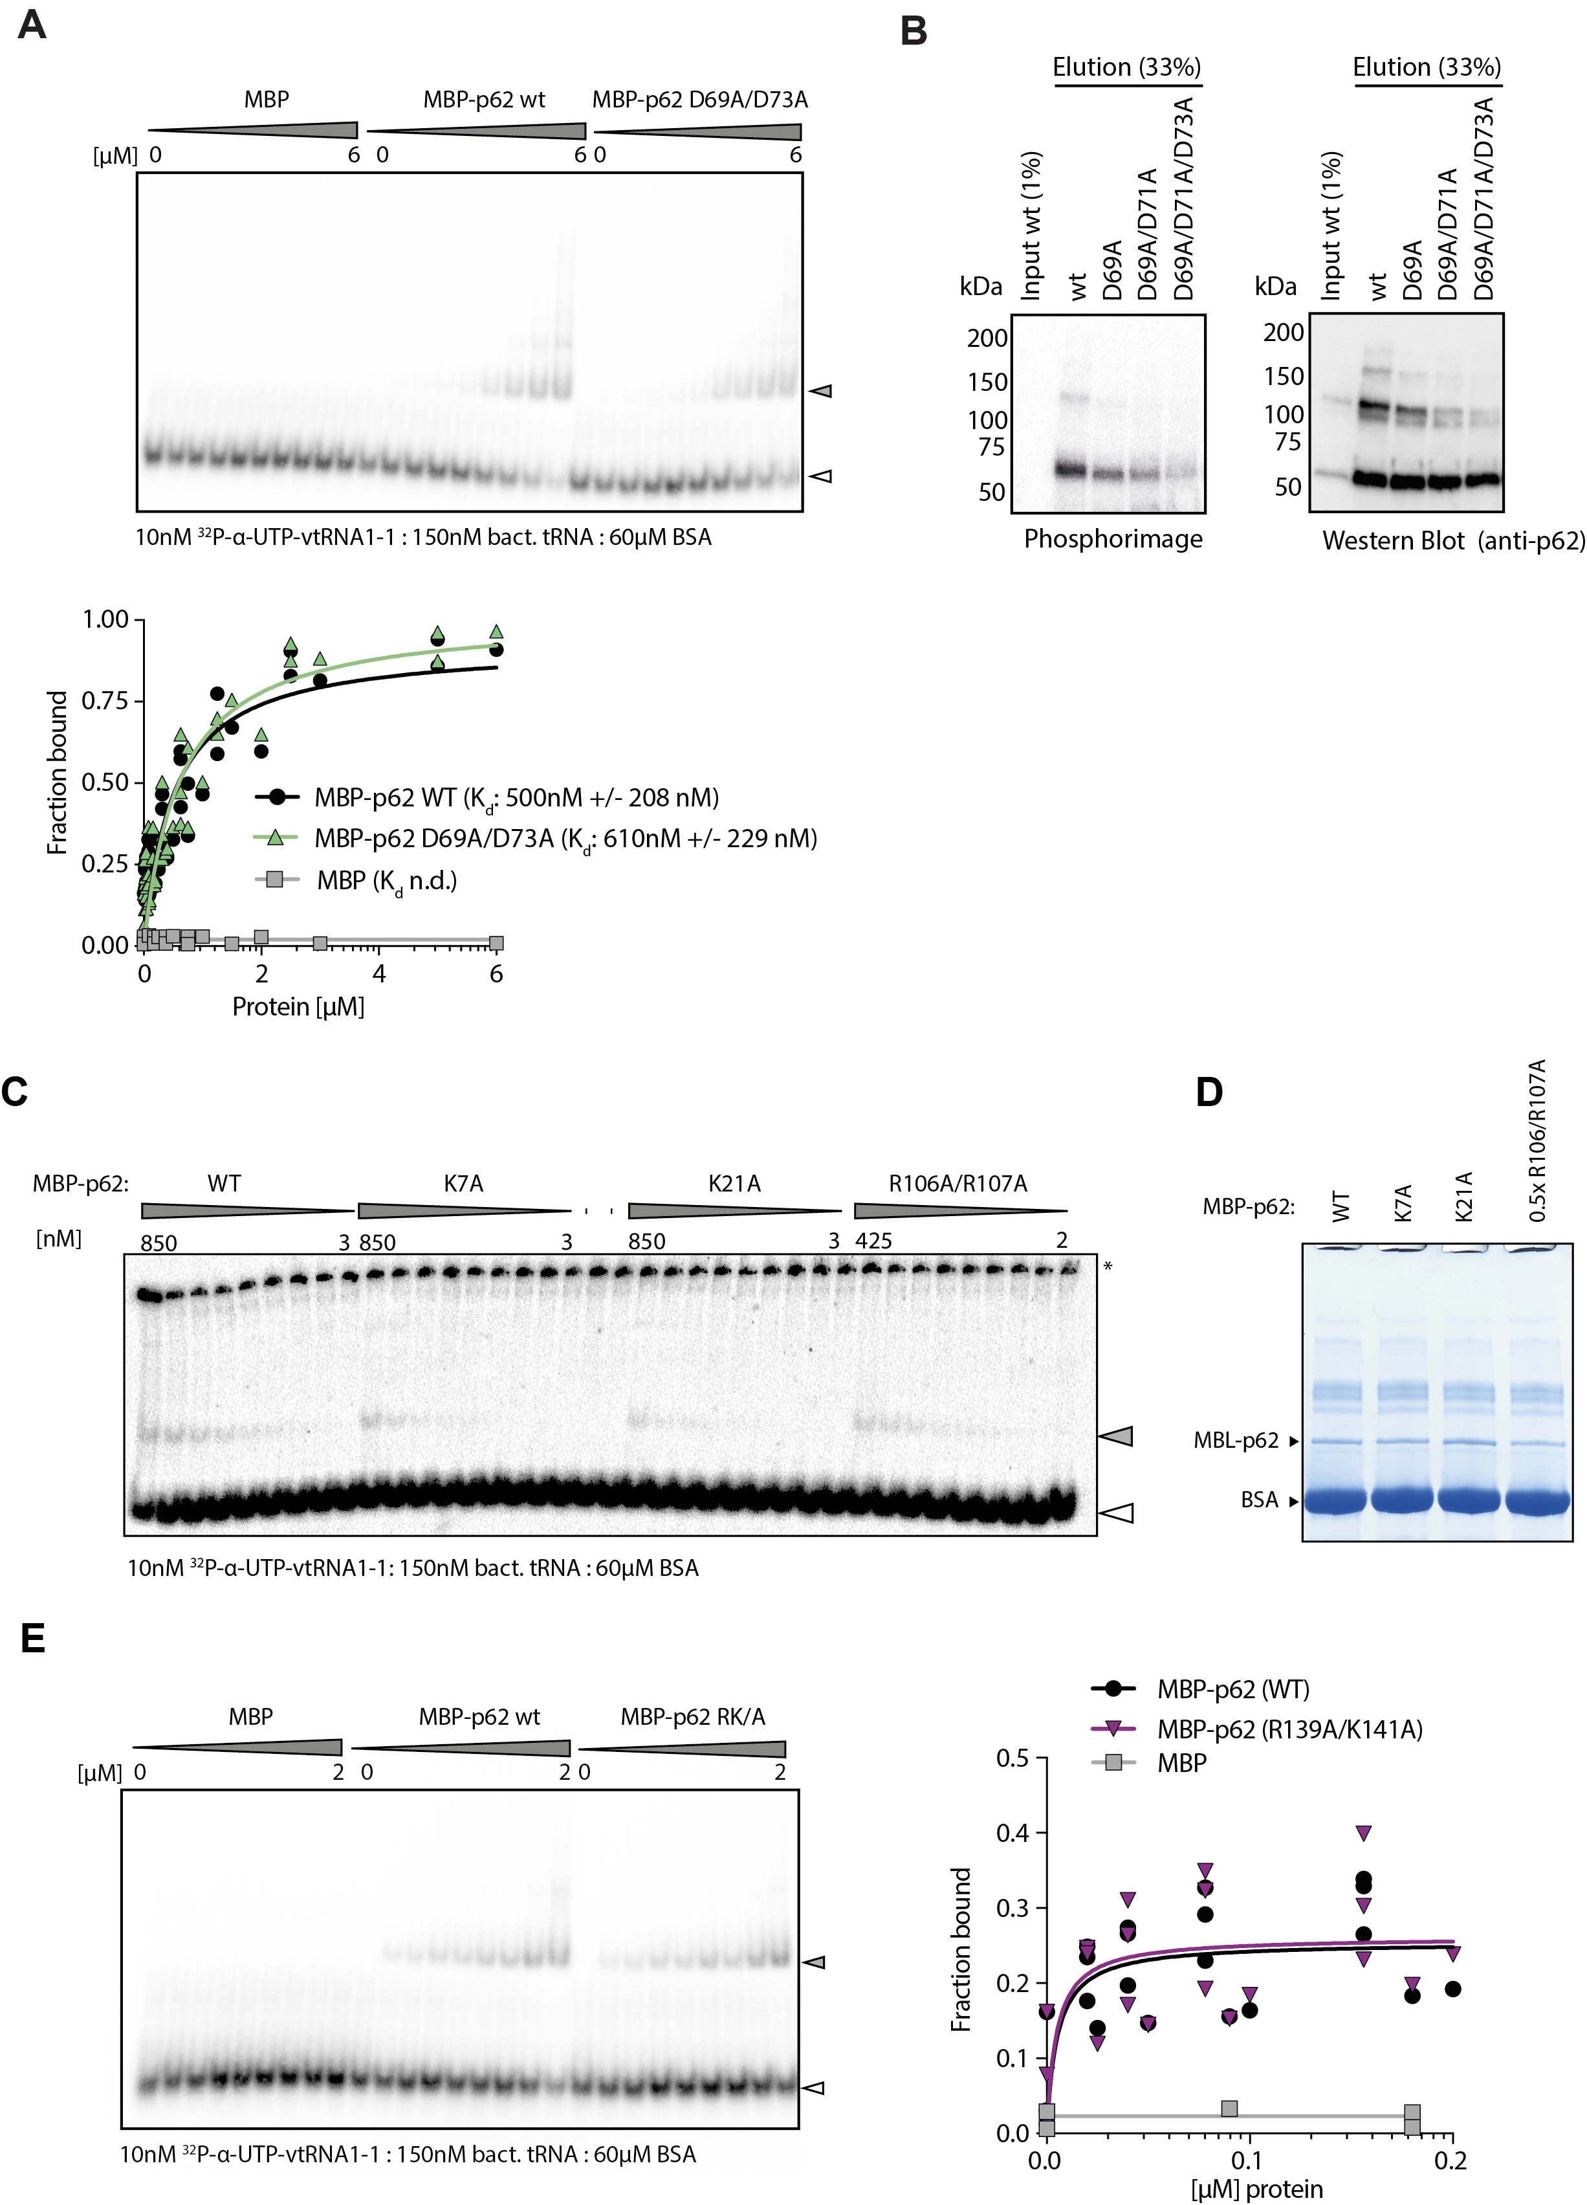

- Representative EMSA and quantification. Radioactively labelled vault RNA 1-1 and increasing amounts of recombinantly expressed and purified MBP (n=2), MBP-p62 WT (n=5) or MBP-p62 (D69A/D73A) (n=5) in the presence of an unspecific competitor.
- Representative Polynucleotide kinase labelling assay (PNK) of FLAG-HA-p62 mutants in HuH-7 p62 KO cells.

- Representative EMSA with 10 nM radioactively labelled vault RNA 1-1, 60 µM BSA, 150 nM bacterial tRNAs and increasing amounts of recombinantly expressed and purified MBP-p62 WT, MBP-p62 K7A, MBP-p62 K21A and MBP-p62 R106A/R107A. A white arrow indicates free radioactively labelled probe, a grey arrow indicates RNA-protein complex, * indicates the wells.
- SDS-PAGE followed by InstantBlue staining of EMSA protein reaction from B.
- Representative EMSA and quantification. Radioactively labelled vault RNA 1-1 and increasing amounts of recombinantly expressed and purified MBP-p62 WT (n=5), MBP-p62 R139A/K141A (n=5) or MBP (n=2) in the presence of unspecific competitor (data also partly shown in Figure 2D).

Supplementary Figure 3:

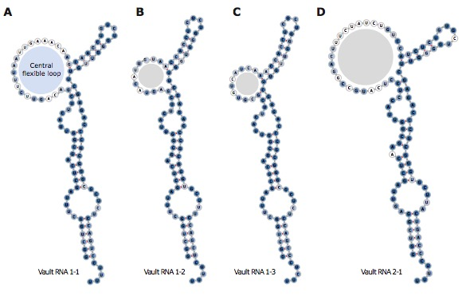

- Integration of secondary structure model with vault RNA paralogue conservation. The intensity of blue shading represents higher paralogue conservation as assessed by LocARNA (http://rna.informatik.uni-freiburg.de, v. (4.5.8); [47–49].
- – (D) Secondary structure models for the other human vault RNAs based on chemical probing of vault RNA 1-1 and paralogue conservation as in A.

Supplementary Figure 4:

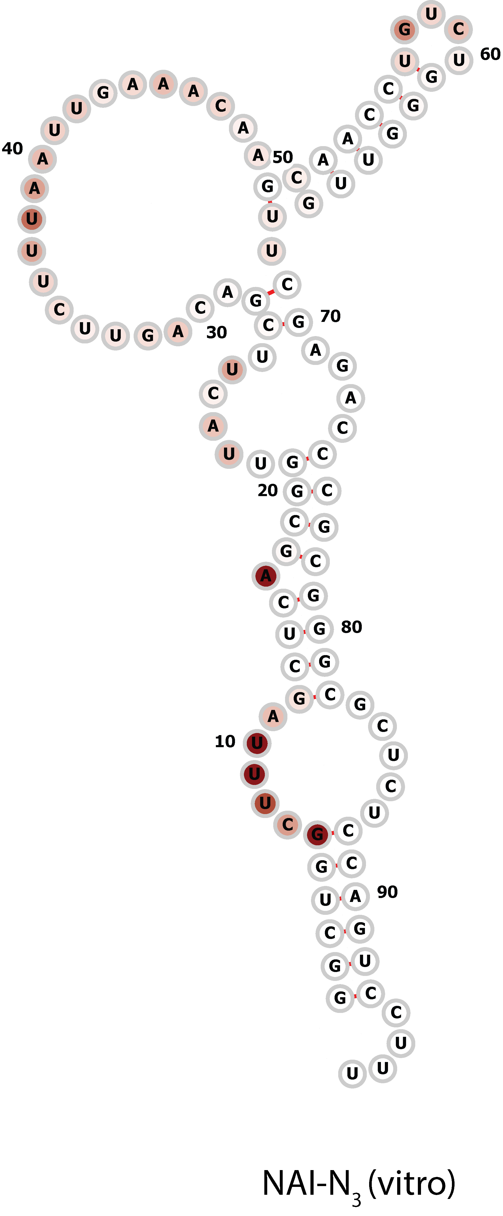

Integration of the proposed secondary structure model for human vtRNA1-1 with SHAPE reactivities reported in the RASP atlas of transcriptome-wide RNA secondary structure probing (RASP atlas: Li et al, 2021; original data: Sun et al., 2019; Hela total RNA, in vitro). Increased red shading represents increased reactivity towards NAI-N₃.

Supplementary Figure 5:

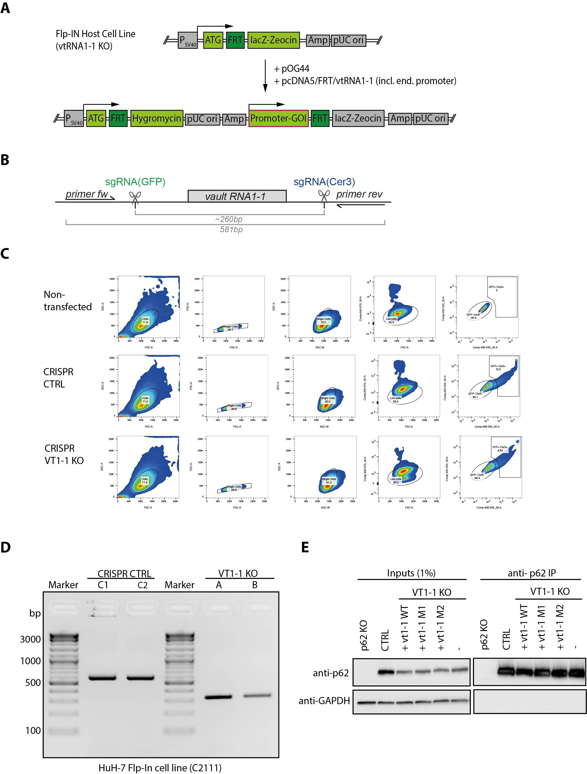

- Schematic overview of Flp-IN cell line for the reintegration of vault RNA 1-1 and mutants thereof. A gene of interest can be introduced through Flp-FRT recombination by co-transfection of an FRT site containing plasmid with the respective recombinase (pOG44). Upon successful integration, the cells gain hygromycin resistance and loose zeocin resistance.
- Schematic representation of the vault RNA 1-1 locus with localisation of single-guide RNAs (sgRNAs) and primers for PCR analysis.
- Single-cell FACS sorting of double-positive HuH-7 Flp IN cells that express both single guide RNAs targeting vault RNA 1-1 and CRISPR/Cas9.
- PCR analysis of genomic vault RNA1-1 loci of two single-cell derived HuH-7 Flp-IN CRISPR/Cas9 Control cell lines and vault RNA 1-1 KO cell lines.
- Native co-immunoprecipitation of p62 in HuH-7 FlpIN cells followed by quantitative RT-PCR of bound RNA. Representative Western blot analysis of p62 immunoprecipitation.
Supplementary Figure 6:
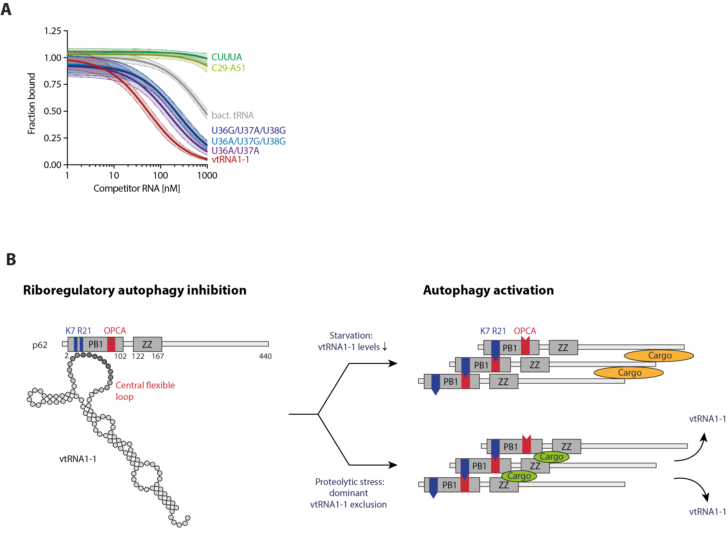

- Quantification of competitive EMSAs with vtRNA1-1 WT or full-length mutants, bacterial tRNAs, or synthetic RNA oligos representing the linear flexible loop region or the motif CUUUA (n≥2). Shading indicates 95% confidence interval. The analysis was performed with Prism 8.
- Summary model. Under physiological, nutrient-replete conditions, vtRNA1-1 inhibits p62 oligomerisation by binding the critical hinge points K7 and R21. When starvation reduces cellular vtRNA1-1 levels, p62 oligomerisation and autophagy are facilitated¹⁹. By contrast, cargo binding to the ZZ domain and linker region during proteotoxic stress[17,40] triggers ‘sequestosome’ formation and cargo clearance even when vtRNA1-1 levels are high, excluding vtRNA1-1 sterically in a dominant fashion. (blue: positively charged surface patch including K7 and R21, red: negatively charged OPCA motif; PB1: Phox and Bem1; ZZ: ZZ-type zinc finger; orange: cargo targeted for degradation via the UBA binding domain; green: cargo that binds the ZZ domain and linker region upon proteotoxic stress.

Supplementary Table 1:

Materials used in this study.

Antibodies
Anti-p62 rabbit pAb | MBL | Cat#: PM045
Anti-GAPDH rabbit pAB | Sigma-Aldrich | Cat#: G9545;  RRID: AB_796208
Anti-FLAG mouse mAb | Sigma-Aldrich | Cat#: F1804-50UG
Anti-HA magnetic beads | Thermo Scientific | Cat#: 88836
Bacterial Strains
E.coli TOP10 | Thermo Scientific | Cat#: C404010
E.coli BL21(DE3) CodonPlus-RIL | Agilent | Cat#: 230240
E.coli BL21 RosettaTM 2 (DE3) | Sigma-Aldrich | Cat#: 71400
Chemicals, Peptides, and Recombinant Proteins
InstantBlue Protein stain | Expedeon | Cat#: ISB1L
Precision Plus Protein Dual Color | Biorad | Cat#: 1610374
XIE62-1004-A | ¹⁹ | Synthesized by D. Dziuba
AMV Reverse Transcriptase | Promega | Cat#: M5101
Benzonase (100U/ml) | Merck Millipore | Cat#: 71206
cOmplete, EDTA free | Sigma-Aldrich | Cat#: 11873580001
FastAP alkalische phosphatase | Thermo Scientific | Cat#: EF0651
FastDigest BbsI/Bpil | Thermo Scientific | Cat#: FD1014
Phusion HF DNA polymerase | NEB | Cat#: M0530S
Quickligase | NEB | Cat#: M22000S
RNaseA | Sigma-Aldrich | Cat#: R5503
T4 Polynucleotid kinase (PNK) | NEB | Cat#: M0201L
Turbo Dnase | Thermo Fisher | Cat#: AM2238
Critical Commercial Assays
ChromaSpin + TE-10 columns | Takara | Cat#: 636066
Fast SYBR Green Master Mix | Thermo Scientific | Cat#: 4385610
HiSpeed Plasmid Maxi Kit | Qiagen | Cat#: 12663
Lipofectamine 3000 | Thermo Scientific | Cat#: L3000008
Maxima First Strand cDNA Synthesis Kit | Thermo Scientific | Cat#: K1641
MEGAshortscript | Thermo Scientific | Cat#: AM1354
QIAprep Spin Miniprep Kit | Qiagen | Cat#: 27106
QIAquick PCR purification kit | Qiagen | Cat#: 28104
Qubit RNA Broad Range Assay Kit | Thermo Scientific | Cat#: Q10210
Quick-RNA Microprep | Zymo Research | Cat#: R1050
Quick-RNA Miniprep | Zymo Research | Cat#: R1054
SF Cell Line 4D-Nucleofector X Kit | Lonza | Cat#: V4XC-2012
TGX Precast gels 12+2, 4-15% | Biorad | Cat#: 5671083
TGX Precast gels 18, 4-15% | Biorad | Cat#: 5671084
TGX Precast gels 26, 4-15% | Biorad | Cat#: 5671085
TransBlot Turbo Midi Nitrocellulose | Biorad | Cat#: 1704159
TransBlot Turbo Midi PVDF | Biorad | Cat#: 1704159
TRI-reagent | Sigma-Aldrich | Cat#: T9424

Supplementary Table 2:

Oligonucleotides used in this study.

Oligonucleotides
RT-qPCR primer vault RNA 1-1
fw: 5’-TTAGCTCAGCGGTTACTTCGACAGTTC
rev: 5’- AAAAGGACTGGAGAGCGCCC
RT-qPCR primer vault RNA 1-2
fw: 5’-GGCTGGCTTTAGCTCAGCGG
rev: 5’-AAAAGAGCTGGAAAGCACCC
RT-qPCR primer vault RNA 1-3
fw: 5’-AGCGGTTACTTCGCGTGTCATC
rev: 5’-AAGAGGGCTGGAGAGCGCC
RT-qPCR primer vault RNA 2-1
fw: 5’-GGGTCGGAGTTAGCTCAAGC
rev: 5’-AAAGGGTCAGTAAGCACCCG
RT-qPCR primer GAPDH
fw: 5’-ATGGGGAAGGTGAAGGTCG
rev: 5’-GGGGTCATTGATGGCAACAATA
RT-qPCR primer 5S
fw: 5’-GGCCATACCACCCTGAACGC
rev: 5’-CAGCACCCGGTATTCCCAGG
Northern blot probe for vault RNA locus 1 (not mutant sensitive):
5’-GAACTGTCGAAGTAACCGCTGAGCT
Genotyping primer vault RNA 1-1
fw: 5’-AAGACTCCACTCCCCTGGC
rev: 5’-TCCGAGGAGCCCTGATTCC
Sequencing primer FRT plasmid:
5’-TAGTTAAGCCAGTATCTGCTCC
Sequencing primer px458-SpCas:
5’-TTTATGGCGAGGCGGCGG
sgRNA vault RNA 1-1 #1
fw: 5’-CACCGCCTCAATTGTCTGGAGGTCG
rev: 5’-AAACCGACCTCCAGACAATTGAGGC
sgRNA vault RNA 1-1 #2
fw: 5’-CACCGCCCCGACCTCCAGACAATTG
rev: 5’-AAACCAATTGTCTGGAGGTCGGGGC
sgRNA vault RNA 1-1 #3
fw: 5’-CACCGAAAGGACTGGAGAGCTCCCG
rev: 5’-AAACCGGGAGCTCTCCAGTCCTTTC
sgRNA vault RNA 1-1 #4
fw:5’-CACCGAAAGGACTGGAGAGCGCCCG
rev:5’-AAACCGGGCGCTCTCCAGTCCTTTC

