Supplementary Materials for
The rRNA modifying enzyme Tsr3 coordinates the activity of the Rio1 and Rio2 kinases during 40S ribosome assembly
Haina Huang^{1,2}, Melissa Parker^{1,2}, Katrin Karbstein^{1,2,3*}
*Correspondence: kkarbst@scripps.edu
This file includes:
Figures: S1 to S4
Tables: S1 to S4

Figure S1.
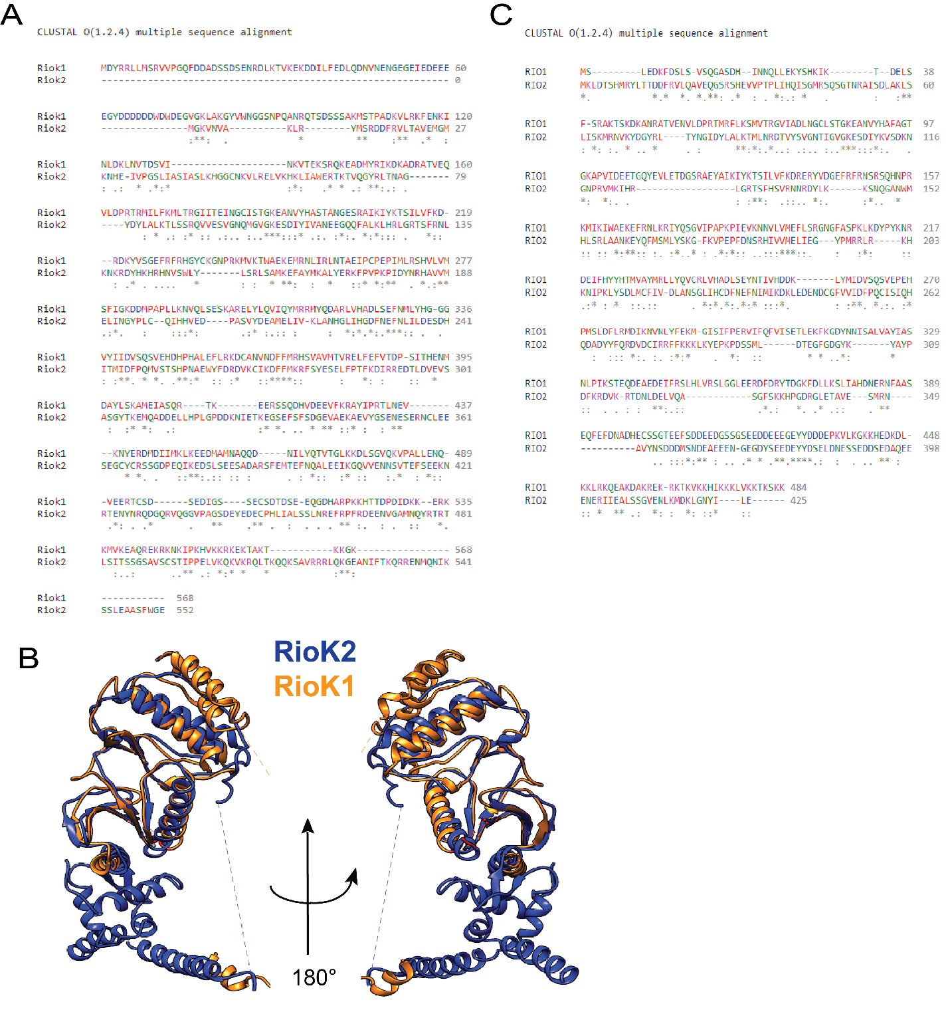
Figure S1. Rio1 and Rio2 are highly homologous.
- Sequence alignment of human Rio1 (RioK1) and Rio2 (RioK2) obtained from NCBI RefSeq (https://www.ncbi.nlm.nih.gov/refseq/) using Clustal Omega.
- Structure overlay of human Rio1 (PDBID 6ZXE chain z) and Rio2 (PDBID 6G18 chain v) using the Needleman-Wunsch algorithm.
- Sequence alignment of Saccharomyces cerevisiae Rio1 and Rio2 obtained from the Saccharomyces Genome database (https://www.yeastgenome.org) using Clustal Omega.
Figure S2.
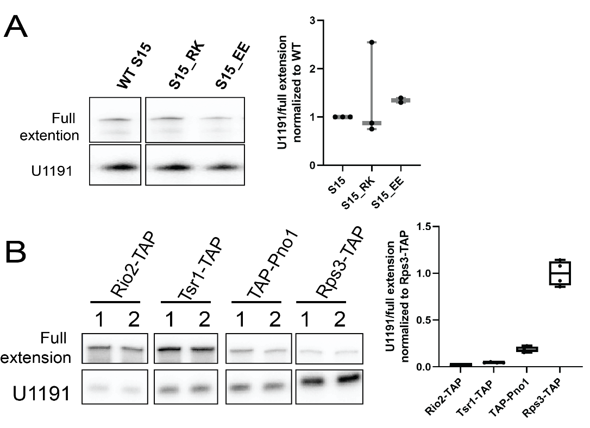
Figure S2. Acp modification of mutant 40S ribosomes and assembly intermediates.
- (Left) Primer extension results show acp modification at U1191 of ribosomes from Gal:S15 cells supplemented with WT S15 or S15_RK or S15_EE plasmid and grown in glucose. (Right) Quantifications of the U1191 signal normalized to the full extension from the data on the left and additional replicates. n$≥$2.
- (Left) Primer extension results indicating the installation of acp modification at U1191 in different purified pre-40S intermediates and mature 40S. Note that results for Rps3-TAP are identical to those in Figure 1E, and shown here for direct comparison. Signal for U1191 was first normalized to full extension before further normalization to mature 40S (Rps3-TAP). 2 representative biological replicates (1, 2) are shown for each cell type. (Right) Quantification of the normalized U1191 stop from the left and two additional replicates (n=4).

Figure S3.
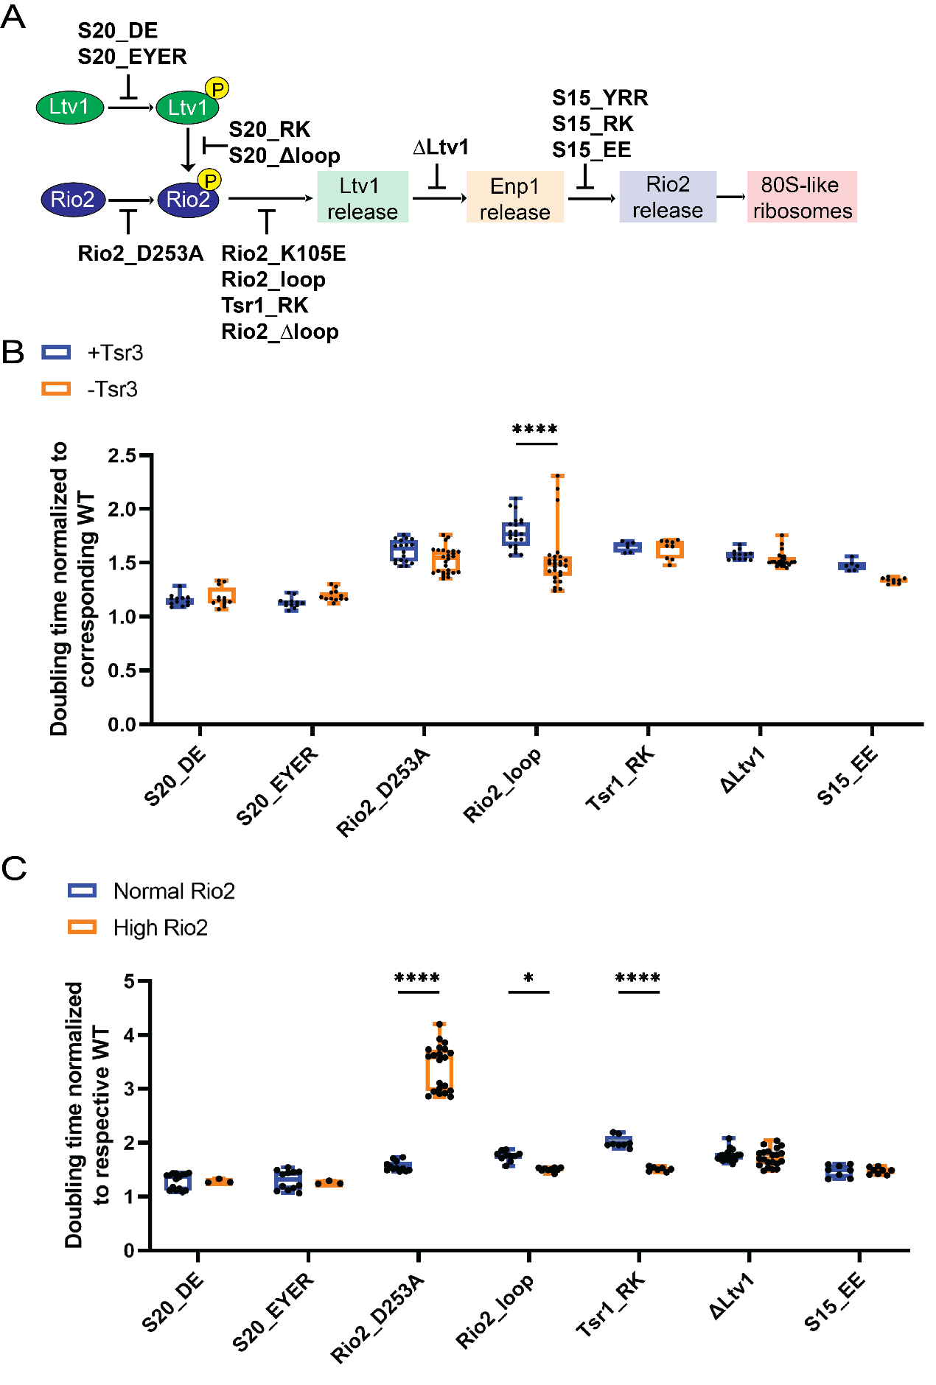
Figure S3. Synthetic sick effects from ΔTsr3 are specific for mutants affecting Rio2 release.
- Scheme showing where within the ordered release of Ltv1, Enp1 and Rio2 during 80S-like ribosome formation the indicated mutants block the process (Huang et al., 2020). Note that the mutations deleted in Rio2_Δloop are mutated in Rio2_loop (see Table S2).
- Normalized doubling times of yeast cells encoding WT S20/S20_DE/S20_EYER, WT Rio2/Rio2_D253A/Rio2_loop, and WT Tsr1/Tsr1_RK, WT S15/S15_EE in the presence and absence of Tsr3. WT or mutant proteins were expressed from plasmids in strains where the endogenous protein is under the GAL-promoter and depleted by growth in glucose. BY4741(WT), ΔLtv1, ΔTsr3 and ΔLtv1ΔTsr3 cells were used to test the genetic interactions between ΔLtv1 and ΔTsr3. Shown in the figure are doubling times of mutants normalized to corresponding WT protein in the same Tsr3 background. Significance was tested using a two-way ANOVA test. ****, p_{adj}<0.0001. n≥6.
- Normalized doubling times of yeast cells encoding WT S20/S20_DE/S20_EYER, WT Rio2/Rio2_D253A/Rio2_loop, and WT Tsr1/Tsr1_RK, WT Ltv1 or empty vector and WT S15/S15_EE with normal and overexpressed Rio2. WT or mutant proteins were expressed from plasmids in strains where the endogenous protein is under the GAL-promoter and depleted by growth in glucose. Shown in the figure are doubling times of mutants normalized to corresponding WT protein in the same Tsr3 background. Significance was tested using a two-way ANOVA test. ****, p_{adj}<0.0001. n≥3.

Figure S4.

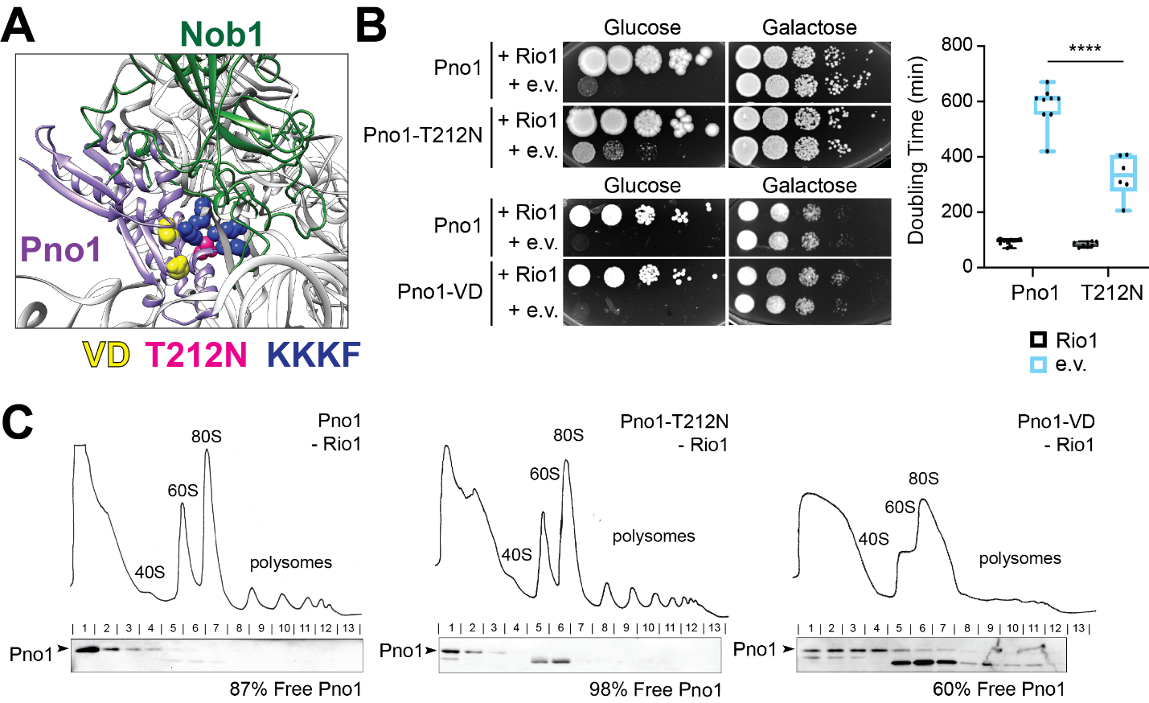
Figure S4. The dissociation of Tsr3 is required for accommodation of Rio1 in 80S-like ribosomes.
- Composite structure of S. cerevisiae pre-40S ribosomal rRNA (grey) bound to Pno1 (S.c., PDBID: 6FAI, purple) and Nob1 (H.s., PDB ID: 6ZXE, green). The overlay was generated based on Pno1.Ribosomal proteins were omitted for clarity. Mutations in Pno1 are shown in colored spheres: K208E/K211E/K213E/F214A (KKKF) is a weakly binding mutation shown in dark blue, T212N is a weakly binding mutant shown in pink, and V225A/D228N (VD) is not weakly binding and shown in yellow.
- (Left) Growth of Gal:Pno1,Gal::Rio1 cells expressing either wild type (WT) Pno1, Pno1-T212N, or Pno1-VD and either an empty vector (e.v.) or Rio1 was compared by 10-fold serial dilutions on minimal glucose or galactose plates. (Right) Doubling times of Gal:Pno1,Gal:Rio1 cells expressing either WT Pno1 or Pno1-T212N and in the presence (black) or absence of Rio1 (blue). ****p<0.0001 by one-way ANOVA test.
- 10%-50% sucrose gradients of lysates from cells depleted of Rio1 and expressing WT Pno1 (left), Pno1-T212N (middle), or Pno1-VD (right) encoded on plasmids. The endogenous Pno1 protein, transcribed from a GAL-promoter, is depleted by growth in glucose. Shown below the absorbance profiles at 254 nm are Western blots probing for Pno1. Arrowhead notes the upper band corresponding to Pno1. The percentage of Pno1 that is not bound to ribosomes is listed below the gradients.

Table S1: Yeast strains used in this study
Strains | Description | Genotype | Reference
YKK200 | BY4741 | MATa His3-1 Leu2-0 Met15-0 Ura3-0) | Open Biosystems
YKK218 | Gal:Fap7 | BY4741, Gal:Fap7(KAN) | (Strunk et al., 2011)
YKK1387 | ΔTsr3, Gal:Fap7 | BY4741, ΔTsr3 (KAN), Gal:Fap7 (HYG) | This work
YKK1141 | Rio2-TAP, Gal:Tsr1, Gal:S15 | BY4741, Rio2-TAP, Gal:Tsr1(KAN), Gal:S15(NAT) | This work
YKK96 | Tsr1-TAP | BY4741, Tsr1-TAP (HIS) | Open Biosystems
YKK731 | Tsr1-TAP,Gal:Fap7 | BY4741, Tsr1-TAP (HIS), Gal:Fap7 (NAT) | (Ghalei et al., 2017)
YKK988 | Gal:Pno1,Gal:Rio1 | BY4741, Gal:Pno1 (KAN), Gal:Rio1 (NAT) | (Parker et al., 2019)
YKK135 | Rps3-TAP | BY4741, Rps3-TAP (HIS) | Open Biosystems
YKK1150 | Gal:S15 | BY4741, Gal:S15(NAT) | (Huang et al., 2020)
YKK1324 | ΔTsr3 | BY4741, ∆Tsr3(KAN) | This work
YKK1181 | Gal:Rio2 | BY4741, Gal:Rio2(KAN) | (Huang et al., 2020)
YKK1399 | ΔTsr3, Gal:Rio2 | BY4741, ∆Tsr3(KAN),Gal:Rio2(NAT) | This work
YKK730 | Gal:S20 | BY4741, Gal:Rps20 (HYG) | (Collins et al., 2018)
YKK1398 | ΔTsr3, Gal:S20 | BY4741, ∆Tsr3(KAN),Gal:S20(HYG) | This work
YKK1396 | ΔTsr3, Gal:S15 | BY4741, ∆Tsr3(KAN),Gal:S15(NAT) | This work
YKK1201 | Gal:Rio2, Gal:S20 | BY4741, Gal:S20(HYG),Gal:Rio2(NAT) | (Huang et al., 2020)
YKK1183 | Gal:Rio2, Gal:S15 | BY4741, Gal:Rio2(KAN),Gal:S15(NAT) | (Huang et al., 2020)
YKK1492 | ΔTsr3, Gal:Pno1 | BY4741, ΔTsr3(KAN),Gal:Pno1(HYG) | This work
YKK1397 | ΔTsr3, Gal:Tsr1 | BY4741, ∆Tsr3(KAN),Gal:Tsr1(NAT) | This work
YKK73 | ΔLtv1 | BY4741, ΔLtv1(KAN) | (Strunk et al., 2011)
YKK1385 | ΔTsr3, ΔLtv1 | BY4741, ∆Tsr3(KAN), ∆Ltv1(NAT) | This work
YKK1190 | Gal:Rio2, ΔLtv1 | BY4741, Gal:Rio2(KAN), ∆Ltv1(HYG) | (Huang et al., 2020)
YKK1184 | Gal:Rio2, Gal:Tsr1 | BY4741, Gal:Rio2(KAN),Gal:Tsr1(NAT) | (Huang et al., 2020)
YKK493 | Gal:S3 | BY4741, Gal:Rps3 (KAN) | (Collins et al., 2018)
YKK1557 | Tsr1-TAP, ΔTsr3, Gal:Fap7 | BY4741, Tsr1-TAP (HIS), ΔTsr3 (KAN), Gal:Fap7(HYG) | This work

Table S2: Plasmids used in this study
Plasmid | Description | Vector | Reference | Detailed description
PKK30116 | WT S15 | TEF 416 | (Huang et al., 2020)
PKK30180 | S15_YRR | TEF 416 | (Huang et al., 2020) | Y123I,R127K,R130K
PKK30181 | S15_RK | TEF 416 | (Huang et al., 2020) | R137E,K142E
PKK30394 | S15_EE | TEF 416 | (Huang et al., 2020) | E110K,E118K
PKK30130 | WT Fap7 | 415 | This work | Endogenous promoter/terminator
PKK30157 | TAP-Pno1 | TEF 413 | (Parker et al., 2019)
PKK30696 | WT Tsr3 | TEF 413 | This work
PKK30711 | Tsr3_W114A | TEF 413 | This work
PKK30801 | Tsr3_R131A | TEF 413 | This work
PKK30802 | Tsr3_RK | TEF 413 | This work | R60A,K65A
PKK30807 | Tsr3_RK/R131A | TEF 413 | This work | R60A,K65A,R131A
PKK30803 | Tsr3_W114A/R131A | TEF 413 | This work
PKK30804 | Tsr3_W114A/RK | TEF 413 | This work | R60A,K65A,W114A
PKK30808 | Tsr3_W114A/R131A/RK | TEF 413 | This work | R60A,K65A,R131A,W114A
PKK30156 | WT Rio1 | TEF 415 | (Parker et al., 2019)
PKK3313 | WT Rio1 | CYC1 415 | (Parker et al., 2019)
PKK3350 | WT Rio2 | TEF 413 | (Huang et al., 2020)
PKK3795 | Rio2_K105E | TEF 413 | (Huang et al., 2020) | K105E; see also (Ferreira-Cerca et al., 2012)
PKK3452 | Rio2_D253A | TEF 413 | (Huang et al., 2020) | D253A; see also (Ferreira-Cerca et al., 2012)
PKK30356 | Rio2_loop | TEF 413 | (Huang et al., 2020) | R129A, H133A, R136A, R139A, D140A, K143A, K144A; see also (Ferreira-Cerca et al., 2012)
PKK30332 | Rio2_RQQR | TEF 413 | (Huang et al., 2020) | R17E,Q20E,Q24E,R27E
PKK30354 | Rio2_Δloop | TEF 413 | (Huang and Karbstein, 2021) | Deletion of amino acids 129-146.
PKK30208 | WT Rio2 | CYC1 415 | (Huang et al., 2020)
PKK30348 | Rio2_loop | CYC1 415 | (Huang et al., 2020) | See PKK 30356
PKK30211 | Rio2_K105E | CYC1 415 | (Huang et al., 2020)
PKK30253 | Rio2_D253A | CYC1 415 | (Huang et al., 2020)
PKK30369 | Rio2_Δloop | CYC1 415 | (Huang and Karbstein, 2021) | See PKK30354
PKK3890 | WT S20 | TEF 415 | (Collins et al., 2018)
PKK3934 | S20_DE | TEF 415 | (Collins et al., 2018) | D113K,E115K
PKK3891 | S20_EYER | TEF 415 | (Collins et al., 2018) | E80K,Y82A,E83K,R85E
PKK30302 | S20_RK | TEF 415 | (Huang et al., 2020) | R68E,K69E; see also (Mitterer et al., 2019)
PKK30303 | S20_Δloop | TEF 415 | (Huang et al., 2020) | Substitution of residues 68 to 78 and with GG; see also (Mitterer et al., 2019)
PKK30224 | WT Pno1 | TEF 415 | (Johnson et al., 2017)
PKK30225 | Pno1_KKKF | TEF 415 | (Johnson et al., 2017) | K208E, K211E, K213E, F214A
PKK30226 | WT Pno1 | CYC1 415 | This work
PKK30817 | Pno1_T212N | CYC1 415 | This work
PKK30818 | Pno1_VD | CYC1 415 | This work | V225A,D228N
PKK 3270 | WT Pno1 | TEF 416 | This work
PKK30620 | Pno1_T212N | TEF 416 | This work
PKK30438 | Pno1_VD | TEF 416 | This work | See PKK30818
PKK30183 | WT Tsr1 | TEF 415 | (Huang et al., 2020)
PKK3295 | WT Tsr1 | TEF 416 | (Huang et al., 2020)
PKK3716 | Tsr1_RK | TEF 416 | (Huang et al., 2020) | R709E,K712E
PKK3606 | WT Ltv1 | TEF 413 | (Ghalei et al., 2015)
PKK3521 | WT S3 | TEF 416 | (Collins et al., 2018)
PKK3933 | S3_KK | TEF 416 | (Collins et al., 2018) | S3_K7D,K10E
PKK3001 | WT Fap7 | CYC1 415 | (Ghalei et al., 2017)
PKK3003 | Fap7_G19S | CYC1 415 | (Ghalei et al., 2017)
PKK3075 | Fap7_K20R | CYC1 415 | (Ghalei et al., 2017)

Table S3: Yeast strains and plasmids used in each Figure.
Figure | Yeast strains | Plasmids | Vectors
Figure 1C, 3G | Gal:Fap7 | / | /
Figure 1C, 3G | ΔTsr3, Gal:Fap7 | / | /
Figure 1E, S2B | Rio2-TAP, Gal:Tsr1, Gal:S15 | Tsr1 & S15 | TEF 415 & TEF 416
Figure 1E, S2B | Rio2-TAP, Gal:Tsr1, Gal:S15 | Tsr1 & S15_RK | TEF 415 & TEF 416
Figure 1E, S2B | Tsr1-TAP | / | /
Figure 1E, S2B | Tsr1-TAP,Gal:Fap7 | / | /
Figure 1E, S2B | Gal:Pno1,Gal:Rio1 | TAP-Pno1+ Rio1 | TEF 413 & TEF 415
Figure 1E, S2B | Gal:Pno1,Gal:Rio1 | TAP-Pno1+ empty vector | TEF 413 & TEF 415
Figure 1E, S2B | Rps3-TAP | / | /
Figure 2B | Gal:S15 | WT S15 + empty vector | TEF 416 & TEF 413
Figure 2B | Gal:S15 | S15_YRR+ empty vector | TEF 416 & TEF 413
Figure 2B | Gal:S15 | WT S15 + Tsr3 | TEF 416 & TEF 413
Figure 2B | Gal:S15 | S15_YRR+ Tsr3 | TEF 416 & TEF 413
Figure 2C | Gal:S3 | WT S3 + empty vector | TEF 416 & TEF 413
Figure 2C | Gal:S3 | S3_KK + empty vector | TEF 416 & TEF 413
Figure 2C | Gal:S3 | WT S3 + Tsr3 | TEF 416 & TEF 413
Figure 2C | Gal:S3 | S3_KK + Tsr3 | TEF 416 & TEF 413
Figure 3A & S3B | Gal:Rio2 or ΔTsr3, Gal:Rio2 | WT Rio2 | CYC1 415
Figure 3A & S3B | Gal:Rio2 or ΔTsr3, Gal:Rio2 | Rio2_K105E | CYC1 415
Figure 3A & S3B | Gal:Rio2 or ΔTsr3, Gal:Rio2 | Rio2_D253A | CYC1 415
Figure 3A & S3B | Gal:Rio2 or ΔTsr3, Gal:Rio2 | Rio2_loop | CYC1 415
Figure 3A & S3B | Gal:Rio2 or ΔTsr3, Gal:Rio2 | Rio2_Δloop | CYC1 415
Figure 3A & S3B | Gal:S20 or  ΔTsr3, Gal:S20 | WT S20 | TEF 415
Figure 3A & S3B | Gal:S20 or  ΔTsr3, Gal:S20 | S20_DE | TEF 415
Figure 3A & S3B | Gal:S20 or  ΔTsr3, Gal:S20 | S20_EYER | TEF 415
Figure 3A & S3B | Gal:S20 or  ΔTsr3, Gal:S20 | S20_RK | TEF 415
Figure 3A & S3B | Gal:S20 or  ΔTsr3, Gal:S20 | S20_Δloop | TEF 415
Figure 3A & S3B | Gal:S15 or ΔTsr3, Gal:S15 | WT S15 | TEF 416
Figure 3A & S3B | Gal:S15 or ΔTsr3, Gal:S15 | S15_YRR | TEF 416
Figure 3A & S3B | Gal:S15 or ΔTsr3, Gal:S15 | S15_RK | TEF 416
Figure 3A & S3B | Gal:S15 or ΔTsr3, Gal:S15 | S15_EE | TEF 416
Figure 3A & S3B | Gal:Tsr1 or ΔTsr3, Gal:Tsr1 | WT Tsr1 | TEF 416
Figure 3A & S3B | Gal:Tsr1 or ΔTsr3, Gal:Tsr1 | Tsr1_RK | TEF 416
Figure 3A & S3B | BY4741 | / | /
Figure 3A & S3B | ΔTsr3 | / | /
Figure 3A & S3B | ΔLtv1 | / | /
Figure 3A & S3B | ΔTsr3, ΔLtv1 | / | /
Figure 3D & S3C | Gal:Rio2 | WT Rio2 | TEF 413
Figure 3D & S3C | Gal:Rio2 | Rio2_K105E | TEF 413
Figure 3D & S3C | Gal:Rio2 | Rio2_D253A | TEF 413
Figure 3D & S3C | Gal:Rio2 | Rio2_loop | TEF 413
Figure 3D & S3C | Gal:Rio2 | Rio2_Δloop | TEF 413
Figure 3D & S3C | Gal:Rio2 | WT Rio2 | CYC1 415
Figure 3D & S3C | Gal:Rio2 | Rio2_K105E | CYC1 415
Figure 3D & S3C | Gal:Rio2 | Rio2_D253A | CYC1 415
Figure 3D & S3C | Gal:Rio2 | Rio2_loop | CYC1 415
Figure 3D & S3C | Gal:Rio2 | Rio2_Δloop | CYC1 415
Figure 3D & S3C | Gal:S20 | WT S20 | TEF 415
Figure 3D & S3C | Gal:S20 | S20_RK | TEF 415
Figure 3D & S3C | Gal:S20 | S20_Δloop | TEF 415
Figure 3D & S3C | Gal:S20 | S20_DE | TEF 415
Figure 3D & S3C | Gal:S20 | S20_EYER | TEF 415
Figure 3D & S3C | Gal:S20,Gal:Rio2 | WT S20 + WT Rio2 | TEF 415 & TEF413
Figure 3D & S3C | Gal:S20,Gal:Rio2 | S20_RK + WT Rio2 | TEF 415 & TEF413
Figure 3D & S3C | Gal:S20,Gal:Rio2 | S20_Δloop + WT Rio2 | TEF 415 & TEF413
Figure 3D & S3C | Gal:S20,Gal:Rio2 | S20_DE + WT Rio2 | TEF 415 & TEF413
Figure 3D & S3C | Gal:S20,Gal:Rio2 | S20_EYER + WT Rio2 | TEF 415 & TEF413
Figure 3D & S3C | Gal:S15 | WT S15 | TEF 416
Figure 3D & S3C | Gal:S15 | S15_YRR | TEF 416
Figure 3D & S3C | Gal:S15 | S15_RK | TEF 416
Figure 3D & S3C | Gal:S15 | S15_EE | TEF 416
Figure 3D & S3C | Gal:S15,Gal:Rio2 | WT S15 + WT Rio2 | TEF 416 & TEF413
Figure 3D & S3C | Gal:S15,Gal:Rio2 | S15_YRR + WT Rio2 | TEF 416 & TEF413
Figure 3D & S3C | Gal:S15,Gal:Rio2 | S15_RK + WT Rio2 | TEF 416 & TEF413
Figure 3D & S3C | Gal:S15,Gal:Rio2 | S15_EE + WT Rio2 | TEF 416 & TEF413
Figure 3D & S3C | Gal:Tsr1,Gal:Rio2 | WT Tsr1 + TEF Rio2 | TEF 416 & TEF413
Figure 3D & S3C | Gal:Tsr1,Gal:Rio2 | Tsr1_RK + TEF Rio2 | TEF 416 & TEF413
Figure 3D & S3C | Gal:Tsr1,Gal:Rio2 | WT Tsr1 + CYC1 Rio2 | TEF 416 & CYC1 415
Figure 3D & S3C | Gal:Tsr1,Gal:Rio2 | Tsr1_RK + CYC1 Rio2 | TEF 416 & CYC1 415
Figure 3D & S3C | Gal:Rio2, ΔLtv1 | TEF Rio2 + WT Ltv1 | TEF 413 & TEF416
Figure 3D & S3C | Gal:Rio2, ΔLtv1 | TEF Rio2 + empty vector | TEF 413 & TEF416
Figure 3D & S3C | Gal:Rio2, ΔLtv1 | CYC1 Rio2 + WT Ltv1 | CYC1 415 & TEF416
Figure 3D & S3C | Gal:Rio2, ΔLtv1 | CYC1 Rio2 + empty vector | CYC1 415 & TEF416
Figure 3E | Gal:Rio2 or ΔTsr3, Gal:Rio2 | WT Rio2 | TEF 413
Figure 3E | Gal:Rio2 or ΔTsr3, Gal:Rio2 | Rio2_RQQR | TEF 413
Figure 3E | Gal:Rio2 or ΔTsr3, Gal:Rio2 | WT Rio2 | CYC1 415
Figure 3F | BY4741 | / | /
Figure 3F | ΔTsr3 | / | /
Figure 4A | ΔTsr3 | WT Tsr3 | TEF 413
Figure 4A | ΔTsr3 | Empty vector | TEF 413
Figure 4A | ΔTsr3 | Tsr3_W114A | TEF 413
Figure 4B | BY4741 | WT Tsr3 | TEF 413
Figure 4B | BY4741 | Tsr3_W114A | TEF 413
Figure 4C | ΔTsr3 | WT Tsr3 | TEF 413
Figure 4C | ΔTsr3 | Tsr3_W114A | TEF 413
Figure 4C | ΔTsr3 | Tsr3_R131A | TEF 413
Figure 4C | ΔTsr3 | Tsr3_RK | TEF 413
Figure 4C | ΔTsr3 | Tsr3_RK/R131A | TEF 413
Figure 4C | ΔTsr3 | Tsr3_W114A/R131A | TEF 413
Figure 4C | ΔTsr3 | Tsr3_W114A/RK | TEF 413
Figure 4C | ΔTsr3 | Tsr3_W114A/R131A/RK | TEF 413
Figure 4D, 5A | ΔTsr3 | HA-Tsr3 | TEF 413
Figure 4D, 5A | ΔTsr3 | HA-Tsr3_W114A | TEF 413
Figure 5B | Tsr1-TAP, ΔTsr3, Gal:Fap7 | HA-Tsr3 | TEF 416
Figure 5B | Tsr1-TAP, ΔTsr3, Gal:Fap7 | HA-Tsr3_W114A | TEF 416
Figure 5C | ΔTsr3, Gal:Pno1 | WT Tsr3 + WT Pno1 | TEF 413 + TEF 415
Figure 5C | ΔTsr3, Gal:Pno1 | WT Tsr3 + Pno1_KKKF | TEF 413 + TEF 415
Figure 5C | ΔTsr3, Gal:Pno1 | Tsr3_W114A + WT Pno1 | TEF 413 + TEF 415
Figure 5C | ΔTsr3, Gal:Pno1 | Tsr3_W114A + Pno1_KKKF | TEF 413 + TEF 415
Figure 5D | ΔTsr3, Gal:Pno1 | WT Tsr3 + WT Pno1 | TEF 413 + CYC1 415
Figure 5D | ΔTsr3, Gal:Pno1 | WT Tsr3 + Pno1_T212N | TEF 413 + CYC1 415
Figure 5D | ΔTsr3, Gal:Pno1 | WT Tsr3 + Pno1_VD | TEF 413 + CYC1 415
Figure 5D | ΔTsr3, Gal:Pno1 | Tsr3_W114A + WT Pno1 | TEF 413 + CYC1 415
Figure 5D | ΔTsr3, Gal:Pno1 | Tsr3_W114A + Pno1_T212N | TEF 413 + CYC1 415
Figure 5D | ΔTsr3, Gal:Pno1 | Tsr3_W114A + Pno1_VD | TEF 413 + CYC1 415
Figure 6A | BY4741 | / | /
Figure 6A | ΔTsr3 | / | /
Figure 6B | ΔTsr3, Gal:Pno1 | WT Tsr3 + WT Pno1 | TEF 413 & TEF 415
Figure 6B | ΔTsr3, Gal:Pno1 | Empty vector + WT Pno1 | TEF 413 & TEF 415
Figure 6B | ΔTsr3, Gal:Pno1 | WT Tsr3 + Pno1_KKKF | TEF 413 & TEF 415
Figure 6B | ΔTsr3, Gal:Pno1 | Empty vector + Pno1_KKKF | TEF 413 & TEF 415
Figure 6C | ΔTsr3, Gal:S15 | WT Tsr3 + WT S15 | TEF 413 & TEF 416
Figure 6C | ΔTsr3, Gal:S15 | WT Tsr3 + S15_YRR | TEF 413 & TEF 416
Figure 6C | ΔTsr3, Gal:S15 | WT Tsr3 + S15_RK | TEF 413 & TEF 416
Figure 6C | ΔTsr3, Gal:S15 | Tsr3_W114A + WT S15 | TEF 413 & TEF 416
Figure 6C | ΔTsr3, Gal:S15 | Tsr3_W114A + S15_YRR | TEF 413 & TEF 416
Figure 6C | ΔTsr3, Gal:S15 | Tsr3_W114A + S15_RK | TEF 413 & TEF 416
Figure 6D | ΔTsr3, Gal:Fap7 | WT Tsr3 + WT Fap7 | TEF 413 & CYC1 415
Figure 6D | ΔTsr3, Gal:Fap7 | WT Tsr3 + Fap7_G19S | TEF 413 & CYC1 415
Figure 6D | ΔTsr3, Gal:Fap7 | WT Tsr3 + Fap7_K20R | TEF 413 & CYC1 415
Figure 6D | ΔTsr3, Gal:Fap7 | Tsr3_W114A + WT Fap7 | TEF 413 & CYC1 415
Figure 6D | ΔTsr3, Gal:Fap7 | Tsr3_W114A + Fap7_G19S | TEF 413 & CYC1 415
Figure 6D | ΔTsr3, Gal:Fap7 | Tsr3_W114A + Fap7_K20R | TEF 413 & CYC1 415
Figure S2A | Gal:S15 | WT S15 | TEF 416
Figure S2A | Gal:S15 | S15_RK | TEF 416
Figure S2A | Gal:S15 | S15_EE | TEF 416
Figure S4B &S4C | Gal:Pno1,Gal:Rio1 | WT Pno1 + WT Rio1
Figure S4B &S4C | Gal:Pno1,Gal:Rio1 | WT Pno1 + empty vector
Figure S4B &S4C | Gal:Pno1,Gal:Rio1 | Pno1_T212N + WT Rio1
Figure S4B &S4C | Gal:Pno1,Gal:Rio1 | Pno1_T212N + empty vector
Figure S4B &S4C | Gal:Pno1,Gal:Rio1 | Pno1_VD + WT Rio1
Figure S4B &S4C | Gal:Pno1,Gal:Rio1 | Pno1_VD + empty vector

Table S4: Oligos used in this study
Description | Sequence | Reference
18S probe | TCCCCTAACTTTCGTTCTTG | (Strunk et al., 2012)
20S probe | GCT CTC ATG CTC TTG CC | (Strunk et al., 2012)
25S probe | GCCCGTTCCCTTGGCTGTG | (Strunk et al., 2012)
RT probe for acp- modification detection | CCACAAAATCAAGAAAGAGCTCTC | This work

References
Collins, J.C., Ghalei, H., Doherty, J.R., Huang, H., Culver, R.N., and Karbstein, K. (2018). Ribosome biogenesis factor Ltv1 chaperones the assembly of the small subunit head. Journal of Cell Biology 217, 4141-4154.
Ferreira-Cerca, S., Sagar, V., Schafer, T., Diop, M., Wesseling, A.M., Lu, H.Y., Chai, E., Hurt, E., and LaRonde-LeBlanc, N. (2012). ATPase-dependent role of the atypical kinase Rio2 on the evolving pre-40S ribosomal subunit. Nature Structural & Molecular Biology 19, 1316-+.
Ghalei, H., Schaub, F.X., Doherty, J.R., Noguchi, Y., Roush, W.R., Cleveland, J.L., Stroupe, M.E., and Karbstein, K. (2015). Hrr25/CK1delta-directed release of Ltv1 from pre-40S ribosomes is necessary for ribosome assembly and cell growth. J Cell Biol 208, 745-759.
Ghalei, H., Trepreau, J., Collins, J.C., Bhaskaran, H., Strunk, B.S., and Karbstein, K. (2017). The ATPase Fap7 Tests the Ability to Carry Out Translocation-like Conformational Changes and Releases Dim1 during 40S Ribosome Maturation. Mol Cell 67, 990-1000 e1003.
Huang, H., Ghalei, H., and Karbstein, K. (2020). Quality control of 40S ribosome head assembly ensures scanning competence. Journal of Cell Biology 219.
Huang, H., and Karbstein, K. (2021). Assembly factors chaperone ribosomal RNA folding by isolating helical junctions that are prone to misfolding. Proceedings of the National Academy of Sciences 118, e2101164118.
Johnson, M.C., Ghalei, H., Doxtader, K.A., Karbstein, K., and Stroupe, M.E. (2017). Structural Heterogeneity in Pre-40S Ribosomes. Structure 25, 329-340.
Mitterer, V., Shayan, R., Ferreira-Cerca, S., Murat, G., Enne, T., Rinaldi, D., Weigl, S., Omanic, H., Gleizes, P.E., Kressler, D., et al. (2019). Conformational proofreading of distant 40S ribosomal subunit maturation events by a long-range communication mechanism. Nat Commun 10, 2754.
Parker, M.D., Collins, J.C., Korona, B., Ghalei, H., and Karbstein, K. (2019). A kinase-dependent checkpoint prevents escape of immature ribosomes into the translating pool. PLoS Biol 17, e3000329.
Strunk, B.S., Loucks, C.R., Su, M., Vashisth, H., Cheng, S., Schilling, J., Brooks, C.L., 3rd, Karbstein, K., and Skiniotis, G. (2011). Ribosome assembly factors prevent premature translation initiation by 40S assembly intermediates. Science 333, 1449-1453.
Strunk, B.S., Novak, M.N., Young, C.L., and Karbstein, K. (2012). A translation-like cycle is a quality control checkpoint for maturing 40S ribosome subunits. Cell 150, 111-121.

