Supplementary Figures:
Supplementary Figure 1 | Overview of the different library preparation protocols from ONT for the analysis of RNAs. 2
Supplementary Figure 2 | Bioanalyzer analysis of RNA quality, polyA-tailing efficiency and PCR amplification effect on fragment size. 2
Supplementary Figure 3 | Total sequencing throughput. 3
Supplementary Figure 4 | Raw read characteristics. 4
Supplementary Figure 5 | Overview of mapping statistics. 5
Supplementary Figure 6 | Quality control of mapped reads. 6
Supplementary Figure 7 | Relative quantification of mapped reads. 7
Supplementary Figure 8 | Aligned read quality control. 8
Supplementary Figure 9 | RT artefacts lead to 2D-like reads in the (PCR-)cDNA datasets. 9
Supplementary Figure 10 | Correlation between sequencing depth, sample treatment and the number of seen genes. 10
Supplementary Figure 11 | Influence of PCR on quantification. 11
Supplementary Figure 12 | Identification of full-length cDNA reads using Pychopper. 11
Supplementary Figure 13 | Base identities of terminal read positions and effects of trimming. 12
Supplementary Figure 14 | 5´ end detection using ONT data. 12
Supplementary Figure 15 | Reproducibility and comparability of 5´end detection. 13
Supplementary Figure 16 | Comparison of 5´ends detected by ONT and SMRT-Cap. 13
Supplementary Figure 17 | Features of primary 5´ends in E. coli. 14
Supplementary Figure 18 | 3´ end detection using ONT data. 14
Supplementary Figure 19 | Effect of read trimming on natural poly(A) sequences. 15
Supplementary Figure 20 | Correlation matrix of primary 3´ends. 15
Supplementary Figure 21 | Features of primary 3´ends in E. coli. 16
Supplementary Figure 22 | 3´-5´coverage bias in long transcriptional units. 17
Supplementary Figure 23 | Comparability of operon detection to SMRT-Cap and the Regulon database. 17
Supplementary Figure 24 | Operon analysis of the rpsB-containing operon. 18
Supplementary Figure 25 | Operon analysis of a genomic region containing many ribosomal proteins. 19
Supplementary Figure 26 | Detection of transcriptional heterogeneity and processing sites of the rpsO gene. 20

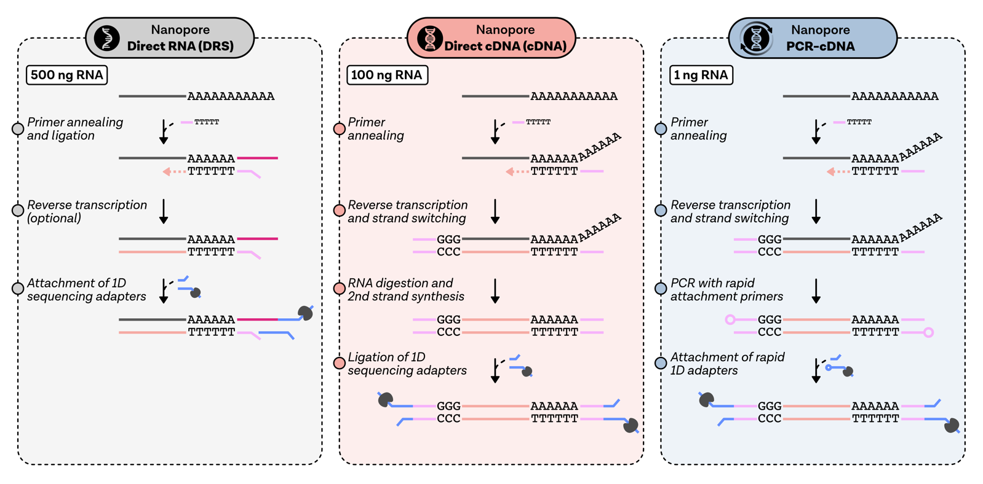
Supplementary Figure 1 | Overview of the different library preparation protocols from ONT for the analysis of RNAs.
Main steps are highlighted as bullet points on the left. Color-code: Input RNA (grey), cDNA (orange), motor-protein-carrying adapter (blue), barcoding primer (pink ds), splint adapter (pink-red ds). Please note that strand switching is visualised in a simplified way, and not always precisely three Cs are added during this process.

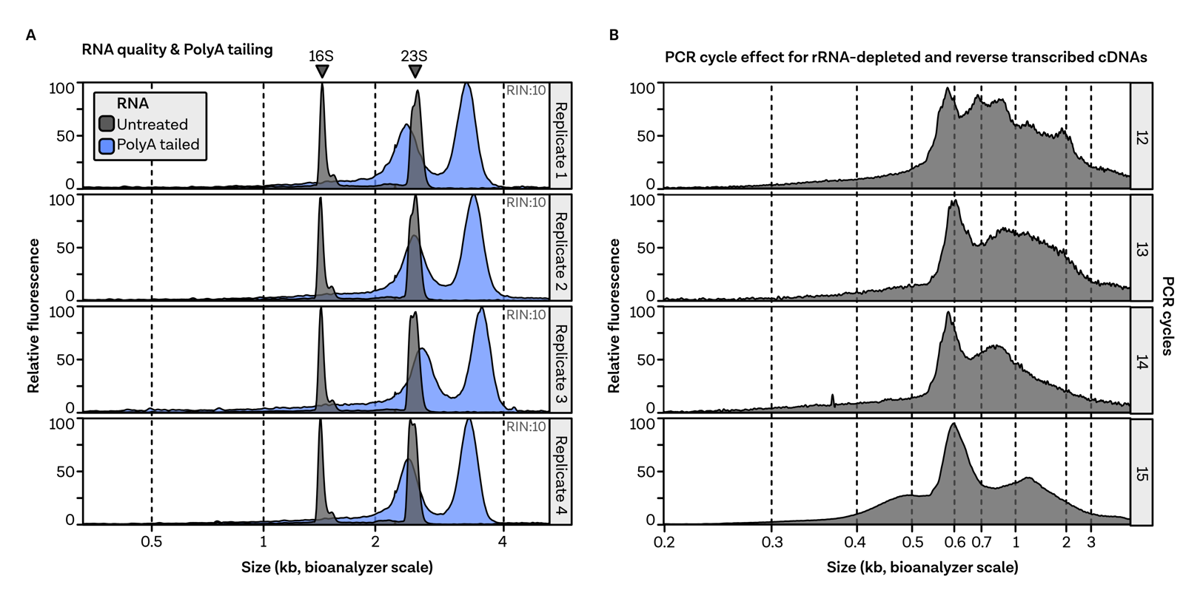
Supplementary Figure 2 | Bioanalyzer analysis of RNA quality, polyA-tailing efficiency and PCR amplification effect on fragment size.
A, Representative Bioanalyzer profiles for untreated (grey) and polyadenylated (blue) RNAs of four E. coli replicates. RIN values are highlighted in the top right corner (Schroeder et al., 2006). B, Increasing PCR cycles lead to overamplification of small transcripts, which can be seen in the Bioanalyzer profiles of PCB109 generated cDNAs using 12 to 15 cycles.

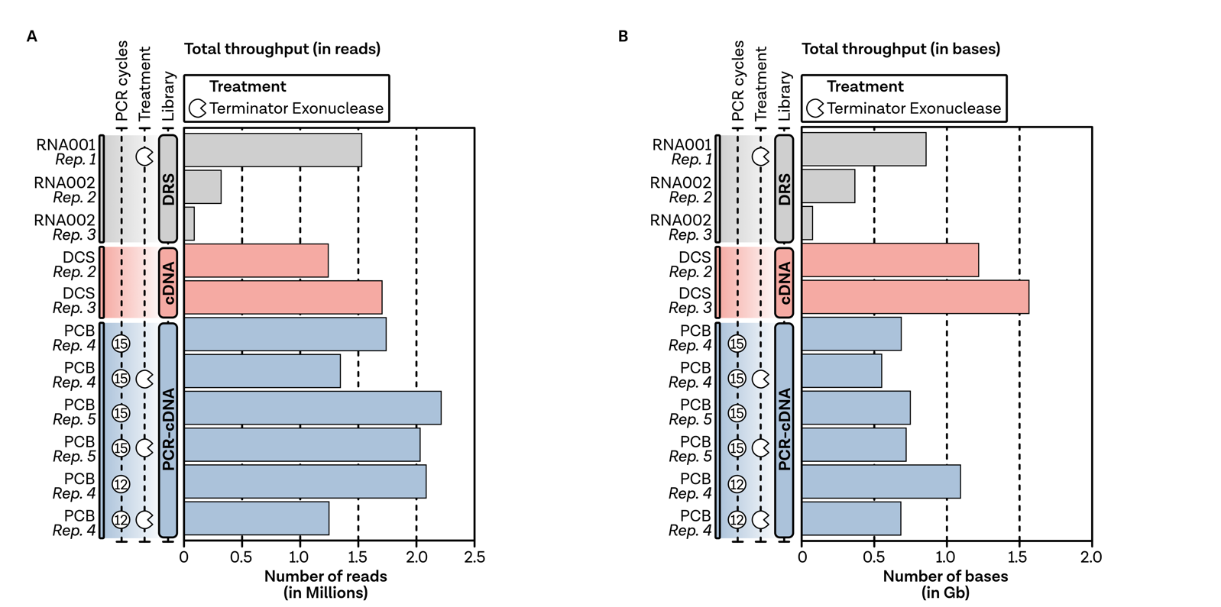
Supplementary Figure 3 | Total sequencing throughput.
A, Total number of sequenced reads (in Millions) color-coded by the respective library preparation protocol. ONT protocol (RNA001, RNA002, DCS, PCB), replicate number (1-5), number of PCR cycles (circle with number of PCR cycles inside) and TEX-treatment (pacman symbol) are summarised on the left. B, Total number of sequenced bases for each sample (in Gb).

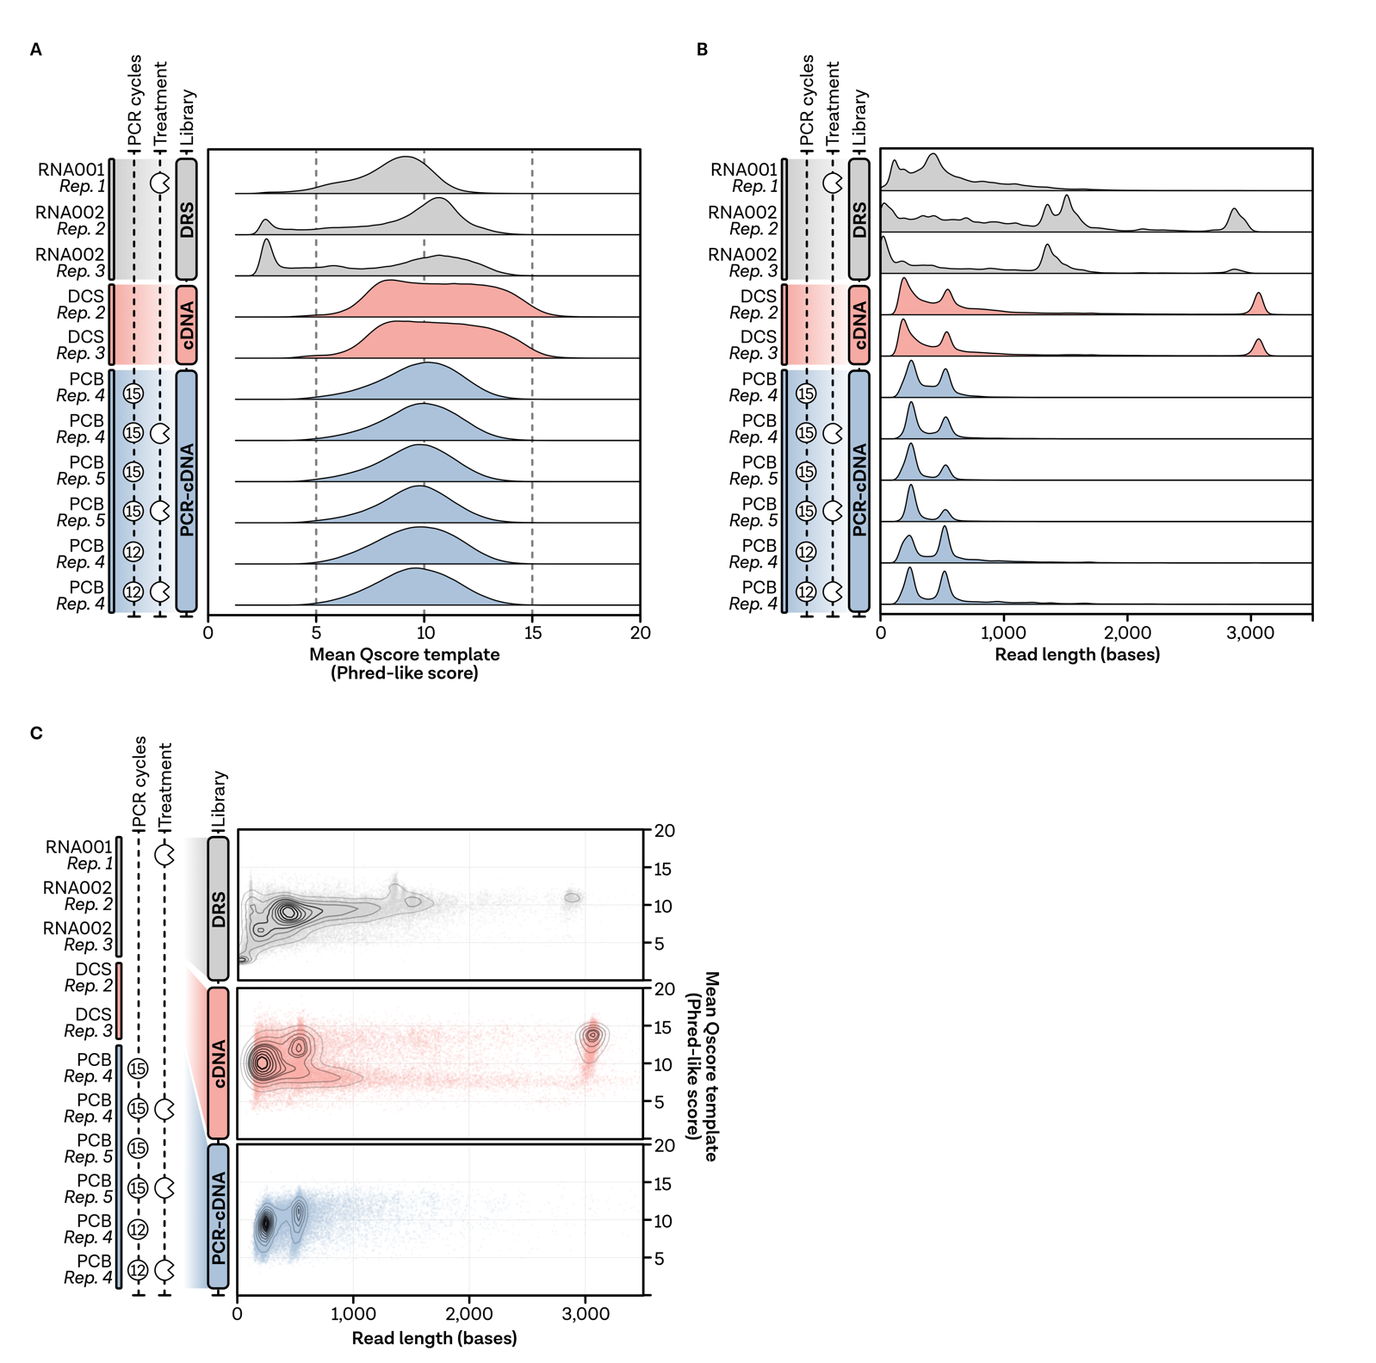
Supplementary Figure 4 | Raw read characteristics.
A, Distribution of raw read qualities, measured as qscore, from all unfiltered reads. B, Distribution of raw read lengths (bases) from all unfiltered reads. C, Relationship between read length and read quality shown as a 2D density plot. Black lines show the contour of the distribution, while the transparency of the filled area is reflecting the density of the data. 50,000 randomly sampled reads in each library group were used to generate this plot.

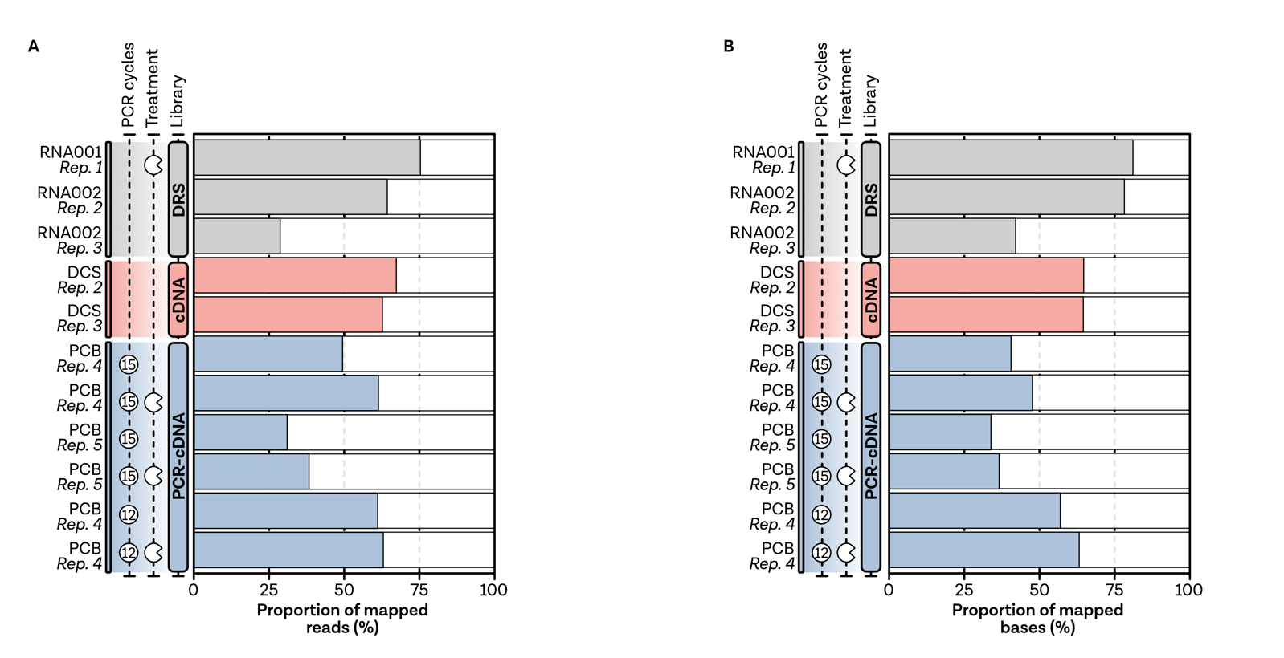
Supplementary Figure 5 | Overview of mapping statistics.
A, Proportion of mapped reads calculated by the number of minimap2-mapped reads divided by the total number of sequenced reads per sample. B, Proportion of mapped bases calculated by the sum of aligned reads divided by the total sum of the sequenced read length per sample.
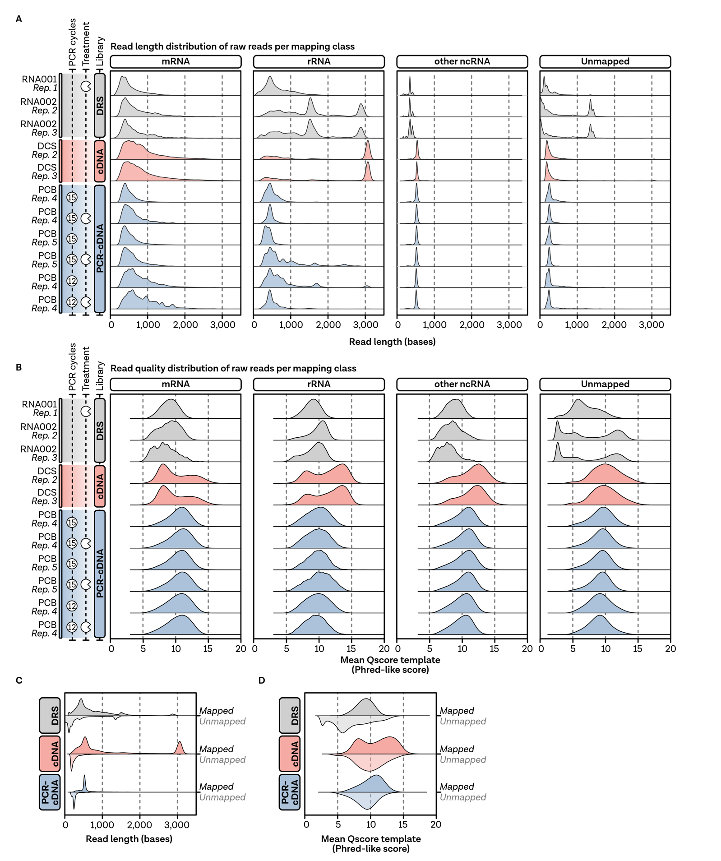
Supplementary Figure 6 | Quality control of mapped reads.
A, Raw read length distribution (sequence length template in ONTs sequencing summary file) per mapping class (column) and sample (row). Reads have been assigned to classes found in the GenBank entry U00096.3 (Riley et al., 2006). ncRNAs and tRNAs were combined and termed “other ncRNAs”. B, Raw read quality distribution (mean qscore value in ONTs sequencing summary file) per mapping class and sample. C, Distribution of raw read lengths and D, read qualities averaged per library method and separated by mapping behaviour. For this comparison, all reads of each library type were taken into account.
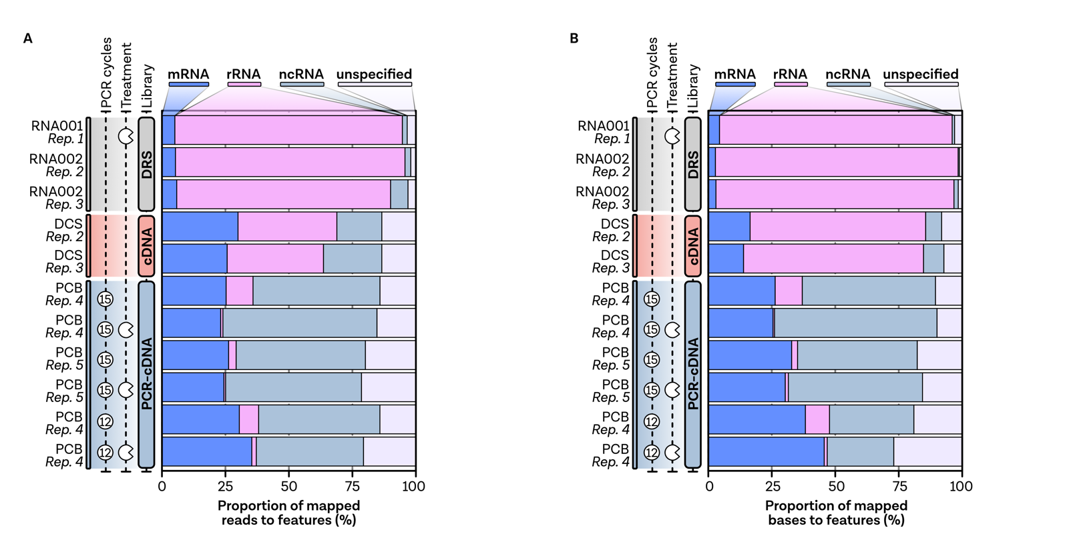
Supplementary Figure 7 | Relative quantification of mapped reads.
A, Barplot showing the relative proportion of mapped reads per color-coded features, calculated by comparing the total number of mapped reads in each class and dividing it by the total number of mapped reads. B, Proportion of mapped bases to features. In contrast to panel A, the sum of the aligned bases was compared in each class and divided by the total sum of aligned bases in each sample.

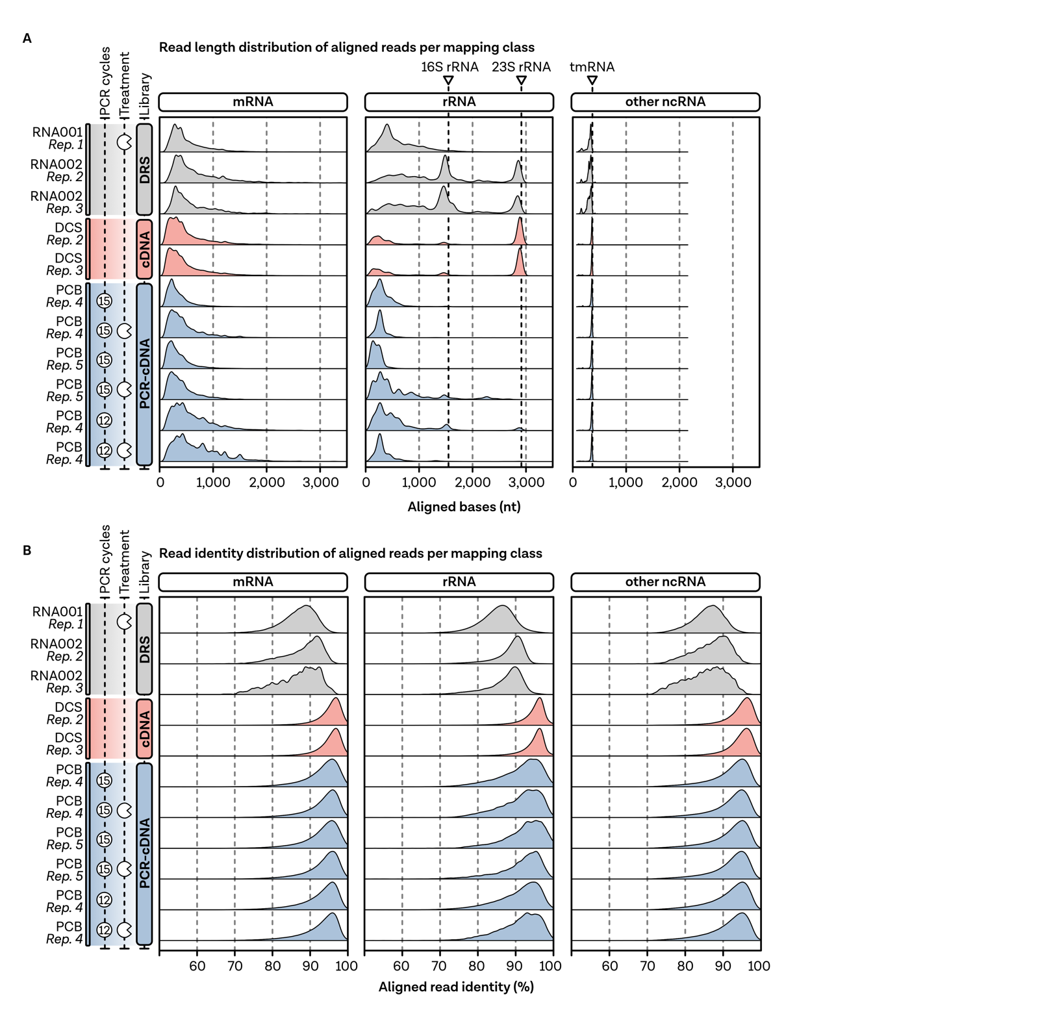
Supplementary Figure 8 | Aligned read quality control.
A, Distribution of aligned reads per mapping class. Reads have been assigned to classes found in the GenBank entry U00096.3 (Riley et al., 2006). ncRNAs and tRNAs were combined and termed “other ncRNAs”. Triangles indicate the expected sizes of highly abundant 16S rRNA, 23S rRNA and tmRNA. B, Aligned read identity per mapping class. Identity was defined as (1-NM/aligned_reads)*100, where NM is the edit distance reported taken from minimap2.

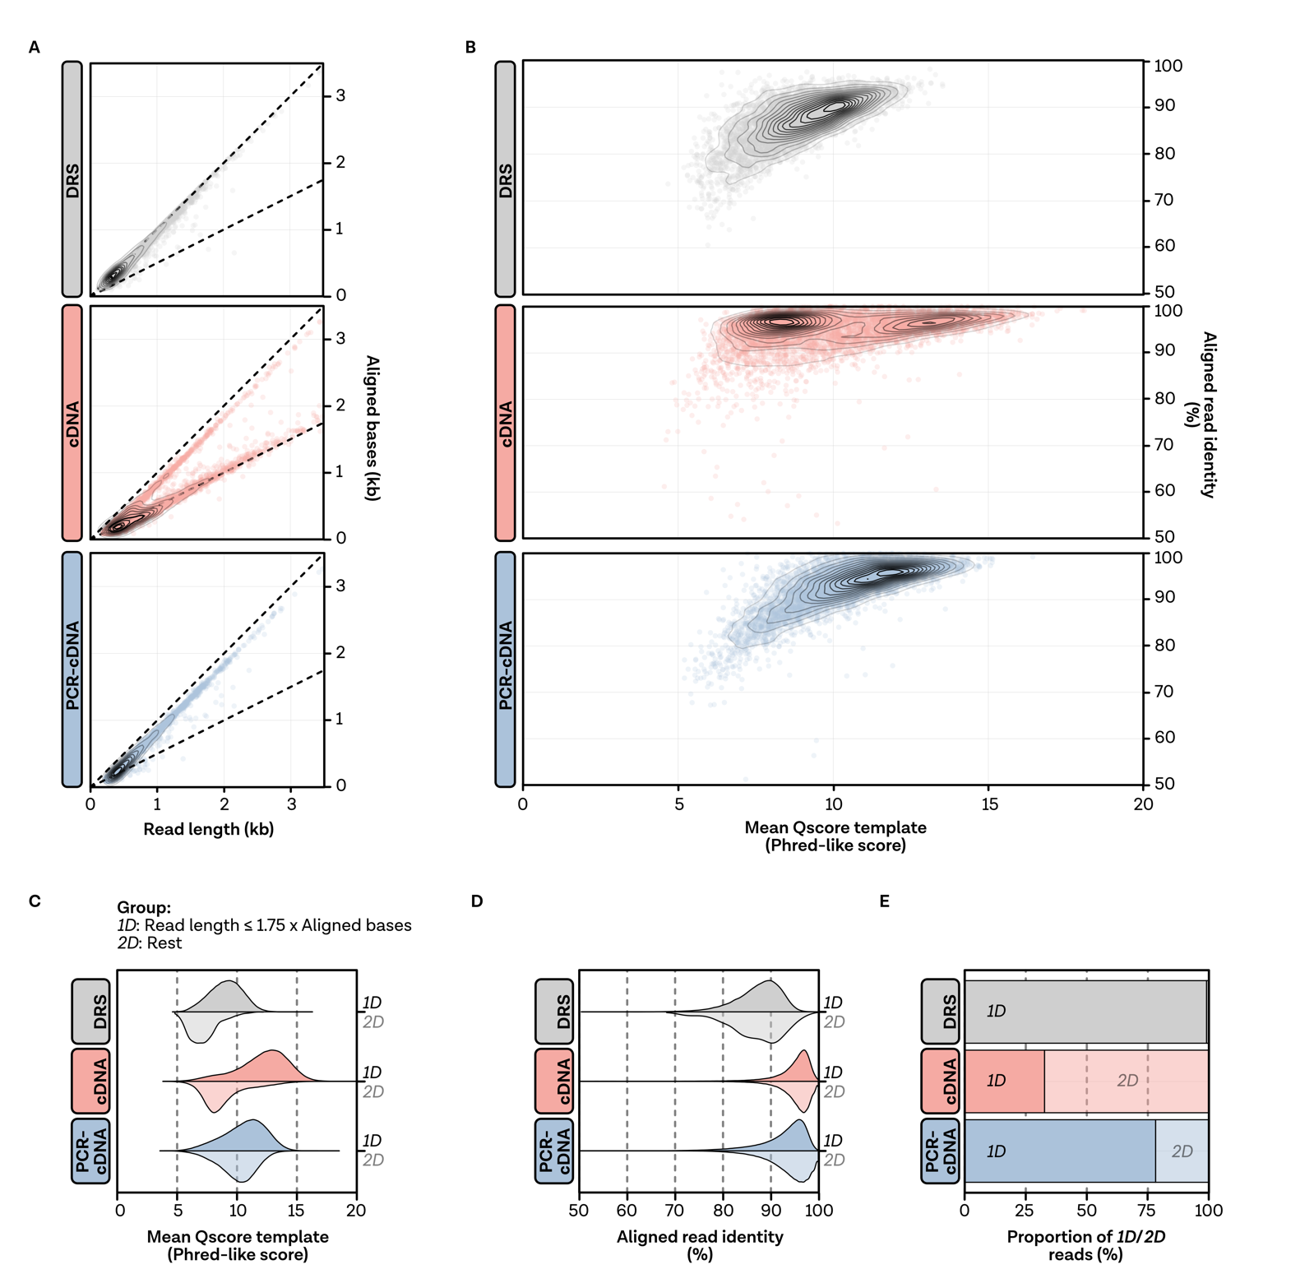
Supplementary Figure 9 | RT artefacts lead to 2D-like reads in the (PCR-)cDNA datasets.
A, Correlation between sequenced read length and aligned bases shown as a 2D density plot. Single reads are shown as points. To visualize the data, 50000 randomly sampled reads in each library group have been used. Different levels of the density plot are shown as contour plot. B, Correlation between read qualities and aligned read identity. 50,000 randomly sampled reads in each library group have been used to generate the plot. Density levels are shown as contour plots, while single reads are shown as points. C, Distribution of read qualities and D, read identities averaged per library method and separated by 1D or 2D-like group. E, Proportion of 1D and 2D read per library preparation method. For C, D and E all mRNA-mapping reads of all samples were taken into account. Reads were grouped based on the comparison between read length and aligned bases in group 1D (read length <= 1.75 x aligned bases) and group 2D (rest).

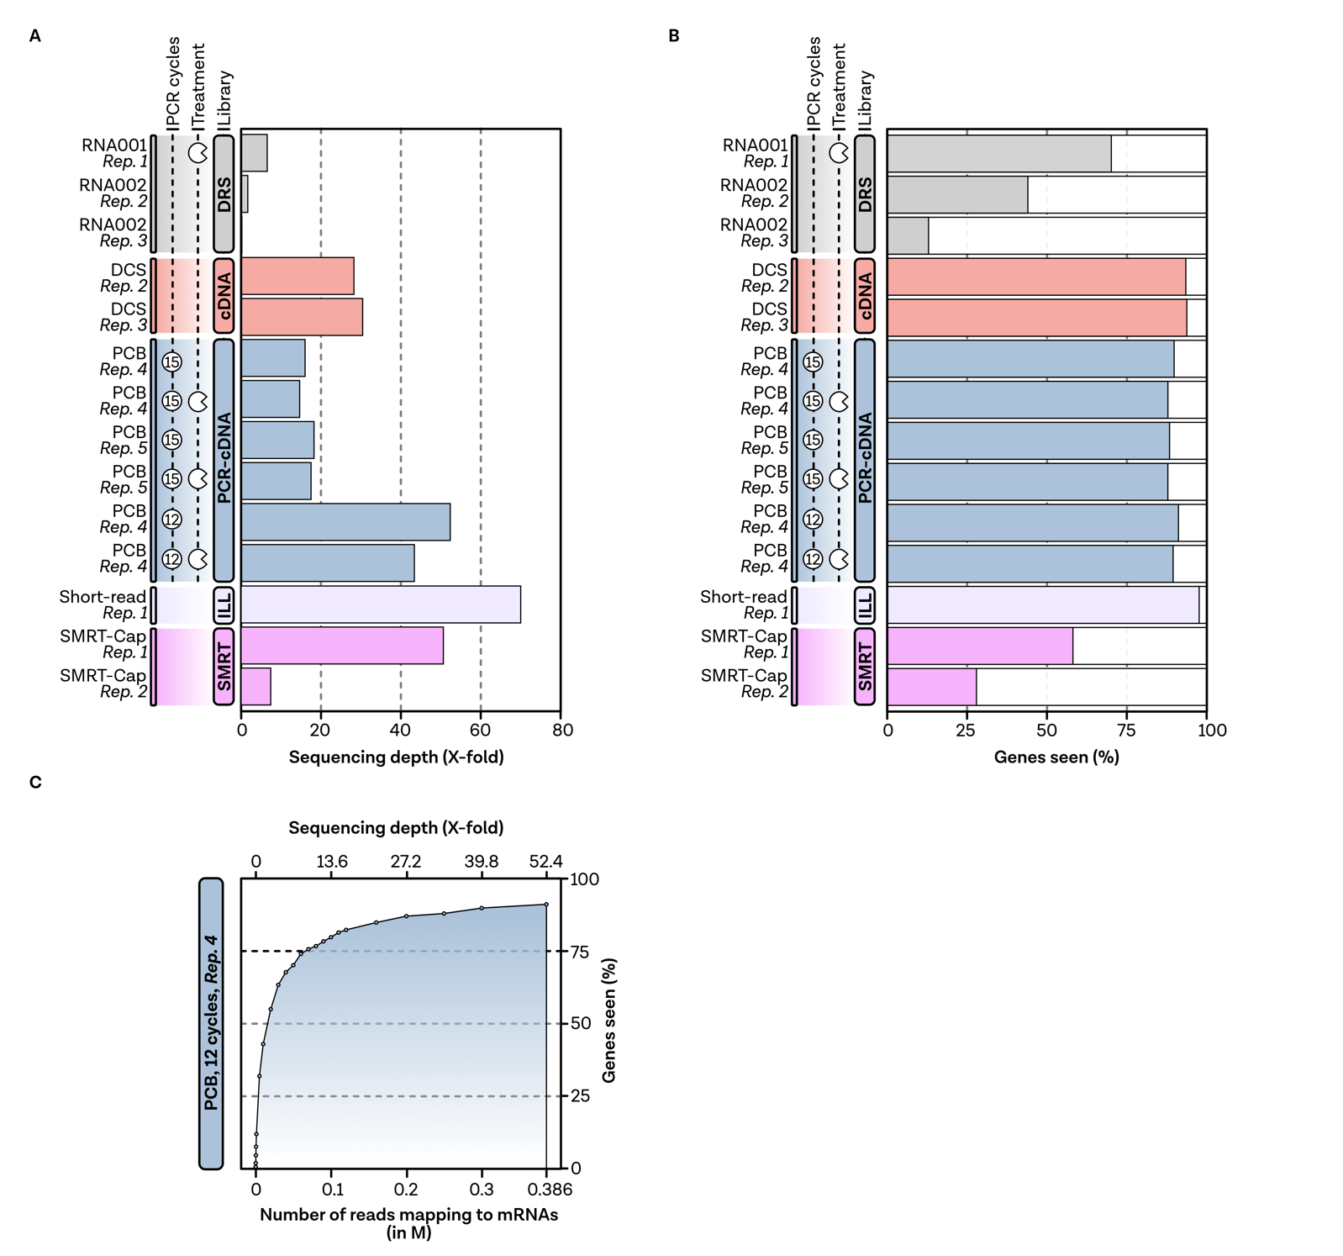
Supplementary Figure 10 | Correlation between sequencing depth, sample treatment and the number of seen genes.
A, Sequencing depth, calculated by the sum of aligned reads divided by the sum of all annotated CDS sizes, filtered for mRNA-mapping reads only. B, Percentage of genes seen per sample. C, Random subsampling of reads shows the correlation between sequencing depth and the percentage of genes seen. This analysis has been performed with reads from the PCR-cDNA sample (replicate 4) with 12 PCR cycles.

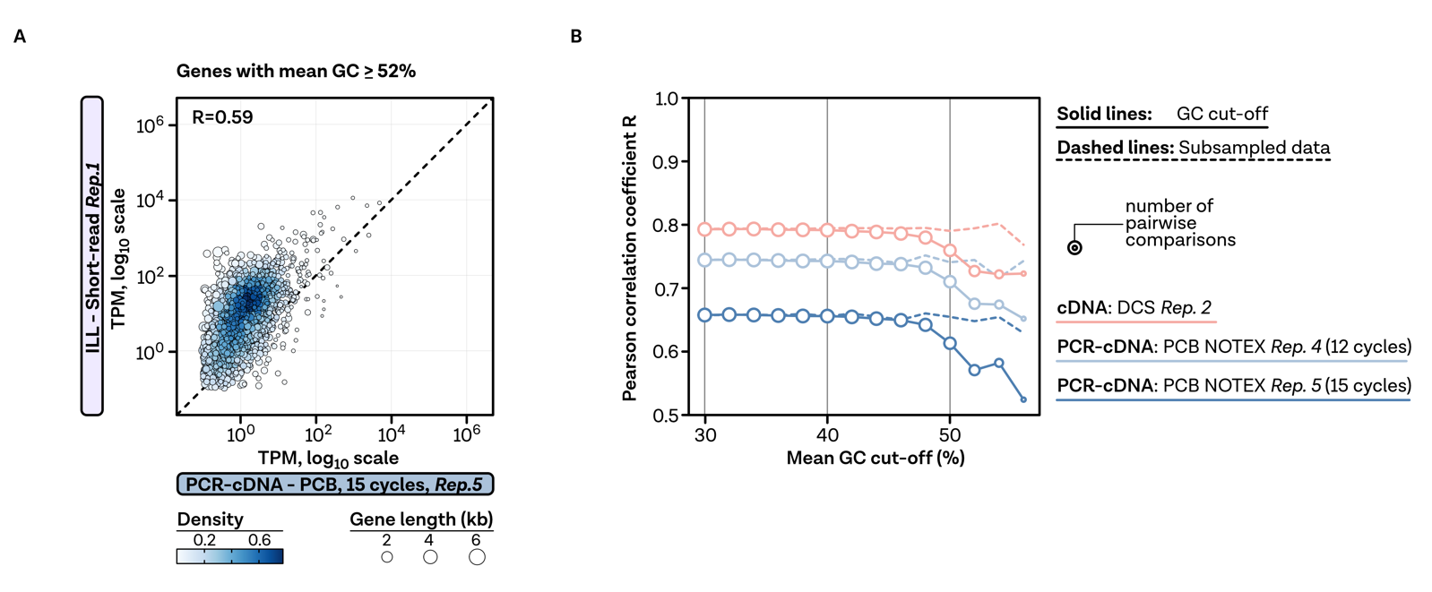
Supplementary Figure 11 | Influence of PCR on quantification.
A, Correlation between TPM counts of PCR-cDNA replicate 5 and short-read dataset for genes with a GC content bigger than 52% per gene. Each point represents one gene, color-coded by density at the plot position. Gene lengths are indicated by circle size. Pearson correlation calculated from pairwise complete observations is given at the top left. B, Pearson correlation coefficient for indicated datasets at the given GC cut-offs. The number of pairwise comparisons is shown by circle size, while the line type is used to compare genes with the GC cut-off to randomly subsampled data. The color-code on the right refers to selected samples from the different (PCR)-cDNA libraries.

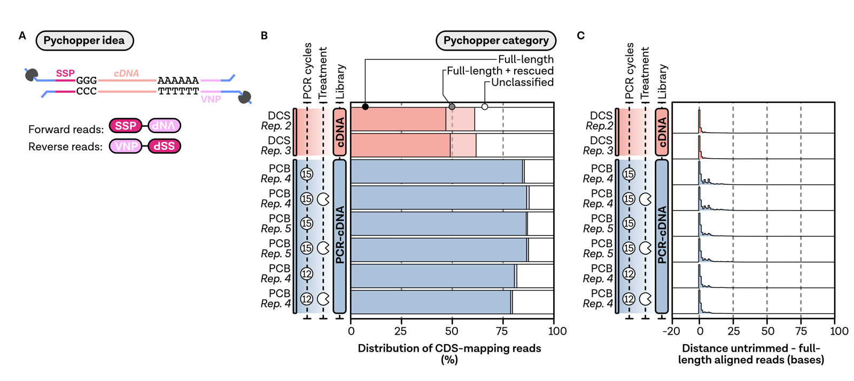
Supplementary Figure 12 | Identification of full-length cDNA reads using Pychopper.
A, After cDNA library preparation, two recognition adapters (SSP, VNP) can be found at the 5´ and 3´ read ends. This allows a reorientation of the reads based on the adapter configuration and selection of full-length-sequenced reads containing both adapter sequences. B, Stacked barplot of CDS-mapping reads in Pychopper categories: full-length (solid filling), unclassified (white). Pychopper can be run in DCS-specific mode to rescue many 2D-like reads, which are highlighted with a half-transparent filling. C, Distance of aligned reads of untrimmed to Pychopper-trimmed full-length-sequenced reads.

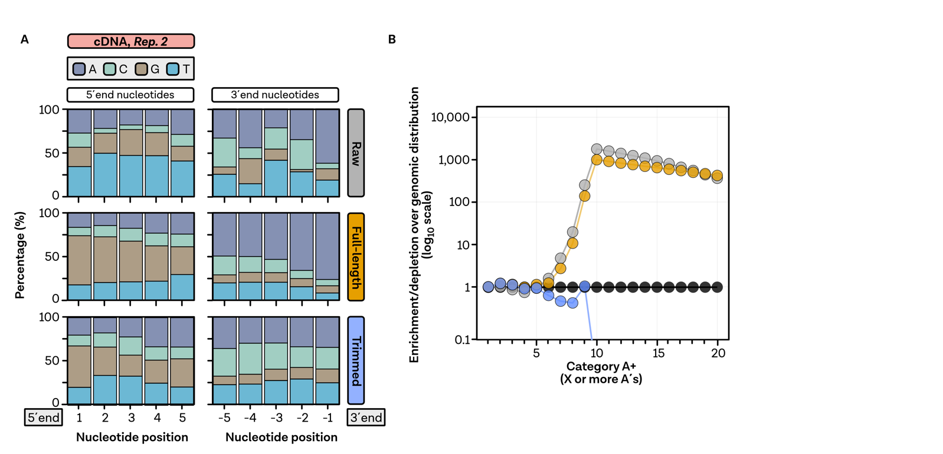
Supplementary Figure 13 | Base identities of terminal read positions and effects of trimming.
A, Proportion of bases at the 5´and 3´end for raw, full-length-sequenced and poly(A)- and SSP-trimmed reads. Color-code of the bases is indicated in the top left corner. Base identities were exemplarily calculated for a cDNA-sequenced samples (replicate 2). B, Enrichment/depletion of poly(A) sequences over the expected genomic distribution shown for the base identities calculated in A.
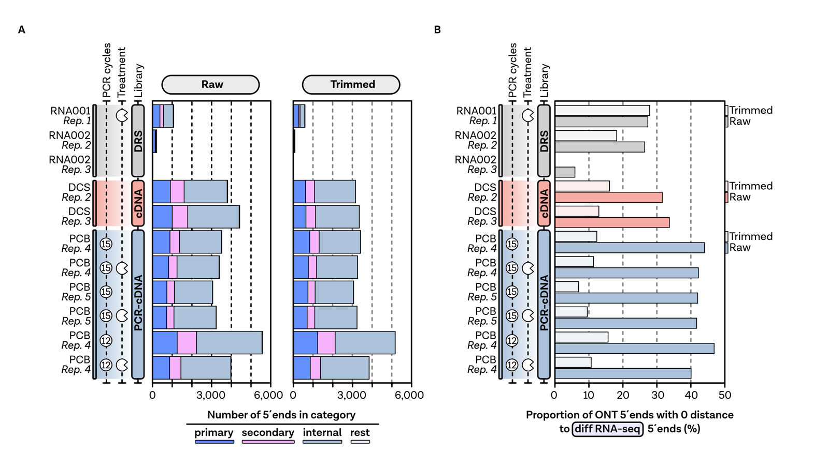
Supplementary Figure 14 | 5´ end detection using ONT data.
A, Number of detected 5´ends in the color-coded categories based on the analysis of raw and fully trimmed reads. The categories have been assigned based on the relative orientation of an enriched position to a gene and additionally considering the height of the peak. B, Accuracy of 5´end detection analysed by looking at the proportion of primary 5´ends that are at the same position as primary sites detected using short-read differential RNA-seq (Thomason et al., 2015). The proportion calculated by the comparison of positions derived from raw reads is shown in the respective color of the different library protocols, while trimmed data are shown in a lighter color, respectively.

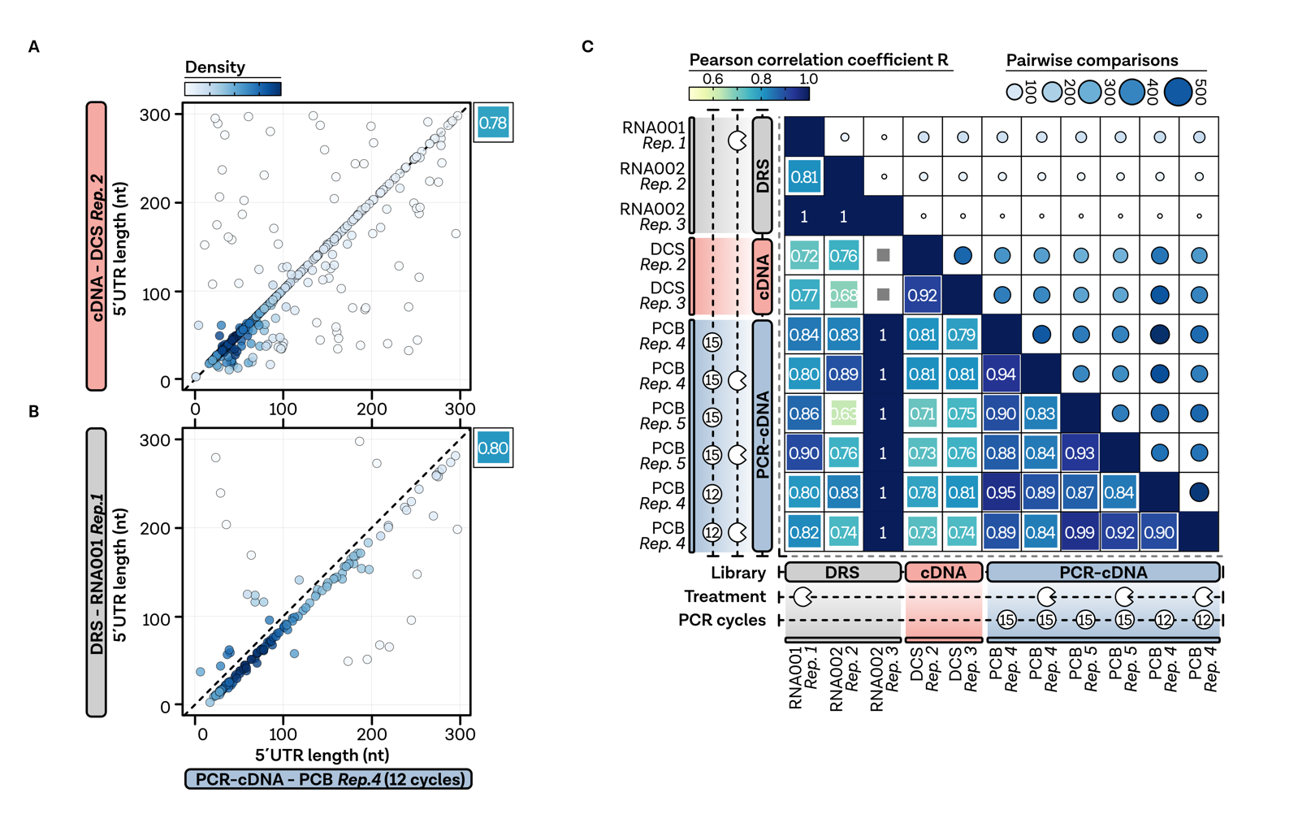
Supplementary Figure 15 | Reproducibility and comparability of 5´end detection.
A, Correlation between primary 5´ends detected by PCR-cDNA sequencing (indicated sample) to cDNA sequencing and B, short-read differential RNA-seq (Thomason et al., 2015). Each point represents one gene, color-coded by density at the plot position. Pearson correlation is given at the top right. C, Correlation matrix between all samples derived from pairwise-complete observations. Pearson correlation coefficient is depicted and colour- and square-size coded. Additionally, the number of available pairwise comparisons is shown by circle size and colour. Missing values are shown by grey boxes.

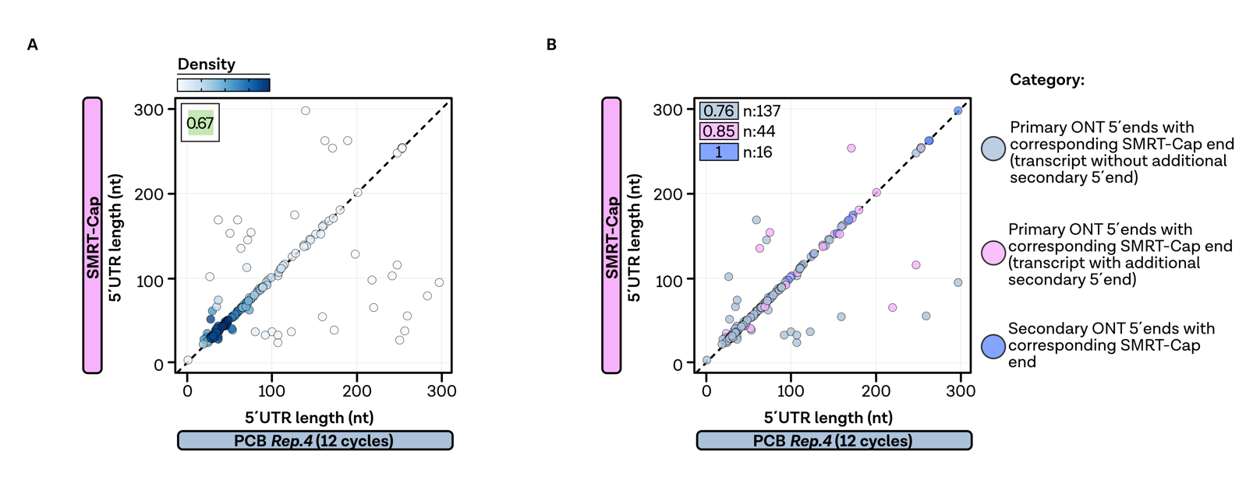
Supplementary Figure 16 | Comparison of 5´ends detected by ONT and SMRT-Cap.
A, Correlation between primary 5´ends detected by PCR-cDNA sequencing (indicated sample) to SMRT-Cap sequencing (Yan et al., 2018). Each point represents one gene, color-coded by density at the plot position. Pearson correlation is given at the top left. B, Correlation plot for genes grouped into the categories depicted on the right. Pearson coefficient and comparison size are shown on the top left of the plot.

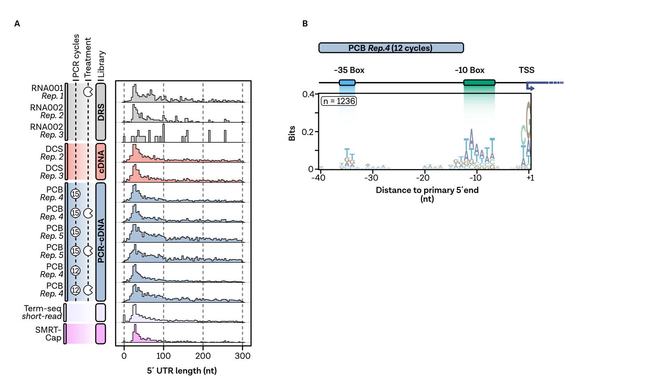
Supplementary Figure 17 | Features of primary 5´ends in E. coli.
A, Comparison of 5´UTR lengths of primary 5´ends for all samples compared to short-read differential RNA-seq and SMRT-Cap protocol. 5´UTR lengths have been calculated by comparing the primary TSS of a gene with the annotated CDS start. B, Nucleotide enrichment plot of the upstream regions of 1236 detected primary 5´ends in the depicted PCR-cDNA sample, highlighting bacterial-typical promoter elements, like the -35 and -10 box. Plot was calculated using ggseqlogo (Wagih, 2017).

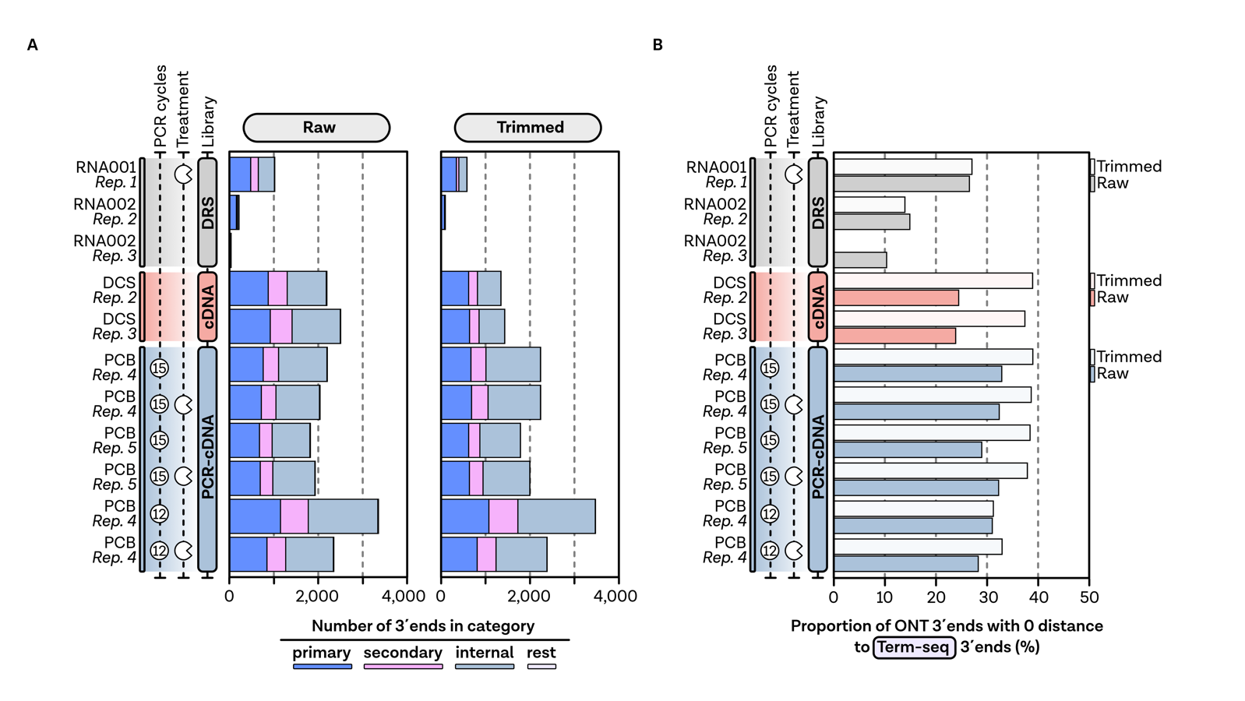
Supplementary Figure 18 | 3´ end detection using ONT data.
A, Number of detected 3´ends in the color-coded categories based on the analysis of raw and fully trimmed reads. The categories were assigned based on the relative orientation of an enriched position to a gene and additionally considering the height of the peak. B, Accuracy of 3´end detection analysed by looking at the proportion of primary 3´end that are at the same position as primary sites detected using short-read Term-seq (Dar and Sorek, 2018). The proportion calculated by the comparison of positions derived from raw reads is shown in the respective color of the different library protocols, while trimmed data are shown in a lighter color, respectively.

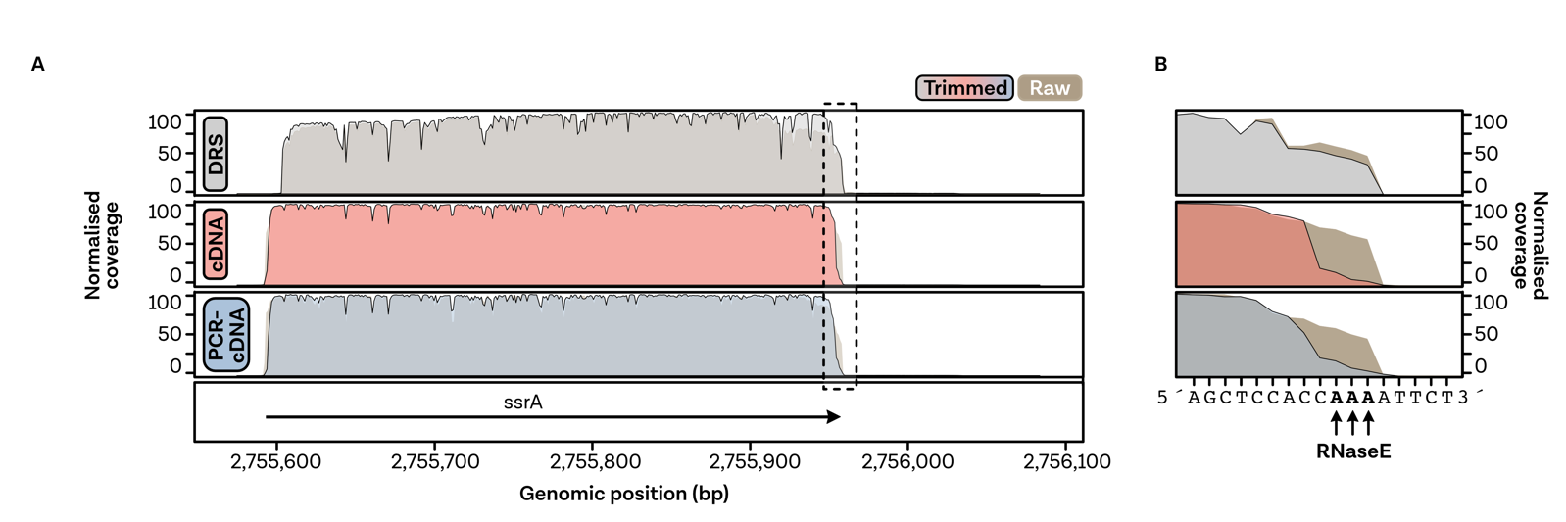
Supplementary Figure 19 | Effect of read trimming on natural poly(A) sequences.
A, Normalized coverage profiles for representative Nanopore datasets (DRS: RNA001, replicate 1; cDNA: DCS, rep2; PCR-cDNA: PCB, 12 cycles, rep4, untreated). Coverages are shown for mappings generated from raw (brown, background) and trimmed (respective library preparation colour) reads. Scaling was performed from zero reads to the maximum number of reads per position in the genomic window shown. Gene annotations and genomic positions are shown at the bottom of the plot. The dashed rectangle indicates the windows highlighted in B. Additionally, bases and RNAse E-processed sites are shown at the bottom of the plot (Lin-Chao et al., 1999).

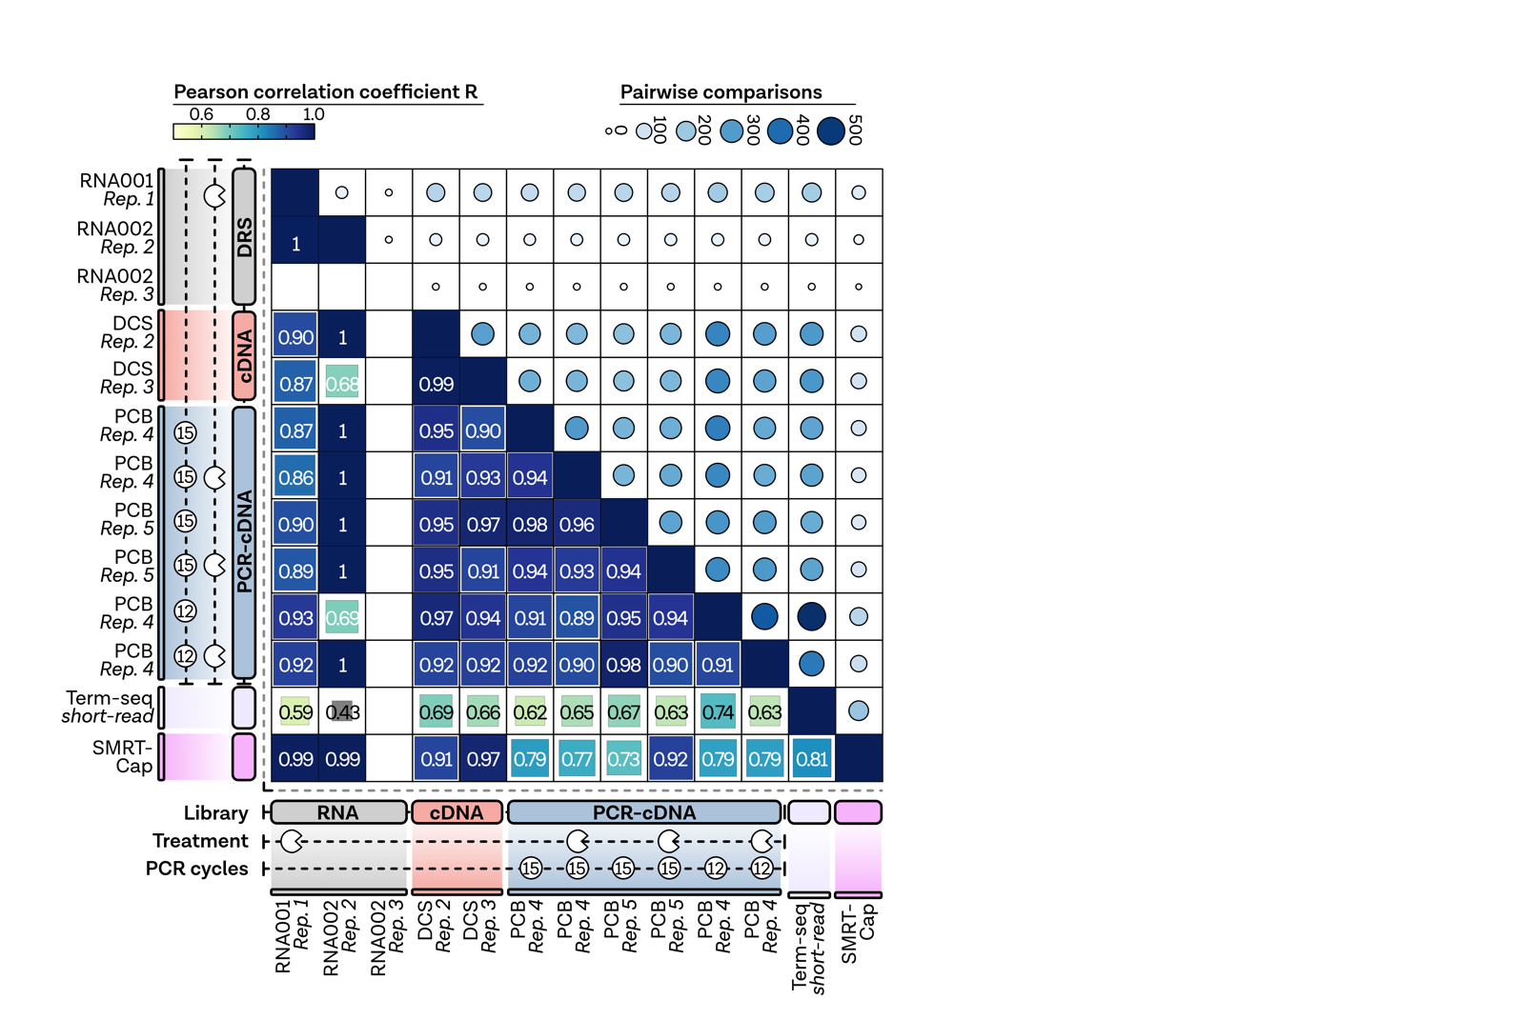
Supplementary Figure 20 | Correlation matrix of primary 3´ends.
Correlation matrix between all samples. Pearson correlation coefficient is depicted and colour- and square-size coded. Additionally, the number of available pairwise comparisons is shown by circle size and colour.

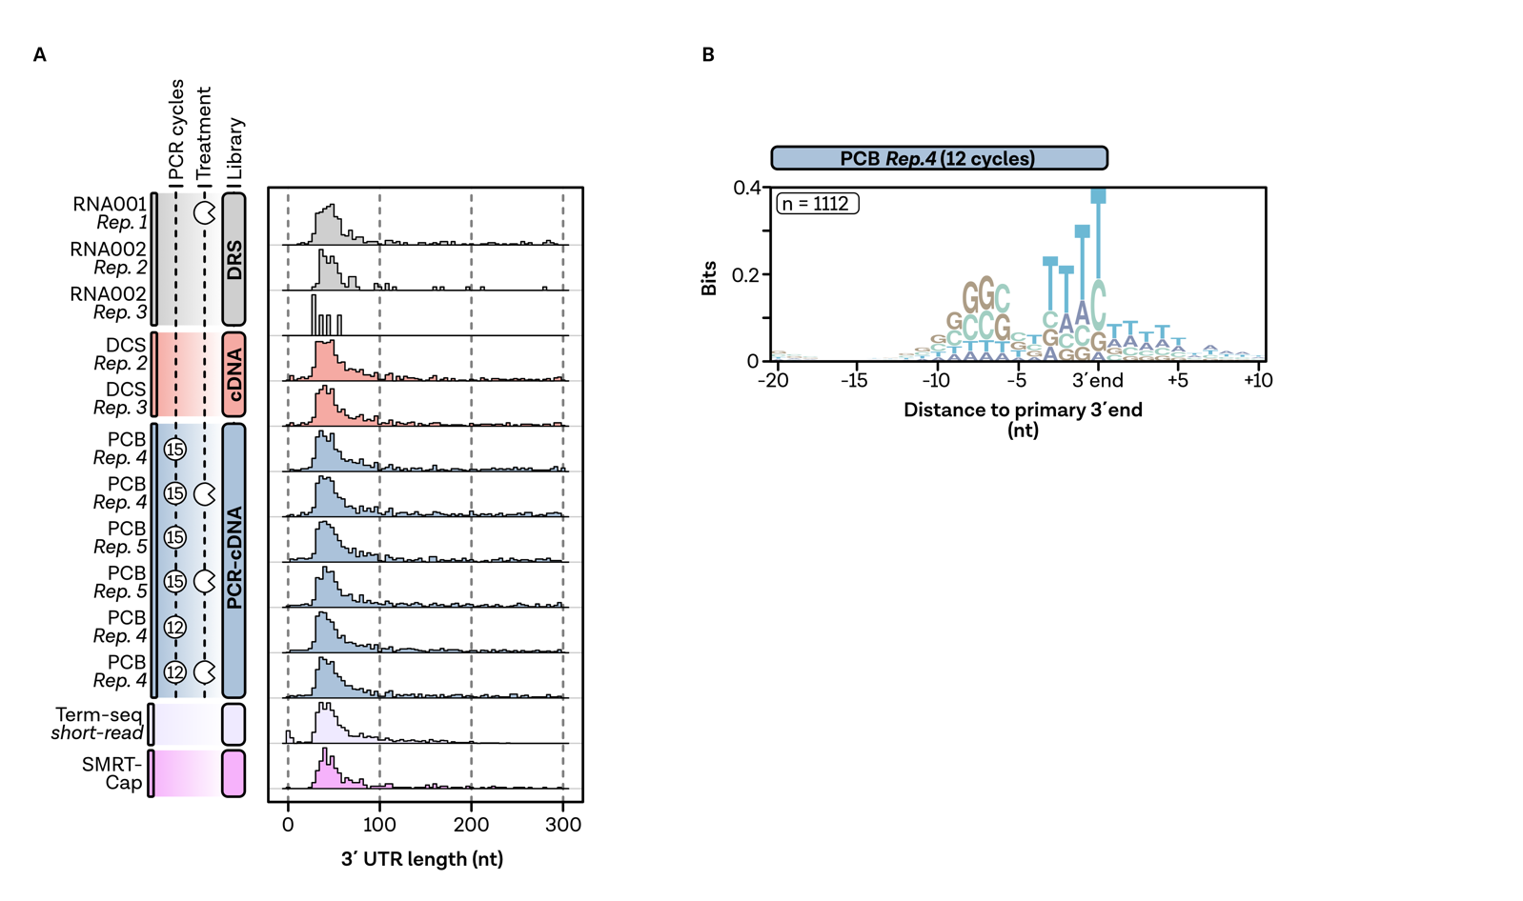
Supplementary Figure 21 | Features of primary 3´ends in E. coli.
A, Comparison of 3´UTR lengths of primary 5´ends for all samples compared to short-read Term-seq and SMRT-Cap protocol. B, Nucleotide enrichment plot (calculated using ggseqlogo (Wagih, 2017)) of the 3´end surrounding regions of 1112 detected primary 3´ends in the depicted PCR-cDNA sample, showing a bacterial-typical intrinsic terminator motif, containing a stretch of Ts.

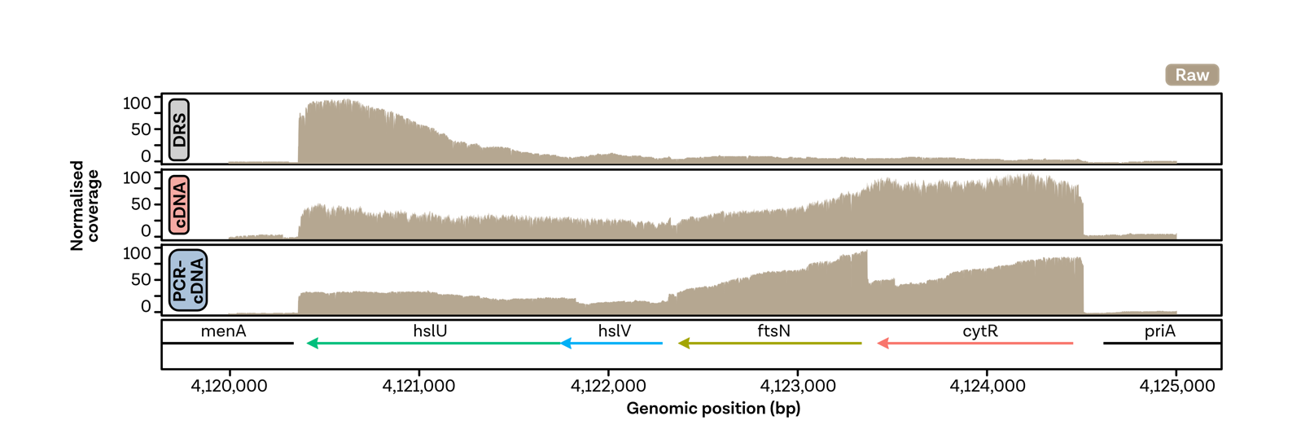
Supplementary Figure 22 | 3´-5´coverage bias in long transcriptional units.
Normalized coverage profiles for representative Nanopore datasets (DRS: RNA001, replicate 1; cDNA: DCS, Rep. 2; PCR-cDNA: PCB, 12 cycles, Rep. 4, untreated). Coverages are shown for mappings generated from raw reads shown with a brown color. Scaling was performed from zero reads to the maximum number of reads per position in the genomic window shown. Gene annotations, directions and genomic positions are shown at the bottom of the plot.

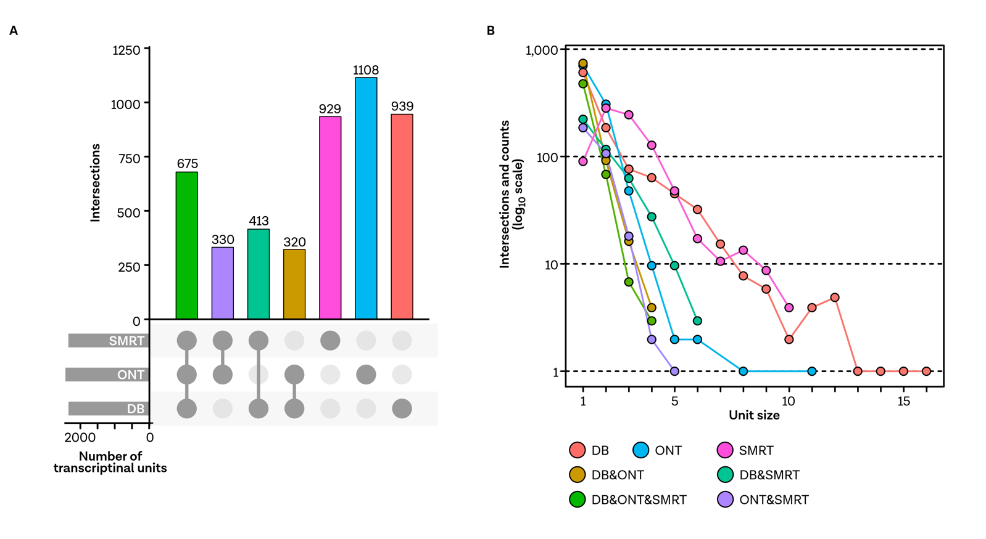
Supplementary Figure 23 | Comparability of operon detection to SMRT-Cap and the Regulon database.
A, UpSet- plot showing the comparability and number of identically detected operons in SMRT-Cap, PCR-cDNA ONT (PCB, 12 cycles, Rep.4, untreated) and Regulon DB data (Yan et al., 2018; Santos-Zavaleta et al., 2019). B, Comparison of the operon sizes in the detected intersections.

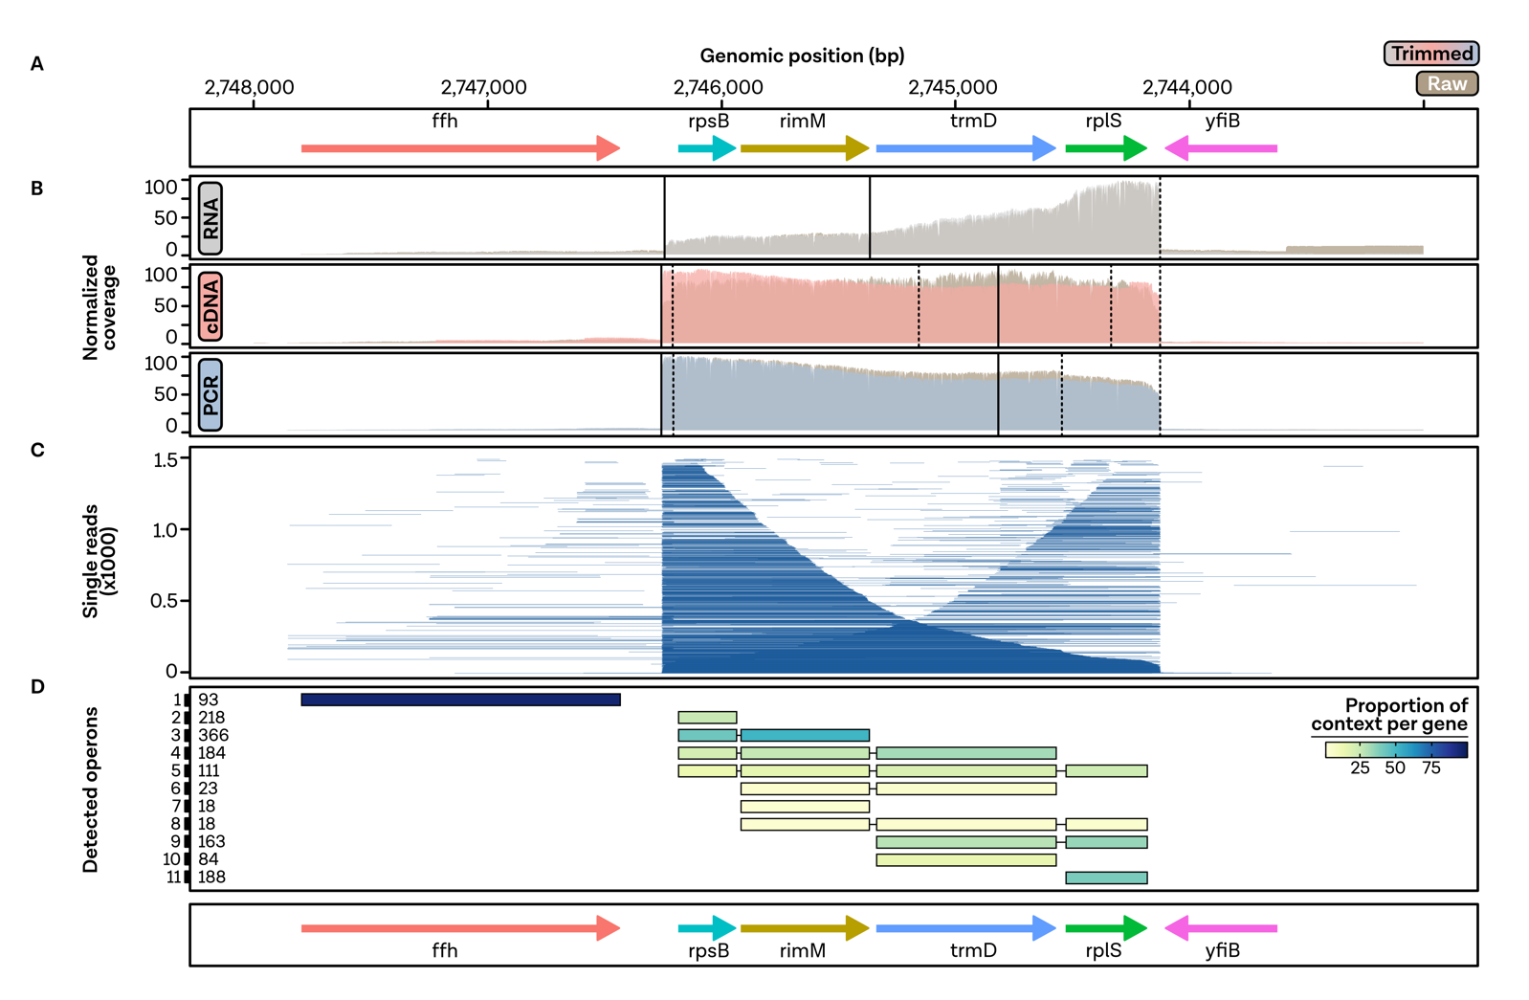
Supplementary Figure 24 | Operon analysis of the rpsB-containing operon.
A, Genome annotation. B, Normalized coverage profiles are shown for representative Nanopore datasets (DRS: RNA001, replicate 1; cDNA: DCS, Rep. 2; PCR-cDNA: PCB, 12 cycles, Rep.4, untreated). Coverages are shown for mappings generated from raw (brown, background) and trimmed (respective library preparation colour) reads. Vertical solid lines indicate positions of Nanopore-detected primary 5´ends from untrimmed reads, while enriched primary 3´ends derived from trimmed reads of the respective sample are shown as dashed lines. C, Single-read track of the PCR-cDNA sample (12 cycles, replicate 12, untreated) sorted by read lengths from bottom (longest) to top (shortest). D, Detected operons. Operon abundance is depicted on the left, while the proportion of context per gene is colour-coded and scales to 100.

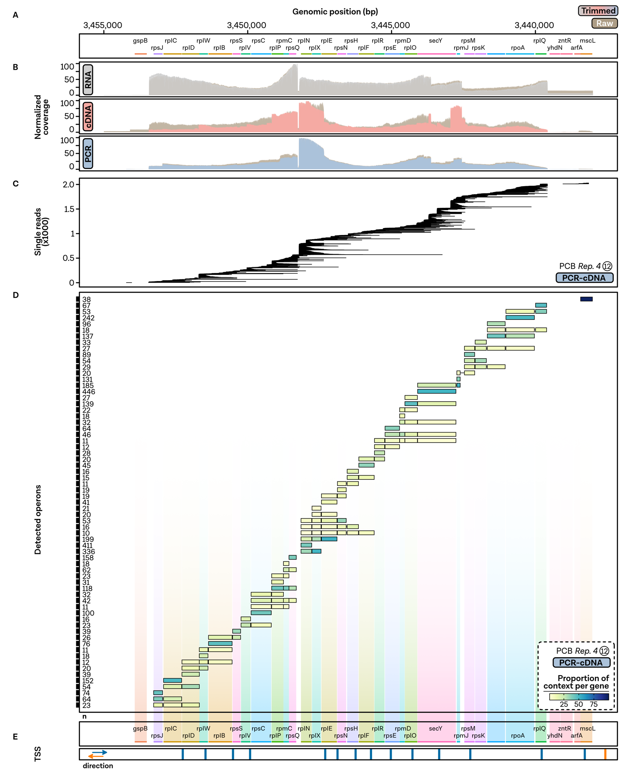
Supplementary Figure 25 | Operon analysis of a genomic region containing many ribosomal proteins.
A, Genome annotation. B, Normalized coverage profiles are shown for representative Nanopore datasets (DRS: RNA001, replicate 1; cDNA: DCS, Rep. 2; PCR-cDNA: PCB, 12 cycles, Rep. 4, untreated). Coverages are shown for mappings generated from raw (brown, background) and trimmed (respective library preparation colour) reads. C, Single-read track of the PCR-cDNA sample (12 cycles, replicate 12, untreated) sorted by read start positions from bottom to top. D, Detected operons. Operon abundance is depicted on the left, while the proportion of context per gene is color-coded and scales to 100. E, Vertical lines indicate primary transcription start sites found on the minus (blue) or plus (orange) strand in the publicly available differential RNA-seq dataset (Thomason et al., 2015).

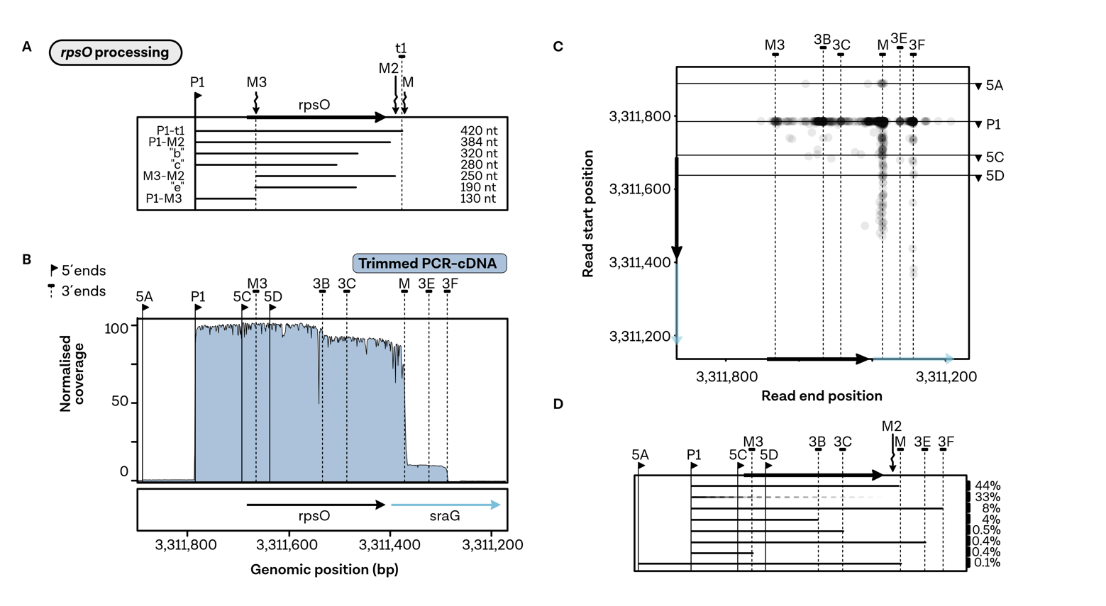
Supplementary Figure 26 | Detection of transcriptional heterogeneity and processing sites of the rpsO gene.
A, Structure of the rpsO transcript including a schematic depiction of sizes and processing positions of processed mRNAs adapted from (Hajnsdorf and Régnier, 1999). The map shows the positions of the promoter P1, terminator t1, RNAseE processing sites M2 and M3, and of read-through transcript processed at position M. These short names are also used in the description of the individual transcripts. Additionally, transcripts b, c and e refer to intermediates of degradation. Sizes of the transcripts are shown on the right. Note that the respective designations were taken from the original publication (Hajnsdorf and Régnier, 1999). B, Normalised coverage profiles for a representative PCR-cDNA Nanopore dataset (12 cycles, replicate 4, untreated, trimmed). Vertical lines indicate positions of enriched 5´ (solid) and 3´ends (dashed) calculated from trimmed reads, while the annotation and genomic coordinates are shown at the bottom. C, Scatter plot of read start (y-axis) and read end (x-axis) positions. Each read is plotted as a single point with a transparency of 90%. Positions of enriched 5´ends (y-axis) and 3´ends (x-axis) are indicated by horizontal (5´) and vertical (3´) end lines. D, Quantification of read groups derived from the scatter plot. Reads were grouped according to their respective proximity to the enriched 5´and 3´end positions in a 10 base window. The quantification of prominent groups is shown on the right side of the plot, while the position of the transcript is indicated by a line plot from the read start to the read end position. The dashed horizontal lines indicate that this group has a fixed 5´end, starting at the promoter P1, but a random 3´end, which is true for 33% of all of the reads in this genomic window and possibly derives from the degradation events described in A.

References:
Dar, D., and Sorek, R. (2018). High-resolution RNA 3-ends mapping of bacterial Rho-dependent transcripts. Nucleic Acids Res. 46, 6797–6805. doi:10.1093/nar/gky274.
Hajnsdorf, E., and Régnier, P. (1999). E. coli rpsO mRNA decay: RNase E processing at the beginning of the coding sequence stimulates Poly(A)-dependent degradation of the mRNA. J. Mol. Biol. 286, 1033–1043. doi:10.1006/jmbi.1999.2547.
Lin-Chao, S., Wei, C.-L., and Lin, Y.-T. (1999). RNase E is required for the maturation of ssrA RNA and normal ssrA RNA peptide-tagging activity. Proc. Natl. Acad. Sci. 96, 12406–12411. doi:10.1073/pnas.96.22.12406.
Riley, M., Abe, T., Arnaud, M. B., Berlyn, M. K. B., Blattner, F. R., Chaudhuri, R. R., et al. (2006). Escherichia coli K-12: a cooperatively developed annotation snapshot--2005. Nucleic Acids Res. 34, 1–9. doi:10.1093/nar/gkj405.
Santos-Zavaleta, A., Salgado, H., Gama-Castro, S., Sánchez-Pérez, M., Gómez-Romero, L., Ledezma-Tejeida, D., et al. (2019). RegulonDB v 10.5: Tackling challenges to unify classic and high throughput knowledge of gene regulation in E. coli K-12. Nucleic Acids Res. 47, D212–D220. doi:10.1093/nar/gky1077.
Schroeder, A., Mueller, O., Stocker, S., Salowsky, R., Leiber, M., Gassmann, M., et al. (2006). The RIN: an RNA integrity number for assigning integrity values to RNA measurements. BMC Mol. Biol. 7, 3. doi:10.1186/1471-2199-7-3.
Thomason, M. K., Bischler, T., Eisenbart, S. K., Förstner, K. U., Zhang, A., Herbig, A., et al. (2015). Global Transcriptional Start Site Mapping Using Differential RNA Sequencing Reveals Novel Antisense RNAs in Escherichia coli. J. Bacteriol. 197, 18–28. doi:10.1128/JB.02096-14.
Wagih, O. (2017). Ggseqlogo: A versatile R package for drawing sequence logos. Bioinformatics. doi:10.1093/bioinformatics/btx469.
Yan, B., Boitano, M., Clark, T. A., and Ettwiller, L. (2018). SMRT-Cappable-seq reveals complex operon variants in bacteria. Nat. Commun. 9, 3676. doi:10.1038/s41467-018-05997-6.

