Supplementary Information

Unique anticodon loop conformation with flipped-out wobble nucleotide in the crystal structure of unbound tRNA^{Val}

Hyeonju Jeong¹ and Jungwook Kim^{1*}

Supplementary Figure S1 The geometry of base triplet motifs found in D stem. The interactions between Watston-Crick base pair and third base are observed in both NCS tRNA molecules. (A)U12∙A23-A9 (B) C13∙G22-G46 (C) G10∙C25-G45

Supplementary Figure S2 The geometry of tertiary interactions of E. coli tRNA^{Val1}. (A) Reverse Hoogsteen base pair found in U8∙A14 which is located in linker of acceptor stem and D stem. U8 forms hydrogen bond with A21. (B-C) The interactions between D stem and TΨC stem-loop. (B) G15∙C48 (C) G18-U55 (D) The tertiary interaction between A26-G44 in D stem.

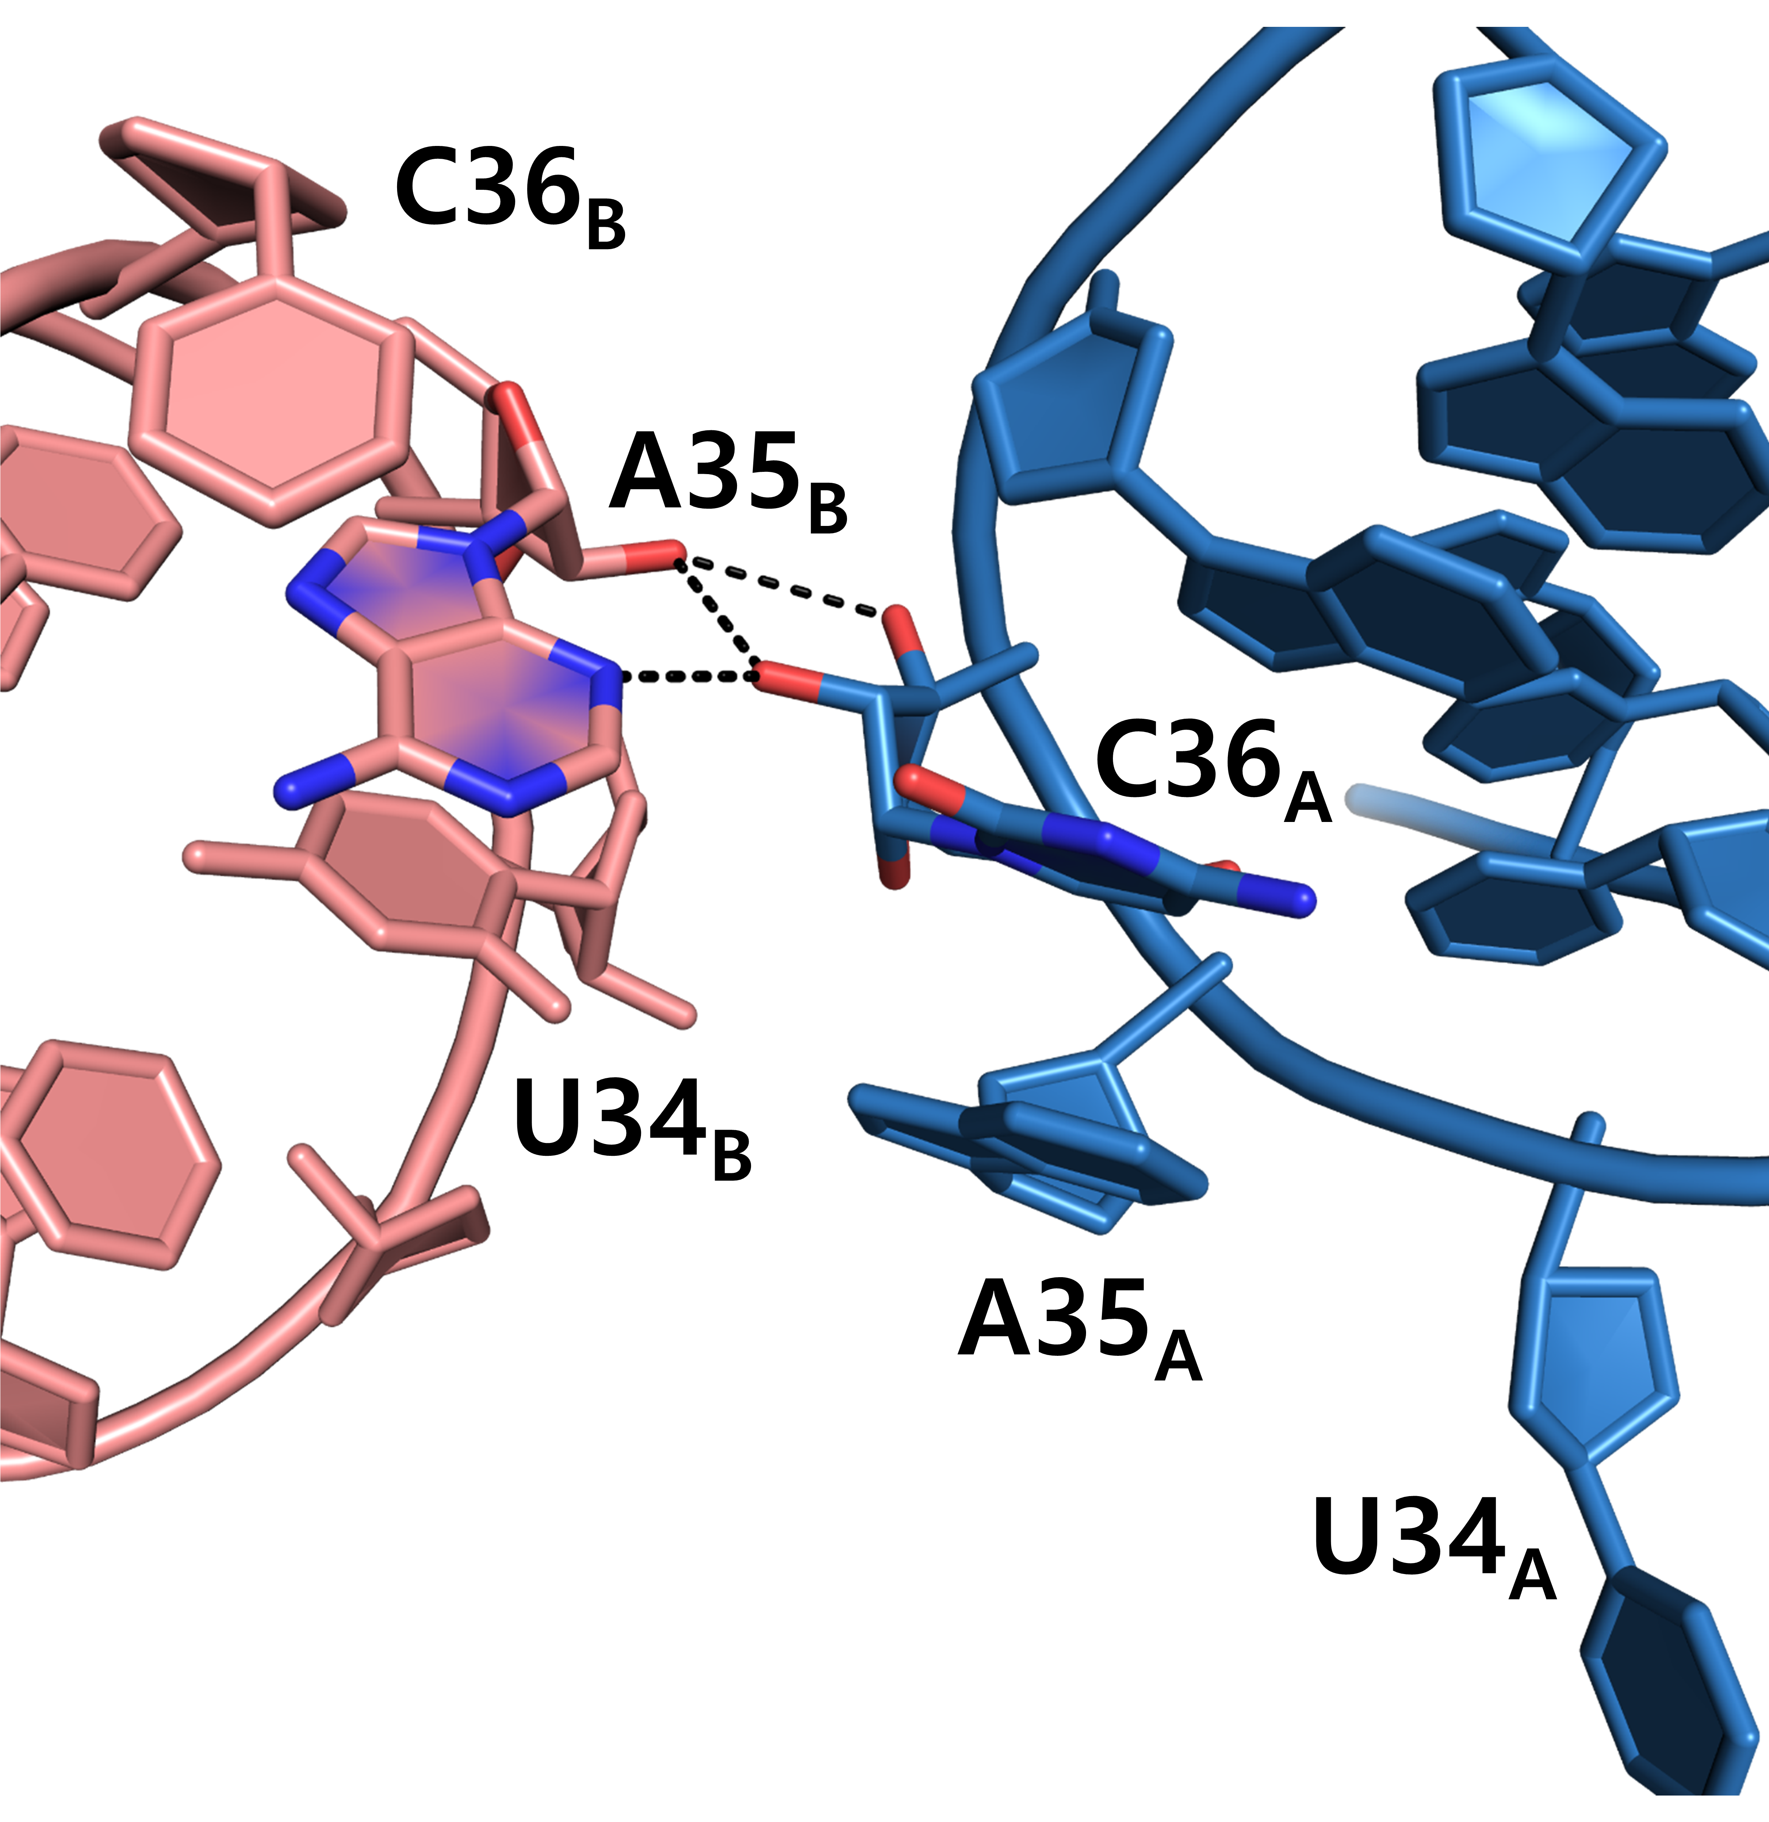
Supplementary Figure S3. Dimerization interface interaction. Two tRNA molecules are dimerized by hydrogen bond from N3 and 2´-OH of A35_{B} with ribose ring of C36_{A}, with the dimeric interface of 129.8Å².

Supplementary Figure S4. Mg²⁺ coordination. Mg²⁺ (green) is coordinated with water molecules (red sphere). Oxygen of tRNA backbone phosphate or nitrogen of base participate Mg²⁺ coordination in octahedral geometry. (A) OP1 of G19_{A} and five water molecules are coordinated with Mg²⁺ (B) OP1 of G19_{B} and five water molecules are coordinated with Mg²⁺ (C) N7 of G15_{B} and five water molecules are coordinated with Mg²⁺ (D) Mg²⁺ is coordinated by six water molecules surrounded by phosphate backbone from U8_{B} to C13_{B} in the region of D-arm. (E) N7 of G15_{A} and five water molecules are coordinated with Mg²⁺ (F) OP2 of A37_{B} and five water molecules are coordinated with Mg²⁺

Supplementary Figure S5. Na⁺ coordination. Na⁺ (purple) is coordinated with water molecules (red sphere). Oxygens of tRNA backbone phosphate participate Na⁺ coordination in various geometry. (A) OP2 of G20 and OP1 of A21 are participated in Na+ coordination with two water molecules which shows distorted sewsaw geometry. (B) Na⁺ is coordinated by six water molecules surrounded by phosphate backbone from U8_{A} to C13_{A} in the region of D-arm. (C) OP1 of A37_{A} is coordinated with Na+ with four water molecules which shows distorted trigonal bipyramidal geometry. (D) OP1 of G20 and OP2 of A21 are participated in Na+ coordination with three water molecules which shows distorted trigonal geometry.

