Supplementary Tables and Figures

Comparative study on tertiary contacts and folding of model RNase P RNAs from a psychrophilic, a mesophilic/radiation-resistant and a thermophilic bacterium

Michal Marszalkowski1,2, Andreas Werner3,4, Ralph Feltens1,5, Dominik Helmecke1, Markus Gößringer1, Eric Westhof3 and Roland K. Hartmann1

1 Institut für Pharmazeutische Chemie, Philipps-Universität Marburg,
Marbacher Weg 6, D-35037 Marburg, Germany, e-mail: roland.hartmann@staff.uni-marburg.de

2 present address: Michał Marszałkowski, ul. Jabłoniowa 22/12, 80-175 Gdańsk, Polska

3 Université de Strasbourg, Institut de biologie moléculaire et cellulaire du CNRS, Architecture et Réactivité de l'ARN, 2 allée Konrad Roentgen, F-67084 Strasbourg, France

4 present address: European Patent Office, Bob-van-Benthem-Platz 1, 80298 Munich, Germany

5 present address: Berufsschulzentrum 1 der Stadt Leipzig, Crednerstraße 1, D-04289 Leipzig, Germany

Table S1: Summary of kinetic data of RNA-alone activity assays performed at 15°C or 37°C.

P RNA | kreact( min-1) |  | Km(sto) (µM) |  |  | kreact/Km(sto)  (min-1 µM-1)  15°C | kreact/Km(sto)  (min-1 µM-1)  37°C | ratio  37°/ 15°C
P RNA | 15°C | § 37°C | 15°C |  | § 37°C | kreact/Km(sto)  (min-1 µM-1)  15°C | kreact/Km(sto)  (min-1 µM-1)  37°C | ratio  37°/ 15°C
Ptr | 1.11 (±0.09) | 10.5 (±0.76) | 0.29 ±0.08 |  | 0.40 (±0.09) | 3.8 | 26.3 | 6.9
Dra | 0.7 (±0.04) | 4.41 (±0.29) | 0.63 ±0.11 |  | 0.83 (±0.13) | 1.1 | 5.3 | 4.8
Tth. | 0.29 (±0.02) | 5.34 (±0.31) | 0.06 ±0.02 |  | 0.49 ±0.07 | 4.8 | 10.9 | 2.3
Eco | 0.46 (±0.02) | 14.2 0.1 | 0.06 ±0.01 |  | 0.65 ±0.02 | 7.7 | 21.8 | 2.8
 | kreact(37°)/kreact(15°C) |  | Km(sto)(37°C)/ Km(sto)(15°C)
Ptr | 9.5 |  |  | 1.4
Dra | 6.3 |  |  | 1.3
Tth | 18.4 |  |  | 8.2
Eco | 30.9 |  |  | 10.8
§ Values taken from Table 1 of the main text.

Table S2: Holoenzyme kinetics for the different wt P RNAs reconstituted with the E. coli P protein and assayed at 37°C versus 15°C.

P RNA | kobs(min–1) at 37°C | kobs(min–1) at 15°C | kobs(37°C)/ kobs(15°C)
Eco | 3.8 (±0.2) | 0.13 (±0.04) | ~29
Tth | 3.8 (±0.2) | 0.12 (±0.03) | ~32
Dra | 6.3 (±0.4) | 0.89 (±0.09) | ~7
Pha | 3.0 (±0.1) | 0.06 (±0.04) | 50
For abbreviations, see Table 2 of the main text. Reactions were performed as multiple turnover kinetics with recombinant E. coli P protein at 37°C in a buffer KN4.5 containing 20 mM Hepes, 150 mM NH4OAc, 2 mM spermidine, 0.05 mM spermine, 4 mM β-mercaptoethanol, pH 7.4, 4.5 mM Mg(OAc)2 at 37°C, at concentrations of 10 nM P RNA, 100 nM substrate and 40 nM P protein; kobs is given as nmoles substrate converted per nmole of P RNA per min. P RNA and pre-tRNA solutions were preincubated separately for 5 min 55°C and 55 min 37°C; after 50 min at 37°C, P protein was added to the P RNA solution. For kinetic assays at 15°C, enzyme and substrate solutions were shifted to 15°C before starting the reaction through combining the two solutions.

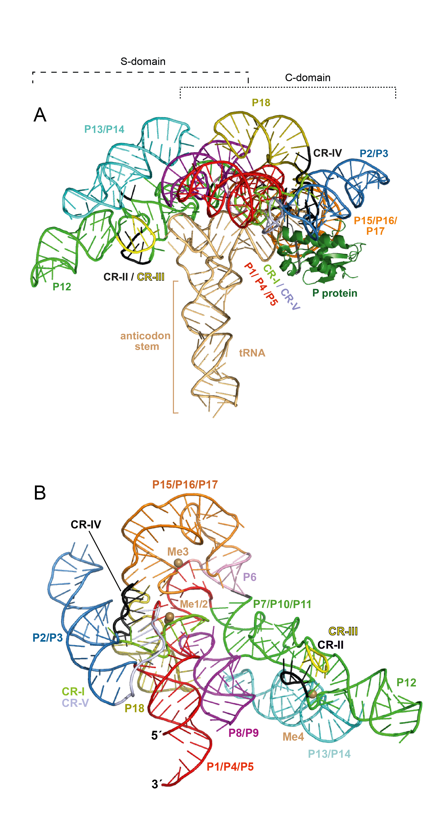

Fig. S1: Crystal structure of the bacterial RNase P holoenzyme from Thermotoga maritima (A) in complex with tRNA and (B) the same P RNA alone in a different view (Reiter et al., 2010; PDB 3Q1Q); adopted from Schencking et al. (2020) with minor changes. (A) The P protein is shown in dark green in the ribbon presentation; tRNAPhe from T. maritima, carrying an engineered anticodon stem extension, is shown in sand color. The tRNA anticodon arm of the bound tRNA extends away from the complex and only the 3’-ACCA end of the acceptor stem and the tRNA corner, where D and T arm interact, make specific contacts with the slightly bended RNA subunit. The P RNA architecture consists of two layers of helices (P13/P14 and P18 are piled onto the core helices). The areas of the C- and S-domains are marked by brackets at the top, P8/P9 (colored in violet) are located in the background. Coaxially stacked helices are illustrated in the same color and the five regions with highest sequence conservation (CR-I to CR-V) cluster in two distinct areas in the C- and S-domain, respectively; note that CR-I and CR-V overlap with helix P4. (B) Structural elements are colored as in panel A. The two active site metal ions (Me1/2) and two structurally important metal ions (Me3, Me4) are depicted as sand-colored spheres. The orientation of the molecule visualizes the two CR clusters, the position of P8/P9 sandwiched between C-domain and the more distal parts of the S-domain, and the P15/16/17/6 round arch into which the tRNA 3’-NCCA end is threaded with support from Me4.

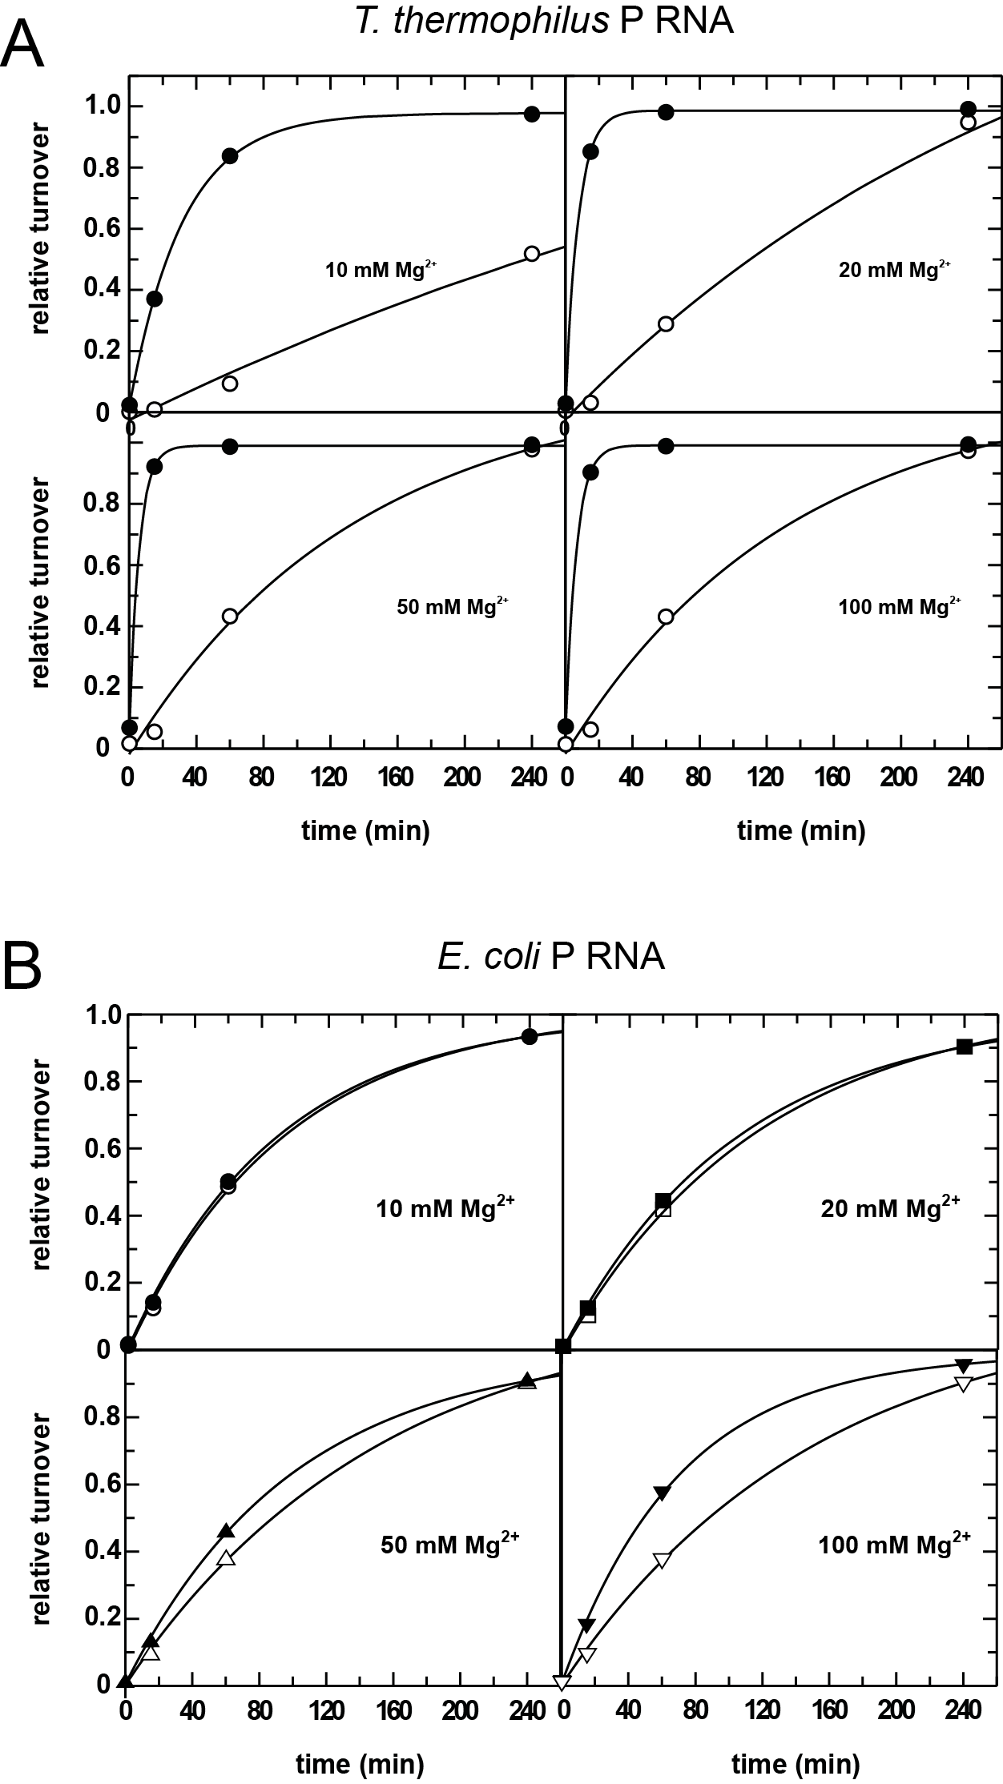
Fig. S2: RNA-alone activity of (A) T. thermophilus or (B) E. coli P RNA as a function of P RNA preincubation at 37°C (open symbols) or 55°C (filled symbols) for 20 min in the presence of different Mg2+ concentrations. Cleavage reactions at 37°C were started by adding the pre-tRNAGly substrate (f.c. 190 nM). The P RNA concentration was 20 nM and assay conditions were 100 mM NH4OAc, 50 mM Hepes, pH 7.0, and varying Mg(OAc)2 concentrations (10, 20, 50 or 100 mM). After preincubation of RNase P RNAs for 15 min at either 37°C or 55°C, substrate solution was added and the reaction incubated at 37°C. Aliquots were withdrawn at different time points and analyzed by 20% denaturing PAGE (see Materials and Methods of the main text).

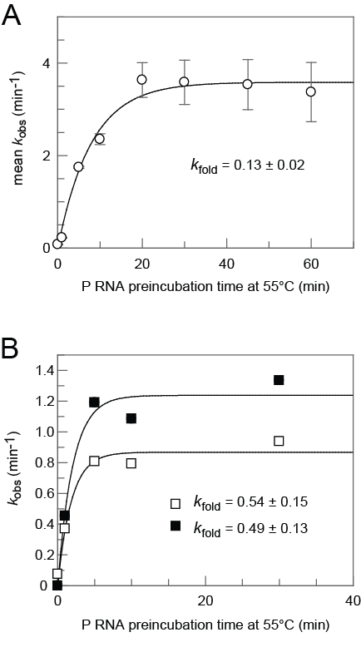
Fig. S3: Rate constants of pre-tRNA processing by Tth P RNA as a function of P RNA preincubation time at 55°C, either in the (A) absence or (B) presence of 3 M urea. (A) 2.5 µM Tth P RNA were preincubated at 55°C in 1 x buffer (50 mM Hepes-KOH, pH 7 at 37°C, 20 mM Mg(OAc)2, 1 M NH4OAc) for different periods; samples were put on ice after the preincubation step; 0 min at 55°C means that this sample was continuously kept on ice (omission of the preincubation step). The substrate (unlabeled plus 5'-32P-labeled pre-tRNAGly) in the same buffer was preincubated separately for 5 min at 55°C and 25 min at 37°C. Substrate and enzyme mixes were combined (final concentration: 2 µM Tth P RNA, 3 µM pre-tRNAGly) and incubated at 37°C; aliquots were withdrawn at appropriate time points (to cover the entire range of substrate turnover) and added to precooled ethanol precipitation mixes. (B) As in panel A, but preincubation of Tth P RNA was performed in the presence of 3 M urea and the processing assay contained 1 µM Tth P RNA, 1.5 µM pre-tRNAGly and 250 mM urea. Open and filled square symbols represent two independent experiments. First-order rate constants of cleavage (kobs) and rate constants kfold were calculated by fitting the data to a 1st order rate equation, At = A∞ × (1 − e−kt) using the Grafit Erithacus Software (version 5.0.13), with At indicating the fraction cleaved or folded at time point t, A∞ the fraction at the endpoint and k the rate constant for substrate cleavage or P RNA folding. The curve in panel A was based on 3 to 4 independent experiments, error bars are standard errors of the mean.
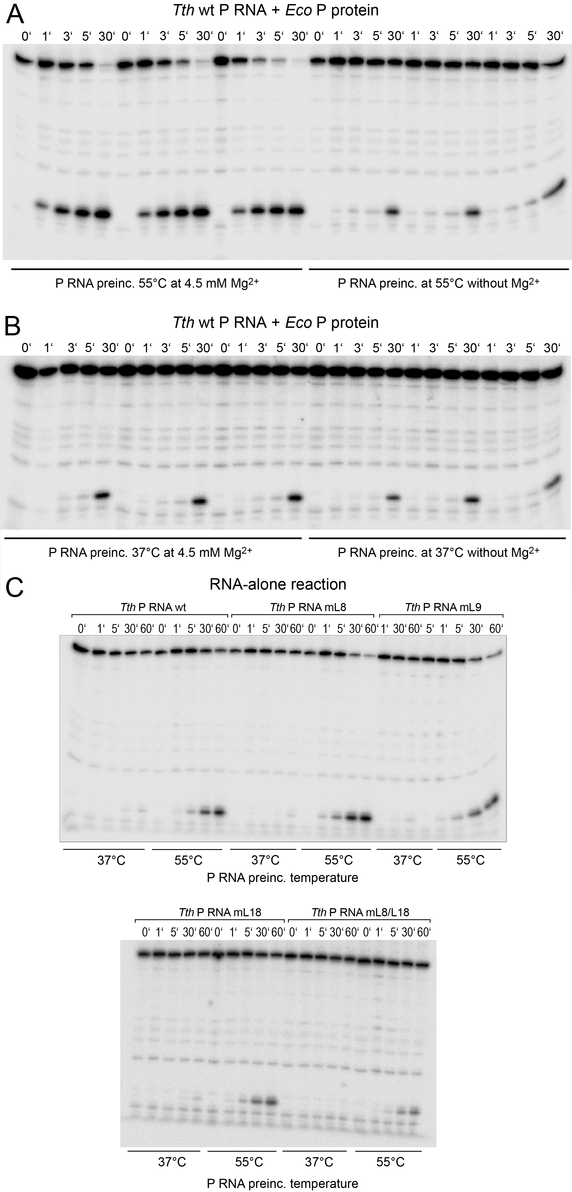
Fig. S4: Native folding of T. thermophilus (Tth) RNase P RNA. The dependence on the high temperature step (55°C) is also seen in the presence of the protein cofactor and the presence of Mg2+ is essential for folding to the native state. (A) P RNA was preincubated for 5 min at 55°C in KN buffer containing 4.5 mM Mg2+ (triplicate data sets on the left) or lacking Mg2+ (triplicate data sets on the right); then E. coli P protein was added to the P RNA and the Mg2+ concentration was additionally adjusted to 4.5 mM in the samples that lacked Mg2+ during the P RNA preincubation, followed by incubation for 5 min at 37°C to assemble the holoenzyme. Then pre-tRNAGly substrate mix was added to start the reaction and kinetics were monitored at 37°C; aliquots were withdrawn at the indicated time points; the final concentrations were 10 nM P RNA, 40 nM E. coli P protein and 100 mM substrate. For both conditions, reactions were conducted in triplicate. (B) As panel A, but P RNA preincubation with and without Mg2+ performed for 5 min at 37°C. Here, the presence of Mg2+ during P RNA preincubation had only a marginal (1.6-fold) effect on activity. (C) The high activation barrier for the native folding transition is also observed for T. thermophilus P RNA variants mL8, mL9, mL18 and mL8/L18 with disrupted interdomain contacts. P RNAs (final concentration 10 nM) were preincubated for 5 min at 37°C or 55°C in reaction buffer C (100 mM Mg[OAc]2, 100 mM NH4OAc, 0.1 mM EDTA, 50 mM MES, pH 6.0 at 37°C). Then the pre-tRNAGly substrate (final concentration 100 nM) preincubated (5 min at 55°C, 25 min at 37°C) in the same buffer mix was added to start the reaction performed at 37°C and aliquots were withdrawn at the indicated time points. Samples were analyzed by electrophoresis on 20% PAA/8 M urea gels.
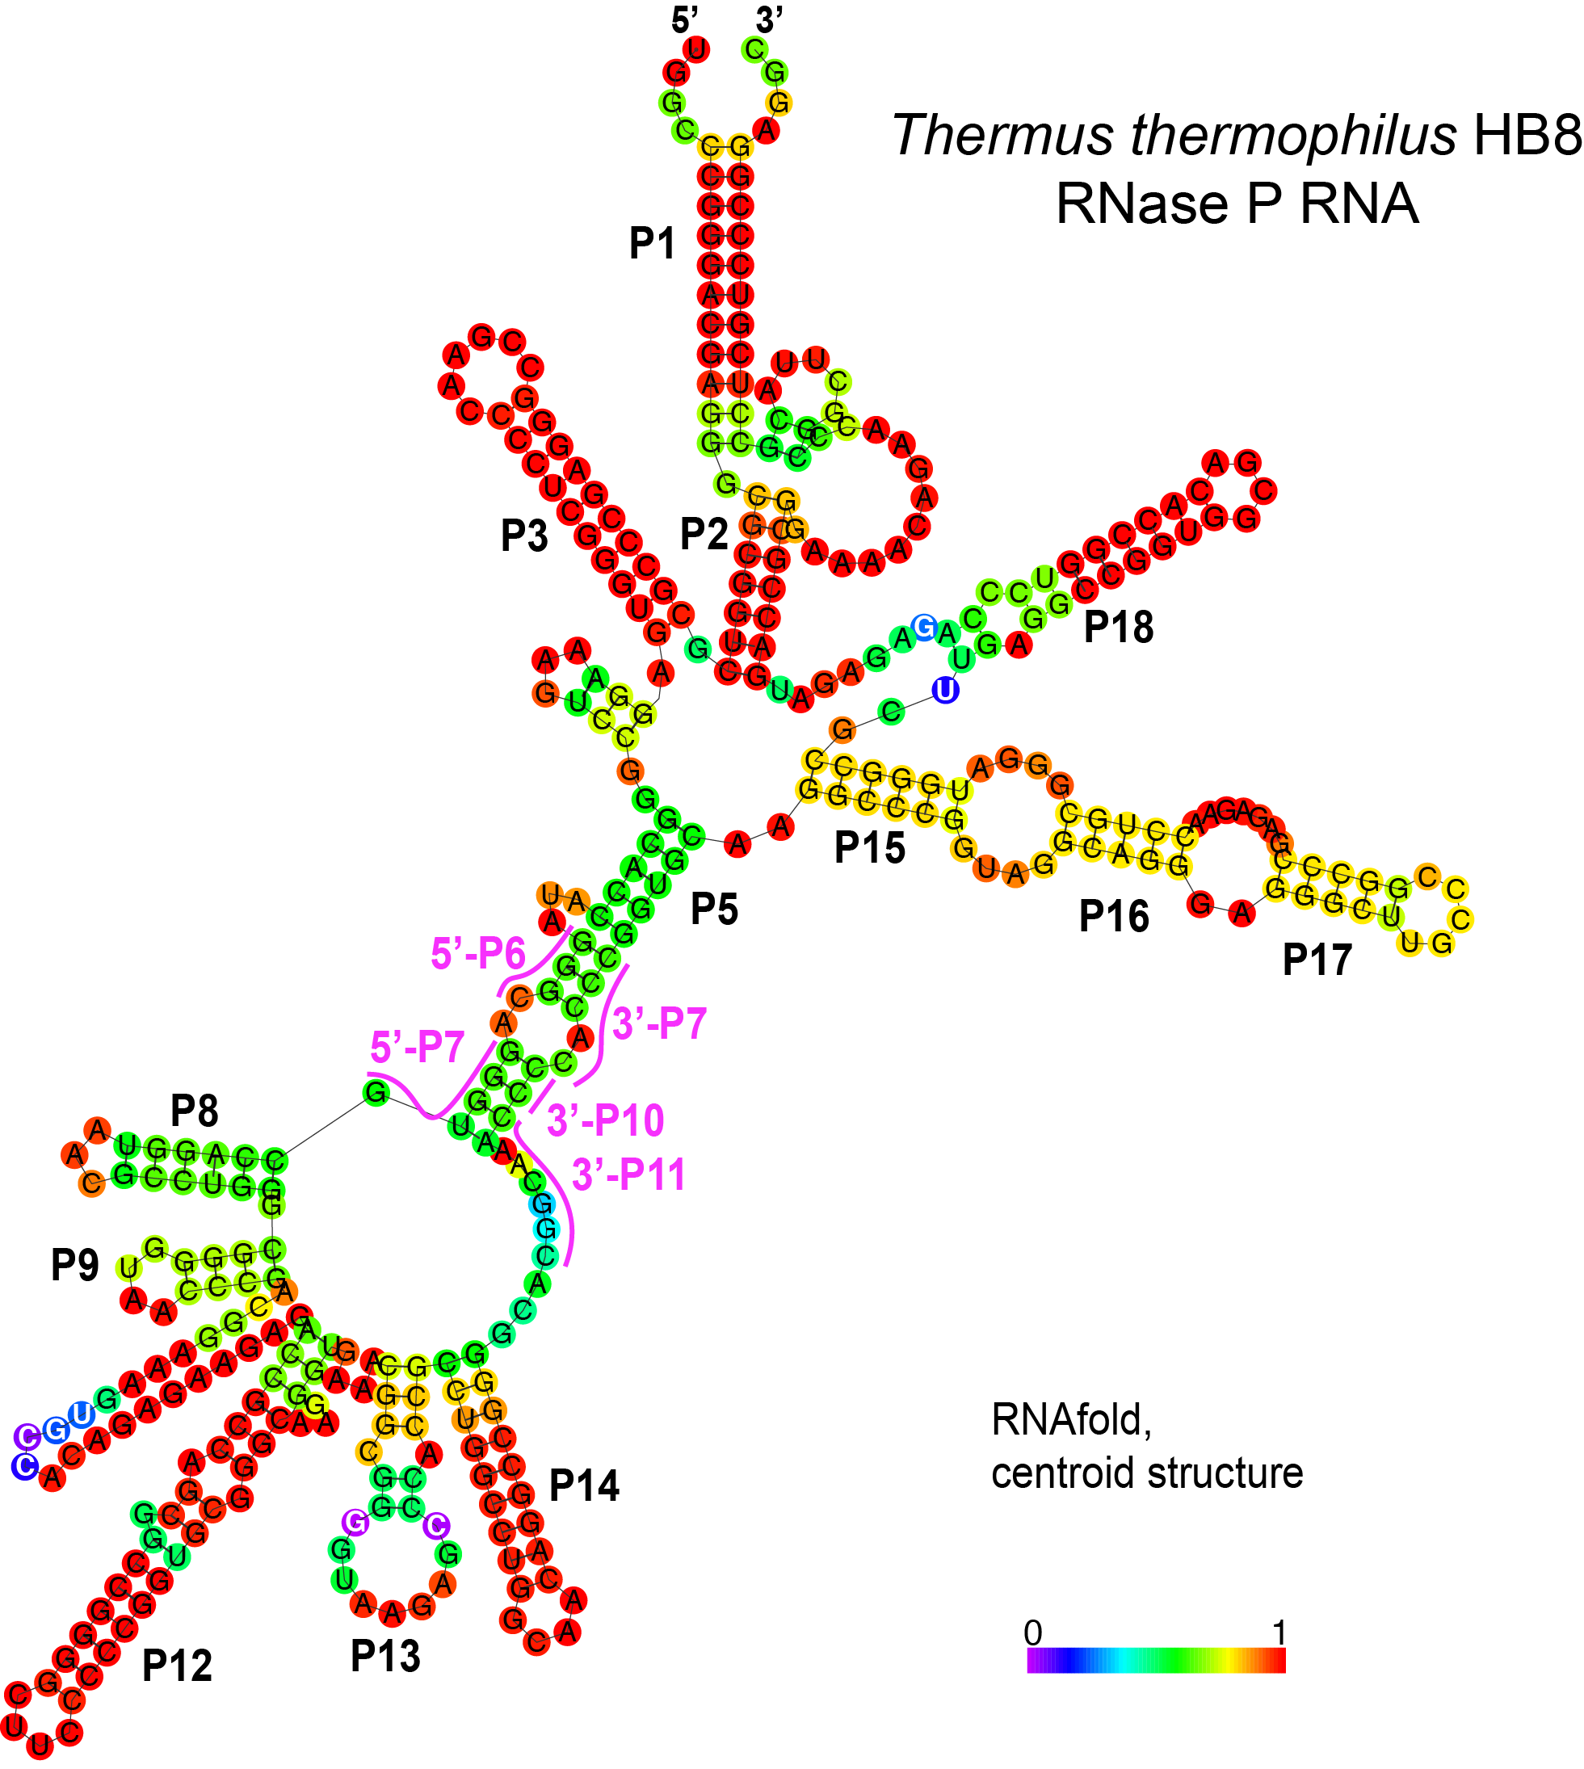

Fig. S5: RNA secondary structure prediction for T. thermophilus RNase P RNA using RNAfold with the default settings. The color code of the centroid structure indicates the probability (red: highest; blue: lowest) that a nucleotide is involved in base pairing or is unpaired. The possible folding trap involving pairings between 5'-P6/3'-P7 and 5'-P7/3'-P10/P11 is highlighted by pink lines and letters. The 5'-end of the RNA is the native one, whereas the one shown in Fig. 1C of the main text was exchanged for cloning purposes; the same folding result was obtained with the 5'-end shown in Fig. 1C.

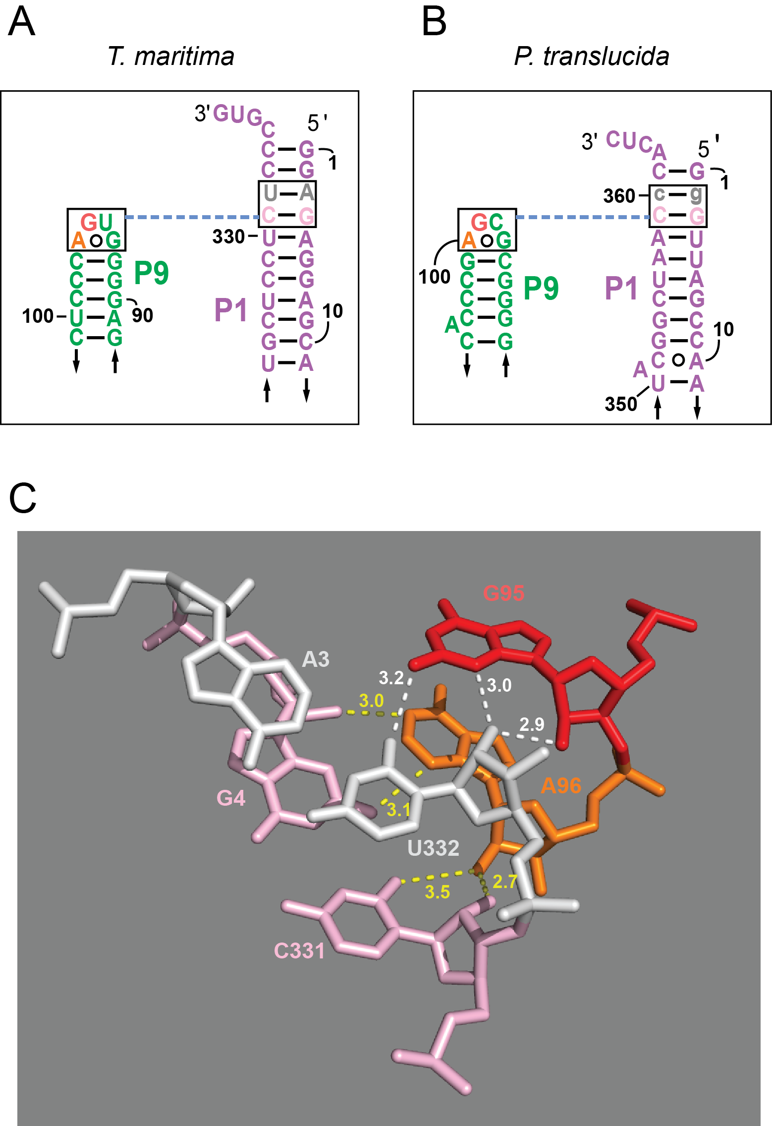

Fig. S6: L9-P1 interaction. Secondary structural sketch of the L9-P1 contact in T. maritima P RNA (A) and the putative corresponding contact in Ptr P RNA (B); the original A2:U360 was replaced with g2:c360 in Ptr P RNA for cloning purposes. (C) Hydrogen bonding interactions (length in Å) according to the T. maritima P RNA crystal structure (Reiter et al., 2010; PDB 3Q1Q); white dashed lines: H-bonds between G95 and bp A3:U332; yellow dashed lines: H-bonds between A96 and bp G4:C331).

Discussion related to Fig. S6

In the wild-type Ptr P RNA, the two P1 base pair identities are 5'-A2:U360-3' (2nd bp) and 5'-G3:C359-3' (3rd bp) (Fig. S6B), corresponding to 5'-A3:U332-3' and 5'-G4:C331-3' in T. maritima (Tma) P RNA (Fig. S6A). Thus, the L9-P1 contact is almost identical to that seen in the crystal structure of Tma P RNA, except that the latter has a U residue at the second position of loop L9 (5'-GUGA-3'; Fig. S6A versus B). In the Tma RNase P structure (Reiter et al., 2010; PDB 3Q1Q), the major component of the contact is an A-minor type I interaction between the tetraloop A96 and G4:C331 bp in P1 (Fig. S6A). This interaction can form in Ptr P RNA as well (Fig. S6B). For cloning and expression purposes we changed the second P1 bp of Ptr P RNA from A:U to G:C (Fig. S6B, gray g2:c360 bp). The T. maritima structure further indicates that G95 (G99 in Ptr P RNA, cf. Figs. S6A and B) additionally forms a G-minor type II interaction with the A3:U332 bp, where the 2'-OH of G95 donates an H bond to the O2' of U332, and the 2'-OH of U332 simultaneously donates an H bond to the N3 of G95; in addition, the 2-amino group of G95 could form a hydrogen bond with the O2 of U332 (Fig. S6C). Although we mutated the second A:U bp in P1 of Ptr P RNA to G:C (Fig. S6B), the nucleoside triple should principally be able to form in our “WT” Ptr P RNA derivative with the P1 bp exchange. Even the corresponding H bond from the 2-amino group of G99 to the O2 of C360 in our "WT" Ptr P RNA (Fig. S6B) seems possible and such G-minor type II G-C:G nucleoside triples have indeed been observed in crystal structures (Xin et al., 2008). Likewise, a previous mutational analysis of a type I/II nucleoside triple pair in the context of the Tetrahymena group I intron ribozyme revealed that G-minor type II G-C:G and A-U:G nucleoside triples, when occurring together with a type I G-C:A triple, result in similar interaction affinities (with a measured minor advantage of the type II A-U:G triple; Doherty et al., 2001).
In conclusion, we assume that the L9-P1 interaction would basically be able to form in our “WT” Ptr P RNA despite the change of the second P1 bp from A:U to G:C.

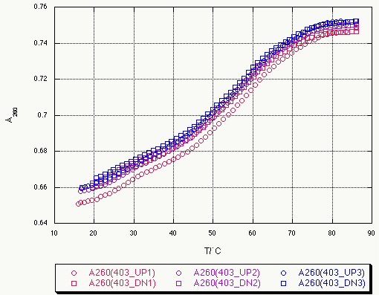

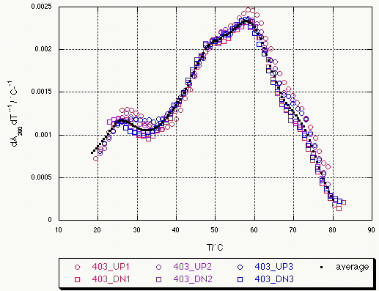

Fig. S7: UV denaturation and renaturation profiles for Dra P RNA at 10 mM NaCl, showing reversibility. UP1-DN1-UP2-DN2-UP3-DN3, three consecutive cycles of temperature increase (UP = unfolding) and decrease (DN = Down = refolding); raw data are shown at the top and first derivatives at the bottom.

References

Doherty EA, Batey RT, Masquida B, Doudna JA (2001) A universal mode of helix packing in RNA. Nat Struct Biol 8:339-343. doi: 10.1038/86221.

Schencking I, Rossmanith W, Hartmann RK. 2020. Diversity and Evolution of RNase P. In: Pontarotti P. (eds) Evolutionary Biology—A Transdisciplinary Approach. Springer, Cham. https://doi.org/10.1007/978-3-030-57246-4_11

