Supplementary Materials

The m⁶A landscape of polyadenylated nuclear (PAN) RNA and its related methylome in the context of KSHV replication.
Sarah Elizabeth Martin¹, Huachen Gan¹, Gabriela Toomer¹, Nikitha Sridhar¹, and Joanna Sztuba-Solinska^{1,}*
¹Department of Biological Sciences, Auburn University, 120 W. Samford Ave, Rouse Life Sciences Building, Auburn, AL 36849, United States

*To whom correspondence should be addressed. tel: 334-844-1650; email: jzs0165@auburn.edu

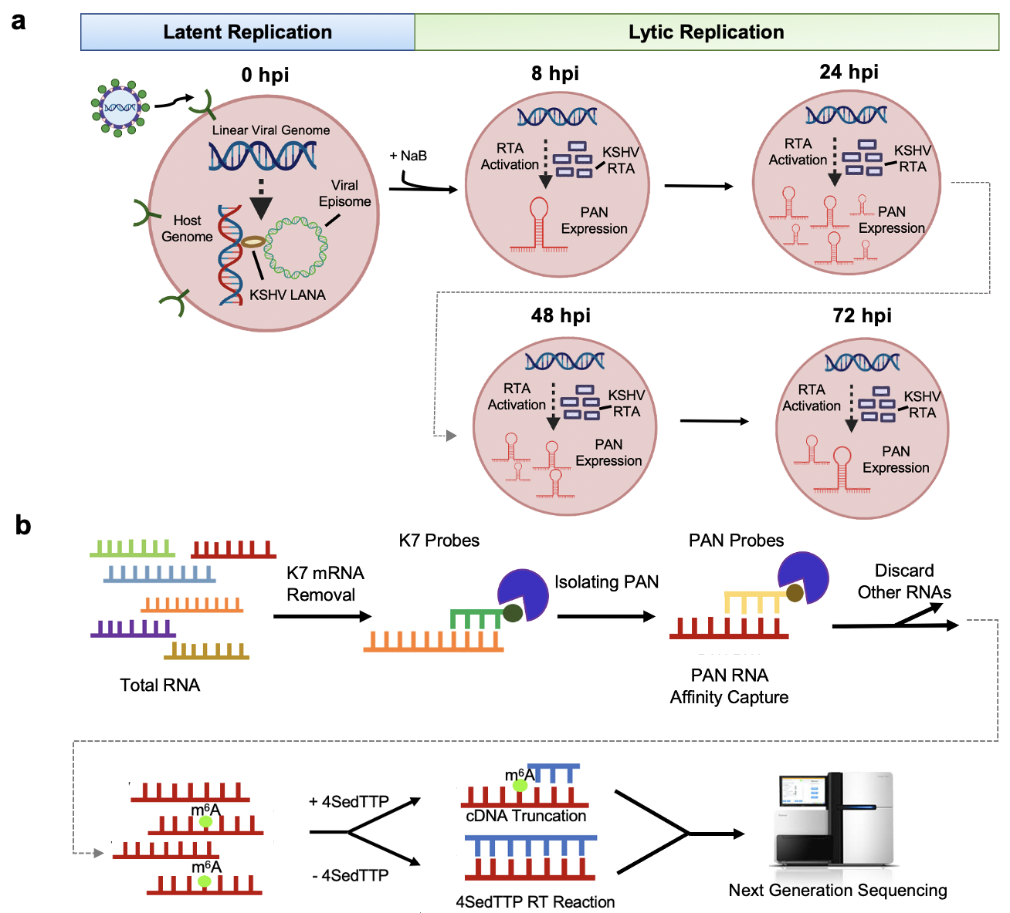Supplementary Fig. 1 a, The KSHV infectivity cycle. Latent (uninduced, 0 h pi) and lytic stages of KSHV infectivity cycle are indicated. Lytic cycle is further divided into the following stages: immediate early (8 h post induction, h pi), early (24 h pi), and late lytic (48 h pi and 72 h pi) based on distinct gene expression panel. PAN RNA expression is the most abundant at early lytic stage of KSHV infection (24 h pi). b, The schematic overview of 4SedTTP RT and next-generation sequencing methodology. Total RNA was subjected to the K7 mRNA depletion with a K7-specific biotinylated antisense probe (green). Fractions depleted of K7 mRNA were then subjected to the affinity capture of PAN with specific biotinylated antisense probes (yellow). Captured PAN RNA (red) was reverse transcribed in the presence of 4SedTTP to induce RT stops at m⁶A (bright green). The 4SedTTP RT experimental and control reactions were subjected to library preparation and next-generation sequencing.
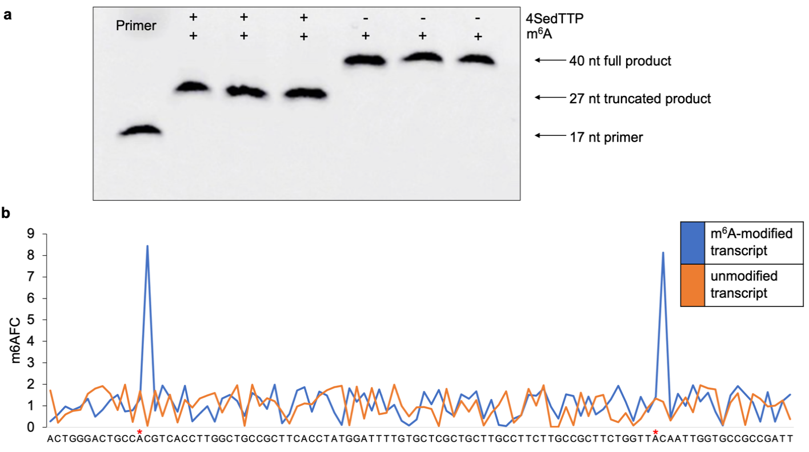

Supplementary Fig. 2 4SedTTP RT strategy for detection of m⁶A. a, The electropherogram representing the results of initial assessment of 4SedTTP RT strategy. Fluorescent primer (17 nt) and in vitro transcript (40 nt) carrying one m⁶A residue were used in the RT reaction in the presence of either 4SedTTP (+) or dTTP (-). The presence of 4SedTTP in RT reactions induced the truncation of cDNA products (27 nt) as compared to the full-length cDNA product (40 nt). b, The plot represents the next-generation sequencing analysis performed on in vitro synthesized transcripts carrying m⁶A at positions 13 and 82 (blue), and another unmodified transcript. The X-axis represents nucleotide sequence, the Y-axis indicates m⁶A fold change values (m⁶A_{FC}).
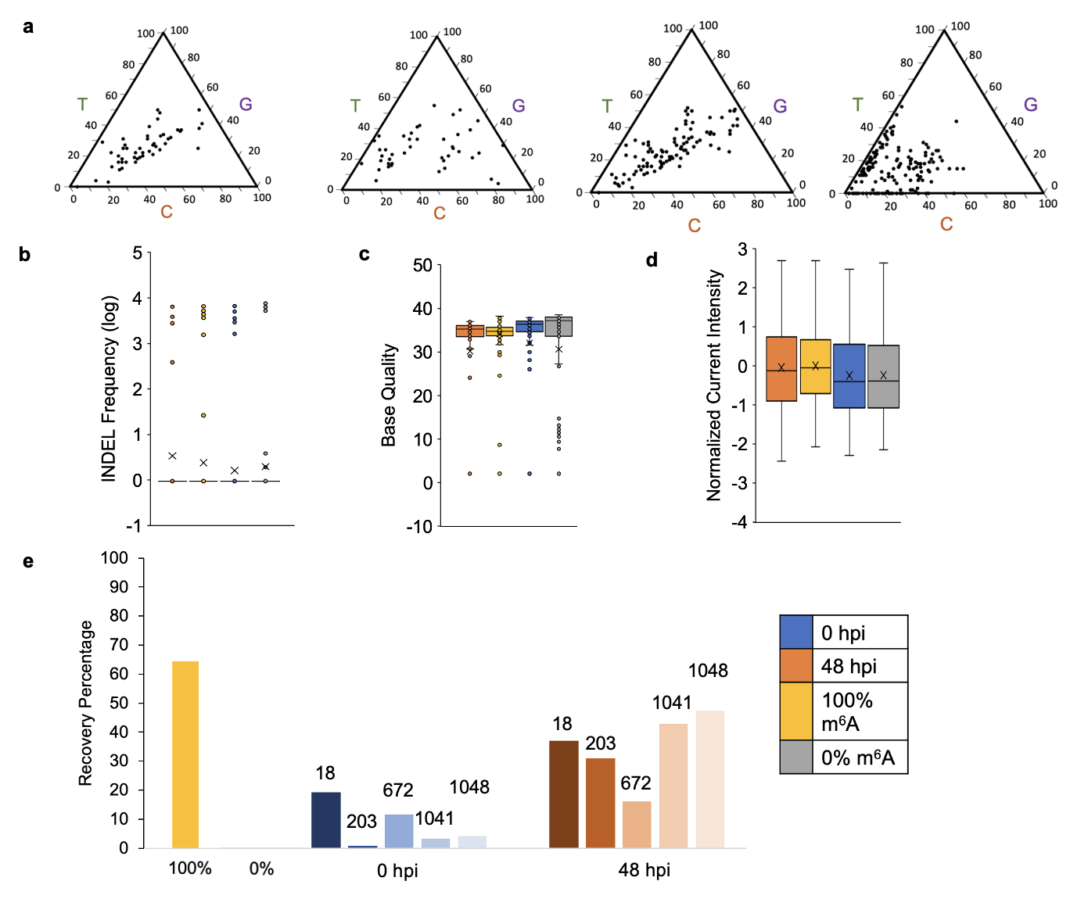

Supplementary Fig. 3 Direct PAN RNA sequencing analysis. a, Ternary diagrams depicting the mismatch directionality for m⁶A residues in (from left to right) 0% modified, 100% modified control transcripts and PAN RNA expressed during uninduced (0 h pi) and lytic (48 h pi) stages of KSHV infection. The scale on triangle sides reflects base proportions. b, Total insertions and deletions (INDEL), c, base-quality (BQ), d, normalized current intensity values assessed for PAN RNA expressed during uninduced (blue) and lytic (orange) stages of KSHV infection and contrasted with values obtained for 100% modified (yellow) and unmodified transcripts (gray). e, Predicted stoichiometry of m⁶A at specified sites performed using k-nearest neighbors (KNN) algorithm that classifies reads as modified or non-modified. X-axis represents all adenosines in 100% and 0% modified control PAN transcripts, and specific modified adenosines on PAN RNA expressed during uninduced (0 h pi, blue), and lytic stages of KSHV replication (48 h pi, orange). Y-axis represents m⁶A recovery percentage.

Supplementary Figure 4. The schematic overview of SLAP method. a, Total RNA is reverse transcribed in the presence (experimental reaction) or absence (control reaction) of selenium-modified deoxythymidine triphosphate (4SedTTP) that invokes reverse transcriptase (RT) stops 1 nts downstream of m⁶A. b, Oligonucleotide adapter that introduces a common binding site for a forward primer is site-specifically ligated to truncated m⁶A-specific products and full-length products that correspond to unmodified site. Next, that forward primer and reverse primer that binds downstream sequence present on both modified and unmodified products, are used to generate two distinct products corresponding to the modified and unmodified site in the same sample during single PCR reaction. c, The obtained products are separated during polyacrylamide gel electrophoresis and quantified by densitometry measurements. The comparison of the obtained densitometry values to the calibration curve yields the information about the modification frequency at each analyzed site.

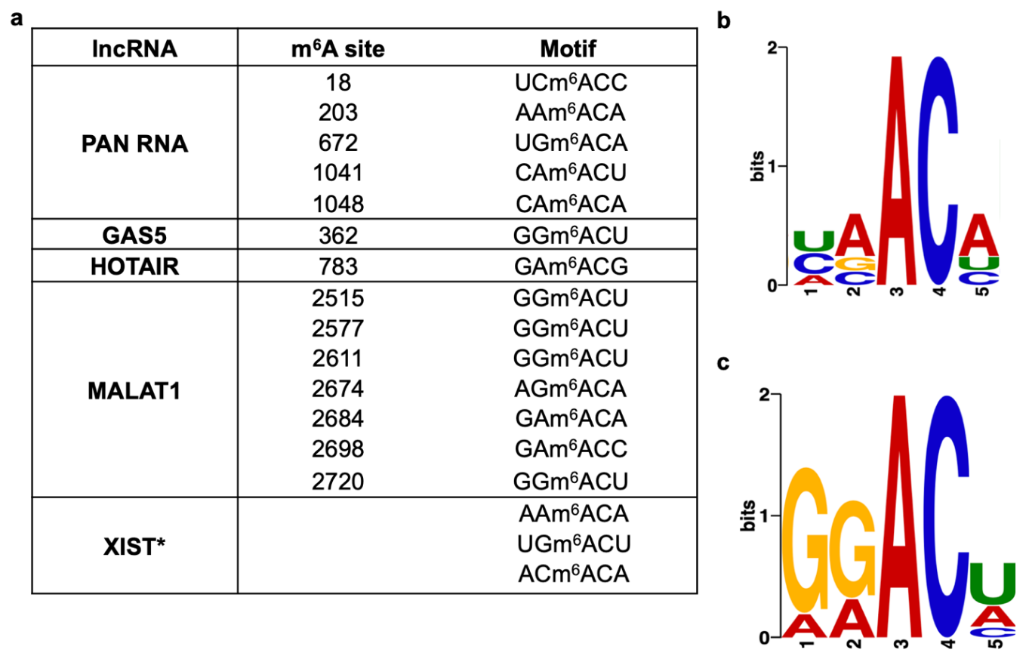

Supplementary Fig. 5 The m⁶A consensus on PAN RNA. a, The list of sequences carrying m⁶A within PAN and selected cellular lncRNAs, i.e., Growth Arrest Specific 5 (GAS5, Ni et al., 2019), HOX antisense intergenic RNA (HOTAIR, Porman et al., 2020), Metastasis Associated Lung Adenocarcinoma Transcript 1 (MALAT1, Zhou et al., 2016; Wang et al., 2021), and X-inactive specific transcript (XIST, Patil et al., 2016). b, MEME analysis of PAN RNA m⁶A signatures. c, MEME analysis of the m⁶A sequence environment in cellular lncRNAs.

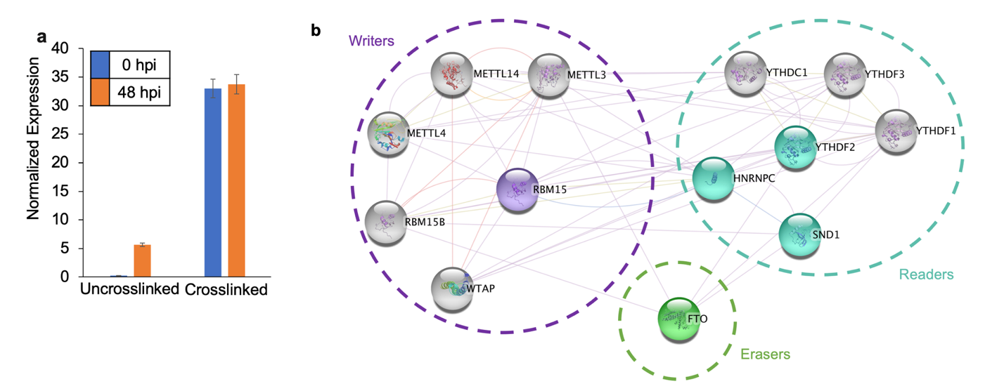

Supplemental Fig. 6 The RAP MS analysis for PAN RNA m⁶A methylome. a, Normalized expression of PAN RNA assessed by RT qPCR of total RNA samples extracted during KSHV latent (0 hpi) and lytic (48 hpi) stages of replication, both with and without PAN RNA-protein crosslinking and affinity capture. b, The lncRNA-protein interactions network (LPI) for the PAN RNA m⁶A methylome visualized by Cytoscape. Proteins that were found to associate with PAN RNA are shown in purple (writers), blue (readers), and green (erasers).

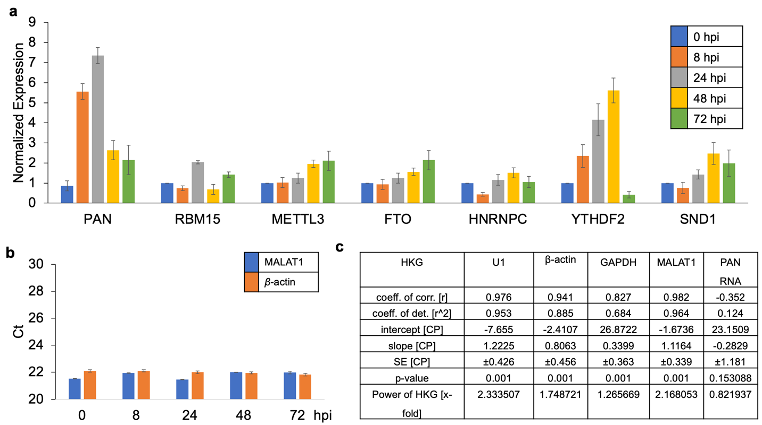

Supplemental Fig. 7 a, The normalized expression of methylome-associated mRNAs encoding RBM15, METTL3, FTO, HNRNPC, YTHDF2, SND1 during the latent and lytic stages of KSHV replication. b, The expression levels of MALAT1 and β-actin during uninduced (0 h pi), immediate early (8 h pi), early (24 h pi), and late lytic (48 – 72 h pi) stages of KSHV infection. All data normalization analysis were performed using MALAT1 and β-actin as they were determined in our and previous studies (Borah et al., 2002) to be not significantly affected by the progression of KSHV replication (n = 3). c, The results of pair-wise correlation and regression analyses performed by BestKeeper using housekeeping genes (HKG): U1 snRNA, β-actin, GAPDH, MALAT1 and PAN lncRNAs (outlier).

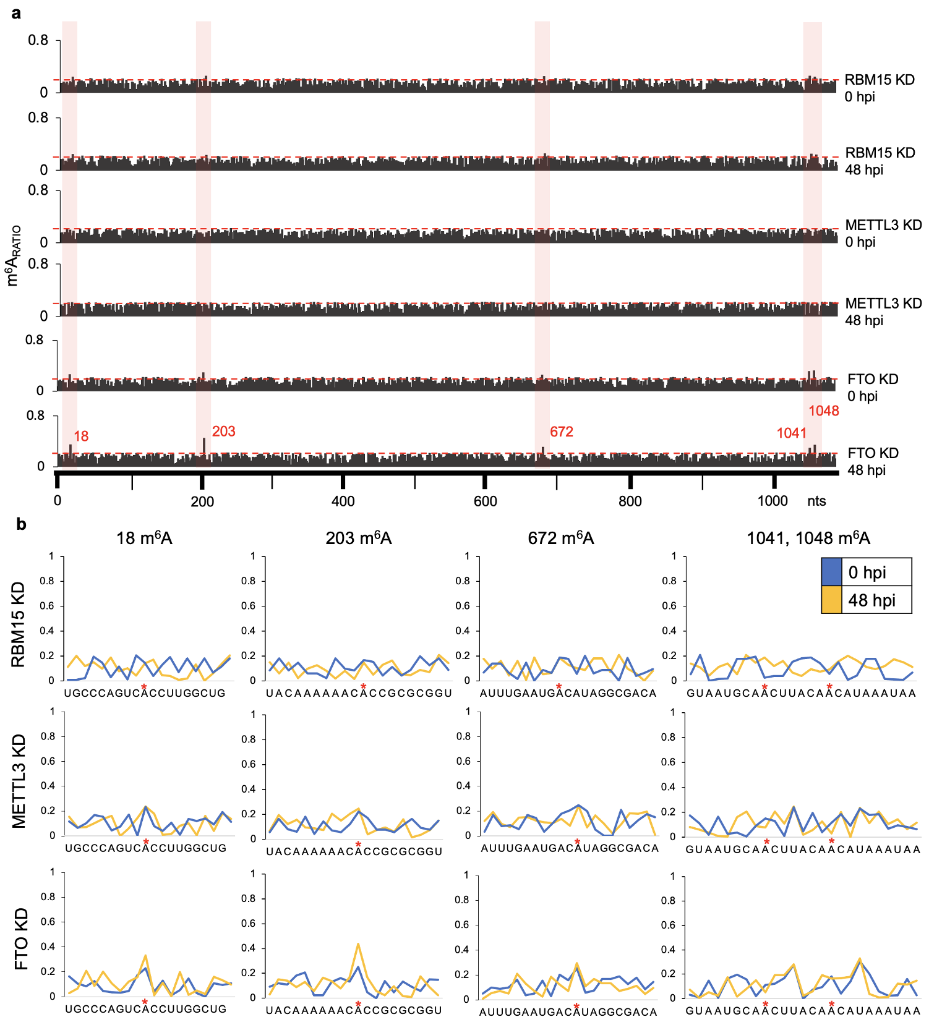
Supplementary Fig. 8 a, The graphs represent m⁶A_{RATIO} (Y-axis) against PAN RNA sequence (X-axis). The peaks correspond to the expected RT stop 1 nt downstream of m⁶A. The threshold line (red) for calling m⁶A peaks is set at 0.2 and it was calculated by dividing the average m⁶A_{RATIO} values calculated for all PAN nucleotides divided by the total number of nucleotides. b, The charts representing the signal-to-noise ratio for PAN sequence overlapping m⁶A within specified nucleotide window (X-axis) in BCBL-1 for RBM15, METTL3, and FTO knockdown (KD) cell lines. Time points of KSHV infection are color-coded as follows: uninduced stage - 0 h pi is indicated with blue line; late lytic stage – 48 h pi is indicated with yellow line.

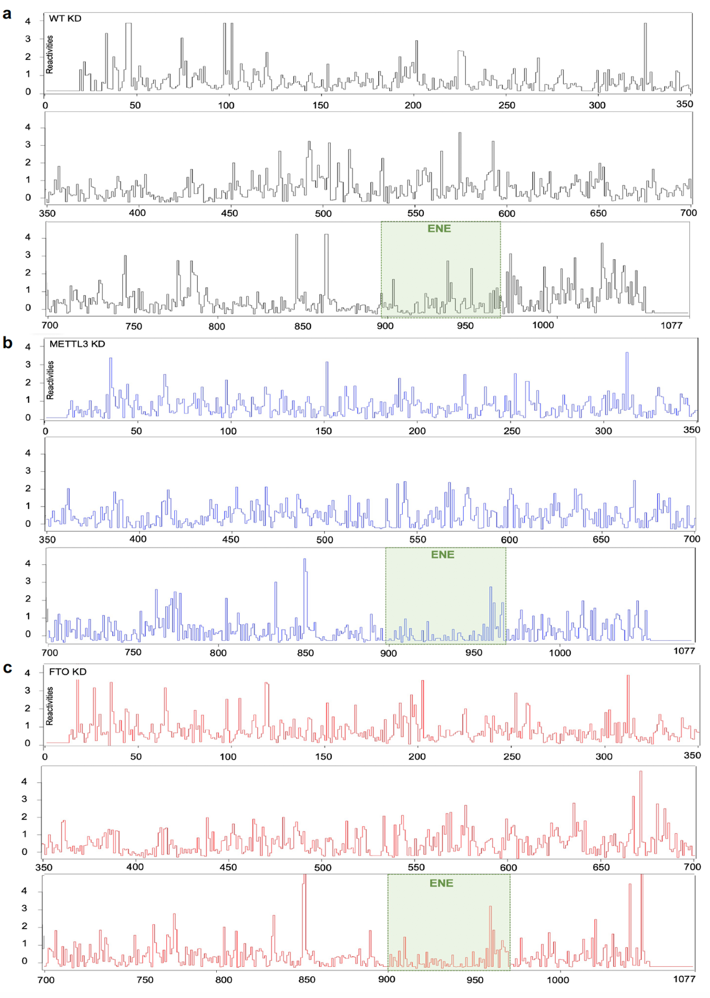
Supplementary Fig. 9 Step-plots representing SHAPE-MaP reactivity profiles for PAN RNA probed in a, wild-type, b, METTL3. c, FTO knockdown BCBL-1 cells. X- axis corresponds to PAN RNA nucleotide sequence, Y-axis represents SHAPE-MaP reactivity values. Nucleotides 1-14 and 1056-1077 were not covered in the analysis due to primer annealing. The position of the expression and nuclear retention (ENE) motif is indicated with green square.

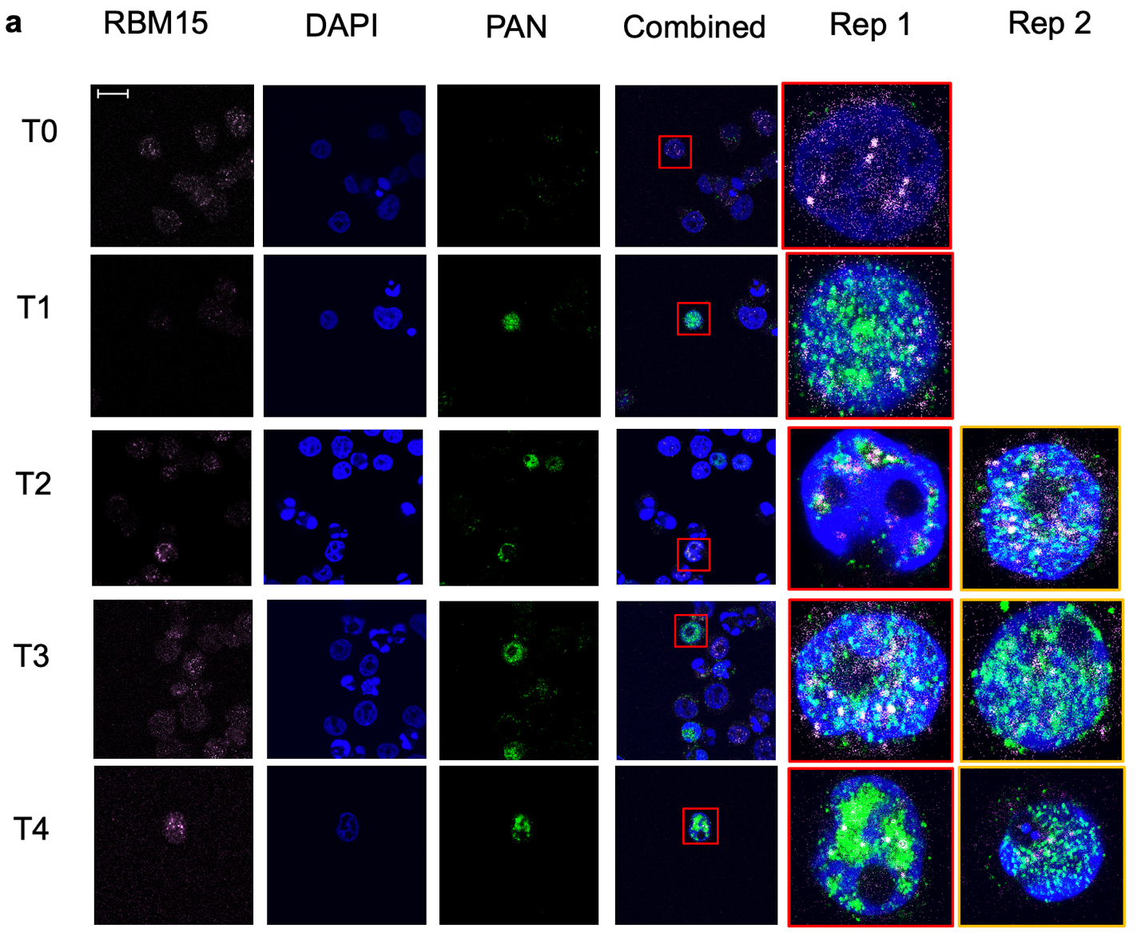
72 hpi
48 hpi
24 hpi
8 hpi
0 hpi

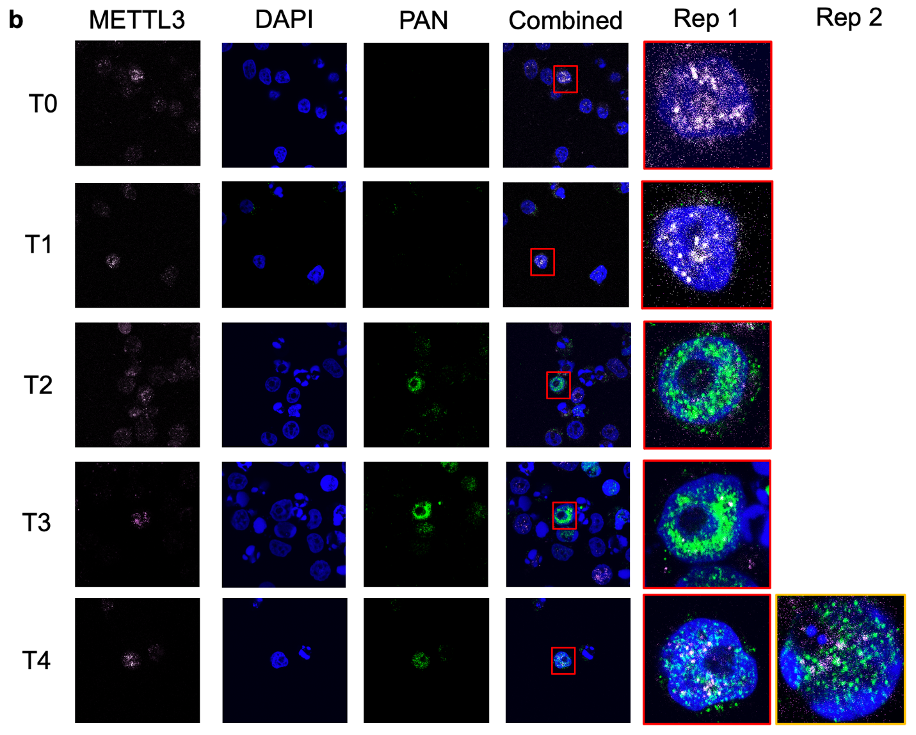
8 hpi
24 hpi
48 hpi
0 hpi
72 hpi

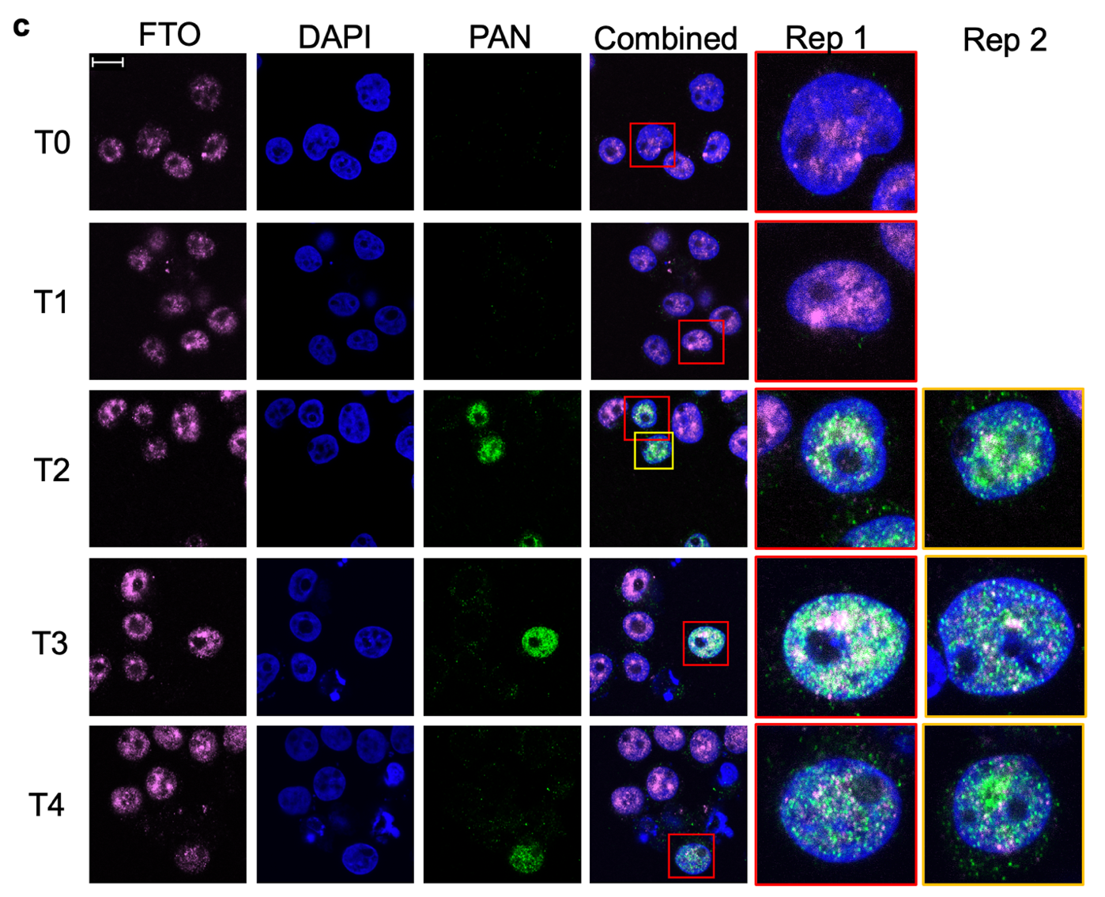
48 hpi
24 hpi
8 hpi
0 hpi
72 hpi

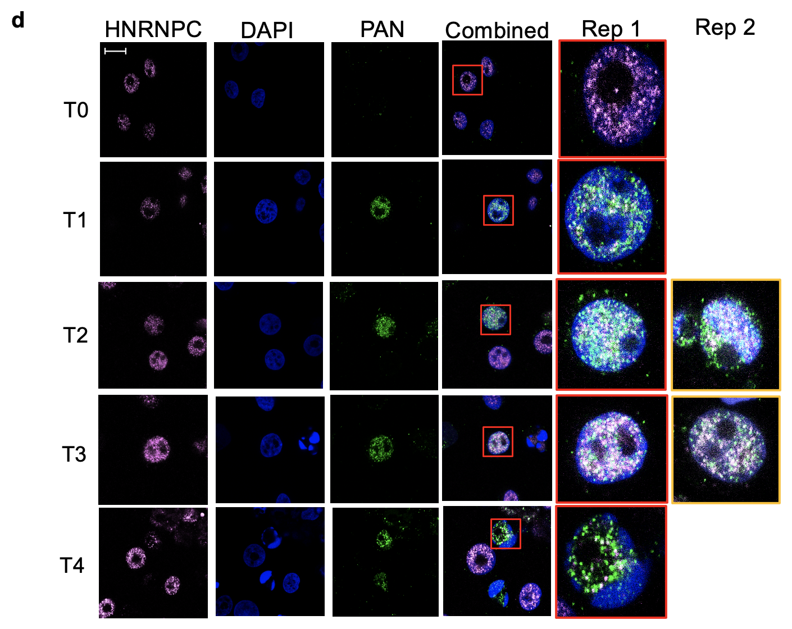
0 hpi
8 hpi
24 hpi
48 hpi
72 hpi

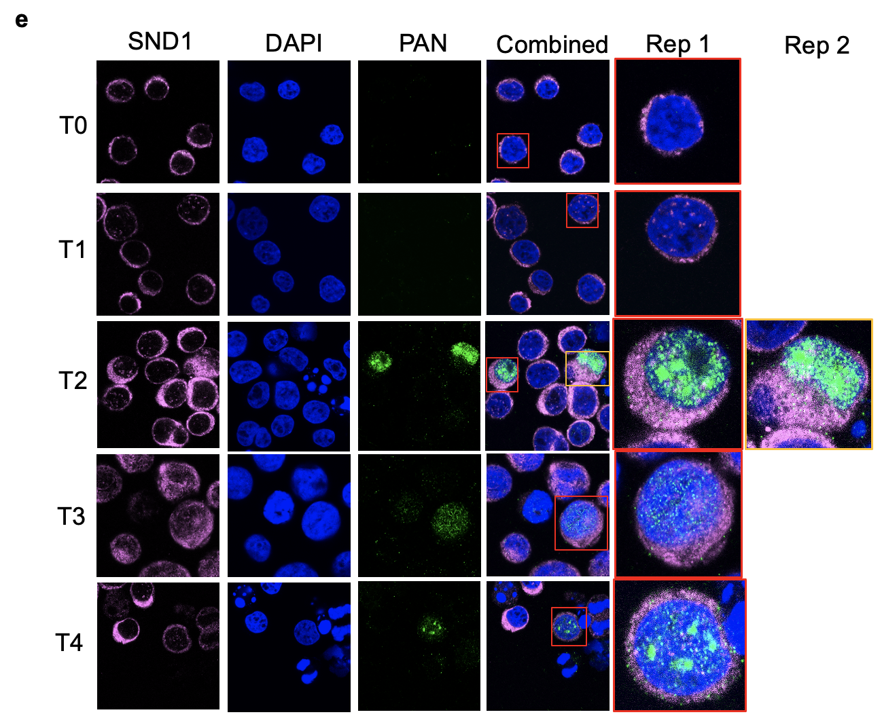
48 hpi
24 hpi
8 hpi
0 hpi
72 hpi

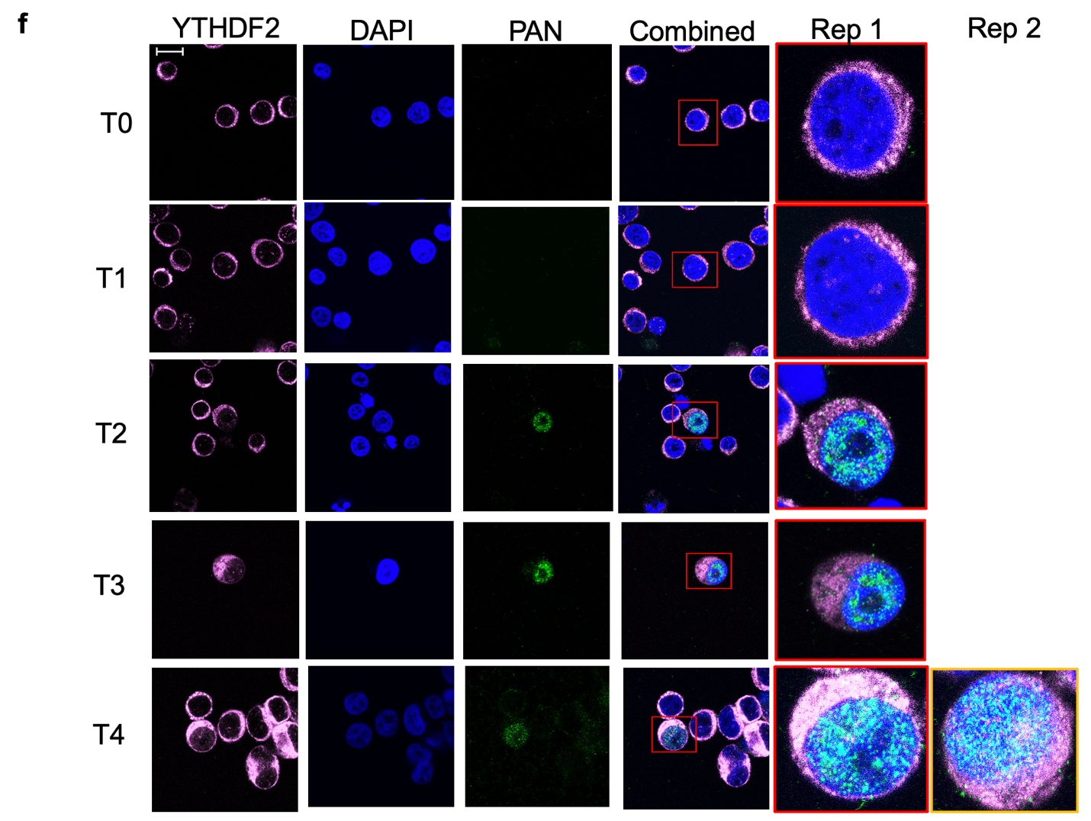
72 hpi
48 hpi
24 hpi
8 hpi
0 hpi
Supplementary Fig. 10 Confocal fluorescent microscopy analysis of PAN and related m⁶A methylome components performed in BCBL-1 cells during the latent (0 hpi) and lytic (8-72 hpi stages of KSHV replication. The confocal microscopy micrographs representing the individual methylome enzymes (in pink) are ordered as follows: a, RBM15, b, METTL3, c, FTO, d, HNRNPC, e, SND1, and f, YTHDF2. DAPI staining of the nuclei is in blue, and PAN RNA is green.

Supplementary Table 1. List of oligonucleotides used in this study. The following abbreviations have been used to indicate specific to the sequences: 5Biosg - 5’ biotinylation. 5Phos - 5’ phosphorylation. N - random nucleotides. 5Sp9 - triethylene glycol spacer. 3ddc - 3’ dideoxycytidine chain terminator, Fw – forward, Rv-reverse orientation. The bolded sequences indicate Illumina Tru-seq indexes.
Method | Primer | Sequence
PAN Affinity  Capture | Bio-LeftTagPrimer | /5’Biotin/ATGAGCCCCTTAACATGTGC
PAN Affinity  Capture | TAG1-Left | GGACGCTTGCTACACCGTAT
PAN Affinity  Capture | TAG2-Left | ATGAGCCCCTTAACATGTGC
PAN Affinity  Capture | T7RightTagPrimer (antisense probes to capture PAN-RNA) | GGATTCTAATACGACTCACTATAGGGATACGGTGTAGCAAGCGTCC
PAN Affinity  Capture | T7LeftTagPrimer (sense probes) | GGATTCTAATACGACTCACTATAGGGATGAGCCCCTTAACATGTGC
PAN Affinity  Capture | ProbeK7 primers Fw | ATGAGCCCCTTAACATGTGCGCTAAACTGACTCAAGCTGG
PAN Affinity  Capture | ProbeK7 primers Rv | ATACGGTGTAGCAAGCGTCCATGGGAACACTGGAGATAAAAG
PAN Affinity  Capture | Probe8 primers Fw | ATGAGCCCCTTAACATGTGCAGGGGGCTACAACTGGCCTG
PAN Affinity  Capture | Probe8 primers Rv | ATACGGTGTAGCAAGCGTCCCTCCATAAGCCCGCAGAAC
PAN Affinity  Capture | Probe9 primers Fw | ATGAGCCCCTTAACATGTGCTGCGGGCTTATGGAGAGCTC
PAN Affinity  Capture | Probe9 primers Rv | ATACGGTGTAGCAAGCGTCCCTTTTGGCAATATACCCATC
PAN Affinity  Capture | Probe10 primers Fw | ATGAGCCCCTTAACATGTGCGTATATTGCCAAAAGCGACG
PAN Affinity  Capture | Probe10 primers Rv | ATACGGTGTAGCAAGCGTCCCAGTCACCTTGGCTGCCGC
SHAPE-MaP Primers | PAN_RT1 | CATTATATTCCACATTCAGAC
SHAPE-MaP Primers | PAN_RT2 | CCGCACACCACTTTAGTTC
SHAPE-MaP Primers | PAN_RT3 | GGATTAAACATTGACCTTTATTTATG
SHAPE-MaP Primers | PZ1, For | GACTGGAGTTCAGACGTGTGCTCTTCCGATCTNNNNNCCCAGTCACCTTGGCTGCCG
SHAPE-MaP Primers | PZ2, For | GACTGGAGTTCAGACGTGTGCTCTTCCGATCTNNNNNCCTTGCGGGTTATTGCATTG
SHAPE-MaP Primers | PZ3, For | GACTGGAGTTCAGACGTGTGCTCTTCCGATCTNNNNNGGCGACAAAGTGAGGTGG
SHAPE-MaP Primers | PZ3, Rev | CCCTACACGACGCTCTTCCGATCTNNNNNGGATTAAACATTGACCTT
SHAPE-MaP Primers | PZ2, Rev | CCCTACACGACGCTCTTCCGATCTNNNNNCTTACACGACTTTGAAAC
SHAPE-MaP Primers | PZ1, Rev | CCCTACACGACGCTCTTCCGATCTNNNNNGTATCCTCGCATATCATAAA
SHAPE-MaP Primers | P7,I-1 | CAAGCAGAAGACGGCATACGAGATCGTGATGTGACTGGAGTTCAGAC
SHAPE-MaP Primers | P7, I-2 | CAAGCAGAAGACGGCATACGAGATACATCGGTGACTGGAGTTCAGAC
SHAPE-MaP Primers | P7, I-3 | CAAGCAGAAGACGGCATACGAGATGCCTAAGTGACTGGAGTTCAGAC
SHAPE-MaP Primers | P7,I-4 | CAAGCAGAAGACGGCATACGAGATTGGTCAGTGACTGGAGTTCAGAC
SHAPE-MaP Primers | P7,I-5 | CAAGCAGAAGACGGCATACGAGATCACTGTGTGACTGGAGTTCAGAC
SHAPE-MaP Primers | P7, I-6 | CAAGCAGAAGACGGCATACGAGATATTGGCGTGACTGGAGTTCAGAC
SHAPE-MaP Primers | P7,I-7 | CAAGCAGAAGACGGCATACGAGATGATCTGGTGACTGGAGTTCAGAC
SHAPE-MaP Primers | P7,I-8 | CAAGCAGAAGACGGCATACGAGATTCAAGTGTGACTGGAGTTCAGAC
SHAPE-MaP Primers | P7,I-9 | CAAGCAGAAGACGGCATACGAGATCTGATCGTGACTGGAGTTCAGAC
SHAPE-MaP Primers | P7,I-10 | CAAGCAGAAGACGGCATACGAGATAAGCTAGTGACTGGAGTTCAGAC
SHAPE-MaP Primers | P7,I-11 | CAAGCAGAAGACGGCATACGAGATGTAGCCGTGACTGGAGTTCAGAC
SHAPE-MaP Primers | P7,I-12 | CAAGCAGAAGACGGCATACGAGATTACAAGGTGACTGGAGTTCAGAC
SHAPE-MaP Primers | P7, I-20 | CAAGCAGAAGACGGCATACGAGATGGCCACGTGACTGGAGTTCAGAC
SHAPE-MaP Primers | P7, I-21 | CAAGCAGAAGACGGCATACGAGATCGAAACGTGACTGGAGTTCAGAC
SHAPE-MaP Primers | P7-I-22 | CAAGCAGAAGACGGCATACGAGATCGTACGGTGACTGGAGTTCAGAC
SHAPE-MaP Primers | P5 | AATGATACGGCGACCACCGAGATCTACACTCTTTCCCTACACGACGCTCTTCCG
qPCR primers | K7-qPCR-Fw  (KSHV; 28597-28918) | AAAAGCGACGCAATCAACCC
qPCR primers | K7-qPCR-Rv | TGGAGATAAAAGGGGCCAGC
qPCR primers | PAN-qPCR-Fw  (KSHV; 29489-29567) | ATAGGCGACAAAGTGAGGTGGCAT
qPCR primers | PAN-qPCR-Rv | TAACATTGAAAGAGCGCTCCCAGC
qPCR primers | β-actin Fw  (Human; 1027-1204) | ATTGCCGACAGGATGCAGA
qPCR primers | β-actin Rv | GAGTACTTGCGCTCAGGAGGA
qPCR primers | Malat1 Fw  (Human; 258-339) | GACGGAGGTTGAGATGAAGC
qPCR primers | Malat1 Rv | AATCGGGGCTCTGTAGTCCT
qPCR primers | RBM15_Fw  (Human; 2819-3017) | CGAGATAGGAAGCACCGGAC
qPCR primers | RBM15_Rv | CAACCAGTTTTGCACGGACA
qPCR primers | YTH_Fw  (Human; 785-1130) | CTGTTGGTAGCGGGTCCATT
qPCR primers | YTH_Rv | TGTTGCCCTACTGATGCCTG
qPCR primers | hnRNP-C_Fw  (Human; 135-597) | TCCCCTTCTTGTTTTCGGCT
qPCR primers | hnRNP-C_Rv | ACGTTTCGAGGGCACTACAG
Library preparation | RiL-19 RNA adapter | /5Phos/rArGrArUrCrGrGrArArGrArGrCrGrUrCrGrUrG/3ddC/
Library preparation | 3Tr3 DNA adapter | /5Phos/AGATCGGAAGAGCACACGTCTG/3ddC/
Library preparation | AR17 primer for reverse transcription | ACACGACGCTCTTCCGA
Library preparation | Universal PCR primer | AATGATACGGCGACCACCGAGATCTACACTCTTTCCCTACACGACGCTCTTCCGATCT
Library preparation | Index with barcode 1 | CAAGCAGAAGACGGCATACGAGATGTGAATATGTGACTGGAGTTCAGACGTGTGCTCTTCCGATCT
Library preparation | Index with barcode 2 | CAAGCAGAAGACGGCATACGAGATACAGGCGCGTGACTGGAGTTCAGACGTGTGCTCTTCCGATCT
Library preparation | Index with barcode 3 | CAAGCAGAAGACGGCATACGAGATCATAGAGTGTGACTGGAGTTCAGACGTGTGCTCTTCCGATCT
Library preparation | Index with barcode 4 | CAAGCAGAAGACGGCATACGAGATTGCGAGACGTGACTGGAGTTCAGACGTGTGCTCTTCCGATCT
Library preparation | Index with barcode 5 | CAAGCAGAAGACGGCATACGAGATTCTCTACTGTGACTGGAGTTCAGACGTGTGCTCTTCCGATCT
Library preparation | Index with barcode 6 | CAAGCAGAAGACGGCATACGAGATCTCTCGTCGTGACTGGAGTTCAGACGTGTGCTCTTCCGATCT
Library preparation | Index with barcode 7 | CAAGCAGAAGACGGCATACGAGATCCAAGTCTGTGACTGGAGTTCAGACGTGTGCTCTTCCGATCT
Library preparation | Index with barcode 8 | CAAGCAGAAGACGGCATACGAGATTTGGACTCGTGACTGGAGTTCAGACGTGTGCTCTTCCGATCT
Library preparation | Index with barcode 9 | CAAGCAGAAGACGGCATACGAGATGCAGAATTGTGACTGGAGTTCAGACGTGTGCTCTTCCGATCT
Library preparation | Index with barcode 10 | CAAGCAGAAGACGGCATACGAGATATGAGGCCGTGACTGGAGTTCAGACGTGTGCTCTTCCGATCT
Library preparation | Index with barcode 11 | CAAGCAGAAGACGGCATACGAGATACTAAGATGTGACTGGAGTTCAGACGTGTGCTCTTCCGATCT
Library preparation | Index with barcode 12 | CAAGCAGAAGACGGCATACGAGATGTCGGAGCGTGACTGGAGTTCAGACGTGTGCTCTTCCGATCT
Library preparation | Index with barcode 13 | CAAGCAGAAGACGGCATACGAGATATCACGACGTGACTGGAGTTCAGACGTGTGCTCTTCCGATCT
Library preparation | Index with barcode 14 | CAAGCAGAAGACGGCATACGAGATATCACGGTGACTGGAGTTCAGACGTGTGCTCTTCCGATCT
Library preparation | Index with barcode 15 | CAAGCAGAAGACGGCATACGAGATCGATGTGTGACTGGAGTTCAGACGTGTGCTCTTCCGATCT
m⁶A Controls | m⁶A Short RNA | CCGCCAGCUUUGG/m⁶A/CUUUCCGUUUAGCCCGUCUCUCUCUCG
m⁶A Controls | m⁶A Short RNA primer | AUCCCGUCUCUCUCUCG
m⁶A Controls | m⁶A_T7_rev | TAATACGACTCACTATAGGGGAAGCCAAAATAACCACAC
m⁶A Controls | m⁶A_for | TCTCAGGCCATGTGGGAAAAG
m⁶A Controls | m⁶A_PAN_RNA | ACTGGGACTGCCC/m⁶A/GTCACCTTGGCTGCCGCTTCACCTATGGATTTTGTGCTCGCTGCTTGCCTTCTTGCCGCTTCTGGTTTTC/m⁶A/TTGGTGCCGCCGATT
The SLAP Primers | RT 18 | GACTGGGCAGTCCCAGT
The SLAP Primers | Splint 18 | CCAGTCCATGGCCTTGGCTGC/3SpC3
The SLAP Primers | Adapter 18 | /5Sp9/CATGGAAGCGGCAAGAAGGCAAGCAG
The SLAP Primers | RT 672 | ATGTTCTTACACGACTTTGAA
The SLAP Primers | Splint 672 | AACATCATGGGTCGCCTATG/3SpC3
The SLAP Primers | Adapter 672 | /5Sp9/CATGGGGAAAAATAAACACACCATTA
The SLAP Primers | RT 203 | TGGGCAAATCGCAGCTTTTGT
The SLAP Primers | Splint 203 | GCCCACATGGCACCGCGCGG/3SpC3
The SLAP Primers | Adapter 203 | /5Sp9/CATGGAATGTGGGAAAAGTAGGACGG
The SLAP Primers | Forward 203 | TCCGTCCTACTTTTCCCACATT
The SLAP Primers | RT 1048/1041 | TATGGATTAAACATTGACCTT
The SLAP Primers | Splint 1048 | CCATACATGGCATAAATA/3SpC3
The SLAP Primers | Adapter 1048/1041 | /5Sp9/CATGGTTAGTTTAATTTGAGCTCTAG
The SLAP Primers | Splint 1041 | CCATACATGGCTTACAAC/3SpC3
The SLAP Primers | RT Control 14 | GGAAAAGTAGGACGGAAAACC
The SLAP Primers | Splint Control 14 | TTTCCCATGGCTCTGGCTTT/3SpC3
The SLAP Primers | Adapter Control 14 | /5Sp9/CATGGACCCACAATCGGCGGCACCAA
The SLAP Primers | Forward Control 14 | TTGGTGCCGCCGATTGTGGGTT
The SLAP Primers | RT Control 83 | CCAAAAGCGACGCAATCAACC
The SLAP Primers | Splint Control 83 | TTTGGCATGGTTGGTGCC/3SpC3
The SLAP Primers | Adapter Control 83 | /5Sp9/CATGGGAAAACAGAAG
The SLAP Primers | Forward Control 83 | CTTCTGTTTTC
 | SB2 | ACAAATGCCACCTCACTTTGTCGC
PAN RNA oligonucleotide probes (confocal) | SB85 | CGCTGCTTTCCTTTCACATT
 | SB88 | GTGAAGCGGCAGCCAAGGTGACTGG

Supplementary Table 2. Primary and secondary antibodies used in this study.
Primary antibody | Dilution for Western blot | Dilution for immunofluorescence analysis | Secondary antibody
RBM15 Polyclonal (ThermoFisher, PA5-22067) | 1:1000 | 1:50 | goat anti-rabbit immunoglobulin conjugated to horseradish peroxidase (Enzo, ADI-SAB-300-J)
METTL3 (ThermoFisher, MA5-34248) | N/A | 1:50
METTL3 (ThermoFisher, MA5-27527) | 1:1000 | N/A | goat anti-rabbit immunoglobulin conjugated to horseradish peroxidase (Enzo, ADI-SAB-300-J)
FTO (ThermoFisher, PA5-51074) | 1:1000 | 1:200 | goat anti-rabbit immunoglobulin conjugated to horseradish peroxidase (Enzo, ADI-SAB-300-J)
hnRNP-C (ThermoFisher, PA5-22280) | 1:1000 | 1:200 | goat anti-rabbit immunoglobulin conjugated to horseradish peroxidase (Enzo, ADI-SAB-300-J)
YTHDF2 (Cell Signaling Technologies, 80014) | 1:1000 | 1:50 | goat anti-rabbit immunoglobulin conjugated to horseradish peroxidase (Enzo, ADI-SAB-300-J)
SND1 (Protein Technologies,10760-1-AP) | 1:1000 | 1:200 | goat anti-rabbit immunoglobulin conjugated to horseradish peroxidase (Enzo, ADI-SAB-300-J)
Tubulin (ABCAM, Ab185224) | 1:1000 | N/A | goat anti-rabbit immunoglobulin conjugated to horseradish peroxidase (Enzo, ADI-SAB-300-J)
Actin - Mouse | 1:1000 | N/A | goat anti-mouse immunoglobulin conjugated to horseradish peroxidase (Abcam, ab97023)

REFERENCES:
1. Ni,W., Yao,S., Zhou,Y., Liu,Y., Huang,P., Zhou,A., Liu,J., Che,L. and Li,J. (2019) Long noncoding RNA GAS5 inhibits progression of colorectal cancer by interacting with and triggering YAP phosphorylation and degradation and is negatively regulated by the m6A reader YTHDF3. Mol. Cancer, 18.
2. Porman,A.M., Roberts,J.T., Chrupcala,M., Kennedy,M., Williams,M.M., Richer,J.K. and Johnson,A.M. (2020) A single N6-methyladenosine site in lncRNA HOTAIR regulates its function in breast cancer cells. bioRxiv, 1, 2020.06.08.140954.
3. Wang,X., Liu,C., Zhang,S., Yan,H., Zhang,L., Jiang,A., Liu,Y., Feng,Y., Li,D., Guo,Y., et al. (2021) N6-methyladenosine modification of MALAT1 promotes metastasis via reshaping nuclear speckles. Dev. Cell, 56, 702-715.e8.
4. Zhou,K.I., Parisien,M., Dai,Q., Liu,N., Diatchenko,L., Sachleben,J.R. and Pan,T. (2016) N6-Methyladenosine Modification in a Long Noncoding RNA Hairpin Predisposes Its Conformation to Protein Binding. J. Mol. Biol., 428, 822–833.
5. Patil,D.P., Chen,C.K., Pickering,B.F., Chow,A., Jackson,C., Guttman,M. and Jaffrey,S.R. (2016) M6 A RNA methylation promotes XIST-mediated transcriptional repression. Nature, 537, 369–373.

