Ensemble Switching Unveils a Kinetic Rheostat Mechanism of the Eukaryotic Thiamine Pyrophosphate Riboswitch
Junyan Ma1,2,*§,, Nabanita Saikia3,*, Subash Godar3,*, George L. Hamilton3,*, Feng Ding3, Joshua Alper3,4,5, Hugo Sanabria2,3
1Department of Chemistry, Clemson University, Clemson, S.C., USA
2Center for Optical Materials Science and Engineering Technologies, Clemson, S.C., USA. 3Department of Physics and Astronomy, Clemson University, Clemson, S.C., USA 4Department of Biological Sciences, Clemson University, Clemson, S.C., USA 5Eukaryotic Pathogen Innovation Center, Clemson University, Clemson, S.C., USA

To whom correspondence should be addressed: Hugo Sanabria, Clemson University, hsanabr@clemson.edu, Joshua Alper, Clemson University, alper@clemson.edu, Feng Ding, Clemson University, fding@clemson.edu
* These authors contributed equally
§ Current affiliation: College of Chemistry and Chemical Engineering, Anyang Normal University, Anyang, P. R. China.

SUPPLEMENTAL INFORMATION

SUPPLEMENTARY NOTES

Acceptor quenching in the presence of Mg²⁺ and TPP

Static quenching refers to the process by which a fluorophore is rendered non-fluorescent due to the formation of a complex with another molecule, inducing a new, stable ground state. Decays to this ground state are non-photon-emitting. This is often due to hydrophobically-induced stacking with elements of the labeled macromolecule near the labeling site. This form of quenching does not affect the fluorescence lifetime, however, as those fluorophores do not emit any photons while unaffected fluorophores emit normally. However, this results in a net loss of fluorescence signal; thus, the mean of F_{D}/F_{A} is affected if either donor or fluorophore is more likely to experience static quenching. Thus, changes in FRET efficiency are tractable most easily through the change in the donor fluorescence lifetime. Static quenching differs from the case of dynamic quenching which results from processes such as collisions of the fluorophore with "quencher" molecules. Dynamic quenching refers to quenching by additional, non-radiative decay pathways that effectively increase the decay rate of the excited-state population (thus reducing the fluorescence lifetime). In our case, we identified that in the closed configuration (High-FRET), there is significant acceptor quenching that shifts the population upward over the expected F_{D}/F_{A} ratio as given by the static FRET line. For that reason, we used two distinct FRET lines (Figure 2D). The corrected FRET line for the acceptor quenching overlays the High-FRET population. Note that the F_{D}/F_{A} ratio reports on the fluorescence of the donor and acceptor, but ${〈τ_{D\left(A\right)}〉}_{f}$ only reports on the donor quenching by FRET, without considering the emission of the acceptor. This is one of the reasons why MFS is uniquely poised to identify and quantify potential photophysical problems. For this reason, in this study we focus our analysis on the one-dimensional projection of the ${〈τ_{D\left(A\right)}〉}_{f}$.

SUPPLEMENTARY METHODS

Sequences for Optical Tweezer DNA Extensions

The RNA-flanking DNA extension sequence is
5’ GGTATTAACGCCGCCTCACTTTTGTGGCGTTAGGTauauau TPP RIBOSWITCH uaacaa CACGACGCCGATGGGTACCGCATCCCCCTTTCGCCA 3’

5’ GGTATTAACGCCGCCTCACTTTTGTGGCGTTAGGT auauau RNA uaacaa CACGACGCCGATGGGTACCGCATCCCCCTTTCGCCA 3’

where capital letter nucleotides represent DNA bases. For each handle, the primer sequences are given by

Handle 1 – Forward primer: 5’ N CGCCGATCAACTGGGTGCCA 3’
Handle 1 – Reverse primer: 5’ ACCTAACGCCACAAAAGTGAGGCGGCGTTAATACC F TGCGCT 3’
Handle2-Forward primer: 5’ CACGACGCCGATGGGTACCGCATCCCCCTTTCGCCAG*C*T*GG 3’
Handle 2 - Reverse primer: 5’ b CGGCGGGTGTGGTGGTTACG 3’

where N refers to amine group modification, F refers to a tetrahydrofuran abasic site, * refers to a phosphorothioate bond modification, and b refers to a biotin modification.

FRET with Multiparameter Fluorescence Spectroscopy

F_{D|D} (F_{D}) and F_{A|D} (F_{A}) are the signals to the donor and acceptor detection channels (green and red, respectively) following donor excitation, corrected for their corresponding detection efficiencies and backgrounds. The ratio of donor over acceptor fluorescence is related to FRET efficiency as $\frac{F_{D|D}}{F_{A|D}}=\frac{Φ_{FA}}{Φ_{FD\left(0\right)}}\left(E^{-1}-1\right)$, where $Φ_{FD(0)}$ and $Φ_{FA}$are the donor and acceptor quantum yields. Therefore, when $\frac{F_{D|D}}{F_{A|D}}→∞$ , then the FRET efficiency, $E,$ approaches 0, and when $\frac{F_{D|D}}{F_{A|D}}→0$, then $E\sim 1$. ${〈τ_{D\left(A\right)}〉}_{f}$ is the burst-integrated fluorescence average lifetime of the donor fluorophore in the presence of acceptor, as determined by maximum likelihood estimation for each burst. $E$ is related to ${〈τ_{D\left(A\right)}〉}_{f}$ by $E=1-{〈τ_{D\left(A\right)}〉}_{f}/{〈τ_{D\left(0\right)}〉}_{f}$ in the case of non-exchanging, static FRET states.
Obtaining information about dynamic processes at sub-millisecond timescales is challenging, even for smFRET experiments (Sisamakis et al. 2010). To overcome these challenges, we use MFS and its ability to map biomolecular dynamics effects over several orders of magnitude in time (Felekyan et al. 2012; Felekyan et al. 2013; Dolino et al. 2016; Yanez Orozco et al. 2018; Tsytlonok et al. 2019; Sanabria et al. 2020). For example, if molecules sample multiple conformational states during the observation time, a single average distribution over the FRET intensity indicators F_{D}/F_{A} and the ${〈τ_{D\left(A\right)}〉}_{f}$ will appear. On the contrary, if conformational states are stable for times longer than the observation time (burst duration), isolated populations corresponding to each state will show up. Moreover, due to intensity weighting of the calculated fluorescence lifetime distribution, the weighted mean of the donor lifetime for exchanging states is biased toward longer lifetime states since more photons from the donor fluorophore are observed in low-FRET states. Thus, in multidimensional histograms, the observed population deviates from the expected relationship for static states that follow Förster theory, called the static FRET line. This static FRET line, corrected for donor and acceptor quantum yields (and thus accounting for factors such as partial dye quenching), follows $\frac{F_{D|D}}{F_{A|D}}=\frac{Φ_{FA}}{Φ_{FD\left(0\right)}}\left({(1-\frac{{〈τ_{D\left(A\right)}〉}_{f}}{{〈τ_{D\left(0\right)}〉}_{f}})}^{-1}-1\right)$, assuming the variance in distance due to linker dynamics for a given static state is negligible. As the variance in the underlying distance distribution for static states increases, the line becomes skewed toward the right. Additional broadening of the underlying distance distribution due to transitions between two or more conformational states leads to further rightward skew in the FRET population away from the static FRET line corrected for linker movement. In this case, between the points corresponding to the limiting states, the FRET population lays along the line corresponding to an underlying distance distribution which is a fractional mixture of the limiting states, from 100% state 1 to 100% state 2. Therefore, plotting F_{D}/F_{A} against the average fluorescence lifetime ${〈τ_{D\left(A\right)}〉}_{f}$ per single-molecule event, as done in Figure 2, serves as the first visual indicator of conformational dynamics. For Mg²⁺ & TPP buffer conditions, we calculated two static FRET lines, one corresponding to the unquenched acceptor population with $Φ_{FA}=0.48$ and a second corresponding to nearly fully-quenched acceptor with $Φ_{FA}=0.01$. A more detailed description of FRET line calculations beyond the qualitative details necessary for this work is available elsewhere (Sanabria et al. 2020).
Our implementation of MFS with pulsed-interleaved excitation (PIE) also allows the use of apparent stoichiometry, S_{PIE}, to quantify the donor-to-acceptor stoichiometry for each molecule. S_{PIE} is the ratio of photon counts following donor excitation to the total number of photon counts after both excitation pulses, normalized according to the fluorophore quantum yields and the ratio of donor to acceptor excitation intensities and corrected for background, crosstalk from the donor to acceptor channel, and direct excitation of the acceptor by the donor excitation laser (Hellenkamp et al. 2018).
$S_{PIE}=\frac{F_{A|D}+F_{D|D}}{F_{A|D}+F_{D|D}+F_{A|A}}$ (1)

Ensemble Time-Correlated Single Photon Counting (eTCSPC) analysis

Time-resolved fluorescence decays (F(t)) were modeled using a multi-exponential model given by
 | $$F(t)=\sum_{i}{\left.x_{}^{\left(i\right)}exp(-t/{τ_{}^{\left(i\right)}}\right)}$$ | (2)
where x^{(i)} is the corresponding population fraction, and $τ^{(i)}$ is the fluorescence lifetime component. Here, we used a two-exponential model to fit TCSPC data, resulting in a reasonably low χ². The species-averaged lifetimes and fluorescence-averaged lifetimes are

 | ${〈τ〉}_{x}=\sum_{i}{x^{(i)}⋅τ^{(i)}}$ , and  ${〈τ〉}_{f}=\frac{\sum_{i}{x^{\left(i\right)}⋅{\left(τ^{\left(i\right)}\right)}^{2} }}{{〈τ〉}_{x}}$, | (3)
Respectively, with x^{(i)} and $τ^{(i)}$ as defined above for Equation 2.
To model a superposition of j Gaussian-distributed FRET states, with population fractions $x_{DA}^{\left(j\right)}$, one needs to generate an interdye distance distribution p(R_{DA}) following
 | $p\left(R_{DA}\right)=\sum_{j}{x_{DA}^{(j)}}\frac{1}{\sqrt{2π}⋅σ_{DA}}\exp\left(-\frac{{\left(R_{DA}-〈R_{DA}^{\left(j\right)}〉\right)}^{2}}{2 σ_{DA}^{2}}\right)$, | (4)
where $σ$_{DA} is the width of the distribution determined by the Accessible Volume of the fluorescent dyes. $〈R_{DA}〉$ is the mean interdye distance.

Filtered Fluorescence Correlation Spectroscopy
The primary observables probed by fFCS are the timescales of transitions between underlying states which are reflected as changes in the fluorescence and anisotropy decays of samples as they diffuse through the confocal volume. (Felekyan et al. 2012) As such, the timescales of transitions are limited to a degree by the mean diffusion time of molecules through the confocal volume. Further, due to the complexity of the transition rate matrix for multi-state systems, individual rate constants (e.g. k_{ij}) cannot be determined exactly. Instead, the eigenvalues corresponding to the transition rate matrix can be probed by fitting the anti-correlation terms of the fFCS curves with terms corresponding to the overall relaxation times (t_{R}) corresponding to each rate eigenvalue. As a result, the number of relaxation terms required to satisfactorily fit the fFCS cross-correlation curve for a sample can be used to establish a lower limit on the number of exchanging states that underlie the transition matrix (number of relaxation terms plus one) (Sanabria et al. 2020).
To properly fit the species auto- and cross-correlation function, $G_{i,i}\left(t_{c}\right)$ for auto and $G_{i,m}\left(t_{c}\right)$ for cross-correlation, we used a set of equations given by
 | $$G_{i,i}\left(t_{c}\right)=1+\frac{1}{N_{Br}}⋅G_{diff}^{\left(i,i\right)}\left(t_{c}\right)⋅G_{T}^{\left(i,i\right)}\left(t_{c}\right)⋅G_{B}^{\left(i,i\right)}\left(t_{c}\right)⋅\left[1+\sum_{y=1}^{5}{AC_{i,i}^{(y)}} (exp\left(-\frac{t_{c}}{t_{R,(i,i)}^{(y)}}\right)-1)\right]$$  $$G_{i,m}\left(t_{c}\right)=1+\frac{1}{N_{Br}}⋅G_{diff}^{\left(i,m\right)}\left(t_{c}\right)⋅G_{B}^{\left(i,m\right)}\left(t_{c}\right)⋅\left[1-{CA}_{i,m}\sum_{y=1}^{5}{CC_{i,m}^{(y)}} \exp\left(-\frac{t_{c}}{t_{R,(i,m)}^{(y)}}\right)\right]$$ | (5)

where $t_{R,(i,i)}^{(y)}$ are the relaxation times that correspond to the y exchange times between selected filtered species (i, m) with corresponding absolute amplitudes of the species auto-correlation functions (sACF) $AC_{i,i}^{(y)}$and the relative normalized amplitudes of the species cross-correlation function (sCCF) $CC_{i,m}^{(y)}$, normalized to the absolute amplitude CA_{i,m}. The contribution to the correlation function from the triplet state or dark state kinetics of the dyes is $G_{T}^{\left(i,i\right)}\left(t_{c}\right)=\left[1-T^{\left(i,i\right)}+T^{\left(i,i\right)}⋅\exp\left(-\frac{t_{c}}{t_{T}^{(i,i)}}\right)\right]$, where $T^{(i,i)}$ is the triplet state dynamics amplitude. N_{Br} is the average number of bright molecules in the focus corresponding to the sACF, and N_{CC} in the sCCF corresponds to the inverse of the initial amplitude $G_{i,m}(0)$. $G_{B}^{(i,i)}(t_{c})$ is defined for the bleaching term as $G_{B}^{\left(i,i\right)}\left(t_{c}\right)=\left[1-B^{\left(i,i\right)}+B^{\left(i,i\right)}⋅\exp\left(-\frac{t_{c}}{t_{B}^{(i,i)}}\right)\right]$, where B is a fractional contribution to the correlation amplitude.
$G_{diff}^{\left(i,i\right)}(t_{c})$ is the diffusion term of species x:
 | $G_{diff}^{\left(i,i\right)}\left(t_{c}\right)={\left(1+\frac{t_{c}}{t_{diff}^{(i,i)}}\right)}^{-1}⋅{\left(1+{\left(\frac{ω_{0}}{z_{0}}\right)}^{2}⋅\left(\frac{t_{c}}{t_{diff}^{\left(i,i\right)}}\right)\right)}^{-1/2}$, | (6)
where $\frac{ω_{0}}{z_{0}}$ is a geometric parameter defining the confocal illumination volume, and $t_{diff}^{\left(i,i\right)}$ is the characteristic time of diffusion. To model the conformational switching, we needed four relaxation times for both the sACF and sCCF. This model complements the limiting states observed in TCSPC experiments.

Error propagation

To estimate the statistical uncertainty for the determined distances, we use an error propagation rule which considers the uncertainty of the optimization algorithm while minimizing the figure of merit, χ ² (Δχ²), and the uncertainty associated with the orientation of the dyes, κ ² (Δκ ²). For Δχ ², we first calculate the maximum allowed $χ_{r,max}^{2}$ for a given confidence level (P; e.g., for 2σ or P = 0.95), given by
 | $$χ_{r,max}^{2}(P)=χ_{r,min}^{2}⋅\left[\left.1+n/υ⋅{\text{cdf}}^{-1}(F(n,υ,P)\right)\right]$$ | (7)
The minimum, $χ_{r,min}^{2}$, is obtained from the fit for each of the identified distances, R_{DA}. Here, n is the number of data points fit, $υ$ is the number of degrees of freedom in the fit, and $\left.{\text{cdf}}^{-1}(F(n,υ,P)\right)$ is the inverse of the cumulative distribution for the F-distribution for given n, $υ$, and P. It is worth noting that increasing the number of states in the model function tends to reduce χ² through an increase in $υ$, as each additional term introduces additional fit parameters. To avoid over-fitting in this way, we only accept the addition of a term corresponding to an additional state if it results in significant improvement to χ² compared to the model with one fewer state. Δκ² is determined based on the arithmetic mean of the κ² distribution. For the overall uncertainty, we apply the following equation:
 | $ε\left(κ^{2},k_{FRET}\right)=ΔR_{DA}^{2}\left(κ^{2}\right)+ΔR_{DA}^{2}\left(k_{FRET}\right)$, | (8)
where $ΔR_{DA}^{2}\left(κ^{2}\right)$ and $ΔR_{DA}^{2}\left(k_{FRET}\right)$ are the distance uncertainty contributions due to the orientation factor and the width of the FRET distance distribution, respectively.

SUPPLEMENTARY TABLES AND FIGURES

Table S1. Standard mix parameters (Armstrong et al. 2004; Talmard et al. 2007; La Verde et al. 2017).
Molecule | Molecular Weight [kDa] | R_{H} (Å)
Thyroglobulin | 669 | 86
γ-Globulin | 150 | 53
Ovalbumin | 43 | 28
Myoglobin | 17.6 | 19
Vitamin B12 | 1.35 | 8.5

Table S2. Static FRET Lines
- Line equations
Sample | FRET lines (x=⟨ τ _{D(A)}⟩_{f})
Apo | (0.76/0.47)/((3.78/((-0.0427*x³)+(0.2999*x²)+0.4862*x+-0.0415))-1)
Mg | (0.72/0.38)/((3.61/((-0.0471*x³)+(0.317* x²)+0.4805*x+-0.0402))-1)
TPP | (0.61/0.32)/((3.76/((-0.0441*x³)+(0.2327*x²)+0.7660*x+-0.0712))-1)
TPP&Mg²⁺ | (0.73/0.48)/((3.65/((-0.046*x³)+(0.3127*x²)+0.4819*x+-0.0405))-1)  (0.73/0.01)/((3.65/((-0.0461*x³)+(0.3129*x²)+0.4818*x+-0.0405))-1)
- Correction Parameters
Sample | Φ_{D} | Φ_{A} | τ_{D0} [ns] | Detection Eff. Ratio, G/R | Crosstalk G→R (%) | Prob. Of Acceptor Excitation by Donor Laser (%) | BG_{G} [kHz] | BG_{R} [kHz]
Apo | 0.76 | 0.47 | 3.78 | 3.7 | .017 | .02 | .640 | .369
Mg | 0.722 | 0.38 | 3.61 | 3.7 | .017 | .02 | .651 | .381
TPP | 0.61 | 0.32 | 3.76 | 3.7 | .017 | .02 | .670 | .370
TPP&Mg²⁺ | 0.73 | 0.48 (0.01 for quenched A) | 3.65 | 3.7 | .017 | .02 | .435 | .305

Table S3. χ ²improvement upon the addition of free parameters.
Sample | One Gaussian χ ² | Two Gaussian χ ² | Three Gaussian χ ²
Apo | 6.8 | 2.5 | 2.1
Mg | 15.0 | 2.4 | 2.1
TPP | 3.6 | 2.0 | 2.0
TPP&Mg²⁺ | 9.3 | 2.8 | 2.6

Table S4. System setup with #counterions in APO, Mg²⁺, TPP, and Mg²⁺&TPP conditions for the riboswitch in REXDMD simulations.
# counterions | APO | Mg²⁺ | TPP | Mg²⁺&TPP
Na⁺ | 77 | 1 | 80 | 2
Mg²⁺ | - | 38 | - | 39

Table S5. Ensemble Time-Correlated Single Photon Counting
A) Donor only Lifetime Decay

Species | τ₁ [ns] | x₁ | τ₂ [ns] | x₂ | τ₃ [ns] | x₃ | τ₄ [ns] | x₄ | ⟨τ⟩_{x}  [ns] | ⟨τ ⟩_{f}  [ns] | χ _{r}²
Apo | 3.95 | 0.59 | 2.42 | 0.14 | 0.79 | 0.11 | 0.09 | 0.16 | 2.771 | 3.618 | 2.01
TPP | 3.85 | 0.54 | 2.29 | 0.15 | 0.80 | 0.12 | 0.09 | 0.19 | 2.536 | 3.492 | 2.23
Mg | 4.18 | 0.53 | 2.69 | 0.17 | 0.82 | 0.11 | 0.10 | 0.19 | 2.781 | 3.822 | 2.75
TPP&Mg²⁺ | 4.04 | 0.57 | 2.77 | 0.17 | 0.88 | 0.09 | 0.10 | 0.17 | 2.867 | 3.724 | 2.21

B) Donor Acceptor Distances and fractions as model with a two Gaussian distributed state model

Species | R_{DA1} [Å] ± ε | σ₁ | x₁ | R_{DA2} [Å] ± ε | σ₂ | x₂ | χ _{r}² | Donly
Apo | 33.90±2.3 | 6 | 0.26 | 66.42±4.5 | 6 | 0.74 | 2.52 | 0.73
Mg | 31.71±1.9 | 6 | 0.61 | 58.67±3.3 | 6 | 0.39 | 2.40 | 0.67
TPP | 25.36±1.0 | 6 | 0.78 | 43.26±1.2 | 6 | 0.22 | 2.00 | 0.59
TPP&Mg²⁺ | 26.08±1.2 | 6 | 0.83 | 55.63±2.5 | 6 | 0.17 | 2.83 | 0.59

C) fFCS fit parameters. τ in units ms.

AC
Sample | Correlation | N | (w₀/z₀)² | τ_{diff} | T | τ_{T} | B_{i} | τ_{B} | AC₁ | τ_{R1} | AC₂ | τ_{R2} | AC₃ | τ_{R3} | AC₄ | τ_{R4} | AC₅ | τ_{R5}
apo | LF-LF | 1.062 | 4.415 | 0.774 | 0.095 | 0.000 | 0.132 | 0.004 | 0.005 | 0.002 | 0.052 | 0.050 | 0.012 | 0.435 | 0.000 | 3.246 | 0.000 | 1.626
 | HF-HF | 1.062 | 4.415 | 0.774 | 0.095 | 0.000 | 0.132 | 0.004 | 0.005 | 0.002 | 0.052 | 0.050 | 0.012 | 0.435 | 0.000 | 3.246 | 0.000 | 1.626
Mg2+ | LF-LF | 0.429 | 4.415 | 1.186 | 0.255 | 0.000 | 0.100 | 0.010 | 0.069 | 0.004 | 0.098 | 0.080 | 0.042 | 1.150 | 0.000 | 3.219 | 0.000 | 10.598
 | HF-HF | 1.051 | 4.415 | 1.186 | 0.131 | 0.000 | 0.109 | 0.010 | 0.107 | 0.004 | 0.050 | 0.080 | 0.036 | 1.150 | 0.000 | 3.219 | 0.000 | 10.598
TPP | LF-LF | 0.528 | 4.415 | 0.671 | 0.000 | 0.003 | 0.000 | 0.050 | 0.278 | 0.001 | 0.188 | 0.008 | 0.099 | 0.098 | 0.000 | 2.381 | 0.000 | 11.033
 | HF-HF | 1.024 | 4.415 | 0.671 | 0.092 | 0.003 | 0.081 | 0.050 | 0.118 | 0.001 | 0.088 | 0.008 | 0.000 | 0.098 | 0.000 | 2.381 | 0.000 | 11.033
Mg2+ & TPP | LF-LF | 0.325 | 4.415 | 1.165 | 0.191 | 0.000 | 0.011 | 0.006 | 0.167 | 0.000 | 0.221 | 0.003 | 0.109 | 0.072 | 0.018 | 1.521 | 0.000 | 1.883
 | HF-HF | 1.072 | 4.415 | 1.165 | 0.101 | 0.000 | 0.156 | 0.006 | 0.084 | 0.000 | 0.049 | 0.003 | 0.088 | 0.072 | 0.018 | 1.521 | 0.000 | 1.883
CC |  | N | (w₀/z₀)² | τ_{diff}
Sample | Correlation | N | (w₀/z₀)² | τ_{diff} |  |  | B_{i} | τ_{B} | CC₁ | τ_{R1} | CC₂ | τ_{R2} | CC₃ | τ_{R3} | CC₄ | τ_{R4} | CA
apo | LF-HF | 3.491 | 4.415 | 0.774 |  |  | 0.336 | 1.626 | 0.194 | 0.002 | 0.089 | 0.050 | 0.203 | 0.435 | 0.515 | 3.246 | 1.357
 | HF-LF | 2.220 | 4.415 | 0.774 |  |  | 0.000 | 1.626 | 0.194 | 0.002 | 0.089 | 0.050 | 0.203 | 0.435 | 0.515 | 3.246 | 1.356
Mg2+ | LF-HF | 3.443 | 4.415 | 1.186 |  |  | 0.314 | 3.219 | 0.235 | 0.004 | 0.089 | 0.080 | 0.219 | 1.150 | 0.463 | 10.598 | 1.186
 | HF-LF | 2.401 | 4.415 | 1.186 |  |  | 0.000 | 3.219 | 0.235 | 0.004 | 0.089 | 0.080 | 0.219 | 1.150 | 0.463 | 10.598 | 1.134
TPP | LF-HF | 6.541 | 4.415 | 0.671 |  |  | 0.083 | 11.033 | 0.450 | 0.001 | 0.205 | 0.008 | 0.121 | 0.098 | 0.224 | 2.381 | 2.258
 | HF-LF | 6.446 | 4.415 | 0.671 |  |  | 0.000 | 11.033 | 0.450 | 0.001 | 0.205 | 0.008 | 0.121 | 0.098 | 0.224 | 2.381 | 2.197
Mg2+ & TPP | LF-HF | 6.057 | 4.415 | 1.165 |  |  | 0.417 | 1.521 | 0.628 | 0.000 | 0.148 | 0.003 | 0.051 | 0.071 | 0.173 | 1.883 | 3.937
 | HF-LF | 5.523 | 4.415 | 1.165 |  |  | 0.314 | 1.521 | 0.628 | 1.000 | 0.148 | 1.003 | 0.051 | 1.071 | 0.173 | 2.883 | 4.034

D) The value of χ² for each Gaussian distribution model.
Sample | One Gaussian χ ² | Two Gaussian χ ² | Three Gaussian χ ²
Apo | 6.8 | 2.5 | 2.1
Mg | 15.0 | 2.4 | 2.1
TPP | 3.6 | 2.0 | 1.9
TPP&Mg²⁺ | 9.3 | 2.8 | 2.6

E) The diffusion time in each condition
Species | t_{diff}
Apo | 0.91
Mg | 1.16
TPP | 1.55
TPP&Mg²⁺ | 2.60

F) Anisotropy values of each sample
Sample/Anisotropy | r_{donly} ^{(GG)} | r_{DA} ^{(GR)} | r_{DA}^{(AA)}
Apo | 0.13 | 0.05 | 0.34
Mg | 0.11 | 0.16 | 0.43
TPP | 0.18 | 0.13 | 0.16
TPP&Mg²⁺ | 0.18 | 0.19 | 0.34

Figure S1. Coarse grained simulations. (A) RMSD as a function of coarse-grained time for TPP-riboswitch. (B) Histogram of RMSD depicting the “close” and “open” states for TPP-riboswitch. (C–D) Representative conformations of “closed” and “open” states in TPP-riboswitch. The blue and red loop regions correspond to the 5’ and 3’ ends.

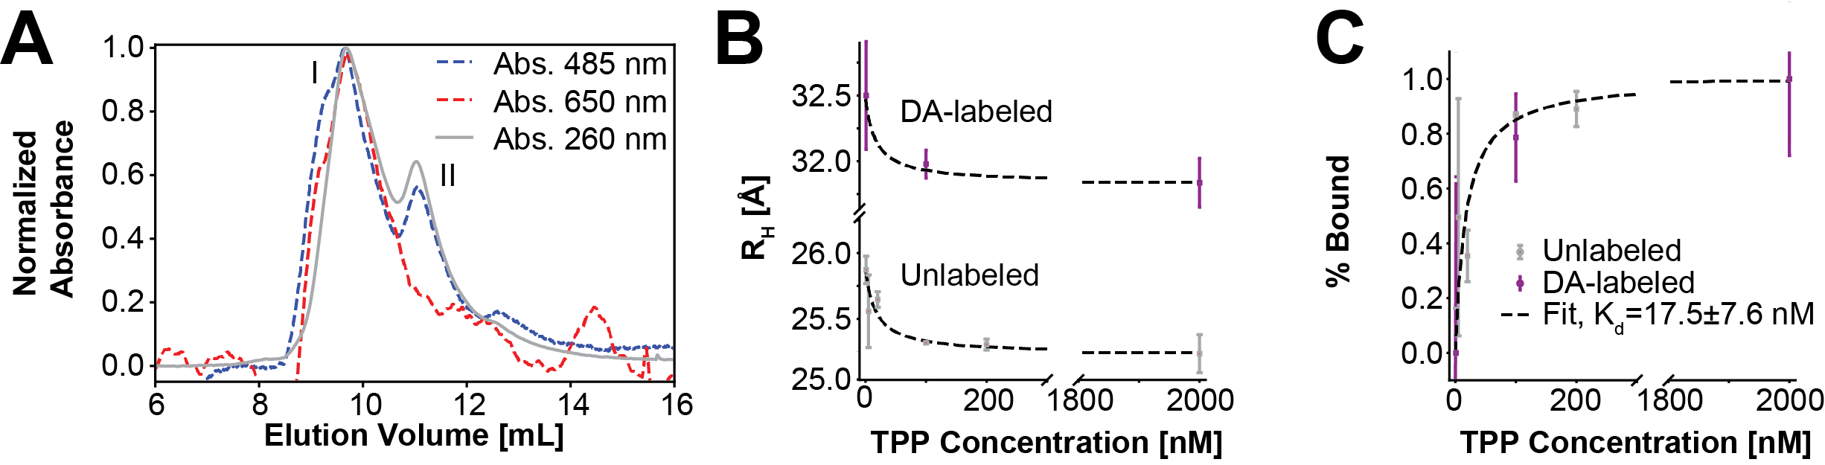
Figure S2. Riboswitch binding to TPP. (A) Example chromatogram of labeled and unlabeled aptamer in the presence of 200 mM Mg²⁺ only. Aptamer domain was monitored at 260 nm, the donor label at 485 nm, and the acceptor label at 650 nm. The Donor-Acceptor (DA) – labeled aptamer domain eluted at ~ 9mL (peak I) and donor only labeled eluted at ~ 11 mL (peak II). (B) Calculated hydrodynamic radius (R_{H}) for the unlabeled and labeled aptamer domain based on calibration curves from measurements of mass standards (Table S1). Experiments were performed in triplicate and standard deviation of the resulting R_{H} is presented as error bars. Black dashed lines follow the binding isotherm fit from panel C. For the DA-labeled aptamer domains, the same fit curve is displayed but shifted by the difference in the apparent R_{H} in in the absence of TPP. (C) Binding isotherm for unlabeled TPP riboswitch was fit assuming complete saturation at 2 mM.

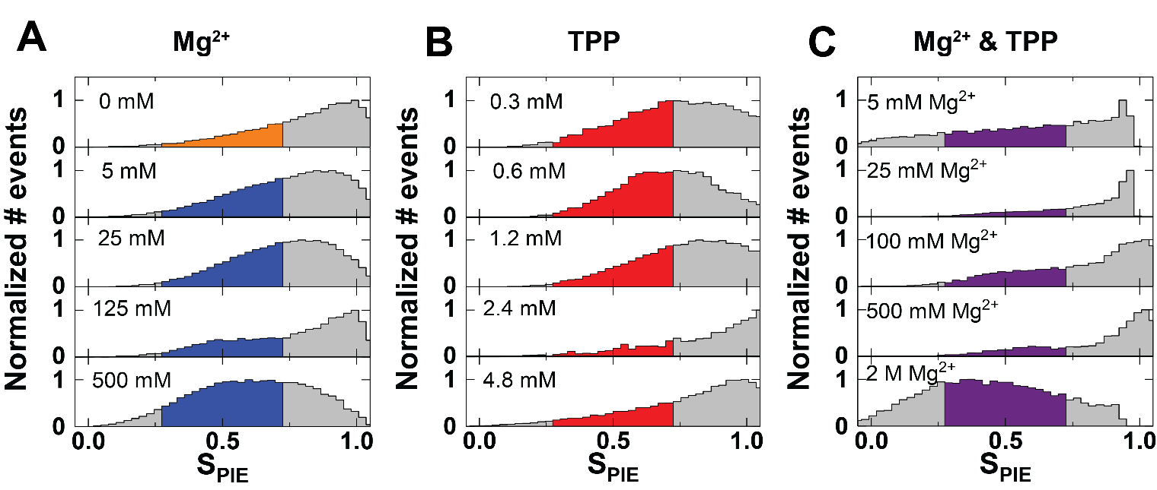
Figure S3. MFS Analysis was restricted to bursts with values of S_{PIE} between .3 and .7 to further reduce the number of molecules analyzed with inactive acceptor and to further ensure 1:1 donor to acceptor stoichiometry. 0.5 stoichiometry is the ideal case for which, after accounting for all correction parameters to normalize donor and acceptor photon counts, the number of photons observed during donor excitation account for half the total observed photons during donor and acceptor excitation, or the case in which one active acceptor and one active donor are present. Transitions between active and inactive states, or unquenched and quenched states of the fluorophores, as well as statistical variability in fluorescence events and uncertainty in correction parameters, contribute to deviations from $S_{PIE}=0.5$ even in the ideal 1:1 stoichiometry case. Colored regions of each plot represent the selected data which was used for analysis in Figure 3. Utilized correction parameters are in Table S2, B.

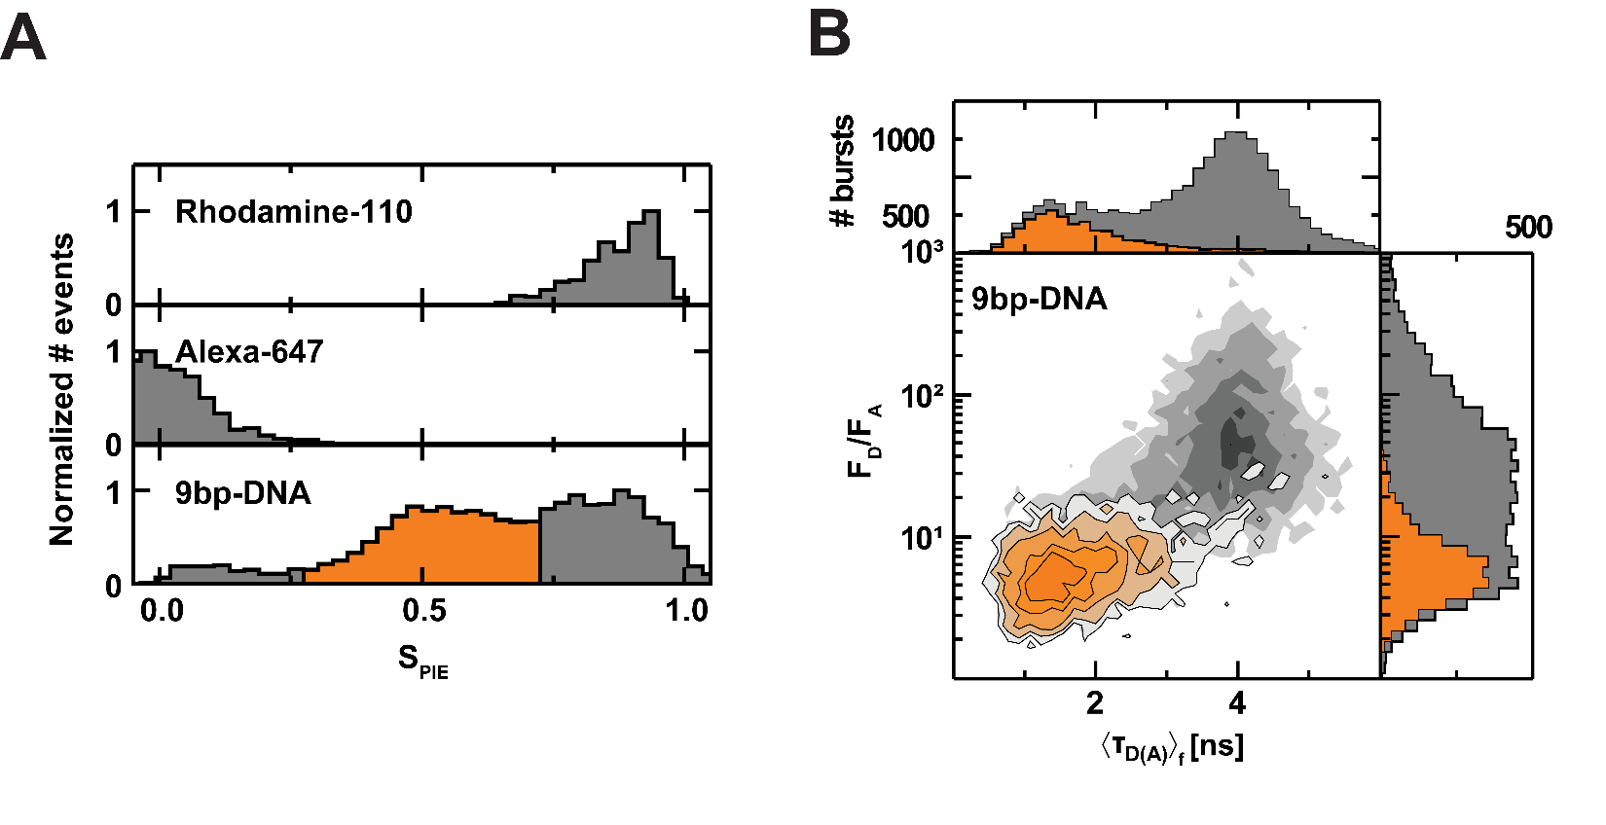
Figure S4. A) S_{PIE} histograms for standards used to quantify instrumental correction parameters (Table S2 B) by single-molecule PIE measurements. When properly corrected, Rhodamine-110 peaks near S_{PIE}=1, Alexa-647 peaks near S_{PIE}=0, and the DNA standard with 9 bp fluorophore separation will have 3 resolvable peaks corresponding to Acceptor-only, Donor and Acceptor labeled, and Donor-only molecules, respectively. (Hellenkamp et al. 2018) The used DNA was characterized as part of a multi-laboratory study for establishing quantitative FRET standards. (Hellenkamp et al. 2018) Orange indicates the burst selection according to S_{PIE}, from 0.3<S_{PIE}<0.7. B) MFD histogram for DNA with 9 bp fluorophore separation with the ratio of donor over acceptor fluorescence (F_{D}/F_{A}) vs the average fluorescence lifetime of the donor in the presence of acceptor ${〈τ_{D\left(A\right)}〉}_{f}$. Orange indicates bursts selected according to S_{PIE} as in A. Grey contours indicate bursts without S_{PIE} selection, exhibiting a distinct separation between the Donor-only population and the FRET population due to the high apparent FRET of the sample.

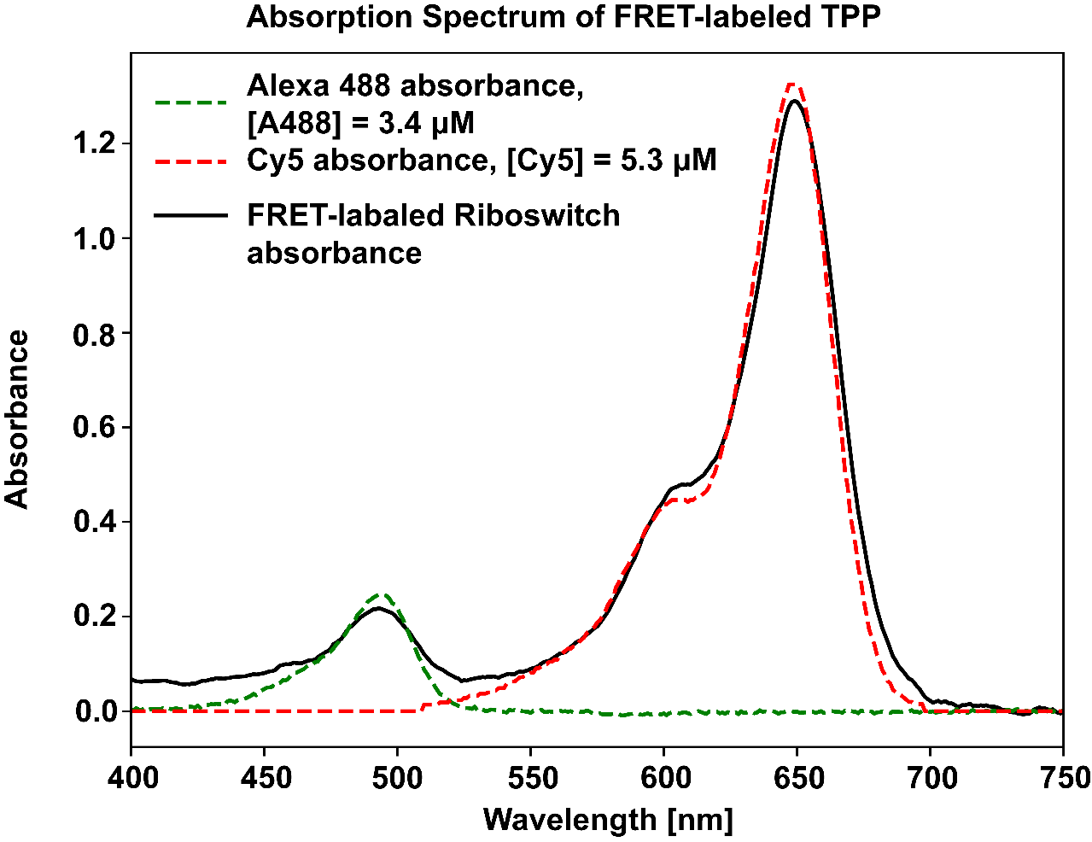
Figure S5. Absorption spectrum measured for FRET-labeled TPP riboswitch. Concentrations of the fluorophores were calculated based on the absorption at peak after fitting to the total absorption spectrum of the labeled riboswitch sample. The extinction coefficients for Alexa 488 and Cy5 are ε_{A488} = 73000 cm⁻¹ M⁻¹ and ε_{A488} = 250000 cm⁻¹ M⁻¹, respectively. 1 cm was used for the optical path length. The relative concentrations of the fluorophores indicate incomplete labeling of the riboswitch sample. However, there is not an overwhelming majority of molecules with only one of the two fluorophores, and selection by S_{PIE} allows analysis to be performed only on molecules with both active acceptor and donor fluorophores.
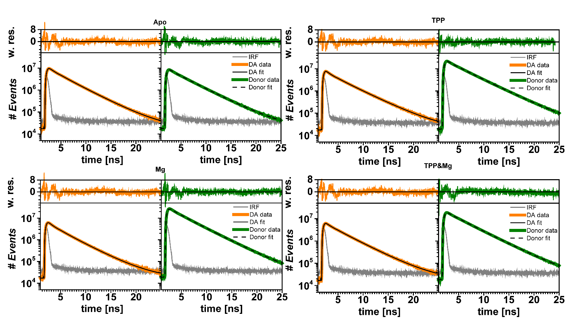

Figure S6. Time-resolved fluorescence decays in each experimental condition. Each fit model term corresponds to a state with Gaussian-distributed interdye distance described by the donor fluorescence lifetime of that term. Each DA curve is fit with a no-FRET decay term in addition to two FRET-exhibiting state fluorescence decay terms. The fluorescence lifetimes resulting from the fits correspond to representative averages of quickly-exchanging, FRET-exhibiting ensembles of states. Corresponding weighted residuals (w. res.) are shown above each fluorescence decay curve.

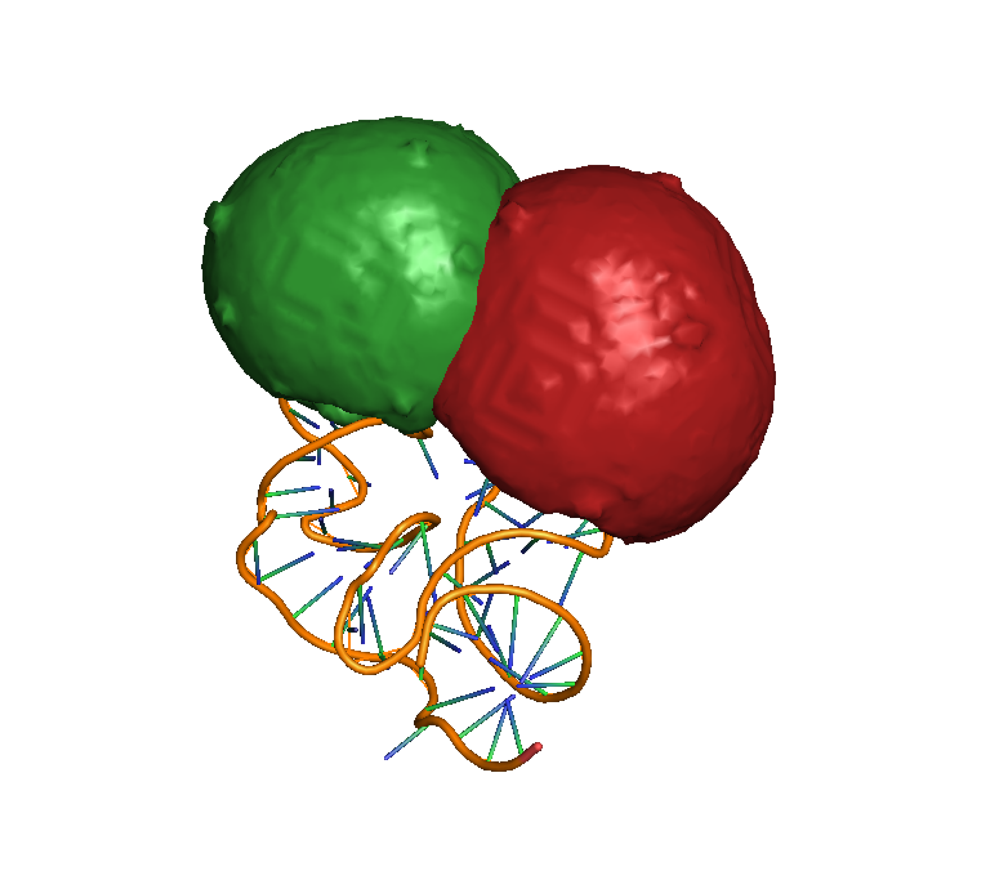

Figure S7. Accessible volumes from AV simulations of donor and acceptor for the TPP riboswitch closed state from the crystal structure. The donor Alexa-488 AV is shown in green, while the acceptor Cy5 AV is shown in red.

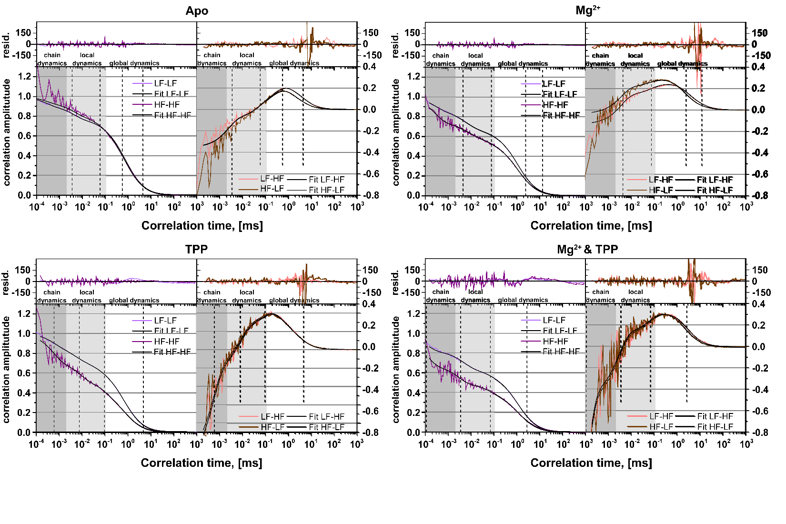
Figure S8. Filtered FCS Species auto and cross-correlation (sACF and sCCF) function for TPP riboswitch in a variety of experimental conditions. Timescales for transitions between filtered species appear in the sCCFs as anti-correlation terms and are indicated on both sCCF and sACF curves by dotted black lines. Because filtered species correspond to different FRET states, these correlation times correspond to timescales of transitions which result in changes of FRET efficiency.

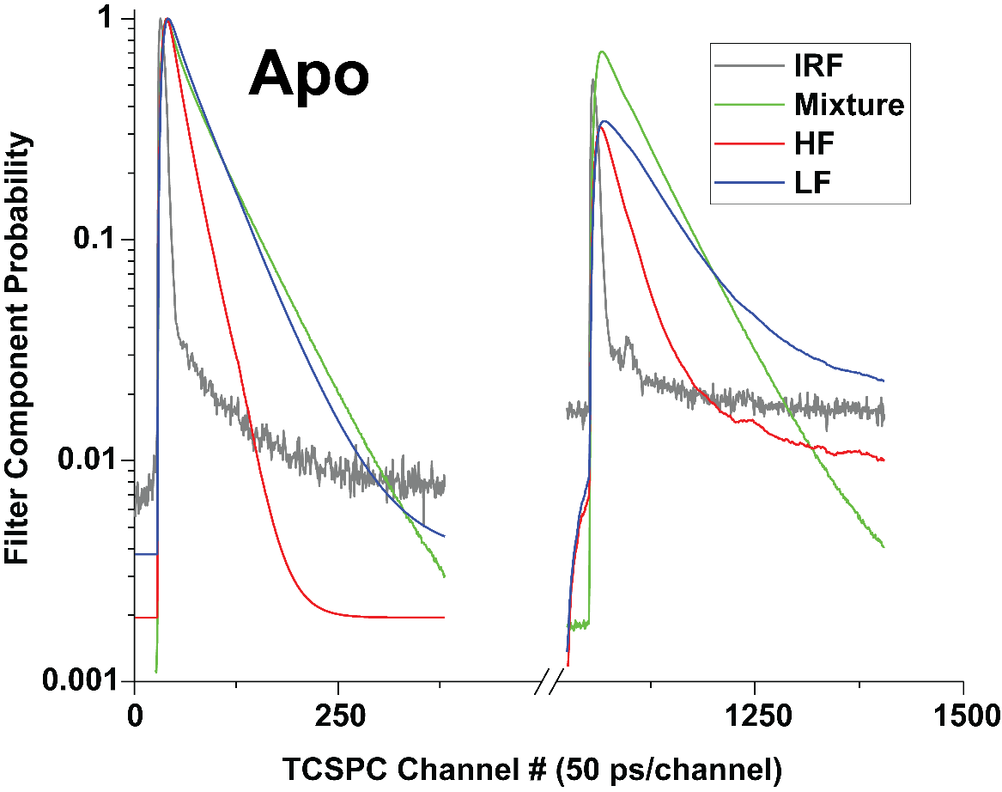
Figure S9. Amplitudes of the filter components used for fFCS analysis of the TPP riboswitch in Apo conditions based on the fFCS methodology described in (Felekyan et al. 2012), with maximum values of each component normalized to 1. The mixture represents the donor fluorescence decay for the measured sample, or the mixture of the filter component species (in this case, FRET-labeled TPP riboswitch in the Apo buffer). The instrument response function (IRF) component is not correlated in Figure S5, instead being defined as an unused filter component to remove it from correlated signal. The high FRET (HF) and low FRET (LF) filter components were defined using software-generated, idealized donor fluorescence decay signals with fixed lifetimes to encapsulate the high and low FRET fluorescence decay regimes. The mixture decay represents the fluorescence decay observed from the FRET-sensitized donor of the FRET-labeled TPP riboswitch. The HF donor lifetime was set to 0.38 ns, while the donor lifetime was set to 3.10 ns for apo, 2.90 ns for Mg²⁺, 3.20 ns for TPP, and 3.10 ns for Mg²⁺ & TPP. While filter quality, including accuracy of filter component lifetimes, has been seen to distort correlation term amplitudes, the correlation times in these cases can still be correctly recovered (Felekyan et al. 2012).
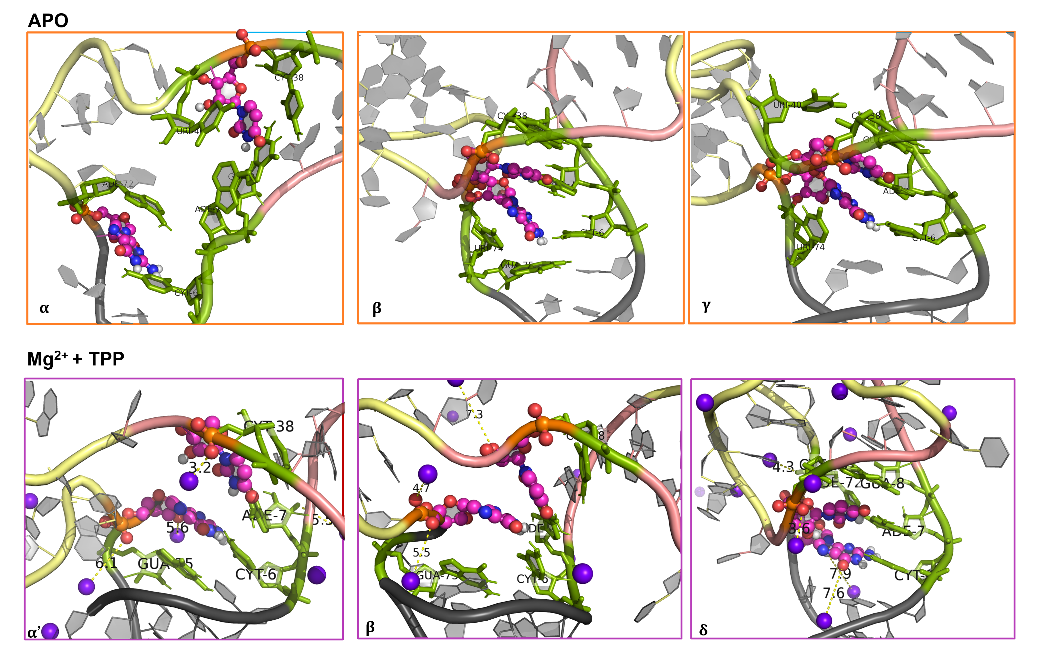

Figure S10. Snapshots depicting the co-stacking of U39 and G73 bases in apo (top panel, α, β, γ) and Mg²⁺&TPP conditions (bottom panel, α’, β, δ). The Mg²⁺ are shown as purple spheres, nucleotides U39 and G73 are shown in ball-and-stick representation, and the neighboring bases are colored in green.

Figure S11. (A) Time evolution of the inter-arm (G25 and U56) distance and (B) time evolution of the co-stacked distance (U39 and G73) of the riboswitch in apo condition. The total simulation time for each replica is 200 ns, and the sixteen individual trajectories corresponding to replicas 1-16 are shaded to separate the different replicas. The basins correspond to open state with no co-stacking (α), open state with co-stacking (β), and partially closed state with co-stacking (γ) are marked.

Figure S12. (A) Time evolution of the inter-arm (G25 and U56) distance and (B) time evolution of the co-stacked distance (U39 and G73) of the riboswitch in Mg²⁺ ion condition. The total simulation time for each replica is 200 ns, and the sixteen individual trajectories corresponding to replicas 1-16 are shaded to separate the different replicas. The basins correspond to open state with no co-stacking (α'), open state with co-stacking (β), and partially closed state with co-stacking (γ') are marked.

Figure S13. (A) Time evolution of the inter-arm (G25 and U56) distance and (B) time evolution of the co-stacked distance (U39 and G73) of the riboswitch in TPP condition. The total simulation time for each replica is 200 ns, and the sixteen individual trajectories corresponding to replicas 1-16 are shaded to separate the different replicas. The basins correspond to open state with no co-stacking (α''), open state with co-stacking (β'), and partially closed state with co-stacking (γ) are marked.

Figure S14. (A) Time evolution of the inter-arm (G25 and U56) distance and (B) time evolution of the co-stacked distance (U39 and G73) of the riboswitch in Mg²⁺ & TPP condition. The total simulation time for each replica is 200 ns, and the sixteen individual trajectories corresponding to replicas 1-16 are shaded to separate the different replicas. Partial refolding is observed e.g. in replicas 5, 6, and 11 of Panel A and the native state is found to be stable in Mg²⁺ & TPP buffer. The basins correspond to open state with no co-stacking (α'), open state with co-stacking (β), partially closed state with co-stacking (γ), and closed state with co-stacking (δ) are marked.

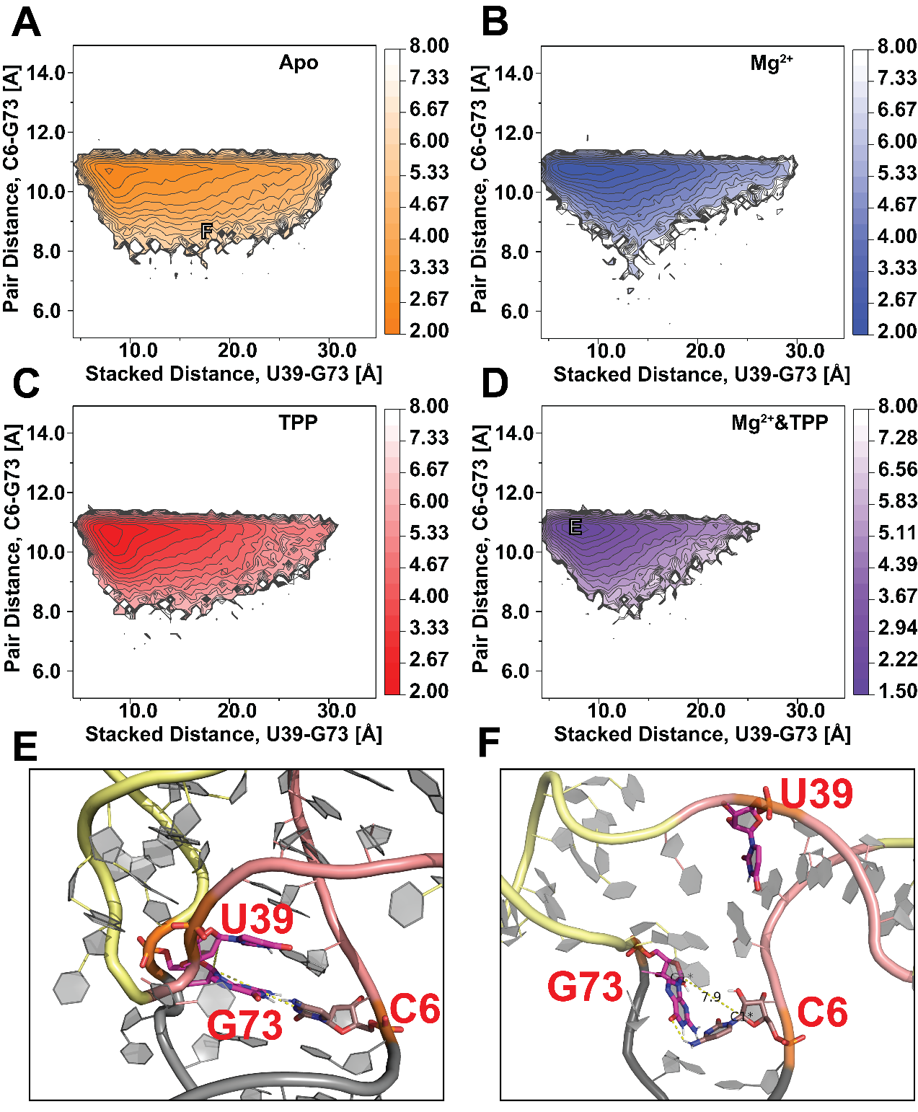

Figure S15. 2D PMFs relating C6.C1’-G73.C1’ pair distance to the U39-G73 co-stacking distance in apo (A), Mg²⁺ (B), TPP (C), and Mg²⁺ & TPP (D) simulation conditions. (E) Co-planar base-pairing of C6-G73 concomitant with P1/P2 co-stacking (U39/G73). (F) Buckling of C6-G73 base-pair and loss of P1/P2 co-stacking.


-NH₂ modification
Biotin
Silane
-NHS functionalized
Blocked NHS
Streptavidin

Figure S16. Schematic of riboswitch stretching and passive force dynamics optical tweezer experiments (not to scale). The NH₂-modified end of DNA-TPP riboswitch construct is anchored to the previously silanized coverglass using NHS-amine chemistry. The biotin-modified end is linked to a streptavidin-coated bead, which is trapped by the optical tweezer. The coverslip is translated relative to the fixed trap pulling the riboswitch construct. The pulling force is calculated using the calibrated trap stiffness and the displacement of the bead center from the center of the optical trap. The stretching displacement is calculated using the known stage translation, the displacement of the bead from the center of the optical trap, and the geometry of the DNA-TPP riboswitch/bead construct.

Figure S17. Histogram of riboswitch folded state dwell time measured in the presence of 4.8 mM TPP and 0.5 M Mg²⁺ at (A) 42.6 pN, N=309, and (B) 43.7 pN, N=319. The characteristic dwell times were $τ_{\text{off}}=74.2 ± 7.2$ and $τ_{\text{off}}=61.1± 8.2$ (single exponential decay fit constant $±$ std. error of the fit) respectively.

REFERENCES

Armstrong JK, Wenby RB, Meiselman HJ, Fisher TC. 2004. The hydrodynamic radii of macromolecules and their effect on red blood cell aggregation. Biophys J 87: 4259-4270.
Dolino DM, Rezaei Adariani S, Shaikh SA, Jayaraman V, Sanabria H. 2016. Conformational Selection and Submillisecond Dynamics of the Ligand-binding Domain of the N-Methyl-d-aspartate Receptor. J Biol Chem 291: 16175-16185.
Felekyan S, Kalinin S, Sanabria H, Valeri A, Seidel CA. 2012. Filtered FCS: species auto- and cross-correlation functions highlight binding and dynamics in biomolecules. Chemphyschem 13: 1036-1053.
Felekyan S, Sanabria H, Kalinin S, Kuhnemuth R, Seidel CA. 2013. Analyzing Forster resonance energy transfer with fluctuation algorithms. Methods Enzymol 519: 39-85.
Hellenkamp B, Schmid S, Doroshenko O, Opanasyuk O, Kuhnemuth R, Rezaei Adariani S, Ambrose B, Aznauryan M, Barth A, Birkedal V et al. 2018. Precision and accuracy of single-molecule FRET measurements-a multi-laboratory benchmark study. Nat Methods 15: 669-676.
La Verde V, Dominici P, Astegno A. 2017. Determination of Hydrodynamic Radius of Proteins by Size Exclusion Chromatography. Bio-protocol 7: e2230.
Sanabria H, Rodnin D, Hemmen K, Peulen T-O, Felekyan S, Fleissner MR, Dimura M, Koberling F, Kühnemuth R, Hubbell W et al. 2020. Resolving dynamics and function of transient states in single enzyme molecules. Nature Communications 11: 1231.
Sisamakis E, Valeri A, Kalinin S, Rothwell PJ, Seidel CAM. 2010. Accurate Single-Molecule Fret Studies Using Multiparameter Fluorescence Detection. Methods in Enzymology, Vol 475: Single Molecule Tools, Pt B 475: 455-514.
Talmard C, Guilloreau L, Coppel Y, Mazarguil H, Faller P. 2007. Amyloid‐beta peptide forms monomeric complexes with CuII and ZnII prior to aggregation. ChemBioChem 8: 163-165.
Tsytlonok M, Sanabria H, Wang Y, Felekyan S, Hemmen K, Phillips AH, Yun MK, Waddell MB, Park CG, Vaithiyalingam S et al. 2019. Dynamic anticipation by Cdk2/Cyclin A-bound p27 mediates signal integration in cell cycle regulation. Nat Commun 10: 1676.
Yanez Orozco IS, Mindlin FA, Ma J, Wang B, Levesque B, Spencer M, Rezaei Adariani S, Hamilton G, Ding F, Bowen ME et al. 2018. Identifying weak interdomain interactions that stabilize the supertertiary structure of the N-terminal tandem PDZ domains of PSD-95. Nat Commun 9: 3724.

