Figure S1. Ratio of green channel TO1-B signal to red channel TO3-B signals for round 12 and round 15 aptamers. Clones from rounds 12 and 15 of the TO3-B selection were incubated with TO1-B (100 nM) and TO3-B (200 nM) in WB buffer. Logs of the resulting ratios were compared between clones within (A) Round 12 and (B) Round 15 with Mango III A10U as a control.

Figure S2. K_{D} measurements for RNA aptamer:fluorophore complexes. Binding affinity curves were done in WB buffer for (A) Peach I, (B) Peach II, and (C) Mango III A10U for TO1-B (green curve), YO3-B (orange curve), TO3-B (red curve) using 10 nM of each fluorophore. Error bars represent the standard deviation for an experiment performed in triplicate.

Parameter
K_{D}(TO3-B) nM | 18.3 ± 0.3
F_{max} | 104 ± 1.08
Unbound TO3-B Slope | 0.14 ± 0.001
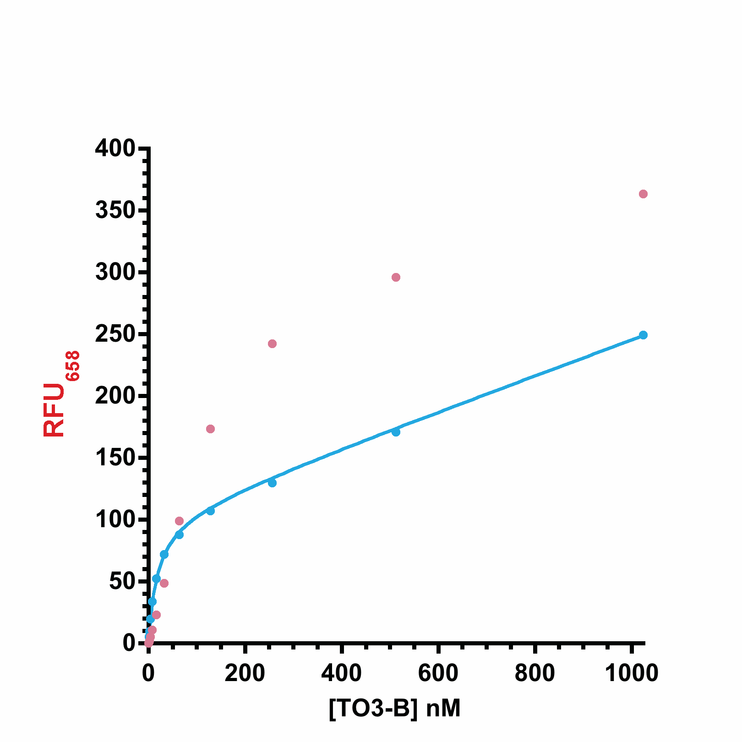

Figure S3. TO3-B Titration with Peach I (blue) or Peach II (pink). Measurements were done in WB buffer using 10 nM of each aptamer. The Peach I curve was fitted to a 2 parameter fit (eq. 2) with an addition of a linear portion to account for increasing unbound TO3-B signal with values shown in the table.

Figure S4. Salt titrations with Li⁺ (blue), Na⁺ (purple), or K⁺ (pink) for either (A) Peach I or (B) Peach II with TO3-B (top) and TO1-B (bottom). Potassium data was fitted to the Hill equation with the Hill coefficients listed in Table B. However, grey diamond data points were not included.
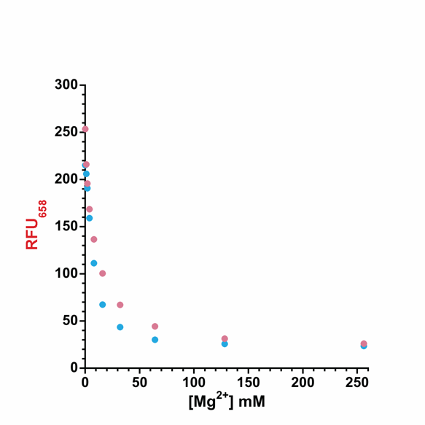
Figure S5. Effect of increasing concentrations of MgCl₂. The red channel TO3-B (50 nM) signal of Peach I (blue) and Peach II (pink) (25 nM each) exponentially decreases with increasing Mg²⁺ concentrations.

Figure S6. DMS Probing for (A) Peach I and (B) Peach II. Lane 1 corresponds to the hydrolysis ladder, 2 to the T1 RNase ladder, 3 to (-), and 4 to DMS probing with denatured RNA. Lanes 5 and 6 are in the presence of K⁺ (140 mM) with and without TO3-B (1 µM), as well as both 7 and 8 in the presence of Li⁺ (140 mM) with and without TO3-B respectively. Lane 9 corresponds to incubation with K⁺ and TO1-B (1 µM).

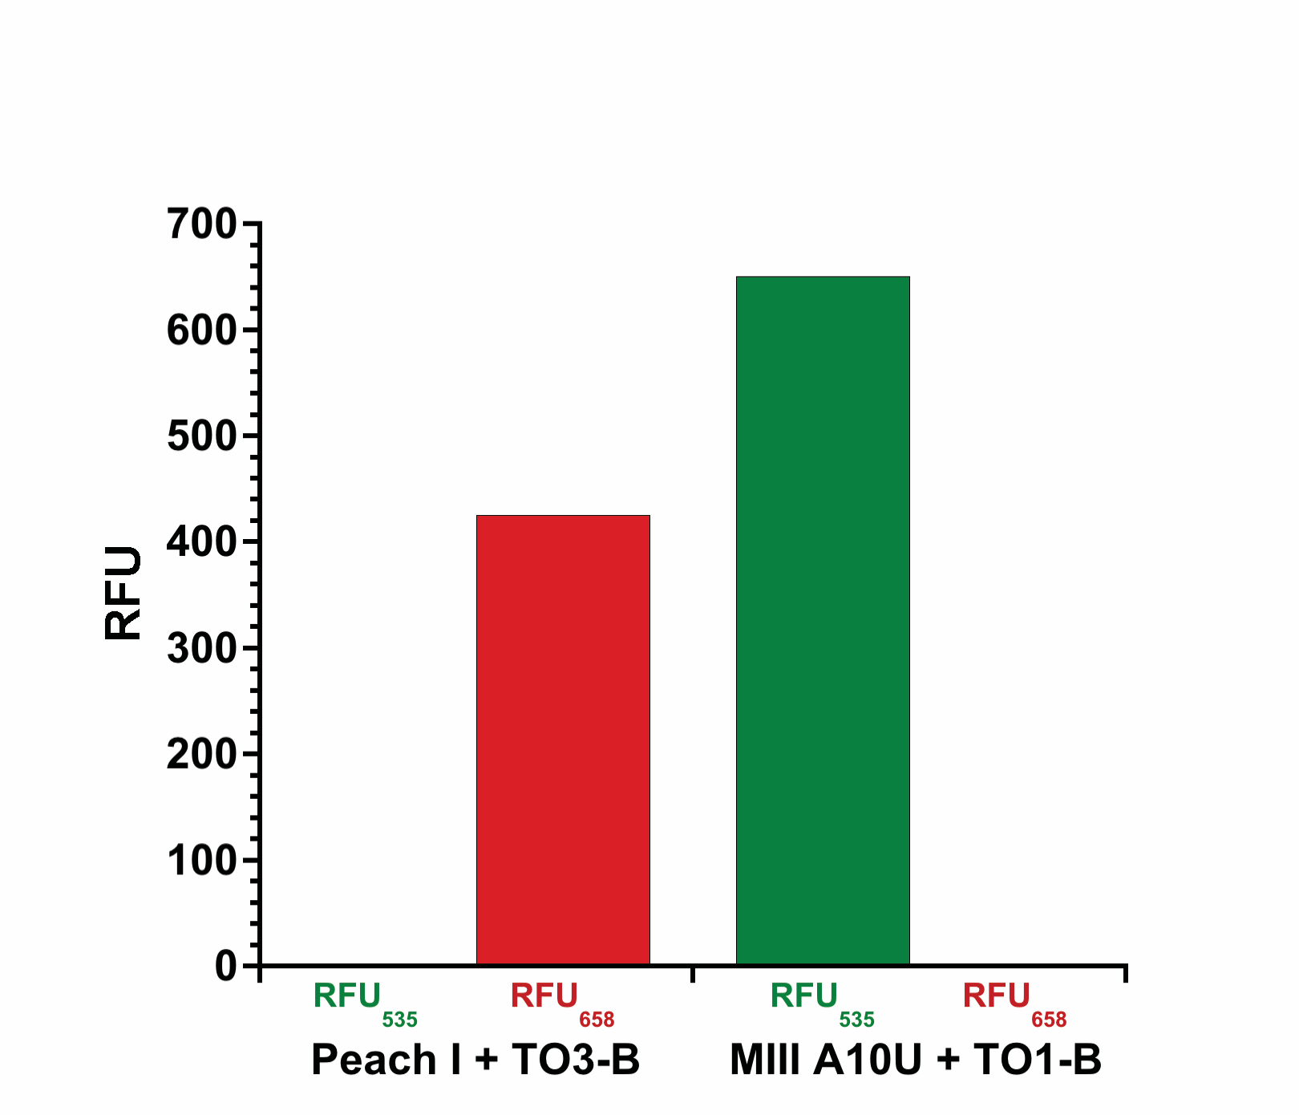

Figure S7. Absence of bleed through between the red TO3-B channel and green TO1-B channel. Peach I or MIII A10U (50 nM) were incubated with their respective fluorophore TO3-B or TO1-B (100 nM each) and simultaneously read in the green TO1-B channel (ex: 510 nm, em: 535 nm) and red TO3-B channel (ex: 637 nm, em: 658 nm). Readings were taken on a Varian Cary Eclipse spectrophotometer.

Figure S8. Linear fits for (A) MIII A10U and (B) Peach I. Linear fits were derived from fluorescent green or red signals from the three different RNA aptamer gradients (0 to 50 nM) including simultaneously increasing and decreasing Peach I and MIII A10U (square), both increasing aptamers (circle), and solo aptamer gradients (diamond). Error bars represent SD from readings taken in triplicate in figure 6 of the main text.

Figure S9. Extinction coefficients between unbound and bound TO3-B/YO3-B are the same between the two states. Linear fits for (AB) YO3-B or (CD) TO3-B either (AC) bound to Peach I (4 µM) or (BD) unbound were performed on absorbance normalized samples in WB buffer.

Table S1: Conditions of in vitro selection for TO3-B aptamers
Round | RNA Binding (min) | Wash 1 (min) | Wash 2 (min) | Competitors Used | [Competitor] µM | Pre-incubation (min)
3 | 30 | 5 | 15 | TO1-Acetate | 2.5 | 0
 |  |  |  | TO3-Acetate | 2.5 | 0
 |  |  |  | NMM | 2.5 | 0
4-5 | 30 | 5 | 30 | TO1-Acetate | 5 | 0
 |  |  |  | TO3-Acetate | 5 | 0
 |  |  |  | NMM | 5 | 0
6 | 30 | 60 | 60 | TO3-Acetate | 5 | 5
 |  |  |  | NMM | 5 | 5
 |  |  |  | TO1-Propylamine | 5 | 5
7 | 15 | 60 | 60 | TO3-Acetate | 5 | 30
 |  |  |  | NMM | 5 | 30
 |  |  |  | TO1-Propylamine | 5 | 30
8 | 4 | 60 | 60 | TO3-Acetate | 20 | 60
 |  |  |  | NMM | 20 | 60
 |  |  |  | TO1-Propylamine | 20 | 60
9 | 1 | 60 | 60 | TO3-Acetate | 20 | 60
 |  |  |  | NMM | 20 | 60
 |  |  |  | TO1-Propylamine | 20 | 60
10 | 0.5 | 60 | 60 | TO1-Propylamine | 20 | 60
11-16 | 0.5 | 60 | 60 | TO1-Propylamine | 20 | 60
 |  |  |  | TO1-Methoxyethlyamine | 20 | 60

